


Occupation Mobility Graph
  - Labour Market Efficiency
July 2026

Contents
1 In Brief 2
2 Background 2
3 Occupation Mobility 4
3.1 Occupation Mobility Interactive Tool: Sales Assistant (General) 4
3.2 The Occupation Mobility Graph 7
3.2.1 Social, Education and Service cluster 8
3.2.2 Health, Science and Research cluster 10
3.2.3 Engineering and ICT cluster 12
4 Reflecting on Mobility Patterns 13
5 References 14
6 Disclaimer 16

1 In Brief
Occupation mobility refers to the way people move between jobs over time. These movements help workers find roles where their skills are better used, support career development and job satisfaction, and are often linked with higher wages. For employers, mobility improves access to workers with the skills they need, helping to address shortages and support productivity.
This report uses Jobs and Skills Australia’s (JSA) data showing how workers move between occupations across years (known as Data on Occupation Mobility (DOM)) (JSA 2024) to illustrate these movements. The Occupation Mobility Interactive Tool (OMIT) published on JSA's website allows users to select an occupation and view the top ten occupations people moved from, and the top ten jobs they moved to, during the 2022-23 financial year (FY).
Another way to view these movements is through the Occupation Mobility Graph. This tool provides a broader perspective by showing how multiple occupations are related through worker movements and allowing several transitions to be considered at once. This visualisation supports a deeper understanding of common career pathways, which occupations act as stepping stones to others, and how groups of occupations form distinct segments within the labour market.
This report provides an initial view of how workers move between occupations and demonstrates the kinds of insights that occupation mobility data can reveal. Future work will extend this analysis by examining mobility through different lenses, including how patterns vary across demographic groups.

2 Background
Labour mobility refers to workers' ability to move between firms, occupations and locations. It is a key feature of a well-functioning labour market because it allows workers to move into roles where their skills are better utilised (D'Arcy et al., 2012; Victorian Skills Authority, 2025). Furthermore, labour mobility contributes to productivity growth as workers who switch roles tend to move to firms that are, on average, 13.1 per cent more productive than the firms they leave, with this effect strongest for younger workers (Buckley 2023). However, it is important to note that the average productivity gap between 'origin' and 'destination' firms has more than halved since the mid-2000s, which could suggest a decline in productivity enhancing relocation (Buckley, 2023).
The Australian Government’s Employment White Paper on Jobs and Opportunities (The Treasury, 2023) also highlighted that labour market mobility is important for both workers and employers. At the individual level, changing roles allows workers to find positions that better suit their interests, preferred working hours and skills. Therefore, mobility not only improves satisfaction and career progression but can also support productivity as workers are more effectively using the skills they have (Racionero, 2025). When workers move into roles that use their skills more efficiently, firms benefit from higher productivity, and this is often reflected in higher wages, with research consistently showing that moving from one role to another is linked to faster growth in average wages (Deutscher, 2019).
Meanwhile, for employers, higher labour market mobility improves access to workers with the skills needed to fill vacancies, supporting workforce planning, easing skills shortages and strengthening the adaptability of the jobs and skills system (The Treasury, 2023). By helping employers match roles with workers whose skills fit the role, mobility also supports firm level productivity, as businesses are better able to utilise their workforce effectively (Wiley and Wang, 2024). Despite these benefits, the share of Australian workers who change roles each year has declined since the 1990s, a contributing factor in Australia's weak productivity growth since the mid-2010s (Wiltshire, 2025).
Following the COVID19 pandemic, mobility rose noticeably in late 2021 and increased sharply through early 2022. This was driven by a rapid tightening in labour market conditions, high vacancy levels and strong competition for workers, which made it easier for people to change roles and encouraged many to pursue changes they had delayed during the pandemic. Much of this movement occurred in higher skilled occupations, where labour demand was particularly strong (Black and Chow, 2022; Wiley and Wang, 2024). Even though mobility has since fallen again, a steady share of workers still change industry or occupation, and highly educated workers are the most likely to do so (Fontenay et al., 2024).
It is important to note that while occupation changes are one way to increase productivity, many workers also contribute to productivity growth without moving occupations. Workers also contribute to productivity growth through in‑job skill deepening (Mustafa and Lleshi, 2024), where they build greater expertise and undertake more complex work while remaining within the same occupation. Additionally, it is important to recognise that job mobility is not always positive or voluntary, as workers’ employment situations can change for a range of reasons not driven by choice. These points show that while occupation to occupation movement is an important lens, it represents only one part of a broader and more complex picture of labour mobility.
To analyse these labour mobility patterns, this report constructs an Occupation Mobility Graph explained in more detail in the following section. This approach builds on earlier research that models labour flows as networks, including Guerrero and Axtell (2013) and Schmutte (2014) who identified mobility segments between which mobility is constrained.

3 Occupation Mobility
The DOM is constructed from administrative tax data available under the ABS' Person Level Integrated Data Asset (PLIDA) (PLIDA; ABS, 2023). This data captures transitions of individuals who report a different occupation on their tax return from one FY to the next. The DOM data utilised for the Occupation Mobility Graphs spans the FY 2011-12 to FY 2022-23 period. This report utilises the data and presents two visualisation methods to provide insights into labour market mobility. The Occupation Mobility Interactive Tool (OMIT) is used to introduce the concept of occupation transitions. It focuses on a particular occupation and shows the occupations people worked in directly before and after. The OMIT is available on the JSA website and allows users to select from over 1,000 different occupations at the most detailed (6--digit) level of the Australian and New Zealand Standard Classification of Occupations (ANZSCO).
The second method is through network graphs. These visualisations show the relationships between all occupations in the labour market at the ANZSCO 4-digit Unit Group level - the second most detailed level. This allows us to see the large range of career pathways Australians take and lets users think about multiple occupation changes they might take into the future. Because there are over 400 occupation Unit Groups at the 4-digit level of ANZSCO, this is a complicated and crowded chart, so we have presented three examples of occupation clusters to highlight segments of the labour market.

3.1 Occupation Mobility Interactive Tool: Sales Assistant (General)
As Sales Assistant (General) is the most common occupation in Australia (JSA, 2024) and has inflows from and outflows to a broad array of occupations, this occupation offers a strong illustration of how workers move between roles. Furthermore, its scale, with employment estimated at around 559,800 people, and its median age of 23, position it as a frequent early career entry point where many workers first develop transferable frontline service capabilities (ABS and JSA, 2025). These characteristics allow the occupation to reveal a wide range of linkages across the labour market and help to frame mobility patterns.
The OMIT shows the volume and direction of flows between occupations. For inflows, each band begins at a source occupation on the left and ends at Sales Assistant (General) on the right (Figure 1). The width of each incoming band reflects how many workers are entering the occupation, making it clear which prior roles contributed higher volumes of workers into the role in FY2021-22 to 2022-23 and how diverse or concentrated these entry pathways are.
For instance, Figure 1 shows the ten largest movements into the occupation in FY 2022-23, with the most common transitions coming from Waiter with 2,240 movements and Fast Food Cook with 2,185 movements.
Figure 1: Sales Assistants (General) occupation, top 10 occupation inflows, 2021-22 to 2022-2023.
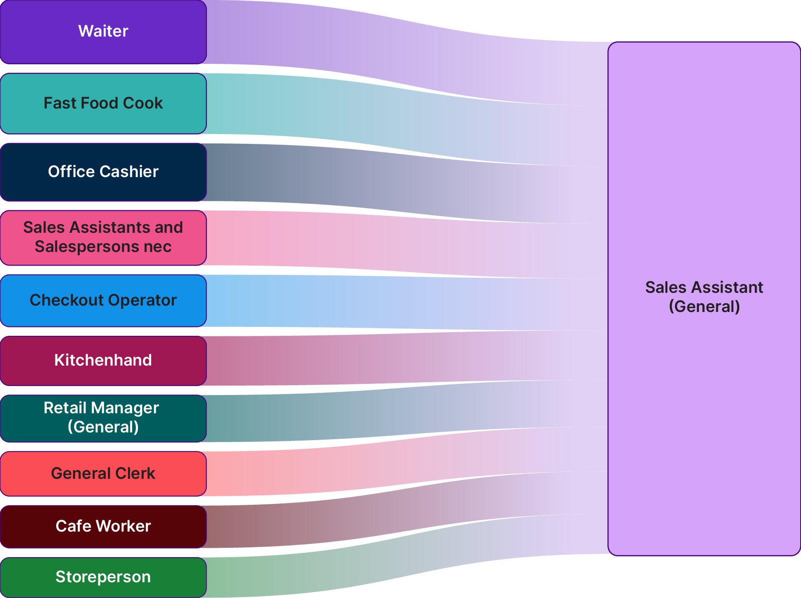
Source: Jobs and Skills Australia, Data on Occupation Mobility (DOM), 2021-22 to 2022-23, ABS Datalab, filtered at the 6-digit ANZSCO level, top 10 occupation movements. Findings based on use of PLIDA data.
These transitions illustrate the strong transferability of frontline service capabilities that are common across these roles, including customer interaction, use of point-of-sale systems, cash handling and routine problem-solving.
Checkout Operator, with 1,250 movements, is also a relevant pathway in this group. Movement from Checkout Operator into Sales Assistant (General) can also involve a shift into a role with a broader mix of retail tasks while still drawing on the same foundational service capabilities.
The OMIT can also be read in reverse to show outflows from Sales Assistant (General). In this case, each band starts at Sales Assistant (General) on the left and connects to a destination occupation on the right (Figure 2).

Figure 2: Sales Assistants (General) occupation, top 10 occupation outflows, 2021-22 to 2022-2023.
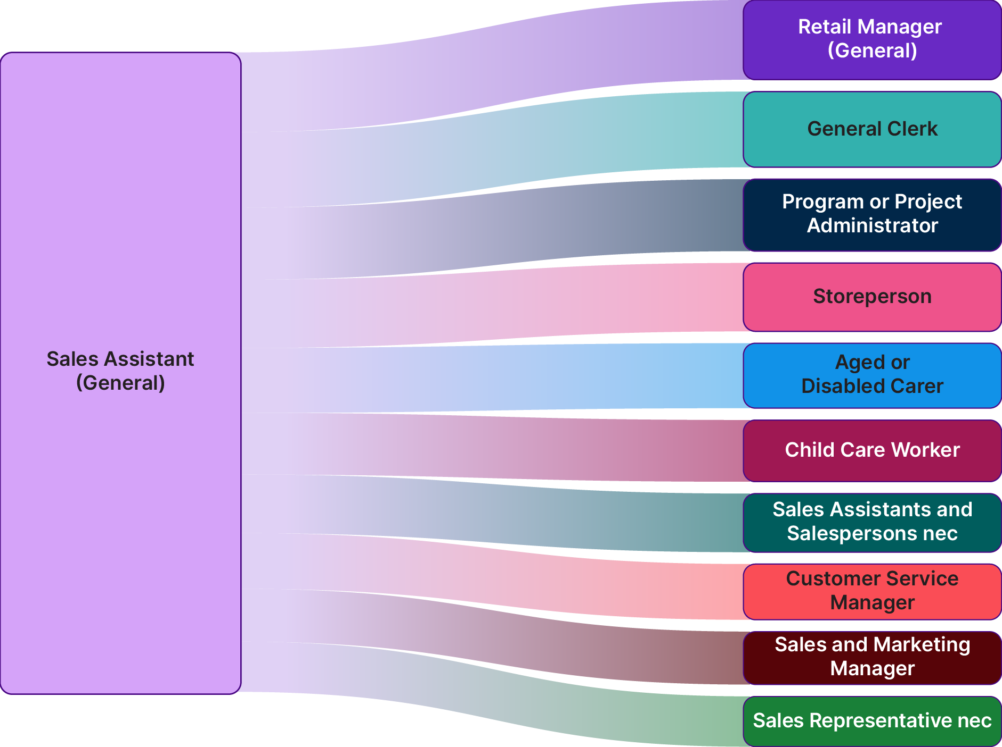
Source: Jobs and Skills Australia, Data on Occupation Mobility (DOM), 2021-22 to 2022-23, ABS Datalab, filtered at the 6-digit ANZSCO level, top 10 occupation movements. Findings based on use of PLIDA data.
Figure 2 shows the ten largest movements out of Sales Assistant (General) during FY 2021-22 to 2022-23. The most common transition was into Retail Manager (General) with 3,795 movements. Sales Assistant (General) is a Skill Level 5 occupation (commensurate with compulsory secondary education), while Retail Manager (General) is classified at Skill Level 2 (commensurate with a Diploma), indicating movement into roles with broader supervisory or managerial responsibilities.
General Clerk (Skill Level 4, commensurate with a Certificate II or III) with 2,345 movements is another upward skill transition from Sales Assistant (General). This occupation involves a broader set of administrative and organisational tasks, including processing documentation, maintaining records and providing customer or internal support. These tasks draw on capabilities that can be developed in retail environments, and the transition reflects movement into roles with increased administrative scope and responsibility.
Some of the other transitions in Figure 2 probably reflect individuals undertaking study and gaining qualifications while working as a Sales Assistant. For example, Aged or Disabled Carer roles typically require a Certificate III in Individual Support (Australian Government, 2022), while Child Care Worker positions generally require a Certificate III in Early Childhood Education and Care or active progress toward one (ACECQA, 2025). While formal qualifications attained while working as a Sales Assistant were likely the critical factor in people making these movements, the people focused skills learned on the job may also have stood them in good stead.
These pathways illustrate how foundational service and organisational capabilities developed in retail can support mobility into higher skilled occupations and provide opportunities for career development.
Additional examples of these pathways can be explored through the OMIT available on the JSA website, which allows users to examine inflows and outflows across a wide range of occupations.

3.2 The Occupation Mobility Graph
Another way to examine these patterns of occupation movement is through the Occupation Mobility Graph, which helps to identify the broader structure of mobility across the labour market. The key components of the Occupation Mobility Graph are:
- Nodes represent occupations
- Edges represent movement of people between occupations
- Weights indicate the volume of movement along each edge
Through a clustering analysis, which partitions the Occupation Mobility Graph into smaller segments, 8 algorithmically derived clusters are identified. Broadly, these clusters can be described as:
- Professional and Clerical
- Arts
- Engineering and ICT
- Nursing and Caring
- Social, Education and Service
- Agricultural
- Manufacturing
- Health, Science and Research
In the context of the Occupation Mobility Graph, a cluster refers to a group of occupations that data show to be more closely connected to one another through worker movements than to others in the wider labour market. These clusters highlight the underlying structure of mobility, often showing where occupations share similar capabilities and where transitions are most likely to occur. By identifying these groups, the Occupation Mobility Graph helps reveal how skills are related and where workers have the clearest pathways for progression or lateral movement.
For this report, three clusters are featured to highlight their characteristics, including the relationship between occupations and potential career pathways. These three clusters are the Social, Education and Service cluster; the Health, Science and Research cluster; and the Engineering and ICT cluster.

3.2.1 Social, Education and Service cluster
The Social, Education and Service cluster shows there are multiple paths of entry into many occupations, with work experience and study choices across Vocational Education and Training (VET) and higher education all playing an important role.
To maintain continuity with the earlier Sankey analysis, this section again uses Sales Assistant (General) as the example occupation. While the Sankey diagram highlighted how the occupation connects to a wide range of occupations, the Occupation Mobility Graph builds a richer picture by showing how these occupations relate to one another and connect to more distant occupations (Figure 3).
Because the Occupation Mobility Graph shows a wide range of linkages from Sales Assistant (General), this section narrows the focus to one set of pathways for readability. The pink lines in Figure 3 highlight movements from Sales Assistant (General) into education and teaching occupations, which are shown in green. These transitions illustrate how some workers with experience in retail roles move into professional occupations, primarily through formal qualifications, but perhaps also drawing on the communication and organisational capabilities developed in frontline service work.
Figure 3: Social, Education and Service cluster, occupation mobility network graph, 2021-22 to 2022-2023.
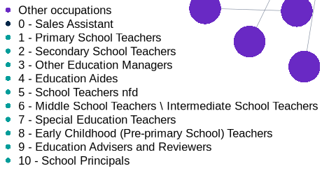
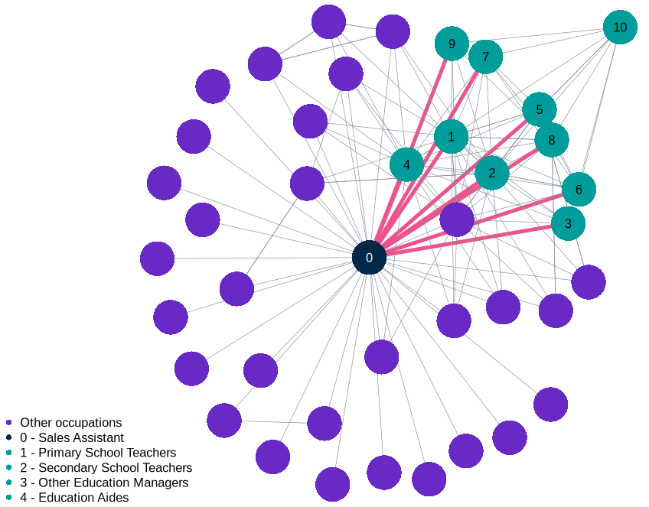
Source: Jobs and Skills Australia, Data on Occupation Mobility (DOM), 2021-22 to 2022-23, ABS Datalab, filtered at the 4-digit ANZSCO level. Findings based on use of PLIDA data.
In 2022-2023, 940 people who had previously employed as Sales Assistants (General) in FY 2021-22 became Education Aides. Sales Assistants (General) represent the second largest occupation of people who transitioned into being Education Aides, making up 10 per cent of the 9,365 people who transitioned from other occupations.
This Skill Level 4 occupation is an early point of entry into the teaching field. The skills required for this role show a progression from those developed in retail environments. Job advertisement data indicate that three of the six most frequently requested skills for Education Aides - communication, organisational skills, and planning - build on foundational skills learned by Sales Assistants (General) (Your Career, 2026). Progression into Teachers' Aide roles can be supported by the nationally recognised CHC30221 Certificate III in School Based Education Support, which provides the foundational training required to assist teachers across a range of classroom settings (Djerriwarrh Community and Education Services, 2026).
There were 1,125 movements from Education Aides (Skill Level 4) into Primary School Teachers (Skill Level 1). Progression into these teaching roles typically requires the completion of a Bachelor of Education or another bachelor’s degree followed by a Master of Teaching, providing the training and practicum experience required for registration as a teacher (Department of Education, 2026). Demonstrating a diversity of pathways, 830 people moved directly from Sales Assistants (General) into Primary School Teachers roles, indicating many were likely working in sales while studying for entry into Primary School Teaching.
Progression continues further along the occupation network, with 560 transitions from Primary School Teachers and 325 from Secondary School Teachers into School Principals (Skill Level 1), supported by gaining teaching experience, leadership development and in some instances postgraduate study (University of Canberra, 2026).
Subsequent movements of teaching roles into Other Education Managers reflect advancement into roles responsible for planning, directing and coordinating educational programs, providing strategic advice, and overseeing staff and operational functions within education systems. Together, these transitions illustrate how workers may build on foundational capabilities developed initially in retail roles and, with additional training and more advanced qualifications at each stage, move into progressively higher-skilled and higher paid education and teaching occupations.

3.2.2 Health, Science and Research cluster
Figure 4 illustrates two distinct but related sub‑clusters: a Healthcare sub‑cluster characterised by structured medical training pathways, and a Science and Research sub‑cluster displaying more distributed, cross‑disciplinary flows.
Figure 4: Health, Science and Research cluster, occupation mobility network graph, 2021-22 to 2022-2023.
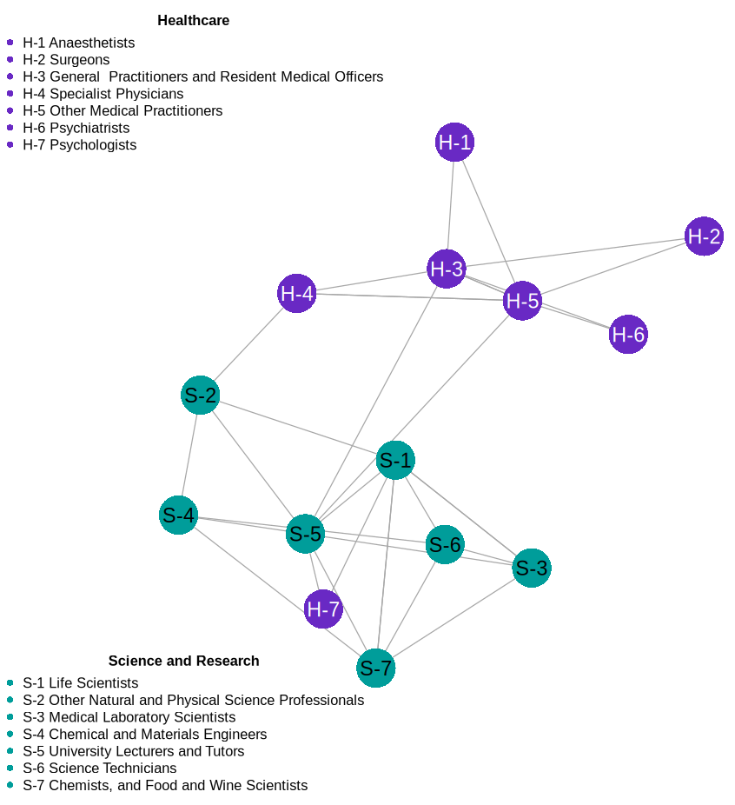
Source: Jobs and Skills Australia, Data on Occupation Mobility (DOM), 2021-22 to 2022-23, ABS Datalab, filtered at the 4-digit ANZSCO level. Findings based on use of PLIDA data.
Within the Healthcare sub‑cluster, General Practitioners and Resident Medical Officers form a node. From this origin point, the network shows 215 movements to Specialist Physicians, 95 movements to Anaesthetists, 50 movements to Surgeons, and 1,030 movements to Other Medical Practitioners. These flows reflect the rotations and supervised practice required in early medical careers along with career specialisation over-time.
As practitioners progress into specialty training, mobility across occupations narrows as capability development becomes increasingly discipline specific. At this point, people are less likely to change occupations and more likely to deepen their skills and progress their careers within their chosen profession. In Figure 4, this narrowing is reflected in the limited number of occupations mapped to specialist roles (including Anaesthetists and Surgeons) compared to General Practitioners and Resident Medical Officers.
These inflows align with the structure of Australia’s specialist medical training pathways, where practitioners transition from earlier generalist stages into advanced clinical programs. Surgical training typically spans 10 to 15 or more years, including a medical degree, internship, pre-vocational residency and a five- to six-year Surgical Education and Training program delivered by the Royal Australasian College of Surgeons (RACS) (RACS, 2026; University of Sydney, 2026a).
Anaesthesia training is equally demanding, encompassing an approximately 12-year sequence overseen by the Australian and New Zealand College of Anaesthetists (ANZCA), including a minimum five-year supervised specialist program built on extensive pre-specialty clinical experience (ANZCA, 2026; University of Sydney, 2026b). This contained pattern illustrates how medical skills accumulate through extended, sequenced training rather than through movement across different occupations, leading to stable but less re-allocative mobility within the Healthcare sub-cluster.
The Science and Research sub-cluster, in comparison, is tightly interconnected and characterised by multidirectional mobility and transfer between scientific, technical and academic roles. At the centre of this network sits University Lecturers and Tutors. University tutors are frequently higher degree research students who transition to other scientific and technical careers upon completion. Scientific professionals may also have adjunct affiliations that involve teaching. University Lecturers and Tutors anchor movement across the wider cluster and connect with, for example, Life Scientists (140 movements), Psychologists (145 movements), Chemists, and Food and Wine Scientists (95 movements).
When viewed alongside the Healthcare sub-cluster, the Science and Research sub-cluster reveals several important bridging points. Other Natural and Physical Science Professionals serve as a connector between scientific roles and clinical expertise, showing 25 movements into Specialist Physicians. University Lecturers and Tutors form another link, with 135 movements into General Practitioners and Resident Medical Officers and 40 movements into Other Medical Practitioners. These relationships suggest a flow of knowledge and practice between academic instruction, applied scientific research and clinical teaching roles, underscoring the interrelationship between scientific inquiry and medical capability.
Within this cluster, Psychologists occupy a distinctive position. While Psychologists align with the Healthcare sub-cluster, within the graph the occupation sits closer to occupations in the Science and Research sub-cluster, possibly reinforcing the discipline’s grounding in behavioural and biological science (Monash University, 2026). The occupation only connects to University Lecturers and Tutors and to Life Scientists (50 movements) within this graph. Looking at the broader data, people become Psychologists from a wide and diverse range of other occupations, but, as the numbers of movements from each are very small, they appear in other clusters.
The Figure 4 cluster highlights how different training systems shape distinct mobility patterns. The Healthcare sub-cluster exhibits structured, sequential mobility concentrated within defined clinical pathways, while Science and Research sub-cluster fields display broader movement across analytical and technical roles. These patterns reflect the way each system develops and deploys capability within the workforce.

3.2.3 Engineering and ICT cluster
Figure 5 shows that the Engineering and ICT cluster separates into two distinct sub‑clusters: one comprising engineering occupations and the other comprising ICT and statistics occupations. Engineering occupations tend to be grounded in physical and applied systems, such as telecommunications, electronics and mechanical infrastructure, whereas ICT and statistics occupations are more closely aligned with computational, data‑focused and digital systems. The points of connection between the two sub‑clusters suggest some overlap in foundational capabilities, and they also highlight pathways from VET‑qualified Draftspersons and Technicians into higher‑skilled engineering occupations.
Figure 5: Engineering and ICT cluster, occupation mobility network graph, 2021-22 to 2022-2023.
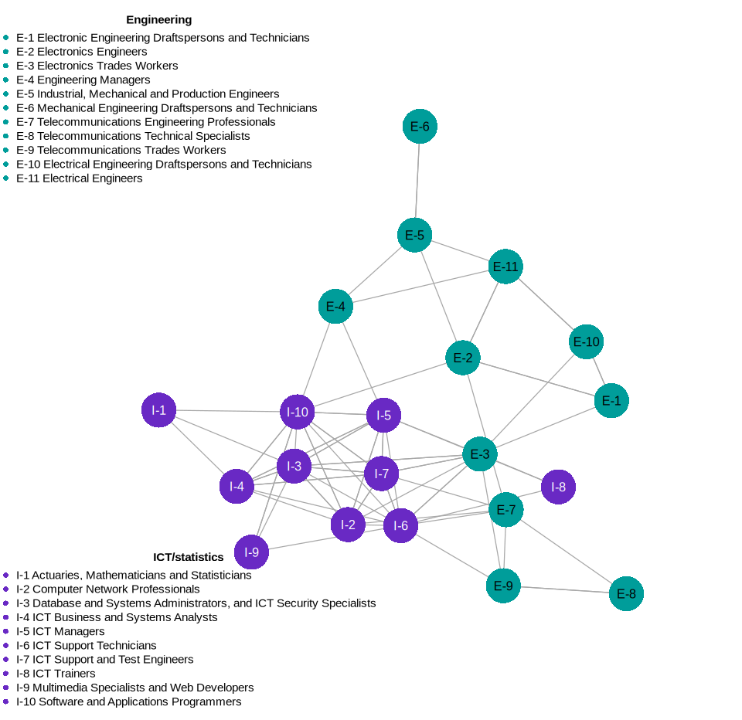
Source: Jobs and Skills Australia, Data on Occupation Mobility (DOM), 2022-23, ABS Datalab, filtered at the 4-digit ANZSCO level. Findings based on use of PLIDA data. Note: this graphic has been simplified for ease of display, for a full list of occupations in the cluster see Appendix B
Within the Engineering sub‑cluster, the occupations Electrical Engineers, Electronics Engineers, Industrial, Mechanical and Production Engineers, Electrical Engineering Draftspersons and Technicians, Electronic Engineering Draftspersons and Electronic Trades Workers cluster together. This grouping perhaps reflects their shared reliance on applied technical, mathematical and problem‑solving capabilities.
Movements from Electrical Engineering Draftspersons and Technicians (120) to Electrical Engineers, and from Electronic Engineering Draftspersons (25) to Electronic Engineers, may reflect structured pathways in which VET qualifications support entry into technical occupations (Walker, 2022), and further study and experience enable movement into more specialised occupations.
Movements from Electrical Engineers (115) and Industrial, Mechanical and Production Engineers (215) into Engineering Managers indicate a progression pathway into supervisory and managerial responsibilities.
The ICT and Statistics sub-cluster shows a closely connected set of occupations that form a tight cluster within the network. Their proximity reflects a high degree of occupation mobility within ICT related occupations, supported by shared competencies in programming, systems administration, data analysis and digital infrastructure.

4 Reflecting on Mobility Patterns
The analyses presented in this report illustrate a sample of the occupation transitions that occurred in the FYs 2021-22 to 2022-23 and highlight how capability development, work experience, and formal education shape movement across occupations. These patterns reinforce how mobility helps workers find occupations that better match their interests and abilities, support job satisfaction, career progression, increase wages and can contribute to improved productivity as skills are used more effectively.
Across the Occupation Mobility Graph clusters examined, the networks show how different parts of the labour market function as connected systems. Some pathways are broad and flexible, while others are shaped by structured training requirements that lead to deeper specialisation. Together, these insights provide a clearer picture of how people progress through the labour market and how Australia’s skills and training systems, combined with on-the-job experience, influence the opportunities available to workers.
Understanding these patterns helps explain how mobility contributes to a well-functioning labour market and underscores the importance of supporting workers to build and apply their capabilities over time. Further analysis currently underway within JSA will provide more detailed insights into the labour market and the ways different groups of workers experience mobility.

5 References
Australian Bureau of Statistics, 2023, Person Level Integrated Data Asset (PLIDA) web site, https://www.abs.gov.au/statistics/data-integration/integrated-data/person-level-integrated-data-asset-plida (accessed 2 June 2026).
ANZCA, 2026, Considering a career in anaesthesia?, ANZCA, accessed 6 March 2026, <https://www.anzca.edu.au/education-and-training/anaesthesia-training-and-pathways/anaesthesia-training-program/considering-a-career-in-anaesthesia.>
ABS and JSA, 2025, ANZSCO 4-digit occupations, Labour Force Survey, Detailed, November 2025, JSA trend data, Australian Government.
ACECQA, 2025, Qualifications for centre-based services with children preschool age or under, Australian Children's Education and Care Quality Authority, accessed 4 March 2026, < https://www.acecqa.gov.au/qualifications-0/qualification-requirements/qualifications-centre-based-services-children-preschool-age-or-under>
Australian Government, 2022, CHC33015: Certificate III in Individual Support (Release 6), training.gov.au, accessed 4 March 2026, <https://training.gov.au/training/details/chc33015/qualdetails>
Black, S. & Chow, W., 2022, Job Mobility in Australia during the COVID-19 Pandemic, Reserve Bank of Australia Bulletin, Australia.
Buckley, J., 2023, Productivity in Motion: The Role of Job Switching, e61 Micro Note 14, 6 November 2023, e61 Institute
D’Arcy, P., Gustafsson, L., Lewis, C. & Wiltshire, T., 2012, Labour Market Turnover and Mobility, Reserve Bank of Australia, pp.1-12.
Department of Education, 2026, Considering a teaching career?, Australian Government, accessed 4 March 2026, < https://www.education.gov.au/considering-teaching-career>
Deutscher, N., 2019, Job-to-Job Transitions and the Wages of Australian Workers, Treasury Working Paper 2019-07, The Treasury, Australian Government.
Djerriwarrh Community & Education Services, 2026, Education Support, Djerriwarrh Community & Education Services, accessed 4 March 2026, <https://djerriwarrh.org.au/courses-programs/education-support/>
Fontenay, C., Nuch, H., Burns, C., Fransen, N., & Sheehan, J. 2024. Talent in transit: Occupation and industry mobility in Australia, ABS-RBA Conference Paper, 11-12 June, Sydney.
Guerrero, OA. & Axtell, AL., 2013, Employment Growth through Labor Flow Networks, PLOS ONE 8(5): e60808. Jobs and Skills Australia, 2023, Data on Occupation Mobility
Jobs and Skills Australia, 2024, New data reveals Australia’s top industries and occupations, accessed 19 March 2026, < https://www.jobsandskills.gov.au/news/new-data-reveals-australias-top-industries-and-occupations>
Jobs and Skills Australia, 2024, Data on Occupation Mobility: Unpacking Workers Movements, accessed 04 June 2026, < https://www.jobsandskills.gov.au/news/new-data-reveals-australias-top-industries-and-occupations>
Monash University, 2026, Biomedical and behavioural sciences, Monash University, accessed 5 March 2026, < https://www.monash.edu/science/future-students/undergraduate-study-options/our-majors/biomedical-and-behavioural-sciences>
Mustafa, B., & Lleshi, S., 2024, The impact of lifelong learning and investments in employee development on employee productivity and performance, Multidisciplinary Reviews, Vol. 7(8): 2024175.
Racionero, M., 2025, Enhancing labour market competition and productivity in Australia, The Treasury, Australian Government, Australia.
RACS 2026, How to become a surgeon - education for SET Trainees and SIMGs, RACS, accessed 5 March 2026, <https://www.surgeons.org/become-a-surgeon/How-to-become-a-surgeon>
Schmutte, I.M., 2014, Free to move? A network analytic approach for learning the limits to job mobility, Labour Economics, vol. 29, pp. 49–61.
The Treasury, 2023, Working Future: The Australian Government’s White Paper on Jobs and Opportunities, The Treasury, Australian Government, Australia.
University of Canberra, 2026, How to become a school principal, University of Canberra, accessed 4 March 2026, < https://studyonline.canberra.edu.au/blog/how-to-become-school-principal>
University of Sydney, 2026a, How to become a surgeon, University of Sydney, accessed 5 March 2026, <https://www.sydney.edu.au/medicine-health/study-medicine-and-health/study-areas/medicine-and-surgery/how-to-become-a-surgeon.html>
University of Sydney, 2026b, How to become an anaesthetist, University of Sydney, accessed 5 March 2026, <https://www.sydney.edu.au/medicine-health/study-medicine-and-health/study-areas/medicine-and-surgery/how-to-become-an-anaesthetist.html>
Victorian Skills Authority, 2025, The critical role of labour mobility, Victorian Government, accessed 3 March 2026, < https://www.vic.gov.au/state-victorian-labour-market-2023/critical-role-labour-mobility>
Walker, C., 2022, Get on the tools: VET Pathways into Trades and Engineering, Careers with Stem, accessed 6 March 2026, <https://careerswithstem.com.au/vet-pathways-into-engineering/#:~:text=If%20you%20enjoy%20working%20with,or%20even%20a%20boat%20builder!>
Wiley, G. & Wang, L., 2024, Skills Match Quality Following the COVID-19 Pandemic, Bulletin - July 2024, Reserve Bank of Australia, Sydney.
Wiltshire, T., 2025, Low job mobility is holding Australia back, Grattan Institute, accessed 3 March 2026, < https://grattan.edu.au/news/low-job-mobility-is-holding-australia-back/>
Your Career, 2026, Teacher’s Aide, Australian Government, accessed 4 March 2026, <https://www.yourcareer.gov.au/occupations/422116/teachers-aide?tab=skills>

6 Disclaimer
The results of these studies are based, in part, on data supplied to the ABS under the Taxation Administration Act 1953, A New Tax System (Australian Business Number) Act 1999, Australian Border Force Act 2015, Social Security (Administration) Act 1999, A New Tax System (Family Assistance) (Administration) Act 1999, Paid Parental Leave Act 2010 and/or the Student Assistance Act 1973. Such data may only used for the purpose of administering the Census and Statistics Act 1905 or performance of functions of the ABS as set out in section 6 of the Australian Bureau of Statistics Act 1975. No individual information collected under the Census and Statistics Act 1905 is provided back to custodians for administrative or regulatory purposes. Any discussion of data limitations or weaknesses is in the context of using the data for statistical purposes and is not related to the ability of the data to support the Australian Taxation Office, Australian Business Register, Department of Social Services and/or Department of Home Affairs’ core operational requirements.
Legislative requirements to ensure privacy and secrecy of these data have been followed. For access to PLIDA and/or BLADE data under Section 16A of the ABS Act 1975 or enabled by section 15 of the Census and Statistics (Information Release and Access) Determination 2018, source data are de-identified and so data about specific individuals has not been viewed in conducting this analysis. In accordance with the Census and Statistics Act 1905, results have been treated where necessary to ensure that they are not likely to enable identification of a particular person or organisation.

Although ANZSCO has been replaced by the Occupation Standard Classification of Skills (OSCA), the DOM dataset remains classified to ANZSCO.
Further information on the Occupation Mobility Network graph methodology is provided in the Occupation Mobility Graph - Methodology Paper.
Child Care Worker existed as a 6-digit occupation in ANZSCO v1.3. It has since been reclassified into the new 6-digit occupation of Early Childhood Educator in the more recent classification, the Occupation Standard Classification for Australia (OSCA).
A complete list of occupations by cluster is available in the Occupation Mobility Graph - Methodology Paper.
For ease of reference, all linked occupations have not all been labelled in the diagram but are instead listed in Appendix A of the Occupation Mobility Graph - Methodology Paper.
General Practitioners and Resident Medical Officers formed a single 4-digit Unit Group in ANZSCO. They have been split into two separate Unit Group in the more recent classification Occupation Standard Classification for Australia (OSCA) following changes to General Practitioner registration in Australia.

