


Occupation Shortage Report
  - December quarter 2025
12 March 2026

Contents
Introduction 2
National results 2
Metropolitan area results 3
Regional area results 4
Results by Skill Level 5
Results by major group 6
Spotlight analysis: explaining the surge and decline in total applicants per vacancy 8
Surge in applicants per vacancy in 2024-25 8
The surge in applicant numbers is not unique to SERA 9
Potential drivers underlying the surge in applicants per vacancy 9
Explanatory Notes 11
Definitions of metrics 11

Introduction
The Occupation Shortage Report offers quarterly analysis on select data from the Jobs and Skills Australia Survey of Employers who have Recently Advertised (SERA). The Explanatory notes section defines the metrics covered in this report.

National results
Table 1: National snapshot ▲
 | December quarter 2025 | Change over the quarter | Change over 12 months
Vacancy fill rate (%) | 70.7% | ▲ 0.4% pts | ▲2.1% pts
Applicants per vacancy (no.) | 22.9 | ▼ 1.7 | ▼ 7.1
Qualified applicants per vacancy (no.) | 9.2 | — | —
Suitable applicants per vacancy (no.) | 4.9 | ▲0.1 | ▲ 1.3
Source: Jobs and Skills Australia, SERA.
Note: The change from previous quarter refers to the change from September quarter 2025 to December quarter 2025. The change from the previous 12 months refers to the change from December quarter 2024 to December quarter 2025.
The vacancy fill rate (fill rate) increased in the December quarter 2025 by 0.4 percentage points to 70.7%. Over the last 12 months to the current quarter, the rate increased by 2.1 percentage points (Table 1 and Figure 1).
Figure 1: Fill rate (%) and total, qualified, and suitable applicants per vacancy (no.), national level
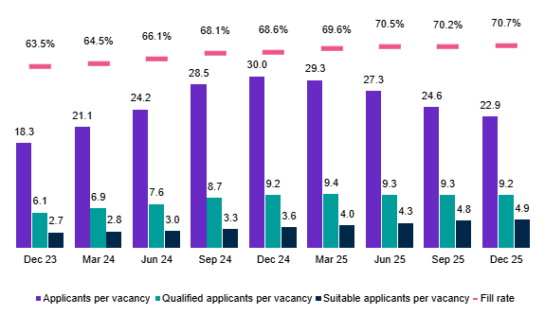
Source: Jobs and Skills Australia, SERA.
The fill rate has remained above 70% for the 3 most recent quarters, but appears to be plateauing.
The number of total applicants per vacancy has continued to decrease over the quarter and past 12 months and has been falling since the peak of 30 reached in December quarter 2024. The spotlight piece provides some possible explanations for this trend.
Qualified applicants per vacancy have been stable over the last 2 quarters, while the number of suitable applicants per vacancy has continued its steady increase over time.

Metropolitan area results
Table 2: Metropolitan snapshot
 | December quarter 2025 | Change over the quarter | Change over 12 months
Vacancy fill rate (%) | 71.8% | ▲ 0.3% pts | ▲1.8% pts
Applicants per vacancy (no.) | 27.5 | ▼ 2.0 | ▼ 7.4
Qualified applicants per vacancy (no.) | 11.4 | ▲ 0.1 | ▲0.5
Suitable applicants per vacancy (no.) | 5.6 | ▲0.1 | ▲1.5
Source: Jobs and Skills Australia, SERA.
The changes in metropolitan areas over the quarter and past 12 months to the current quarter generally mirrored the national level results (Table 2).
- The fill rate for the December quarter 2025 was 71.8%. The rate slightly increased over the quarter and improved over the past 12 months.
- Total applicants per vacancy decreased over the quarter and past 12 months.
- Qualified and suitable applicants per vacancy increased over the quarter and last 12 months.
Figure 2: Metropolitan fill rate (%) and applicants, qualified, and suitable applicants per vacancy (no.)
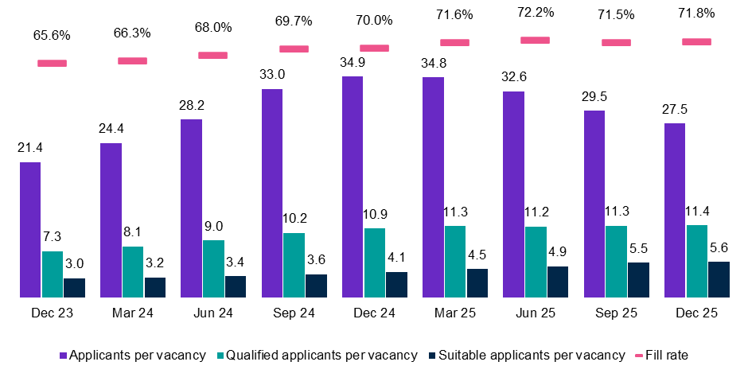
Source: Jobs and Skills Australia, SERA.

Regional area results
Table 3: Regional snapshot
 | December quarter 2025 | Change over the quarter | Change over 12 months
Vacancy fill rate (%) | 68.6% | ▲1.6% pts | ▲5.6% pts
Applicants per vacancy (no.) | 14.4 | ▼0.5 | ▼3.6
Qualified applicants per vacancy (no.) | 5.5 | — | —
Suitable applicants per vacancy (no.) | 3.5 | ▲0.2 | ▲1.0
Source: Jobs and Skills Australia, SERA.
While fill rates in regional areas remained below that of metropolitan areas in December quarter 2025, the gap narrowed to 3.2 percentage points. This is well below the average gap of 6.5% that prevailed in the past 2 years prior to the December quarter 2025.
- Regional areas continued to show strongly improved fill rates, reaching 68.6% (Table 3). Compared to national and metropolitan fill rates, the regional level fill rates do not appear to have plateaued.
- Total applicants per vacancy decreased over the quarter and past 12 months.
- Qualified applicants per vacancy stayed the same over the quarter and last 12 months.
- Suitable applicants per vacancy increased over the quarter and past 12 months.
Figure 3: Regional fill rate (%) and total applicants, qualified, and suitable applicants per vacancy (no.)
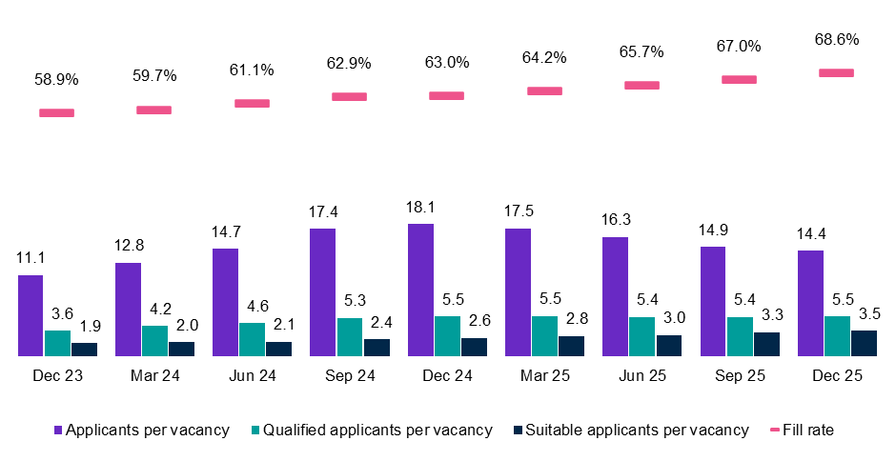
Source: Jobs and Skills Australia, SERA.

Results by Skill Level
In the December quarter 2025, the fill rates improved for all Skill Level occupation groups. Nevertheless, the fill rate for Skill Level 3 occupations showed marginal improvement and remained well below that of the other groups at 54.5%.
Total applicants per vacancy fell across the skill level 1 to 4 groups over the quarter and past 12 months.
The change in qualified applicants per vacancy was largely stable over the 12 months but varied by Skill Level occupation groups.
- For Skill Level 2 there was a slight increase in qualified applicants per vacancy in the December 2025 quarter and over the last 12 months.
- For Skill Level 1, there was a slight decrease in qualified applicants per vacancy in the December 2025 quarter and over the last 12 months.
Suitable applicants per vacancy improved over the quarter and in the past 12 months across all the skill level occupations.
Table 4: ANZSCO skill level snapshot
Skill levels |  | December quarter 2025 | Change over the quarter | Change over 12 months
Skill level 1 | Vacancy fill rate (%) | 73.0% | ▲0.2% | ▲2.1%
Skill level 1 | Applicants per vacancy (no.) | 22.3 | ▼2.2 | ▼10.0
Skill level 1 | Qualified applicants per vacancy (no.) | 11.0 | ▼0.1 | ▼0.9
Skill level 1 | Suitable applicants per vacancy (no.) | 4.7 | ▲0.1 | ▲1.0
Skill level 2 | Vacancy fill rate (%) | 75.1% | ▲0.7% | ▲0.3%
Skill level 2 | Applicants per vacancy (no.) | 28.1 | ▼1.3 | ▼6.7
Skill level 2 | Qualified applicants per vacancy (no.) | 11.2 | ▲0.2 | ▲1.0
Skill level 2 | Suitable applicants per vacancy (no.) | 5.8 | ▲0.2 | ▲1.8
Skill level 3 | Vacancy fill rate (%) | 54.5% | ▲0.2% | ▼0.5%
Skill level 3 | Applicants per vacancy (no.) | 15.2 | ▼0.3 | ▼2.3
Skill level 3 | Qualified applicants per vacancy (no.) | 5.2 | ▼0.1 | ▲0.8
Skill level 3 | Suitable applicants per vacancy (no.) | 2.8 | ▲0.1 | ▲0.7
Skill level 4 | Vacancy fill rate (%) | 72.8% | ▲0.7% | ▲0.3%
Skill level 4 | Applicants per vacancy (no.) | 24.4 | ▼1.8 | ▼9.6
Skill level 4 | Qualified applicants per vacancy (no.) | 7.7 | ▲0.1 | ▼0.6
Skill level 4 | Suitable applicants per vacancy (no.) | 5.5 | ▲0.1 | ▲0.9
Source: Jobs and Skills Australia, SERA.

Results by Major Group
Table 5: ANZSCO major group snapshot
Major group |  | December quarter 2025 | Change over the quarter | Change over 12 months
Managers | Vacancy fill rate (%) | 78.5% | ▲ 0.9% pts | ▼ 2.5% pts
Managers | Applicants per vacancy (no.) | 33.4 | ▼ 0.8 | ▼ 5.6
Managers | Qualified applicants per vacancy (no.) | 14.7 | ▲ 0.9 | ▲ 1.7
Managers | Suitable applicants per vacancy (no.) | 6.7 | ▲ 0.6 | ▲ 1.9
Professionals | Vacancy fill rate (%) | 71.0% | ▼ 0.3% pts | ▲ 1.6% pts
Professionals | Applicants per vacancy (no.) | 19.0 | ▼ 3.1 | ▼ 11.4
Professionals | Qualified applicants per vacancy (no.) | 9.7 | ▼ 0.5 | ▼ 1.5
Professionals | Suitable applicants per vacancy (no.) | 4.2 | ▼ 0.1 | ▲ 0.7
Technicians and Trades Workers | Vacancy fill rate (%) | 55.7% | ▲ 0.3% pts | ▲ 0.1% pts
Technicians and Trades Workers | Applicants per vacancy (no.) | 20.4 | ▼ 0.6 | ▼ 1.4
Technicians and Trades Workers | Qualified applicants per vacancy (no.) | 8.0 | ▲ 0.1 | ▲ 1.8
Technicians and Trades Workers | Suitable applicants per vacancy (no.) | 4.3 | ▲ 0.3 | ▲ 1.9
Community and Personal Service Workers | Vacancy fill rate (%) | 69.6% | ▲ 1.7% pts | ▼ 1.7% pts
Community and Personal Service Workers | Applicants per vacancy (no.) | 14.9 | ▼ 1.4 | ▼ 8.0
Community and Personal Service Workers | Qualified applicants per vacancy (no.) | 6.3 | ▲ 0.2 | ▼ 0.4
Community and Personal Service Workers | Suitable applicants per vacancy (no.) | 3.4 | ▲ 0.0 | ▲ 0.3
Clerical and Administrative Workers | Vacancy fill rate (%) | 83.3% | ▲ 1.3% pts | ▲ 2.2% pts
Clerical and Administrative Workers | Applicants per vacancy (no.) | 36.8 | ▼ 1.2 | ▼ 16.0
Clerical and Administrative Workers | Qualified applicants per vacancy (no.) | 11.2 | ▲ 0.7 | ▲ 1.2
Clerical and Administrative Workers | Suitable applicants per vacancy (no.) | 7.2 | ▼ 0.1 | ▲ 0.2
Sales Workers | Vacancy fill rate (%) | 73.5% | ▲ 2.8% pts | ▲ 3.6% pts
Sales Workers | Applicants per vacancy (no.) | 26.4 | ▲ 0.2 | ▼ 2.3
Sales Workers | Qualified applicants per vacancy (no.) | 6.1 | ▼ 0.1 | ▼ 0.4
Sales Workers | Suitable applicants per vacancy (no.) | 3.9 | ▼ 0.3 | ▼ 0.2
Machinery Operators and Drivers | Vacancy fill rate (%) | 65.1% | ▼ 1.5% pts | ▼ 2.3% pts
Machinery Operators and Drivers | Applicants per vacancy (no.) | 18.4 | ▼ 3.5 | ▼ 15.1
Machinery Operators and Drivers | Qualified applicants per vacancy (no.) | 7.4 | ▼ 1.1 | ▼ 3.9
Machinery Operators and Drivers | Suitable applicants per vacancy (no.) | 5.2 | ▲ 0.2 | ▲ 0.9
Source: Jobs and Skills Australia, SERA.
Major group |  | December quarter 2025 | Change over the quarter | Change over 12 months
Labourers | Vacancy fill rate (%) | 59.5% | ▼ 3.8% pts | ▼ 2.5% pts
Labourers | Applicants per vacancy (no.) | 18.6 | ▲ 2.4 | ▲ 4.8
Labourers | Qualified applicants per vacancy (no.) | 7.3 | ▲ 1.6 | ▲ 3.2
Labourers | Suitable applicants per vacancy (no.) | 4.9 | ▲ 1.1 | ▲ 2.8
Source: Jobs and Skills Australia, SERA.
Fill rate movements varied by major groups in the December quarter 2025 and over the past 12 months to the current quarter.
- For Clerical and Administrative Workers and Sales Workers, fill rates increased in both the current quarter and over the past 12 months.
- For Technicians and Trades Workers, fill rates increased marginally over the quarter and remained stable over the past 12 months.
- For Machinery Operators and Drivers and Labourers, fill rates decreased over the quarter and past 12 months.
- For Managers, fill rates increased over the quarter but decreased over the past 12 months.
- For Professionals, fill rates decreased slightly over the last quarter, but increased over the past 12 months.
Total applicants per vacancy and qualified applicants per vacancy results were mixed across major groups over both periods. For Labourers, total applicants, qualified applicants per vacancy and suitable applicants per vacancy increased over the quarter and past 12 months.

Spotlight analysis: explaining the surge and decline in total applicants per vacancy
This spotlight explores the possible reasons underlying the pattern of rise and fall in total applicants per vacancy and how it may be connected to broader labour market trends.

Surge in applicants per vacancy in 2024-25
Figure 4 presents the evolution of total applicants per vacancy from the December quarter 2021 to the December quarter 2025, using the current 12-month moving average as well as the Henderson moving average method.
Figure 4: Applicants per vacancy, 12-month vs Henderson moving average, 2021 to 2025

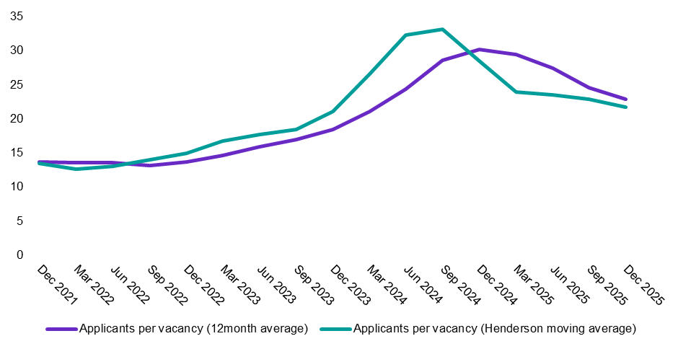
Source: Jobs and Skills Australia, SERA.
Note: The Henderson Moving Average was not adjusted for seasonality due to data limitations.
The 12-month moving average yields a stable series by mitigating short-term fluctuations. However, it can mask important changes in the data and delay the identification of turning points. In contrast, the Henderson moving average (HMA) smooths data volatility or seasonal spikes while capturing turning points without substantial lag.
Results of HMA show that applicants per vacancy increased rapidly from late 2023, peaked in mid-to-late 2024 before declining quickly until March quarter 2025. While still falling, the pace appears to be gradual. The pattern of movement over time is different to that exhibited by qualified and suitable applicants per vacancy and fill rates – all three metrics, generally, increased over the same period.

The surge in applicant numbers is not unique to SERA
Similar trends have been observed in other datasets, although the timing of peak applicant activity varies. This suggests that the rise and fall pattern could be underpinned by broader labour market shifts.
- SEEK reported a significant rise in applications per job advertisement (APJ) beginning in 2023 and continued throughout 2024, peaking in May 2025 and then starting to fall.
- Global recruitment platform, JobAdder, highlighted record-high applicant competition during the final quarter of 2024, followed by a seasonal plateau in early 2025. Potential drivers underlying the surge in applicants per vacancy.
The pattern observed in applicants per vacancy is likely to be attributable to a combination of different labour market factors occurring at similar points in time, causing a sudden spike in applicants, followed by a plateau and decline.

Potential drivers underlying the surge in applicants per vacancy
Following the COVID-19 pandemic, the strength of the Australian labour market increased and became tight.
- Demand for workers, as indicated by Jobs and Skills Australia’s Internet Vacancy Index (IVI), rose sharply.
- With more opportunities, job mobility rate increased as employed workers increasingly searched for alternative or better-paid roles.
- Employment to population ratio increased to record highs.
Figure 5: Applicants per vacancy, internet vacancy index (IVI) and employment-to-population ratio, quarterly, Sep 2019- Dec 2025
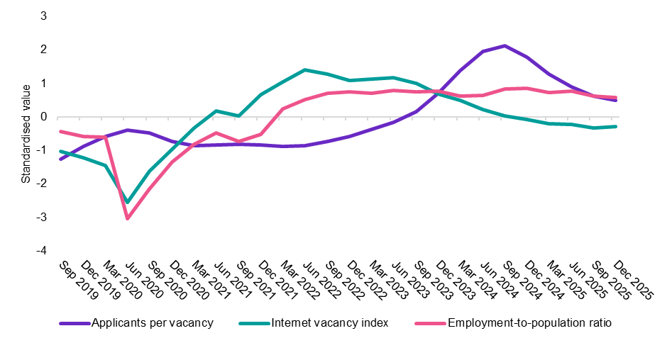
Source: Jobs and Skills Australia, SERA; Jobs and Skills Australia, IVI; Australian Bureau of Statistics, Labour Force, Australia, December 2025.
Note: Data is standardised to present the various metrics on the same scale and for ease of comparison across time.
Figure 5 shows that the IVI fell from its peak in late 2023; meanwhile the employment-to-population ratio largely stabilised in early 2023 and started dipping from late 2024. Job mobility rates peaked in 2023 before declining over 2024 and 2025.
Higher vacancies, job mobility and employment growth add to applicant volumes. But as these waned, so too has total applicants per vacancy. With that, the trends in the above labour market indicators align with the trend in total applicants per vacancy.
Elevated cost-of-living pressures from higher inflation and interest rates could have led to people seeking additional jobs, adding to job seeking activity and total applications.
Figure 6 shows trends in applicants per vacancy alongside the RBA cash rate, inflation rate, and number of multiple job holders from December quarter 2019 to December quarter 2025.
Figure 6: Applicants per vacancy, multiple job holder rate, RBA cash rate and inflation rate, Sep 2019- Dec 2025
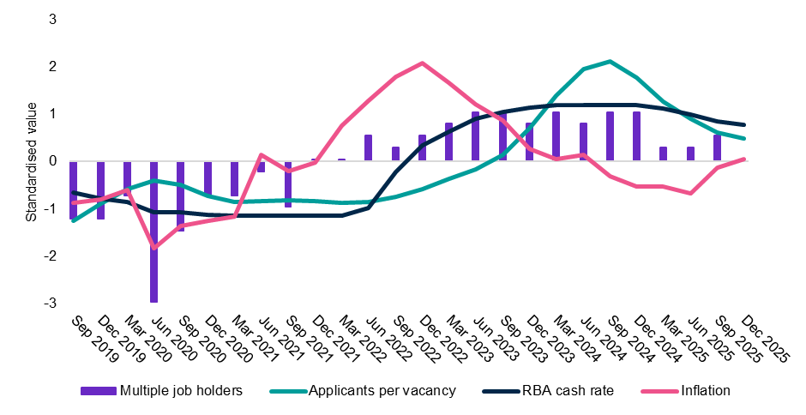
Source: Jobs and Skills Australia, SERA; Australian Bureau of Statistics, Multiple Job Holders, September 2025; Australian Bureau of Statistics, CPI, December 2025; Reserve Bank of Australia, February 2026.
Note: Data is standardised to present the various metrics on the same scale and for ease of comparison across time.
The movement of the RBA cash rate generally mirrors that of the applicants per vacancy: both began rising in 2023, levelled off in late 2024, and then declined in early 2025. Notably, similar patterns could be seen in consumer price index (CPI) movements several quarters before changes in cash rates occurred. The number of people holding multiple jobs rose sharply in 2023-24, peaking at 987,500 in December 2024 before dropping in early 2025. As financial pressures eased for some households, the incentive to seek additional or alternative employment could have diminished.
Total applicants per vacancy appears to be stabilising in line with stabilisation in the labour market. This may suggest that the spike in applicant activity was a temporary response to changing market conditions.

Explanatory Notes
SERA is a monthly, telephone-based survey of employers with advertised vacancies online. The survey collects information on employers' recruitment experience. Annually, data is collected from over 11,000 employers and covers 577 occupations. Only those occupations with a sufficient quarterly sample size are included for analysis in this report.
The survey covers skill level 1 to 4 occupations, as defined by 2022 Australian and New Zealand Standard Classification of Occupations. As a result, the survey outcomes are reflective of occupations requiring post-school education and training.

Definitions of metrics
The fill rate is the percentage of vacancies employers advertised that were filled. The metric is calculated by dividing the number of filled vacancies by total advertised vacancies.
The average number of applicants per vacancy is calculated as the sum of the number of applicants divided by the sum of advertised vacancies.
The average number of qualified applicants per vacancy is calculated as the sum of the number of qualified applicants divided by the sum of advertised vacancies. Qualified applicants are the applicants who are assessed by employers as meeting the required qualification criteria of an advertised vacancy.
The average number of suitable applicants per vacancy is calculated as the sum of the number of suitable applicants divided by the sum of advertised vacancies. Suitable applicants are those who are deemed by employers to be suitable for the job advertised.
The average years of labour market experience sought by employers is the average number of years that employers require applicants to have spent in relevant occupations and is calculated as the mean of the years required per employer.
Metropolitan area refers to Capital City, while Regional area refers to Rest of State locations. Capital City and Rest of State areas are defined by the Australian Statistical Geography Standard (ASGS) Edition 3, July 2021.
For more information, contact OccupationShortageList@jobsandskills.gov.au.

This metric shows the percentage of advertised vacancies that are filled by employers.
The fill rate and other metrics in the table are based on a 12-month moving average up to the latest quarter. Using a rolling annual period, as opposed to the latest quarter itself, removes the impact of data volatility.
Australian Bureau of Statistics, Australian and New Zealand Standard Classification of Occupations, 2022 version.
The Henderson moving average (HMA) is a weighted smoothing technique used in time series analysis for estimating trends. A 5-term Henderson filter was applied on quarterly data in this analysis. Future OSR will be based on HMA. More details of HMA will be included in the Explanatory section of the 2026 March quarter OSR report.
Australian Bureau of Statistics, Participation, Job Search and Mobility, Australia, February 2025

