

First Nations VET Workforce Research Paper

Contents
Acknowledgement of Country v
Appreciation of support of First Nations VET experts vi
Glossary vii
Note on language used viii
Executive summary ix
Previous relevant studies xii
Research approach xiii
Design Principles xv
Chapter 1 Introduction 1
1.1 What this research paper does 1
1.2 Background 3
1.2.1 National Skills Agreement and the National Agreement on Closing the Gap 3
1.2.2 VET Workforce Blueprint 4
1.2.3 First Nations vocational education traditions 5
1.3 How this paper is organised 7
Chapter 2 VET Sector 8
2.1 The Australian VET Sector and First Nations Peoples 8
2.1.1 VET governance 8
2.1.2 Foundation Skills 9
2.1.3 VET delivered in First Nations languages 11
2.1.4 First Nations support units 12
2.2 RTO delivery settings 13
2.2.1 Aboriginal Community Controlled and First Nations owned RTOs 14
2.2.2 TAFE and dual sector providers 15
2.2.3 Independent and Private RTOs 16
2.2.4 Adult and Community Education providers 16
2.2.5 VET delivered in secondary schools 16
2.3 Accredited VET in other Adult and Community Education settings 17
2.3.1 Aboriginal Medical Services and Aboriginal Community Controlled Health Organisations 17
2.3.2 Employment Services 17
2.3.3 VET in Australian prisons 18
2.4 The First Nations VET workforce 18
2.4.1 Understanding the workforce 19
2.4.2 VET teacher, trainer and assessor pipeline 37
2.5 International Case Studies 40
2.6 Summary 41
Chapter 3 Current Practice 42
3.1 First Nations Sector 42
3.1.1 Innovation among Aboriginal Community Controlled RTOs and First Nations owned independent RTOs 42
3.1.2 Teaching First Nations students and First Nations content 43
3.1.3 Connections between growing the First Nations VET workforce and students 44
3.1.4 Intellectual Property, Moral Rights and Restricted Content 45
3.2 Mainstream Organisations 48
3.2.1 Recruitment Strategies 48
3.2.2 Workforce strategies and Reconciliation Action Plans 49
3.2.3 Governance, leadership, management and regulatory compliance 51
3.2.4 Other HR Policies 53
3.3 Enablers and Barriers 55
3.3.1 Entry qualifications, volatile income and uncompetitive salaries 55
3.3.2 Employment type, access to professional development and career progression 58
3.3.3 Compliance mindset can act as a barrier to job satisfaction and retention 60
3.3.4 Cultural responsibility is a reason to join and stay in VET 60
3.3.5 Lack of understanding and respect of cultural responsibility 61
3.3.6 Colonial load and a lack of cultural safety is a barrier to retaining staff 61
3.3.7 Cultural responsibility and connection can also be exploited to become a burden to First Nations peoples in the workplace 62
3.4 Summary 63
Chapter 4 Design Principles 64
4.1 Authentic embeddedness in community, connection to place and context 65
4.1.1 Promising Practice: Wurreker Brokers 65
4.1.2 Promising Practice: Queensland Indigenous Workforce and Skills Development Grant 66
4.2 Ensure self-determination and First Nations understandings throughout organisations, work tasks, pedagogies, control of data and intellectual property 66
4.2.1 Promising Practice: Tangentyere Council (ACCO) ‘Two way’ teaching 67
4.3 Acknowledge, value, respect and pay for First Nations expertise and cultural responsibilities 67
4.3.1 Promising Practice: Tranby College 67
4.4 Recruit, support and enable careers for First Nations peoples at all levels in an environment that offers equal and competitive pay and conditions 68
4.4.1 Promising Practice: Federation University personalised career development 69
4.4.2 Promising Practice: Offering Culturally Appropriate TAE Qualifications 69
4.5 Empower, back and embed leadership, connectedness, mentoring, First Nations systems of governance and emotional and cultural sustenance 70
4.5.1 Promising Practice: Tauondi Aboriginal College 71
4.5.2 Promising Practices: TAFE NSW 71
4.6 Summary 72
References 73
Appendix A: Design Principles - Concept Details 79

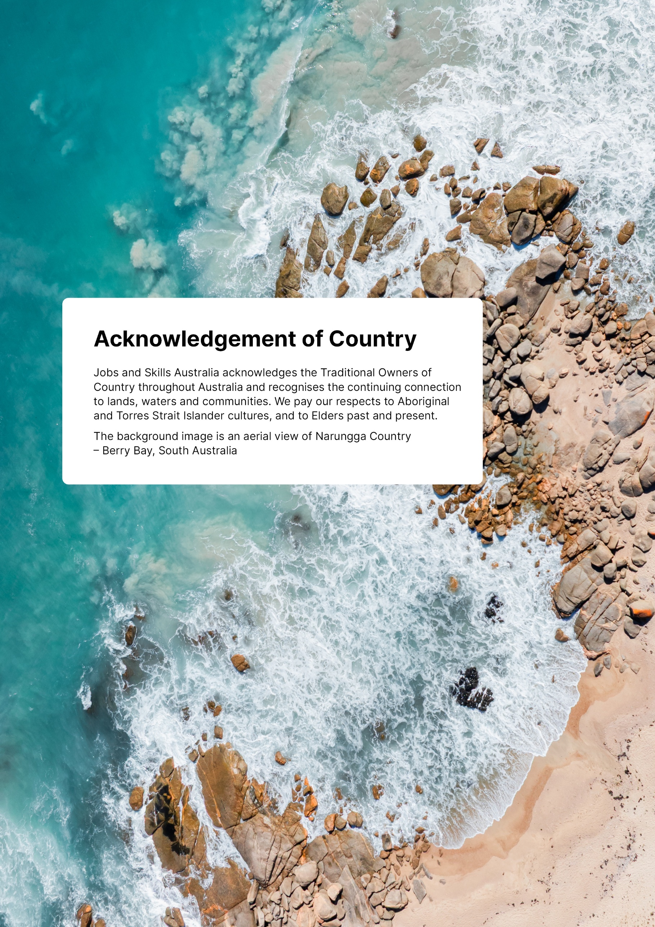
Acknowledgement of Country
Jobs and Skills Australia acknowledges the Traditional Owners of Country throughout Australia and recognises the continuing connection to lands, waters and communities. We pay our respects to Aboriginal and Torres Strait Islander cultures, and to Elders past and present.
The background image is an aerial view of Narungga Country – Berry Bay, South Australia.

Appreciation of support of First Nations VET experts
In drawing together research and insights about the work of First Nations peoples in the VET sector delivering accredited training, it is important to recognise that learning and engagement in vocational forms of education has been a key part of communities in Australia for millennia. Further, there is much to learn from traditional Indigenous understandings, teaching methodologies and ways of sharing knowledges.
We are grateful for the leadership and guidance of First Nations peoples in the production of this paper and have endeavoured to ensure that their voices and experiences are heard. We appreciate the time and effort of First Nations peoples who work in VET, and who took part in Aboriginal-led focus groups which contributed to the finalised paper.
This paper aims to support structural change in the engagement of Aboriginal and Torres Strait Islander people in the accredited VET sector and work towards aligning with the National Agreement in acknowledging that to Close the Gap, First Nations peoples must determine, drive and own the desired outcomes, alongside all governments.

Glossary
Term or acronym | What it means
ABS | Australian Bureau of Statistics
ACC | Aboriginal Community Controlled
ACCHO | Aboriginal Community Controlled Health Organisation
ACCO | Aboriginal Community Controlled Organisation
Accredited training | Nationally recognised training (e.g. training packages and accredited courses).
ACE | Adult and community education
AEU | Australian Education Union
AMS | Aboriginal Medical Services
ANZSCO | Australian and New Zealand Standard Classification of Occupations
ANZSIC | Australian and New Zealand Standard Industrial Classification
ASQA | Australian Skills Quality Authority
AQF | The Australian Qualifications Framework is the national policy for regulated qualifications in Australian education and training.
AVETMISS | Australian Vocational Education and Training Management Information Statistical Standard
Certificate IV in TAE | The Certificate IV in Training and Assessment (TAE), which is included in the Training and Education Training Package.
DEWR | Department of Employment and Workplace Relations
Digital literacy skills | Digital literacy refers to the skills and competencies needed to use digital technologies to achieve personal goals, enhance employability skills and support education and training.
Dual professional | Teachers, trainers and assessors who have relevant qualifications and expertise in vocational education and training methodology and their industry area.
Dual-sector provider | An institution that provides VET qualifications in addition to their higher education qualifications.
EAL | English as an additional language
ERTO | Enterprise registered training organisation
FNO | First Nations owned ‘business, charity, not-for-profit organisation, incorporated under Commonwealth, state or territory legislation, that has at least 51% First Nations ownership and/or directorship and is operated for the benefit of First Nations communities.’
JSA | Jobs and Skills Australia
LLND | Language, literacy, numeracy and digital
NACCHO | The National Aboriginal Community Controlled Health Organisation (NACCHO) is the national peak body representing Aboriginal Community Controlled Health Organisations (ACCHOs) across Australia.
NATSIEC | National Aboriginal and Torres Strait Islander Education Corporation is a national peak body for educators
NCVER | National Centre for Vocational Education Research
OECD | Organisation for Economic Co-operation and Development
PLIDA | Personal Level Integrated Data Asset
RTO | Registered training organisation
VET | Vocational education and training
VRQA | Victorian Registration and Qualifications Authority
WA TAC | Training Accreditation Council – Western Australia’s VET Regulator

Note on language used
Throughout this report we have used the term First Nations in line with Reconciliation Australia’s drafting resource on ‘Demonstrating inclusive and respectful language’ and the APS Style Manual. At times we use other terms including Aboriginal and Torres Strait Islander where appropriate. The term Indigenous is only used when we are required to for accuracy of describing data from surveys or as a known widely used term such as Indigenous knowledges. However, in some instances we have replicated the language choices of First Nations peoples themselves, including in stakeholder contributions. We will continue to have conversations with Aboriginal and Torres Strait Islander people about the most useful and respectful language to use.

Executive summary
Australia’s vocational education and training (VET) sector is witnessing the emergence of a growing First Nations workforce. Aboriginal Community Controlled and First Nations owned registered training organisations (RTOs), alongside TAFE, private, independent, adult and community education, and school RTOs, and Jobs and Skills Councils, are embracing the goal of increasing First Nations leadership, self-determination, and workforce representation.
This growth—marked by a higher rate of increase in First Nations representation in the VET workforce than that of the broader population—reflects locally driven support for self-determination and strategic organisational planning. However, as this research demonstrates, the First Nations VET workforce requires urgent expansion and stronger advocacy.
There’s just not enough time: we need more, we need a bigger pool of qualified local trainers, and I’ve heard that from everywhere around the country as well.
- Focus Group Participant
Australia continues to tackle the challenge of national skills shortages in an environment of significant national priorities that demand more VET-trained workers. Yet the VET workforce itself is under strain. Expanding this workforce—and pulling every available lever to do this—is essential. Increasing First Nations representation is a strategic solution, which is supported by compelling evidence:
- First Nations representation in the VET workforce was 2% in 2021, compared to 2.2% of the whole Australian workforce and a 3.8% share of the population (ABS Census 2021, ABS 2021).
- National Centre for Vocational Education Research (NCVER 2025) analysis suggests that Indigenous students make up 5.6% of all domestic students enrolled in VET qualifications.
- First Nations students achieve better outcomes when taught by First Nations teachers, trainers and assessors (Griffin and Andrahannadi 2023; Guenther 2017b; Windley 2017; Cleverly and Mooney 2010), potentially delivering strong return on investment in this workforce.
- Under-representation of First Nations peoples in the workforce is most pronounced in regional areas—the same regions where national priorities require more VET-trained workers and more VET teachers, trainers and assessors to deliver that training (JSA analysis of ABS 2021 Census Data). Almost half (48%) of the First Nations VET workforce is concentrated in major cities and a further 27% in inner regional areas.

Together, the National Skills Agreement and National Agreement on Closing the Gap targets provide a clear imperative to grow and strengthen the First Nations VET workforce across all roles. Increasing First Nations representation in teaching, training, and assessing roles is particularly critical in sectors such as agriculture and land conservation, mining and textiles, tourism, care services, finance and business, and emerging technological fields.
Expanding the First Nations VET workforce will not only address skills shortages but will also support culturally responsive training and improved equity outcomes for First Nations peoples, and pathways into VET and leadership roles in the sector.
The lived experiences of First Nations peoples in the VET workforce are central to this effort. While many find deep fulfilment in supporting the success of First Nations students, structural challenges—including cultural responsibilities and the enduring impacts of colonisation—continue to shape their participation in this workforce. Disparities in access to training, pay, and career progression remain significant barriers to entry, retention and advancement in the sector. As one participant said:
…[that] sense of feeling in your wellbeing, your inner conscious, your compass: it’s fulfilling being with students and it’s even more fulfilling to get through an entire qualification and be standing with them on graduation day. That makes you sort of want to come back and do it all again next year.
- Focus Group Participant
Current VET system design often fails to reflect the strengths and perspectives of First Nations peoples, contributing to disengagement from learning and lower completion rates for First Nations students. Underrepresentation of First Nations teachers, trainers, assessors and mentors limits the availability of culturally responsive training, while the lack of comprehensive data about this workforce hampers targeted solutions to growth and well-being.
This research paper addresses these interconnected issues and provides practical insights for meaningful change.
Further insights into the First Nations VET workforce provided in this paper include:
- The First Nations VET workforce has grown faster than the mainstream VET workforce, growing by 18% between the 2016 and 2021 Censuses, compared to 1% growth in the total VET workforce (JSA analysis of ABS Census for 2016, 2021).
- Completions of the Certificate IV in Training and Assessment (TAE) by Indigenous students represent a strong and growing share of overall graduates (JSA analysis of NCVER Total VET students and courses, 2024). On average, about 370 Indigenous students completed this qualification each year between 2015 and 2024, while completions by non-Indigenous students of the same qualification fell over the same period.
- First Nations peoples are more likely to work full-time hours when working in VET (68%) compared to those in the general workforce, where the full-time rate for First Nations peoples is 56% (JSA analysis of ABS 2021 Census Data).
- Around 2% of the VET workforce identified as First Nations peoples (JSA analysis of ABS 2021 Census Data) compared to around 3.5% of VET students (JSA analysis of NCVER Total VET students and courses).
- First Nations VET teachers, trainers and assessors experience greater income volatility and earn lower median weekly income compared to the overall VET teaching workforce (JSA analysis of Person Level Integrated Data Asset (PLIDA) Data).
Expanding First Nations representation in the VET workforce is not just a policy imperative, it is a strategic opportunity to deliver on national priorities, strengthen industry capability, and advance the National Agreement for Closing the Gap and equity outcomes when enacted in ways consistent with the design principles proposed in this report. This First Nations VET Workforce research paper was initiated to provide a deeper insight into, and better understanding of, the First Nations VET workforce and to identify practical opportunities to support and improve workforce planning.
The aim of this paper is to contribute to a more inclusive and culturally competent VET sector that better serves First Nations communities, people working in VET and learners engaging with the sector. This also builds on the National Skills Agreement, Jobs and Skills Australia’s (JSA) VET Workforce Study (2024a), and supports the opportunities and actions identified in the Department of Employment and Workplace Relation’s (DEWR) VET Workforce Blueprint (2024b).
The research focuses only on the First Nations VET workforce involved in the delivery and support of students undertaking accredited, nationally recognised VET courses and qualifications, particularly recruitment, retention, and cultural safety needs. The key areas of focus include: First Nations workforce needs, training outcomes, gaps and opportunities, policy development, workforce planning, cultural competency practices, and leadership across the VET sector. The purpose is not to prescribe specific methods for engaging and growing the First Nations VET workforce, rather to synthesise existing knowledge and promising practices within the sector that support First Nations workers’ representation, well-being and career success.
This paper builds on the VET workforce taxonomy and occupational framework proposed in the JSA VET Workforce Study (2024a:12) by identifying further occupations for First Nations peoples across the VET sector, including in TAFEs, select dual sector universities, schools, independent and private RTOs, adult and community education providers and services provided by Aboriginal Community Controlled Organisations (ACCOs).
It does not undertake an evaluation of current workforce practices, traditional job profiling nor a supply and demand modelling of the First Nations VET workforce. Instead, it seeks to synthesise existing evidence, drawing together what we know works and is important to this workforce—or does not work and imposes barriers to First Nations success—to articulate what needs to improve.
The research is intended for a broad audience of stakeholders who influence, deliver, or benefit from VET services for First Nations learners. These include:
- First Nations peoples who work in the VET sector.
- First Nations communities and organisations—including leaders and advocacy bodies—that provide the most viable pathways to programs that align with cultural values and community priorities.
- Commonwealth, state and territory government departments responsible for skills and training, who play a central role in shaping VET policy and allocating funding for the sector.
- RTOs and other VET providers delivering VET for First Nations students, including the teachers, trainers and assessors and support staff who directly work with these students.
- Academics and researchers who provide the evidence for informed decision-making.
- Employers and industry groups relying on VET to build a skilled workforce.
By targeting this wide range of stakeholders, this research aims to ensure its findings are relevant and impactful across the VET system.

Previous relevant studies
Almost twenty years ago a study by Kemmis and colleagues (2006) found significant barriers to work faced by First Nations peoples in the VET sector. The paper recommended employment targets, funding stabilisation, better data collection and support for First Nations ways of working and community development. These approaches would create supportive environments for First Nations VET teachers, trainers and assessors, and the broader First Nations workforce, thereby improving outcomes for First Nations students.
Five years later, the Productivity Commission’s (2011:194) report into the VET teaching workforce made clear recommendations about the importance of engaging more First Nations teachers, trainers and assessors:
To improve delivery to Indigenous VET students, VET providers should attempt to secure the services of more Indigenous VET workers.
In 2017, a report by NCVER on enhancing training in remote areas for First Nations peoples highlighted the importance of trainer qualities in supporting student success, particularly the importance of the symbiotic learning relationship and the development of respect between students and trainers (Guenther 2017a). In 2019, the OECD’s Indigenous Employment and Skills Strategies in Australia identified the need for culturally appropriate mentoring programmes in attracting, training, and placing First Nations peoples into employment (OECD 2019). The report recommended embedding mentorship into the delivery of employment and training programs.
In the 2020s, further structural planning and development was undertaken to attract more First Nations peoples into employment, including in jurisdictional based strategies and plans, such as the Queensland ‘Paving the Way’ First Nations Training Strategy in 2022 and the Victorian Skills Plan (VSA 2023). Both strategies highlighted the importance of First Nations staff to supporting skills development and responding to local and community employment needs.

In Queensland’s ‘Paving the Way’ Strategy, the first focus area for action is First Nations-led training and workforce solutions. In the Victorian Skills Plan (VSA 2023:11), the 14th action aims to empower self-determination for First Nations peoples. First Nations employment targets are included in TAFE SA’s Roadmap for the Future (TAFE SA 2023).
Research shows that a shortage of First Nations teachers, trainers and assessors in the VET workforce is a key barrier to VET provision in remote areas. Griffin and Andrahannadi (2023:25) captured the positive impact that is made by First Nations teachers, trainers and assessors in a quote from an RTO in the Northern Territory:
The reaction that you have when you have an Aboriginal person up the front of the room is totally different.

Research approach
Our research was designed to offer data-informed insights that improve the sector’s understanding of the VET experience for First Nations learners and VET workforce participants. In completing the research, we engaged with individuals in different key roles in a wide range of VET organisations and with VET First Nations experts, unions, and jurisdictions across the country.
Many jurisdictions and VET organisations shared successful strategies and programs for the First Nations workforce currently being implemented in different regions across Australia. First Nations VET experts gave us valuable feedback on a confidential basis. Unions, workers, VET experts and advocates spoke to us about the strategies they are using to address the systemic barriers that First Nations peoples experience. These strategies include community engagement rooted in First Nations knowledge systems, mentoring programs, and the inclusion of cultural commitments in enterprise agreements, which are explored in this paper.
We further undertook organised focus groups of First Nations peoples working in Aboriginal Community Controlled RTO settings, with the support of the ACCO RTO Community of Practice through an Aboriginal-led research unit, after receiving ethics approval from the Australian Institute of Aboriginal and Torres Strait Islander Studies (AIATSIS).
This included First Nations teachers, trainers and assessors who told us:
You feel for your students and that is definitely a strength for us as Aboriginal educators and trainers that we do have compassion and understanding, but it’s not as easy to switch off.
- Focus Group Participant
Our analysis also drew on policy literature from Australia and abroad, data from the ABS Census of Population and Housing (2021) and earlier Censuses, PLIDA, and NCVER Total VET Activity, as well as utilising JSA’s typology of RTOs (2024b) to better understand the range of VET organisations. We also examined job advertisements (including via Lightcast) and enterprise agreements and awards for the sector.

Qualitative insights gained from stakeholder roundtables, submissions, communications, and VET worker focus groups enriched our understanding of the enablers and barriers for First Nations peoples within the VET workforce from multiple perspectives. For example:
If I’m not being supported to do something then how do I continue to be the strong Aboriginal person that I am because I’m not actually participating or able to be continue on with our practices.
- Focus Group Participant
While we heard of many successes during our consultations, more needs to be done to realise a VET sector that enables achievement of the National Agreement on Closing the Gap priority reforms. What is now required is a more coherent, yet flexible and locally responsive approach to developing and sustaining a strong First Nations VET workforce.
This paper provides a foundation for a more systemic approach that avoids imposing a 'one-size-fits-all' model. Stakeholders consistently told us that standardised, inflexible strategies are unlikely to succeed and that the contribution of First Nations peoples to the design and implementation of workforce plans in VET is essential for culturally appropriate workplaces and career opportunities.
Another key contribution of this research is the identification of gaps in our knowledge and understanding of systemic barriers to participation by First Nations peoples in the VET workforce. By analysing these barriers, we were able to highlight areas where cultural competency, workforce development, and training access and provision can be strengthened.
These insights will enable stakeholders to implement strategies, that we understand from our research and from stakeholder testimony, may respond directly to the needs of First Nations learners. These include embedding First Nations knowledge systems into curriculum, recruiting more First Nations teachers, trainers and assessors, and other First Nations staff, and providing cultural competency training for non-Indigenous staff.
They need a support system themselves for the staff as well as students that people should be remunerated for their cultural knowledge especially if you’re coming into a white organisation and you’re expected to then be the cultural advisor as well as your regular job. That shouldn’t just be expected.
- Focus Group Participant
Workforce capacity building is another major priority of this research. By creating more pathways for First Nations peoples to become teachers, trainers and assessors, mentors and leaders in the VET sector, the workforce can become more representative and effective for VET’s diverse range of students. Increased access to professional development, mentorship and other programs, and an improved understanding of the needs and interests of First Nations staff members, will help them to thrive and improve outcomes for learners.

Design Principles
This paper proposes a set of Design Principles to guide the VET sector to grow and enhance the First Nations VET workforce. Design Principles provide guide ropes for decisions about RTO governance, program design, recruitment and induction strategies and systems for supporting professional identity formation and career development for First Nations peoples working in VET.
The five Design Principles proposed in this paper are intended to be adapted to suit the specific needs of individual places, local communities, and industries. Our research showed that adapting a set of Design Principles to specific contexts will enable First Nations VET leadership, workforce and local communities to flourish and help to achieve the National Agreement on Closing the Gap objectives.
The five Principles are based on an analysis of the promising practices we found during our research and were informed by stakeholder consultation and listening to the experiences of the First Nations VET workforce. The principles are fully explored in Chapter 4 of this paper and are summarised below:
- Authentic embeddedness in community, connection to place and context.
- Ensure self-determination and First Nations understandings throughout organisations, work tasks, pedagogies, control of data and intellectual property.
- Acknowledge, value, respect and pay for First Nations expertise and cultural responsibilities.
- Recruit, support and enable careers for First Nations peoples at all levels in an environment that offers equal and competitive pay and conditions.
- Empower, back and embed leadership, connectedness, mentoring, First Nations systems of governance, and emotional and cultural sustenance.
These Design Principles are presented below in commissioned artwork by Gomeroi woman Jodie Brennan, Mazart Communications, who collaborated with First Nations researchers working on this paper to develop the artwork story. This figure is available on the paper’s website.
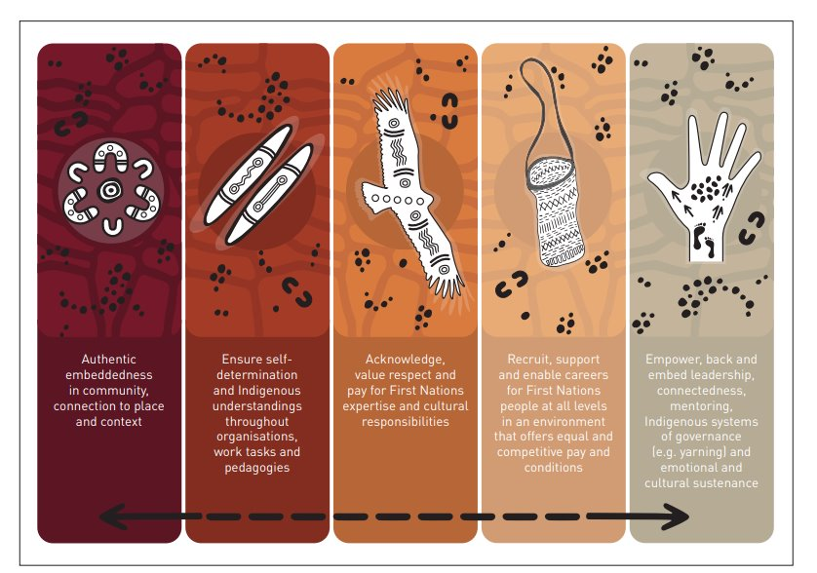
JSA First Nations VET Workforce Design Principles
In summary, this paper aims to inform VET policy and funding decisions and RTO employment planning and practices by providing robust, evidence-based insights into the First Nations VET workforce. Policymakers may use these findings to more effectively allocate resources to the initiatives most likely to improve outcomes for First Nations VET workers and learners. RTOs can use the findings to create more inclusive and empowering workplaces for First Nations staff and students and to grow their teaching, training and assessing workforce. Industry can benefit by forming partnerships to strengthen training pathways and job opportunities for First Nations peoples.
Lastly, the paper highlights the importance of strong sustained partnerships between VET institutions and First Nations communities. Recognising the importance of First Nations community control and collaboration with local First Nations organisations and community leaders can help to ensure that VET programs are culturally relevant, responsive to local needs, and grounded in community support.
Adopting the Design Principles can assist in achieving these goals and a larger and more robust, systemic and resilient First Nations VET workforce.
Really exciting to start working with the next generation and help to embed change at that level and support it at that level and reach out as well into our communities and give people access to training that they never had before.
- Focus Group Participant

Introduction
Building and sustaining a strong vocational education and training (VET) workforce is essential to maintaining effective education and training pipelines of skilled workers for Australian industries. These pipelines are more robust when they are diverse and responsive to the needs of First Nations peoples and local communities.
Governments across Australia—at both national and state and territory levels—recognise the critical role that high-quality VET plays in driving current and future productivity, enhancing wellbeing, and addressing social and economic disadvantage.
A vital component of this effort is the growth and support of the First Nations VET workforce, and the long-term sustainability of Aboriginal Community-Controlled (ACC) and First Nations owned (FNO) Registered Training Organisations (RTOs). Expanding the First Nations VET workforce is not only an economic imperative, it is also a matter of equity, ensuring fair access to opportunities within the VET sector and the industries it serves.
Equally important is the recognition and fulfilment of First Nations peoples’ inherent right to self-determination. This means ensuring they have a meaningful role in decision-making within the VET sector. Shared governance and culturally informed policy development are essential to creating education training systems that reflect the values, needs, and teaching traditions of First Nations communities.

What this research paper does
This research paper was developed by Jobs and Skills Australia (JSA) to provide critical evidence, insights, and principles to support the needs of the current and potential First Nations VET workforce. With input from First Nations experts at leadership, research and operational levels, it seeks to include the voices of the First Nations VET workforce as a core part of the analysis.
The research focuses on the First Nations VET workforce involved with delivery and support of students undertaking accredited, nationally recognised, VET courses and qualifications, particularly regarding workforce attraction and retention. This will build upon the actions and opportunities identified in the Department of Employment and Workplace Relation’s (DEWR) VET Workforce Blueprint (2024b) and inform and complement the broader work within the National Skills Agreement and the National Agreement on Closing the Gap.
This paper also builds on JSA’s occupational mapping work undertaken for the VET Workforce Study (2024a), by identifying and analysing further occupations for First Nations peoples across various parts of the VET sector, including in TAFEs, select dual sector universities, independent and private RTOs, adult and community education providers, schools and services provided by Aboriginal Community Controlled Organisations (ACCOs).

The research is limited to RTOs delivering nationally accredited training programs and does not undertake an evaluation of current workplace practices, traditional job profiling nor a supply and demand modelling of the VET workforce. Instead, it seeks to synthesise existing evidence, drawing together what we know works and is important–or does not work and imposes barriers to First Nations success–to articulate what needs to improve.
The analysis draws on policy literature from Australia and abroad, data from the ABS Census of Population and Housing 2021 (ABS Census) and earlier Censuses, the Person Level Integrated Data Asset (PLIDA), and the National Centre for Vocational Education Research (NCVER) Total VET Activity, as well as utilising JSA’s typology of RTOs (2024b) to better understand the range of VET organisations. We also examined job advertisements (including via Lightcast) and relevant enterprise agreements and awards.
Additionally, qualitative insights from stakeholder roundtables, submissions, communications, and VET worker focus groups enriched our understanding of the enablers and barriers within the VET workforce from multiple perspectives. Our data insights into the First Nations VET workforce include:
- First Nations representation in the VET workforce was 2% in 2021, compared to 2.2% of the whole Australian workforce and 3.8% in the overall population (ABS Census 2021).
- The First Nations VET workforce grew by 18% between the 2016 and 2021 Censuses, outpacing 1% growth in the overall VET workforce (JSA analysis of ABS Census Data for 2016 and 2021).
- First Nations students represent a strong and growing share of Certificate IV in Training and Assessment (TAE) graduates (JSA analysis of NCVER Total VET students and courses). On average, about 370 Indigenous students completed this qualification each year between 2015 and 2024, while completions by non-Indigenous students of the same qualification fell over the same period.
- First Nations peoples are more likely to work full-time hours when working in VET (68%) compared to working in the general workforce, where the full-time rate for First Nations peoples is 56% (JSA analysis of ABS 2021 Census Data).
- Around 2% of the VET workforce identified as First Nations peoples (JSA analysis of ABS 2021 Census Data) compared to around 3.5% of VET students (JSA analysis of NCVER Total VET students and courses).
- First Nations VET teachers, trainers and assessors experience greater income volatility and earn lower median weekly income compared to the overall VET teaching workforce (JSA analysis of PLIDA Data).
These insights underpin our analysis of the factors impacting on training, attracting, retaining and promoting career development for the First Nations VET workforce and informed the five Design Principles proposed in this paper.
While the experience and success of First Nations students is critically important to the VET sector, this report concentrates on the experiences of the First Nations VET workforce. We therefore only present student data when it is needed to provide career pathways for people working in VET and context for VET delivery within certain settings.
JSA takes care to ensure that all data, figures, and research is evidence based and accurate at the date of publication. Please note, however, that they may be subject to change after publication and that changes may be made to the data or the JSA website at any time.

Background

National Skills Agreement and the National Agreement on Closing the Gap
The National Skills Agreement, which commenced on 1 January 2024, is a 5-year agreement between the Australian and state and territory governments working in partnership to ensure that the national VET system provides high-quality, responsive, and accessible education and training. The aim is to boost productivity, deliver national priorities and support Australians to obtain the skills and capabilities they need to obtain well-paid, secure jobs and careers.
The Australian Government has committed to improving the lives of First Nations peoples and achieving the Priority Reforms and socio-economic targets outlined in the National Agreement on Closing the Gap. This Agreement has 19 national socio-economic targets, which include targets for education, employment and training for First Nations peoples.
The National Skills Agreement provides a range of mechanisms and flexible funding arrangements that states and territories can use to support First Nations learners. Through the National Skills Agreement, the Australian Government is partnering with states and territories to work with First Nations peoples on a package of reforms focused on the four Priority Reform Areas of the National Agreement on Closing the Gap. The Government has committed to investing up to $214 million over the life of the Agreement to:
- Priority Reform 1: Formal partnerships and shared decision making. Establish partnerships with First Nations organisations in VET to provide genuine engagement and agency in policy making.
- Priority Reform 2: Building the community-controlled sector. Expand investment in the capability, sustainability, and growth of the Aboriginal Community-Controlled and First Nations owned training sector.
- Priority Reform 3: Transforming government organisations. Grow the First Nations VET workforce and boost cultural capability of mainstream RTOs.
- Priority Reform 4: Shared access to data and information at a regional level. Fund activities to boost data and evaluation capability in the First Nations VET sector.

The National Agreement on Closing the Gap Bilateral Implementation Plans are designed to support place-based Closing the Gap activities developed by states and territories with First Nations partners. Policy initiatives specified in the National Skills Agreement also provide opportunities to support First Nations learners. The goal is to improve completion rates for these learners and improve the pipeline for First Nations peoples into the workforce, including the VET workforce, which research shows is enhanced when First Nations peoples, values and knowledges are incorporated (Miller 2005).

VET Workforce Blueprint
The DEWR VET Workforce Blueprint (2024b) shows that labour supply issues are a significant concern facing the VET workforce. The sector is under increasing pressure to attract and retain skilled individuals to meet training demand and diversity in delivery needs. This is why the Australian Government, in collaboration with states and territories, developed the Blueprint to support, grow and sustain the VET workforce.
DEWR commissioned JSA to complete research to inform the Blueprint, which included a VET Workforce Study (JSA 2024a) and further research on the First Nations VET workforce (this paper). JSA’s VET Workforce Study, published in October 2024, found that:
- First Nations peoples are underrepresented in many segments of the VET workforce when compared to the overall workforce but represent a higher proportion in the Learning Support and Curriculum Development and Learning Design segments of the Occupational Map published in the Study.
- The sector is experiencing high demand, but a low supply of teachers, trainers and assessors (and consequently workers) in some industries, and training pipeline constraints.
- VET consists of an older workforce when compared to the Australian workforce average. It is also slightly less culturally and linguistically diverse, and segments are highly casualised.
The Blueprint highlights opportunities to expand, support, and better understand the VET workforce, and includes an action with a focus on First Nations workers. It emphasises the importance of developing localised, tailored strategies for First Nations workers in collaboration with First Nations communities to strengthen their representation in the VET workforce. The Blueprint acknowledged that First Nations stakeholders have valuable insights into effective methods for attracting, retaining, and supporting their workforce.
Empowering First Nations peoples to lead the development of these approaches will enhance cultural competency and responsiveness to First Nations learners across the sector. These approaches encourage co-designed and collaborative solutions that acknowledge and can build on the effective and appropriate models and strategies already in action across the sector. While recognising the success of these approaches however, more work needs to be done. One objective of this paper is to highlight successful models and strategies that could be adapted and extended more broadly.

In First Nations communities, especially in very remote or disadvantaged locations, delivery of VET by First Nations staff (especially teachers, trainers and assessors) is correlated with better student outcomes (Guenther 2017a). Similar outcomes have also been found in on-community delivery contexts (Windley 2017). Staff who identify as First Nations, and staff working at Aboriginal Community Owned and/or operated RTOs, provide relevant and focused training in locally distinctive contexts.
Approaches cited by organisations for this research include responding to the skills needs of local communities and incorporating local cultural knowledge and occasionally local languages into teaching and courses. This enabled these organisations to provide culturally appropriate wrap-around student support (Guenther 2017b).
Stakeholder consultation in the development of the VET Workforce Blueprint suggested that failing to recognise the local skills, knowledge and community connections of First Nations peoples is frustrating and disempowering for First Nations VET workers. In addition, the requirement to obtain the Certificate IV in Training and Assessment (TAE) can act as a challenge to employment for teacher, trainer and assessor roles, for which First Nations peoples are otherwise suited (DEWR 2024b). Actions and opportunities suggested in the Blueprint include:
- The VET sector could develop localised and bespoke First Nations strategies for the First Nations VET workforce in partnership with First Nations peoples.
- That a First Nations led approach to supporting the workforce in First Nations VET delivery contexts will improve training and support for First Nations students.
- The need to explore the introduction of specialisations and gain a better understanding of the roles within VET (including for First Nations peoples) in future work on VET occupational mapping.
- The need to improve data collection systems to better understand the VET workforce.
- Additionally, new research is needed to better identify the various roles and pathways in and across all VET contexts.
The Australian Government has allocated $100 million in funding over five years to strengthen the VET workforce through the National Skills Agreement. This includes $70 million for state and territory initiatives (which requires state or territory matched funding), including to support local actions to respond to the VET Workforce Blueprint; and $30 million to support agreed areas of national action.

First Nations vocational education traditions
For millennia First Nations peoples have protected and passed on knowledge and skills that are vocational in nature. First Nations peoples have protected and taught historical and linguistic knowledge, food cultivation and production, creative and cultural traditions and innovations, and scientific and technological understanding. These have been taught using pedagogical approaches that have been adapted over time, and which continue in flexible and adaptive ways, into the present.

Much traditional knowledge has combined economic, geographical and spiritual understanding. Walking through Country, as Aboriginal educationalist Coral Edwards showed, is a learning experience that combines knowledge of calendar, history, economy and food, where ‘songlines…mark out time and space’ and you ‘know how far you’ve yet to go by how many stories there are yet to come’. Such stories, she said, are ‘spiritual’ and also tell ‘who the People were and are, within the Country, and their place in it’ (Edwards, cited in Karskens 2010:41-42).
These ways of entangling forms of knowledge and practice are efficient and align in many respects to the purpose and practice of VET. They can, however, be markedly different to Western knowledge traditions that tend to segment knowledge into discrete components that align to classifications by discipline or sector and are expected to apply universally across space and time. For example, when the black march flies start biting, crocodile eggs are ready for collection, and when green march flies start biting, bush plums are ripe. Neither is the cause of the other, yet this knowledge is true and remains an important aspect of managing ecology and food production (Rose 2000).
As well as showing the ways First Nations knowledge might be entangled with spirituality, the march fly-crocodile egg example also demonstrates the value of recognising and sharing knowledge that is bound to a particular place. This is one of the reasons that embedding VET in communities is beneficial not only to a First Nations VET workforce but also to a wider understanding of place-based vocational and traditional knowledge.
Colonisation disrupted the traditional knowledge systems and teaching methods that First Nations peoples used to manage land, culture, and economies. This disruption was further compounded by discriminatory laws, policies, and practices that historically denied First Nations peoples access to education, leading to long-term impacts on educational and employment outcomes. Additionally, the forced removal of children, now known as the Stolen Generations, by Australian governments, churches, and welfare organisations within the last century, has affected every Aboriginal and Torres Strait Islander community (AIATSIS n.d.).
These removals severed crucial community and family connections, significantly impacting the transmission of cultural, traditional, and vocational knowledge across generations and between First Nations peoples.
With considerable tenacity and resilience, First Nations communities have maintained their rich vocational traditions despite colonial obstacles – some of these, such as fire management, are growing in importance in mainstream settings (Smith et al. 2021; Pattison et al. 2023). Other skills and knowledge have been actively revived; a result of painstaking research ‘against the grain’ of the colonial record. Alongside ethnographic and archaeological research, this work has exposed details of past economic practices (many best-known examples can be found in Gammage 2011; Pascoe 2014).
Recognising the value of First Nations educational and knowledge traditions, the Commonwealth Scientific and Industrial Research Organisation (CSIRO) is among several research and innovation organisations that now use First Nations science and knowledge sharing techniques to improve Australia’s capacity to build a sustainable economy (CSIRO 2024a). It is important to note the use of First Nations knowledges must be supported by attention to intellectual property, cultural practices and policy, legal frameworks and regular and sustained community engagement.

How this paper is organised
Chapter 2 of this paper provides an overview of RTO governance and delivery settings and programs and support systems for First Nations participants within these settings. It then assesses the representation of First Nations peoples in the VET workforce and the roles they can hold via government collected demographic data and examines the pipeline into VET for teachers, trainers and assessors. Based on desktop research, we also provide some international case studies that Australia might use as comparative workforce benchmarks.
Chapter 3 details current RTO settings in more detail. Firstly, it discusses the First Nations sector, consisting of First Nations owned and Aboriginal Community Controlled RTOs and specialised First Nations courses and teaching and support practices. It then moves to describing ‘mainstream’ RTOs and the place of First Nations peoples, understandings, pedagogies and career opportunities within these organisations. This section concludes with an analysis of the enablers and barriers to First Nations inclusion in VET.
Chapter 4 outlines a set of Design Principles informed by the research undertaken for this paper to guide further planning and growth in the First Nations VET workforce. A sample of the promising practices that RTOs currently have in place is provided for each principle.

VET Sector

The Australian VET Sector and First Nations Peoples
With more than 4,000 RTOs operating across Australia, VET is a highly diversified sector that delivers education and training to around 5 million learners each year (JSA analysis of NCVER Total VET students and courses). Of these students, around 3.46% (or almost 175,000), identified themselves as First Nations peoples.
The type of courses and qualifications that VET offers is also highly diverse, ranging from programs that lead to employment, to those that provide pathways into education for disengaged or disadvantaged learners, to programs that provide pathways to higher education and higher skills. The complexity of such diversification presents a challenge to understanding the First Nations VET workforce, which does not necessarily conform to a readily recognisable group in official statistics.
However, the sector’s diversification has also facilitated First Nations ownership and leadership in many VET settings. This is a key enabling characteristic for First Nations peoples and communities as it presents opportunities for them to design and control VET service provision. First Nations communities and individuals have been innovative in VET and related areas, including employment, economic development, maintaining cultural knowledge traditions, and providing targeted training to address local needs, in many cases connecting training to broader related community needs.

VET governance
Most RTOs are regulated by the Australian Skills Quality Authority (ASQA), with RTOs delivering only in Western Australia or Victoria regulated by the relevant state-based authority; the Western Australian Training Accreditation Council (TAC) and the Victorian Registration and Qualifications Authority (VRQA). Dual sector institutions are accredited by both ASQA, who regulates VET, and the Tertiary Education Quality and Standards Agency (TEQSA) which regulates higher education.
TAFE Directors Australia (TDA) serves as the peak body for public institutions within the TAFE network, including dual-sector institutions. Several organisations represent adult and community education providers, each with a specialised focus, including Community Education Australia (CEA) and Adult Learning Australia (ALA). The Enterprise Registered Training Organisation Association (ERTOA) represents enterprise-based RTOs and the Independent Tertiary Education Council of Australia (ITECA) represents both private and independent vocational education and higher education providers.
There is no single Aboriginal and Torres Strait Islander peak body for VET. However, there is significant representation (57 as of January 2026) of Aboriginal Community Controlled and First Nations owned RTOs in a Community of Practice (CoP) facilitated through the National Aboriginal Community Controlled Health Organisation (NACCHO). There are also organisations relevant to tertiary education for First Nations peoples including the Alliance, which is a recent peak body uniting the Indigenous employment and training sectors, and the National Aboriginal and Torres Strait Islander Education Corporation (NATSIEC). These organisations are members of the Coalition of Peaks.
Following extensive consultation undertaken by the Coalition of Peaks, the Commonwealth committed to establishing the Indigenous Centre of Vocational Excellence (ICOVE). The ICOVE will operate as an alternative model to a First Nations skills peak and perform the role of a national, evidence-informed best practice hub to create and promote high quality, culturally responsive VET opportunities for Aboriginal and Torres Strait Islander students with strong pathways to employment outcomes. The ICOVE will be built around four pillars: innovation, capacity building, policy and advocacy, and research and data.
There are also state-based peak bodies for First Nations education, including the NSW Aboriginal Education Consultative Group, the Queensland First Nations Education Consultative Body, Victorian Aboriginal Education Association Incorporated, the South Australian Aboriginal Education and Training Consultative Council, and the Northern Territory’s Aboriginal Education Steering Committee.

Foundation Skills
Foundation skills are a focus of the Australian Government for all adults as part of the National Skills Agreement (DEWR 2024a). Foundation skills delivery includes accredited and non-accredited training and for this paper, the accredited provision is in scope. This includes a feasibility study as part of JSA’s Foundation Skills Study into how to best collect the foundation skills of First Nations peoples.
Foundation skills include adult language, literacy, numeracy, digital literacy and employability skills (LLNDE). DEWR’s Future Delivery of Foundation Skills Training in Remote Australia (2022:5) says that:
Foundation skills give people confidence to take part in daily life, training and employment. They include listening and speaking, reading, writing, numeracy and digital literacy, as well as skills like initiative and innovation, planning and organising, problem solving and teamwork. Foundation skills are the skills needed for a secure job.
In 2023, there were 6,000 First Nations students enrolled in the Foundation Skills Training Package, which made up 8% of enrolments in this training package (JSA analysis of NCVER Total VET students and courses). In Circelli and colleagues’ study (2022), 44% of learners enrolled in foundation skills courses spoke a language other than English at home, 8% were First Nations peoples, and 16% were people with disabilities.

In the NCVER report VET Delivery in Regional, Rural and Remote Australia, Griffin and Andrahannadi (2023:38) demonstrated the connection between English as a second language in many remote communities and the need to build English language literacy as foundation skills, as most VET courses are delivered in English:
Many of the RTO interviewees reported that language, literacy and numeracy issues were a large barrier to delivering VET in regional, rural and remote locations, with some suggesting that it intensifies as training locations become more remote.
Over 2020-2023, four projects in remote Australia tested different approaches to community-based foundation skills development programs for First Nations learners. An evaluation of these programs by Dandolo Partners (DEWR 2023) found that these pilot programs were more successful when they:
- Took a holistic approach, outsourced ‘wraparound’ services as needed, and were delivered face to face and in small groups.
- Were flexible enough to cater for individual learning, scheduling and cultural needs.
- Provided discretion, cultural safety and learner support and celebrated achievements no matter how modest.
- Gave participants the opportunity to engage with local employers and targeted learning to specific employment pre-requisites, such as gaining a driver’s licence.
- Were authentically embedded in local community, employed local staff and enabled past participants to act as mentors.
- Actively worked on staff retention, including continuing professional development, but also ensuring autonomy in selecting work tasks and career pathways that best suited individual talents and ambitions.
While foundation skills are clearly an important component of learning for First Nations students in VET, there are concerns that there has been a longstanding ‘deficit’ model of understanding First Nations academic achievement. To shift government attention instead towards a strengths-based model, the Murtu Yayngiliyn Study was commenced in 2023 under the Australian Government's broader Foundation Skills Study.
This Study seeks to determine how best to assess the LLND skills levels of First Nations peoples, including those in regional and remote areas, in a culturally safe and statistically sound manner. It provides a promising basis for strengths-based policy that concentrates and builds upon the existing strengths of First Nations peoples and communities.
The growth of foundation skills, and the development of better metrics by which to evaluate them, will positively impact the First Nations VET workforce. JSA’s VET Workforce Study (2024a) found that the demand for foundation skills teachers is likely to increase, in part due to reforms currently underway. In a survey of 382 providers, 32% of respondents cited the lack of qualified teachers as a barrier to delivering LLND programs (Reading Writing Hotline n.d.).
Investing in First Nations Foundation Skills teachers, based in and engaged with their local community, will likely be crucial to the success of First Nations learners.

VET delivered in First Nations languages
In the ABS Census 2021, 76,978 (or 10%) First Nations peoples reported speaking a First Nations language (ABS 2022a). Although a diminishing proportion of people speak a First Nations language at home (10%, down from 16% in 1991), a growing number of people are developing First Nations language skills, or speak a form of creole, including Kriol, Yumplatok, Gurindji Kriol and Light Warlpiri. Others may speak Aboriginal English (Australian Academy of Humanities 2021).
First Nations teachers have an important part to play in both supporting VET for First Nations peoples for whom English is a second language, as well as in reviving and expanding proficiency in one or more of the over 150 First Nations languages that are spoken in Australia.
Traditional languages are a key element of Indigenous peoples’ identity, cultural expression, autonomy, spiritual and intellectual sovereignty, and wellbeing, (Sivak et al. 2019:1).
It also matters to teach other vocational courses in First Nations languages. For First Nations communities where an Aboriginal language (such as Arrente, Pitjantjatjara and Warlpiri) or Torres Strait Islander language (such as Meriam Mir or Kala Lagaw Ya) is spoken at home, especially in remote parts of Australia, English is a second language for most people.
Supporting teaching in language is therefore a pillar of VET success, especially in remote regions. The NCVER report (Guenther et al. 2017b:6) on VET retention in remote communities found that:
Where the learning is mediated by local trainers, in language, ‘on Country’ or for a cultural purpose, training was viewed as being more valuable and ultimately more successful.
RTOs delivering VET in remote areas of Australia are more likely than others to teach in a First Nations language (including Kriol etc), though comprehensive data is not currently available. Research on First Nations schooling, especially in remote areas, frequently makes the case that bilingual education is important even when students’ first language is Kriol or Aboriginal English (Bundgaard-Nielson 2023). Language is a crucial vehicle of identity (Guenther et al. 2017b:6):
Training that embraces and encompasses local culture and knowledge has the power to make connections between Country, technology and intergenerational knowledge, and relevant local employment options.
First Nations peoples live in vastly different areas across Australia, each region representing a considerable diversity in lifestyle and linguistic tradition, not just languages as they were before colonisation, but as they have become, including a variety of English dialects. First Nations adult education in and of language requires considerable sensitivity to place as adult educators require skills that are contextualised on the social and cultural needs of their environment (Simpson et al. 2009).

TAFEs and other RTOs have developed programs for learning – and for learning how to teach – First Nations languages. These programs have enabled considerable progress towards addressing the need Caffery (2010) highlighted to ensure the ongoing viability of languages that have been considered ‘endangered’. While the ABS Census shows the number of people speaking First Nations languages in Australia is expanding, this work is still urgent (ABS 2022a).
The Batchelor Institute of Indigenous Tertiary Education in the Northern Territory, Tauondi Aboriginal College in Adelaide, and Yalga-binbi Institute in Central Queensland all teach 10892NAT - Certificate IV in Teaching an Australian First Nation’s Language. Similarly, the Muurrbay Aboriginal Language and Culture Co-operative in Nambucca Heads, NSW, teaches coastal languages including Awabakal – Wonnarua, Bundjalung, Darkinyung, Dhanggati, Gathang (Birrbay, Warrimay & Guringay), and Yaygirr - Yaegl (Muurrbay n.d.).
Training First Nations teachers, trainers and assessors to teach these languages has been a priority. The TAFE SA Centre of Excellence for Early Childhood Education and Care has committed to partner with First Nations stakeholders to ensure curriculum and learning resources are translated and customised into local community languages.

First Nations support units
Educational institutions of all kinds, including VET institutions, have found that providing a dedicated space for First Nations students that is staffed by First Nations support workers, helps students to build confidence and achieve their goals and supports improved completion rates. Employing First Nations workers for the purpose of helping students has longstanding support in the research on First Nations educational outcomes in Australia and overseas.
This is based on decades of experience and research, most likely beginning with the earliest First Nations Teachers’ Aides courses that commenced in the Department of Adult Education at the Sydney Teachers College in 1975. This program developed into a support unit for university students called the Koori Centre (Cleverley and Mooney 2010).
Evidence that Aboriginal Teachers’ Aides improved schooling for First Nations children (Cleverley and Mooney 2010), and that First Nations Support Units similarly enhanced outcomes for those studying at tertiary level, was soon extended into VET. In the 1980s, for example, Victoria TAFE funded Koorie Liaison Officers, an initiative that evolved in the 1990s into Koorie Support Units, intended to increase First Nations enrolment and employment (both in TAFE and the community) and to improve cultural competence among TAFE staff (Helme 2007).

These units were universally endorsed by First Nations students, who found that the combination of academic and interpersonal support helped them to build confidence, develop social as well as employment skills, and bolster their First Nations identity (Helme 2007). Now, First Nations student support units provided by many TAFEs. For example:
- At Canberra Institute of Technology (CIT), CIT Yurauna provides scholarships, bespoke courses, community activities and personalised assistance on academic skills, foundation skills, administrative processes, accommodation and advocacy (CIT n.d.).
- North Regional TAFE in Western Australia has an Aboriginal Support Centre that offers mentoring, in-class support and connections to both employment and other services (North Regional TAFE n.d.).
- At Western Australia’s North Metropolitan TAFE, Koolark (meaning ‘home’) is a centre for First Nations students, offering a yarning space, employment connections and mentoring as well as support for TAFE staff and other organisations in developing cultural competency (North Metropolitan TAFE 2023).
- TAFE SA has an Aboriginal Access Centre and provides a Training Support Officer for First Nations students in South Australia, as well as a tutor for those enrolled in a Certificate III or higher qualifications (TAFE SA n.d.).
- Wodonga TAFE in Victoria has Koorie Education units which, like those at other TAFEs, describe themselves as ‘culturally safe spaces.’ Their key role is to connect First Nations students to one another (Wodonga TAFE n.d.).
The centrality of support for First Nations students, and of dedicated spaces for shame-free social and academic development, has been very important in growing First Nations student enrolments in VET (Helme 2007). However, First Nations Support Units serve multiple purposes. Those who work in them know, and research has consistently found, that these units are important to course completions and that studying VET boosts confidence, improves communication and enables learning that can be applied in a wide variety of settings, including employment and First Nations community support.
O’Callaghan’s (2005) summary of First Nations VET showed that young people typically pursue VET for work purposes, but that older people tend to seek personal achievement. The success of First Nations Support Units must not only be measured by inflexible metrics such as graduate employment, but by the tangible and intangible benefits of support for First Nations students.
First Nations support, whether in dedicated units or through teachers’ aides and other support staff, are also a key source of employment for First Nations peoples in the VET workforce. First Nations support workers provide learning support, which can include generic skill development, as well as moral and cultural support.

RTO delivery settings
Understanding the First Nations VET workforce requires a deeper appreciation of the variety of approaches and settings in which VET is delivered. RTOs are generally classified by ownership and funding, which tends to conceal the diversity of the services provided. JSA undertook a project to add to our understanding of how the VET system operates, by segmenting RTOs in a new typology that considers how RTOs operate and relate to students, communities and industry (JSA 2024b).
The typology highlights the diversity of the VET sector, even within singular categories such as Private RTOs and Adult and Community Education providers. The project shows that 80% of all RTOs are classified as private or independent based on Australian Vocational Education and Training Management Information Statistical Standard (AVETMISS) provider type classification (JSA 2024b:3).
The distinctiveness of RTOs adds additional but important complexity to the Occupational Mapping established by JSA in the VET Workforce Study (JSA 2024a). For example, working at a large urban TAFE differs significantly from working at an Aboriginal Community Controlled Organisation with a specific focus, or a remote First Nations owned employment and training service. These differences extend across urban, regional, and remote settings, further diversifying the VET landscape. While this variation can make data analysis more challenging, it is crucial to recognise that such diversity allows RTOs to appropriately address the unique needs of the students and communities they serve.
In addition, the purpose of different types of RTOs, even within the Aboriginal Community Controlled sector, varies considerably, contributing to a wide variety of workplace experiences for the VET workforce. Analysis of available workforce data reported in the VET Workforce Study, shows that while First Nations VET staff are often employed in education support roles, they also hold many other jobs across the sector. For example, First Nations peoples hold roles ranging from TAFE senior managers in urban centres, to institutional bus drivers, to educators of Early Childhood teachers, to administrators of remote private RTOs that may primarily provide employment services. These roles are discussed further in later sections.

Aboriginal Community Controlled and First Nations owned RTOs
Aboriginal Community Controlled Organisations are recognised not-for-profit organisations that are controlled and operated by Aboriginal and Torres Strait Islander people. These organisations deliver services that build the strength and empowerment of First Nations communities. They operate across multiple areas of industry specialisations, including Health, Arts, Land Management, Building and Construction, and Property, and are:
- Incorporated under relevant legislation and not-for-profit
- Controlled and operated by First Nations peoples
- Connected to the community, or communities, in which they deliver services including VET
- Governed by a majority First Nations governing body.
Aboriginal Community Controlled Organisations are an act of self-determination. All people have a right to self-determination, but the history of colonisation makes this markedly more important for First Nations peoples. This is recognised by the fact that Australia is a signatory to the United Nations Declaration on the Rights of Indigenous Peoples, which commits all sectors, including VET, to supporting First Nations self-determination. Considering this imperative, Aboriginal Community Controlled RTO ownership and control is a key site of interest.
The classification of a First Nations owned RTO is derived from the National Agreement on Closing the Gap (2020:52) and refers to a ‘business, charity, not-for-profit organisation, incorporated under Commonwealth, state or territory legislation, that has at least 51% First Nations ownership and/or directorship and is operated for the benefit of First Nations communities.'
Most Aboriginal Community Controlled and First Nations owned RTOs are classified as Community Education (40%) or Private Providers (51%) in the existing AVETMISS provider type classification. A well-known exception is Batchelor Institute of Indigenous Tertiary Education, which is a dual sector tertiary education provider accredited to deliver VET and postgraduate higher education.
The JSA RTO Typology (JSA 2024b) shows that beyond AVETMISS classifications, almost half (49%) of Aboriginal Community Controlled and First Nations owned RTOs were categorised in the RTO Typology as Indigenous specialists (Figure 2.1). The remaining RTOs can be broken up into other cohort specific providers (including associations, enterprise, schools and very small RTOs), and generalists or industry specialist providers.
Figure 2.1. Proportion of Aboriginal Community Controlled and First Nations owned RTOs by JSA RTO typology
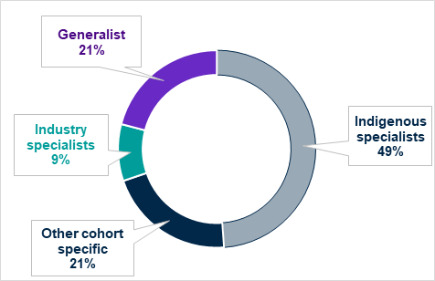
Source: JSA analysis of supplied list of ACCO and FNO RTOs as of 6 September 2024.
Notes: ^ 'First Nations specialist' is a partition/segment in the JSA RTO typology which includes those where >60% of enrolments (2018-2020) are First Nations students.
Aboriginal Community Controlled Organisations and other First Nations owned enterprises serve a crucial purpose in fulfilling the diverse needs of First Nations peoples and communities. Through the National Skills Agreement, the Australian Government is partnering with states and territories to work with First Nations peoples to expand investment in the capability, sustainability and growth of this sector.

TAFE and dual sector providers
TAFE Institutes are the main Australian public providers of VET and employ First Nations VET staff across a range of roles and play a key role in the development of the First Nations workforce. The inclusion of First Nations staff in these providers is important as TAFEs across Australia accounted for 27% of enrolments by students in 2023 who identified as First Nations peoples. This is higher than (and almost double) their 15% share of all VET enrolments (JSA analysis of NCVER Total VET students and courses).

Independent and Private RTOs
Independent and Private RTOs operate in a range of non-government settings and include for - and – not for profit providers, religious owned colleges, Enterprise RTOs, industry bodies, and a growing number of Aboriginal Community Controlled and First Nations owned RTOs. They are represented in AVETMISS as ‘Private Providers’. Increasing representation and presence of First Nations staff is also critical for independent and private providers as almost two-thirds (65%) of First Nations VET students are undertaking training with these providers. This figure is higher when including First Nations students pursuing VET short courses, such as First Aid, in independent training providers (JSA analysis of NCVER total VET activity).

Adult and Community Education providers
Adult and Community Education providers offer both accredited and non-accredited training including in regional and remote areas and include several Aboriginal Community Controlled RTOs. Across First Nations VET students, 12% were enrolled in Adult and Community Education providers (JSA analysis of NCVER total VET activity).

VET delivered in secondary schools
VET delivered in secondary schools is a critical part of both education systems. Over 100,000 VET students undertook training in schools in 2023, and 7% of this cohort identified as First Nations peoples (JSA analysis of NCVER total VET activity).
There are significant variations in the way VET is delivered in schools, which can include offsite and/or in-school delivery (day or block engagement) by an RTO separate to a school, and delivery by schools registered as an RTO or auspiced to deliver VET for another RTO in-school or offsite (Figure 2.2). School RTOs need to employ teachers who are qualified to deliver certain VET courses.
Figure 2.2. Five models of VET delivery to secondary students in Australia
MODEL 1 –  School is an RTO  A school is registered as an RTO and can deliver VET and issue qualifications. | MODEL 2 –  School partners with an RTO  School auspices or partners with an RTO to deliver training. VET qualifications are issued by the RTO. | MODEL 3 –  School engages an RTO to deliver VET  Delivery is within the school. The RTO issues VET qualifications. | MODEL 4 – Students attend an external RTO  Students attend a TAFE, another school, or a private RTO to study VET. The RTO issues VET qualifications. | MODEL 5 – School-based apprenticeships  Students attend an RTO for VET and work part-time, in addition to school studies. The RTO issues VET qualifications.
Source: AITSL (2021) Building a high quality and sustainable dual qualified VET workforce
In some settings, particularly in remote areas of Australia, there are very diverse delivery modes that do not always rely on online delivery. Because of this diversity in delivery, there are substantial gaps in data collection and reporting that impede our understanding of the VET teaching workforce, including of First Nations teachers, trainers and assessors. What we do know however, is that First Nations teachers remain under-represented in the national teaching workforce (Perkins and Shay 2022; Perkins 2019).

Accredited VET in other Adult and Community Education settings
VET is often delivered in settings which are beyond those traditionally understood as VET and, while organisations in these settings frequently operate as RTOs, their primary purpose may not be education and training delivery. Examples of these organisations are provided below.

Aboriginal Medical Services and Aboriginal Community Controlled Health Organisations
In many communities across Australia the role of the Aboriginal Medical Services (AMS) or Aboriginal Community Controlled Health Organisations (ACCHOs) is to provide a key community hub for culturally safe, community engaged primary medical care. The importance of First Nations led health care has been recognised and there are growing numbers of AMS and ACCHOs with their own RTOs to ensure that health care training is culturally responsive for First Nations students.
Training in these organisations is often but not always related to health and medical training and can include the Certificate IV in TAE. For example, the First Nations Trainer and Assessor Demonstration Project, delivered by NACCHO supporting the First Nations Health Worker Traineeship program by upskilling health workers and practitioners to train and assess up to 500 new health worker trainees. Feedback highlights the success in building culturally safe training capacity across ACCHO RTOs to support trainees in the program.

Employment Services
Employment Services primarily refer to organisations that provide support to jobseekers and are funded by government, either directly or indirectly. The interaction of employment services and VET is a well-known path to employment and is important for both sectors.
Connections between RTOs, employers and employment services is not the same in every community. Many employment services have in-house RTOs or have auspicing arrangements with RTOs, including large TAFEs or national providers. In some settings, dedicated employment services staff work with First Nations peoples in a culturally safe and community connected way, drawing on their connections with local employers and delivering training as part of their service.
In their 2023 study of VET Delivery in Regional, Rural and Remote Australia, Griffin and Andrahannadi (2023:43) reported RTO stakeholders saying:
Things are different in every location. Two different regional centres will need to be managed differently. You know, one small Indigenous community is going to be different to another small Indigenous community. And I think that is one of the barriers for people, is that unless you understand the regional towns and the way that they are all unique (RTO, National).
Every program will be different because participants will be so different and there'll be a different need at the time… you can't do one size fits all. It will never, ever work (RTO, NT).

For First Nations communities, connecting VET to employment is particularly important, not only to help facilitate employment for graduates but also to keep RTOs authentically embedded in the community with a focus on building relationships and forming partnerships. To strengthen these connections, many enterprises in remote areas, as well as some in large regional and metropolitan centres, integrate RTOs within employment services.
For example, the Tiwi Training and Employment Board (TITEB) operates a Community Development Program that links job seekers to employment opportunities, providing comprehensive support, from interview preparation to vocational training (TITEB n.d.). In addition to assisting individuals receiving welfare payments with job readiness and placement, TITEB functions as an RTO, offering Certificate II qualifications in Community Services, Hospitality, and Foundation Skills.

VET in Australian prisons
In the last ABS Census in 2021, First Nations peoples represented 3.8% of the population. In contrast, the ABS also reports that, as of 30 June 2024, First Nations peoples represented 36% (15,871 people) of all prisoners in Australia, which increased by more than 2,000 over the previous year (ABS 2024a).
The disproportionate rate of incarceration of First Nations peoples highlights the importance of understanding prison-based VET delivery and supporting First Nations teachers in this context. This is not only a matter of equity – which is to say, fairness dictates that education be made available to people in prison – but also a matter of reducing recidivism. A 2018 study of VET in Australian prisons in New South Wales, South Australia, the Northern Territory and the Australian Capital Territory showed that participation in VET in custody improved the likelihood of people staying out of prison at two and five years after being released (Cale et al. 2019).
The imperative to keep people out of prison opens new opportunities to grow this segment of the First Nations VET teaching workforce and provide more culturally appropriate and effective approaches to teaching, training and assessment that will improve life and employment after prison for First Nations peoples. Art and design, both as opportunities for employment and entrepreneurship, have been fruitful fields for First Nations peoples and communities to develop skills and employment prospects that are also culturally congruent.
Other institutional connections that seek to facilitate cultural congruence, such as the CSIRO’s commitment to engaging with First Nations Science, suggest that there is opportunity to develop prison-based VET with a growing First Nations VET workforce in ways that will improve outcomes for First Nations prisoners, while in prison, and for their lives and employment prospects after their release (CSIRO 2024b).

The First Nations VET workforce
Our understanding of the First Nations VET workforce is informed by the research JSA completed for the VET Workforce Blueprint (in the VET Workforce Study). Data limitations discussed in that research are even more pronounced for the First Nations VET workforce, whose roles and identities can sometimes be invisible or underreported in aggregated workforce data.

Understanding the workforce
The ABS Census classifies Census respondents into occupations and industries based on their answers to questions about the main job they held in the last week. For this research paper the VET workforce includes respondents coded to Vocational Education Teacher (Aus)/Polytechnic Teacher occupation (ANZSCO 242211) and/or Technical and Vocational Education and Training industry (ANZSIC 8101).
However, as noted earlier, VET is delivered in a wide variety of settings. Even in ABS Census data, our analysis shows that 1 in 5 VET teachers work in one of 243 industries outside Education and Training (JSA 2024a). The ABS Census occupational categories do not capture the entire VET sector resulting in an undercount of the VET workforce in the Census. For example, the occupations ‘Training and Development Professional’, ‘First Aid Trainer’, ‘University Lecturers and Tutors’ and ‘Teachers of English to Speakers of Other Languages’ are more common in independent RTOs.
In addition, not all RTOs operate within VET specific industries, and not all teachers, trainers and assessors will identify as a VET teacher, identifying with their industry role more strongly than their teaching role. An electrical VET teacher may – for example – choose to identify as an electrician rather than a teacher, which would influence how the ABS would classify their occupation and industry.
There are also problems capturing the number of volunteer teachers, trainers and assessors, secondary teachers working in VET, and teachers, trainers and assessors who work across multiple RTOs. Secondary jobs holders are common in VET but are not reflected in the standard ABS industry and occupational counts of main jobs, which reduces the number of people identified as working in VET.
In the 2021 ABS Census, our analysis of the occupation and industry codes that make up the VET workforce showed that 2% of respondents identified as being Aboriginal and Torres Strait Islander people. This is similar to the wider Australian workforce, where 2% of workers identified as Aboriginal and Torres Strait Islander people, but is lower than the 3.5% of the VET student population who say they are Indigenous (JSA analysis of NCVER Total VET students and courses).
Further specific limitations to the ABS Census data include its ability to present a comprehensive view of the workforce and particularly for First Nations peoples, noting that work is being undertaken towards improving the available data. In 2021, there was a 17% net undercount of Aboriginal and Torres Strait Islander people who chose not to identify themselves in the Census (ABS 2022b). However, despite these limitations, the ABS Census 2021 is the best available data for understanding the personal and employment characteristics of the First Nations VET workforce.

Roles within the VET workforce
Using the occupational categories in the ABS Census 2021, and analysis and engagement with stakeholders, JSA developed a mapping of the VET workforce, shown in Figure 2.3a. The visualisation was derived from analytical frameworks applied to the Census data. To develop the mapping, the occupations of people who said they worked within the Technical and Vocational Education and Training industry (ANZSIC 8101) were mapped into one of six segments to develop an understanding of the breadth of the VET workforce.
Appendix A of the VET Workforce Study (JSA 2024a) provides a list of occupational codes that correspond to each derived segment. This mapping is illustrated with sample jobs from publicly available data and job advertisements. Figure 2.3b is a novel visual representation of this mapping relating to the First Nations VET workforce derived from ABS Census results and examples of First Nations VET workforce-specific job titles.

Figure 2.3a. VET Workforce Occupational Mapping - Proportion of the ABS Census estimate VET workforce in each VET workforce segment (JSA 2024a), with sample job titles
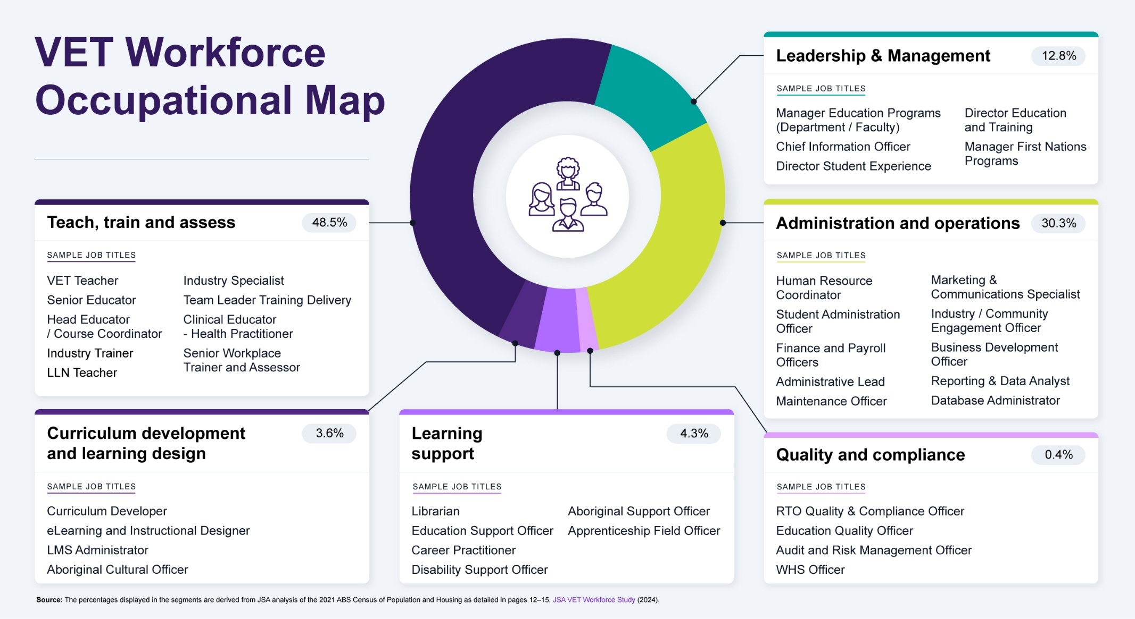

Figure 2.3b. First Nations VET Workforce Occupational Mapping - Proportion of the ABS Census estimate First Nations VET workforce in each VET workforce segment (JSA 2024a), with sample job titles
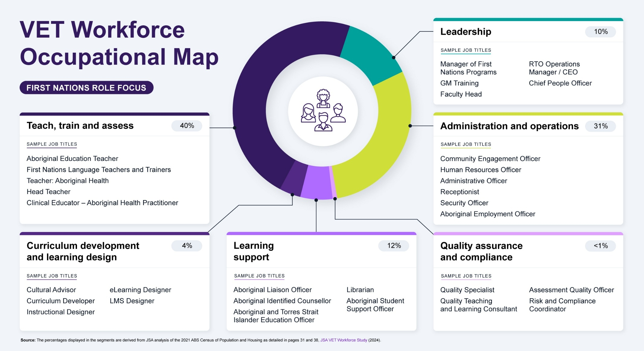

This is not an exhaustive list of job titles and indeed some job titles could cross more than one segment. For example, depending on the size of the provider, Faculty Heads may have a part-time teaching role or a distinct educational executive position in addition to their main role.
This mapping of the VET workforce indicated that 40% of First Nations peoples working in VET who responded to the 2021 Census were in roles in the Teach, Train, and Assess segment, delivering VET programs. These roles may vary significantly depending on an RTO’s setting and in some cases, they may be delivering programs specific to First Nations learners, and/or in First Nations contexts, and/or using First Nations content. For example, we heard during our research about the distinctive and rich learning environment provided by Aboriginal Community Controlled RTOs.
Across RTOs there is a spectrum of teaching, training and assessing roles that range from entry-level practitioners working under supervision, to those focused almost exclusively on teaching, training and assessment, to those with broader and extended responsibilities and scope. The roles performed by VET teachers, trainers and assessors depend on their level of experience, industry expertise and personal preferences, the size of the provider, the delivery context, and the student cohort.
Example Teach, Train and Assess role:
Teacher of Aboriginal Health at TAFE NSW
This role educates students on the health practices, challenges and perspectives of Aboriginal communities. It is intended to allow teachers to utilise their current industry experience and knowledge, while leveraging their cultural knowledge to enhance the learning experience of Aboriginal and Torres Strait Islander students and support community health outcomes.
Source: Job advertisement on Indigenous Employment Australia website 7 August 2023, accessed 1 August 2024.
The next largest segment in the VET Occupational Map is Administration and Operations (31%) which includes clerical, reception, recruitment roles, as well as commercial cleaning and grounds keeping. These roles, and the skills and knowledge required to fulfil them, are typically not unique to the VET sector and may be fully or highly transferable from other industries.
However, some roles require a higher degree of expertise in the VET system. For example, enrolment or student loan support officers are specialised administrative officers that use knowledge of the VET system and their employing RTO to respond to student enquiries, and supports students navigating processes, funding and requirements.
Example Administration and Operations role:
Senior Project Officer at NACCHO
This role will be part of a team that will support and coordinate the delivery of a range of workforce and training programs. Requirements for this role include experience working in the VET sector or higher education sector, with strong organisational and engagement skills.
Source: Job advertisement on NACCHO website 28 August 2023, accessed 1 August 2024
Learning Support account for 12% of the VET workforce. Roles in this segment provide VET specific educational support and ancillary educational professional services, like librarians and counsellors. These roles offer services and support that may be available to all students (e.g. library services) or focused on providing direct support to First Nations students, helping them succeed academically and personally.
According to the ABS Census 2021, First Nations peoples account for a higher proportion of all Learning Support roles (6%), compared with their share of the total VET workforce (2%) or the total Australian workforce (2%). This may be partly explained by the inclusion of all First Nations Educator Workers in the overall VET workforce in the Learning Support segment. Our profiling of job roles in the VET Workforce Study (JSA 2024a) also showed that some learning support roles in TAFE are dedicated to First Nations student support.
Example Learning Support role:
Aboriginal and Torres Strait Islander Learning Support Officer at Federation University
The Learning Support Officer will be responsible for providing learning support to Aboriginal and Torres Strait Islander students engaged in a range of further education and training programs in Correctional Centres. They will be required to work closely with the Teacher, Corrections Education (Aboriginal and Torres Strait Islander) and the broader team of university staff engaged in providing vocational education and learning in the Correctional Centres in line with the contractual obligations of Corrections Victoria. This is a role that will be carried out at both Federation TAFE and on location at Hopkins Correctional Centre.
Source: Job advertisement on Ethical jobs posted 25 October 2021, accessed 1 August 2024
The Leadership segment makes up 10% of the VET workforce and roles range across areas such as training services, stakeholder relationships and corporate services, and encompass management positions in each of the VET workforce segments. This segment contains roles dedicated to developing, implementing, and overseeing policies and programs that enhance the educational experiences and outcomes for First Nations students. For example, Manager of First Nations Programs, Policy Development Officer, Director of First Nations Education, and Coordinators of Mentoring programs.
While the Teach, Train and Assess segment plays a role in developing learning materials and customising training programs to suit specific learners and contexts, the Curriculum Development and Learning Design segment designs and develops learning programs and resources from training packages and industry sources. This segment accounts for 4% of the First Nations VET workforce.

Example Curriculum Development and Learning Design role:
Aboriginal and Cultural Diversity Officer at TAFE NSW
A Cultural Diversity Officer is responsible for advising on and supporting the design, development, and implementation of culturally inclusive teaching and learning resources. This Officer will leverage expertise in Indigenous matters and community expectations to influence key stakeholders on the design, development and implementation of teaching and learning resources. TAFE NSW has locations across NSW and is proud of its vital role in providing vocational education in rural and regional NSW.
Source: NSW Government website, accessed 1 August 2024
The VET Workforce Occupational Mapping also includes a Quality and Compliance segment with roles such as RTO Risk and Compliance Officer. However, this segment makes up less than 1% of the First Nations VET workforce in the ABS Census 2021.
Changes from ANZSCO to the new Occupation Standard Classification for Australia (OSCA) classification may improve our ability to measure the VET workforce. From 2023, the ABS has reviewed ANZSCO to reflect current industry practices and shifts in workforces such as VET. Changes include more fit-for-purpose occupation classifications for the VET workforce, like adding the alternative occupations titles TAFE Teacher, TAFE Lecturer and VET Trainer and Assessor for the Vocational Education Teacher principal occupation title and Learning Designer for the Education Officer principal occupation title.
The OSCA changes could enhance workforce mapping specific to the First Nations VET workforce. For instance, the role of Aboriginal and Torres Strait Islander Education Officer Coordinator is proposed as a specialisation under Aboriginal and Torres Strait Islander Education Worker, a position commonly found in larger public VET providers.

Additionally, First Nations learning support roles may be more accurately represented due to the reclassification of ANZSCO Teachers’ Aide to Teaching Assistant, which includes alternative titles and specialisations that align with current industry practices. The finalised OSCA classification was published by the ABS in December 2024 (Figure 2.4).
Figure 2.4. Relevant OSCA changes, and their corresponding existing ANZSCO
ANZSCO | OSCA
Aboriginal and Torres Strait Islander Education Worker  Specialisation:  - Aboriginal Education Worker Coordinator  - Aboriginal Home-School Liaison Officer | Aboriginal and Torres Strait Islander Education Officer  Alternative titles:  - Aboriginal and Torres Strait Islander Community Education Counsellor  - Aboriginal and Torres Strait Islander Community Education Officer  Specialisation:  - Aboriginal and Torres Strait Islander Education Officer Coordinator
Vocational Education Teacher / Polytechnic Teacher  Specialisations:  - Adult Education Teacher  - TAFE Lecturer  - TAFE Teacher  - Workplace Trainer and Assessor | Vocational Education Teacher  Alternative titles:  - TAFE Lecturer  - TAFE Teacher  - VET Trainer and Assessor
Teachers’ Aide  Specialisations:  - School Services Officer  - Student Liaison Officer  - Teachers' Assistant | Teaching Assistant  Alternative title:  - Education Assistant  - Education Support Officer  - Learning Support Officer  - Student Support Officer  - Teacher Aide  Specialisations:  - School Services Officer  - Student Liaison Officer
Source: Australian Bureau of Statistics (2024b) Updating ANZSCO: Reflecting a Modern Australian labour Market, Confirmed Changes, Version 2.0, ABS Website, accessed 19 June 2024

Workforce size and growth
According to the ABS Census 2021, the current First Nations VET workforce consists of just over 1,500 people who said that they identify as Aboriginal, Torres Strait Islander, or Both which equates to roughly 2% of the overall VET workforce. However, the First Nations workforce has been growing as a share of the overall VET workforce.
As shown in Figure 2.5, there was greater growth in the size of the First Nations VET workforce from 2006-2011 compared to the overall VET workforce (19% growth in people who said in both Censuses that they were Aboriginal and/or Torres Strait Islander, as compared to 8% overall growth). Over 2016-2021, there was again greater growth in the First Nations VET workforce compared to the overall VET workforce (18% of people who said in both Censuses that they were Aboriginal and/or Torres Strait Islander, as compared to 1% overall growth).
Figure 2.5. Percentage change in VET workforce size between ABS Census years
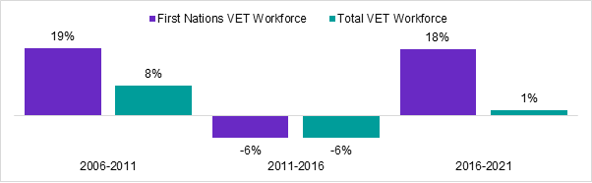
Source: Australian Bureau of Statistics (2006, 2011, 2016, 2021) Occupation (OCCP) and Industry of Employment (INDP) by Labour Force Status (LFSP) by Indigenous Status (INGP) [Census TableBuilder], accessed 15 July 2024

Geographic characteristics of the workforce
Like the First Nations workforce Australia wide, the First Nations VET workforce is concentrated in the Major Cities of Australia (Table 2.1). Only 8% of the First Nations VET workforce resides in Remote or Very Remote Australia, which is slightly lower than the First Nations workforce broader (10%).
Table 2.1. First Nations workforce and VET workforce by remoteness of usual residence
Remoteness of Usual Residence | Proportion of First Nations VET workforce | Proportion of First Nations workforce
Major Cities of Australia | 48% | 47%
Inner Regional Australia | 27% | 25%
Outer Regional Australia | 17% | 18%
Remote Australia | 5% | 4%
Very Remote Australia | 3% | 6%
Source: Australian Bureau of Statistics (2021) Occupation (OCCP) and Industry of Employment (INDP) by Labour Force Status (LFSP) by Remoteness Areas (National) (UR) and Indigenous Status (INGP) [Census TableBuilder], accessed 08 July 2024

There is substantial variation in how the First Nations VET workforce is distributed across states and territories, which also reflects a similar distribution of the general First Nations workforce. For example, while New South Wales and Victoria have a similar share of the national VET workforce (33% and 25% respectively), 41% of the First Nations VET workforce were in New South Wales and only 9% were in Victoria (Figure 2.6). However, this is consistent with their 36% and 9% shares of the First Nations workforce (ABS Census 2021).
Figure 2.6. First Nations VET workforce by state or territory
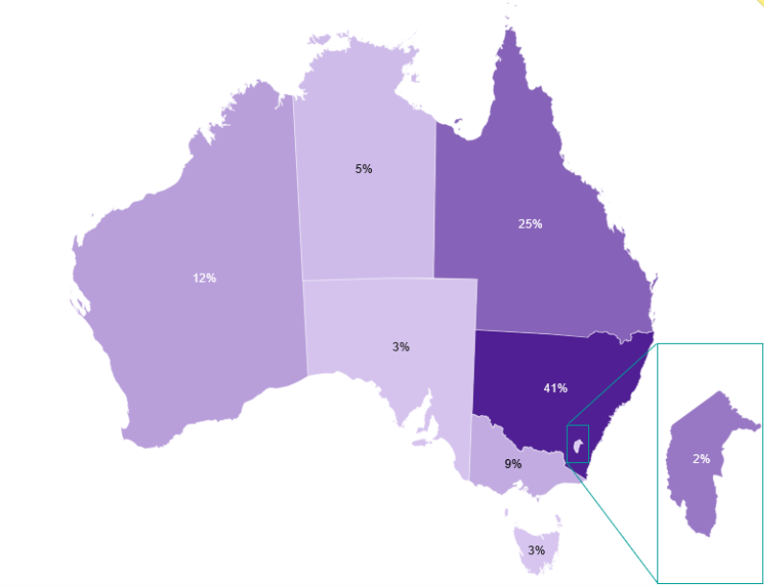
Source: Australian Bureau of Statistics (2021) Occupation (OCCP) and Industry of Employment (INDP) by Labour Force Status (LFSP) by Main Statistical Area Structure (Main ASGS) (UR) and Indigenous Status (INGP) [Census TableBuilder], accessed 08 July 2024

Figure 2.7 shows that most of the First Nations VET workforce (59%) travel a similar distance to work as the broader VET workforce (63%) and the broader First Nations workforce (57%). However, more of the First Nations VET workforce travel large distances (over 50km) to get to work than the broader VET workforce and the wider First Nations workforce (15%, compared with 9% and 12% respectively).
Fewer members (5%) of the First Nations VET workforce require no travel to get to work at all – i.e. they are working from home or living onsite – than is the case for the rest of the First Nations workforce (3%). Both figures are lower than the whole VET workforce, where 7% do not travel to work at all.
Figure 2.7. Distance travelled to work by First Nations VET workforce, compared to the VET workforce, the broader First Nations workforce and the Australian workforce
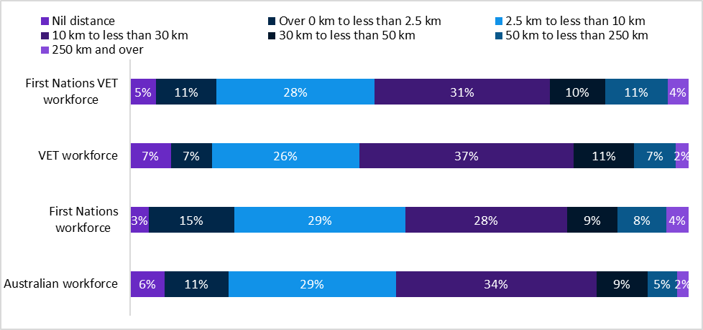
Source: Australian Bureau of Statistics (2021) Occupation (OCCP) and Industry of Employment (INDP) by Labour Force Status (LFSP) by Distance to Work (ranges) (DTWP) [Census TableBuilder], accessed 9 October 2024. Due to 'not applicable' responses, not all categories equal 100%. Note: This variable presents the distance in kilometres between a person's Place of usual residence and Place of work and is calculated from answers to other Census questions. Several regions across the country were in various stages of lockdown on Census Day in 2021, and the week preceding it, resulting in a greater number of people working from their homes. Respondents were instructed, 'If you are currently working from home due to COVID restrictions, but usually attend a workplace, please write the employer's usual workplace address.'

Figure 2.8 shows that the main transport to work for the First Nations VET workforce is a vehicle, which is much the same for the Australian workforce but lower than the overall First Nations workforce.
Figure 2.8. Mode of Transport to work for the First Nations VET Workforce compared to the VET Workforce, and the broader First Nations and Australian workforces.
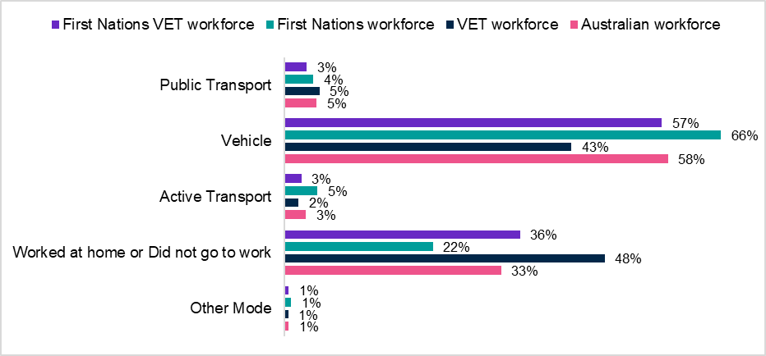
Source: Australian Bureau of Statistics (2021) Occupation (OCCP) and Industry of Employment (INDP) by Labour Force Status (LFSP) by Method of Travel to Work (MTWP) by Indigenous Status (INGP) [Census TableBuilder], accessed 08 July 2024. Note: Percentages don’t add to 100% because not stated and not applicable are excluded

Sex and age
The ABS 2021 Census shows that the First Nations VET workforce has more women than men (60% female). Figure 2.9 shows that 37% of this workforce is aged 50 years and over, compared with 22% of the wider First Nations workforce, and 45% of the general workforce.
Figure 2.9. Distribution of age for First Nations VET workforce, compared to the whole First Nations workforce and general workforce
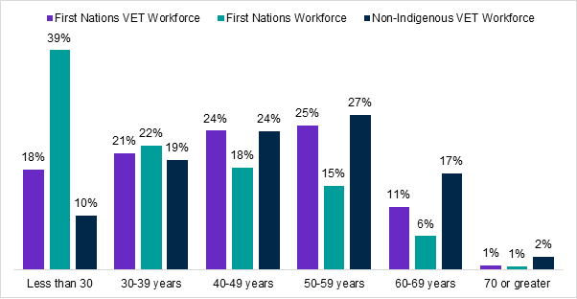
Source: Australian Bureau of Statistics (2021) Occupation (OCCP) and Industry of Employment (INDP) by Labour Force Status (LFSP)by Age in Ten Year Groups (AGE10P) by Indigenous Status (INGP) [Census TableBuilder], accessed 08 July 2024
Figure 2.10 shows that First Nations men working in the VET workforce are more likely to have a Certificate III or Certificate IV level qualification (37% compared to 29% of females). However, females are more likely to have a higher level of education, except at Graduate Diploma and Graduate Certificate Levels.
Figure 2.10. Qualifications by Sex for First Nations VET Workforce
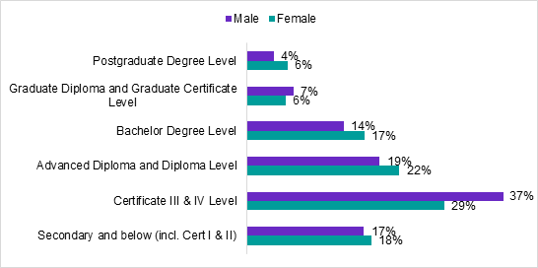
Source: Australian Bureau of Statistics (2021) Occupation (OCCP) and Industry of Employment (INDP) by Labour Force Status (LFSP) by Sex (SEXP) by Level of Highest Educational Attainment (HEAP) by Indigenous Status (INGP) [Census Tablebuilder], accessed 08 July 2024
Note: Percentages don’t add to 100% because supplementary codes, not stated and not applicable all excluded.
Females are more likely to work in Outer Regional, Remote or Very Remote areas where Males are more likely to work in Major Cities or Inner Regional areas (Figure 2.11).
Figure 2.11. Regional remote split by sex for First Nations VET Workforce
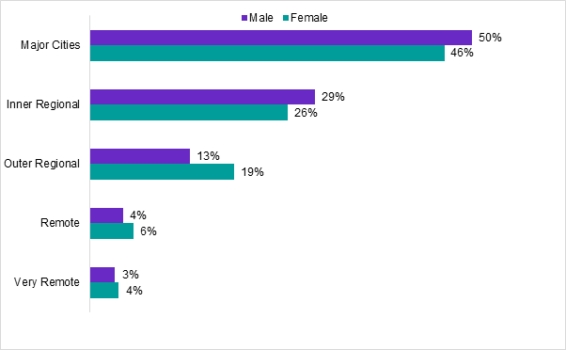
Source: Australian Bureau of Statistics (2021) Occupation (OCCP) and Industry of Employment (INDP) by Labour Force Status (LFSP) by Sex (SEXP) by Remoteness Areas (National) (UR) by Indigenous Status (INGP)
Note: Numbers may not add to 100% as Migratory and No usual address excluded

Health and caring
Being an older and more feminised workforce is correlated with other characteristics, including health conditions and unpaid work, which usually relates to caring for a relative. A substantial portion (42%) of the First Nations VET workforce has a long-term health condition (Figure 2.12), which is greater than the broader First Nations workforce (34%), the VET workforce (31%) and the Australian workforce (25%).
Figure 2.12. Proportion of each workforce that has one or more long-term health condition
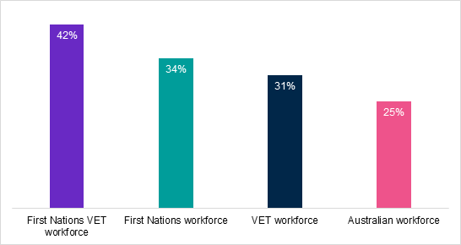
Source Australian Bureau of Statistics (2021) Occupation (OCCP) and Industry of Employment (INDP) by Labour Force Status (LFSP) by Count of Selected Long-term Health Conditions (CLTHP) by Indigenous Status (INGP) [Census TableBuilder], accessed 11 October 2024
Note: Long-term health conditions include arthritis, asthma, cancer (including remission), dementia (including Alzheimer’s), diabetes (excluding gestational diabetes), heart disease (including heart attack or angina), kidney disease, lung condition (including COPD or emphysema) mental health condition (including depression or anxiety) and stroke.

Unpaid work
The ABS Census asks questions about unpaid work, including unpaid assistance to a person with a disability, a health condition, or due to old age, caring for own and/or other child/children, and doing voluntary work for an organisation or group. Roughly one in five people in the First Nations VET workforce reported providing unpaid assistance to a person with a disability, a health condition, or due to old age (Figure 2.13). Likewise, almost two in five people in the First Nations VET workforce (38%) spent time caring for a child or children aged under 15 years. Again, this was greater than those in the First Nations workforce (36%), the broader VET workforce (35%) and the Australian workforce (33%).
Figure 2.13. Proportion of each workforce participating in unpaid work
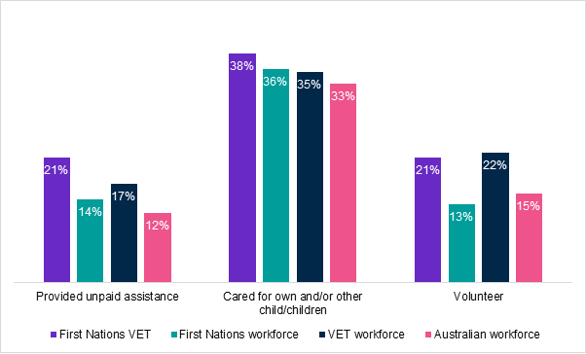
Source: Australian Bureau of Statistics (2021) Occupation (OCCP) and Industry of Employment (INDP) by Labour Force Status(LFSP) by Unpaid Assistance to a Person with a Disability, Health Condition, or due to Old Age (UNCAREP) by Unpaid Child Care (CHCAREP) by Voluntary Work for an Organisation or Group (VOLWP) by Indigenous status (INGP) [Census TableBuilder], accessed 11 October 2024
Note: Provided unpaid assistance' includes people who in the two weeks prior to Census Night spent time providing unpaid care, help or assistance to family members or others because of a disability, a long-term health condition, problems related to old age. 'Cared for own and/or other child/children' includes people who, in the two weeks prior to Census Night, spent time caring for a child or children aged under 15 years without pay. These two variables do not include people who provided care through a volunteer organisation. 'Volunteer' includes people who spent time doing unpaid voluntary work for an organisation or group in the twelve months prior to Census Night.

Educational attainment
More than one quarter (28%) of the First Nations VET workforce hold a Bachelor degree or higher as their highest level of educational attainment (Figure 2.14). The most common highest level of educational attainment for this workforce is a Certificate III or IV level qualification (at 32%). The prevalence of Certificate III or Certificate IV level qualification attainment may be driven by a wide coverage of the Certificate IV in TAE, which is the minimum training and assessment credential for VET teachers, trainers and assessors, and the main qualification held by most of the teaching workforce (Knight et al. 2020).
Figure 2.14. Highest qualification in the First Nations VET workforce across segments
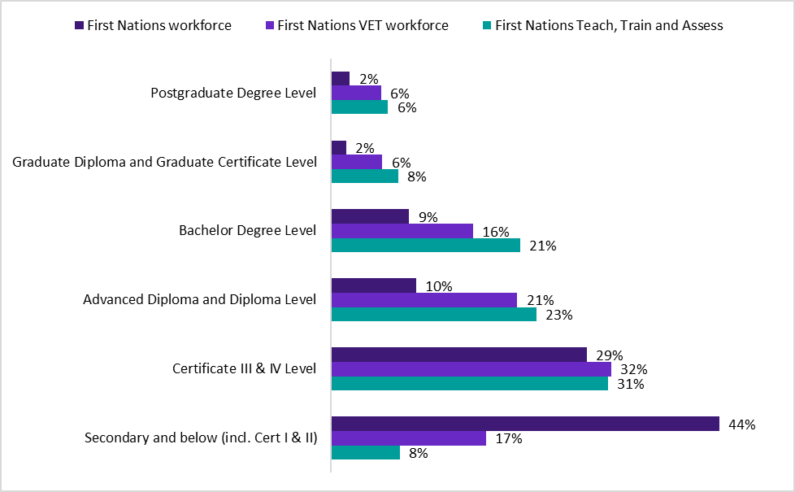
Source: Australian Bureau of Statistics (2021) Occupation (OCCP) and Industry of Employment (INDP) by Labour Force Status (LFSP) by Level of Highest Educational Attainment (HEAP) and Indigenous Status (INGP) [Census TableBuilder], accessed 23 July 2024. Due to non-stated responses, not all categories equal 100%.
Note: Teach, Train and Assess segment includes occupations which deliver vocational training and educational programs

For those in Teach, Train and Assess roles, 58% of First Nations VET workers hold a Diploma level qualification or above. These qualifications include both education and industry qualifications, which exposes a key limitation of ABS Census data when analysing the VET workforce. By asking about the ‘highest’ educational level achieved, the ABS Census does not capture the dual qualifications of many VET professionals. Yet 38% of the teaching, training and assessing segment of the First Nations VET workforce hold a qualification in education as their highest level of educational attainment (Figure 2.15). Outside of Education, the most common fields of education are Society and Culture (12%), Health (8%) and Management and Commerce (7%).
Figure 2.15. Field of study of qualification of highest level of educational attainment of Teach, Train and Assess segment of the First Nations VET workforce and VET workforce
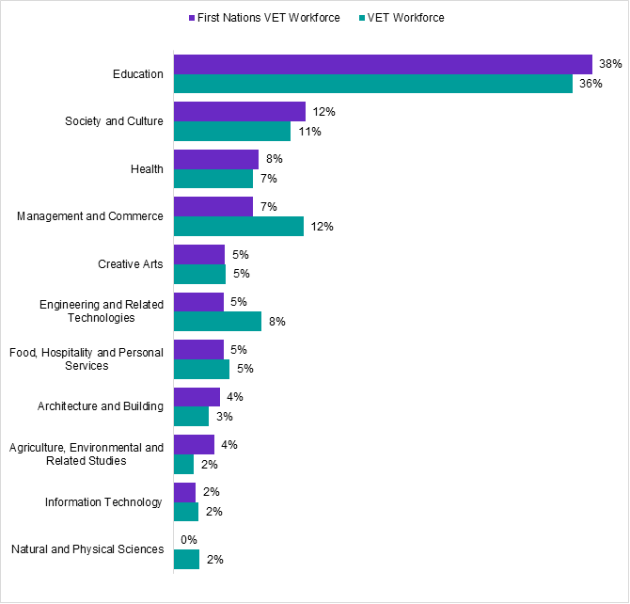
Source: Australian Bureau of Statistics (2021) Occupation (OCCP) and Industry of Employment (INDP) by Labour Force Status (LFSP) by Qualification of Highest level of Educational Attainment (QALFP) [Census TableBuilder], accessed 17 July 2024
Note: Teach, Train and Assess segment includes occupations which deliver vocational training and educational programs.

Employment characteristics
The ABS 2021 Census shows that more than two-thirds (67%) of people who were working in VET and stated they were First Nations, were employed in the public VET sector, and that 32% were employed in the private sector. The public sector primarily consists of TAFE Institutes, including dual-sector institutions, but may include other providers such as government schools and agricultural colleges.
The VET Workforce Study (JSA 2024a) used statistics from the ABS’s Employee Earnings and Hours survey to describe employment characteristics including employment type (e.g., casual vs ongoing) and method of pay setting. However, this work does not include a variable for First Nations status to allow us to report on these employment characteristics for the First Nations VET workforce, limiting our analysis to hours worked, sector of employment and reported income.
Table 2.2 shows that most of the First Nations VET workforce (68%) work full-time hours (over 35-hours per week across all jobs). First Nations VET teachers are more likely to work part-time hours than the broader First Nations VET workforce.
Table 2.2. Proportion of First Nations VET workforce, VET teachers and workforce working full- and part-time hours
 | First Nations VET workforce | First Nations VET teachers | First Nations workforce
Full-time | 68% | 62% | 56%
Part-time | 26% | 32% | 34%
Away from work | 6% | 5% | 11%
Source: Australian Bureau of Statistics (2021) Occupation (OCCP) and Industry of Employment (INDP) by Labour Force Status (LFSP) by Indigenous Status (INGP) [Census TableBuilder], accessed 19 July 2024
Note: 'Full-time' work means 35 hours or more per week in all jobs. 'Part-time' work means less than 35 hours per week in all jobs. Away from work means, for example, on leave from work

VET teacher, trainer and assessor pipeline

Qualifications
The qualification requirements for VET teachers, trainers and assessors are outlined in the Standards for RTOs, and as of 1st July 2025, a credential policy is in place. Under the Standards, RTOs are responsible for ensuring that their staff are appropriately qualified and current to perform their duties.

While the Certificate IV in TAE is the minimum and most commonly held credential for VET teachers, trainers and assessors, other qualifications exist as pathways into roles that can deliver training under supervision or that conduct assessment only (Knight et al. 2020). These include multiple skillsets and Diploma level qualifications and various higher education qualifications in the field of adult education. Some RTOs define these diploma level and above qualifications as pre-requisites for career progression for existing teachers, trainers, and assessors.
The year-to-year fluctuations in completions of key VET teaching, training and assessing qualifications is similar for First Nations and non-Indigenous students to 2019 when completions peaked for the Certificate IV in TAE (Figure 2.16). After that, completions dropped for both cohorts but then steadily increased for First Nations students. On average, roughly 370 First Nations students completed the Certificate IV in TAE each year between 2015 and 2024 (JSA analysis of NCVER Total VET students and courses).
Figure 2.16. Completions in key VET teaching qualifications, by years by Indigenous students and total completions, 2015-2024
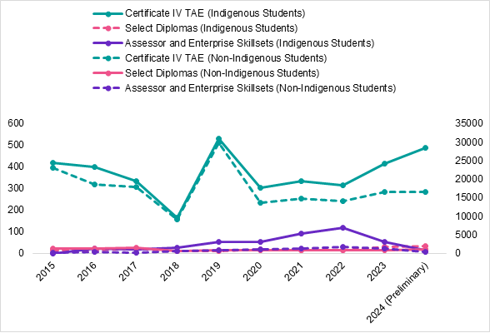
Source: NCVER VOCSTATS, Total VET students and courses program completions by First Nations status by Type of accreditation by Provider type 2015-2024, accessed 25th September 2025.
Note: 2024 data is preliminary data in NCVER VOCSTATS and may be revised in the future

Completions by non-Indigenous students remained relatively the same from 2020-2024. Notably, completions in Assessor and Enterprise Skillsets by Indigenous students declined significantly from 2022-2024. Research has found that, while skillsets can reduce the costs and other barriers for First Nations peoples to enter VET teaching, training and assessment roles, if they only complete a skill set, they may not progress to a full qualification, potentially limiting their ability to access higher salaries and reducing their confidence and flexibility in teaching (Smith and Tuck 2023).
The reasons behind the decline in Certificate IV in TAE completions for non-Indigenous students remain unclear. However, feedback from scholarship participants and stakeholders for this research paper suggests some dissatisfaction with the qualification, which is often viewed as an unnecessarily difficult barrier to entry and insufficiently advanced to effectively support VET teaching (Smith and Tuck 2023).
Importantly, research has also found that completions in the key VET qualifications do not necessarily reflect a pipeline to teaching, training or assessing in VET. In the NCVER Student Outcome Surveys, only a small proportion of graduates are using the Certificate IV in TAE to move into VET teaching, training and assessing roles, and, overall, almost 70% of graduates are doing the qualification for their existing job (JSA 2024a). Qualifications in adult education at Diploma level and above fulfil the requirement to teach VET, but in practice, are usually undertaken after the Certificate IV in TAE.

First Nations Trainer and Assessor Demonstration project
The First Nations Trainer and Assessor Demonstration project mentioned earlier was established to deliver culturally safe and accessible pathways for First Nations peoples to become qualified teachers, trainers and assessors and enhance the capacity and capability of ACCHOs. The project was delivered through NACCHO using culturally tailored training and support models to deliver the Certificate IV in TAE. At the end of 2025, there were 48 student commencements, 40 completions and an 83% completion rate for this qualification. This will help build capacity in the training and certification of new health practitioners and mentoring students on placement.

Earn While You Learn
Several TAFE institutes have been progressively introducing Earn While You Learn Programs (EWYLPs) to attract people into the VET workforce. Each EWYLP has similar components with additional extras particular to each TAFE institute to attract entrants who may be considering changing career paths.
Key components of EWYLPs include mentoring, supervision by experienced teachers, the provision of wraparound support services and institute funding to support completion of the Certificate IV in TAE, as well as wage while studying the program, and a pathway to employment as a teacher on successful completion within a set timeframe.
Several RTOs are conducting programs and pilots to enable First Nations individuals and cohorts to complete an EWYLP. This will expand Australia’s capacity to deliver First Nations healthcare, cultural courses and other VET subjects that are sometimes also targeted at First Nations students.

Delivery of VET teaching qualifications
An examination of completions by First Nations students shows that most program completions in the key VET teaching qualifications are from private/independent training providers (Figure 2.17). JSA analysis of NCVER data, shows that about 62% of Certificate IV in TAE completions were from these providers.
Figure 2.17. Total completions of VET teach, train and assess qualifications of Indigenous students by provider type 2020-2024
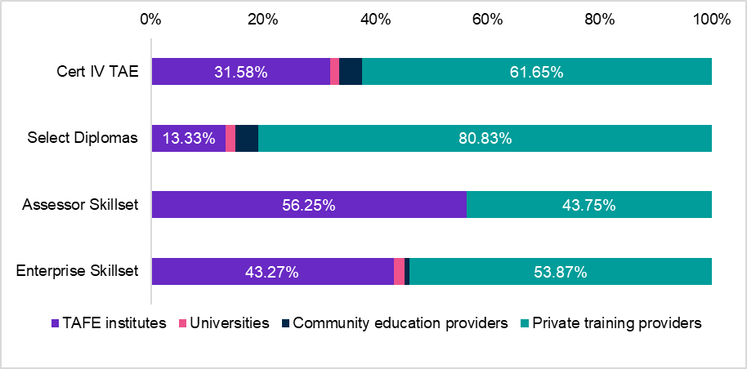
Source: NCVER VOCSTATS, Total VET students and courses, program completions by First Nations status by Type of accreditation by Provider type 2020-2024, accessed 25th September 2025. Aggregate of all years.

International Case Studies
VET organisations internationally also seek to empower and grow their First Nations VET workforce. In preparing this paper we investigated the following promising practices overseas.
Marae (Māori Community Hubs), Aotearoa New Zealand. The Manukau Institute of Technology has a Marae, which acts as a central hub for Māori community life within the VET institution. Built with traditional cultural facades, it includes classrooms, offices, kitchens, a dining area, social communal areas, areas for support provision, translation advice, Māori classes, events, workshops and lectures. The Marae also includes a meeting house where traditional ceremonial meetings take place.
The First Nations Technical Institute (FNTI), Canada. Canada has a large number of Indigenous owned and governed vocational education institutions and a number of institutions that address barriers to employment and retention for First Nations staff. For example, the First Nations Technical Institute (FNTI) incorporates Indigenous learning worldviews and values. The Institute promotes Indigenous learning methodologies and cultural practices in the classroom and Indigenous perspectives through cultural advisors, Indigenous professionals, alumni and community representatives.

Sami Regional Education Centre, Finland, Scandinavia. The Sami Regional Education Centre is a public institution with a majority Sami board. It is a vocational education institution that focuses on fostering First Nations teachers by enabling and encouraging Sami ways of teaching, in collaboration with Sami businesses and communities, in Sami language on relevant community courses – e.g. Reindeer herding, Sami handcraft, social services, tourism, media, and business. The centre’s priority is to integrate modern technology into traditional practices and lifestyle.
Coleg Cymraeg, Wales. Welsh institutions, policies and programs increasingly focus on the retention of Welsh speaking teachers in the vocational education sector through the creation and provision of resources, training and networking. This enables them to recognise and support qualifications in Welsh as well as English. Coleg Cymraeg is an institution established by the Welsh government in 2011 to work with post-secondary institutions to develop Welsh-medium courses. Coleg Cymraeg has a project targeting Welsh speaking VET teachers called the Gwreiddio Scheme which provides resources, training and networking opportunities.

Summary
This section of the paper outlined the structure of the VET sector for the First Nations workforce. It described the different types of RTOs and delivery settings such as Aboriginal Community Controlled RTOs, First Nations owned independent RTOs, TAFEs, community, private and independent RTOs, VET in secondary schools, and VET in prisons. The Aboriginal Community Controlled and Owned RTOs often provide specialised training services tailored to the needs of specific communities, particularly in healthcare and education, and in remote areas. This represents a critical area of VET for First Nations peoples in Australia, and more efforts need to be made to support this type of VET delivery.
Our analysis of First Nations employment in VET shows that a small but growing First Nations workforce has been established. This workforce is highly educated and is more likely than other First Nations peoples or VET workers to be employed full-time. However, a higher proportion of the First Nations VET workforce has ongoing health needs and caring responsibilities. This workforce is feminised and aging, where women make up 60% of First Nations VET workers.
We also explored the pipeline for First Nations peoples entering teaching, training, and assessing roles in VET, noting that this pipeline is growing slightly due to recent increases in completions of the Certificate IV in TAE. Some promising developments are emerging, such as Earn While You Learn Programs across various industries and NACCHO’s Aboriginal and Torres Strait Islander Trainer and Assessor Project which recognised the value of utilising First Nations expertise to deliver the Certificate IV in TAE and is significantly enhancing First Nations training in healthcare. Key findings and recommendations from this project's evaluation may inform an expansion in 2026.

Current Practice
The First Nations VET workforce is growing across Australia as a result of localised strategies, actions and programs. This is appropriate, as it avoids one-sized-fits-all approaches, which stakeholders have repeatedly told us will not be successful. However, the sector needs a more coherent, though also flexible, adaptive and place-based approach to growing, developing and nourishing our First Nations VET workforce.
This section of our paper examines some of the strategies that are currently being used to grow this workforce. We have segmented this section into two components:
- First, we focus on the First Nations sector, which includes Aboriginal Community Controlled and First Nations owned RTOs, First Nations curriculum development, and support for First Nations students in both public and private RTOs.
- Second, we examine the inclusion of First Nations peoples in 'mainstream' RTOs and course materials, such training packages that may not initially appear to be related to First Nations knowledge and traditions. We then explore the human resource policies and strategies employed to recruit and retain First Nations employees in TAFEs and settings other than Aboriginal Community Controlled RTOs.
The separation between the First Nations and mainstream sectors is not intended to suggest or enable a difference of First Nations content or peoples. Rather, it reflects an experienced distinction for First Nations peoples between activities run by and about First Nations peoples and those that are not. The aim is to provide an analysis of current approaches that can support RTOs, governments, and VET sector stakeholders to adapt approaches that will expand, support and enable First Nations peoples to be employed across the sector and pursue a successful career.

First Nations Sector

Innovation among Aboriginal Community Controlled RTOs and First Nations owned independent RTOs
First Nations communities across Australia have been remarkably innovative in building VET training that is entangled with other activities needed for community and local economies. Building on learning theories and knowledge traditions that First Nations peoples have used for millennia, First Nations groups have collaboratively developed bespoke strategies for developing and supporting a First Nations VET workforce that meets contemporary needs.
Many Aboriginal Community Controlled RTOs are also geared to meeting other community goals, including employment, cultural knowledge, local economic and service needs and non-work-related skills development, which compels us to look beyond mainstream RTOs. Not all enterprises that deliver VET are solely, or even primarily, VET organisations. Instead, some have integrated VET training with other activities in novel ways that also offer best practice models for future funding and development.
First Nations control and ownership of educational institutions is not only a pragmatic set of initiatives that enable training to be directed to community needs. In the context of colonial education traditions that have been complicit in suppressing First Nations languages, culture and sometimes in facilitating Stolen Generations, ownership and control also have a decolonising imperative.
Our analysis of the Aboriginal Community Controlled RTOs and First Nations owned RTOs in the previous section, showed that around half were First Nations specialists, catering for specific community needs and goals. The specialised teaching, training and assessment practices in these RTOs embodies a key purpose for growing the First Nations VET workforce. In a similar spirit, stakeholders informed us that industries and sectors are looking to boost the First Nations VET workforce in the training packages related to their area. This, they hope, will also help grow First Nations employment in industry, beyond VET.
Like everyone, First Nations peoples hold a wide variety of career objectives, which for some means that they look beyond community needs. Although many First Nations owned RTOs are focused on community goals, the First Nations sector also presents opportunities for First Nations individuals and groups to pursue the ambitions that best suit them.

Teaching First Nations students and First Nations content
In recent decades educational institutions, including across the VET sector, have sought to embed First Nations knowledge, perspectives and pedagogies into curricula and teaching practices. There are multiple reasons for this, including:
- Respecting and valuing First Nations knowledges by embedding First Nations perspectives and knowledge such as land management, environmental sciences, health, art, and construction, and First Nations practices in medicine, pedagogy and land supervising in VET subjects and courses. This also provides a rich, culturally diverse education for all students.
We can embed Aboriginal and Torres Strait Islander perspectives into the content of what we teach. Not every educator can do this but with cultural competency training and connections with local First Nations groups, we are confident we can get to the point where this is commonplace across our training packages that are services and arts focused.
Confidential Stakeholder contribution 2025
- Developing courses with First Nations experts by collaborating with First Nations Elders and knowledge holders to create culturally authentic content. Their insights help ensure the curriculum is accurate and aligned with community values and protocols.
- Local and community-centric approaches: First Nations communities have region-specific knowledge. Partnering with local First Nations community corporations and groups ensures that regional customs, language, and skills are embedded accurately and respectfully.

A significant portion of the First Nations VET workforce is likely employed to teach First Nations-focused content. Within all units listed as current on Training.gov.au, there are 68 units of competency, 20 qualifications and 7 skillsets which appear to contain First Nations, Aboriginal and/or Torres Strait Islander-specific content with ‘Aboriginal’ or ‘Indigenous’ included in the title. These make up 0.4%, 1.7% and 0.4% of all units of competencies, qualifications and skillsets respectively.

Connections between growing the First Nations VET workforce and students
A key argument for growing the First Nations VET workforce is to support the needs of First Nations students. Most of the students enrolled in qualifications with the word ‘Aboriginal’ in their title (henceforth First Nations focused qualifications) report they are Indigenous (and we note we use the term Indigenous here as that is what is used in the VET learner data collection AVETMISS). Indigenous students accounted for 86% of enrolments into qualifications that were First Nations focused across 2018-2023. However, these enrolments make up only 3% of all Indigenous student enrolments, which means that most Indigenous students were enrolled in mainstream units.
JSA identified a segment of RTOs in the RTO Typology (2024b) as ‘Indigenous Specialist’. More than 60% of enrolments in these Indigenous Specialist RTOs are Indigenous students and half of these enrolments are in the ABS Australian Standard Classification of Education (ASCED) in Architecture and Building, and Creative Arts (Table 3.1). This is greater than that across all RTOs where these fields make up only 8% and 2% of enrolments respectively.
Table 3.1 Share of enrolments of First Nations learners in top 5 Fields of Education in Indigenous Specialist RTOs compared to all RTOs
 | Indigenous Specialist RTOs^ | All RTOs
Architecture and Building | 30% | 8%
Creative Arts | 20% | 2%
Society and Culture | 16% | 19%
Management and Commerce | 9% | 22%
Health | 8% | 7%
Source: JSA analysis of NCVER 2020 Total VET Activity data using JSA typology
Note: ^ ‘Indigenous Specialist' is a partition/segment in the JSA RTO typology which includes those where >60% of enrolments (2018-2020) are First Nations students.
The top program enrolments for Indigenous students in 2023 were similar to the whole student cohort with almost half (44%) of Indigenous program enrolments in the five most popular training packages for all VET students—Community Services, Business Services, Construction, Plumbing & Services Integrated Framework, Tourism, Travel and Hospitality and Health.

Intellectual Property, Moral Rights and Restricted Content
Embedding First Nations education into VET with respect for intellectual property (IP) involves integrating First Nations cultural knowledge, skills, and practices while ensuring these contributions are protected, respected, and appropriately credited. This is a complex and important aspect of First Nations representation and participation in VET.

Principles of First Nations Intellectual Property
According to Janke (2005), the three acknowledged principles of First Nations intellectual property are:
1. Protecting Intellectual Property. This requires:
  - Consent and Protocols: obtaining informed consent from First Nations communities and following protocols for using traditional knowledge and cultural expressions. Many communities have specific guidelines for what can and cannot be shared publicly, and these guidelines need to be strictly followed.
  - Community Ownership and Rights: this involves establishing agreements to ensure that any First Nations intellectual property included in the curriculum remains owned by the community. This protects it from being misappropriated or commercialised without permission.
  - Indigenous Cultural and Intellectual Property (ICIP) Frameworks: implementing ICIP protocols and frameworks in VET to recognise collective rights over traditional knowledge and cultural expressions. This can include specific intellectual property clauses or guidelines in educational materials.
2. Recognising Indigenous Expertise and Authorship. This includes:
  - Crediting Indigenous Knowledge Holders: acknowledging the contributions of First Nations peoples and their communities in teaching materials, publications, and certifications. Recognising authorship and cultural contributions helps to honour First Nations expertise.
  - Promoting economic and Employment Opportunities: engaging First Nations educators, Elders, and community members as consultants, lecturers, or curriculum advisors, providing compensation and professional development opportunities. This promotes knowledge sharing while providing economic benefits to the community.
3. Protecting Sacred Knowledge and Restricted Cultural Content. This requires:
  - Controlled Sharing: some knowledge is restricted and only meant for certain members within First Nations communities. In VET settings, it is essential to work with communities to identify what knowledge can be shared and ensure restricted knowledge remains confidential.
  - Culturally Sensitive Learning Materials: adapting learning materials to be culturally appropriate, respectful, and sensitive. This can include using appropriate language, symbols, and references and avoiding materials that may be culturally offensive or intrusive.

Policies and Practices that Protect Intellectual Property
RTOs and other stakeholders in the VET sector can take steps to ensure that First Nations knowledges and traditions are respected, not appropriated. These steps include:
Student Awareness and Cultural Competence Training
- Training educators and students on First Nations cultural, history, intellectual property and cultural protocols through workshops or courses. This helps educators and students to understand the importance of respecting First Nations intellectual property.
- Encouraging Cultural Competence: encouraging all VET students to learn cultural competence, which includes an understanding of the significance of intellectual property to First Nations peoples and its implications in their future work fields.
Establishing Legal and Institutional Support
- Policies to Safeguard Intellectual Property: institutions can adopt policies that safeguard First Nations intellectual property within their curriculum, research, and teaching practices. Policies should reflect respect for First Nations intellectual property rights and have mechanisms for enforcement.
- Intellectual Property Laws and First Nations Intellectual Property Frameworks: advocating for the legal recognition of ICIP within intellectual property law to ensure that traditional knowledge and cultural expressions are protected as part of VET programs.
The benefits of embedding First Nations intellectual property in VET accrue to students, the community and the economy. This:
Promotes Knowledge and Cultural Pride: First Nations students see their heritage and contributions acknowledged, fostering pride and a sense of belonging.
Strengthens Cultural Preservation: Embedding First Nations intellectual property in VET helps preserve traditional knowledge and skills by passing them on to the next generation.
Creates Inclusive Learning Environments: Recognising First Nations intellectual property creates a more inclusive and respectful educational environment for students from diverse backgrounds.
Provides Unique Industry Skills: Incorporating traditional First Nations knowledge (e.g., in land management or health) gives all students valuable, unique skills relevant to their industries.
By embedding First Nations education into VET with strong intellectual property protections, VET institutions can help preserve and honour First Nations cultural heritage, support community autonomy over cultural knowledge, and enrich the educational experience for all students.

Promising Practice: Charles Darwin University Intellectual Property Policy
Charles Darwin University (CDU) is a dual sector provider with primary responsibility for TAFE delivery in the Northern Territory. Darwin has a much higher concentration of First Nations peoples than any other jurisdiction and CDU has implemented several promising practices in relation to First Nations recruitment, retention and community engagement. CDU’s Intellectual Property Policy is particularly useful and could be relatively easily adapted for other organisations (Charles Darwin University 2022, np). In addition to expressing respect and complying with Australian law, the Intellectual Property Policy specifies that:
The University does not assert ownership of IP relating to First Nations works by staff, students and visitors, being a copyright work created predominantly by people of Aboriginal or Torres Strait Islander descent.
The policy also specifies that a procedure must be undertaken in the case of commercialisation:
If First Nations Knowledge is to be used in any proposed commercialisation activities, the relevant administrative unit within the University must be consulted prior to the commencement of those activities to ensure appropriate recognition and protection are given to owners and their First Nations Knowledges.
CDU also extends its intellectual property to ethical research practice, protocols, rewards (including acknowledgement) and any future need to review the policy. The University will also ensure that:
- any academic activities that include First Nations Peoples and their Knowledges and IP are respectful to and underpinned by the core ethical values of integrity and acting in the right spirit, which are at the centre of the four principles of the AIATSIS research ethics framework,
- the protocols, processes and procedures involved in accessing First Nations Knowledges and IP are acknowledged and followed faithfully,
- any use of First Nations Knowledges and IP is agreed to by the person or people whose knowledge is being shared or used,
- the informed consent by the person or people whose Knowledge or IP is being shared or used has been freely given, is properly recorded and is renegotiated regularly and in a timely manner,
- there is equitable sharing of any benefits relating to the commercial use of First Nations Knowledge and IP on pre-agreed terms,
- the source(s) of the Traditional Knowledge from which IP is created is(are) appropriately acknowledged,
- the University responds promptly to representations by First Nations People regarding any need to review or revise this Policy in relation to First Nations Knowledges and IP (CDU, 2022, np).

Mainstream Organisations
While many members of the First Nations VET workforce are driven by opportunities within the First Nations sector, others pursue career paths that involve mainstream VET providers and courses. The term ‘mainstream’ is used here simply to reflect common terminology, not to further normalise Western education traditions. It is crucial that First Nations peoples have opportunities to participate in mainstream leadership, teaching, human resources, and all other areas of VET. These opportunities are as important as those within the First Nations sector for helping VET contribute to achieving the National Agreement on Closing the Gap targets.

Recruitment Strategies
Recruitment of First Nations peoples into teaching, training and assessing roles and other positions in VET has been a priority for institutions and a feature of many organisational Reconciliation Action Plans (RAPs). Larger employers such as TAFE NSW and Victorian TAFEs have established employment strategies that target growth in First Nations recruitment. These are linked to engagement with community, and systems of networking and support, which help to support attraction and retention.
Approaches to recruitment include setting recruitment targets, special measures, affirmative measures, establishing identified positions, and targeted recruitment, which are explained below. While the Human Rights Commission and Australian law consider such measures an approach to redressing systemic forms of inequality, and the International Labor Organisation sees it as way of ensuring equal access to employment, many First Nations peoples report mixed views because of misapprehensions in the community about receiving special treatment.
Although these recruitment strategies are discussed in the context of mainstream VET organisations, they are equally applicable to Aboriginal Community Controlled and First Nations owned RTOs.

Special Measures
Special Measures is a clause in the Commonwealth Racial Discrimination Act (1975). The Act is intended to eliminate racial discrimination in recruitment to the Australian workforce. To achieve this goal, the Act acknowledges that special measures may be needed to ensure that members of certain racial or ethnic groups have the same opportunity as others, which includes First Nations peoples. The Human Rights Commission has a set of guidelines for the application of special measures to address existing inequalities. JSA research suggests that this term is very rarely used in advertising for First Nations recruitment to VET positions.

Affirmative Measures
Affirmative Measures is a term often used interchangeably with Special Measures and can be treated the same way in the law. Affirmative measures could have the same heft as special measures but are frequently ‘weaker’ in that they use methods that will support First Nations ideas and peoples, and more passively seek parity with the population. JSA research suggests that this term is sometimes used in advertising for First Nations recruitment to VET positions.

Identified Positions
Unlike Special or Affirmative Measures, the term ‘Identified Positions’ refers to a job role that requires First Nations expertise. This expertise is most frequently obtained through firsthand experience and therefore privileges First Nations applicants. This is the most common way of specifying recruitment in advertising for VET roles, especially for roles that provide learning support for First Nations students.

Targeted Recruitment
Targeted Recruitment is another word for Special Measures. Targeted recruitment actively seeks to fulfil the recruitment targets articulated in a RAP and is usually aimed at achieving population parity in the VET workforce. The Human Rights Commission provides a set of guidelines on targeted recruitment. Targeted positions seek to enable equal opportunity for First Nations applicants to mainstream roles that do not require any specific First Nations expertise.

Promising Practice: Purposeful Boosting
The TAFE NSW Managing Recruitment for Aboriginal/Identified Positions Guide provides guidelines and strategies for the recruitment of targeted/ identified positions, that cover Aboriginality, the promotion of jobs, and engagement with community. It provides clear directions on engagement with First Nations organisations and RTOs and is intended to be a complementary document to the TAFE NSW Aboriginal Employment Strategy 2023-2027.

Workforce strategies and Reconciliation Action Plans
Reconciliation Action Plans and First Nations employment strategies provide a framework for organisations to develop and implement specific, targeted, and quantifiable commitments towards reconciliation and are intended to facilitate a level of accountability for organisations toward achieving their aims. RAPs and workforce strategies are related in that either document may commit to the development of the other. Often these documents commit towards increased First Nations representation and retention in the workforce.
Most TAFEs and dual sector providers have some form of publicly available First Nations employment strategies or RAP, which includes the development of an employment strategy. These strategies vary in their scope and detail, but typically contain a suite of actions and commitments, including employment targets. For example, the TAFE NSW Aboriginal Employment Strategy 2023-2027 indicates a commitment to strengthening and supporting the First Nations VET workforce with a range of initiatives, including a dedicated Aboriginal Employment team, the introduction of yarning circles, cultural mentoring and a re-established Aboriginal Staff Network.
Initiatives in Western Australia's South Metropolitan TAFE’s Aboriginal Employment Strategy (2022) incorporate building cultural capability of all staff, increasing Aboriginal staff, quarantining positions for First Nations candidates, establishing an Aboriginal Employee Networking Group, encouraging and supporting First Nations employees to apply for positions, ensuring managers of First Nations employees participate in an Aboriginal Leadership employer program and growing First Nations employment.
RAPs and workforce strategies are common in large institutions across many industries. Eva et al. (2024) surveyed non-First Nations businesses to understand the uptake and impact of these and other policies on First Nations employment. They found that RAPs and workforce strategies alone, allowing for other policies and for general business characteristics like size and location, were not significantly associated with growth in First Nations employment.
There is scepticism surrounding RAPs and other practices, given their potential to be used as marketing instruments rather than genuine commitments. However, the Gari Yala Report (Jumbunna 2020) surmised that the implementation of RAPs within workplaces in Australia is related to positive workplace experiences for First Nations employees, but only where First Nations employees see authentic commitments to actions beyond words.
For example, in interviews undertaken by Eva et al. (2024), First Nations employees viewed RAPs, cultural competency training, and First Nations employment targets negatively when seen as ‘tick the box’ exercises, or where businesses didn’t truly recognise the value or purpose of these exercises. Actionable items in such a strategy must be allocated to an appropriate organisational position or team to ensure responsibility for the carriage of these initiatives (AEU submission to this research paper).

Employment targets
Employment targets are a common method for encouraging the employment of First Nations workers and are commonly included in First Nations employment strategies. From JSA analysis, some TAFE and dual sector universities have reported employment targets publicly, shown here in Table 3.2.
Table 3.2. TAFE and Dual-Sector University First Nations Employment Targets and Deadlines
Provider | Target | Deadline
TAFE NSW | 3.5% | 2027
North Metropolitan TAFE | 3.7% | Dec 2023
Central Queensland University | 3% | 2025
Federation University | 3% | 2025
Swinburne University of Technology | 2% | 2023
Source:
TAFE NSW (2023) Innovate Reconciliation Action 2023-2025, TAFE NSW.  North Metropolitan TAFE (2021) Reconciliation Action Plan September 2021 – December 2023, North Metropolitan TAFE.  Central Queensland University (CQUni) (2022) Innovate Reconciliation Action Plan Annual Report 2023, CQUni. | Federation University (2022) Aboriginal and Torres Strait Islander Peoples Workforce Strategy 2022-2025, Federation University.  Swinburne University of Technology (2020) Elevate Reconciliation Action Plan 2020 – 2023, Swinburne University of Technology.

Distinct population differences in First Nations communities as well as demographics throughout Australia mean that employment targets may not reflect the diversity of the local working population or student body. As an example, 3.4% of Canberra Institute of Technology's workforce are First Nations peoples (CIT 2023), higher than the 2% of both the national and Australian Capital Territory workforces.
A criticism of employment targets is that progress towards overall First Nations employment can overshadow representation in management and executive positions (Eva et al 2024; Minderoo Foundation 2022). Some institutions therefore have disaggregated targets. For example, Federation University commits to establishing a 3% employment target for First Nations staff, with specific targets for both the higher education and TAFE sectors (Federation University 2022). Additionally, Federation University’s strategy noted an aspiration to recruit at least one First Nations person to a senior executive role, or equivalent.

Governance, leadership, management and regulatory compliance
Governance is a critical part of self-determination and, as JSA’s analysis of publicly available information shows, there is First Nations leadership on the Board/Councils of 9 TAFEs and dual sector universities (Table 3.3). There is also First Nations representation at executive level in 1 TAFE institute.
Table 3.3 First Nations identified engagement in TAFE and Dual Sector Providers
Form of engagement | No. of TAFEs and Dual Sectors
Identified First Nations Senior Executive | 1^
Board / Council members Identified as First Nations peoples | 9
Source: JSA analysis of public information on TAFE Boards/Councils as of 1 Aug 2024. Members of Boards/Councils and Executive members are only noted when published text identifies the member as First Nations peoples.
Note: Several dual sector TAFE Boards were not public and there were some dual sector higher education executive level Identified First Nations staff who may have remit over TAFE, but that was not clear from public sources
Note: ^ This does not include First Nations representation at Batchelor Institute of Indigenous Tertiary Education.

First Nations Governance and Leadership
Research in educational leadership has shown that it is not adequate to simply include a First Nations representative at leadership levels. Drawing on First Nations-led research on leadership in higher education, it is noted that in some situations:
Indigenous people were to fill a gap within universities merely by being present, embodying cultural difference without significant change to the status quo (Bunda et al.:941–942).
It is also important to move beyond ‘token’ representation where a single voice can easily be drowned out. Rather, it is increasingly acknowledged that organisations need to work towards positioning First Nations knowledge, perspectives and leadership at the core of all aspects of tertiary education. Training and professional development in compliance with complex regulatory requirements will help First Nations leaders and managers to develop the skills and capacities needed to succeed in these roles and meet the Standards for RTOs.
Publications that emerged from Marramarra Murru, the First Nations Economic Development Symposium held at the Australian National University (ANU) in 2022, made the case that it was time to pivot away from longstanding welfarist approaches to First Nations economic opportunity and instead make spaces for First Nations leadership at the centre of economic development (Barnett 2023).
Ensuring First Nations peoples have the opportunity to pursue positions of leadership, including on boards and in management, is a key pathway towards this goal. In this context, it is important that strategies seeking growth in First Nations employment include but are not confined to roles at lower levels of an organisation’s hierarchy. Instead, First Nations representation in governance and leadership should be a key priority – as indeed it is, in many mainstream organisations – for several reasons.
Aboriginal leaders bring unique cultural perspectives that significantly influence the culture and priorities of workplaces. This leadership emphasises collaborative decision-making, cultural safety, and community-driven approaches, such as the use of yarning circles to facilitate open, respectful dialogue.
This method fosters inclusive discussions where all voices are valued equally, promoting shared understanding and trust. However, the mainstream hierarchical structures of many organisations can present challenges, as these culturally grounded practices differ from conventional decision-making models.
While this approach isn’t yet fully understood, there is growing recognition of its value, with leadership beginning to embrace these ways of working as part of their commitment to reconciliation and meaningful engagement with Aboriginal communities.
Confidential stakeholder contribution 2025
There are multiple benefits of First Nations representation in governance and leadership, including:
- First Nations-Centred Leadership Builds Resilience
We heard from stakeholders that First Nations values and perspectives can build resilience into educational organisations. Further we also heard that organisations that feature First Nations voices make fewer mistakes in supporting First Nations staff and students.
- First Nations Management Promotes Cultural Safety
The cultural safety of First Nations employees is strongly influenced by their manager’s cultural knowledge, particularly when navigating complex and personal matters (Minderoo Foundation 2022). Managers serve as key decision-makers in granting leave, addressing complaints, and fostering a culturally safe workplace. First Nations managers play a crucial role in recruiting and retaining First Nations staff. Additionally, businesses led by First Nations managers are more likely to implement practices that honour and celebrate First Nations cultures and histories, even beyond employment-focused initiatives.

For instance, 73% of businesses with First Nations managers conduct Acknowledgment of Country at significant events, compared to just 46% of businesses without First Nations leadership (Eva et al. 2024). One stakeholder noted that First Nations leadership enabled:
- Local knowledge and understanding
- Flexibility around scheduling of training
- Empathy and understanding
- Understanding and acceptance of challenges and cultural obligations.

Other HR Policies
Growth of the First Nations VET workforce depends on retention as well as recruitment. Kemmis et al. (2006) found that a key barrier to First Nations peoples staying in VET was the experience of not being recognised, understood or respected, particularly regarding cultural responsibilities. Some VET providers have sought to accommodate the needs of the First Nations VET workforce with targeted HR policies, including leave provisions, to accommodate cultural responsibilities.
Enshrining these policies in enterprise agreements reduces the stigma that First Nations workers can face when asking for cultural leave or leave for Sorry Business, which is subject to individual managers’ level of cultural understanding and sensitivity (Minderoo Foundation 2022). Including clauses that recognise First Nations cultural knowledge and respect community responsibility signal to an organisation the value that First Nations staff bring (AEU submission to this Research Paper). However, enterprise bargaining provisions should be developed and led by First Nations staff (AEU 2023).
Indigenous staff report that there are many opportunities to be involved in decision-making about Indigenous education, but not necessarily about Indigenous employment or employment conditions. Indigenous staff report that their employment conditions have a positive impact on the provision of VET, especially in relation to Indigenous people and communities, but concerns about employment, especially job security, reduce morale and commitment (Kemmis et al. 2006:9).
The Fair Work Ombudsman encourages (but does not mandate) the inclusion of cultural leave and/or Sorry Business provisions in enterprise agreements (Fair Work Ombudsman n.d.). While most TAFE and dual sector institutions have specific leave provisions for First Nations employees in their enterprise agreements, they are generally not cumulative year to year nor available to casual staff.
Leave provisions for specific First Nations purposes varies in each enterprise agreement but in general, cultural leave is usable for preparation or attendance at National Aboriginal and Islanders Day Observance Committee (NAIDOC) Week functions, initiations, birthing and naming ceremonies, funerals, smoking or cleansing ceremonies, some First Nations meetings and community cultural events, ceremonies and obligations. These provisions vary in length, with most institutions providing a mixture of paid and unpaid leave (see Figure 3.1).

Figure 3.1. Cultural Leave allowance for First Nations employees in TAFE and Dual-Sector Universities
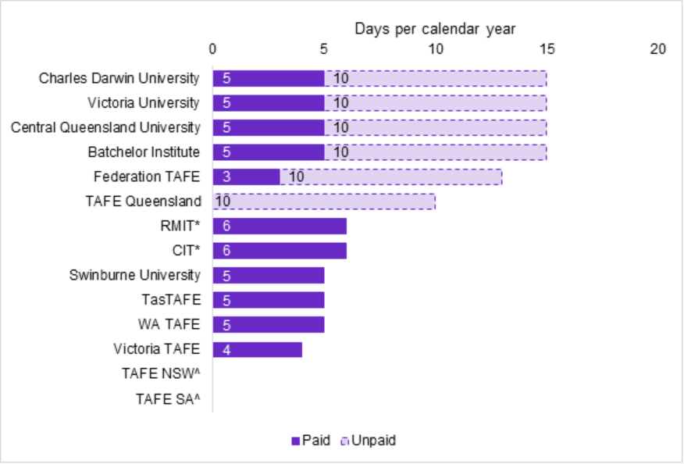
Source: JSA analysis of institutional Enterprise Bargaining Agreements via Fair Work Commission website
Note: *RMIT states unpaid leave is negotiable, CIT is ten days over two-years with a day a year for NAIDOC week.
^No specific First Nations cultural leave was identified in TAFE NSW and TAFE SA but may be captured under cultural provision for all staff.
Some enterprise agreements contain additional flexibility (e.g. RMIT states that additional leave may be approved in agreement with the university) and in some agreements, leave is partitioned or allocated to particular leave types (e.g. Victoria TAFE provides one day of paid leave for NAIDOC week activities and events, as well as up to three days for ceremonial leave). Also included at some institutions is leave for employees to attend meetings convened under the then Aboriginal Affairs Planning Authority Act (1972) or to contest an election for employees elected to an Aboriginal and Torres Strait Islander Council.
Central Queensland University recognises cultural duties as a part of a First Nations employee’s workload. In addition, First Nations employees who are required to perform work outside of working hours are compensated through overtime or Time Off in Lieu (TOIL).

3.2.4.1 Other HR policy provisions
Some institutions, including Charles Darwin University, Batchelor Institute of Indigenous Tertiary Education and Canberra Institute of Technology, provide funding for staff who are required to use a language other than English in their teaching capacity, including First Nations languages. The allowance varies from $1,200 to $3,300 per annum depending on proficiency and teaching requirements.

3.2.4.2 Room to grow
One policy that is often omitted from TAFE and dual sector enterprise agreements, but was discussed in the stakeholder roundtables, are provisions for unrecognised workload often referred to as ‘cultural load.’ This refers to the additional responsibilities First Nations peoples have in the workplace. In a survey of First Nations workers conducted in 2023 by the Australian Education Union (AEU), 44% of respondents felt responsible for First Nations issues in their workplace, which is higher than the Gari Yala cohort of 39% feeling a high cultural load (AEU 2023).
Stakeholders told us that these additional responsibilities are important and should be represented with provisions in enterprise agreements as paid workload. The AEU (2023) wrote regarding the additional duties:
Where an Aboriginal or Torres Strait Islander employee agrees to undertake work that requires a cultural responsibility their work and/or duties will be adjusted to consider the work and/or duties associated with that cultural responsibility in context of their other duties, and/or paid an allowance/special payment at the daily rate of a casual teaching rate to recognise that responsibility.

Enablers and Barriers
It is important to understand the enablers and barriers to growth in the First Nations VET workforce. Building on the 2006 study by Kemmis and colleagues which revealed a number of barriers for this workforce, further research completed by TAFE Directors Australia (TDA), and for this report, has captured several common enablers and barriers.
Key barriers include challenging elements of the Certificate IV in TAE, uncompetitive employment conditions, and structural racism. Key enablers, which have been building across the sector, include growing commitment to community engagement and to sustained relationships with local First Nations peoples and elders, and improving opportunities for First Nations peoples to work with First Nations students in a well-supported way. Aboriginal Community Controlled and First Nations owned RTOs continue to demonstrate these enablers, despite the challenges of thin markets and organisational capability.

Entry qualifications, volatile income and uncompetitive salaries
Stakeholders report that entry level qualifications continue to be a barrier to initial employment for First Nations peoples in the VET sector. Qualifications relating to First Nations languages, social affinity, knowledge of community and culture are rarely valued by RTOs as relevant in recruitment processes. A small but growing number of exceptions are emerging where First Nations experience is explicitly valued to balance the need for formal qualification requirements as more culturally sensitive and inclusive recruitment practices are sought.
Still today, local skills, knowledge and community connection of First Nations peoples are not always adequately recognised as enhancements to the sector, and more needs to be done. The requirement for potential First Nations teachers, trainers and assessors to complete a formal qualification to teach in the VET sector is a source of frustration for them and the RTOs who would like to employ them.

Such barriers are greater in remote areas where a shortage of First Nations trainers is one of the most pressing challenges for VET provision. RTOs reported that they wanted to recruit First Nations trainers but that there were too many hurdles (Griffin and Andrahannadi 2023:40):
So ideally it would be to have First Nations trainers. Every job I've done in Broome, I always aspire to train someone, an Aboriginal person to take my place because I always work in Aboriginal community organisations or areas. But why? Why would they go through getting all those qualifications? Because they're in such demand as leaders and role models, so there's other avenues that can be taken where you will get higher wages and be able to do the task without having to go through all of those skills and jump those hurdles. (RTO, WA)
Members of the VET workforce employed by public institutions generally earn more than those working for private RTOs. This also applies to the First Nations VET workforce. People working in public institutions, including TAFE and dual-sector employees, tend to be employed under union bargained enterprise agreements, where pay is set higher than award rates (JSA 2024a). Numerous resources note the importance of First Nations teachers, trainers and assessors in providing culturally appropriate and quality education for First Nations students. While visibility of their diverse responsibilities is growing (Peacock & Prehn 2021, AITSL 2021), little is known of the day-to-day economic sustainability of First Nations education professionals. However, as one stakeholder reported:
The biggest challenge we have as educators in a large bureaucracy is around having enough students for our programs to be financially viable. Our funding model is such that unless students pass, we … are not paid in full. This puts enormous pressure on our educators as they are always needing to justify their position. This is slowly changing but still a challenge and under values the work we do with our First Nations students.
Confidential Stakeholder Contribution 2025
JSA is currently undertaking an exploratory analysis of income volatility in the VET workforce that utilises Single Touch Payroll (STP) data reported by employers to the Australian Taxation Office (ATO). The analysis of linked administrative data allows us to determine the number of jobs a particular employee holds, which of these is their highest earning job, and to track their income from one pay period to the next. In this way, we can compare income volatility for different employee cohorts.
The data for 2022-23 indicates that First Nations teachers face greater income volatility in their highest earning job compared to their non-First Nations colleagues in all education sectors. The only exception is in universities, where First Nations lecturers and tutors experienced the same level of income volatility as their non-First Nations counterparts (see Table 3.4).

Table 3.4. Income volatility of education professionals in their highest earning job, by First Nations and non-First Nations employees, 2022-23
Occupation | Median volatility  (% of time) | Median weekly income  ($) | Average  total  income  ($) | Number  of jobs
Early Childhood  (Pre-primary School) Teachers – Other Peoples | 8.0 | 1,246.92 | 52,634.19 | 23,045
Early Childhood  (Pre-primary School) Teachers – First Nations People | 10.0 | 1,089.90 | 47,077.87 | 467
Primary School Teachers – Other Peoples | 6.0 | 1,948.93 | 87,141.64 | 19,406
Primary School Teachers – First Nations People | 8.0 | 1,769.50 | 78,989.00 | 125
Secondary School Teachers – Other Peoples | 4.0 | 1,877.44 | 79,026.31 | 157,669
Secondary School Teachers – First Nations People | 5.0 | 1,839.81 | 79,061.90 | 2,146
University Lecturers  and Tutors – Other Peoples | 6.0 | 1,886.85 | 80,696.90 | 62,564
University Lecturers  and Tutors – First Nations People | 6.0 | 1,905.23 | 82,708.24 | 738
Vocational Education Teachers / Polytechnic Teacher – Other Peoples | 8.0 | 1,573.77 | 62,669.43 | 22,183
Vocational Education Teachers / Polytechnic Teacher – First Nations People | 10.0 | 1,561.16 | 61,895.76 | 520
Source: Australian Bureau of Statistics Person Level Integrated Data Asset (PLIDA) 2024: Single Touch Payroll (STP) (1 July 2021–30 June 2023). ATO Income Tax Return (ITR) Context, (Financial Year 2022–23). Census 2021 and Combined Demographic Table 2021. Total number of employees rounded to the nearest 100.
Note: Employees in this data are unique individuals, and no employees are counted in more than one occupation. STP data is current in PLIDA up to August 2025 and includes, amongst other things, salary and wage income paid by employers to employees.
The median income volatility experienced by First Nations VET teachers in 2022-23 was 10%, compared to 8% for their non-First Nations colleagues. The only other educational occupation analysed for this table with an income volatility this high was the First Nations Early Childhood Teacher cohort.

Securing the financial sustainability of the First Nations VET workforce is a prerequisite to growing this workforce and achieving the National Agreement on Closing the Gap targets. Unpredictable income over the course of the year is likely to contribute to issues with retention in the sector. Across all occupations nationwide, JSA has found that employees in jobs who experience less income volatility, on average, earn a higher annual income and remained in that job for longer.
Low incomes also pose a challenge for attraction and retention. Stakeholders have reported that some teachers, trainers and assessors may have lower incomes than their industry peers in industries such as trades and engineering, or higher incomes compared to industries such as hairdressing or care-based industries (DEWR 2024b).
The taxation data analysed by JSA reveals that the median weekly income and average total income for First Nations teachers in their highest earning job was lower compared to their non-First Nations colleagues in VET. This trend also occurred in the early childhood, primary and secondary education sectors but was not the case in universities where First Nations Tutors and Lecturers were paid more at that time (see Table 3.4). Possible causes for lower incomes for First Nations VET teachers could be associated with differences in their form of employment for teachers, trainers and assessors and the types of roles they are employed in, as discussed in the next section.

Employment type, access to professional development and career progression
Stakeholders echoed Kemmis and colleagues (2006) concerns relating to significant barriers to professional development and consequent career progression for the VET workforce. First Nations peoples working in VET reported difficulties in gaining access to professional and career development programs, particularly part-time or contract staff. Considering the rate of health conditions and care responsibilities held by the First Nations VET workforce, these structural barriers will be hard to dismantle without significant attention.
Other barriers reported to JSA have included a lack of support and commitment from management in RTOs to support performance development, including insufficient and unstable funding, an organisation’s poor record in training, and issues relating to a sense of belonging, confidence and motivation for First Nations VET workers. Unstable funding provides a lack of permanency and concerns about employment conditions, especially job security, reduced morale and commitment to the sector, which in turn leads to poor retention (Kemmis et al. 2006).
VET Workforce Blueprint consultations also raised issues related to the employment status of the VET workforce, finding that only 56% of VET teachers are permanent employees, compared to 70% of the Australian workforce (DEWR 2024b). Most TAFE employees are now employed in permanent or ongoing roles (62% - 85%), except for TAFE NSW where almost half of employees were casual at the time of data collection (JSA 2024a).
The ABS Employee Earnings and Hours survey data can be used to analyse employment types and arrangements; however, it does not include a variable for First Nations status and does not provide a sufficiently large sample to be able to provide insights for a small workforce. This limits our ability to report on the specific employment characteristics of the First Nations VET workforce.

Fluctuating or volatile income is an important element of insecure work (Select Committee on Job Security, Parliament of Australia, 2022). The Fair Work Commission’s discussion paper, Job Security 2023 (2023:23), argues that ‘job security is a multi-faceted concept with no single definition’. The Commission suggested some commonly understood indicators of insecure work, which include: Low, unpredictable or irregular income; Irregular, fragmented and/or unpredictable hours; Limited access or lack of access to paid leave, redundancy and other entitlements; Poor and/or limited security of tenure; Uncertainty around hours or duration of employment; Social and/or physical isolation; and Low worker control.
Higher median income volatility for a cohort (e.g. 10% for First Nations VET teachers in 2022-23 in Table 3.4) could indicate a higher prevalence of insecure forms of employment, but as noted above, it is only one measure of insecure work. In August 2024, only 15.0% of permanent employees in Australia reported that their income varied from one pay period to the next compared to 51.2% of casual employees. It should be noted that casual employment is the preferred type of employment for some employees, particularly those looking for greater flexibility who are studying or have caring responsibilities, for example.
While JSA’s income volatility methodology can provide indications of working arrangements associated with insecure work, it cannot be used to quantify rates of casual employment or fixed-term contract employment. These forms of employment tend to be more insecure as they provide no guarantee of ongoing employment, and cannot be uniquely characterised by patterns of income and/or hours alone. For example, ABS data suggest around a third of casual employees in Australia have regular working arrangements in their main job.
JSA is currently undertaking further research on casual employment and other insecure forms of work within the VET workforce that will utilise STP data to analyse patterns of income across multiple job holdings. This will assist in addressing current data limitations associated with identifying those working as VET teachers, trainers and assessors working in VET as a secondary job and include investigations by employees’ First Nations status.

Compliance mindset can act as a barrier to job satisfaction and retention
Stakeholders reported that compliance requirements have intensified and that training for VET teachers, trainers and assessors is now focused on compliance with training package requirements. The resulting ‘compliance mindset’ reduces the ability of First Nations staff to bring First Nations understandings into their work in VET. This makes recruitment to identified roles more difficult and reduces job satisfaction. For example,
I quite often struggled to balance and maintain my cultural identity against the requirements of the TAFE curriculum…. As Quality and Compliance tightened…the aspects that I really enjoyed … disappeared. The way that curriculum needed to be written and delivered stripped the ability to show any cultural identity.
Confidential Stakeholder contribution 2025
Stakeholders suggested that this barrier could be reduced by enabling RTOs to adjust curriculum requirements to local circumstances and allowing teachers more flexibility and autonomy.

Cultural responsibility is a reason to join and stay in VET
In the wider VET workforce, expecting to enjoy teaching or seeking to give back to the industry and society are the most widely held motivations for becoming a VET teacher (Smith et al. 2023). In his doctoral thesis titled, ‘Learning from the lived experiences of Indigenous teachers who have remained in the profession', Ren Perkins, a Quandamooka education researcher, describes how responsibility to community is an overarching motivation to join the teaching profession in the school sector (Perkins 2024:143):
But one of the main reasons I wanted to become a teacher was basically because I wanted to teach. I wanted to give back to community. And I think […], that you would find that's a common answer for a lot of us. We have that drive to give back to community. That's an important drive. I always wanted to empower people, the way I was empowered. Because I recognise that it's not easy for everybody.
In VET, this motivation may take the form of seeking to assist First Nations students to navigate the VET system; as well as supporting First Nations VET students to increase representation in specific fields (TDA n.d.).
As a VET teacher, being a role model and sharing positive experiences with First Nations students is a motivation to both join and stay in the teaching profession (Perkins 2024). Senior Lecturer Dr Tracy Woodroffe, who is a Warumungu Luritja woman, described the personal satisfaction she received from sharing positive experiences of education with First Nations students (2016:121):
For many Indigenous people education has meant adversity however, my own experience has been different. I have experienced success in education. I know that I am a good teacher. I know the thrill that I get from teaching students. I want to share this knowledge and understanding with other people. I want more Indigenous people to know that education is something to thrive in and to love. It is important and it improves lives. The recognition of Indigenous knowledge and then the shared understandings around education is a way forward.

Lack of understanding and respect of cultural responsibility
When First Nations peoples encounter difficulties combining their VET work with home, work and community relationships, this often leads to them leaving the sector. Kemmis et al. (2006) found that the bond between work and community life was misunderstood by non-First Nations VET institutions. They suggested that First Nations staff see home and community life as intertwined with activities that constitute working life, yet that they are constrained by the dominant cultural view in Australia that work should be separate from non-work life. Although some RTOs have sought to address this barrier, stakeholders reported that it continues to present difficulties.
[After staff experiences of racism], Cultural Respect training is being delivered to all staff…a Principal Advisor First Nations [was appointed] to change some of the operational procedures to ensure they include processes when racism or cultural safety issues arise.
Confidential Stakeholder contribution 2025

Colonial load and a lack of cultural safety is a barrier to retaining staff
The AEU survey (2023) of First Nations teachers, trainers and assessors found that the themes identified by Kemmis et al. (2006) are still relevant today. The study found mainstream organisations are often experienced by some First Nations workers as ‘assimilative’, with interviewees commenting that, without strategies to protect the rights of these workers in mainstream settings, First Nations peoples may only want to work in First Nations environments (Kemmis et al. 2006).
The AEU survey found that 63% of respondents noted that the workplace was generally welcoming for them and their communities, but 44% of respondents felt they had to minimise aspects of their culture such as language and ways of being and knowing to fit in. Experiences of racism were widespread, with 51% of teachers, trainers and assessors, who responded to the survey reporting that offensive actions or objects directed at their First Nations identity occurred yearly or more frequently, and that 12% experienced racism at least weekly.
The Gari Yala study on the workplace experiences of First Nations peoples found that staff who counter racism are 2.5 times more likely to seek to leave their current employer within 12 months (Jumbunna Institute 2020). In the AEU survey, 21% of respondents had previously left a role due to discrimination, while 36% were aware of a colleague who had moved positions because of racism (AEU, 2023:30):
I am seriously considering leaving my current workplace because of poor treatment and lack of opportunities, but am scared to, because there are no other Aboriginal people on staff to keep an eye out for our Aboriginal students.

The burden this adds to the experience of work is a consequence of structures that have been imposed on First Nations peoples historically and is increasingly known as ‘colonial load'. While the findings of the AEU cannot be necessarily generalised to the VET workforce because of the different settings of respondents, it is worth noting that racism and culturally insensitive treatments were more commonly directed from other employees and leaders, than by students. Such racism is frequent, despite 36% noting that their workplace (and 42% for their department) provides professional development for all staff on First Nations cultures (AEU 2023). Gari Yala 2 will build on these findings to track progress and identify ongoing challenges, with results expected in 2026.

Cultural responsibility and connection can also be exploited to become a burden to First Nations peoples in the workplace
Cultural responsibility, unlike colonial load, is not experienced as a burden for most First Nations peoples, but the workload attached to it can. In the workforce, many First Nations peoples are asked to represent and speak for other First Nations peoples (AEU 2023). This can result in additional work demands that non-First Nations workers do not experience. For example, organising NAIDOC events, running cultural awareness training or being expected to represent the views of all First Nations peoples (AEU 2023).
The AEU study found that 44% of educators surveyed felt responsible for First Nations issues in the workplace, and 56% of respondents felt they were expected to speak on behalf of First Nations peoples.
I am frequently called on when anything ‘Aboriginal’ needs to be done, displayed, consulted, or achieved.
I became a Koorie Liaison Support on top of my teaching title at the same wage (AEU 2023:21-22).
In the broader workforce, more than one third (39%) of First Nations workers carry unrecognised workload attached to their responsibility for culture (Jumbunna Institute 2020). When this adds workload burden, First Nations peoples are less likely to be satisfied with their job, less likely to recommend their workplace to other First Nations peoples, and more likely to plan to leave their employment in the next year.

Summary
This section has described current practices in VET to support the First Nations VET workforce, both in the First Nations focused segment of the sector, and in mainstream RTOs. It is a diverse sector, which has enabled considerable innovation by First Nations organisations and communities. TAFEs and other RTOs have actively integrated First Nations peoples and understandings into their organisations, but there is a long way to go to meet the National Agreement on Closing the Gap targets and ensure culturally appropriate training pathways for the First Nations VET workforce.
Expanding the First Nations VET workforce offers significant benefits to the sector. As one Jobs and Skills Council put it (FSO 2023):
An inclusive workforce that incorporates First Nations peoples brings numerous advantages, including enhanced cultural knowledge and competence, improved service delivery, and contributions to reconciliation efforts.
Key enablers of First Nations success in VET include the opportunity to align VET with community needs, provide support for students, and create better opportunities for First Nations peoples. However, barriers such as uncompetitive salaries and non-supportive working conditions, challenging elements of the Certificate IV in TAE, and the added workload due to elevated cultural expectations for First Nations individuals in VET still exist.

Design Principles
Stakeholder feedback to JSA has consistently asserted that no one-size-fits-all approach to First Nations leadership of, or recruitment into, VET will be effective. Instead, our research shows that adapting a set of design principles to specific contexts will support First Nations VET leadership, community and workforce and help to achieve the National Agreement on Closing the Gap objectives.
This final section of the paper proposes five design principles to provide guide ropes for decisions about RTO governance, program design, recruitment and induction strategies and systems to support the professional identity and career development of First Nations peoples working in VET. By adhering to the design principles, this paper suggests that a more robust, systemic, and resilient First Nations VET workforce can grow. The principles are based on our analysis of the most promising of practices described in this paper and on stakeholder feedback and the experiences of First Nations peoples working in the VET workforce and include (Figure 4.1):
- Authentic embeddedness in community, connection to place and context
- Ensure self-determination and First Nations understandings throughout organisations, work tasks, pedagogies, control of data and intellectual property
- Acknowledge, value, respect and pay for First Nations expertise and cultural responsibilities
- Recruit, support and enable careers for First Nations people at all levels in an environment that offers equal and competitive pay and working conditions
- Empower, back and embed leadership, connectedness, mentoring, First Nations systems of governance and emotional and cultural sustenance.
Figure 4.1 JSA First Nations VET Workforce Design Principles, Artwork by Mazart Communications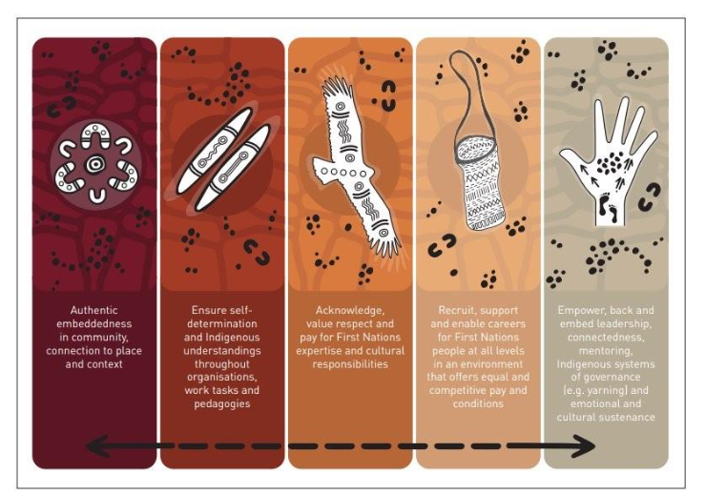

Authentic embeddedness in community, connection to place and context
Connection to local, place-based community is a crucial component of First Nations engagement in VET. It is essential that relationships and consultation with local communities are authentic and sustained, not cursory, token or bound to the life of a short-term project.
[Our mission is] giving ownership by engaging with community in making sure their needs are met. It’s about our people - looking after our people.
Confidential Stakeholder Contribution 2025
Members of the First Nations VET workforce often have an important role to play in connection to community. We heard from members of the workforce that by connecting VET to community needs, many First Nations peoples found their VET work markedly more meaningful. This is not to suggest that First Nations staff should be required to perform this work. Like the rest of the workforce, First Nations VET workers have a wide range of motivations and ambitions. All of those can and should be respected and accommodated.
Communities, moreover, are all unique and their needs and priorities change. VET organisations need relationships with communities that are continuous, unique and place based. Elements of embeddedness in community that emerged from our research include:
- VET initiatives should be co-designed with First Nations peoples and communities at all stages of the design, development, delivery, review, and revision process.
- When new initiatives are being developed, early consultation with community shapes priorities and enables First Nations peoples to anticipate and plan for employment opportunities.
- Unbroken relationships between RTOs and First Nations communities, especially by First Nations leaders and staff, strengthen the employment pipeline. The benefits also accrue to students.
- By embedding VET in community, training packages and courses are better adapted to local cultural, economic and workforce needs.
- Connection to community and context often helps VET organisations to recognise and include First Nations as guest expert presenters, especially Elders.

Promising Practice: Wurreker Brokers
Marrung Aboriginal Education Plan is part of the Victorian Skills Plan, which seeks to empower self-determination for First Nations peoples. Working with the Victorian Aboriginal Education Association, the Victorian government funds eight Wurreker Broker positions. The concept of Wurreker (message carriers) has been applied in TAFE Victoria for more than 20 years. Wurreker Brokers maintain relationships with communities and connects them to training providers and industries. This enables communities to identify community needs, including economic goals and employment opportunities especially for young First Nations peoples.

Promising Practice: Queensland Indigenous Workforce and Skills Development Grant
The Indigenous Workforce and Skills Development Grant scheme enables First Nations communities to design and lead projects that they have identified for local training and labour needs. The scheme provides up to $250,000 for eligible First Nations organisations (with at least 50% Aboriginal and Torres Strait Islander Board) developing and delivering culturally appropriate training, wrap around support and connection to local employers.

Ensure self-determination and First Nations understandings throughout organisations, work tasks, pedagogies, control of data and intellectual property
Self-determination is a human right. The International Covenant on Civil and Political Rights defines self-determination in a way that is relevant to VET, as ‘freely pursue their economic, social and cultural development.’ Self-determination is also a component of the United Nations Declaration on the Rights of Indigenous Peoples (2007) because First Nations peoples living in settler colonies like Australia, Canada and New Zealand have historically had their right to self-determination undermined or threatened. This means that Australian agencies and organisations need to be particularly diligent in applying the right to self-determination. The Declaration says:
Indigenous peoples have the right to maintain and strengthen their distinct political, legal, economic, social and cultural institutions, while retaining their right to participate fully, if they so choose, in the political, economic, social and cultural life of the State.
For the First Nations VET workforce, this means that all agencies related to the VET sector have a responsibility to ensure VET workplaces are physically and culturally safe places to work. Our research shows that this is not always available to First Nations VET workers but that the risks of culturally unsafe encounters can be mitigated by widespread cultural competency training for all members of the VET sector.
Further, First Nations peoples and communities must also have the opportunity to develop and conduct VET in settings and ways that maintain and strengthen their distinctiveness. Such self-determination also extends as a design principle, to the wider VET workforce. This means that First Nations peoples in VET should have:
- the opportunity to bring specifically First Nations understandings of governance, science, knowledge, culture and teaching to VET.
- formal recognition and reward for the additional workload that is attached to Aboriginality as expertise (often described as ‘cultural load’), further recognising that this work is specific and confined to First Nations peoples.
- opportunity to develop and participate in their workplace in ways that are consistent with their community’s distinctive ways of understanding social and organisational systems.
- recognition of distinctive cultural and legal obligations, including, but not limited to, leave entitlements for Sorry Business or cultural events.

Promising Practice: Tangentyere Council (ACCO) ‘Two way’ teaching
This Aboriginal Community Controlled Organisation provides a range of services for Town Camps in the Northern Territory. Town Camps with populations of less than 200 people typically have formal origins in the 1970s. Tangentyere Council was incorporated in 1979 and is structured to keep decision-making local to each Town Camp. Local Aboriginal languages dominate the Camps, and culture is central to individual and collective identity. Tangentyere Council builds capacity in VET by training teachers, teachers' aides, early childhood educators and Elders to deliver 'two way' learning, which encompasses both western and traditional approaches to learning and teaching.
Two-way learning centres ensure Aboriginal understanding but also ensures that Aboriginal people have the opportunity to work in mainstream educational services. Two-way learning that platforms local Elders and is under local control, is especially important in remote Australia, where attempts to transfer models for community engagement have not always succeeded (Guenther et al. 2014). Local and bespoke solutions by Aboriginal Community Controlled Organisations that are adequately embedded to adapt two-way learning to local conditions and culture work best.

Acknowledge, value, respect and pay for First Nations expertise and cultural responsibilities
In recent decades, educational institutions and other organisations have valued First Nations knowledges and wisdom as part of their mission to teach more inclusively, in support of truth telling or to enhance educational outcomes. This move to acknowledging, valuing and respecting First Nations expertise is important. As a design principle, it includes:
- Recognising that First Nations knowledges, understandings and wisdom have been long accumulated, and applied for vocational purposes and continues into the present.
- Respecting First Nations knowledges without correcting Elders or experts or referring to First Nations traditions solely in the past tense.
- Acknowledging Aboriginality as expertise, especially the expertise of Elders. It is likely to be inappropriate to ask Elders to also complete Western qualifications as this disrespects and delegitimises their hard earned First Nations expertise and status.
- Understanding that expertise is contextual and specific to place and country. First Nations experts often cannot speak on behalf of other First Nations peoples, and no First Nations person should expect to be an expert on everything to do with First Nations peoples.
- Appreciating the diversity of First Nations skills, experience, ambitions, expertise, personal strengths, political perspectives and social and emotional needs.

Promising Practice: Tranby College
Tranby is a co-operative First Nations RTO and a centre for mob to gather. It was launched in Glebe, Sydney in the late 1950s and provides training for First Nations peoples under conditions that former students report helped them to learn, develop a career and get to know diverse First Nations peoples.
Tranby seeks to develop its First Nations workforce through community engagement and collaboration, enabling opportunities for a wide variety of First Nations staff to further develop their knowledge and skills (Goodall et al. 2022).

Recruit, support and enable careers for First Nations peoples at all levels in an environment that offers equal and competitive pay and conditions
Our research shows that it is important that VET employers see recruitment, retention and career progression as part of the same strategy and not focus just on entry to the VET sector. Its success, moreover, relies on pay and working conditions that are fair and competitive. In particular:
- First Nations peoples have the right to work in an environment that is physically and culturally safe. RTOs will not retain any staff if it is not a safe place to work. This is a professional development issue for non-First Nations colleagues, which should be addressed in an ongoing way. This is frequently achieved with training in cultural competency, which needs to be embedded in workplace culture.
- Reconciliation Action Plans and recruitment targets that do not also include strategies for retention and career progression present risks to First Nations employees, who have often seen or heard of organisations that do not seek to retain their First Nations workforce after a recruitment target has been met. Anecdotally, this not only makes for insecure work, it also ultimately discourages job applicants.
- Combinations of recruitment and retention that can be effective (depending on specific circumstances) such as Earn While You Learn (traineeship, cadetship, apprenticeship) entry programs that offer wrap-around support systems and take into account a range of complexities, including family, community and cultural responsibilities, and individual career development and planning processes.
- These programs can be enabled through employment conditions that provide for cultural and Sorry Business leave and incorporate cultural responsibility into the workloads of First Nations employees. These measures can help RTOs to maintain connection to community, which further enhances recruitment and retention.
- Retention of a First Nations VET workforce depends on feelings of embeddedness and belonging in a workplace. This is a complex and ongoing personal experience. Promising practices among employers include recruiting multiple First Nations peoples who can support one another, establishing First Nations networks, and developing mentoring and other schemes.
- A variety of stakeholders indicated ambivalence about roles that are identified as First Nations or which utilise affirmative measures to encourage First Nations applicants. Even where First Nations knowledges are among the types of expertise sought for a role, some First Nations peoples are concerned about the stigma that can be directed at them due to perceptions of ‘special’ treatment.

After the massive upheavals to education during the COVID pandemic, Professor Helen Proctor suggested that the metaphor of the ‘opportunity ladder’ in education should be discarded, since it concealed and entrenched underlying forms of social inequality (Proctor 2022). This is no less the case for First Nations VET workers, who experience structural disadvantage, but like everyone else, have diverse career goals.
Our research suggests that First Nations peoples in VET are likely to be given fewer opportunities for career advancement than others. At the same time, we were also told of occasions where the pressure of expectations to progress up a career ladder did not match some people’s desire for steadiness and stability at work. This issue needs to be addressed across the sector. Supporting career development includes:
- Understanding and respecting a wide variety of career motivations, which is enabled by systems that encourage individual First Nations staff to develop, communicate and grow their career goals, acknowledging that these may also change over time.
- Many First Nations VET workers are recruited to the Aboriginal-controlled sector, or in support of First Nations students or curricula. Despite these being specialised roles, opportunities for career progression, including into mainstream roles, supports job satisfaction and retention.
- Providing training and development opportunities for First Nations employees in areas that help develop current and future roles, including in leadership and management.

Promising Practice: Federation University personalised career development
Federation University in Ballarat, Victoria is a dual-sector institution offering TAFE and higher education courses. Federation University’s Aboriginal and Torres Strait Islander Workforce Strategy includes individual career progression and professional development plans, that enable the University to tailor First Nations careers to individual goals, aspirations, talents and skills. The workforce plan targets mainstream and First Nations designated roles and includes mentoring, a trainee program and training scholarships in both TAFE and university courses.

Promising Practice: Offering Culturally Appropriate TAE Qualifications
Several organisations are seeking to offer Certificate IV in TAE in ways that reduce this qualification’s perceived impact on the recruitment of First Nations VET teachers. Federation University trains an all-First Nations cohort of Certificate IV in TAE participants. As mentioned, NACCHO has supported up to 40 First Nations health workers to also complete the Certificate IV in TAE together, with culturally tailored training and wraparound supports.
Northern Institute in the Northern Territory is conducting a pilot program with culturally appropriate Certificate IV in TAE resources that will be trialled with at least 10 VET teachers, trainers and assessors. As these practitioners will then be equipped to train others, Northern Institute expects that this will expand capacity and evaluate the effectiveness of the resources.

In addition, the Queensland Government’s Indigenous Land and Sea Ranger Program launched the Ranger to Trainer Program in 2024 with a second round in 2025. This program provided Indigenous rangers with tailored face-to-face workshops as well as online and self-paced learning, to achieve a strong completion rates of the Certificate IV in Training & Assessment. Ranger to Trainer enables rangers to deliver culturally appropriate training within their communities, supporting land and sea management, with the aim to improve access to cost effective training for Indigenous Ranger Groups, youth, and communities across Queensland, particularly in remote areas.

Example: Kimberley Aboriginal Medical Services Council (KAMSC)
KAMSC is an Aboriginal Community Controlled Organisation comprised of other ACCO members delivering health services in the Kimberley region of Western Australia. KAMSC collaborates with member organisations to identify qualified people working in industry who have an interest in teaching VET. KAMSC funds and guides learners to complete the Certificate IV in TAE part-time over a 2-year period through stackable skill sets to effectively build knowledge of VET teaching. Program flexibility and wrap-around support are key to producing successful results, acknowledging that learners must balance work, travel, family and care responsibilities and cultural needs.

Empower, back and embed leadership, connectedness, mentoring, First Nations systems of governance and emotional and cultural sustenance
While most strategies for recruiting, retaining, and developing the First Nations VET workforce focus on employment, it is equally important to empower First Nations leadership, ownership, and control. This extends beyond First Nations owned and Community Controlled Organisations to include leadership and management roles within all RTOs and across the wider VET sector.
There is also an opportunity for VET organisations to strengthen First Nations self-determination by integrating systems of First Nations governance, connectedness, and mentoring. These initiatives aim to go beyond merely providing culturally safe spaces, striving instead to create a VET sector that offers cultural sustenance to its First Nations workforce, students, and the broader community. This design principle includes:
- Systems that enable Aboriginal Community Control and First Nations Ownership and First Nations representation at governance level and other organisational structures that privilege First Nations decision-making.
- Robust and culturally safe training in leadership, governance, administration and regulation that supports First Nations peoples to start their own RTOs, and take leadership positions in the First Nations sector and mainstream leadership roles in all segments of VET.
- Active integration of First Nations understandings and influence on governance boards, in leadership positions and in management of all aspects of the organisation, preferably empowering more than one First Nations voice in any governance structure.
- Flexibility that enables teach, train and assess members of the VET workforce to connect course content to Country, First Nations knowledges and pedagogies.
- An active decolonisation of course structure and content, infusing First Nations understandings, knowledges and practices into teaching.
- Support for First Nations members of the VET workforce to develop work practices that align to culture and values.
- Networks for personal and cultural support, career and professional opportunity and for shared decision-making. This covers a spectrum of First Nations control and culture in the workplace, spanning informal social groups, formal networks with limited decision-making up to traditional First Nations self-governance structures known as ‘yarning’. Note that it is not respectful to appropriate Aboriginal words like yarning under other conditions and without permission.
- Mentoring structures that enable more experienced members of the First Nations VET workforce to support those earlier in their career.
- Celebration and recognition of key First Nations dates, scientific and cultural expressions, knowledge traditions and community achievements.
- Use of Aboriginal or Torres Strait Islander words for projects, buildings, places, programs or initiatives wherever permission has been granted to do so by an appropriate community who has provided the name.

Promising Practice: Tauondi Aboriginal College
As an Aboriginal Community Controlled RTO, over 60% of Tauondi Aboriginal College employees are First Nations, ensuring that staffing and operations are grounded in genuine cultural understanding and representation.
Tauondi Aboriginal College’s long-standing history and connection to the local First Nations community helps create safe and supportive learning environments. Tauondi is more than just an educational institute—it is a place where First Nations students feel valued, respected, and empowered to learn within a setting that honours their cultural identities. This environment is reinforced by strong relationships between First Nations and non-First Nations staff, who work together to foster a culturally responsive and sensitive educational experience.
Non-First Nations staff actively consult with First Nations colleagues on any cultural matters, seeking their guidance, input, and feedback to ensure culturally appropriate responses. In cases requiring heightened cultural sensitivity, senior First Nations staff members take on a leading role, further embedding culturally safe practices in all aspects of operations.

Promising Practices: TAFE NSW
TAFE NSW is pursuing a number of projects to improve First Nations self-determination in their workforce:
- The Aboriginal Strategic Leadership Group supports First Nations initiatives across the institution (TAFE NSW RAP). The leadership group advises TAFE NSW about allocating resources and budget needs to implement RAP initiatives. Members also champion, drive and embed implementation of these initiatives (TAFE NSW RAP).
- A First Nations staff network was established to support staff, facilitate connections and advance job satisfaction and professional development opportunities for First Nations TAFE employees (TAFE NSW Aboriginal Employment Strategy). Currently 38% of First Nations staff participate in the network. TAFE NSW has plans in place that will expand this group to 70% of First Nations TAFE staff by 2027 (TAFE NSW Aboriginal Employment Strategy).
TAFE NSW employs 2 advocates who provide support for over 350 First Nations staff. Advocates are agile support workers who provide career advice or planning, directing or following up on queries. They also support First Nations staff facing challenging personal or professional circumstances (DEWR 2024b).

Summary
This section of the paper has outlined five design principles for growing the First Nations VET workforce and provided some examples of current promising practices for each principle.
No one-size-fits-all solution will be appropriate. This is because First Nations communities are all unique and different communities have distinctive needs and priorities. However, our research suggests that principles that can be adapted, and applying these principles in a place-based manner, will help overcome some of the barriers identified in the previous section (Section 3.3) and strengthen the qualities of the VET sector that are enabling for First Nations peoples.
Key to all the design principles is the centring of First Nations understandings, governance, self-determination and empowerment. Embedding VET in community must be authentic and continuing. Self-determination will continue to unfold but is also a non-negotiable human right. Respecting First Nations skills, knowledges and contributions requires appropriate financial recompense. And systems that support and empower First Nations peoples who continue to experience structural and interpersonal barriers to full inclusion, will need to be grown, refined and bolstered as strategies for retention are better connected to recruitment targets.
Many organisations and RTOs are working towards these goals. The practices that we have offered are only a handful of those presently being pursued. These are ‘promising’ in the sense that we recognise they are only the beginning and may not be suitable for all circumstances. Such promising practices, however, offer tangible examples of ways the ideas underpinning the design principles have been implemented already. And they may prompt or inspire new ideas, strategies and organisational structures that help build, empower and back a vital and robust First Nations VET workforce.

References
ABS (Australian Bureau of Statistics) (2021) 2021 Census of Population and Housing. ABS website. accessed 08 July 2024.
—— (2022a) Language Statistics for Aboriginal and Torres Strait Islander Peoples ABS website.
—— (2022b) 2021 Census overcount and undercount, ABS Website.
—— (2022c) 2021 Census overcount and undercount methodology, ABS Website.
—— (2024a) Corrective Services, Australia: National and state information about adult prisoners and community based corrections, including legal status, custody type, Indigenous status, sex, ABS.
—— (2024b) Updating ANZSCO: Reflecting a Modern Australian labour Market, [Preliminary] Proposed Changes, Version 2.0, ABS Website.
ACEA (Australasian Corrections Education Association) (n.d.) ACEA - Australasian Corrections Education Association - ACEA, ACEA.
AITSL (Australian Institute for Teaching and School Leadership) (2021). Building a high quality and sustainable dual qualified VET workforce, AITSL.
ANTA (Australian National Training Authority) (2001) National Strategy for Vocational Education & Training for Adult Prisoners and Offenders in Australia, ANTA.
Australian Academy of Humanities (2021) Kriol, Yumplatok and Aboriginal English: Australia’s "contact languages", Australian Academy of Humanities.
Australian Education Union (AEU) (2023) Understanding the experiences of Aboriginal and Torres Strait Islander educators in the workforce, Jumbunna Institute.
Australian Government et al. (2020). National Agreement on Closing the Gap. Department of Prime Minister and Cabinet, Barton, ACT. https://www.closingthegap.gov.au/national-agreement
Australian Institute of Aboriginal and Torres Strait Islander Studies (AIATSIS) (n.d.). Stolen Generations, AIATSIS website.
Barnett, R. (2023) Marramarra murru : First Nations Economic Development Symposium Background Paper, Australian National University.
Bunda, T., Zipin, L. and Brennan, M. (2012) ‘Negotiating University ‘equity’ from Indigenous Standpoints: A Shaky Bridge.’ International Journal of Inclusive Education 16, no. 9: 941–57. https://doi.org/10.1080/13603116.2010.523907
Bundgaard-Nielson, R., Baker, B., Bell, E. and Wang, Y. (2023) ‘Stop contrast acquisition in child Kriol: Evidence of stable transmission of phonology post Creole formation’, Journal of Child Language, doi.org/10.1017/S0305000923000430.
Caffery, J. (2010). Central Australian endangered languages: So what? Dialogue, 29(1), 78–86.
CAG (Council of Australian Governments) (2016) Prison to work report, CAG.
Cale, J., Day, A., Casey, S., Bright, D., Wodak, J., Giles, M. & Baldry, E. (2019) 'Australian prison vocational education and training and returns to custody among male and female ex-prisoners: A cross-jurisdictional study', Australian & New Zealand Journal of Criminology, 52(1), 129–147. doi.org/10.1177/0004865818779418.
Charles Darwin University (CDU) (2022) Intellectual Property Policy, Charles Darwin University.
Chavez, R. (2015) 2014 Inquiry to Consider the Efficiency and Performance of WA Prisons discussion paper, ACEA.
Circelli, M., Hall, M., Li, Z., Ong, A. & Lim, P. (2022) Journey Through VET: a case study of foundation skills learners, NCVER.
CIT (Canberra Institute of Technology) (n.d.) CIT Yurauna : Canberra Institute of Technology, CIT.
CIT (Canberra Institute of Technology) (2023) Annual Report, CIT.
Cleverley, J. & Mooney, J. (2010) Taking Our Place: Aboriginal Education and the Story of the Koori Centre at the University of Sydney, Sydney University Press.
Corrective Services Administrators’ Committee (2006) Rebuilding lives: VET for prisoners and offenders, ANTA.
CSIRO (2024a) Indigenous Knowledge - CSIRO, Commonwealth Scientific and Industrial Research Organisation (CSIRO), Canberra.
CSIRO (2024b) Indigenous science - CSIRO, Commonwealth Scientific and Industrial Research Organisation (CSIRO), Canberra.
DEWR (Department of Employment and Workplace Relations) (n.d.) Foundational Skills, DEWR website.
——(2022) Future delivery of foundation skills training in remote Australia, DEWR website.
——(2023) Remote Community Pilots evaluation, prepared by Dandolo partners, DEWR website.
——(2024a) National Skills Agreement, DEWR website.
——(2024b) VET Workforce Blueprint, DEWR website.
——(2025) Credential Policy, Training.gov website.
Eva, C., Foley, D., Bodle, K., Hunter, B., Harris, J., & Nichols, N. (2024) Indigenous workplace policies: the crucial role of Indigenous management. Journal of Industrial Relations, OnlineFirst version published 7/8/24 https://doi.org/10.1177/00221856241267831
Fair Work Commission (2023). Discussion Paper: Job Security, Modern Awards Review 2023 –24. Fair Work Commission, 18 December 2023. https://www.fwc.gov.au/hearings-decisions/major-cases/modern-awards-review-2023-24/job-security-modern-awards-review-2023
FWO (Fair Work Ombudsman) (n.d.). First Nations people: a guide to starting a new job, Fair Work Ombudsman website.
Federation University (2022) Aboriginal and Torres Strait Islander Peoples Workforce Strategy 2022-2025.
FSO (Future Skills Organisation) (2023) First Nations Representation in the Finance, Technology and Business Workforce.
Gammage B (2011), ‘The biggest estate on earth: how Aborigines made Australia’, Aleen & Unwin.
Goodall, H., Norman, H. & Russon, B. (2022) 'Proper Deadly': Student memories of adult education under Indigenous control: Tranby, 1980-2000, The Australian Journal of Indigenous Education, 51(2).
Griffin, T. & Andrahannadi, U. (2023) VET delivery in regional, rural and remote Australia: barriers and facilitators, National Centre for Vocational Education Research (NCVER).
Gruppetta, M., Southgate, E., Ober, R., Cameron, L., Fischetti, J., Thunig, A., Heath, T., Burns, K. & Clifton, S. (2018) Yarning the way: the role of Indigenous paraprofessionals in guiding the post-school educational pathways of Aboriginal and Torres Strait Islander youth, University of Newcastle.
Guenther, J., Bat, M., Stephens, A., Skewes, J., Boughton, B., Williamson, F., Wooltorton, S., Marshall, M. & Dwyer, A. (2017a) Enhancing training advantage for remote Aboriginal and Torres Strait Islander learners, NCVER.
Guenther, J., Bat, M., Stephens, A., Skewes, J., Boughton, B., Williamson, F., Wooltorton, S., Marshall, M. & Dwyer, A. (2017b) VET retention in remote Aboriginal and Torres Strait Islander communities, NCVER.
Guenther, J., Mcrae-Williams, E., Kilgariff, C. (2014) Engineering employment pathways in remote communities and the (false) hope of collaborative service provision, NARU public seminar 19 November 2014.
Helme, S. (2007) ‘From the sidelines to the centre: Indigenous support units in vocational education and training’, Journal of Vocational Education & Training, 59(4):451–466,
Heeres, J.E. (1899), The Part Borne by the Dutch in the Discovery of Australia 1606-1765, Luzac & Co.
Janke, T. (2005) ‘Managing indigenous knowledge and indigenous cultural and intellectual property.’ Australian Academic & research libraries 36, no. 2: 95-107.
JSA (Jobs and Skills Australia) (2024a) VET Workforce Study, JSA website.
——(2024b) RTO Typology Methodology Paper, JSA website.
——(unpublished) Income Volatility Report 2 – Gender, First Nations and Age groups. JSA.
——(unpublished) Murtu Yayngiliyn Study – leading the way in developing a culturally safe, responsive, and respectful Government approach. JSA.
Karskens, G. (2010) The Colony: A history of early Sydney, Allen and Unwin.
Jumbunna Institute (Brown, C., DAlmada-Remedios, R., Gilbert, J. OLeary, J. and Young, N. 2020). Gari Yala (Speak the Truth): Centreing the Work Experiences of Aboriginal and/or Torres Strait Islander Australians, Sydney, Jumbunna Institute. https://www.uts.edu.au/about/faculties/business/research/centre-for-indigenous-people-and-work-cipw/gari-yala-speak-the-truth
Kemmis, S., Thurling, M., Brennan Kemmis, R., Rushbrook, P. & Pickersgill, R. (2006) Indigenous Staffing in vocational education and training: Policies, strategies and performance, NCVER.
Knight, G., White, I. & Granfield P (2020). Understanding the Australian vocational education and training workforce, NCVER.
Lamb, S., Maire, Q., Walstab, A., Newman, G., Doecke, E. & Davies, M. (2018). Improving participation and success in VET for disadvantaged learners, NCVER.
Louis, C. (2021) ‘Indigenous ways of knowing: Returning to the women fire KIWEYTOTAHK ISKWEW ISKOTAYOW’, In Brigham, S., McGray, R. & Jubas, K. (2021) Adult education and lifelong learning in Canada, Thompson Educational Publishing.
Miller, C. (2005), Aspects of Training that meet Indigenous Australians’ Aspirations: A systematic Review of Research, NCVER.
Minderoo Foundation, Bankwest Curtin Economics Centre (BCEC) at Curtin University, and Murawin (2022) Woort Koorliny - Australian Indigenous Employment Index National Report Minderoo Foundation
Muurrbay Aboriginal language and Culture Co-operative (n.d.) Muurrbay Languages, Muurrbay website.
NCVER (National Centre for Vocational Education Research) (2025). Total VET students and courses 2024. Australian vocational education and training statistics. National Centre for Vocational Education Research, Adelaide.
NIAA (National Indigenous Australians Agency) (2024) Framework for Governance of Indigenous Data, NIAA.
North Metropolitan TAFE (2023) Annual Report, North Metropolitan TAFE.
North Regional TAFE (2023) Annual Report, North Regional TAFE.
North Regional TAFE (n.d.) Aboriginal training Services, North Regional TAFE website.
O’Callaghan, K. (2005) At a glance: Indigenous vocational education and training, NCVER.
OECD (2019). Indigenous Employment and Skills Strategies in Australia, OECD.
Parliament of Australia (2022). Final report: matter of possible privilege. Select Committee on Job Security, Commonwealth of Australia, March 2022.
Pascoe B (2014) ‘Dark Emu Black Seeds: Agriculture of Accident?’, Magabala Books.
Peacock, H. & Prehn, J. (2021) ‘The importance of Aboriginal Education Workers for decolonising and promoting culture in primary schools: an analysis of the longitudinal study of Indigenous children (LSIC)’. The Australian Journal of Indigenous Education 50:196–202 https://doi.org/10.1017/jie.2019.13
Perkins, R. (2019) We need more Indigenous voices to help attract and keep Indigenous teachers, EduReseach Matters.
Perkins, R. & Shay, M. (2022) How can Australia support more Aboriginal and Torres Strait Islander teachers?, The Conversation.
Perkins, R. (2024) Learning from the lived experiences of Indigenous teachers who have remained in the profession, PhD Thesis, School of Education, University of Queensland.
Prete, T. & Lange, E. (2021) ‘Indigenous voices and decolonising lifelong education’, International Journal of Lifelong Education, 40(4):303-309. https://doi.org/10.1080/02601370.2021.1968240
Proctor, H. (2022) ‘Climbing the opportunity ladder: The burden of hope and ambition’, Griffith Review, 75:166-176. informit.306040885352253
Productivity Commission (2011) Vocational education and training workforce, Productivity Commission.
——(2024) Review of the National Agreement on Closing The Gap: volume 1, Productivity Commission.
Reading Writing Hotline (n.d.) Adult Literacy Specialists – still and endangered species, Reading Writing Hotline website.
Rose, D.B. (2000) Dingo Makes Us Human: Life and Land in an Australian Aboriginal Culture, Cambridge University Press.
Roth, L. (2004) Privatisation of Prisons, NSW Parliamentary Library Research Service.
Pattison, A., McGee, K., Birch, J., Saunders, K., Ashby, R., Quinnell, R., Bell-Anderson, K. & Way, A. (2023). ‘What Do We Know About Threshing Traditional Grains in Australia?’ Journal of Ethnobiology 43(4), 339–50. https://doi.org/10.1177/02780771231209134
Parliament of Australia (2022) Select Committee on Job Security, Australian Government
Queensland Government (2022). Paving the Way. First Nations Training Strategy. Department of Employment Business and Training, Queensland. https://www.publications.qld.gov.au/dataset/paving-the-way-the-first-nations-training-strategy
Simpson, J., Caffery, J., Mcconvell P. (2009). Gaps in Australia's Indigenous Language Policy: Dismantling bilingual education in the Northern Territory
Sivak, L., Westhead, S., Richards, E., Atkinson, S., Richards, J., Dare, H., Zuckermann, G., Gee, G., Wright, M. & Rosen, A. (2019). ‘‘Language Breathes Life’—Barngarla Community Perspectives on the Wellbeing Impacts of Reclaiming a Dormant Australian Aboriginal Language.’ International Journal of Environmental Research and Public Health 16(20), 3918-. https://doi.org/10.3390/ijerph16203918
Smith, E., South, D. & Foley, A. (2023) What makes people want to become VET teachers?, [conference presentation], ACDEVEG.
Smith, L. (1999) Decolonizing methodologies: Research and Indigenous peoples, ZED Books.
Smith, E. & Tuck, J. (2023) ‘Do the qualifications of vocational teachers make a difference to their teaching?’, Research in Post-Compulsory Education, 28(1), 1–25. https://doi.org/10.1080/13596748.2023.2166690
Smith, W., Neale, T. & Weir J. K. (2021) ‘Persuasion without policies: The work of reviving Indigenous peoples’ fire management in southern Australia’, Geoforum 120, 82-92, https://doi.org/10.1016/j.geoforum.2021.01.015
TAFE NSW, TAFE NSW Aboriginal Employment Strategy.
South Metropolitan TAFE (2022) Aboriginal Employment Strategy 2022-2025, South Metropolitan TAFE.
TAFE South Australia (TAFE SA) (2023). Roadmap for the Future of TAFE SA. Department of Education, South Australia.
TAFE South Australia (TAFE SA) (n.d.) Aboriginal Access Centre, TAFE SA website.
TDA (TAFE Directors Australia) (n.d.) First Nations Focus Story collection, TDA website.
The Victorian Government (2023) Victorian Skills Plan, The Victorian Government.
TITEB (Tiwi Islands Training and Employment Board) (n.d.) Tiwi Training and Employment, TITEB.
Tyler, M.& Dymock, D. (2021) Attracting industry experts to become VET practitioners: a journey, not a destination, NCVER.
OHCHR (Office of the High Commissioner for Human Rights) (2007), United Nations Declaration on the Rights of Indigenous Peoples, United Nations website.
VSA (Victorian Skills Authority) (2023). Victorian Skills Plan for 2023 into 2024, Shared prosperity through skills. Victorian Skills Authority, Victorian State Government, Melbourne. https://www.vic.gov.au/sites/default/files/2023-12/2023-Victorian-Skills-Plan__web.pdf
Windley, G. (2017) Indigenous VET participation, completion and outcomes: change over the past decade, NCVER.
Wodonga TAFE (n.d). Koorie Education Unit - Your Mob at TAFE, Wodonga TAFE website.
Woodroffe, T. (2016) ‘Indigeneity – A Skill-set for Teaching’, Journal of Australian Indigenous Issues, 16(1-2): 117-131. Informit.200155395882036

Appendix A: Design Principles - Concept Details
Jobs and Skills Australia Design Principles – Concept Details
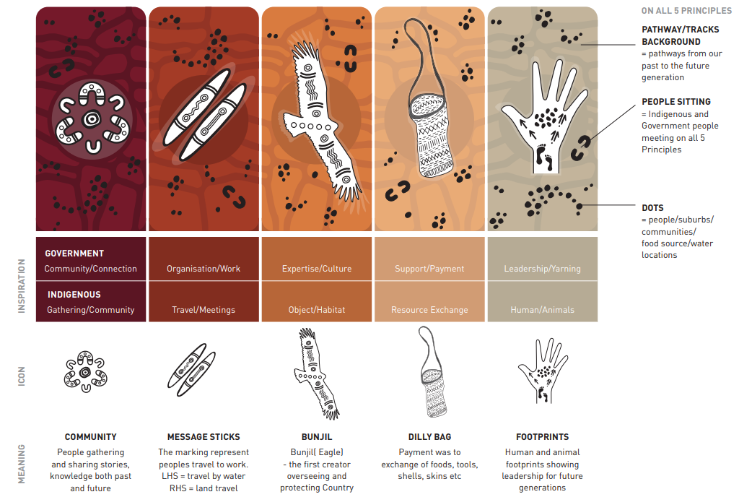
The image presents the concept details behind the five design principles. Across all five principles, the background includes pathways or tracks that represent journeys from the past to the future, ‘people sitting’ symbols that show Indigenous and Government people meeting on all five principles, and scattered dots that indicate people, suburbs, communities, food source and water locations. Principle 1 pairs Government: Community/Connection with Indigenous: Gathering/Community, shown by a circular Community symbol meaning people gathering and sharing stories, knowledge both past and future. Principle 2 pairs Government: Organisation/Work with Indigenous Travel/Meetings, shown by Message Sticks which represents peoples’ travel to work. The left Stick indicates travel by water and the right Stick indicates land travel. Principle 3 pairs Government: Expertise/Culture with Indigenous: Object/Habitat, shown by Bunjil (Eagle) who is the first creator overseeing and protecting Country. Principle 4 pairs Government: Support/Payment with Indigenous: Resource Exchange, shown by a Dilly Bag meaning payment was the exchange of foods, tools, shells, skins, etc. Principle 5 pairs Government: Leadership/Yarning with Indigenous Human/Animals, shown by Footprints meaning human and animal footprints showing leadership for future generations.

We use the term Indigenous here as this is the term used in the Australian Vocational Education and Training Management Information Statistical Standard (AVETMISS).
We use the term Indigenous here as this is the term used in AVETMISS.
Income volatility, in this report, is defined as the proportion of time that an employee experiences a change (either increase or decrease) in income of at least 25% as compared to the previous week. For example, if a person experiences 5 weekly changes in income, greater than 25%, over a period of 50 weeks, that person has income volatility of 10%.
This figure includes an analysis of Single Touch Payroll, ATO Income Tax Return Data for 2022 – 2023 Financial year from PLIDA.
We use the term Indigenous here as this is the term used in AVETMISS.
This included an analysis of Single Touch Payroll, ATO Income Tax Return Data for 2022 – 2023 Financial year from PLIDA.
All proportion of VET students who are First Nations are under-counts. In VET, the number of students whose First Nations status is unknown (532,920 in 2023) is three times higher than the number who are identified as First Nations people (174,960 in 2023). https://www.ncver.edu.au/research-and-statistics/data/databuilder
Adelaide TAFE Centre of Excellence for Early Childhood Education and Care - Department of Employment and Workplace Relations, Australian Government (dewr.gov.au)
JSA analysis of supplied list of ACCO and FNO RTOs as of 6 September 2024.
Note that the ABS reviewed ANZSCO, with the aim of reflecting the current industry practices and shifts in workforces, such as VET. OSCA replaced ANZSCO in 2024, but most data are still currently only available on an ANZSCO basis.
Using the ABS Census GNGP variable which is used to classify employed people according to whether they are employed in the government (public) or non-government (private) sector.
Including the Facilitation Skill Set, Enterprise Trainer Skillsets, Assessor Skillsets, Volunteer Trainer Delivery Skillsets, Workplace Trainer Skillset, Work Skill Instructor Skillset and a VET Delivered to School Students Teacher Enhancement Skillset.
Diplomas include TAE50111/TAE50116/TAE50112 Diploma of Vocational Education and Training, TAE50211/TAE50216 Diploma of Training Design and Development and TAE80113/TAE80213 Graduate Diploma of Adult Language, Literacy and Numeracy Practice. Skillsets include TAESS00007/TAESS00014 Enterprise Trainer - Presenting Skill Set, TAESS00008/TAESS00013 Enterprise Trainer - Mentoring Skill Set, TAESS00015 Enterprise Trainer and Assessor Skill Set; as well as TAESS00011/TAESS00001/TAESS00019 Assessor Skill Set.
This figure includes TAA40104/TAE40110/TAE40116/TAE40122 Certificate IV in Training and Assessment
JSA analysis of 2023 total VET student courses program enrolments via NCVER table builder
61%, or 17 out of the 28 included in the analysis of publicly available sources conducted by JSA.
See Kemmis et al. 2006 for further discussion.
Income volatility, in this report, is defined as the proportion of time that an employee experiences a change (either increase or decrease) in income of at least 25% as compared to the previous week. For example, if a person experiences 5 weekly changes in income, greater than 25%, over a period of 50 weeks, that person has income volatility of 10%.
For this analysis JSA used a data asset called Skills Tracker through the ABS PLIDA.
ABS Characteristics of Employment survey, August 2024. First Nations status not available.
https://www.fairwork.gov.au/starting-employment/types-of-employees/casual-employees
ABS Characteristics of Employment August 2024 - 918,800 or 35.2% of employees without paid leave entitlements had a guaranteed a minimum number of hours each week in their main job and at least one of the following: (i) earnings/income did not vary from one pay period to the next in main job; (ii) usually worked the same number of hours each week in main job.
Available STP Phase 1 data in PLIDA does not include any form of employment or hours variables. PLIDA integration of such STP Phase 2 variables in future would significantly increase research possibilities in this area.
Of the respondents who provided demographic information, almost half were primary school staff, 37% were in secondary schools and 7% were in TAFE.

