


2025-26 Work Plan
  - Jobs and Skills Australia

Acknowledgement of Country
Jobs and Skills Australia acknowledges the Traditional Owners of Country throughout Australia and recognises the continuing connection to lands, waters and communities. We pay our respects to Aboriginal and Torres Strait Islander cultures, and to Elders past and present.

The background image is an aerial view of the country of the Nhanda people, showing Pink Lake at Port Gregory.
Acknowledgement of Country
Jobs and Skills Australia acknowledges the Traditional Owners of Country throughout Australia and recognises the continuing connection to lands, waters and communities. We pay our respects to Aboriginal and Torres Strait Islander cultures, and to Elders past and present.
The background image is an aerial view of the country of the Nhanda people, showing Pink Lake at Port Gregory.
Contents
Commissioner's message 4
Our operating environment 5
Work program framing and key areas of focus 6
Current Labour Market 7
Future Labour Market 7
National Skills System 7
Productivity 7
Inclusive Participation 8
Activating an informed dialogue 8
JSA’s approach to selecting new projects 9
Our priority projects across 2025-26 10
Current Labour Market 10
Future Labour Market 13
National Skills System 14
Productivity 17
Inclusive Participation 18
Activating an informed dialogue 20
2025-26 Work Plan: At a glance 22

Commissioner's message
I am pleased to present Jobs and Skills Australia’s (JSA) 2025-26 work plan.
During the development of the 2025-26 work plan, we have engaged extensively with key tripartite partners and other stakeholders to shape our priorities to ensure that JSA’s work contributes to the ongoing economic and skills reform agenda and align to the broader policy landscape and the Government’s priorities. Thank you to all our partners and stakeholders who took the time to provide us with detailed input to inform the development of the work plan.
With an overarching focus on deep engagement and close collaboration, our 2025-26 work plan is framed around our five Commissioners’ outcomes from JSA’s strategic plan with an additional focus on productivity.
JSA has a unique and important ability to contribute to Australia’s productivity performance. The Australian labour market and skills system are key drivers of productivity. With investment and focus on skills development, we can help better match people’s skills and the requirements of jobs. This in turn will facilitate innovation and drive long term growth in incomes. This will provide Australian businesses and industries with a dynamic and resilient workforce in which all Australians can prosper and thrive.
A key outcome for JSA is fostering inclusive participation. Removing barriers traditionally faced by some cohorts supports full participation by everyone to their full preference and potential. Optimising pathways and system architecture prepares for the opportunities and challenges of the future by building a fairer, more inclusive and stronger workforce by leaving no one behind.
I am particularly excited about our significant existing work program being supported by key new studies. These projects align with our legislative functions, strategic objectives and the governments priorities. JSA has unique expertise that adds value to the evidence base and informs national workforce planning, to deliver a more responsive labour market. This ensures we have the right skills mix for the industries of the future.
This sharpened focus for JSA, builds on our multi-year forward outlook to be responsive across government policy and reform priorities. We look forward to working with our partners and stakeholder to support individual, business and industry needs.

Professor Barney Glover AO
Jobs and Skills Australia Commissioner

Our operating environment
The work plan for 2025-26, is consistent with our functions under the Jobs and Skills Australia Act 2022, builds on existing work and aligns our new studies and projects to the Government’s priorities.
JSA is working towards the Australian Government’s commitment to build a stronger economy and help give more Australians the skills and training they need today and to harness the jobs and opportunities of the future. We assist the Government to deliver a more responsive labour market, for the benefit of individuals, organisations and the economy and society as a whole.
Skills and capability development is a key driver of the productivity agenda. Data driven reforms and policy settings, and a widely connected and integrated education and employment system are necessary for Australia to meet its productivity challenges.
JSA helps drive productivity-enhancing ongoing reforms taking place in collaboration between government, industry, education providers and workers. JSA’s work is particularly relevant to the ‘building a skilled and adaptable workforce’ pillar of the Government’s productivity agenda that aims to support Australians to engage in work and learning throughout their life; make sure our education system (from schools to skills and higher education) is producing productive, highly capable graduates; and enable employers to access and use the best talent locally and internationally.
JSA provides advice that considers how Australia might maximise jobs and skills related opportunities and address challenges associated with major Government priorities including helping with the cost of living and growing our economy, creating opportunity through education, strengthening healthcare services and supports, implementing the Homes for Australia plan, and building a future made in Australia.

Work program framing and key areas of focus
JSA has a key role in supporting governments and other stakeholders to better understand and respond to current, emerging and future labour market needs.
Australia needs a strong skills and training system to ensure it has a dynamic labour market that can meet the nation’s skills needs and ensure everyone who wants a job can find one that meets their needs and preferences.
Matching people with the right skills and the right jobs, will help increase productivity and participation across the economy. Developing and effectively utilising our workforce’s skills is an important strategy for enhancing productivity.
The skill system is a key lever in supporting cohorts, who have historically experienced barriers to economic participation, to access stable, rewarding and valuable work.
Our 2025-26 work program is divided into six key areas of focus, which align with the Commissioner Outcomes from our Strategic Plan 2024-27, and link to broader Government strategic agendas.
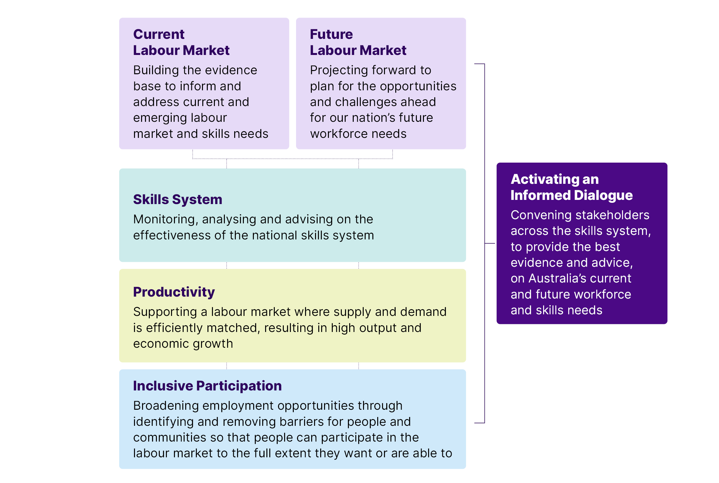
- Current Labour Market – Building the evidence base to inform and address current and emerging labour market and skills needs.
- Future Labour Market – Projecting forward to plan for the opportunities and challenges ahead for our nation’s future workforce needs.
- Skills System – Monitoring, analysing and advising on the effectiveness of the national skills system.
- Productivity – Supporting a labour market where supply and demand is efficiently matched, resulting in high output and economic growth.
- Inclusive participation – Broadening employment opportunities through identifying and removing barriers for people and communities so that people can participate in the labour market to the full extent they want or are able to.
- Activating an Informed Dialogue – Convening stakeholders across the skills system, to provide the best evidence and advice, on Australia’s current and future workforce and skills needs.

Current Labour Market
Understanding today’s workforce - building the evidence base to inform and address current and emerging labour market and skills needs
A contemporary skilled workforce is critical for delivering for Australia today, and for our future tomorrow. We provide solid and broad evidence and advice to better understand the current workforce. Skills shortages and mismatches has been identified as a key reason for the decline in productivity growth over recent years. JSA will continue to play a key role in supporting a labour market where people and jobs are well matched, resulting in high output and economic growth.
We are committed to an ongoing program of work that provides valuable insights about the current and emerging trends in our labour market, and advice about the implications of this for policy development and program delivery.

Future Labour Market
Projecting forward to plan for the opportunities and challenges ahead for our nation’s future workforce needs
JSA provides advice to the Government in relation to Australia’s emerging and future skills and training needs and priorities. Forecasting where our skilled workforce will be needed is a critical input to investing into our skills pipelines and pathways. Our advice will support understanding how jobs and skills are likely to evolve to help the national skills system respond to, and deliver, the required skills pipeline.

National Skills System
Monitoring, analysing and advising on the effectiveness of the national skills system
JSA has an important role in providing advice to inform how the domestic skills system, complemented by targeted migration pathways, can best address present skills needs across industries. We help policy makers and individuals to better understand the interactions between the skills system and employment pathways. We analyse the performance of the skills system in meeting Australia’s current, emerging and future skills needs through continued development of linked data assets to look at outcomes from education and training as well as pathways from the education system into the labour market.
A key priority for JSA is to advise the Government on meeting the challenge of ensuring all elements of the national skills system to be joined up and working cohesively together.

Productivity
Supporting a labour market where supply and demand is efficiently matched, resulting in high output and economic growth
Improving productivity is essential to maintaining a high standard of living and ensuring more opportunity for all Australians. This task is one of the biggest challenges facing our nation, and it will require the collaboration of government, industry, education providers and workforces to help address Australia’s productivity challenge.
Australia’s continued prosperity depends on having appropriately skilled people well matched to the requirements of jobs. Building the skills and capacity of our current and future workforce is key to our economic development and productivity agenda.

Inclusive Participation
Broadening employment opportunities through identifying and removing barriers for people and communities so that people can participate in the labour market to the full extent they want or are able to
Inclusive participation is crucial for the wellbeing of Australians and for addressing Australia's skills and workforce shortages by broadening the talent pool and ensuring equitable access to opportunities. This approach helps mitigate the impact of an aging population and skills gaps in emerging industries, ultimately leading to a stronger and more prosperous economy.
By prioritising inclusive participation, Australia can ensure a more robust and sustainable workforce, capable of meeting the challenges and seizing the opportunities of the future.
JSA is actively working to foster inclusive participation and address skills shortages through various initiatives, including evidence-based research and policy advice.

Activating an informed dialogue
Convening stakeholders across the skills system, to provide the best evidence and advice, on Australia’s current and future workforce and skills needs
We value the knowledge and experience of our tripartite partners and stakeholders in helping plan for the nation’s current and future skills, labour market and workforce needs and in bringing the voices of all Australians to these important workforce and skills issues.
A robust, effective and collaborative working relationships with our key partners and stakeholders is the key to the impactful delivery of JSA’s legislated functions. Additionally, we are committed to fostering inclusive participation in research design to ensure diverse voices are heard and incorporated across all JSA insights and advice.

JSA’s approach to selecting new projects
To support more flexible, timely and responsive research outputs, the 2025-26 work plan will deliver a new range of output types across the targeted streams of skills, productivity and inclusive participation. This will allow JSA to be responsive to emerging priorities and specialise in particular areas while maintaining flexibility to explore a diverse range of topics. Importantly, the studies across the three key themes of productivity, participation and skills will be interconnected and support a longer-term focus on topics aligned with key government agendas.
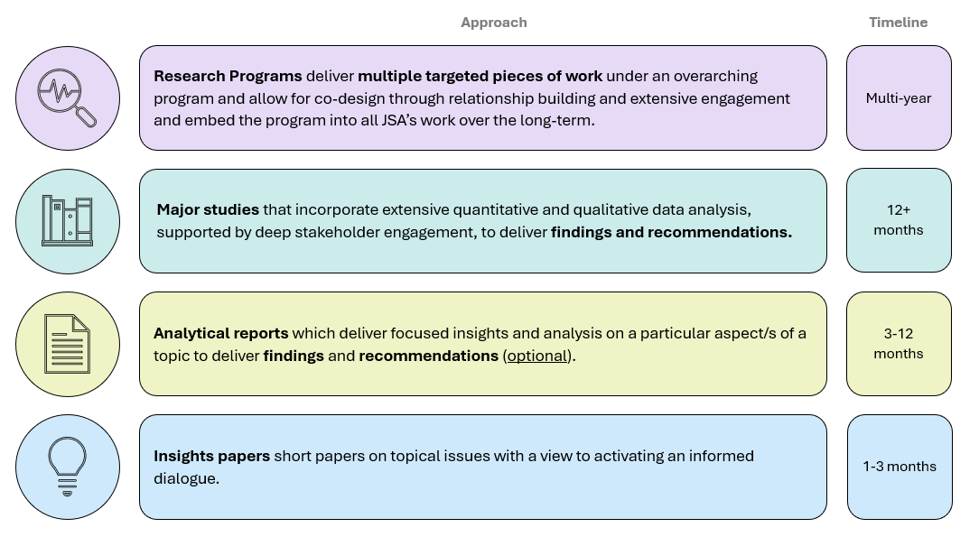
Approach | Timeline
Research programs deliver multiple targeted pieces of work under an overarching program and allow for co-design through relationship building and extensive engagement and embed the program into all JSA’s work over the long-term. | Multi-year
Major studies that incorporate extensive quantitative and qualitative data analysis, supported by deep stakeholder engagement, to deliver findings and recommendations. | 12+ months
Analytical reports which deliver focused insights and analysis on a particular aspect/s of a topic to deliver findings and recommendations (optional). | 3-12 months
Insights papers short papers on topical issues with a view to activating an informed dialogue. | 1-3 months

Our priority projects across 2025-26

Current Labour Market
JSA is committed to an ongoing program of work that provides valuable insights about the current and emerging trends in our labour market, and advice about the implications of this for policy development and program delivery.
Our 2025-26 project is dedicated to current labour market skills and workforce issues:

Deepening analysis and insights on skills shortage drivers
Our preliminary analysis to date of skills shortage drivers has been based on numerous different datasets. Increased use of longitudinal data to assess labour market transitions and more detailed stakeholder consultation will create a deeper understanding of where worker training, suitability and retention may play a significant role in skills shortages.
Our ongoing functions build the evidence base to inform and address current and emerging labour market challenges and opportunities:

Continuing the Regional Labour Market Indicator (RLMI) framework
The Regional Labour Market Indicator (RLMI) combines key measures of labour market capacity, from both an employee and an employer perspective, into a single measure of regional labour market performance. These results highlight both progress made and the ongoing challenges facing regional and remote labour markets.

Producing Employment Regions dashboards and profiles
JSA develops a range of resources which provide insights on the labour market and employment conditions across Australia including Monthly Labour Market Dashboards, Recruitment Trends and Employer Needs Profiles and Industry Profiles.

Producing the annual Occupation Shortage List
JSA leads work on occupation shortage analysis including the annual Occupation Shortage List (formerly the Skills Priority List) and reports on occupation shortages. The Occupation Shortage List provides a detailed view of occupations in shortage in Australian and by each state and territory.

Providing advice to the Australian Government on the Core Skills Occupations List for temporary skilled migration (annual)
The Core Skills Occupation List (CSOL) was proposed in the Australian Government’s Migration Strategy, published in December 2023 and applied to the Skills in Demand visa. JSA is responsible for the analysis and stakeholder engagement needed to provide advice to the Australian Government on the CSOL, to help inform the final decisions that are made by the Minister for Immigration and Citizenship.

Survey of Employers who Recently Advertised (SERA)
The Survey of Employers who have Recently Advertised is a survey of employers and recruiters. It collects information about recruitment experiences from participants who have recently advertised vacancies online.
The information collected is used to produce insights on current labour market conditions and to identify occupations and sectors that are experiencing skills shortages.

Recruitment Experiences and Outlook Survey (REOS)
JSA conducts the Recruitment Experiences and Outlook Survey to monitor recruitment activity and conditions across Australia. It surveys employers across Australia and up to 14,000 businesses respond to the survey throughout the year.
The survey collects information on employer recruitment activity, recruitment difficulty and staffing outlook – all important indicators to help policy makers and analysts monitor and understand current and emerging labour market conditions. Data are released as close to collection as possible and provides an almost real-time view of recruitment activity across Australia.

Internet Vacancy Index (IVI)
This is a monthly data series measuring online job advertisements, compiled by JSA.
Internet Vacancy Index data counts job advertisements lodged on SEEK, CareerOne and Workforce Australia online job boards during the reference month. These job advertisements are coded to a fine level of detail by JSA, with data available by occupational groups (down to the 4-digit ANZSCO level) and skill level groups. Regional breakdowns include by state or territory, Statistical Areas Level 4, as well as custom IVI Regions. The IVI is the only publicly available source of detailed information of this kind.

Regular labour market reporting
JSA leverages our extensive analysis and research to deliver a range of regular labour market releases. This includes regular reporting on SERA, REOS and IVI data noted above, and detailed occupation and industry profiles.

Nowcast of Employment by Region and Occupation (NERO)
The Nowcast of Employment by Region and Occupation provides estimates of employment in 355 occupations across 88 regions in Australia. Previously this type of data was only readily available every five years as part of the Australian Bureau of Statistics (ABS) Census of Population and Housing. With NERO these insights can be produced on a monthly basis.

Jobs and Skills Atlas
This digital atlas combines labour market data at regional, state and national levels across occupations, skills and industries into a single tool, enabling users to interactively explore these datasets.

Australia Jobs Publication
Australian Jobs provides an overview of trends in the Australian labour market. The publication is a great resource for job seekers as they look to navigate the labour market, as well as employment service providers and career advisors who support job seekers. It also contains information for those considering future training and people interested in labour market issues.
The publication is widely used by Workforce Australia providers, industry associations, tertiary institutions, in secondary schools and in Centrelink offices, and is available online.

Insecure work research
In partnership with the DEWR Office of Chief Economist, our analysis of employees earning volatile incomes and/or employed in multiple jobs will increase the evidence base about groups that are most at risk of insecurity.

Future Labour Market
JSA’s purpose is to activate the potential of all individuals to meet present and future skills needs within an inclusive labour market and a productive economy. We will continue to assist with understanding the emerging skill needs across industries to enable to equip workers with the training and qualifications they need to fill expected workforce demands and participate more fully in the labour market.
One 2025-26 project is dedicated to the future labour market.

Jobs and Skills Regional Roadmap
The Jobs and Skills Roadmap for Regional Australia (Roadmap) provides an enduring, shared and overarching strategic framework to enhance the equity, effectiveness and efficiency of Australia’s regional jobs and skills system, both now and into the future. The Roadmap is underpinned by five core principles which support action through the monitoring and assessment of the regional jobs and skills system and its outcomes over time.
We are fostering local conversations, planning and actions to enable states and territories to lay the groundwork for establishing Regional Jobs and Skills Roadmaps for each state and territory, as part of Phase 2 of the Roadmap.
Our ongoing functions enable us to project forward, to plan for the opportunities and challenges ahead for our nation’s future workforce needs

Employment projections and supply and demand modelling, including analysis of progress toward post-school attainment targets
JSA’s employment projections are useful for understanding the impact of the current economic and labour market outlook on Australia’s future workforce needs. The projections give insights into trends and growth areas in the labour market and are used by industry and governments to inform policy decisions and workforce planning activities.
The employment projections have been calibrated to the macroeconomic and labour market outlook provided by the Australian Treasury and are available by industry, occupation and state/territory.

Providing advice to support implementation of Australia’s Migration Strategy and supporting work on better utilisation of migrants’ skills
The Migration Strategy formalises a role for JSA’s labour market analysis in targeting migration to current, future and emerging workforce needs. This includes analysis of visa and labour market data to inform Parliamentary and other reviews on migration. The Migration Strategy also notes a role for JSA in monitoring the labour market impacts of the Specialist Skills Pathway of the new Skills in Demand (SID) visa program, and provision of advice on a new Core Skills Occupation List (CSOL).
JSA will also support work underway in other Commonwealth agencies on how to better utilise migrants’ skills in the Australian workforce.

Continuing to support the uptake of recommendations from the completed JSA studies
JSA will continue to support the uptake of recommendations from the Clean Energy Workforce and Early Childhood Education and Care Workforce capacity studies, Food Supply Chain study, and VET workforce study.

National Skills System
Our evidence-based advice and products provide better understanding of linkages and options for harmonisation across the education, training and migration systems.
Our 2025-26 projects are dedicated to informing policy, approaches and programs for improving harmonisation and performance across the national skills system

Undertaking an analytical report focused on lifelong learning
Skills and knowledge acquisition underpins the capability of the workforce. As the Australian economy and labour market undergo considerable change, people will need to update their skills and learn new skills to adapt, thrive and compete in the workforce.
We are interested in understanding how people move through learning across their lives by tracking interactions between education and work, to provide a strong evidence base on when and how people are learning and what the employment and participation benefits are.

Undertaking an analytical report focused on apprenticeships and traineeships
We will work with key stakeholders to further scope how JSA can expand the evidence base on understanding apprenticeships and traineeship use, pathways and outcomes.

Undertaking an insights paper focused on business investment in training
We will focus on examining existing data to better understand the level and scope of investment in training, its effectiveness and alignment with workforce needs.

Beginning work on a major study focused on Foundation Skills
Foundation skills are the competencies that underpin workforce participation, productivity and social inclusion. Improving foundation skills in Australia supports people in finding meaningful work, earning higher wages, and making Australia a more prosperous, competitive economy.
This work will build on our extensive existing data collection and analysis work relevant to foundation skills and provide actionable insights.

Development of a national skills taxonomy
A skills taxonomy developed in collaboration with industry will underpin an integrated tertiary education system, and help Australia understand and keep pace with rapidly changing skills needs. This includes undertaking deep, two-way stakeholder engagement with our partners and their stakeholder groups, beginning with a first principles approach to understand the aims, principles, and scope of the taxonomy.

Supporting the establishment of ATEC
To assist the Australian Tertiary Education Commission, the JSA Commissioner Glover will provide expertise to the Australian Tertiary Education Commissioners, including but not limited to, areas such as regional, rural and remote education, research policy, regulatory settings and national skills needs and shortages.

Supporting VET Workforce Blueprint National Actions
Developed in collaboration with states and territories, the VET Workforce Blueprint outlines 8 opportunities and 14 actions to attract, retain, develop, and support the VET workforce. It reflects extensive consultation with the VET sector and JSA’s VET Workforce Study.
This project will lead to the development of a National Consistent Collection of VET Workforce data that can be used to inform VET sector policy considerations.

Supporting reform of the Australian Apprenticeship Incentive System
The Australian Apprenticeship Incentive System is a cornerstone of apprenticeships and traineeships, providing financial support to apprentices, trainees and employers working in priority occupations facing skill shortages.
JSA will support broader work focused on the response to the Strategic Review of the Australian Apprenticeship Incentive System. This will include our work to undertake an analytical report focused on apprenticeships and traineeships.
Our ongoing functions enable us to monitor, analyse and advise on the effectiveness and the adequacy of the skills system in meeting Australia’s skills needs.

Providing advice on tertiary harmonisation
Tertiary harmonisation is the strategic alignment of the Higher Education and Vocational Education and Training (VET) sectors. It involves the effective coordination and cooperation of key system actors, to enable learners to obtain the combination of knowledge, skills and their application needed to be successful in a changing labour market. JSA will work with the ATEC, Department of Education, Department of Employment and Workplace Relations to take forward the Government’s commitments to promote a more a joined up tertiary education system.

Publishing new insights on VET and Higher Education student outcomes
JSA is leveraging integrated datasets to produce insights on VET and higher education students economic and social outcomes. By bringing together a range of government administrative data sets, we are able to track and analyse the outcomes and performance of the education, skills and training system, from students’ and providers’ perspectives.

Reporting against the National Skills Agreement (NSA) Outcome Framework
JSA is working closely with Department of Employment and Workplace Relations to develop the ongoing reporting for the NSA Outcomes Framework, which will help identify how the system is working to deliver economic and social improvements under NSA.

Producing datasets to map VET and higher education pathways into occupations
JSA is continuing the work using real-world administrative data to look at people who have studied both VET and higher education to better understand student pathways between the sectors. Work is also continuing to map VET and higher education qualifications to relevant occupations.

Initial work on training system capacity
JSA’s legislative functions include undertaking research and analysis on the adequacy of the Australian system for providing VET, including training outcomes. During 2025-26 JSA will undertake scoping work and initial stakeholder engagement on this topic.

Productivity
Our 2025-26 projects are dedicated to the Government’s productivity agenda

Undertaking an analytical report focused on labour market efficiency
A well-functioning labour market is a critical contributor to productivity growth and benefits both employers and workers. A labour market with an efficient matching of jobs and skills can generate more economic output from the available workforce, contributing to improved prosperity for all Australians.
JSA will contribute to the Government’s productivity agenda through our analysis focusing on labour market efficiency.

Undertaking an analytical report focused on the preferences and experiences of job seekers
Reconsidering job design and hiring practices in a changing labour market can help ensure that employers can get the most out of the skills of the workforce. Understanding what motivates job seekers and those seeking a career change will help employers target their recruitment activities, to offer quality jobs that attract the right candidates, to minimise the cost of recruitment and maximise the productivity of the workforce. The needs and expectations of workers are incredibly diverse, with workers preferences impacting their productivity.
JSA will contribute to research gaps by focusing on measuring workers preferences.

Undertaking an analytical report focused on small business and self-employment
Small businesses are a vital part the Australian economy providing jobs, innovation, revenue and services. They play a key role in shaping Australia’s skilled workforce through training and migration.
The reshaping of the Australian economy and labour market are changing the composition of businesses, workforce needs and the nature of work itself. By understanding the workforce dynamics of small businesses, how they have changed over recent times and the challenges and opportunities they face, governments can better target policies and intervention to ensure all small businesses can adapt and survive in a changing labour market.

Finalising the capacity study on generative artificial intelligence (Gen AI)
JSA will finalise our capacity study on the implications of Gen AI for the Australian labour market and skills system.
The Gen AI Capacity Study (the Study) provides critical evidence and insights to inform government strategy and policy regarding the impacts of Gen AI on the labour market, on workforce planning and on associated needs within the national skills system.
The Study has considered related domestic and international research and policy developments, including related parliamentary inquiries at the Commonwealth and state levels, in analysing workforce and skills issues and opportunities. The study includes assessment of the implications of Gen AI for job creation, job displacement, transitions as well as skills demand.

Inclusive Participation
Our 2025-26 projects focus on all Australians’ inclusive participation in the labour market:

Establishing a longer-term First Nations focused research program
Improving skills and employment outcomes for First Nations Australians remains a national priority. Despite significant focus, persistent gaps in employment, income and access to skills development highlight the need for renewed, evidence-based approaches.
JSA is committed to establishing a Cultural Advisory Panel to co-design and advise its First Nations research program and embed this focus into the JSA work program over the long-term.

Establishing a longer-term research program focused on people with disability
Enhancing employment outcomes for people with disability is central to inclusive workforce policy and national reform efforts. People with disability represent a large and diverse population group which has traditionally faced difficulty accessing the skills system and the labour market. Helping understand and offer advice on overcoming these barriers can improve the lives of people with disability and generate positive economic outcomes.
JSA is committed to establishing an advisory panel to co-design and advise its people with disability research program and embed this focus into JSA’s work over the longer-term. This is designed to complement work undertaken elsewhere (e.g. the Centre for Inclusive Employment) through research that JSA is best positioned to undertake.

Undertaking an analytical report focused on outcomes for displaced workers
The reshaping of the Australian economy and labour market by demographic and global forces will have an uneven impact across industries and occupations and for individuals.
JSA can make an important and unique contribution to this topic by examining how job displacement (people who leave or lose a job) affects individuals’ labour market outcomes.

Finalising the cohort study focused on gender economic equality
JSA will finalise our Gender Economic Equality Study. The study examines the gendered nature of workforce participation, education choices, career progression and pay gaps, to inform targeted public policy solutions.
An intersectional approach considers how factors like cultural identity, First Nations status, geography, disability and caregiving responsibilities interact with gender, to create unique experiences of privilege and of discrimination. By addressing these overlapping challenges, JSA will provide evidence to assist with the development of policies that reflect the real-world experiences of Australia’s diverse labour market.

Undertaking a population level survey of adult literacy and numeracy
The Understanding Skills Across Australia Survey will measure adult skill levels in literacy and numeracy to form an up-to-date national evidence base to help researchers, policymakers and program managers improve services nationally. The survey is designed to provide reliable results at the national level as well as for the states and territories, with field work completing by the end of 2025.
JSA also is undertaking a qualitative study aimed at understanding the behaviours, attitudes and personal experiences that may contribute to a person’s literacy and numeracy skill level.

Implementing Program for International Assessment of Adult Competencies (PIAAC)
PIAAC is an international survey of adult foundation skills (literacy, numeracy and problem solving) conducted by the Organisation for Economic Cooperation and Development and is conducted in 10-year cycles. JSA will lead the delivery of PIAAC Cycle 2, Round 2 as National Project Manager, with results due in 2029.

Murtu Yayngiliyn (Walking Together) to identify best practice ways of measuring literacy, numeracy, and digital skills in First Nations communities
JSA will work with First Nations communities to undertake a feasibility study into how best to collect the literacy, numeracy, and digital literacy skill levels of First Nations people.

Analysis of Commonwealth administrative data to gain insights into foundation skills for priority groups of interest, including women, First Nations people and people from a CALD background
Continuing and extending the analysis to include additional demographic groups - specifically by age, regionality, and highest level of education. It will also examine intersectional outcomes by combining demographic information with a focus on gender, First Nations people and people from a CALD background, providing targeted insights into the foundation skills across these intersecting dimensions.

Activating an informed dialogue
As part of convening stakeholders across the skills system we will continue to produce annual deliverables and engaging with our partners and stakeholders to provide the best evidence and advice on Australia’s current and future workforce and skills needs during 2025-26:

Annual Jobs and Skills Report
We will produce a Jobs and Skills Report as a legislative annual requirement outlined by section 27A of the Jobs and Skills Australia Act 2022. Our Annual Jobs and Skills Report will provide an assessment of the national skills system and Australia’s current, emerging, and future skills needs.

Engaging with tripartite and other stakeholders through our annual work plan development process
As required by the Jobs and Skills Australia Act 2022, we will invite public submissions and consult with states and territories, Australian Government agencies, Jobs and Skills Councils, our Ministerial Advisory Board and other relevant stakeholders in the development of our work plan for 2026-27.

Supporting Jobs and Skills Councils
Our ongoing engagement with Jobs and Skills Councils strengthens tripartite input into the national evidence base and facilitates the Jobs and Skills Councils’ role in determining sectoral workforce needs, defining job roles, mapping pathways, and developing fit-for purpose qualifications and micro-credentials. We will continue our partnerships with JSCs, providing a platform to share workforce planning and training data.

Publishing and communicating our insights and analysis
We aim to make our data and insights widely available so they can inform research, policy, programs and initiatives and improve decision making. We are committed to sharing our work back with those who have contributed to its development, as well as others who can use it to make a real difference in Australia’s skills system.

Actively participating in public forums and stakeholder events
Our engagement activities use a range of channels and are designed to connect with a broad and expanding range of stakeholders. We actively participate in public events and forums to share and promote our analysis, publications and products.

Convening stakeholders to pursue workforce and skills opportunities, including through:

Ministerial Advisory Board
Our Ministerial Advisory Board has been established under the Jobs and Skills Australia Act 2022 to advise the Commissioner and the Minister for Skills and Training on the performance of the functions of JSA. The Ministerial Advisory Board enables us to consult strategically and critically to shape our forward work agenda and deliver on our legislated remit.

Other JSA engagement forums
JSA maintains regular engagement forums with Jobs and Skills Councils, state and territory governments and Commonwealth government departments and agencies.

Project-specific forums
We are committed to bringing together the right mix of stakeholders and partners to inform and advise on aspects of our specific projects.

Providing regular advice to DEWR Secretary and Ministers
We have a key role to provide advice to the Minister for Skills and Training and the Secretary of the Department of Employment and Workplace Relations on Australia’s current and emerging labour market (including workforce needs) and Australia’s current, emerging and future skills and training priorities.

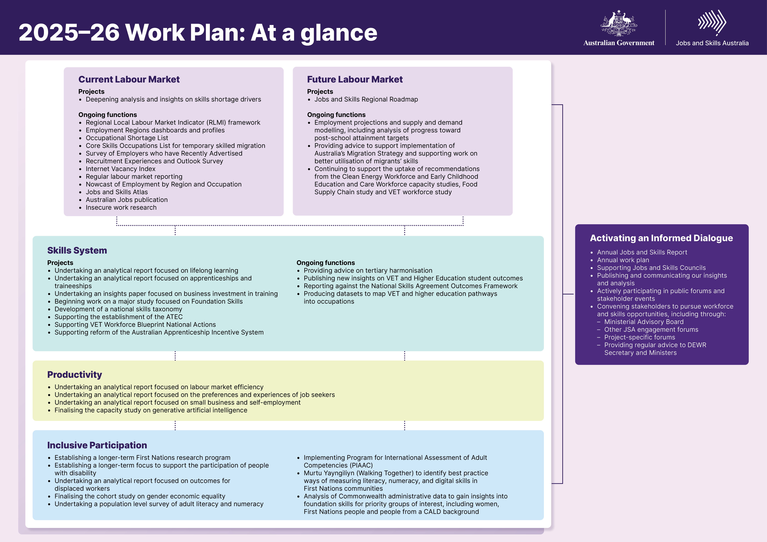
2025-26 Work Plan: At a glance
Current Labour Market | Projects  - Deepening analysis and insights on skills shortage drivers  Ongoing functions  - Regional Local Labour Market Indicator (RLMI) framework  - Employment Regions dashboards and profiles  - Occupational Shortage List  - Core Skills Occupations List for temporary skilled migration  - Survey of Employers who have Recently Advertised  - Recruitment Experiences and Outlook Survey  - Internet Vacancy Index  - Regular labour market reporting  - Nowcast of Employment by Region and Occupation  - Jobs and Skills Atlas  - Australian Jobs publication  - Insecure work research
Future Labour Market | Projects  Jobs and Skills Regional Roadmap  Ongoing functions  - Employment projections and supply and demand modelling, including analysis of progress toward post‑school attainment targets  - Providing advice to support implementation of Australia’s Migration Strategy and supporting work on better utilisation of migrants’ skills  - Continuing to support the uptake of recommendations from the Clean Energy Workforce and Early Childhood Education and Care Workforce capacity studies, Food Supply Chain study and VET workforce study
Skills System | Projects  - Undertaking an analytical report focused on lifelong learning  - Undertaking an analytical report focused on apprenticeships and traineeships  - Undertaking an insights paper focused on business investment in training  - Beginning work on a major study focused on Foundation Skills  - Development of a national skills taxonomy  - Supporting the establishment of the ATEC  - Supporting VET Workforce Blueprint National Actions  - Supporting reform of the Australian Apprenticeship Incentive System  Ongoing functions  - Providing advice on tertiary harmonisation  - Publishing new insights on VET and Higher Education student outcomes  - Reporting against the National Skills Agreement Outcomes Framework  - Producing datasets to map VET and higher education pathways into occupations
Productivity | - Undertaking an analytical report focused on labour market efficiency  - Undertaking an analytical report focused on the preferences and experiences of job seekers  - Undertaking an analytical report focused on small business and self-employment  - Finalising the capacity study on generative artificial intelligence
Inclusive Participation | - Establishing a longer-term First Nations research program  - Establishing a longer-term focus to support the participation of people with disability  - Undertaking an analytical report focused on outcomes for displaced workers  - Finalising the cohort study on gender economic equality  - Undertaking a population level survey of adult literacy and numeracy  - Implementing Program for International Assessment of Adult Competencies (PIAAC)  - Murtu Yayngiliyn (Walking Together) to identify best practice ways of measuring literacy, numeracy, and digital skills in First Nations communities  - Analysis of Commonwealth administrative data to gain insights into foundation skills for priority groups of interest, including women, First Nations people and people from a CALD background
Activating an Informed Dialogue | - Annual Jobs and Skills Report  - Annual work plan  - Supporting Jobs and Skills Councils  - Publishing and communicating our insights and analysis  - Actively participating in public forums and stakeholder events  - Convening stakeholders to pursue workforce and skills opportunities, including through:  - Ministerial Advisory Board  - Other JSA engagement forums  - Project-specific forums  - Providing regular advice to DEWR Secretary and Ministers

