


All content is provided under a Creative Commons Attribution 4.0 International Licence with the exception of:
- content supplied by third parties
- the Commonwealth Coat of Arms
- material protected by a trademark
- any images and/or photographs.
Details of the Creative Commons BY 4.0 licence are available on the Creative Commons website.
Use of all or part of any material on this website must include the following attribution:
© Commonwealth of Australia
Terms under which the Commonwealth Coat of Arms can be used are set out on the Department of the Prime Minister and Cabinet website.
Attribution
You may link to this website at your full expense and responsibility. In doing so you must not alter any of the website's contents, frame or reformat the files, pages, images, information and materials from this website on any other website. We reserve the right to prevent linking.
Other use
If you want to use material on this website in a way that is beyond the scope of the terms of use that apply to it, ask us for authorisation. You could infringe our copyright if you use anything on this website in a way that is not permitted or otherwise allowed under the Copyright Act 1968 (Cth).
Please email copyright@dewr.gov.au or address requests and enquiries to:
The Copyright Officer
Department of Employment and Workplace Relations
GPO Box 9828 Canberra ACT 2601.

JSA acknowledges and thanks the Australian Centre for Student Equity and Success (ACSES), Social Research Centre, Department of Education, Department of Employment and Workplace Relations, Engineers Australia, and Australian Education Union for their input and feedback on this report, as well as contributors Victor Gomez, Shekhar Singh and Wenze Lu and lead authors Tram Le, Athos Nicolaou and Natasha Yemm.

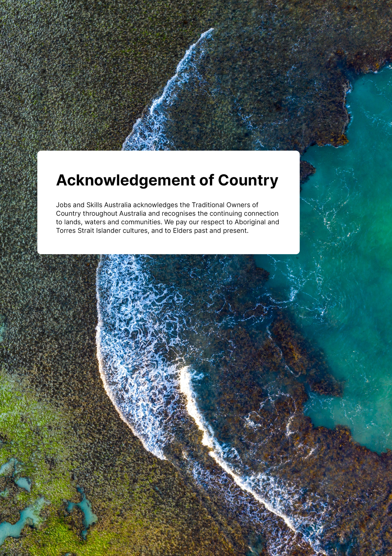
Contents
Executive Summary 4
In brief 5
Detailed methodology and findings 13
Research purpose 13
Data sets 13
Higher Education Outcomes 15
Work Status 15
Employment Income 16
Income Progression 19
Undergraduate and postgraduate income 21
Career pathways 26
Occupation transitions 26
Longitudinal career tracking 33
Higher education as an upskilling pathway 36
Next Steps 40
Conclusion 40
Appendix A: Higher education data overview 41
Appendix B: Sample used in labour market analysis and other sampling considerations 45
Appendix C: Variables and description 47
Appendix D: Business income 49
Appendix E: Undergraduate and postgraduate employment and earnings 51

Figure 1: Percentage of individuals who graduated between 2010 and 2017 who had evidence of wage/salary work in Tax data. 6
Figure 2: Wage/salary income of graduates 6
Figure 3: Wage/salary work and income by top 50 fields of education by total graduates five years post completion 7
Figure 4 Top 30 fields of education with highest median annual income growth between 1-5 years post completion 8
Figure 5: Top 30 fields of education with the largest difference in median annual income between undergraduates and postgraduates after five years 9
Figure 6: Percentage of graduates employed in the top three most common occupational groups for each field of study one year after graduation 10
Figure 7: Occupations of people with Information Technology qualifications 11
Figure 8: Flows of people with Information Technology undergraduate degrees between occupations 12
Figure 9: Person Level Integrated Data Asset 14
Figure 10: Wage/salary work among individuals who graduated between 2010 and 2017 16
Figure 11: Employment income of graduates 17
Figure 12: Paid work and income by top 50 fields of education by total graduates five years post completion 18
Figure 13: Top 30 fields of education with the highest median annual income growth between 1-5 years post completion 19
Figure 14: 30 fields of education with lowest median annual income growth between 1-5 years post completion 20
Figure 15: Top 30 fields of education with the largest difference in median annual income between undergraduates and postgraduates after five years 22
Figure 16: 30 fields of education with the lowest difference in median annual income between undergraduate and postgraduates after five years 23
Figure 17: Undergraduate and Postgraduate employment income distributions for Engineering and Related Technologies 25
Figure 18: Distribution of graduates by fields of education and occupations one year post completion 28
Figure 19: Distribution of graduates by fields of education and occupations five years post completion 29
Figure 20: Occupations of people with Information Technology qualifications 31
Figure 21: Occupations of people with Teacher Education: Secondary qualifications 1 and 5 years post completion 32
Figure 22: Flows of Teacher Education: Secondary graduates between occupations 33
Figure 23: Flows of people with Information Technology undergraduate degrees between occupations 35
Figure 24: Top 10 transitions from lower skilled to higher skilled occupations between one and three years post completion 37
Figure 25: Top 10 transitions from lower skilled to higher skilled occupations between three-and five-years post completion 39
Figure 26: Annual total number of commencements and completions 2010-2017 42
Figure 27: Postgraduate completions by broad fields of education 2011-2017 43
Figure 28: Postgraduate completions by broad fields of education 2010-2017 44
Figure 29: Median undergraduate employment and earnings for top 40 narrow fields of education by study volume 52
Figure 30: Median postgraduate employment and earnings for top 40 narrow fields of education by study volume 53

Executive Summary
This research tracks labour market outcomes for people who completed a higher education qualification, including transitions from study into work and longer-term career progression. The study is designed to fill knowledge gaps and set up a program of work on student outcomes to support a high-quality, inclusive higher education system that meets Australia’s current and future needs. The Report uses the Personal Level Integrated Data Asset (PLIDA) to construct a profile of higher education graduates’ transitions and progression from study into work.

Key Findings
 | Linked longitudinal administrative data can provide detailed, long-term insights to support policy development.
 | Higher education leads to strong labour market outcomes across a diverse range of careers.
 | Graduate’s incomes jumped 35% in their first five years — from $63,500 to $85,500 — with Mining Engineering, Medical Studies, and General Medicine leading in both starting pay and growth.
 | Education and Engineering degrees show strong qualification-to-career alignment — 72% of Education graduates became teachers and 60% of Engineering graduates entered professional engineering roles.
 | Degrees in Management, Commerce, and Society & Culture unlock broad career pathways — graduates entered over 70 distinct occupational groups, highlighting strong employment versatility.
 | Postgraduate qualifications can boost earnings — e.g. Business graduates earn a median of $54,800 more annually than their undergraduate counterparts.
Our findings show that completing a higher education qualification leads to improved labour market outcomes. Students can use our findings together with existing data to better understand the potential links between fields of education and occupation and income, which could inform their choices in higher education. Universities can draw on this material to strengthen industry linkages. Industry and policy makers can apply the findings in workforce planning.
Our research highlights the diversity among students, underscoring the intricate connections between higher education and employment pathways. To address labour supply, productivity and economic wellbeing, we need to understand how students’ choices are shaped and how we can use administrative data to unpack these complex linkages.
This report is the first in an ongoing stream of work on higher education. It explores administrative data, highlighting examples of the value it provides in investigating individuals’ higher education journeys, their work activities after graduation and long-term career progressions.

In brief

Introduction
Jobs and Skills Australia's legislative functions include providing advice on Australia's current, emerging and future labour market, skills and training needs. The higher education sector has and will continue to play an important role in the supply of skilled workers and meeting Australia's future skills needs. Over 90% of the employment growth over the next 10 years is estimated to be in occupations associated with post-secondary qualifications. However, the proportion of the projected growth in occupations related to a bachelor's degree or higher is projected to fall from 51% to 49%. Considering the changing demand for skills, it is useful to undertake research into higher education graduates and their labour market outcomes.
This project uses Personal Level Integrated Data Asset (PLIDA) data to address the sample size and longitudinal constraints associated with survey data. In collaboration with the Australian Centre for Student Equity and Success (ACSES), the research will be conducted in multiple phases. Phase 1 explores linked administrative data to build a longitudinal overview of higher education graduates and their transition into and through the labour market (work status, occupation and income).

Employment and income
By linking student’s higher education data to their tax data, we can get some information about their labour market outcomes. This is an indication only and must be interpreted with caution because an absence of evidence of employment in tax data does not necessarily indicate unemployment as defined by official statistics and surveys.
One year post-completion, evidence of wage/salary work could be found for 92% of graduates in our cohort. This percentage decreased over time. This may suggest some individuals who completed a higher education qualification (hereafter referred to as graduates) moved from employee income to business income, left the workforce or left Australia.
Figure 1: Percentage of individuals who graduated between 2010 and 2017 who had evidence of wage/salary work in Tax data

Source: Australian Bureau of Statistics, Person Level Integrated Data Asset (PLIDA).
For further discussion see page 16.
Graduate income from employment increased over time, rising by 35% over the first five years after graduation. Income levels differed significantly across different fields of education.
Figure 2: Wage/salary income of graduates

Source: Australian Bureau of Statistics, Person Level Integrated Data Asset (PLIDA).
For further discussion see page 17.
Figure 3 shows the 50 most common fields of education by the percentage share of graduates who were in wage/salary work five years post completion and their median employment income. The weighted average income across all fields of education was $84,800 and the average of the median percentages of graduates who were in wage/salary work in each field was 91%.

Figure 3: Wage/salary work and income by top 50 fields of education by total graduates five years post completion
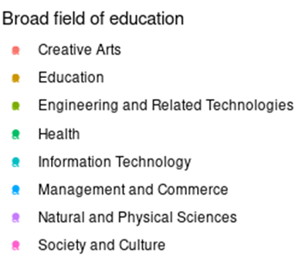
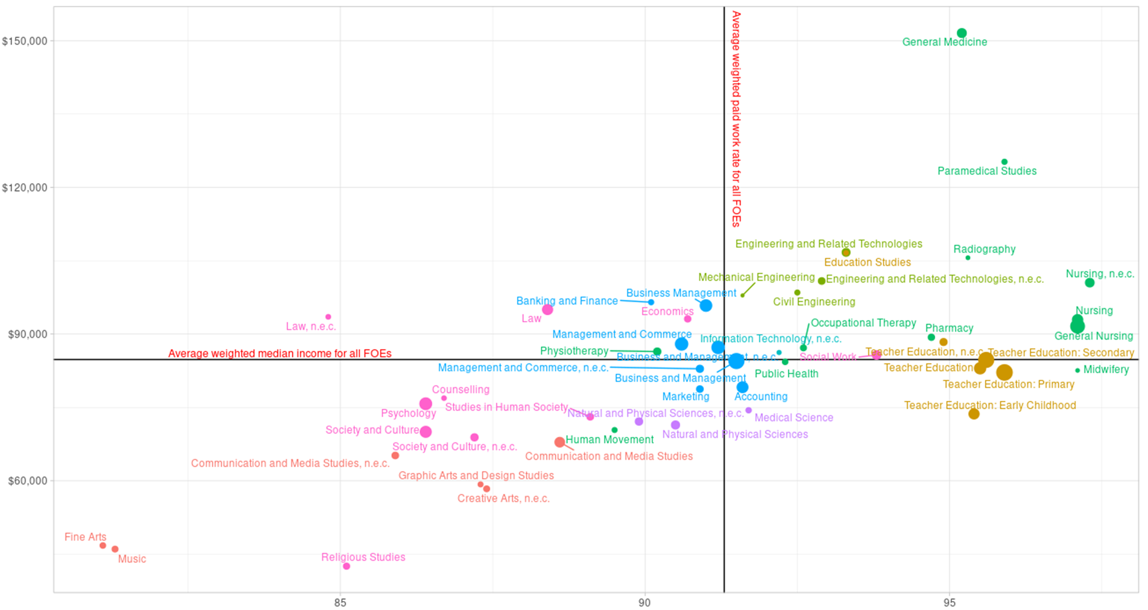
Average weighted employment rate for all FOEs
Graduate employment earnings 5 years after completion
Percentage of graduates with evidence of employment 5 years after completion

Source: Australian Bureau of Statistics, Person Level Integrated Data Asset (PLIDA). For further discussion see page 18.

Figure 3 shows that median incomes and employment rates for graduates in Management and Commerce and Information Technology fields of education tended to cluster around the average. Health fields tended to have above average employment rates, and some had high median incomes. Society and Culture and Creative Arts fields tended to have lower median incomes and employment rates.
Graduates in some fields of education saw substantial growth in employment income over the five years following graduation. Figure 4 shows the top 30 fields of education that had the highest median income growth between one and five years post completion.
The top three fields of education associated with a relatively high starting median annual income and a high median annual income in year five were Mining Engineering, Medical Studies and General Medicine. Graduates in fields like Geology and Actuarial Studies saw substantial growth from lower starting incomes.
Figure 4 Top 30 fields of education with highest median annual income growth between 1-5 years post completion

Source: Australian Bureau of Statistics, Person Level Integrated Data Asset (PLIDA).
For further discussion see page 19

There was a substantial difference in employment earnings between undergraduates and postgraduates, but this varied significantly between fields of study. Therefore, the actual premium associated with higher levels of education may need further exploration, to determine the actual causal effect of postgraduate education on income. Figure 5 shows the top 30 fields of education with the largest difference in employment earnings between people with undergraduate and postgraduate degrees. These included a range of business management fields, education, engineering and science related fields. Overall, these findings may indicate a larger premium associated with postgraduate education compared to undergraduate education. However, other factors such as prior work experience, informal learning and current work status that may contribute to this difference in income and further analysis is required to determine the exact benefit of completing a postgraduate degree compared to an undergraduate degree in a specific field.
Figure 5: Top 30 fields of education with the largest difference in median annual income between undergraduates and postgraduates after five years
Source: Australian Bureau of Statistics, Person Level Integrated Data Asset (PLIDA).
See page 22 for more discussion

Career Pathways
By linking multiple years of tax data, we can track graduates’ careers over time. Some fields of study seem to prepare graduates for a wide range of careers, whereas others see graduates concentrated in specific occupations.
Figure 6 provides an indication of the range of occupations entered by graduates one year after their studies by showing the percentage of graduates working in the three most common occupational groups for each Broad Field of Study. The highest concentration was amongst Education graduates, 72% of whom became School Teachers, with no other occupational group accounting for more than 4%. Engineering and Related Technologies had the second highest concentration of graduates in an occupational group behind Education, with 60% of graduates working as Engineering Professionals.
Figure 6: Percentage of graduates employed in the top three most common occupational groups for each field of study one year after graduation
Source: Australian Bureau of Statistics, Person Level Integrated Data Asset (PLIDA).
See page 26 for more discussion
Over time, the proportion of graduates working in occupations related to their studies increased as did the numbers working in more senior roles. For example, Figure 7 shows the percentages of graduates in Information Technology in different occupation types one and five years after graduation. Graduates worked in a range of other ICT related occupations in year one, with the percentages in most of these categories increasing by year five. In year one, the largest group of graduates (35%) were working in the occupation Minor Group Business and Systems Analysts and Programmers; by year five, this had increased to 36%. In year one, 21% of graduates were working in other occupations less related to Information Technology; by year five, this category had reduced to 18%.
Figure 7: Occupations of people with Information Technology qualifications
Source: Australian Bureau of Statistics, Person Level Integrated Data Asset (PLIDA).
See page 31 for more discussion
Technicians
7%
Technicians
10%
Managers
7%
Professionals
57%
Professionals
55%
Figure 8 draws on longitudinal data to show the career pathways of individual people with undergraduate Information Technology qualifications. It shows flows of some graduates moving into occupations more closely related to their studies and others moving into more senior roles. In general, the majority of movement between year one and year five was towards either more technical or more managerial occupation groups.
This discussion of the flow of Information Technology graduates through the labour market is provided as a case study to demonstrate the potential uses of longitudinal linked administrative data. The Detailed Methodology and Findings section of this report includes examples of other sectors and student cohorts.
Figure 8: Flows of people with Information Technology undergraduate degrees between occupations
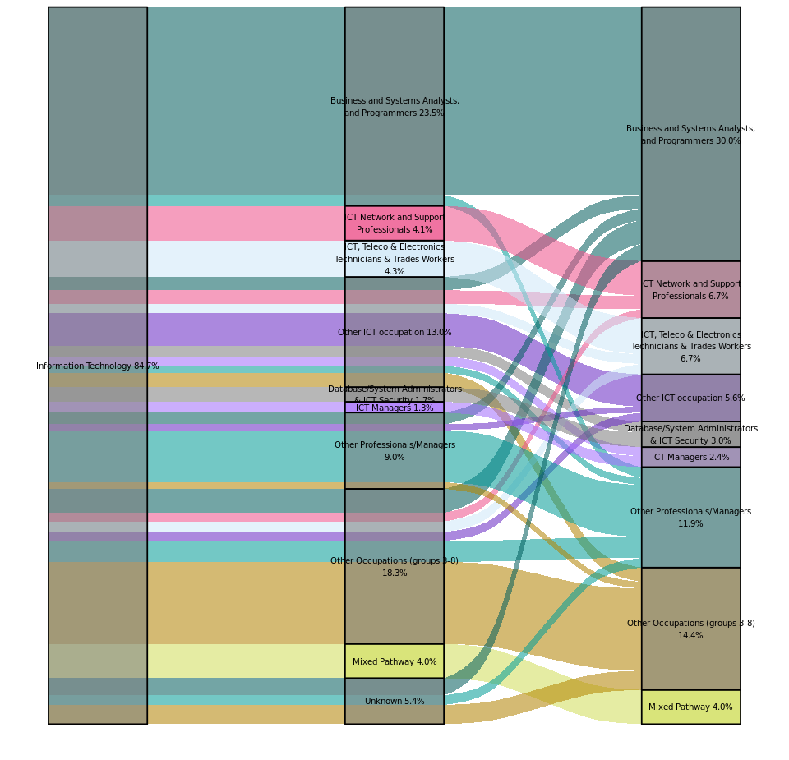Note: “Other ICT occupations” aggregates individuals who moved across diverse ICT occupations between years 1 and 5 post-graduation. See page 35 for more discussion
Source: Australian Bureau of Statistics, Person Level Integrated Data Asset (PLIDA).
Occupation in year five
Occupation in year one
Study field of education

The Power of Administrative Data
This Report provides an overview of occupation transitions and income progression of higher education graduates. Administrative data allows us to drill down to a finer level of detail and track students for longer than existing survey data. We have shown there are multiple pathways graduates can take from higher education into work and the potential income associated with completing undergraduate and postgraduate degrees.
While there are constraints with administrative data, the value adds far outweigh these limitations. The power of longitudinal administrative data increases as more years of data and data sources become available. This will give us a very rich data asset to examine transitions and progression of individuals in relation to labour supply and economic outcomes.

Detailed methodology and findings

Research purpose
This research tracks the outcomes of individuals who completed a higher education qualification (hereafter referred to as graduates), including transitions from study into work and long-term career progression, using data from the Personal Level Integrated Data Asset (PLIDA). The study is designed to fill knowledge gaps and set up a program of work on student outcomes to support a high-quality, inclusive higher education system that meets Australia’s current and future needs.
The research will be conducted in multiple phases and in collaboration with the Australian Centre for Student Equity and Success (ACSES). Phase 1 has involved building a longitudinal overview of higher education graduates and their transition into the labour market (work status, occupation and income). Future phases of research will focus on cohort analysis, in particular students who are historically underrepresented in higher education, their transition into the labour market and their progression.

Data sets
Survey data provide rich sources of information on higher education graduates and their background, where they work and what they earn. However, small sample sizes, attrition rates and short coverage limit longitudinal research into the transitions of graduates over extended periods of time.
This project uses PLIDA data to address the sample size and longitudinal constraints associated with survey data. PLIDA is a linked administrative data asset that is accessed via the Australian Bureau of Statistics' (ABS) secure DataLab environment.
Figure 9 shows the processes involved in PLIDA. The ABS collects data from different sources (e.g., income tax data from the Australian Taxation Office (ATO), higher education data from the Department of Education (DOE)) as well as ABS survey data; and prepares the data for linkage. The ABS creates a unique individual identifier called the Person Linkage Spine to link different data sources. Once the data are deidentified and assembled, they are available as assembled extracts or tables to approved analysts in the DataLab. Analysts must follow strict rules to successfully request data to be extracted for sharing and publication outside of the DataLab. This ensures the information is kept secure and no person or organisation can be identified in the output.
Figure 9: Person Level Integrated Data Asset

Peoples’ work and education
Government
data
Deidentified and combined
Linked
Analysis
Insights
For this project, we used DOE's administrative higher education data. The data asset includes enrolments and completions from 2005 to 2021. This data asset contains for example, demographic characteristics (gender, country of birth, disability status), main language spoken at home, parents' education attainment, location of residence, field of education and level of education. This data asset is linked with data from the ATO from 2010-11 to 2022-23 using the Person Linkage Spine.
The ATO data asset used in this project is the Personal Income Tax (PIT) data, which comprises the Payment Summary (PS) and individual’s Income Tax Returns (ITR) datasets. Occupation data are obtained from ITR data, while income data are obtained from both ITR and the PS data.
By linking higher education and ATO data, we can explore labour market outcomes of individuals prior to and post completion. In addition, the data enable us to explore occupation transitions and income progression post completion.
The higher education population in scope for this project is students with a Commonwealth Higher Education Student Support Number (CHESSN) who completed a qualification between 2010 and 2017. For more information on this population, including total enrolments and completions please see Appendix A: Higher education data overview.

Higher Education Outcomes
The population in scope for this labour market analysis is higher education students who completed an award course qualification at any time between 2010 and 2017. This allows the analysis to be undertaken with at least five years of data post completion. See Appendix B: Sample used in labour market analysis and other sampling considerations.
In this section we first look at graduates’ post completion work status to provide an overview of what graduates do in the immediate (one year) to short-term (three and five year) periods after completing their degree. We then delve into occupation outcomes of graduates to explore how graduates transition into work and their occupations. Finally, we explore graduates’ incomes over time to see how they fare financially across field of education and level of education.

Work Status
By linking student’s higher education data to their tax data, we can get some information about their labour market outcomes. This is an indication only and must be interpreted with caution because:
- Not everyone submits a tax return (for example, some people do not submit because their income is below the tax-free threshold).
- Some people may report all income as business income or part as business income and part as wage/salary income. The income measure here does not include income from business. More information on business income is in Appendix D: Business income.
- An absence of evidence of employment in tax data does not necessarily indicate unemployment as defined by official statistics and surveys.
We constructed a proxy variable for work status Wage/salary work. This captures graduates with an identifiable occupation and an annual income greater than zero, or graduates who have an annual income greater than zero but do not have an identifiable occupation for the relevant year (see Appendix B: Sample used in labour market analysis and other sampling considerations for further details).
Because measurement of work status was not straightforward using administrative data, it will be refined in future phases of this research. For example, future work may include analysis of Department of Social Services income support data. In addition, we could investigate the different channels through which income was received to fine tune working status and include a wider coverage of earnings outcomes.
Our proxy for work status is not the same as the measures of employment, unemployment or not in the labour market from other surveys including the ABS Labour Force Survey, Census of Population and Housing, or Quality Indicators for Learning and Teaching (QILT) Graduate Outcomes Survey – Longitudinal; and should not be used for direct comparison. For example, the ABS defines employment based on one or more hours of work per week regardless of whether the work was paid or unpaid or whether the person was a wage/salary earner or self-employed. We do not have access to administrative data on hours worked or self-employment status from the tax data, hence we cannot apply the same measure of employment as the ABS.
Figure 10 shows the work status for students (undergraduates and postgraduates) who completed their qualifications at any time between 2010 and 2017. One year post completion, 92% of graduates were in wage/salary work but this fell between three and five years post completion. This could partly reflect graduates leaving the country, leaving the workforce or not being captured because they have reported a business income only.
Figure 10: Wage/salary work among individuals who graduated between 2010 and 2017

Source: Australian Bureau of Statistics, Person Level Integrated Data Asset (PLIDA).

Employment Income
Several factors can affect individuals’ income such as hours worked, part time versus full-time status, the number of years spent working, occupation or industry, to name a few. We have not estimated the income equation to obtain the impact of completing a qualification in a specific field of education, while controlling for these factors. Instead, for this phase of research, we have shown general trends that can be observed in our data. Our analysis is limited to data availability, and we do not have access to hours worked or part time versus full time status. It is likely that the trends observed in our data reflect these factors.
Graduate income from employment increased in real terms over time, rising by 35% over the first five years after graduation. Real average annual employment income across all graduates in the sample was $63,466 one year after graduation, $75,653 three years after graduation and $85,557 five years after graduation. Because no data is available on hours worked, we are not able to account for changes in hours worked as a possible factor contributing to higher average income among graduates over time.
Figure 11: Employment income of graduates

Source: Australian Bureau of Statistics, Person Level Integrated Data Asset (PLIDA).
Income levels differed significantly across different fields of education. Figure 12 shows the top 50 fields of education by the percentage share of graduates with employment income against their median income five years post completion. The horizontal axis measures the percentage share of graduates who were in wage/salary work. The vertical axis measures their weighted average median annual income. The sizes of the bubbles represent the number of graduates who completed a qualification in the field of education with a larger bubble showing a higher number of graduates compared to a smaller bubble. The sample for median income only includes graduates who continuously reported above zero annual wage income post completion.
Health and Engineering and Related Technologies fields appear in the top right quadrant, indicating they had above average median incomes and higher rates of graduates who were in wage/salary work. Education fields appear mostly in the bottom right quadrant. At the broad level, Education had above average median rates of graduates who were in wage/salary work, but below average median annual employment incomes.
General Medicine (upper right-hand quadrant) had a high median income ($152,000) and above median rates of graduates who were in wage/salary work at around 95%.
In the bottom left-hand quadrant, Fine Arts and Music had a low rate of students in wage/salary work (82%) and median employment incomes under $48,000. This may be partly because graduates are earning business income rather than salaries. In tax return data around 14% of Music and Fine Arts graduates reported business income only and a further 17% (Fine Arts) and 25% (Music) graduates reported both employee and business income. For further information on business income see Appendix D: Business income.
There are also differences in labour market outcomes between undergraduates and postgraduates. For some fields of education, postgraduate study is associated with higher employment income and higher percentages of graduates in wage/salary work. For further information see Appendix E: Undergraduate and postgraduate employment and earnings.
Figure 12: Paid work and income by top 50 fields of education by total graduates five years post completion
Average weighted employment rate for all FOEs
Graduate employment earnings 5 years after completion
Percentage of graduates with evidence of employment 5 years after completion

Source: Australian Bureau of Statistics, Person Level Integrated Data Asset (PLIDA).

An area of further exploration and analysis is assessing if there is a difference between male and female graduates in each field of education when comparing evidence of employment and earnings 5 years post-completion. This may provide insights into which fields may have the greatest gender differences in employment outcomes.

Income Progression
Graduates in some fields of education saw substantial growth in employment income over the five years following graduation. Figure 13 shows the top 30 fields of education that had the highest median income growth between one and five years post completion. The top three fields of education associated with a relatively high starting median annual income (between $106,000 and $120,000) were Mining Engineering, Medical Studies and General Medicine. Of these, General Medicine and Mining Engineering reported the highest annual median income growth by the 5th year, with employment income of around $152,000.
Figure 13: Top 30 fields of education with the highest median annual income growth between 1-5 years post completion
Source: Australian Bureau of Statistics, Person Level Integrated Data Asset (PLIDA).
At the lower end of Figure 13 are Other Health and Human Movement, with median incomes of $31,840 and $33,740 respectively one-year post completion, rising to $63,870 and $70,390. The lower income observed could reflect several things including hours worked. According to the 2021 Census, around 15% of graduates in Human Movement worked between one and 19 hours a week, a further 19% worked between 20 and 34 hours a week and 67% worked at least 35 hours a week. In comparison, around 5% of graduates in Mining Engineering worked between one and 19 hours a week, 7% worked between 20 and 34 hours a week and 81% worked at least 35 hours a week.
A field of education with noticeable median income growth in percentage terms was Insurance and Actuarial Studies, whose median starting salary increased by 64% from $72,780 to $119,170. Similarly, the median annual income of Geology graduates grew by 68% from $68,750 in year one to $115,270 in year five.
Graduates in some fields of education saw minimal growth. Figure 14 shows the 30 fields of education with the lowest median annual employment income growth over five years. Median incomes for Public and Health Care Administration graduates increased by 7% from the relatively high first year median of $120,000 to $128,000. The median income for Religious Studies graduates increased from $40,000 to $43,000.
Figure 14: 30 fields of education with lowest median annual income growth between 1-5 years post completion

Source: Australian Bureau of Statistics, Person Level Integrated Data Asset (PLIDA).
Gender differences in income progression
There were gender differences in the level of income progression over the five years following completion for graduates in most fields of education. Across all fields of education, the average five year income progression was $79,640, a 30% increase, for women and $95,274, a 42% increase for men. The weighted average gender income gap across all fields of education was $5,750 one year after graduation. This rose to $15,635 five years after graduation.
Median employment income for female Mining Engineering graduates was $2,500 less than their male counterparts after one year. Five years post completion, this gap had increased to $12,550. This could be partly due to gender differences in occupation. One year post completion, similar percentages of female and male graduates were working as Mining Engineers (excluding Petroleum) (46% and 44% respectively). Five years post completion, the percentage of female graduates who were working in the occupation had dropped to 38%, while the percentage of male graduates remained stable at 44%. More women (42%) were also working in non-engineering related occupations than men (18%) five years post completion.
A similar pattern was observed in Insurance and Actuarial Studies where median income was $4,741 higher for men one year post completion and $9,690 higher five years post completion. One year post completion 15% of men were working as Actuaries compared to 10% of women. While the percentage of graduates of both genders working in the occupation had increased by about a third, men were still more likely to be working in the occupation than women (20% compared to 14%).
Female graduates’ income grew faster than male graduates in only five of the largest 50 fields of education. Of these, Mechanical Engineering saw the largest positive change for females, where the five year income progression was $28,630 or 40% higher for females and $27,290 or 39% higher for males. More detailed discussion of gender pay differences can be found in Jobs and Skills Australia’s publication Education and Training Divides. Gendered skills, pathways and outcomes.

Undergraduate and postgraduate income
There was a substantial difference in earnings between those with undergraduate and postgraduate qualifications for some fields of education, but this varied considerably. Figure 15 shows the 30 fields of education with the largest difference in median annual income between undergraduates and postgraduates after five years. A postgraduate degree in Business Management or Business and Management not elsewhere classified (nec) showed a postgraduate income difference of $54,820 and $51,570, respectively. In comparison, a postgraduate degree in Mathematics returned a smaller median income difference of $21,230.
For some fields of education, there was a large difference in postgraduate income in percentage terms because median undergraduate employment income was relatively low. For example, median postgraduate income in Education Studies was $44,840 higher than the undergraduate median income of $64,690, this may reflect higher levels of part time work or different career stages. Visual Arts and Craft undergraduate median income was $46,060 and the postgraduate degree median income was $22,270 higher.
Figure 15: Top 30 fields of education with the largest difference in median annual income between undergraduates and postgraduates after five years
Source: Australian Bureau of Statistics, Person Level Integrated Data Asset (PLIDA).
The fields of education with the lowest median income differences between undergraduates and postgraduates are shown in Figure 16. Medical Studies, Building Construction Management, Occupational Therapy, Teacher Education: Primary and General Medicine were some of the fields of education where PLIDA data seems to indicate lower median employment incomes for postgraduates. It should be noted that postgraduate training provided outside of Australian higher education institutions, such as through specialist medical colleges, does not appear in these data, so some people who appear in the undergraduate category in this analysis will have completed postgraduate studies elsewhere. It is also likely that some graduates are receiving business income rather than employment income. For further information, see Appendix D: Business income.
Figure 16: 30 fields of education with the lowest difference in median annual income between undergraduate and postgraduates after five years
Source: Australian Bureau of Statistics, Person Level Integrated Data Asset (PLIDA).
While the median income is useful to gauge overall differences in income between undergraduate and postgraduate studies, analysing income along the entire distribution can show where the income difference between undergraduate and postgraduate study is likely to be most noticeable and enable us to have a deeper understanding of the potential impact of the level of education on income.
In particular, the income gain associated with a postgraduate completion could be substantial for those at top of the income distribution. For example, the income gain five years post completion for postgraduates at the 95th percentile of the income distribution in General Medicine was $135,760, Medical Studies $52,940, Occupational Therapy $11,180 and Building Construction Management $10,910.
The results suggest the potential income gain from a postgraduate qualification was at the upper end of the distribution rather than improving employment income for graduates at the lower end of the distribution. The observed income differences along the distribution could be due to differences in hours worked, occupation or sector of employment.
Age differences between undergraduates and postgraduates
Differences in earnings seen between undergraduates and postgraduates could be influenced by the age and career stage in which people undertake postgraduate study. There were noticeable differences in age during postgraduate study across fields of education.
In some fields of education like Law, graduates appear to progress straight from undergraduate to postgraduate study, which is likely to reflect additional qualifications required to become a practicing lawyer. The median completion age of a Law undergraduate qualification is 24 years and the commencement age for a postgraduate is 25 years.
For other fields of education, undergraduates may work prior to undertaking postgraduate study. The median completion age for an undergraduate in Business Management is 23 years and the median commencement age for a postgraduate in the same field of education is 32 years.
This suggests the difference in income between undergraduates and postgraduates could partly reflect work experience or differences in career stages. The decision to undertake postgraduate studies could be influenced by several factors including demand for workers with additional qualifications as well as the opportunity and direct costs to the individuals pursuing further studies. This can be further explored in the next phase of research.

Figure 17 provides examples of the income distributions for fields of education in Engineering and Related Technologies five years post completion. The box plots graph an entire income distribution for each field of education. The box shows the range of income, with the middle or median 50% (solid line), the lower end of the box is the 1st quartile (25%) and the upper end is the 3rd quartile (75%). The dot inside the box is the average income. The bottom whisker (bottom T-shaped line) denotes the lowest 5th percentile and the top whisker (top T-shaped line) denotes the highest 95th percentile. The dotted line across all the boxes shows the median undergraduate annual income for the equivalent fields of education as a benchmark.
As shown in Figure 17, the 95th percentile income across all Engineering and Related Technologies fields of education for undergraduate degrees ranged from $147,000 to $216,000. The weighted median income across the four Fields of Education was around $105,000.
Among Engineering and Related Technologies, Environmental Engineering had the lowest income with most of the graduates’ income truncated around the median ($92,000) and the average income at $93,000 was at least $10,000 lower than the average income for the other three Fields of Education. Our data show that five-years-post completion, 32% of these graduates were working as Environmental Engineers and a further 79% as Environmental Consultants. In contrast, Mining Engineering graduates received the highest income with an average of $143,000 and median $149,000. Around 43% of these graduates were working as Mining Engineers (excluding petroleum).
Income distributions for people with postgraduate qualifications in Engineering and Related Technologies were higher than for those with undergraduate qualifications. The median income across the four Fields of Education was higher at $135,000. The 95th percentile income ranged from $182,000 to $300,000. As observed for undergraduate degrees, Environmental Engineering returned the lowest income. Completing a postgraduate degree in this field of education only raised median income to that of undergraduate degrees across all Engineering and Related Technologies. In addition, income was clustered around the median ($98,000). Postgraduate qualifications in Mining Engineering returned a median income of $160,000 and the 95th percentile was $300,000.
Figure 17: Undergraduate and Postgraduate employment income distributions for Engineering and Related Technologies
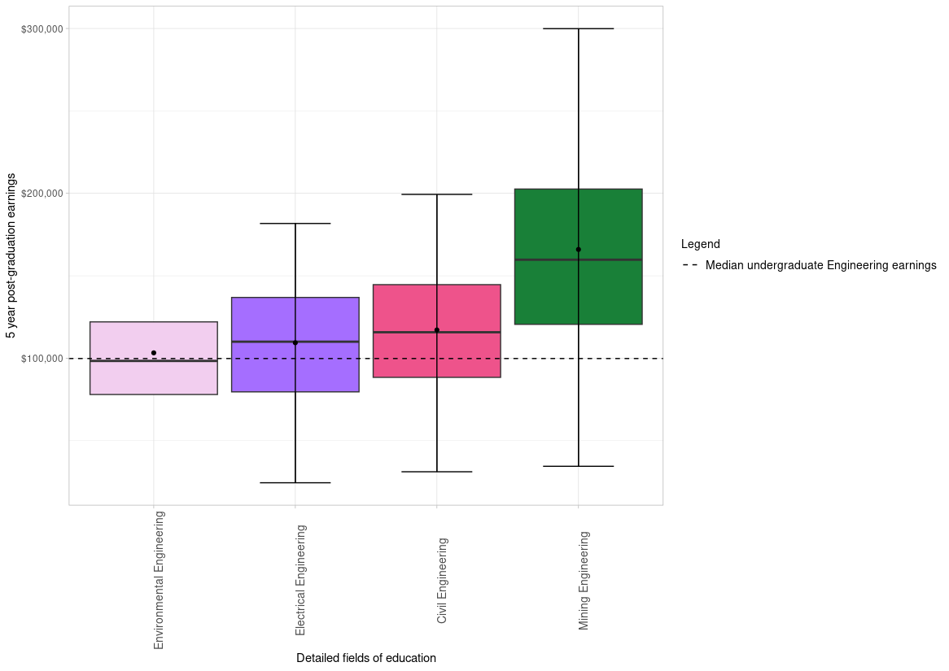
Environmental Engineering
Civil Engineering
Electrical Engineering
Mining Engineering
Postgraduate employment income
Undergraduate employment income
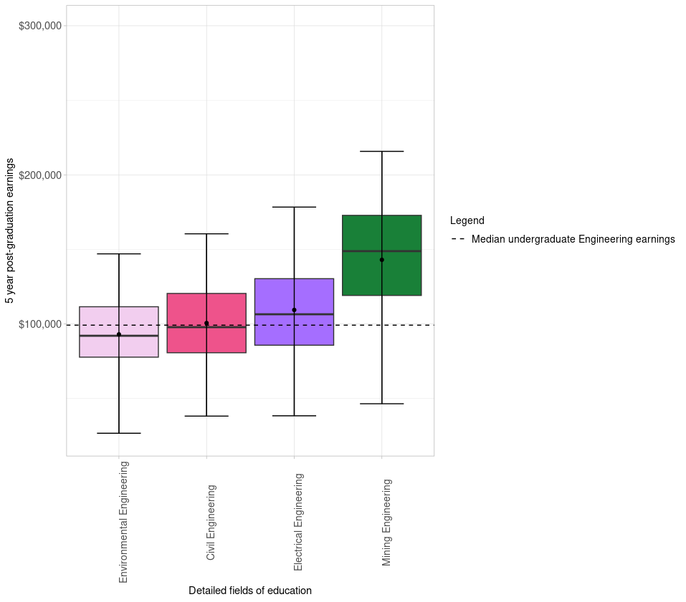
Employee earning 5 years post-graduation
Environmental Engineering
Civil Engineering
Electrical Engineering
Mining Engineering
$100,000
$200,000
$300,000
Source: Australian Bureau of Statistics, Person Level Integrated Data Asset (PLIDA).

Career pathways
By linking multiple years of tax data, we can track graduates’ careers over time. In this analysis, a graduate’s occupation outcome is based on the occupation reported in their ITR for the relevant year. Because tax data are coded to standardised occupation taxonomies, they do not capture different seniority levels within the same occupation. Promotion from a job can only be captured if a graduate moves up the occupation hierarchy, such as from a Human Resource Adviser to a Human Resource Manager.

Occupation transitions
Table 1 shows the overall spread of higher education graduates into occupations based on the broad field of education of their qualification. From the data we were able to extract from DataLab, Management and Commerce graduates had the highest spread of occupations in the first year after completion (81 occupation groups across 292 different individual occupations), while Information Technology graduates had a much narrower spread with only 36 different occupation groups across 76 occupations. However, there were large numbers of Management and Commerce graduates compared to other fields of education and the broad nature of these qualifications possibly influenced the wide variety of occupational pathways taken post completion across a larger cohort of graduates.
Table 1: Number of Occupation Minor Groups (ANZSCO 3-digit level) and Occupations (ANZSCO 6-digit level) by ASCED Field of Education of graduates who completed a higher education qualification between 2010 and 2017.
Broad Field of Education | Number of Minor Groups | Number of Occupations
Management and Commerce | 81 | 292
Natural and Physical Sciences | 73 | 190
Society and Culture | 70 | 265
Creative Arts | 69 | 177
Education | 58 | 151
Health | 55 | 205
Engineering and Related Technologies | 44 | 114
Agriculture, Environmental and Related Studies | 41 | 80
Architecture and Building | 38 | 77
Information Technology | 36 | 76
Source: Australian Bureau of Statistics, Person Level Integrated Data Asset (PLIDA).
While graduates in some fields of education worked across a wide range of occupation groups, they were not evenly spread across these groups. Figure 18 and Figure 19 show the percentages of graduates from each broad field of education who were working in different occupational groups one year and five years post completion, respectively.
While Education graduates entered 58 different occupation groups, Figure 18 shows that the majority (72%) of them became School Teachers, with no other occupational group accounting for more than 4%. Health graduates entered a similar number of occupational groups (55) but were more evenly spread between them with 38% working as Midwifery and Nursing Professionals, 14% as Health Therapy Professionals, 10% as Medical Practitioners and 9% as Health Diagnostic and Promotion Professionals.
Engineering and Related Technologies had the second highest concentration of graduates in an occupational group behind Education, with 60% of graduates working as Engineering Professionals. In comparison, Creative Arts had the lowest concentration of graduates working in a single occupation group, with 11% working as Sales Assistants and Salespersons. The highest concentration of Society and Culture graduates was in Social and Welfare Professionals occupations (16%) and the highest concentration of Management and Commerce graduates was in Accountants, Auditors and Company Secretaries (17%).

Figure 18: Distribution of graduates by fields of education and occupations one year post completion (%)
 | Natural and Physical Sciences | Information Technology | Engineering and Related Technologies | Architecture and Building | Agriculture, Environmental and Related Studies | Health | Education | Management and Commerce | Society and Culture | Creative Arts
Chief Executives, General Managers and Legislators |  |  | 1 | 1 | 1 |  |  | 3 | 1 | 1
Advertising, Public Relations and Sales Managers |  |  |  |  | 1 |  |  | 3 | 1 | 3
Business Administration Managers |  |  |  |  | 1 |  |  | 3 | 1
Construction, Distribution and Production Managers |  |  | 2 | 8 | 1 |  |  | 1
ICT Managers |  | 4 |  |  |  |  |  | 1
Arts Professionals |  |  |  |  |  |  |  |  |  | 3
Media Professionals |  |  |  |  |  |  |  |  |  | 7
Accountants, Auditors and Company Secretaries | 1 |  |  |  |  |  |  | 17 | 2
Human Resource and Training Professionals |  |  |  |  |  |  |  | 3 | 1
Information and Organisation Professionals | 2 | 4 | 1 | 1 | 2 |  |  | 4 | 3
Sales, Marketing and Public Relations Professionals | 1 | 1 |  |  | 1 |  |  | 5 | 2 | 7
Architects, Designers, Planners and Surveyors |  | 2 | 2 | 39 | 3 |  |  |  |  | 8
Engineering Professionals | 1 |  | 60 | 2 | 1 |  |  | 1
Natural and Physical Science Professionals | 22 |  | 1 |  | 35 | 3
School Teachers | 3 |  |  |  |  |  | 72 |  | 4 | 2
Tertiary Education Teachers | 4 | 2 | 2 | 1 | 1 | 1 | 3 | 1 | 2 | 1
Health Diagnostic and Promotion Professionals | 1 |  |  |  |  | 9
Health Therapy Professionals |  |  |  |  |  | 14
Medical Practitioners | 2 |  |  |  |  | 10
Midwifery and Nursing Professionals |  |  |  |  |  | 38
Business and Systems Analysts, and Programmers | 2 | 35 | 3 |  |  |  |  | 1
Database and Systems Administrators, and ICT Security |  | 4
ICT Network and Support Professionals |  | 8 | 2
Legal Professionals |  |  |  |  |  |  |  | 1 | 8
Social and Welfare Professionals |  |  |  |  |  |  |  |  | 16
Agricultural, Medical and Science Technicians | 7 |  |  |  | 1
Building and Engineering Technicians |  |  | 3 | 12
ICT and Telecommunications Technicians |  | 6
Electronics and Telecommunications Trades Workers |  | 3
Health and Welfare Support Workers |  |  |  |  |  | 5 |  |  | 4
Child Carers |  |  |  |  |  |  | 3 |  | 1
Hospitality Workers | 3 |  |  | 1 | 2 |  | 1 | 2 | 2 | 6
Contract, Program and Project Administrators | 1 | 1 | 1 | 4 | 3 |  |  | 2 | 3 | 1
General Clerks | 4 | 2 | 1 | 3 | 5 | 1 | 1 | 5 | 5 | 5
Accounting Clerks and Bookkeepers |  |  |  |  |  |  |  | 3
Financial and Insurance Clerks | 1 |  |  |  | 1 |  |  | 3 | 1
Miscellaneous Clerical and Administrative Workers |  |  |  |  |  |  |  | 1 | 3 | 1
Sales Assistants and Salespersons | 7 | 3 | 1 | 4 | 5 | 2 | 2 | 4 | 5 | 11
Farm, Forestry and Garden Workers |  |  |  |  | 3

Figure 19: Distribution of graduates by fields of education and occupations five years post completion (%)
 | Natural and Physical Sciences | Information Technology | Engineering and Related Technologies | Architecture and Building | Agriculture, Environmental and Related Studies | Health | Education | Management and Commerce | Society And Culture | Creative Arts
Chief Executives, General Managers and Legislators | 1 | 1 | 1 | 1 | 2 |  | 1 | 4 | 2 | 1
Farmers and Farm Managers
Advertising, Public Relations and Sales Managers | 1 |  |  | 1 | 1 |  |  | 5 | 1 | 4
Business Administration Managers | 1 |  |  |  | 1 |  |  | 4 | 2
Construction, Distribution and Production Managers |  |  | 4 | 9 | 1 |  |  | 1
ICT Managers |  | 5 |  |  |  |  |  | 1
Miscellaneous Hospitality, Retail and Service Managers |  |  |  |  | 1 |  |  | 3 | 1 | 1
Arts Professionals |  |  |  |  |  |  |  |  |  | 3
Media Professionals |  |  |  |  |  |  |  |  | 1 | 8
Accountants, Auditors and Company Secretaries | 1 |  |  |  |  |  |  | 17 | 2
Human Resource and Training Professionals | 0 |  |  |  |  |  |  | 3 | 2
Information and Organisation Professionals | 3 | 4 | 1 | 1 | 2 |  |  | 5 |  | 1
Sales, Marketing and Public Relations Professionals | 1 | 1 |  |  |  |  |  | 5 | 2 | 8
Architects, Designers, Planners and Surveyors |  | 1 | 2 | 41 | 3 |  |  |  |  | 9
Engineering Professionals | 1 |  | 56 | 2 | 1 |  |  | 1
Natural and Physical Science Professionals | 24 |  | 1 | 1 | 34 | 3
School Teachers | 3 |  |  |  |  |  | 74 |  | 4 | 2
Tertiary Education Teachers | 3 | 1 | 1 | 1 | 1 | 1 | 2 | 1 | 2 | 1
Health Diagnostic and Promotion Professionals | 1 |  |  |  | 1 | 9
Health Therapy Professionals |  |  |  |  |  | 14
Medical Practitioners | 2 |  |  |  |  | 9
Midwifery and Nursing Professionals |  |  |  |  |  | 38
Business and Systems Analysts, and Programmers | 3 | 36 | 4 |  |  |  |  | 1 |  | 1
Database and Systems Administrators, and ICT Security |  | 5
ICT Network and Support Professionals |  | 8 | 1
Legal Professionals |  |  |  |  |  |  |  | 1 | 8
Social and Welfare Professionals |  |  |  |  |  |  | 1 |  | 17
Agricultural, Medical and Science Technicians | 7 |  |  |  | 1
Building & Engineering Technicians |  |  | 2 | 9
ICT and Telecommunications Technicians |  | 5
Health and Welfare Support Workers |  |  |  |  |  | 5 |  |  | 3
Contract, Program and Project Administrators | 3 | 2 | 2 | 4 | 5 | 1 | 1 | 3 | 4 | 2
General Clerks | 3 | 1 |  | 2 | 4 | 1 | 1 | 3 | 4 | 3
Sales Assistants and Salespersons | 3 | 1 |  | 1 | 2 | 1 |  | 2 | 2 | 5
Source: Australian Bureau of Statistics, Person Level Integrated Data Asset (PLIDA). Note: Graduates without valid occupation five years post completion were removed and some data suppressed so columns do not add up to 100%.
As shown in Figure 19, five years post completion, the concentration of Health graduates working as Midwifery and Nursing Professionals remained unchanged. There was a slight increase in the concentration of Education graduates working as School Teachers (2 percentage points).
While the largest concentration of Engineering and Related Technologies graduates remained in Engineering Professionals, there was a slight decrease (56% compared to 60%) and an increase in those working as Construction, Distribution and Production Managers (4% compared to 2%).
While Creative Arts graduates remained distributed across a wide range of occupation groups, there was a decrease in the percentage working as Sales Assistants and Salespersons (5% compared to 11%) and small increases (1 percentage point each) in occupation groups related to creativity and design, such as Media Professionals, Architects, Designers, Planners and Surveyors and Sales; and Marketing and Public Relations Professionals. Some of the distribution of Creative Arts graduates is a function of the way creative professions are broken up across the ANSZCO Minor Groups resulting in smaller percentages in each.
The trends described above for Engineering and Related Technologies and Creative Arts graduates may indicate career progressions over the five year period, with graduates moving into more relevant or more senior occupations. Figure 20 shows the percentages of graduates in Information Technology in different occupation types one and five years after graduation. In year one, the largest group of graduates (35%) were working in the occupation Minor Group Business and Systems Analysts and Programmers; by year five, this had increased to 36%.
Graduates worked in a range of other ICT related occupations in year one, with the percentages in most of these categories increasing by year five. In year one, 21% of graduates were working in other occupations less related to Information Technology; by year five, this category had reduced to 17%.
Over the five years, there was a decrease in the percentage of graduates working in Technicians and Trades Workers roles, those that apply technical ICT specific skills, (from 10% to 7%) and small increases in those working as Managers (1 percentage point) and Professionals (2 percentage points). In ANZSCO, Manager roles are defined as those that involve planning, organising and directing activities within an organisation and Professional roles as those that perform analytical and conceptual tasks using ICT knowledge. These represent two potential career progression pathways – managerial and technical.
The Longitudinal career tracking section of this report (page 32) further explores this trend, using longitudinal data to show the pathways of individual Information Technology graduates between occupations.
Figure 20: Occupations of people with Information Technology qualifications
Technicians
7.2%
Professionals
57.2%
Managers
7.4%
Technicians
9.7%
Professionals
55.2%
Source: Australian Bureau of Statistics, Person Level Integrated Data Asset (PLIDA).
So far, occupation transitions have been discussed at the broad field of education and occupation minor group level. More occupation transitions can be seen when we zoom in to look at more detailed results.
Post-study occupations for the detailed field of education Teacher Education: Secondary follows a similar pattern of concentration to its parent broad field (Education). Figure 21 shows a high percentage of graduates (60%) working as Secondary School Teachers one year after completion and this increases to 63% five years after completion. The second most common single occupation was Primary School Teacher at just under 7% in both years one and five, and a similar percentage were working as other school teachers. Just under 5% were working as other education professionals. In year one, 14% were working in other occupations less related to teaching and education (across other managers professionals and other occupations); this reduced to 9% by year five.

Figure 21: Occupations of people with Teacher Education: Secondary qualifications
1 and 5 years post completion

Source: Australian Bureau of Statistics, Person Level Integrated Data Asset (PLIDA).
The following section, Longitudinal Career Tracking, uses longitudinal data to show the pathways of individual Teacher Education: Secondary graduates between occupations.

Longitudinal career tracking
Figure 22 demonstrates the power of linked longitudinal administrative data to track individuals over time, showing the pathways of people with undergraduate qualifications in Teacher Education: Secondary as they changed jobs. It shows the flows of graduates through the labour market over five years.
Figure 22: Flows of Teacher Education: Secondary graduates between occupations
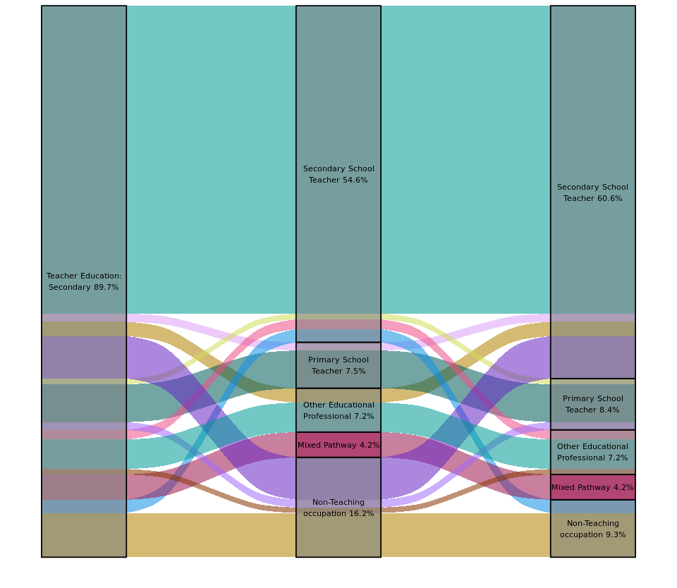
Study field of education
Occupation in year one
Occupation in year five
Source: Australian Bureau of Statistics, Person Level Integrated Data Asset (PLIDA).
Each ‘ribbon’ of colour represents the journey of a group of graduates. Of the 16% of graduates (2,570) in this cohort who were working in non-teaching occupations in year one, 42% (1,090) went on to work as Secondary School Teachers by year five; 8% (200) became Primary School Teachers and 5% (140) became Other Education Professionals. Of those working as Primary School Teachers in year one, 17% (210) became Secondary School Teachers by year five. Of the 54% working as Secondary School Teachers in year one, 8% (740) left the occupation to enter the following occupations: 2% (150) becoming Primary School Teachers, 3% (250) becoming Other Education Professionals and 4% (340) moving into non-teaching occupations.
While there was some movement between occupations for people who studied Teacher Education: Secondary, there was also considerable concentration in the Secondary School Teacher occupation. The same technique can also be used to show movement within broader categories and more distributed pathways.
To build on Figure 20 in the previous section (page 31), which shows static percentages of Information Technology graduates in different occupations one and five years post-graduation, Figure 23 draws on longitudinal data to show the career pathways of individual people with undergraduate Information Technology qualifications between occupation groups. It shows people entering the Business and Systems Analysts and Programmers occupation group in year 5 from the Other Occupations (groups 3-8) category (3%, 570) as well as from Other ICT occupations (2%, 320), and Other professionals and managers (1%, 280). People who left the Business and Systems Analysts and Programmers occupation group after year 1 most commonly became Other professionals and managers (1%, 260) in year 5. In general, the majority of movement between year one and year five was towards either more technical or more managerial occupation groups.
Figure 23: Flows of people with Information Technology undergraduate degrees between occupations
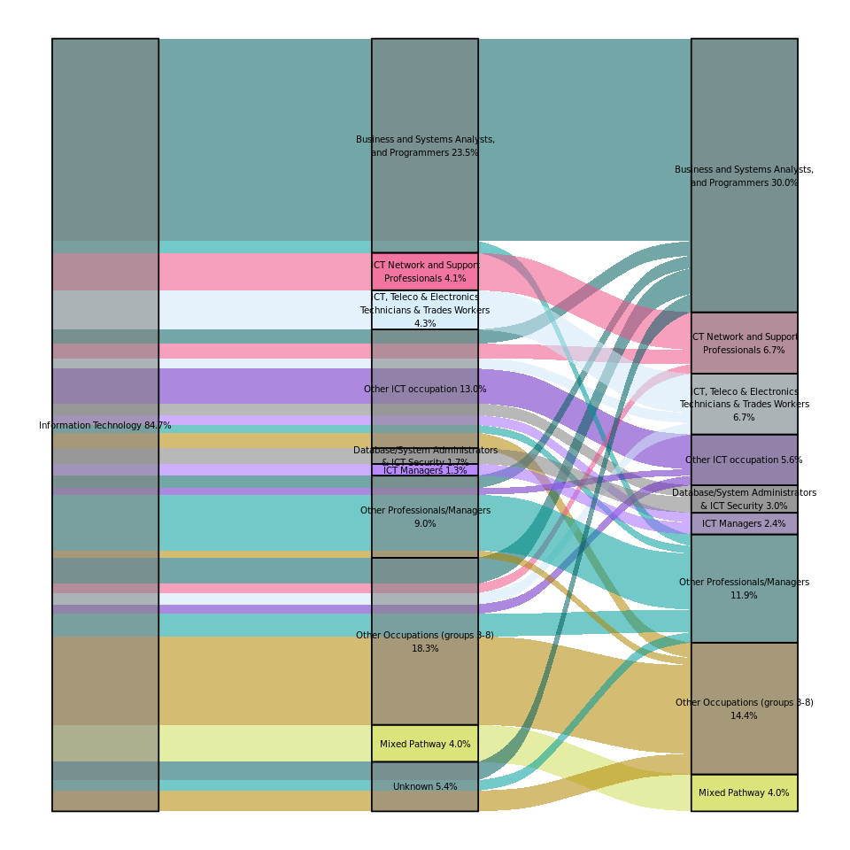
Occupation in year five
Occupation in year one
Study field of education
Source: Australian Bureau of Statistics, Person Level Integrated Data Asset (PLIDA).

Higher education as an upskilling pathway
While a high percentage of students enter higher education directly after completing their secondary education, there is a notable group that seem to have already entered their careers and are using higher education to grab the next rung on the career ladder. Our data also indicate that a small but notable cohort of students seem to take some time between graduation and moving into a higher skilled occupation.
Figure 24 displays the top ten occupation transitions (by number of graduates) where the skill level of occupations three years post completion was higher than the skill level of occupations graduates worked in one year post completion. The transitions shown are not the only transitions into an occupation but the transitions with the highest headcounts for specific field of education, level of education and occupation combinations. As common transitions are based on counts of graduates, the results will naturally gravitate towards common fields of education, levels of education and occupations.
The first column ‘Occupation during study’ denotes the occupation graduates worked in the year prior to completion. The flows follow the latest field of education completed then occupation transitions post completion. The second column ‘Latest field of education’ is the latest field of education completed. The third, fourth and fifth columns denote the occupation graduates were working in one, three and five years post completion.
These students worked in a range of occupations during study, from Skill Level 5 (equivalent to a Certificate I level of skill) such as Sales Assistant General to Skill Level 2 (equivalent to a Diploma) Architectural Draftsperson. All moved into a Skill Level 1 (equivalent to a Bachelor Degree or higher) within three years of completing their studies.
Figure 24: Top 10 transitions from lower skilled to higher skilled occupations between one and three years post completion

Skill Level 2 (Diploma)
Skill Level 3 (Certificate III or IV)
Skill Level 4 (Certificate II or III)
Skill Level 5 (Certificate I)
Latest study field and level
Occupation 5 years post study
Occupation 3 years post study
Occupation 1 year post study
Occupation during study
Secondary School Teacher 100
Secondary School Teacher 100
Registered Nurse
110
Early Childhood Teacher 140
Retail Pharmacist 210
Retail Pharmacist 210
Primary School Teacher 435
Solicitor
95
Solicitor
95
Architect
75
Architect
75
Registered Nurse
110
Primary School Teacher 435
Early Childhood Teacher 140
Teachers’ Aide 75
Law Clerk 95
Architectural Draftsperson 75
Nursing Support Worker
110
Pharmacy Sales Assistant 210
Sales Assistant General 250
Childcare Worker
350
Architecture Masters
75
Teacher Education Secondary Bachelor
100
Law Bachelor
95
General Nursing
110
Pharmacy Bachelor 210
Teacher Early Childhood Bachelor 270
Teacher Education Primary Bachelor 305
Architectural Draftsperson 75
Law Clerk 95
Teachers’ Aide 75
Childcare Worker
350
Nursing Support Worker
110
Sales Assistant General 250
Pharmacy Sales Assistant 210
Source: Australian Bureau of Statistics, Person Level Integrated Data Asset (PLIDA).
As an example, among graduates who worked as Pharmacy Sales Assistant (see top flow in ‘Occupation during study’ column), the most common field of education was Pharmacy. These graduates worked as Pharmacy Sales Assistant one year post completion before transitioning into Retail Pharmacy between one and three years post completion.
A small group of graduates who worked as Teachers’ Aides prior to completing their degree in Teacher Education: Primary, transitioned into Primary School Teacher roles between one- and three-years post completion. The results do not suggest it takes up to three years for all graduates to find work as a Primary School Teacher post completion. The raw data show 67% of graduates worked as Primary School Teachers one year post completion. Hence, the results show the different lengths of time taken for graduates who complete a degree in the same field of education to transition into the same occupation post completion.
It is also notable that all the pathways in Figure 24 are from a lower skilled occupation to a higher skilled occupation in a related field, indicating students using higher education as a stepping stone in their chosen careers. This is particularly apparent in the Architectural Draftsperson to Architect, Law Clerk to Solicitor and Nursing Support Worker to Registered Nurse transitions. This trend is further highlighted in Figure 25.
For some students, it appears to take more than three years after graduation to enter their chosen profession. In some cases, the need for additional professional accreditation may explain part of this delay. Figure 25 provides an insight into the most common pathways for graduates whose occupation skill level increased between three and five years post completion.
This is an indication of the time it could take some graduates to find work or obtain the registration to work in an occupation that aligns with their field of education. At this stage, we have not controlled for any other factors that could influence the time it took a graduate to find a job that matches their field of education, and the results are only indicative of the possible pathways graduates experience post completion.
Figure 25: Top 10 transitions from lower skilled to higher skilled occupations between three-and five-years post completion

Enrolled Nurse
40
Enrolled Nurse
40
Nursing Bachelor
40
Childcare Worker
35
Occupation 5 years post study
Occupation 3 years post study
Occupation 1 year post study
Latest study field and level
Occupation during study
Architect
65
Solicitor
25
Accountant General
25
Primary School Teacher
85
Registered Nurse
80
Early Childhood Teacher
75
Child Care Centre Manager
35
Retail Pharmacist 50
Sales Assistant General
35
Childcare Worker
35
Nursing Support Worker
40
Pharmacy Sales Assistant 50
Accounting Clerk 25
Law Clerk 25
Architectural Draftsperson 65
Accounting Clerk 25
Architectural Draftsperson 65
Law Clerk 25
Childcare Worker
125
Childcare Worker
125
Pharmacy Sales Assistant 50
Nursing Support Worker
40
Childcare Worker
35
Sales Assistant General
35
Architecture Masters
65
Law Bachelor
25
Accounting Bachelor
25
Teacher Early Childhood Bachelor 160
Pharmacy Bachelor
50
Teacher Education Primary Bachelor
General Nursing Bachelor
40
Architectural Draftsperson 65
Law Clerk 25
Accounting Clerk 25
Childcare Worker
125
Enrolled Nurse
40
Nursing Support Worker
40
Sales Assistant General
35
Pharmacy Sales Assistant 50
Source: Australian Bureau of Statistics, Person Level Integrated Data Asset (PLIDA).
Occupation in year one
Occupation in year three
Occupation in year five
Occupation during study
Latest Course
As with Figure 24, the results shown on Figure 25 gravitate towards the larger fields of education and occupations. Some graduates who completed a degree in General Nursing and who worked as an Enrolled Nurse prior to completion can take between three and five years post completion before working as a Registered Nurse. A similar occupation transition is observed for graduates who previously worked as a Nursing Support Worker and completed a degree in General Nursing.
The above analysis demonstrates the potential value add of linked administrative data. The data can be analysed in multiple ways to look at change in occupation skill level, supply into a particular occupation, or outcomes for a particular field of education. In each of these cases, the data can follow graduates’ transitions over time, make inferences on the retention of skills as graduates move into similar occupations or loss of skills as graduates move into different occupations altogether over time.

Next Steps
The above analysis demonstrates the value add of administrative data to inform transitions and progressions of graduates over time. The longitudinal component of the data is crucial for examining how graduates enter the workforce, any further studies they undertake after completing their first degree and the extent of job churn and their work status over time.
Future phases will refine some of the measures and concepts explored in this Report, including gender differences, socio-economic status, work status, incomplete degrees and labour market benefits from further study. The next phase of the research will focus priority groups that have historically been underrepresented.
This research is important. Higher education is critical in meeting Australia’s skill needs and boosting productivity. The Government has committed to lift tertiary education attainment to 80% of working aged people by 2050. Meeting this target will require attracting a more diverse range of students, including historically under-represented groups.
Higher education can be an engine for social mobility, providing lifelong financial and non-financial benefits. Future phases of this research will fill knowledge gaps and support the continued development of a high-quality, inclusive higher education system.

Conclusion
This Report uses administrative data to examine higher education graduates in the workforce. While there are constraints with administrative data, the value adds far outweigh these limitations. The power of longitudinal administrative data increases as more years of data and data sources are available in PLIDA. This will give us a very rich data asset to examine transitions and progression of individuals in relation to labour supply and economic outcomes.
This Report provides an overview of occupation transitions and income progression post completion, thus filling a data analysis gap in this research. We have shown there are multiple pathways graduates can take from higher education into work and shed light on the potential income associated with completing undergraduate and postgraduate degrees in different fields of education.

Appendix A: Higher education data overview
The higher education population in scope for this project is students with a Commonwealth Higher Education Student Support Number (CHESSN) present between 2010 and 2021. CHESSN is a number to uniquely identify a Commonwealth assisted student. All Commonwealth supported students or students with any HELP assistance (HECS-HELP, FEE-HELP and OS-HELP) must have a CHESSN. Only students with a CHESSN and Linkage Spine are included in our population scope. Our sample population includes domestic and overseas students. The linkage rate of overseas students has improved since 2017, particularly for completions in the last year of the data (2021). However, as our sample population is students who completed their study anytime between 2010 and 2017, the improvement in Linkage Spine for overseas students 2017 is unlikely to have an impact on our overall numbers.
To provide an overview of our entire sample population (prior to further selection restrictions for occupation and income analyses), Figure 26 below show commencements and completions. Commencements capture the number of initial student enrolments in a particular course., Completions capture the number of completions in a particular course. These figures show the number of individuals who commenced or completed a course in the calendar year. For a list of variables and description see Appendix C: Variables and description

The number of students who commenced and completed their study follow the same trend between 2010 and 2017. The growth in the number of commencements and completions between 2010 and 2017 are comparable at around 26%.
Figure 26: Annual total number of commencements and completions 2010-2017

Source: Australian Bureau of Statistics, Person Level Integrated Data Asset (PLIDA).
Our sample could undercount certain groups of students, particularly those undertaking postgraduate studies as these are typically full fee-paying places so Commonwealth support places are more limited. A comparison between published data on postgraduate completions by broad fields of education and PLIDA data is shown in Figure 27 and Figure 28. The data are presented in (a) larger fields of education and (b) smaller fields of education. While the overall trend for broad fields of education is similar for published and PLIDA data, there are a couple of differences between published and PLIDA data as shown in Figure 27. Society and Culture saw a decline in the number of completions in PLIDA data between 2011 and 2012 and a small increase in completion numbers in published data over the same period. Management and Commerce saw an increase in the number of completions between 2016 and 2017 in PLIDA data and a decrease in published data over the same period. In Figure 28, the trend in completion is similar across published and PLIDA for most fields of education. One noticeable difference is Engineering and Related Technologies which showed a consistent increase in completion in PLIDA but not in published data.

Figure 27: Postgraduate completions by broad fields of education 2010-2017

Source: Department of Education, Microsoft Power BI.

Source: Australian Bureau of Statistics, Person Level Integrated Data Asset (PLIDA).

Figure 28: Postgraduate completions by broad fields of education 2010-2017

Source: Department of Education, Microsoft Power BI.

Source: Australian Bureau of Statistics, Person Level Integrated Data Asset (PLIDA).

Appendix B: Sample used in labour market analysis and other sampling considerations
The objective of phase one research and this report is to explore the potential of PLIDA to follow labour market progression of graduates, rather than an in-depth modelling of higher education outcomes. Therefore, we designed the sample population and labour market outcome measures to meet phase one research. Further refinement of work status and income will be undertaken in the next phase of research.
We combined the data for all individuals who completed a qualification at any time between 2010 and 2017. Depending on the analysis, the sample and the incidence where we capture occupation and income, can vary. We have noted the sample and other data restrictions for specific analysis in the report.
Our analysis on employment and/or income is not undertaken separately for each cohort year (i.e., 2010, 2011, 2012, etc.). Instead, we pooled all individuals who completed a qualification at any time between 2010 and 2017 to follow their occupation and/or income progression one, three and five years post completion. We selected the latest completion and everyone is only captured once in our sample population.
Work status
PLIDA does not contain a measure of employment. The work status measure is constructed by combining Payment Summary (PS) and individual’s Income Tax Returns (ITR) data. The occupation in ITR is based on the ATO’s own occupation encoding standard. We assigned ATO codes to ANZSCO v1.3. Annual income captures wage/salary data only and no business income is included.
Wage/salary work captures all graduates with an assigned ANZSCO code and an annual wage/salary income greater than zero, or those with an annual wage/salary income greater than zero but do not have an assigned ANZSCO code. The measure is not the same as the Graduate Outcomes Survey which follows the ABS Labour Force Survey concepts and definitions, or international concept of paid employment which are those who engaged in any activity to produce goods or provide services for pay or profit.
The Wage/salary work measure does not include individuals for whom we do not have valid data on both occupation and income, or those with only valid occupation but not income in the tax data. Since business income is not captured in ITR or PS data, we can underestimate an individual’s income if they report both wage/salary income and business income (see Appendix D: Business income for examples). In addition, this measure does not capture those who only report a business income.
It is possible that individuals not captured in our Wage/salary work measure could include those who only reported a business income, in unpaid work, have an income below the tax-free threshold, or unemployed and looking for work. We have not investigated these groups and advise against using the current measure to infer work status of these individuals.
Sampling considerations
The sample restrictions applied in the report are specific to the type of analysis undertaken. Where relevant we have noted this in the report. In general, where we analyse both employment and income together, we used the Wage/salary work measure. Where we focus on income only, we selected all individuals who have an annual wage/salary income greater than zero. In cases where we look at income progression one, thee and five years, we selected individuals who have an annual wage/salary income greater than zero in each of the years. Hence, our analysis excluded those who do not report a greater than zero wage/salary income over three consecutive years. Where our analysis is on occupation outcomes only, we selected individuals with valid ANZSCO codes. We did not require the individuals to have valid ANZSCO codes in three consecutive years.
Tax data from the ATO are reported in financial year. Higher education data are reported in calendar year. To align these two data sources, we converted financial year to calendar year. The six months of the financial year becomes the calendar year. For example, financial year 2018-19 is converted to the 2018 calendar year.
For occupation and income analysis, one year post completion is defined as the year immediately following the completion year. For example, an individual who completed a qualification in 2017, one year post completion is 2018 (2018-19 financial year). We do not have data on whether the individual completed mid year or at the end of the calendar year. For the mid year cohort, using the conversion approach one year post graduation we take labour market outcome at 12 months. For the end of year cohort, we take labour market outcome at six months.
Three years post completion is defined as three years following the completion year. An individual who completed in 2017, three years after completion would be calendar year 2020 (2020-21 financial year). Similarly, five years post completion is defined five years following the completion year. For an individual who completed in 2017, five years after completion would be 2022 (2022-23 financial year).

Appendix C: Variables and description
Variable | Description
Commencement | Number of individuals who commenced a course by calendar year.
Completions | Number of individuals who completed a course by calendar year.
One year post completion | Between six months to one year following the year of completion by calendar year.
Three years post completion | Three years following the year of completion by calendar year.
Five years post completion | Five years following the year of completion by calendar year.
Gender | The most frequently reported value for the individual - ‘Male’, ‘Female’, ‘Non binary’.
Postgraduate education | Graduate Certificate, Higher Doctorate, Doctorate (Research), Doctorate (Coursework), Masters (Coursework), Masters (extended), Cross-institutional Program (Postgraduate Courses), Graduate Diploma/Postgraduate Diploma (area previously studied), Graduate Diploma/Postgraduate Diploma (new area).
Undergraduate education | Advanced Diploma, Associate Degree, Bachelors Graduate Entry, Bachelors Honours, Bachelors Pass, Cross-institutional Program (undergraduate courses), Diploma.
Field of Education | Based on the Australian Standard Classification of Education (ASCED) at detailed (6-digit) and narrow (4-digit).
Level of Education | Based on the Australian Qualification Framework.
Wage/salary work | Individuals with a valid occupation record and reported annual wage income greater than zero, or those with an income greater than zero and no valid occupation record post completion.
Average annual wage income | For individuals who reported continuous non-zero annual income post completion. The average income is for completers of each field of education post completion.
Quartile annual wage income | The income distribution is categorised into the following by field of education: 5th percentile; 25th percentile; 50th percentile (median income); 75th percentile; and 95th percentile.
Occupation during study | Occupation in the year prior to latest completion, coded to ANZSCO v1.3 at 6-digit resolution.
Occupation_1YR | Occupation one year after completion, coded to ANZSCO v1.3 at 6-digit resolution.
Occupation_2YR | Occupation two years after completion, coded to ANZSCO v1.3 at 6-digit resolution.
Occupation_3YR | Occupation three years after completion, coded to ANZSCO v1.3 at 6-digit resolution.
Occupation_5YR | Occupation five years after completion, coded to ANZSCO v1.3 at 6-digit resolution.

Appendix D: Business income
The data on wage/salary (employee) income is from the ATO Payment Summary or the ATO individual’s Income Tax Returns (ITR). Income is calculated by adding the following data items from the ATO Payment Summary – salary or wages, allowances, earnings, tips, directors’ fees, attributed personal services income, reportable employer superannuation contributions and total reportable fringe benefits. Income is adjusted to the Wage price Index 2020-21. This measure can lead to an underestimation in occupations with a high percentage of individuals reporting their income through businesses. The income measure in this report does not capture individuals who report a business income.
The ATO income and loss table reports total net income or loss from business. To assess the magnitude of individuals who reported a business income and whose income may not be captured in whole or in part in our income analysis, we derived business and employee or wage income and business activity (income) only.
Table 2: Top 10 fields of education with largest percentage of individuals reporting business income only
Field of education | % Business income 1 year post completion | % Business income 3 years post completion | % Business income 5 years post completion
Traditional Chinese Medicine | 33.3 | 38.6 | 38.6
Chiropractic and Osteopathy | 40.0 | 41.4 | 36.7
Dentistry | 20.3 | 29.9 | 32.6
Complementary Therapies n.e.c. | 26.7 | 26.7 | 26.7
Visual Arts and Crafts | 12.5 | 12.5 | 16.9
Podiatry | 9.4 | 15.3 | 16.5
Photography | 9.3 | 13.1 | 15.8
Philosophy | 10.6 | 12.8 | 14.9
Translating and Interpreting | 11.1 | 11.1 | 14.3
Language and Literature | 9.4 | 12.6 | 13.8
Source: Australian Bureau of Statistics, Person Level Integrated Data Asset (PLIDA).
Table 2 shows the top 10 fields of education with the largest percentage of individuals reporting a business income only five years post completion. Some graduates in these fields of education who only report business income would not be counted in our measure of income. It should be noted that most graduates are currently captured in our income measure.
Our income measure can also understate income for fields of education where there is a high percentage of individuals reporting an employee or wage income as well as business income. Table 3 shows the top 10 fields of education with the largest percentage of graduates reporting employee or wage income and business income five years post completion.
Table 3: Top 10 fields of education with largest percentage of individuals reporting employee or wage income and business income
Field of education | % Wage and business 1 year post completion | % Wage and business income 3 years post completion | % Wage and business income 5 years post completion
Dance | 24.4 | 28.9 | 26.7
Music | 23.7 | 24.6 | 24.9
Performing Arts n.e.c. | 21.8 | 22.6 | 23.3
Drama and Theatre Studies | 23.2 | 24.3 | 23.2
Podiatry | 25.3 | 24.7 | 22.4
Medical Studies n.e.c. | 9.8 | 13.5 | 19.5
Traditional Chinese Medicine | 26.3 | 21.1 | 19.3
Translating and Interpreting | 19.0 | 20.6 | 19.0
Photography | 24.3 | 20.6 | 18.7
Dentistry | 24.1 | 19.5 | 18.2
Source: Australian Bureau of Statistics, Person Level Integrated Data Asset (PLIDA).

Appendix E: Undergraduate and postgraduate employment and earnings
Figure 29: Median undergraduate employment and earnings for top 40 narrow fields of education by study volume
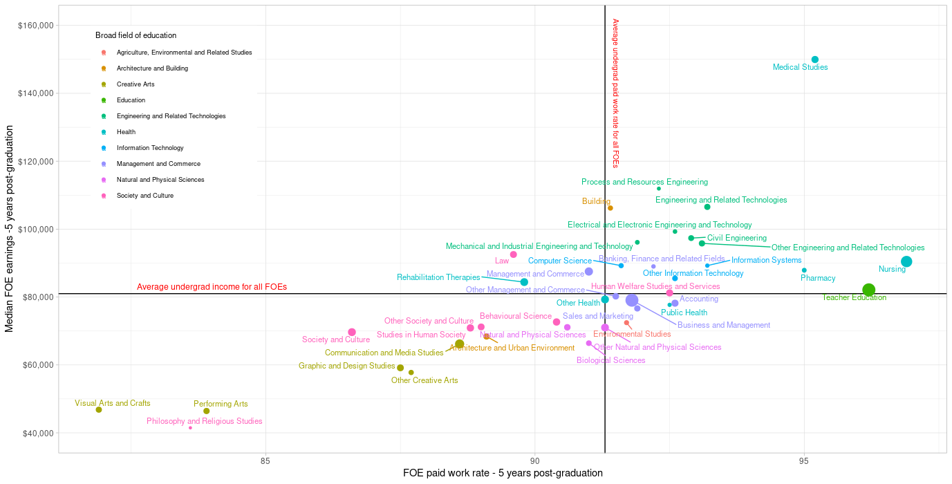
Average undergrad employment rate

Figure 30: Median postgraduate employment and earnings for top 40 narrow fields of education by study volume
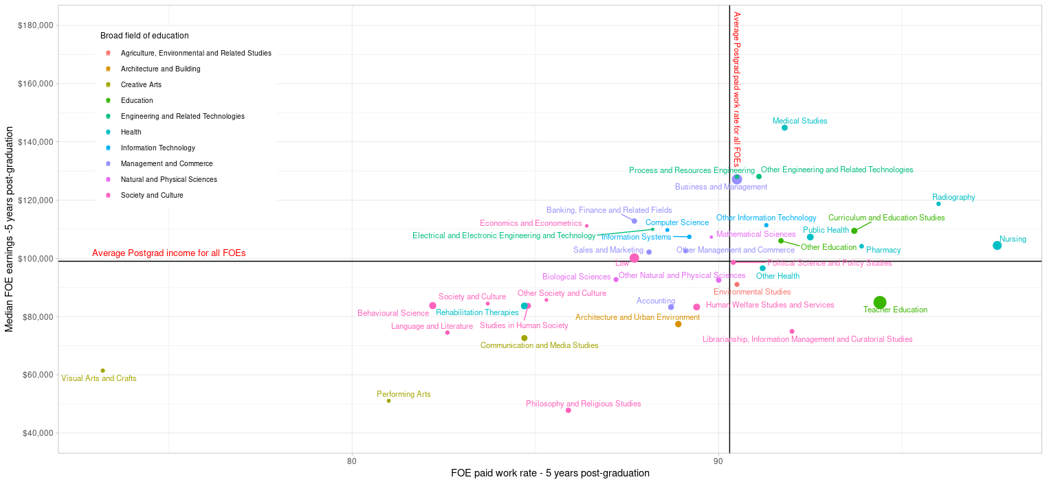
Average postgrad employment rate

Jobs and Skills Australia (2024), Better Together: The Jobs and Skills Report 2024.
We constructed a proxy variable for work status. The ‘wage/salary work’ category captures graduates with an identifiable occupation and an annual income greater than zero, or those with an annual income greater than zero and no identifiable occupation for the relevant year in tax data. This measure is based on employee income reported through personal income tax data and does not include profit and loss data. Annual income is indexed to the 2020-21 Wage Price Index.
The Spine is a unique identifier for everyone who were resident in Australia at any point during a given period. The current Spine used in this report covers January 2006 to June 2023. The Spine is based on the combined population from three core datasets: Medicare Consumer Directory; DOMINO Centrelink Administrative Data; and Personal Income Tax (https://www.abs.gov.au/about/data-services/data-integration/person-linkage-spine).
The higher education statistics collection is from public universities, private universities and non-university providers.
Where an ITR record is available for an individual in a year, it was used. Where an ITR record was not available, PS data was used.
While the higher education data series is from 2005 to 2021 inclusive, we focused on 2010 onwards to align with our analyses on labour market outcomes post completion.
For further details on the conversion of financial year to calendar year, see Appendix B: Sample used in labour market analysis and other sampling considerations.
For future research, we will investigate if work status is partly driven by a change in the uptake of postgraduate studies.
Annual employment income is indexed to 2021-22 Wage Price Index.
Our sample includes all undergraduate and postgraduate students who completed at any time between 2010 and 2017, ensuring at least five years of data post completion. Weighted average income is calculated for individuals who completed a qualification in a single or multiple fields of education. Annual income is based on wage/salary income reported through tax data and do not include profit and loss data.
The denominator is not the number of total graduates across all fields of education but the total graduates for specific field of education.
This analysis has not focused on comparing earnings before enrolment and after completion (income uplift as measured in VET National Data Asset (VNDA) publications) due to the high percentage of students commencing higher education directly following Year 12 (Department of Education, Key findings from the 2023 Higher Education Student Statistics).
The weighted average income for all fields of education is calculated for individuals who completed a qualification in a single field of education.
Australian Bureau of Statistics, Census of Population and Housing, 2021, TableBuilder.
Our sample population could have an undercount of postgraduates in some fields of education. For more information see Appendix A: Higher education data overview.
Business and Management nec includes facilities management, recreation management, business and financial risk management and transport management.
Our data show that most Education Studies and Teacher Education graduates were working as Teachers. The Australian census of Population and Housing 2021 (ABS TableBuilder) shows part-time work among undergraduates with a teaching qualification ranging between 31% and 54%. Between 29% and 50% of postgraduates had a qualification in teaching work part-time. The median completion age of undergraduates in Teacher Education is 24 years and the median commencement age of postgraduates in Teacher Education is 30 years. This suggests postgraduates in this field of education have an additional six years in the workforce compared to undergraduates prior to commencing their postgraduate study.
Medical Studies is a narrow field of education, rather than a detailed field like others in this chart. For some courses, raw data are coded at the narrow rather than detailed level by contributing higher education institutions. The Medical Studies narrow field includes the detailed fields General Medicine, Surgery, Psychiatry, Obstetrics and Gynaecology, Paediatrics, Anaesthesiology, Pathology, Radiology, Internal Medicine and General Practice. It should be noted that postgraduate training through specialist medical colleges does not appear in these data.
The Australian census of Population and Housing 2021 (ABS TableBuilder) shows a slightly higher percentage of undergraduates in Teacher Education: Primary working part time (38%) compared to postgraduates in the same field of education (36%).
The graphs do not show all FOEs within Engineering and Related Technologies because not all detailed FOEs have valid data (e.g., some FOEs are only undergraduate and/or only postgraduate) and meeting DataLab requirements means detailed data cannot be extracted for all FOEs.
Due to data suppression rules, data for the 5th and 95th percentiles could not be extracted.
The tax data include for each ITR the occupation the taxpayer reports as their primary source of employment income, which is a 6-digit ATO specific occupation code that can be transformed to a 6-digit Australian and New Zealand Standard Classification of Occupation (ANZSCO) version1.3 occupation code. We have converted the ATO occupation code to their ANZSCO v1.3. Individuals are not required to update their occupation on the ITR and this could result in an undercount or overcount of occupations compared to other published data.
The spread of occupations across fields of education could be influenced by limitations of data extraction. Some fields of education and occupation outcomes have very long tails with small counts and were not extracted from DataLab.
The column totals do not sum to 100% as not all graduates had identifiable occupation in the tax data and some data was suppressed to meet ABS data extraction rules on nondisclosure. Cells with less than 0.05% were rounded to zero and excluded from this visualisation for ease of reading. Occupational groups which did not have at least 3% of any one of the eight broad fields of education were excluded from these heat maps. The complete data set is available for download from the Jobs and Skills Australia website.
Engineering and Related Technologies broad field of education includes, for example, Civil Engineering, Process and Resources Engineering and Mechanical and Industrial Engineering and Technologies.
Society and Culture broad field of education includes, for example, Political Science and Policy Studies, Law and Economics and Econometrics.
Management and Commerce broad field of education includes, for example, Accounting, Business and Management and Sales and Marketing.
Some occupation groups have been aggregated for ease of reading. Percentages do not add up to 100% in each year due to cell suppression requirements and missing data.
‘Unknown’ captures individuals who do not have a valid occupation. Other Occupations (groups 4-8) is an aggregation of all occupations in these ANZSCO Major Groups. ICT, Teleco & Electronics Technicians & Trades Workers is an aggregation of ANZSCO Minor Groups 313, 399 and 342.
Other school teachers is an aggregation of the remaining ANZSCO 6 digit occupations in the Unit Group School Teachers. Other education professionals is an aggregation of ANZSCO Minor Groups 134, 240, 242, 249 and 272 and includes occupations such as School Principals, Education Managers and educational psychologists. Other managers is an aggregation of occupations from ANZSCO Major Group 1 not mentioned elsewhere in the chart. Similarly other professionals is an aggregation of the remaining occupations from Major Group 2. Other Occupations (groups 3-8) is an aggregation of all occupations in these groups.
The data capture pathways of Teacher Education: Secondary graduates and not the retention rate of graduates working as teachers post completion.
The ‘Mixed Pathways’ ‘ribbon’ represents people who moved in and out of teaching and non-teaching occupations between one and five years post completion. They were aggregated into one category due to low pathway numbers.
The cohort for Figure 22 is different to Figure 21 because it includes only those undergraduate degrees who could be tracked across the 5 years following their graduations. This made up 89.7% of all those in our sample with undergraduate degrees in Teacher Education: Secondary.
Other ICT occupations” aggregates individuals who moved across diverse ICT occupations between years 1 and 5 post-graduation. The cohort for Figure 23 is different to Figure 20 because it includes only those undergraduate degrees who could be tracked across the 5 years following their graduations. This made up 84.7% of all those in our sample with undergraduate degrees in Information Technology.
Department of Education, Key findings from the 2023 Higher Education Student Statistics.
Skill level refers to ANZSCO skill level and is a function of the range and complexity of the tasks performed in a particular occupation.
Financial year data from the ATO are converted to calendar year to align with the completion data. The first year of the financial year becomes the calendar year. For example, financial year 2018-19 is converted to the 2018 calendar year. An individual who completed a qualification in 2017, one year post completion is 2018 (financial year 2018-19). See Appendix B: Sample used in labour market analysis and other sampling considerations for further details.
Future analysis could determine which areas of study graduates are taking longer to find relevant employment in or are experiencing less direct transitions into an occupation. This analysis would be beneficial for estimating the workforce pipeline for different occupations, especially those which are in shortage.
While the higher education data series is from 2005 to 2021 inclusive, we focused on graduates who completed their study 2010 onwards to align with our analyses on labour market outcomes post completion.
See Tertiary Collection of Student Information for more details.
We only include students with CHESSN_FLAG = 1. To analyse labour market outcomes of graduates, we need to link students to other data assets in PLIDA and students with CHESSN_FLAG=0 who do not have a Linkage Spine. Who receives a CHESSN is policy driven and can change over time. Given the low rate of Linkage Spine for overseas students, our sample population captures mostly domestic students.
A domestic student is one of the following: Australian citizen; New Zealand citizen or diplomatic or consular representative of New Zealand, a member of the staff of such a representative or the spouse or dependent relative of such a representative; a permanent humanitarian visa holder; or a holder of a permanent visa other than a permanent humanitarian visa. An overseas student is one who is not a domestic student (Tertiary Collection of Student Information).
Commencements and completions are shown on the same graph for convenience rather than for comparative purposes. The trend in completions will naturally lag to that of commencements.
The commencement numbers are generated from a flag in the administrative data indicating if the student is a commencing student. If a student commences multiple courses in the same year they would only be counted once as a distinct person. Similarly, if a student has completed more than one course in a year they would only be counted once as a distinct person.
Our data on commencements and completions may differ from that reported by the Department of Education for several reasons including: our sample may have undercounts of post-graduate students and overseas students; there may be data loss from linking administrative data assets. We cleaned the data to remove records of the same individuals with multiple unique identifiers or the same unique identifier with demographic records (date of birth, country of birth) that appear to belong to multiple individuals. We have not removed overseas students with a CHESSN_FLAG = 1; and meeting the ABS’s data disclosure risk rules meant not all data can be extracted outside of the DataLab environment. Our counts of individuals are perturbed and rounded to the nearest whole number of five or 10.
For future research we will undertake further exploration to understand the gap between commencement and completion, such as distinguishing between those who completed a course they commenced and those who did not, plus the number of times an individual commenced a course and did not complete.
Study Assist, https://www.studyassist.gov.au/financial-and-study-support/commonwealth-supported-places-csps.
The data capture domestic postgraduate students only.
These charts capture the number of completions rather than distinct students.
Graduates are employed if they work at least one hour in the reference week or usually work at least one hour per week (Social Research Centre, Graduate Outcomes Survey: Short-term Graduate Outcomes in Australia, September 2021).
Australian Bureau of Statistics (2023), Employment: Labour Statistics: Concepts, Sources and Methods.

