


Speeding up progress towards gender economic equality
10 next steps


All content is provided under a Creative Commons Attribution 4.0 International Licence with the exception of:
- content supplied by third parties
- the Commonwealth Coat of Arms
- material protected by a trade mark
- any images and/or photographs.
Details of the Creative Commons BY 4.0 licence are available on the Creative Commons website.
Use of all or part of any material on this website must include the following attribution:
© Commonwealth of Australia
Terms under which the Commonwealth Coat of Arms can be used are set out on the Department of the Prime Minister and Cabinet website.
Attribution
You may link to this website at your full expense and responsibility. In doing so you must not alter any of the website's contents, frame or reformat the files, pages, images, information and materials from this website on any other website. We reserve the right to prevent linking.
Other use
If you want to use material on this website in a way that is beyond the scope of the terms of use that apply to it, ask us for authorisation. You could infringe our copyright if you use anything on this website in a way that is not permitted or otherwise allowed under the Copyright Act 1968 (Cth).
Please email copyright@dewr.gov.au or address requests and enquiries to:
The Copyright Officer
Department of Employment and Workplace Relations
GPO Box 9828 Canberra ACT 2601.

JSA acknowledges and thanks Deputy Commissioner Megan Lilly, and Bjorn Jarvis for overseeing the study; Dr Emma Cannen for leading the project; and team members Lachlan Camilleri, Professor Troy Heffernan, Mel Ochocki, Dr Camilla Stonier, and Luke Wilson for their contributions to this Paper. JSA also acknowledges former Gender Equality Study Team members, Study Steering Committee members, Kirsty Leslie, Dr Elizabeth Knight and Kristy Birss for their contributions to this final study publication.
.
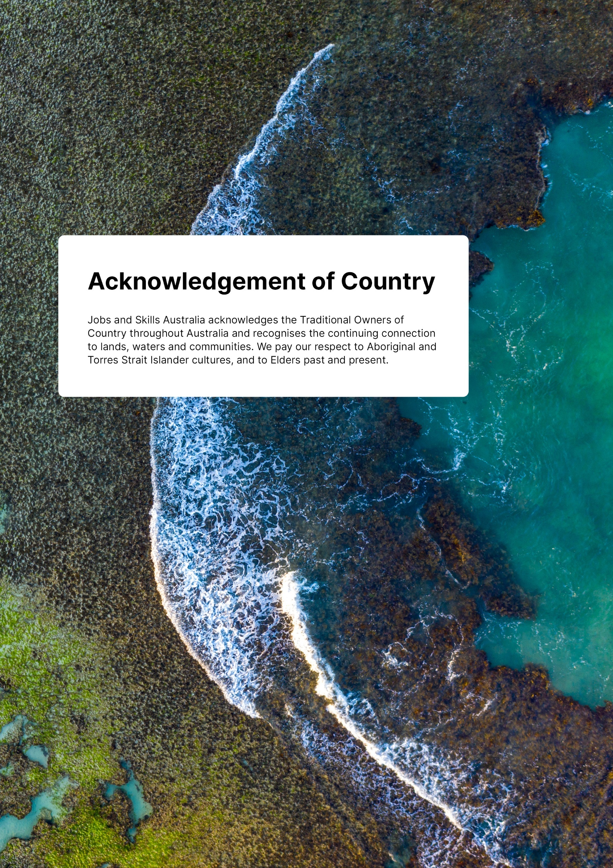
Acknowledgement of Country
Jobs and Skills Australia acknowledges the Traditional Owners of Country throughout Australia and recognises the continuing connection to lands, waters and communities. We pay our respect to Aboriginal and Torres Strait Islander cultures, and to Elders past and present.
Contents
Deputy Commissioner's Foreword 3
Executive Summary 4
Introduction—the pathway to recommendations 13
Recap of Study findings and new evidence 15
Five key reform themes from the Study's public engagement and submissions 17
Building on previous Gender Economic Equality work 18
The need for a standalone First Nations Women's Economic Equality Plan 20
Recommendation 1 24
Recommendation 2 37
Recommendation 3 40
Recommendation 4 43
Recommendation 5 47
Recommendation 6 50
Recommendation 7 57
Recommendation 8 60
Recommendation 9 62
Recommendation 10 65
Appendix 70
Engagement and Consultation Summary 70
Building on recent recommendations on unpaid care 72
World Bank Gender-based Employment Segregation: Understanding Causes and Policy Interventions - Key Research Questions 74
Example levers for change 74
Glossary 79
Reference List 82



Deputy Commissioner's Foreword
Gender economic inequality remains one of the most persistent and complex challenges facing Australia’s labour market and skills systems. The Gender Economic Equality Study provides a compelling evidence base and new analytical tools to better understand and address this challenge.
Across three papers, the Study reveals how deeply gendered our jobs, work, pay, education and training pathways continue to be. Paper 1 introduces the Gender Segregation Intensity Scale (GSIS), a new framework for measuring occupational segregation, and highlights the enduring nature of gendered divisions in the workforce. Paper 2 extends this analysis into education and training, showing how gendered study choices and skills mismatches reinforce inequality and limit the full economic potential of women and other underrepresented cohorts. Paper 3 brings these findings together, offering 10 practical and ambitious recommendations to accelerate progress towards gender economic equality.
This Study makes clear that gender economic inequality is not just a matter of fairness—it is a structural barrier to productivity, workforce sustainability and inclusive economic growth. It also shows that compounding disadvantage for different types of people—particularly for First Nations women, culturally and linguistically diverse (CALD) communities, and people with disability—requires targeted and nuanced policy responses.
The recommendations in Paper 3 call for coordinated national action across governments, industry, education and training providers, and communities. They include early interventions in education, reforms to vocational pathways, improved workplace safety and inclusion, and the adoption of new tools like the GSIS to monitor progress. Importantly, they also call for a standalone First Nations Women’s Economic Equality Plan to address the unique and compounding barriers faced by First Nations women.
Jobs and Skills Australia (JSA) is proud to contribute this work to the national conversation. We encourage all stakeholders to engage with the findings and recommendations, and to work together to build a more equitable, inclusive and productive future for all Australians.
I would like to acknowledge the significant contribution of JSA staff, especially Dr Emma Cannen, Bjorn Jarvis and the Gender Economic Equality Study Project team. I also express my appreciation for JSA’s Ministerial Advisory Board and the deep commitment from the Gender Economic Equality Study Steering Committee who have been instrumental in providing considered advice and expertise to the three reports.
Megan Lilly
Deputy Commissioner
Jobs and Skills Australia


Executive Summary
The Gender Economic Equality Study has explored three key and complex challenges for the jobs and skills systems that contribute to gender economic inequality: occupational segregation, pay gaps and gendered divides in the education, training and skills systems.
Our final paper—Paper 3—presents a series of recommendations to address these complex policy challenges based on the new evidence, findings and policy implications presented in Paper 1 and Paper 2. We have also drawn on important recent work, such as the Women's Economic Equality Taskforce (WEET) Report (2023) and various First Nations work, and this collected body of findings, initiatives and recommendations from others has informed our pathway to the 10 recommendations in this paper.
Figure 1: Gender Economic Equality Study publications
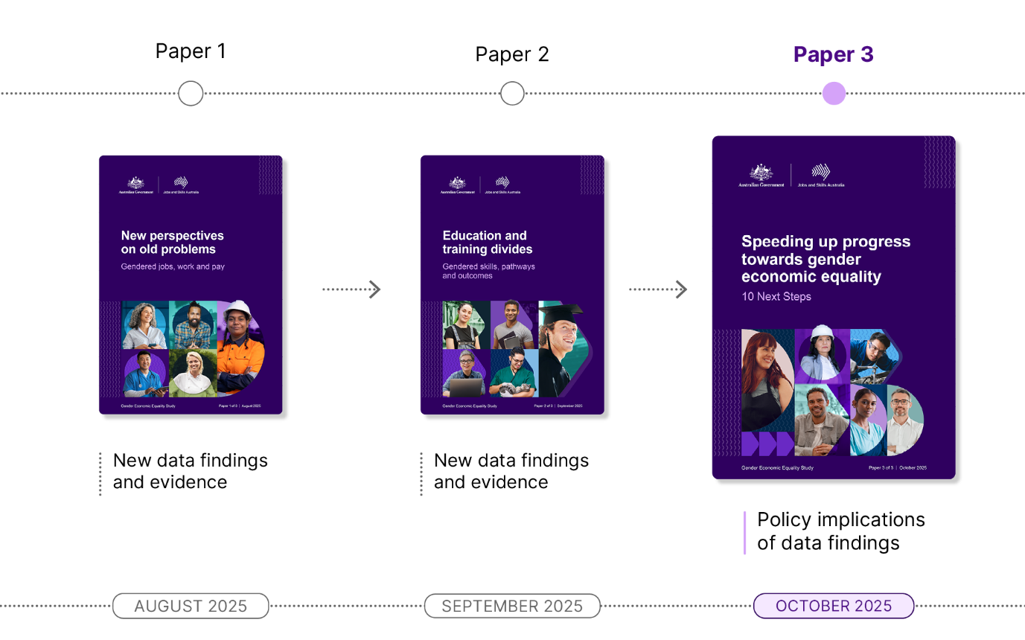
Our 10 next steps focus on addressing:
- How to best intervene in gendered occupational segregation patterns.
- Why early intervention into gendered norms that define gendered study, career and occupational choices is crucial.
- The urgent need for more targeted attention to and intervention into the intersecting and compounding forms of sex, race, cultural and age discrimination across workplaces and industries, including their longer term and cumulative impact on women's career trajectories and economic wellbeing.
- The identification of and solutions for gendered barriers in training pathways at both the individual and system level.
- How gender pay gaps and unique segregation patterns for culturally diverse, migrant and First Nations women mean we need more nuanced policy solutions and urgent action including a standalone First Nations Women's Economic Equality Plan.
- Why we need to invest in occupational pathways and life-long career supports to improve women's economic wellbeing over their life course.
- How to harness opportunities where education and training outcomes for disadvantaged cohorts such as students or workers with disability are already positive or direct policymaker attention where more support is needed.
- How to identify where women's skills are being underutilised and how addressing it can improve productivity.
- Why intersectional data is so integral to more nuanced policy solutions and speeding up progress towards gender economic equality for women with compounding disadvantage.
- How to shift gender biases embedded in labour market frames like occupational classifications and skill definitions as well as education and training structures and institutions themselves.
- How it would be useful to adopt the Gender Segregation Intensity Scale (GSIS) as a shared framework across government to inform action and monitor progress towards gender economic equality.

In our pathway to these 10 recommendations, we considered a range of factors such as:
- socio-cultural norms, including caring load and the role that the family and other social networks play in influencing views on education and training, and occupations
- education and training awareness, options and choices (from childhood to adulthood)
- career learning, options and choices (also from childhood to adulthood)
- career pathways (and mentoring and coaching)
- attraction, progression and retention dynamics within occupations
- safe and respectful workplaces (with inclusive culture and design)
- leadership and accountability.

In developing our recommendations, we have also been balancing a range of inherent tensions between:
- short-term or long-term actions
- broad whole-of-system reforms and more targeted system policy changes or levers
- new reforms or supercharging existing government efforts
- a focus on workplaces, industries, occupations, institutions, systems or broader society
- government-led action or action led by jobs and skills systems actors
- supply-side or demand-side levers
- a focus on male dominated occupations, workplaces and problematic cultures compared with action in female dominated or increasingly gender balanced parts of the economy
- actions focused on the population and broader economy or the need for cohort-specific policy levers, supports and nuance
- generalising from examples that are currently making a difference, to the need for further data and research compared with action on existing evidence.
JSA openly encourages further discussion of these tensions and complexities with policymakers in the consideration and implementation of these 10 next steps.

Recommendation 1: Implement a three year Shifting the Dial on Gender Segregation Policy Action and Evaluation Agenda with findings informing the Working for Women Strategy mid-term review and further action beyond 2029.
JSA recommends four priority policy actions be implemented from 2026 to 2029 that leverage and extend existing efforts and are informed by the Study's new evidence, measures and findings:
- A Jobs and Skills Council (JSC) gender segregation intervention sprint and evaluation impact report.
- Industry gender segregation action plans across existing and emerging Australian Government reforms.
- The establishment of a systematic cross-jurisdictional evaluation mechanism led by the Australian Government.
- An independent evaluation review and report on ‘Shifting the Dial’ as a key input into the mid-term review of Working for Women with recommendations to inform further action beyond 2029.
JSA recommends the Australian Government work towards national coordinated action for balancing occupational and industry segregation beyond 2029.
WHO? All Australian governments with leading coordination and stewardship from three Australian Government agencies: Office for Women (OFW) within the Department of the Prime Minister and Cabinet (PM&C), Department of Employment and Workplace Relations (DEWR) and JSA. JSCs would also play a key role.
Recommendation 2: All Australian governments consider how to intervene earlier in education and training study choices through innovative changes to career learning and exploration in curriculum, campaigns and supports in both primary and secondary schooling.
JSA recommends priority policy action in four areas:
- The Australian Curriculum, Assessment and Reporting Authority (ACARA) develop a national Years 3-10 curriculum on career exploration and learning that all States and Territories can adapt or utilise.
- Scaling low cost national campaigns, such as Your Career, or initiatives including the Diversity in STEM Toolkit (DiST) and Little Ripples as interventions in early gendered study choices that can also be used as teaching resources.
- Empowering and uplifting gender-aware informed career advice, practitioner capacity and counselling through the funding and development of continuing professional development (CPD) including CPD that is fit-for-purpose for primary school teachers and education settings.
- In the longer term, the introduction of mandatory career learning and exploration curriculum for Years 3-12.
WHO? All Australian governments with the Department of Education, ACARA and DEWR playing leading roles. Non-government actors such as Career Industry Council Australia (CICA), Education Services Australia, teachers, career practitioners, and parents.

Recommendation 3: All Australian governments scale occupational gender segregation interventions across future National Skills Agreements and outcomes reporting including the introduction of explicit gender targets for national priorities.
JSA recommends priority policy action in four areas:
- The introduction of more explicit gender-focused targets for national priorities or a framework for measuring progress against them in the renegotiated National Skills Agreement (NSA) from 2028.
- The consideration of Study findings in the pending NSA review.
- Further leveraging and uplifting existing procurement levers at all jurisdictional levels including expanding the Australian Skills Guarantee beyond construction and ICT projects at the federal level and considering a review of the Skill Guarantee's current targets and thresholds.
- More systematic evaluation of interventions and initiatives, and cross-jurisdiction sharing of outcomes and public reporting of progress including contributions to the independent evaluation under Recommendation 1 to ensure scale and impact for national coordinated action beyond 2029.
WHO? All Australian governments with the Skills and Workforce Ministerial Council (SWMC) and DEWR playing a leading role.
Recommendation 4: All Australian governments and lead skills system actors coordinate a national and economy-wide approach to gender segregated VET training pathways for occupations in shortage through four main policy actions.
JSA recommends four policy actions:
- A scholarship and supports package for trainers.
- A gender-conscious national VET pathways awareness and promotion campaign.
- A suite of career introduction, entry-level programs.
- An equity by design approach to systems, classrooms, qualification design and occupational pathways and supports.
WHO? All Australian governments with leading roles for skills and education departments and authorities. Education and training institutions and actors, such as the National TAFE Network, TAFE Centres of Excellence, Science in Australia Gender Equity (SAGE) and schools and Registered Training Organisations (RTOs) involved in VET in Schools (VETiS) delivery will also play key roles.

Recommendation 5: All Australian governments and lead skills system actors complement current Closing the Gap reforms with additional and immediate national and economy-wide action for First Nations women.
JSA recommends priority policy action in three areas be progressed and co-designed with First Nations stakeholders:
- A standalone First Nations Women's Economic Equality Plan including coordinated action to address, and ongoing reporting and monitoring of, First Nations gender pay gaps.
- Strengthened industry partnerships and longer-term investment in the capability, capacity and sustainability of Aboriginal Community Controlled (ACC) and First Nations Owned (FNO) Registered Training Organisations (RTOs).
- The progression of the Indigenous Centre of Vocational Excellence (ICOVE) that leads innovation, capacity building, advocacy, and evidence-informed best practice research in VET with the aim to support the growth of First Nations participation and leadership in VET.
WHO? All Australian governments with stewardship from PM&C in partnership with the National Women's Alliances to reflect the urgent need for action on First Nations women’s economic inequality. In the skills space, ACC and FNO RTOs, the VET First Nations Policy Partnership under existing Closing the Gap governance settings, DEWR and JSCs will also be key players.


Recommendation 6: Industry and employers to accelerate progress on inclusive and safe workplaces and training settings.
JSA recommends employers and industry prioritise three actions:
- Going above and beyond what is required by the legislated Workplace Gender Equality Agency (WGEA) Gender Equality Targets Scheme. For example, employers below the legislated 500 employee requirement could voluntarily devise and set targets and independently monitor their progress, while larger employers could consider setting additional targets and independently monitoring their progress separate to the legislated three target requirement reporting to WGEA.
- Strengthening workplace health and safety settings to not just meet regulation but foster safe, and respectful workplace cultures where workers thrive. For example, replicating National Construction Industry Forum (NCIF) Blueprint for the Future recommendations in other industries.
- Accelerating recognition of cultural load for First Nations and CALD workers.
WHO? Industry, particularly employers, as well as unions, industry associations, education and training institutions and JSCs. WGEA and the Australian Human Rights Commission (AHRC) could play supporting roles as Australian government agencies, as well as SAGE who are working with education and training institutions as employers to create safe and inclusive workplaces.

Recommendation 7: Extend policy settings and supports to normalise men's involvement in unpaid care, domestic work and paid care work, with the longer-term aim of addressing social and cultural norms.
JSA recommends the Australian Government and employers consider an expansion of Australia's paid parental leave (PPL) model to 52 weeks in line with previous Women's Economic Equality Taskforce and 2025 Work and Family Roundtable recommendations. This means the:
- inclusion of a strong 'use it or lose it' model for fathers and 'secondary' carers, which earmarks four months of PPL for each parent and four months to share.
- potential flexibility to take PPL across the life course of the child (up to 12-13 years as per other best-practice international models).
- the leveraging of other policy levers in the tax and transfer system that could further normalise men's involvement in unpaid care, and not just support women's return to work, but drive more equitable career progression and promotion for mothers and carers.
WHO? All Australian governments but leading action from the Australian Government as well as employers, fathers, and 'secondary' carers.

Recommendation 8: Government and others adopt the GSIS as a common and shared framework for informing action and monitoring progress towards gender economic equality.
JSA recommends adoption of the GSIS in evaluation, monitoring and reporting of diverse projects, reforms and work across government, industry and education and training institutions. As a first step JSA recommends the GSIS is adopted in:
- Various JSA research and public reporting.
- The Shifting the Dial policy and evaluation agenda and JSC workforce planning.
- The upcoming NSA Balanced Scorecard reporting framework.
- Gender pay gap research and reporting.
- Gender Impact Assessments and Gender Responsive Budgeting infrastructure.
WHO? All Australian governments as well as key jobs and skills system actors such as JSCs and education and training institutions. JSA and OFW would be lead Australian Government agencies who will provide early demonstrations of its use and applications.
Recommendation 9: Further address gender and other biases in labour market and skills frameworks that reflect gendered language, structure and norms.
JSA recommends leveraging the Australian Bureau of Statistics (ABS) progress on the Occupational Standard Classification for Australia (OSCA), the Fair Work Commission's (FWC) ongoing work on gender undervaluation, and JSA’s work on the National Skills Taxonomy to further address gender and other biases in labour market and skills frameworks. Examples of frameworks and work that could be part of this include:
- Statistical classifications such as OSCA and the Australian and New Zealand Standard Industrial Classification (ANZSIC) including in its upcoming review.
- Skills system frameworks such as the National Skills Taxonomy, the Training Package Organising Framework, the Australian Qualifications Framework and more broadly Recognition of Prior Learning models.
- Policy frameworks such as the Australian Apprenticeships Incentives System.
- Industrial frameworks such as modern awards.
WHO? All Australian governments with leadership from Australian Government agencies such as the ABS, the FWC, JSA, OFW and DEWR. Non-government actors include employers, unions and individual education and training institutions.

Recommendation 10: Expanded research, data and reporting to monitor progress on gender economic equality and increase intersectional perspectives and understanding.
JSA recommends the Australian Government fund repeating, deepening and extending the data and research work of this Study. JSA also recommends more coordinated government action to improve and expand existing data assets to allow for more intersectional insights and reporting. JSA recommends priority action to:
- Identify the most appropriate Australian Government agency to use the data and methods in this Study to do ongoing intersectional, life course and detailed occupation pay gap reporting.
- Fund the ABS to expand and extend the available integrated data to support improved gender pay gap monitoring.
- Fund regular research on differences in labour market situation and outcomes for women and men (including working arrangements, conditions, preferences), differences in superannuation accumulation and retirement, and women's entrepreneurship and business ownership.
- Incorporate additional data and research, especially newer intersectional insights, into existing and future reporting such as the Working for Women Status of Women Annual Report card.
WHO? Lead Australian Government agencies including JSA, the ABS, the NIAA in their role in coordinating Closing the Gap, and OFW and Gender Data Steering Group. Agencies that are data custodians for key datasets that could further usefully extend Person Level Integrated Data Asset (PLIDA) and the National Disability Data Asset (NDDA).

Introduction—the pathway to recommendations
Progressing gender economic equality calls for a holistic approach that addresses barriers at societal, educational, industry and workplace levels. This includes addressing entrenched norms and systemic barriers, and mitigating compounding intersectional disadvantages. Sustained commitment, targeted interventions and robust accountability mechanisms—such as transparent monitoring, regular audits and evaluations and genuine accountability of leadership—are critical to driving lasting change.
As the World Bank helpfully summarises, policies that aim to intervene in the drivers of occupational gender segregation are those that target 'supply-side gender gaps in skills, capital, domestic and care responsibilities, safety and mobility, and role models and networks' and 'demand-side behaviours at recruitment, selection, hiring, evaluation and promotion, as well as features of the workplace culture' (Carranza et al. 2023). In particular, 'governments provide the macro-fiscal, legal and regulatory frameworks that play a role in perpetuating or correcting employment segregation by gender. Their involvement may be critical to coordinate market-wide change, address general equilibrium effects and make a dent on employment segregation' (Carranza et al. 2023).
This means that potential recommendations to intervene in occupational gender segregation are wide and complex, let alone broader recommendations to speed up progress towards gender economic equality or to tackle the gender norms that drive both.
Our 10 next steps offer recommendations across this wide scope and introduces new supply, demand-side levers as well as macro-fiscal, legal and regulatory interventions. Recommendation 1 focuses on a Shifting the Dial on gender segregation policy action and evaluation agenda for balancing occupational and industry gender segregation, which includes all three. Others are narrower, such as the focus of Recommendation 6 on supercharging industry efforts through demand-side drivers and Recommendation 7 on supply-side drivers to normalise men's involvement in unpaid care.
Moreover, policy levers and action on addressing gendered norms in education and training settings are equally as complex. The OECD (2022) has developed an analytical framework to promote more equitable and inclusive education systems for all students. Key policy areas to dismantle gender stereotypes include:
- Governance—goals, from international to local, and equitable choices; legislation, responsibility and support; and educational offerings that include learning environments.
- Capacity building—creating educational environments that foster inclusion through mechanisms such as public awareness campaigns, assessing needs for training and implementing strategies.
- School-level interventions—providing resources for students, from a positive school climate to counselling, inclusive curriculum, and organisations.
This Study recommends actions in all three policy areas, for example changes to the shared VET stewardship system under the next NSA in Recommendation 3, equity by design for capacity building in Recommendation 4 and earlier school-level interventions in changes to curriculum and resources for career learning and exploration in Recommendation 2.
The OECD notes that it is also important to consider how educational curricula, teaching and learning materials, and classroom learning perpetuate gender stereotypes. These should be designed in a way that aims to dismantle stereotypes and promote inclusivity, such as implementing more inclusive curricula and textbooks, preparing teachers and other school staff, and promoting whole-school approaches by engaging parents and the broader community (Brussino and McBrien 2022).
'We are underutilising the economic potential of more than 50 per cent of our community. Australia simply does not work without women’s active participation in our society and workforces' (WEET 2023)
Furthermore, the intersecting and compounding forms of gender, age, disability, racial, ethnic and cultural discrimination and inequality across Australia—and a key theme in the data findings of our Study—adds another layer of complexity in any study recommendations. Gender inequality is often exacerbated by intersecting factors which can create complex and layered barriers to access, participation and progression in workplaces and education settings. More attention to the dynamics between gender, First Nations and CALD occupational segregation and pay gaps is needed to drive better policy solutions to challenges across the workforce including in occupation shortages.
Our Recommendation 5 focused on complementary action to Closing the Gap reforms across the jobs and skills system including additional, immediate and economy-wide action for First Nations women in a standalone plan is designed to do this. However, across all recommendations we include intersectional principles and levers to target compounding disadvantage across work and study that extend beyond gender. This comes into focus in Recommendation 10 where we recommend funding to expand intersectional data and to repeat this Study's research to continue to develop the evidence base.
Our qualitative research findings also found that experiences of inequality vary by industry and life stage. Inequality manifests differently across male dominated, female dominated and gender balanced industries, with distinct patterns of discrimination and barriers in each. Male dominated industries were associated with higher rates of harassment and entrenched biases, while female dominated industries faced challenges such as lower pay and casualised employment. Gender balanced industries showed progress but still grappled with subtle forms of discrimination. This points to the importance of adopting the GSIS as a shared framework across government to keep segregation in focus in Recommendation 8 and addressing gender biases in statistical, policy, skills, and industrial frameworks in Recommendation 9. Frameworks like the Australian Apprenticeship Priority List ultimately direct government funding and supports to workers so addressing gender biases has real-life impacts on Australians.
Similarly, experiences of inequality evolved across life stages, with early career participants navigating workplace dynamics and learning how to respond to inappropriate behaviour from colleagues, mid-career participants balancing caregiving responsibilities with career progression, and late-career participants seeking flexibility or reskilling opportunities. These findings suggest the need for tailored sector-specific and life-stage-sensitive interventions which we include across our 10 recommendations.

This Study has also had to wrangle with key recommendation tensions including balancing:
- Whole-of-system, national stewardship or cross-jurisdictional government action against more targeted interventions or collaborations with specific industry actors such as employers and JSCs.
- What to do about gendered norms in line with existing government efforts, especially in line with the Working for Women current plan and indicators in this area (see the Working for Women Reporting Framework on gendered attitudes and stereotypes).
- Where to focus initiatives and interventions in the education and training pipeline; at tertiary, secondary and primary level or outside formal education and training settings to maximise impact.
- Longer term structural interventions such as gender equity assessments versus shorter term policy levers across the education, training skills system that may more immediately address occupation shortages or support women and men currently in highly gendered training pathways.
- Whether we expand the policy focus away from male dominated trades and the care economy considering current government efforts in these areas.
- How we can leverage lessons from gender balanced occupations or industries where gender pay gaps have declined and what further research needs to be done to better target solutions.
- The need for further research to fill intersectional gaps versus policy action and reform in the most needed occupations and industries.
JSA openly encourages further discussion and consideration of these tensions and complexities with policymakers in the consideration and implementation these 10 next steps including the funding implications. Investment is required to transform structural bias across both the labour market and skills system and implement gender equitable policies and programs that will shift occupational segregation, pay gaps and education and training divides.

Recap of Study findings and new evidence
As a recap, our data and findings in Paper 1 identified the following policy implications:
- Australia's workforce remains highly gender segregated, and there are clear connections with gendered choices, divides and outcomes across education and training pathways.
- Gendered occupational segregation is complex and difficult to shift. However, there are encouraging examples of gender balancing change over time that we can leverage lessons from.
- Gendered occupational segregation is a problem for addressing occupation shortages—with clear economic impacts—and this worsens at selected skill levels and in male dominated occupations. This has significant skills-system policy implications.
- There are large gender pay gaps at the detailed occupation level, even in gender balanced or highly female dominated occupations.
- There are sources of compounding gendered and racial discrimination in the world of work, education and training—particularly for First Nations women.
- There is value in more data and monitoring detailed occupational gender segregation and occupational gender pay gaps.
Figure 2: World Bank Theory of Change of Gender-based Employment Segregation
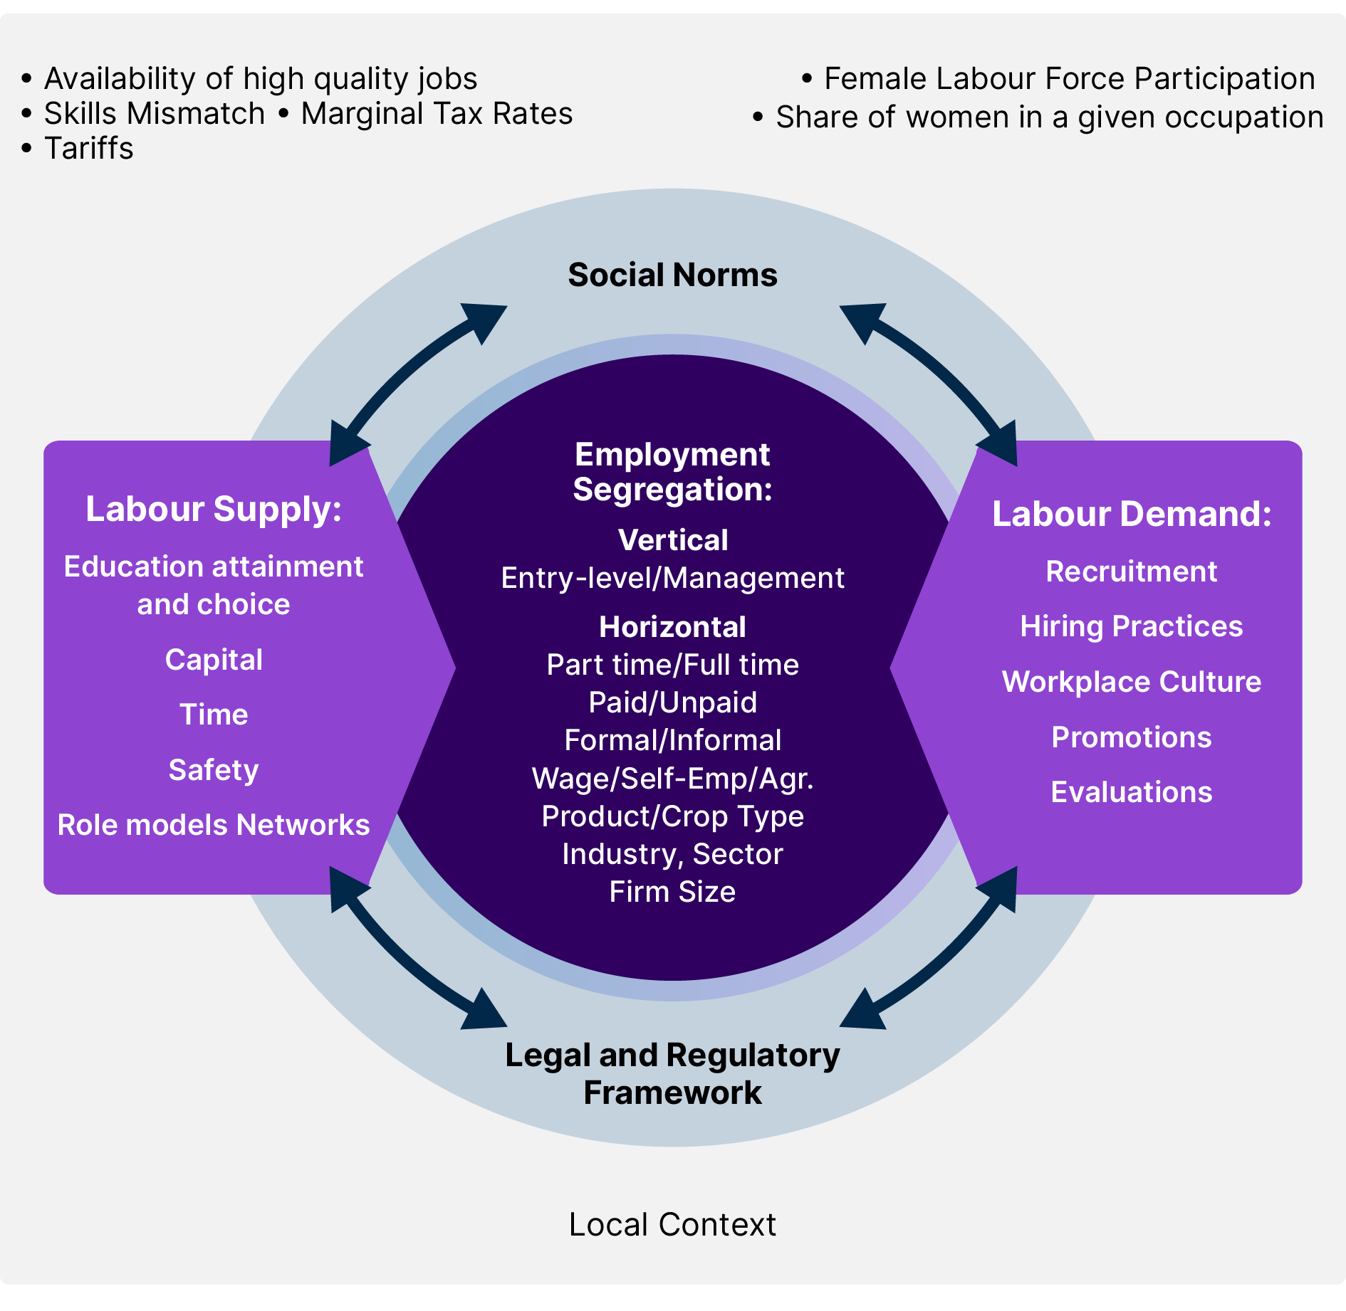
Source: This is an adaption original visual from World Bank’s publication Gender-based employment segregation: understanding causes and policy interventions (Carranza et al. 2023, page 10).
In Paper 2, we expanded on these to identify further policy implications specific to the intersections between occupational segregation and the education, training and skills system. We found that:
- Gendered segregation in education and training remains entrenched, with current enrolment and completion patterns unlikely to shift occupational gender segregation.
- Only 20% of narrow fields of education have gender balance in their graduates – like the 20% of occupations that were identified as gender balanced in Paper 1 from this Study.
- Social and cultural norms strongly influence education and training choices and pathways, and subsequent occupation and career pathways.
- Women are more likely to be ‘skills mismatched’—working in occupations below their level of qualification—indicating underutilisation of female talent and skills (Risse 2018). This is also an indication that women are not reaping the full "returns" of their educational and training investment, compared to men which has been an ongoing identified barrier.
- Economic inequality persists post-training, with women consistently earning less and being more likely to exit the workforce despite being similarly or more qualified.
- Men generally achieve better economic outcomes than women across most VET qualifications, even in female dominated fields.
- Workers tend to stay longer in occupations dominated by their own gender, which further contributes to occupational segregation over time.

Five key reform themes from the Study's public engagement and submissions
Our public consultation submissions and expert forum engagements also highlighted similar policy implications with five key reform themes:
- Various gender occupational segregation reforms and interventions including the need for a more systematic evaluation of existing levers and programs to understand what is and what is not currently working.
- Early interventions into gendered norms that define gendered study, career and occupational choices.
- More targeted attention to, monitoring of and intervention into, the intersecting forms of sex and cultural/race discrimination in workplaces and as women's careers progress.
- Identification of, and solutions to alleviate, gendered barriers and embedded biases in training pathways at both the individual and system level across diverse education, training and skills system settings.
- Improved intersectional data and research to support better evidence for policymaking.
Other themes raised that have supported the development of the recommendations in this paper are from the 40 public consultation submissions, four expert forums and surveys, and engagements with the Study Steering Committee and relevant agencies across government are:
- The economic impact of unpaid caring responsibilities and its link to persistent occupational segregation.
- The lack of recruitment of female trainers in trades.
- How entry into trades for women can happen at older life stages due to the lack of parental support at a younger age.
- Calls to analyse the impact of visa settings on occupational segregation and education and training divides, with particular attention to secondary applicants in skilled migration.
- Support for specific initiatives, such as industry-led diversity networks and mentoring.
- The role of flexible work arrangements across all industries and improving the inclusivity of parental leave policies to address the gaps in economic outcomes faced by women juggling career and caregiving responsibilities.
- Flexible career progression models could contribute to diversity in the workforce.
- The need for early career sponsorship programs and mentoring targeted towards underrepresented groups and career showcases of women in non-traditional roles to expand teacher, parent and student mindsets.

"Strong female leadership is what attracts me to a lot of my positions. It's aspirational finding strong female leaders who have had to overcome adversity to get to where they are now. Female managers have had more trust and have allowed me more autonomy and to speak up more."
— Female focus group participant aged 18-29 years, Executive Assistant

"I still remember speaking to a female partner during my internship to this day. She was speaking about her experience as a woman, like about having children and how she was supported through that phase of her life. I spoke to her for almost 2 hours, which is something I haven't even done with my male partner in my own team now."
— Female focus group participant aged 18-29 years, Software Engineer

Building on previous Gender Economic Equality work
In 2023, the Women's Economic Equality Taskforce (WEET) published a snapshot of women's economic inequality and its impact on productivity and economic loss to Australia and what to do about it. It found that "we could add $128 billion to the economy through boosting women’s workforce participation and productivity growth if we tackle the factors holding women back" (WEET 2023).
The WEET set out an ambitious 10-year roadmap for reform across five economic pillars: care, work, education and skills, tax and transfers, and governments. It made several recommendations, many of which have been progressed by government or translated into the Working for Women Strategy (the Strategy) which was published in 2024. Our Study recommendations are an extension and reiteration of both sets of work and key to our pathway to the 10 recommendations included here. Throughout this paper, we reiterate where our recommendations align with the WEET recommendations.
We highlight where our findings further support the WEET recommendations that are not already taken up by government or were not translated into the Strategy. We also contextualise our recommendations in the Strategy's foundational view that harmful gender attitudes and stereotypes drive gender inequality as well as its long-term ambitions, priority areas for action, principles for impact and reporting framework to maintain government momentum on speeding up progress towards gender economic equality. Indeed, our first recommendation on a 'Shifting the Dial' agenda is intentionally designed to align with the Strategy's mid-2029 review point.

This also aligns with the timelines for renegotiating the NSA by 2028 where the national priorities of gender equality and Closing the Gap—or the policy programs and state and territory jurisdictional plans that sit underneath them—could be supercharged, scaled or reviewed based on our Study findings and the potential early implementation of Study recommendations. In particular, results and new evidence on best practice intervention levers based on the results of more national and systematic evaluation mechanisms. Both the full review of the NSA (which is due at the end of 2027), and the annual reviews of national and jurisdictional plans also provide upcoming opportunities to consider this Study's new data and evidence and the who, what, and how of addressing shortcomings in existing approaches as per the NSA's shared stewardship model (DEWR 2023). There are no targets for delivering on the national priorities or a framework for measuring progress. JSA recommends this is addressed in the full review and becomes part of the renegotiated NSA from 2028. As we noted in Paper 1, what is invisible in the reporting of data will also be invisible in the policymaking process.
Our pathway to recommendations has also been shaped by other gender strategies and work across various jurisdictions including the National Plan to End Violence Against Women and Children 2022-2032 which offers an excellent example of how to tackle a complex policy problem with a whole-of-society effort. It includes a change agenda, principles including intersectionality, priority areas and action plans, and very importantly a First Nations specific action plan. Our Ways Strong Ways Our Voices is the forthcoming standalone First Nations family safety plan. There is also a distinct National Outcomes Framework Performance Measurement Plan. This plan has a theory of change and outcomes framework with both 10 year long-term and sub-term outcomes, reform areas, priority groups and targets. Action plans are also updated and reported on annually and there are unique governance structures such as the Lived Experience Advisory Council (LEAC) to ensure the voices of people with lived experience are considered in reporting and overall plan reviewing and action plan reworking.
Additionally, at a state and territory level, significant action has been taken towards achieving gender economic equality, with examples included in the accompanying appendix. For example, the Our Equal State 2023-2027 Victorian Gender Equality Strategy sets out a roadmap of action and investment in gender equality and takes a life course approach to gender equality (DFFH 2023).
JSA recommends replicating these comprehensive approaches to the complex problem of occupational gender segregation throughout the Shifting the Dial agenda on occupational intervention (2026-2029), especially as the evaluation of existing levers is undertaken and priority action plans are progressed.

The need for a standalone First Nations Women's Economic Equality Plan
A National Action Plan on Advancing the Wellbeing of Aboriginal and Torres Strait Islander Women and Girls—Recommendation 1 of the Wiyi Yani U Thangani report (2020)—has still not been implemented, despite the in-principle support of the Government (NIAA 2022). Likewise, the 2023 WEET Recommendation 4.6 to 'develop a national strategy and invest in action to close the First Nations employment gap (as per Closing the Gap Targets 7 and 8) with a focus on meaningful, skilled and well-paid employment for First Nations women, and to increase funding in Indigenous Employment Programs run by Aboriginal Community Controlled Community Organisations' has also not been progressed.
Our Study reiterates both recommendations. We recommend a standalone co-designed First Nations Gender Economic Equality Plan in Recommendation 5 in conjunction with other policy levers, such as strengthened industry partnerships with, and longer-term funding of, ACC and FNO training organisations. We also recommend the funding and establishment of a First Nations TAFE Centre of Excellence to support and strengthen these partnerships.
Current state and territory jurisdictional action plans on the NSA Closing the Gap priority focus on the pathways for First Nations learners to build and deepen their skills, but states and territories should also address the underlying drivers and institutional racism, discrimination and unconscious bias impacting First Nations people.
A standalone co-designed First Nations Women’s Economic Equality Plan could draw on recent work by the Wiyi Yani U Thangani (Women's Voices Report) and the First Nations Gender Justice Institute (Wiyi Yani U Thangani Institute for First Nations Gender Justice 2022; 2024). The Institute's more recent Implementation framework and Change Agenda—a 'blakprint' for transformation—combined with our Study's findings, especially in relation to First Nations gender pay gaps, offers further evidence to progress a standalone First Nations Women Economic Equality plan. The National Aboriginal and Torres Strait Islander Women's Alliance is now active and the very recently signed First Nations Economic Partnership Agreement between the Coalition of Peaks, the First Nations Economic Empowerment Alliance, and various First Nations Policy Partnerships under National Agreement on Closing the Gap could also be leveraged.
Recommendation 10 on improving intersectional data and monitoring of workplace racism as well as ongoing reporting and monitoring of First Nations gender pay gaps is also designed to accelerate progress towards First Nations women economic equality and security. JSA recommends coordination across government be prioritised to address the unique gender economic inequalities and barriers First Nations women face in work and education as our Study findings highlighted.

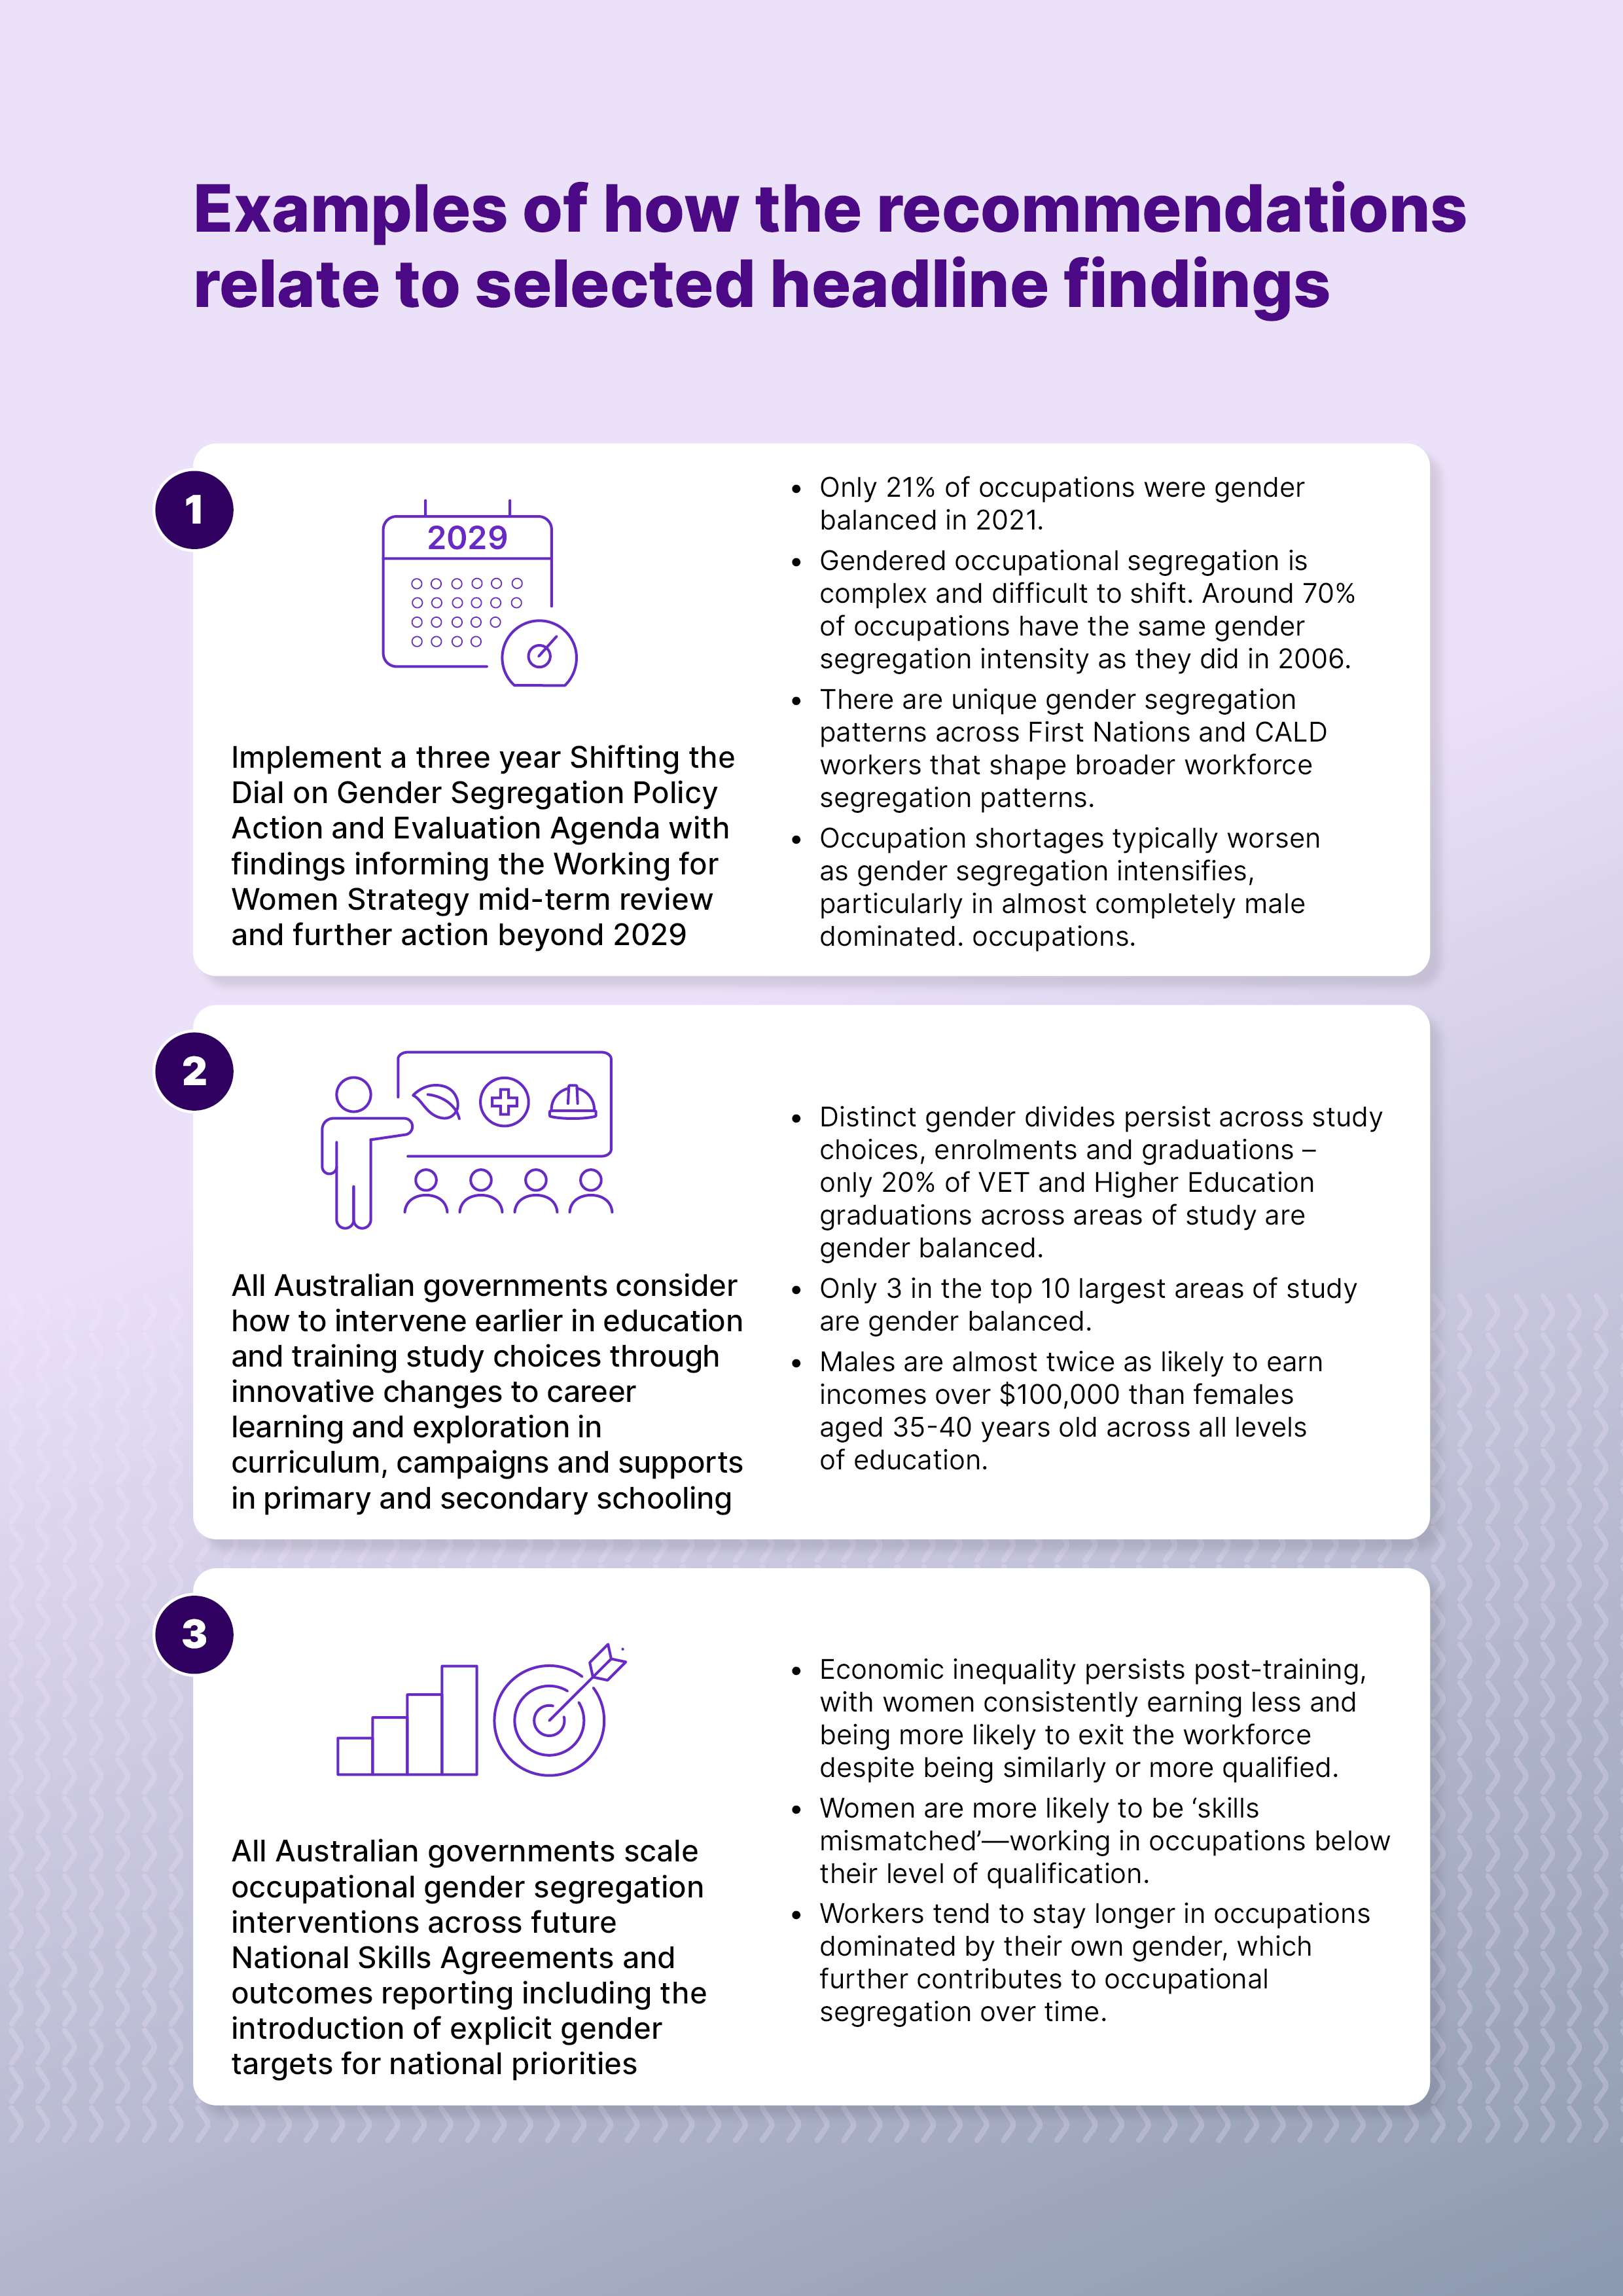
Three stylised pages with following table information:
Recommendation | Selected key headline findings
- Implement a three year Shifting the Dial on Gender Segregation Policy Action and Evaluation Agenda with findings informing the Working for Women Strategy mid-term review and further action beyond 2029 | - Only 21% of occupations were gender balanced in 2021.  - Gendered occupational segregation is complex and difficult to shift. Around 70% of occupations have the same gender segregation intensity as they did in 2006.  - There are unique gender segregation patterns across First Nations and CALD workers that shape broader workforce segregation patterns.  - Occupation shortages typically worsen as gender segregation intensifies, particularly in almost completely male dominated. occupations.
- All Australian governments consider how to intervene earlier in education and training study choices through innovative changes to career learning and exploration in curriculum, campaigns and supports in primary and secondary schooling | - Distinct gender divides persist across study choices, enrolments and graduations – only 20% of VET and Higher Education graduations across areas of study are gender balanced.  - Only 3 in the top 10 largest areas of study are gender balanced.  - Males are almost twice as likely to earn incomes over $100,000 than females aged 35-40 years old across all levels of education.
- All Australian governments scale occupational gender segregation interventions across future National Skills Agreements and outcomes reporting including the introduction of explicit gender targets for national priorities | - Economic inequality persists post-training, with women consistently earning less and being more likely to exit the workforce despite being similarly or more qualified.  - Women are more likely to be ‘skills mismatched’—working in occupations below their level of qualification.  - Workers tend to stay longer in occupations dominated by their own gender, which further contributes to occupational segregation over time.
- All Australian governments and lead skills system actors coordinate a national and economy-wide approach to gender segregated VET training pathways for occupations in shortage through four main policy actions | - Men generally, achieve better economic outcomes across most VET qualifications, even in female dominated fields.  - Pronounced gender segregation patterns exist in key VET training pipelines for Australia’s Net Zero transition, digital transformation and growing care sector needs.  - Skill Level 3 jobs are the most gender segregated, with many facing occupation shortages.
- All Australian governments and lead skills system actors complement current Closing the Gap reforms with additional and immediate national and economy-wide action for First Nations women | - First Nations females have the highest gender pay gaps in Australia (35.3%).  - There are sources of compounding gendered and racial discrimination in the world of work, education and training—particularly for First Nations women.  - Despite this, there are key VET training pathways where First Nations females and males are securing good outcomes.
- Industry and employers to accelerate progress on inclusive and safe workplaces and training settings | - Sexual harassment and safety is still an issue in many workplaces, especially in male dominated occupations and industries.  - Age, race, sexuality and other identity factors compound with gender and shape experiences of workplace discrimination and inequity.  - Vertical segregation and high gender pay gaps are still an issue across management and leadership roles, especially in Health and Finance.
- Extend policy settings and supports to normalise men’s involvement in unpaid care, domestic work and paid care work, with the longer-term aim of addressing social and cultural norms | - Gendered norms and decisions around unpaid care and domestic work have major implications for women’s earnings, employment outcomes and career pathways.  - Accumulated 10-year gender pay gaps are higher at 30.7% (in contrast to single year point-in time figures of 25.7%) highlighting the lifetime disadvantage of part time and unpaid care work.  - There is a clear ‘motherhood penalty’ in our gender pay gap findings, females aged 25-39 years old have the worst accumulated 10-year pay gaps.
- Government and others to embed the Gender Segregation Intensity Scale (GSIS) as a common and shared framework for informing action and monitoring progress towards gender economic equality | - The GSIS reveals how gendered Australia’s job, work, pay, areas of study really are and how it can be used to inform more targeted policy solutions to diverse labour market and skills challenges.  - Gender pay gaps and occupational shortages widen and worsen at the highest grades of gender segregation intensity and the GSIS identifies the occupations where more urgent action is needed.  - There has been a broader balancing of managerial and professional occupations over time and lessons can be leveraged from these detailed occupational GSIS findings.
- Further address gender and other biases in labour market and skills frameworks that reflect gendered language, structure and norms | - OSCA increases our understanding of occupational segregation especially in relation to new or more disaggregated female dominated jobs eg. allied health roles and Assistant School Principals.  - OSCA better recognises women’s skill levels and leadership roles including invisible gendered and cultural skills in female dominated and First Nations specific occupations. Eg. team leaders in early learning and Aged Care.  - Despite progress, there is still gender bias in OSCA and other frameworks that translates into policy settings.
- Expanded research, data and reporting to monitor progress on gender economic equality and increase intersectional perspectives and understanding | - Paper 1 and 2 findings demonstrate the value of intersectional analysis in labour market and skills for policymaking.  - Various intersectional insights on occupational segregation patterns, pay gaps, skills mismatches, post-training employment and economic outcomes deepen our understanding of how inequality plays out in work, education and training.  - Future intersectional insights using the JSA approach should be expanded to disability, geography, ancestry, socio-economic status and visa status to continue to fill evidence gaps and develop the most effective policy solutions.

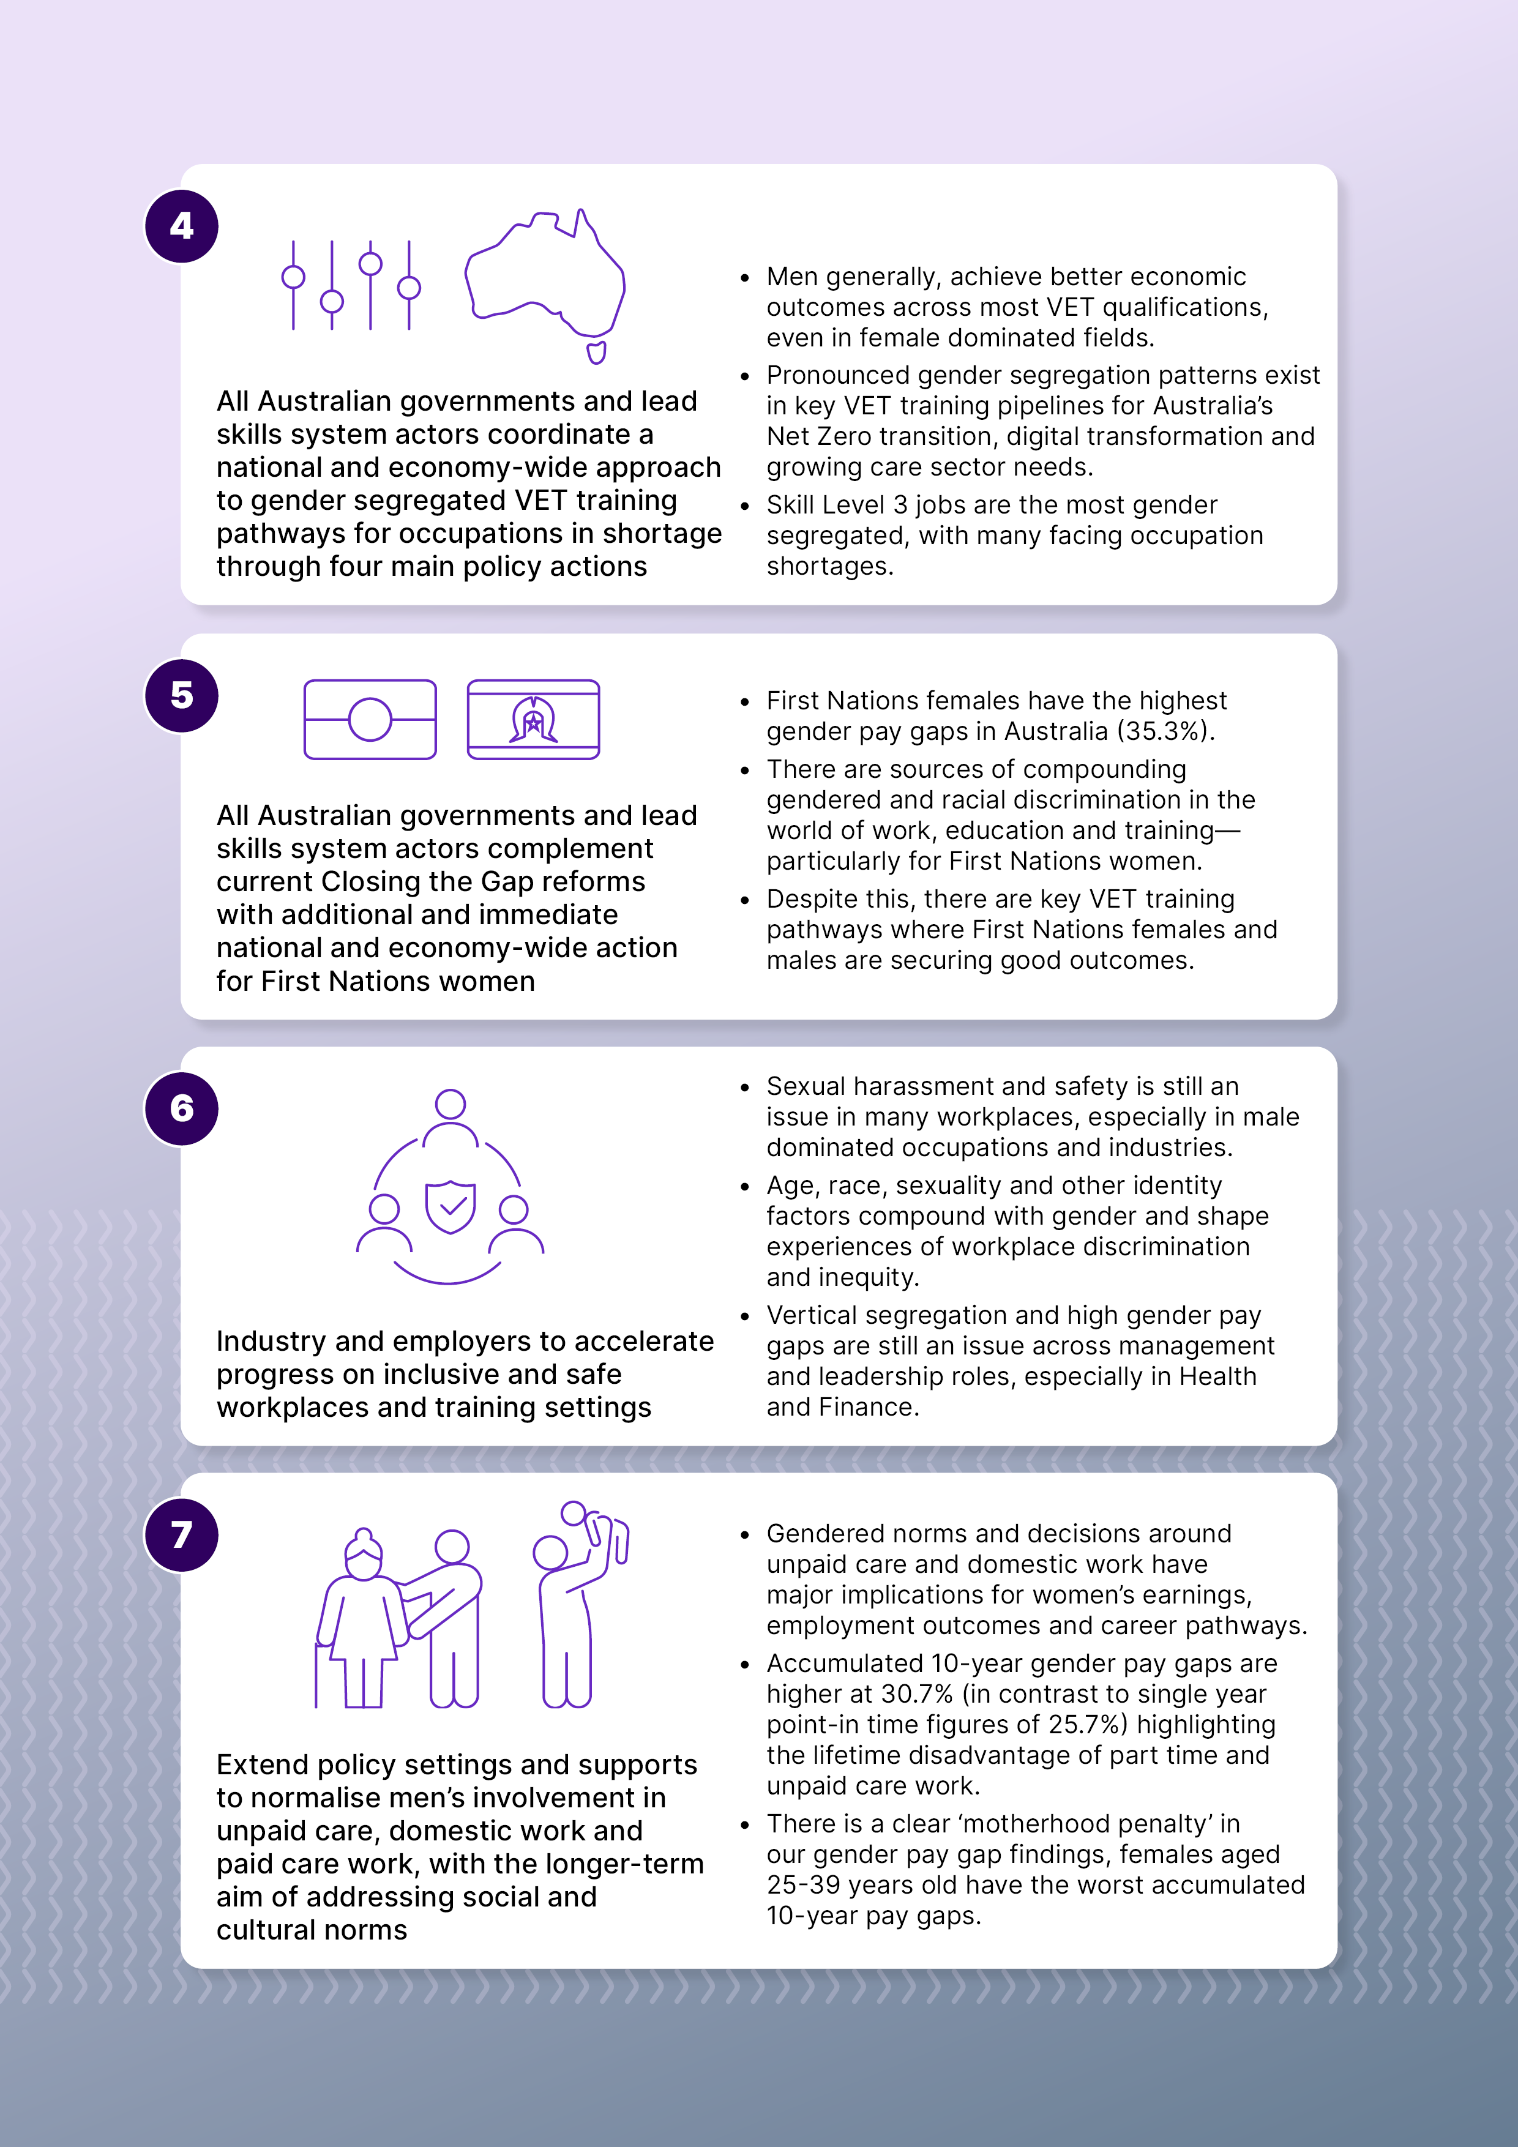
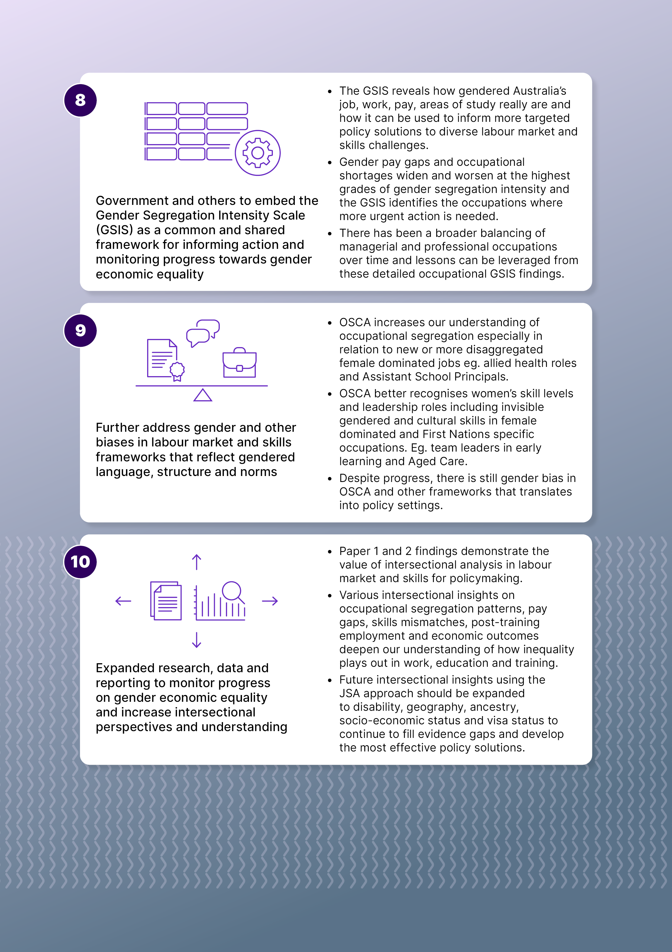

Recommendation 1
Implement a three year Shifting the Dial on Gender Segregation Policy Action and Evaluation Agenda with findings informing the Working for Women Strategy mid-term review and further action beyond 2029

WHAT?
JSA recommends a three year ‘Shifting the Dial on Gender Segregation Policy Action and Evaluation Agenda’ from 2026-2029 that identifies knowledge gaps and tests scalable interventions to inform nationally coordinated action on balancing occupational and industry segregation beyond 2029. Shifting the Dial is informed by the Study's new evidence, measures and our four recommended priority policy actions for 2026-2029 are:
- A three year JSC gender segregation intervention sprint and evaluation impact report.
- Industry gender segregation action plans across existing and emerging Australian Government reforms.
- The establishment of a systematic cross-jurisdictional evaluation mechanism, led by the Australian Government, that includes annual reporting to the Women and Women's Safety Ministerial Council on ‘Shifting the Dial’ progress and the development of a best practice levers resource for intervening in gendered occupational segregation.
- An independent evaluation review and report on ‘Shifting the Dial’ as a key input into the mid-term review of Working for Women to inform further action beyond 2029.
Beyond 2029, JSA recommends the Australian Government consider coordinated national reform to balance occupational and industry gender segregation, potentially in line with the last five years of the Working for Women Strategy from 2029-2034.
Testing and scaling existing interventions, including to different industries (that are not just male dominated), and far more systematic cross-jurisdictional evaluation of what is and is not working from 2026 to 2029 is crucial. The recommendation to replicate and fund a Building Women’s Career style Partnership or Working for Women grants model across selected in shortage Health occupations is key to this. JSA strongly recommends comparative policy action and evaluation intervention in female dominated, gender balanced, and more professional male dominated occupations to shift the dial on workforce segregation.
This will ensure further action beyond 2029 is evidence informed and designed for maximum, national and economy-wide impact. The overall mobility, share and movement of workers across different industries and occupations needs to be considered to achieve more balance across the whole economy. This is key to achieving the right shifts in occupational and industry segregation from a truly national perspective and speeding up progress towards gender economic equality. Our Paper 1 and Paper 2 data findings also show that these shifts are important in addressing longstanding labour market and skills system challenges like occupational shortages or skills mismatches that impact national productivity.
The GSIS and new intersectional, detailed occupation and life course gender pay gap measures from the Study can also be used and tested in the ‘Shifting the Dial’ actions and the final independent evaluation report can inform their further use beyond 2029.
The ‘Shifting the Dial’ agenda timeline also aligns with the end of the first target cycle of the new WGEA Gender Equality Targets Scheme for designated large employers in 2029 and the renegotiated NSA from 2028. Both could be leveraged to inform further nationally coordinated action beyond 2029.
Figure 3: Shifting the Dial on Gender Segregation Action and Evaluation Agenda
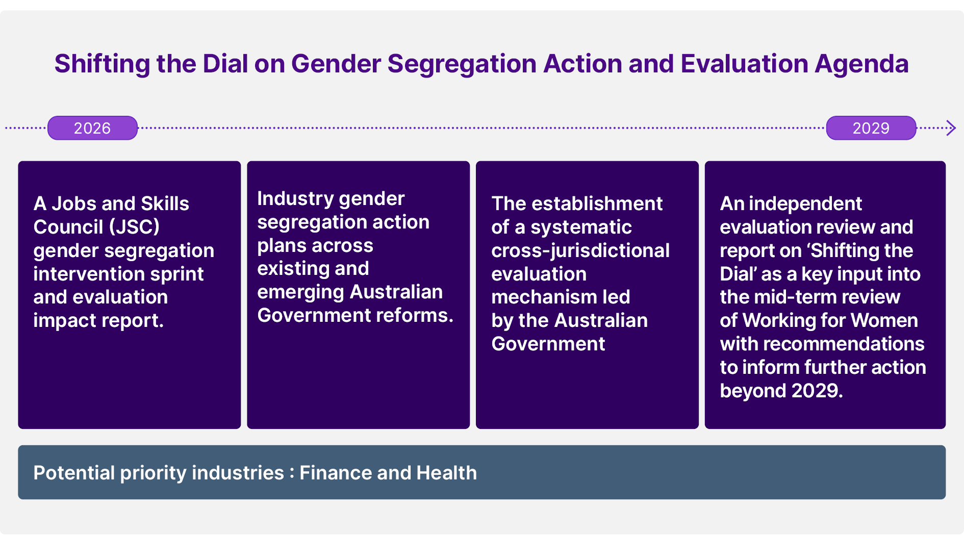

WHO?
JSA recommends the three year ‘Shifting the Dial’ agenda be coordinated by the OFW in partnership with the DEWR and JSA. JSCs are also lead actors including the JSC Cross Council Committees on Gender Equity and Closing the Gap.
WGEA could also be a key Australian Government collaborator, leveraging their work with peak bodies and employers, including their masterclasses and workshops to educate about gender segregation and provide advice and strategies for gender equity. These agencies should work closely with working groups under the Women and Women's Safety Ministerial Council and the existing cross-jurisdictional Women's Economic Equality Outcomes Senior Officials Working Group (WEO-SOWG).
JSA also recommends a Gender Equality Senior Officials Working Group is set up alongside the existing Gender Equality Jurisdictional Working Group under the Council which already has responsibility for women's policy, including workplace gender segregation, under the Terms of Reference (PM&C 2025a).
Both groups and the Council more broadly could drive the ‘Shifting the Dial’ agenda in collaboration with existing governance settings such as the Working for Women Implementation Interdepartmental Committee, the Working for Women Strategy Group, the Gender Data Steering Group, as well as the SWMC and Senior Skills Official Network (SSON) due to the close links between occupational segregation and skills system settings. See also Recommendations 3, 4 and 5.
Other leading actors include:
- Australian Tertiary Education Commission (ATEC)
- National Women's Alliances under the existing Working for Women governance settings
- Evaluation teams across all levels of government
- Australian Government agencies leading relevant emerging industries or priority reform programs including the Department of Health in any implementation across in shortage Health occupations
- State and Territory governments including in their roles as major employers in health and in their role as leading education and training providers across VET
- Education and training institutions
- Employers, unions, industry peaks and community organisations
- An independent evaluator.
Timely opportunity for Australian Tertiary Education Commission (ATEC) action in higher education training pathways
The recent formation of the interim ATEC, their objectives and their role in setting individual and system level goals for all higher education institutions, provides a strategic and timely opportunity for the ATEC to lead change across several study recommendations.
One of the ATEC's objectives is to raise equity participation and attainment, drive a joined-up tertiary system between VET and higher education and to foster partnerships with First Nations people and organisations. JSA encourages the ATEC to review the Study’s findings and recommendations including applying Recommendations 3, 4 and 5 in the VET space to higher education settings, as appropriate. For example, JSA recommends the ATEC consider:
- Introducing a gender or at the least intersectional lens to the current First Nations, Disability, low socio-economic status, and geographical priority cohort outcomes.
- Investigate how to apply our recommendations on leveraging the National Skills Agreement in Recommendation 3 in VET and highly gender segregated in shortage training pathways in Recommendation 4 to their agenda and work.
- Implement equity by design approach for systems, qualification design and occupational pathways and wraparound supports as per Recommendation 4.
- Develop and mandate evaluation and reporting frameworks to ensure accountability, transparency and sharing of what is and is not working in higher education to progress equity and inform later agenda policy action and evaluation and further reforms beyond 2029 from Recommendation 1.
- Experiment and explore a joined-up approach to the tertiary system and Closing the Gap across various policy actions in this paper. For example, in relation to in shortage Health-related occupations and the related education and training pathways or in supports for female educators and trainers in male dominated fields of study.

HOW?

A JSC gender segregation intervention sprint and evaluation impact report
JSCs offer a good opportunity for increasing the focus on the key intersections between education and training settings and workforce planning for intervening in gender segregation. JSA recommends more targeted gender segregation planning and program interventions in JSC workforce planning, including working towards using the GSIS in systematic reporting across all JSCs. JSCs can use the GSIS to monitor improvements in education and training pathway choices and show how these intersect with occupational and industry segregation. An explicit intersectional consideration of compounding gender and other biases, segregation and barriers in workforce planning, programs and evaluation should also be a key principle underpinning the sprint. Capacity building across JSCs to uplift capability should also be supported by the Australian Government.
JSA also strongly recommends a shift away from recruitment as the major lever in this work to increasingly focus on retention, career progression and long-term success especially for women in male dominated occupations. More interventions that focus on the combined challenges of attraction, progression, retention and promotion within occupations including how to best scale mentoring and career pathways initiatives is needed. Success goes beyond simply entering an occupation but thriving in your job and career in safe and respectful ways.
JSA recommends JSCs progress the below activities over the sprint, either individually or in collaboration across 2026, 2027 and 2028. They should also deliver an evaluation impact report in early 2029 to the Women and Women's Safety Ministerial Council and independent evaluator to inform the Working for Women 2029 mid-review and further action beyond that.
- JSCs should continue to identify gender segregation issues in the workplans and develop a JSC system-wide approach to mapping their top 10 gender segregated and in shortage training pathways and occupations to work towards more holistic and systematic approaches across industries.
- JSCs should consider highly CALD or First Nations segregated occupations in this system-wide approach. JSA suggests the JSC Cross Council Committees on Gender Equity and Closing the Gap could lead this work as a high priority in 2026.
- Across 2026-28 JSCs should develop, implement and review at least one industry-wide gender segregation action plan or intervention program targeting at least three occupations or qualifications.
- By early 2029, JSCs should submit an evaluation impact report on their sprint activities to the Council and the independent evaluator on lessons learnt and options that should be scaled.
JSA also suggests JSCs could action further research into, and target resolution of, high gender pay gaps in particular occupations and their causes in collaboration with WGEA employer and industry advice, targets and published levers.

Progressively reviewing, evaluating and reworking action plans or intervention programs across the three year sprint in different male and female dominated or gender balanced occupations to help build an evidence base is also warranted. Examples of intervention programs from existing JSC work that could be leveraged and replicated across JSCs include:
- Publicly transparent gender equity reviews of training packages and qualifications as per Future Skills Organisation gender equity assessment of digital apprenticeship models.
- Industry culture taskforces like BuildSkills Australia engagement with the Construction Industry Culture Taskforce and Net Zero initiatives.
- BuildSkills Australia's recommendation in their Housing Workforce Capacity Study to adopt the Construction Industry Culture Standard on all government projects, which includes the goal of closing the gender pay gap in the construction industry.
- Research being undertaken on gender diversity in the mining industry, and the need for further research to understand the gender pay gap and initiatives that can support women in the automotive industry by the Mining and Automotive Skills Alliance.
- Cultural competency training and outreach initiatives to attract and retain CALD workers in the Fire and Emergency Services sector from Public Skills Australia.
- Career mapping projects to better understand job mobility and re-entry into work post caring responsibilities as Service and Creative Skills Australia (SaCSA) identified for floristry in their 2025 Personal Services Workforce Plan Update.
- The Manufacturing Industry Skills Alliance forthcoming project on Women in Manufacturing which will publish a directory of employer and industry initiatives on attracting and retaining and supporting women in male dominated manufacturing roles.
- Industry Skills Australia’s recent commitment in their 2025 workforce plans to further stakeholder engagement to identify barriers for underrepresented cohorts for the maritime, transport and logistics sectors.
More immediate action in Finance sector on workplace culture and high gender pay gaps needed
Given our Study's findings on the finance industry's workplace culture and high gender pay gaps, Future Skills Organisation could consider creating an industry culture taskforce that is like the tripartite approach of the NCIF (see Recommendation 6). Our findings indicate that while finance has many gender balanced occupations, there are some of the highest gender pay gaps in this industry and a disproportional underrepresentation of women in senior and technical roles.
- Future Skills Organisation has already noted diversity and inclusion as a key opportunity for the industry in their 2024 Workforce Plan, while their stakeholders flagged strategic partnerships between peak bodies, employers and community organisations to promote pathways for First Nations people into occupations.
- These partnerships were reinforced by the consultation for a new National Workforce Strategy for financial counsellors and financial capability workers, which identified addressing labour market imbalance, targeted support for marginalised groups, and building on successful First Nations workforce measures as key priority issues. The introduction of Financial Counsellor (Community) as a new occupation in OSCA, as highlighted in Paper 2, also offers further research potential.
- The finance sector could also benefit from mirroring the Property Champions of Change model which includes an industry charter, committing to closing gender pay gaps and achieving inclusive gender equality across the workplace by 2030.
Consideration of how these taskforces, forums and codes of conduct intersect with WGEA's Gender Equality Targets Scheme and our Recommendation 6 is suggested.

When I got an award as employee of the month, in the speech my boss gave for me, he didn’t talk about all the things I had done for work – he just talked about my fashion. And I was so disappointed. Like is that all I’m good for – fashion. It’s like if you look good it’s a problem, if you don’t it’s a problem. Like men will never have to deal with that."
—LGBTQIA+ focus group participant, Finance Manager
"When you’ve got a lot of graduates that are female but there is not a proportionate representation in the workforce or at a more senior level, it feels like organisations aren’t accepting the responsibility of bringing women into the workforce"
—Female focus group participant, aged 30-44 years, Accountant
I see the payroll and women are getting paid less. Once, when an interim female director came in, she was getting a lot less, even though she was doing so much more and had more qualifications"
—Female focus group participant aged 55+ years, Accountant/ Finance Manager
"Tax at the junior level is very balanced because companies all have quotas… but as you get higher up it's definitely male heavy. Males at those levels start being more comfortable and blokey and it affects females’ opportunities for promotions. A friend of mine was competing against someone from the same rank and even though she had done more chargeable work, she didn’t have the same relationship with the male who was making the decision. Even though she had the numbers, he had the personality and the relationship."
—Female focus group participant aged 18-29 years, Tax Consultant

Industry gender segregation action plans across new Australian Government reforms
Australian Government lead existing, or in development, reforms should develop industry gender segregation action plans based on the Study findings and early evaluation work. Emerging industries and priority government reforms in Future Made in Australia, National Net Zero Workforce Roadmap, and Skills for Tomorrow apprenticeship reforms could be a focus to target the most entrenched segregation and critical shortages. For example:
- Work in development, such as the National AI Capability Plan, also offers a blank slate to develop an industry segregation action plan.
- JSA recommends the Department of Climate Change, Energy, the Environment and Water (DCCEEW) review study findings and continue participation in the Equality in Energy Transitions Initiative.
- A gender analysis of First Nations specific workforce strategies currently planned or in development to leverage opportunities across several study recommendations including action under Recommendation 1 or to better support First Nations trainers and learners under Recommendations 4 and 5 could also be done. For example, the First Nations Clean Energy Strategy - DCCEEW and the First Nations Teacher strategy under the National Teacher Workforce Action Plan (Department of Education 2024).
- Once the NDDA is fully operational, which is expected in 2026, research or pilot interventions on gender and disability segregation in the workforce and across education and training divides should also be prioritised across later ‘Shifting the Dial’ policy actions in 2027-28.
Leveraging existing and funding new government efforts in Health
JSA recommends the Australian Government consider replicating a Building Women's Careers Partnership Model and/or Working for Women Grants approach across in shortage VET and Higher Education Health occupations. Currently, the Building Women's Careers model focuses on the four male dominated sectors of construction, clean energy, advanced manufacturing and digital and technology industries.
In contrast, health offers a mix of occupations across the GSIS as well as high CALD and First Nations segregated occupations. This means Health offers a more holistic occupational segregation intervention opportunity into various occupations such as Aged and Disabled Carers, Nurses, and several allied health, professional or technician roles. Evaluation should be built into this from the beginning so there is an evidence base of what is and is not working in interventions across all categories of the GSIS for the independent evaluation. Any partnerships and evaluations that occur could also inform more targeted action in selected Health occupations beyond 2029.
JSA suggests Australian Government-led coordination from DEWR and OFW with HumanAbility and ATEC involvement in the partnership or grants approach. This is also an opportunity to further progress a joined-up approach to the tertiary system and Closing the Gap across both VET and higher education pathways. For example, ATEC could also undertake analysis to provide evidence-based advice for expanding the existing Commonwealth Practicum Payments (CPP) program to other degrees with significant unpaid placement requirements, many of which are pathways to female dominated health occupations to improve equity for students with caring responsibilities or who are from more disadvantaged backgrounds.
Likewise, HumanAbility could focus on allied health assistant occupations, where occupational pay gaps are some of the highest nationally and different roles across aged care and disability support, which are now disaggregated in more detail under OSCA which provides an opportunity for more focused workforce planning and segregation interventions. HumanAbility could consider the VET training pathways where different cohorts are achieving good outcomes or need supports as revealed in JSA's Intersectional VET Outcomes Dashboards. ACC and First Nations owned RTOs in health areas could also be leveraged under Recommendation 4 and 5.
It will be important to not duplicate but rather align with workforce initiatives being developed or already underway. Undertaking a stock take of initiatives and current policy actions in this sector in 2026 as a priority for the evaluation is also recommended. Currently several national strategies and plans are being, or have been developed for Australia's health sector, including the Draft National Nursing Workforce Strategy, Draft National Allied Health Workforce Strategy, Draft National Oral Health Plan, National Mental Health Workforce Strategy 2022-2032, and National Aboriginal and Torres Strait Islander Health Workforce Strategic Framework and Implementation Plan 2021-2031.
This would involve consultation and collaboration with various health stakeholders including departments of health across all Australian governments including in their role as large employers of health workforces.

The establishment of a systematic cross-jurisdictional evaluation mechanism and reporting
JSA strongly recommends a relevant part of the Australian Government is tasked to provide a targeted evaluation mechanism for mapping, evaluating and reporting on best practice levers for intervening in gendered occupational segregation—and related segregation in education and training pathways.
Establishing a more systematic cross-jurisdictional evaluation mechanism for best practice levers for intervening in segregation including three annual progress reports provided to the Women and Women's Safety Ministerial Council across 2026, 2027 and 2028 on the ‘Shifting the Dial’ actions should also be a key part of this mechanism. More systematic evaluation of interventions and initiatives by state and territory governments, and cross-jurisdiction sharing of outcomes and public reporting of progress is crucial. In line with the Pathway to Diversity in STEM Review (Department of Industry, Science and Resources (DISR) 2024), JSA also suggests evaluation mechanisms include more intersectional solutions and interventions into segregation.
Once set up, JSA recommends rapid review reports in two key areas in 2026:
- Existing and promising levers that support CALD or First Nations cohorts in highly gendered training pathways.
- A stocktake of existing Government efforts or promising levers in Health to support the development of a Building Women’s Careers style partnership in the sector.
What interventions are and are not working across all categories of the GSIS and what can be scaled to ensure more balance across the national workforce is key to filling knowledge gaps to inform work beyond 2029.
"There is a genuine opportunity to gather insights around the many relevant initiatives and interventions occurring across Australia and provide analysis around what has and has not worked, and why that has been the case in the specific contexts in which those initiatives were introduced. This could then feed into future government funding initiatives, ensuring grant guidelines capture the kinds of activities that are most likely to be effective across different industries."
— Australian Chamber of Commerce and Industry (Consultation Paper Submission, 2025)
Leveraging the upcoming Building Women's Careers evaluation which will be delivered in 2028—at least for levers that are working in male dominated sectors—is suggested. It is crucial that the ‘Shifting the Dial’ agenda and work beyond is strongly underpinned by a systematic evaluation of interventions and different programs across different levels of segregation intensity on the GSIS both on the male and female dominated side.
Grants provided under the Working for Women Program, including multiple programs targeted at cohorts facing intersectional barriers to economic participation, and the Advancing Gender Equality in Gender Segregated Industries grant program all include some evaluation requirements which can also be leveraged and are well within ‘Shifting the Dial’ timelines.
Evaluation mechanisms in the National Children's Education and Care Workforce Strategy 2022-2031 could be drawn on, which includes an annual review of the evaluation plan, and biennial stakeholder forums to discuss workforce issues and priorities.
Another key goal is embedding rigorous evaluation and knowledge sharing across jurisdictions. For example, there are a significant and disparate number of small-scale grants and programs that have been developed aimed at getting women and girls into non-traditional/male dominated pathways. These range from providing early trades experience (Girls Can Too! in NSW) to supporting school-aged girls and beyond to start a businesses (Future Female Entrepreneurs Program), to scholarships, internships, site tours and mentorship (Attracting, Retaining and Empowering Women in Construction), Women in Trades Tool Skills day (aimed at female secondary school students), 'try a trade' events. These and other initiatives at the state and territory level need to be evaluated more systematically as a priority to inform the mid-strategy Working for Women review and further action on workforce segregation beyond this. Recommendation 3 includes suggestions on cross-jurisdictional sharing of outcomes in VET using existing NSA governance settings and pending reviews and renegotiations.
JSA also suggests the development of comprehensive case book guide or Best Practice Pathways Towards Occupational and Industry Balance resource targeted primarily for an industry audience to be developed and delivered to the independent evaluator for review. It could include recommendations on programs that could be replicated, funded or expanded in more coordinated national work beyond 2029 in line with the last five years of the Working for Women Strategy. These case book guides or publications could be incorporated with other WGEA guides, resources, masterclasses and Workplace Gender Equality Action Plans.
"At a system level, the limited coordination results in missed opportunities for initiatives to learn and build from each other. There is a clear need for engagement across government and industry to support strategic approach that addresses the diverse drivers of underrepresentation. Given the multifaceted barriers to participation, no single initiative or stakeholder will be able to generate the systemic change required."
— Women in STEM initiatives evaluation report (DISR, 2023)

A ‘Shifting the Dial’ review and report by an independent evaluator
A comprehensive review and report by an independent evaluator, submitted to the Women and Women's Safety Ministerial Council in 2029 as a key input into the mid-Working for Women review, is key to the success of the ‘Shifting the Dial’ agenda. It should evaluate all four priority policy actions and build on existing evaluations in train or any that emerge from the implementation of Study recommendations. For example, comparative analysis of what works to shift the dial in female, gender balanced or more professional male dominated occupations in Health compared to what has succeeded in the male dominated industries and occupations across the Building Women’s Careers partnership.
It could also consider how to expand future interventions and reform to focus more on disability (including neurodivergence) and LGBTQIA+ segregation patterns based on data developments or any later priority policy actions during the ‘Shifting the Dial’ timeline of 2026-2029. See Recommendation 10.
JSA strongly suggests the independent evaluation report make recommendations to Government on longer term nationally coordinated action to balance occupational and industry gender segregation, potentially in line with the remaining five years of the Working for Women Strategy.
Coordinated national action could be modelled on the National Plan to End Violence against Women which aims to make change across a generation. By 2029, the ‘Shifting the Dial’ policy action and evaluation agenda will deliver evidence to do the same for balancing occupational and workforce segregation, and further actions could include a theory of change model and an outcomes framework.


Recommendation 2
All Australian governments consider how to intervene earlier in education and training study choices through innovative changes to career learning and exploration in curriculum, campaigns and supports in primary and secondary schooling

WHAT?
To shift entrenched gender norms and stereotypes that steer students into highly segregated career pathways, all Australian governments should intervene earlier in education and training choices. JSA recommends earlier interventions to improve career learning and exploration of primary and secondary school aged children, which can be achieved through changes to curriculum and more coordinated career advice and supports. This recommendation is closely aligned with the Working for Women foundation pillar of gender attitudes and stereotypes.
As a more immediate priority JSA suggests ACARA develop a national Years 3-10 curriculum on career exploration and learning that all States and Territories can adapt or utilise. In the longer term, JSA recommends the introduction of mandatory career learning and exploration curriculum for Years 3-12 as a longer term investment and intervention into stubborn occupational segregation trends.
Innovative low-cost options such as gender-informed continuing professional development (CPD) and resources that can be easily used by both career practitioners, teachers and parents across different settings is also recommended. As an example, ACARA's current development of a Career education focused Curriculum connection will provide support to educators to see the interrelationships across the dimensions of the Australian Curriculum for Foundation - Year 10.
"Invest in education in early childhood, schools and tertiary education systems to deliver opportunities for girls and women that will enable them to participate in every aspect of economic, social and cultural life."
— Women's Economic Equality Taskforce Recommendation 4.4 (WEET, 2023)

"It is recommended that Government supports increased in-reach into schools from industry professionals to share insights of career opportunities and upskilling teachers and career counsellors to ensure an objective and broad understanding of the vast opportunities available in all industries is provided to students"
— Chamber of Minerals and Energy WA (Consultation Paper Submission, 2025)

WHO?
All Australian governments through their Departments of Education and Australian Government agencies such as ACARA, and DEWR. Peak career advisory bodies such as CICA and cross-jurisdictional government funded organisations such as Education Services Australia. Collaborations between peak career advisory bodies and JSCs could also be effective.
Primary and secondary school teachers, career practitioners and parents are also key and ultimately the most influential actors in this recommendation.
Independent gender experts could also provide services, reviews, supports and resources to de-bias curriculum and resources so that education authorities like ACARA have support and can easily be taken up by educators. JSA is conscious of existing pressures on the teaching workforce so reiterates this approach as a key plank of our recommendation.

HOW?

Curriculum changes
As a first and immediate step, ACARA could be funded to develop a best practice Years 3-10 curriculum on career exploration and learning that all States and Territories could adapt or use. This could be based on international evidence and models, which has shown that children in primary school begin to eliminate potential careers, jobs and interests based on who they perceive themselves to be at this age (Gottfredson 2002). Career education for primary school aged children should focus on exploration, experimentation, identity and overall understanding of self, and curiosity about the future, rather than forcing a career decision on children at a young age.
ACARA and states and territories could also consider mandating some career exploration curriculum across years 3 to 12 in upcoming reviews especially in Victoria, Queensland, Western Australia and South Australia and as part of the next national curriculum review.
Options for consideration to broaden career exploration curriculum for secondary school students based on existing activity across jurisdictions include:
- Leveraging Queensland’s optional Work Studies subject to structure units on self-awareness and goal setting (career action plans), strengths and interests diagnostics, work-based learning taster sessions (industry visits, micro-internships), and one-to-one career counselling embedded in pastoral care for early Years 7-8 curriculum development.
- Empowering and uplifting gender informed career advice and counselling across existing and future programs, such as the Work Studies learning area currently for Years 9 and 10 developed by ACARA, and other state initiatives (for example, the School to Work program in New South Wales, and the Year 9 Career Taster program in Western Australia).

Scaling career learning supports and campaigns and uplifting gender-aware career advice and practitioner capacity
Nationally scaling low cost Your Career campaigns or initiatives such as Diversity in STEM Toolkit (DiST) and Little Ripples as interventions in early gendered study choices that can also be used as teaching resources is suggested. Nationally scaling CPD for schoolteachers or anyone talking to children about career learning in schools is another. The Australian Government could fund one organisation to develop a base CPD course and states and territories could fund additional modules or adaptions to their curriculum for a low cost.
Developing a national professional development pathway, endorsed by state training authorities, to upskill school-based practitioners' gender-aware informed career advice, GSIS analysis, equity coaching and cultural safety to better support the needs of secondary school students could also be considered.
Small low-cost changes to the Your Career platform based on our new Study measures and intersectional findings could also be explored by DEWR. For example:
- Your Career could consolidate micro-sites that surface the latest GSIS dashboards, interactive quizzes and short videos disproving gender job stereotypes, including prominent champions in their fields to share their journeys.
- To improve children's cultural awareness, Your Career campaigns could feature short animated “little yarns” co-created with primary students and First Nations elders to spark curiosity in non-traditional roles as early as Year 4.
"The important thing is at an early age not setting gender-based expectations around professions. It goes right back to early education where equality needs to be taught, and it comes right down to gender stereotyping. If that happens early on, it gets ingrained into young kids. When they go into the workforce, they will have these ideas still ingrained in their heads."
— Male focus group participant aged 55+ years, Design Manager

Recommendation 3
All Australian governments scale occupational gender segregation interventions across future National Skills Agreements and outcomes reporting including the introduction of explicit gender targets for national priorities

WHAT?
JSA recommends Australian governments under the shared VET Stewardship model of the National Skills Agreement scale occupational segregation interventions in the upcoming review over 2027 and renegotiation of the agreement over 2028. The introduction of more explicit gender-focused targets on the national priorities or a framework for measuring progress against them in the renegotiated NSA from 2028 or any similar partnership agreements beyond 2029 is recommended.
The aim is to build the evidence base and inform and work towards national coordinated action for balancing occupational and industry segregation beyond 2029. JSA also recommends more systematic evaluation of interventions and initiatives, and cross-jurisdictional sharing of outcomes on current plans and programs to inform the Shifting the Dial activities and evaluation across 2026-2029 in Recommendation 1.
JSA notes that the national, state and territory jurisdictional NSA plans include diverse policy programs, many of which are focused on intervening in training pathways into in shortage and highly gender segregated occupations and encourages collaboration between NSA reviewers in 2027 and any evaluation mechanism set up from Recommendation 1. State and territories should be mandated or incentivised in the renegotiated NSA to contribute to any evaluation mechanisms and outputs developed from Recommendation 1 in a coordinated role via SWMC and the SSON.
JSA also recommends the introduction of selected programs or initiatives in the renegotiated NSA from any actions that result from Recommendations 4 and 5.
Further leveraging and uplifting existing procurement levers at all jurisdictional levels is also recommended and JSA reiterates the Women's Economic Equality Taskforce Recommendation 3 that:
"The Australian Government must utilise its legislative, regulatory and spending powers to ensure all Australian workplaces create safe, secure, flexible and equitable work opportunities that support women’s economic participation." (WEET 2023:5)

WHO?
The shared national stewardship model established in the NSA including the SWMC and SSON provide existing governance settings for national cooperation and stewardship across the VET system and the intersection of skills and training policy with workforce issues. JSA recommends SWMC and SSON with DEWR and education and training institutions as the lead actors in this recommendation.
An additional cross-jurisdictional forum or council involving a combination of Skills, Womens', Disability and First Nations ministers could also be considered, to support national coordinated action beyond 2029 or the implementation of policy priorities in Recommendation 4.
JSCs and industry representatives from peak bodies, such as Women in Adult & Vocational Education (WAVE), TAFE institutes, group training organisations, RTOs, unions, employer groups, and sector organisations representing First Nations, CALD, and people with disability communities are also key.

HOW?

Leveraging NSA reviews and introducing explicit gender-focused targets
JSA suggests that the pending full review of the NSA in 2027 is a timely opportunity to consider the Study's evidence and accelerate progress by scaling national priorities, and/or initiatives in the plans underneath them, that have so far made the biggest impact in segregation patterns or training pipelines or outcomes.
The annual reviews of national and jurisdictional plans also provide upcoming opportunities to consider this Study's new evidence and the who, what, and how of addressing shortcomings in existing approaches as per the agreement's shared stewardship model (DEWR 2023).
The independent full review is also an opportunity to consider the lack of explicit targets for national priorities and more systematic national evaluation mechanisms across the varying jurisdictional plans to identify what is and is not working, and what is and is not being shared, piloted or implemented across the skills system. Identifying activities that are accelerating progress and providing the biggest difference can focus policy making decisions on the programs that are most effective.
JSA strongly recommends introducing more explicit gender-focused targets for delivering on the national priorities or a framework for measuring progress against them in the renegotiated NSA from 2028 or any similar agreements beyond this. As we noted in Paper 1, what does not get measured is invisible in the policymaking process. The interconnectedness between the skills system and occupational segregation is crucial to tackling segregation in key VET qualified highly gender segregated training pathways across trades, health and early learning that are pathways to Skill Level 3 occupations in shortage.
To support long-term shifts in segregation and equity outcomes, supports and systems to sustain female learners and trainers in male dominated pathways or males in female dominated pathways across their careers and life course is critical. Even a handful of participants staying in these areas can shift an occupation from almost completely gendered to highly gendered on the GSIS and lay a useful foundation for further momentum and good returns on investment.
The NSA has an agreed outcomes framework and balanced scorecard system that looks at cohorts such as First Nations students and students with a disability which also could be leveraged to include GSIS reporting. To drive measurable change, time-bound targets could be established in the next NSA. Governments could amend the NSA Outcomes Framework and national priorities as part of the stewardship review cycle to embed equity metrics and GSIS reporting and mirror WGEA’s target menu under GEI 1: Gender composition of the workforce.

Leveraging government procurement influence
JSA recommends expanding the Australian Skills Guarantee beyond construction and ICT projects at the federal level and states and territories do similar expansions of procurement settings in their jurisdictions. This could include all energy infrastructure projects that involve significant public finance or procurement. The Australian Government should also consider whether the Skill Guarantee's current targets and thresholds are sufficient to generate the transformational change required in highly gender segregated industries.
JSA also recommends all Australian governments reconsider the Strategic Review of the Australian Apprenticeship Incentive System Recommendation 2.12 on targets and Gender Equality Action Plans. This recommendation aimed to leverage the Australian Skills Guarantee to increase apprenticeship commencements and completions for priority cohorts in industries that align with the government's economic priorities and social equity objectives.
The Strategic Review of the Australian Apprenticeship Incentive System also recommended expansion of the scope of Gender Equality Action Plans to resemble a ‘cultural contract’ through which employers take specific actions to address intersectional gender challenges and promote a gender-inclusive workplace culture specific to their industry. JSA suggests consideration of this in conjunction with Recommendation 6 especially where governments are both large employers and procurers.
JSA also suggests governments consider introducing procurement incentives through equity performance clauses in Skills First and other state funding contracts, enabling RTOs to earn bonus payments for meeting or exceeding cohort targets for female learners and trainers in male dominated pathways or males in female dominated pathways.
The Australian Government's previous election commitment to strengthen compliance procurement requirements to ensure the Government is only working with companies that meet WGEA requirements is also an opportunity to continue to progress.

Recommendation 4
All Australian governments and lead skills system actors coordinate a national and economy-wide approach to gender segregated VET training pathways for occupations in shortage through four main policy actions

WHAT?
Our Study findings strongly indicate VET trained occupations in shortage are where skills underutilisation and stubborn gender segregation patterns compound productivity losses and labour shortages in the Australian economy. A national approach to gender segregated VET trained occupations in shortage is needed to coordinate and implement:
- a scholarship and supports package for trainers
- a suite of career introduction, entry-level programs
- an equity by design approach to systems, classrooms, qualification design and occupational pathways and supports
- a gender-conscious national VET pathways awareness and promotion campaign.
By more explicitly committing to intersectional equity by design in VET, Australian governments, industry, training providers and communities can turn isolated pilots, or diverse unevaluated or under-evaluated policy programs, into coordinated system-wide action, closing gender divides, filling critical shortages, and unlocking the full economic and social potential of every learner. Leveraging existing VET in Schools (VETiS) delivery, which is currently being reviewed by all governments to explore initiatives and identify potential policy reforms to strengthen quality delivery and outcomes, is recommended. This and other levers could supercharge diversity in the training pipeline for longer term impacts.

WHO?
Key actors in this recommendation mirror those in Recommendation 3 with the addition of:
- TAFE Centres of Excellence
- Australian Skills Quality Authority (ASQA)
- Secondary schools through the VETiS program
- SAGE—a not-for-profit public company with a demonstrated record in higher education, which has government funding from 2025-2030 to strengthen diversity, equity and inclusion initiatives in VET
- First Nations led and owned organisations
- The National TAFE Network could also be involved in potential collaborations.
The National TAFE Network is a new Australian Government and state and territory governments partnership set up to harness the capacity of Australia's TAFEs. JSA suggests they could potentially play a collaborative role across all four priority policy actions.

HOW?

A scholarship and supports package for trainers
"To increase female participation in the electrical industry, more female trainers, as well as providing training in mental health awareness and/or ‘accidental counsellor’ training would benefit both trainers and students."
— Master Electricians Australia (Consultation Paper Submission, 2025)
There are known diversity challenges in the VET workforce, and this lack of representation potentially influences and impacts on the outcomes of its diverse student cohort (JSA 2024). JSA recommends the introduction of national scholarship and support packages to target both attraction and retention of female teachers and trainers in male dominated fields and incentives for male teachers and trainers in female dominated fields under the renegotiated National Skills Agreement. Consideration on how to increase LGBTQIA+ representation in trainer roles and support employers and education and training providers is also recommended. JSA suggests consideration of the following levers in this package:
- A review of existing levers to identify training pathways where there are already supports to support more systematic evaluation and the targeting of any new programs.
- Greater access to part-time trainer roles for female trainers in male dominated trades or other training pathways to foster flexible working arrangements and assist workers juggling caring responsibilities. Supporting women to maintain visibility in industry and training roles is also important. This should initially prioritise industries and occupations not covered by the Building Women's Careers Program as to not duplicate effort.
- Funding and supports to access paid care for women with caring responsibilities so they can complete placements, upskill or participate in paid on ramps to in shortage occupations or even complete VET training and assessment qualifications to become trainers. These supports could also work to incentivise men into these occupations.
- Trainer pipeline scholarships and expansion of practical placement style payments to additional VET qualifications to grow diverse teaching supply and capacity across in shortage pathways.

A suite of career introduction, tertiary entry-level programs
JSA recommends trialling targeted gender balanced, career introduction or entry-level programs aimed at increasing participation in skill shortage areas in the next NSA. These should only be developed and used in consultation with industry, including relevant unions, and where they do not undermine existing pathways. JSCs, ASQA through its state accreditation powers, Self-Accrediting TAFEs and the National TAFE Network could collaborate to consider levers such as:
- Short format programs like a one or two day “Gateway to IT” or “Essential Engineering Skills,” which would facilitate interview opportunities with employers, helping to bridge the gap between training and employment.
- Mobile training vans in trades to distil best practice levers for reducing male or female concentration in key shortage roles in different regional or thin market contexts.
- Career introduction programs fully subsidised for school leavers from low socio-economic or First Nations backgrounds or from regional areas to provide paid on-ramps into in shortage qualifications for female learners in male dominated pathways or males in female dominated pathways. For example, this would complement existing plans by the ACT Government to develop specialised courses for female construction workers and school leavers.
- Embedding guaranteed work placements in entry-level courses, including wrap-around supports (early learning stipends, transport vouchers and mentors) modelled on state skilling voucher schemes.
- The NSW Gender Equity Action Plan model—featuring a Memorandum of Understanding (MoU) between TAFE NSW and partner universities—could be scaled nationally or replicated. These MoUs commit institutions to joint delivery of career expos (such as Trade & Tech Fit) and coordinated placement pipelines for underrepresented groups.
- Apprenticeship and traineeship wrap-around plans for all to female learners in male dominated pathways or males in female dominated pathways including mentoring, harassment response, more flexible rostering to support caring responsibilities.

An equity by design approach to systems, classrooms, qualification design and occupational pathways and supports
An equity by design approach that includes various policy levers and programs at all points across training pathways, such as:
- gender aware training package reviews and updates
- the exploration of a National Code to Address Gender-Based Violence in VET to support safer classrooms
- inclusion support toolkits for employers and schools
- the clustering of apprentices for equity groups
- improved transparency for tracking outcomes and targets including applying GSIS to enrolments and completions.
Tailored programs could also help boost VET participation and employment outcomes in in-shortage occupations that were shown to secure good outcomes for people with disability in Paper 2, such as veterinary nursing, carpentry and joinery, metal fitting and machining.
JSA recommends leveraging the Victorian Government commitment to a Centre of Excellence in Disability Inclusion as well as their plans to expand the centre's work across the Victorian TAFE Network, and SAGE's expanded impact to the Vocational Education and Training Sector in this work in the short term. SAGE has received funding from the DISR to increase resources, tools and support for diversity initiatives from 2025-2030 in VET. With evaluation planned for this project in 2030, early evaluations could be encouraged to inform 'Shifting the Dial' in later years.
"Move beyond "fixing women" approaches to address the structural and cultural barriers embedded in Australia's VET and employment systems. This requires examining how gender biases are codified in policy frameworks, funding mechanisms, and skill definitions."
— WAVE (Consultation Paper Submission, 2025)
"To achieve meaningful change, we urge policymakers to expand gender-sensitive apprenticeships and training programs to break down occupational segregation."
— Youth Projects (Consultation Paper Submission, 2025)

A gender-conscious national VET pathways awareness and promotion campaign
JSA recommends a national VET pathways awareness and promotion campaign, expanding on existing initiatives but ensuring that they are gender-conscious in their approach. Creating a national campaign to promote VET pathways was a key recommendation from the Inquiry into the perceptions and status of vocational education and training, which outlined that these national campaigns should be developed through various platforms (e.g. social media, government websites), promote success and positive experience stories in VET, and target diverse cohorts, with a focus on improving the perceptions for women, First Nations people and CALD cohorts.

Recommendation 5
All Australian governments and lead skills system actors complement current Closing the Gap reforms with additional and immediate national and economy-wide action for First Nations women

WHAT?
JSA reiterates the WEET's 2023 call that there is now time and space for a specific First Nations plan on progressing gender economic equality to be developed in a culturally appropriate manner. There is even more evidence in 2025, not only from this Study and Wiyi Yani U Thangani, but also recent leading work by the AHRC including the National Anti-Racism Framework (NARF) and Speaking from Experience Report.
- The NARF provides a roadmap for governments, business, workplaces and community organisations to address all forms of racism and built on An Anti-Racism Framework: Voices of First Nations People.
- The Speaking from Experience report fills evidence gaps on what workers from First Nations and CALD backgrounds think needs to change to make workplaces safer and address workplace sexual harassment. It includes recommendations on reducing barriers to information, safety, victim-survivors being heard, access to supports, and justice and accountability.
Recent industrial relations decisions and research on the undervaluation of and need to recognise the cultural and colonial load First Nations workers carry in workplaces also offers further evidence (Jumbunna Institute 2020; Fair Work Commission 2025). For example:
- The Hidden History of Aboriginal Women's work in the Community Controlled Health Sector.
- The Fair Work Commission provisional decision that dental assistants and dental therapists covered by the Aboriginal and Torres Strait Islander Health Workers and Practitioners and Aboriginal Community Controlled Health Services Award (AITSIHW Award) were subject to gender-based undervaluation. The Fair Work decision also highlighted evidence that exercising Aboriginal and Torres Strait Islander cultural skills is a common and expected feature of the work under the ATSIHW Award (Fair Work Commission 2025).

- Moves to remunerate cultural load have also been introduced by some universities and public sector employers, including Murdoch University, and the Queensland Department of the Environment, Tourism, Science and Innovation (Murdoch University 2024; Queensland Government 2025).
Furthermore, in addition to ongoing Closing the Gap work, there will be new evidence from upcoming research and new organisations and governance structures to lead, co-design and partner on a standalone plan. For example:
- The 2025 establishment of the Centre for Indigenous People and Work and the forthcoming second Gari Yala report on First Nations experiences at work.
- The Working for Women five year Research Partnership to build further evidence to inform progress towards gender economic equality which includes focused First Nations research, surveys and partnerships.
- The National Women's alliances are now established, including The National Aboriginal and Torres Strait Islander Women's Alliance.
In the skills space there is also:
- The commitment to scope the development of a Sector Strengthening Plan for the ACC and FNO RTO Sector under the current NSA and the First Nations VET Policy Partnership (First Nations VetPP) under existing Closing the Gap governance settings.
- A forthcoming JSA First Nations VET Workforce Research Paper which includes specific insights into the attraction, retention, and cultural safety of the First Nations VET workforce. It will also identify promising practices and key design principles for the VET sector that address barriers and support enablers to advance a more coherent, though flexible, adaptive and place-based, approach to growing, developing and nourishing a First Nations VET workforce.
- The JSA 2025-26 Workplan also includes a multi-year First Nations Research Program on how to improve skills and employment outcomes for First Nations Australians.

WHO?
All Australian governments with stewardship and coordination from the PM&C in partnership with the National Women's Alliances especially The National Aboriginal and Torres Strait Islander Women's Alliance to reflect the urgent need for action on First Nations women’s economic inequality. Organisations that represent First Nations women with compounding disadvantage such as the First Peoples Disability Network can also be drawn on.
In the skills space, ACC and FNO RTOs, the First Nations VETPP, and DEWR will play leading roles. JSCs, NIAA, AHRC, JSA, the Productivity Commission (in their responsibility for annual Closing the Gap reporting), and various Policy Partnerships under Closing the Gap are also key.

HOW?
JSA recommends strengthening industry partnerships and longer-term investment in the capability, capacity and sustainability of ACC and FNO RTOs to deliver diverse and wide-ranging First Nations-led training pathways. This includes as part of the current commitment under the NSA for the sector strengthening plan and the First Nations VETPP.
Levers, programs or supports that could be used as a starting point for consultations on co-design and collaboration with First Nations stakeholders and ultimately funded by the renegotiated NSA from 2028 are:
- increasing funding in VET related Indigenous Employment Programs run by ACCs and FNO RTOs (in alignment with Recommendation 4.6 from the WEET).
- VET in Schools delivery run by ACCs and FNOs.
- Industry-Backed Apprenticeship Hubs in regional or selected areas which are co-governed by ACC and FNO RTOs, unions, JSCs, and key employers in priority sectors.
- Interventions including apprenticeship and trainee clustering, wrap around supports and paid on ramps into in shortage highly gender segregated training pathways led by ACC and FNO RTOs as above in Recommendation 4. Paid on-Country work-integrated placements to mitigate transport and cultural dislocation barriers could also be considered.
- ACC and FNO development of a National Cultural Safety Credential for VET trainers and teachers.
JSA also recommends Government continues to progress work to fund, establish and prioritise the ICOVE. The ICOVE is built on four pillars of innovation, capacity building, policy and advocacy, and research and data. The ICOVE aims to support the growth of First Nations participation and leadership in VET. It will operate as a national evidence-informed best practice VET hub to create and promote high quality, culturally responsive training opportunities for Aboriginal and Torres Strait Islander students that have strong pathways to employment outcomes.
"Development programs would be good in my workplace. There is an Aboriginal mentoring program to give Indigenous workers a chance at management and leadership and to give them opportunities to advance. Good mentors are useful. I work very well under mentorships where people take the time to teach you and give you the time to learn."
— Male focus group participant aged 30-44 years, Corrections Officer

Recommendation 6
Industry and employers to accelerate progress on inclusive and safe workplaces and training settings

WHAT?
JSA recommends leveraging and supercharging existing efforts by organisations and associations focused on improving gender and diversity equality, safety and respect across workplaces, industry and the whole-of-economy. JSA recommends leveraging WGEA targets, strengthening workplace health and safety settings and accelerating the recognition of cultural load for workers. JSA also suggests the consideration of advocacy programs and inclusive leadership development to foster inclusive workplace cultures and challenge entrenched gender and other norms, facilitating the attraction of women and diverse workers to these occupations.

WHO?
The main actor in this recommendation are employers. Leveraging and supercharging existing efforts by organisations and associations could include existing work by JSCs, unions, industry associations, WGEA, AHRC, Diversity Council Australia, University of Technology Sydney Centre for Indigenous People and Work, and Pride in Diversity who manage the Australian Workplace Equality Index. This work can also be accelerated in education and training institutions via SAGE.
The AHRC's involvement could leverage their role in developing materials for inclusive workplaces and their power to investigate complaints under Australia's federal anti-discrimination law, including the Age Discrimination Act 2004, Disability Discrimination Act 1992, Racial Discrimination Act 1975, and Sex Discrimination Act 1984.

HOW?

Leveraging WGEA's Targets Scheme to accelerate progress
From 2026, large employers (Designated Relevant Employers, those with 500+ employees) must select three gender equality targets from a legislated menu (at least one must be numeric), then meet or show improvement over a three year cycle against their 2024-25 baseline. The first target cycle includes employers monitoring progress of their targets in 2027 and 2028, with WGEA assessing whether the targets have been met or improvement demonstrated in 2029.

JSA suggests that employers below the legislated 500 employee requirement could voluntarily devise and set targets and independently monitor progress, while larger employers could consider setting additional targets and independently monitoring their progress separate to the legislated three target requirement reporting to WGEA. Employers could also consider implementing flexible ‘return-to-work’ roadmaps, combining modular micro-credentials, on-site elder-care stipends and virtual catch-up cohorts, which could help women re-enter male dominated sectors after career interruptions, including periods of unpaid family or community care.
Examples of the levers employers can pull from WGEA's Targets Scheme include:
- Setting targets for increased representation of the underrepresented gender for managers, non-managers, promotions to management, and by pay quartile.
- Undertaking a comprehensive gender pay gap analysis annually, demonstrating transparency about pay scales and salary bands, or completing remuneration review processes without gender biases.
- Setting targets to reduce the gender pay gap, including specifically for managers or non-managers.
- Increasing the representation of the underrepresented gender taking primary parental leave.
- Improving employer funded parental leave, such as extending the length of leave that does not distinguish between primary and secondary carers, and the employer paying superannuation contributions while on parental leave (both employer-funded and unpaid).
For further information and the full list of targets, please see the WGEA Gender Equality Targets Menu webpage.

Strengthening safe and respectful workplaces to address barriers to gender balance
JSA recommends that the Australian Government continue to implement the AHRC 2020 Respect@Work: Sexual Harassment National Inquiry, consider implementing recommendations from the 2025 Speaking from Experience report and replicate the 2025 National Construction Industry Forum (NCIF) Blueprint work in other industries with evaluation mechanisms built in to measure impact and progress. For example, employers could:
- Engage specialist organisations to deliver accessible and culturally appropriate education and outreach on workplace sexual harassment. This could build upon the existing Australian Government funding of not-for-profit Working Women's Centres who provide free information, advocacy, advice, and assistance to women on workplace issues, including workplace entitlements and rights, gender issues, cultural diversity, discrimination, and sexual harassment.
- Consider requiring stronger positive duties on employers to accommodate the needs of workers who have caring responsibilities to go above and beyond existing sexual discrimination legislation that places a positive duty on employers (AHRC 2025).
Employers, particularly in industries more exposed to occupational hazards, should strengthen safe workplaces. It is recommended that regulatory arrangements explicitly mandate the provision of workplace amenities that are regularly serviced, accessible, culturally appropriate, and suitable for all workers, with particular attention to the needs of priority cohorts. Gender segregated occupational industry reference committees, comprising employer and worker representatives, could be established to advise on regulatory priorities and monitor progress in education and compliance related to workplace amenities.
"I've had men older than my father shut shed doors and try and kiss me. I called and said I don't feel comfortable going back to the job site and I never got another shift."
— Female LGBTQIA+ focus group participant, former Construction Labourer
"I make myself smaller and not as feminine, because unfortunately for me, I've been sexually harassed. There were many incidences, but I never said anything. I only reported one of the incidences because I had a panic attack in front of my manager. You feel embarrassed by the situation, and you don't want other people to know because you don't want them to think badly about you."
— Female focus group participant aged 18-29 years, Tax Consultant
In construction, I worked directly for the builder so I was telling sub-contractors what to do. They just wouldn’t listen to you. I would go in and yell and be really stern the same way a man would and they would say what a bitch. Everything is called emotional – if you have a great strategy or really great ideas.
— LGBTQIA+ Female focus group participant, Youth Work (formerly construction)
Almost completely male dominated occupations could pilot ‘Men as Allies’ advocacy programs and male-led leadership academies to challenge traditional norms, normalise career breaks for caregiving and create pathways for women to rise into site-supervisor and managerial roles. Research has shown that men benefit from active involvement as fathers in their children's lives. Supporting men to take paid parental leave can also lead to a double benefit for employers of attracting and retaining talented men by normalising working fatherhood and removing some of the penalties facing by working mothers (Diversity Council Australia 2017; WGEA 2025). This could build on work to adopt the Construction Industry Culture Standard to improve diversity and inclusion, work-life balance, and the mental and physical wellbeing of workers (Construction Industry Culture Taskforce 2025) or recent NCIF work.
National Construction Industry Forum (NCIF) Blueprint
The NCIF is a tripartite statutory advisory body. The NCIF provides advice to government on issues relating to work in the building and construction industry including, but not limited to, workplace relations, skills and training, safety, productivity, diversity and gender equity, and industry culture. At its 22 September 2025 meeting, NCIF members agreed and endorsed the Blueprint for the Future (Blueprint) which comprised 44 recommendations that set out a pathway to create change within the industry. NCIF members also agreed to commence work on nine priority recommendations in the first tranche, with a forward workplan expected to be published by the end of 2025. JSA recommends monitoring and evaluation of the NCIF's efforts to inform national coordinated action for balancing occupational and industry gender segregation beyond 2029.
Priority recommendations within the Blueprint that align with the supercharging of industry reforms on inclusive workplaces include:
- Recommendation 3.1(g): NCIF to identify best practice and provide advice on procurement frameworks and settings with a view to developing a nationally consistent set of procurement principles, by considering how procurement frameworks can operate to drive quality, productivity, mutually beneficial and lawful behaviour, and deliver safe, secure, well-paid jobs in the construction industry. This includes addressing the overreliance on labour hire, eliminating gender inequities and obligations to report unlawful behaviour, as part of the Secure Australian Jobs Code consultation process.
- Recommendation 4.3: NCIF to provide advice to government about the pathways to the construction industry, to identify targeted strategies to address structural barriers to entry.
- Recommendation 4.4: NCIF to explore structural barriers to women’s participation in the industry, for example, support for care, access to childcare for shift workers, PPL entitlements, flexible work arrangements, and adequate facilities.
Other recommendations in the Blueprint beyond Tranche 1 consider advice to address gendered violence and provide respectful workplace training including:
- Regulators taking a more proactive approach to enforcement.
- Asking the Fair Work Ombudsman to consider investigation into sex discrimination, sexual harassment, and vulnerable cohorts in the industry.
- Industry mandating safe and respectful workplace training developed by JSCs for new and existing employees and managers.

Apply an intersectional lens and recognising cultural load
As outlined by Victoria's Commission for Gender Equality in the Public Sector (CGEPS), employers could apply intersectionality to workplace gender auditing and analysis to improve the understanding and visibility of demographic cohorts, enabling more effective policymaking. Considerations for employers, including employee privacy and psychological support, are outlined in CGEPS's intersectional gender auditing and analysis resource. This also includes utilising tools such as the Australian Workplace Equality Index, a benchmarking tool for LGBTQIA+ inclusion in Australian workplaces.
Supporting inclusion of First Nations LGBTQIASB+ (SB stands for Sistergirl and Brotherboy and are terms used by First Nations transgender women and men) people in education and employment is also recommended. Research shows they are disproportionately impacted by discrimination and disadvantage (Day et al. 2022).
A more tangible example of what employers can action is recognition and renumeration of cultural and colonial load for First Nations and CALD workers. Public and private sector employers can create culturally safe and gender-focused workplace policies by offering cultural leave and embedding First Nations gender justice and equality into anti-discrimination training and work practices, as outlined by the Wiyi Yani U Thangani Implementation Framework (2022). Unions should continue to bargain for explicit recognition and renumeration of cultural load in enterprise agreements to explicitly recognise cultural load.
Industry associations could commission cultural-safety audits for major worksites and training centres. These audits would map every service, meeting, policy workshop or informal ‘yarning circle’ that relies on Indigenous or CALD staff to lead or represent their community and then offer to compensate those staff through additional paid hours, leadership allowances or study credits.
"We're often disengaged because we have to do workplace diversity training modules back-to-back because it feels impersonal. What's better is a meeting because you see people, converse with them and understand what it's like to interact with people from that marginalisation."
— LGBTQIA+ focus group participant, Finance Manager

"I think for me it's been more to do with culturally as opposed to my gender. I was born in Kenya and culturally some things aren't appropriate, like having afternoon drinks, I'm not the most comfortable hanging out with my colleagues after work and it felt like I was being left behind because of that"
— CALD female focus group participant aged 30-44 years, Lawyer
The Diversity in STEM Review report’s Workplace Action Framework also offers a good example of what can be adapted to increase the attraction, retention and promotion of underrepresented cohorts in highly gender segregated occupations and industries.

Figure 4: Diversity in STEM Workplace Action Framework
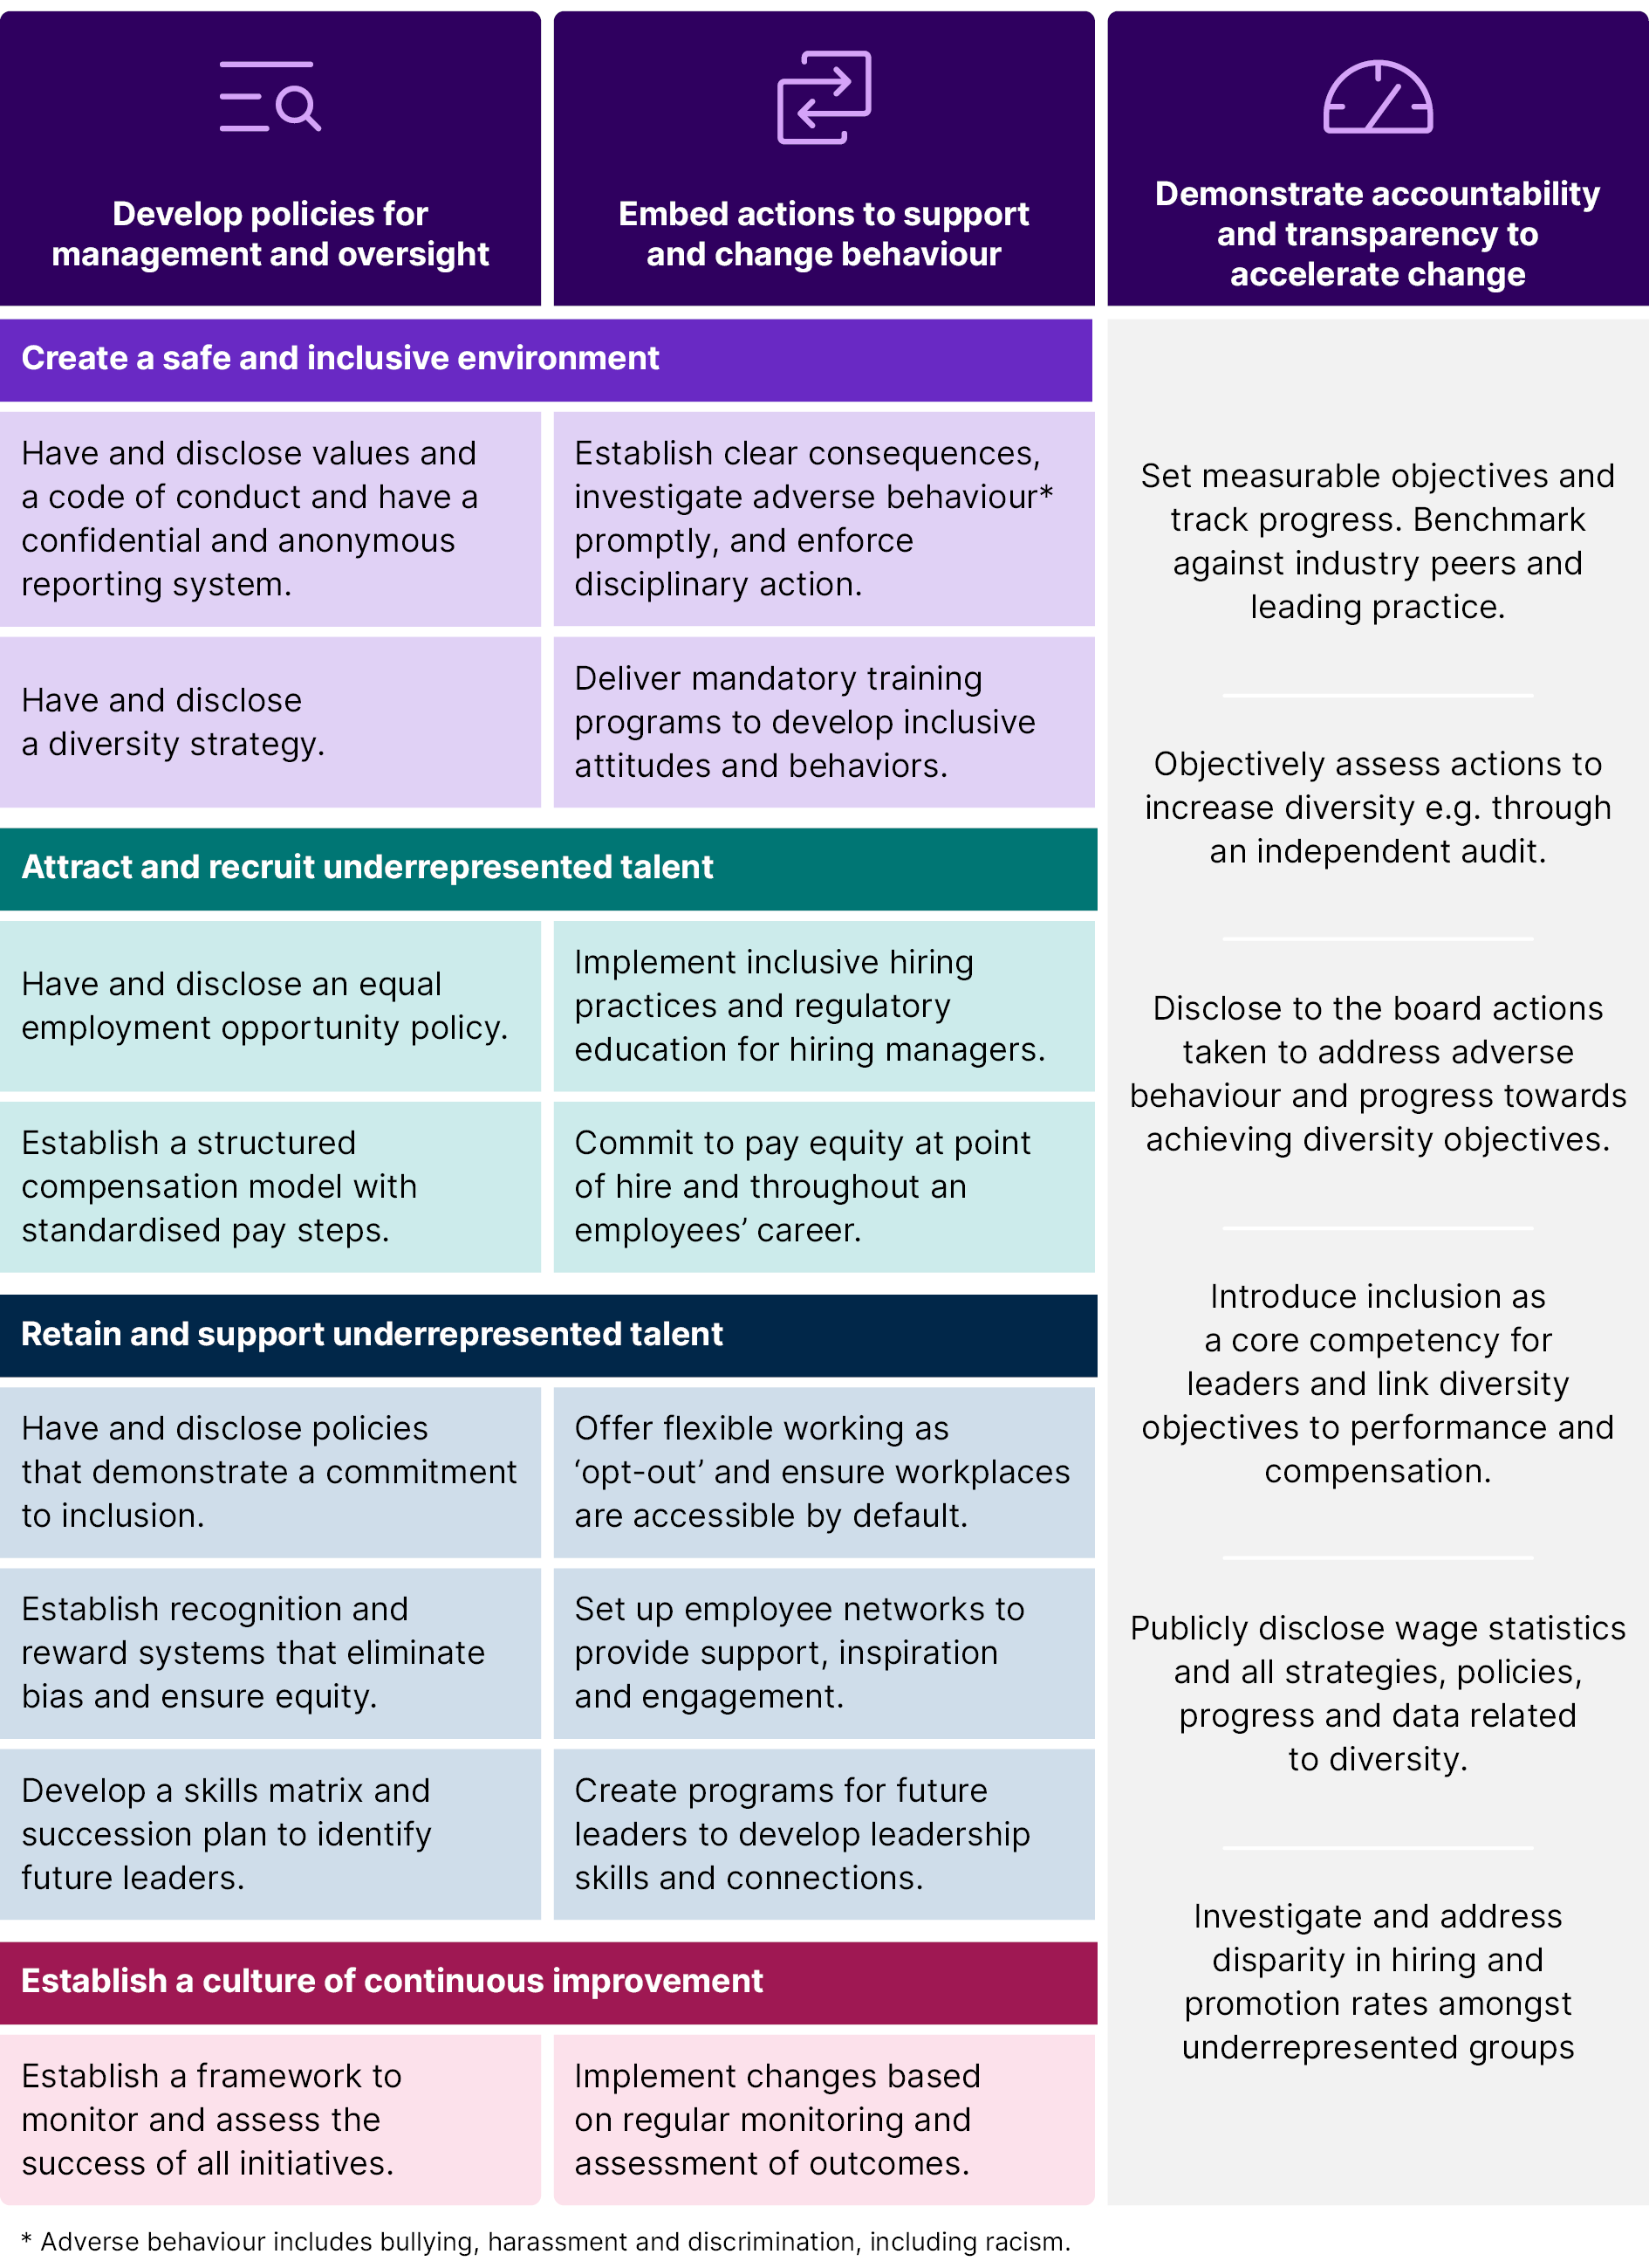
Source: DISR, Pathway to Diversity in STEM Review final recommendations report | Department of Industry Science and Resources, 2024.

Recommendation 7
Extend policy settings and supports to normalise men's involvement in unpaid care, domestic work and paid care work, with the longer-term aim of addressing social and cultural norms

WHAT?
Social and cultural norms influence education and training, occupation and career pathways, and gendered decisions around unpaid care and domestic work have major implications for earnings and employment outcomes. In addition to our jobs and skills system focused recommendations, JSA notes a need to recognise the cross-cutting role that family and household patterns of decisions and behaviours play in gendered work, jobs, pay and education and training divides.
Women being disproportionate primary carers of children can shape their children's perceptions and reinforce traditional gender norms and stereotypes related to caring. This can make it more likely for young girls to imitate what they have seen and take on care roles, and the reverse for young boys.
JSA recommends the Australian Government and employers consider extending current policy settings, in particular the PPL model, to promote uptake by men and 'secondary' carers. This recommendation has an intentionally longer-term aim to dismantle the long standing gendered socio-cultural norms around caregiving being feminised and undervalued so that we can shift:
- stubborn segregation patterns in high-demand female dominated occupations across Health, Care and Education.
- gendered education and training choices including the early job and career role models in one generation to shift training pathways into these occupations.
This recommendation builds on Priority Area 2 of Working for Women on unpaid and paid care, and recommendations previously made by the WEET (2023) and Work and Family Roundtable (WFPR 2025).
Acknowledging that care responsibility goes beyond primary school aged children, and the compounding caring responsibilities for the 'sandwich' generation—where women have caring roles for both their children and elderly parents or relatives (Miller 1981). Employers can do this by increasing the accessibility of flexible working arrangements to both women and men to support employees with caring responsibilities.

There is also a need for improving the visibility, support and recognition of First Nations unique care work—especially that is disproportionately done by First Nations women—by employers, which encompasses collective care for family, community and country as a means of intergenerationally transferring knowledge and culture.
"Women in our study were undertaking very high volumes of care that accounted for approximately 62% of their time on a usual weekday. We estimate that the market value of [unpaid care work by First Nations women] ranges between $223.01 to $457.39 per day."
— Klein et al. 2023

WHO?
Key actors are employers, fathers and secondary carers and the Australian Government with leading action from the Department of Social Services (DSS).

HOW?
JSA recommends employers and the Australian Government consider expanding PPL to 52 weeks in line with previous WEET and Work and Family Roundtable recommendations.
JSA recommends the inclusion of a strong 'use it or lose it' model for fathers and 'secondary' carers as part of this as well as potential flexibility to take PPL across the life course of the child. International best practice in Sweden and Iceland, both of which have some of the highest rates of male uptake of PPL, use a similar approach where sections of the leave is reserved (and non-transferable) for each parent and in Sweden can be taken up until 12 years old (Duvander and Löfgren 2025).
Access and the roll out from 26 to 52 weeks of PPL could be implemented in stages over the remaining 8 years to end of Working for Women in 2034 or in line with Work and Policy Roundtable recommendations (WFPR, 2022 and 2025). This roundtable has also recommended increasing the PPL rate of payment to wage replacement levels, which alleviates women's economic inequality over the life course and in retirement but also results in an increased uptake of PPL by male partners. JSA recommends the current evaluation of the PPL scheme by DSS also inform policy and next steps.
"I think we really have equality in the workforce, but not at the home department. I feel like women have now got two full time jobs and men still have one."
— Female focus group participant aged 45-55 years, Project Administrator
"I wouldn't share any life changes, like getting married or planning to have kids, with the male partners because it might affect my career progression."
—Female focus group participant, aged 18-29 years, Software Engineer
Employers should also be implementing workplace initiatives to normalise men asking for care leave and being able/comfortable to request flexible arrangements for caring. See Recommendation 6 on examples of employer initiatives.

"Men mistakenly believed that their colleagues disapprove of them taking parental leave. An increase in team awareness and support gender-neutral parental leave increased the amount of parental leave intended to be taken by men."(WEET 2023)
Continued adoption and evaluation of government funded programs by employers, such as the Carer-Inclusive Workplace Initiative, which the Australian Government has extended to fund to 30 June 2026 in order to assist employers in adopting and developing practices which support employees with caring responsibilities enter and remain in the workforce is also recommended.
The Australian Government is currently working with state and territory governments to implement the National Carer Strategy locally, which is a national agenda to support Australia's unpaid carers. As this strategy rolls out and is reviewed in 2030-31, JSA recommends considering this work in any implementation of Recommendation 1.


Recommendation 8
Government and others to embed the Gender Segregation Intensity Scale (GSIS) as a common and shared framework for informing action and monitoring progress towards gender economic equality
"Programs funded by the Commonwealth, states and territories must be rigorously evaluated to ensure accountability and provide reliable information on the success and progress of initiatives. Evaluations must inform future policy. We must have ambitious and measurable targets in place to demonstrate progress over time towards ending gender-based violence". (DSS 2023)

WHAT?
The recommendation is for all Australian governments and other key skills system actors to adopt the GSIS to ensure occupation and industry segregation is at the forefront of monitoring and reporting on structural reforms to progress gender economic equality. Using the GSIS offers a tool for raising awareness and enables a more nuanced level of understanding and analysis as our data findings in Paper 1 and Paper 2 showed. A key principle driving this recommendation is that the more we consistently talk about and measure occupational segregation, the more likely we are to make change.

WHO?
All Australian governments as well as skills system actors such as JSCs and individual education and training institutions. JSA and OFW would be lead Australian Government agencies who will provide early demonstrations of its use and applications.

HOW?
In the three year 'Shifting the Dial' agenda, different actors could test measurable goals and metrics of success using the GSIS as part of evaluations and outcomes measurement to inform how the GSIS might be best used in the future. For example, reducing the number of occupations in almost completely and highly male or female dominated intensity across the GSIS and ultimately working towards 70:30 or even more gender balanced shares in all occupations in the longer term is recommended. JSA notes existing evidence that 30% representation by women in the workforce emerges as the critical mass threshold to target to bring about observable change in an organisation's performance outcomes and practices (Risse 2024).
The midpoint review of Working for Women in 2029 would be a timely opportunity to further consider use of the GSIS as well as ongoing intersectional gender pay gaps and updated GSIS analysis of occupational segregation over time using detailed 2021 and 2026 ABS Census of Population and Housing (the Census) data to further develop evidence and target policy solutions.
Examples of frameworks and research that could adopt the GSIS include:
- Various JSA research and reporting including the Occupation Shortage List, Jobs and Skills Atlas Dashboard and the occupation matrix as part of the Australian Jobs report, aligning with the JSA Gender Framework.
- The Shifting the Dial agenda as per Recommendation 1 including across all JSC workforce plans.
- The upcoming NSA Balanced Scorecard reporting framework. In the longer term, any explicit gender-focused targets for delivering on the national priorities that are developed in the renegotiated NSA or for evaluating any reforms or programs that are implemented from Recommendation 4 or 5.
- In any ongoing reporting and monitoring of gender pay gaps as per Recommendation 10 or in the longer term as part of WGEA's pay gap research and/or reporting.
- Gender Impact Assessments and Gender Responsive Budgeting infrastructure across all Australian governments after discussion with relevant lead agencies or departments. For example, departments could refer to, or use, the GSIS in the workforce criteria for Gender Impact Assessments for Cabinet Submissions and New Policy Proposals.
- Future work across frameworks in Australia's national skills architecture as per Recommendation 9.

Recommendation 9
Further address gender and other biases in labour market and skills frameworks that reflect gendered language, structure and norms

WHAT?
JSA recommends leveraging the ABS's progress through developing OSCA and JSA’s work through the National Skills Taxonomy to codify and value skills that have been less visible or insufficiently described, along with continuing work on other statistical, policy and industrial frameworks. This can be done in conjunction with the Fair Work Commission's current work on gender undervaluation including pending hearings on assessing the recognition of skills within five priority female dominated awards. Alignment with Recommendations 8 and 10, to ensure intersectional approaches are part of these reviews is important.
Australia’s national skills architecture needs reform to better recognise undervalued and underacknowledged skills, particularly those common in female dominated, care-based and service-oriented roles. These skills must be made more visible, measurable and valued across education, employment, and policy systems. Actively recognising invisible skills in education and training settings, development and training packages can be achieved by:
- Recognising invisible skills in curriculum and course design, pedagogy, and assessment across VET and higher education.
- Equipping educators and trainers with resources and professional development to teach and assess these skills effectively.
- Ensuring these skills are documented and visible in qualifications, learning outcomes, and publicly available education materials.
- Improving data collection on the use and value of previously under-recognised skills across gender, cultural, and occupational lines.
- Funding longitudinal analysis to explore the impact of invisible skills on career outcomes, job satisfaction, and economic mobility.

WHO?
All Australian governments with lead agency actors such as the ABS, JSA, DEWR, the FWC and individual education and training institutions.

HOW?
JSA recommends the following frameworks could be prioritised:
Statistical classifications such as OSCA and ANZSIC including in its upcoming review (ABS 2022). While the Study's findings demonstrate how much progress OSCA has made in addressing gender biases and improving the way we understand female dominated jobs in Australia's workforce, some imbalances remain. Further consultation is expected in early 2026, as the ABS looks at further updates to OSCA in 2027 and beyond.
The ABS should also continue work with international organisations, such as the International Labour Organisation and the United Nations Statistical Division, that develop international statistical classifications and standards on this and other intersectional data reforms. Once OSCA is fully adopted in key data sets, the Fair Work Commission Pay Equity Panel could consider a Phase 3 of Gender Pay Equity Research.
Skills system frameworks including NSA reporting such as the Balanced Scorecard or any explicit gender targets on national priorities that are implemented from these recommendations. JSA also recommends in the development of the National Skills Taxonomy:
- Gender inclusive codification and valuation of skills.
- Development of a national common language to support the identification and articulation of skills currently absent from existing frameworks.
- Addressing gender-based undervaluation by ensuring cognitive, interpersonal, and intrapersonal skills are recognised and embedded.
- Establishing a clear methodology for capturing and codifying previously invisible skills, distinguishing them from personality traits and embedding them as legitimate, measurable competencies and learning outcomes.
- Investing in tools and methodologies that can demonstrate and assess skills not easily captured through traditional models.
"I've learnt a lot from working with women… I've taken onboard the compassion and care they display to clients. [Support work] is not just a job, but its care you give someone that affects them, their day and their life. When I've seen these women display such a genuine level of care, it's inspiring and makes you want to take it on and do it yourself."
— Male focus group participant aged 30-44 years, Disability and Aged Care Support Worker
Developing consistent and transparent Recognition of Prior Learning (RPL) frameworks that enable the validation of skills is another example. This would particularly benefit highly skilled migrant women as research indicates that the majority of non-White skilled migrant women experienced downward occupation mobility because their qualifications and skills were devalued (Carangio et al. 2020). For example, the Chisholm TAFE was funded to develop an RPL toolkit for the Certificate III in Early Childhood Education and Care which supports the use of work experience for a key in shortage occupation. RPL toolkits could also support the transfer of competencies acquired for other occupations in the care economy (Victorian Skills Authority 2024).
Policy frameworks such as the Australian Apprenticeship Priority List which could be amended beyond the requirement of Technician and Trade Workers, and Community and Personal Service Workers occupation major groups. This would reduce the gendered disparity of apprenticeship incentives and funding, which has been demonstrated to disadvantage women in Australia (Smith 2025). In alignment with the Strategic Review of the Australian Apprenticeship Incentive System, the Australian Apprenticeship Priority List should be better aligned with Australia's economic priorities and social equity objectives, such as Working for Women and the National Agreement on Closing the Gap among other priorities (DEWR 2025).
And a range of other frameworks, including industrial frameworks such as awards as well as the Training Package Organising Framework, Australian Qualifications Framework, Gender Impact Assessments and Gender Responsive Budgeting infrastructure, and ongoing reporting and monitoring of gender pay gaps.
Figure 5: JSA Gender Framework
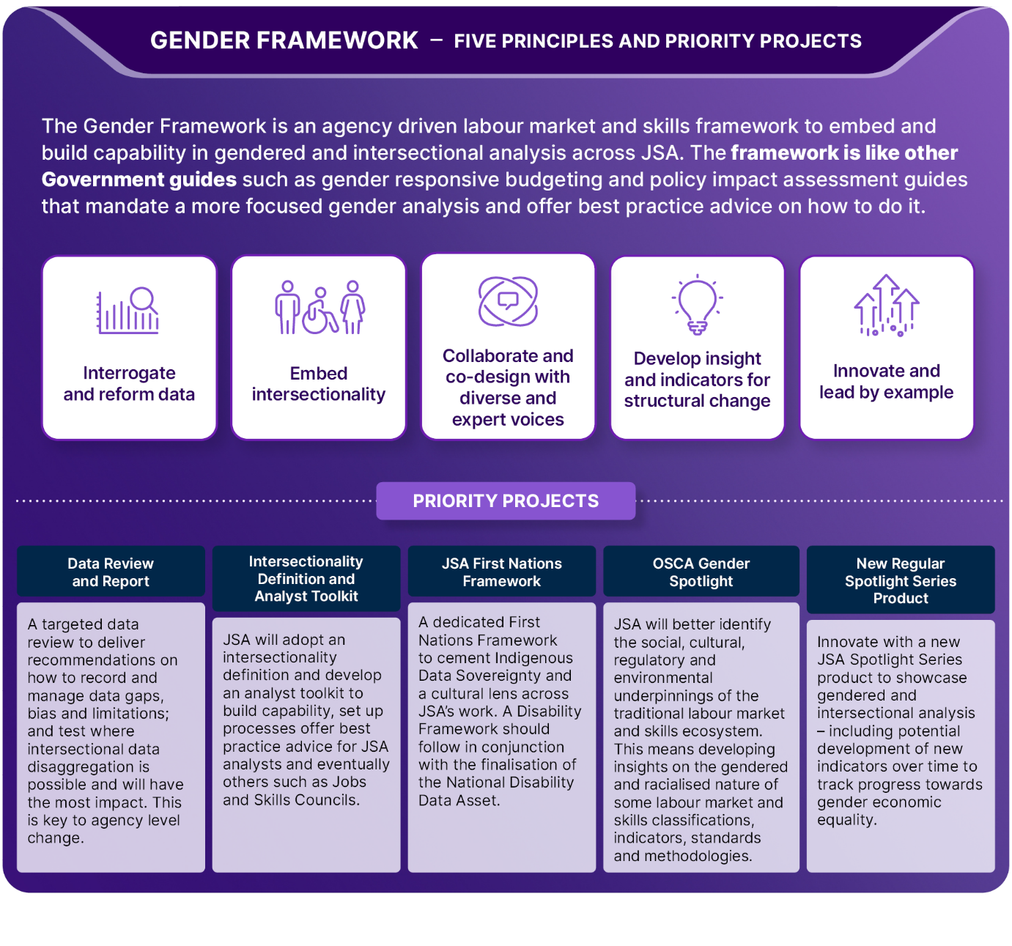

Recommendation 10
Expanded research, data and reporting to monitor progress on gender economic equality and increase intersectional perspectives and understanding

WHAT?
JSA recommends the Australian Government fund repeating, deepening and extending the data and research work of this Study and more coordinated government action to improve and expand intersectional data, insights and reporting. The aim of both is to transparently monitor progress towards gender economic equality, increase intersectional perspectives and develop more nuanced and fit-for-purpose policy solutions. Our Study findings point to the need to continue to build an evidence base to support practical policy implementation. This means increasing and mandating the regular reporting of specific data and making it directly visible and accessible to the public, including in Working for Women reporting.
There is also a need for funding further research into gender economic equality that was not covered in this Study, including differences in labour market situation and outcomes for women and men (including working arrangements, conditions, preferences), and differences in superannuation accumulation and retirement, and women's entrepreneurship and business ownership.
Additionally, governments and stakeholders are encouraged to partner with university researchers and centres to develop and scale tools that generate data-informed insights to measure, understand and address gender and intersectional differences and gaps in the labour market.

WHO?
Lead Australian Government agencies including JSA, the ABS, NIAA and the Productivity Commission in their role in reporting on Closing the Gap, and the OFW and Gender Data Steering Group. Agencies that are data custodians for key datasets that could further usefully extend PLIDA and the NDDA and education and training institutions as research partners are also key.

HOW?

Increasing the availability of detailed and intersectional data and analysis
Embedding intersectional data analysis is crucial to understanding compounding discrimination according to race, disability and other factors and accelerates progress towards gender economic equality. Longer-term reform of ‘intersectional’ data and analysis to deepen the evidence base for policymaking is also crucial, including in JSA’s own reporting on occupation shortages. Options for consideration and prioritisation could include:
- JSA in collaboration with OFW could suggest priority datasets for intersectional disaggregation in line with scheduled policy reforms or implementation and/or recommend expansion of data variables to allow it. For example, expanded VET outcome data collection and reporting for non-binary students, as per developments in higher education statistics from 2026.
- Funding the ABS to integrate additional datasets into PLIDA to support additional detailed and intersectional analysis that extends the work of this Study, including both cross-sectional and longitudinal analysis.
- The ABS could explore the development of additional data variables to understand racial and cultural discrimination, including additional CALD or Cultural and Racially Marginalised (CARM) variables in official statistics.
- In line with the JSA Gender Framework, continuing to embed and extend gender and intersectional analysis across JSA’s own reporting (various submissions made specific suggestions), or developing specific research collaborations across government.
- There is value in exploring factors that contribute to different labour mobility and retention patterns for women and men over time, now that additional integrated data is becoming available. Also extending this to better understand differences in working arrangements beyond median hours worked, and the intersection of this with occupational segregation and gender pay gaps. For example, our new evidence could allow new data collection and analysis on new almost completely female dominated occupations that would meet criteria in the National Gender Segregation Profile (Cortis et al. 2023), such as, Aged Care Coordinator and Community Aged Care Support Workers.
- Commissioning dedicated research into gendered barriers in business ownership and capital investment to support women's entrepreneurship. This could include identifying how access to equipment loans, equity finance or co-investment models could accelerate female entrepreneurship in high-demand trades, professional services including in ICT and AI, and community services. The Wealth and Housing Asset Module dataset pilot may be able to provide administrative data on firm ownership to be linked with other datasets to fill existing data gaps.
- Diverse tripartite consultation paper submissions also identified specific data gaps and recommended research to fill them. For example, around motivation and retention in highly gendered occupations; the impact of gender pay gaps and menopause on mature age women; the reasons why men are not taking up parental leave; and career progression and pathways over the life course.
"Ageism comes into it more than gender. [At an older age] it's often difficult to find a new job. I was made redundant at 50 and when I was interviewing for a new job they kept saying everyone had more experience than me despite having 8 years of experience myself."
—Female focus group participant aged 55+ years, Property Consultant
- Following the 2026 Census, which will include a new topic of sexual orientation and gender for people aged 16 years and older, completing exploration of new data to identify experiences of LGBTQIA+ individuals.
- Explore data gaps and recognition of prior learning in migration pathways to support migrant skill underutilisation and occupation shortages.
- Following full operation of the NDDA in 2026, expand reporting in Working for Women and Status of Women Report Cards on females with disability.
- Employers collecting and reporting on their own workforce profiles and remuneration data disaggregated by not just gender. This could be supported by WGEA through forthcoming employer resources on workforce diversity data guidance collection including on disability and First Nations.
A stewardship role across all governments to collect, monitor or report on race discrimination in workplaces is also needed, including the intersection between race discrimination and gender discrimination. Overlapping forms of disadvantage create complex and layered barriers to access, participation and progression in both workplaces and education/ training settings. Our findings showed that women from CALD backgrounds, First Nations women, individuals with disabilities and LGBTQIA+ participants reported heightened challenges, including discrimination, exclusion and limited access to opportunities.
The NARF recommends that the Australian Government fund the AHRC to convene a national council to develop nationally consistent standards for employers and employees to report experiences of racism and racial discrimination in the workplace. This is one option for consideration and coordination in a stewardship model.
- Within the NARF, several recommendations within the priority area of Workplaces and Employment focus on the need for organisations of all sizes to implement internal anti-racism strategies, develop internal cultural safety frameworks, and to implement strategies for hiring, promoting and retaining First Nations staff.
- The AHRC has also stressed that data on racism is limited, inconsistent, and often ad hoc, and that workplaces are key to addressing racism. Employers should commit enacting organisational change to address intersecting forms of discrimination and develop cultural safety frameworks for First Nations employees.
"One of the key issues facing culturally and linguistically diverse (CALD) women in Australia is the lack of comprehensive data that accurately reflects their experiences and challenges."
— Australian Multicultural Women’s Alliance (Consultation Paper Submission, 2025)
"Overseas skills and qualifications should be considered as an aspect of the leaky pipeline as the evidence to date indicates that migrant and refugee women who come to Australia lose career pathways."
— Settlement Services International (Consultation Paper Submission, 2025)

“Marginalisation of your identity can stack up against you. At my previous workplace, many of us were immigrants and we were all paid badly and did not know, nor were encouraged, about unionisation. As an immigrant on a working visa… I’m conscious of how much space I take up and how much I press for the accommodations I need to survive comfortably”
—LGBTQIA+ focus group participant, Chef

Increasing the availability of more detailed gender pay gap data and analysis
The Australian Government could explore how this Study's approach to using integrated administrative data to develop complementary gender pay gap measures could be most effectively used and which data agencies would be best placed to be funded to deliver ongoing intersectional, life course and detailed occupational pay gap reporting.
Using administrative data that is linked to the Census enables rich, detailed intersectional insights, reflecting how individuals choose to identify and without adding additional reporting challenges for employers (and how employees choose to identify to their employers in their workplace).
This could be further enhanced by government funding the ABS to roll out additional data integration initiatives, such as making full use of the range of data now available from the ATO through Single Touch Payroll Phase 2 (STP Phase 2), with the view of filling evidence gaps on intersectional pay gaps. This data set would allow incorporation of employment status into the integrated administrative data the Study has used effectively to provide initial detailed and intersectional insights into gender pay gaps, including over the life course.
"Addressing the gender pay gap requires attention to wages, but also systemic workplace dynamics. Narrowing the full-time gender pay gap is not enough. Policy must go beyond equal pay for equal work and address career progression, leadership representation and access to bonuses, super and flexible arrangements without penalty. Workplace structures and practices are still entrenching gender inequality. Policy needs to focus on transparency, value of care work, career pathways and the fair distribution of rewards." (PM&C 2025b)
"To effectively address systemic gender inequalities, intersectional analysis and inclusive data collection are vital."
— Anonymous (Consultation Paper Submission, 2025)
Options for consideration on gender pay gap data include:
- NIAA and the Productivity Commission could explore incorporating reporting on First Nations gender pay gaps on the Closing the Gap dashboard. These agencies could also work with the Data Policy Partnership under the Closing the Gap Agreement to maintain momentum on ongoing reporting of First Nations gender pay gaps.
- Closing the retirement income gender gap is a priority area under Working for Women and further research in retirement and lifelong pay gaps should be considered in the complementary gender pay gap reporting and responsibility. This includes the impact of unpaid care and other work on women's economic equality and wellbeing.
- Exploration of gender pay gaps in small businesses by using the Business Longitudinal Analysis Data Environment (BLADE) linked to other datasets, and migrant pay gaps using nuanced visa status variables to further fill evidence gaps is also recommended. This research can also help push towards the achievement of Working for Women's Outcome 3.6 to increase the proportion of women owned businesses.
- Government and industry efforts that are uplifting employer capability in gathering and using intersectional data in a way that is secure, private and safe for employees and assists reporting on voluntary submissions from employers is also recommended.


Appendix

Engagement and Consultation Summary
The Study has been underpinned by close consultation and collaboration with stakeholders. The purpose of stakeholder engagement and partner consultation was to enable JSA to gather robust qualitative data and insights from stakeholders across the economy and the country.
JSA’s Engagement and Outreach Strategy articulates the following engagement principles, which have informed the development of the engagement plan for this Study:
- Our engagement is inclusive and aims to ensure our analysis and advice represents a diverse community and economy.
- Our engagement is effective and ongoing, that meaningfully impacts on the development, delivery, and quality of our work.
- Our engagement is two-way and empowers others to use our advice to benefit their communities.
- Our engagement is open and transparent.
- Engaging with us is easy.
The Study used multiple approaches and avenues to achieve this by:
- establishing a Steering Committee made up of Advocacy Peaks, Industry/Business Peak Associations, Unions, Education and Training bodies, and government entities.
- releasing a consultation paper for public submissions.
- holding a series of expert forums with policymakers, scholars, skills stakeholders and workers.
- Targeted consultation across government and other relevant stakeholders. In addition to Steering Committee members, key stakeholders consulted include:
  - DEWR
  - WGEA
  - Working for Women Interdepartmental Committee and Strategy Group
  - NIAA
  - Department of Education
  - Australian Curriculum, Assessment and Reporting Authority
  - DISR
  - WEO - SWOG
  - CICA
  - Education Services Australia.

The Gender Economic Equality Study Steering Committee
A Steering Committee was established to provide expert advice to inform and support the Study. Membership was broad to ensure it reflected diverse tripartite representation of key stakeholders and experts to inform the Study.
Table 1: Gender Economic Equality Study Steering Committee membership
Advocacy Peaks | Unions | Industry/Business Peaks | Academics | Government
- Diversity Council of Australia  - Women in Adult and Vocational Education  - Migration Council Australia  - Women With Disabilities Australia | - Australian Council of Trade Unions  - Transport Workers’ Union  - Australian Education Union | - Australian Industry Group  - Business Council of Australia  - Australian Chamber of Commerce and Industry | - University of Canberra  - University of Sydney  - The University of Melbourne  - Centre of Indigenous People and Work (University of Technology Sydney)  - Wiyi Yani U Thangani Institute for First Nations Gender Justice, based at the Australian National University (ANU) | - Office For Women, Department of the Prime Minister and Cabinet  - State government representatives from Victoria  - State government representatives from South Australia
The purpose of the Steering Committee was to:
- Assist with the Study’s strategic direction (outlined by the Study’s Terms of Reference) and assist with identifying key issues.
- Provide subject matter expertise on relevant academic research; key evidence gaps; and significant policy reforms, evaluations and challenges that are central to the study research scope.
- Provide feedback on Study materials, inputs and findings to inform interim and final Study products.
- Help facilitate consultation with and input from critical stakeholders, to address the Study’s scope.
- The Steering Committee was advisory with final decision-making powers resting with the independent JSA Deputy Commissioner.

Public consultation and submission process
The key questions for partners and stakeholders were outlined in the Study’s Consultation Paper, which invited submissions from the public on the issues the Study considered. The paper also included the Study’s Terms of Reference.
The consultation paper was published in February 2025 and was open for submissions over three weeks.
There were over 40 substantive submissions received, and these were analysed using manual themes drawn from the foundational work of the Study. Public submissions were used in the preparation of the Study Papers and where the submission was marked as public, stakeholder organisation names have been cited.

Expert Forums
Experts Forums were held to target key subject matter expertise and explore perspectives on gender economic equality with academics, policymakers, experts from the skills sector, unions, peak bodies, and individuals with intersectional and worker lived experiences.
The forums occurred on the following dates:
- Experts Scholars Forum with 35 academics representing over 20 universities—Wednesday 13 November 2024.
- Experts Policymakers Forum with 21 policy makers from across different Australian, state and territory government agencies—Wednesday 20 November 2024.
- Expert Skills Forum with 26 representatives from across academia, industry, unions, peak bodies, and JSCs—Monday 3 March 2025.
- Lived Experience Forum with 13 representatives, including those with intersectional and worker lived experiences, industry and union representatives—Monday 5 May 2025.

Building on recent recommendations on unpaid care
As outlined in Recommendation 7, this Study's recommendation reiterate and support the previous policy recommendations related to unpaid care from the WEET and WFPR, which are summarised below.

Women's Economic Equality Taskforce care recommendations
JSA recommends and reiterates:
- taking a life course approach to career advice and support to women who have interrupted career trajectories due to unpaid caring. As outlined in WEET's recommendations, this could include trial programs for older Australian women returning to the workforce and engaging with education providers on a range of courses for upskilling (WEET 2023). Initiatives like the Future Women Jobs Academy, which as a program to improve job readiness, workforce participation and economic security for marginalised women aged 40 years and older, could be funded and expanded further by employers and the Government.
- continuing to fund, create and evaluate programs for supporting single mothers, as per the WEET recommendation to reimagine the previous ParentsNext program, which has been replaced with the current Parents Pathways program. The Parent Pathways program is for parents or carers who are receiving Centrelink parent or carer payments with children aged under six years old, as well as First Nations, parents without a Year 12 qualification as early school leavers, or parents aged under 22 years old.
- Employers and the Government should reduce the financial penalty of the uptake of caring responsibilities, such as pausing indexation of HECS-HELP debt during periods of leave. Additionally, there are recommendations from the Wiyi Yani U Thangani (Women's Voices) report (2020) linked to making superannuation schemes fair for First Nations women through annual government contributions to low-income earners.
- 'Review the taxation and transfer systems with a gender lens to identify negative gender biases and examine options to address the high Effective Marginal Tax Rates (EMTRs) experienced by women' (WEET 2023:43). Whilst this was not part of the Study's scope, JSA recommends future research, data and reporting consider the role of the tax system in impeding women's workforce participation and driving unpaid care work responsibilities in families. This is one of the next big complex policy challenges to tackle in progressing gender economic equality.

Work and Family Roundtable 2025 Submission care recommendations
- Extend the duration of PPL to 52 weeks with an extended period earmarked for each parent (4 months for each parent and 4 months to share). This could be achieved by first extending the system so that mothers have at least 26 weeks and fathers/partners have access to a longer period (8 weeks) of reserved leave (i.e. a total of 34 weeks with 8 weeks of that period reserved for each parent).
- Incentivise employers to top up the government scheme from the National Minimum Wage rate to wage replacement rates (where this makes the worker better off).
- Safeguard and ringfence superannuation payments on PPL so it is available for those who take PPL (majority being women) in their retirement and not used as a substitute for extending the period of PPL.
- Extend the definition of care in the National Employment Standards (NES) on carer’s leave to include a greater range of care recipients and a greater range of care responsibilities.
- Split personal/carer’s leave into separate periods of 10 days paid personal and 10 days paid carer’s leave to reduce the disadvantages experienced by carers in accessing sick leave and set a long-term goal to extend paid carer’s leave in line with international leading practice.
- Extend the period of job-protected unpaid carer’s leave to 30 days per annum and amend income support provisions so workers on unpaid carer’s leave can receive income support payments while on leave.

World Bank Gender-based Employment Segregation: Understanding Causes and Policy Interventions - Key Research Questions
The World Bank's 2023 publication explores the factors that perpetuate employment segregation, and the policies that attempts to reduce segregation (Carranza et al. 2023). The World Bank highlights areas for future research, some of which have been targeted during the Study's research, but should be explored further in future research:
- Education Attainment: Which soft skills matter for overcoming internal biases and gender norms? How to encourage entry into high return education streams?
- Capital Control: How does access to capital affect investment in education or businesses/crops? Should policies focus on loan application rates?
- Intra-Household Allocation of Time: How does segregation vary with lifecycle, whether women are primary earners, household composition? What can effectively change norms on division of responsibilities? Effect of childcare/ technology/ wage gap.
- Safety and Mobility: What is the prevalence of threats to safety?
- Networks: What is the relative importance of the aspirations/information/referrals provided by networks? Can they be replaced directly? Do role models/networks need to be female? Are visible role models or large cohorts necessary to change biases/gender norms?
- Recruitment, Selection and Hiring: When women enter male-dominated sectors, how does income/placement differ? What recruitment strategies reduce use of cognitive shortcuts? What are the demand-side barriers to entry in non-wage employment?
- Work Culture: How do men and women respond to benefits/childcare incentives for men/women? How prevalent is harassment/unfair treatment? What policies are effective? How can a firm increase inclusion in male-dominated sectors and education streams?
- Promotions and Evaluations: What policies can reduce the devaluation of female work/qualities? Do women who climb the employment ladder change their values/personalities to accommodate biases?
- Legal and Regulatory Framework: How can governments incentivise firms to attract, hire, and promote women?

Example levers for change
The following tables highlights actions taken by industry and governments to promote gender economic equality, by pulling supply-side, demand-side, and institutional and regulatory levers. The examples are not an exhaustive list of the actions taken to promote gender economic equality, and they primarily focus on addressing the policy issues highlighted throughout the Study, including gendered occupational and industry segregation, inequality in education and training settings, and the gender pay gap. Socio-cultural levers also intersect across multiple levers and are further highlighted in the policy interventions outlined by the World Bank in the previous section.

Supply-side Levers
Table 2: Examples of supply-side levers to address gendered occupational and industry segregation, education and training divides, and the gender pay gap.
Lever for Change | Policy Issue to Address | Impact | Examples
Career Advice, Awareness Campaigns, Training Pathways and Work Experience | Gendered occupational and industry segregation; education and training divides | Initiatives such as gender-conscious career advice, training pathways and work experience opportunities can support women entering male dominated occupations and industries. | Future You Australia  Victorian Digital Jobs Program  Career Conversations WA Grant  It's Possible Campaign  Steam Ahead Program  Women in Plumbing  Inspiring Girls Career Forum  Mining and Automotive Skills Alliance Market Research
Increased Access to Education | Gendered occupational and industry segregation; education and training divides | Financial supports such as Commonwealth Prac Payments can lessen the burden of undergoing placement in female dominated subjects, making the education pathway more accessible, and more appealing for all students. Programs such as Free TAFE financially support study for priority groups including women studying in non-traditional fields. | Free TAFE  Commonwealth Prac Payments
Addressing gendered disparity in unpaid care and domestic work through access and availability to childcare | Gender pay gap | Enhancing the availability of childcare reduces the disparate gender distribution of females exiting the workforce or suffering significant career interruptions due to caring responsibilities. | Victoria Best Start, Best Life reforms  Subsidised early childhood education and care  Gender-neutral paid parental leave
Access to Capital and Support for Starting a Business | Gendered occupational and industry segregation | Increasing access to capital and supports assists women in being able to start and grow their own businesses. | Backing Female Founders Program  AMPLI-FI Female Founders Program

Demand-side Levers
Table 3: Examples of demand-side levers to address gendered occupational and industry segregation, education and training divides, and the gender pay gap.
Lever for change | Policy Issue to Address | Impact | Examples
Industry Culture Change | Gendered occupational and industry segregation | Programs that target changing biased and hostile cultures in gender segregated industries, encourage greater participation for women.  Many existing initiatives are focused on the construction industry and STEM fields, for example the mitigation of work health and safety hazards, and improved amenities. | Culture Standard | Construction Industry Culture Taskforce  Allyship in Action: Transforming Culture to Attract and Retain Women  Queensland Women Rise - Breaking Barriers, Building Equity
Mentoring programs | Gendered occupational and industry segregation; education and training divides | Mentoring programs provide supports that can assist women in joining, navigating and taking on leadership positions in gender segregated industries and workplaces. | Strong Women Strong Business  Women in Electricity  BUSY Sisters  Women in Security Mentoring Program
Employer Policies | Gendered occupational and industry segregation; gender pay gap | Initiatives to address structural barriers within places of employment can include flexible working and job-sharing policies, more equitable access to PPL, gender-conscious recruitment and promotion policies.  Charters, strategies and targets can also be instituted at the employer and industry level to set goals and track progress towards gender equality. | Intersectional gender equity assessment on digital apprenticeships  Female-only recruitment and training programs  Deloitte Flex  Australian Skills Guarantee  Achieving 50:50 Gender - ASTRO 3D
Increasing female trainers in non-traditional pathways | Education and training divides | Increasing female vocational trainers in trade pathways can provide pre-employment role models and assist in women navigating gender segregated workplaces. | Women in Construction  Victorian Women in Manufacturing Strategy
Pay increases in female dominated industries | Undervaluation of female dominated industries and occupations | By addressing the undervaluation of female dominated roles, this provides a lever to address gendered occupational and industry segregation. | Fair Work Commission Gender-based Undervaluation Awards Review  Wage increases for early childhood educators
Increasing the share of women in leadership positions | Gender pay gap | The unequal distribution of discretionary pay and bonuses play a more significant role in gender pay gaps at the most senior management levels. Increasing the share of women in leadership positions reduces the gendered divide in managerial gender pay gaps. | Transferable Pathways Program  500 Women in Property  Equal by 30 Clean Energy Sector  Realise Inspire Support Energise (RISE) Project  Turn the Tide

Institutional and Regulatory Levers
Table 4: Examples of institutional and regulatory levers to address gendered occupational and industry segregation, and the gender pay gap.
Lever for change | Policy Issue to Address | Impact | Examples
Sex Discrimination Legislation | Gendered occupational and industry segregation | Legislation aimed at addressing specifically gendered experiences of discrimination and harassment in the workplace. | Respect@Work changes to the Sex Discrimination Act 1984
Intersectional Gender Pay Reporting | Gender pay gap | Disaggregated data that documents the different layers of advantage and disadvantage faced by demographic cohorts allows policymakers to develop and implement more effective and targeted policies to address specific cohort gender pay gaps. | Commission for Gender Equality in the Public Sector Reporting  The JSA Gender Study is releasing an intersectional gender pay gap dashboard in October 2025.
Industry and Organisation Gender Pay Gap Reporting and Publishing | Gender pay gap | Required reporting of gender data from employers, including on the gendered nature of their organisation, and the subsequent publishing of employer gender pay gaps, can bring transparency and incentivise action. | WGEA Gender Pay Gap Reporting
Gender equality target setting | Gendered occupational and industry segregation; gender pay gap | A data-driven approach brings objectivity and transparency to organisations' gender equality efforts and enables measurable tracking of progress towards gender equality. Research has shown that companies that undertake regular analyses of their gender pay gap and other gender indicators see a faster narrowing of their gender gaps compared to companies which do not track data as extensively (Cassells and Duncan 2018). | WGEA Targets Menu for Designated Large Employers
Measuring unpaid care | Gender pay gap | Improving the visibility of the contribution of unpaid care to society and the economy can help to highlight the gendered disparity in unpaid care. | ABS Unpaid Care in Labour Account
Development of OSCA | Gendered occupational and industry segregation | As identified in Paper 2, the new OSCA classification has provided greater detail on female dominated occupations and vertical segregation, allowing for more targeted policy development. | Major changes between ANZSCO and OSCA

Glossary
Abbreviation | What it stands for
ABS | Australian Bureau of Statistics
ACARA | Australian Curriculum, Assessment and Reporting Authority
ACC and FNO | Aboriginal Community Controlled and First Nations Owned
AHRC | Australian Human Rights Commission
ANZSIC | Australian and New Zealand Standard Industrial Classification
ASQA | Australian Skills Quality Authority
ATEC | Australian Tertiary Education Commission
ATSIHW | Aboriginal and Torres Strait Islander Health Workers
BLADE | Business Longitudinal Analysis Data Environment
CALD | Culturally and Linguistically Diverse
CARM | Culturally and Racially Marginalised
CGEPS | Commission for Gender Equality in the Public Sector
CICA | Career Industry Council Australia
CPD | Continuing professional development
CPP | Commonwealth Practicum Payments
DCCEEW | Department of Climate Change, Energy, the Environment and Water
DEWR | Department of Employment and Workplace Relations
DISR | Department of Industry, Science and Resources
DiST | Diversity in STEM Toolkit
DSS | Department of Social Services
EMTR | Effective Marginal Tax Rates
FWC | Fair Work Commission
GSIS | Gender Segregation Intensity Scale
JSA | Jobs and Skills Australia
JSC | Jobs and Skills Councils
ICOVE | Indigenous Centre of Vocational Excellence
LEAC | Lived Experience Advisory Council
LGBTQIA+ | Lesbian, Gay, Bisexual, Transgender, Queer, Intersex and Asexual and other identities
LGBTQIASB+ | Lesbian, Gay, Bisexual, Transgender, Queer, Intersex, Asexual, Sistergirl and Brotherboy and other identities
MoU | Memorandum of Understanding
NARF | National Anti-Racism Framework
NCIF | National Construction Industry Forum
NDDA | National Disability Data Asset
NES | National Employment Standards
NIAA | National Indigenous Australians Agency
NSA | National Skills Agreement
OFW | Office for Women
OSCA | Occupational Standard Classification for Australia
PLIDA | Personal Level Integrated Data Asset
PM&C | Department of Prime Minister and Cabinet
PPL | Paid Parental Leave
RISE | Realise Inspire Support Energise Project
RPL | Recognition of Prior Learning
RTO | Registered Training Organisations
SaCSA | Service and Creative Skills Australia
SAGE | Science in Australia Gender Equity
SSON | Senior Skills Official Network
STP | Single Touch Payroll
SWMC | Skills and Workforce Ministerial Council
TAFE | Technical and Further Education
The Strategy | Working for Women Strategy
VET | Vocational Education and Training
VETiS | VET in Schools
VetPP | VET Policy Partnership
WAVE | Women in Adult and Vocational Education
WEET | Women’s Economic Equality Taskforce
WEO-SOWG | Women's Economic Equality Outcomes Senior Officials Working Group
WFPR | Work and Family Policy Roundtable
WGEA | Workplace Gender Equality Agency

Reference List
ABS (Australian Bureau of Statistics) (26 September 2022) Public consultation to help shape the future of classification on industries in Australia [media release], ABS, Australian Government, accessed July 2025.
AHRC (Australian Human Rights Commission) (2024) The National Anti-Racism Framework: a roadmap to eliminating racism in Australia, AHRC, Australian Government, accessed September 2025.
AHRC (2025) Speaking from experience: what needs to change to address workplace sexual harassment, AHRC, Australian Government, accessed September 2025.
Brussino O and McBrien J (2022) Gender stereotypes in education: policies and practices to address gender stereotyping across OECD education systems, OECD Education Working Papers, 271, accessed September 2025.
Carangio V, Farquharson K, Bertone S and Rajendran D (2020) Racism and white privilege: highly skilled immigrant women workers in Australia, Ethnic and Racial Studies, 44(1):77– 96, accessed February 2025.
Carranza E, Das S and Kotikula A (2023) Gender-based employment segregation: understanding causes and policy interventions, Jobs Working Paper, 26, World Bank.
Cassells R and Duncan A (2018) Gender equity insights 2018: inside Australia's gender pay gap, WGEA-BCEC Gender Equity Insight Series, Bankwest Curtin Economics Centre.
Construction Industry Culture Taskforce (2025) A culture standard for the construction industry, accessed September 2025.
Day M, Carlson B, Bonson D, and Farrelly T (2022) Aboriginal and Torres Strait Islander LGBTQIASB+ people and mental health and wellbeing, Australian Institute of Health and Welfare, accessed October 2025.
DEWR (2023) Stewardship in the National Skills Agreement: governments working collaboratively and purposefully to address Australia's Skills needs, DEWR, Australian Government, accessed September 2025.
DEWR (2024) National Skills Agreement outcomes framework, DEWR, Australian Government, accessed September 2025.
DEWR (2025) Skills for tomorrow: shaping the future of Australian apprenticeships, DEWR, Australian Government, accessed August 2025.
Diversity Council Australia (Flood M and Russell G) (2017), Men Make a Difference: How to Engage Men on Gender Equality, accessed September 2025.
DFFH (Department of Families, Fairness and Housing) (2023) Our equal state: Victoria’s gender equality strategy and action plan 2023-2027, DFFH, Victorian Government, accessed February 2025.
DISR (Department if Industry, Science and Resources) (2023) Women in STEM initiatives evaluation report, accessed July 2025.
DJSIR (Department of Jobs, Skills, Industry and Regions) (2024) Victorian jurisdictional action plan for skills and TAFE 2024-25, Victoria State Government, accessed September 2025.
DSS (Department of Social Services) (2022) National plan to end violence against women and children 2022-2032, Australian Government, accessed September 2025.
DSS (2023) First Action Plan 2023-2027: under the national plan to end violence against women and children 2022-2023, Australian Government, accessed September 2025.
Duvander A and Löfgren N (2025) Sweden country note, International Review of Leave Policies and Research 2025, accessed September 2025.
Department of Education (2024) 2024-25 Budget: Funding for the First Nations Teacher Strategy fact sheet - Department of Education, Australian Government, accessed September 2025
FWC (Fair Work Commission) (2025) Gender-based undervaluation - priority awards review, Australian Government, accessed September 2025.
GABI (Gender and Behavioural Insights) Sharing parental care, GABI, accessed September 2025.
Gottfredson L (2002) Gottfredson’s theory of circumscription, compromise, and self-creation, in Brown D (ed), Career Choice and Development, Jossey-Bass, San Francisco.
Industry Skills Australia (2025) 2025 workforce plans, accessed September 2025.
JSA (Jobs and Skills Australia) (2024) VET workforce study, JSA, Australian Government, accessed September 2025.
Jumbunna Institute (2020) Gari Yala (speak the truth): centreing the work experiences of Aboriginal and/or Torres Strait Islander Australians, UTS, accessed September 2025.
Klein E, Hunt J, Staines Z, Dinku Y, Brown C, Glynn-Braun K and Yap M (2023) Caring about care, Centre for Indigenous Policy Research, Australian National University, University of Queensland, accessed August 2025.
Miller D (1981) The 'sandwich' generation: adult children of the ageing, Social Work, 26(5): 419-423.
Murdoch University News (27 March 2024) New policy recognises cultural load of First Nations community, Murdoch University News, accessed September 2025.
NIAA (National Indigenous Australians Agency) (2022) Australian Government response to the Wiyi Yani U Thangani (women's voices): securing our rights, securing our future report, Australian Government, accessed September 2025.
PM&C (2025a) Women and women's safety ministerial council terms of reference, PM&C, Australian Government, accessed September 2025.
PM&C (28 April 2025b) Women's economic performance: a decade in review 2015-2025 [unpublished conference presentation], OFW IDC follow-up presentation, Canberra.
Queensland Government (2025) First Nations payment guide, Queensland Government, accessed September 2025.
Risse L (20 November 2018) The gender qualification gap: women 'over-invest' in workplace capabilities, The Conversation, accessed September 2025.
Risse L (2024) Target setting for gender equality: a review of the literature, report prepared for the Workplace Gender Equality Agency, accessed September 2025.
Smith, E (2025) How women are disadvantaged in the Australian apprenticeship system | The Economic and Labour Relations Review | Cambridge Core, accessed October 2025.
Victorian Skills Authority (2024) Victorian skills plan for 2024 into 2025: shared prosperity through skills, Victoria State Government, Jobs, Skills, Industry and Regions, accessed September 2025
WEET (Women's Economic Equality Taskforce) (2023) A 10 year plan to unleash the full capacity and contributions of women to the Australian economy, WEET, accessed September 2025.
WGEA (2025) Supporting men as fathers in the workplace: A scorecard closer look, accessed September 2025.
WFPR (Work and Family Policy Round table) (2022) Work Family Policy Roundtable Senate Inquiry into Work and Care Sept 2022, accessed September 2025.
WFPR (Work and Family Policy Roundtable) (2025) Work care and family policies: federal election benchmarks 2025, accessed September 2025.
Wiyi Yani U Thangani Institute for Gender Justice (2020) Wiyi Yani U Thangani report, Wiyi Yani U Thangani Institute, accessed September 2025.
Wiyi Yani U Thangani Institute for Gender Justice (2022) Implementation framework, Wiyi Yani U Thangani Institute for Gender Justice website, accessed September 2025.
Wiyi Yani U Thangani Institute for Gender Justice (2024) Change agenda for First Nations gender justice, Wiyi Yani U Thangani Institute for Gender Justice website, accessed September 2025.

The Economic Partnership will focus on the full range of policy levers available to the Commonwealth Government to support economic empowerment, self-determination and wealth creation for First Nations people, including advancing gender equity and the important role of First Nations women in the Australian economy.
The existing Policy Partnerships under the National Agreement on Closing the Gap include the: Justice Policy Partnership, Social and Emotional Wellbeing Partnership, Languages Policy Partnership, Housing Policy Partnership, Early Childhood Care and Development Partnership, and Data Policy Partnership.
WEO-SOWG is an interjurisdictional committee that includes Treasury representatives from the federal, state, and territory governments in the Australia Council on Federal Financial Relations
The Fair Work Commission has outlined their provisional views on appropriate award variations to remedy the gender-based undervaluation, however further hearings will occur before the Expert Panel varies the award.
Gari Yala is now the sole property of the Jumbunna Institute/Centre for Indigenous People and Work pursuant to principles of Indigenous self-determination and data sovereignty.
Cultural load is the invisible, additional work and pressure placed on Aboriginal and Torres Strait Islander people in the workplace. It involves expectations to educate non-Indigenous colleagues, speak on behalf of their communities, organise cultural events, and manage responsibilities beyond their formal role without recognition or compensation.

