


Occupation Shortage Report
  - June quarter 2025
15 September 2025

Contents
Introduction 2
National results 2
Metropolitan area results 3
Regional area results 4
Results by Skill Level 5
Results by major group 6
Spotlight piece: the Mismatch Index 8
Explanatory Notes 12
Definitions of metrics 12

Introduction
The Occupation Shortage Report offers quarterly analysis on metrics derived from the Jobs and Skills Australia Survey of Employers who have Recently Advertised (SERA). The Explanatory notes section defines the metrics covered in this report.

National results
Table 1: National snapshot
 | June quarter 2025 | Change over the quarter | Change over 12 months
Vacancy fill rate (%) | 70.6% | ▲0.9% pts | ▲4.5% pts
Applicants per vacancy (no.) | 27.4 | ▼2.0 | ▲3.2
Qualified applicants per vacancy (no.) | 9.3 | ▼0.1 | ▲1.7
Suitable applicants per vacancy (no.) | 4.3 | ▲0.3 | ▲1.3
Source: Jobs and Skills Australia, SERA.
Note: The change from previous quarter refers to the change from March quarter 2025 to June quarter 2025. The change from the previous year refers to the change from June quarter 2024 to June quarter 2025.
The vacancy fill rate (fill rate) increased over the quarter and the last 12 months to June quarter 2025 to 70.6% (Table 1 and Figure 1). Increasing fill rates, likely, indicate employers are filling vacancies more easily.
Figure 1: Fill rate (%) and total, qualified, and suitable applicants per vacancy (no.), national level
Source: Jobs and Skills Australia, SERA.
During June quarter 2025, total and qualified applicants per vacancy decreased, but were higher than 12 months ago. Suitable applicants per vacancy increased slightly over the quarter and last 12 months. The improvements in the metrics, particularly over the last 12 months, are consistent with trends in other labour market indicators.

Metropolitan area results
Table 2: Metropolitan snapshot
 | June quarter 2025 | Change over the quarter | Change over 12 months
Vacancy fill rate (%) | 72.2% | ▲0.6% pts | ▲4.3% pts
Applicants per vacancy (no.) | 32.7 | ▼2.2 | ▲4.5
Qualified applicants per vacancy (no.) | 11.2 | ▼0.1 | ▲2.2
Suitable applicants per vacancy (no.) | 4.9 | ▲0.5 | ▲1.6
Source: Jobs and Skills Australia, SERA.

Figure 2: Metropolitan fill rate (%) and applicants, qualified, and suitable applicants per vacancy (no.)
Source: Jobs and Skills Australia, SERA.

Regional area results
Table 3: Regional Snapshot
 | June quarter 2025 | Change over the quarter | Change over 12 months
Vacancy fill rate (%) | 65.8% | ▲1.5% pts | ▲4.6% pts
Applicants per vacancy (no.) | 16.3 | ▼1.2 | ▲1.7
Qualified applicants per vacancy (no.) | 5.4 | ▼0.1 | ▲0.9
Suitable applicants per vacancy (no.) | 3.0 | ▲0.1 | ▲0.9
Source: Jobs and Skills Australia, SERA.

Figure 3: Regional fill rate (%) and total applicants, qualified, and suitable applicants per vacancy (no.)
Source: Jobs and Skills Australia, SERA.
Fill rates in both metropolitan (metro) and regional areas improved over the quarter and the last 12 months to June quarter 2025.
The direction of changes in the total, qualified and suitable applicants per vacancy metrics were consistent between both areas (Table 2 and Table 3) and the national level (Table 1).
In regional areas, the fill rate remained well below that of metro areas. But in the June quarter 2025, the difference in fill rates between the two areas reduced to 6.5 percentage points from 7.3 percentage points in March quarter 2025.

Results by Skill Level
The fill rate improved for Skill Levels 1 and 2 occupations during June quarter 2025 and over the previous 12 months. For Skill Level 4, the fill rate remained relatively unchanged over both periods. For these 3 skill level groups, the fill rate was high at above 72%.
The fill rate for Skill Level 3 occupations (55.1%) remained stable during the quarter but has improved consistently over time including over the past 12 months.
- Notably applicants per vacancy have nearly doubled for Skill Level 3 since June quarter 2023.
- But the fill rate remains distinctly lower than other skill level occupations.
Figure 4: Fill rate (%), total applicants, qualified and suitable applicants per vacancy (no.), by Skill Level, June quarter 2025
Source: Jobs and Skills Australia, SERA.

Results by major group
Table 4: ANZSCO major group snapshot
Major group |  | June quarter 2025 | Change over the quarter | Change over 12 months
Managers | Vacancy fill rate (%) | 78.5% | ▼1.7% pts | ▼3.4% pts
Managers | Applicants per vacancy (no.) | 36.4 | ▼2.0 | ▲3.8
Managers | Qualified applicants per vacancy (no.) | 13.5 | ▲0.2 | ▲2.9
Managers | Suitable applicants per vacancy (no.) | 5.7 | ▲0.5 | ▲1.8
Professionals | Vacancy fill rate (%) | 71.3% | ▲0.8% pts | ▲6.5% pts
Professionals | Applicants per vacancy (no.) | 25.2 | ▼3.6 | ▲0.2
Professionals | Qualified applicants per vacancy (no.) | 10.6 | ▼0.6 | ▲1.1
Professionals | Suitable applicants per vacancy (no.) | 4.0 | ▲0.4 | ▲1.2
Technicians and Trades Workers | Vacancy fill rate (%) | 57.0% | ▲1.0% pts | ▲5.2% pts
Technicians and Trades Workers | Applicants per vacancy (no.) | 23.4 | ▲0.7 | ▲6.1
Technicians and Trades Workers | Qualified applicants per vacancy (no.) | 7.5 | ▲0.7 | ▲2.8
Technicians and Trades Workers | Suitable applicants per vacancy (no.) | 3.2 | ▲0.3 | ▲1.2
Community and Personal Service Workers | Vacancy fill rate (%) | 68.6% | ▼1.4% pts | ▼3.8% pts
Community and Personal Service Workers | Applicants per vacancy (no.) | 19.7 | ▼2.1 | ▲0.9
Community and Personal Service Workers | Qualified applicants per vacancy (no.) | 6.1 | ▼0.4 | ▲0.4
Community and Personal Service Workers | Suitable applicants per vacancy (no.) | 3.1 | ▼0.1 | ▲0.1
Clerical and Administrative Workers | Vacancy fill rate (%) | 81.8% | ▲0.1% pts | ▲0.9% pts
Clerical and Administrative Workers | Applicants per vacancy (no.) | 40.6 | ▼5.4 | ▼4.9
Clerical and Administrative Workers | Qualified applicants per vacancy (no.) | 9.9 | ▲0.4 | ▲1.1
Clerical and Administrative Workers | Suitable applicants per vacancy (no.) | 6.8 | ▲0.1 | ▲1.0
Sales Workers | Vacancy fill rate (%) | 69.4% | ▲1.7% pts | ▼0.7% pts
Sales Workers | Applicants per vacancy (no.) | 25.4 | ▼2.9 | ▲3.9
Sales Workers | Qualified applicants per vacancy (no.) | 6.0 | ▲0.3 | ▲2.3
Sales Workers | Suitable applicants per vacancy (no.) | 3.8 | ▼0.3 | ▲1.0
Machinery Operators and Drivers | Vacancy fill rate (%) | 68.3% | ▼1.2% pts | ▼1.7% pts
Machinery Operators and Drivers | Applicants per vacancy (no.) | 27.2 | ▼4.5 | ▲2.5
Machinery Operators and Drivers | Qualified applicants per vacancy (no.) | 8.6 | ▼2.1 | ▼0.8
Machinery Operators and Drivers | Suitable applicants per vacancy (no.) | 4.7 | ▲0.1 | ▲1.3
Source: Jobs and Skills Australia, SERA.
Major group |  | June quarter 2025 | Change over the quarter | Change over 12 months
Labourers | Vacancy fill rate (%) | 65.3% | ▼1.2% pts | ▲8.1% pts
Labourers | Applicants per vacancy (no.) | 16.8 | ▲0.3 | ▲6.2
Labourers | Qualified applicants per vacancy (no.) | 5.0 | ▲0.5 | ▲1.8
Labourers | Suitable applicants per vacancy (no.) | 2.2 | ▼0.2 | ▲0.1
Source: Jobs and Skills Australia, SERA.
Fill rates increased for 3 major groups in both June quarter 2025 and over the past 12 months. These include Professionals, Technicians and Trades Workers, and Clerical and Administrative Workers.
For Technicians and Trades Workers, the fill rate has consistently improved over time. The fill rate for the major group increased to 57.0% in June quarter 2025:
- Over the quarter, this was a 1 percentage point improvement.
- Over the last 12 months, this was a 5.2 percentage points improvement.
Metrics for total, qualified and suitable applicants per vacancy for Technicians and Trades Workers also improved in the June quarter 2025 and over the past 12 months.
Fill rates fell over the June quarter 2025 and the last 12 months for Managers, Community and Personal Service Workers, and Machinery Operators and Drivers major groups. Despite falling in both periods, the June quarter 2025 fill rates:
- remain high at 78.5% for Managers
- close to the national-level rate for Community and Personal Service Workers, and Machinery Operators and Drivers (68.6% and 68.3%, respectively).

Spotlight piece: the Mismatch Index
The mismatch index (MI) measures how unevenly vacancies and applicants in the labour market are distributed among different occupations. It is equal to the proportion of applicants that would need to change occupations for there to be an equal ratio of applicants to vacancies across all occupation groups.
The mismatch MI was calculated using the formula:

$$MI= \frac{1}{2}\sum_{i ∈ I}{\left|\frac{S_{i}}{S}-\frac{D_{i}}{D}\right|}$$

Where:
- $I$ is the set of occupation groups (here we use ANZSCO unit groups)
- $S_{i}$ is the supply (number of applicants) for the specific unit group $i$
- $S$ is the total supply (number of applicants in total)
- $D_{i}$ is the demand (number of vacancies) in the specific unit group $i$
- $D$ is the total demand (number of vacancies).

$$MI= \frac{1}{2}\sum_{i ∈ I}{\left|\left(\begin{matrix}proportion of applicants \\ in occupation i\end{matrix}\right) -\left(\begin{matrix}proportion of vacancies \\ in occupation i\end{matrix}\right) \right|}$$

The Jobs and Skills Australia MI was based on SEEK’s approach.
Data for the index was based on SERA, Recruitment Experiences and Outlook Survey (REOS), and similarity scores from the Australian Skills Classification (ASC). The MI was calculated for the national level, and for metropolitan (metro) and regional areas.
Figure 5 (next page) shows the MI by financial year.

Figure 5: Mismatch index, 2020–21 to 2024–25
Source: Jobs and Skills Australia: SERA and REOS (2025).
The national level MI increased each year before peaking in 2023–24 and then fell to 30% in 2024–25.
The overall MI trend in metro areas mirrors the national, which mostly reflects that most of the survey data are in metro areas. This aligns with the proportion of job advertisements in metro areas according to the Jobs and Skills Australia Internet Vacancy Index and the proportion of the labour force in regional areas according to the Australian Bureau of Statistics.,
However, the regional MI trend is slightly different and lower in magnitude. But it still peaks in 2023–24, before falling the following financial year. Possible reasons for the slight difference from the national and metro area MIs include:
- The MI calculation is closely related to variation between unit groups in the number of applicants per vacancy; this metric varies more between unit groups in metro than in regional areas.
- Some of the unit groups that contributed the most to the mismatch had insufficient data in regional areas.
Figure 66 shows a deconstruction of Figure 5 indicating the contribution to the national MI from each major group between 2020-21 and 2024-25 and the direction of the mismatch. The width of each coloured band shows the contribution, while the positive and negative portions indicate how much of the mismatch is from excess supply and excess demand.

Figure 6: Mismatch from different major groups, between 2021 and 2025
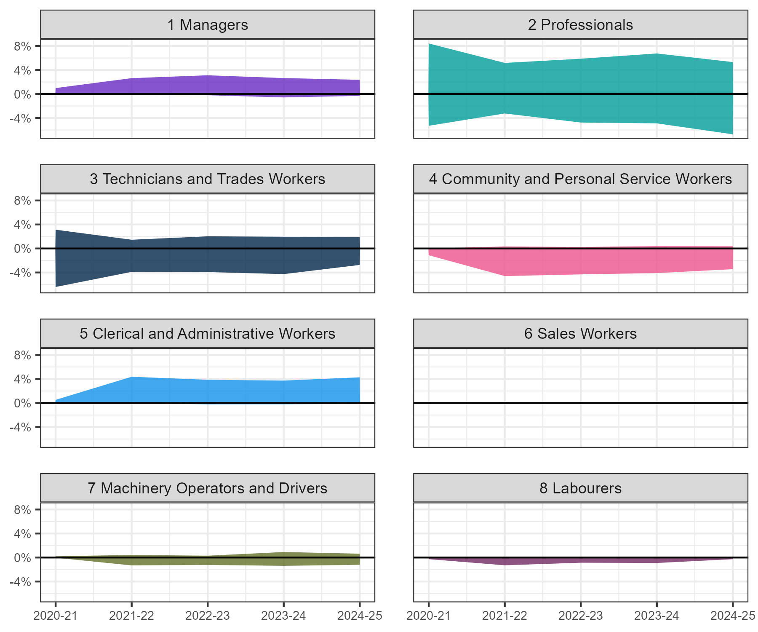
Source: Jobs and Skills Australia: SERA and REOS (2025).
Excess supply
Excess demand
Over the period 2020–21 to 2024–25, for Professionals there were, generally, twice as many unit groups with excess supply than excess demand. However, total contributions of unit groups with excess supply or excess demand to the overall MI was similar (Figure 6).
- For example, in 2024–25, Professionals contributed 7 percentage points to the overall MI due to excess demand and 5 percentage points due to excess supply. This amounts to a total contribution of 12 percentage points. This mismatch contribution was more than a third of the total MI value.
- Over the last 5 years, in fact, Professionals contributed most to the total mismatch in labour market.
- Within the major group, mismatch from excess demand is particularly an issue for health and allied health unit groups.
Over the period 2020–21 to 2024–25, for Technicians and Trades Workers, there were more unit groups with excess demand than excess supply. Technicians and Trades Workers contributed 5 percentage points to the MI in 2024–25.
Managers generally had unit groups with excess supply over the 5 year period and contributed 3 percentage points to the MI in 2024–25.

For Clerical and Administrative Workers, there were generally more unit groups with excess supply. But for Community and Personal Service Workers, there were more unit groups with excess demand. Each of these major groups contributed 4% percentage points to the MI index in 2024–25, but in the opposite direction.
The skill levels of unit groups in Clerical and Administrative Workers or in Community and Personal Service Workers are generally similar. This indicates that the labour market would be more balanced if some applicants switched from applying for Clerical and Administrative Workers unit groups to applying for Community and Personal Service Workers unit groups.
For lower skilled Sales Workers, Machinery Operators and Drivers, and Labourers, demand and supply were generally more balanced. Hence the mismatch was relatively close to zero (Figure 6) for these major groups. Together these 3 major groups contributed 2 percentage points to the MI.

Explanatory Notes
SERA is a monthly, telephone-based survey of employers with advertised vacancies online. The survey collects information on employers' recruitment experience. Annually, data is collected from over 10,000 employers and covers 577 occupations. Only those occupations with a sufficient quarterly sample size are included for analysis in this report.
The survey covers skill level 1 to 4 occupations, as defined by 2022 Australian and New Zealand Standard Classification of Occupations. As a result, the survey outcomes are reflective of occupations requiring post-school education and training.

Definitions of metrics
The fill rate is the percentage of vacancies employers advertised that were filled. The metric is calculated by dividing the number of filled vacancies by total advertised vacancies.
The average number of applicants per vacancy is calculated as the sum of the number of applicants divided by the sum of advertised vacancies.
The average number of qualified applicants per vacancy is calculated as the sum of the number of qualified applicants divided by the sum of advertised vacancies. Qualified applicants are the applicants who are assessed by employers as meeting the required qualification criteria of an advertised vacancy.
The average number of suitable applicants per vacancy is calculated as the sum of the number of suitable applicants divided by the sum of advertised vacancies. Suitable applicants are those who are deemed by employers to be suitable for the job advertised.
The average years of labour market experience sought by employer is the average number of years that employers require applicants to have spent in relevant occupations and is calculated as the mean of the years required per employer.
Metropolitan area refers to Capital City, while Regional area refers to Rest of State locations. Capital City and Rest of State areas are defined by the Australian Statistical Geography Standard (ASGS) Edition 3, July 2021.
For more information, contact OccupationShortageList@jobsandskills.gov.au.

This metric shows the percentage of advertised vacancies that are filled by employers.
The fill rate and other metrics in the table are based on a 12 month moving average up to the latest quarter. Using a rolling annual period, as opposed to the latest quarter itself, removes the impact of data volatility.
Two such partial forward indicators include internet vacancies from Jobs and Skills Australia’s Internet Vacancy Index and recruitment difficulty rate, from Jobs and Skills Australia’s Recruitment Experiences and Outlook Survey.
Australian Bureau of Statistics, Australian and New Zealand Standard Classification of Occupations, 2022 version.
Sinclair, T. M. (2020). Mismatch in Online Job Search. https://www2.gwu.edu/~iiep/assets/docs/papers/2020WP/SinclairIIEP2020-1.pdf
Occupations are used as a general term for a job in the paragraph. It does not refer to the 6-digit ANZSCO definition.
Labour Market Mismatch Report | SEEK
Calculation of the MI uses similarity scores from the ASC, which was developed to provide a common language of skills to increase understanding and recognition of skills across occupations, sectors, and contexts. More information on the ASC is available on the Jobs and Skills Australia webpage.
Recruitment activity was concentrated in metropolitan Australia, with 71.0% of job advertisements in November 2024 found in Australia’s capital cities. https://www.jobsandskills.gov.au/sites/default/files/2024-12/vacancy_report_-_november_2024_-_jobs_and_skills_australia.pdf
Summing up the “Rest of …” state series as a proportion of the Australia total for series matching “Labour force total ; Persons ;" indicated that the proportion of the labour market in regional areas is 30% Labour Force, Australia, Detailed, November 2024 | Australian Bureau of Statistics (index 6291.0.55.001).
For instance, Keyboard Operators and ICT Support Technicians each contributed 0.7% to the national MI figure, but there were too few contacts in regional areas for either unit group to be counted in the regional figure.
For an analysis of specific unit groups refer to Spotlight analysis: Labour Supply Index in Occupation Shortage Report – March 2025 | Jobs and Skills Australia.

