


New perspectives on old problems
Gendered Jobs Work and Pay


All content is provided under a Creative Commons Attribution 4.0 International Licence with the exception of:
- content supplied by third parties
- the Commonwealth Coat of Arms
- material protected by a trademark
- any images and/or photographs.
Details of the Creative Commons BY 4.0 licence are available on the Creative Commons website.
Use of all or part of any material on this website must include the following attribution:
© Commonwealth of Australia
Terms under which the Commonwealth Coat of Arms can be used are set out on the Department of the Prime Minister and Cabinet website.
Attribution
You may link to this website at your full expense and responsibility. In doing so you must not alter any of the website's contents, frame or reformat the files, pages, images, information and materials from this website on any other website. We reserve the right to prevent linking.
Other use
If you want to use material on this website in a way that is beyond the scope of the terms of use that apply to it, ask us for authorisation. You could infringe our copyright if you use anything on this website in a way that is not permitted or otherwise allowed under the Copyright Act 1968 (Cth).
Please email copyright@dewr.gov.au or address requests and enquiries to:
The Copyright Officer
Department of Employment and Workplace Relations
GPO Box 9828 Canberra ACT 2601.

Acknoledgement of Country
Jobs and Skills Australia acknowledges the Traditional Owners of Country throughout Australia and recognises the continuing connection to lands, waters and communities. We pay our respect to Aboriginal and Torres Strait Islander cultures, and to Elders past and present.
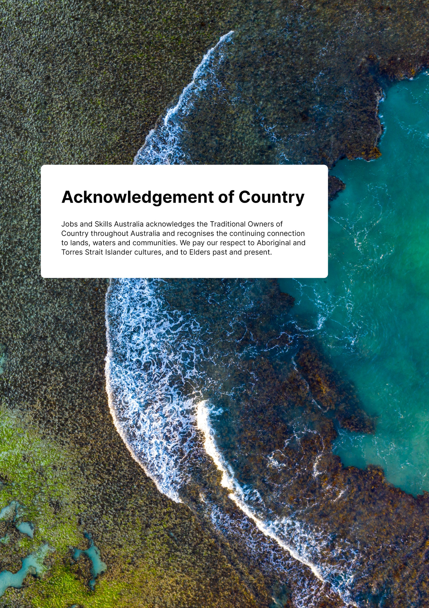


Executive Summary
Jobs, work and pay are highly gendered in Australia—contributing to significant gender economic inequality. Accelerating progress towards gender economic equality requires improving gender balance across work, jobs and pay—and the education and training choices, pathways and divides that lead into them.
In this Study we provide new perspectives, data and evidence to support both goals. Improving gender balance across the labour market and skills system is essential—not only to boost productivity and expand opportunities, but also to shift the underlying gendered 'norms', behaviours and expectations that continue to dominate our society and economy.
This first data findings paper (Paper 1) of the Gender Economic Equality Study presents new data and insights on the gendered division of jobs, work and pay.
Our second data findings paper (Paper 2), to be released in early September, will shift analytical focus to gendered skills, training pathways and outcomes.
In late September 2025, our third and final publication (Paper 3) will explore the policy implications of findings from papers 1 and 2, offering recommendations to accelerate progress towards gender economic equality.
Figure 1: Gender Economic Equality Study planned publications
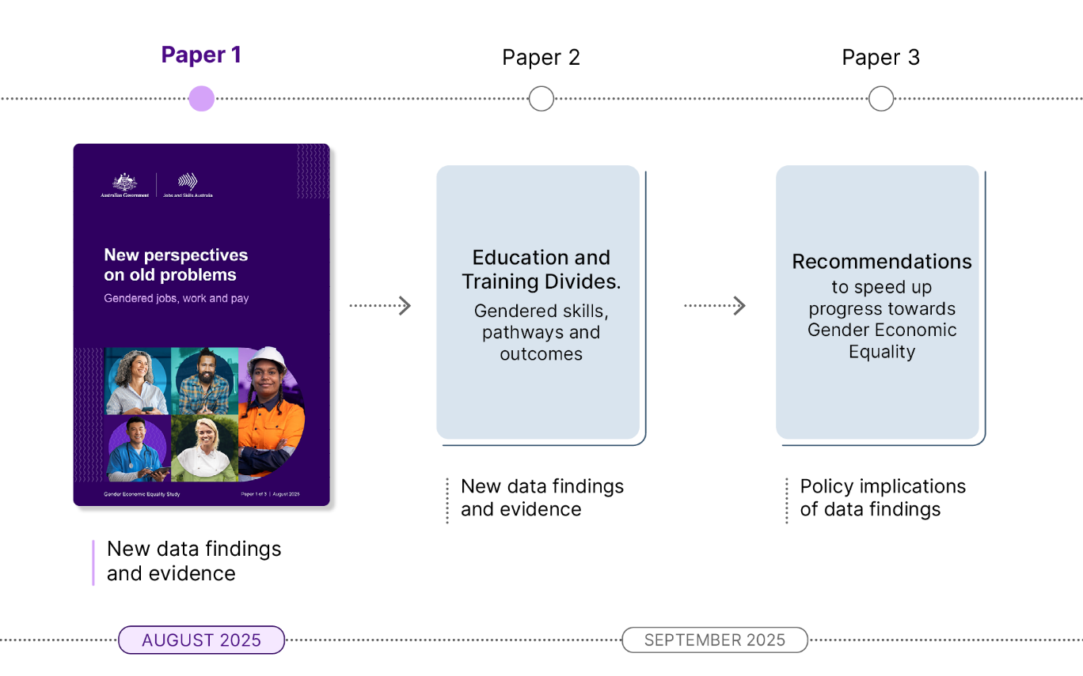


Part 1: New perspectives on occupational segregation
In this paper, we introduce the Gender Segregation Intensity Scale (GSIS) and use it to frame new perspectives, data, evidence and policy implications analysis across the study's three papers. The GSIS is a new and more detailed approach for measuring and understanding segregation intensity across the Australian Labour market. The GSIS reveals how gendered Australian jobs, work and pay really are and how gendered occupational segregation is particularly difficult to shift.
In 2021, only 21% of the Australian workforce worked in gender balanced occupations, and around 70% of occupations had the same gender segregation intensity they had in 2006.
Other key findings on gendered occupational segregation include:
- There has been a broad gender balancing of managerial and professional occupations over time, and growth in female dominated occupations, including:
  - Ambulance Officers and Paramedics, Dental Practitioners and Barristers, which became less segregated, changing from male dominated to gender balanced
  - Veterinarians and School Principals, which shifted away from gender balanced and tipped into being moderately female dominated
  - Aged and Disabled Carers and Pharmacy Assistants, which more males are working as, but this didn't translate into shifts on the GSIS.
- Occupation shortages typically worsen as gender segregation intensifies, particularly in almost completely male dominated occupations.
- Higher skill level jobs (Skill Level 1 and 2) are more likely to be gender balanced, and Skill Level 3 and 4 are where segregation is particularly acute.
- Almost completely male dominated occupations make up most jobs at Skill Level 3 and many are in shortage. There is clear historical gender bias in how we identify, describe and categorise occupations. We understand male dominated jobs in far more detail (for instance, there are 66 almost completely male-dominated jobs but only 16 almost completely female dominated jobs). The move to a new occupation classification—the Occupation Standard Classification for Australia (OSCA)—is better addressing this.
Gendered occupational segregation is a clear problem that needs addressing across the interconnected jobs and skills systems, including through early interventions in education and training pathways, such as when formative study choices are being made in early schooling. This will be explored further in Paper 2 of this study.
We also use the GSIS to frame intersectional insights into how occupations and industries are not just gender segregated but also divided along other demographic lines, including for First Nations people and CALD migrants.
Just as gendered norms reinforce the gendered divisions of jobs, work and pay in Australia, norms around race, culture and ethnicity, along with established pathways (e.g. migration) also shape which jobs different groups of workers gravitate towards, succeed in or can get stuck in. Both individual choices but also structural discrimination and bias are at play in these dynamics.


Key intersectional insights from this study for First Nations workers are that:
- First Nations workers are more concentrated in community and personal services occupations (e.g. Education Aides and Welfare Support Workers), and several large employing almost completely male dominated trade occupations compared to the total workforce.
- First Nations workers are more likely to work in highly gender segregated jobs and less likely to work in gender balanced jobs, and there are unique gender segregation trends across these workers.
Likewise, CALD workers are over or underrepresented in certain jobs across the economy and are slightly more likely to work in gender balanced occupations than the total population or First Nations counterparts.
CALD workers are overrepresented in some occupations (IT, health, driving, hospitality, etc) and underrepresented in others (teaching, law, farming; highly male dominated trades, emergency services, police, etc).
Gender segregation patterns across CALD workers are also unique:
- The growth in female dominated occupations, across health and care, aligns with growth in CALD dominated occupations.
- CALD females have played a significant role in the broader gender balancing of higher skill level managerial and professional occupations over time (e.g. in health, IT and accounting).
- CALD males have higher shares of health roles, including Aged and Disabled Carers and Registered Nurses, compared to males across the economy. These occupations are less gender segregated among CALD workers than the total workforce.
- Occupations like Doctors, Accountants, Software Programmers, and Civil Engineers have both become more gender balanced and increasing culturally diverse at the same time.
For First Nations workers and CALD workers, changes in selected occupations identify important and promising changes that are contributing to broader occupation growth and gender segregation changes over time.
To explore the occupational gender segregation over time, for all jobs and across different groups of people like First Nations workers or CALD workers, see the JSA Gender Segregation Intensity Scale Dashboard.
We also draw on qualitative insights from the lived experience of workers from diverse backgrounds—including different genders, CALD and culturally and racially marginalised (CARM) communities, migrants, age groups, and LGBTQIA+ identities—across a range of occupations and qualifications. These insights are drawn from research specifically commissioned for the study that included nine focus groups and 15 in-depth interviews.
Like our quantitative findings, the qualitative data revealed that gender inequality is deeply entrenched in the workforce. It is further compounded by intersecting factors such as, race and varies depending on industry gender segregation and life stage.
We will continue to reference these findings throughout the study, especially in Paper 3, which focuses on the policy implications of both our quantitative and qualitative research.

Part 2: New perspectives on gender pay gaps
This Paper presents three new perspectives on gender pay gaps to expand the evidence base and accelerate progress towards gender equality. The Study complements existing national measures, by introducing additional and unique approaches to fill key data gaps— particularly around detailed occupational and intersectional pay gaps.
We report pay gaps for 688 occupations across the economy, along with intersectional pay gap data for First Nations people, CALD people and migrants.
We also develop a new accumulated 10-year gender pay gap measure to better capture the longer-term and life course impacts of gender economic inequality.
You can explore all 688 occupational gender pay gaps in the JSA Gender Pay Gap Dashboard.
Our key findings on occupational gender pay gaps include:
- In 2020-21, the accumulated 10-year occupational gender pay gap was 30.7%, which is greater than the single year point-in-time gender pay gap (25.7% in 2022-23).
- Males are outearning females in 98% of the 688 occupations and only 2% of occupations have a relatively neutral pay gap.
- There are over 100 occupations where the pay gap is over 25% and almost 30 occupations with a pay gap over 35%.
- Some of the occupations with the highest gender pay gaps in the country are in the male dominated trades, health and finance.
- Gender pay gaps widen and worsen at the highest grades of segregation intensity but there are still high gender pay gaps in some gender balanced occupations.
- There are high gender pay gaps in management jobs across industries of varying gender segregation intensity, pointing towards the enduring problem of both vertical and horizontal gender segregation in the Australian labour market.
- Differences in patterns, hours and amount of work explain some, but at times very little, of the variation in occupational pay gaps.
- Gender pay gaps increase with age and peak among 40-54 year olds at 29.6%. However, the 'motherhood penalty' is clearly seen in the accumulated 10-year gender pay gaps, with females aged 25-39 years old seeing the worst subsequent economic outcomes.
- Both total workforce and occupational gender pay gaps have been decreasing over time and this reflects similar trends to the most recent WGEA and ABS analysis of Australia's gender pay gaps.
Without intersectional pay gap data and analysis, "the true state of gender equality in the economy is not being reflected and therefore is not being fully leveraged to drive targeted action" (PM&C 2021).
Our Study has begun filling these pay gaps, which show that:
- Regardless of which pay gap measure or benchmark is used, First Nations females have the highest gender pay gaps in Australia. Compared with all Australian males, they had a gap of 35.3%, which was almost 10 percentage points higher than for females generally and for CALD females (which were both similar).
- First Nations males also have the highest gender pay gaps among male cohorts at 19.3% but is still below all of the pay gap measures for different groups of females. CALD and migrant male pay gaps are far lower at under 5%.
- The First Nations female 10-year gender pay gap was 38.1%, more than 7 percentage points higher than for females generally and for CALD females (which were both similar).
- In contrast, accumulated gender pay gaps for First Nations males were lower than the single year point-in-time measures (19.3% to 16.7%), while the accumulated measure was almost double the point-in-time measure for CALD males (4.2% to 8.5%).
- As at the total workforce level, pay gaps have been decreasing for First Nations people, CALD people and migrants.
JSA will publish an Intersectional Gender Pay Gap Dashboard in the coming months to support further insights.


Paper 2: Additional insights coming on education and training divides
Across both Parts 1 and 2 in this paper, we consistently highlight that the way we identify, measure and describe jobs or pay is highly gendered. This is reflected in occupation classifications, both internationally and in Australia, which mirror gender bias embedded in labour market structures and limit our understanding of women's jobs, work and pay compared with men. Female dominated jobs have been far less disaggregated in occupation classification systems and in data in most countries, even those with rich and detailed labour market data, like Australia.
In Paper 2: Education and Training Divides—Gendered Skills, Pathways and Outcomes, which will be released in early September 2025, we further address these evidence gaps with the first ever insights into gender segregation in occupations that are now specifically identified under the new OSCA.
In developing OSCA, the ABS has sought to better address the gender bias in our national occupational classification system and official statistics. JSA has partnered with the ABS through this study to produce the first ever analysis that demonstrates the value of these improvements for understanding occupational segregation and the greater recognition of female dominated occupations in the labour market. From an international perspective, OSCA positions Australia as leader in how to better understand gendered work, jobs and pay and, as a result better, to support efforts towards economic equality.

Paper 3: From data and findings to recommendations for change
The data and findings in this in this paper point to the need for policy change if we are to accelerate progress towards gender economic equality. In Paper 3, we will present recommendations, drawing on the six themes that have emerged throughout this first paper:
- Australia's workforce remains highly gender segregated, and there are clear connections with gendered choices, divides and outcomes across education and training pathways. This is a serious challenge that needs actors across these systems to come together to make progress.
- Gendered occupational segregation is complex and difficult to shift. However, there are encouraging examples of gender balancing change over time that we can supercharge into accelerating trends, along with leveraging lessons on how to make progress on more stubborn patterns of occupational segregation.
- Gendered occupational segregation is a problem for addressing occupation shortages—with clear economic impacts—and this worsens at selected skill levels and in male dominated occupations. This has significant skills-system policy implications. Also, the occupational, industry and workplace culture and high pay gaps in traditionally male dominated occupations need to change for Australia to make faster and broader progress on balancing out our highly gender segregated workforce.
- There are very large gender pay gaps that are visible at the detailed occupation level, with some particularly high gaps in certain occupations, even in gender balanced or highly female dominated occupations. All need attention. For example, our data findings can focus policy makers attention on addressing the high gender pay gaps in particular occupations such as almost completely male dominated trades—all of which are in national shortage and key to Australia's Net Zero transition and Future Made in Australia reform—when designing policy levers to encourage women into them. It is also important to have policies focused on retaining women in these occupations, including upskilling opportunities and other career-long enabling supports.
- Intersectional insights show nuanced policy actions are needed to address significant sources of compounding gendered and racial discrimination in the world of work, education and training—particularly for First Nations females in this country. But intersectional insights also highlight how different groups of workers contribute significantly to broader positive segregation changes in the labour market. Our Study demonstrates the value of intersectional data, approaches and analysis and these should be part of ongoing work to progress gender economic equality.
- The GSIS should be used to monitor shifts in detailed occupational gender segregation over time, alongside detailed occupational gender pay gaps. Ongoing monitoring should identify the gendered jobs and work that need the most serious intervention or offer the biggest return on investment opportunities for speeding up progress to gender economic equality.

