Jobs and Skills Roadmap for Regional Australia

Phase 1

**3 July 2025**

Acknowledgement of Country

Jobs and Skills Australia acknowledges the Traditional Owners of Country throughout Australia and recognises the continuing connection to lands, waters and communities. We pay our respect to Aboriginal and Torres Strait Islander cultures, and to Elders past and present.****

Contents

Commissioner’s Foreword 5

Executive Summary 6

The Purpose of the Roadmap 6

Where is Regional Australia? 6

What is the Regional Jobs and Skills System? 6

Overarching Vision for the Regional Skills System 7

How is the jobs and skills system in Regional Australia performing? 7

Making progress in enhancing the jobs and skills system in Regional Australia 9

Using this Regional Roadmap to move towards Phase 2 13

What is the purpose of JSA’s Jobs and Skills Roadmap for Regional Australia? 15

Why do we need a jobs and skills roadmap for Regional Australia? 15

Where is ‘Regional Australia’? 18

1. Overview of the jobs and skills system in Regional Australia 21

Overview of Regional Australia’s jobs and skills system 22

What are the challenges and opportunities for Regional Australia? 25

4 key trends influencing the jobs and skills system in Regional Australia 28

2. Vision and evaluative framework for Regional Australia’s jobs and skills system 34

Overarching vision for the jobs and skills system in Regional Australia 35

Evaluative metrics to measure progress towards the vision 36

Vision Principle 1 – Addressing Barriers 41

Vision Principle 2 – Developing Skills 54

Vision Principle 3 – Quality Jobs 71

Vision Principal 4 – Meeting Demand 80

Vision Principle 5 – Efficient matching of labour supply and demand 96

Vision and evaluative framework conclusion 106

3. Making progress towards the vision for Regional Australia 110

10 policy design principles for Regional Australia 113

Emerging priorities to enhance the jobs and skills system in Regional Australia 116

Examples of models that are already making a difference 118

Supporting state and territory based regional roadmaps 128

Supporting local place-based strategies 131

Public consultation and submission process – including guiding questions 133

Appendix 1: Roadmap metrics by State and Territory 137

Summary of Roadmap indicators by state and territory 138

Regional New South Wales 139

Regional Victoria 140

Regional Queensland 141

Regional South Australia 142

Regional Western Australia 143

Tasmania 144

Northern Territory 145

Australian Capital Territory 146

Remote Australia 147

Appendix 2: Acknowledgements, definitions and references 150

Acknowledgements 150

Metrics Data Dictionary 153

Definition of Regional Australia 157

List of Figures 160

References 162

# Commissioner’s Foreword

The vast spans of the country that extend beyond our major cities are vital to the economic and social wellbeing of our nation. Around a third of working age Australians live in Regional Australia, which makes it a major part of the national jobs and skills system and a key focus for Jobs and Skills Australia.

Given its significance, I resolved to shine a spotlight on Regional Australia as part of JSA’s 2024–25 Workplan. My aim was for JSA to provide a more detailed look at the regional jobs and skills related opportunities and issues so frequently analysed through JSA’s ongoing program of work.

JSA’s Jobs and Skills Roadmap for Regional Australia does just that. It provides an overarching strategic framework for Australia’s regional jobs and skills system with a clear vision that aims to enhance the equity, effectiveness and efficiency of the system across Regional Australia, both now and into the future.

This national framework and vision for Regional Australia is underpinned by 5 vision principles and a number of evaluative measures to monitor progress and is supported by a key list of policy design principles and emerging areas of potential action to drive change. This is an ambitious vision, but one I truly believe is achievable.

As the regional jobs and skills system involves many different stakeholders and various shared responsibilities, it will require collaboration. JSA is thankful for the significant input from stakeholders across Regional Australia and the jobs and skills system at large which have shaped and informed the report. Many regional voices and case studies have been highlighted in the report, but the experiences of stakeholders across Australia underpin the entire Roadmap.

The critical need for collaboration in achieving our vision has necessitated a phased approach to the delivery of JSA’s Jobs and Skills Roadmap for Regional Australia. In coming months, this report will form the basis for an extensive consultation, including a public submission process and series of roundtables across Regional Australia to test the framework and develop possible actions and commitments. A second report will subsequently be delivered to build on this important work.

I am thankful for the work of JSA Deputy Commissioner Megan Lilly in leading the delivery of this report, as well as the significant contributions of JSA staff including Peter Lake, and former JSA Commissioner Professor Peter Dawkins AO, who was a special advisor for this project.

I also express my appreciation for JSA’s Ministerial Advisory Board and Regional Advisory Group who were instrumental in providing considered advice and expert input to this report.

**Professor Barney Glover, AO**

Commissioner

Jobs and Skills Australia

# Executive Summary

The Purpose of the Roadmap

The purpose of Jobs and Skills Australia’s (JSA’s) Regional Roadmap is to provide an enduring, shared and overarching framework that empowers stakeholders to work collaboratively to improve the equity, effectiveness and efficiency of the jobs and skills system across Regional Australia, both now and into the future.

The *Regional, Rural and Remote Jobs and Skills Roadmap* interim report, published in October 2024, was the first step in the development of such a roadmap. Focusing on the unique experiences and perspectives of Australians who live and work outside Major Cities, the interim report presented preliminary data and analysis on the trends shaping regional labour markets and provided a basis for engagement in delivering the roadmap.

Phase 1 of the Roadmap (this Report) builds upon the interim report and provides an overarching national framework, identifies system-wide priorities to enable progress towards the vision, and offers a starting point for fostering local conversations, planning and actions to enable each region of each State and Territory and region to also progress towards the vision.

This process will be underpinned by a public stakeholder submission process and roundtables across Regional Australia in the second half of 2025. A Phase 2 Report will be subsequently published by JSA to reflect this further engagement and feedback.

Where is Regional Australia?

For the purposes of this Roadmap, Regional Australia is defined as all regions in Australia except for those in the Major Cities of Sydney, Melbourne, Brisbane, Adelaide and Perth and the Australian Capital Territory (ACT).

What is the Regional Jobs and Skills System?

The jobs and skills system incorporates the education, training and skills system, the migration system and the jobs and labour market itself. In each of these sub-systems, there are a range of government and non-government stakeholders responsible for the design, delivery and coordination of the system. Conceptually, the regional jobs and skills system is that part of the system that operates for and in Regional Australia. Much of it is a shared system that also applies to the Major Cities, which tailors to varying degrees how it operates in Regional Australia.

There are a number of key factors and features that mean the jobs and skills system needs to operate differently in Regional Australia when compared with the Major Cities. In particular, Regional Australia has a more geographically dispersed population, which leads to higher costs of delivery and an enduring challenge to ensure equity of access to programs and services for individuals and employers in Regional Australia. The skills needs in Regional Australia also differ to those in Major Cities.

Overarching Vision for the Regional Skills System

|  |
| --- |
| JSA’s vision for the jobs and skills system in Regional Australia  The jobs and skills system in Regional Australia helps realise the aspirations of its people. |

The foundation of the vision is underpinned by a set of core principles that should support action through the ongoing monitoring and assessment of the effectiveness of the jobs and skills system and its outcomes over time.

How is the jobs and skills system in Regional Australia performing?

Analysis of key indicators (summarised in the Table 1, below) shows that while some components of JSA’s vision for the jobs and skills system in Regional Australia is performing at an appropriate level, demonstrating an area of comparative strength, many indicators show a moderate or significant gap.

Table 1: Vision principle contributing metrics, indicators and current assessment for Regional Australia

| Vision Principle | Underpinning Vision Principle | Contributing metric | Current rating in Regional Australia | Overall Vision Principle rating |
| --- | --- | --- | --- | --- |
| Addressing Barriers | People with barriers in Regional Australia receive timely high-quality support to move towards participating in education, training and employment. | School non-attendance | Deteriorating or significant gap | Deteriorating or significant gap |
| Youth not in employment, education or training | Deteriorating or significant gap |
| Prime age participation rate | On track or performing at an appropriate level |
| Unemployment rate | On track or performing at an appropriate level |
| Prop. on long-term income support | Deteriorating or significant gap |
| Developing skills | Everyone in Regional Australia is supported to efficiently develop skills that enable them to meaningfully contribute to community, economy and culture. | Youth tertiary participation rate | Deteriorating or significant gap | Slow progress, stagnating or moderate gap |
| Completion rates for apprentices and trainees | Slow progress, or stagnating or moderate gap |
| Proportion working in same field as most relevant qual | Slow progress, or stagnating or moderate gap |
| Proportion working in jobs below their qualification level | Slow progress, or stagnating or moderate gap |
| Quality jobs | Everyone employed in Regional Australia can work in a quality job that is safe, fair, rewarding and satisfying. | High job satisfaction | On track or performing at an appropriate level | On track or performing at an appropriate level |
| Underemployment rate | On track or performing at an appropriate level |
| Income inequality ratio | Slow progress, or stagnating or moderate gap |
| Workers’ compensation incidence rate | Slow progress, or stagnating or moderate gap |
| Meeting demand | Regional Australia and its employers can access, attract and develop sufficient suitable labour, including as skills needs change. | Vacancy fill rate | Slow progress, or stagnating or moderate gap | Slow progress, stagnating or moderate gap |
| Essential services vacancy rate | Deteriorating or significant gap |
| Persistent hiring pressure indicator | Deteriorating or significant gap |
| Business creation rate | Slow progress, or stagnating or moderate gap |
| Efficient matching | The labour market in Regional Australia efficiently matches labour demand with labour supply. | Beveridge Curve analysis | On track or performing at an appropriate level | Slow progress, stagnating or moderate gap |
| Labour market matching efficiency | Slow progress, or stagnating or moderate gap |

An effective jobs and skills system in Regional Australia would see the majority of people working in a quality job that is safe, fair, rewarding and satisfying. It is therefore encouraging that high job satisfaction has been a relatively consistent feature of the labour market in Regional Australia, with the rate of satisfaction increasing in recent years. This may be a reflection of stronger labour market conditions in recent years that have allowed people to move closer to their preferred working hours. Additionally, it may also reflect remote and hybrid working arrangements that provide people with more choice regarding where they live and work.

Of particular concern, however, is the prevalence of barriers that hinder the participation and skill acquisition of people living in Regional Australia in the labour market, particularly those from priority equity groups. Many young people face barriers that are often complex and inter-related. Such barriers hinder their participation in the jobs and skills system altogether with around 1 in 6 young people in Regional Australia not in any form of employment, education or training in Regional Australia, well above the 1 in 10 young people in the Major Cities.

The prevalence of barriers that hinder participation in the labour market, including the acquisition of skills through the tertiary and higher education system, as well as completion of apprenticeship and traineeships, likely contributes to recruitment difficulty for employers in Regional Australia. Although recruitment difficulty appears to be showing some sign of easing, it continues to remain one of the greatest challenges for employers in Regional Australia. This is particularly true for essential services where almost 1 in 10 essential service jobs remain vacant in Regional Australia, well above the 1 in 15 vacant essential service jobs in the Major Cities. This highlights the urgent need for additional support to ensure the adequate provision of essential services in Regional Australia that is central to supporting a strong labour market and the wellbeing of the community.

Importantly, these results echo the views stakeholders provided to JSA during discussions across Australia. At present, Regional Australia predominantly faces a people (or labour supply) issue rather than a jobs (or demand) issue. There is a very strong demand for labour with many jobs in chronic long-term shortage that are often left unfilled. And although employers often demonstrate an increased willingness to fill vacancies from the available supply of people, with on-the-job training and support often enhancing the productivity of the employee over time, more progress must be made to addressing the prevalence of complex and inter-related barriers that prevent the necessary skill acquisition and participation in the labour market to enable Regional Australia to thrive.

Making progress in enhancing the jobs and skills system in Regional Australia

There are 2 key areas of potential action to enhance the jobs and skills system in Regional Australia:

Part 1: 10 policy design principles for Regional Australia

Part 2: Emerging areas of focus to enhance the jobs and skills system

### 10 policy design principles to enhance the jobs and skills system across Regional Australia

There are a range of foundational policy principles that can be used to support the jobs and skills system. Such principles are often cross-cutting in that they can apply across sectors, including for schooling, vocational education and training, employment services and related skills programs as well as place-based strategies.

When considering these policy design principles, users should:

* **Hold the principles together** (rather than individually or in isolation), noting the interrelations between the principles and the possibilities for trade-offs between them.
* **Consider the principles as directional and a starting point** to stimulate policy thinking, rather than being prescriptive or limiting.
* **Use the guide to support, rather than constrain**, possibilities for future reform.

JSA intends to work with policy makers across all levels of government to further test their usefulness and refine these design principles in Phase 2 of the Roadmap.

Table 2: Proposed policy design principles to enhance the jobs and skills system across Regional Australia

|  |
| --- |
| 10 Design Principles for the jobs and skills system in Regional Australia |
| **Consultation and alignment principles** |
| 1. Are local communities being supported to develop and deliver solutions including by empowering the people and communities most affected by an issue or opportunity? |
| 1. Has the policy been developed in line with the spirit of co-design with stakeholders in Regional Australia (including by ensuring any steering committees have appropriate representation of stakeholders from Regional Australia) and genuinely refined in response to feedback? |
| 1. Does the policy align with, and complement, existing initiatives in Regional Australia, including by leveraging existing areas of success and strength and fostering collaboration in the system? |
| 1. Does the policy recognise the differing workforce and skills needs of Regional Australia, including the local needs of individual regions, and provide appropriate flexibility to adapt and respond accordingly? |
| **Service design principles** |
| 1. Does the policy seek to initially pilot or trial new approaches or initiatives (including undertaking evaluations), and provide long-term funding (preferably for a minimum of 4 years) for known models of success? |
| 1. Does the policy ensure continuity of access to quality services, and allow government to deliver services where appropriate (such as through TAFEs, local governments, Government-Business Enterprises and so forth)? |
| 1. Does the policy consider using block-grant funding to support service delivery in situations where it is difficult to achieve viable cohorts of participants (rather than using activity or outcome-based funding)? |
| **Funding principles** |
| 1. Does the policy provide higher levels of funding to Regional Australia – including for remote areas – in response to higher costs of delivery and thin markets? |
| 1. Does the funding incorporate periodic (or annual) uplifts in funding in response to changes in the cost of delivery in Regional Australia? |
| 1. Does the policy ensure any substantial changes to funding or service delivery in Regional Australia (including cessations or extensions) occur progressively over time and with sufficient notice for regions to adapt? |

### Emerging areas of focus for continued action to enhance the jobs and skills system in Regional Australia

In addition to the cross-cutting policy settings incorporated in the checklist above, there are also a range of emerging areas of focus and opportunity. These areas represent more focused and deliberate actions that should be explored with stakeholders to determine their feasibility and options for co-designing specific policy responses.

In many regions and jurisdictions, the proposed areas of focus draw on existing strengths or successes in Regional Australia. There are opportunities for these approaches to be shared more broadly to enable other regions to learn from and build on the successes.

The list below is a starting point for the proposed roundtables and stakeholder submission process to inform Phase 2 of the Roadmap.

#### Cross-cutting strategies and approaches

1. All future workforce, capacity and cohort studies progressed by JSA should explicitly consider Regional Australia.
2. The skills needs of regional and remote areas often differ to those of the Major Cities. Commonwealth and State and Territory Governments (where applicable) should work towards identifying such differences in all future skills needs lists.
3. More comprehensive, frequent and useful data for Regional Australia is needed in relation to:
4. foundational skills – particularly among adults
5. workforce and skills needs, particularly in remote Australia
6. education and employment pathways of students and youth, including through the continuing integration of linked datasets to enable more effective evaluation of outcomes over time
7. economic activity by region, to support insights into labour productivity
8. barriers to participation in education and employment faced by young people under the age of 18
9. greater collection of qualitative data to enhance and complement quantitative data including those related to people’s experiences and wellbeing.
10. Using place-based and centralised points-of-contact (‘hubs’) for students and jobseekers alike has proven successful in some regions (including cross-government initiatives), noting the need to ensure access to services for those who are more isolated from transport links.
11. Supporting roles that focus on fostering collaboration and partnerships in the jobs and skills system are proving effective, including through the Jobs Coordinators (Employment Facilitators) under the Local Jobs Program and other related initiatives.

#### Reducing Barriers

1. Individuals who face complex barriers to employment require intensive case-managed strategies that incorporate work components and other targeted forms of social and wrap-around support. Such strategies should be developed on a personalised and individualised basis. Additionally:
2. Work connection activities are a priority but must be not hinder the provision of necessary social services and support.
3. Long-term income support reliant recipients may be better provided for through a predominantly social-support focussed program.
4. Adults who previously disengaged from schooling often face significant barriers to participation in further education or employment. Ongoing access to appropriate foundation skills development programs and initiatives is essential.
5. Where lack of aspiration or motivation is a key barrier (particularly in cases of intergenerational disadvantage or disengagement from schooling), consideration should be given to trialling a program targeting this particular barrier (leveraging areas of existing success). Such a program could work closely with local employers across a diverse range of industries to provide students with the opportunity to visit a variety of workplaces to inspire career aspirations.

#### Skills and Education

1. The Commonwealth Government should work with State and Territory Governments to explore additional reporting focused on Regional Australia (as a whole, at the national level), to support performance reporting around the National Skills Agreement (NSA). Governments should also work together to support each individual jurisdiction to monitor performance across the regional areas of their own State/Territory as an additional identified priority area.
2. The Australian Tertiary Education Commission (ATEC), when established, should work with regional universities (including those who have a regional presence) to explore incorporating regional focussed performance indicators into Mission Based Compacts. If the Higher Education Accord’s recommendations pertaining to regional higher education are adopted and effectively implemented, that will greatly increase the ability of regional universities to drive up these indicators.
3. The jobs and skills system in Regional Australia would benefit from improved strategic alignment, coordination and cooperation between the Higher Education and Vocational Education and Training (VET) sectors. Enabling the development and effective implementation of a tertiary harmonisation roadmap of the kind proposed by JSA in its report *Opportunity and Productivity: Towards a Tertiary Harmonisation Roadmap* would go some way to realising this opportunity.
4. Ensure that all secondary students have access to high quality careers education in school that is broadly based, well researched and deeply connected to local community and its businesses.
5. Secondary school students in Regional Australia need access to a broad range of education and employment pathways. Provision of vocational and trade-based opportunities in senior secondary schooling is essential, including by exploring opportunities to enhance access to dedicated trade colleges.
6. The availability of accommodation in Regional Australia for Vocational Education and Training (VET) students needs to be examined to support access to in-person training blocks for vocational students in regional centres.
7. Jobs and Skills Councils, in developing the Workforce Plans and their products, including training packages and training materials, should explicitly consider how regional needs have been accommodated, including Aboriginal and Torres Strait Islander perspectives.
8. Improvements to visa processing and skills accreditation (or recognition) processes for skilled migrants could unlock important productivity benefits in Regional Australia. This should be complemented by ensuring visa types and related support help meet the needs of Regional Australia.

Using this Regional Roadmap to move towards Phase 2

In Phase 1, JSA has developed an overarching Regional Roadmap at the national level in consultation with key stakeholders. This has included undertaking fieldwork in specific regions across the states and territories. It identifies the cross-cutting themes, develops performance indicators and provides an overall assessment of the way forward and looked at how this vary across states and territories.

Improving the jobs and skills system, and harmonising its various components (e.g., VET and Higher Education) for the benefit of individual regions, will require collaboration between the levels of government.

In Phase 2, JSA will seek to work with states and territories to lay the groundwork for establishing Regional Jobs and Skills Roadmaps for each state and territory. This will commence with a series of roundtables in regional locations across the Commonwealth and will be supported by a public consultation submission process.

Figure 1: Overview of JSA Regional Roadmap- Phase 1 and Phase 2

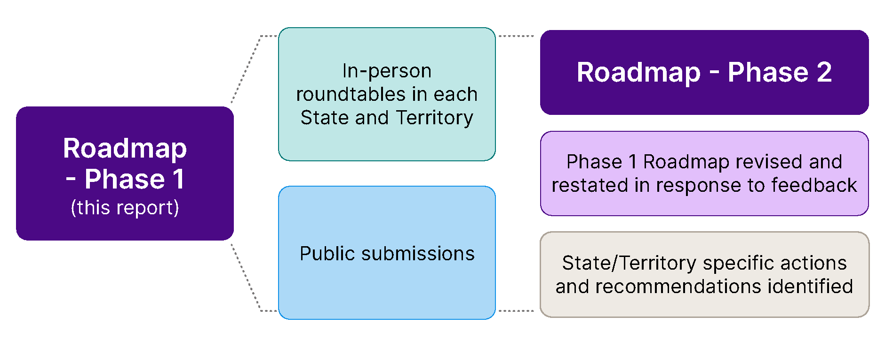

Introduction to the Roadmap

Chapter 1

**The study**

Provides the study’s purpose, approach and contextual information. Outlines the domestic and international policies driving the energy transition.

What is the purpose of JSA’s Jobs and Skills Roadmap for Regional Australia?

|  |
| --- |
| Purpose of JSA Regional Roadmap  To provide an enduring, shared and overarching framework that empowers stakeholders to work collaboratively to enhance the equity, effectiveness and efficiency of the jobs and skills system across Regional Australia both now and into the future. |

The purpose statement above reflects the inherent nature of roadmaps – that is, they are meant to provide an overarching strategic plan or pathway towards a shared goal or mission. This is not a statement for a single organisation or person to pursue, but one that should apply across the entire jobs and skills system, resonating with individuals and organisations alike, many of whom are already working to strengthen the jobs and skills system in Regional Australia.

By developing an overarching roadmap, JSA aims to bring together and join-up the collective actions already being taken across Regional Australia, into a coherent framework and vision. It is hoped that the roadmap will foster and support further collaboration and provide a starting point for continuing, focusing and accelerating local conversations, planning and actions being undertake in pursuit of an improved jobs and skills system.

Pursuing a roadmap for the jobs and skills system requires a deep understanding of how the various challenges and opportunities impacting on the regional jobs and skills system. This includes the perspectives of people who live and work in Regional Australia, or who are working to enhance the jobs and skills system.

The roadmap is a shared and collaborative vision. To this end, a collection of insights and voices have been incorporated and highlighted as ‘stakeholder insights’, reflecting that the roadmap draws on and shares the experiences and expertise of those interacting with the regional jobs and skills system.

Why do we need a jobs and skills roadmap for Regional Australia?

The significance of Regional Australia in supporting the economic and social wellbeing of Australians, as well as the unique challenges and opportunities of the regions (among other factors) demonstrates the clear need for the Regional Roadmap.

Regional Australia accounts for around 30% of Australia’s total working-age population and covers 99% of the geographic area of the country, demonstrating its size and significance in contributing to national ambitions and goals.[1]

* Around 90% of those living in Regional Australia in 2011 were also living in Regional Australia ten years later in 2021, indicating that most people in Regional Australia are likely to stay there over the long-term. Regional Australia contributes significantly to the overall social and economic wellbeing of Australia through key sectors such as agriculture, mining, tourism and renewable energy.

**Figure 2: Selected statistics on the size and importance of Regional Australia**

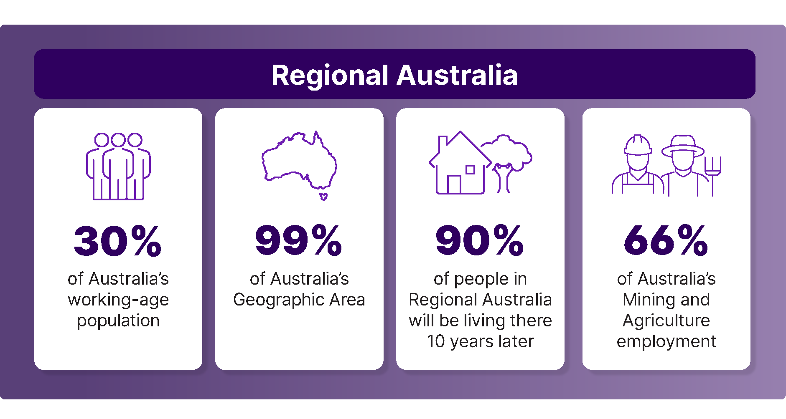

|  |
| --- |
| Stakeholder insight  *‘Regional Australia makes a substantial contribution to the economic and social wellbeing of the nation. However, unleashing the underutilised skills potential of Regional Australia, by major enhancement of the regional jobs and skills system, will be critical to ensuring the future prosperity of our country.’*  **Peter Dawkins AO**  Emeritus Professor of Economics  Mitchell Institute, Victoria University |

Labour market conditions can vary widely across Regional Australia resulting in marked disparities in outcomes across regions. JSA’s Regional Labour Market Indicator (RLMI) consistently shows that regional and remote areas are more likely to experience weaker labour market conditions than their counterparts in Major Cities. JSA has produced *experimental* labour market ratings at the SA3 level, based largely on JSA’s methodology used to create the SA4 labour market ratings,[2] which further highlights this variation.

Figure 3: JSA RLMI ratings of labour market strength by SA3 regions

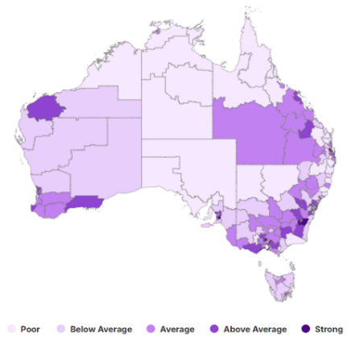

*Source: JSA, Regional Labour Market Indicator (RLMI), experimental estimates.*

Overall, there is a strong and well-accepted rationale for undertaking more locally-led place-based focussed research and analysis, particularly where place-based policy initiatives may be a successful mechanism for improving outcomes for communities. Place-focussed research and analysis cuts across sectors and industries, providing a picture of the skills system and economy of a region (or regions) as a whole.

Undertaking workforce planning on a geographic basis, including for Regional Australia, is critical for ensuring the jobs and skills system reflects and is aligned to the specific workforce needs of different parts of the country. The Regional Roadmap provides a foundational framework as a starting point for developing further and more detailed roadmaps targeted to specific regions or types of regions in the future.

Notably, JSA’s Regional Roadmap is an overarching framework focussed on the jobs and skills system, alongside other initiatives and plans that seek to support broader regional development processes and aspirations. While such regional development plans often incorporate a jobs or skills component, JSA’s Regional Roadmap is centred on the jobs and skills system in Regional Australia.

JSA acknowledges that the National Agreement on Closing the Gap remains the most critical policy platform for delivering improved outcomes for First Nations people. This includes the National Agreement’s Priority Reforms as well as the 19 socio‑economic targets across areas that have an impact on life outcomes for Aboriginal and Torres Strait Islander people. JSA’s Jobs and Skills Roadmap for Regional Australia seeks to complement existing efforts to Close the Gap, noting the Regional Roadmap provides a broader framework that pertains to Regional Australia as a whole.

|  |
| --- |
| Box: The Australian Government’s Regional Investment Framework  The Australian Government's [Regional Investment Framework](https://www.infrastructure.gov.au/territories-regions-cities/regional-australia/regional-investment-framework) (the Framework) sets out a new approach to delivering regional investment, coordinating across governments to make investment work better for regions and placing regions and their people at the centre of decision making. It outlines guiding principles, priority areas for investment and an implementation approach that will support the delivery of smart and responsible investments that support regions to adapt and thrive, regardless of their economic circumstances.  The Framework supports a joined-up and cohesive approach to seizing opportunities and responding to challenges across Australia's diverse regions. The Framework supports the Government's commitments to valuing local voices and priorities; informed and evidence-based decision making; and delivery of investment in our regions with integrity and transparency.  Under the Framework, government investment will be targeted and support better outcomes for regional people, the places they live in, the services they rely on, and the regional industries and economies that are core to Australia's prosperity.  Working in genuine partnerships with communities, other levels of government and the private sector, the Australian Government is committed to supporting regional Australia to ensure no one is held back or left behind. |

Where is ‘Regional Australia’?

Regional boundaries and classifications can be defined in many ways, depending on the purpose of the research, policy or program. One geographic definition or classification may be used for one purpose, and a different definition may be appropriate for another.

The definition of Regional Australia used in this report (unless otherwise stated) is:

|  |
| --- |
| Regional Australia includes all regions of Australia except for those in the major capital cities of Sydney, Melbourne, Brisbane, Adelaide and Perth and the Australian Capital Territory (ACT). |

In defining Regional Australia, it’s important to remember the range of different population sizes, resources, economic conditions and access to services across regions. Australia’s regions and their economies are diverse, with each region having unique strengths, opportunities and challenges. In this way, Regional Australia is not homogeneous.

JSA’s definition of Regional Australia closely follows the ABS Australian Statistical Geography Standard (ASGS) Greater Capital City Statistical Areas (GCCSAs)[3], which differentiates between Major Cities and rest of state/territory regions. The exceptions to this are the Northern Territory (NT) and Tasmania, which are wholly considered as being part of Regional Australia for the purposes of this Roadmap.

Compared with other capital cities, Darwin and Hobart have smaller populations and are more geographically isolated from the rest of Australia. Hobart faces additional unique challenges being located on an island that is geographically separated from mainland Australia, while Darwin is also distinct in its climate, population structure and geographic distance and is much closer to cities in South-East Asia than many of the other capital cities.

Figure 4: Visual representation of the definition of ‘Regional Australia’ for the purposes of the JSA Regional Roadmap

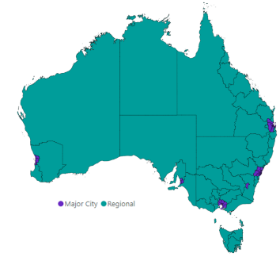

|  |
| --- |
| Stakeholder insight  *‘Regional Australia is not a single labour market, but a group of diverse local communities and regions that each have their own challenges and opportunities. While some issues are shared or cross-cutting, many issues require tailoring to the needs of local communities.’*  **Professor Jeff Borland**  Professor of Economics  University of Melbourne. |

### JSA’s commitment to intersectional analysis – including by gender

JSA is committed to embedding and building capability in intersectional analysis across its research and analysis. This acknowledges that outcomes achieved across the jobs and system are influenced by a range of factors, which often interact – or intersect – with each other.

JSA has recently established a Gender Framework that seeks to support more focused gender analysis and provides best practice advice on how to approach this through the form of a Placemat. JSA will also publish the outcome of its Gender Economic Equality Study in the coming months. This reflects JSA’s emerging focus on considering key intersectional factors as part of its data, research, analysis and advice around the jobs and skills system.

While Phase 1 of this Roadmap includes some consideration of differences in outcomes for different groups of people in the jobs and skills system, this will have an increased focus in the next phase. Phase 2 of the Regional Roadmap will further consider how other factors (such as gender, ethnicity, disability and other factors) interacts with geography from a jobs and skills system perspective, including by highlighting some of the current data opportunities and limitations.

An increased focus on intersectionality in Phase 2 of the Roadmap will be informed by feedback from the roundtables and public submission processes, and the findings and recommendations from the Gender Economic Equality Study, and emerging work being undertaken to better understand the outcomes and experiences of Aboriginal and Torres Strait Islander peoples, people with disability, and other groups of people.

### Structure of the remainder of this Report

The remainder of this Report is structured in 3 key parts:

* **Chapter 1** will provide an overview of the jobs and skills system in Regional Australia, including by identifying current trends, challenges and opportunities in the system, including examples of models that are making a difference.
* **Chapter 2** presents the aspirational vision for the jobs and skills system in Regional Australia, including underpinning vision principles, before drawing on both quantitative metrics and qualitative insights to assess how the system is currently performing in reference to the stated vision.
* **Chapter 3** sets out actions to pursue JSA’s overarching vision for the regional jobs and skill system, including a new cross-cutting policy design checklist, a list of emerging policy priorities and the pathway to refine and enact the Roadmap with stakeholders, including through roundtables and a public consultation process.

### Glossary of key terms to remember when reading this report

* **Regional Australia** – all regions of Australia except for those in the Major Cities of Sydney, Melbourne, Brisbane, Adelaide and Perth, and the Australian Capital Territory.
* **Roadmap** – refers to this report, an indicative strategic plan for the jobs and skills system in Regional Australia, noting that there are other roadmaps and plans that exist.
* **Major Cities** – Sydney, Melbourne, Brisbane, Adelaide and Perth, and the Australian Capital Territory.
* **Remote areas** – sparsely populated, low-density regions that are isolated or well away from other main concentrations of population.

# 1. Overview of the jobs and skills system in Regional Australia

Overview of Regional Australia’s jobs and skills system

Before examining the jobs and skills system across Regional Australia, it is important to outline the jobs and skills system in Australia. The jobs and skill system in Australia is complex, made up of many sub-systems, stakeholders and associated policies that work to ensure the prosperity of Australia and its communities. The system incorporates the education, training and skills system, the migration system, and the jobs and labour market itself. In each of these sub-systems, there is a range of key stakeholders (both government and non-government) responsible for the design, delivery and coordination of the system.

The role of the jobs and skills system starts in the early learning years of a child's life, and extends through to schooling, vocational education and training and higher education. Skills accreditation and qualification reform, including the role of Jobs and Skills Councils, also intersects these components. The system also incorporates the various actors who are responsible for a functioning and efficient jobs market, from industry bodies to unions, recruitment firms and employment service providers, each of which work to facilitate the efficient matching between workers and firms.

When seeking to illustrate this system, (see Figure 5, below), the system is clearly represented in a complex and interrelated form. While such representations are complex, this is reflective of what the system is like – a complex, interrelated system.

The driving source of activity for the jobs and skills system stems predominantly from demand for products and services which is linked to population, among other factors. Typically, demand is not uniform, and thus the division of labour becomes critical to ensuring the efficient functioning of the economy. A jobs market is therefore required to align the skills and labour of workers with the processes required to efficiently produce the goods and services that are in demand. Demand for labour thus can be met through firms, employers and businesses, or through the direct labour of entrepreneurs, self-employed persons or sole-traders.

To ensure workers have the skills necessary to meet the demand for products and services, and also the demands of employers, skills and training development is essential. However, where the population or the education and training system cannot supply the labour to meet the demands (of both employers in terms of the demand for labour and consumers in terms of demand for products and services), overseas migration plays an important role. In effect, migration helps firms access enough labour with the right skills mix to meet demand. Although skills gaps or shortages can be an indicator of a growing and innovative economy and provide opportunities for jobseekers, they also have a cost on the economy, and thus an efficient and effective education training and skill system and a quality regional migration system are critical to the success of the nation.

In seeking to support and enhance the system, there are a range of policies in place that can influence the various parts of the system – both at the Commonwealth and State/Territory level. This includes education and skills policies, social policies, migration policies, employment policies, economic, tax and trade policies as well as wages and conditions policies (including workplace relations and safe work). Through these various policy principles, the intention is to enhance and support the jobs and skills system, with specific policy and delivery responsibilities are shared between Commonwealth and State/Territory governments (depending on the policy).

Figure 5: Overview of the jobs and skills system, stakeholders and policies

Regulatory environment

Unions

Recruitment firms

Employment services

Industry bodies

Childcare providers

TAFES & RTOs

Schools

Universities

Regional development associations

Jobs & Skills Councils

*Sole-traders & self-employment*

**Jobs market**

**Employers, businesses and firms**

*(demand for labour)*

**Jobseekers and workers**

*(supply of labour)*

***Demand for products & services***

**Education, training & skills development**

**Overseas Migration**

**Social services**

*Employer-based apprenticeships & traineeships*

*International students*

Education & skills policies

Wages & conditions policies

Employment policies

Migration policies

Social policies

**Legend**

Govt Policies

Stakeholders

**Systems**

Economic, trade and tax policies

***Population***

***Drivers***

*Business creation*

*Internal and inter-region mobility*

Conceptually, the regional jobs and skills system is part of the system that operates for and in Regional Australia. Much of it is the system that also applies to the Major Cities, that may nor may not vary the way it operates in Regional Australia. In effect, while the illustration of the jobs and skills system above is representative of the system across Australia, there are some notably differences or distinctions in the operation of the system when it comes to Regional Australia. Examples of this include:

* Differences in government incentives, both in terms of equity adjustments and adjustments for regional and remote delivery (noting such incentives vary across jurisdictions and sectors)
* A greater focus on VET, reflecting differences in the composition of the labour market in Regional Australia
* Differences in access and modes of delivery, reflecting the large geographic distances and dispersed populations, the differing needs of student cohorts as well as operational differences
* Challenges in recruiting and retaining staff, leading to the use of differing staffing models (such as temporary or FIFO teaching staff)
* Greater exposure to mobility issues, including in relation to the movement of people between Regional Australia and the Major Cities.

In effect, while the system operates at a national or jurisdictional level, differences in how the system is structured and operate are evident in Regional Australia.

|  |
| --- |
| Stakeholder insight  *‘The jobs and skills system in Australia has evolved over time and is effectively designed for the majority of the population, and is thus more tailored for the Major Cities of Australia. Regional Australia requires a different approach that is more targeted to the specific issues and opportunities of the regions.’*  **Megan Lilly**  Deputy Commissioner  Jobs and Skills Australia |

|  |
| --- |
| Box: Jobs and Skills Councils  Jobs and Skills Councils (JSCs) are industry-led partnerships that provide leadership to address skills and workforce challenges for their industry. JSCs focus bring together employers, unions and governments in a tripartite arrangement to find solutions to skills and workforce challenges in their industry, including through qualification reform. JSCs play a crucial role in shaping the workforce and skills landscape in Australia and operate at the intersection of skills and training policy with workplace issues and labour market needs. These insights inform the development of training packages and are related to the curriculum, ensuring that tertiary education design and delivery is tied to the needs of the modern workforce.  JSCs are playing a key role in VET qualification reform, which involves a new purpose-based approach to VET qualifications design to improve quality and simplify course designs while also reducing complexity. The reforms provide industry with opportunities for new approaches for qualifications linked to a broader industry or vocational education purpose. As national industry skills bodies, JSCs have been central to the reform working closely with unions, employers, educators and state/territory governments in developing a revised Training Package Organising Framework. This will enhance learning outcomes and improve alignment with industry needs alternative approaches to VET qualification design.  Workforce planning is also a key strategic function of JSCs. It involves developing an in-depth understanding of Australia’s current, emerging, and future workforce challenges and opportunities (including skills gaps and shortages) for all sectors within a JSC’s remit and developing advice and strategies to address the challenges and take advantage of the opportunities. JSA, DEWR, and JSCs work together in the development of workforce plans, with a key role for JSA in providing national data, including regional level data, as well as technical guidance.  JSA’s role in supporting the JSCs is demonstrated through its Jobs and Skills Atlas (‘Atlas’). Officially launched by JSA in August 2024, Atlas is an interactive data visualisation and exploration tool that combines a range of jobs and skills datasets at national, state, and regional levels by occupation, industry and training. By combining various data sets and information sources in one tool, Atlas enables access to the information in a consistent and user-friendly format with the ability to reference and cross-reference these data points. |

What are the challenges and opportunities for Regional Australia?

At present, Regional Australia is impacted by a range of factors that influence its propensity to succeed. Some of these issues are cross-cutting or national challenges, that are also felt in Regional Australia. Other issues are specific to Regional Australia, more remote areas or indeed selected regions in Regional Australia, reflecting the wide and varied regions of Australia. Figure 6 below summarises some of the key issues evident in Regional Australia under these broad categories.

Figure 6: Issues impacting Regional Australia

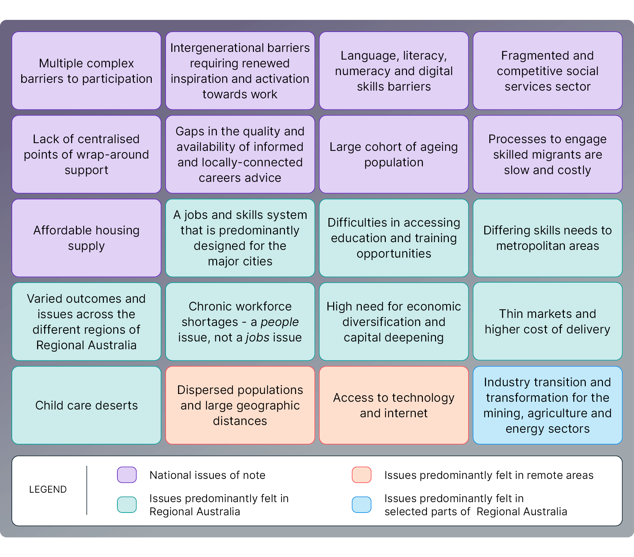

While Regional Australia faces several challenges and issues, it nonetheless possesses key strengths and attractions that provide an advantage when compared with Major Cities. Examples include both lifestyle and community factors (such as opportunities for stronger community connections, better work-life balance and access to natural beauty across land, water and sea) and also economic and labour market factors (such as potentially lower competition for jobs, opportunities to access more affordable housing, and unique career opportunities particularly across mining, energy and agriculture) (see Figure 7, below).

Many of the key issues and opportunities facing Regional Australia also need deeper consideration for Australia more broadly but require an explicit consideration of the impacts on Regional Australia. In leading the development of the Roadmap, JSA is committing to its future sector-based or issue-specific workforce studies explicitly considering the potential implications for Regional Australia, including how impacts and outcomes may vary across regions.

Figure 7: Strengths and attractions of Regional Australia

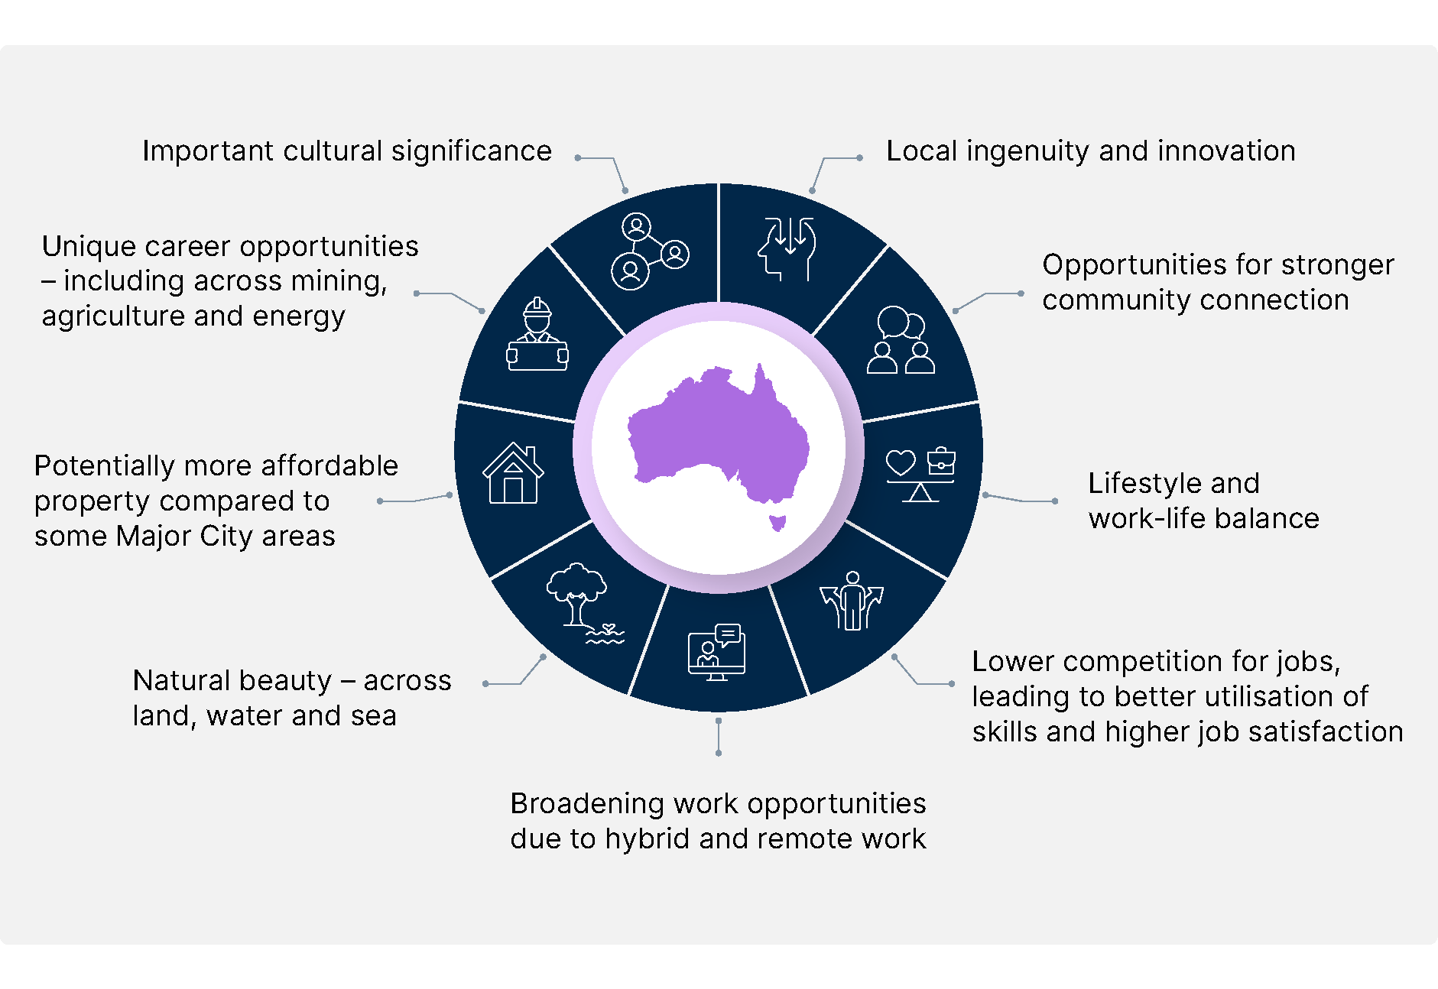

In support of this, the framework embedded in this Roadmap is designed to be an overarching and enduring framework for the jobs and skills system in Regional Australia. It should support complementary subsidiary roadmaps and analysis relating to other significant factors and drivers, to specifically consider regional implications.

While the jobs and skills system is critical to the success of Regional Australia, it is not always the sole or key determinant of success. We should therefore not expect the jobs and skills system to be able to solve issues that arise from all other challenges or drivers. The Roadmap works alongside and complements other sector or region-specific studies and policy responses with the shared goal of delivering improved outcomes for people and communities across Regional Australia. The Roadmap has also been developed in a way that it could be replicated for these other systems for Regional Australia, beyond the jobs and skills system.

4 key trends influencing the jobs and skills system in Regional Australia

While there have always been differences in regional economies and labour markets across Australia, changes in the fortunes of particular industries, infrastructure, technological developments and other factors mean that these differences vary over time and by region. Gaining an understanding of the trends that are associated with regional labour market performance will help better inform policy development and assist in ensuring Australia has the necessary pre-requisites to build a better-skilled and more adaptable workforce to position the Australian labour market for the future.

### Coastal regions have benefited from strong population growth[4]

Population growth (and decline) has important social, economic and policy implications. Population growth can lead to increased economic activity and stronger labour market outcomes, although it can also pose some challenges if the supply of labour does not match the increased demand for services or if it puts excessive pressure on infrastructure and services. By contrast, regions experiencing low or negative population growth may struggle to attract investment, which can lead to reduced economic activity and service availability and poorer labour market outcomes.

As can be seen in Figure 8, over the longer-term, there has been considerable population growth in both capital cities and coastal regions, while inland regions have lagged behind. Coastal regions have become an increasingly popular destination to live and as a result have experienced particularly strong population growth, especially when compared with inland regions. The Regional Australia Institute (RAI) *Regional Movers December 2024* report showing that city to regional migration continues to outpace regional to city flows.[5]

Population growth in coastal regions has been driven predominantly by strong net internal migration as more people move to coastal regions from capital cities and inland regions than back in the other direction (see Figure 9, below).

For inland regions, however, and except for 2021 and 2022, net internal migration has been detracting from population growth, with growth instead driven by natural increase and net overseas migration (although with rates that still lag behind that seen in coastal regions). While Australia’s regional visa settings, which offer incentives to encourage skilled migrants to live and work in regional Australia, is contributing to some of the increase in net overseas migration, the majority of migrants (close to 90%) settle in capital cities, predominately Sydney and Melbourne.[6]

Figure 8: Annual population growth (%), 2002 to 2024

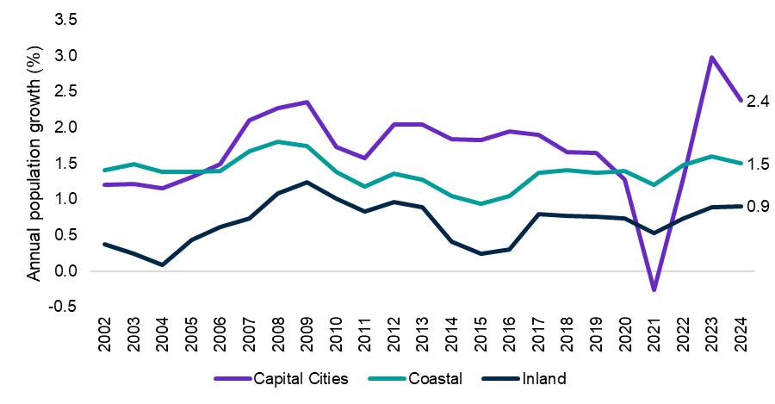

Source: ABS, *Regional population,* 2023-24 (Estimated Resident Population)

Figure 9: Population components, 2017 to 2024

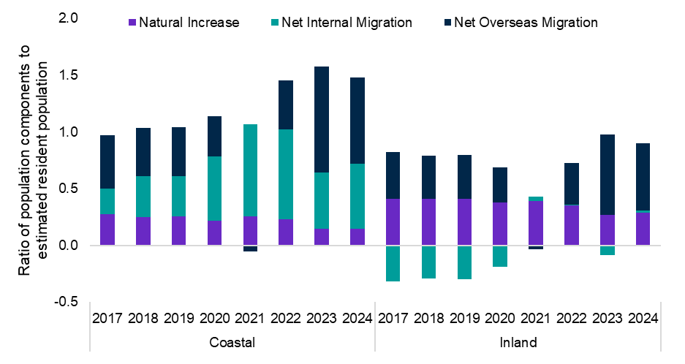

Source: ABS, *Regional population,* 2023-24 (Estimated Resident Population); Data prior to 2022 is sourced from ABS, *Regional population* (Estimated Resident Population), using .Stat Data Explorer

### An ageing population and the importance of the health and care sector

Demographic change is a key driver of labour supply and can greatly affect the size and shape of the workforce. Population ageing, through a long-term decline in fertility rates and rising longevity, is a global trend amongst most of the advanced economies, including Australia, and will place downward pressure on labour supply as older workers retire.[7] That said, a relatively high net migration rate and increasing participation by females and older cohorts has helped mitigate some of the impact of ageing on the labour market in Australia.

Nevertheless, Australia’s population is expected to continue to age over the next 40 years, while the share of the working age population to fall. Treasury’s *2023 Intergenerational Report* estimating that the share of the population aged 65 years and over is projected to increase from 17% in 2022–23 to 23% in 2062–63, while the share of the working age population will fall from 65% to 61% over the same period.[8]

As can be seen from Figure 10, regional areas have a much older age structure than Major City areas. Only 19% of the civilian population in major cities were aged 65 years and over in March 2025, compared with 28% in regional areas. With an older population and less people of prime working age, regional areas have a smaller pool of prime age workers available to them which may lead to labour market challenges including labour shortages and reduced productivity levels.[9]

Figure 10: Proportion of population (%) by age by remoteness category, 2025

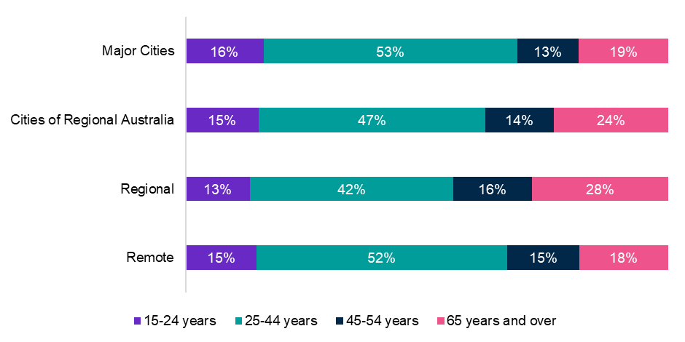

Source: ABS, *Labour Force, Detailed*, *Australia*, March 2025, 6-month averages of original estimates

### Growth in the high skilled, services-based workforce

Compositionally, employment has continued to shift towards jobs that are higher skilled (commensurate with some level of post-secondary school qualification) and away from jobs that are lower skilled (and do not require such a qualification). For instance, Skill Level 1 occupations (commensurate with a Bachelor Degree or above) accounted for more than a third (35%) of the share of total employment in February 2024, well above the 23% recorded 3 decades ago.

The shift towards employment in higher skilled occupations in recent years is a continuation of a long-term trend, as the workforce has become more highly educated and employment has transitioned towards more services-based industries.[10] These changes have occurred against the backdrop of a rapid improvement in computer technology, including automation and the emergence of artificial intelligence, that has helped shift demand for labour away from routine tasks (repetitive physical labour that can be replicated by machines) towards non-routine cognitive (non-repetitive or non-codifiable) jobs.[11] This trend has increased the demand for higher levels of technical and digital skills across all industries, for both ICT and non-ICT occupations.[12]

The increasing demand for more highly skilled jobs has had an uneven impact across regions. Unlike Major Cities and Cities of Regional Australia, where there has been the largest shift in the share of employment towards Skill Level 1 occupations (see Figure 11, below), Regional and Remote areas have experienced a shift in the share of employment towards occupations where VET is the primary pathway (Skill Level 2 to 4), in addition to an increase in Skill Level 1 occupations.

Figure 11: Skill level employment share, change (% pts) between 2019 and 2024

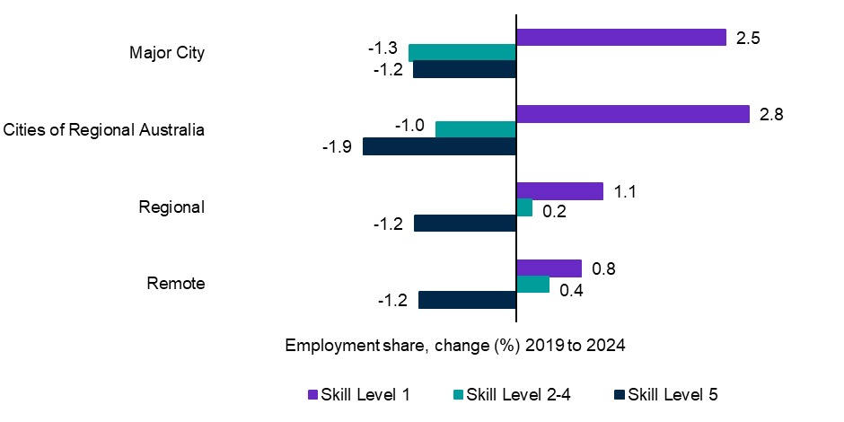

Source: JSA, *Nowcast of Employment by Region and Occupation (NERO)*, April 2024

Note: Skill Level 1 relates to Bachelor Degree or above qualification; Skill Level 2 relates to Advanced Diploma or Diploma; Skill Level 3 relates to Certificate IV or III (including at least 2 years on-the-job training); Skill Level 4 relates to Certificate II or III; Skill Level 5 relates to Certificate I or secondary education.

The shift toward high skilled employment will continue to be a key driver of labour market performance going forward as the demand for high skilled workers is expected to grow strongly. Over the 10 years to May 2033, more than 9 out of 10 new jobs (around 92%) expected to be created will require post-secondary qualifications (kill levels 1 to 4).[13] Around half (48%) will require a Bachelor Degree or above qualification as the primary education training pathway (Skill Level 1), and around 44% will have VET as the primary pathway (Skill Levels 2 to 4).

The projected continued compositional shift towards high skilled employment highlights the importance of the tertiary education system to ensure the workforce has appropriate training and skills.

### The clean energy transformation

Achieving the net zero transformation[14] represents one of the most significant economic structural shifts since the Industrial Revolution. It presents both challenges and opportunities for the Australian economy and will accelerate investment in capital, people, and communities. The transformation has particular implications for regional Australia, both in terms of the regional location of the existing workforce and the likely changes to regional employment.

#### The clean energy workforce

Clean energy jobs are found right across the workforce and the regions of Australia, extending well beyond obvious sectors like wind, solar and hydroelectricity generation into parts of construction and research and development amongst others.

New employment opportunities are likely to be created from the net zero transformation, particularly in regional Australia, although there is some variation across regions. Reflecting growth in renewable energy projects and the associated construction pipeline, many regions are likely to have average annual employment growth rates close to 2% between 2023 and 2030, including Northern NSW, and ACT and Southern NSW. Eastern Victoria and the Northern Territory are also expected to have relatively high growth rates (close to 2%), but in these 2 regions the growth is off a small base.

The strong projected employment growth in regional Australia highlights the importance of the VET sector to fill the workforce supply gaps for qualified workers, such as electrical and engineering trade roles that are critical to the construction and maintenance of renewable energy projects.

#### Regional implications of decarbonisation

There are, however, a number of regional areas across Australia that will be disproportionately impacted by the impact of decarbonisation due to the high share of workers in transitioning sectors.[15] There are 12 regions (SA3s) where workers in transitioning industries make up more than 2% of local employment, all of which are located in regional Australia (see Figure 12, below).

By comparison, there are only 5 regions where clean energy supply workers (generation and distribution) make up over 1% of their local labour market. This highlights the differences between the 2 segments, with clean energy typically being less concentrated and labour intensive than transitioning work.

Figure 12: Regions with high proportions of local employment in transitioning industries

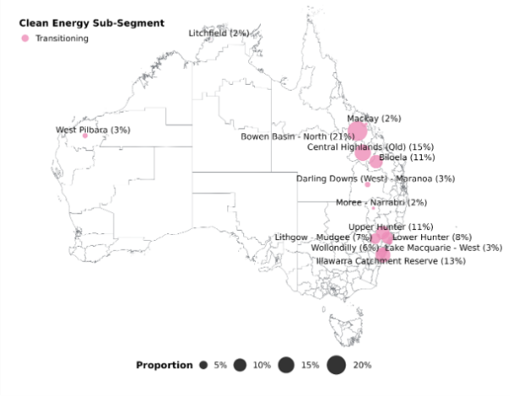 Source: ABS, *Census of Population and Housing,* 2021. SA3 regions.

While some transitioning workers will likely move into clean energy jobs, this isn’t the only (or necessarily the best) outcome. Mismatches in skills, location, timing and preferences are just some of the considerations policy makers will need to consider in delivering targeted, localised and individualised supports to drive successful outcomes for workers and their communities.

In looking ahead, JSA partnered with Deloitte Access Economics, conducting scenario modelling to explore the workforce implications of reaching next zero by 2050. The results point to strong growth in trades and technical occupations, particularly those that are critical to clean energy such as electricians, metal fitters and machinists, and plant operators. Importantly, the modelling showed that growth in these occupations is likely to be concentrated in Regional Australia. As such, a key part of JSA’s study was the focus on transitioning workers and communities. Among the key recommendations put forward by JSA was the need for government to develop targeted education plans for transitioning communities to ensure an uplift in education attainment.

Overall, JSA found that Regional Australia can benefit from the net zero transformation. The implications of the workforce transformation at the local level will be more significant in some parts of Australia, particularly those with a relatively high proportion of employment based on fossil-fuels. Economic growth and development provide good prospects for supporting these communities, provided there is local investment in new industries and impacted workers receive targeted training and other forms of support to transition into roles that build on their existing skills.

# 2. Vision and evaluative framework for Regional Australia’s jobs and skills system

Overarching vision for the jobs and skills system in Regional Australia

JSA’s overall vision provides an aspirational picture of what the various parts of the jobs and skills system in Regional Australia should work together to achieve. It’s about ensuring the jobs and skills system in Regional Australia is enabling the right people, to be in the right jobs, at the right time to support individuals, businesses and communities to thrive both now and into the future. It’s about minimising the impact that geography or locale has on the effectiveness of the jobs and skills system.This vision can be summarised as:

|  |
| --- |
| JSA’s vision for the jobs and skills system in Regional Australia  The jobs and skills system in Regional Australia helps realise the aspirations of its people. |

This vision statement is intentionally inclusive and applies to all people, regions, industries and employers across Regional Australia. This means the pursuit of the vision is underpinned by an aspirational priority to ensure no-one is left behind. That all individuals, employers and communities across Regional Australia are prepared to respond to labour market and skills opportunities and challenges – both now and into the future. The Roadmap also provides an opportunity to be more ambitious in establishing greater connections with the schooling system, which is a key factor or precursor to success in the jobs and skills system.

Examining differences in progress and outcomes across cohorts and groups in Regional Australia can help identify areas of existing strength that can be learnt from, and areas of weakness where additional investment or a new approach may be required. But this, undertaken with the view to the underpinning vision and vision principles applying to everyone across Regional Australia.

How a vision is pursued and achieved may differ across sectors, regions and time. This is one of the key reasons why an aspirational vision for the jobs and skills system in Regional Australia is needed – not necessarily because the vision would not equally apply to the Major Cities of Australia, but because in many cases the way the vision will be pursued is different in regional, rural and remote Australia. In fact, the way the vision is achieved could vary from region to region *within* Regional Australia.

This further highlights the need for a shared overarching aspirational vision that can help guide the pursuit of a more effective jobs and skills system in Regional Australia. JSA’s vision for the jobs and skills system provides such an overarching framework to help align efforts across stakeholders, regions and jurisdictions.

In a practical sense, pursuing an aspirational vision will have its challenges. In many ways, seeking improvements in complex systems like the jobs and skills system of Regional Australia quickly becomes a maximisation or optimisation problem. There are often tensions and trade-offs between elements and it is therefore critical to ensure that system design thinking, which is central to planning and action in pursuit of the vision.

### Summary of core underpinning vision principles

The Roadmap’s vision for the jobs and skills system in Regional Australia is underpinned by a set of core principles. These principles form the foundations of the vision that should support action through the ongoing monitoring and assessment of the effectiveness of the jobs and skills system and its outcomes over time.

Breaking down the vision into a set of foundational principles also helps identify areas where investment and new policy responses are necessary to support the jobs and skills system in Regional Australia. These vision principles work together to simultaneously underpin the overall vision statement, noting that each principle is distinct but without being mutually exclusive of each other. As such, the overall vision cannot be achieved without the underlying core principles all being effectively pursued and satisfied.

The 5 underpinning principles are:

1. People with barriers in Regional Australia receive timely high-quality support to move towards participating in education, training and employment.
2. Everyone in Regional Australia is supported to efficiently develop skills that enable them to meaningfully contribute to community, economy and culture.
3. Everyone employed in Regional Australia can work in a quality job that is safe, fair, rewarding and satisfying.
4. Regional Australia and its employers can access, attract and develop sufficient suitable labour, including as skills needs change.
5. The labour market in Regional Australia efficiently matches labour demand with labour supply.

Evaluative metrics to measure progress towards the vision

For each vision principle, a number of partial indicators have been identified for assessing the jobs and skills system against each vision principle, and subsequently together as a whole. While these indicators cannot simply and fully capture a vision principle in its entirety, they nonetheless provide a useful and important indication of the current state of the jobs and skills system. They focus on an assessment of the current state, rather than examining potential future gaps or issues.

Each indicator is subject to an informed assessment based on a number of factors including:

* **The current level of the indicator**, including how it compares to historical outcomes, outcomes for the Major Cities of Australia and other useful benchmarks
* **The direction of trend of the indicator**, such as whether the indicator is improving, deteriorating or relatively unchanged.

Once each indicator is curated and assessed, each group of indicators for each vision principle are considered in totality to derive an overall rating or assessment for each vision principle. These ratings are provided under 3 broad categories (see Table 3, below):

Table 3: Categories used to evaluate and assess various components of the jobs and skills system across Regional Australia

|  |  |
| --- | --- |
| Rating | Description |
| Green | On track or performing at an appropriate level |
| Orange | Slow progress, stagnating or moderate gap |
| Red | Deteriorating or significant gap |

Table 4 below lists the key indicators that contribute to the evaluative assessment of each vision principle, which are detailed in the following sections of this report, including a summary of the rationale for inclusion of the indicator.

Table 4: List of key indicators used to assess the current state of the jobs and skill system in Regional Australia, as measured in reference to the vision

| Summary of Vision Principle | Indicators | Rationale |
| --- | --- | --- |
| **Addressing Barriers** | School non-attendance rate | Provides an early indication of barriers to participation in education, as well as an indicator of foundational skills development, which underpins future participation in education and employment. |
| Youth not in employment, education or training | A key indicator of how well youth transition from school into further education, training or employment – a critical junction or transition for labour market activity. |
| Participation rate | Provides an indicator of proportion of people participating in the labour market – a good indicator that barriers have been sufficiently addressed to enable participation in the labour market |
| Unemployment rate | Provides an indicator of proportion of people looking for work and available to start, but who are being marginalised or excluded from employment, often due to the prevalence of barriers (such as skills mismatch). |
| Proportion on income support[16] for 5 or more years | Provides an indicator of individuals who are on income support in the very long-term, suggesting that their barriers are not being sufficiently addressed to move towards participation. |
| 1. **Developing Skills** | Youth tertiary participation rate | An indicator of the proportion of youth going on to post-school education, either through vocational education and training and/or higher education. A key indicator of skills development. |
| Completion rates for apprentices and trainees | An indicator for skills development processes that typically have a higher level of engagement with employers (such as through work placements or on-the-job learning). |
| Proportion working in the same field as their highest qualification | An indicator of how well the skills system is functioning in supporting the development of skills in demand. Skills development works best when skills are quickly utilised after development. |
| Proportion of people working in jobs below their qualification level | Complementing the previous indicator, this indicator also relates to how well the skills system is supporting the development of appropriate skills, albeit with a focus on |
| **Quality Jobs** | High job satisfaction | An indicator of the proportion of employed people indicating that are ‘totally satisfied’ with their job – that is, recording a very high level of job satisfaction. |
| Underemployment rate | An indicator of employed persons who are seeking more hours of work, suggesting that their current employment is not meeting their preferences. |
| Income inequality ratio | An indicator of the difference between higher income earners (80th percentile) and low income earners (20th percentile). Large income differentials are an indication of disparity between jobs. |
| Workers’ compensation incidence rate | An indicator of accepted workers compensation claims involving one or more working weeks lost, expressed as a proxy incidence rate per 1,000 workers. A safe workplace is a key component of a quality job. |
| 1. **Meeting Demand** | Vacancy fill rate | Indicates how successful employers are in filling their vacancies, providing a complementary indicator of hiring pressure and the effectiveness of the jobs and skills system in meeting demand. |
| Essential services vacancy rate | Provides an indication of how well a region is servicing essential service occupations. Essential services are critical to a regions overall wellbeing and prosperity and provide basic needs and opportunities for the individuals in those communities. |
| Persistent hiring pressure indicator | Provides an indication of the proportion of occupations that have experienced very high vacancy rates for a prolonged period, suggesting that the jobs and skills system is not functioning effectively to meet demand. |
| Business creation | Provides an indication of how well the system is working to support individuals to start their own business in response to unmet demand in the economy. |
| **Efficient matching** | Beveridge Curve | Provides an indication of the efficiency of the labour market by comparing the unemployment rate and vacancy rate. |
| Labour market matching efficiency | Provides an estimate of how well the labour market is matching unemployed persons with vacancies, based on the rate of new hiring (or matching) occurring in the labour market. |

Despite some areas of comparative strength and improving outcomes, there remains a strong case and need for enduring change to improve the equity, effectiveness and efficiency of the jobs and skills system in Regional Australia. Many indicators of success remain well below the comparative figure for the Major Cities.The evaluative metrics provide opportunities to identify areas of strength and areas where new approaches and strategies may be required.

Examining the outcomes achieved in the regional areas of each state and territory in a comparative analysis provides a useful framework to identify opportunities for change. This is particularly the case, as the variation in outcomes achieved across Regional Australia is contributed to by differences in policies and programs, including areas of best-practice that may be highly effective in one region or jurisdiction, but remain unrealised potential for impact in others.

In many cases there is strong evidence of solutions that work, but further work needs to ensure best-practice approaches are adopted where needed. The development of underpinning vision principles helps break down the vision to support the identification of such opportunities.

Vision Principle 1 – Addressing Barriers

People with barriers in Regional Australia receive timely high-quality support to move towards participating in education, training and employment.

Vision Principle 1 – Addressing Barriers

### Overview of Vision Principle 1

#### People with barriers in Regional Australia receive timely high-quality support to move towards participating in education, training and employment.

For many individuals, gaining and sustaining employment is challenging due to the prevalence of barriers that hinder their ability to participate in the labour market. Where such barriers exist, individuals should receive timely and effective support to enable them to move towards finding a job or participating in education and training as a pathway to a job, ideally within the region that they live.

Vision Principle 1 for the jobs and skills system in Regional Australia is about enabling participation in the jobs and skills system by supporting potential workers, helping to remove barriers and prepare individuals for education and training or participate in employment (measured by participation rate). This principle is about addressing and removing barriers that prevent participation in the jobs and skills system in the first place.

The barriers behind reduced participation in employment, education or training (including non-participation) for those that want to work more can vary and are often interconnected. They may include financial barriers, lack of digital connectivity, lack of access to childcare, transport barriers, lack of affordable housing, as well as disability and health issues (among other barriers).

Barriers may also include insufficient foundation and employability skills in language, literacy, numeracy and digital skills, all of which are critical to enabling participation in the jobs and skills system. These are typically developed during schooling but can become a substantial barrier when not acquired sufficiently during the formative ages of childhood and youth (measured by student non-attendance rate and youth not in employment, education and training). In an effective jobs and skills system, there should be a focus on addressing and overcoming barriers that hinder Australians from their initial participation in education, training and/or employment and maximising their labour market participation after that.

Individuals should be supported to overcome barriers and find employment in a timely manner. Employment underpins the economic productivity of the nation and is inextricably connected to an individual’s health, happiness and wellbeing. By contrast, unemployment can be costly for the individual, the economy and society more broadly (measured by unemployment rate). People who have been unemployed for long periods of time may face greater difficulty finding work due to skill atrophy, loss of confidence and motivation particularly where employers favour candidates with more recent and transferable experience (measured by proportion on income support for more than 5 years).

Given this, this vision principle is about ensuring that the *duration* of unemployment is minimised, with the ambition of reducing the incidence of people on income support on a longer-term basis. Assessments should focus on how well the system is operating in pursuit of this.

**Evaluative indicators and insights**

Table 5: Metric summary table – Vision Principle 1

|  |  |
| --- | --- |
| JSA Regional Roadmap - Vision Principle 1 | Current rating |
| Overall rating for Vision Principle 1 | **Red** |
| Contributing indicators |  |
| 1. Student non-attendance rate | **Red** |
| 1. Youth not in employment, education or training (NEET) | **Red** |
| 1. Prime age labour force participation rate | **Green** |
| 1. Unemployment rate | **Green** |
| 1. Proportion on income support for 5 or more years | **Red** |

#### Contributing indicators

##### School attendance

Table 6: School non-attendance rates (Years 1 – 10) (%)

|  |  |  |  |  |  |
| --- | --- | --- | --- | --- | --- |
|  | Current Rating | Current rate in Regional Australia | Current Trend | Best on record | Gap to the Major Cities |
| School non-attendance rate (%) | Red | 14.6% | **Weakening** | 9%  (2014) | +4.1% pts |

***Source:*** *Australia Curriculum Assessment and Reporting Authority (ACARA), School Attendance, unpublished data.*

School attendance[17] has significant and long-lasting social and economic impacts on both future educational and labour market outcomes. Attendance at school provides children with opportunities to develop basic blocks for learning and educational attainment as well as social and emotional skills such as communication, resilience and teamwork[18]. Such key foundation skills are critical for future engagement in education and employment, and is thus a key measure in assessing the likelihood of foundation skills being developed by youth in their early years.

|  |
| --- |
| Stakeholder insight  *‘Language, literacy and numeracy is a significant barrier in Regional Australia. An intergenerational divide has emerged in Regional Australia leaving some disadvantaged cohorts without the foundational skills required to participate in training, education or employment opportunities. Unless addressed as a key priority, this divide will only worsen.’*  **Lynette Ross**  Director  Central Australia and Regional Development, Batchelor Institute and Jobs and Skills Australia (JSA) Regional Advisory Group member |

Schooling can help children develop routines, understand structures, take on responsibilities and reduce feelings of isolation. There are also broader impacts on the community from school attendance, with children attending school allowing for parents and caregivers to participate in the labour market. Lifting school attendance is essential for improving future educational and labour market outcomes.

Non-attendance rates in Regional Australia have consistently been higher than the rates recorded in Major Cities. This gap has widened in recent years with Regional Australia falling further behind its Major Cities counterpart. In the years prior to COVID-19, Year 1-10 attendance rates had been declining slightly in both Regional Australia and Major Cities. Between 2019 and 2022, attendance rates across Australia were heavily impacted by COVID-19 and the disruption that the associated lockdowns caused to schooling over this period.

While there has been some recovery post COVID, non-attendance rates in Regional Australia (14.6% in 2024), remain well above their pre-COVID levels (10.6% in 2019). This may reflect the incidence of key emerging barriers due to the disruptions to schooling caused by COVID (as well as other factors in those years, such as natural disasters in certain regions) that are now hindering participation in school more than in previous years, particularly for priority equity groups. The barriers for student absence from school are often complex, interrelated and often specific to the student, family, school and community involved.

Figure 13: School student non-attendance rates, by Regional Australia and Major City

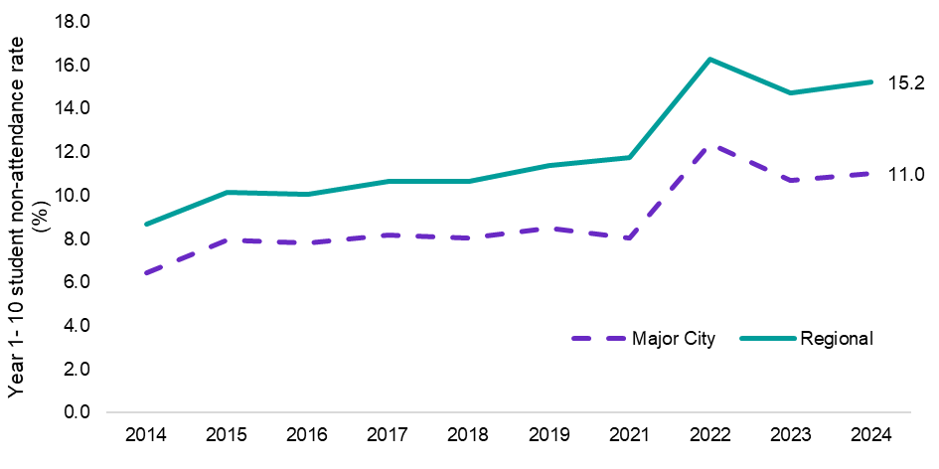

*Source: Australia Curriculum Assessment and Reporting Authority (ACARA), School Attendance, unpublished data*

|  |
| --- |
| Stakeholder insight  *‘The funding landscape has become extremely competitive and an ongoing cycle. We spend so much time responding to funding opportunities to sustain what we are doing that it distracts from being able to actually deliver high quality services. Better alignment of funding between programs and opportunities would lead to more stability, higher levels of collaboration and better services.’*  **Peter Renehan**  CEO  Centre for Appropriate Technology |

|  |
| --- |
| Box: The role of boarding schools in delivering education to students from Regional Australia  Boarding schools are a key pillar of Australia’s education system in providing students in Regional Australia with access to the high school education they require to successfully complete schooling and progress to further study and employment. In some parts of Australia, boarding schools can be the only option for students in regional or remote areas without a physical school nearby to complete their school education.  Currently there are more than 200 boarding schools across Australia, and more than two-thirds of Australia’s boarding school students are from regional areas. Of key significance is that they are becoming a growing option for education of First Nations young people.  The main difficulty with this model is that attendance at boarding school is expensive. Assisting with the costs of boarding school is the Assistance for Isolated Children (AIC) Basic Boarding Allowance. This was introduced in 1973 to meet half of the average boarding school fees to assist geographically isolated students to access boarding schools, however the rate of payment has not kept up with increases in the cost of boarding school education over time.  In 2024, the Australian Government launched the [Commonwealth Regional Scholarship](https://www.education.gov.au/commonwealth-regional-scholarship-program) a pilot program delivering 100 scholarships worth up to $20,000 a year to contribute towards the cost of boarding school education for low to middle income families of young aspiring students from Regional Australia.  Boarding schools remain a key part of the educational pathway for many students from Regional Australia. An improved understanding of the subsequent educational and employment outcomes of such students – including their rate of return to the regions they came from – remains an area of potential future research.  Sources: Australian Boarding Schools Association (2024) [Census 2024](https://resources.finalsite.net/images/v1716776521/boardingorgau/wqcxakqtpqvqef94dxyu/ABSA3359_census-2024_digital.pdf), May; The Australian (2023) [Numbers show the ‘home away from home’ is here to stay](https://www.theaustralian.com.au/special-reports/numbers-show-the-home-away-from-home-is-here-to-stay/news-story/01c8a2c848c9bea0b70eb1034a23bb5c), 6 September; Cardak et al (2017) [Regional Student Participation and Migration](https://www.acses.edu.au/app/uploads/2017/02/Regional-Student-Participation-and-Migration-20170227-Final.pdf), February; Regional Education Commissioner (2024) [Annual Report 2023](https://www.education.gov.au/regional-education-commissioner/resources/regional-education-commissioner-annual-report-2023), p24, 26 March. |

##### Youth (18-24) NEET rate

Table 7: Youth (18-24) NEET rate (%)

|  |  |  |  |  |  |
| --- | --- | --- | --- | --- | --- |
|  | Current Rating | Current rate in Regional Australia | Current Trend | Best on record | Gap to the Major Cities |
| Youth NEET rate (%) | Red | 15.3% | **Weakening** | 12.6%  (2023) | +5.9% pts |

*Source: ABS, Survey of Education and Work, 2024*

Participating in education or starting employment after concluding compulsory education helps individuals to develop abilities and skills and encourages a socially inclusive and productive society. While most youth are either engaged in some form of work or study, a key concern is the number of young people who are not in employment, education or training (often referred to as the ‘disengaged’ group).

While a proportion of the disengaged group may, for various reasons, be voluntarily outside the labour market (for instance, looking after children, which is more likely to be the case for disengaged women), many are at risk of ultimately failing to make a successful transition from schooling to employment or further education or training.

The proportion of the youth (18-24 years) population who are NEET in Regional Australia increased significantly over the year, from 12.2% in 2023, to 15.3% in 2024. The increase, of 3.1 percentage points, was well above the increase in Major Cities, of 0.5 percentage points, to 9.4% in 2024. The substantial gap highlights the additional support that is required for youth in Regional Australia to overcome barriers and move towards participating in education, training and employment.

Figure 14: Youth (18-24) NEET rate (%), by Major City and Regional Australia

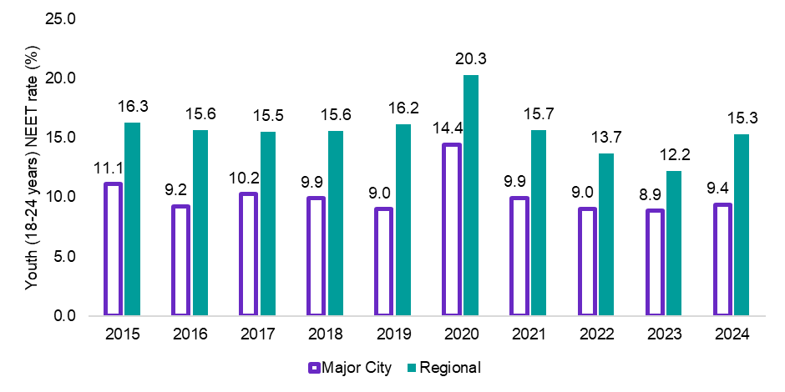

*Source: ABS, Survey of Education and Work, 2024*

|  |
| --- |
| Stakeholder insight  *‘In some regions the social services industry has been fractured and compartmentalised by specialisation, with little collaboration between providers. This makes it difficult for disadvantaged individuals to receive the comprehensive wrap-around support they need. Direct competition in service delivery in Regional Australia often hinders success and should be minimised.’*  **Chris Booth**  Local Employment Facilitator - Bendigo |

Figure 15: Youth (18-24) NEET rate (%), by gender in Regional Australia, 2016 and 2021

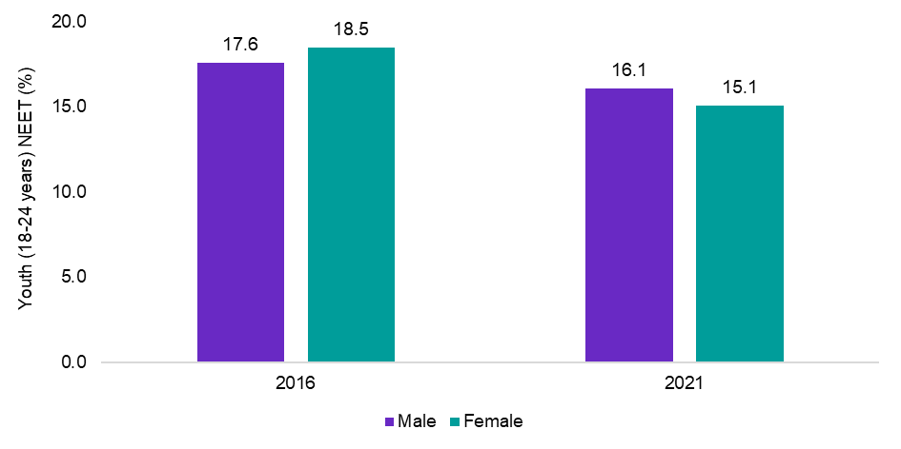

*Source: ABS, Census of Population and Housing, 2021 (latest available data)*

|  |
| --- |
| Stakeholder insight  *‘Many people in Regional Australia face intergenerational barriers and require a renewed inspiration and activation to encourage higher levels of participation in education and work. Most employers in Regional Australia – including small businesses – are willing and able to help facilitate this.’*  **Annette Gebhardt**  Head of People  3ME Technology |

##### Prime age labour force participation rate

Table 8: Prime age participation rate (25-54 years) (%)

|  |  |  |  |  |  |
| --- | --- | --- | --- | --- | --- |
|  | Current Rating | Current rate in Regional Australia | Current Trend | Best on record | Gap to the Major Cities |
| Prime age labour force participation rate (%) | Green | 85.4% | **Improving** | 85.4%  (current) | -1.9% pts |

Source: ABS, *Labour Force, Detailed,* April 2025*,* 12-month averages of original estimates

The participation rate is an important indicator of the supply of labour. It measures the share of the prime age population either working or looking for work. Increasing labour force participation promotes social inclusion and boosts economic potential. Over the longer term, the increase in the participation rate has been driven by structural factors including the rise in participation amongst women and older people. The more recent increases seen in the participation rate is likely a combination of strong population growth, the continued availability of jobs, greater flexibility in working arrangements and ongoing cost of living pressures.

The prime age participation rate in Regional Australia has generally lagged behind that recorded in the Major Cities, although it has been steadily increasing over the last 15 years and is currently at a record high, of 85.4%.

Figure 16: Prime age (25-54) participation rate (%), by Major City and Regional Australia

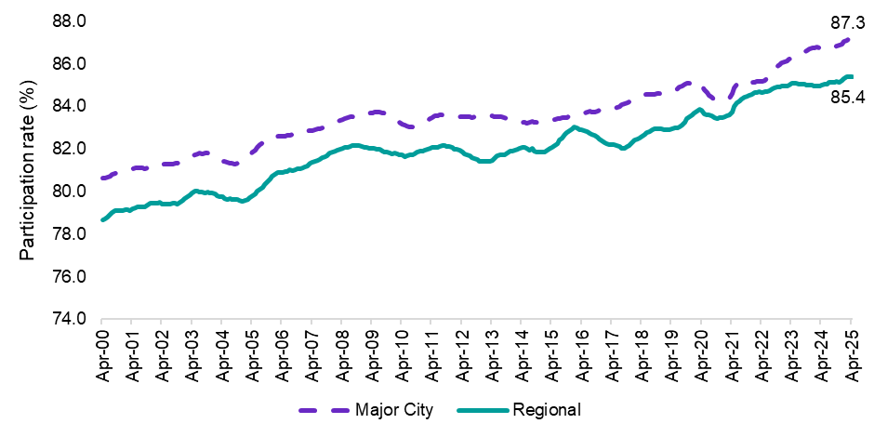

Source: ABS, *Labour Force, Detailed,* April 2025, 12-month averages of original estimates

But not all Australians are experiencing the same increases in employment. Indeed, complex personal circumstances can make it difficult for an individual to participate in the labour market. Family and cultural background and long-term health conditions can all affect a person’s ability to participate in employment. As can be seen in the chart below, people in Regional Australia with a long-term health condition (76.1%), or those who identify as Aboriginal and Torres Strait Islander (62.3%) and lone parents (73.0%) have participation rates well below the overall participation rate in Regional Australia (85.4%) highlighting the difficulties some cohorts with multiple barriers can face.

Reducing disadvantage improves Australia’s economic security and resilience by supporting greater economic activity, which also eases pressure on government spending, and bolsters revenue in the face of significant forces including ageing.[19]

Figure 17: Prime age (25-54) participation rate (%), selected cohorts, Regional Australia and Major City

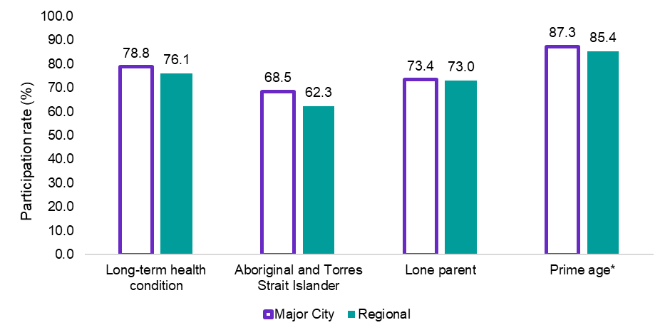

Source: ABS, *Census of Population and Housing, 2021*

*\**Prime age participation rate is for April 2025 and is sourced from *ABS, Labour Force, Detailed,* 12-month averages of original estimates

##### Unemployment rate

Table 9: Unemployment rate (%)

|  |  |  |  |  |  |
| --- | --- | --- | --- | --- | --- |
|  | Current Rating | Current rate in Regional Australia | Current Trend | Best on record | Gap to the Major Cities |
| Unemployment rate (%) | Green | 4.0% | **Stable** | 3.2%  (2022) | -0.4% pts |

Source: ABS, *Labour Force, Detailed,* April 2025, modelled estimates, 3-month average of original estimates

Employment underpins the economic productivity of the nation and enables individuals to support their families and communities. It is fundamentally interwoven with an individual’s health, happiness and wellbeing. By contrast, unemployment can be costly for the individual, the economy and society more broadly.

Ensuring that unemployment is minimised is critical to ensuring that everyone in Regional Australia who is willing to work can obtain a job in a timely manner. While a level of unemployment will always be prevalent due to what’s termed ‘frictional unemployment’ (as people move between jobs), the unemployment rate nonetheless provides an indicator of the incidence of people being marginalised in the labour market, typically due to the barriers they are facing (including skills mismatch).

Since COVID and against the backdrop of strong and sustained labour market conditions, Regional Australia has experienced historically low levels of unemployment, with the unemployment rate reaching 3.2% in late 2022. While there has been some increase since this time, Regional Australia’s unemployment rate has tended to be lower than for Major Cities.

Figure 18: Unemployment rate (%), by Major City and Regional Australia

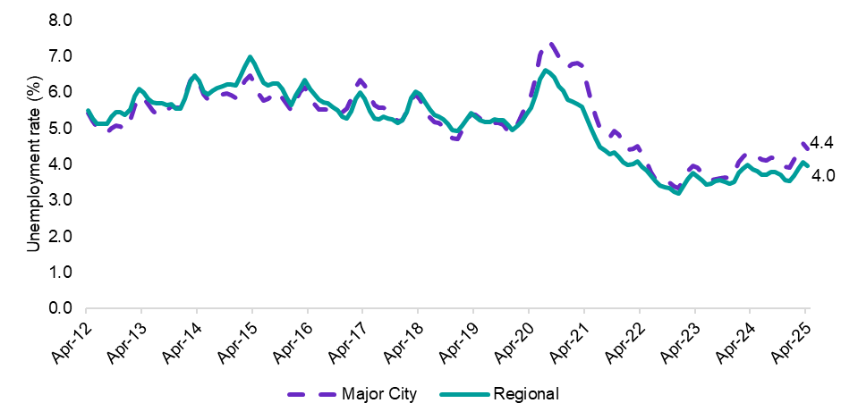

Source: ABS, *Labour Force, Detailed,* April, 2025, modelled estimates, 3-month average of original estimates

##### Proportion of the working age population on income support[20] for more than 5 years

Table 10: Proportion of the population (15-64) on income support for more than 5 years (%)

|  |  |  |  |  |  |
| --- | --- | --- | --- | --- | --- |
|  | Current Rating | Current rate in Regional Australia | Current Trend | Best on record | Gap to the Major Cities |
| Proportion on income support for more than 5 years (%) | Red | 2.4% | **Stable** | 2.0%  (2015) | +1.1% pts |

*Source: DSS, JobSeeker Payment and Youth Allowance (other) Recipients by Duration on Income Support and ABS, Labour Force, Detailed,* March 2025

Longer spells of unemployment are particularly costly, as people who have been unemployed for long periods of time may face greater difficulty finding employment due to loss of skills, a decline in confidence and motivation and the prospect of competing with more highly qualified short-term job seekers.

While a number of characteristics can influence a person’s likelihood of becoming part of the long-term unemployed population, this likelihood generally rises during periods of weak economic growth and labour market activity and tends to decline during periods of strong and sustained growth.

Against the backdrop of relatively solid employment growth recently, those who have been on income support for more than 5 years in Regional Australia had been generally declining although there has been a recent tick-up in the second half of 2024. Despite some improvement in recent years, the proportion of the working age population on long-term income support in Regional Australia remains well above the rate recorded in the Major Cities (2.4% compared with 1.3%), with around 1 in 45 people (aged 15-64 years) in Regional Australia having been on income support for more than 5 years.

Notably, this figure also variers markedly across Regional Australia, with 5.0% (or 1 in 20 persons) of the working age population in the Northern Territory having been on income support for more than 5 years in March 2024. This is an indication that some people are becoming stuck on income support for the very long-term and are thus not receiving adequate support to move towards education or employment.

Figure 19: Proportion of population (15-64) on income support for more than 5 years (%), by Major City and Regional Australia

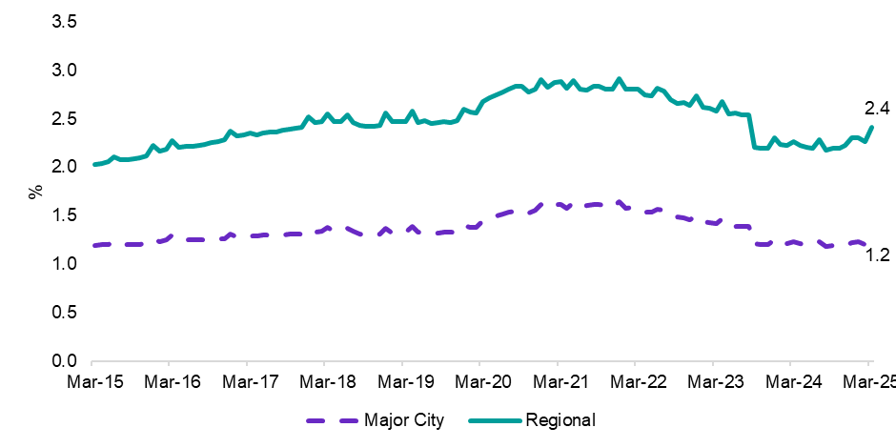

*Source: DSS, JobSeeker Payment and Youth Allowance (other) Recipients by Duration on Income Support and ABS, Labour Force, Detailed,* March 2025

|  |
| --- |
| Stakeholder insight  *‘Many people in Regional/Remote Australia, who are or would be assessed JSCI Stream C participants, face multiple and complex barriers to successful participation in education, training and employment.   These people would benefit from a wrap-around support program that incorporates practical hands-on work components, with delivery methods that align with their traditional ways of learning prior to the current approach of utilising work readiness programs that have a social support component.’*  **Nathan Aucote**  Manager - Industry Engagement  Kimberley Region, North Regional TAFE WA |

### Summary

For many individuals, gaining and sustaining employment is challenging due to the prevalence of barriers that hinder their ability to participate in the labour market. Where such barriers exist, individuals should receive timely and effective support to enable them to move towards finding a job or participating in education and training as a pathway to a job, ideally within the region that they live. In an effective jobs and skills system, there should be a focus on addressing and overcoming barriers that hinder Australians from their initial participation in education, training and/or employment and maximising their labour market participation after that.

* School attendance rates (Years 1 to 10) in Regional Australia have consistently lagged the rates recorded in Major Cities. Between 2019 and 2022, attendance rates across Australia were heavily impacted by COVID-19. While there has been some recovery post COVID, non-attendance rates in Regional Australia (14.6% in 2024), remain well above their pre-COVID levels (11.4% in 2019) and the rate recorded in Major Cities (11.0% in 2024).
* A key concern is the number of young people (aged 18-24 years) who are not in employment, education or training. The proportion of the youth population who are NEET in Regional Australia stood at 15.3% in 2024, well above the 12.2% recorded a year earlier and the 9.4% recorded in the Major Cities.
* The prime age participation rate in Regional Australia has generally lagged behind that of the Major Cities, although it has been steadily increasing over the last 15 years and is currently at a record high, of 85.4%.
* Since COVID and against the backdrop of strong and sustained labour market conditions, Regional Australia has been experiencing historically low levels of unemployment, with the unemployment rate reaching 3.2% in late 2022. While there has been some increase since this time, Regional Australia’s unemployment rate has generally been lower than the Major Cities.
* The proportion of the working age population on long-term income support in Regional Australia remains well above the rate seen in the Major Cities (2.4% compared with 1.3%), with around 1 in 45 people in Regional Australia having been on income support more than 5 years.

Vision Principle 2 – Developing Skills

Everyone in Regional Australia is supported to efficiently develop skills that enable them to meaningfully contribute to community, economy and culture.

## Vision Principle 2 – Developing Skills

### Overview of Vision Principle 2

#### Everyone in Regional Australia is supported to efficiently develop skills that enable them to meaningfully contribute to community, economy and culture.

Skills and knowledge acquisition underpins the capability of the workforce. How people respond to opportunities in the labour market relies on investment in skills and knowledge, as well as the core transferable skills needed to be resilient and adaptable to changes in the labour market.

As such, the second principle underpinning the vision for the jobs and skills system in Regional Australia is about supporting the acquisition of the necessary skills to best position them to take advantage of opportunities in the labour market and contribute to their local community and culture, both now and into the future.

All participants within the jobs and skills system, including education and training and employment service providers, employers, unions and all levels of government, play an important role in building the capability of individuals in Regional Australia to reach their skills potential.

When it comes to the jobs and skills system in Regional Australia, geographic location should not hinder the ability of individuals to access education and training and develop their skills. This means fostering a skills system that enables school students to continue their education and training in the tertiary education system – either through vocational education and training (including through access to apprenticeship and traineeship opportunities), higher education, or a combination of both.

Employers, play an important role in supporting the acquisition of skills, either through accredited or non-accredited training, including on-the-job training. It also involves supporting lifelong learning, which may occur to facilitate career changes or as people progress through their career and seek access to further and higher levels of education (measured by youth tertiary participation rate and apprenticeship and trainees’ completion rate).

Regardless of which path individuals in Regional Australia take, this vision principle is about ensuring people have the access and support they need to reach their skills development potential.

Vision Principle 2 also acknowledges the importance of skills being utilised. It provides the ambition for workers in Regional Australia to be employed in a role that optimally leverages their knowledge, skills and experience in accordance the needs of the economy, community and culture of their region (measured by skills relevance and working at lower skill level).

Measuring productivity by region is challenging, however, central to the vision for Regional Australia is to have high labour productivity through the development and utilisation of skills, good matching between workers and firms and efficient labour market mobility. Improving the skills utilisation of workers aids in increasing productivity and economic growth. This will in turn deliver more stable employment and higher wages while enhancing job satisfaction and improving economic and social outcomes at the local level.

Achieving this vision principle would see skills utilisation occur quickly after the completion of education and/or training (accredited and non-accredited) and remain activated for as long as possible. This would constitute a maximisation in the benefits of training and education.

Beyond just focusing on immediate education and training outcomes, this vision principle gets to the heart of pursuing an efficient labour market system, which aligns the skills of all existing workers with the skills demanded by employers, including those required by small businesses. Achieving this vision principle would reflect that the jobs and skills system is working effectively to provide the skills and knowledge required by the economy of Regional Australia.

|  |
| --- |
| Box: Harmonisation of the Tertiary Education sector  Vision Principle 2 is about ensuring individuals in Regional Australia have the access and support they need to reach their skills development potential and in turn can withstand the challenges and take advantage of opportunities in an evolving labour market. Tertiary harmonisation, as detailed in JSA’s recently released report, *Opportunity and Productivity*: *Towards a Tertiary Harmonisation Roadmap*, will be instrumental in helping to meet this vision principle.  Tertiary harmonisation is the strategic alignment of the Higher Education and Vocational Education and Training (VET) sectors. It involves the effective coordination and cooperation of key system actors, to enable learners to obtain the combination of knowledge, skills and their application that they need to be successful in a changing labour market. In some regions of Australia, dual-sector tertiary education institutions already exist, such as Charles Darwin University-TAFE and the Batchelor Institute of Indigenous Tertiary Education. In others, tertiary harmonisation will mean building stronger alliances and partnerships between existing institutions within the distinct sectors of Higher Education and VET.  The case for tertiary harmonisation has been building in recent years with growing recognition that a lack of cohesion between VET and Higher Education is hindering students' ability to choose, and move between, programs of study that best suit them and their career objectives. Although large numbers of students already move from VET to Higher Education and vice versa, those pathways are not always easy to navigate and appropriate credit for pre-existing knowledge and skills is often difficult to obtain. Research by JSA shows that jobs of the future in emerging industries such as clean energy where Regional Australia plays a vital role, will need workers trained through both VET and Higher Education.  JSA’s report on Tertiary Harmonisation outlines the range of benefits that can be expected to result from a harmonised system and presents a roadmap to achieving through the collaboration of all tertiary system actors. If tertiary harmonisation is implemented effectively, with a focus on building an adaptable and resilient tertiary education system able to respond to the changing needs of industry, labour markets and citizens, it will address barriers to pathways between sectors, improve access and reduce inequality – including in Regional Australia.  More information: Jobs and Skills Australia (2025) [*Opportunity and Productivity: Towards a Tertiary Harmonisation Roadmap*](https://www.jobsandskills.gov.au/publications/opportunity-and-productivity-towards-tertiary-harmonisation-roadmap), 22 February 2025. |

**Evaluative indicators and insights**

Table 11: Metric summary table – Vision Principle 2

|  |  |
| --- | --- |
| JSA Regional Roadmap - Vision Principle 2 | Current rating |
| Overall rating for Vision Principle 2 | **Orange** |
| Contributing indicators |  |
| 1. Youth tertiary participation rate | **Red** |
| 1. Apprenticeship and traineeship completion rate | **Orange** |
| 1. Proportion working at lower skill level than qualification level | **Orange** |
| 1. Proportion of population (25-44) working in the same field as their most relevant qualification | **Orange** |

#### Contributing indicators

##### Youth tertiary participation rate

Table 12: Youth (15-24 years) participation rate (%)

|  |  |  |  |  |  |
| --- | --- | --- | --- | --- | --- |
|  | Current Rating | Current rate in Regional Australia | Current Trend | Best on record | Gap to the Major Cities |
| Youth tertiary participation rate (%) | **Red** | 22.2% | **Stable** | 25.1%  (2019) | -15.2% |

*Source: ABS, Survey of Education and Work, 2024*

Teritary education provides a range of benefits for both the individual and community. For instance, tertiary education can improve an individual’s employability, financial capability and social wellbeing as well as contributing to regional development. Tertiary education is a key pillar of the skills system and will play an increasingly important role in building Australia’s future workforce, a key outcome of Vision Principle 2.

The mix of skills required in the labour market is changing as Australia’s (including Regional Australia) economy evolves. Projections produced by Victoria University for JSA show that over the next 10 years, more than 9 out of 10 new jobs expected to be created will require post-secondary qualifications. [21] Around 44% of jobs will require a vocational education and training (VET) qualification, and around half (48%) will require a bachelor’s degree or higher qualification. In the current labour market, around 51% per cent of jobs require a VET qualification, while around 35% require a bachelor’s degree or higher. The future labour market will demand ongoing rebalancing of the types of skills delivered across the tertiary sector.

To meet Australia’s future skills needs, both the VET and higher education sectors will play an important role in delivering quality education and training that meets the needs of students but also develop the skills needed by industry in the regions. Ensuring the right balance between higher education and VET involves aligning education with workforce needs, promoting diverse pathways, and fostering a culture that values both types of learning.

At a regional level, the right balance between higher education and VET also involves ensuring considering the skills needs of industries and occupations in the region, as well as the needs of local community and culture. JSA’s report ‘*Opportunity and Productivity: Towards a Tertiary Harmonisation Roadmap’* notes ‘improving coordination and cooperation of the tertiary sectors will help increase productivity, address skill shortages and allow for better matching of skill supply with skill demand.

As employment in Regional Australia continues to shift towards jobs that require occupations where VET or higher education is the primary pathway, ensuring that participation in tertiary education in Regional Australia continues to grow is critical. Unlike capital cities, where there has been the largest shift in the share of employment towards Skill Level 1 occupations (where higher education is the primary pathway), regional and remote areas have experienced a shift in the share of employment towards occupations where VET is the primary pathway, in addition to an increase in Skill Level 1 occupations.

Against this backdrop, the youth tertiary participation rate in Regional Australia has been relatively stable over recent years at around 22%, although is well below the rate recorded in Major Cities. Lower rates of tertiary study in Regional Australia could be due to a range of factors including access issues, financial barriers, family and community expectations. Ensuring that students in Regional Australia have the same access to tertiary education opportunities as those in the Major Cities is critical, including by ensuring suitable students receive the support they need to meet associated entry requirements for Higher Education. Without this, Australia will face difficulties in developing the skills required for the future.

Figure 20: Youth (15-24 years) tertiary participation rates (%) by Major City and Regional Australia

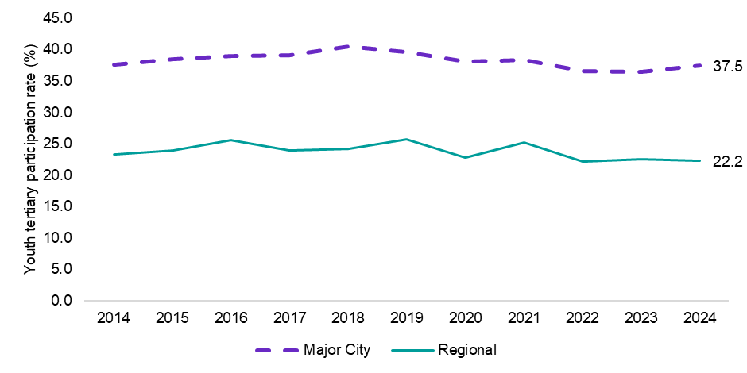

*Source: ABS, Survey of Education and Work, 2024*

In line with the lower rates of tertiary education participation recorded in Regional Australia, the share of higher education participation is particularly low in Regional Australia. For instance, although around 30% of the youth population resides in Regional Australia, youth living in Regional Australia only make up around 14% of higher education students.

While some youth would move to take up higher education opportunities, broadening access to higher education among students in Regional Australia is critical to ensuring everyone in Regional Australia can develop skills that enable them to access employment that meaningfully contribute to community, economy and culture.

Figure 21: Youth share of higher education, VET and population (%) by Major City and Regional Australia

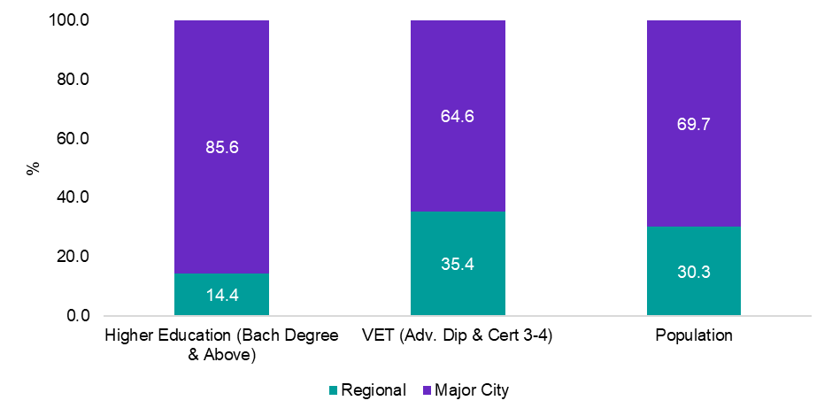

*Source: ABS, Survey of Education and Work, 2024*

|  |
| --- |
| Stakeholder insight  *‘Ensuring prospective students in Regional Australia have the opportunity to access education and training is key to developing the workforce Regional Australia needs both now and into the future.’*  **Alec Webb**  CEO  Regional Universities Network |

|  |
| --- |
| Box: The role of the 2024 Universities Accord in uplifting Regional Australia  Higher education participation and attainment rates are low in Regional Australia compared with metropolitan Australia. The 2018 Independent Review into Regional Rural and Remote Education (Halsey Review) found that the proportion of young Australians with bachelor or higher degrees declines as geographical remoteness increases. The 2019 National Regional and Rural Remote Education Strategy (Napthine Review) identified that Australians in regional, rural and remote areas were 40% less likely than their metropolitan peers to gain a higher-level tertiary education qualification and only half as likely to gain a bachelor level qualification by age 35.  The 2024 Universities Accord Final Report concluded that these disparities are ‘long-term and stubborn.’ The Review argued that ‘considerations of equity, social cohesion, productivity and future economic prosperity compel Australia to take strong action to improve access to regional, rural and remote students’.  Further it noted that ‘if Australia is to achieve the necessary attainment of higher education to meet its future economic and social needs, regional higher education attainment rates must increase’. The Accord Final Report recommended that the Australian Government adopt a regional, rural and remote higher education student participation target of 24% by 2035.  The Accord Review noted the value of regional higher education students studying in regional settings, which increases the probability that they would stay in the region and contribute to the regional skills needs. It emphasised the chronic shortages of rural doctors and allied health workers. The review argues that improved access to healthcare in the regions requires an overall increase and better distribution of Australia’s health workforce. This would involve getting more graduates from the cities to come to regional areas, as well as supporting regional universities to grow their own workforce.  ‘Studies have shown that health student from regional areas and those who undertake extensive training in a rural setting are more likely to practice in the regions. Further, students from rural backgrounds are more likely than metropolitan origin graduates to remain in rural practice’.  It also emphasised the considerable financial hurdles that regional universities face compared with universities in the Major Cities. There were many factors that contribute to this problem including for example:   * Lacking high value investments, valuable infrastructure, established and diverse revenue profiles and philanthropic support. * Maintaining campuses and courses with lower student density. * Operating in thinner student markets and have higher proportions of part-time, First Nations and low SES students. * Cost of regulatory compliance more difficult to absorb than their Major City counterparts.   The review argued that ‘the full cost of educational delivery in regional Australia needed to be addressed as a matter of urgency.’ This would require increased investment in infrastructure and a needs-based student funding model that reflected the higher cost of delivery in Regional Australia.  The Review suggested that ‘lifting tertiary education participation rates amongst regional and remote Australians requires a shift towards more flexible delivery in regional communities. It recommended an increase in investment in Regional Study Hubs in its interim report, which led to more study hubs.  Recommendation 29 of the Accord Final Report, has more detail on how the Australian Government can recognise the benefits of access and challenges to delivery of higher education. |

##### Completion rates for apprentices and trainees

Table 13: Completion rates for apprentices and trainees (commencing year 2019) – all occupations (%)

|  |  |  |  |  |  |
| --- | --- | --- | --- | --- | --- |
|  | Current Rating | Current rate in Regional Australia | Current Trend | Best on record | Gap to the Major Cities |
| Completion rates for apprentices and trainees (%) | Orange | 56.7% | n/a | n/a | +3.9% |

*Source: NCVER 2024, Apprentices and trainees 2024 - March quarter estimates*

Apprenticeships and traineeships play an important role in Australia’s skill system and are central components of the vocational education and training system. They provide a pathway toward a nationally recognised qualification, combining on- and off-the-job training to enable individuals to develop industry-specific skills and knowledge while participating in the workforce and earning an income.

Ensuring that Regional Australia is providing a skills and training system that is supporting high levels of apprenticeship and traineeship completion is critical as it helps to provide a qualified workforce to meet current and future workforce needs. This includes the provision of good supervision and mentoring in workplaces but also supporting employers to successfully support the apprentices and trainees. This will help increase completion rates for apprentices and trainees.

The Government’s *Strategic Review of the Australian Apprenticeship Incentive System[22]* made 34 recommendations to support high-quality apprenticeships and ensure the Incentives System is effective and responsive to the needs of the labour market, apprentices and government. As part of its initial response, the Government has increased the *Living Away From Home Allowance* to support apprentices in remote and regional areas. JSA will work closely with the Department of Employment and Workplace Relations (DEWR) on opportunities for longer-term reforms.

Completion rates for apprentices and trainees (for those commencing year 2019) for all occupations in Regional Australia stood at 56.7%, above the rate recorded in the Major Cities of 52.8%.

Figure 22: Completion rates for apprentices and trainees (commencing year 2019) – all occupations, by Regional Australia and Major City (%)

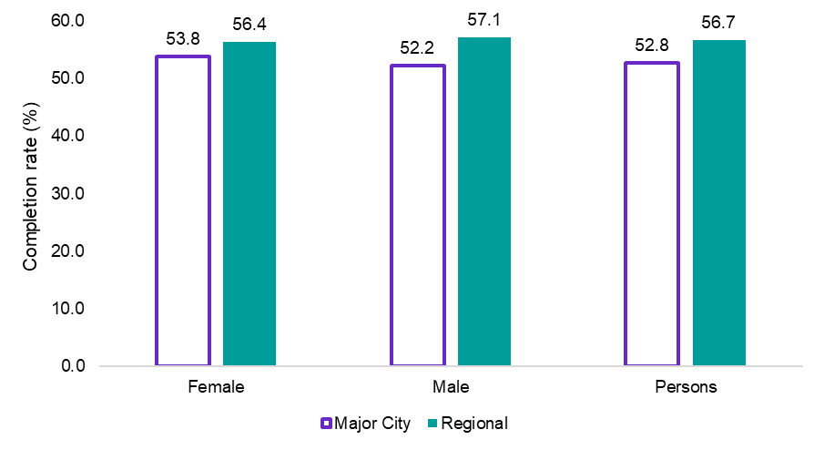

*Source: NCVER 2024, Apprentices and trainees 2024 - March quarter estimates*

Seeking greater gender-balance in trades is critical to upholding the equity of the jobs and skills system. Encouragingly, the female share of trade apprenticeship commencements in Regional Australia is higher than that of Major Cities and has increased in recent years. This is a positive trend for Regional Australia, particularly as JSA research had previously shown that gendered-skewed occupations are more likely to be in shortage, highlighting the need for a more balanced labour market.**[23]** Among 15-29 year olds, females made up 14.7% of trade apprenticeship commencements in Regional Australia in 2024 (up from 13.9% in 2023) compared with 12.4% in Major Cities.

Figure 23: Share of trade apprenticeship commencements that are female (15-29 years) (%)

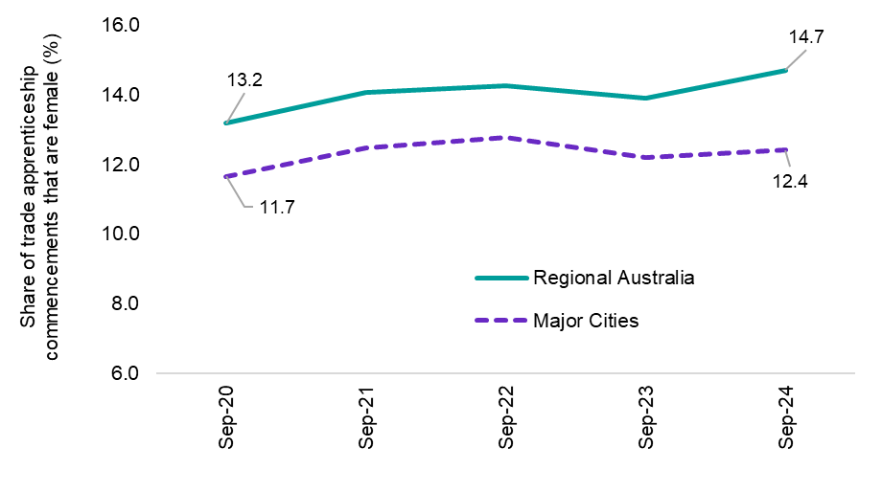

*Source: NVCER 2025, Apprentices and trainees 2024, 12-month series*

##### Proportion working at lower skill level than qualification level (%)

Table 14: Proportion of persons (aged 15 years and over) working at lower skill level than qualification level (%)

|  |  |  |  |  |  |
| --- | --- | --- | --- | --- | --- |
|  | Current Rating | Current rate in Regional Australia | Current Trend | Best on record | Gap to the Major Cities |
| Prop. working at lower skill level than qualification level (%) | Orange | 25.7% | **Stable** | 23.3%  (2020) | -5.2% pts |

*Source: ABS, Survey of Education and Work, 2024*

The importance of skills in increasing productivity and economic growth is well known. While traditionally the focus has been on boosting skills supply through vocational and higher education qualifications, it is also important that these skills are being used effectively in the labour market (skill utilisation). This goes to the central aspect of Vision Principle 2 around seeking for skills to be utilised in meaningful employment that contributes to economy, culture and community. Although someone may work below their level of education or in a different field for a time, ideally this period would be limited and would contribute to a person’s career development.

Where skills are being underutilised in the workplace it can result in significant costs to the individual, business and the economy. In contrast, improvements in skill utilisation supports increased productivity, reduced skills gaps, enhanced innovation, improved earnings and job satisfaction and increased returns on investment in education and training.

In Regional Australia, around 26% of people with a post school qualification (Skill Level 1-4) are working in a job with a skill level that is lower than their qualification. While this is better than in the Major Cities, this suggests that the skills of around a quarter of persons with post school qualifications in Regional Australia are being underutilised.

Figure 24: Proportion working at lower skilled level than qualification (%), by Major City and Regional Australia

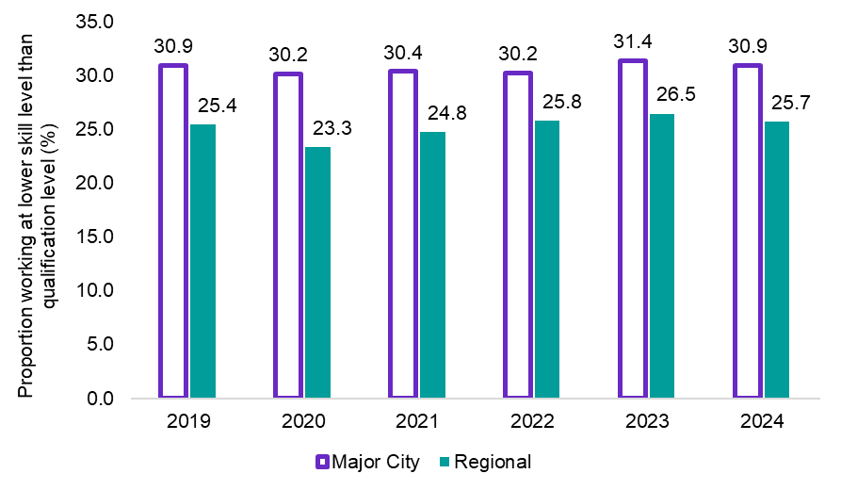

*Source: ABS, Survey of Education and Work, 2024*

Skill underutilisation is highest in Regional Australia for persons with a Bachelor Degree or above (Skill Level 1), with 31% working in an occupation that is lower than their qualification, representing a considerable opportunity for increased skills utilisation. By comparison, around 21% of persons in Regional Australia with a qualification where VET is the primary pathway (Skill Level 2-4) are working in an occupation below their skill level. Put together, these figures represent a considerable opportunity for increased skills utilisation in Regional Australia.

Figure 25: Proportion working at lower skilled level than qualification (%), by Major City and Regional Australia

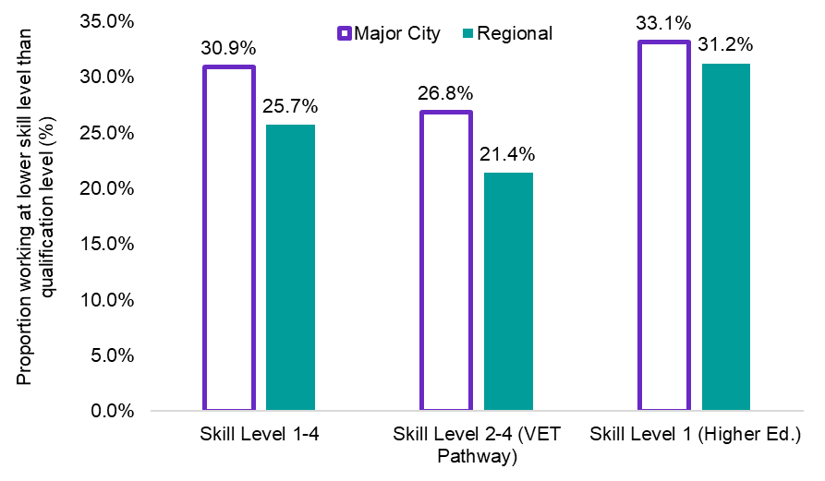

*Source: ABS, Survey of Education and Work, 2024*

##### Proportion of population (25-44) working in same field as most relevant qualification

Table 15: Proportion of population (25-44) working in same field as most recent qualification

|  |  |  |  |  |  |
| --- | --- | --- | --- | --- | --- |
|  | Current Rating | Current rate in Regional Australia | Current Trend | Best on record | Gap to the Major Cities |
| Prop. working in same field as most relevant qualification (%) | Orange | 72.7% | **Worsening** | 79.3% (2019) | +1.7% pts |

*Source: ABS, Qualifications and Work, 2023*

Beyond level of skill, another key question in assessing the effectiveness of the jobs and skills system is the utilisation of specific field of their skills in the labour market and whether workers are being utilised in the labour market. It is useful to consider the alignment of skills using an indicator of the proportion of people aged 25-44 who are working in the same field as their most recent qualification is utilised. This is a sign that the jobs and skills system is helping to develop skills that support people to meaningfully contribute to economy, culture and community.

The focus of this indicator on a younger cohort seeks to capture people who are more likely to be recent education completers. As illustrated in the chart below, historically Regional Australia has seen a higher proportion of people working in a relevant field of their qualification (currently 72.7%) than Major Cities, though this gap has narrowed in recent years.

Figure 26: Proportion of population (25-44 years) working in the same field as most relevant qualifications (%), by Major City and Regional Australia

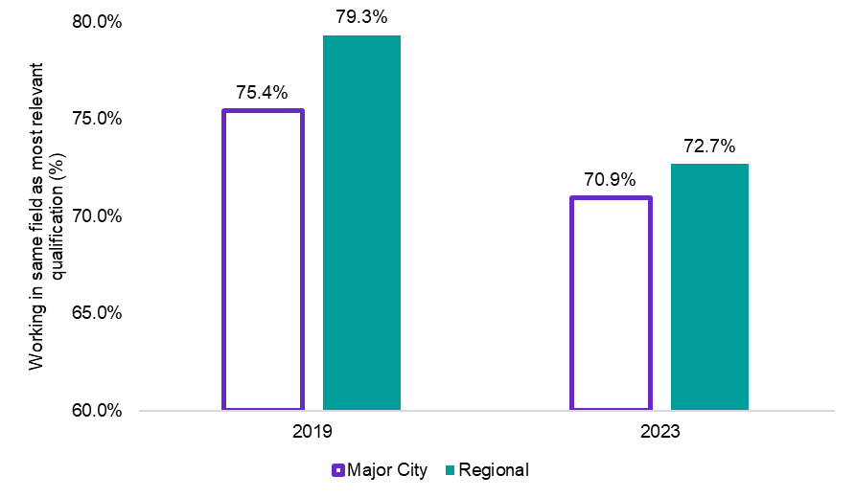

*Source: ABS, Qualifications and Work, 2023*

|  |
| --- |
| Box: Where do students from Regional Australia end up? Developing labour supply within a region plays an important role in meeting local demand for goods and services. Young regional people are an important direct resource for employers (particularly small businesses) to fill vacancies and to build their future workforces around. Ensuring that young people are receiving the right skills and training to equip them with the needs of Regional Australia is critical.  Overwhelmingly, the results suggest that students who attend a regional school who go on to attend university are more likely to stay in the region that they attend university in – whether it be a city or a regional area. This is an expected outcome.  In comparison, 76.9% of regional school students who moved to a major city to study at university were living in a major city 5 years later (see Figure 27, below). Similarly, 70.0% of regional school students who attended a university in regional Australia were living in a regional area 5 years later. This highlights that providing access to higher education in the regions is critical to supporting the development of skilled labour into the future.  Between the 2016 and 2021 Census periods this trend softened slightly, with the proportion of students who attended a regional school who stayed in the region that they attended university in fell slightly. For instance, the number of students who attended a regional secondary school who attended university in a major city and subsequently were living in a regional area 5 years later increased from 18.5% in 2016 to 23.1% in 2021.  In addition, the number of students who attended a regional secondary school who attended university in a regional area and subsequently lived in a major city 5 years later rose from 26.3% in 2016 to 30.0% in 2021.   * Caution should be exercised with the latest available data, due to the fact the 2021 Census was conducted during the COVID-19 pandemic when many parts of Australia were in lockdown and movements within, into and out of Australia were tightly controlled.   However, this nonetheless suggests that there may be a growing trend for students who attend a regional secondary school who move to the city for higher education to return to the regions post-study.  Figure 27: Students who have attended a regional school who return to live in Regional Australia after studying at university in a Major City (%)  A column chart that shows students who have attended a regional school who return to live in Regional Australia after studying at university in a Major City (%). The chart shows that students who attend a regional school who go on to attend university are more likely to stay in the region that they attend university in – whether it be a city or a regional area.  *Source: ABS Australian Census Longitudinal Dataset, 2006-2011-2016-2021. Measured as proportion of students from Regional Australia studying in a Major City, returning to Regional Australia.* |

### Summary

Skills and knowledge acquisition underpins the capability of the workforce. The mix of skills required in the labour market is changing as the economy evolves. Over the next 10 years more than 9 out of 10 new jobs expected to be created will require post-secondary qualifications, a significant uplift from current levels. An effective jobs and skills system in Regional Australia should therefore support the acquisition of the necessary skills to best position individuals to take advantage of opportunities in the labour market and contribute to their local community and culture, both now and into the future.

Beyond level of skill, another key question in assessing the effectiveness of the jobs and skills system is the utilisation of specific field of their skills in the labour market and whether workers are being utilised in the labour market. Where skills are being underutilised in the workplace it can result in significant costs to the individual, business and the economy. In contrast, improvements in skill utilisation supports increased productivity, reduced skills gaps, enhanced innovation, improved earnings and job satisfaction and increased returns on investment in education and training.

* The youth tertiary participation rate in Regional Australia has been relatively stable over recent years at around 22%, although it is well below the rate recorded in Major Cities. Lower rates of tertiary study in Regional Australia could be due to a range of factors including access issues, financial barriers, family and community expectations.
* Completion rates for apprentices and trainees (commencing year 2019) for all occupations in Regional Australia stood at 56.7%, above the rate recorded by in the Major Cities of 52.8%. Completion rates for both males and females are higher in Regional Australia compared with Major Cities.
* The female share of trade apprenticeship commencements in Regional Australia is higher than that of Major Cities and has increased in recent years. Among 15–29 year olds, females made up 14.7% of trade apprenticeship commencements in Regional Australia in 2024 (up from 13.9% in 2023) compared with 12.4% in Major Cities.
* In Regional Australia, around 31% of people with a Skill Level 1 qualification (higher education) are working at a skill level that is lower than their qualification, while for Skill Level 2-4 (VET pathway) around 21% are working at a lower skill level. Notably, both figures are below the comparable result for Major Cities. This may indicate that an investment in tertiary education in Regional Australia is more likely to lead to a job at the associated skill level, making a strong case for greater support for tertiary education in Regional Australia.

Vision Principle 3 – Quality Jobs

Everyone employed in Regional Australia can work in a quality job that is safe, fair, rewarding and satisfying.

## Vision Principle 3 – Quality Jobs

### Overview of Vision Principle 3

#### Everyone employed in Regional Australia can work in a quality job that is safe, fair, rewarding and satisfying.

The third vision principle for the jobs and skills system in Regional Australia is that everyone employed in Regional Australia can work in a quality job that is safe, fair, rewarding and satisfying.

For workers in Regional Australia, this means being able to work the number of hours sought, rather than being underemployed (measured by the underemployment rate). It means being fairly and equitably compensated (measured by income inequality ratio) and having safe work conditions. It means being able to work one primary job that provides for a person’s needs, rather than having to work multiple jobs or continuing to rely on income support. Vision Principle 3, therefore, goes beyond job creation to consider the *types* of jobs in Regional Australia, with a focus on the quality of the job.

A quality job enhances an individual’s health and wellbeing (measured by job satisfaction). Providing quality employment opportunities also leads to a range of benefits for employers including higher productivity and innovation and reduced staff turnover and associated hiring costs. Unions, as employee representatives, play an important role in helping to ensure the right balance between supporting productive and fulfilling careers and ensuring employees have access to safe, secure and fairly renumerated work.

Casual employment offers flexibility often required by workers and employers alike. For example, casual employment can provide opportunities for people to gain work experience, connect with employers and access further employment opportunities. For businesses that are new, growing or have a seasonal business, casual employment also provides appropriate flexibility, particularly for small businesses. However, for Vision Principle 3 to be satisfied, it is important that flexibility does not become precarious, with people remaining in a cycle of insecure employment over the long-term. Instead, all workers should be able to aspire to have meaningful and satisfying employment that is underpinned by safe and fair workplaces.

### Evaluative indicators and insights

Table 16: Metric summary table – Vision Principle 3

|  |  |
| --- | --- |
| JSA Regional Roadmap - Vision Principle 3 | Current rating |
| Overall rating for Vision Principle 3 | **Green** |
| Contributing indicators |  |
| 1. ‘Totally satisfied’ job satisfaction | **Green** |
| 1. Underemployment | **Green** |
| 1. Income inequality ratio | **Orange** |
| 1. Workers’ compensation incidence rate | **Orange** |

#### Contributing indicators

##### Job Satisfaction

Table 17: Proportion of employed who self-report ‘totally satisfied’ with their job (%)

|  |  |  |  |  |  |
| --- | --- | --- | --- | --- | --- |
|  | Rating | Current rate in Regional Australia | Current Trend | Best on record | Gap to the Major Cities |
| Job satisfaction (%) | Green | 38.8% | **Improving** | 40.9%  (2001) | +5.8% pts |

*Source: Melbourne University, Household, Income and Labour Dynamics in Australia (HILDA) Survey.*

A worker’s job satisfaction is not simply a matter of individual happiness, but is closely linked to their decisions around how they work, how much they work, their recent and potential mobility and their productivity. Job satisfaction can be influenced by a range of external and personal factors including work environment, financial compensation, job role, values, work-life balance and engagement. This is a key outcome of Vision Principle 3.

Research suggests that people living in Regional Australia tend to report higher levels of happiness and wellness compared to Major Cities, for a variety of reasons including a stronger sense of community, lower stress levels and lower cost of living. While not directly related these factors are likely to also influence a person’s level of job satisfaction.

Those who report as being totally satisfied with their job in Regional Australia has been relatively stable over the last couple of decades, although more recently there has been considerable improvement from the pre COVID-19 level, with those who report being totally satisfied with their job increasing from around 35% of workers 2019 to almost 39% in 2023, well above the 33% recorded in Major Cities.

The recent improvement in those reporting as being totally satisfied with their job Regional Australia may be a reflection of new technologies and remote working allowing people with the choice to work where they want to live rather than having to live where they work, with increasing opportunities for work and work-life balances.

Figure 28: Proportion of employed who self-report ‘totally satisfied’ with their job, by Major City and Regional Australia

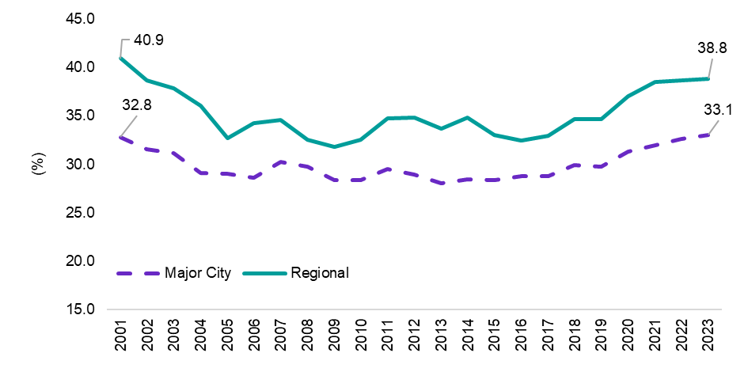

*Source: Melbourne University, Household, Income and Labour Dynamics in Australia (HILDA) Survey*

##### Underemployment rate

Table 18: Underemployment rate (%)

|  |  |  |  |  |  |
| --- | --- | --- | --- | --- | --- |
|  | Rating | Current rate in Regional Australia | Current Trend | Best on record | Gap to the Major Cities |
| Underemployment rate (%) | Green | 6.1% | **Stable** | 6.1%  (Current) | 0% pts |

*Source: ABS, Labour Force, Detailed, Datalab, 12-month averages of original estimates*

The underemployment rate is not only a measure of spare capacity in the labour market (sometimes referred to by economists as ‘slack’) but is also a measure of sub-optimal employment outcomes for the individual. The underemployment rate measures the number of people who are currently employed, but are willing and able to work more hours than they currently are, as a proportion of the total labour force.

Underemployment can impact productivity and innovation and can be associated with lower-quality jobs, characterised by lower pay and fewer benefits. Ensuring that workers in Regional Australia can work the number of hours sort is a key outcome for Vision Principle 3.

Against the backdrop of strong labour market conditions in recent years, the underemployment rate in Regional Australia has been declining, with strong demand allowed people to move closer to their preferred working hours, pushing the underemployment rate down to 6.1%, well below its long-term average and broadly in line with the figure for the Major Cities.

Figure 29: Underemployment rate (%), by Major City and Regional Australia

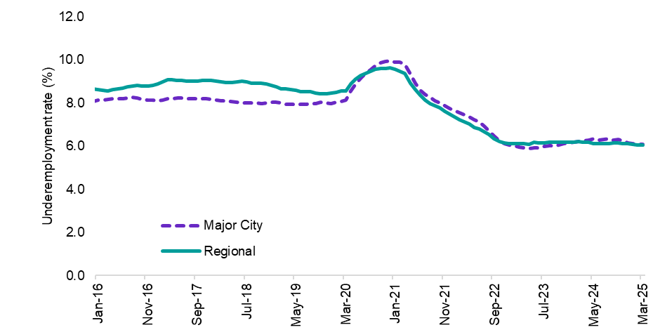

*Source: ABS, Labour Force, Detailed, Datalab, 12-month averages of original estimates*

##### Income inequality[24]

Table 19: Income inequality ratio (p80 and p20)

|  |  |  |  |  |  |
| --- | --- | --- | --- | --- | --- |
|  | Rating | Current ratio in Regional Australia | Current Trend | Best on record | Gap to the Major Cities |
| Income inequality ratio (%) | Orange | 3.5 | **Stable** | 3.5  (2022-23) | +0.4 |

*Source: ABS, PLIDA, 2022-23, latest available data*

While some degree of income inequality will always occur to some degree due to differences in education, skills and effort, high rates of income inequality can have wide ranging impacts on social and economic outcomes by hindering economic growth and increasing social inequity and instability.

Overall, the income inequality ratio has been relatively stable over the last decade and has consistently tracked higher in Regional Australia than in Major Cities.

This likely reflects the influence of Mining in Regional Australia, with the industry generally paying high wages. For example, in Western Australia – Outback where Mining accounts for just over 20% of employment (compared with just 2% nationally), the income ratio was 4.2 in 2022-23. On the other hand, there is a greater spread of occupations in the Major Cities, from lower wage services to high wage professional occupations, generally resulting in a lower income ratio for Major Cities.

Figure 30: Income ratio (p80 and p20), Regional Australia and Major Cities

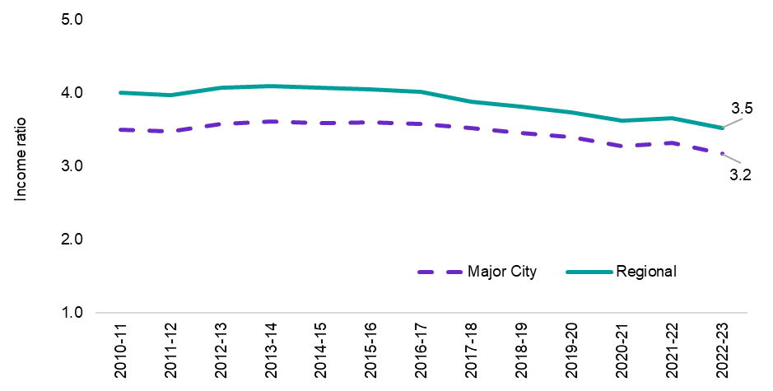

*Source: ABS, PLIDA, 2022-23, latest available data*

|  |
| --- |
| Stakeholder insight  *‘Significant wage differentials are evident both within and between regions – especially where there are significant differences in the industries and skills needs of across local economies and labour markets.’*  **Aaron Wong**  Senior Research Economist  e61 Institute |

##### Workers’ compensation incidence rate[25]

Table 20: Workers’ compensation incidence rate (per 1,000 workers)

|  |  |  |  |  |  |
| --- | --- | --- | --- | --- | --- |
|  | Rating | Current rate in Regional Australia | Current Trend | Best on record | Gap to the Major Cities |
| Workers’ compensation incidence rate (per 1,000 workers) | Orange | 9.6 | **Increasing** | 8.3  (2017-18) | +0.4 |

*Source: Safe Work Australia (SWA), National Dataset for Compensation-based Statistics (NDS), 2021-22, and ABS, Labour Force, Detailed, modelled estimates*

The Government’s White Paper on Jobs and Opportunities[26] recognises that a safe workplace is a fundamental component of job quality. Work is not a risk-free activity and while there have been significant strides towards reducing both the frequency and severity of work-related injuries and illnesses, there still exists many opportunities for improvement.[27]

Employers, businesses, unions and governments all have a role to play in working to improve workplace safety through regulation, training and technology adaption. Safety at work remains a central concern for governments, workers and employers and unsafe workplaces can pose a significant burden on individuals and their households, businesses and the economy (through reduced labour force participation and lost productivity).

The incidence and impacts of work-related injuries are not spread evenly across Regional Australia due to a range of factors, including sectoral differences, workers’ eligibility to make a workers compensation claim, ready access to health services, differences in scheme design features[28] and different workplace populations, to name a few. As such, any comparative analysis of serious claims data (workers’ compensation data) for different geographic areas should be interpreted with caution.

The workers’ compensation incidence rate in Regional Australia has generally been relatively stable over the last decade, although this indicator has been trending upwards over the last 5 years (from 8.3 serious claims per 1,000 workers in 2016-17 to 9.6 in 2021-22).

The workers’ compensation incidence rate varies from around 5 serious claims per 1,000 workers in the Northern Territory to almost 15 in Rest of Western Australia. There is also variation within jurisdictions. For example, while the differential between Brisbane and Rest of Queensland was 3.4 claims per 1,000 workers in 2021-22, it was just 0.2 in New South Wales (see Appendix 1 for state and territory metrics).

Figure 31: Workers’ compensation incidence rate (per 1,000 workers), Regional Australia

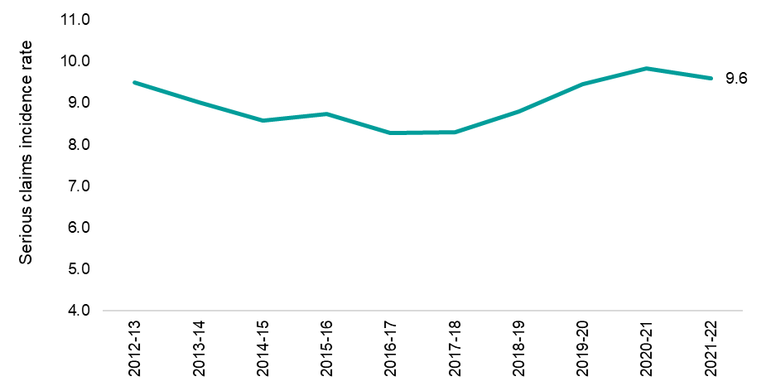

*Source: Safe Work Australia (SWA), National Dataset for Compensation-based Statistics (NDS), 2021-22, and ABS, Labour Force, Detailed, modelled estimates*

Figure 32: Workers’ compensation incidence rate, 2021-22, Regional Australia

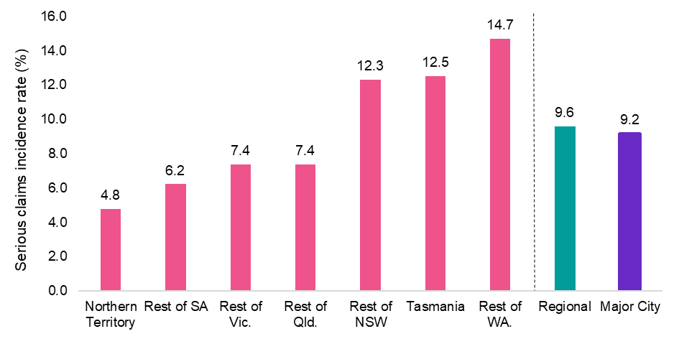

*Source: Safe Work Australia (SWA), National Dataset for Compensation-based Statistics (NDS), 2021-22, and ABS, Labour Force, Detailed, modelled estimates*

### Summary

A quality job enhances an individual’s health and wellbeing and leads to a range of benefits for employers including higher productivity and innovation and reduced staff turnover and associated hiring costs. An effective jobs and skills system in Regional Australia would see individuals working in a quality job that is safe, fair, rewarding and satisfying.

High job satisfaction has been a relatively consistent feature of the Regional Australia labour market over the last few decades. There has been considerable improvement since just prior to COVID-19, with those reporting high job satisfaction increasing from around 35% in 2019 to almost 39% in 2023, well above the 33% recorded in Major Cities. The recent improvement in the high rate of job satisfaction in Regional Australia may be a reflection of remote and hybrid working arrangements that provide people with more choice regarding where they live and work.

* Against the backdrop of strong labour market conditions in recent years, the underemployment rate in Regional Australia has been declining, with strong demand allowing people to move closer to their preferred working hours, pushing the underemployment rate down to 6.1%, well below its long-term average.
* Overall, the income inequality ratio has been relatively stable in Regional Australia over the last decade and has consistently tracked higher in Regional Australia than in Major Cities.
* The workers’ compensation incidence rate in Regional Australia has generally been relatively stable over the last decade, although this indicator has been trending upwards over the last 5 years (to 9.6 serious claims per 1,000 workers in 2021-22). The impacts of work-related injuries are not spread evenly across jurisdictions, with the workers’ compensation incidence rate varying from around 5 serious claims per 1,000 workers in the Northern Territory to almost 15 in Rest of Western Australia.

Vision Principle 4 – Meeting Demand

Regional Australia and its employers can access, attract and develop sufficient suitable labour, including as skills needs change.

## Vision Principal 4 – Meeting Demand

### Overview of Vision Principle 4

#### Regional Australia and its employers can access, attract and develop sufficient suitable labour, including as skills needs change.

In all regions and communities, goods and services demand forms the foundation of economic activity, and subsequently, labour market activity. The fourth Vision Principle for this Roadmap relates to Regional Australia and its employers being able to access, attract and develop sufficient suitable labour to meet this demand, including as skills needs change. This includes meeting social and community needs that are spread across the population and thus may not typically eventuate in a single vacancy despite such demand not being met, such as in the case of the demand for health services in a community.

Figure 33: Illustrative representation of labour market activity and the role of entrepreneurialism, business creation and portfolio self-employment

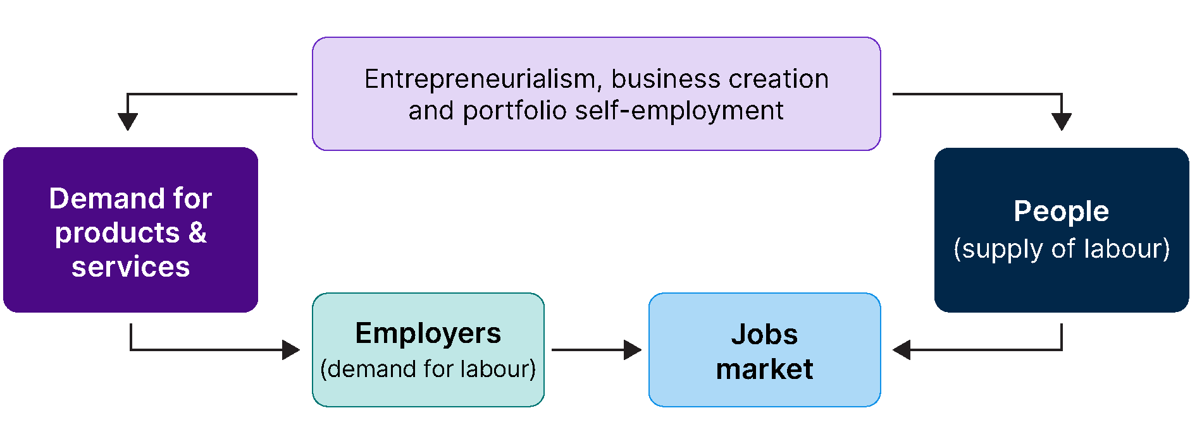

An effective jobs and skills system in Regional Australia should ensure that employers have access to the labour they need – both in terms of available people and with the skills that are needed. Such access should also not be predicated on the businesses size or type – both large and small businesses, and both firms and not-for-profit organisations, should be able to have their skills needs met. This includes by supporting the development of a ‘home-grown’ workforce and options for regional students who move to the Major Cities for their studies to return once their education is completed.

Persistent labour or skill shortages occur when employers are unable to fill or have considerable difficulty in quickly filling vacancies (measured by vacancy fill rate and persistent hiring pressures). When widespread, these shortages can have material impacts on productivity and output. By contrast, ensuring employers have access to suitable labour can support growth in output and productivity improvements. This has direct benefits for Regional Australia, ensuring goods and services are delivered in accordance with what communities need and want. It also has multiplier effects, facilitating stronger economic growth and improvements in living standards in Regional Australia, and as a whole.

Important to the achievement of this Vision Principle is enabling entrepreneurialism and business creation in Regional Australia. In addition to fuelling innovation, competition and important local economic activity, entrepreneurs provide a critical source of employment in communities and help meet unmet goods and services demand in the economy. Empowering individuals to be innovative and create business opportunities is central to a flourishing Regional Australia.

Migration, either within Australia or from overseas, can also support the achievement of Vision Principle 4 by providing supplementary sources of labour to address persistent skills gaps, particularly where there is a long training pathway. An efficient migration system supports visa applications being processed as quickly as possible – including through the timely recognition and accreditation of skills – to enable employers to address persistent shortages and strengthen capacity building activities in their businesses.

|  |
| --- |
| Stakeholder insight  *‘There are significant opportunities to increase productivity in Regional Australia by fast-tracking access to overseas sources of high-skilled labour in cases of sustained shortage. Such workers also often become excellent mentors for local apprentices and contribute significantly to local Australian communities. The processing of Visa applications and accreditation of skills should be prioritised and fast-tracked for regional employers with a history of community support, compliance and success.’*  **Carlene Lawson**  Recruitment Manager  Incat |

#### Migration

Migration plays an important role in addressing the diverse workforce needs of Regional Australia where local labour or skills are not available. Many parts of Regional Australia also experience seasonal fluctuations in labour demand, generally associated with busy periods around agriculture and tourism. The size and timing of seasonal labour demand in different industries and regions is contingent on a range of factors and the labour supply challenges associated with filling seasonal vacancies can vary in nature and severity depending on the context. There are several visa pathways for migration depending on the needs of employers.

##### Temporary skilled migration

As articulated in the Government’s Migration Strategy, the purpose of Australia’s temporary skilled migration system is to address labour shortages and provide a pathway for potential future permanent residents.

Currently, the primary visa used to facilitate temporary skilled migration is the Skills in Demand visa (subclass 482). This visa has 3 streams:

* Core Skills stream: for occupations on the Core Skills Occupation List (CSOL), paid no less than the Core Skills Income Threshold (CSIT).
* Specialist Skills stream: for occupations listed in the [Australian and New Zealand Standard Classification of Occupations (ANZSCO)](https://www.abs.gov.au/statistics/classifications/anzsco-australian-and-new-zealand-standard-classification-occupations/2022) Major Groups 1,2,4,5 or 6 with a salary that meets the [Specialist Skills Income Threshold](https://immi.homeaffairs.gov.au/visas/employing-and-sponsoring-someone/sponsoring-workers/nominating-a-position/salary-requirements).
* Labour Agreement stream: for employers and workers who do not meet standard visa rules.

##### Working Holiday Maker (WHM) program

The WHM program was created to provide opportunities for young people to stay in Australia for up to 12 months and undertake short-term work or study to supplement their holiday experience. WHMs are permitted to do any kind of work while in Australia and may work for the full duration of their 12-month visa. However, they are typically limited to no more than 6 months of work for the same employer (by visa condition 8547). Some exemptions currently apply to this condition, including but not limited to exemptions for work in different locations for the same employer and in critical sectors, including agriculture, food processing, health, aged and disability care and childcare, tourism and hospitality, anywhere in Australia.

WHMs can become eligible for a second or third visa by completing a prescribed minimum period of ‘specified work’. Approved industries and areas for specified work are strongly weighted towards regional Australia.

##### Permanent migration

The vast majority of Australia’s permanent migration program is comprised of the Skilled and Family streams. The objectives of the permanent migration program include:

* delivering economic benefits and supporting productivity growth by Australia’s ageing population, improving labour force participation, and helping businesses to source skills that are difficult to develop at short notice
* delivering social benefits through family reunification that strengthens social bonds by ensuring the unity of loved ones and promoting a sense of belonging and support amongst our multicultural communities, and
* supporting population planning, enabling Australia to plan for population growth and address specific demographic challenges.

##### Humanitarian program

Australia’s humanitarian program provides resettlement for those displaced as a result of persecution, conflict and human rights violations. Like other permanent migrants, humanitarian entrants make significant contributions to Australian society and its labour force. The Australian Government settles humanitarian entrants in 21 regional locations across Australia, outside of Sydney, Melbourne and Brisbane.

##### PALM

The PALM scheme allows eligible Australian businesses to hire workers from nine Pacific countries and Timor-Leste when there are not enough local workers available. Eligible businesses can recruit workers for short-term placements of up to 9 months or long-term placements of one to 4 years in unskilled, low-skilled and semi-skilled positions. The PALM scheme helps to fill labour gaps nationally for Agriculture and select agriculture-related Food Product Manufacturing sectors and in Regional Australia for other sectors. It also allows Pacific and Timor-Leste workers to work in Australia, develop their skills and send income home.

##### The role of internal migration

Patterns of migration between Australia’s cities and regions are an important consideration in assessing the regional jobs and skills system. Analysis by the Regional Australia Institute indicates that in recent decades more people have been moving from Australia’s capital cities to regions than the opposite direction. Recent developments, particularly the onset of COVID-19, have brought an increased focus to patterns of migration between Australia’s cities and regions.

With this in mind, recent results from the RAI Regional Movers Index indicate that while movements from capital cities to Regional Australia appear to have peaked and may be trending down, they nevertheless remain well above the pre-COVID average. In December 2024, relocations from Capital Cities to Regional Australia (11.4%) also remained well above movements in the opposite direction, from Regional Australia to Capital Cities (8.6%).

Analysis of data from the Australian Census Longitudinal Dataset (ACLD) can also provide further insights into the skill level of those who move to the regions, albeit on a less frequent and timely basis. JSA has undertaken analysis that compares the occupational skill level of prime age workers (25 to 54 years) working in Regional Australia for those that were living in a Major City 5 years ago (‘movers’), compared to those who were living in Regional Australia 5 years ago (‘stayers’).

The results show a marked difference in the proportion of high skilled workers among those who moved from a Major City to Regional Australia as compared with those who stayed in Regional Australia. For instance, 37.8% of prime age persons who moved from a Major City 5 years ago were working in an occupation that is commensurate with a Bachelor Degree or higher (Skill Level 1) in Regional Australia in 2021, up from 27.7% recorded over the period from 2011 to 2016. By contrast, just 28.8% of prime age persons who were living in Regional Australia 5 years ago were working in a high skilled job (Skill Level 1) in Regional Australia in 2021, up slightly from the 28.5% recorded over the period from 2011 to 2016.

It should be noted, however, that although a higher proportion of ‘recent movers’ are employed in high skilled occupations when compared to those who stay in Regional Australia, more than half of all recent movers are employed in jobs where VET qualifications are the primary pathway (Skill Levels 2 to 4). This is a potentially encouraging sign for Regional Australia as over the 10 years to May 2033, JSA projects that more than 9 out of 10 new jobs expected to be created will require post-secondary qualifications (Skill Levels 1 to 4), with around 44% of such jobs are expected to have VET as the primary pathway.

Figure 34: Proportion of prime-age (25-54 yrs old) employment by occupation and whether the person moved from a Major City to Regional Australia or remained in Regional Australia, 2016 to 2021

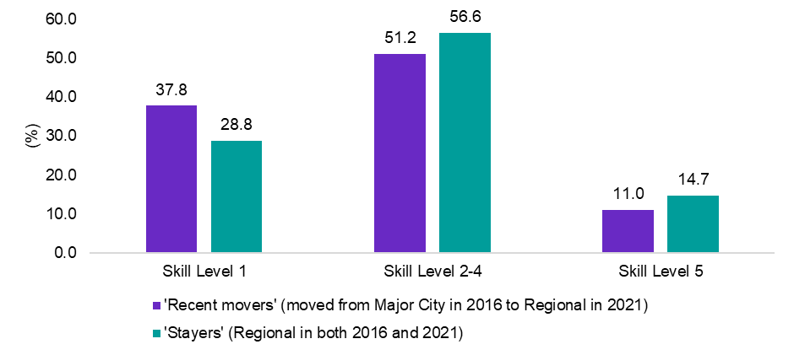

*Source: ABS Australian Census Longitudinal Dataset, 2006-2011-2016-2021. Measured as the proportion of persons (aged 25-54 years) employed in Regional Australia in 2021*

|  |
| --- |
| Box: The Australian Government’s Regional Migration Strategy  Migration is central to Australia’s national story. The migration system plays a key role in supporting regional Australia to prosper through the injection of culture, skills, innovation and economic benefits that migration brings.  Regional Australia faces a number of challenges, including population decline in some areas, an ageing workforce, pronounced labour shortages and environmental pressures. Ensuring migration settings work for regional Australia will be critical in supporting strong and sustainable regions and the broader Australian economy.  The Australian Government’s [Migration Strategy](https://immi.homeaffairs.gov.au/what-we-do/migration-strategy) was released on 11 December 2023 and outlined a new vision for Australia’s migration system, with a policy roadmap containing eight key actions and over 25 new policy commitments and areas for future reform, including for regional Australia.  The Australian Government released the discussion paper, [Supporting Strong and Sustainable Regions – Review of Regional Migration Settings](https://www.homeaffairs.gov.au/reports-and-publications/submissions-and-discussion-papers/review-of-regional-migration-settings-discussion-paper) (June 2024) that raises key issues for regional Australia identified by the Migration Strategy and previous reviews. These include:   * Raising living standards through supporting the unique skills needs of the regions. * Ensuring a fair go in the workplace by making sure that visa settings do not contribute to migrant worker exploitation and support the wages and conditions of regional workers. * Building stronger communities by planning for regional migration and giving all communities the opportunity to benefit from migration. * Strengthening Australia’s international relationships by using regional migration settings to support stronger international relationships and connect Australia’s regions with our international partners. * Making the system work by providing tailored approached to migration without being overly complex.   The information, feedback and suggestions gathered from the consultation will be used to inform development and implementation of future policy options.  Note: The definition of Regional for migration purposes differs to the definition of Regional for this Roadmap. For more information on definitions of regional for migrations settings please refer to [Supporting Strong and Sustainable Regions – Review of Regional Migration Settings](https://www.homeaffairs.gov.au/reports-and-publications/submissions-and-discussion-papers/review-of-regional-migration-settings-discussion-paper) |

**Evaluative indicators and insights**

Table 21: Metric summary table – Vision Principle 4

|  |  |
| --- | --- |
| JSA Regional Roadmap - Vision Principle 4 | Current rating |
| Overall rating for Vision Principle 4 | **Orange** |
| Contributing indicators |  |
| 1. Vacancy fill rate | **Orange** |
| 1. Essential services vacancy rate | **Red** |
| 1. Incidence of persistent hiring pressure | **Red** |
| 1. Business creation rate | **Orange** |

#### Contributing indicators

##### Vacancy Fill Rate (%)

Table 22: Vacancy fill rate (%)

|  |  |  |  |  |  |
| --- | --- | --- | --- | --- | --- |
|  | Current Rating | Current rate in Regional Australia | Current Trend | Best on record | Gap to the Major Cities |
| Vacancy fill rate (%) | Orange | 64.7% | **stable** | 75.1%  (2014) | -5.3% pts |

*Source: JSA, Survey of Employers who have Recently Advertised (SERA). Measured as the proportion of advertised vacancies that are filled in the preceding 12-months*

Ensuring regional employers – including small businesses – have access to suitable labour is critical to ensuring goods and services are delivered in accordance with what communities need and want to promote economic growth and dynamism in Regional Australia.

One of the greatest challenges regional employers face, however, is finding staff to fill vacancies. Employers in Regional Australia often face greater difficulty recruiting, particularly for occupations requiring a post school qualification, when compared to their Major City counterparts. Data from JSA’s Survey of Employers who have Recently Advertised shows that the vacancy rate (the proportion of advertised vacancies that are filled in the preceding 12-months) fell sharply in recent years, from 68.1% in 2020, to a recent low of 53.2% in 2023 (see Figure 35, below).

Although recruitment difficulty appears to show some signs of easing in Regional Australia, with the vacancy rate increasing to 64.7% in 2024, recruitment difficulty continues to remain higher for employers in Regional Australia than for employers in Major Cities.

Figure 35: Vacancy Fill Rate (%), by Major City and Regional Australia

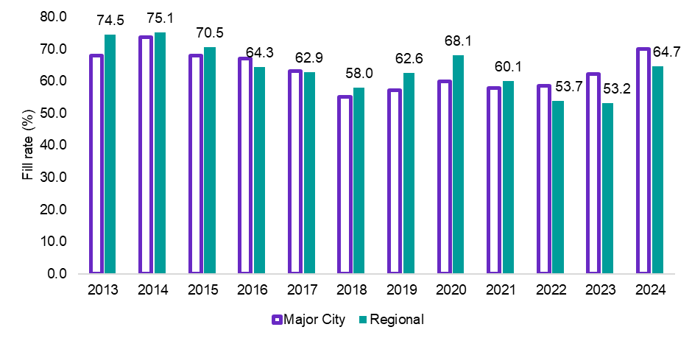

*Source: JSA, Survey of Employers who have Recently Advertised (SERA)*

|  |
| --- |
| Stakeholder insight  *‘Regional Australia predominantly faces a people issue rather than a jobs issue, with many jobs in chronic long-term labour shortage and left unfilled. There is a very strong demand for labour in Regional Australia.’*  **Dean Deighton**  Head of Northern Australia  Australian Industry Group (Ai) |

The increase in recruitment difficulty in Regional Australia in recent years, particularly when compared to Major City areas may be the result, at least partly, of the rapid increase in recruitment activity in Regional Australia. Recruitment activity in Regional Australia (estimated by adjusting JSA IVI data according to the proportion of vacancies advertised online using JSA REOS data) increased rapidly in recent years, with recruitment activity almost 5 times larger in 2023/24 as it was in 2013, a much greater increase than for Major City areas. While recruitment activity has fallen over the last year, it remains well above its long-term trend which is likely continuing to be putting significant pressure on employers to attract enough qualified and suitable candidates in Regional Australia.

Figure 36: Job advertisements (adjusted for proportion of jobs advertised online as a proportion of employed persons) (2013=100), by Major City and Regional Australia

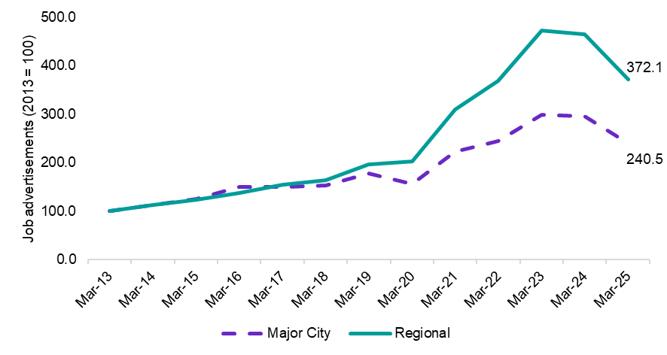

*Source: JSA, Internet Vacancy Index (IVI), April 2025 (adjusted for proportion of jobs advertised online – JSA, Recruitment Experiences and Outlook Survey, April 2025)*

|  |
| --- |
| Stakeholder insight  *‘Many regional centres were founded on one or two industries, and for years have relied on those industries to succeed. Often these industries are seen as more attractive and secure, leading to shortages of skilled workers across other industry sectors. This is why it's critical to invest in local training, so that there are adequately skilled workforces that ensure local economies to thrive.’*  **Lena Constantine**  Associate Director  Chamber of Commerce and Industry Western Australia |

##### Essential services[29] vacancy rate (%)

Table 23: Essential services vacancy ratio (job advertisements as a proportion of employed persons) (%)

|  |  |  |  |  |  |
| --- | --- | --- | --- | --- | --- |
|  | Current Rating | Current rate in Regional Australia | Current Trend | Best on record | Gap to the Major Cities |
| Essential services vacancy rate (%) | Red | 8.5% | **Improving** | 2.3%  (2013) | +2.4% pts |

*Source: JSA Nowcast of Employment by Region and Occupation (NERO) and JSA, Internet Vacancy Index (IVI), April 2025 (adjusted for proportion of jobs advertised online – JSA, Recruitment Experiences and Outlook Survey, April 2025)*

Essential services (Teachers, Child Carers, Nurses, Doctors, Pharmacists and emergency services) are critical for a region to support and ensure the safety, health and well-being of the community. They can also influence economic growth, stability and productivity of a region. Access to quality health care and education and upholding public safety are vital for addressing poverty, promoting social inclusion, powering economic growth and supporting strong community. By helping to attract and retain works in the region, the provision of essential services is central to supporting a strong labour market.

The essential services vacancy rate measures the total number of essential service job vacancies (a new total vacancy measure is estimated by adjusting JSA IVI data according to the proportion of vacancies advertised online using JSA REOS data) divided by the number of persons employed in essential services. Figure 37 shows that the essential services vacancy rate for Regional Australia increased sharply over the last 5 years, from 4.7% in Mar-20, to a high of almost 11% in 2023. While the vacancy rate has shown signs of improvement over the last year, almost 1 in 10 essential service jobs remain vacant, with this figure likely to be understated as employers chose not to continue advertising chronically hard to fill vacancies.

Figure 37: Essential services vacancy ratio (job advertisements adjusted for proportion of jobs advertised online as a proportion of employed persons) (%), Major City and Regional Australia

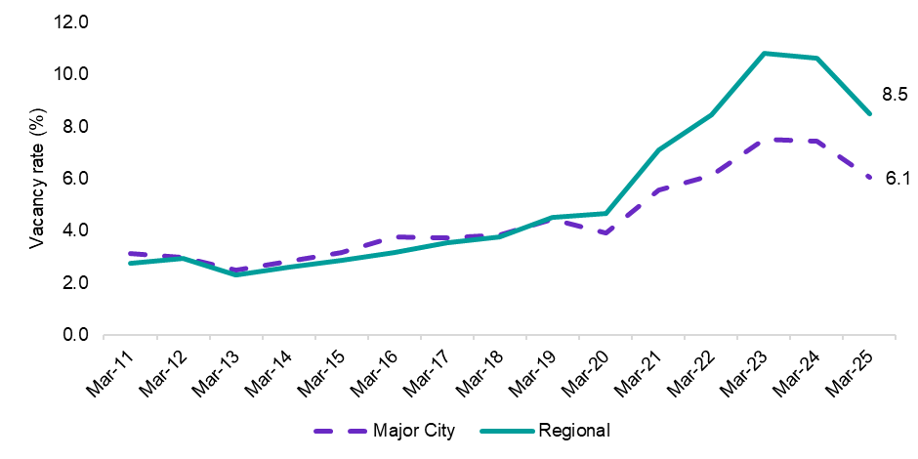

*Source: JSA Nowcast of Employment by Region and Occupation (NERO) and JSA, Internet Vacancy Index (IVI), April 2025 (adjusted for proportion of jobs advertised online – JSA, Recruitment Experiences and Outlook Survey, April 2025)*

Importantly, the data is supported by the feedback stakeholders provided to JSA during discussions out in the regions. Long wait times to see the GP, courses not being offered in school due to a lack of specialist teachers, and commuting hours into the city to receive specialist and urgent medical care are all common examples (amongst many more) of the types of challenges and barriers that people in Regional Australia face when it come to accessing essential services. This highlights the urgent need for additional support to ensure the adequate provision of essential services in Regional Australia that is central to supporting a strong labour market and the wellbeing of the community.

##### Incidence of persistent hiring pressure (%)

Table 24: Incidence of persistent hiring pressure (%)

|  |  |  |  |  |  |
| --- | --- | --- | --- | --- | --- |
|  | Current Rating | Current rate in Regional Australia | Current Trend | Best on record | Gap to the Major Cities |
| Incidence of persistent hiring pressure | Red | 36.8% | **Improving** | null | +13.6% pts |

Source: *JSA Internet Vacancy Index (IVI) and JSA Nowcast of Employment by Region and Occupation (NERO). Excludes occupations with less than 100 employed persons or less than 10 internet vacancies.*

Even if an occupation is not in shortage nationally, in specific locations the picture can be very different, particularly in regional areas. While labour supply nationally might be enough to broadly satisfy the demand from the employers, not all potential employees are able or willing to move to areas where there may be employment opportunities.

In recent times, labour shortages have been particularly challenging in Regional Australia, with employers in more than 1 in 3 (or 36.8%) occupations in Regional Australia facing persistent hiring pressure (that is, recording a high vacancy rate for at least 18 of the previous 24 months), well above the 23.2% recorded in Major Cities (see Figure 38, below).

Figure 38: Incidence of persistent hiring pressure (%) – proportion of occupations exhibiting high vacancy rates in 18 of the past 24 months

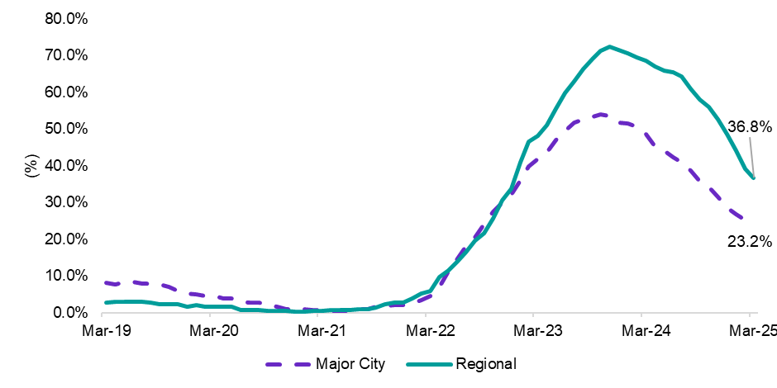

*Source: JSA Internet Vacancy Index (IVI) and JSA Nowcast of Employment by Region and Occupation (NERO). Excludes occupations with less than 100 employed persons or less than 10 internet vacancies.*

|  |
| --- |
| Stakeholder insight  *‘The skills needs of Regional Australia differ from the Major Cities, even when looking within the same State or Territory. The targeting of funding and training programs needs to be better aligned with the workforce needs of regional and remote Australia.’*  **Jimmy Cocking**  CEO  Desert Knowledge Australia |

The higher incidence of persistent hiring pressure in Regional Australia is consistent with JSA’s Occupation Shortage List (OSL). The State and Territory ratings of the OSL are typically informed through engagement with the relevant jurisdictions, giving consideration to the national shortage ratings derived by JSA. Analysis shows a sharp rise in the number of occupations that are reportedly only in shortage in regional areas in recent years.

Figure 39: Incidence of occupations reportedly only exhibiting ‘regional’ shortages

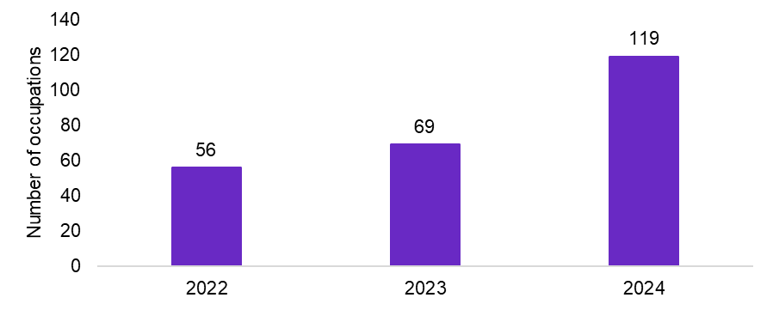

*Source: JSA Occupational Shortage List, by State and Territory and whether or not an occupation is exhibiting a ‘regional’ shortage. This chart is based only on NSW, QLD, SA, VIC and WA.*

Importantly, data from the OSL shows that occupations that that emerge as being in shortage only within a regional area of a state often develop into state-wide shortages in subsequent periods. This suggests that jobs and skills issues in Regional Australia are often a precursor to issues becoming prevalent on a broader scale. Clearly, addressing emerging regional shortages quickly is critical to ensuring shortages do not become broad-based and persistent.

Examining JSA’s OSL more closely, we can also identify a number of specific occupations reportedly facing persistent regional shortages. These are occupations which are only assessed as being in shortage in the regional part of each state, with the number below indicating the number of years the shortage has been limited to just regional areas. This is not to say that other occupations aren’t also in persistent shortage in regional areas, as many occupations are in shortage state or nation-wide. Rather, this shows there are distinct and prevailing shortages in Regional Australia.

Of note are key shortages of Urban and Regional Planners and many occupations in the health sector which may actually be contributing to the prevalence of all other shortages. The prevalence of regional only shortages also appears more apparent in Queensland and Victoria.

Table 25: Occupations only in regional shortage 2021-2024, including count of times in shortage during the time period and States of shortage

|  |  |  |  |  |  |
| --- | --- | --- | --- | --- | --- |
|  | Regional NSW | Regional QLD | Regional SA | Regional VIC | Regional WA |
| Urban and Regional Planner | 1 | 2 | 2 | 2 | 3 |
| Anaesthetist | 2 | 2 | 2 | 2 | 2 |
| Obstetrician and Gynaecologist | 2 | 2 | 2 | 2 | 2 |
| Diagnostic & Interventional Radiologist | 2 | 2 | 2 | 2 | 2 |
| Hospital Pharmacist | 1 | 2 | 2 | 2 | 2 |
| Environmental Health Officer | 0 | 2 | 2 | 1 | 2 |
| Retail Manager (General) | 1 | 2 | 2 | 1 | 2 |
| Optometrist | 1 | 3 | 1 | 1 | 1 |
| Liaison Officer | 1 | 2 | 2 | 2 | 0 |
| Agricultural Mobile Plant Operator | 0 | 2 | 1 | 3 | 0 |
| Logging Plant Operator | 2 | 2 | 1 | 2 | 0 |
| Orthoptist | 1 | 1 | 1 | 2 | 1 |
| Dermatologist | 1 | 1 | 1 | 1 | 1 |
| Pastrycook | 1 | 1 | 1 | 1 | 1 |
| Cardiologist | 2 | 1 | 1 | 1 | 1 |
| Midwife | 1 | 2 | 1 | 1 | 1 |
| Retail Pharmacist | 1 | 1 | 1 | 2 | 1 |
| Shearer | 1 | 1 | 1 | 2 | 1 |
| Waiter | 2 | 1 | 1 | 1 | 0 |
| Environmental Research Scientist | 0 | 0 | 2 | 2 | 1 |

*Source: JSA Occupational Shortage List, by State and Territory and whether or not an occupation is exhibiting a ‘regional’ shortage.*

##### Business creation rate[30]

Table 26: Business creation rate (%), Regional Australia

|  |  |  |  |  |  |
| --- | --- | --- | --- | --- | --- |
|  | Current Rating | Current rate in Regional Australia | Current Trend | Best on record | Gap to the Major Cities |
| Business creation rate (%) | Orange | 2.2% | **Stable** | 2.7%  (2007-08) | -1.0% pts |

*Source: ABS, Counts of Australian Businesses and ABS, Labour Force, Detailed, 6-month average of original estimates, March 2025*

Businesses are a vital part of any community, providing jobs, revenue and services. Entrepreneurship and business creation promotes economic growth and creates job opportunities, as 4 out of every 5 jobs added to the Australian economy have historically been created by young firms (typically within their first 2 years of operation).[31]

Ensuring that Regional Australia is creating an environment that is supportive for businesses to enter, compete and innovate will strengthen local economies and is a key outcome for Vision Principle 4. This includes supporting individuals to create a new business to meet unmet goods and services demand in the economy, provide innovative solutions or even creating their own work (such as through arts).

The business creation rate in Regional Australia has been relatively stable over time, with about 2 new businesses created per person living in Regional Australia each year. However, this rate lags the pace of increase and level recorded in the Major Cities, highlighting the need for further action to encourage entrepreneurialism and business creation in Regional Australia in order to meet unmet goods and services demand and provide labour market opportunities for workers.

Figure 40: Business creation rate (%), Major City and Regional Australia

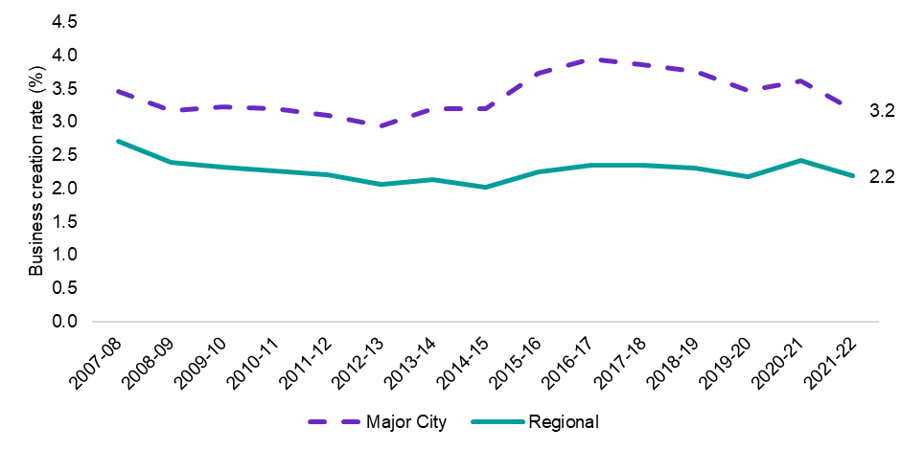

*Source: ABS, Counts of Australian Businesses and ABS, Labour Force, Detailed, 6-month average of original estimates, March 2025*

*Note: The business creation rate is calculated by dividing the proportion of new business entries (over the financial year) as a proportion of the working age (15-64 years) population.*

### Summary

An effective jobs and skills system in Regional Australia should ensure that employers have access to the labour they need – both in terms of available people and with the skills that are needed. Ensuring employers have access to suitable labour, including by supporting the development of a ‘home-grown’ workforce, can support growth in output and productivity. Migration also plays an important role in addressing the diverse workforce needs of Regional Australia where local labour or skills are not available.

This has direct benefits for Regional Australia, ensuring goods and services are delivered in accordance with what communities need and want, helping to facilitate improvements in living standards.

One of the greatest challenges regional employers face, however, is finding staff to fill vacancies, particularly for occupations requiring a post school qualification. Indeed, the vacancy fill rate has fallen sharply in recent years, from around 68% in 2020, to a recent low of almost 53% in 2023. Although recruitment difficulty appears to be showing some sign of easing, it continues to remain higher for employers in Regional Australia than for employers in Major Cities, including for essential services where almost 1 in 10 essential service jobs remain vacant.

This highlights the urgent need for additional support to ensure the adequate provision of essential services in Regional Australia that is central to supporting a strong labour market and the wellbeing of the community. Furthermore, data from the OSL Occupations that emerge as being in shortage only within a regional area of a state or territory often develop into state-wide shortages in subsequent periods.

* Of note are key shortages of Urban and Regional Planners and many occupations in the health sector which may actually be contributing to the prevalence of all other shortages.

This suggests that regional jobs and skills issues are often a precursor to issues becoming prevalent on a broader scale. Addressing emerging regional shortages quickly is critical to ensuring shortages do not become broad-based and persistent.

Vision Principle 5: Efficient matching of labour supply and demand

#### The labour market in Regional Australia efficiently matches labour demand with labour supply

Vision Principle 5 – Efficient matching of labour supply and demand

### A cross-cutting measure

#### The labour market in Regional Australia efficiently matches labour demand with labour supply

A well-functioning labour market is a critical contributor to productivity growth, particularly though the efficient matching of jobs seekers and vacancies. A labour market with an efficient matching of jobs and skills can generate more economic output for a given level of available workers and demand for labour, contributing to improved economic welfare and prosperity for all communities across Australia, including in Regional Australia.**[32]**

In an efficient labour market, employers fill vacancies in a timely manner, and those who are unemployed do not remain out of work for long. However, this is not always the case.

Matching efficiency can be limited, particularly during an economic downturn, by disconnects between the skills and location of potential workers, and the requirements, renumeration, and location of available jobs.**[33]** As a result, the unemployed may remain unemployed for longer, because they are unable to find work.

In addition, the remaining vacancies may go unfilled, as suitable workers cannot be obtained from the pool of available unemployed people. In such circumstances, poor labour market efficiency is at play, and the economic cost (including a loss of potential output and stifling of business opportunities) and social cost (that result from spells of unemployment) can be substantial.**[34]**

Figure 41: Conceptualising labour market efficiency

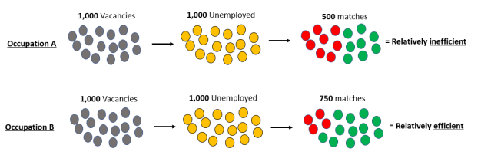

### Evaluative indicators and insights

Table 27: Metric summary table – Vision Principle 5

|  |  |
| --- | --- |
| JSA Regional Roadmap - Vision Principle 5 | Current rating |
| Overall rating for Vision Principle 5 | Orange |
| Contributing indicators |  |
| 1. Beveridge Curve analysis | Green |
| 1. Efficiency of labour market matching | Orange |

##### Beveridge Curve

Table 28: Beveridge Curve analysis for Regional Australia

|  |  |  |  |
| --- | --- | --- | --- |
|  | Current Rating | Current Trend | Gap to the Major Cities |
| Beveridge Curve analysis | Green | **Stable** | More efficient |

One analytical tool used by labour economists to analyse trends in labour market efficiency is the Beveridge Curve. The Beveridge Curve is the relationship between job vacancies and job seekers in the labour market and can be used to assess the current state of the labour market during the economic cycle and as a measure of efficiency.

Figure 42: Beveridge Curves show labour market efficiency and tightness

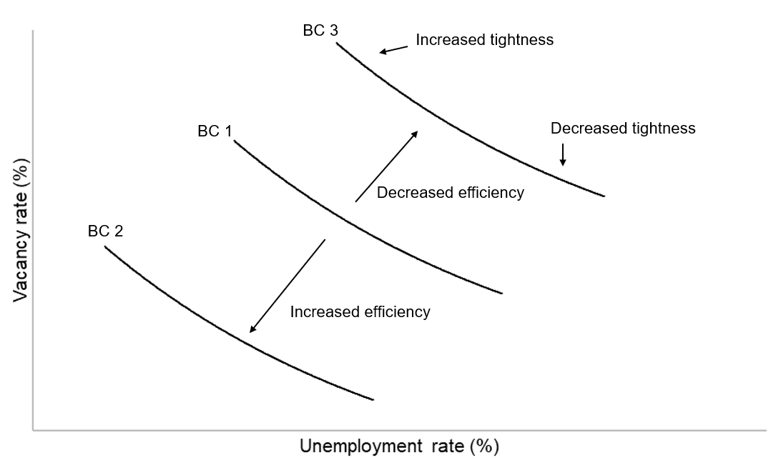

The closer the overall Beveridge Curve is to the origin, the more efficient the labour market is. If unemployment and vacancies are both low, this suggests that workers and vacancies may be efficiently matched, including the role that job mobility plays in some employed people moving into new jobs to free up jobs for unemployed people to go into. If the curve moves further away from the origin and unemployment and vacancies are both high, firms may be unable to find the workers they are looking for despite there being many unemployed people.

The Beveridge Curve also tells us something about spare capacity in the labour market as movements along the curve will generally reflect cyclical changes in labour market conditions. For instance, a tight labour market is represented by a point on the left-up part of the curve and is typically defined by a high number of job vacancies for each unemployed person that may result in labour shortages and upward pressure on wages. Conversely, in a weak labour market, that is represented by a point on the lower-right part of the curve, is typically defined by a high rate of unemployment (particularly involuntary) and fewer job vacancies. As such, it is possible for different local labour markets to be located on different points of the curve, indicating varying degrees of spare capacity (i.e. unemployment), despite having an overall similar rate of efficiency.

#### Results for Regional Australia

Figure 43 shows the Beveridge Curve for Major City areas and Regional Australia from 2019 to March 2025. The job vacancy rate is the total number of job vacancies divided by the total labour force.

* It should be noted that a new total vacancy measure is estimated by adjusting JSA IVI data according to the proportion of vacancies advertised online using JSA REOS data. This helps to account for some of the differences in recruitment methods between employers in Regional Australia and Major City areas.

The results show the Beveridge Curve for Regional Australia is closer to the origin than for Major City areas, providing evidence that, on average, labour markets in Regional Australia may have been more efficient than in Major City areas since 2019 (earliest available data). That is, workers and vacancies appear to be more efficiently matched in Regional Australia since 2019.

Furthermore, the shift along the curve (to the upper left-hand side) reflects a tightening of labour market conditions in Regional Australia over the last 5 years, with a relatively higher number of job vacancies for each unemployed person, consistent with increased labour shortages over the period.

Figure 43: Beveridge Curve for Major City and Regional areas of Australia, 2019 to 2025

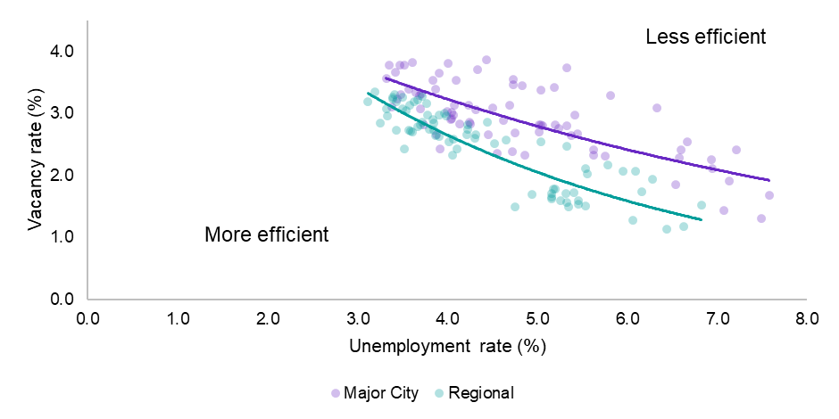

*Source: JSA, Internet Vacancy Index (adjusted for proportion of jobs advertised online – JSA, Recruitment Experiences and Outlook Survey, April 2025)*, ABS, *Labour Force, Detailed,* March 2025, modelled estimates.

*Note: The job vacancy rate is the total number of job vacancies (a new total vacancy measure is estimated by adjusting JSA IVI data according to the proportion of vacancies advertised online using JSA REOS data) divided by the total labour force.*

Higher matching efficiency between the unemployed (supply) and job vacancies (demand) may reflect, at least partly, the increased willingness of employers in regional areas to be more flexible in regard to associated job and qualification requirements when assessing potential applications (potentially using on-the-job training as a replacement for formal qualifications).

Furthermore, the efficiency results for Regional Australia may also echo the views stakeholders provided to JSA during discussions out in the regions – at present, Regional Australia predominantly faces a people (or labour supply) issue rather than a jobs (or demand) issues. There is a very strong demand for labour in Regional Australia with many jobs in chronic long-term shortage that are often left unfilled. This often leads to a greater willingness among employers to fill vacancies with available supply, leading to data showing such regions as more efficient.

This is supported by Figure 44, which shows that although the vacancy fill rate in Regional Australia (64.7%) is below the rate recorded for Major City areas (69.9%), employers in Regional Australia receive half the number of qualified applicants per vacancy (4.9) than employers in Major City areas (2.5). These results may indicate that employers in Regional Australia may be more willing to train employees on the job than employers in Major City areas.

Figure 44: Fill rate (%), suitable applicants and qualified applicants (no.), January 2025

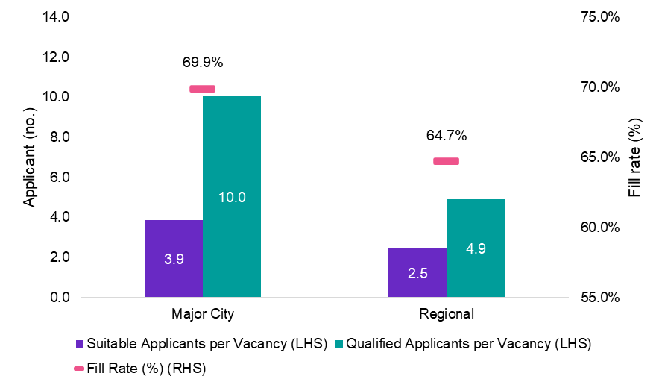

*Source: JSA, Survey of Employers who have Recently Advertised, January 2025, 12-month averages of original estimates*

#### Examining the Beveridge Curve for different areas within Regional Australia

It is important to note, however, that while the Beveridge Curve analysis provides evidence of higher labour market efficiency within Regional Australia compared to Major Cities, significant variation exists across regions.

For instance, Figure 45 shows that in March 2025 Regional Northern Territory, Queensland and South Australia were far further away from the origin than Regional Victoria and Tasmania (which, based on the Beveridge Curve, suggests these are currently more efficient local labour markets). This variation in labour market efficiency may be due, at least partly, to the significant variation in the proximity to markets, access to services and a region’s amenities that exists across Regional Australia that contribute to the disconnect between skills of workers and available jobs.

Figure 45: Beveridge Curve for Regional Australia, including position of selected regions

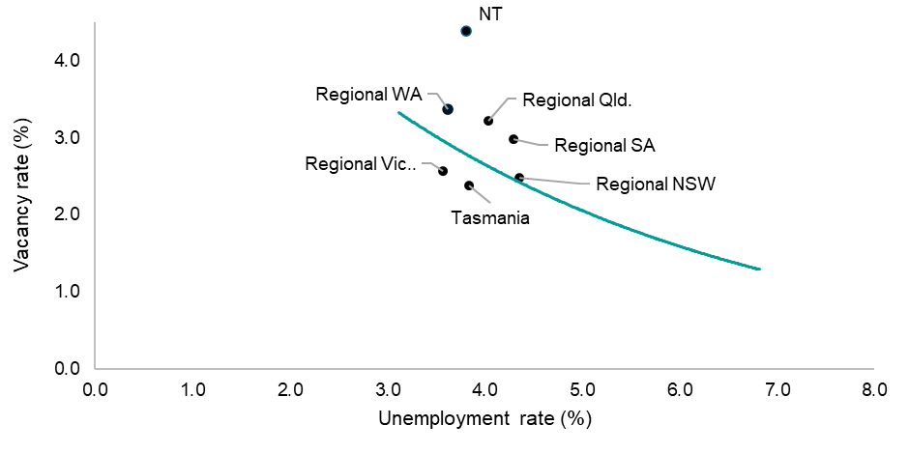

*Source: JSA, Internet Vacancy Index (adjusted for proportion of jobs advertised online – JSA, Recruitment Experiences and Outlook Survey, April 2025)*, ABS, *Labour Force, Detailed,* March 2025, modelled estimates.

*Note: The data points show for the Regional New South Wales, Victoria, Queensland, South Australia, Western Australia Tasmania and the Northern Territory are for March 2025. The curve is based on the average result for 2019 to 2025 across Regional Australia as a whole.*

##### Experimental insights from JSA’s *MUVER model*

Table 29: JSA experimental estimates of matching efficiency (*MUVER model),* Regional Australia 2025

|  |  |  |  |  |  |
| --- | --- | --- | --- | --- | --- |
|  | Current Rating | Current rate in Regional Australia | Current Trend | Best on record | Gap to the Major Cities |
| Efficiency of labour market matching (%) | Orange | 80.7% | **Worsening** | 84.4% (2011) | +2.3% pts |

*Source: JSA experimental estimates of matching efficiency by region, 2025, and ABS, Labour Force, Detailed, 6-month average of original estimates, March 2025*

Further insights on job matching efficiency in the labour market can be derived from JSA’s *MUVER* model which uses data from both JSA and the Australian Bureau of Statistics (ABS), to deliver experimental insights on job matching efficiency for regions.

Figure 46: A simple model underpinning the Beveridge Curve

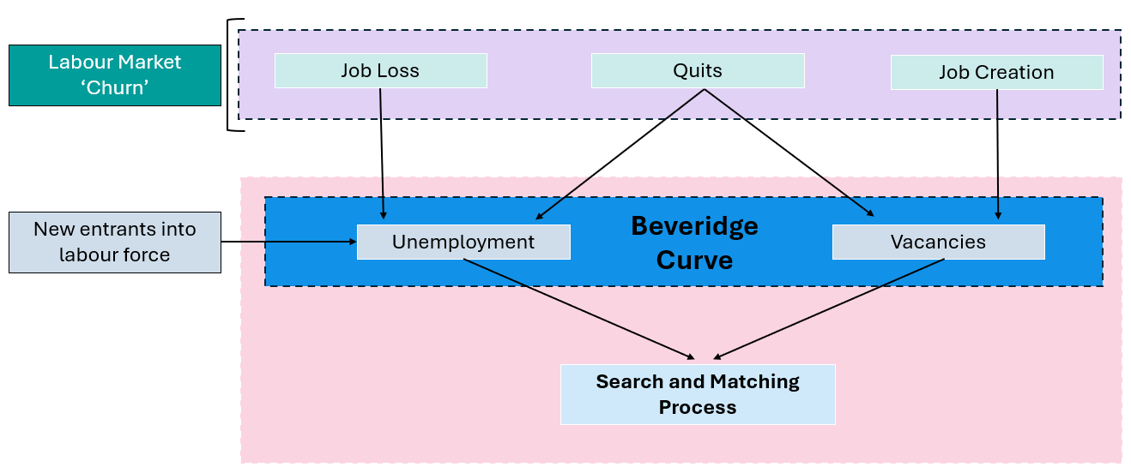

While the Beveridge Curve is a useful tool to analyse efficiency in the labour market, it cannot be used to unambiguously identify periods of high and low job matching efficiency. Rather, it is the *flows* into and out of unemployment and vacancies, together with the job-matching process, that determine the outcomes for unemployment and vacancies that are summarised in the Beveridge Curve (see Figure 46, above). As such, shifts in the Beveridge Curve can be attributed to changes in labour market ‘churn’ (including job loss, quits – including workers moving between jobs – and job creation), growth in the labour force (new entrants into the labour force) and the search and matching process (job matching efficiency).

JSA’s *MUVER* model, however, is based on the production function concept with the numbers of unemployed (supply) and vacancies (demand) taken as ‘inputs’ and the flow of newly matched worker-employer pairs as the ‘output’. This model is a well-regarded economic framework first theorised by Nobel-prize winners Diamond, Mortensen and Pissarides. The resulting matching function describes the rate at which successful job matches ‘output’ are created from the stocks of ‘inputs’ and the relative weights of each input (labour demand and supply) in the job matching process (job matching efficiency).

#### Estimates of job matching efficiency

When examining the experimental estimates of average matching efficiency for Regional Australia as a whole, we find evidence that job matching efficiency has fallen in Regional Australia in recent years, from a recent peak of 83.4% in 2023, to 80.7% in 2025. This is below the rate recorded in the Major Cities (83.0%), although the gap has remained relatively stable in recent years.

Figure 47: JSA experimental estimates of matching efficiency (*MUVER* model)*,* Major City and Regional Australia

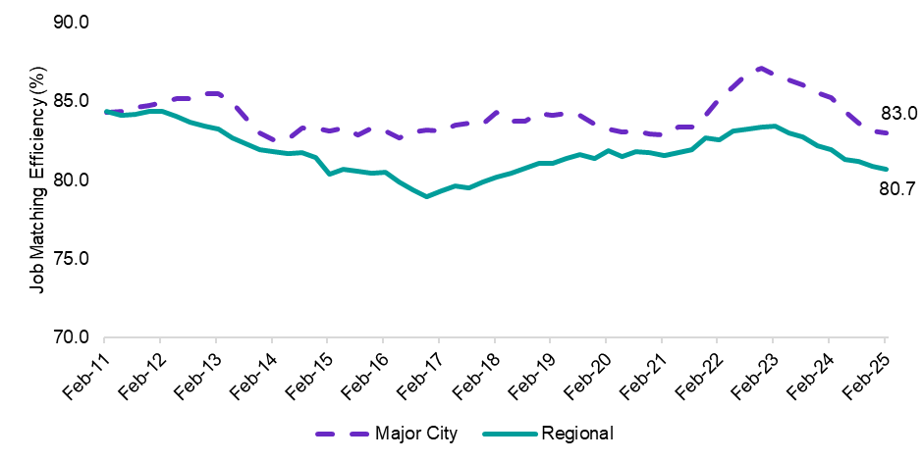

*Source: JSA experimental estimates of matching efficiency by region, 2025, and ABS, Labour Force, Detailed, 6-month average of original estimates, March 2025*

While the average results can provide an indication of trends for Regional Australia as a whole, it hides the significant variation in the efficiency of the labour market in matching unemployed persons with job vacancies within Regional Australia. For instance, while Regional Western Australia and South Australia appear to be relatively inefficient labour markets (with a relatively low rate of job matching between the unemployed and job vacancies), the results show that matching efficiency is higher for Regional Victoria, Queensland and New South Wales.

Figure 48: JSA experimental estimates of matching efficiency (*MUVER model), 2025*

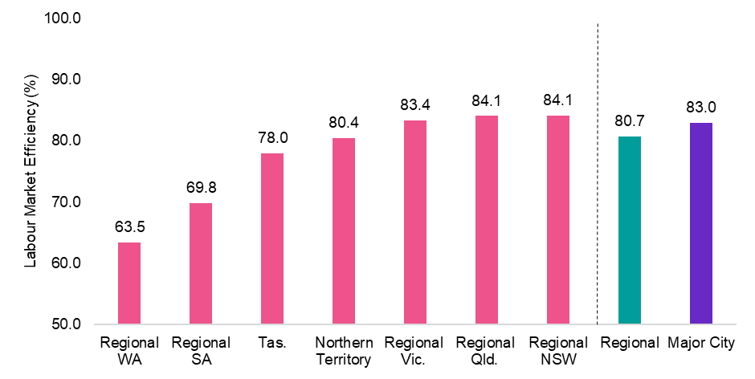

*Source: JSA experimental estimates of matching efficiency by region, 2025, and ABS, Labour Force, Detailed, 6-month average of original estimates, March 2025*

While these findings of job matching efficiency from JSA’s *MUVER* modelappear to be at odds with the results from the Beveridge Curve analysis, there are a number of limitations and gaps in the analysis that are worth noting when interpreting the experimental estimates of matching efficiency from the *MUVER* model. Particular limitations worth noting include:

* **Transitions in the labour market are difficult to measure**, particularly those with a short job tenure, and those that are difficult to observe (such as internal with-in form movements and promotions).
* **Unemployment is a narrow way to consider/analyse labour supply** given a large number of movements into employment also come from those not in the labour force (labour force growth).
* **The analysis does not attempt to evaluate the quality of a match.** Instead, he *MUVER* model focuses on the level (or rate) of matching occurring.

**Summary**

Efficiency, in the context of labour markets, can be thought of as being a measure of how successful the labour market is at matching available jobseekers to available jobs. In an efficient labour market, employers fill vacancies in a timely manner, and those who are unemployed do not remain out of work for long.

However, this is not always the case. Frictions in the labour market arising from disconnects between the skills and location of potential workers with available jobs may hinder the efficiency of the labour market that may hinder the economic welfare and prosperity for all communities across Australia, including for Regional Australia.

Combining job vacancies and unemployment data shows that, on average, labour market efficiency may have been more efficient in Regional Australia than in Major City areas since 2019.

The results may reflect, at least partly, insights from meetings with regional stakeholders and data from JSA’s Survey of Employers who have Recently Advertised which show an increased willingness of employers to fill vacancies with available supply, with on-the-job training and support often enhancing the productivity of the employee over time.

While the Beveridge Curve is a useful tool to analyse efficiency in the labour market, it cannot, however, be used to unambiguously identify periods of high and low job matching efficiency. In addition to job matching efficiency, shifts in the Beveridge Curve can also be attributed to changes in labour market churn (including job loss, quits and job creation) and growth in the labour force (new entrants into the labour force).

Further insights on job matching efficiency in the labour market can, however, be derived from JSA’s *MUVER* model which uses data from both JSA and the Australian Bureau of Statistics (ABS), to deliver experimental insights on job matching efficiency. Notwithstanding the limitations and gaps in analysis, the results provide evidence that job matching efficiency is lower in Regional Australia than for Major City areas. While experimental, this framework provides important additional insights which would increase and improve with additional development in the methodology.

Vision and evaluative framework conclusion

Vision and evaluative framework conclusion

**JSA’s vision for jobs and skills system in Regional Australia**

JSA’s vision is for the jobs and skills system in Regional Australia to help realise the aspirations of its people. It’s about ensuring the jobs and skills system in Regional Australia is enabling the right people, to be in the right jobs, at the right time to support individuals, businesses and communities to thrive. Importantly, this vision is intentionally inclusive and applies to all people, regions, industries and employers across Regional Australia.

Skills and knowledge acquisition underpins the capability of the workforce. Regional Australia faces a number of challenges, including population decline in some areas, an ageing workforce, pronounced labour shortages and environmental pressures. Furthermore, the mix of skills required in the labour market is changing as the economy evolves. Indeed, over the next 10 years more than 9 out of 10 new jobs expected to be created will require post-secondary qualifications, a significant uplift from current levels.

As such, an effective jobs and skills system in Regional Australia should support the acquisition of the necessary skills to best position individuals to take advantage of opportunities in the labour market and contribute to their local community and culture, both now and into the future.

**Evaluative metrics to measure progress towards the vision**

The foundation of JSA’s vision for the jobs and skills system is underpinned by a set of core vision principles. These core principles are not mutually exclusive as the overall vision cannot be achieved without all underlying principles being effectively pursued and satisfied. As such, the core vision principles should support action through the ongoing monitoring and assessment of the effectiveness of the jobs and skills system and its outcome over time, ensuring that people living in Regional Australia are equipped with the skills to take advantage of opportunities in the labour market.

Analysis of key indicators (summarised in Table 30, below) shows that while some components of the of JSA’s vision for the jobs and skills system in Regional Australia is performing at an appropriate level, demonstrating an area of comparative strength, many indicators show a moderate or significant gap.

Table 30: Vision principle contributing metrics, indicators and current assessment for Regional Australia

| Vision Principle | Underpinning Vision Principle | Contributing metric | Current rating in Regional Australia | Current rating in Regional Australia | Overall Vision Principle rating |
| --- | --- | --- | --- | --- | --- |
| Addressing Barriers | People with barriers in Regional Australia receive timely high-quality support to move towards participating in education, training and employment | School non-attendance | 14.6% | Deteriorating or significant gap | Deteriorating or significant gap |
| Youth not in employment, education or training | 15.3% | Deteriorating or significant gap |
| Prime age participation rate | 85.4% | On track or performing at an appropriate level |
| Unemployment rate | 4.0% | On track or performing at an appropriate level |
| Prop. on long-term income support | 2.4% | Deteriorating or significant gap |
| Developing skills | Everyone in Regional Australia is supported to efficiently develop skills that enable them to meaningfully contribute to community, economy and culture. | Youth tertiary participation rate | 22.2% | Deteriorating or significant gap | Slow progress, stagnating or moderate gap |
| Completion rates for apprentices and trainees | 56.7% | Slow progress, stagnating or moderate gap |
| Proportion working in same field as most relevant qual | 72.7% | Slow progress, stagnating or moderate gap |
| Proportion working in jobs below their qualification level | 25.7% | Slow progress, stagnating or moderate gap |
| Quality jobs | Everyone employed in Regional Australia can work in a quality job that is safe, fair, rewarding and satisfying. | High job satisfaction | 38.8% | On track or performing at an appropriate level | On track or performing at an appropriate level |
| Underemployment | 6.1% | On track or performing at an appropriate level |
| Income inequality ratio | 3.5 | Slow progress, stagnating or moderate gap |
| Workers’ compensation incidence rate | 9.6 | Slow progress, stagnating or moderate gap |
| Meeting demand | Regional Australia and its employers can access, attract and develop sufficient suitable labour, including as skills needs change. | Vacancy fill rate | 64.7% | Slow progress, stagnating or moderate gap | Slow progress, stagnating or moderate gap |
| Essential services vacancy rate | 8.5% | Deteriorating or significant gap |
| Persistent hiring pressure indicator | 36.8% | Deteriorating or significant gap |
| Business creation rate | 2.2% |  |
| Efficient matching | The labour market in Regional Australia efficiently matches labour demand with labour supply. | Beveridge Curve analysis | n/a | On track or performing at an appropriate level | Slow progress, stagnating or moderate gap |
| Labour market matching efficiency | 80.7% | Slow progress, stagnating or moderate gap |

An effective jobs and skills system in Regional Australia would see individuals working in a quality job that is safe, fair, rewarding and satisfying. It is therefore encouraging that high job satisfaction has been a relatively consistent feature of the labour market in Regional Australia, with the rate of satisfaction increasing in recent years. This may be a reflection stronger labour market conditions in recent years that have allowed people to move closer to their preferred working hours. Additionally, it may also reflect remote and hybrid working arrangements that provide people with more choice regarding where they live and work.

Of particular concern, however, is the prevalence of barriers that hinder the participation of people living in Regional Australia in the labour market, particularly those from priority equity groups. While Regional Australia has been experiencing historically low levels of unemployment, with the unemployment rate reaching a recent low of 3.2% in late 2022, many young people face barriers, that are often complex and inter-related. Such barriers hinder their participation in the jobs and skills system altogether with around 1 in 6 young people in Regional Australia not in any form of employment, education or training in Regional Australia, well above the 1 in 10 young people in the Major Cities.

Furthermore, school attendance rates in Regional Australia have consistently lagged the rates recorded in Major Cities and remain well above their pre-COVID levels. This may reflect the incidence of key emerging barriers due to the disruptions to schooling caused by COVID (as well as other factors in those years, such as natural disasters in certain regions) or local labour market conditions, as well as other factors that are hindering participation in school.

How people respond to opportunities in the labour market relies on investment in technical skills and knowledge, as well as the core transferable skills needed to be resilient and adaptable to changes in the labour market. As employment in Regional Australia continues to shift towards jobs that require occupations where VET or higher education is the primary pathway, ensuring that participation in tertiary education in Regional Australia continues to grow is critical.

Against this backdrop, the youth tertiary participation rate in Regional Australia has been relatively stable over recent years at around 22%, although it is well below the rate in Major Cities (37%). Lower rates of tertiary study in Regional Australia could be due to a range of factors including access issues, financial barriers, family and community expectations.

* It is important to note that while the average result can provide an indication of trends for Regional Australia as whole, it can hide significant within Regional Australia. For instance, the youth tertiary participation rate ranges from around 28% in Regional Western Australia, to just above 14% in Regional Victoria (see Appendix 1 for state and territory metrics)

Ensuring that students in Regional Australia have the same access to tertiary education opportunities as their Major City counterparts is critical, including by ensuring suitable students receive the support they need to meet associated entry requirements for Higher Education. Without this, Australia will face difficulties in developing the skills required for the future.

The prevalence of barriers that hinder participation in the labour market, including the acquisition of skill through the tertiary and higher education system, as well as completion of apprenticeship and traineeships, likely contributes to recruitment difficulty for employers in Regional Australia. Although recruitment difficulty appears to be showing some sign of easing, it continues to remain one of the greatest challenges for employers in Regional Australia. This is particularly true for essential services where almost 1 in 10 essential service jobs remain vacant in Regional Australia, well above the 1 in 15 vacant essential service jobs in the Major Cities. This highlights the urgent need for additional support to ensure the adequate provision of essential services in Regional Australia that is central to supporting a strong labour market and the wellbeing of the community.

Importantly, these results echo the views stakeholders provided to JSA during discussions across Australia – that, at present, Regional Australia predominantly faces a people (or labour supply) issue rather than a jobs (or demand) issue. There is a very strong demand for labour with many jobs in chronic long-term shortage that are often left unfilled. And although employers often demonstrate an increased willingness to fill vacancies with available supply, with on-the-job training and support often enhancing the productivity of the employee over time, more progress must be made to addressing the prevalence of complex and inter-related barriers that prevent the necessary skill acquisition and participation in the labour market to enable Regional Australia to thrive.

# 3. Making progress towards the vision for Regional Australia

**Introduction**

Pursuing the vision for the jobs and skills system in Regional Australia will require deliberate action. Although many policies and initiatives are already in place to improve the equity, effectiveness and efficiency of the jobs and skills system in Regional Australia, additional steps can be taken to continue to pursue the vision. This includes specific actions targeting uplift in particular parts of the system, or in response to challenges and opportunities identified under a specific vision principle.

In considering these proposed actions, there are 3 key guiding principles to keep in mind.

1. In many regions and jurisdictions, there are already areas of existing strength or success in enhancing the jobs and skills system in Regional Australia. With this in mind, the opportunities highlighted below are not seeking to disrupt such areas of strength, but rather complement and build on them, including by enabling areas of success to be shared and enacted more broadly across other parts of Regional Australia.
2. The suggestions are provided as directional suggestions, rather than prescriptive proposals or requirements, reflecting the need for local tailoring and differences in approaches across jurisdictions. Given the vast and diverse differences between regions and communities with Regional Australia, such flexibility is critical to ensuring future success.
3. The proposed actions will also continue to be informed and designed (in line with the spirit of co-design) with stakeholders, with further refinement and testing (such as through policy pilots and trials) potentially required.

With these principles in mind, the following sub-sections present 2 key areas of potential action, namely:

* Part 1: Policy checklist to guide future policy design for Regional Australia
* Part 2: Emerging areas of focus to enhance the jobs and skills system

Following this, a proposed approach for further refining and enacting the roadmap is presented, including in-person roundtables across Regional Australia and a public stakeholder submission process. This will support the refining of the Roadmap between Phase 1 and Phase 2, and support the development of State and Territory level and other regional roadmaps.

10 policy design principles for Regional Australia

Guiding principles to enhance the jobs and skills system across Regional Australia

## 10 policy design principles for Regional Australia

Across Regional Australia, there are a number of prevailing factors and features that cause the fundamental context within which the jobs and skills system operates to differ when compared with the major capital cities. In particular, Regional Australia faces a more dispersed population that leads to higher costs of delivery and an enduring challenge to ensure equity of access to programs and services for individuals and employers.

To help account for and alleviate this pressure, there are a range of foundational policy principles that can be used to support the jobs and skills system. Such principles are often cross-cutting in that they can apply across sectors, including for schooling, vocational education and training, employment services and related skills programs.

Utilising the following policy-design checklist both in new policy formation and in relation to existing policies and programs (including sectoral-based and place-based approaches) provides a significant opportunity for impact.

When considering these policy design principles, users should:

* **Hold the principles together concurrently** (rather than individually or in isolation), noting the interrelations between the principles and the possibilities for trade-offs between them.
* **Consider the principles as directional and a starting point** to stimulate policy thinking, rather than being prescriptive or limiting.
* **Use the guide to support, rather than constrain**, possibilities for future reform.

JSA intends to work with policy makers across all levels of government to refine these design principles and test their usefulness in Phase 2 of the Roadmap. This may include developing illustrative examples of how the design principles could be pursued for different sectors within the jobs and skills system and for localised place-based approaches (including across different types of regions).

Table 31: Proposed policy design principles to support policy formation that enhances the jobs and skills system across Regional Australia

|  |
| --- |
| 10 Design Principles for the Jobs and Skills System in Regional Australia |
| **Consultation and alignment principles** |
| 1. Are local communities being supported to develop and deliver solutions including by empowering the people and communities most affected by an issue or opportunity? |
| 1. Has the policy been developed in line with the spirit of co-design with stakeholders in Regional Australia (including by ensuring any steering committees have appropriate representation of stakeholders from Regional Australia) and genuinely refined in response to feedback? |
| 1. Does the policy align with, and complement, existing initiatives in Regional Australia, including by leveraging existing areas of success and strength and fostering collaboration in the system? |
| 1. Does the policy recognise the differing workforce and skills needs of Regional Australia, including the local needs of individual regions, and provide appropriate flexibility to adapt and respond accordingly? |
| **Service design principles** |
| 1. Does the policy seek to initially pilot or trial new approaches or initiatives (including undertaking evaluations), and provide long-term funding (preferably for a minimum of 4 years) for known models of success? |
| 1. Does the policy ensure continuity of access to quality services, and allow government to deliver services where appropriate (such as through TAFEs, local governments, Government-Business Enterprises and so forth)? |
| 1. Does the policy consider using block-grant funding to support service delivery in situations where it is difficult to achieve viable cohorts of participants (rather than using activity or outcome-based funding)? |
| **Funding principles** |
| 1. Does the policy provide higher levels of funding to Regional Australia – including for remote areas – in response to higher costs of delivery and thin markets? |
| 1. Does the funding incorporate periodic (or annual) uplifts in funding in response to changes in the cost of delivery in Regional Australia? |
| 1. Does the policy ensure any substantial changes to funding or service delivery in Regional Australia (including cessations or extensions) occur progressively over time and with sufficient notice for regions to adapt? |

Emerging priorities to enhance the jobs and skills system in Regional Australia

Opportunities for impact and examples of models already making a difference in Regional Australia

Emerging priorities to enhance the jobs and skills system in Regional Australia

In addition to the cross-cutting policy settings incorporated in the checklist above, there are also a range of emerging areas of focus and opportunity. These areas represent more focused and deliberate actions that should be explored with stakeholders to determine their feasibility and options for co-designing specific policy responses.

In many regions and jurisdictions, the proposed areas of focus draw on existing strengths or successes in Regional Australia, a number of which are highlighted in the subsequent section below via a series of case studies. There are opportunities for these approaches to be shared more broadly to enable other regions to learn from and build on the successes.

The list below is a starting point for the proposed Roundtables and Stakeholder Submission Process to inform Phase 2 of the Roadmap.

#### Cross-cutting strategies and approaches

1. All future workforce, capacity and cohort studies progressed by Jobs and Skills Australia should explicitly consider Regional Australia.
2. The skills needs of regional and remote areas often differ to those of the Major Cities. Commonwealth and State and Territory Governments (where applicable) should work towards identifying such differences in all future skills needs lists.
3. More comprehensive, frequent and useful data for Regional Australia is needed in relation to:
4. foundational skills – particularly among adults
5. workforce and skills needs, particularly in remote Australia
6. education and employment pathways of students and youth, including through the continuing integration of linked datasets to enable more effective evaluation of outcomes over time
7. economic activity by region, to support insights into labour productivity
8. barriers to participation in education and employment faced by young people under the age of 18
9. greater collection of qualitative data to enhance and complement quantitative data including those related to people’s experiences and wellbeing.
10. Using place-based and centralised points-of-contact (‘hubs’) for students and jobseekers alike has proven successful in some regions (including cross-government initiatives), noting the need to ensure access to services for those who are more isolated from transport links.
11. Supporting roles that focus on fostering collaboration and partnerships in the jobs and skills system are proving effective, including through the Jobs Coordinators (Employment Facilitators) under the Local Jobs Program and other related initiatives.

#### Reducing Barriers

1. Individuals who face complex barriers to employment require intensive case-managed strategies that incorporate work components and other targeted forms of social and wrap-around support. Such strategies should be developed on a personalised and individualised basis. Additionally:
2. Work connection activities are a priority but must be not hinder the provision of necessary social services and support.
3. Long-term income support reliant recipients may be better provided for through a predominantly social-support focussed program.
4. Adults who previously disengaged from schooling often face significant barriers to participation in further education or employment. Ongoing access to appropriate foundation skills development programs and initiatives is essential.
5. Where lack of aspiration or motivation is a key barrier (particularly in cases of intergenerational disadvantage or disengagement from schooling), consideration should be given to trialling a program targeting this particular barrier (leveraging areas of existing success). Such a program could work closely with local employers across a diverse range of industries to provide students with the opportunity to visit a variety of workplaces to inspire career aspirations.

#### Skills and education

1. The Commonwealth Government should work with State and Territory Governments to explore additional reporting focused on Regional Australia (as a whole, at the national level), to support performance reporting around the National Skills Agreement (NSA). Governments should also work together to support each individual jurisdiction to monitor performance across the regional areas of their own State/Territory as an additional identified priority area.
2. The Australian Tertiary Education Commission (ATEC), when established, should work with regional universities (including those who have a regional presence) to explore incorporating regional focussed performance indicators into Mission Based Compacts. If the Higher Education Accord’s recommendations pertaining to regional higher education are adopted and effectively implemented, that will greatly increase the ability of regional universities to drive up these indicators.
3. The jobs and skills system in Regional Australia would benefit from improved strategic alignment, coordination and cooperation between the Higher Education and Vocational Education and Training (VET) sectors. Enabling the development and effective implementation of a tertiary harmonisation roadmap of the kind proposed by JSA in its report *Opportunity and Productivity: Towards a Tertiary Harmonisation Roadmap* would go some way to realising this opportunity.
4. Ensure that all secondary students have access to high quality careers education in school that is broadly based, well researched and deeply connected to local community and its businesses.
5. Secondary school students in Regional Australia need access to a broad range of education and employment pathways. Provision of vocational and trade-based opportunities in senior secondary schooling is essential, including by exploring opportunities to enhance access to dedicated trade colleges.
6. The availability of accommodation in Regional Australia for VET students needs to be examined to support access to in-person training blocks for vocational students in regional centres.
7. Jobs and Skills Councils, in developing the Workforce Plans and their products, including training packages and training materials, should explicitly consider how regional needs have been accommodated, including Aboriginal and Torres Strait Islander perspectives.
8. Improvements to visa processing and skills accreditation (or recognition) processes for skilled migrants could unlock important productivity benefits in Regional Australia. This should be complemented by ensuring visa types and related support help meet the needs of Regional Australia.

|  |
| --- |
| Box: Examples of other visions for Regional Australia – the Regional Australia Institute’s Regionalisation Ambition to 2032  In September 2022, the Regional Australia Institute (RAI) launched its Regionalisation Ambition 2032, a framework designed to help direct the actions of government, industry and the community towards achieving a greater proportion of Australians living prosperously in the regions by 2032 and beyond. The framework is based on 5 cross-cutting themes, including population, liveability, productivity and innovation, sustainability and resilience and importantly, jobs and skills.  The framework sets out 4 targets or ambitions to be achieved by 2032 for the regional jobs and skills system, namely:   * Reduce the recruitment difficulty in Regional Australia to below 40%. * Increase the share of skilled workers employed in Regional Australia to 80% of the regional workforce. * Increase the school attainment rate of young people in Regional Australia to 75% or above. * Boost post-school qualification completion in Regional Australia to 65% or above.   Each year, RAI releases an annual report detailing progress towards the targets aligned to each of the 5 main pillars of its regionalisation framework. |

Examples of models that are already making a difference

In many regions there are already areas of existing strength or success in enhancing the jobs and skills system in Regional Australia. In such cases, opportunities exist to leverage areas of strength, both by continuing to extend programs or through the emulation of such programs in other regions.

Given the non-homogenous nature of Regional Australia, what works in one region might not work in other, which is why trialling and piloting is essential, although this must not come at the expense long-term funding for service delivery.

There nonetheless remains opportunities to enable areas of success to be shared across other parts of Regional Australia. In essence, this is about connecting regions facing challenges with other regions that have identified and developed potential models to address them.

The case studies below provide a range of examples of models that are making a difference in the jobs and skills system across Regional Australia, that have already been shared with JSA. These models have helped put a spotlight on potential opportunities for action to enhance the jobs and skills system in Regional Australia, including through resultant policy design principles (see Section 3 for more details).

### Local Jobs Program – Employment Facilitators

The Local Jobs Program is a collaborative place-based initiative designed to ensure local labour markets work well for all Australians in partnership with business and communities. The program was established in 2020 and is administered by the Commonwealth Department of Employment and Workplace Relations to 51 Employment Regions across Australia. It plays a valuable role in supporting communities to strengthen their local labour markets, address workforce shortages and structural or systemic barriers to employment.

Central to the program are Job Coordinators (previously called Employment Facilitators), bringing together businesses, employment and skill services and community organisations in each of the 51 regions, providing connections to training, jobs and support services. Other key elements of the program include a local jobs and skills taskforce, local jobs plan and a local recovery fund.

As part of its commitment to place-based approaches, the Australian Government recently extended funding for the Local Jobs Program to 30 June 2027 and made changes to enhance flexibility in helping individuals, businesses and communities.

Feedback on the Local Jobs Program gathered through JSA’s engagement indicates that the Local Jobs Program is highly regarded by communities across Regional Australia. The feedback was particularly important in highlighting the value placed on Job Coordinators in driving the success of the program.

The key insight being that while program design is important, the people that implement the program on the ground are even more important. Their understanding and connections across various elements of the jobs and skills systems in their communities is what matters most and is key in driving successful place-based initiatives like the Local Jobs Program. For more information visit the Local Jobs Program webpage at <https://www.dewr.gov.au/local-jobs>.

### Regional University Study Hubs: Uni Hub Spencer Gulf

[Uni Hub Spencer Gulf](https://unihubsg.org/) is a not-for-profit, community-owned and driven tertiary education facility that brings educational opportunities to people in the Spencer Gulf region. It is funded as part of the [Regional University Study Hubs](https://www.education.gov.au/regional-university-study-hubs) program administered by the federal Department of Education.

Uni Hub Spencer Gulf was first established in Port Pirie in 2019 and has since branched out with additional centres established in Port Augusta, Port Lincoln, Kadina and Roxby Downs. The hubs provide students with the support, space, and technology to study individually or in groups and for those studying with Uni Hub’s university partners there is also face-to-face mentoring and tutorials to assist them achieve their academic goals. UniHub Spencer Gulf works closely with industry, the community, schools and tertiary providers, to offer tertiary courses that address labour shortages in the region, with a vision to grow a competitive, vibrant and self-reliant economy and community.

Key features of the Uni Hub Spencer Gulf’s operations are the partnerships it has developed with local employers, universities and schools. While the Hub provides support to students regardless of the course or degree an individual may be studying, the Hub is particularly focused on addressing local workforce needs. This comes from early recognition that buy-in from local employers would be essential to the success of Uni Hub in lifting university completion rates across the region.

### Tasmania’s Regional Jobs Hubs

Figure 49: Tasmanian Jobs Hub

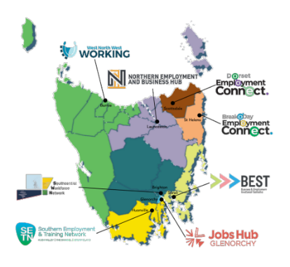Tasmania’s Regional Jobs Hub (RJH) initiative is a state-led community-driven employment, education and training program that connects local people to local jobs and develops lasting workforce solutions for employers and industry. There are currently eight Regional Jobs Hubs that work with their local Advisory Boards and Jobs Tasmania as a state-wide network, advancing regional issues to collectively inform statewide policy and program implementation.

A [recent evaluation of the RJH initiative](https://library.bsl.org.au/bsljspui/bitstream/1/13495/1/RegionalJobsHub_Final_Eval_Report_2024.pdf), conducted by the Social Policy and Research Centre at the Brotherhood of St Laurence, found that the RJH initiative is driving effective and efficient individual and state wide results. Emerging findings indicate that the RJH initiative has led to strong training and employment outcomes, innovative workforce solutions for priority industries and jobseekers and greater alignment of policy, programs and resources across state government departments. The evaluation detailed a number of key learnings:

* To establish a genuine place-based, networked model, government must change its stewardship role through for example devolving power to community to drive the work and by adopting funding models that are non-competitive between HUB providers to reduce overlap between jurisdictions (regions) and incentive collaboration.
* Being embedded in the community is important for developing a strategic outlook of a region’s workforce challenges and opportunities, as well as community trust borne of their familiarity and visibility in community as a single point of contact.
* A person-centred approach to supporting individual job seekers and employers, unbound from time constraints or compliance requirements, is key to delivering meaningful, lasting education, training and employment outcomes.
* Hubs and state government have the employer and industry connections to work effectively on the demand-side and as a bridge between job seekers and businesses.

Engaging with stakeholders for the Roadmap, JSA heard that Tasmania’s RJH initiative is highly regarded and is being used as a prototype for the development of place-based initiatives in other parts of the regional jobs and skills system, particularly Whyalla in South Australia. This is a great example of parts of Regional Australia, learning from and leveraging innovation from elsewhere in the jobs and skills system.

### University of Tasmania – studying health and medicine in Burnie

The University of Tasmania (UTAS) is the predominant higher education provider in Tasmania. Such a positioning brings with it both unique opportunities and responsibilities. UTAS is naturally inclined to be more responsive to local needs for training, tailor offerings to align with local cohorts and steward the system effectively as the primary provider for a key pillar of the system. UTAS also seeks to act strategically and systematically across sectors and regions to help contribute to the future success of Tasmania. An example of this in practice is the expansion of the UTAS medical school to Burnie in North West Tasmania.

As a result of this, the University of Tasmania’s rural medical school program now enables students to start and finish a medical degree at its Cradle Coast campus. Previously, such students were required to spend 3 years in Hobart before electing to complete their final 2 years of study on the northwest coast of Tasmania. Through the expansion of its offering, UTAS is now providing greater access and opportunities for people to pursue a medical career, while also helping to meet the current and future workforce needs of North-West and West Coast of Tasmania.

* The ‘Rural Clinical School’ reputation has grown to the point where it is the preferred destination for the final 2 years over placements at the Royal Hobart Hospital. The partnership with the community has been pivotal to the medical students feeling welcomed and valued by the community.
* Ahead of doing the full course, the Rural Clinical School ran a pilot with a small cohort (who for practical reasons couldn’t have done their first 3 years in Hobart) so the model was well tested launching. In the first cohort, 5 of the 20 students are Aboriginal.

Developing such an offering required an intentional investment. Expanding training and education delivery to smaller markets, such as in Regional Australia, requires a different perspective given the implications for the size and timing of expected returns. This goes beyond just establishing staff and teaching facilities, to also developing curriculum and ensuring that the program will be viable in the long-term. Planning beyond typical funding cycles or investment horizons is often required, with collaborative action and long-term thinking a precursor to success.

### VET student accommodation: Batchelor Institute

In March 2025, the Australian Government announced funding to provide more First Nations students in Central Australia with greater access to quality education, including $5.1 million to support construction of a new culturally safe and supported accommodation centre at the Batchelor Institute of Indigenous Tertiary Education in the Desert Knowledge Precinct in Alice Springs.

The Institute is a leader in Aboriginal and Torres Strait Islander tertiary education, committed to empowering Aboriginal and Torres Strait Islander peoples through education and ensuring students from remote communities have the support they need to succeed. The new accommodation will support students enrolled in the Institute’s diverse range of programmes, from vocational certificates to higher education degrees, enabling them to focus on their education without the challenges of unsuitable accommodation.

Expressing gratitude for the funding, the Institute’s Executive Dean of Higher Education, Professor Kathryn Gilbey, noted that the new accommodation will create a home away from home for its students, many of whom travel vast distances to study at the Institute. Professor Gilbey added that the funding will be particularly important in supporting the Institute’s ‘both ways’ philosophy, which positions First Nations people as knowledge holders.

The Australian Government’s funding of student accommodation at the Batchelor Institute provides an example of delivering education that respects Indigenous and/or Torres Strait Islander ways of learning, helping students build futures, whilst preserving their cultural identities.

### University of Newcastle – University Pathway Programs

The University of Newcastle has a strong history of success in running supporting pathway programs to enable people to prepare for and access further study opportunities, including those who may not follow typical education pathways.

Open Foundation is a free pathway program offered at the University of Newcastle for people who do not have the preparation or qualifications required for direct entry into their desired undergraduate degree. Support includes academic advice, career advice, counselling and in-depth support around key subject areas including mathematics, science and health science, English language, academic writing and study skills.

The first pathway program in Australia, Open Foundation has seen tens of thousands of students set out on their educational journeys, helping them to realise their dreams and achieve their goals. This includes high school students doing non-award courses at the university to assist with preparing them for a future career.

In addition, the University of Newcastle Yapug program is a pathway program specifically designed to enable to Aboriginal and Torres Strait Islander people to gain skills for entry into university while immersing them in Indigenous knowledge, history and culture.

Aboriginal and Torres Strait Islander students can also draw on a range of programs and social activities through the Wollotuka Institute – a dedicated support and research centre for Aboriginal and Torres Strait Islander students. Some of the key services offered by the Wollotuka Institute include counselling, tutorial assistance, a well-equipped resource centre, audio and visual materials on Indigenous topics and issues, health support and cultural programs.

### Transition to Work

Transition to Work (TtW) is a youth-focused pre-employment service that operates alongside the Australian Government’s mainstream employment service. It targets young people aged 15-24 years old who may not have completed school, have limited or no work experience, identify as Aboriginal or Torres Strait Islander, or are experiencing challenges that impact the ability to work or study. By design, the TtW cohort have very low labour market competitiveness, facing both vocational and non-vocational barriers in their transition from school to work.

Participants in TtW (now Workforce Australia – Transition to Work) receive intensive, pre-employment support from youth-specialist providers to develop practical skills to get a job, connect with education or training, find local job opportunities and connect with relevant local community organisations and other government agencies. The TtW model services young people who are at risk of long-term unemployment in a more holistic way than the mainstream employment program, in recognition of the fact it takes time for young people experiencing vocational and non-vocational barriers to employment to build the skills and personal capabilities they need to move into sustainable work.

Key features of the program design include:

* a stronger focus on human capability development and less of a ‘work-first’ focus than typical mainstream services
* an equal focus on education and employment outcomes
* limiting the number of providers to one per region to reduce competition in delivery, ensure sufficient caseload sizes and provide a central point of contact for disengaged youth
* time-limited with young people able to access the program for up to 18 months (or 24 months where more complex barriers are recognised)
* higher up-front payments for providers, including the provision of funding on a quarterly basis based on the number of allocated ‘places’ (or expected participants).

The [Supplementary Evaluation Report](https://www.dewr.gov.au/download/16743/transition-work-supplementary-evaluation-report-2016-2021/39210/transition-work-supplementary-evaluation-report-2016-2021/pdf) for Transition to Work (published December 2024) demonstrated the success of the program, with a key highlight being the demonstrated validity of focussing on human capability building and less of a ‘work-first’ focus than mainstream services for disadvantaged young people. In addition, some of the impacts achieved for targeted cohorts were also substantial. For example, TtW participants who were ex-offenders at referral were 11.5 percentage points less likely than ex-offenders in the matched comparison group to reoffend in the 4 years from commencement.

### Hunter Trade College

Hunter Trade College is an Independent school that is an accredited RTO and senior school (years 11 and 12). Hunter Trade College provides the opportunity for students to complete their Higher School Certificate (including core subjects in Maths, English and Computing Studies), undertake key work readiness training (such as First Aid, White Card, Working at Heights) and engage in trade-focussed vocational education and training.

Trades encompass the automotive, construction, electrical, plumbing and metals/engineering fields, with students either completing or achieving a Statement of Attainment towards a Certificate I, II or III qualification. Students develop their trade skills under the leadership of qualified, experienced and caring staff who provide expert training in vocational skills and supporting academic skills.

Students also work in purpose-built, modern education facilities featuring current and industry-standard equipment and undertake up to 144 days of industry experience across a range of employers (including small businesses) and industries, with around 400 regional employers engaging in the work placement program. A Student Wellbeing Program also provides students with well-being and support services, alongside dedicated learning support where needed.

Hunter Trade College offers a successful model of education and skills development that simultaneously addresses multiple challenges and opportunities. Hunter Trade College helps increase youth engagement in education and training, supports students through appropriate job readiness and wellbeing support, and provides a clear pathway to completing a trade via an apprenticeship with an employer in key skill priority areas. Around 80% of Hunter Trade College students progress to a paid apprenticeship or other employment, with the school also supporting a growing cohort of young women and Aboriginal and Torres Strait Islander students among its approximately 270 or so students.

### Incat – Model of apprenticeships support and development

Incat Tasmania is working towards the transition to zero emission passenger and vehicle ferries. Incat offers trade pathways in fabrication, welding, engineering, electrical, electronics and instrumentation in partnership with TasTAFE and other specialist RTOs.

Incat’s industry-leading apprentice training program blends hands-on experience with theoretical learning. First-year apprentices spend up to six months in the shipyard’s dedicated training centre, where they develop foundational skills before transitioning to the production floor – ensuring they are well-prepared for the challenges ahead. Incat engages external organisations to ensure holistic support is available to apprentices throughout their training journey, including exercise physiology services, financial advice and targeted mentoring.

Seven dedicated training staff are employed at Incat, including an Apprentice Supervisor and a Training Support Officer who are responsible for the wellbeing and educational requirements of every apprentice. This approach is highly effective in engaging students who may otherwise drop out of schooling (noting the very low school completion rate in Tasmania), who may prefer more hands-on learning, or who lack the work-readiness or language, literacy and numeracy skills to move immediately into an apprenticeship.

Figure 50: Overview of Incat Tasmania’s model of engaging and supporting apprentices

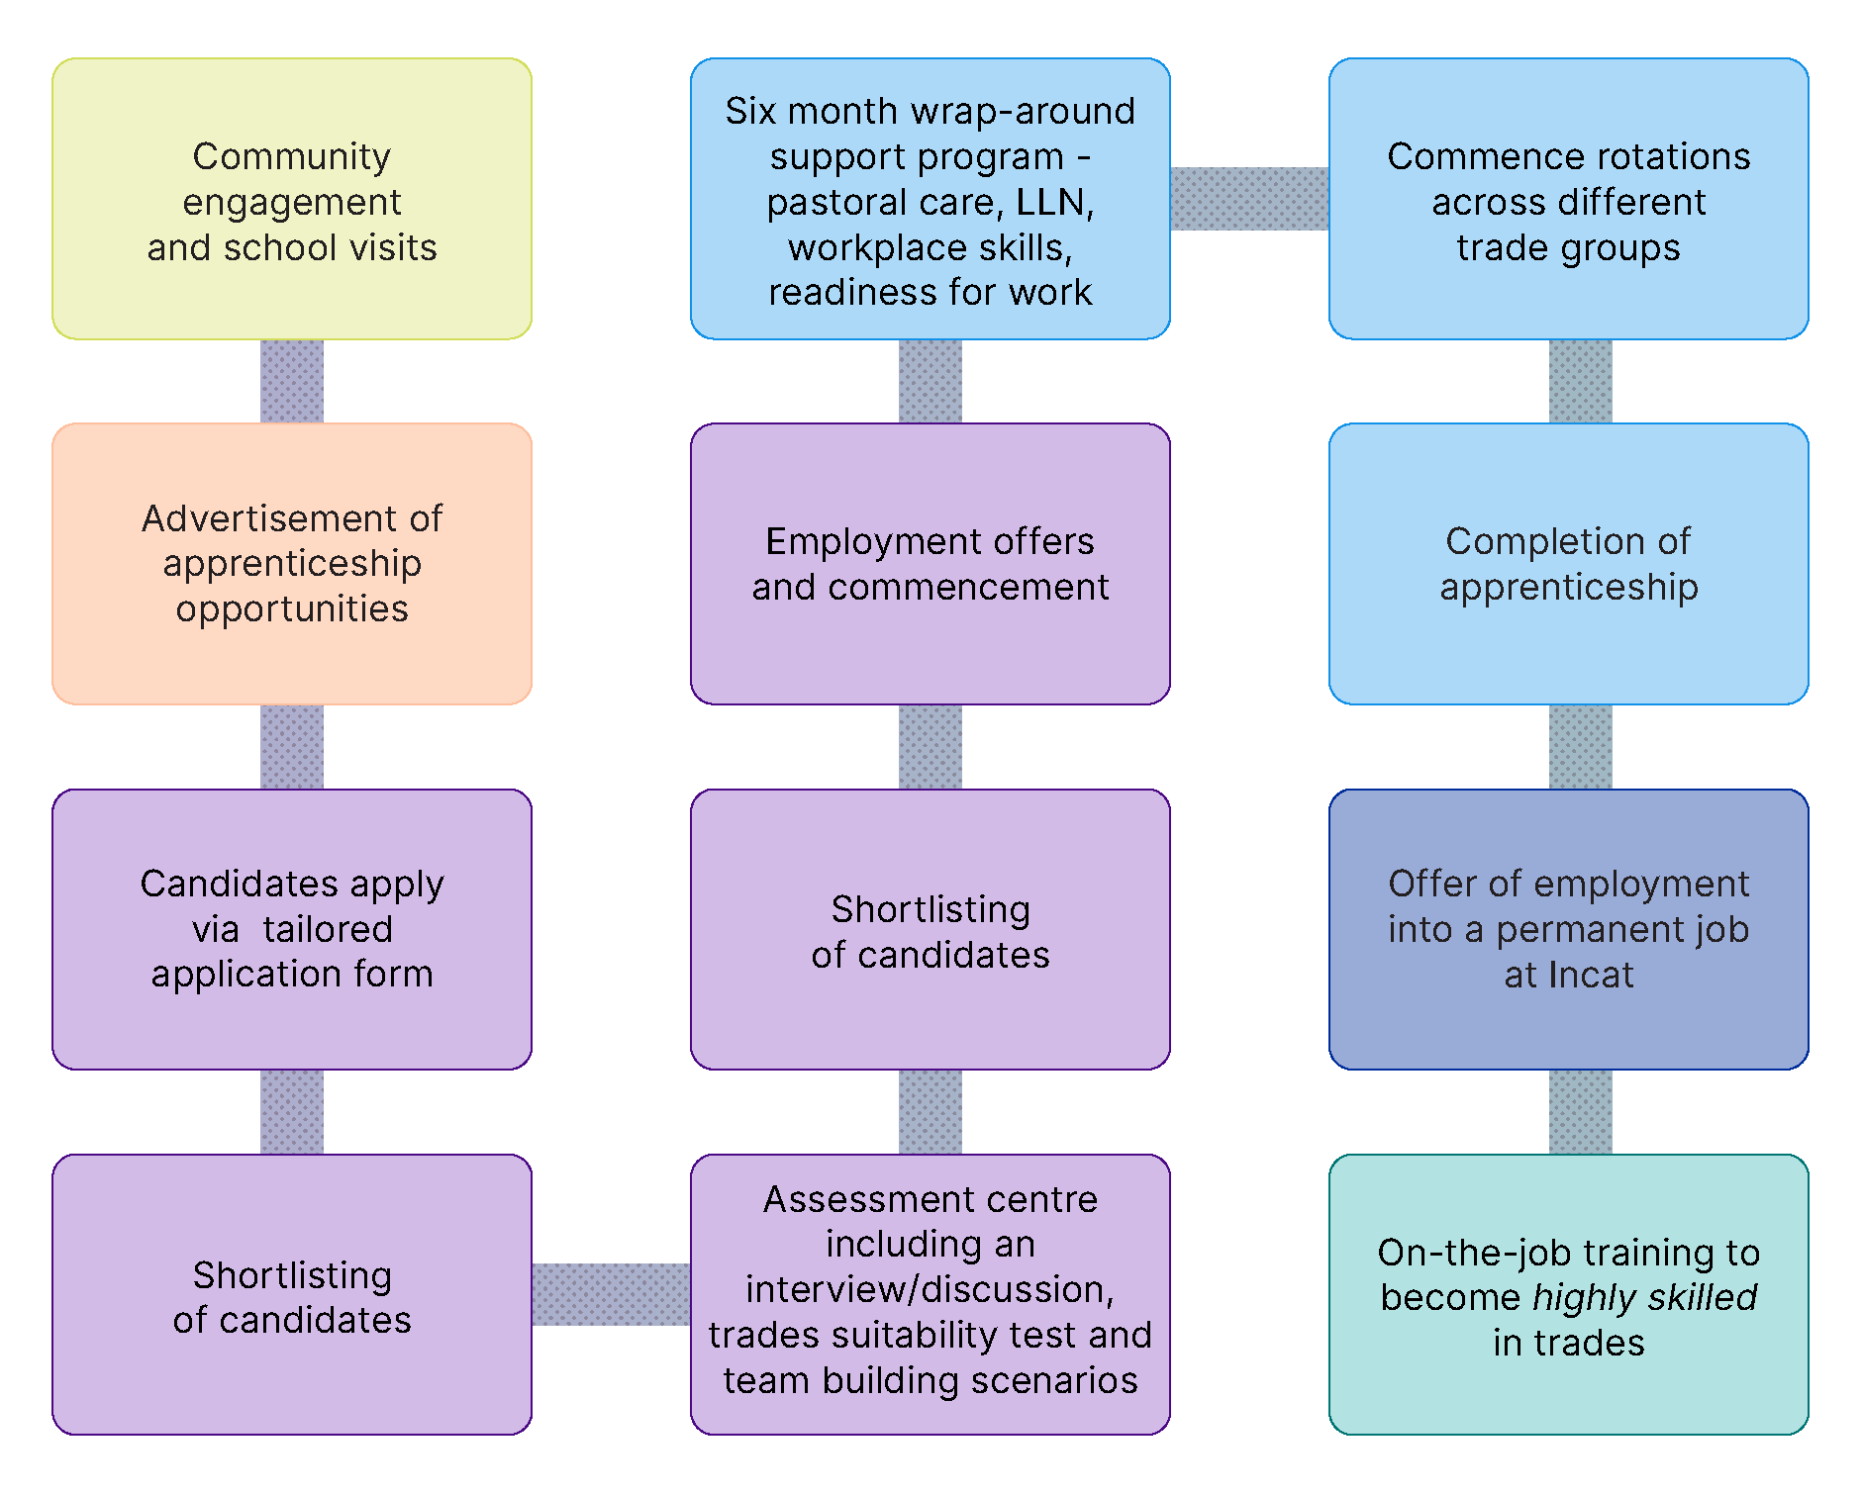

### Skills for Education and Employment (SEE) Program

The Skills for Education and Employment (SEE) Program is an Australian Government initiative that delivers free language, literacy, numeracy and digital skills training to eligible Australians. The SEE Program is delivered by a national network of training providers across the Major Cities and regional and remote Australia. It is delivered in 2 distinct and complementary streams.

* **General SEE Delivery:** skills training delivered by contracted training providers, offering both accredited and non-accredited training, providing more support for learners and includes workplace-based training options.
* **SEE First Nations:** dedicated to whole of community skills training delivery to First Nations people. SEE First Nations grants fund First Nations organisations including Aboriginal Community Controlled Organisations (ACCOs), registered training organisations (RTOs), Adult Community Education (ACE) providers or peak bodies (applying on behalf of their eligible members) to design appropriate training to suit their needs.

Both SEE delivery models are critical to addressing barriers to participation in education, training and employment across Regional Australia through strengthening foundation skills. Key elements include:

* In-person, in-community or online
* Flexible training, tailored to the individual needs of participants
* Training is available full-time or part-time, up to 25 hours a week
* Accredited and non-accredited training options
* Participants can begin at their own level and learn at their own pace

For more information, including participant success stories, visit the SEE Program webpage at <https://www.dewr.gov.au/skills-education-and-employment>.

### Jobs and Skills Australia’s Foundation Skills Study[35]

Foundation skills are the competencies that underpin workforce participation, productivity and social inclusion. They include English language, literacy, numeracy and digital (LLND) and employability skills. Foundation skills are core ‘learning to learn’ skills, necessary to provide people access to an education system from which follows opportunities to develop careers and engage in lifelong learning.

Currently there is no single data source measuring levels of foundation skills across Australia. School level data exist with both the Programme for International Student Assessment (PISA) and the National Assessment Program – Literacy and Numeracy (NAPLAN). However, the only national level adult data for Australia is from the Programme for International Assessment of Adult Competencies (PIAAC) survey, conducted in 2011-12. As a result, JSA is currently undertaking a number of major pieces of work to address these data gaps and better understand the foundation skills levels of Australian adults.

* ***National Survey of Adult Literacy and Numeracy Skills*** also known as *Understanding Skills Across Australia* will measure adult literacy and numeracy levels to assist researchers, policy makers and program managers to improve services related to foundation skills.
* ***Murtu Yayngiliyn – Walking Together*** is a feasibility study being conducted in consultation with the National Indigenous Australians Agency to determine how best to assess the literacy, numeracy, and digital literacy levels of First Nations people, including those living in regional and remote areas.
* ***Administrative Data Project*** explores personal and *aggregate* level data to uncover new insights on the literacy and numeracy levels of priority groups of interest.
* ***Defining Digital Literacy*** aims to define digital literacy as a foundation skill for the Australian context, through a comprehensive review of national and international frameworks, stakeholder consultation, and integration into the broader National Skills Taxonomy initiative

JSA is committed to ensuring the study delivers on the promise of building an evidence base for foundation skills in Australia.

Path to enacting the Roadmap

Forthcoming stakeholder consultation process and roundtables to support the development of local and State/Territory based regional roadmaps

## Supporting state and territory based regional roadmaps

In Phase 1, JSA has developed this overarching Regional Roadmap, focusing on Regional Australia at the broad, national level, in consultation with key stakeholders across the country. This has been underpinned by meetings in person in a range of regions across the states and territories. We have sought to identify the cross-cutting themes, develop performance indicators and provide an overall assessment of the way forward. We have also considered how this can vary across states and territories.

Reforming the jobs and skills system, and harmonising its various components (e.g., VET and Higher Education) for the benefit of individual regions, will require collaboration between the tiers of government. In Phase 2, JSA will seek to work with each state and territory to support them as they lay the groundwork for establishing Regional Jobs and Skills Roadmaps for their own state and territory. This will commence with a series of roundtables in regional locations across Regional Australia in the second half of 2025.

### Partnership between Commonwealth and State/Territory Governments

Commonwealth and state and territory governments share responsibilities for education and training. State governments have primary responsibility for primary and secondary schooling and vocational education and training (VET), and the Commonwealth has primary responsibility for higher education.

The Commonwealth provides major funding support for VET and for schools, especially non-government schools, and there are key national regulatory frameworks and regulations, and national bodies like the Australian Curriculum Assessment and Reporting Authority (ACARA), the Australian Skills Quality Authority (ASQA), and the Tertiary Education Quality and Standards Agency (TEQSA) , giving the Commonwealth major roles in school education, VET and higher education respectively.

In higher education, although funding comes primarily from the Commonwealth, universities are mostly established under state legislation and their governance shaped by state governments.

The establishment of JSA and the proposed establishment of the Australian Tertiary Education Commission (ATEC) under Commonwealth legislation, are 2 more important developments at the national level. To be effective they need to work closely with state governments.

### Development of state and territory Regional Roadmaps

This Roadmap (‘Phase 1 Report’) provides a national framework with a national vision for Regional Australia. It is underpinned by 5 vision principles and progress measures.

This work has identified a number of important common challenges for Regional Australia that exist across the states and territories. However, these challenges have different levels of importance – higher or lower - for different states and territories and their various regions. How they seek to meet these challenges will often require Commonwealth-State collaboration with some principles in the hands of the Commonwealth and some in the hands of the states and territories.

A second Roadmap (‘Phase 2 Report’) will be developed which will test the national framework at the state and territory level (for example, for Regional Victoria). Such an approach would also be informed by public submissions provided in response to this Roadmap.

In the Phase 2 Report, JSA will highlight more state and territory specific interventions that could be useful for other jurisdictions to consider in pursuit of the shared vision for the jobs and skills system in Regional Australia. Appendix 1 of this Report includes a range of State and Territory level data relevant to the overarching framework of the Roadmap as a starting point. JSA welcomes partnering with individual states and territories with an interest in developing jurisdiction roadmaps as an output of Phase 2.

Figure 51: Overview of JSA Regional Roadmap - Phase 1 and Phase 2



|  |
| --- |
| Box: Tasmanian Government’s Youth Jobs Strategy 2024-2030  The Tasmanian Government’s Youth Jobs Strategy 2024-2030 aims to increase youth engagement and participation in employment, further education or training by aligning effort across governments, industry, the education and training sector, and community to help young Tasmanians live fulfilling and productive lives.  The Strategy will build on existing efforts in place to ensure that all young people in Tasmania can access opportunities for employment in decent, meaningful work, and employers and industry can attract, develop and retain skilled young employees for a thriving community and productive economy.  It was informed by an extensive consultation process with input from industry, community, and – most importantly – young people. It will be supported by successive 2-year actions plans that will detail the specific activities, initiatives, and policies that will collectively work towards achieving the strategy’s ambition. This includes activating the systems, policy and program principles across the employment, education and training ecosystem, and joining up efforts both in place and across government, industry and community.  Tasmanian Government’s Youth Jobs Strategy 2024-2030 provides an example of stakeholders working together to develop a place-based response to a key jobs and skills issues facing the local community. While the strategy is centred on youth, this nonetheless is a strong example of the types of strategies and roadmaps JSA’s Regional Roadmap seeks to support and inspire. |

## Supporting local place-based strategies

The relationship between Regional Australia and the rest of the country is not uniform. The connections and interactions with Major Cities and other parts of Regional Australia vary by region, depending on its degree of remoteness, industry composition, transport links, population flows and mobility and many other factors.

JSA's Regional Roadmap can also be used in the development of further roadmaps at the local community level. Given the wide range of education and training outcomes seen across Australia and the varying structure and operation of the jobs and skills system across regional areas, in many cases the development of a more localised roadmap will be appropriate and advantageous.

There are strategies and roadmaps already in place or in development at the local level. However, there also remains substantial opportunities to develop jobs and skills roadmaps for different groups or clusters of regions, such as for remote Australia and for Northern Australia. JSA welcomes engagement with organisations involved in developing regional-level roadmaps to help inform Phase 2.

|  |
| --- |
| Stakeholder insight  *‘As regional people are well aware, what is needed in regional, rural and remote Australia is different to what is needed in the cities. To take these differences into account we need a local approach, not one-size-fits-all, and we need to listen to people on the ground in the regions and their homegrown solutions to challenges.’*  **Fiona Nash**  Regional Education Commissioner |

|  |
| --- |
| Stakeholder insight  *‘Capturing data that reflects the strengths, voices and realities of regional and remote Australia—particularly First Nations communities—is essential to shaping a more responsive and inclusive jobs and skills system for the future.’*  **Natasha Storey**  Project Manager  Mount Isa Regional Jobs Committee |

|  |
| --- |
| Box: Mount Isa: Future Ready Economy Roadmap  In February 2025, Mount Isa City Council released Mount Isa Future Ready Economy Roadmap. [36] This Roadmap formulates a plan to transform and diversify the local economy while delivering immediate jobs and long-term benefits for Mount Isa residents. Mount Isa City Council initiated development of the Roadmap to take advantage of opportunities associated with the net zero transformation and in response to the announcement by Glencore, the town’s biggest employer as owner of Mount Isa Mines, that its underground copper operations would close.  The roadmap presents 28 pathways and nearly 400 potential actions for local stakeholders, industry, government and community to strengthen and diversify the Mount Isa economy across energy, mining and minerals, transport, agriculture, and tourism. The roadmap highlights a number of key initiatives to diversify the local economy, including memorandums of understanding to support innovative regional energy and transport solutions, such as Green Gravity’s energy storage system and Flying Whales’ airship for cargo transport.  The recommendations put forward in Mount Isa’s Future Ready Economy Roadmap, accord with the recommendations in JSA’s Clean Energy Generation report. This report highlighted the need for Government support and leadership in regions where economic diversity and adaptability are relatively low. In particular, it points to the need for local investment in new industries and in ensuring that impacted workers receive targeted training and other forms of support to transition into roles that build on their existing skills. |

## Public consultation and submission process – including guiding questions

To date, Jobs and Skills Australia (JSA) has consulted with a range of organisations from Regional Australia through meetings, roundtables, field trips to Regional Australia, the JSA Regional Advisory Group, the JSA Ministerial Advisory Board, correspondence and other means and forums. This includes engaging with higher education providers, vocational education and training institutions, schools, employment service providers, industry bodies, businesses, trade unions, other social service organisations, academics, government agencies across Commonwealth, State/Territory and local levels, and other non-government organisations.

|  |
| --- |
| Stakeholder insight  *‘People and their connections to community are integral to the success of the regional jobs and skills system. Genuine progress can only be made through collaboration and shared ownership among stakeholders. Having the right people to deliver collaborative change is just as critical as having the right policies and programs.’*  **Justin Page**  Hunter Jobs Alliance |

JSA is seeking insights and feedback from stakeholders to help support the refinement and implementation of the Regional Roadmap. JSA’s Jobs and Skills Roadmap for Regional Australia – Phase 1 seeks to provide an overarching framework that can be shared by stakeholders as they work together to enhance the equity, effectiveness and efficiency of the jobs and skills system across Regional Australia.

Further consultation and engagement via this stakeholder submission process will help to refine and strengthen the Regional Roadmap and enhance its usefulness for stakeholders across Regional Australia.

### How will the submissions and responses be used by JSA?

Following the receipt of submissions from stakeholders, JSA will review and consider all submissions. The submissions will be used by JSA to help inform Phase 2 of JSA’s Regional Roadmap, which will include refined Phase 1 content (in response to feedback from stakeholders) and outline potential pathways to enacting the Roadmap at the local, jurisdictional and sectoral level. JSA plans to publish the Phase 2 – Regional Roadmap in late 2025 or early 2026.

### What are the key guiding questions to help inform submissions?

The list below provides an indication of the key questions JSA is seeking to hear stakeholder views on through this public consultation process. The questions are not intended to be prescriptive, however the list below nonetheless provides guidance to help inform responses. Respondents can also provide further information or insights that they consider relevant to the Regional Roadmap or Regional Australia more broadly.

1. To what extent do the underpinning vision principles of the Roadmap provide a comprehensive vision for the jobs and skills system in Regional Australia? Are these vision principles a useful framework to help consider the jobs and skills system? Do they support an appropriate consideration of the jobs and skills system for all groups of people?
2. Do the evaluative metrics included in the Roadmap sufficiently reflect the jobs and skills system in Regional Australia? Do the ratings included in the Roadmap reflect your current experience or perspective of the jobs and skills system in Regional Australia?
3. How relevant and useful are the 10 policy design principles? Are the other emerging policy priorities to enhance the jobs and skills system in Regional Australia consistent with your perspective of priority needs and actions for your region/sector?
4. How likely are you to use the JSA Regional Roadmap as an initial framework to guide the development of a regional roadmap for your specific region or sector? What would make JSA’s Roadmap more useful and impactful?
5. How can stakeholders work together and commit to enhancing the jobs and skills system in Regional Australia? How can JSA help facilitate and support this?

### Where can I find out more about how to make a submission?

Further information about the submission and consultation process, including how to make a submission, can be found at <https://www.jobsandskills.gov.au/consultations/>

For questions or assistance, please email: [RegionalWorkforceAssessment@jobsandskills.gov.au](mailto:RegionalWorkforceAssessment@jobsandskills.gov.au)

**Privacy Statement & Disclaimer**

Jobs and Skills Australia (JSA) may use the information provided to help inform further iterations of the Roadmap, policy and research, but any quotes or direct references will only be used with your permission. JSA reserves the right to not review or utilise any material submitted as part of this stakeholder consultation process. This includes (but is not limited to) material that is offensive, potentially defamatory, or clearly out of scope. All submissions are confidential and will not be published. If JSA wishes to quote any part of your submission, we will contact you via the email address you have provided. Information provided, including personal details, will only be used for the purpose for which they have been provided, as per JSA’s [Privacy Policy](https://www.jobsandskills.gov.au/privacy).

Appendices

Appendix 1: Roadmap metrics by State and Territory

An initial assessment of the current state of the jobs and skills system across the regional areas of each State and Territory, utilising the framework of the Roadmap

# Appendix 1: Roadmap metrics by State and Territory

### Evaluative metrics by State and Territory

The Regional Roadmap provides a national framework with a national vision for Regional Australia. It is underpinned by 5 vision principles and progress measures. This work has identified a number of important common challenges for Regional Australia that exist across the states and territories.

The Phase 2 Report will test the national framework at the state and territory level and allow for sub-state analysis to be targeted to specific regions or types of regions. In Phase 2, where possible, each indicator will be assessed on the current rate (how it compares to historical outcomes, outcomes for the Major Cities of Australia and other useful benchmarks) and direction of trend (is whether the indicator is improving, weakening or relatively stable) and a overall rating or assessment will be provided for each vision principle. The tables below highlight a snapshot of evaluative framework from the current rate perspective, by state and territory.

## Summary of Roadmap indicators by state and territory

Table 32: Summary of Roadmap indicators state and territory

|  |  |  |  |  |  |  |  |  |  |  |
| --- | --- | --- | --- | --- | --- | --- | --- | --- | --- | --- |
| Roadmap Indicators | Reg. NSW | Reg. Vic | Reg. QLD | Reg. SA | Reg. WA | TAS | NT | Regional Australia | *ACT* | *Major Capitals* |
| 1. School non-attendance rate (%) | 14.0 | 13.0 | 13.7 | 15.0 | 17.1 | 13.9 | 26.0 | **14.6** | *11.4* | **10.5** |
| 1. Youth not in education, employment, training (%) | 13.8 | 17.4 | 18.1 | 19.3 | 9.2 | 13.4 | 13.7 | **15.3** | *5.6* | **9.4** |
| 1. Prime age participation rate (%) | 85.0 | 86.1 | 86.6 | 81.6 | 84.5 | 83.9 | 83.3 | **85.4** | *90.8* | **87.3** |
| 1. Unemployment rate (%) | 4.1 | 3.6 | 4.1 | 4.3 | 3.6 | 3.8 | 4.2 | **4.0** | *3.3* | **4.4** |
| 1. Prop. of population on long-term income support (%) | 2.3 | 2.3 | 2.1 | 3.8 | 2.8 | 2.6 | 5.0 | **2.4** | *0.7* | **1.3** |
| 1. Completion rates for apprentices and trainees (%) | 62.0 | 53.8 | 57.6 | 55.3 | 57.4 | 61.3 | 50.6 | **56.7** | *50.4* | 52.8 |
| 1. Youth tertiary participation rate (%) | 27.5 | 14.1 | 21.4 | 14.5 | 28.2 | 19.0 | 17.8 | **22.2** | *36.1* | **37.5** |
| 1. Prop. working in lower skill level than qualification level (%) | 23.8 | 26.6 | 27.9 | 19.8 | 18.4 | 26.4 | 31.3 | **25.7** | *28.8* | **30.9** |
| 1. Prop. working in same field as most relevant qualification (%) | 70.1 | 74.4 | 74.8 | 63.0 | 69.7 | 72.3 | 72.9 | **72.7** | *73.4* | **70.9** |
| 1. High job satisfaction (%) | n/a | n/a | n/a | n/a | n/a | n/a | n/a | **38.8** | *n/a* | **33.1** |
| 1. Underemployment rate (%) | 6.5 | 5.8 | 6.4 | 7.5 | 4.8 | 7.4 | 4.0 | **6.1** | *4.9* | **6.1** |
| 1. Income inequality ratio | 3.3 | 3.2 | 3.5 | 3.4 | 4.2 | 3.1 | 3.8 | **3.5** | *2.7* | **3.2** |
| 1. Workers’ compensation incidence rate | 12.3 | 7.4 | 7.4 | 6.2 | 14.7 | 12.5 | 4.8 | **9.6** | *6.1* | **9.2** |
| 1. Vacancy fill rate (%) | 63.0 | 59.5 | 69.7 | 54.7 | 68.8 | 70.1 | 60.8 | **64.7** | *71.4* | **69.9** |
| 1. Essential services vacancy rate (%) | 6.3 | 7.1 | 6.3 | 13.8 | 7.1 | 6.6 | 8.2 | **8.5** | *7.1* | **6.1** |
| 1. Incidence of persistent hiring pressures (%) | n/a | n/a | n/a | n/a | n/a | n/a | n/a | **36.8** | *n/a* | **23.2** |
| 1. Business creation rate (%) | 2.2 | 2.4 | 2.5 | 1.7 | 1.7 | 1.7 | 1.6 | **2.2** | *2.2* | **3.2** |
| 1. Beveridge Curve analysis | n/a | n/a | n/a | n/a | n/a | n/a | n/a | **n/a** | *n/a* | n/a |
| 1. Efficiency of labour market matching (%) | 84.1 | 83.4 | 84.1 | 69.8 | 63.5 | 78.0 | 80.4 | **80.7** | *89.0* | **83.0** |

## Regional New South Wales

Table 33: Roadmap indicators for Regional New South Wales, Sydney and Regional Australia

|  |  |  |  |
| --- | --- | --- | --- |
|  | Regional NSW | Sydney | Regional Australia |
| Vision Principle 1 |  |  |  |
| 1. School non-attendance rate (%) | **14.0** | 9.9 | **14.6** |
| 1. Youth not in education, employment, training (%) | **13.8** | 8.3 | **15.3** |
| 1. Prime age participation rate (%) | **85.0** | 87.0 | **85.4** |
| 1. Unemployment rate (%) | **4.1** | 4.3 | **4.0** |
| 1. Proportion of population on long-term income support (%) | **2.3** | 1.2 | **2.4** |
|  |  |  |  |
| Vision Principle 2 |  |  |  |
| 1. Completion rates for apprentices and trainees (%) | **62.0** | 50.2 | **56.7** |
| 1. Youth tertiary participation rate (%) | **27.5** | 39.3 | **22.2** |
| 1. Proportion working in lower skill level than qualification level (%) | **23.8** | 30.9 | **25.7** |
| 1. Proportion working in same field as most relevant qualification (%) | **70.1** | 68.8 | **72.7** |
|  |  |  |  |
| Vision Principle 3 |  |  |  |
| 1. Job satisfaction (%) | **n/a** | n/a | **38.8** |
| 1. Underemployment rate (%) | **6.5** | 5.8 | **6.1** |
| 1. Income inequality ratio | **3.3** | 3.4 | **3.5** |
| 1. Workers’ compensation incidence rate | **12.3** | 12.5 | **9.6** |
|  |  |  |  |
| Vision Principle 4 |  |  |  |
| 1. Vacancy fill rate (%) | **63.0** | 68.6 | **64.7** |
| 1. Essential services vacancy rate (%) | **6.3** | 5.2 | **8.5** |
| 1. Incidence of persistent hiring pressures (%) | **n/a** | n/a | **36.8** |
| 1. Business creation rate (%) | **2.2** | 3.3 | **2.2** |
|  |  |  |  |
| Vision Principle 5 |  |  |  |
| 1. Beveridge Curve analysis | n/a | n/a | n/a |
| 1. Efficiency of labour market matching (%) | 84.1 | 81.8 | **80.7** |

## Regional Victoria

Table 34: Roadmap indicators for Regional Victoria, Melbourne and Regional Australia

|  |  |  |  |
| --- | --- | --- | --- |
|  | Regional VIC | Melbourne | Regional Australia |
| Vision Principle 1 |  |  |  |
| 1. School non-attendance rate (%) | **13.0** | 10.9 | **14.6** |
| 1. Youth not in education, employment, training (%) | **17.4** | 8.3 | **15.3** |
| 1. Prime age participation rate (%) | **86.1** | 87.8 | **85.4** |
| 1. Unemployment rate (%) | **3.6** | 5.0 | **4.0** |
| 1. Proportion of population on long-term income support (%) | **2.3** | 1.2 | **2.4** |
|  |  |  |  |
| Vision Principle 2 |  |  |  |
| 1. Completion rates for apprentices and trainees (%) | **53.8** | 52.4 | **56.7** |
| 1. Youth tertiary participation rate (%) | **14.1** | 39.6 | **22.2** |
| 1. Proportion working in lower skill level than qualification level (%) | **26.6** | 32.9 | **25.7** |
| 1. Proportion working in same field as most relevant qualification (%) | **74.4** | 71.0 | **72.7** |
|  |  |  |  |
| Vision Principle 3 |  |  |  |
| 1. Job satisfaction (%) | n/a | n/a | **38.8** |
| 1. Underemployment rate (%) | **5.8** | 6.7 | **6.1** |
| 1. Income inequality ratio | **3.2** | 3.4 | **3.5** |
| 1. Workers’ compensation incidence rate | **7.4** | 6.5 | **9.6** |
|  |  |  |  |
| Vision Principle 4 |  |  |  |
| 1. Vacancy fill rate (%) | **59.5** | 72.5 | **64.7** |
| 1. Essential services vacancy rate (%) | **7.1** | 4.9 | **8.5** |
| 1. Incidence of persistent hiring pressures (%) | **n/a** | n/a | **36.8** |
| 1. Business creation rate (%) | **2.4** | 3.8 | **2.2** |
|  |  |  |  |
| Vision Principle 5 |  |  |  |
| 1. Beveridge Curve analysis | n/a | n/a | n/a |
| 1. Efficiency of labour market matching (%) | **83.4** | 85.2 | **80.7** |

## Regional Queensland

Table 35: Roadmap indicators for Regional Queensland, Brisbane and Regional Australia

|  |  |  |  |
| --- | --- | --- | --- |
|  | Regional QLD | Brisbane | Regional Australia |
| Vision Principle 1 |  |  |  |
| 1. School non-attendance rate (%) | **13.7** | 11.0 | **14.6** |
| 1. Youth not in education, employment, training (%) | **18.1** | 10.9 | **15.3** |
| 1. Prime age participation rate (%) | **86.6** | 87.2 | **85.4** |
| 1. Unemployment rate (%) | **4.1** | 4.6 | **4.0** |
| 1. Proportion of population on long-term income support (%) | **2.1** | 1.4 | **2.4** |
|  |  |  |  |
| Vision Principle 2 |  |  |  |
| 1. Completion rates for apprentices and trainees (%) | **57.6** | 52.9 | **56.7** |
| 1. Youth tertiary participation rate (%) | **21.4** | 31.2 | **22.2** |
| 1. Proportion working in lower skill level than qualification level (%) | **27.9** | 29.2 | **25.7** |
| 1. Proportion working in same field as most relevant qualification (%) | **74.8** | 73.1 | **72.7** |
|  |  |  |  |
| Vision Principle 3 |  |  |  |
| 1. Job satisfaction (%) | **n/a** | n/a | **38.8** |
| 1. Underemployment rate (%) | **6.4** | 6.5 | **6.1** |
| 1. Income inequality ratio | **3.5** | 3.2 | **3.5** |
| 1. Workers’ compensation incidence rate | **7.4** | 10.8 | **9.6** |
|  |  |  |  |
| Vision Principle 4 |  |  |  |
| 1. Vacancy fill rate (%) | **69.7** | 73.1 | **64.7** |
| 1. Essential services vacancy rate (%) | **6.3** | 6.1 | **8.5** |
| 1. Incidence of persistent hiring pressures (%) | **n/a** | n/a | **36.8** |
| 1. Business creation rate (%) | **2.5** | 2.5 | **2.2** |
|  |  |  |  |
| Vision Principle 5 |  |  |  |
| 1. Beveridge Curve analysis | n/a | n/a | n/a |
| 1. Efficiency of labour market matching (%) | **84.1** | 81.8 | **80.7** |

## Regional South Australia

Table 36: Roadmap indicators for Regional South Australia, Adelaide and Regional Australia

|  |  |  |  |
| --- | --- | --- | --- |
|  | Regional SA | Adelaide | Regional Australia |
| Vision Principle 1 |  |  |  |
| 1. School non-attendance rate (%) | **15.0** | 10.7 | **14.6** |
| 1. Youth not in education, employment, training (%) | **19.3** | 12.6 | **15.3** |
| 1. Prime age participation rate (%) | **81.6** | 85.5 | **85.4** |
| 1. Unemployment rate (%) | **4.3** | 4.1 | **4.0** |
| 1. Proportion of population on long-term income support (%) | **3.8** | 2.1 | **2.4** |
|  |  |  |  |
| Vision Principle 2 |  |  |  |
| 1. Completion rates for apprentices and trainees (%) | **55.3** | 54.6 | **56.7** |
| 1. Youth tertiary participation rate (%) | **14.5** | 35.1 | **22.2** |
| 1. Proportion working in lower skill level than qualification level (%) | **19.8** | 30.0 | **25.7** |
| 1. Proportion working in same field as most relevant qualification (%) | **63.0** | 69.4 | **72.7** |
|  |  |  |  |
| Vision Principle 3 |  |  |  |
| 1. Job satisfaction (%) | **n/a** | n/a | **38.8** |
| 1. Underemployment rate (%) | **7.5** | 6.9 | **6.1** |
| 1. Income inequality ratio | **3.4** | 3.0 | **3.5** |
| 1. Workers’ compensation incidence rate | **6.2** | 8.0 | **9.6** |
|  |  |  |  |
| Vision Principle 4 |  |  |  |
| 1. Vacancy fill rate (%) | **54.7** | 66.6 | **64.7** |
| 1. Essential services vacancy rate (%) | **13.8** | 6.2 | **8.5** |
| 1. Incidence of persistent hiring pressures (%) | **n/a** | n/a | **36.8** |
| 1. Business creation rate (%) | **1.7** | 2.7 | **2.2** |
|  |  |  |  |
| Vision Principle 5 |  |  |  |
| 1. Beveridge Curve analysis | n/a | n/a | n/a |
| 1. Efficiency of labour market matching (%) | **69.8** | 84.0 | **80.7** |

## Regional Western Australia

Table 37: Roadmap indicators for Regional Western Australia, Perth and Regional Australia

|  |  |  |  |
| --- | --- | --- | --- |
|  | Regional WA | Perth | Regional Australia |
| Vision Principle 1 |  |  |  |
| 1. School non-attendance rate (%) | **17.1** | 10.6 | **14.6** |
| 1. Youth not in education, employment, training (%) | **9.2** | 10.2 | **15.3** |
| 1. Prime age participation rate (%) | **84.5** | 87.4 | **85.4** |
| 1. Unemployment rate (%) | **3.6** | 3.9 | **4.0** |
| 1. Proportion of population on long-term income support (%) | **2.8** | 1.4 | **2.4** |
|  |  |  |  |
| Vision Principle 2 |  |  |  |
| 1. Completion rates for apprentices and trainees (%) | **57.4** | 56.0 | **56.7** |
| 1. Youth tertiary participation rate (%) | **28.2** | 35.9 | **22.2** |
| 1. Proportion working in lower skill level than qualification level (%) | **18.4** | 29.7 | **25.7** |
| 1. Proportion working in same field as most relevant qualification (%) | **69.7** | 73.0 | **72.7** |
|  |  |  |  |
| Vision Principle 3 |  |  |  |
| 1. Job satisfaction (%) | **n/a** | n/a | **38.8** |
| 1. Underemployment rate (%) | **4.8** | 5.7 | **6.1** |
| 1. Income inequality ratio | **4.2** | 3.6 | **3.5** |
| 1. Workers’ compensation incidence rate | **14.7** | 6.7 | **9.6** |
|  |  |  |  |
| Vision Principle 4 |  |  |  |
| 1. Vacancy fill rate (%) | **68.8** | 68.3 | **64.7** |
| 1. Essential services vacancy rate (%) | **7.1** | 4.7 | **8.5** |
| 1. Incidence of persistent hiring pressures (%) | **n/a** | n/a | **36.8** |
| 1. Business creation rate (%) | **1.7** | 2.5 | **2.2** |
|  |  |  |  |
| Vision Principle 5 |  |  |  |
| 1. Beveridge Curve analysis | n/a | n/a | n/a |
| 1. Efficiency of labour market matching (%) | **63.5** | 86.4 | **80.7** |

## Tasmania

Table 38: Roadmap indicators for Tasmania and Regional Australia

|  |  |  |  |  |  |
| --- | --- | --- | --- | --- | --- |
|  | | Tasmania | | Regional Australia | |
| Vision Principle 1 | |  | |  | |
| 1. School non-attendance rate (%) | | **13.9** | | **14.6** | |
| 1. Youth not in education, employment, training (%) | | **13.4** | | **15.3** | |
| 1. Prime age participation rate (%) | | **83.9** | | **85.4** | |
| 1. Unemployment rate (%) | | **3.8** | | **4.0** | |
| 1. Proportion of population on long-term income support (%) | | **2.6** | | **2.4** | |
|  | |  | |  | |
| Vision Principle 2 | |  | |  | |
| 1. Completion rates for apprentices and trainees (%) | | **61.3** | | **56.7** | |
| 1. Youth tertiary participation rate (%) | | **19.0** | | **22.2** | |
| 1. Proportion working in lower skill level than qualification level (%) | | **26.4** | | **25.7** | |
| 1. Proportion working in same field as most relevant qualification (%) | | **72.3** | | **72.7** | |
|  | |  | |  | |
| Vision Principle 3 | |  | |  | |
| 1. Job satisfaction (%) | | **n/a** | | **38.8** | |
| 1. Underemployment rate (%) | | **7.4** | | **6.1** | |
| 1. Income inequality ratio | | **3.1** | | **3.5** | |
| 1. Workers’ compensation incidence rate | | | **12.5** | | **9.6** | | |
| \ | |  | |  | |
| Vision Principle 4 | |  | |  | |
| 1. Vacancy fill rate (%) | | **70.1** | | **64.7** | |
| 1. Essential services vacancy rate (%) | | **6.6** | | **8.5** | |
| 1. Incidence of persistent hiring pressures (%) | | **n/a** | | **36.8** | |
| 1. Business creation rate (%) | | **1.7** | | **2.2** | |
|  |  | |  | |  | |
| Vision Principle 5 |  | |  | |  | |
| 1. Beveridge Curve analysis | | | **n/a** | | **n/a** | |
| 1. Efficiency of labour market matching (%) | | | **78.0** | | **80.7** | |

## Northern Territory

Table 39: Roadmap indicators for Northern Territory and Regional Australia

|  |  |  |  |  |  |
| --- | --- | --- | --- | --- | --- |
|  | | Northern Territory | | Regional Australia | |
| Vision Principle 1 | |  | |  | |
| 1. School non-attendance rate (%) | | **26.0** | | **14.6** | |
| 1. Youth not in education, employment, training (%) | | **13.7** | | **15.3** | |
| 1. Prime age participation rate (%) | | **83.3** | | **85.4** | |
| 1. Unemployment rate (%) | | **4.2** | | **4.0** | |
| 1. Proportion of population on long-term income support (%) | | **5.0** | | **2.4** | |
|  | |  | |  | |
| Vision Principle 2 | |  | |  | |
| 1. Completion rates for apprentices and trainees (%) | | **50.6** | | **56.7** | |
| 1. Youth tertiary participation rate (%) | | **17.8** | | **22.2** | |
| 1. Proportion working in lower skill level than qualification level (%) | | **31.3** | | **25.7** | |
| 1. Proportion working in same field as most relevant qualification (%) | | **72.9** | | **72.7** | |
|  | |  | |  | |
| Vision Principle 3 | |  | |  | |
| 1. Job satisfaction (%) | | **n/a** | | **38.8** | |
| 1. Underemployment rate (%) | | **4.0** | | **6.1** | |
| 1. Income inequality ratio | | **3.8** | | **3.5** | |
| 1. Workers’ compensation incidence rate | | **4.8** | | **9.6** | |  |
|  | |  | |  | |
| Vision Principle 4 | |  | |  | |
| 1. Vacancy fill rate (%) | | **60.8** | | **64.7** | |
| 1. Essential services vacancy rate (%) | | **8.2** | | **8.5** | |
| 1. Incidence of persistent hiring pressures (%) | | **n/a** | | **36.8** | |
| 1. Business creation rate (%) | | **1.6** | | **2.2** | |
|  |  | |  | |  |
| Vision Principle 5 |  | |  | |  |
| 1. Beveridge Curve analysis | | **n/a** | | **n/a** | |
| 1. Efficiency of labour market matching (%) | | **80.4** | | **80.7** | |

## Australian Capital Territory

Table 40: Roadmap indicators for Australian Capital Territory and Regional Australia

|  |  |  |  |  |  |  |
| --- | --- | --- | --- | --- | --- | --- |
|  | | | ACT | | Regional Australia | |
| Vision Principle 1 | | |  | |  | |
| 1. School non-attendance rate (%) | | | 11.4 | | **14.6** | |
| 1. Youth not in education, employment, training (%) | | | 5.6 | | **15.3** | |
| 1. Prime age participation rate (%) | | | 90.8 | | **85.4** | |
| 1. Unemployment rate (%) | | | 3.3 | | **4.0** | |
| 1. Proportion of population on long-term income support (%) | | | 0.7 | | **2.4** | |
|  | | |  | |  | |
| Vision Principle 2 | | |  | |  | |
| 1. Completion rates for apprentices and trainees (%) | | | 50.4 | | **56.7** | |
| 1. Youth tertiary participation rate (%) | | | 36.1 | | **22.2** | |
| 1. Proportion working in lower skill level than qualification level (%) | | | 28.8 | | **25.7** | |
| 1. Proportion working in same field as most relevant qualification (%) | | | 73.4 | | **72.7** | |
|  | | |  | |  | |
| Vision Principle 3 | | |  | |  | |
| 1. Job satisfaction (%) | | | n/a | | **38.8** | |
| 1. Underemployment rate (%) | | | 4.9 | | **6.1** | |
| 1. Income inequality ratio | | | 2.7 | | **3.5** | |
| 1. Workers’ compensation incidence rate | | | **6.1** | | **9.6** | |  |
|  | | |  | |  | |
| Vision Principle 4 | | |  | |  | |
| 1. Vacancy fill rate (%) | | | 71.4 | | **64.7** | |
| 1. Essential services vacancy rate (%) | | | 7.1 | | **8.5** | |
| 1. Incidence of persistent hiring pressures (%) | | | **n/a** | | **36.8** | |
| 1. Business creation rate (%) | | | 2.2 | | **2.2** | |
|  |  | | |  | |  |
| Vision Principle 5 |  | | |  | |  |
| 1. Beveridge Curve analysis | | **n/a** | | | **n/a** | |
| 1. Efficiency of labour market matching (%) | | 89.0 | | | **80.7** | |

## Remote Australia[37]

The Regional Roadmap provides a foundational framework as a starting point for developing further and more detailed roadmaps targeted to specific regions or types of regions in the future – such as remote areas. Remote areas are sparsely populated, low-density regions that are isolated or well away from other main concentrations of population. This includes the outback and very remote areas of Western Australia, Queensland, South Australia and the Northern Territory. Examining selected key Roadmap indicators for Remote Australia provides an indication of the differing outcomes achieved in Remote Australia.

Table 41: Key Roadmap indicators for Remote Australia

|  |  |  |
| --- | --- | --- |
| Roadmap indicators | Remote Australia | Regional Australia |
| 1. School non-attendance rate (%) | 21.9 | 14.6 |
| 1. Youth not in education, employment or training (%) | 29.1 | 15.3 |
| 1. Unemployment rate (%) | 4.9 | 4.0 |
| 1. Prime age participation rate (%) | 80.5 | 85.4 |
| 1. Proportion of population on long-term income support (%) | 4.8 | 2.4 |
| 1. Income inequality ratio | 4.3 | 3.5 |
| 1. Vacancy fill rate (%) | 59.0 | 64.7 |
| 1. Business creation rate (%) | 1.5 | 2.2 |

*Remote Australia includes Far West and Orana (NSW), Queensland – Outback, South Australia – Outback, West Australia – Outback, West and North West Tasmania, Northern Territory – Outback*.

|  |
| --- |
| Stakeholder insight  *‘Delivering new or expanded services in Regional Australia takes time and flexibility to ensure funding models address the unique challenges being faced in regional areas. Populations are dispersed across large geographical and cultural areas and therefore services in Regional Australia should be delivered under long-term contracts with realistic commitments that adapt to remote complexities.’*  **Kelly McCarthy**  Deputy CEO - Central Australia  Charles Darwin University TAFE |

It is important to recognise, however, that Remote Australia is not a single labour market. Remote Australia is a group of diverse and vibrant local communities comprising around 80% of Australia’s geographic area. Varying access to economic, transport and social services, as well as an enormous diversity in population size contribute to the unique opportunities and challenges faced across Remote Australia.

Table 42: Key indicators for selected LGAs

|  |  |  |  |
| --- | --- | --- | --- |
|  | Halls Creek (WA) | West Coast (Tas.) | Dubbo (NSW) |
| Unemployment rate (%) | 24.1 | 8.2 | 2.5 |
| Prime age participation rate (%) | 51.5 | 73.3 | 84.3 |
| Youth not in education, employment or training (%) | 71.2 | 26.1 | 16.9 |

For example, the Local Government Areas (LGA) of Halls Creek (WA) and West Coast (Tas.) have a long history of entrenched labour market disadvantage. Contributing to the poor overall conditions in these regions is a very high rate of unemployment, a very low rate of participation, and a very high rate of youth not engaged in education, employment of training (NEET). By contrast, labour market conditions in the LGA of Dubbo are strong, with a low rate of unemployment, a high participation rate, and a relatively low rate of youth NEET.

Figure 52: Unemployment rate (%) by LGA for Remote Australia, December 2024

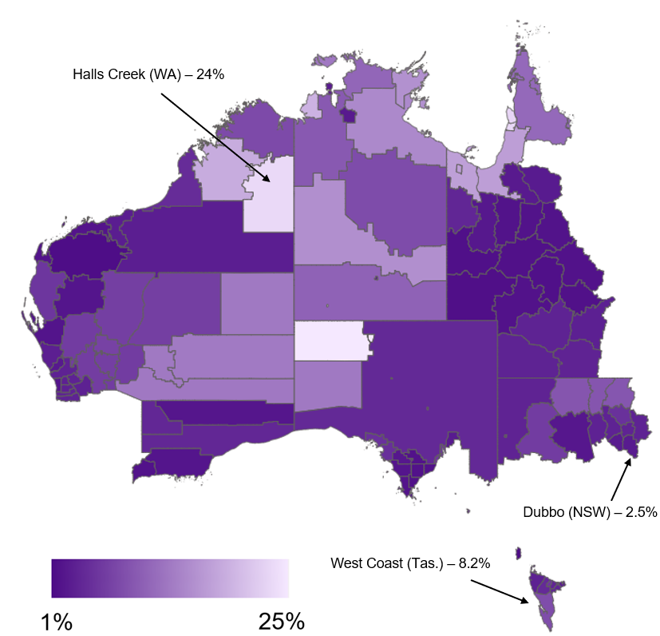

*Source: DEWR, SALM Smoothed LGA, December quarter 2024*



**Appendix 2: Acknowledgements, definitions and references**

# Appendix 2: Acknowledgements, definitions and references

## Acknowledgements

#### JSA Regional Advisory Group

On advice from JSA’s Ministerial Advisory Board (MAB), a Regional Advisory Group was established to provide independent and expert advice during the development of the Regional Roadmap. JSA acknowledges and recognises the contribution of this group, both as a collective and through the individual contributions that were also provided through its engagement to date.

Table 43: JSA Regional Advisory Group

|  |  |  |
| --- | --- | --- |
| Advisory Group Member | Position | Organisation |
| Megan Lilly (Chair) | Deputy Commissioner | Jobs and Skills Australia |
| Dean Deighton | Head of Northern Australia | Australian Industry Group |
| Adele Sutton | Head of Policy | Council of Small Business Organisations Australia |
| Lena Constantine | Associate Director – Industry Skills | Chamber of Commerce & Industry WA |
| Jonathan Cook | National Organiser | Australian Workers’ Union |
| Chris Croker | Director | First Nations Clean Energy Network |
| Brook Orr | Director | Northern Australia Universities Alliance |
| Lynette Ross | Director – Central Australia | Batchelor Institute of Indigenous Tertiary Education |
| The Hon Fiona Nash | Regional Education Commissioner | Department of Education |
| Liz Ritchie | CEO | Regional Australia Institute |
| Amanda Threlfall | Assistant Secretary | Victorian Trades Hall Council |
| David Coltman | CEO & Deputy Board Chair | TAFE SA & TAFE Directors Australia |
| Alec Webb | CEO | Regional Universities Network |
| Prof. Peter Dawkins AO | Special Advisor | Jobs and Skills Australia |

#### JSA Regional Field Trips 2025

JSA undertook seven field trips across Regional Australia to undertake consultations with a range of stakeholders. These informal consultations were typically undertaken via in-depth and in-person meetings with one stakeholder at a time, and helped shape and inform JSA’s development of the Roadmap by providing insights into the current state of the jobs and skills system in Regional Australia. JSA recognises the diverse and varied insights and perspectives shared with JSA throughout this process and acknowledges the contribution of stakeholders.

Table 44: JSA Regional Field Trips 2025

| Field trip location | Stakeholders |
| --- | --- |
| New South Wales: Newcastle, Hunter | Hunter Regional Workforce Transition Officer |
| Hunter Employment Facilitator |
| 3ME Technology |
| Hunter Trades College |
| Joblink - Maitland |
| Newcastle University |
| Hunter Jobs Alliance |
| Victoria: Melbourne, Bendigo, Shepparton | Australian Manufacturing Workers Union |
| Axis Employment: Transition to Work – Bendigo |
| Employment Facilitator – Bendigo |
| Peppergreen Farm |
| Gouge Linen & Garment Services |
| Goulburn Valley Designated Area Migration Area |
| Queensland: Mount Isa | National Indigenous Australians Agency – Mount Isa |
| Commerce North West |
| Q.I.T.E employment services |
| Regional Jobs Committee |
| Country Universities Centre |
| TAFE Qld - Mount Isa |
| South Australia: Whyalla, Port Agusta, Port Pirie | Jobs and Skills Network Meeting Whyalla |
| Jobs and Skills Network Meeting Port Augusta |
| Uni Hub Spencer Gulf (Port Augusta) |
| APM (Port Augusta) |
| Regional Development Australia (Port Pirie) |
| Whyalla City Council |
| Workskil Australia (Port Pirie Youth) |
| Western Australia: Broome | Broome Study Hub |
| Headspace Broome |
| West Australian Country Health Service |
| TAFE WA - North region |
| Employment Facilitator – Broome |
| Kimberley Port Authority |
| WA Jobs and Skills Centre |
| Tasmania: Hobart & Surrounds | TasTAFE |
| Skills Tasmania (Department of State Growth) |
| University of Tasmania |
| Incat |
| Tassal |
| Max Employment – Bridgewater |
| Employment Facilitator - Hobart & Southern Tasmania |
| Northern Territory: Alice Springs | Charles Darwin University TAFE |
| Employment Facilitator Assistant |
| Centre for Appropriate Technology (CfAT) |
| Desert Knowledge Australia |
| Batchelor Institute of Indigenous Tertiary Education |

## Metrics Data Dictionary

Table 45:Metrics Data Dictionary

| **Vision Principle** | **Indicators** | **Definition** | **Source** | **Geographic availability** |
| --- | --- | --- | --- | --- |
| **Addressing Barriers** | School attendance rate | Days not attended as a proportion of possible days (%) | Australia Curriculum Assessment and Reporting Authority (ACARA), School Attendance, unpublished data. | National, GCCSA, Remote |
| Youth not in employment, education or training | The proportion of the youth (18-24) population not in employment, education or training (%) | ABS, Survey of Education and Work, 2024 (national and GCCSA). ABS, Census of Population and Ageing, 2021 (Remote) | National and GCCSA (SEW), Remote (Census) |
| Prime age participation rate | The proportion of the population (25-54 years) that is participation in the labour market (either employed or unemployed) (%) | ABS, Labour Force, Detailed, 12-month averages of original estimates | National, GCCSA, Remote |
| Unemployment rate | The proportion of the labour force that is unemployed (available and looking for work) (%) | ABS, Labour Force, Detailed, 3-month averages of modelled estimates | National, GCCSA, Remote |
| Proportion on income support for 5 or more years | Proportion of the working age (15-64 years) population on JobSeeker income support (includes those on JobSeeker payment and Youth Allowance (other)) (%) | Services Australia Administrative data, and working age population estimates from ABS Labour Force, Australia, Detailed | National, GCCSA, Remote |
| **Quality Jobs** | Youth tertiary participation rate | Proportion of the population (15-24 years) participating in Vocational and Educational Training (VET) (including Adv. Diploma & Cert. III/IV) and/or Higher Education (%) | ABS, Survey of Education and Work, 2024 | National, GCCSA |
| Completion rates for apprentices and trainees (commencing 2019) | An estimate of individual completion rates for apprentices and trainees is derived by adjusting the contract completion rates by a factor representing the average recommencements in a particular occupation over a 5-year period (%) | NCVER, 2024, Apprentices and trainees 2024 – March quarter estimates, unpublished data | National, GCCSA |
| Proportion working in the same field as most relevant qualification | Proportion of employed (25-44 years) population working in same field as their qualification (%) | ABS, Survey of Qualification and Work, 2023 | National, GCCSA |
| Proportion working in jobs below their qualification level | Proportion of employed population working at a lower skill level than their qualification (%) | ABS, Survey of Education and Work, 2024 | National, GCCSA |
| **Quality Jobs** | High job satisfaction | Proportion of employed who self-report ‘totally satisfied’ with their job (%) (where ‘totally satisfied’ is responding either 9 or 10 when asked how satisfied or dissatisfied you are with your job) | Melbourne University, Household, Income and Labour Dynamics in Australia (HILDA) Survey | National |
| Underemployment rate | Proportion of labour force who are underemployed (people are underemployed if they are part time and want more hours, or full-time and worked part-time hours in the reference week for economic reasons) (%) | ABS, Labour Force, Detailed, Datalab, 12-month averages of original estimates | National, GCCSA |
| Income inequality ratio (P80/P20) | The median income received by those at the 80th income percentile (a person who is at the top 20% of the income distribution) with those at the 20th income percentile (a person who is at the bottom 20% of the income distribution) (%) | PLIDA | National, GCCSA |
|  | Workers’ compensation incidence rate | Workers who have had an accepted workers compensation claim involving one or more working weeks lost, expressed as a rate per 1,000 workers | Safe Work Australia (SWA), National Dataset for Compensation-based Statistics (NDS), and ABS, Labour Force, Detailed, modelled estimates | National and GCCSA |
| **Meeting Demand** | Vacancy fill rate | The percentage of vacancies that have been filled (%) | JSA, Survey of Employers who have recently advertised (SERA), 12-month averages (national and GCCSA), JSA, Recruitment Experiences and Outlook Survey (REOS) | National, GCCSA (JSA SERA) and Remote (JSA REOS) |
| Essential services vacancy rate | The proportion of the civilian population employed in essential service occupations (defined as Teachers (early childhood, primary and secondary), Nurses (Managers, Enrolled and Registered), GPs and Resident Medical Officers, Pharmacists, Police, Fire and Emergency, Ambulance and Paramedics) | JSA Nowcast of Employment by Region and Occupation (NERO) and JSA, Internet Vacancy Index (adjusted for proportion of jobs advertised online – JSA, Recruitment Experiences and Outlook Survey) | National, GCCSA |
| Persistent hiring pressure | Proportion of occupations exhibiting high vacancy rates in 18 of the past 24 months (%) | JSA Internet Vacancy Index (IVI) and JSA Nowcast of Employment by Region and Occupation (NERO). | National, GCCSA |
| Business creation rate | The proportion of new business entries (over the financial year) as a proportion of the working age (15-64 years) population. | ABS, Counts of Australian Businesses, including Entries and Exits and ABS, Labour Force, Detailed, 6-month average of estimates | National, GCCSA and Remote |
| **Efficient matching** | Beveridge Curve | The current position of the Beveridge Curve, based on the relationship between the vacancy rate and the unemployment rate. | JSA, Internet Vacancy Index (adjusted for proportion of jobs advertised online – JSA, Recruitment Experiences and Outlook Survey, April 2025) and ABS, Labour Force, Detailed, March 2025, modelled estimates. | National, GCCSA and Remote |
| Efficiency of labour market matching | Matching efficiency indicator (%) based on modelling the level of new hires occurring in the labour market as a function of unemployment and vacancies. Results are considered ‘more efficient’, and 100% is considered ‘best practice’ (based on stochastic frontier analysis). | JSA experimental MUVER model, which is based on JSA, Internet Vacancy Index (adjusted for proportion of jobs advertised online – JSA, Recruitment Experiences and Outlook Survey, April 2025) and ABS, Labour Force, Detailed (estimates of unemployment and new hires), derived from Datalab. | National, GCCSA and Remote |

## Definition of Regional Australia

Table 46 below provides a correspondence of SA4s and remoteness areas to the definition of Regional Australia utilised in this report, namely:

|  |
| --- |
| Regional Australia includes all regions of Australia except for those in the major capital cities of Sydney, Melbourne, Brisbane, Adelaide and Perth and the Australian Capital Territory (ACT). |

Table 46: Correspondence of SA4s and Remoteness Areas to the definition of Regional Australia

| State | SA4 | ABS ARIA definition | JSA Regional Australia definition |
| --- | --- | --- | --- |
| NSW | Capital Region | Inner Regional | Regional |
| New South Wales - Central West | Inner Regional | Regional |
| Coffs Harbour - Grafton | Inner Regional | Regional |
| Mid North Coast | Inner Regional | Regional |
| Murray | Inner Regional | Regional |
| New England & North West | Inner Regional | Regional |
| Richmond - Tweed | Inner Regional | Regional |
| Riverina | Inner Regional | Regional |
| Southern Highlands & Shoalhaven | Inner Regional | Regional |
| Far West & Orana | Outer Regional | Regional |
| Hunter Valley exc Newcastle | Major City | Regional |
| Illawarra | Major City | Regional |
| Newcastle & Lake Macquarie | Major City | Regional |
| Central Coast | Major City | Major City |
| Sydney - Baulkham Hills & Hawkesbury | Major City | Major City |
| Sydney - North Sydney & Hornsby | Major City | Major City |
| Sydney - Northern Beaches | Major City | Major City |
| Sydney - Ryde | Major City | Major City |
| Sydney - Blacktown | Major City | Major City |
| Sydney - Outer West & Blue Mountains | Major City | Major City |
| Sydney - Parramatta | Major City | Major City |
| Sydney - City & Inner South | Major City | Major City |
| Sydney - Eastern Suburbs | Major City | Major City |
| Sydney - Inner South West | Major City | Major City |
| Sydney - Inner West | Major City | Major City |
| Sydney - Sutherland | Major City | Major City |
| Sydney - Outer South West | Major City | Major City |
| Sydney - South West | Major City | Major City |
| Vic. | Ballarat | Inner Regional | Regional |
| Bendigo | Inner Regional | Regional |
| Hume | Inner Regional | Regional |
| Latrobe - Gippsland | Inner Regional | Regional |
| Shepparton | Inner Regional | Regional |
| Warrnambool & South West | Inner Regional | Regional |
| Victoria - North West | Outer Regional | Regional |
| Geelong | Major City | Regional |
| Melbourne - Inner | Major City | Major City |
| Melbourne - Inner East | Major City | Major City |
| Melbourne - Inner South | Major City | Major City |
| Melbourne - North East | Major City | Major City |
| Melbourne - Outer East | Major City | Major City |
| Melbourne - North West | Major City | Major City |
| Melbourne - South East | Major City | Major City |
| Mornington Peninsula | Major City | Major City |
| Melbourne - West | Major City | Major City |
| Qld. | Darling Downs - Maranoa | Inner Regional | Regional |
| Central Queensland | Inner Regional | Regional |
| Mackay - Isaac - Whitsunday | Inner Regional | Regional |
| Toowoomba | Inner Regional | Regional |
| Wide Bay | Inner Regional | Regional |
| Cairns | Outer Regional | Regional |
| Townsville | Outer Regional | Regional |
| Queensland - Outback | Remote Australia | Regional |
| Gold Coast | Major City | Regional |
| Sunshine Coast | Major City | Regional |
| Brisbane - East | Major City | Major City |
| Brisbane - South | Major City | Major City |
| Logan - Beaudesert | Major City | Major City |
| Brisbane - North | Major City | Major City |
| Brisbane Inner City | Major City | Major City |
| Moreton Bay - North | Major City | Major City |
| Moreton Bay - South | Major City | Major City |
| Brisbane - West | Major City | Major City |
| Ipswich | Major City | Major City |
| SA | Barossa - Yorke - Mid North | Outer Regional | Regional |
| South Australia - Outback | Outer Regional | Regional |
| South Australia - South East | Outer Regional | Regional |
| Adelaide - Central & Hills | Major City | Major City |
| Adelaide - South | Major City | Major City |
| Adelaide - North | Major City | Major City |
| Adelaide - West | Major City | Major City |
| WA | Bunbury | Inner Regional | Regional |
| Western Australia - Wheat Belt | Outer Regional | Regional |
| Western Australia - Outback (North & South) | Remote | Regional |
| Mandurah | Major City | Major City |
| Perth - South East | Major City | Major City |
| Perth - South West | Major City | Major City |
| Perth - Inner | Major City | Major City |
| Perth - North East | Major City | Major City |
| Perth - North West | Major City | Major City |
| Tas. | Launceston & North East | Inner Regional | Regional |
| Greater Hobart | Inner Regional | Regional |
| Tasmania - South East | Outer Regional | Regional |
| Tasmania - West & North West | Outer Regional | Regional |
| NT | Darwin | Outer Regional | Regional |
| Northern Territory - Outback | Remote | Regional |
| ACT | Australian Capital Territory | Major City | Major City |

## List of Figures

Figure 1: Overview of JSA Regional Roadmap- Phase 1 and Phase 2 13

Figure 2: Selected statistics on the size and importance of Regional Australia 16

Figure 3: JSA RLMI ratings of labour market strength by SA3 regions 17

Figure 4: Visual representation of the definition of ‘Regional Australia’ for the purposes of the JSA Regional Roadmap 19

Figure 5: Overview of the jobs and skills system, stakeholders and policies 23

Figure 6: Issues impacting Regional Australia 26

Figure 7: Strengths and attractions of Regional Australia 27

Figure 8: Annual population growth (%), 2002 to 2024 29

Figure 9: Population components, 2017 to 2024 29

Figure 10: Proportion of population (%) by age by remoteness category, 2025 30

Figure 11: Skill level employment share, change (% pts) between 2019 and 2024 31

Figure 12: Regions with high proportions of local employment in transitioning industries 33

Figure 13: School student non-attendance rates, by Regional Australia and Major City 44

Figure 14: Youth (18-24) NEET rate (%), by Major City and Regional Australia 46

Figure 15: Youth (18-24) NEET rate (%), by gender in Regional Australia, 2016 and 2021 47

Figure 16: Prime age (25-54) participation rate (%), by Major City and Regional Australia 48

Figure 17: Prime age (25-54) participation rate (%), selected cohorts, Regional Australia and Major City 49

Figure 18: Unemployment rate (%), by Major City and Regional Australia 50

Figure 19: Proportion of population (15-64) on income support for more than 5 years (%), by Major City and Regional Australia 51

Figure 20: Youth (15-24 years) tertiary participation rates (%) by Major City and Regional Australia 58

Figure 21: Youth share of higher education, VET and population (%) by Major City and Regional Australia 58

Figure 22: Completion rates for apprentices and trainees (commencing year 2019) – all occupations, by Regional Australia and Major City (%) 62

Figure 23: Share of trade apprenticeship commencements that are female (15-29 years) (%) 63

Figure 24: Proportion working at lower skilled level than qualification (%), by Major City and Regional Australia 64

Figure 25: Proportion working at lower skilled level than qualification (%), by Major City and Regional Australia 65

Figure 26: Proportion of population (25-44 years) working in the same field as most relevant qualifications (%), by Major City and Regional Australia 66

Figure 27: Students who have attended a regional school who return to live in Regional Australia after studying at university in a Major City (%) 68

Figure 28: Proportion of employed who self-report ‘totally satisfied’ with their job, by Major City and Regional Australia 73

Figure 29: Underemployment rate (%), by Major City and Regional Australia 74

Figure 30: Income ratio (p80 and p20), Regional Australia and Major Cities 75

Figure 31: Workers’ compensation incidence rate (per 1,000 workers), Regional Australia 77

Figure 32: Workers’ compensation incidence rate, 2021-22, Regional Australia 77

Figure 33: Illustrative representation of labour market activity and the role of entrepreneurialism, business creation and portfolio self-employment 80

Figure 34: Proportion of prime-age (25-54 yrs old) employment by occupation and whether the person moved from a Major City to Regional Australia or remained in Regional Australia, 2016 to 2021 83

Figure 35: Vacancy Fill Rate (%), by Major City and Regional Australia 86

Figure 36: Job advertisements (adjusted for proportion of jobs advertised online as a proportion of employed persons) (2013=100), by Major City and Regional Australia 87

Figure 37: Essential services vacancy ratio (job advertisements adjusted for proportion of jobs advertised online as a proportion of employed persons) (%), Major City and Regional Australia 89

Figure 38: Incidence of persistent hiring pressure (%) – proportion of occupations exhibiting high vacancy rates in 18 of the past 24 months 90

Figure 39: Incidence of occupations reportedly only exhibiting ‘regional’ shortages 91

Figure 40: Business creation rate (%), Major City and Regional Australia 93

Figure 41: Conceptualising labour market efficiency 96

Figure 42: Beveridge Curves show labour market efficiency and tightness 97

Figure 43: Beveridge Curve for Major City and Regional areas of Australia, 2019 to 2025 99

Figure 44: Fill rate (%), suitable applicants and qualified applicants (no.), January 2025 100

Figure 45: Beveridge Curve for Regional Australia, including position of selected regions 101

Figure 46: A simple model underpinning the Beveridge Curve 102

Figure 47: JSA experimental estimates of matching efficiency (*MUVER* model)*,* Major City and Regional Australia 103

Figure 48: JSA experimental estimates of matching efficiency (*MUVER model), 2025* 103

Figure 49: Tasmanian Jobs Hub 120

Figure 50: Overview of Incat Tasmania’s model of engaging and supporting apprentices 125

Figure 51: Overview of JSA Regional Roadmap - Phase 1 and Phase 2 129

Figure 52: Unemployment rate (%) by LGA for Remote Australia, December 2024 148

## References

Australian Bureau of Statistics. (2021, June). *Statistical Area Level 4 Australian Statistical Geography Standard (ASGS) Edition 3 July 2021 - June 2026*. Retrieved from <https://www.abs.gov.au/statistics/standards/australian-statistical-geography-standard-asgs-edition-3/jul2021-jun2026/main-structure-and-greater-capital-city-statistical-areas>

Australian Government (2014). Productivity Commission. *Geographic labour mobility – Commissioned Study.* Retrieved from <https://www.pc.gov.au/inquiries/completed/labour-mobility/report>

Australian Government (2025) Department of Employment and Workplace Relations. *Local Jobs – A Workforce Australia Program.* Retrieved from <https://www.dewr.gov.au/local-jobs>

Australian Government (2025). Department of Education, *Regional University Study Hubs.* Retrieved from <https://www.education.gov.au/regional-university-study-hubs>

Australian Government (2025). Department of Education. Tertiary Access Payment. Retrieved from <https://www.education.gov.au/tertiary-access-payment>

Australian Government (2025). Department of Employment and Workplace Relations. *Skills for Education and Employment (SEE) Program.* Retrieved from [Skills for Education and Employment (SEE) Program - Department of Employment and Workplace Relations, Australian Government](https://www.dewr.gov.au/skills-education-and-employment)

Australian Government (2025). Department of the Prime Minister and Cabinet. *Care and Support Economy Reform.* Retrieved from <https://www.pmc.gov.au/domestic-policy/care-and-support-economy>

Australian Government. (2024). *Australian Universities Accord Final Report.* Canberra: Department of Education. Retrieved from <https://www.education.gov.au/australian-universities-accord/resources/final-report>

Australian Government. (2025). Department of Climate Change, Energy, the Environment and Water. *the Net Zero Plan.* Retrieved from <https://www.dcceew.gov.au/climate-change/emissions-reduction/net-zero>.

Australian Government. (2025). Department of Social Services. *Social Enterprise Development Initiative.* Retrieved from <https://www.dss.gov.au/social-impact-investing/social-enterprise-development-initiative>

Australian Government. (2025). Department of Social Services. *The Entrenched Disadvantage Package.* Retrieved from <https://www.dss.gov.au/supporting-community-change/resource/entrenched-disadvantage-package>

Australian Government. (2025). The Treasury. *Future Made in Australia.* Retrieved from <https://treasury.gov.au/policy-topics/future-made-australia>

Brotherhood of St. Laurence – Social Policy and Research Centre (2024). *Regional Jobs Hubs Initiative Final Evaluation Report.* Retrieved from <https://library.bsl.org.au/bsljspui/bitstream/1/13495/1/RegionalJobsHub_Final_Eval_Report_2024.pdf>

Commonwealth of Australia. (2023a). *Working Future: the Australian Government's White Paper on Jobs and Opportunities.* Canberra: Commonwealth of Australia. Retrieved from <https://treasury.gov.au/sites/default/files/2023-10/p2023-447996-working-future.pdf>

Firth, J. (2020). *Review into vocational and applied learning pathways in senior secondary schooling Final Report November 2020.* Retrieved from <https://www.education.vic.gov.au/Documents/school/vocational-applied-learning-pathways-report.pdf>

Jobs and Skills Australia (2023a). *Foundation Skills Study.* Retrieved from <https://www.jobsandskills.gov.au/studies/foundation-skills-study>

Jobs and Skills Australia (2023b). *JSA Foundation Skills Study Discussion Paper April 2023.* Retrieved from <https://www.jobsandskills.gov.au/sites/default/files/2023-04/Foundation%20Skills%20Study%20-%20Discussion%20paper.pdf>

Jobs and Skills Australia (2024). *Better Together The Jobs and Skills Report November 2024.* Retrieved from <https://www.jobsandskills.gov.au/download/19681/jobs-and-skills-report-2024/2833/better-together-jobs-and-skills-report-2024/pdf>

Jobs and Skills Australia (2024). *From the Big Smoke to the Back of Bourke: Recruitment experiences across Australia’s regions.* Retrieved from <https://www.jobsandskills.gov.au/sites/default/files/2024-10/recruitment_experiences_across_australias_regions_-_october_2024.pdf>

Jobs and Skills Australia (2025). Opportunity and Productivity *Towards a Tertiary Harmonisation Roadmap.* Retrieved from <https://www.jobsandskills.gov.au/publications/opportunity-and-productivity-towards-tertiary-harmonisation-roadmap>

Mount Isa City Council (2025) *Mount Isa Future Ready Economy Roadmap*, February 2025. Retrieved from <https://www.mountisa.qld.gov.au/files/assets/public/v/3/council/documents/future-ready-economy-roadmap.pdf>

Parliament of Australia (2013). House of Representatives Standing Committee on Regional Australia. *Cancer of the bush or salvation for our cities?* Retrieved from <https://www.aph.gov.au/parliamentary_business/committees/house_of_representatives_committees?url=ra/fifodido/report/index.htm>

Queensland Government (2025) Department of Trade, Employment and Training. *User Choice program documents.* Retrieved from <https://desbt.qld.gov.au/training/providers/funded/userchoice/resources>

Regional Australia Institute (2022). *Regionalisation Ambition 2032: A Framework to Rebalance the Nation*. Retrieved from <https://rebalancethenation.com.au/common/Uploaded%20files/Rebalance-the-Nation/Rebalance-the-Nation-Report-2022.pdf>

Regional Australia Institute (2025). *What is Regional Australia?,* Retrieved from <https://www.regionalaustralia.org.au/Web/Web/About-Us/What-is-Regional-Australia.aspx>

UniHub Spencer Gulf (2025) *Welcome to UniHub*. Retrieved from <https://unihubsg.org/>

Victorian Government (2025). *Senior secondary schooling pathway reforms.* Retrieved from <https://www.vic.gov.au/senior-secondary-schooling-pathway-reforms>

Volunteering Australia (2015) *The National Standards for Volunteer Involvement. Retrieved from* [*https://www.volunteeringaustralia.org/wp-content/uploads/National-Standards-Document-FINAL_Web.pdf*](https://www.volunteeringaustralia.org/wp-content/uploads/National-Standards-Document-FINAL_Web.pdf)

Volunteering Australia (2020), *Submission made to the Review to achieve educational excellence in Australian Schools,* Volunteering Australia. Retrieved from <https://www.education.gov.au/system/files/documents/document-file/2020-12/volunteering-australia.pdf>

WISE Employment (2025). *Peppergreen Farm.* Retrieved from <https://www.peppergreenfarm.com.au/>



All content is provided under a Creative Commons Attribution 4.0 International Licence with the exception of:

* content supplied by third parties
* the Commonwealth Coat of Arms
* material protected by a trade mark
* any images and/or photographs.

Details of the Creative Commons BY 4.0 licence are available on the [Creative Commons website](https://creativecommons.org/).

Use of all or part of any material on this website must include the following attribution:

© Commonwealth of Australia

Terms under which the Commonwealth Coat of Arms can be used are set out on the [Department of the Prime Minister and Cabinet website](https://www.pmc.gov.au/).

Attribution

You may link to this website at your full expense and responsibility. In doing so you must not alter any of the website's contents, frame or reformat the files, pages, images, information and materials from this website on any other website. We reserve the right to prevent linking.

Other use

If you want to use material on this website in a way that is beyond the scope of the terms of use that apply to it, ask us for authorisation. You could infringe our copyright if you use anything on this website in a way that is not permitted or otherwise allowed under the Copyright Act 1968 (Cth).

Please email [copyright@dewr.gov.au](mailto:copyright@dewr.gov.au) or address requests and enquiries to:

The Copyright Officer  
Department of Employment and Workplace Relations  
GPO Box 9828 Canberra ACT 2601.



1. See, for example, [*Working Future: The Australian Government’s White Paper on Jobs and Opportunities*](https://treasury.gov.au/employment-whitepaper/final-report)*;* the [*Net Zero Plan*](https://www.dcceew.gov.au/climate-change/emissions-reduction/net-zero), [*Future Made in Australia,*](https://treasury.gov.au/policy-topics/future-made-australia)[*The Entrenched Disadvantage Package*](https://www.dss.gov.au/supporting-community-change/resource/entrenched-disadvantage-package), and [*Care and Support Economy Reform*](https://www.pmc.gov.au/domestic-policy/care-and-support-economy)*.*
2. In some cases, however, the currency and source of the data differs from that used for the SA4 ratings due to limitations on data availability at the SA3 level.
3. [Main Structure and Greater Capital City Statistical Areas](https://www.abs.gov.au/statistics/standards/australian-statistical-geography-standard-asgs-edition-3/jul2021-jun2026/main-structure-and-greater-capital-city-statistical-areas), Australian Bureau of Statistics (ABS), accessed April 2025.
4. Coastal and inland regions have been determined using an SA2 population weighted concordance.
5. Regional Australia Institute, *Regional Movers Index*, December 2024
6. Australian Government, *State of Australia’s Regions 2024*
7. Reserve Bank of Australia (2017), *Ageing and Labour Supply in Advanced Economies*
8. Treasury (2023) *Intergenerational Report 2023, Australia’s future to 2063.*
9. While there is no academic consensus on the relationship between population ageing and productivity, some recent international studies identify a negative impact (see Maestas, N., Mullen, K. J. & Powell, D, 2023, Poplawski-Ribeiro, M, 2020 and Calvo-Sotomayor, I., Laka, J. & Aguado, R 2019).
10. Close to 80% of workers are employed in the service industries. Service industries include all industries besides Manufacturing; Construction; Agriculture, Forestry and Fishing; Mining; and Electricity, Gas, Water and Waste Services, although, even within these industries, there are service components.
11. Borland & Coelli (2022). *The Australian labour market and the digital economy.*
12. Treasury: *Working Future. The Australian Government’s White Paper on Jobs and Opportunities*, September 2023
13. JSA (2023). *Towards a National Jobs and Skills Roadmap.*
14. In 2023 JSA undertook a comprehensive workforce capacity study on the clean energy transformation (*The Clean Energy Generation: workforce needs for a net zero economy*), including an analysis on future skill needs, transition challenges, and opportunities for innovation in the education and training system, to support a successful clean energy transformation. This section draws on material from this study
15. Fossil-fuel related groups which will decline and transform substantially as a result of decarbonisation.
16. ‘Income support’ is a combination of the JobSeeker payment and Youth Allowance (other) payment. The payment is designed to provide financial assistance to support those looking for work, including those who may be working part-time. It is also worth noting that the payment is designed to provide financial assistance to those who are sick or injured and cannot work for short periods of time.
17. As measured by the Australia Curriculum Assessment and Reporting Authority (ACARA) and applies to all government, Catholic and Independent schools in Australia. The student attendance rate refers to days attended as a proportion of possible days.
18. Victoria Department of Education and Training, 2025. Attendance and Missing School
19. Australian Treasury, 2023, *Working Future: The Australia Government’s White Paper on Jobs and Opportunities*
20. ‘Income support’ is a combination of the JobSeeker payment and Youth Allowance (other) payment. The payment is designed to provide financial assistance to support those looking for work, including those who may be working part-time. It is also worth noting that the payment is designed to provide financial assistance to those who are sick or injured and cannot work for short periods of time.
21. JSA (2023). *Towards a National Jobs and Skills Roadmap.*
22. Australian Government, *Strategic Review of the Australian Apprenticeship Incentive System - Skills for tomorrow: Shaping the future of Australian apprenticeships*
23. JSA, [*2024 Occupation Shortage List*](https://www.jobsandskills.gov.au/sites/default/files/2024-10/2024_osl_key_findings_and_insights_report_0.pdf)
24. Income ratios (such as the P80/P20) are a common measure of income inequality. They compare the median income received by those at the 80th income percentile (a person who is at the top 20% of the income distribution) with those at the 20th income percentile (a person who is at the bottom 20% of the income distribution) (see Australian Treasury, [*Income inequality in Australia*](https://treasury.gov.au/publication/economic-roundup-issue-2-2013-2/economic-roundup-issue-2-2013/income-inequality-in-australia), November 2013).
25. Measured by the serious claim incidence rate (per 1,000 workers) (serious workers compensation claims are accepted claims involving one or more working weeks lost). Please note that this rate should be considered as a proxy measure as it is not strictly comparable to the incidence rate of serious claims published by Safe Work Australia (SWA) given differences in data sources and methods of calculation.
26. Treasury: *Working Future. The Australian Government’s White Paper on Jobs and Opportunities*, September 2023
27. Safe Work Australia, *Safer healthier, wealthier: The economic value of reducing work-related injuries and illnesses*, October 2022
28. Safe Work Australia, *Comparison of Workers’ Compensation Arrangements in Australia and New Zealand 2023*, April 2024, https://www.safeworkaustralia.gov.au/doc/comparison-workers-compensation-arrangements-australia-and-new-zealand-2023
29. Definitions of essential services vary, but for the purposes of this analysis essential service occupations include Teachers (early childhood, primary and secondary), Child Carers (inc. Managers), Nurses (Managers, Enrolled and Registered), GPs and Resident Medical Officers, Pharmacists, Police, Fire and Emergency and Ambulance and Paramedics.
30. The business creation rate is calculated by dividing the proportion of new business entries (over the financial year) as a proportion of the working age (15-64 years) population. This measurement is consistent with the approach taken by the [Institute of Public Affairs](https://treasury.gov.au/sites/default/files/2021-05/171663_institute_of_public_affairs_supporting_document_3.pdf).
31. ABS, [Recent Developments in Small Business Finance and Economic Conditions](https://www.rba.gov.au/publications/bulletin/2023/sep/recent-developments-in-small-business-finance-and-economic-conditions.html), 2023
32. Productivity Commission (2023) [*5-year Productivity Inquiry: A more productive labour market*](https://www.pc.gov.au/inquiries/completed/productivity/report/productivity-volume7-labour-market.pdf), accessed 21 May 2025
33. The Treasury (2025) [*Treasury Round Up*](https://treasury.gov.au/sites/default/files/2024-03/p2024-495252-full-report_0.pdf), accessed 21 May 2025
34. Lake P et al. (2024) ‘How efficient is the Australian labour market? Analysing job matching efficiency for regions’, occupations and industries*, Australian Journal Labour Economics,* Vol. 27 No 1, pp. 101-117, accessed 22 May 2025
35. [*JSA Foundation Skills Study*](https://www.jobsandskills.gov.au/studies/foundation-skills-study); JSA (2023) [*JSA Foundation Skills Study Discussion Paper*](https://www.jobsandskills.gov.au/sites/default/files/2023-04/Foundation%20Skills%20Study%20-%20Discussion%20paper.pdf), April; JSA (2024) [*Better Together: The Jobs and Skills Report 2024*](https://www.jobsandskills.gov.au/download/19681/jobs-and-skills-report-2024/2833/better-together-jobs-and-skills-report-2024/pdf), pp33-34, November.
36. Mount Isa City Council (2025) *Mount Isa Future Ready Economy Roadmap*, February 2025.
37. Please note data for Remote Australia are subject to considerable statistical variability and should be viewed with caution.