



Occupation Shortage Report

March quarter 2025

**12 June 2025**

**Contents**

Introduction 2

National results 2

Metropolitan area results 3

Regional area results 4

Results by Skill Level 5

Results by major group 7

Spotlight analysis: Labour Supply Index 9

Undersupplied, oversupplied, and balanced unit groups 10

Undersupply, oversupply and balance among largest employing unit groups 12

Labour Supply Index by Skill Level 13

Labour Supply index grouped by unit group shortage drivers 14

Labour Supply index by gender balance status 15

Explanatory Notes 17

Definitions of metrics 17

# Introduction

The Occupation Shortage Report offers quarterly analysis on potential shortage pressures of occupations. The insights are based on data from the Jobs and Skills Australia (JSA) Survey of Employers who have Recently Advertised (SERA). Explanatory Notes includes detail on the metrics covered in the report.

Box 1: The vacancy fill rate

|  |
| --- |
| Based on this definition, the proportion of advertised vacancies filled (fill rate) is the key proxy measure of shortages. This metric has a simple intuition: if the fill rate is high, the likelihood of an occupation being in shortage or having high shortage pressures is low. In contrast, if the fill rate is low, the opposite is likely to be true.  Higher probability of No shortage  Higher probability of  Shortage  High  Low  Fill rate |

# National results

Table 1: National snapshot

|  |  |  |  |
| --- | --- | --- | --- |
|  | March quarter 2025 | Change over  the quarter | Change over  12 months |
| Vacancy fill rate (%) | 69.7% | ↑1.1% pts | ↑5.2% pts |
| Applicants per vacancy (no.) | 29.3 | ↓0.6 | ↑8.3 |
| Qualified applicants per vacancy (no.) | 9.4 | ↑0.2 | ↑2.5 |
| Suitable applicants per vacancy (no.) | 4.0 | ↑0.3 | ↑1.1 |

Source: Jobs and Skills Australia, SERA.  
Note: The change from previous quarter refers to the change from December quarter 2024 to March quarter 2025. The change from the previous year refers to the change from March quarter 2024 to March quarter 2025.

The fill rate increased by 1.1 percentage points to 69.7% over the March quarter 2025 (Table 1 and Figure 1).[1],[2] It increased by 5.2 percentage points over the last 12 months to the March quarter 2025. Total applicants, qualified applicants and suitable applicants per vacancy were largely unchanged over the quarter but were all higher than 12 months ago.

**Figure 1: Fill rate (%) and total, qualified, and suitable applicants per vacancy (no.), national level**

Source: Jobs and Skills Australia, SERA.

Rising fill rates potentially indicate easing employer difficulty in filling vacancies. The consistent improvements in the fill rate could reflect the number of internet vacancies and the recruitment difficulty rate, which have both trended down since mid-2023.[3]

# Metropolitan area results

Table 2: Metropolitan snapshot

|  |  |  |  |
| --- | --- | --- | --- |
|  | March quarter 2025 | Change over  the quarter | Change over 12 months |
| Vacancy fill rate (%) | 71.6% | ↑1.6% pts | ↑5.3% pts |
| Applicants per vacancy (no.) | 34.9 | 0.0 | ↑10.5 |
| Qualified applicants per vacancy (no.) | 11.3 | ↑0.5 | ↑3.3 |
| Suitable applicants per vacancy (no.) | 4.5 | ↑0.4 | ↑1.3 |

Source: Jobs and Skills Australia, SERA.

The metropolitan (metro) area fill rate increased by 1.6 percentage points to 71.6% over the March quarter 2025, and by 5.3 percentage points from the March quarter 2024 (Table 2).

Figure 2: Fill rate (%) and total applicants, qualified, and suitable applicants per vacancy (no.), Metro level

Source: Jobs and Skills Australia, SERA.

# Regional area results

**Table 3: Regional Snapshot**

|  |  |  |  |
| --- | --- | --- | --- |
|  | March quarter 2025 | Change over the quarter | Change over 12 months |
| Vacancy fill rate (%) | 64.3% | ↑1.3% pts | ↑4.6% pts |
| Applicants per vacancy (no.) | 17.6 | ↓0.5 | ↑4.7 |
| Qualified applicants per vacancy (no.) | 5.5 | 0.0 | ↑1.3 |
| Suitable applicants per vacancy (no.) | 2.8 | ↑0.3 | ↑0.9 |

Source: Jobs and Skills Australia, SERA.

The regional area fill rate increased by 1.3 percentage points to 64.3% in the March quarter 2025 and by 4.6 percentage points over the past 12 months (Table 3).

For both metro and regional areas, total applicants, qualified applicants, and suitable applicants per vacancy were broadly stable over the quarter. But the metrics were all higher than 12 months ago.

In regional areas, the fill rate remained well below that of metro areas. The average difference in fill rates between the two areas has widened over time from 2.6 percentage points in March quarter 2023 to 7.3 percentage points in March quarter 2025, indicating shortage pressures in metro areas are easing faster.

Figure 3: Fill rate (%) and total applicants, qualified, and suitable applicants per vacancy (no.), Regional level

Source: Jobs and Skills Australia, SERA.

# Results by Skill Level

During March quarter 2025 and over the previous 12 months, fill rates improved across skill level 1, 3 and 4. The fill rate for Skill Level 2 occupations, while higher than 12 months ago, declined slightly by 0.7 percentage points over the quarter (Figure 5).

The fill rate for Skill Level 3 occupations has been improving overtime but remains significantly lower than the other skill level occupation groups, at 55.5%.

The applicants per vacancy metrics either fell slightly or remained broadly stable over the quarter for skill level groups. But they were all much higher than 12 months ago.

Figure 4: Fill rate (%), total applicants, qualified and suitable applicants per vacancy (no.), by Skill Level

Source: Jobs and Skills Australia, SERA.

# Results by major group

Table 4: ANZSCO[4] Major group snapshot

|  |  |  |  |  |  |
| --- | --- | --- | --- | --- | --- |
| Major group |  | | March quarter 2025 | Change over the quarter | Change over 12 months |
| Managers | Vacancy fill rate (%) | 80.1% | | ↓0.8% pts | ↑0.7% pts |
| Applicants per vacancy (no.) | 38.4 | | ↓0.6 | ↑8.9 |
| Qualified applicants per vacancy (no.) | 13.3 | | ↑0.3 | ↑3.4 |
| Suitable applicants per vacancy (no.) | 5.2 | | ↑0.4 | ↑1.5 |
| Professionals | Vacancy fill rate (%) | 70.4% | | ↑1.0% pts | ↑6.6% pts |
| Applicants per vacancy (no.) | 28.8 | | ↓1.5 | ↑7.6 |
| Qualified applicants per vacancy (no.) | 11.2 | | ↑0.1 | ↑2.7 |
| Suitable applicants per vacancy (no.) | 3.6 | | ↑0.2 | ↑1.0 |
| Technicians and Trades Workers | Vacancy fill rate (%) | 56.1% | | ↑0.6% pts | ↑6.3% pts |
| Applicants per vacancy (no.) | 22.7 | | ↑0.9 | ↑7.0 |
| Qualified applicants per vacancy (no.) | 6.8 | | ↑0.6 | ↑2.4 |
| Suitable applicants per vacancy (no.) | 2.9 | | ↑0.5 | ↑1.0 |
| Community and Personal Service Workers | Vacancy fill rate (%) | 70.0% | | ↓1.3% pts | ↓1.1% pts |
| Applicants per vacancy (no.) | 22 | | ↓1.0 | ↑5.0 |
| Qualified applicants per vacancy (no.) | 6.5 | | ↓0.2 | ↑1.4 |
| Suitable applicants per vacancy (no.) | 3.2 | | ↑0.1 | ↑0.4 |
| Clerical and Administrative Workers | Vacancy fill rate (%) | 81.7% | | ↑0.5% pts | ↑2.4% pts |
| Applicants per vacancy (no.) | 46.0 | | ↓6.8 | ↑5.3 |
| Qualified applicants per vacancy (no.) | 9.5 | | ↓0.5 | ↑1.0 |
| Suitable applicants per vacancy (no.) | 6.7 | | ↓0.2 | ↑1.0 |
| Sales Workers | Vacancy fill rate (%) | 67.7% | | ↓2.2% pts | ↓3.2% pts |
| Applicants per vacancy (no.) | 28.2 | | ↓0.4 | ↑9.0 |
| Qualified applicants per vacancy (no.) | 5.8 | | ↓0.8 | ↑2.0 |
| Suitable applicants per vacancy (no.) | 4.1 | | ↑0.1 | ↑1.7 |

|  |  |  |  |  |
| --- | --- | --- | --- | --- |
| Machinery Operators and Drivers | Vacancy fill rate (%) | 69.6% | ↑2.1% pts | ↑0.6% pts |
| Applicants per vacancy (no.) | 31.7 | ↓1.8 | ↑10.5 |
| Qualified applicants per vacancy (no.) | 10.7 | ↓0.6 | ↑2.3 |
| Suitable applicants per vacancy (no.) | 4.7 | ↑0.4 | ↑1.5 |
| Labourers | Vacancy fill rate (%) | 66.5% | ↑4.5% pts | ↑9.1% pts |
| Applicants per vacancy (no.) | 16.5 | ↑2.7 | ↑8.1 |
| Qualified applicants per vacancy (no.) | 4.5 | ↑0.4 | ↑1.2 |
| Suitable applicants per vacancy (no.) | 2.4 | ↑0.3 | ↑0.6 |

Source: Jobs and Skills Australia, SERA.

In the March quarter 2025 and over the past 12 months, the fill rates for most major group occupations increased.

Fill rates improved most for Labourers major group occupations over the quarter and past 12 months.

For Managers, the fill rate appears to have stabilised at 80.1%.

For Community and Personal Service Workers (70.0%), and Sales Workers (67.7%), the fill rate fell over the quarter and was lower than 12 months ago. Sales Workers experienced the largest decrease in fill rates over both periods.

# Spotlight analysis: Labour Supply Index

In some occupations, job seekers have trouble work because they are competing with hundreds of other applicants. Meanwhile, in other occupations, employers struggle to find workers because their advertised vacancies receive very few applicants. The extent to which these difficulties are occurring simultaneously will be analysed using a Labour Supply Index (LSI).

The LSI was created for unit groups by considering how far the applicants per vacancy for a specific unit group deviates from the overall average as a measure of how oversupplied or undersupplied the unit group is.

$$Labour Supply Index = \frac{applicants for unit group i }{vacancies with applicants known for unit group i} - \frac{applicants (total)}{vacancies with applicants known (total)}$$

The LSI was created using SERA and REOS data. The SERA data was current as of December 2024 and the REOS data was current as of November 2024. Insufficient data (or missing unit groups) in SERA or REOS, were buttressed or imputed. These sources were amalgamated to develop overall counts for the number of vacancies, and applicants for each unit group by calendar year.

The LSI results in the following definition of undersupply, oversupply, and balanced unit groups:

* **Undersupplied unit groups**: Average applicants per vacancy for a unit group is below the national average applicants per vacancy or where the LSI is negative.
* **Oversupplied unit groups**: Average applicants per vacancy for a unit group is above the national average applicants per vacancy or where the LSI is positive.
* **Balanced unit groups**: Average applicants per vacancy for a unit group is equal to the national average applicants per vacancy or where the LSI is zero.

The LSI is created for the national level and for metropolitan and regional areas.

The average number of applicants per vacancy for the three region types over the calendar year 2024 are as follows:

* Nationally 27
* Metropolitan areas 32
* Regional areas 17.

The LSI is based on total applicants per vacancy data as there are more data available for analysis. However, an equivalent index and definition was also created using qualified applicants per vacancy or QLSI. The results and insights are similar with slight variation due to only SERA being used. Only the LSI results based on total applicants per vacancy are reported in the spotlight section.

### Undersupplied, oversupplied, and balanced unit groups

Using the LSI score, the top 5 unit groups that were most undersupplied, oversupplied, and balanced are identified. These results are presented in the table below, with data shown at the national level, as well as for metropolitan (metro) and regional areas.

In 2024, the undersupplied unit groups received fewer than 5 applicants per vacancy on average (Table 5). This was well below the national, metro, and regional level average applicants per vacancy (25, 32 and 17 respectively). These are the unit groups with the most negative LSI scores.

For all area types, unit groups were predominantly health professionals. This indicates a lack of applicants or workers for vacancies (or demand) for health sector professionals. The LSI also indicated a constrained pipeline of applicants for Child Carers in regional areas, aligning with research showing that regional areas have less access to such services.[5]

All the unit groups were in shortage in the 2024 OSL.

Table 5: Undersupplied occupations: very few applicants per vacancy

|  |  |  |
| --- | --- | --- |
| National | Metropolitan | Regional |
| Audiologists and Speech Pathologists/Therapists LSI -25.0,  Applicants/vacancy 2.3 | Psychiatrists  LSI -29.6 Applicants/vacancy 2.3 | Occupational Therapists  LSI -16.0 Applicants/vacancy 1.4 |
| Psychiatrists  LSI -24.8 Applicants/vacancy 2.5 | Audiologists and Speech Pathologists/Therapists LSI -29.5 Applicants/vacancy 2.4 | Audiologists and Speech Pathologists/Therapists LSI -15.2 Applicants/vacancy 2.1 |
| Occupational Therapists LSI -24.7 Applicants/vacancy 2.6 | Veterinarians LSI -28.5 Applicants/vacancy 3.4 | Midwives LSI -15.0 Applicants/vacancy 2.4 |
| Veterinarians LSI: -23.9 Applicants/vacancy 3.4 | Occupational Therapists LSI -28.0 Applicants/vacancy 3.9 | Medical Imaging Professionals LSI -13.4 Applicants/vacancy 3.9 |
| Podiatrists LSI -23.5 Applicants/vacancy 3.8 | Medical Imaging Professionals LSI -27.5 Applicants/vacancy 4.4 | Child Carers LSI -13.2 Applicants/vacancy 4.2 |

Source: Jobs and Skills Australia: SERA and REOS (2024).

Oversupplied unit groups, or those with the most positive LSI scores and high average applicants per vacancy numbers (Table 6) include Keyboard Operators, and various ICT professionals and managerial roles in national and metro areas.

For regional areas, the top 5 oversupplied unit groups were different to metro areas and nationally, in addition to managerial roles, include engineers, receptionists, delivery drivers. All these unit groups, except for Industrial, Mechanical and Production Engineers, were not assessed as being in shortage in the 2024 OSL.

Regarding Industrial, Mechanical and Production Engineers, advertised vacancies received above average numbers of applicants. However, a key reason for the unit group being in shortage was due to a lack of suitable applicants per vacancy: over 80% of qualified applicants are considered unsuitable for the position by surveyed employers.[6] This result may suggest that:

* applicants lack employability skills and relevant work experience;
* unrealistic employer expectations of graduates and workers, including unconscious bias of employers.

Table 6: Oversupplied occupations: excess applicants per vacancy

|  |  |  |
| --- | --- | --- |
| National | Metropolitan | Regional |
| Keyboard Operators  LSI 156.7 Applicants/vacancy 184.0 | Keyboard Operators  LSI 153.0  Applicants/vacancy 184.9 | Industrial Mechanical and Production Engineers LSI 48.9 Applicants/vacancy 66.2 |
| ICT Support Technicians LSI 96.9 Applicants/vacancy 124.2 | ICT Support Technicians LSI 103.7 Applicants/vacancy 135.6 | Hotel Service Managers LSI 41.3  Applicants/vacancy 58.6 |
| Multimedia Specialists and Web Developers LSI 76.7  Applicants/vacancy 104.0 | Multimedia Specialists and Web Developers LSI 83.6  Applicants/vacancy 115.5 | Receptionists   LSI 34.8  Applicants/vacancy 52.1 |
| ICT Managers LSI 69.5  Applicants/vacancy 96.8 | ICT Managers LSI 69.7  Applicants/vacancy 101.6 | Delivery Drivers LSI 34.5  Applicants/vacancy 52.1 |
| ICT Support and Test Engineers LSI 63.6 Applicants/vacancy 25.3 | Finance Managers LSI 63.7 Applicants/vacancy 95.6 | Finance Managers LSI 28.5  Applicants/vacancy 45.8 |

Source: Jobs and Skills Australia: SERA and REOS (2024).

The top 5 unit groups with LSI scores that are closest to zero are shown in Table 7. These are the unit groups with the most balanced average applicants per vacancy figures, when compared to the average across the labour market.

Occupations identified as ‘balanced’ may still experience difficulties attracting adequate numbers of qualified applicants per vacancy.

Table 7: Most balanced occupations: average number of applicants per vacancy

| National | Metropolitan | Regional |
| --- | --- | --- |
| Cafe and Restaurant Managers  LSI -0.1  Applicants/vacancy 27.2 | Occupational and Environmental Health Professionals  LSI -0.0  Applicants/vacancy 31.9 | Bar Attendants and Baristas   LSI -0.1  Applicants/vacancy 17.2 |
| Architects and Landscape Architects LSI 0.1 Applicants/vacancy 27.4 | Hotel Service Managers  LSI -0.1  Applicants/vacancy 31.8 | Welfare Support Workers  LSI 0.8  Applicants/vacancy 18.1 |
| Policy and Planning Managers  LSI 0.3 Applicants/vacancy 27.6 | Waiters  LSI -0.2  Applicants/vacancy 31.7 | Welfare Recreation and Community Arts Workers LSI 1.1  Applicants/vacancy 18.4 |
| Welfare Support Workers   LSI 0.4  Applicants/vacancy 27.7 | Financial Investment Advisers and Managers LSI -0.2  Applicants/vacancy 31.7 | Occupational and Environmental Health Professionals LSI 1.2  Applicants/vacancy 18.5 |
| Forklift Drivers  LSI -0.4  Applicants/vacancy 26.8 | Electrical Engineering Draftspersons and Technicians LSI -0.4 Applicants/vacancy 31.5 | Accountants  LSI 1.2  Applicants/vacancy 18.6 |

Source: Jobs and Skills Australia: SERA and REOS (2024).

### Undersupply, oversupply and balance among largest employing unit groups

S

Table 8 below lists the LSI score in the 2024 calendar year for the largest employing unit groups.

The largest employing undersupplied unit groups, nationally, include Registered Nurses, Truck Drivers, Electricians, and Child Carers. These unit groups are also undersupplied in metro areas and regions except for Truck Drivers, where it was broadly balanced in regional areas.

Nationally, the largest employing oversupplied unit groups include General Clerks, Software and Applications Programmers, Receptionists, and Storepersons. Except for Software and Applications Programmers, the oversupplied unit groups are lower skill level roles. The unit groups are generally oversupplied across metro and regional areas also.

The remaining unit groups are either slightly oversupplied or balanced, but their LSI score was mixed across the region type.

Table 8: LSI scores and average applicants per vacancy of highest employing unit groups

|  |  |  |  |
| --- | --- | --- | --- |
| Unit group | National | Metro | Regional |
| Registered Nurses  S | LSI -17.2  Applicants/vacancy 10.1 | LSI -21.7 Applicants/vacancy 10.2 | LSI -7.3 Applicants/vacancy 10.0 |
| Aged and Disabled Carers  S | LSI 6.6  Applicants/vacancy 33.9 | LSI 8.0 Applicants/vacancy 39.9 | LSI 3.8  Applicants/vacancy 21.1 |
| General Clerks  NS | LSI 11.9  Applicants/vacancy 39.2 | LSI 8.6  Applicants/vacancy 40.5 | LSI 19.7  Applicants/vacancy 37.0 |
| Retail Managers  NS | LSI -1.3  Applicants/vacancy 26.0 | LSI -6.7  Applicants/vacancy 25.1 | LSI 9.9  Applicants/vacancy 27.2 |
| Accountants  NS | LSI 5.5  Applicants/vacancy 32.8 | LSI 5.8  Applicants/vacancy 37.7 | LSI 1.2 Applicants/vacancy 18.6 |
| Software and Applications Programmers  S | LSI 57.1  Applicants/vacancy 84.4 | LSI 54.1 Applicants/vacancy 86.0 | Insufficient data |
| Truck Drivers  S | LSI -8.4 Applicants/vacancy 18.8 | LSI -9.1 Applicants/vacancy 22.7 | LSI -2.8 Applicants/vacancy 14.5 |
| Electricians  S | LSI -13.2 Applicants/vacancy 14.0 | LSI -16.2  Applicants/vacancy 15.7 | LSI -6.2 Applicants/vacancy 11.1 |
| Receptionists  NS | LSI 41.9 Applicants/vacancy 69.2 | LSI 45.6 Applicants/vacancy 77.5 | LSI 34.8 Applicants/vacancy 52.1 |
| Advertising, Public Relations and Sales Managers  S | LSI 7.3 Applicants/vacancy 34.6 | LSI 4.4 Applicants/vacancy 36.3 | Insufficient data |
| Storepersons  NS | LSI 21.4 Applicants/vacancy 48.7 | LSI 22.5 Applicants/vacancy 54.4 | LSI 12.0 Applicants/vacancy 29.3 |
| Child Carers  S | LSI -18.2 Applicants/vacancy 9.1 | LSI -21.2 Applicants/vacancy 10.7 | LSI -13.2 Applicants/vacancy 4.2 |

Source: Jobs and Skills Australia: SERA and REOS (2024).

### Labour Supply Index by Skill Level

Box plots of the LSI scores were analysed by skill level. These box plots are useful as they illustrate where the data is clustered, its skewness and how spread out the data is. If a larger section of the box is to the right of the thick black line (the median), it suggests that the data is skewed or more spread out toward higher values (Figure 5). The dots on the right represent outlier occupations, which received many more applicants per vacancy than is typical for their skill level.

The figure also shows the national average applicants per vacancy as a red line, which represents an LSI score of zero.

Skill Level 3 unit groups are the most severely undersupplied, with their average, first quartile and third quartile applicants per vacancy all falling below the national average applicants per vacancy figure of 25.[7]

Figure 5: Boxplots of LSI by ANZSCO skill level, 2024

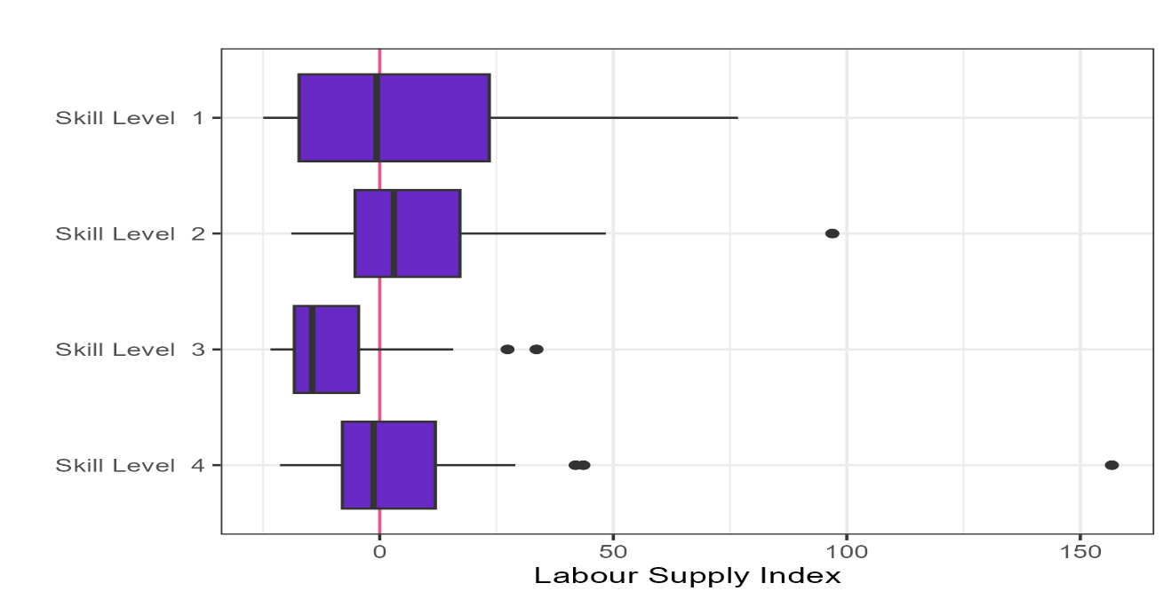  
Source: Jobs and Skills Australia: SERA and REOS (2024).

While Skill Level 1 has many undersupplied unit groups, it still has many with above average applicants per vacancy. Skill Level 2 and 4 groups are oversupplied on average, with most unit groups within those skill levels receiving above average applications per vacancy.

### Labour Supply index grouped by unit group shortage drivers

A plot of each unit group’s fill rates and applicants per vacancy is categorised based on its 2024 occupation shortage driver rating: Long training gap, Short training gap, Suitability gap, and Retention gap (Figure 6).

The dashed horizontal line indicates the vacancy fill rate of 67%.[8] Unit groups with fill rates above the horizonal line have relatively high fill rates and those below the line have relatively low fill rates.

The dashed vertical line indicates an LSI score of zero or the national level average applicants per vacancy. Unit groups with negative LSI values or those to the left of the vertical line are undersupplied, while points to the right of the line are oversupplied unit groups with positive LSI figures.

The intersection of the horizontal and vertical lines occurs at fill rate of 67% and average applicants per vacancy. This intersection divides the unit groups into 4 quadrants and generates some key observations, which are summarised below.

Figure 6: Applicants per Vacancy, fill rate and shortage drivers

Figure 6 shows a scatter plot of the fill rate vs the applicants per vacancy on a logarithmic scale. The plot indicates a moderately strong positive relationship. 

Furthermore the shortage drivers are indicated by colour. Shortage drivers indicate the primary underpinning cause for shortage in each occupation and can be one of six categories: Long-training gap, short training gap, retention gap, suitability gap, uncertain, or no shortage. 

The plot shows clusters of shortage drivers in different quadrants. In the first quadrant (with below 67% fill rate and below average applicants per vacancy we have clusters of long and short-training gaps. There is a cluster of Retention gap drivers closer to the middle with below average applicants per vacancy and average fill rates. Suitability gap and no-shortage driver occupations are clustered in the top-right quadrant, having above average fill rates and applicants per vacancy. 

**Undersupplied**

Low fill rate & shortage due to training gap

**Oversupplied**

High fill rate & shortage due to suitability gap

Source: Jobs and Skills Australia (2024): SERA and REOS

**Bottom left quadrant**: most of the unit groups in this quadrant are those with a training gap (long or short) or retention gap shortage. They have very low average applicants per vacancy and low fill rates (below 67%). There are not enough applicants (qualified or otherwise) in the labour market for these unit groups. Some examples of such unit groups are Psychiatrists and Panelbeaters.

**Top right quadrant**: most of the unit groups in this quadrant are those that are not in shortage or those that are in shortage due to a suitability gap. They have relatively high average applicants per vacancy and relatively high fill rates (above 67%). Some of the unit groups with suitability gap shortage have average applicants per vacancy and fill rates close to 67%. Some examples include Managerial, engineering and ICT roles.

### Labour Supply index by gender balance status

Many unit groups are men dominated. Approximately 20% of the male workforce are employed in unit groups where over 95% of their peers are men.[9] This has important implications for skills shortage research, because occupations that have over 80% of the workforce that are men are more likely to be in shortage.

The level of segregation by gender can be quantified using the Duncan Index. ABS Census data shows that the Duncan Index, for unit groups on the OSL scope, has been trending downward gradually – from 57% in 2006 to 52% in 2021. The 2021 figure means that 52% of the workforce would need to shift roles for all unit groups to match overall workforce gender proportions.

Figure 7 shows the vacancy fill rate and applicants per vacancy for each unit group, coloured according to the following gender splits:

* At least 80% of the workforce are men.
* At least 80% of the workforce are women.
* Gender balanced.

The figure is divided into the same quadrants as Figure 6 to help reveal insights from the data.

Based on the lines of best fit, the analysis suggests that unit groups where over 80% of the workforce are men typically require about four times as many applicants per vacancy as unit groups where over 80% of the workforce are women to achieve the same fill rate.

Figure 7: Imbalance occupation and fill rate by gender split

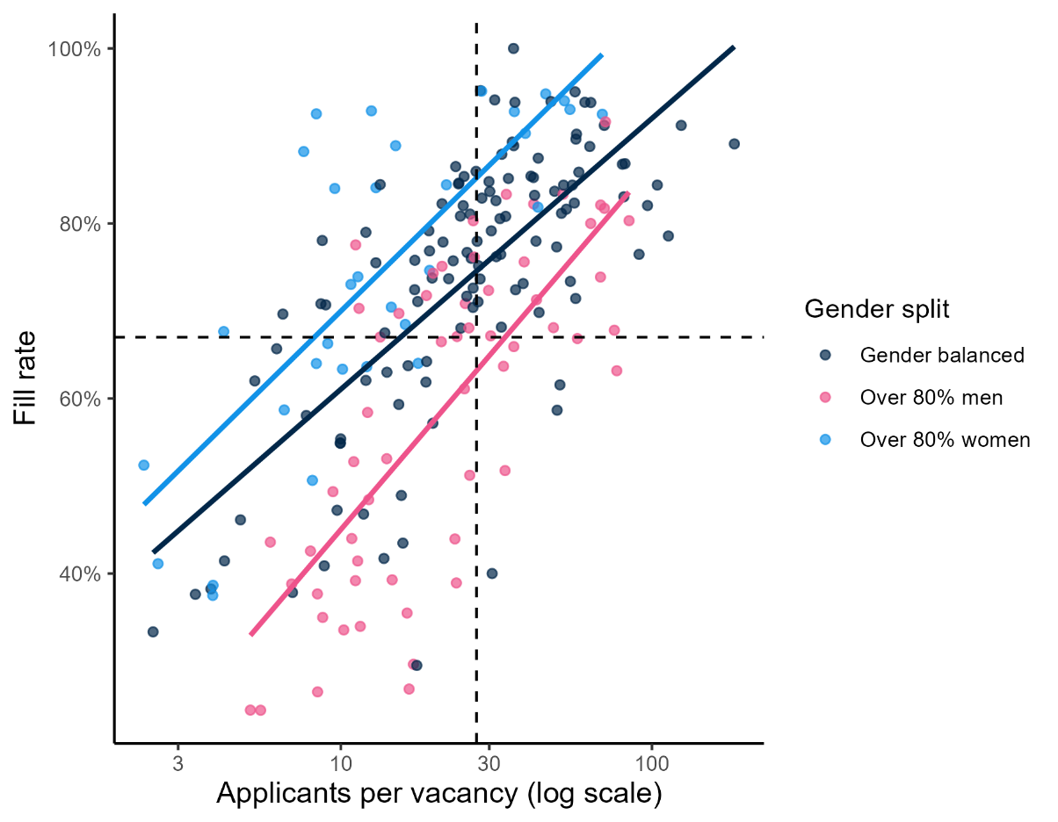  
Source: JSA: SERA, REOS, ABS LFS for Gender Split.

The analysis of also illustrates that there are many unit groups with over 80% of the workforce that are men or women, but particularly women, with below average applicants per vacancy (negative LSI scores). Some examples of women-dominated unit groups are Health and Early Childhood Education-based roles.

There are men-dominated unit groups with below average applicants per vacancy but have low fill rates. This could perhaps be related to workplace cultures in men-dominated occupations being less flexible in terms of hours and working conditions when selecting candidates.[10]

There are men-dominated unit groups with many applicants per vacancy and relatively high fill rates. This aligns with higher suitability gaps in male-dominated occupations such as engineer and ICT-based roles.

Unit groups that are gender balanced more likely to have above average applicants per vacancy (positive LSI scores) and/or higher fill rates.

# Explanatory Notes

The SERA is designed for the specific purpose of assessing occupational shortages for skilled occupations and provides a direct measure of the employer experience when recruiting. The survey receives around 2,500 responses each quarter from employers who have advertised vacancies online. Only those occupations with a sufficient quarterly sample size are included for analysis in this report to ensure data changes are more reflective of labour market developments.

The survey covers occupations, as defined by [Australian and New Zealand Standard Classification of Occupations](https://www.abs.gov.au/statistics/classifications/anzsco-australian-and-new-zealand-standard-classification-occupations/latest-release), generally requiring a university degree, trade apprenticeship or Certificate III or Certificate IV. As a result, the survey outcomes are reflective of occupations requiring post-school education and training.

Data found in Occupation Shortage Quarterly is not an indicator of occupations appearing on the 2024 Occupation Shortage List (OSL).

## Definitions of metrics

**The fill rate** is the percentage of vacancies employers advertised that were filled. The metric is calculated by dividing the number of filled vacancies by total advertised vacancies.

**The average number of applicants per vacancy** is calculated as the sum of the number of applicants divided by the sum of advertised vacancies.

**The average number of qualified applicants per vacancy** is calculated as the sum of the number of qualified applicants divided by the sum of advertised vacancies. Qualified applicants are the applicants who are assessed by employers as meeting the required qualification criteria of an advertised vacancy.

**The average number of suitable applicants per vacancy** is calculated as the sum of the number of suitable applicants divided by the sum of advertised vacancies. Suitable applicants are those who are deemed by employers to be suitable for the job advertised.

**The average years of labour market experience** sought by employer is the average number of years that employers require applicants to have spent in relevant occupations and is calculated as the mean of the years required per employer.

**Metropolitan area** refers to Capital City, while **Regional area** refers to Rest of State locations. Capital City and Rest of State areas are defined by the [Australian Statistical Geography Standard (ASGS): Volume 1 – Main Structure and Greater Capital City Statistical Areas](https://www.abs.gov.au/ausstats/abs@.nsf/mf/1270.0.55.001), July 2016.

For more information, contact [OccupationShortageList@jobsandskills.gov.au](mailto:OccupationShortageList@jobsandskills.gov.au).

Please refer to [Occupation Shortage Analysis | Jobs and Skills Australia](https://www.jobsandskills.gov.au/data/occupation-shortages-analysis#occupationshortage-1) for more information on the 2024 OSL.

1. The fill rate and other metrics in the table are based on a 12 month moving average up to the latest quarter. Using a rolling annual period, as opposed to the latest quarter itself, removes the impact of data volatility.
2. Data presented in this report for the December quarter 2024 is slightly different to that reported for that period in previous December quarter 2024 publication. This is due to a change in the SERA methodology and inclusion of additional SERA data for the December quarter 2024.
3. Internet vacancies are measured by JSA’s Internet Vacancy Index (IVI), while recruitment difficulty rate is based on data from JSA’s Recruitment Experiences and Outlook Survey (REOS).
4. ABS, Australian and New Zealand Standard Classification of Occupations (ANZSCO), 2022 version.
5. [Australia’s childcare divide is growing. Here are the suburbs getting left behind - ABC News](https://www.abc.net.au/news/2024-08-20/mapping-australia-s-growing-childcare-divide/104243302)
6. Jobs and Skills Australia, SERA 2024.
7. If LSI scores are arranged from lowest to highest, then divided into four equal parts, each part is a quarter or 25% of the data. The 1st quartile is the score below which the lowest 25% of scores fall. The 3rd quartile is the score above which the highest 25% of scores fall.
8. This fill rate of 67% is threshold fill rate used by Jobs and Skills Australia in the OSL methodology to ascertain the likelihood of an occupation to be in shortage. An occupation with a fill rate below this level has a higher chance of being in shortage than an occupation with a fill rate above this level.
9. Based on ABS Census 2021 data.
10. [Policy-and-strategy-guidance-flexible-working-arrangements.pdf](https://www.wgea.gov.au/sites/default/files/documents/Policy-and-strategy-guidance-flexible-working-arrangements.pdf)