


Opportunity and Productivity:
  - Towards a Tertiary Harmonisation Roadmap

22 February 2025

All content is provided under a Creative Commons Attribution 4.0 International Licence with the exception of:
content supplied by third parties
the Commonwealth Coat of Arms
material protected by a trademark
any images and/or photographs.
Details of the Creative Commons BY 4.0 licence are available on the Creative Commons website.
Use of all or part of any material on this website must include the following attribution:
© Commonwealth of Australia
Terms under which the Commonwealth Coat of Arms can be used are set out on the Department of the Prime Minister and Cabinet website.
Attribution
You may link to this website at your full expense and responsibility. In doing so you must not alter any of the website's contents, frame or reformat the files, pages, images, information and materials from this website on any other website. We reserve the right to prevent linking.
Other use
If you want to use material on this website in a way that is beyond the scope of the terms of use that apply to it, ask us for authorisation. You could infringe our copyright if you use anything on this website in a way that is not permitted or otherwise allowed under the Copyright Act 1968 (Cth).
Please email copyright@dewr.gov.au or address requests and enquiries to:
The Copyright Officer
Department of Employment and Workplace Relations
GPO Box 9828 Canberra ACT 2601.

Acknowledgement of Country

Jobs and Skills Australia acknowledges the Traditional Owners of Country throughout Australia and recognises the continuing connection to lands, waters and communities. We pay our respect to Aboriginal and Torres Strait Islander cultures, and to Elders past and present.
Acknowledgement of Country
Jobs and Skills Australia acknowledges the Traditional Owners of Country throughout Australia and recognises the continuing connection to lands, waters and communities. We pay our respect to Aboriginal and Torres Strait Islander cultures, and to Elders past and present.
Contents

Jobs and Skills Australia Commissioner’s foreword 6
Executive summary 7
Tertiary Harmonisation 2
Who, what and why? 3
The elements of tertiary harmonisation 4
Summary of recommendations 5
Chapter 1 Background 7
1.1 What is tertiary harmonisation? 7
1.2 The high-level case for a more harmonised system 8
1.3 The pressure for Tertiary Harmonisation to meet the needs of students and industry 10
1.4 The current disjointedness 11
Chapter 2 Tertiary harmonisation – the who, what, and why 17
2.1 Tertiary harmonisation system actors 17
2.2 System architecture 22
2.3 Benefits of Tertiary Harmonisation 25
Chapter 3 The Elements of Tertiary Harmonisation 37
3.1 Pillars and elements of the tertiary harmonisation framework 38
3.2 Elements of Pillar 1: Key Players: roles and relationships 38
3.3 Elements of Pillar 2: Knowledge, skills and qualifications: architecture and perceptions 40
3.4 Elements of Pillar 3: Legislative, regulatory financial and data architecture 42
Chapter 4 A pathway to harmonisation – concluding remarks and recommendations 44
4.1 The path to harmonisation 44
4.2 Tertiary Harmonisation Roadmap 45
4.3 Concluding remarks 52
Appendix A JSA tertiary harmonisation roundtable consultations 54
1.1 Prioritisation and implementation of tertiary harmonisation 54
1.2 The tertiary harmonisation framework: Pillars, elements and system actors 55
1.3 Qualification design 56
1.4 Making tertiary harmonisation work for providers 57
1.5 A mechanism to connect VET and Higher Education 57
1.6 Culture and operational barriers 59
Appendix B JSA tertiary harmonisation roundtable stakeholder engagement details. 60
References 63

Figures and Tables
Figure 1. Tertiary Harmonisation System Actors 18
Figure 2. The System Architecture of Tertiary Harmonisation 24
Figure 3. The four benefits of Tertiary Harmonisation 26
Figure 4. TAFE Queensland Enrolled Nurse to Registered Nurse Pathway 27
Figure 5. School to VET pathway - TAFE NSW and the University of Canberra 29
Figure 6. Engineering Dual Qualification - AI Group and RMIT 32
Figure 7. Impacts and benefits of harmonisation 33
Figure 8. JSA Tertiary Harmonisation Framework 38
Figure 9. Number of roundtable participants by state or territory 60

Table 1. Organisations that attended the roundtables 61

Glossary of acronyms
Acronym | Expanded form
ABS | Australian Bureau of Statistics
AQF | Australian Qualifications Framework
ASQA | Australian Skills Quality Authority
ATEC | Australian Tertiary Education Commission
CPD | Continuing Professional Development
DEWR | Department of Employment and Workplace Relations
NSA | National Skills Agreement
NST | National Skills Taxonomy
RPL | Recognition of prior learning
RTO | Registered Training Organisation
SES | Socio-economic Status
TAFE | Technical and Further Education
TEQSA | Tertiary Education Quality and Standards Authority
VET | Vocational Education and Training

Jobs and Skills Australia Commissioner’s foreword

At this moment, Australia has a unique opportunity for game-changing reform of tertiary education to increase opportunities for all and boost productivity.
Pressure has been building over the last decade to break down the barriers between VET and Higher Education - for the benefit of learners, the benefit of the industries who employ them, and for the broader benefit of society and the economy. If we get it right, these benefits will be large.
Tertiary harmonisation is about the strategic alignment of the VET and Higher Education sectors. It is the effective coordination and cooperation of key system actors, to enable learners to obtain the combination of skills and knowledge they need, and the ability to apply them, to be successful in the labour market.
It is not about merging or integrating VET and Higher Education. Each sector has distinctive missions and strengths that need to be nurtured. But they need to be able to work more effectively together.
The establishment of Jobs and Skills Australia (JSA) to advise government about the operation of both VET and Higher Education, and how effectively they work together, was itself a significant step on the path towards harmonisation.
In this report we outline how a tertiary harmonisation roadmap can be developed and implemented, collaboratively between the Commonwealth and state and territory governments, and in partnership with industry and tertiary providers. Getting the governance right is a critical first step. We outline a way forward to achieve this, and then provide advice on the early priorities for a roadmap.
In doing so, we build on important first steps that are already underway as a result of the recommendations of the Australian Universities Accord. We also draw on the recommendations of the House of Representatives Inquiry into the Perceptions and Status of VET. It is critical that tertiary harmonisation supports the enhancement of the perceptions and status of VET.
VET providers must be at least equal players with Higher Education providers. JSA is committed to working with all governments and with the planned Australian Tertiary Education Commission, which will have a key coordinating role, to help make this agenda successful.
We have benefitted greatly from roundtables in every state and territory that we have convened along with our colleagues Deputy Commissioners Megan Lilly and Trevor Gauld and Executive Director, David Turvey. We have been impressed by the appetite for tertiary harmonisation that has been displayed in those roundtables, and we have benefitted from many very helpful suggestions from the participants.
Along the way we have been alerted to a significant number of examples of impressive collaboration, despite the obstacles, between VET and Higher Education providers, often with industry involvement, to provide harmonised programs and pathways.
The time has come to progressively remove those obstacles and create the platforms that will promote more systemic harmonisation for large-scale benefits for learners and industry.
We provide a framework within which to evaluate the progress of tertiary harmonisation and its significant benefits: increasing efficiency and effectiveness; increasing access and equity; meeting national challenges; and increasing productivity and enhancing labour market outcomes.
We have jointly steered this project over the last year, ably supported by our Tertiary Policy Alignment team. Deputy Commissioner Megan Lilly, who joined JSA in September, has worked closely with us in delivering this report.

Professor Barney Glover AO
Commissioner, Jobs and Skills Australia
Professor Peter Dawkins AO
Special Advisor, Jobs and Skills Australia

Executive summary

Tertiary Harmonisation

What is harmonisation?
Tertiary harmonisation is the strategic alignment of the Higher Education and Vocational Education and Training (VET) sectors. It involves the effective coordination and cooperation of key system actors, to enable learners to obtain the combination of knowledge, skills and their application needed to be successful in a changing labour market.

What it isn’t
Tertiary harmonisation is not about merging or integrating VET and Higher Education. Each would remain a distinctive sector with important differences in their missions and their approaches to learning.

The high-level case for harmonisation
The high-level case for tertiary harmonisation is to:
  - enhance the ability of learners to navigate the education and training system to obtain the knowledge, skills and the ability to apply them, that they need to successfully participate in the labour market.
  - promote equity of access to universal high quality tertiary education.
  - correct for distortions in incentives for learners to participate in one part of the education and training system rather than another.
  - encourage VET providers, Higher Education providers and industry to collaborate in the provision of well-designed education and training programs to secure the development of the knowledge, skills and their application, needed for the Australian economy.

Context – now is the time
Pressure has been building over the last decade to break down the barriers between VET and Higher Education for the benefit of learners, the benefit of the industries who employ them, and broader societal and economic benefits.
There are an increasing number of examples of impressive collaboration between VET and Higher Education, often with industry involvement, to provide harmonised programs and pathways, despite the obstacles. A few such examples are highlighted in this report. The time has come to progressively remove those obstacles and create the platforms that will promote more systemic harmonisation for large-scale benefits for learners and industry.
The range of obstacles, relating to legislative and regulatory settings, qualifications design, and funding arrangements, to name a few, are outlined. The elements of harmonisation to address them and create the platforms for successful collaboration at scale, are elaborated.

Who, what and why?

Realising the benefits of tertiary harmonisation requires critical stakeholders to come together, complemented by an appropriate system architecture.
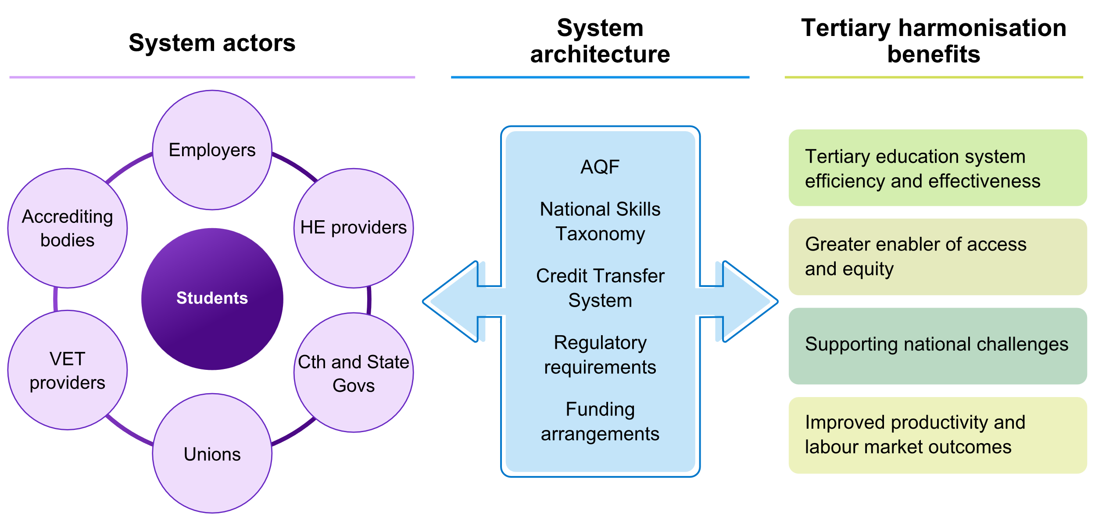

The system actors
A roadmap to tertiary harmonisation will require cooperation among diverse system actors. This includes relationships between state and territory governments and the Australian Government, providers, employers, unions and licensing and accreditation authorities.
The architecture
The current architecture presents many obstacles to harmonisation. Reforming the Australian Qualifications Framework (AQF), developing a national skills taxonomy, fostering a national credit transfer system, harmonising regulatory arrangements, and reforming funding arrangements are key elements in providing the platforms for harmonisation to reap its full benefits.
The benefits
This will improve the efficiency and effectiveness of tertiary education. It will reduce replication and overlap, so that students moving between the sectors do not need to study the same content twice. It will enable qualifications to be designed in ways that draw on the strengths of both VET and Higher Education, enabling workers and industries to apply the latest technologies and skills to a rapidly changing economy. It will boost the total volume of students in tertiary education at all levels, in part by making the system more efficient and extending funding sources further.
It will also enhance opportunities for all, especially disadvantaged groups. Access and equity across the tertiary system will be boosted, with pathways strengthened for those who find the system hard to navigate and succeed in. Enhancing the perceptions and status of VET is a key aspect of this, as disadvantaged groups rely disproportionately on the VET system.
Harmonisation will also enhance our ability to turn the challenges Australia faces into opportunities for positive national change. Meeting the workforce requirements for transitioning to clean energy technologies and enhancing care services are two such examples.
Industries will continue to require new combinations of skills and knowledge which require a system that can effectively meet the needs of reskilling, upskilling and lifelong learning. The more flexible and adaptive tertiary system that will result from harmonisation will be better placed to respond to changing industry needs.
The economic benefits from increased productivity and better matching skill supply with skill demand can be large. There is extensive literature on the effect of enhanced human capital on productivity and participation, and tertiary harmonisation is a key lever to pull in this regard. Better matching of skills to jobs can also reduce the level of unemployment consistent with stable inflation. Standards of living and the wellbeing of Australians stand to make significant gains.

The elements of tertiary harmonisation
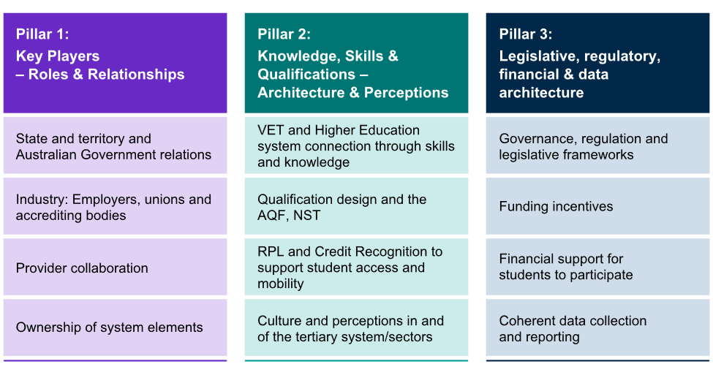
Pillar 1: Key Players – Roles & Relationships | Pillar 2: Knowledge, Skills and Qualifications – Architecture & Perceptions | Pillar 3: Legislative, regulatory, financial & data architecture
- State and territory and Australian Government relations  - Industry: Employers, unions and accrediting bodies  - Provider collaboration  - Ownership of system elements | - VET and Higher Education system connection through skills and knowledge  - Qualification design and the AQF, NST  - RPL and Credit Recognition to support student access and mobility | - Governance, regulation and legislative frameworks  - Funding incentives  - Financial support for students to participate  - Coherent data collection and reporting

Pillar 1: Key players: roles and relationships
A roadmap to tertiary harmonisation will require co-operation among diverse system actors. This includes relationships between state and territory governments and the Australian Government, providers, employers, unions and licensing and accreditation authorities.
Pillar 2: Knowledge, skills and qualifications: architecture and perceptions
Tertiary harmonisation involves developing a common language that will facilitate innovation in qualification design, expand career opportunities that draw on combinations of skill and knowledge levels and that better support industries, especially those in transition. Both VET and Higher Education are involved in supporting learners to acquire knowledge and skills, and the ability to apply them, but they do so in different ways.
Enabling greater flexibility in the design of qualifications and enhancing the status of skills relative to knowledge in the Australian qualification framework and through a common langued in a National Skills Taxonomy are two key elements. Qualifications reform in VET that is underway is an important step that will help this. Increasing the status and perception of VET is critical.
Pillar 3: Legislative, regulatory, financial and data architecture
Tertiary harmonisation will also require legislative, and regulatory reform and funding arrangements that put VET and Higher Education on a level playing field and incentivise harmonisation.

Summary of recommendations

Making a roadmap possible
Recommendation 1: That the Australian Government and state and territory governments agree to collaborate on the development and implementation of a roadmap for tertiary harmonisation.
Recommendation 2: That the Australian and state and territory governments agree that the principal purpose of the roadmap is to support effective coordination and cooperation between the VET and Higher Education sectors in order to:
- enable learners to obtain the skills and knowledge they need to be successful in the labour market and life
- increase the productivity of Australian industry
the two sectors being on an equal footing, drawing on their distinct strengths and complementary roles in a dynamic tertiary education system.
Recommendation 3: That an appropriate governance structure, involving the Australian Government, state and territory governments, the VET sector, Higher Education, unions and employers, be established to advise on, support and guide the development of the roadmap, and that ATEC present the roadmap to relevant Ministerial Councils for their approval.
Recommendation 4: That roles and responsibilities of different Australian Government and state and territory agencies should be identified as part of the roadmap.
Recommendation 5: That Higher Education and VET providers are invited to express interest in being included in a recognised list of participants in collaborative harmonisation projects in a VET-Higher Education Collaboration Agenda. Eligibility and inclusion criteria will include an obligation to commit to agreed collaboration principles, to ensure that VET and Higher Education providers approach such a collaboration as genuine partners. This will build upon the collaboration already underway through TAFE Centres of Excellence and other VET-Higher Education partnerships.
Recommendation 6: That the proposed ATEC, when established, utilise all available levers to promote tertiary harmonisation and drive cultural change, for example the use of mission-based compacts to influence Higher Education providers.
Recommendation 7: That in monitoring the performance of the tertiary system, ATEC and JSA should have regard to evidence of improved tertiary harmonisation and enhanced collaboration between VET and Higher Education providers. This will include the development of measurable indicators of success.
Recommendation 8: That in development of the roadmap, priority is given to drawing on the strengths of VET in driving skills development and growth in productivity. Furthermore, improving the outcomes and experiences of individual students and their current and prospective employers is the central driver of reform.

Early priorities for the roadmap
Recommendation 9: That stakeholders work towards a national credit transfer system.
Recommendation 10: That an innovation fund be established to provide incentives for the expansion of collaboration between providers to foster tertiary harmonisation, for example, for the development of nested and hybrid qualifications. The innovation fund would be available to providers from both sectors who opt into a VET-Higher Education Collaboration Agenda.
Recommendation 11: That guidelines are developed outlining the types of nested and hybrid qualifications that could be developed and receive support through an innovation fund.
Recommendation 12: That Higher Education institutions are encouraged to collaborate with VET providers to move towards a systematic approach to enabling or preparatory courses that are nationally recognised and portable.
Recommendation 13: That the Australian Government consider using new CSP funding for TAFEs, and the ATEC’s role in allocating growth in CSPs, to promote the harmonisation agenda.
Recommendation 14: That, under its legislated responsibility (section 9d of the Jobs and Skills Australia Act 2022) to undertake research and analysis on the resourcing requirements for registered training organisations to deliver accessible quality VET courses, JSA should undertake work in collaboration with ATEC and in consultation with the states and territories about how VET funding models could be enhanced and also help foster collaboration with Higher Education and put VET on a level playing field with Higher Education. This will help inform ATEC in a way that would help ensure that reforms to Higher Education funding are consistent with the harmonisation agenda.

Medium-term horizon roadmap priorities
Recommendation 15: That reform proposals for the Australian Qualifications Framework are updated and finalised by ATEC, in agreement with the Australian and state and territory Governments.
Recommendation 16: That a National Skills Taxonomy is developed.
Recommendation 17: That a strategy is developed and implemented to support students and industry in navigating the tertiary system to obtain the skills and knowledge they need, with required digital resources seen playing an important role as a core part of national infrastructure.
Recommendation 18: That a Tertiary Education National Data Asset is created, building on the good foundation and collaboration involved in the VET National Data Asset.
Recommendation 19: Develop a set of nationally agreed principles for tertiary education funding to support harmonisation.

Background
Key themes in this chapter
- Tertiary harmonisation aims to better align the Higher Education and vocational education and training sectors. This will enable more students to gain the knowledge and skills they need for success and to better meet the needs of industry - including by facilitating student mobility between sectors.
- Tertiary harmonisation is a crucial step in building alignment between Australia's current education and training system and the changing needs of the labour market.
- Better alignment between VET and Higher Education will also improve equity for students and young people, and efficiency in the system.
- While the case for tertiary harmonisation has been building for decades, momentum has grown in recent years as industries, institutions, and governments have conducted inquiries, completed pilots and developed innovative education programs.
- The barriers to tertiary harmonisation are complex, interrelated, and often structural, but there is now an opportunity to develop a roadmap to a less disjointed tertiary system, centred on students.

What is tertiary harmonisation?
Tertiary harmonisation is the strategic alignment of the Higher Education and Vocational Education and Training (VET) sectors. It involves the effective coordination and cooperation of key system actors, enabling students to obtain the combination of knowledge, skills and the application of these needed to be successful in a changing labour market.
Tertiary harmonisation is not about merging or integrating the VET and Higher Education systems. Each will remain a distinctive sector, with important and distinctive differences.
Tertiary harmonisation would result in a more "joined-up" tertiary system, with greater collaboration between VET and Higher Education providers, enabling them to work together more effectively for the benefit of students and industry, and making it easier for students and industry to navigate between them.
A harmonised system will produce a more agile, effective and efficient education system, with better qualified and resilient graduates. It will be more responsive to industry transition needs and facilitate wide-ranging social and economic improvements.
Momentum for tertiary harmonisation has intensified in recent years, based on a strong need to deliver industry aligned graduates, and to improve overall growth and opportunity for Australians to participate in tertiary education. Industries, policy makers and reformers have completed inquiries, launched pilots, and collaborated to develop innovative products that traverse VET and Higher Education, overcoming considerable system-level impediments.
The Australian Government is currently responding to the imperative for reform with the tertiary harmonisation budget measure, launching a coordinated approach that will enable a closer collaboration between VET and Higher Education, while retaining the distinctiveness that gives each sector its unique value.
This report provides an overview of tertiary harmonisation, including:
an analysis of the causes of the tertiary sector’s current disjointedness and the case for a more harmonised tertiary system
outcomes and benefits of tertiary harmonisation, underpinned by an analysis of real-world examples already in effect, and through consultation and stakeholder roundtables conducted across all states and territories, with industries, unions, institutions and governments
a framework to understand the components of the system that will enable and benefit from tertiary harmonisation
recommendations for a roadmap to tertiary harmonisation.

The high-level case for a more harmonised system
The case for a more harmonised system has been building for some decades. Government and sector reports as well as scholarly interventions embody widespread recognition that a lack of cohesion between VET and Higher Education hinders students' ability to choose, and move between, the programs of study that best suit them and their career objectives. Consequently, it is constraining the tertiary system's ability to adequately serve Australia’s labour market needs. Until recently, little progress was made. For example, in 2008, the Bradley Review found:
Various efforts to strengthen connections between Higher Education and VET have been made in Australia over the last twenty-five years with limited success, due to structural rigidities as well as to differences in curriculum, pedagogy and assessment (Department of Education, Employment and Workplace Relations, 2008, p. 179).
The Bradley Review, which drew from a significant body of research as well as the outcomes of national consultations, stakeholder meetings, and the content of some 450 formal submissions, suggested that an effective tertiary system would involve parity of esteem between VET and Higher Education, shared systems and information and shared responsibility for workforce capacity.
The characteristics identified of an effective system included:
- equal value of both VET and Higher Education, reflecting their different roles and their contributions to our economy and society
- a shared and coordinated information base and approach to anticipating future labour market needs, industry needs and demographic trends
- integrated responses to workforce needs
- clearer and stronger pathways between the sectors in both directions.
While the Bradley Review recommendation of a demand-driven system was taken up for undergraduate degrees, the recommendations to strengthen the connections between Higher Education and VET were not.
One of the members of the Bradley review panel, Professor Peter Noonan, led a review of the Australian Qualifications Framework (AQF) that consulted across Australia and received 134 written submissions. He made the case for rethinking tertiary education as a more harmonised system. A book in Professor Noonan’s honour soon after his death (Dawkins, Lilly, & Pascoe, 2023) identified the following four aims of a more harmonised tertiary system:
- enhancing the ability of students to navigate the education and training system to obtain the knowledge, skills and capabilities they need to successfully participate in the labour market
- promoting equitable access to universal high quality tertiary education
- correcting distortions in incentives for students to participate in one part of the tertiary education and training system rather than another
- encourage Vocational Education providers, Higher Education providers and employers to collaborate in the provision of well-designed education and training programs to secure the development of the knowledge, skills and capabilities needed for the Australian economy.
To achieve this, Dawkins, Lilly & Pascoe (2023) recommended:
- a new qualifications, skills and credentials architecture
- a strengthened VET sector
- a Higher Education sector with stronger connections to the VET sector and industry
- a modernised apprenticeship and wider work-based learning system
- seamless pathways from school to the tertiary system
- growing participation in tertiary education
- a reformed funding model for the whole tertiary system overseen by a tertiary education commission with a Commonwealth-State compact underpinning it.
Such longstanding research and extensive consultation points to growing pressure for and confidence in the value of tertiary harmonisation. Ultimately, harmonisation will benefit all participants in the system. Efficiencies in the system will maximise government investment, boost the flow of students, enable innovations that support changing industries, and help the workforce upskill and reskill in ways that improve employment opportunities, working conditions and labour force productivity.

The pressure for Tertiary Harmonisation to meet the needs of students and industry
Large numbers of students already move from VET to Higher Education and vice versa. Those pathways are not always easy to navigate, and appropriate credit for pre-existing knowledge and skills is often difficult to obtain. One of the aims of tertiary harmonisation is to make existing pathways more efficient, effective and easier to navigate, as well as encouraging more people to follow the pathways.
Jobs and Skills Australia (JSA) has conducted research to identify emerging roles in the Australian labour market (Jobs and Skills Australia, 2024). This work shows that jobs of the future, in important emerging fields such as care work, net zero and digital transformation, will need workers trained though both VET and Higher Education.
Not all individuals will need to transition through both sectors, but many current and emerging fields of work and study will gain in terms of quality and efficiency if a growing number of learners are able to access the benefits of both VET and Higher Education.
New emerging roles are also likely to develop in other segments of the economy, demanding innovative qualifications that will rely on a more harmonised system. This will apply as much to people needing to upskill or reskill as part of their lifelong learning as it will to school leavers. It will likely be led by, or developed in collaboration with, rapidly changing industries.
Learners navigating this changing employment and educational environment will require flexibility and administrative interoperability across a tertiary system that benefits from diversity, while acknowledging and sustaining the relative strengths of both VET and Higher Education.
The Employment White Paper (Department of Treasury, 2023) pointed to the importance of enhancing the nation’s human capital by building a skilled and adaptable workforce, which would reignite productivity growth. Tertiary harmonisation is a key plank of this strategy.
Key changes in the ways that employers and industries are engaging with both VET and Higher Education, as well as developments in the tertiary sector itself show that there is demand for a more harmonised tertiary system and for graduates with a combination of higher and vocational education learning outcomes.
While there are an increasing number of such examples, illustrating the impetus for harmonisation, the challenges in working around the barriers to harmonisation have prevented this reform agenda from going to scale. Tertiary education institutions and employers are finding work-around approaches to the presently disjointed system, though this is frequently difficult.
To effectively consider how tertiary harmonisation can be enabled, JSA analysed real-world examples of efforts by tertiary education providers and other system actors to overcome the disjointedness of the VET and Higher Education sectors. Some of these case studies are demonstrated in Chapter 2 of the report against their corresponding benefits.
These 'first movers' and educational innovators highlight the present challenges involved in effective collaboration between VET and Higher Education. While demonstrating student and industry benefits, they also usefully expose the current barriers presented by two largely disconnected sectors, suggesting ways that they might be overcome.
JSA took this analysis to roundtable consultations, listening to the priorities and impediments across the system and integrated these viewpoints into the findings (see Appendix A). What follows is a summary of these emerging trends.

Emerging trends
Tertiary students, graduates, apprentices and trainees working in skilled areas are well-positioned to contribute to the development of new knowledge and skills, and its translation and application at all levels of the tertiary system. This will be better enabled if the sector is harmonised.
Sectors undergoing transition, such as the clean energy sector but also mining, care and defence industries, are at the vanguard of ad-hoc harmonisation. Government expectations of further economic, regulatory and labour force transformations point to the continued acceleration of this trend.
Higher Education providers are increasingly collaborating with VET providers to develop programs that include VET skill sets or training packages within degrees. Others seek to include workplace and other skills in generalist Higher Education degrees. Difficulties presented by the current disjointed system have compelled some institutions to develop short, skill-focused courses themselves. The goals sought by such measures will be more efficient in a structurally harmonised system.
Some industries have developed harmonised education frameworks as nested pathways that articulate from Certificate and Diploma to Degree programs. These seek to fulfil workforce needs at multiple levels. Other industries have blended Higher Education and VET skill sets to produce graduates with specific attributes needed in the contemporary workforce.
Many communities, especially in regional and remote areas, have established a 'one-stop-shop' to combine a range of services including employment, formal skills training and Higher Education in ways that maximise opportunities for individuals to forge their own career pathways and fulfil local community and economic goals. This is particularly important for First Nations communities.
The tertiary system is complex and a coordinated approach to a shared set of practices is critical to the success of the roadmap to harmonisation. However, these trends show that the practical implementation of tertiary harmonisation will differ by institution, industry and jurisdiction.
Even so, more systemic harmonisation, establishing the conditions that will enable innovation, will reduce the need for complex workarounds and accelerate the adoption of joined up approaches.

The current disjointedness
Most barriers to harmonisation are structural. They include governmental, regulatory, reporting and funding systems, institutional and organisational differences, and curriculum, pedagogy and qualification frameworks, including for apprenticeships, traineeships and other work-based training.
The barriers to tertiary harmonisation are complex and interrelated. VET and Higher Education have considerably different curriculum structures and pedagogical systems. Assessment too is markedly different as are the mechanisms for recognising learning attained prior to enrolment.
There is a governance and administrative mismatch between institutions largely connected to the Australian Government while others have much closer relationship to state or territory level decision making. Within Higher Education and VET institutions, there are layers of decision making and approval processes that are not straightforward to connect.
These systems are influenced by distinctive regulatory systems, which in turn drive different forms of data collection and reporting. The forms of data collection and reporting, moreover, encompass a wide variety of provider types, including universities, TAFEs and community based or First Nations owned RTOs. The mechanism for funding individual student enrolments and institutional infrastructure differs markedly, making collaboration complex and in many cases, impractical.
Another key issue that impacts harmonisation is the influence of markets and competition. Collaboration and integration can be undermined by competition and resourcing incentives. These market-driven factors create barriers to effective cooperation and alignment between institutions, further complicating efforts to achieve a cohesive and integrated tertiary education system.
Although VET and Higher Education serve distinctive and necessary roles in education and training, there is currently a disparity in the levels of esteem assigned to the institutions and, by extension, their graduates. This, alongside other cultural differences experienced by staff and students alike, acts as an inhibitor to the levels of cooperation needed to support the changing labour market (House of Representatives Standing Committee on Employment, Education and Training, 2024).
Work-based learning, including apprenticeships and traineeships, and work-integrated learning such as those requiring placements and internships, add further complexity to the tertiary system. These may become enablers of tertiary harmonisation, but currently act as rigidities impeding collaboration and cooperation between the sectors and inhibiting mobility by students and those seeking to reskill or upskill.
It is worth noting that the Skills and Workforce Ministerial Council (SWMC) has agreed to establish a working group for the VET sector, Higher Education Sector, tripartite partners and other key stakeholders to work together to design an apprenticeship system to equip students with knowledge and skills required to enter the Australian labour market (SWMC, 2024).
The experiences of dual sector universities, who regularly navigate these barriers, show:
- unequal access to loans and supported places
- unequal legislative and regulatory settings
- differing definitions in sectors e.g. ‘apprenticeship’
- different course delivery models, teaching requirements, resourcing and funding
- increased overhead for bespoke education design, and administration
- inflexible and out-of-date AQF and education design requirements
- less awareness of the value of bespoke courses.
- The absence of a common language with which to describe the components of student learning and career pathways. This was identified through the roundtable sessions as a key cause of the current disjointedness.
One issue raised consistently was credit transfer, which relies on a shared, systemic and operational understanding of course outcomes and their relationship to one another. Whilst credit transfer is not the sole motivator of the need for a common language, the National Skills Taxonomy can help to facilitate a national approach and thereby contribute to tertiary harmonisation.
While there are differences between VET and Higher Education that sometimes makes it hard to get the sectors to work together, there are important distinctions between the two sectors that are rightly valued by students, staff, industry and the community.
It is important that the tertiary sector demonstrate and enable the validity and value of all opportunities and pathways through either individual Higher Education and VET institutions or both, in either direction.
This will help ensure each individual is best positioned to meet their full potential, leverage their unique talents and bring innovative combinations of knowledge and skills to Australia's changing workforce.
This requires a roadmap to harmonisation that addresses structural distinctions that act as market levers or incentives to select paths of study that are suboptimal for individual students and, ultimately, for the labour market.
Current VET and Higher Education reform context.
A range of significant processes and reforms have been underway, making recommendations and starting to address the disjointedness and support increasing demand for harmonisation. A common thread in these reform processes is the need for better connections between VET and Higher Education.

Inquiry into the Perceptions and Status of VET
The Shared Vision, Equal Pathways report, released in 2024 following the Inquiry into the Perceptions and Status of Vocational Education and Training, recommended that to meet the future skill needs of Australia, a whole-of-tertiary system approach was required.
While activities to progress this existed, a dedicated roadmap should be developed to guide further action (House of Representatives Standing Committee on Employment, Education and Training, 2024). The Government has not yet responded to the recommendations.
VET being an equal partner in the harmonisation process will be an important element in raising the perceptions and status of VET.
The report recommended that the Australian Government work with state and territory governments and other key stakeholders to define the roadmap. Amongst other things, the roadmap should include reforming funding arrangements and developing guidelines for enhanced qualifications, including dual qualifications between VET and Higher Education. It noted that the Universities Accord Final report (see below), had also made recommendations along these lines that should be implemented.
The report proposed the establishment of an appropriate governance structure, to oversee the development of the roadmap, with representatives from the Australian and state and territory governments, and from both the VET and Higher Education sectors (Recommendations 1,2 and 3).

2024 VET Qualification reform
On 6 December 2024, the Qualification Reform Design Group presented their final advice for consideration by the Skills and Workforce Ministerial Council, developed through a tripartite lens and in collaboration with Jobs and Skills Councils, states and territories, and key stakeholders, on how to make progress on advancing VET qualification reform.
Expanding on initial advice delivered in March 2024, the proposed model shifts away from the current ‘one size fits all’ approach, to a purpose-driven system guided by design principles and informed by data and evidence to support the development of each qualification.
The advice included a need to increase connectivity between sectors to support lifelong learning and subsequent career mobility, especially in changing environment with a growing number of emerging job roles, allowing individuals to build on existing skills and knowledge and avoid duplication .
This qualification reform agenda is a major step forward in enabling greater harmonisation of VET and Higher Education and supporting the development of a common language around knowledge, skills and applications, that will increase the complementarity of VET and Higher Education. It will also play an important role in enhancing the perceptions and status of VET and support its ability to be an equal partner with Higher Education in the harmonisation process.
Skills Ministers have agreed to a new, purpose-based approach to VET qualifications design, to be supported by an updated Training Package Organising Framework that reflects the new model and design principles. Reforming Australia’s system of VET qualifications will be undertaken through a phased approach, with new training package templates becoming available for use by developers from 1 July 2025.

Australian Universities Accord
Also in 2024, just as the VET Qualification Reform agenda involved placing emphasis on the knowledge needed to support the skills that are needed, the Australian University Accord final report (Department of Education, 2024), argued that Higher Education should place greater emphasis on, and clarity about, skill development.
In Higher Education, this included recommending the development by JSA of a National Skills taxonomy, that can be used by both Higher Education and VET providers. This will also support the tertiary harmonisation process.
The report, which reviewed the Higher Education sector, argued for drawing together Higher Education and VET into a more cohesive tertiary system. It acknowledged that ‘‘pathways between Vocational Education and Training and Higher Education are currently fragmented and misaligned, making navigation across sectors very difficult” (Department of Education, 2024, p. 91).
The Accord endorsed the broad direction of the 2019 Noonan Review of the AQF, which suggested that some aspects of the AQF acted as an impediment to a more harmonised tertiary system. The reforms the Accord proposed seek a more flexible and fit-for-purpose approach to qualifications design and a more joined up tertiary system.
The Accord proposed a whole of tertiary attainment target of “80 per cent of the working age population achieving a tertiary education by 2050” (Department of Education, 2024, p. 70), acknowledging “the role that a more integrated tertiary education system will play in meeting skills demand and the need to foster greater parity of esteem between the two sectors” (Department of Education, 2024, p. 69).

National Skills Agreement and the National Skills Plan
A five-year National Skills Agreement (NSA) was signed by the Australian and state and territory governments in 2024 to enable a coherent, high quality and supported VET sector (Australian and State and Territory Governments, 2023). The purpose of the agreement is to support Australian labour market needs now and as they change, boosting productivity by ensuring robust training is available in all key skill areas.
This will enable access to stable, well-paid jobs and facilitate transitions in industries, especially for those currently undergoing major changes. The National Skills Plan, developed as part of the NSA, includes a shared commitment to increasing collaboration and harmonisation between VET and Higher Education. For example, it establishes TAFE Centres of Excellence in areas of national significance, which will collaborate with universities in a joined-up approach to dealing with important national challenges such as the clean energy transformation.

Tertiary Harmonisation Budget Measure
This report complements an existing co-ordinated response by Government to tertiary harmonisation. Through the 2024-25 Federal Budget the Australian Government committed $27.7 million to improve tertiary collaboration in response to the recommendations of the Australian Universities Accord.
The Department of Employment Workplace Relations (DEWR) and the Department of Education are leading the coordination and delivery of these measures in close collaboration with JSA, the Australian Skills Quality Authority (ASQA) and the Tertiary Education Quality and Standards Agency (TEQSA). The following measures are being progressed following consultation with VET and Higher Education providers, industry, unions, and state and territory governments.
- Tertiary Sandbox Scoping Study, to better understand and address barriers to the design and delivery of dual sector qualifications and integrated pathways.
- Australian Qualifications Pathways policy improvements, to provide improved guidance on credit transfer and recognition of prior learning. This will facilitate better student pathways to and from qualifications across the tertiary education system.
- Course Accreditation Delegation Pilot, ASQA is working with selected VET providers to pilot delegation of course accreditation in VET. The pilot seeks to enable and evaluate quality, flexibility and innovation in VET allowing participating providers to create, approve and deliver VET accredited courses more quickly and respond to emerging industry needs, particularly in areas of national priority. This also includes a renewed focus from TEQSA regarding self-accreditation for TAFE's.
- Dual-sector strategy, ASQA and TEQSA are working on a strategy of improving regulatory approaches for dual-sector providers. The strategy will provide a medium to long-term blueprint to support and guide regulatory collaboration and alignment.
As part of this work, JSA will also deliver:
- A National Skills Taxonomy, to make it easier to design Higher Education and VET qualifications that meet the needs of business and industry by establishing a common language with which to build shared goals and outcomes.
- Tertiary education pathways data, building better data by aligning VET and Higher Education data sets to better understand student pathways between the sectors and inform future measures to continue to address the barriers between VET and Higher Education.

The Australian Tertiary Education Commission
As part of the next wave of Accord recommendations to be implemented, funding of the Australian Tertiary Education Commission (ATEC) was announced in December 2024, which will commence on an interim basis from 1 July 2025 and will be fully operational by 1 January 2026, subject to the passage of legislation.
The ATEC will implement and govern a new range of Accord reforms with both a Higher Education and tertiary system focus. The ATEC will actively work across the tertiary education system, breaking down barriers between Higher Education and VET to drive better pathways for students between the sectors.
ATEC will also be responsible for driving important structural reforms in the Higher Education sector, including a new range of higher education reforms, such as implementation of the new Managed Growth Funding system that includes Needs-based Funding, and negotiating enhanced mission-based compacts with providers.
These Higher Education reforms have the ability to drive cultural change (see Recommendation 6), and enhance system complementary to VET activities. These reforms will ensure a tertiary education system that collaborates purposefully on agreed national priorities, while maintaining the flexibility to respond to localised needs.
As an independent steward of tertiary system, the ATEC will consult deeply with the VET sector, relevant agencies, state and territory governments, and other system actors to effectively progress tertiary harmonisation.

Tertiary harmonisation – the who, what, and why
Key themes in this chapter
- The tertiary harmonisation roadmap will require collaboration between system actors, which include VET and Higher Education providers, employers, industry organisations, licensing and accreditation bodies, unions, Jobs and Skills Councils and the Australian and state and territory governments.
- The roadmap will need to be attentive to system architecture, including qualifications and skills frameworks, regulatory and legislative requirements and systems that enable credit transfer.
- The benefits for system actors include:
  - improved efficiency and effectiveness,
  - increased access and equity,
  - the ability to draw on the whole tertiary system to tackle national challenges in key areas such as energy and technology transitions, and
  - the growing need for care work; and improved productivity outcomes.
- A harmonised system will result in greater and more effective participation in tertiary education.

Tertiary harmonisation system actors
The growing case for change has been driven by rapidly shifting industry needs, equity concerns and a need to ensure the efficiency of Australia’s educational offerings. It is students who are at the centre of the need for reform, with their diverse career and life goals and the requirement to participate in a job market increasingly requiring innovative combinations of skills and knowledge at a variety of levels for different components and times of their career.
The tertiary education system can be described using the concept of system actors, each of which have a primary role in ensuring the operation of the education system as a whole (Figure 1).
In this system, the student is at the centre, thus prioritising learner goals and experiences. Learners are the focus of other system actors too, as the ‘output’ of the education system and an ‘input’ from the perspective of industry and employers. In the case of lifelong learning, following or during a period in employment, learners may choose to add to their knowledge and skills base by re-entering the tertiary education system.
Many components of the tertiary education system already deploy a student-centric view of teaching and learning, which seeks to provide educational experiences that are responsive to individual needs, both in terms of learning styles and career goals. This long experience of student-centredness has demonstrated that keeping students at the core of system design strengthens achievement and produces positive employment and life course outcomes.
This approach to centring on students needs to be extended to tertiary reform. A more harmonised system will complement best practice in learning and teaching by expanding student-centredness beyond the individual, developing sector connectivity that improves access, mobility, and graduate outcomes for students at a system level.
The connections between the system actors (
Figure 1) are foundational to the exchange of ideas and resources necessary for harmonisation. They allow the student to move within and between education providers and industry, in line with the concept of lifelong learning. It enables greater industry alignment, system efficiency and has the potential to boost student volume.

Figure 1. Tertiary Harmonisation System Actors
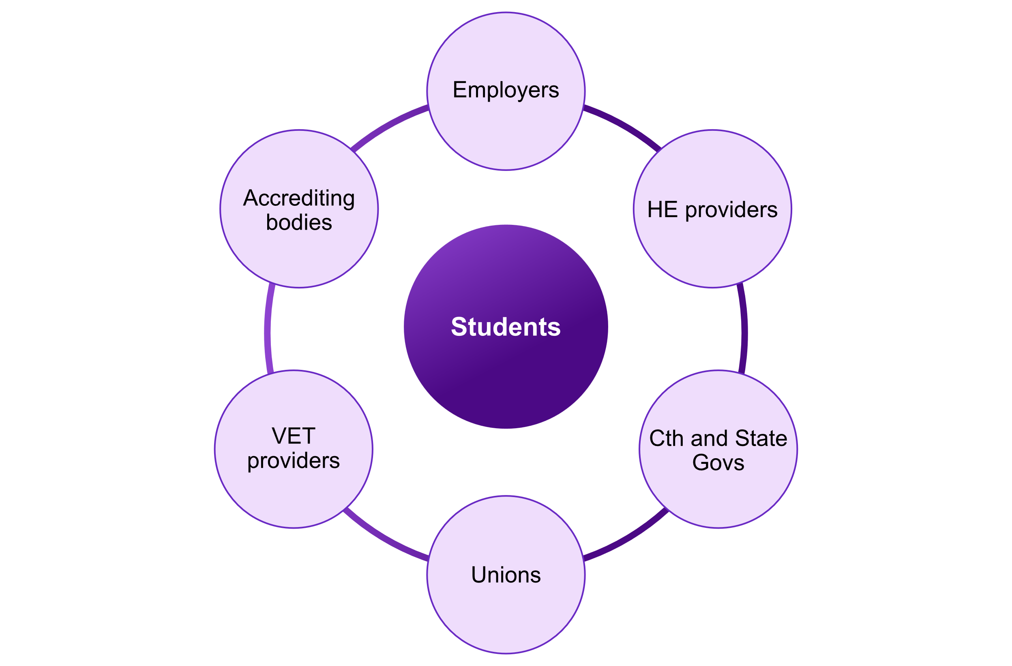
Note: The term student should be interpreted in the broadest sense to include all learners who participate in a wide range of tertiary education and training at various stages of their working lives. An alternative label for student is ‘learner’.

Description of the system actors and their functions.

The Australian and state and territory governments
Australian governments at all levels are responsible for oversight of tertiary education. Tertiary harmonisation will ensure maximum funding efficiency, enabling governments to support more students and to better invest in human capital and skills transitions. State and territory governments also regulate and administer trade licensing, which must retain its integrity for community safety and economic wellbeing.
Australia’s tertiary regulatory framework consists of dual systems for VET and Higher Education, with additional complexity relating to state-based regulation in Victoria and Western Australia. While ASQA is the national VET regulator, the Victorian Registration and Qualifications Authority and the Western Australian Training and Accreditation Council are responsible for registration and assurance of providers operating solely within the state plus general accreditation functions of courses outside of national industry defined qualifications embedded in Training Packages.
ASQA’s jurisdiction accounts for almost 90% of VET providers (ASQA, 2024). The Tertiary Education Quality and Standards Agency (TEQSA) is responsible for regulation and quality assurance in the Higher Education sector (TEQSA, 2024).
All universities and some other Higher Education providers hold self-accreditation status, with accreditation responsibilities for other providers resting with TEQSA.
A key actor in the system will be the Australian Tertiary Education Commission (ATEC) which will begin in an interim capacity from 1 July 2025 and be formally established from 1 January 2026.

VET Providers, such as TAFEs and private RTOs,
VET providers, including First Nations owned and/or operated RTOs, deliver training packages, accredited courses and other programs. The largest VET courses are in the area of: childcare, nursing support, personal care workers, welfare support workers, and nursing.
They also take key responsibility for the education and training of most trades and apprenticeship courses as well as the skill sets that underpin many of Australia’s priority and emerging industries.
By working collaboratively with Higher Education in a more harmonised system, VET providers will be able to deliver a more flexible suite of training products for a wider body of students, including Higher Education students and graduates. This will support an additional inflow of student enrolments as employers boost their upskilling plans.
Beyond institutional leaders, the wider VET workforce is important to the process of tertiary harmonisation. The tertiary harmonisation roadmap needs to be attentive to the VET workforce, especially those involved in administrative processes for credit recognition and student support as well as those in teaching, training and assessment roles.
Since growth is expected, it will be particularly important to ensure an adequate supply of qualified teachers. JSA's VET Workforce Study shows that the VET sector is struggling to recruit VET teachers, who often leave the sector for higher paid roles (Jobs and Skills Australia, 2024). This is a key challenge for a workforce where individuals often require both industry licensing and teaching qualifications, especially in industries where well-qualified workers are in high demand.

Higher Education providers
Universities and other Higher Education providers are responsible for liberal education, which empowers students to deal with complexity, diversity, change, a broad knowledge of the wider world, as well as critical inquiry in a focused area of importance to them and to society. Additionally, Higher Education is responsible for a substantial portion of the training of Australian professionals.
Both liberal and professional Higher Education are underpinned by basic, applied and experimental research that enhances knowledge and application of new creative thinking, techniques, methods and technologies to Australian industries and workplaces.
Many aspects of Higher Education-based skills and knowledge overlap with or complement work performed by people holding VET qualifications - which also include a combination of skills and knowledge.
Tertiary harmonisation will help address shifting career goals and the skills gap identified by employers, support a new flow of students into Higher Education via VET pathways, and enabling Higher Education students and graduates to gain hands-on skills that are currently only available via VET.
The Higher Education workforce will also need to participate in processes of credit transfer, qualification design, teaching and student support in a more harmonised system. This workforce has been highly casualised in the past, and subject to a marked volatility since the 2020 Covid disruptions. Tertiary harmonisation presents an opportunity for the Higher Education sector to draw on the administrative and subject matter expertise of its workforce to better link research and application via credit recognition, teaching and qualification design.

Industry and Employers
Employers have a role in recruiting graduates of VET and Higher Education study programs and as sponsors and facilitators of workplace-based training and further professional development. They are thus expected to be co-investors in tertiary education, especially in areas that apply to their specific workplace.
Many industries with growing labour needs are undergoing significant transitions, with more changes on the horizon. A WEF study found that 85% of employers report their intention to upskill their workforce (World Economic Forum, 2025).
Industries undergoing transitions will benefit from collaborating with VET and Higher Education institutions, often together, to upskill the changing workforce. This will extend the findings of the University-Industry Collaboration in Teaching and Learning Review to incorporate the VET sector (Bean & Dawkins, 2021).
Many of the findings of that review, including the NST, AQF reform and a unified credentials platform confirm the fact that a more harmonised system will better enable industries to apply the latest research and development and upskill their workforce at multiple levels (for individuals and for the industry workforce).
Industry bodies and individual employers will benefit from a more agile tertiary system that is well positioned to respond to technological and economic change, producing graduates with creative thinking skills that are able to apply the latest discoveries and techniques. A more harmonised tertiary system, with greater involvement of industry and employer groups in the tertiary education system with some training occurring in workplaces will more efficiently deliver Australia’s workforce needs.

Licensing and accreditation bodies
Licensing bodies (e.g. for trades licensing and professional accreditation) have responsibility for maintaining standards in the application in key industries and sectors that underpin many aspects of our workforce capacity, including Australia’s health, infrastructure, safety, and educational capacities. Tertiary harmonisation will establish more flexible opportunities in qualifications relevant to their industries.

Unions
Unions represent their members, working in selected industries and sectors where workplace safety, working conditions, pay rates and union coverage are often related to levels and standards of education and training, including in certain awards. The increased flexibility enabled by tertiary harmonisation will provide a basis for unions to support skill recognition and upskilling, improving wages, safety, mobility and employment opportunity for their members.

Jobs and Skills Councils
Jobs and Skills Councils (JSCs) play a crucial role in shaping the workforce and skills landscape in Australia and operate at the intersection of skills and training policy with workplace issues and labour market needs. JSCs take a tripartite approach and work with unions and industry stakeholders to provide insights into workforce capacity and development needs. These insights inform the development of training packages and are related to the curriculum, ensuring that tertiary education delivery is tied to the needs of the modern workforce.

Other actors relevant to the tertiary system
In addition to these primary actors, it is important to acknowledge that the tertiary system articulates with:
Secondary schooling, via tertiary entrance requirements, VET delivered in senior secondary school settings, subject pre-requisites and career advice.
Providers of post-qualification education and training, including workplace training, professional development (including accredited CPD providers) and targeted skill development.

The three pillars and 12 elements of tertiary harmonisation discussed in Chapter 3 provide a guide through which tertiary harmonisation can be examined for both the system as a whole and individual system actors.
This framework enables review of the connections and consideration of their alignment, supporting positive outcomes for students and other system actors. Interventions in the system will impact the system as a whole and the individual system actors.

System architecture
There are key components in tertiary education system architecture, such as the AQF, that when reformed (Recommendation 15) will enable system actors to undertake tertiary harmonisation (Figure 2). These components are the responsibility of a diverse range of systems actors and stakeholders.
There will need to be new system architecture designed to address harmonisation gaps, such as the NST, which will include critical inquiry and conceptual disciplinary knowledge and skills, in a way that supports system connectiveness and enables the strategic alignment of the system (Recommendation 16).
This will further facilitate innovation, enabling new forms of qualification to emerge in line with the growth of knowledge, applications and labour force needs. It will make it possible, for example, to design a higher-level VET program, thus bringing parts of higher and vocational education together, and similarly to embed structured workplace-based training into Higher Education.

Australian Qualifications Framework
The AQF represents a valuable structure for the design, description and interrelations between qualifications (Department of Education, 2019). However, submissions to the Inquiry into the Perceptions and Status of Vocational Education and Training suggested that although all levels of the AQF encompass both skills and knowledge, the hierarchical nature of the AQF contributes to a perception that VET qualifications are of lesser value than Higher Education counterparts, reinforced by the prevalent idea that education pathways should ascend AQF levels rather than moving flexibly between sectors, as part of initial post-secondary training or later in an individual’s career (House of Representatives Standing Committee on Employment, Education and Training, 2024).
This suggests a reformed AQF could deliver benefits “for students, occupations and industries in instances where their development and skills need straddle the current binary structure of the system” (Hodge & Knight, 2021). In 2019, an Expert Panel for the Review of the Australian Qualifications Framework characterised the AQF as “[setting] the overall framework for the design and quality assurance of education and training in Australia” (Department of Education, 2019, p. 8).
The Review found that funding, governance, regulation and institutional responsiveness were influential factors on the tertiary system, beyond the AQF. However, the specifications of the AQF affect the delivery of qualifications and impact the broader regulatory environment in both the VET and Higher Education (Department of Education, 2019). As discussed in the Australian Universities Accord, a “new” AQF will enable the flexible design of fit-for-purpose qualifications (Recommendation 15).

Regulatory Requirements
The dual regulatory model and division of responsibility between the regulators TEQSA and ASQA are “reinforced by different accreditation frameworks, distinct (and for dual sector providers, duplicative) reporting obligations and institutional inertia” (Department of Education, 2024, p. 229).
The duality of Australian regulatory requirements particularly affects dual- or multi-sector providers and inhibit the flow of students between VET and Higher Education (TEQSA, 2023). ASQA and TEQSA are presently engaged in collaborative activities aimed to reduce duplicative regulatory work.
The ASQA and TEQSA Memorandum of Understanding, in effect since July 2016, outlines shared best practice principles relating to risk-based and data driven regulation, collaboration and engagement, continuous improvement and building trust (ASQA & TEQSA, 2016).
The Memorandum also establishes intentions to streamline and deduplicate regulatory processes that add to the regulatory burden and costs of multi-sector providers. This is also the remit of a Dual Sector Provider Working Group and is a key focus area for the National Skills Plan (Australian and State and Territory Governments, 2024).
The outcome will enable providers to benefit from clear and consistent expectations and reduced regulatory duplication and burden, while regulators may leverage potential efficiencies arising from common and/or shared processes, improve stakeholder satisfaction and build capacity for cross−sectoral regulation. Subsequent reform under the stewardship of ATEC will provide further benefits to the sector (Recommendation 4).
Regulatory requirements are not only limited to government regulations, but also include bodies with a responsibility for accreditation, licensing and in some cases wage setting, including awards, trade licensing, professional councils and international accreditation bodies that recognise Australian qualifications for practice overseas.

Funding arrangements
Current funding arrangements are complex for prospective students and providers to navigate. The amount of financial assistance available depends on the sector, the course, the type of provider, and personal circumstances including location. Variations in government support and funding priorities between the two sectors can lead to competition rather than collaboration. A harmonised tertiary system will encourage collaboration and be fairer for students and providers, ensuring that funding incentives do not distort choice or opportunity.
It will be important to design a funding system that prioritises Higher Education qualifications that have nested VET qualifications embedded, enhanced in ways that bring together distinctive blend of applications and knowledge that ensure that the resultant degrees or associate degrees are truly strongly vocational and take advantage of the distinctive capabilities of VET in developing vocational capabilities (Recommendations 11 and 12). One possibility is to leverage Commonwealth Supported Places (CSP) to promote tertiary harmonisation (Recommendation 13).

Credit Transfer System
Improving credit transfer, recognition of prior learning (RPL) and articulation arrangements were consistent topics of discussion throughout the roundtable consultations (see Appendix A). There was a broad acknowledgement that a student-centred approach to mobility would encourage lifelong learning that can help students meet personal aspirations and create efficient upskilling and reskilling opportunities for critical or emerging roles.
While this interest focused on supporting the intake of students, it was also noted that providers felt they could lose students through mobility, facing financial disincentives in terms of reduced full-time enrolment funding and the resourcing effort required.
While this concern would need to be considered as part of a system's development, an opt-in platform (see Recommendation 9) would offer providers a competitive advantage by enabling new flows of students, potentially increasing their overall market share, and helping to move the sector towards a sufficiently connected and standardised system that will allow common units of measurement and language when assessing learning outcomes and progress.

National Skills Taxonomy
Improving credit transfer, recognition of prior learning and articulation arrangements in a systematic way requires a system that is sufficiently connected and standardised to allow a common language when assessing learning outcomes and progress. The current work undertaken by JSA on the NST provides a mechanism to connect the tertiary education systems.
This is through using the language of skills and a common framework for conceptual, disciplinary and applied skill development, enabling both Higher Education and VET to adopt a common understanding using a consistent approach and method to recognise achievement. The National Skills Taxonomy will offer a common language for skills across occupations, employers and industries as well as across VET and Higher Education. It will support a harmonised tertiary education system, by providing tools to education providers that support the improvement of skills articulation in educational design (Recommendation 16).
Figure 2. The System Architecture of Tertiary Harmonisation
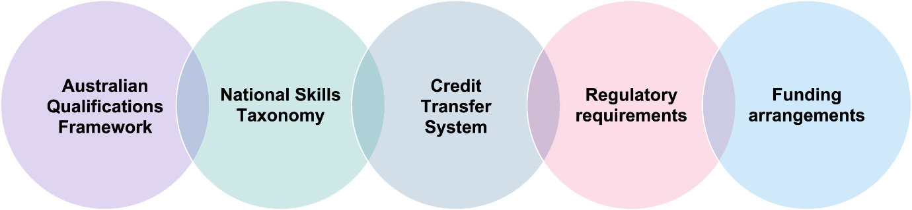

Proposals under consideration
There are additional proposals under consideration by Government that focus on how students can effectively interact with the tertiary education environment to maximise the student benefits identified in the next section.
Importantly, these interactions are designed to begin at the school leaver stage, taking an equal and informed approach to choice between VET, Higher Education, and combined options available, right through to the employment and lifelong learning stage, continuing to support users’ approach to choice, and to better understand the skills and knowledge they have acquired.
Allowing individuals to contextualise their future employment and learning opportunities with their existing skills and knowledge makes continuous development a more efficient and targeted process and can help individuals develop a stronger alignment to aspiring employment opportunities (see Recommendation 17).

Career's Digital Roadmap
Work done by DEWR on a Digital Roadmap proposes consolidating consumer tertiary information into a single, trusted source. Integrating VET and Higher Education consumer information would improve individuals' abilities to make unbiased choices based on their career aspirations by presenting VET and Higher Education options in a single source.
Making informed choices is important at both the school leaver stage, and continuously through lifelong learning, as additional skills and knowledge are required over time. A single source may help individuals reprioritise their choice drivers such as the perception of VET or Higher Education, to more relevant drivers such as education alignment to career goals.

National Skills Passport
A National Skills Passport could link to existing initiatives such as the National Skills Taxonomy to create a practical mechanism for individuals to show their acquired skills and knowledge across VET and Higher Education through a trusted and integrated digital system. It could support personalised guidance on education, training and career pathways including information on workforce demand. This in turn would also promote upskilling and reskilling to help build a culture of lifelong learning.

Benefits of Tertiary Harmonisation
A number of significant structural trends will shape the Australian economy and labour market over the coming years. Australia needs to ensure it has a skilled, diverse, productive and resilient workforce able to meet current and future labour market and economic needs.
Individuals will need to be supported to participate effectively by increasing access to tertiary education both within and following school, and continuously over a career span as the labour market evolves. Lifelong learning, and the opportunity to engage with the benefits of VET and Higher Education when they are needed for initial and ongoing development will need to become a strengthened characteristic of the system.
A harmonised tertiary education sector will ensure Australia has the prerequisite necessary to build a better-skilled and more adaptable workforce for the Australian labour market for the future. Further, a more cohesive and holistic tertiary education system has the potential to support individual's participation, productivity and inclusiveness in the Australian labour market and economy. These benefits will flow to both workers and employers, but also have benefits to education providers and the Australian Government more broadly. These benefits are also closely aligned with the objects and outcomes agreed under the NSA (Australian and State and Territory Governments, 2023).
The potential benefits of harmonisation are considered under four themes with corresponding case studies: system effectiveness, access and equality, tackling national challenges, and productivity and labour market outcomes (Figure 3).
The foundational outcome is improved student experience and outcomes, that creates broad ranging benefits for the education system, individuals, the labour market and the economy. Tertiary harmonisation should enable clear, smooth, and well-informed processes that enable students to move between VET and Higher Education in both directions, without funding disincentives, content duplication or excessive administrative burdens, resulting in strong employment prospects.
Figure 3. The four benefits of Tertiary Harmonisation
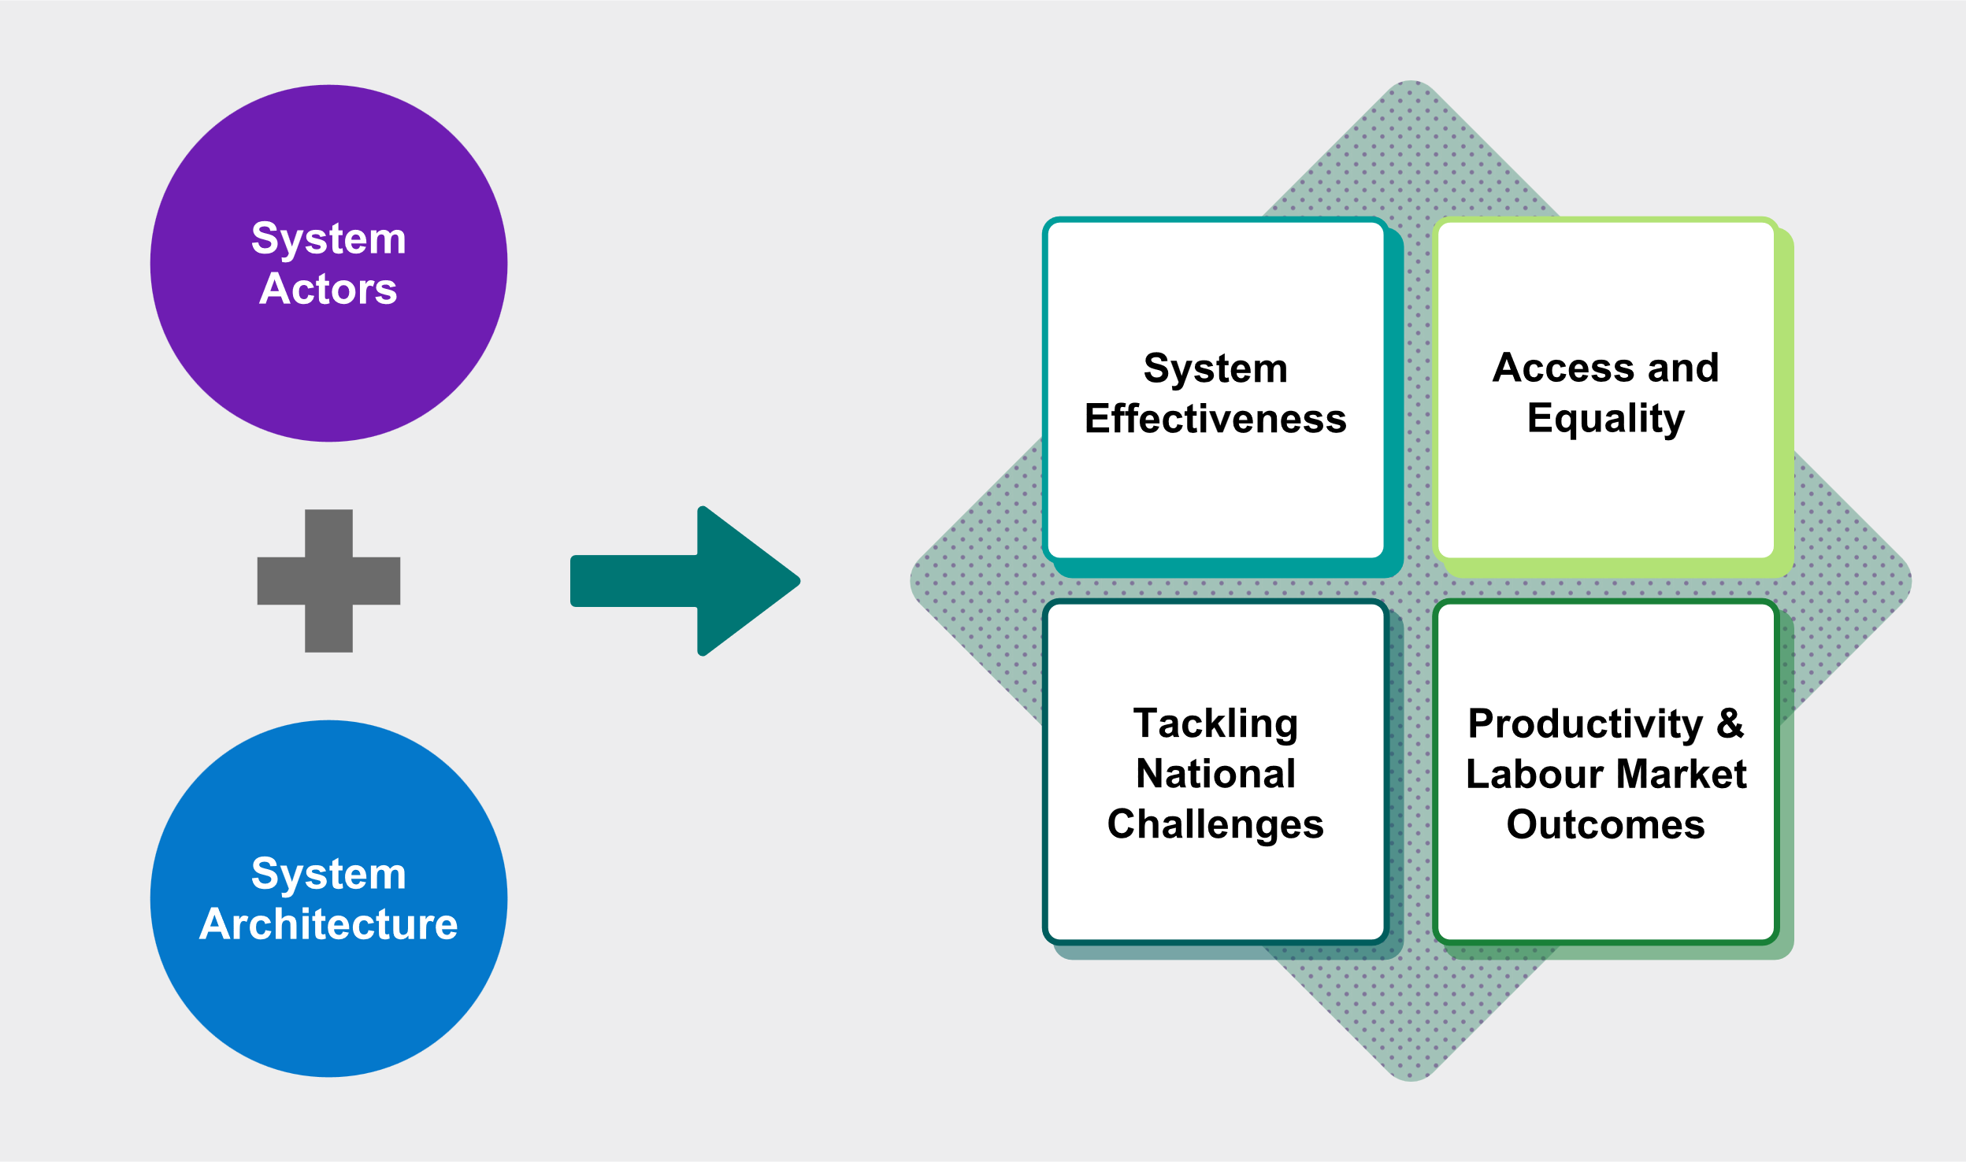

System efficiency and effectiveness
At present, the tertiary sector is not well connected, nor does it have a unifying basis to easily facilitate collaboration. This results in inefficiencies, including duplication between VET and Higher Education, unnecessary barriers to credit transfer and RPL and difficulties accessing the information needed to make informed decisions about career development, upskilling, and reskilling across the system. At a time when the labour market needs more tertiary qualified workers and transitioning workers to meet new workforce challenges, the system's inefficiency does not incentivise lifelong learning for individuals.
Tertiary harmonisation will require collaboration and administrative costs but will ultimately increase the efficiency of the tertiary system by reducing the cost to individuals, industry and government in the delivery of the skills and knowledge that students need.
The current arrangements impede innovation, reducing the effectiveness of the tertiary sector in meeting student and labour force needs. Harmonisation would encourage the development of pathways and programs that meet the needs of individual and industry, increasing system effectiveness.
One way of thinking about the potentially very large benefits of tertiary harmonisation, is that the increase in tertiary participation and success, projected in the Accord final report will be much more possible in a more harmonised tertiary system. It will be more feasible to achieve these ambitious targets, with a major role for the VET system in growing tertiary participation in enabling a big increase in the skilled workforce, many with diplomas, or degrees and associate degrees with nested VET qualification. It will also be more cost effective. Collaborations between VET and Higher Education to provide Tertiary preparation courses will support this objective (Recommendation 7).

Case study - Expanding VET provision into Higher Education to support targeted industry growth (TAFE Queensland)
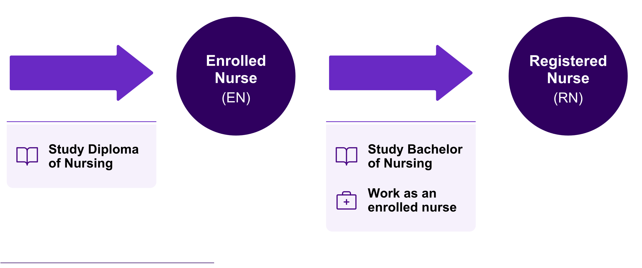
Figure 4. TAFE Queensland Enrolled Nurse to Registered Nurse Pathway
TAFE Queensland is addressing an increased demand for registered nurses in Queensland, using tertiary harmonisation as a mechanism to upskill enrolled nurses into registered nurse roles. They are doing this by providing a pathway between the Diploma of Nursing to the Bachelor of Nursing, while also designing a higher education program with flexibility, acknowledging that students will be working as enrolled nurses throughout their continued studies.
Students receive one year credit from Diploma of Nursing, reducing time and cost of degree completion. Providing a seamless pathway and education journey with the same provider that builds on existing experience could also increase the likelihood of attainment.
Source: TAFE Queensland (n.d.), Introducing TAFE Queensland's first-ever Bachelor of Nursing, https://tafeqld.edu.au/news-and-events/news/2024/introducing-tafe-queensland-s-bachelor-of-nursing-program

Access and equity
Australia is not meeting its current skills needs. On its current trajectory, as the Accord demonstrates, the education system will also fail to meet its future skill needs (Department of Education, 2024). To meet these skill needs, Australia must increase both initial and continuous participation in tertiary education.
One way to raise participation is by increasing the number of people who have access to study in the tertiary education sector. This can be done by taking on a more inclusive approach, supporting higher participation from those groups which are historically underrepresented, including First Nations, regional and low socio-economic status (SES) students.
The Accord shows that a more seamless and aligned tertiary education system will support better life and employment outcomes for under-represented groups, but to achieve this, barriers between VET and Higher Education need to be broken down.
Pathways between VET and Higher Education are important as they support access to Higher Education for all students, but especially for those from under-represented groups.
In 2021, 30,000 domestic students commenced a bachelor degree on the basis of a VET qualification, with First Nations, low SES and female students more commonly using this pathway (Department of Education, 2023).
Equally, a system that is more efficient in its recognition and mobility will improve access to lifelong learning, creating cost and time efficiencies that are beneficial to individuals to continue to upskill and reskill over their careers.
If tertiary harmonisation is implemented effectively, with a focus on building an adaptable and resilient tertiary education system able to respond to the changing needs of industry, labour markets and citizens, it will address barriers to pathways between sectors, improve access and reduce inequality.

Case study - Thoughtful education design, promoted Higher Education attainment for equity cohorts through a VET lead approach (TAFE NSW and University of Canberra)

Figure 5. School to VET pathway - TAFE NSW and the University of Canberra

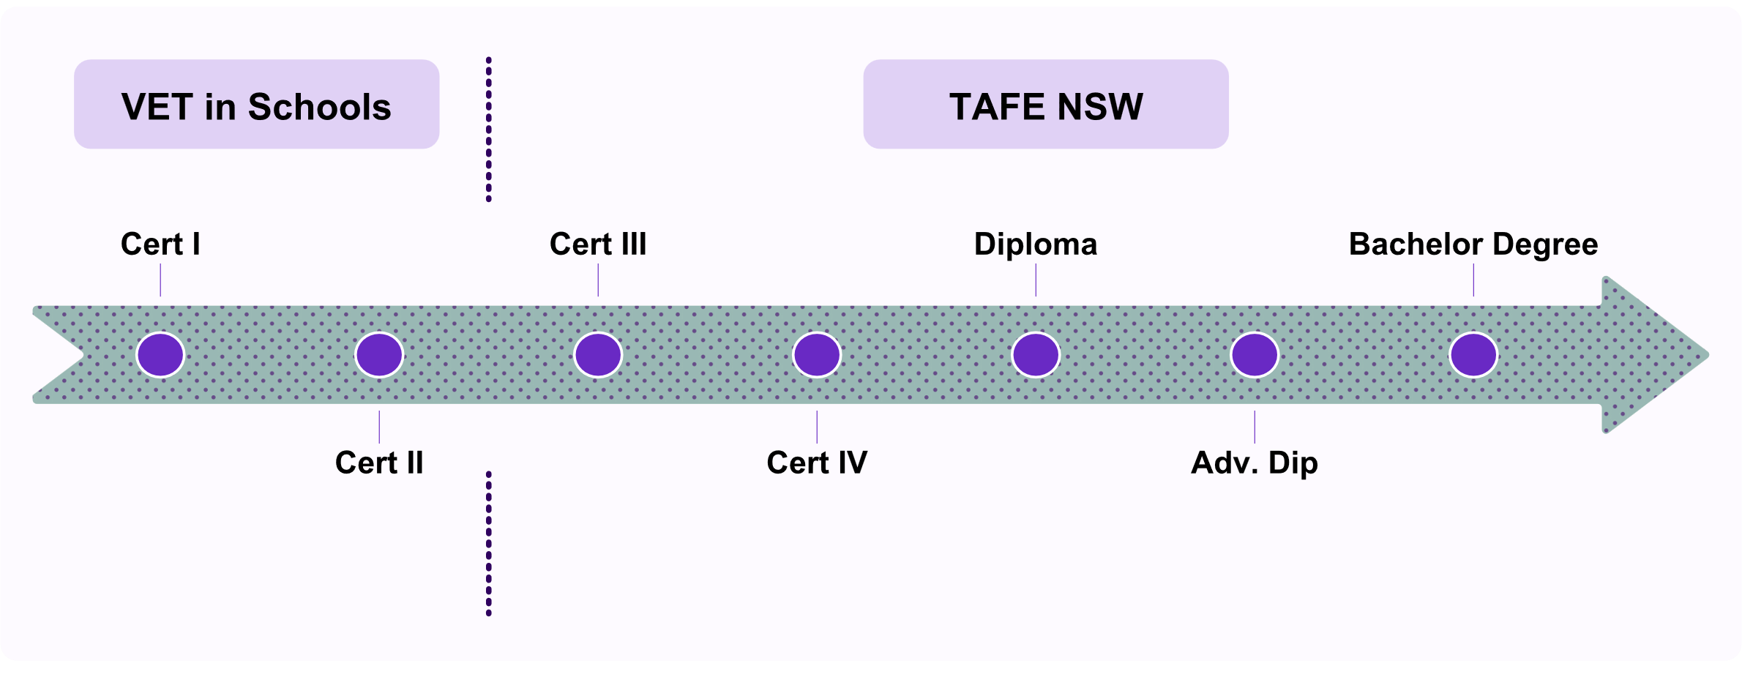
TAFE NSW and the University of Canberra (UC) have collaborated to develop a pathway from Certificate I through VET in Schools, to a bachelor’s degree delivered by TAFE NSW in the area of tourism and event management. This program has specifically been designed for people who are the first in their family to access Higher Education and exemplifies the potential benefits achievable under the tertiary harmonisation agenda, which aims to make tertiary education more accessible and inclusive.

Features of this design include:
- The option to commence VET study through a VET in Schools option, supporting retention and transition into a continued education pathway.
- Complete nesting of VET qualifications, supporting students as the progress towards Higher Education qualifications, but with identified exit pathways along the way to ensure students can leave at any point with a qualification.
- Several pre-determined credit arrangements for both the Diploma and Advanced Diploma into the Bachelor degree. Credit recognition is also available for students who have completed the equivalent qualifications through a private provider, increasing its inclusivity.
- Higher Education program taught in TAFE NSW, providing students with a seamless education experience and a learning model that has a continued practical focus, with small class sizes with enhanced teacher access and support.
The overall benefit of this arrangement is the utilisation of tertiary harmonisation to provide a well-supported education program for students who may prefer a VET-based deliver model, while being able to continue studies through to Higher Education. The pre-established credit arrangement also generates a time and cost saving benefit to students, who do not need to duplicate their learning across sectors.
Source: TAFE Directors Australia (2023), 'First in family students access university through TAFE NSW', First in family students access university through TAFE NSW – TAFE Directors Australia.

Tackling national challenges
Australia needs an industry-ready workforce, and in turn, an education and training system that produces graduates capable of stepping into critical roles. If this can be achieved, it will be much easier to turn the challenges Australia faces into opportunities for positive national change.
Some of the challenges currently faced by Australia include:
- transitioning to clean energy technologies to actively address climate change, while building international competitiveness as a renewable energy superpower, and strengthening domestic energy security.
- strengthening the health and wellbeing of people and communities through enhanced care services, as well as delivering improved infrastructure and affordable housing.
- fostering a sustainable and high-quality early childhood education sector workforce by addressing retention, professional development and the wellbeing of those employed within the sector.
At present, there are persistent occupation shortages (Jobs and Skills Australia, 2024), and the potential for these shortages to further increase if the education system cannot meet industry needs (BIS Oxford Economics Australia, 2023). If this major workforce disruption is not addressed, the ability to solve Australia’s national challenges will be hindered.
Tertiary education will play a key role in addressing national challenges by supporting an increased supply of industry ready graduates, both through school leavers, and reskilling and upskilling non-school leaver pipelines.
It will involve lifelong learning strategies to enable major workforce transitions that support individuals to continue to be engaged in the labour market through major changes. This in turn supports their overall wellbeing and socio-economic prospects and has continued productivity gains for the economy.
The World Economic Forum Future of Jobs Report (World Economic Forum, 2025) demonstrates that skill gaps are 'categorically the biggest barrier to business transformation'. Upskilling the workforce will require more graduates from both VET and Higher Education and continuing learning development for existing employees. Without a more effective tertiary sector to address such skill gaps, Australia will not be competitive.
A more harmonised tertiary sector will boost the tertiary sector's agility in its response to rapidly changing economic, technological and environmental conditions, including:
- facilitating innovation in course design and offerings, including via work-based training, which will have the further benefit of diversifying tertiary education
- producing graduates in new and emerging fields more quickly to supply shifting demand for labour in a changing economy
- better enable lifelong learning for reskilling, upskilling and professional development in industries under transition and to increase Australia’s stock of human capital
Addressing national challenges is complex, and most of these challenges have inter-dependencies to achieve them. One sector alone cannot address such complex challenges. Successfully addressing challenges requires a connected tertiary system, where both sectors can collaborate to improve the timeliness and industry relevance of workforce supply. Transitions in Australia’s economy are already under way, leading a growing number of industries and institutions to facilitate co-operation between VET and Higher Education, despite the present impediments.
This includes:
- Increasing overall graduates by:
  - Improving access and mobility across both sectors by improving tertiary recognition of existing skills and knowledge from education attainment and work experience
  - Lifting parity of esteem across both sectors, to remove bias at a sector and industry level, and improve prospective student choice.
- Improving graduate outcomes and their ongoing workforce resilience by developing education opportunities that have a blend of industry relevant skills and knowledge, that are less constrained by the artificial barriers in education design.
To address national challenges, some workers will need new education and training models, while other industries will benefit from the transfer of existing education and skills of workers into new fields.
RPL will be an invaluable tool in crediting existing skills and knowledge where relevant and reducing re-education time and costs for those workers and employers involved in skill transitions.
The next section discusses the role of tertiary harmonisation in boosting national productivity and performance by increasing diverse workforce participation across industries and leveraging opportunities that digital technologies present.

Case study - Industry-led innovation with dual qualification (RMIT and AI Group collaboration)
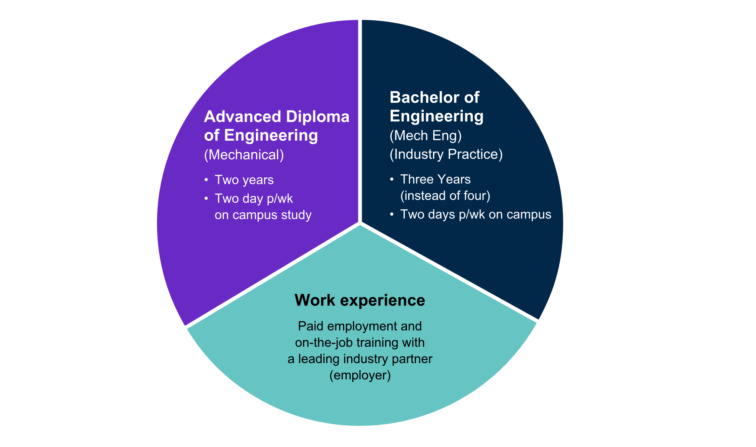
Figure 6. Engineering Dual Qualification - AI Group and RMIT
There is currently a national shortage of systems engineers, and this shortage is expected to grow as the country continues to develop its defence-related manufacturing. The Ai Group Centre for Education and Training partnered with industry and RMIT University to create a dual qualification in systems engineering that includes an apprenticeship.
The program enables a student to complete an Advanced Diploma of Engineering, followed by the Bachelor of Engineering (Mechanical Engineering) (Industry Practice) (Honours), while retaining paid employment with an industry partner across the study period.
This example of industry-led harmonisation shows the multi-faceted benefits to system actors that harmonisation can bring:
Employers gain highly employable, industry-ready graduates, and an ongoing pipeline of talent.
Students are financially supported by employers through their studies, reduce their study time for the honours program, which is typically four years, and have high short and longer term employability prospects.
Source: AI Group Apprentice & Trainee Centre (n.d.), 'Victorian Mechanical Engineering Apprenticeship', Victorian Mechanical Engineering Apprenticeship - Ai Group Apprentice & Trainee Centre.

Productivity and labour market outcomes
An extensive literature links human capital investment to productivity. Investments in education and training increase the knowledge, skills and capabilities of the workforce, which results in higher output per worker (Chou, 2003) (Banerjee & Wilson, 2016) (Borland & Smedes, 2024).
The central economic argument for a harmonised tertiary education system is that by making both VET and Higher Education simultaneously accessible to individuals, school leavers and workers will be able to more readily obtain the skills they need from either part of the system. Additionally, industry will be better positioned to obtain the workforce skills they need.
Stronger pathways and partnerships between VET and Higher Education will also reduce overlap and administrative friction, making skill acquisition less costly.
A more harmonised system will provide greater transparency of the knowledge, skills and capabilities that workers possess, and that employers need from VET and Higher Education. A National Skills Taxonomy mapped onto both VET and Higher Education credentials would better match people to jobs. The outcome will be fewer skills shortages and higher productivity, in turn leading to higher wages. It will reduce the skills gap, highlighted as an urgent issue in the World Economic Forum report (World Economic Forum, 2025).
An advantage of this kind of investment relates to rising wages without inflationary effects. Better matching workers to jobs makes a more efficient skills market and lowers the non-accelerating inflation rate of unemployment (NAIRU). That is, this is how both lower unemployment and stable, low inflation will be achieved.
The potential labour market impacts of a harmonised tertiary education can be separated into the first-round or initial impacts and the subsequent benefits that flow thereafter.
First round impacts include those which may directly arise from tertiary harmonisation and include the potential for improvements in the overall level of human capital available in the labour market, the better alignment of human capital with the needs of employers (firms and industry), improvements in labour market matching, and greater dynamism and responsiveness to opportunities and challenges.
Figure 7. Impacts and benefits of harmonisation
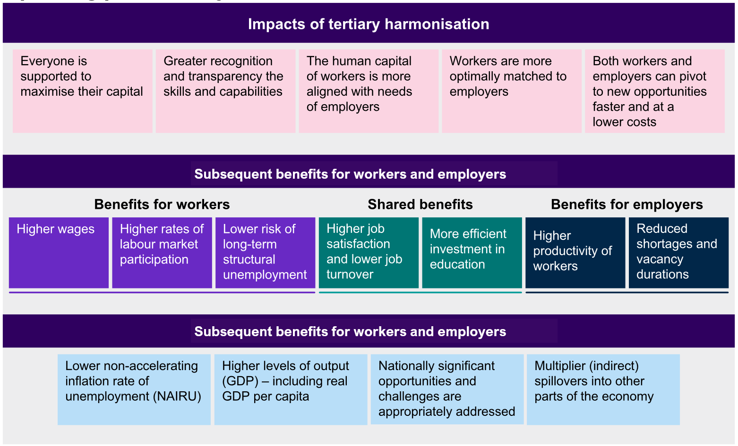
For enterprises, the potential benefits take the form of higher productivity of their workers, which in turn leads to increased output and profit for the employer, as well as reduced labour shortages (which arises both via a decrease in the rate of unfilled vacancies and also a faster speed to hire for those vacancies that go filled). There are a range of shared benefits, such as higher job satisfaction, which is beneficial to workers but is also linked to lower job turnover for firms.
The combined potential impact of tertiary harmonisation will have broader economy-wide benefits, which may also have multiplier effects across the labour market. Examining the benefits for workers and organisations suggests that a more connected and holistic tertiary education system would lower the non-accelerating inflation rate of unemployment (NAIRU) - that is, a lower level of unemployment consistent with stable inflation.
Put another way, tertiary harmonisation would see full employment occur at higher levels of employment and lower levels of unemployment, as result of the more efficient market for skills. With higher labour productivity, the benefits of tertiary harmonisation should also lead to higher levels of output (GDP) – both in aggregate, and on a per capita basis – with the benefits of higher productivity also spilling over into the rest of the economy via multiplier effects, including those that arise from higher real wages.

Maximising the human capital of workers based on their individual circumstances
A more joined up tertiary education system can help optimise the human capital of individuals by enabling more people to undertake tertiary education, supporting people to complete the level of training most suited to their individual aptitude and personal circumstances, and facilitating the completion of lifelong learning that may complement previous education or facilitate a new direction.
There is a strong link between educational attainment and labour market (Leigh, 2024). Data from the ABS Survey of Education and Work shows that those with tertiary qualifications are more likely to participate in the labour market, record lower rates of unemployment and receive higher wages (Australian Bureau of Statistics, 2024).
From the perspective of both merit (or aptitude) and equity, all those with the capacity and capability to undertake higher levels of education should be supported to do so. Tertiary harmonisation can enable this, by creating greater links and pathways for individuals to undertake education and training.
This will be enhanced through greater recognition of existing capabilities when individuals apply for and completing further training. Ideally this capability recognition would occur using a coherent and consistent method that is utilised for all tertiary education and linked to training pathways to identify what capabilities an individual already holds and what potential future training options may be suitable for them (including possibility for fast-tracked qualifications). A harmonised system will do this better and be able to formally recognise a wider array of skills and experience than is currently the case.
The result is that tertiary harmonisation will enable more people to enrol in and complete tertiary education and training, with the speed at which qualifications are completed also increasing due to enhance capability recognition.
This will maximise the value of Australia's investment in human capital, for individuals, the workforce and wider social goals.

Alignment of the human capital of workers with the needs of industry and society
Beyond the level of human capital, it is also important that workers have the skills industry needs. Harmonisation of the tertiary education system will better align the subject matter of that human capital to social and economic needs.
Australia requires a range of skills and knowledge among our population. For industry, this includes capability mixes that may not be adequately captured through a single qualification or training pathway. A harmonised education system will help train workers to have a better mix of knowledge, specific technical skills, general and transferable skills (such as communication, teamwork, critical inquiry, creative thinking and leadership) and foundation skills (such as language, literacy and numeracy) that is difficult to deliver in the current system.
This need applies to Australia's existing workforce, as individuals undertake lifelong learning alongside participation in the labour market, as well as people beginning to undertake tertiary education out of school, or later. Whether through new graduates or experienced workers, tertiary harmonisation will provide a better mix of knowledge and skills that more effectively meets the needs of employers.
A better alignment between the skills of the workforce and the skills required by Australian enterprises will reduce skills shortages. Organisations will be able to more readily access the skills they require, leading to higher fill rates for vacancies, and vacancies being filled more quickly, as people suitable for their positions are more readily available and transferable.
Harmonisation will result in greater recognition and transparency of the knowledge, skills and capabilities that workers have, better matching people to jobs, leading to fewer skills shortages and higher productivity, which in turn will lead to higher wages. This means fewer skills gaps in the labour market, which enables organisations to continue producing outputs and providing services that would otherwise be hindered by labour limitations.
Moreover, better alignment between the skills of the workforce and the skills required by organisations will also reduce unemployment, including the duration of unemployment when workers are laid off. A harmonised tertiary education will make it easier for people to obtain the skills demanded by employers, and transition to new and emerging industries as their jobs are structured out of the industry or economy, reducing the risk of unemployment.

Supporting workers and firms to more effectively pivot to new opportunities and respond to emerging challenges, including National priorities.
In a dynamic economy, new challenges and opportunities require a response from both industry, employers and workers. Effective responses need to be fast, reskilling workers, developing new individual skills and increasing labour capacity. A more harmonised tertiary education sector will enable organisations and workers to more effectively respond to such opportunities and challenges, including through lifelong learning.
This is particularly the case as many new emerging opportunities and challenges require a combination of the knowledge-based, technical and transferable skills best delivered through a harmonised VET and Higher Education system. The increased flexibility and adaptiveness that will arise will be a significant improvement on current settings, which are often too slow to adapt to emerging needs.
Tertiary harmonisation offers the opportunity to better integrate lifelong learning into individual career pathways over a whole career as well as re-shaping our understanding of a flexible and adaptive workforce. By transforming the present informal designation or
categorisation of people into either VET or higher-education pathways towards a more comprehensive and holistic view of skills and capabilities, Australia's post-secondary education and training system can be part of lives over a whole career. For the wider workforce, it will ensure aggregate skills better evolve and expand flexibly with changes and disruptions to the economic environment.
A roadmap will require analysis to move beyond the highest level of educational attainment as a proxy for human capital, currently collected in the census, to consider whole-of-life and cross-sector skill capability and knowledge development.

The Elements of Tertiary Harmonisation

Key themes in this chapter
- Australia's tertiary sector is complex, consisting of diverse public and private actors in an intricate economic, regulatory and administrative system.
- JSA has developed a framework to help stakeholders better understand the structure and function of Australia’s tertiary system, the elements that comprise it, and the interactions and relationships between them.
- The framework outlines the elements of the tertiary system under three pillars:
  - Pillar 1: The key players in the system, their roles and relationships
  - Pillar 2: The knowledge, skills and qualifications gained through the system including the system architecture that supports them, and how they are perceived
  - Pillar 3: The legislative, regulatory, financial and data architecture that supports, enables, and regulates the system.
- Identifying the elements of each pillar and understanding how tertiary harmonisation will affect and be affected by them is a crucial step in developing a roadmap to tertiary harmonisation.

JSA has developed a framework to understand the structure and function of Australia’s tertiary system. The purpose of the framework is to identify the segments of the system that have a role in tertiary reform. Some of these elements are system actors, whose role needs to be articulated, and forms of collaboration established. Other elements are functional, including the nature and design of qualifications and their alignment to skill and knowledge frameworks. The rest are enabling elements, including legislative, funding and governance policies and systems.
This framework is strategically necessary to develop a roadmap to harmonisation. By breaking down the components of the tertiary sector that will need to be involved in the process of enabling a closer collaboration between VET and Higher Education, this report sets the agenda for system actors, including government and 'first movers' as well as other system stakeholders, to actively work together towards a more harmonised system.

Pillars and elements of the tertiary harmonisation framework
There are twelve elements of harmonisation, falling under three pillars. Reform of these elements is needed to enable the government and key actors in the system to address barriers to achieving scaled and consistent harmonisation.
Figure 8. JSA Tertiary Harmonisation Framework
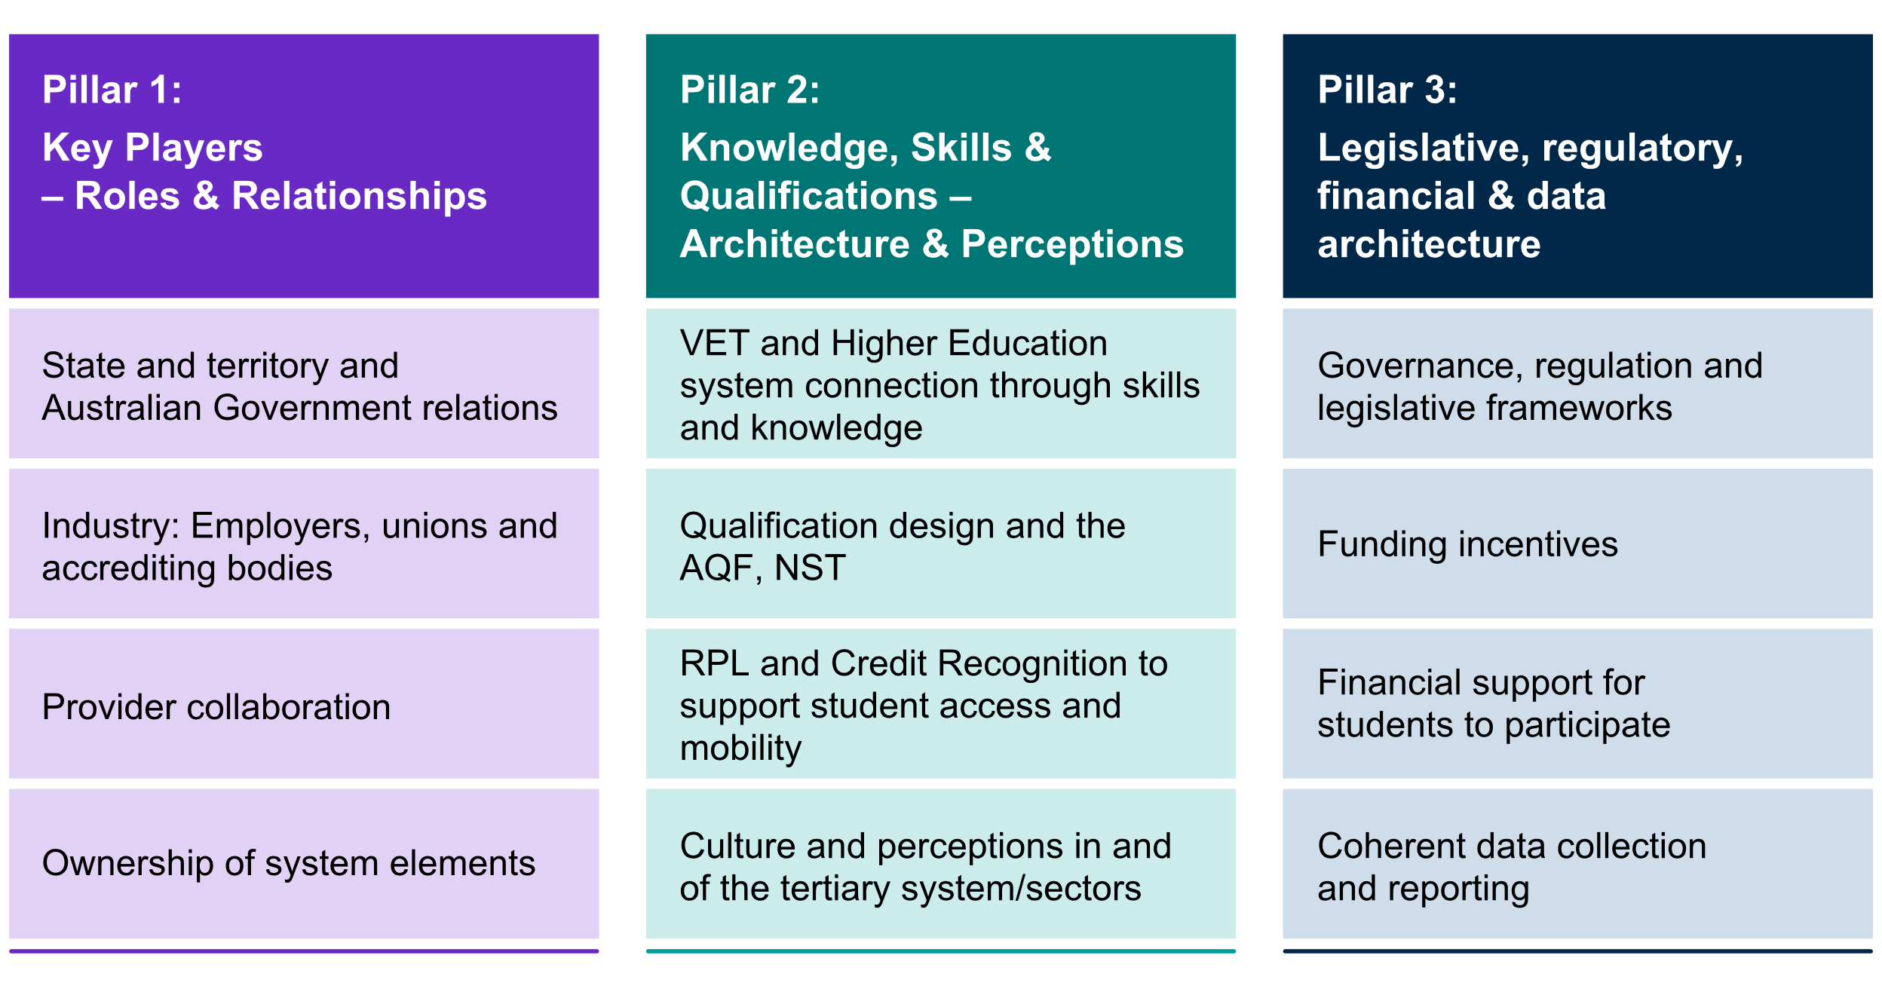
Pillar 1 refers to the actors and their relationships, including: governments; industry and professional organisations; unions and employers; tertiary education providers, including TAFEs; other RTOs; universities and other Higher Education providers.
Pillar 2 describes the system architecture in terms of skills, knowledge, qualifications, systems of RPL and credit recognition and cultural distinctions.
Pillar 3 contains the enabling legislative and funding structures that regulate and drive the tertiary harmonisation system architecture.
Tertiary harmonisation will require policy alignment across all three pillars and between all twelve elements.

Elements of Pillar 1: Key Players: roles and relationships

State and territory, and Australian Government relations
Almost all universities and other Higher Education providers have been established as statutory corporations under state or territory legislation. However, the Australian Government is the primary funder through grants such as the Commonwealth Grants Scheme (CGS) and the Higher Education Loan Program (HELP) scheme and is the level of government with primary responsibility for Higher Education policy. The regulator, TEQSA is also an Australian Government entity.
The VET sector is primarily the responsibility of the states and territories, as the major funding bodies who enter into funding agreements with providers, and own and run their respective TAFE systems.
Substantial funding is also received from the Australian Government under the National Skills Agreement. ASQA, an Australian Government body, is the national regulator although some states (Western Australia and Victoria) have their own state regulator. There are also national training packages which are overseen by national Jobs and Skills Councils, established and funded by the Australian Government. The Australian Government also plays a significant role in the apprenticeship system through the incentives framework and the support services.
The path to harmonisation does not rely on bringing all tertiary provision under one governmental umbrella. However, commitment and support from all governments will be key to ensuring a more harmonised system (see Recommendation 1). All governments will need to collaborate to develop a set of nationally agreed principles for tertiary education funding to support harmonisation (Recommendation 14). An appropriate governance structure involving the Australian and state and territory governments and other key actors, will be needed for the facilitation of the roadmap, with ATEC leading the work on its development in collaboration with JSA (Recommendation 3).
State, territory and the Australian Government stand to benefit by pursuing a more efficient tertiary system, enabling budget allocations to be used with less duplication and waste. Government investment in tertiary education has positive labour market effects, boosts productivity and is likely to reduce inequality.

Industry: employers, unions, licensing/accreditation bodies
Employers benefit when high numbers of students participate in and complete tertiary education. As noted earlier, there is a global trend for employers to upskill their workforce, both by recruiting new graduates and investing in professional development (World Economic Forum, 2025). Australian employers will benefit more than they currently are from an increasingly efficient and effective tertiary education system.
Industries face many challenges in the current environment, with the need to transition to new technologies and environmental priorities, as well as major shifts in global capital flows. This is producing skills gaps that a more harmonised and agile tertiary sector will help address, with new flexibility for collaboration with one another and with industries and enterprises.
Industry input into the design and delivery of courses ensures that the supply of graduates matches labour demand by industry in both quality and quantity. The VET system has a structured system for industry engagement with the development of training packages, through the Jobs and Skills Councils. In the Higher Education system, such engagement is not as structured.
Unions work to support their members' employment conditions, which are sometimes governed by awards linked to specific VET skill sets and training packages. The opportunity to support their members to upskill and reskill in industries, especially those undergoing transition, will help unions secure improved pay, conditions and employment opportunities for their members.
Licensing and accreditation bodies (e.g. trade licensing authorities, professional accreditation associations) maintain and often regulate and accredit standards for industries and occupations. In several sectors this includes the content of study, continuing professional development rules and career progression pathways. Such organisations are key stakeholders in education and training. A harmonised tertiary sector will enable these organisations to work collaboratively with institutions at multiple levels, especially in relation to lifelong learning.

Provider collaboration
Higher Education and VET institutions collaborate with professional and industry partners to ensure that the curriculum and training packages meet current industry standards and licensing needs. In dual sector institutions and between some universities, TAFEs, other Higher Education providers and RTOs, first movers are already collaborating to establish pipelines through certificates and trades into degrees, also accommodating students’ varying schedules and learning needs.
There are currently too many barriers to collaboration to meet the goal of fostering workforce mobility in ways that will enable Australia to meet skills shortages, and in supporting industries in transition. A more harmonised system, supported initially with an innovation fund (Recommendation 10) will facilitate closer collaboration on nested programs (where students progress from one sector to the other) and hybrid programs (where students take an integrated combination of Higher Education and VET). With guidelines to support such innovation (Recommendation 11), this will enable faster implementation of innovative and urgently needed upskilling, with fewer artificial obstacles between fields of study and skill sets.

Ownership of system elements
The ownership and control of tertiary harmonisation elements determines the extent to which system actors (and other parties) can implement tertiary harmonisation. For this reason, closer collaboration between sectors, institutions, accreditation bodies, and governments will be crucial in developing the roadmap to tertiary harmonisation in ways that benefit all system actors.

Elements of Pillar 2: Knowledge, skills and qualifications: architecture and perceptions

VET and Higher Education systems connect through knowledge and skills
Higher Education and VET rely on interactions between skills and knowledge of different kinds. Their distinctiveness is important, but there are key overlaps in disciplines, practices and at the interface of AQF 5, 6 and 7.
Tertiary harmonisation will make a strength of these overlaps, enabling VET and Higher Education to locate common ground, especially in relation to skills.
This will not diminish the importance of critical inquiry and disciplinary knowledge, which is valued highly by both sectors and especially in universities, but instead help to bring such knowledge into the workplace. In this way, tertiary harmonisation will not only better bring the two halves of Australia's tertiary system closer, but it will also mean better transfer of new knowledge and techniques produced by researchers and applied in practice and vice-versa, where problems arising in workplaces can be abstracted into new discoveries, strengthening fields of education and industries alike.
Finding common ground based on skills will benefit students in a similar way. A common unit of measure between the two sectors will allow interoperability, supporting improved student mobility and better drawing together knowledge and skill outcomes. The architecture supporting the tertiary sector, such as the AQF and the NST needs to be designed to support system connectiveness and enable strategic alignment of the sector (Recommendations 15 and 16).
Although system-wide change is needed, institutions and RTOs have different capacities, appetites and markets for increased harmonisation that will need to be recognised in the roadmap to harmonisation (see Recommendation 5).

Qualification Design and the AQF
Expanding on the proposals of the 2019 Noonan Review of the AQF, tertiary harmonisation will enable more qualifications to be designed to allow students to move easily between AQF levels, educational sectors as well as segments of the labour market, and for each sector to have more flexibility in curriculum design.
There are many system actors with a stake in qualification design, including Jobs and Skills Councils, unions, employers, state and territory trade licensing authorities and professional associations.
Offering students the opportunities that increased flexibility enables will have benefits for their careers and the broader labour market. Organisations responsible for qualifications tied to externally certified recognition may also identify benefits in enabling students or licensed workers access to other study, such as project management.
Flexibility of delivery also includes modes of course delivery, teaching arrangements, geographical accessibility and qualification design. These also influence student mobility and accessibility.

RPL and credit recognition to support student access and mobility
Student mobility is about enabling students to move easily within and between Higher Education and VET sectors to pursue their educational and career goals. Mobility can also include movement into and out of employment, career transitions, upskilling, and reskilling.
However, there are considerable challenges for providers to create accessible, streamlined credit transfer arrangements and RPL, including the resource and time intensiveness of credit mapping and re-mapping, and interactions between changes in the National Training Package system and changes to Higher Education course curriculum. Cultural and attitudinal barriers within the sectors also restrict student access to diverse credit transfer arrangements.
Reducing the burden on providers and increasing access and information for students will be imperative to supporting more fit for purpose and efficient credit arrangements. Facilitating a more nationalised credit transfer system through a body such as the ATEC combined with leadership from both sectors will also be important in effecting real change.
To achieve this will require multiple measures, including enhancing credit transfer, enacting articulation agreements, and improving RPL.
There are many procedural barriers to successful credit transfer and RPL for students moving between institutions and for providers seeking to partner for specific student cohorts or targeted industry outcomes. Barriers to successful RPL and credit transfer need to be overcome regardless of the imperative to harmonisation. Tertiary harmonisation presents an opportunity to address a longstanding problem (Recommendation 9).

Culture and perceptions in, and of, the tertiary system/sectors
Higher Education and VET both have long traditions and distinctive missions, which informs the experiences of those working and studying in each sector. Each sector has trained students for specific professions, industries, trades and disciplines. Their link to those occupations has also shaped perceptions of the relative value of VET and Higher Education.
The cultural environment at school as well as in the wider community provides the context in which the tertiary education system functions, guiding student choice, inhibiting collaboration and skewing perceptions of the jobs that graduates will attain.
It is important to maintain the distinctiveness of each sector, which is valued by those who work and study in each. However, addressing cultural and perception issues, especially in schools and the wider community, will need to be incorporated into a roadmap towards tertiary harmonisation. There is also need for leadership to enable a shift in culture in both Higher Education and VET. This will enable improved collaboration and widen student opportunities for career and study selection in ways that align to workforce needs, and their own talents and ambitions.

Elements of Pillar 3: Legislative, regulatory financial and data architecture

Governance, regulation and legislative frameworks that improve tertiary sector operation
Regulatory bodies, especially TEQSA for Higher Education and ASQA for VET, will need to collaborate in ways that enable and facilitate the harmonisation of the two sectors. This process has begun: ASQA and TEQSA are in the process of developing a strategy to improve regulatory approaches for dual-sector providers. The strategy will provide a medium to long-term blueprint that will support and guide regulatory collaboration and alignment.
Other governance and legislative frameworks, across the tertiary sector and in all levels of government, will also need to be reviewed with a view to enabling the level of collaboration and reform that will effectively harmonise post-school education.

Funding incentives and arrangements to facilitate and enable provider parity and interaction
Government funding to providers for different types of courses in VET and Higher Education, vary widely not only between the sectors but also between different states and territories. This will need to be rigorously examined to test the view that these funding rates are not even-handed between VET and Higher Education, and between different subject areas.
Funding is an important component of tertiary harmonisation, which will seek to ensure that there are not inappropriate market levers driving students away from priority skill areas or offering disincentives to pursue the learning and career development that will best suit each student.
Funding structures should also be examined with a view to signalling to providers the Australian Government's commitment to partnerships between VET and Higher Education. This should be based on a set of principles (Recommendation 14).

Financial support for students to participate and succeed in learning
Individuals can experience significant financial barriers that prevent them from participating in tertiary education and this can drive students to leave their studies before they are complete.
Up-front fees for many VET students impose an obstacle not experienced by Higher Education students who have access to income contingent loans. This acts as a disincentive to pursue VET studies and a barrier for moving between Higher Education and VET.
Recent government initiatives include some support for placements and internships as well as continued study assistance. Further work with tertiary system actors and employers could provide a financial basis for expanding work-based and work-integrated learning in VET and Higher Education.

Coherent data collection and reporting
Currently VET and Higher Education are not consistent or complementary in the way that they collect and report data. This affects student choice about education pathways and the benefits they offer, and also hinders the ability of governments to make funding decisions based on the best outcomes for students and the labour market (Recommendation 18).
Efforts will need to be made to reconcile misaligned data collection and reporting and generate data to support harmonisation efforts.
The path to boosting tertiary data harmonisation will help providers opt-in to harmonisation initiatives by making potential partnerships more obvious. It will ease the administrative burden associated with credit transfer and make student mobility more visible, enabling institutions and industries to develop targeted programs in areas of significant student demand (see Recommendation 9).

A pathway to harmonisation – concluding remarks and recommendations
Key themes in this chapter
- There is currently a window of opportunity to produce and implement a roadmap to tertiary reform – building on accelerating momentum in the sector and the economic and strategic imperatives that have been growing for decades.
- To enact this reform and harmonise Australia's complex tertiary system will require a roadmap to enable system actors and elements to understand the pathway to harmonisation and to enable collaboration.
- An appropriate governance structure that includes the Australian and state and territory governments and other key actors will be needed to facilitate the roadmap, with ATEC leading the work on its development and ensuring there are clear roles and responsibilities.
- This report outlines 19 recommendations to enable the roadmap and set out key early and medium-term roadmap priorities.
- Collaboration between system actors to progress the harmonisation agenda is a key focus of the recommendations, including designing and developing harmonisation projects funded by industry and government.
- Early priorities include a national credit transfer system, an innovation fund, guidelines for nested and hybrid courses, extending existing collaboration between VET and Higher Education, consideration of CSP for TAFE and a program of work for JSA to work with ATEC on VET funding models.
- Medium term horizon priorities include AQF reform, the NST, a strategy or tool to help students and industry navigate tertiary education, a Tertiary Education National Data Asset, and a set of nationally agreed principles for tertiary education funding to support harmonisation.

The path to harmonisation
The imperative to build better connections between VET and Higher Education has been growing for decades. Emerging strategic and economic drivers are now making harmonisation more urgent. National priorities and industrial transitions in priority areas such as clean energy, early childhood education, health care and defence industries need a harmonised tertiary sector to produce graduates with the necessary skills.
Momentum has accelerated in recent years, creating a window of opportunity to produce a roadmap to reform. This includes reforms already underway, pilot projects that test the veracity of tertiary harmonisation and government initiatives that establish some of the institutional infrastructure that will enable the roadmap to be developed.

Reforms and projects that have begun to forge the pathway to tertiary harmonisation include:
- AQF Review and moves to develop a National Skills Taxonomy
- VET Qualification reform, including revised models for VET qualifications
- Tertiary Harmonisation Budget Measures, including the implementation of the Australian Tertiary Education Commission.

Tertiary Harmonisation Roadmap
This report articulates the benefits of tertiary harmonisation, provides a definition and describes a pathway towards the implementation of tertiary harmonisation at a national scale through collaboration with system actors.
This is an ambitious but achievable agenda where all key actors can cooperate. The segmentation of this challenge into the pillars and elements will help policy makers and tertiary system actors to make progress. It will be important, however, for the Australian and state and territory Governments to commit to a way forward that draws these elements together in a coherent and achievable manner.
The recommendations below outline a structure through which to achieve this.

Making a roadmap possible
Recommendation 1: That the Australian Government and state and territory governments agree to collaborate on the development and implementation of a roadmap for tertiary harmonisation.
In agreeing on a roadmap, the Australian Government and the states and territories would note that tertiary harmonisation is the strategic alignment of the VET and Higher Education sectors, to enable learners to obtain the combination of knowledge and skills and the ability to apply that knowledge and those skills in relevant contexts, which are needed to be successful in a changing labour market.
Tertiary harmonisation is not about merging or integrating VET and Higher Education. But tertiary harmonisation would result in a more joined-up tertiary system. This will facilitate greater collaboration between VET and Higher Education providers, enabling them to work together more effectively with learners and industry, making it easier to navigate between them.

Recommendation 2: That the Australian and state and territory governments agree that the principal purpose of the roadmap is to support effective coordination and cooperation between the VET and Higher Education sectors in order to:
- enable learners to obtain the skills and knowledge they need to be successful in the labour market and life, and
- increase the productivity of Australian industry;
the two sectors being on an equal footing, drawing on their distinct strengths and complementary roles in a dynamic tertiary education system.
The harmonisation agenda will need to recognise the distinctive contributions that each sector makes to learners and to industry and the community.
It will be a valuable opportunity to work to reach a common understanding of what those distinctive contributions are, which need to be preserved and nurtured in the collaboration agenda.
For example, both sectors contribute to the knowledge and skills of learners and their ability to apply that knowledge and those skills. But they do so in different ways, use different learning styles and tend to have different but overlapping target learners. VET is especially focussed on generic, technical and work-related skills needed for a wide range of occupations, including technical, paraprofessional, services and care sector occupations. And their training packages are specifically linked to those occupations. But in so doing they also impart the knowledge needed to support those skills.
The VET sector also plays an important role in providing foundation skills to learners who require these skills before they can undertake tertiary qualifications that directly relate to occupations. It has a strong tradition of working closely with industry and Jobs and Skills Councils have a key role in bringing an industry lens to the design of training packages. The VET sector has a key role in the learning undertaken by trade apprentices. Their proximity to hands-on problems that arise in day-to-day work mean that the VET sector also undertakes some applied research.
Higher Education generally focusses on a disciplinary or multi-disciplinary knowledge-led approach to learning but also develops generic and specific skills that help learners to be successful in a varying range of occupations depending on the qualification in question. The learners they support will typically be employed in professional, scientific or managerial occupations. The Higher Education sector does have some strong connections with industry and has shown increasing interest in work-integrated learning, but this is an area that needs further development. The Higher Education sector, especially universities, also plays a major role in the creation of new knowledge, technologies and techniques, through research.
Both sectors play important but distinctive roles in their communities and for the society at large.
In promoting a harmonisation agenda, while it is important to recognise the distinctiveness of the two sectors, it is also important to recognise the blurring of the boundary between them and the increasing demand by learners and industry for a blend of knowledge and skills that requires input from both sectors.

Recommendation 3: That an appropriate governance structure, involving the Australian Government, state and territory governments, the VET sector, Higher Education, unions and employers, be established to advise on, support and guide the development of the roadmap, and that ATEC present the roadmap to relevant Ministerial Councils for their approval.

The creation of a coordination council as proposed by the House of Representatives Inquiry into the Perceptions and Status VET, potentially with an expanded membership is very worthy of consideration (House of Representatives Standing Committee on Employment, Education and Training, 2024), as the way to do that. An ATEC Commissioner could chair this council.
A governance structure is required to enable the multitude of actors to cooperate in a coherent and efficient manner on developing and delivering the roadmap.
The Australian Government has announced its commitment to establish the Australian Tertiary Education Commission (ATEC) which in addition to implementing landmark reforms in Higher Education will "work across the tertiary system on breaking down the barriers between Higher Education and vocational and training (VET)". (MYEFO December 2024).

Recommendation 4: That roles and responsibilities of different Australian Government and state and territory agencies should be identified as part of the roadmap.

Implementation will require clarity over the roles and responsibilities of a range of government agencies, including Australian Government and state and territory agencies at both territory levels and their corresponding budgets. These agencies will need to cover the scope of the activities implied by the pillars and elements, as well as the ability to connect with the system actors. ATEC could assume a coordination role between these agencies.

Recommendation 5: That Higher Education and VET providers are invited to express interest in being included in a recognised list of participants in collaborative harmonisation projects in a VET-Higher Education Collaboration Agenda. Eligibility and inclusion criteria will include an obligation to commit to agreed collaboration principles, to ensure that VET and Higher Education providers approach such a collaboration as genuine partners. This will build upon the collaboration already underway through TAFE Centres of Excellence and other VET-Higher Education partnerships.

Education providers are key in imparting knowledge and skills to students. This report seeks to outline both the challenges faced by providers currently and the opportunities for them if harmonisation is realised.
Throughout the roundtable consultations, a number of promising examples of harmonisation in action were presented. It was clear that different institutions had different appetites and capacities for particular aspects of harmonisation.
Enabling harmonisation at scale will require learning and adaptation by all participants. To this effect, Higher Education and VET providers should be invited to express interest in participating in the VET-Higher Education Collaboration Agenda. The ATEC will broker and assist these collaborations by sharing information and advice.

Recommendation 6: That the proposed ATEC, when established, utilise all available levers to promote tertiary harmonisation and drive cultural change, for example the use of mission-based compacts to influence Higher Education providers.

Recommendation 7: That in monitoring the performance of the tertiary system, ATEC and JSA should have regard to evidence of improved tertiary harmonisation and enhanced collaboration between VET and Higher Education providers. This will include the development of measurable indicators of success.

Recommendation 8: That in development of the roadmap, priority is given to drawing on the strengths of VET in driving skills development and growth in productivity. Furthermore, improving the outcomes and experiences of individual students and their current and prospective employers is the central driver of reform.

Early priorities for the roadmap
Given the imperative to commence the work on harmonisation, early priorities for the inclusion in the roadmap are proposed below. Some of these are already in motion, others could commence in the near future.

Recommendation 9: That stakeholders work towards a national credit transfer system.

ATEC should define the features of a nationally consistent credit transfer system and encourage providers to display sector leadership in this area through the VET-Higher Education Collaboration Agenda. Reform of the AQF and the development of a National Skills Taxonomy will assist with enabling a national credit transfer system, but work should proceed on such a credit transfer system without waiting for the AQF reform or the National Skills Taxonomy to be complete.
Throughout the roundtable consultations, credit-transfer was repeatedly highlighted as a key priority. This has been further confirmed by the work undertaken by the Department of Education and DEWR as part of the tertiary sandbox scoping study.

Recommendation 10: That an innovation fund be established to provide incentives for the expansion of collaboration between providers to foster tertiary harmonisation, for example, for the development of nested and hybrid qualifications. The innovation fund would be available to providers from both sectors who opt into a VET-Higher Education Collaboration Agenda.

Tying into the recommendation for innovative collaborative projects (Recommendation 5), this paper presented a case for such a fund by showing that a harmonised system would result in cost-effective ways for students to obtain the skills and knowledge they need. It would therefore be expected that by boosting efficiency, this fund would more than pay for itself.

Recommendation 11: That guidelines are developed outlining the types of nested and hybrid qualifications that could be developed and receive support through an innovation fund.

Informed by this report, such guidelines would help to ensure that the qualifications align with national frameworks, offer the flexibility and accessibility required, and clearly define progression pathways into further study should it be desired.

Recommendation 12: That Higher Education institutions are encouraged to collaborate with VET providers to move towards a systematic approach to enabling or preparatory courses that are nationally recognised and portable.

FEE-FREE Uni Ready Courses are an initiative that resulted from the Accord. One step towards harmonisation would be to make TAFE Institutes eligible providers, noting for example the existence of a Certificate IV in Tertiary Preparation. The next step would be to think more broadly about VET-Higher Education collaboration in the provision of 'tertiary-ready' courses.

Recommendation 13: That the Australian Government consider using new CSP funding for TAFEs, and the ATEC’s role in allocating growth in CSPs, to promote the harmonisation agenda.

In allocating CSP funding for TAFEs, the Australian Government should consider giving priority to providers developing Higher Education qualifications that have nested VET qualifications embedded and ensure that the resultant degrees or associate degrees are vocational and take advantage of the distinctive capabilities of TAFE's in developing skills and knowledge that can be readily applied to the workplace.

Recommendation 14: That, under its legislated responsibility (section 9d of the Jobs and Skills Australia Act 2022) to undertake research and analysis on the resourcing requirements for registered training organisations to deliver accessible quality VET courses, JSA should undertake work in collaboration with ATEC and in consultation with the states and territories about how VET funding models could be enhanced and also help foster collaboration with Higher Education and put VET on a level playing field with Higher Education. This will help inform ATEC in a way that would help ensure that reforms to Higher Education funding are consistent with the harmonisation agenda.

Medium-term horizon roadmap priorities
Recommendation 15: That reform proposals for the Australian Qualifications Framework are updated and finalised by ATEC, in agreement with the Australian and state and territory Governments.

The 2019 Noonan Review of the Australian Qualifications Framework provides for a good start for progressing AQF reform. The direction of that review was endorsed by the Accord Final Report.
The Noonan Report argued for increasing the status of skills in the AQF to make it more equal with knowledge, and that the AQF should be more flexible in ways that would promote improved qualification design and enabling stronger pathways and more collaboration between VET and Higher Education in Qualifications design.

Recommendation 16: That a National Skills Taxonomy is developed.

JSA has commenced work on this priority with the production of a consultation paper. This work aligns strongly with the call for a common language for knowledge and skills to connect the tertiary system.

Recommendation 17: That a strategy is developed and implemented to support students and industry in navigating the tertiary system to obtain the skills and knowledge they need, with required digital resources seen playing an important role as a core part of national infrastructure.

Various reviews including the Accord and the House of Representatives VET inquiry and the Review of University-Industry Collaboration, have made recommendations about the development of a national credentials platform and a National Skills Passport, and the importance of providing valuable careers advice to learners.
Noting that there is ongoing work within government to consider the way forward in relation to these recommendations and to improve careers advice, a strategy needs to be developed and progressively implemented to make it earlier for learners to navigate the tertiary education system as well as navigate the labour market. This should help them to find and enrol in programs of study that will provide them with the knowledge and skills and ability to apply them, in such way that supports their job and career aspiration and enables them to upskill or re-skill more efficiently and effectively to enable their careers to progress. The digital resources involved should also be utilised to support employers to find employees who possess the skills and knowledge they are looking for and identify ways in which they could be upskilled or re-skilled as their requirements change.

Recommendation 18: That a Tertiary Education National Data Asset is created, building on the good foundation and collaboration involved in the VET National Data Asset.
Throughout the consultations and research, it was clear that data availability acted as a barrier towards a proper understanding of how the tertiary system functions, as well as a full understanding of the demand. This recommendation seeks to close this gap by enhancing the quality and availability of data on the joint effects of VET and Higher Education. It does this through expanding the VET National Data Asset to become the Tertiary Education National Data Asset by including higher education.
Alongside the development of a Tertiary Education National Data Asset there are other improvements in tertiary education data that need to be promoted in a tertiary education data strategy. This includes, for example, seeking to ensure that the next Population Census obtains data on all qualifications obtained, not just the "highest".

Recommendation 19: Develop a set of nationally agreed principles for tertiary education funding to support harmonisation.

Funding incentives were consistently identified as a major structural barrier to a harmonised system throughout the consultations. Any reforms must be supported by the right incentives, without which scalable solutions are challenging. Agreement is needed on principles that should underpin the funding of VET and Higher Education, put them on a level playing field, support collaboration and harmonisation, and do not distort the choices of students when investing in the skills and knowledge they need and the qualifications that provide them.
The work in developing these principles would be led by ATEC in consultation with states and territories, and with JSA building on the work done under Recommendation 14.
Further points raised through the consultation
Whilst not at the level of specific recommendations, the suggestions were also raised during consultations:
Further work between the regulators responsible for the VET and higher education sectors to reduce duplication and streamline process. This is in progress.
The development of an adaptive user-friendly framework for the recognition of prior learning.
Consideration whether Fringe Benefits Tax on employers who support the Higher Education of their employees is an inappropriate disincentive for investment in education and training when investment in VET is not treated in that way.
Further quantitative and qualitative modelling as part of the roadmap to evaluate and plan for the impact of implementing tertiary harmonisation, including for establishing systems that incentivise harmonisation between VET and Higher Education, and boost opportunities that include work-based learning. This may include:
    - Modelling student demand and pathways in key areas to understand the extent of the effect on student load and the opportunities tertiary harmonisation presents for providers at all levels.
    - Modelling learner experience and impacts, in terms of debt accrual, career outcomes and earnings potential.
    - Analysing the administrative costs to institutions of a national credit transfer system and developing strategies to mitigate costs and constraints.
    - Quantifying opportunities for system efficiencies in terms of reduced overall student debt, more efficient training pipelines (especially for priority areas) and administrative costs.
    - Modelling employer contributions to training at all levels (including traineeships, apprenticeships and lifelong learning).

Concluding remarks
At a time of low productivity growth, significant skill shortages, and projected strong growth in demand for highly skilled workers to deal with major national challenges, there are increasingly high expectations of our tertiary education system. It needs to play a leadership role in confronting these challenges successfully.
This will require both VET and Higher Education sectors to sharpen their contribution to Australia’s skills needs and to work in a more harmonised way to improve the efficiency and effectiveness of the tertiary education system.
Australia currently has a disjointed tertiary system with a divide between VET and higher education. Distinct histories, tradition and cultures have created two systems that have been described as ‘worlds apart’ (Hurley, 2023). In some senses the distinctions are exaggerated, since both sectors need a combination of skills and knowledge, including original discovery and the application of the latest research and technology. Different approaches pedagogy and assessment are marked. Qualification reform in VET means that competency-based assessment of component skills is now moving to a 'qualifications first' approach that stresses coherence. Higher Education includes a very wide range of approaches to assessment, differentiated largely by discipline with knowledge and skill acquisition linked to research.
VET, unlike Higher Education, has some significant links with the industrial system through AQF levels being referenced in Awards and a structured approach to industry engagement in qualification development. The regulators adopt completely different approaches to regulation, with VET being more compliance based and Higher Education more focussed on continuous quality improvement.
This disjointedness also carries through to the funding and governance arrangements in the Higher Education and VET sectors. There is a disparity of esteem between VET and Higher Education, with VET being widely regarded as of lower value by many in the community.
VET and Higher Education sectors have distinct contributions to make, and it would be a mistake to merge them together into one amorphous system. There is a lot to be gained from the diversity or qualifications and providers that two distinct sectors can provide. But that diversity needs to operate harmoniously and in the best interests of students, workers and industry, to enable to them to more efficiently and effectively navigate and benefit from the system.
This report outlines the range of benefits that can be expected to result from such a harmonised system and presents a roadmap to achieving through the collaboration of all tertiary system actors.
The challenge is formidable, but the benefits are even greater. The tertiary system would be more efficient, effective and transparent, in providing the blend of skills and knowledge that are needed.
It will improve equity and access for disadvantaged groups, including First Nations people, those from lower socio-economic backgrounds, people with disability, and those from regional rural and remote Australia. It is by bringing everyone inside the tent that Australians can achieve their full potential.
Finally, a harmonised system will help Australia to meet some of its biggest challenges such as decarbonisation and the ongoing strong growth in demand for healthcare. It can play a strong role in enhancing Australia’s productivity, meeting skill shortages, increasing employment and reducing unemployment.

- JSA tertiary harmonisation roundtable consultations
Following early research and consultation, JSA undertook a national roundtable series between November 2024 and February 2025 to test early thinking and approaches to harmonisation with stakeholders. See Appendix B for the details of the roundtables and attendance.

Outlined below is an approach towards a more harmonised tertiary education system that identifies key issues that need to be resolved based on the combination of JSA’s research and the state and territory roundtable consultations undertaken.

Prioritisation and implementation of tertiary harmonisation

Measuring the benefits of tertiary harmonisation
There was general support for a more harmonised system that enabled students to obtain the skills and knowledge they required efficiently and effectively. In turn, industry was supportive of measures in the tertiary system that helped employers get the right employees.
The benefits outlined above, including enabling access to tertiary education for under-represented cohorts were understood to be a worthy cause.
Additional points raised regarding the benefits of harmonisation include:
- Quantitative evidence, including modelling is required on tertiary harmonisation to understand the economic benefits of harmonisation and the benefits that accrue to system actors.
- The cost/benefit of harmonisation need to be understood, particularly with respect to providers.
- The demand for integrated qualifications needs to be understood.
- The demand for education is now more complex than before. Students require flexibility in their qualification design so that they can access it when and where they need it.
- Lifelong learning represents a strong source of demand for tertiary harmonisation and was the focus of several providers.
- An expectation of a harmonised system is to accelerate the pathway to employment for students and lead to better matching of the demand and supply of skills for industry

Priorities and implementation of tertiary harmonisation

The complexity of implementation was a recurrent theme in discussions. It was recognised that both individual and coordinated stakeholder action from multiple system actors was necessary.
The tertiary harmonisation framework, comprising the 3 pillars and 12 elements, and the system actors were generally recognised as a useful mechanism to enable implementation. Pillar 3 (Legislative, Regulatory and Funding) was identified regularly as being of the highest priority.
In pillar one (key players: roles and relationships), the two elements of state and territory and Australian Government relations; and the industry element were viewed as being of equal priority and importance. It was agreed that implementation required strong state and territory government buy-in, as well as from Australian Government agencies.
In pillar 2 (knowledge, skills and qualification: architecture and perceptions), credit transfer was identified as a major priority. Further, the development of a common skills language through the development of the NST was seen as a strong enabler of a system level reform that will enable connections across the tertiary sector.
Pillar 3 (legislative, regulatory, financial and data architecture) was discussed as being a major priority, and within it, in particular funding incentives. It was noted that a lot of the current examples of harmonisation are ‘workarounds’ a funding system that is not designed for it.
Union representatives raised that industrial relations, safety and ensuring the integrity of the training system were important aspects to consider.
Employers emphasised the need for progress and urged a pragmatic and incremental approach.

The tertiary harmonisation framework: Pillars, elements and system actors

As noted, the tertiary harmonisation framework was viewed as useful for the harmonisation of the two sectors. The coupling of the framework with the concept of tertiary system actors was regarded as helpful for the design of policy and programs to achieve harmonisation.
Schools and VET in Schools were identified as an important part of harmonisation and it was suggested that it be included as either part of the framework elements and/or system actors.
It was raised that VET in Schools needed further support to be delivered effectively. It was acknowledged that a lot of students were not aware of it, or its benefits. Lack of access at scale to VET in Schools was also implied. It was noted that the current school funding agreements between the Australian and state and territory governments were not conducive towards the VET in Schools program. Further points raised in relation to VET in Schools included that:
- pathways into tertiary education and choices are shaped in the school system
- VET in Schools is a part of the VET system and potentially in JSA’s remit
- the characteristics of the school leaver cohort will impact course design and types of offerings.
Most stakeholders agreed with students being the focal point of harmonisation ‘at the centre’ of the system actors. It was emphasised that students should not unduly bear any risks related to harmonisation and unintended consequences need to be considered, for example for awards. However, some stakeholders raised the concept of industry being at the centre as they are the ‘demand’ side of the tertiary education system and may also need support to make it work.
Professional accreditation bodies were identified as an important contributor to harmonisation. Based on this, this stakeholder group has been included as a system actor.

Qualification design
Innovation in qualification design was a common theme of discussion to help facilitate the connection of the Higher Education and VET sectors for students. Multiple examples of harmonisation were presented, although they centred around the VET to Higher Education pathway. It was discussed that Higher Education to VET also needed equal attention but that it was more difficult to identify these instances as they tended to be an individual or company seeking skills and applications.
This in itself is perhaps an indication of challenges in the system. It was raised by several stakeholders that students or curriculum designers seeking a pathway from Higher Education to VET was “near impossible”. One example offered was in the engineering field where it is common for employers to send qualified engineers to get the skills required from VET courses.
The inclusion of Commonwealth Supported Places for TAFE was raised. An option to do this is through the re-imagining of degrees by including VET qualifications embedded into a Higher Education qualification.
The AQF reform process was raised in all roundtables as work that needs to be finished with the need to ensure skills and knowledge are appropriately recognised at all levels of the AQF. That is, skills are not confined to VET and knowledge is not the sole domain of Higher Education. Even in final year medical degrees students develop skills, not just 'knowledge'.
It was thought that incentivising and piloting is a way to introduce reforms. As an example, the Build Skills Jobs and Skills Council (JSC) is looking at ways to do this within the construction industry. All JSCs are involved in the qualifications reform work.
The following additional issues were raised at the roundtables:
- The role of microcredentials in a harmonised system. It was said that in some instances it is difficult to match skills gained through a microcredential to skills gained through other qualifications.
- Higher level apprenticeships were generally welcomed, while some roundtable participants were interested in exploring the concept of work integrated learning without it being tied to a formal apprenticeship model to allow for more flexibility and a broader range of work-based experiences.
- In the qualifications reform space, some roundtable participants had the view that training packages need to be broadened beyond competencies (as indeed is occurring via the VET Qualification Reform).
- The AQF reforms need to be completed as per the Noonan review.
- Harmonisation must leave space for agility and flexibility between the sectors. A one size fits all approach will not work.
- For VET, the trainer must have vocational competencies in a unit to teach it. This is a capacity and capability risk. At times, one individual has to teach both a Higher Education unit and a VET unit (dual sector provider).
- Lifelong learning is important to support a workforce that is equipped to adapt to technical advancements and industry changes. People need to be upskilled later in their careers and require ‘earn and learn’ models which allow for a work-based learning approach that combines tertiary education with paid employment.
- A more flexible 'stackable system' compiled from components (e.g. units, skill sets) of the education and training system is required from secondary school onwards. Technical schools were noted as a good example of pre-apprenticeship models. However, care needs to be taken in the way tertiary education interacts with the awards system, and in any industrial relations implications as some of these are constructed from the current system of skills and competencies.
- Industry already does and needs to continue to play a strong role in supporting and developing innovation in qualification design.

Making tertiary harmonisation work for providers

Reinforcing the importance of the funding incentives element in pillar 3, it was emphasised that the funding system had to take into account the costs of tertiary harmonisation for providers in both sectors. The funding reforms currently in train arising from the Accord review were highlighted as a source of both opportunity and uncertainty that should be clarified. Points raised included:
- Increased mobility could result in ‘funding leakage’ e.g. losing first year HE funding to VET Diploma at different provider.
- Funding parity is a measure of parity of esteem between the two sectors.
- Ideas such as ring-fencing Commonwealth Supported Places for harmonisation, or other funding mechanisms were considered in some jurisdictions.
- Mobility is positive in bringing more students into a provider but also increases the risk of losing students, particularly as other VET and HE providers are market competitors.
- How does harmonisation impact institutional autonomy and points of differentiation between providers?
- Implementation of tertiary harmonisation will be resource intensive for providers, how will this be resourced and supported?

A mechanism to connect VET and Higher Education
Credit transfer and RPL
Credit transfer and RPL were consistent topics of discussion throughout the consultations, with the acknowledgement that a student-centred approach is needed. It is important that qualifications are recognised nationally, regardless of the state or territory in which they have been obtained. It was argued that a national, standardised credit recognition is required for this.
Credit transfer was noted as a priority by providers across both sectors and seen as a way to facilitate the connection between the two sectors. There was a suggestion of having credit mapped dynamically at a unit of competency level to help with some of the issues providers face when facilitating credit transfers.
Degrees and training packages change at different rates. An example was offered where this led to credit recognition databases becoming out of date relatively rapidly and consequently for pathway arrangements to ‘fall apart’. One of the reasons cited was that training packages were updated less frequently than degrees. Contrary to this were decades-long examples that showed maintaining connections was possible, and while requiring continued effort was a highly valued and beneficial investment.
It was pointed out that RPL is recognised as being a more difficult process than credit transfer. RPL generally requires a more nuanced approach based on individual student skills, knowledge and experience. There was an acknowledgement there is a shortage of educators available to undertake RPL, along with criticism that the training packages are not as differentiated and flexible as they need to be.

National Skills Taxonomy
The necessity of a common language of skills was identified throughout all roundtables and JSA’s National Skills Taxonomy (NST) was highlighted as a priority to support tertiary harmonisation. The National Skills Taxonomy was also identified as a strong priority for better enabling credit recognition and possibly playing a supporting role for RPL. It was thought that the mapping of skills between the VET and HE sectors was required at a disaggregated level, meaning at the level of units of competency and subjects. JSA’s experimental work with universities on mapping VET to Higher Education qualifications was cited as an example of what may be possible. Additional points raised in relation to the requirement for a National Skills Taxonomy included:
- the need for a common language, common datasets and a mechanism to use that language for the purpose of tertiary education design
- the need for a clear explanation on how credit recognition is enabled through the taxonomy
- better understanding of how recognition of prior learning could be supported, noting that it isn’t as straightforward as credit transfer
- some concern about the use of a common language. While it was acknowledged that this would be useful to the sectors, questions were asked about how much resourcing it would take institutions to implement.
- questions around how institutions design and map qualification outcomes without having to undertake redesign, and how this is enabled through the NST
- acknowledgement that concepts, not just skills need to be considered

Culture and operational barriers

Cultural and operational differences between the VET and Higher Education sectors were highlighted during the roundtables, with statements such as ‘an absence of a systematic approach’, ‘a lack of parity of esteem’ and ‘providers themselves continuing to create structural divide’ provided as insights into this issue. Additional points brought up include:
- How different employment agreements for Higher Education and VET staff act as barriers to collaboration.
- The presence of regulatory barriers that make it challenging for the teaching of hybrid qualifications, with different teaching requirements needed depending upon whether it is taught as a VET or Higher Education qualification.
- The cultural divide between VET and Higher Education within institutions, with dual sector providers called out for at times operating essentially as two separate organisations.
- The potential for a lack of trust along with differing priorities between the two sectors, along with the added pressures of competing for students and funding.
- The importance of equity and inclusion and the fact that cultural biases and systemic barriers aren’t understood enough. Ensuring that equal access to opportunities can be a challenge and these biases and systemic barriers need to be addressed.
- The current misalignment of VET and Higher Education data systems and the inability to track students moving between sectors. There was a suggestion by roundtable participants for the need to introduce a common student identifier which allows movements of records between systems with less bureaucracy.
- The different regulatory frameworks and standards set by ASQA for VET and TEQSA for Higher Education, meaning that regulations differ between the two sectors and can create barriers. ASQA and TEQSA will need to continue to work closely with each other to help overcome these barriers, building on the dual sector project under way.
- The funding models of VET and Higher Education differ significantly. If there are legislative and funding barriers, it's hard to take on tertiary harmonisation. Funding reform is a key challenge, and harmonisation will struggle without parity of funding for VET and Higher Education.
- Barriers relating to prior learning and skills attainment. An example of such a barrier was offered in the construction sector, where low levels of functional literacy and numeracy are prevalent.
Feedback from the roundtables provided valuable insight into the opportunities, concerns, ideas and priorities for stakeholders, and how they could be developed into a tertiary harmonisation roadmap.
- JSA tertiary harmonisation roundtable stakeholder engagement details.
JSA held a series of roundtables in all states and territories. The roundtable sought to understand what the benefits, opportunities and challenges of tertiary harmonisation are in the Australian context.
There was a total of 116 participants from a range of organisations across 8 roundtables.
The participants represented a diverse range of stakeholder groups, including universities, public and private VET providers, Jobs and Skills Councils, state/ territory and Commonwealth governments, regulators, industries, and unions. Table 1.provides details of the stakeholder groups.

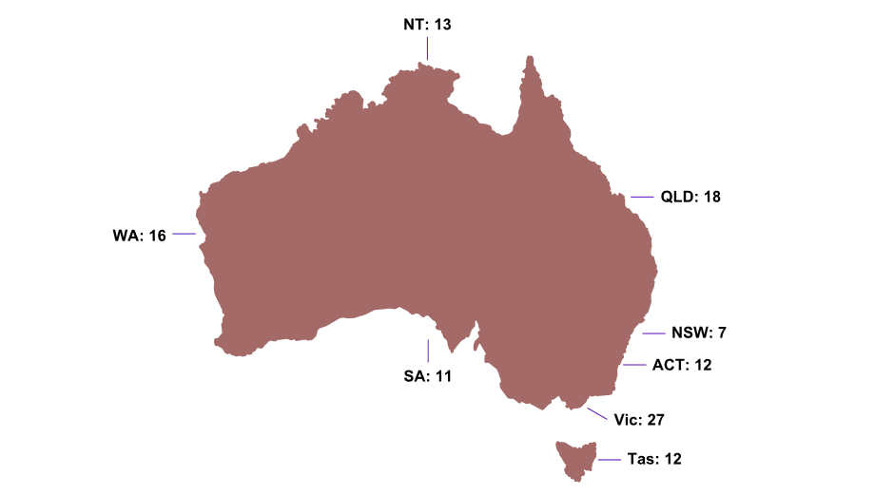
Figure 9. Number of roundtable participants by state or territory
State/territory | Number of roundtable participants
Northern Territory | 13
Queensland | 18
New South Wales | 7
Australian Capital Territory | 12
Victoria | 27
Tasmania | 12
South Australia | 11
Western Australia | 16

The participants represented a diverse range of stakeholder groups, including universities, public and private VET providers, Jobs and Skills Councils, state and territory governments and the Australian Government, regulators, industries, and unions. Table 1 provides details of the stakeholder groups.

Table 1. Organisations that attended the roundtables

Stakeholder categories | Details
Universities | Australian National University  Batchelor Institute  Bond University  Council of Deans of Nursing and Midwifery  Edith Cowan University  Flinders University  Griffith University  Monash University  RMIT University  Swinburne University  University of Adelaide  University of Newcastle  University of Canberra  University of South Australia  University of Tasmania (including Aboriginal Student Adviser)  University of the Sunshine Coast
TAFEs and Private RTOs | Canberra Institute of Technology  Crest NT  Independent Tertiary Education Council Australia  Ironbark training (NSW)  Key 2 Learning College  North Metropolitan TAFE (WA)  South Metropolitan TAFE (WA)  TAFE NSW  TAFE QLD  TAFE SA  TasTAFE  Unihub Spencer Gulf (SA)  William Angliss Institute
Industry | Administrative and Professional Services (Industry Training Council)  Ai Group  Australian Academy of Sciences  Australian Chamber of Commerce and Industry  Business NSW  Business and Employment Southeast Tasmania  Business and Employment Southeast Tasmania  CheckUP Australia  Community Skills WA  Council of Small Business Organisations Australia  Energy Skills Australia  Fibre & Timber Industries Training Council  Industry Skills Advisory Council NT  Industry Skills Advisory Council NT  Institute of Skills and Training Australia  Master Builders Association  Mining and Automotive Industry Training Council  South Australian Business Chamber  Tasmanian Hospitality Association  Western Australian Logistics and Defence (Industry Training Council)
Unions | Australian Council of Trade Unions  Australian Education Union  Australian Manufacturing Workers Union  Communication Electrical Plumbing Union (Electrical Trades Union)  Health Services Union  National Tertiary Education Union
Jobs and Skills Councils | Build Skills Australia  Future Skills Organisation  Skills Insight
Governments | All state and territory governments  Australian Government: Department of Employment and Workplace Relations; Department of Education  Regulators: TEQSA, ASQA.

Consultation questions asked at the state and territory roundtable consultations
Which tertiary harmonisation elements do you consider a priority and why?
Is there a reform agenda in your jurisdiction in relation to tertiary harmonisation?
Do you have any good examples of harmonisation initiatives that we could refer to in the report?
What could be the early priorities for implementation?
What do you see as the benefits and risks in tertiary harmonisation in your jurisdiction?
What are the biggest barriers and challenges to tertiary harmonisation?
What are your views on recommendations and next steps to harmonisation?
How could your jurisdiction work towards harmonisation with or without Australian Government support?

References

ASQA & TEQSA. (2016). ASQA and TEQSA Memorandum of Understanding. Retrieved from https://www.asqa.gov.au/sites/default/files/teqsa_mou_signed_7_july_2016.pdf
ASQA. (2024). VET sector regulation. Retrieved from Australian Skills Quality Authority: https://www.asqa.gov.au/resources/faqs/vet-sector-regulation
Australian and State and Territory Governments. (2023). National Skills Agreement. Retrieved from Federal Financial Relations: https://federalfinancialrelations.gov.au/sites/federalfinancialrelations.gov.au/files/2023-12/national-skills-agreement.pdf
Australian and State and Territory Governments. (2024). National Skills Plan. Retrieved from https://www.dewr.gov.au/download/16467/national-skills-plan/38272/national-skills-plan/pdf
Australian Bureau of Statistics. (2024). Education and Work, Australia. Retrieved from https://www.abs.gov.au/statistics/people/education/education-and-work-australia/latest-release
Banerjee, R., & Wilson, J. K. (2016). Roles of education in productivity growth in Australia, 1860–1939. Economic record, 47-66.
Bean, M., & Dawkins, P. (2021). Review of University-Industry Collaboration In Teaching and Learning. Canberra: Department of Education, Skills and Employment.
BIS Oxford Economics Australia. (2023). Tertiary Education Qualification Demand. Commonwealth Department of Education. Commonwealth Department of Education. Retrieved from https://www.education.gov.au/australian-universities-accord/resources/tertiary-education-qualifications-demand
Borland, J., & Smedes, M. (2024). A review of how economists thinking about human capital has evolved and the current state of research on human capital in Australia. 2024 ABS/RBA Joint Conference on Human Capital.
Chou, Y. K. (2003). he Australian Growth Experience, 1960–2000: Human Capital, R&D or Steady‐State Growth? Australian Economic Review, 397-414.
Davis, G. (2017). The Australian Idea of a University. Melbourne: Melbourne University Press.
Dawkins, P., Lilly, M., & Pascoe, R. (2023). Rethinking Tertiary Education. Melbourne: Melbourne University Press.
Department of Education. (2019). Australian Qualifications Framework Review. Canberra: Australian Government.
Department of Education. (2023). Retrieved from Australian Universities Accord Panel Discussion Paper: https://www.education.gov.au/australian-universities-accord/resources/australian-universities-accord-panel-discussion-paper
Department of Education. (2024). Australian Universities Accord Final Report. Canberra: Commonwealth Department of Education. Retrieved September 2024, from https://www.education.gov.au/australian-universities-accord/resources/final-report
Department of Education, Employment and Workplace Relations. (2008). Australian Higher Education: final report [Bradley Review]. Canberra: Commonwealth Department of Education, Employment and Workplace Relations. Retrieved October 2024, from https://www.voced.edu.au/content/ngv%3A32134
Department of Employment and Workplace Relations. (2024). VET Qualification Reform. Retrieved from Department of Employment and Workplace Relations: https://www.dewr.gov.au/skills-reform/vet-qualification-reform
Department of Treasury. (2023). Working Future: The Australian Government’s White Paper on Jobs and Opportunities. Canberra: Commonwealth Department of Treasury. Retrieved September 2024, from https://treasury.gov.au/employment-whitepaper/final-report
Hodge, S., & Knight, E. (2021). The best of both worlds? Integrating VET and higher education. Adelaide: National Centre for Vocational Education Research.
House of Representatives Standing Committee on Employment, Education and Training. (2024). Shared vision, equal pathways: Inquiry into the perceptions and status of vocational education and training. Parliament of Australia.
Hurley, P., & Pilcher, S. (2023). One system, two sectors: worlds apart. In P. Dawkins, M. Lilly, & R. Pascoe, Rethinking Tertiary Education. Melbourne: Melbourne University Press.
Jobs and Skills Australia. (2024). Emerging Roles Report. Canberra.
Jobs and Skills Australia. (2024). Towards a National Jobs and Skills Roadmap: Annual Jobs and Skills Report 2024. Jobs and Skills Australia. Retrieved August 2024, from https://www.jobsandskills.gov.au/publications/towards-national-jobs-and-skills-roadmap
Jobs and Skills Australia. (2024). VET Workforce Study. Canberra.
Leigh, A. (2024). Returns to Education in Australia 2001–2022. Economic Papers: A journal of applied economics and policy.
SWMC. (2024). Skills and Workforce Ministerial Council Communique - September 2024. Retrieved from https://www.dewr.gov.au/download/16465/skills-and-workforce-ministerial-council-communique-20-september-2024/38104/document/pdf
TEQSA. (2023). TEQSA submission to the Australian Universities Accord Panel. Retrieved from https://www.education.gov.au/australian-universities-accord/consultations/australian-universities-accord-panel-discussion-paper-consultation/submission/16273
TEQSA. (2024). Our approach to quality assurance and regulation. Retrieved from Tertiary Education Quality and Standards Agency: https://www.teqsa.gov.au/how-we-regulate/our-approach-quality-assurance-and-regulation#:~:text=TEQSA%20is%20the%20national%20regulator,standing%20of%20Australian%20higher%20education.
World Economic Forum. (2025). Future of Jobs Report 2025. Geneva: World Economic Forum.



JSA is currently undertaking work to establish a common definition of ‘skill’ that can lead to a common language.

