


An Essential Ingredient
The Food Supply Chain Workforce
January 2025


With the exception of the Commonwealth Coat of Arms, and the Jobs and Skills Australia logo, any material protected by a trade mark and where otherwise noted, all material presented in this document is provided under a Creative Commons Attribution 3.0 Australia licence. The details of the relevant license conditions are available on the Creative Commons website (accessible using the links provided) as is the full legal code for the CC BY 3.0 AU licence (https://creativecommons.org/licenses/by/3.0/au).
The document must be attributed as An Essential Ingredient: The Food Supply Chain Workforce.
The study was produced by the following people:
- Djuna Gladanac
- Tamika Stasiuk
- Ashlyn Pedrotti
- Kayla Slade
- Paul O’Shea
- Andrew Edwards
- Vincent Law
- Brad Waters
Acknowledgement of Country

Jobs and Skills Australia acknowledges the Traditional Owners of Country throughout Australia and recognises the continuing connection to lands, waters and communities. We pay our respect to Aboriginal and Torres Strait Islander cultures, and to Elders past and present.
Acknowledgement of Country
Jobs and Skills Australia acknowledges the Traditional Owners of Country throughout Australia and recognises the continuing connection to lands, waters and communities. We pay our respect to Aboriginal and Torres Strait Islander cultures, and to Elders past and present.
Contents
Glossary 6
Commissioner’s Foreword 8
Executive summary 9
Introduction 14
Part A: Workforce profiles 20
1. Food Production 21
Overview 21
Broadacre 28
Horticulture 35
Dairy Farming 40
Intensive Livestock 43
Aquaculture 46
Wild Catch 49
Food Production Support Services 52
Emerging industries and occupations 55
Cross-cutting roles 56
2. Food Manufacturing 59
Overview 59
Meat and Meat Product Manufacturing 63
Bakery Product Manufacturing 67
Dairy Product Manufacturing 69
Beverage Manufacturing 71
Other Food Manufacturing 74
Cross-cutting roles 76
3. Transport and Distribution 78
Overview 78
Transport 81
Distribution 86
Part B: Contributing workforces 90
4. Veterinary 91
Overview 91
Opportunities for reform 100

5. Biosecurity 107
Roles and responsibilities 108
Pathways and skilling 111
6. Labour Hire 115
Overview 115
Opportunities for reform 119
Part C: The national skills system 123
7. Education and Training 124
A skilled workforce is essential 124
Education and training pathways 128
Challenges and opportunities 142
8. Migration 167
The contribution of migrants 168
Opportunities for reform 181
Part D: Looking forward 208
9. Workforce planning 209
Elevating food as a national priority 209
Developing a shared workforce vision 210
Committing to partnerships and tripartism 212
A joined-up national skills system 212
An open-minded approach 213
Placed-based workforce solutions 213
Investing in better data 215
Recommendations 218
Conclusion 225
Appendix A: Regional and place-based dynamics 227
Appendix B: ANZSIC Industry Mapping 254
References 257

Glossary
Abbreviation | What it stands for
ABARES | Australian Bureau of Agricultural and Resource Economics and Sciences
ABS | Australian Bureau of Statistics
ACMF | Australian Chicken Meat Federation
AFPA | Australian Fresh Produce Alliance
AMIC | Australian Meat Industry Council
AMIEU | Australasian Meat Industry Employees’ Union
ANU | Australian National University
ANZSCO | Australian and New Zealand Standard Classification of Occupations
ANZSIC | Australia and New Zealand Standard Industrial Classification
ARC | Australian Research Council
ATO | Australian Taxation Office
AVBC | Australasian Veterinary Boards’ Council
AVFS | Agricultural, Veterinary and Food Sciences
BITRE | Bureau of Infrastructure and Transport Research Economics
CEO | Chief Executive Officer
CSIRO | Commonwealth Scientific and Industrial Research Organisation
CSU | Charles Sturt University
DAFF | Department of Agriculture, Fisheries and Forestry
DEWR | Department of Employment and Workplace Relations
EFTSL | Equivalent full-time student load
FRDC | Fisheries Research and Development Corporation
FTE | Full-time equivalent
FWO | Fair Work Ombudsman
HELP | Higher Education Loan Program
HERD | Higher Education Expenditure on Research and Development
HHI | Herfindahl-Hirschman Index
JSA | Jobs and Skills Australia
JSC | Jobs and Skills Council
NCVER | National Centre for Vocational Education Research
nec | Not elsewhere classified
nfd | Not further defined
NFF | National Farmers’ Federation
PALM | Pacific Australia Labour Mobility
PLMS | Pacific Labour Mobility Survey
POWP | Place of Work
QILT | Quality Indicators for Learning and Teaching
R&D | Research and Development
RDC | Rural Research and Development Corporation
RTO | Registered Training Organisation
SA | Statistical Area
STEM | Science, technology, engineering and mathematics
STP | Single Touch Payroll
TAFE | Technical and Further Education
TraNSIT | Transport Network Strategic Investment Tool
VET | Vocational Education and Training
VNCA | Veterinary Nurses Council of Australia
VNDA | VET National Data Asset
VSANZ | Veterinary Schools of Australia and New Zealand
WHM | Working Holiday Maker

Commissioner’s Foreword
I am pleased to present Jobs and Skills Australia’s (JSA) third workforce capacity study, An Essential Ingredient: The Food Supply Chain Workforce. The study primarily focuses on Australia’s Food Production, Manufacturing, Transport and Distribution industries and is an ambitious and topical examination of the current and future needs of this workforce.
JSA has undertaken this study following a period of significant disruption to the nation’s food supply chain. In support of this study, JSA has undertaken extensive research, literature and policy reviews, data analysis and in-depth consultation with Jobs and Skills Councils (JSC), employer groups, unions, education and training providers, and subject matter experts. We thank all parties for the valuables contributions they have made to the study.
This study recognises the diversity of workforce needs across the food supply chain and considers how the national skills system—particularly the three key pillars of vocational education and training, higher education and migration—can best address these needs. In this context, the study delivers 41 recommendations which outline practical steps that could be taken to improve outcomes for employers, workers and the broader community.
Analysing the skills and workforce needs of regional, rural and remote Australia is a core component of JSA’s role. Given the importance of the food supply chain as an anchor industry in many parts of regional Australia, the dedicated focus on this supply chain in this study is an important complement to the broader work of JSA in this area.
I am confident that this report and its recommendations will make a positive contribution to a resilient food supply chain workforce that provides rewarding employment opportunities and supports highly productive industries.
Professor Barney Glover AO
Commissioner
Jobs and Skills Australia

Executive summary
A resilient workforce is essential to Australia’s food security and strong export industries. This means having the right skills in the right locations at the right time.
The future of Australia’s food supply chain will be shaped by multiple interacting shifts, including climate change, technological advances and demographic changes. Concerns around sovereign capability, industry viability and cost of living also have an impact. In the midst of these developments, the food supply chain workforce will remain an essential ingredient to our continued success.
This independent report supports the food supply chain workforce by:
- making 41 recommendations that target the Australian Government’s role in workforce planning, including through the tripartite JSCs
- providing new insights, analysis and data to support the activities led by businesses, unions, education and training providers, and state and territory governments, and
- developing the foundations for a shared vision for the food supply chain that unites all parties through common interests, offering opportunities for collective advocacy and action.
Our recommendations span education, training, migration and other system settings and identify key opportunities to improve outcomes for students, workers and employers. These are grouped into 8 overarching themes:
- support apprenticeships and traineeships for critical roles
- improve the relevance and delivery of tertiary education and training
- invest in sustainable veterinary and biosecurity workforce pathways
- combat worker exploitation and ensure migration continues to support regional Australia
- harness opportunities within the PALM scheme
- improve labour hire practices, enforcement and information
- facilitate better planning of the food supply chain workforce
- address barriers in regional, rural and remote Australia
While this study makes an important contribution, a single point-in-time report is unable to resolve all underlying challenges facing this essential workforce. Concerted and enduring action will be required by all parties, including governments, businesses and unions.

Diverse workforce needs
The diversity of workforce needs by region, commodity and stage in the supply chain has been a central finding of this study. This diversity is profoundly felt by employers and workers and shapes the nature, location and timing of their work. It can also be difficult to tackle workforce challenges, particularly when needs are highly localised or commodity specific. Finding the balance between bespoke solutions and achieving sufficient scale is a key challenge for workforce planners.
While there are many components that are essential to the food supply chain, this study focuses on the workforce needs across three key segments:
- Food Production – including Broadacre, Horticulture, Dairy Farming, Intensive Livestock, Aquaculture and Wild Catch and Food Production Support Services.
- Food Manufacturing – including Meat and Meat Product Manufacturing, Bakery Product Manufacturing, Dairy Product Manufacturing, Beverage Manufacturing and Other Food Manufacturing.
- Transport and Distribution – including Freight Transport, Transport Services, Wholesaling, and Warehousing.
It also considers critical enabling workforces across veterinary and biosecurity as well as those involved in education, training and research.

Regional, rural and remote Australia
Employment in the food supply chain is heavily concentrated in regional, rural and remote Australia with the food supply chain providing anchor industries for many communities. While no two regions are the same, there are some common dynamics that are experienced by many food producing regions. These include:
- Accommodation and housing. The affordability and availability of housing is a major challenge and has worsened in many regions. Poor planning, underinvestment and workforce shortages have also contributed to a general undersupply of new housing. Temporary worker accommodation, including hostels and on-farm accommodation, is critical for parts of the food supply chain and presents its own challenges regarding availability, affordability, quality and safety.
- Transportation and connectivity. Remoteness, limited transport options, social isolation and poor internet connectivity can make it difficult to access and attract workers in some parts of the food supply chain.
- Essential services. Access to high quality education, childcare and healthcare varies significantly in regional areas. In some of Australia’s most remote communities, the reliable supply of food, water and electricity is also a challenge.
- Population change. While generally lower than in metropolitan areas, population growth in regional Australia has been very uneven. Some regional cities have experienced very strong population growth in recent years, while many small regional areas are in longer-term decline.
- Labour availability. Regional communities are home to some of the highest and lowest rates of unemployment across Australia. On average, regional labour markets have lower vacancy rates and fewer applicants per vacancy than metropolitan areas. Qualification and suitability gaps are also higher. Employment opportunities can be volatile in some regions and impacted by factors including droughts and seasonal fluctuations in labour demand.
While regional, rural and remote Australia faces many challenges, it is important to acknowledge the many benefits of living outside of our major population centres. Strong communities, access to the natural environment and comparatively lower cost of living are just some of the factors that can encourage people to live, study and work right across Australia.
It is critical that students are supported to study in regional Australia, including via distance education. Accessing and delivering education and training can be particularly difficult and costly in regional areas and it is important that funding reflects these costs. Encouraging more students to undertake placements and other forms of work-based learning in Australia’s regions will pay dividends for rural industries and communities, as students who study regionally are more likely to work regionally post-study.
While regional, rural and remote Australia is critical to the food supply chain, there is also considerable activity in Australia’s major cities. This includes activities in peri-urban regions, which present their own set of opportunities and challenges.

There is also a growing professional services sector that works within and in support of the food supply chain. It employs high skilled workers across business consultancy, science, data and technology, financial services and many more areas that rely on Australia’s tertiary education system. Many of these roles can be and are performed from anywhere, providing rewarding food supply chain careers closer to major population centres.

Education and training
In the face of international competition, rapid technological development, and ever-increasing complexities, a skilled workforce will be essential to the food supply chain. In an increasingly skilled and qualified labour market, the food supply chain may also struggle to attract and retain workers in lower skill roles. Offering meaningful, attractive and rewarding career pathways was raised throughout this study as a prerequisite to securing the next generation of workers.
JSA recognises the broad range of education and training utilised within the food supply chain workforce including on-the-job training, non-accredited training and extension, vocational education and training (VET) and higher education. We also acknowledge the mix of public and private providers that deliver formal education and training, as well as the role of businesses in developing their own staff.
This study makes a range of recommendations to improve outcomes for students, employers and the broader public by supporting work-based learning, improving the sustainability of education, training and research pathways in areas of national priority, and strengthening regional education and training.

First Nations people
First Nations people are underrepresented in senior positions across most Food Production sectors. Business supports at all career stages are needed to make a genuine impact, as is formal education and training.
Equitable access to post-secondary education is essential for supporting First Nations peoples’ success and necessary for meeting Australia’s skills needs. This study finds that supportive scholarships and grant programs, culturally inclusive learning, flexible study options, and on-Country programs can all improve First Nations peoples’ access to, and involvement in, post-secondary education.
These opportunities alone, however, will not be enough to overcome the social and structural barriers still faced by First Nations peoples in Australia today which require collective action by all parties.

Migration
Migration plays an important role in addressing the diverse workforce needs of the food supply chain where local labour or skills are not available. There is a genuine opportunity to rethink the current patchwork of migration pathways available to the food supply chain. However, given high levels of reliance on current pathways in parts of the workforce, changes will need to be approached carefully to avoid unintended consequences for employers and workers.
The food supply chain, particularly in the Horticulture and Meat Processing sectors, provides employment for most PALM workers in Australia. While the PALM scheme delivers important benefits for employers and workers in the food supply chain, there are opportunities to enhance the scheme. One of these opportunities is to trial worker-initiated mobility for experienced PALM workers. Recent analysis from the NSW Anti-slavery Commissioner indicates that the inability of PALM workers to initiate a change of approved employer is a significant risk factor contributing to PALM worker disengagement and vulnerability to exploitation.
Australia’s food supply chain currently relies on Working Holiday Makers (WHMs) across a range of roles and industries. The contribution of WHMs is most highly concentrated in key Horticulture occupations in which seasonal work is common, but is also prominent across other parts of the supply chain including Meat Processing, Broadacre Cropping and Dairy Farming.
Like other temporary migrants, WHMs can be more vulnerable to exploitation than local workers. The vulnerability of WHMs is layered and depends on a range of factors including their language and cultural characteristics, program settings which influence their employment options such as specified work requirements, and whether they are directly employed or engaged through a labour hire firm.
This study calls on the Australian Government to address the need for specified work in the food supply chain by meeting genuine workforce needs through targeted pathways with work as a primary purpose. It also acknowledges the potentially far-reaching implications of this change and affirms that any change should carefully consider:
- the diverse workforce needs currently addressed by Working Holiday Makers
- the extent to which any contemplated changes would impact the supply of labour to meet these needs
- the extent to which other viable pathways are available or would be needed
- the implications for other labour supply options, including the PALM scheme
- the role of specified work in exacerbating the power imbalance between employers and Working Holiday Makers
- the range of other levers available to combat migrant worker exploitation and the drivers of non-compliance, and
- the merits of a phased or differentiated approach by visa year which could include exploring options to offer a targeted work pathway for Working Holiday Makers after their first year.

Labour hire
At its best, labour hire can provide an important mechanism for food supply chain businesses—particularly small and medium enterprises—to manage seasonal fluctuations in labour demand, address labour supply challenges, and reduce their administrative burden. Labour hire firms also play a large role in connecting those looking for work with employment opportunities, especially for newer participants in the labour market such as PALM workers and WHMs.
However, the Fair Work Ombudsman has identified that labour hire firms are associated with a significant proportion of non-compliance in the agriculture sector. Common practices of unscrupulous labour hire firms, including underpayment of wages, are harmful to workers and can create an uneven playing field for employers that are compliant with workplace laws.
Effective reform to protect labour hire workers from exploitation and regulate the behaviour of labour hire entities would have significant flow-on benefits for combating migrant worker exploitation. This study recommends that national labour hire regulation be delivered as an immediate priority, including adequate resourcing for regulators to help detect and address cases of worker exploitation.
There is also poor visibility of the industries and roles that labour hire workers are on-hired to. This is a critical challenge for workforce planning and policy making and should be a priority area for improved data collection and research.

Looking forward
Realising the opportunities and facing the challenges of the food supply chain cannot be done in isolation. Concerted effort is required by all parties, including governments, industry and unions, to ensure the continuation of this important work. JSA finds that the food supply chain workforce would benefit from:
- a shared vision that unites the different industries and components that make up the food supply chain. Collective advocacy and action can have a greater impact than piecemeal approaches.
- a sustained commitment to tripartite consultation and policy development, supported by the Agricultural Workforce Forum and JSCs.
- elevating food as a national priority in workforce policy and development. The national skills system should reflect the food supply chain’s role in sovereign capability and economic security.
- a joined-up approach to the national skills system so that we can tackle workforce challenges with the best mix of solutions.
- an open-minded approach to trialling new ideas and a commitment to monitoring and evaluating new and established approaches to ensure they are fit for purpose. As the food supply chain continues to evolve, it is important that our workforce systems keep pace as a set and forget approach is unlikely to be effective.
- greater investment in workforce data and analysis. The food supply chain workforce is poorly supported by existing labour market data products and requires new solutions to improve our visibility of workforce pressures.
Actions at the national level will need to be accompanied by detailed workforce planning and development undertaken at the industry, region and individual business level. The activities of JSCs, employer groups, unions and local communities will continue to play a vital role in shaping the future of this workforce.
With the right investments and partnerships, Australia can have a resilient food supply chain that provides rewarding employment opportunities across the country and supports highly productive industries.


Introduction

Purpose of this study
Australia has a world class food supply chain that:
- produces a wide variety of affordable, accessible, nutritious and high-quality food for domestic consumption and export around the world
- maintains a significant food and beverage manufacturing sector which remains the largest employing component of Australian manufacturing, and
- transports and distributes food to millions of consumers across a vast continent, including in remote communities.
However, with an outlook characterised by significant challenges and opportunities arising from profound economic, environmental, technological, social, demographic and geopolitical trends, it is clear our food supply chain industries will need to continue to evolve.
The Australian Government commissioned Jobs and Skills Australia (JSA) to produce an independent study on the workforce needs of the food supply chain. Our role is to provide advice on the effectiveness of Australia’s vocational education and training, higher education, and migration systems to meet Australia’s future skills and workforce needs.
Through this study, we aim to support a workforce that can:

- sustain regional Australia. Employment in the food supply chain is heavily concentrated in regional, rural and remote Australia, with Food Production and Manufacturing acting as anchor industries in many communities.
- strengthen the economy. Industries throughout the food supply chain make a significant contribution to the Australian economy. Without an adequate and sustainable workforce, the viability of these sectors—and the regional economies they sustain—will be at risk.
- maintain food security. Access to labour and skills has been widely recognised as a risk to Australia’s food security. While awareness of this risk was heightened by the COVID-19 outbreak and the particular challenges it posed, workforce pressures in Australia’s food supply chain pre-date and extend beyond the pandemic.
- overcome challenges. Australia’s food supply chain will need to navigate multiple interacting changes over the coming years, including managing high levels of market and climate variability while unlocking opportunities from disruptive technologies. The food supply chain will also need to grapple with persistent challenges including: managing seasonal fluctuations in labour demand; attracting and retaining a workforce with a diverse mix of backgrounds, skills and experiences; and ensuring all workplaces provide safe, secure and rewarding employment.

Box 0.1: Megatrends shaping the food supply chain

Food security
Food security has received increased attention in Australia and globally due to the COVID pandemic, war in Ukraine and other disruptions to international supply chains. Relevant considerations for the food supply chain include:
- sovereign capability in Food Production, Processing and Manufacturing
- viability of food supply chain industries in the midst of rising input costs, market power imbalances, issues around climate change and biosecurity
- risks and benefits of increased consolidation
- access to critical inputs, reliable supply chains and logistics infrastructure, and
- the role of exports in supporting food security.
Climate change and net zero
Climate change and the net zero transformation is bringing about one of the most significant shifts in Australia and the global economy. Relevant considerations for the food supply chain include:
- climate change as a headwind to Food Production productivity and profitability
- workforce skills requirements for climate-smart and sustainable practices
- importance of sustainability credentials for trade market access and to attract new workforce entrants
- impact of increased frequency of natural disasters, and
- changing land use and practices due to decarbonisation efforts.
Australia’s changing industrial base
Australia has shifted to a predominantly service-based economy, with Food Production and Manufacturing representing a declining share of the economy and labour market. Relevant considerations for the food supply chain include:
- a declining share of the economy and labour market comprised by Food Production and Manufacturing which may reduce their prominence for prospective workers, the education and training system, and policymakers
- increased competition for labour with service sectors, some of which offer higher wages than common food supply chain roles, and
- the growing role of professional, technical and other services as an important input to the food supply chain.
Technological and digital transformation
Advances in technology continue to shape industries as one of the key drivers of productivity. Relevant considerations for the food supply chain include:
- technology, capital deepening and innovation changing the size, composition and places of work of the food supply chain workforce, and
- growing demand within the food supply chain for digital and data skills.
Population change
Australia is undergoing several major demographic changes such as urbanisation and population ageing which will have significant labour market impacts. Relevant considerations for the food supply chain include:
- implications of urbanisation for provision of services and infrastructure in parts of regional Australia,
- the ageing workforce in parts of the food supply chain, and
- the importance of succession planning as older owner-managers retire out of the workforce.

Scope of our study
While there are many activities vital to the food supply chain, the primary purpose of this study is to explore the production, manufacturing and distribution of food. The study also considers critical enabling workforces, such as the veterinary and biosecurity workforce.
This scope broadly aligns with the definitions developed by the Australian Bureau of Agricultural and Resource Economics and Sciences (ABARES) to help identify the agriculture workforce including beyond the farm gate. However, given the mandate of this study is to consider the food supply chain, industries within agriculture that do not relate to Food Production (e.g. Cotton Growing) are not in scope.
We acknowledge there are many activities that are vital to the food supply chain that fall outside this primary purpose. This includes the consumer-facing part of the food supply chain, namely food and beverages retail and hospitality, which is not in scope for the study. Where possible, we have considered the challenges and opportunities that are shared by different industries and regions rather than replicate the more detailed workforce planning activities of Jobs and Skills Councils (JSCs) and other parties.
This report builds on the extensive work led by JSCs, ABARES, business groups, unions and others. We have also considered the wide-ranging reforms currently being delivered across government to improve the effectiveness of workforce pipelines.
The Terms of Reference for the study were published on 18 April 2024 following a public submissions process and consultation with state and territory governments, businesses, unions, Jobs and Skills Councils, and the education and training sector. The full Terms of Reference are available on JSA’s website. In broad terms, our mandate was to provide critical evidence, insights and recommendations relating to the food supply chain to support workforce planning, policy development and program design.

Food supply chain workforce segments
Classifying components of the food supply chain is an essential step in understanding the workforce. If segmented too broadly, important differences between components of the food supply chain could be obscured or lost. If segmented too narrowly, the number of businesses or workers engaged in each segment may be too small to provide a sufficient sample for data and analysis and commonalities between segments may be missed.
For the purposes of this study, JSA has created three primary segments, including:
- Food Production. Encompassing businesses mainly engaged in Agriculture (excluding non-food commodities), Aquaculture and Wild Catch as well as those providing support services to these industries.
- Food Manufacturing. Encompassing businesses mainly engaged in processing and manufacturing food and beverages, such as Dairy Product Manufacturing.
- Transport and Distribution. Encompassing businesses mainly engaged in freight transport by road, rail sea or air, the wholesale trade of agricultural and food products, and warehousing and storage.
Figure 0.1 provides an overview of these three segments and their component parts. The characteristics of these segments are explored in greater detail in Part A: Workforce Profiles. This figure also recognises the contribution of other parts of the food supply chain, including key inputs and consumer-facing sectors.

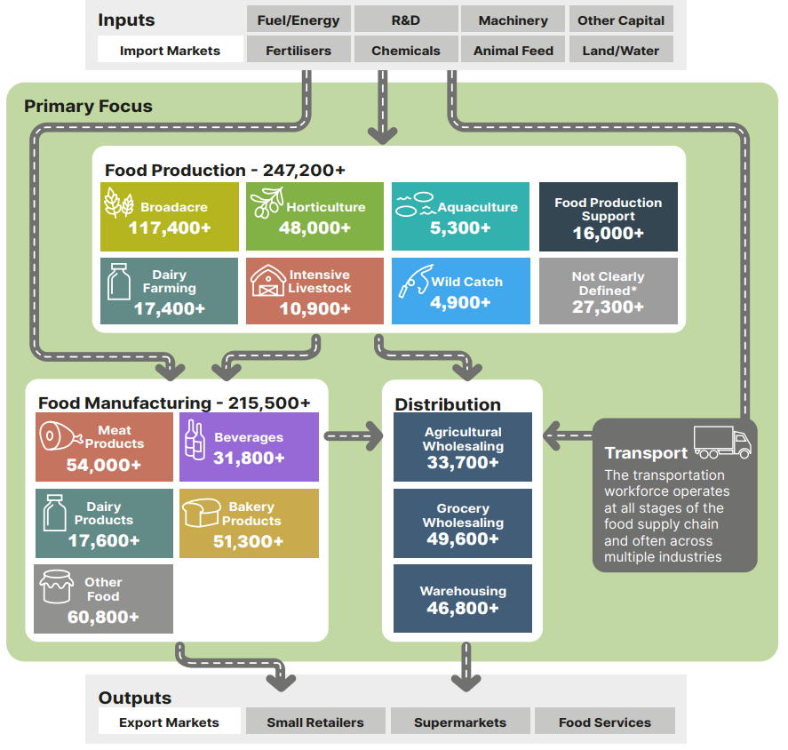
Figure 0.1: Overview of our food supply chain workforce
- This is a flow chart showing the food supply chain split into 3 key areas of focus
- 1. Inputs:
  - Fuel/Energy
  - R&D
  - Machinery
  - Other Capital
  - Import Markets
  - Fertilisers
  - Chemicals
  - Animal Feed
  - Land/Water
  - This leads to:
- 2. Primary Focus: Food Production, Food Manudacturing and Transport
  - Food Production (247200+ Workers)
    - Broadacre (117,200+)
    - Horticulture (25,800+)
    - Aquaculture 5,300+
    - Food production support (16,000+)
    - Dairy Farming (17,400+)
    - Intensive Livestock (10,900 +)
    - Wild Catch (4,900 +)
    - Not clearly defined (27,300+)
  - Food Manufacturing (215,500 +)
    - Meat Products (54,000+)
    - Beverages (31,800+)
    - Dairy products (17,600+)
    - Bakery products (51,300+)
    - Other Food (60,800+)
  - Transport
    - The transportation workforce operates at all stages of the food supply chain and often across multiple industries.
    - This leads to:
      - Distribution
        - Agricultural wholesaling (33,700+)
        - Grocery wholesaling (49,600+)
        - Warehousing (46,800+)
        - This leads to:
  - 3. Outputs
    - Export market
    - Small retailers
    - Supermarkets
    - Food services

Source: ABS Census of Population and Housing 2021, employment counts by aggregated industry codes. Note: Census data only captures those directly employed in relevant industries as their main job at a single point-in-time. JSA acknowledges that Census is an imperfect measure of total employment by industry.
A full mapping of these segments to the Australian and New Zealand Standard Industrial Classification (ANZSIC) is available in Attachment B of this report.
For clarity, the names of these segments and their component parts are capitalised throughout the report. This approach to capitalisation applies to other defined terms such as the names of occupations and industries when we are referring to them as defined by the Australian and New Zealand Standard Classification of Occupations (ANZSCO) or ANZSIC.

The structure of this report
This report is organised into 4 parts that explore different elements of the study.
- Part A provides workforce profiles for the core segments of the supply chain
- Part B explores the workforces that make an important contribution to the supply chain
- Part C explores higher education, training and the migration system, including areas for improvement, and
- Part D looks ahead to the opportunities available to this essential workforce, including ways to improve workforce planning activities.
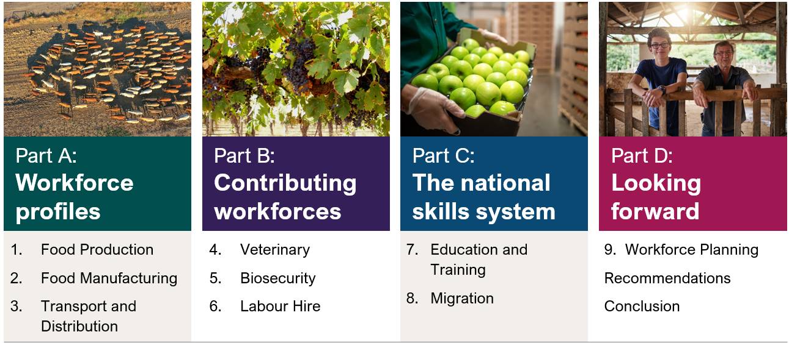

Consultation process
In accordance with JSA’s legislated mandate, the food supply chain capacity study was informed by a tripartite approach to engagement and consultation.
We worked with relevant Australian Government agencies, JSCs, employer peak bodies, businesses, unions, academics and education and training providers. The study was also supported by public Terms of Reference and Discussion Paper processes.
JSA would like to extend our gratitude to all stakeholder contributions, including members of our project advisory group and JSCs.

Skills Insight, Industry Skills Australia, and Manufacturing Industry Skills Alliance are Jobs and Skills Councils funded by the Australian Government Department of Employment and Workplace Relations

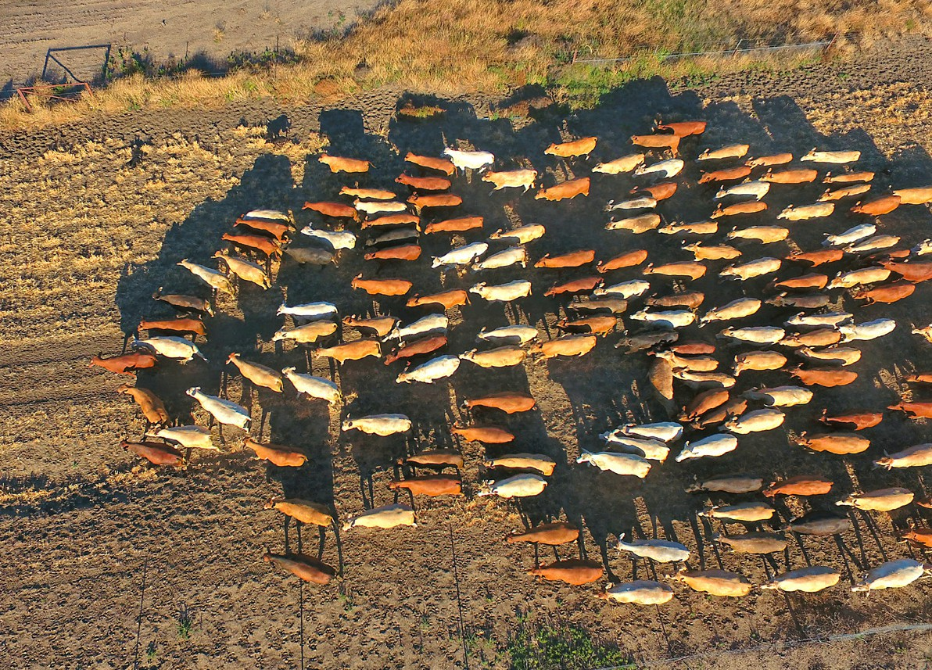
Part A:
Workforce profiles
Chapters 1 to 3 focus on our key segments of Food Production, Food Manufacturing and Transport and Distribution. The workforce profiles contained in these chapters highlight the diversity of workforce needs that exist across the food supply chain and includes key characteristics for individual industries.
How these diverse workforce needs interact with the national skills system is the focus of Part C of this report.


Workforce profiles

1. Food Production

Overview

Food Production employment is concentrated in regional Australia
Food Production is an important source of employment in regional, rural and remote Australia and acts as an anchor industry for many regional communities. While the Broadacre sector is the highest employing Food Production sector across most of Australia’s landmass, each of Aquaculture, Wild Catch, Dairy Farming, Horticulture, and Intensive Livestock are also the highest employing component of Food Production in some parts of the country (Figure 1.1). This reflects the diversity of Australia’s regions and their suitability for different types of Food Production.
Figure 1.1 Highest employing component of Food Production by place of work (SA2)
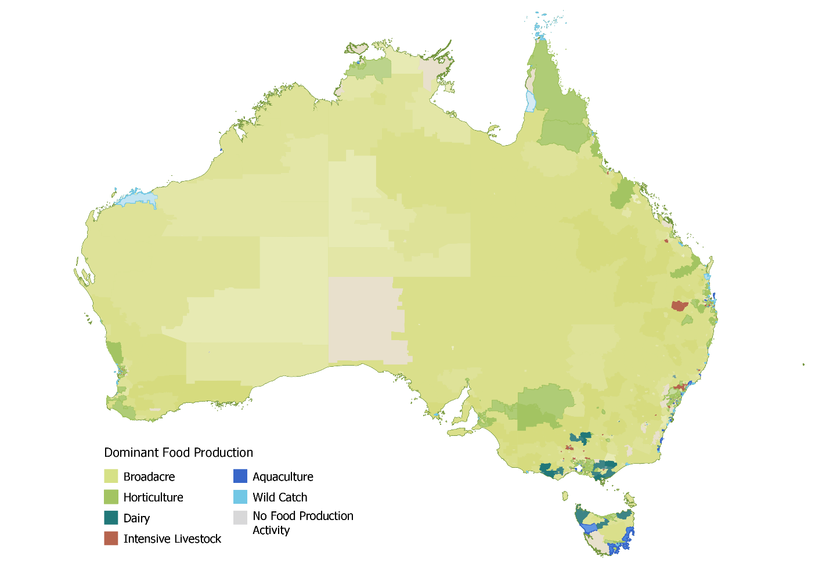
Source: ABS Census of Population and Housing 2021.
Australia’s Food Production sectors also exhibit significant differences in the distribution of the workforce by remoteness. As Figure 1.2 highlights, Intensive Livestock workers are the most likely to reside in major cities whereas the workforce in Broadacre, Wild Catch and Aquaculture sectors are the most likely to live in remote or very remote Australia. In aggregate, around one-in-seven workers in Food Production sectors reside in major cities.
Figure 1.2: Proportion of workforce by remoteness and Food Production sector

Source: ABS Census of Population and Housing 2021.

Most Food Production businesses are small businesses
Over 60% of Australian businesses are non-employing. In the case of Food Production, this increases to almost three-quarters of businesses. Non-employing businesses can include sole operators or businesses that meet their labour needs exclusively through unpaid contributing family workers, labour hire workers, and/or contractors.
This high proportion is driven predominantly by the Broadacre sector given that broadacre farms:
- account for 76% of all Food Production businesses, and
- have the highest share of non-employing businesses at 77%.
Conversely, Horticulture, Intensive Livestock and Aquaculture businesses are as likely, or more likely, to have 20+ employees than the average Australian business.
Figure 1.3: Proportion (%) of businesses by employee size in Food Production sectors

Source: ABS Counts of Australian Businesses, including Entries and Exits, June 2023.
While non-employing businesses comprise the majority of the businesses in Food Production, this does not mean they constitute the majority of production by value in agriculture or seafood industries. Rather, high numbers of non-employing and small businesses in Food Production are part of what has been called the ‘long tail’ that operates alongside an increasing number of larger businesses that have emerged as a result of farm consolidation.

Owner-managers are a significant albeit declining part of the workforce
Consistent with the trend towards greater consolidation, the share of owner managers in this workforce is declining across all Food Production sectors (Figure 1.4). This trend has been particularly pronounced in the Dairy Farming sector.
Figure 1.4: Owner manager share of employment in Food Production sectors over time (%)

Source: ABS Census of Population and Housing 2006, 2011, 2016 and 2021.
The declining share of owner-manager employment has been matched with an increased reliance on the labour of employees. In the decade between the 2011 and 2021 Census, the employee share of the Food Production workforce has grown from little more than one-third to almost half (Figure 1.5).
Figure 1.5: Food Production workforce by status in employment over time

Source: ABS Census of Population and Housing 2006, 2011, 2016 and 2021.
This shift has significant implications for the Food Production workforce given the differences between owner-managers (often of family farms) and employees with respect to motivations, pathways into the industry, methods of skill and knowledge acquisition, demographics, and hours worked.
For example, Figure 1.6 highlights the significantly higher proportion of owner-managers working 50+ hours per week than employees. The data below focuses on those working full-time hours only, with owner-managers also more likely than employees and contributing family workers to work full-time.
Figure 1.6: Proportion of full-time workers working 50+ hours/week

Source: ABS Census of Population and Housing 2021. Figures above compare the hours worked by those working full-time only.

Demographics of the Food Production workforce
Drawing on data from the 2021 Census, the Snapshot of Australia’s Agricultural workforce produced by ABARES found that the agriculture workforce is:
- older than average
- predominantly male
- underrepresented among First Nations people
- strongly represented among people with disability
- increasingly culturally and linguistically diverse, and
- largely comprised of full-time workers.
However, as Table 1.1 shows, workforce characteristics vary across sectors. For example, the share of Australian citizens in Horticulture is much lower than in other sub-sectors, especially Broadacre. Meanwhile, the average age of the Broadacre workforce is significantly higher than other agricultural sectors.
Albeit from different baselines, most Food Production sectors between the 2016 and 2021 Census experienced:
- an increase in the share of women, First Nations Australians and people with disability, and
- a decrease in the share of Australian citizens and full-time workers.
Table 1.1: Workforce characteristics of Food Production sectors
 |   Broadacre |   Horticulture |   Dairy  Farming |   Intensive Livestock |   Aquaculture |   Wild Catch | All  Industries
Directly Employed | 117,000+ | 48,000+ | 17,400+ | 10,900+ | 5,300+ | 4,900+ | 11,522,000+
Average Age | 53  | 44 - | 44  | 42 - | 41 | 47 | 41
Female Workers | 30% | 36% | 34% | 36% | 26% | 19% | 49%
First Nations Workers | 1.5% | 1.7% | 2.0% | 3.1% | 5.4% | 4.2% | 2.1%
Rate of needing assistance with core activities | 1.7% | 1.1% | 1.3% | 1.5% | 0.8% - | 1.4% | 0.9%
Australian Citizen Workers | 97% | 72% | 89% | 82% | 84% | 92% | 87% -
Full Time Workers | 70% | 63% | 70% | 69% | 73% | 48% | 59%
Source: ABS Census of Population and Housing 2021, 2016. Arrows indicate change from the 2016 Census.

First Nations people and Food Production
First Nations people are underrepresented in senior positions across most Food Production sectors. As noted by stakeholders:
‘We don’t have many First Nations people on agricultural boards or in leadership positions or high-level representation.’
Employment of this cohort in supervisor and management roles varies by industry. As explored in the profiles below, First Nations people have higher rates of employment in senior-level roles in Horticulture, Wild Catch and Aquaculture. The highest percentage of First Nations people employed as supervisors is in the Wild Catch sector, with 8.4% of the Fishing Leading Hand occupation identifying as First Nations.
Opportunity: Increasing the number of First Nations people employed in agriculture, especially in senior-level roles, is not only essential in building an inclusive and productive workforce, but necessary for enabling this cohort to realise their full potential. Upskilling First Nations employees through on-the-job training could improve retention rates and address several targeted measures in the National Agreement on Closing the Gap. Greater representation of First Nations people in senior positions would also inspire younger generations to enter the workforce, thereby bolstering workplace attraction.
Insufficient cultural awareness and inclusion in workplaces was noted by stakeholders as a common barrier to attracting and retaining First Nations employees. For an inclusive and productive agricultural workforce, it is imperative that all employees feel safe, respected and welcome in their workplace.
Gari Yala (Speak the Truth) was a survey conducted in 2020 by a First Nations expert panel who sought to collect data on first-hand experiences of First Nations staff in all Australian workplaces. Over 1,000 First Nations workers were asked about cultural safety at work, experiences of workplace exclusion and racism, and the importance of large organisations participating in First Nations-focused activities and events. Key findings included that:
- 28% felt culturally unsafe in the workplace
- 38% reported being treated unfairly because of their First Nations background
- 44% reported hearing racial slurs at work
- 65% reported feeling the need to work harder than their non-First Nations co-workers to prove they could do the job, and
- 71% felt that there was an expectation that they (rather than their organisation) had to educate non-First Nations colleagues about First Nations people.
The survey also found that when organisations implement First Nations-focused initiatives in the workplace it reduces racism and attrition and improves cultural safety. Based on the outcomes of the survey, 10 recommendations were proposed for all workplaces across Australia, including addressing workplace racism, considering specific initiatives for the retention of First Nations staff, and the need for organisations to work on creating environments where First Nations workers feel they belong.
Echoing the Gari Yala project, our stakeholders brought attention to the need for industry to implement strategies to ensure cultural safety and inclusion in the workplace. For instance, the National Farmers’ Federation (NFF) observed:
‘In order to thrive, the sector should do more to enable greater diversity and promote workforce participation and inclusion.’

Stakeholders also suggested that all large agricultural organisations should develop Reconciliation Action Plans (RAPs) that also include procurement targets.
‘There aren’t many large agribusiness organisations that have developed RAPs, which means companies meeting with First Nations graduates don’t have tailored pathways into the workforce and a commitment to reconciliation.’
Opportunity: Better understanding of the experiences of First Nations Australians in the agriculture sector could be achieved through a similar report to Gari Yala targeted to the sector. Such a report could use the responses to Gari Yala survey as a baseline. Understanding of the firsthand employment experiences of First Nations Australians in agriculture would be an important enabler of targeted efforts to improve these experiences and mitigate the risk that well-meaning activities fail to achieve the desired impact due to being based on what non-First Nations voices think is best.

Box 1.1: The native bushfood industry
The native bushfood industry is an important part of Australia’s food supply chain, encompassing the harvesting, processing and marketing of native food and botanicals. The Indigenous Land and Sea Council (ILSC) have reported that First Nations Australians are significantly underrepresented in the native food and botanicals supply chain. This includes First Nations Australians:
- comprising less than 1% of growers, farm managers and exporters in the supply chain, and
- mostly operating at the harvest stage of the supply chain while non-First Nations businesses benefit from the value-added during processing, manufacturing, packaging, warehousing, distribution and marketing.
While equitable participation of First Nations Australians in the native bushfood industry is critical, particularly given the cultural identity and connection to Country associated with native bushfoods, stakeholders highlighted that supporting growth in First Nations’ businesses is imperative more broadly across many parts of the agriculture sector. As one stakeholder observed:
‘If you don’t have the development of First Nations businesses then you [generally] don’t have the employment of First Nations people, so growing those businesses is important.’


Broadacre
The Broadacre sector is comprised of farming operations with livestock or crops that are suited to large-scale production. The sector encompasses broadacre cropping (e.g. cereals, oilseeds, pulses), non-intensive livestock farming (e.g. grass-fed beef, sheep) and mixed-production farms that combine the two. The industries included in this Broadacre profile are detailed in Table 1.2 and do not include non-food cropping industries such as Cotton Growing.
Broadacre is the largest employing sector in agriculture, directly employing over 117,400 people in their main job as at the 2021 Census. Table 1.2 shows for detailed industries within Broadacre:
- the number of people directly employed in the industry as their main job in the 2021 Census, and
- the number of payroll jobs in the industry at the peak period nationally.
A payroll job refers to where there is a record of payment through a payroll process by an employer to their employee. The high proportion of non-employing businesses and owner-manager employment in the Broadacre sector are the key factors behind why the Census figure is substantially higher than the number of payroll jobs.
Table 1.2: Snapshot of employment in the Broadacre sector
Industry class | Census 2021 | Payroll jobs at peak month |  |  | Peak Month
Industry class | Census 2021 | 2021 | 2022 | 2023 | Peak Month
Beef Cattle Farming (Specialised) | 44,450 | 13,910 | 14,960 | 15,260 | Jul
Other Grain Growing | 18,940 | 8,980 | 9,520 | 8,670 | Dec
Sheep Farming (Specialised) | 18,280 | 4,940 | 4,240 | 4,080 | Jul
Grain-Sheep or Grain-Beef Cattle Farming | 18,280 | 14,320 | 15,080 | 13,960 | Dec
Sheep-Beef Cattle Farming | 7,520 | 7,510 | 8,010 | 7,150 | Dec
Sugar Cane Growing | 4,210 | 2,930 | 2,640 | 2,410 | Jul
Other Crop Growing nec | 1,850 | 1,830 | 2,060 | 1,910 | Mar
Beekeeping | 1,640 | 950 | 940 | 880 | Dec
Other Livestock Farming nec | 1,140 | 1,020 | 1,100 | 970 | Dec
Sheep, Beef Cattle and Grain Farming, nfd | 750 | - | - | - | -
Deer Farming | 30 | - | - | - | -
Rice Growing | - | 80 | 90 | 120 | Nov
Total Broadacre | 117,090 | 56,470 | 58,640 | 55,410 | Dec
Source: ABS Census of Population and Housing 2021; Australian Taxation Office, Single Touch Payroll (STP) data. Figures are rounded to the nearest 10. NFD refers to industries that are not further defined in ANZSIC.
Figure 1.7 shows that employment in the Broadacre sector is widely dispersed across Australia. Relative to their population shares, South Australia, Queensland and Western Australia are overrepresented with respect to Broadacre employment. In contrast, Victoria is the most underrepresented jurisdiction for Broadacre employment relative to its share of the total population.
Figure 1.7: Geographical distribution of the Broadacre workforce

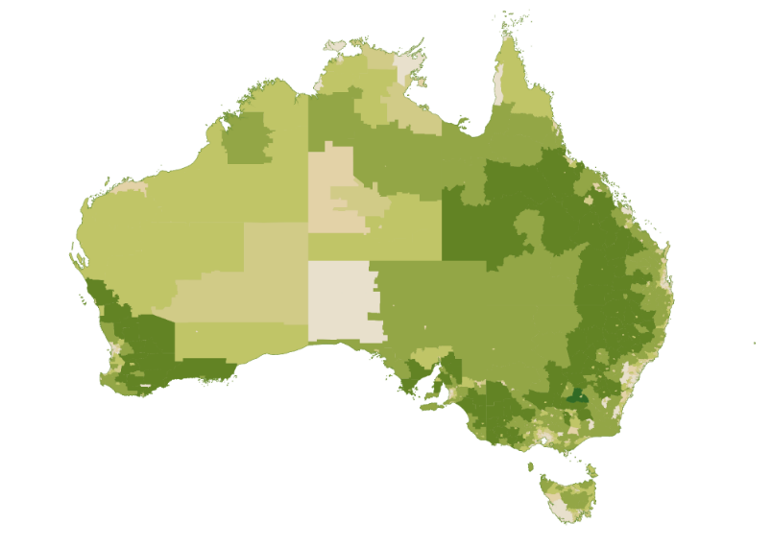
Low High
Source: ABS Census of Population and Housing 2021, Percentage of Total Broadacre Employment by Statistical Area 2 (SA2) and Place of Work (POWP).

Business characteristics
Most Broadacre farms are non-employing businesses reliant on owner-mangers and contributing family workers. However, the share of employed managers in the sector has steadily grown in recent years, largely driven by farm corporatisation and consolidation.

Livestock
A very high proportion of beef cattle farms (the most common type of broadacre farm) are non-employing businesses. These non-employing farms, typical of the southern production regions, are managed by owner-operators with the assistance of contributing family workers. In contrast, beef cattle farms in the northern production region are more likely to engage employees. These employees may be engaged on an ongoing basis or in short-term mustering roles. This is particularly evident in the Northern Territory where employees comprise 80% of those engaged in the beef cattle farming industry, more than double the next highest share of employees of 33% in Queensland.

Cropping
The National Agricultural Workforce Strategy points to broadacre cropping as the sector that has been the ‘most successful at substituting labour for capital.’ ABARES analysis of broadacre cropping input use from 1977-78 to 2018-19 shows that labour inputs (weeks worked on farm by owner-operators, family members and hired labour) have declined by an average of 1% annually. Over the same period, material inputs (such as chemicals, fertilisers, seeds, and fuel) and services inputs (such as costs of electricity, plant hire, advisory services, and repair services) have respectively grown by an average of 4% and 1% annually. Capital deepening in the sector has meant that relative to other industries, broadacre cropping has a greater reliance on machinery operators and drivers and a lesser reliance on labourers for its harvest workforce.

Workforce characteristics
Reflecting the sector’s high proportion of owner-managers, four of the five highest employing Broadacre occupations are Farmer and Farm Manager occupations (Table 1.3). These roles tend to be filled by Australian citizens who are typically male and do not identify as Aboriginal or Torres Strait Islander. There is a significant disparity between the share of First Nations employment in Beef Cattle Farming between the farmer (1.0%), senior staff (2.2%) and farm workers (5.1%). This disparity indicates that while First Nations participation in Beef Cattle Farming is high, this is yet to translate at scale into progression to more senior roles.
Table 1.3: Demographics of select occupations employed within Broadacre
Occupations | Employed in Broadacre | Female (%) | First Nations (%) | Australian Citizen (%)
Beef Cattle Farmer | 26,590 | 33 | 1.0 | 98
Broadacre Crop and Livestock Farmer | 19,600 | 24 | 0.6 | 99
Sheep Farmer | 10,040 | 30 | 0.9 | 98
Grain, Oilseed, Pulse or Pasture Grower | 9,660 | 22 | 0.6 | 98
Beef Cattle Farm Worker | 6,210 | 34 | 5.1 | 96
Mixed Cattle and Sheep Farmer | 5,110 | 29 | 0.8 | 99
Broadacre Crop and Livestock Farm Worker | 3,050 | 20 | 2.3 | 97
Agricultural and Horticultural Mobile Plant Operator | 2,360 | 11 | 2.5 | 94
Sugar Cane Grower | 2,270 | 18 | 0.3 | 99
Sheep Farm Worker | 2,210 | 27 | 2.7 | 96
Grain, Oilseed, Pulse and Pasture Farm Worker | 1,590 | 14 | 2.5 | 95
Bookkeeper | 1,530 | 97 | 0.6 | 96
Apiarist | 1,350 | 20 | 1.7 | 93
Cattle and Sheep Farm Worker | 1,040 | 26 | 2.7 | 97
Source: ABS Census of Population and Housing 2021.

Box 1.2: Ageing Broadacre owner-managers
Broadacre has a high share of older owner-managers, due in part to high capital barriers to entry and the choice of many to work beyond a more usual retirement age. The median age of Broadacre owner-managers is 58, having increased from 53 years in 2006. This is approximately twice the ageing rate for all owner-managers in Australia which only increased by 4%, from 45 to 47. This picture is complicated by potentially different age profiles for hobby farms, intergenerational family farms, and corporate farms.
Broadacre owner-managers can be divided into those with incorporated enterprises (businesses registered as separate legal entities to their owners) or with unincorporated enterprises. Owner-managers of unincorporated enterprises are more common, and nearly 50% of all owner-managers run an unincorporated enterprises without employees (representing smaller farms).
Unincorporated owner-managers have a much higher median age (59) compared to their incorporated counterparts (53). Figure 1.8 shows that this gap has been present since 2006, with unincorporated owner-managers significantly pulling up the industry average.

Additionally, owner-managers of both groups who employ workers have lower median ages than those without employees. The patterns are generally consistent over time, with all subgroups ageing at similar rates, suggesting structural drivers for the differences in median age.
Figure 1.8: Median age of Broadacre owner managers since 2006
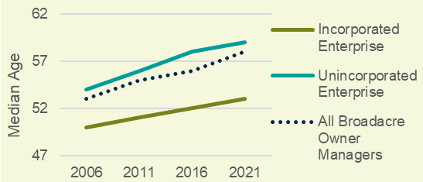 Source: ABS Census of Population and Housing 2021

Figure 1.9: Age differences between Incorporated and Unincorporated Enterprises
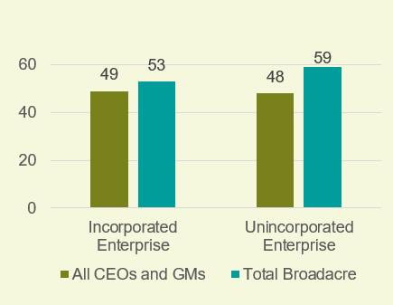Source: ABS Census of Population and Housing 2021
Given the level of responsibility of Broadacre owner-managers, it has been suggested that they are most comparable to Chief Executive Officers (CEOs) and General Managers (GMs). The most comparable sub-group, Broadacre owner-managers of incorporated enterprises with employees, do have a similar median age (52) to CEOs and GMs (49). However, this sub-group only represents 19% of the cohort. Further, Figure 1.11 shows that CEOs and GMs do not share the same gap between those running unincorporated and incorporated organisational structures. Therefore, CEOs and GMs may only be comparable to those running incorporated

enterprises with employees, and not all owner-managers, suggesting structural age patterns unique to the Broadacre sector.
This is further reflected by data from ABARES which shows that smaller farms have a much older and more rapidly ageing owner-manager cohort than medium to large farms, measured by cash receipts. These larger farms represent over 80% of broadacre output, suggesting the ageing demographic of owner-managers may not pose a threat to the industry’s productivity in terms of output, though may highlight an important role for farm succession strategies for many smaller farms.

Workforce trends
Total payroll jobs in the Broadacre sector experienced a slight decline by 710 jobs (1%) over the two years from 1 July 2021 to 29 June 2023. At the detailed industry level, notable changes in payroll jobs over this period include:
- the addition of 480 new payroll jobs in Beef Cattle Farming (Specialised) (up 3%)
- the addition of 420 new payroll jobs in Other Grain Growing (up 5%), and
- declining payroll jobs in Sheep Farming (Specialised) (down 860 payroll jobs or 17%) and Sugar Cane Growing (down 520 jobs or 18%).
Broadacre cropping farms may experience significant seasonal fluctuations in labour demand. For example, Figure 1.12 depicts the seasonal pattern of payroll jobs in Sugar Cane Growing, including a surge in payroll jobs between June and December associated with the harvest.
Figure 1.12: Payroll jobs in Sugar Cane Growing

Source: Australian Taxation Office, Single Touch Payroll (STP) data.
In contrast, employment levels on broadacre farms specialising in livestock (e.g. beef and sheep farms) remain relatively stable throughout the year. In part, this may be due to the engagement of contractors to help manage peak periods or time-limited tasks such as the use of contract shearing, mustering or fencing.


Horticulture
The Horticulture sector encompasses fruit, vegetable, mushroom, and tree nut growing. The industries included in this Horticulture profile are detailed in Table 1.4 and do not include non-food industries such as Nursery and Floriculture Production.
The Horticulture sector directly employed over 48,000 people in their main job as at the 2021 Census, making it the second highest employing Food Production sector behind Broadacre. Table 1.4 shows for detailed industries within Horticulture:
- the number of people directly employed in the industry as their main job in the 2021 Census, and
- the number of payroll jobs in the industry at the peak period nationally.
Common reasons there may be material variation between Census figures and payroll jobs include:
- the Census being undertaken in August which is off-peak for many horticulture crops (this is likely the driver of the higher payroll job figure in Apple and Pear Growing given its significant summer seasonal peak), and
- Singe Touch Payroll focusing on payroll jobs, meaning owner-managers and contributing family workers who are not on the payroll are not captured (this is likely a significant contributing factor where the Census figure is higher than the number payroll jobs, e.g. in Vegetable Growing (Outdoors)).
It should also be recognised that data from the Census and Single Touch Payroll relates to direct employment only (i.e. people employed by a labour hire firm are not captured). ABARES estimates that total labour use on horticulture farms exceeded 100,000 workers throughout 2021-22.
Table 1.4: Snapshot of employment in the Horticulture sector
Industry class | Census 2021 | Payroll jobs at peak month |  |  | Peak Month
Industry class | Census 2021 | 2021 | 2022 | 2023 | Peak Month
Vegetable Growing (Outdoors) | 16,280 | 10,110 | 9,150 | 8,590 | Jul
Other Fruit and Tree Nut Growing | 7,200 | 8,360 | 8,680 | 7,300 | Jan
Grape Growing | 6,010 | 8,490 | 8,320 | 8,360 | Apr
Berry Fruit Growing | 4,940 | 4,800 | 4,360 | 3,360 | Jan
Fruit and Tree Nut Growing, nfd | 4,200 | - | - | - | -
Mushroom Growing | 2,590 | 1,730 | 1,710 | 1,640 | Jul
Citrus Fruit Growing | 2,520 | 1,980 | 1,790 | 1,570 | May
Apple and Pear Growing | 1,450 | 4,230 | 3,540 | 2,940 | Jan
Vegetable Growing (Under Cover) | 1,330 | 2,770 | 2,520 | 2,280 | Dec
Stone Fruit Growing | 800 | 2,080 | 1,790 | 1,430 | Jan
Olive Growing | 490 | 530 | 560 | 480 | May
Mushroom and Vegetable Growing, nfd | 160 | - | - | - | -
Kiwifruit Growing | 70 |  | 70 | 60 | Jan
Total Horticulture | 48,040 | 45,080 | 42,490 | 38,010 | Jan
Source: ABS Census of Population and Housing 2021; Australian Taxation Office, Single Touch Payroll (STP) data. Figures are rounded to the nearest 10. NFD refers to industries that are not further defined in ANZSIC.
Figure 1.13 shows that high concentrations of Horticulture sector employment can be found from far north Queensland stretching down through the Murray-Darling Basin. There are also pockets of high Horticulture employment in Western Australia and the Northern Territory.
Figure 1.13: Geographical distribution of the Horticulture workforce
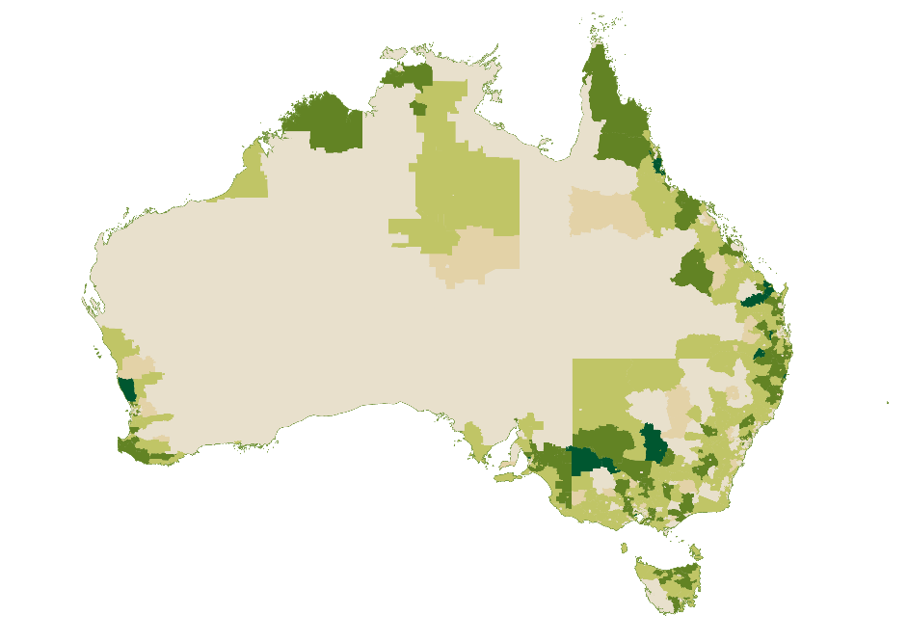
Low High
Source: ABS Census of Population and Housing 2021, Percentage of Total Horticultural Employment by Statistical Area 2 (SA2) and Place of Work (POWP).

Business characteristics
Business models, and consequently trends in labour use, vary considerably within the Horticulture sector. The National Agricultural Workforce Strategy identifies two important distinctions that shape labour dynamics in Horticulture.
The first of these distinctions is the extent to which commodity groups have been able to mechanise. High levels of mechanisation are common in olive, almond and wine grape growing industries. As the mechanised commodity most readily isolated in industry statistics, Olive Growing provides a useful window into the workforce implications of mechanised harvesting. Notable impacts have included:
- a reduction in the total Olive Growing workforce from nearly 700 in 2006 to under 500 in 2021, and
- increased reliance on occupations (e.g. Machinery Operators and Drivers, Technicians and Trades Workers, and Professionals) that sit outside the typically dominant major groups of Manager and Labourer (Figure 1.14).
Figure 1.14: Changing Distribution of Occupations in Olive Growing

Source: ABS Census of Population and Housing 2006, 2011, 2016 and 2021.
Commodity groups without high levels of mechanisation may experience short-term fluctuations in labour demand in peak periods such as harvest. Data collected by ABARES suggests that labour use in Horticulture in 2021-22 peaked in March at over 125,000 workers, around 18,000 more workers than in October when national Horticulture labour use was at its lowest. In contrast, labour demand will typically be more consistent in mushroom growing, banana growing and in protected cropping operations which offer year-round production or extended seasons.
A second distinction is drawn between the large number of small businesses relying chiefly on family labour and a comparatively smaller number of large businesses that produce the majority of horticultural output. Statistics from ABARES farm surveys illustrate these dynamics, showing that from 2016-17 to 2018-19 the largest 10% of vegetable farms by size produced 69% of total output, while the smallest 50% of farms produced around 6% of total output.

Workforce characteristics
Examining the Horticulture sector by occupations provides a more granular view of the characteristics of the different components of its workforce and the sector’s overall attractiveness of work for different cohorts (Table 1.5).
Grower occupations are less likely to be filled by First Nations people or citizens of other countries than their counterparts in labourer occupations within the same commodity group. Conversely, Fruit Picker has the lowest proportion of Australian citizen employment of any occupation in Australia. Indeed, of the top five occupations for non-Australian citizen employment shares, four are Horticulture occupations (Fruit Picker, Vegetable Picker, Mushroom Picker and Fruit and Vegetable Packer).
There is a notable gender split between picking and packing roles in Horticulture, with women accounting for 71% of Fruit and Vegetable Packers and less than half of Fruit Pickers and Vegetable Pickers. The exception to this is Mushroom Pickers in which migrant women are strongly represented.
Table 1.5: Demographics of select occupations employed within Horticulture
Major occupations | Employed in Horticulture | Female (%) | First Nations (%) | Australian Citizen (%)
Fruit Grower | 5,840 | 27 | 1.1 | 85
Vegetable Grower | 5,200 | 32 | 0.7 | 81
Fruit Farm Worker | 3,940 | 27 | 4.5 | 66
Fruit Picker | 3,160 | 36 | 2.3 | 34
Fruit and Vegetable Packer | 2,470 | 71 | 1.7 | 37
Vegetable Farm Worker | 2,380 | 38 | 2.3 | 57
Wine Grape Grower | 2,160 | 22 | 0.5 | 90
Vineyard Worker | 1,620 | 26 | 1.0 | 71
Agricultural and Horticultural Mobile Plant Operator | 1,360 | 10 | 3.2 | 82
Mushroom Picker | 1,200 | 81 | 0.3 | 46
Nut Grower | 960 | 24 | 1.2 | 93
Horticultural Supervisor or Specialist | 960 | 28 | 2.9 | 73
Vegetable Picker | 830 | 48 | 1.4 | 36
Source: ABS Census of Population and Housing 2021.

Workforce trends
Total payroll jobs in the Horticulture sector declined by 4,580 jobs (or 12%) over the two years from 1 July 2021 to 29 June 2023. At the detailed industry level, this decline was driven predominantly by the following:
- Vegetable Growing (Outdoors), down 1,520 payroll jobs (or 15%)
- Other Fruit and Tree Nut Growing, down 950 payroll jobs (or 12%)
- Berry Fruit Growing, down 790 payroll jobs (or 22%).
Industries within the Horticulture sector exhibit some of the strongest seasonal fluctuations in labour demand. However, this is far from uniform across Horticulture industries. Figure 1.15 shows the different patterns of labour demand between a Horticulture industry characterised by short harvest peaks (Stone Fruit Growing) and one characterised by year-round production (Mushroom Growing).
Figure 1.15: Payroll jobs in Mushroom Growing and Stone Fruit Growing

Source: Australian Taxation Office, Single Touch Payroll (STP) data.


Dairy Farming
The Dairy Farming sector encompasses operations farming dairy cattle as well as those engaged in sharemilking, i.e. those contracted to milk the herd and/or perform other farm duties for a share of the milk income. The highest proportion of Dairy Farming employment is in Victoria, which is home to 57% of the over 17,400 people working in the sector as their main job as at the 2021 Census.
Table 1.6 shows for the Dairy Cattle Farming industry:
- the number of people directly employed in the industry as their main job in the 2021 Census, and
- the number of payroll jobs in the industry at the peak period nationally.
A payroll job refers to where there is a record of payment through a payroll process by an employer to their employee. The main factor behind the difference between the Census figure and the payroll jobs is that the Census captures owner-managers and contributing family workers who are not on the payroll. As at the 2021 Census, there were around 9,880 employees in Dairy Cattle Farming and over 7,000 owner-managers and contributing family workers.
Table 1.6: Snapshot of employment in the Dairy Farming sector
Industry class | Census 2021 | Payroll jobs at peak month |  |  | Peak Month
Industry class | Census 2021 | 2021 | 2022 | 2023 | Peak Month
Dairy Cattle Farming | 17,450 | 9,790 | 9,680 | 9,490 | Jul
Source: ABS Census of Population and Housing 2021; Australian Taxation Office, Single Touch Payroll (STP) data. Figures are rounded to the nearest 10.
Dairy Farming employment is centred around eight dairy regions in Victoria, South Australia, New South Wales, Queensland, Tasmania, and Western Australia (Figure 1.16).
Figure 1.16: Geographical distribution of the Dairy Farming workforce
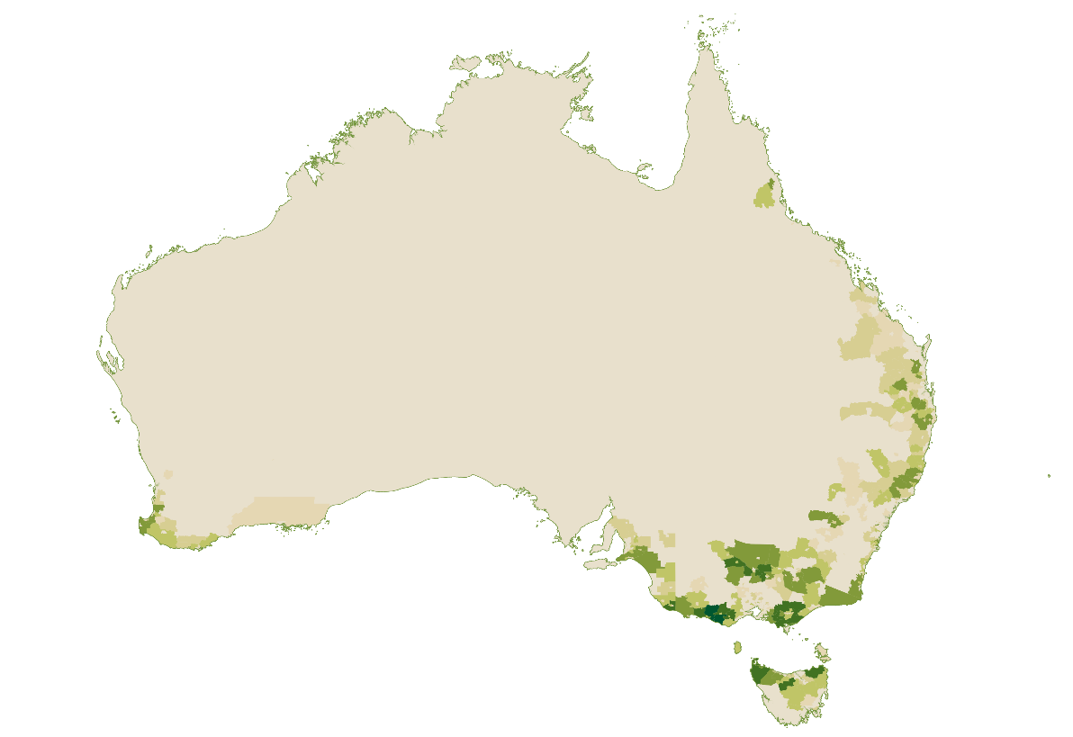
Low High
Source: ABS Census of Population and Housing 2021, Percentage of Total Dairy Farming Employment by Statistical Area 2 (SA2) and Place of Work (POWP).

Business characteristics
While broadacre and horticulture farms have increasingly diverged between a large number of small farms and a smaller number of large farms—with the latter producing most of the output—dairy farms represent something of a middle ground. The largest 10% of dairy farms account for only one-third of total output, compared to around 70% for vegetable farms, 60% for beef farms, and 45% in the grains industry. This middle ground is reflected in statistics from the most recent Dairy Australia workforce survey which indicates a relatively even distribution of farm businesses across herd sizes.
Table 1.7: Dairy Farm businesses by herd size and average number of people working on farm.
 | <150 cows | 151-300 cows | 301-500 cows | >500 cows
Share of dairy farms (%) | 33 | 32 | 20 | 16
Average number of people working on farm | 3.4 | 4.4 | 5.7 | 10
Source: Dairy Australia, Workforce: The Power of People on Australian Dairy Farms in 2020.
Stable labour demand throughout the year means that Dairy Farming typically can offer year-round employment. However, JSA heard from dairy business stakeholders that the sector also often uses contract labour to manage fluctuations in labour demand associated with busy periods such as calving season.

Workforce characteristics
The demographics of major occupations in Dairy Farming mirror trends in agriculture, with higher representation of First Nations people and lower proportions of Australian citizens among labourer roles compared to farmers and farm managers. First Nations people constitute approximately 2.1% of the workforce in Australia, indicating a higher-than-average representation in Dairy Cattle Farm Worker and Senior Dairy Cattle Farm Worker roles.
At 40%, the share of Dairy Cattle Farm Worker employment comprised by women is among the highest of any farm worker role.
Table 1.8: Demographics of select occupations employed within Dairy Farming
Major occupations | Employed in Dairy Farming | Female (%) | First Nations (%) | Australian Citizen (%)
Dairy Cattle Farmer | 8,140 | 33 | 1.5 | 91
Dairy Cattle Farm Worker | 4,130 | 40 | 3.4 | 86
Dairy Products Maker | 380 | 26 | 2.1 | 83
Senior Dairy Cattle Farm Worker | 250 | 34 | 3.5 | 81
Truck Driver (General) | 200 | 0 | 1.5 | 85
Source: ABS Census of Population and Housing 2021.

Workforce trends
Payroll jobs in Dairy Cattle Farming declined by 1,390 jobs (or 14%) from 1 July 2021 to 29 February 2024. As shown in Figure 1.17, the decline in payroll jobs in Dairy Cattle Farming appears to have accelerated since around November 2023.
Figure 1.17: Payroll jobs in Dairy Cattle Farming

Source: Australian Taxation Office, Single Touch Payroll (STP) data.


Intensive Livestock
The Intensive Livestock sector encompasses poultry farming for meat and eggs, pig farming, and beef cattle feedlots. The industries included in this Intensive Livestock profile are detailed in Table 1.9.
As at the 2021 Census, the Intensive Livestock sector directly employed just under 11,000 people in their main job as at the 2021 Census. Table 1.9 shows for detailed industries within Intensive Livestock:
- the number of people directly employed in the industry as their main job in the 2021 Census, and
- the number of payroll jobs in the industry at the peak period nationally.
Table 1.9: Snapshot of employment in the Intensive Livestock sector
Industry class | Census 2021 | Payroll jobs at peak month |  |  | Peak Month
Industry class | Census 2021 | 2021 | 2022 | 2023 | Peak Month
Poultry Farming (Eggs) | 3,900 | 2,380 | 2,210 | 1,980 | Jul
Poultry Farming (Meat) | 2,110 | 11,750 | 11,590 | 12,190 | Nov
Pig Farming | 2,080 | 2,970 | 3,160 | 3,270 | Jul
Poultry Farming, nfd | 1,730 | - | - | - | -
Beef Cattle Feedlots (Specialised) | 1,090 | 740 | 800 | 730 | Dec
Other Livestock Farming, nfd | 20 | - | - | - | -
Total Intensive Livestock | 10,930 | 17,840 | 17,760 | 18,170 | Jul
Source: ABS Census of Population and Housing 2021; Australian Taxation Office, Single Touch Payroll (STP) data. Figures are rounded to the nearest 10. NFD refers to industries that are not further defined in ANZSIC.
The significant difference between the Census and Single Touch Payroll figures for Poultry Farming (Meat) is illustrative of the complexities associated with classifying vertically integrated businesses, where the different stages of production are carried out in succession by different parts of the same business unit. Given the high degree of vertical integration in poultry industries, it is perhaps more instructive to consider Poultry Processing and Poultry Farming (Meat) together. As Table 1.10 shows, this approach indicates a more consistent picture of employment sitting between 15,800 and 18,300 people.
Table 1.10: Snapshot of employment in select poultry industries
Industry class | Census 2021 | Payroll jobs at peak month |  |  | Peak Month
Industry class | Census 2021 | 2021 | 2022 | 2023 | Peak Month
Poultry Processing | 14,710 | 5,550 | 4,250 | 6,040 | Dec
Poultry Farming (Meat) | 2,110 | 11,750 | 11,590 | 12,190 | Nov
Total | 16,820 | 17,300 | 15,840 | 18,230 | -
Source: ABS Census of Population and Housing 2021; Australian Taxation Office, Single Touch Payroll (STP) data. Figures are rounded to the nearest 10.
While the degree of intensification will differ between and within poultry and pig farming and beef cattle feedlots, these industries are generally characterised by the more intensive use of labour and machinery and more limited use of land compared to broadacre or extensive production systems. Given the limited use of land and need for labour, it is perhaps unsurprising that Intensive Livestock employment is concentrated closer to centres of population than other agricultural sectors (Figure 1.18).
Figure 1.18: Geographical distribution of the Intensive Livestock workforce

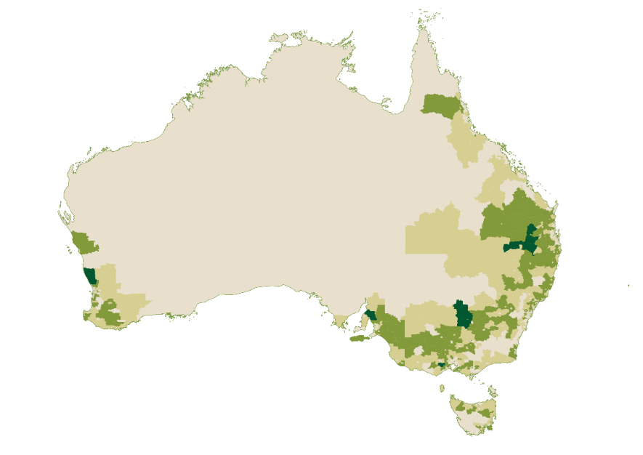
Low High
Source: ABS Census of Population and Housing 2021, Percentage of Total Intensive Livestock Industry Employment by Statistical Area 2 (SA2) and Place of Work (POWP).

Business characteristics
Intensive Livestock farms and feedlots are commonly part of vertically integrated supply chains. This means that one company will own or control multiple stages of the process. For instance, some producers own or controls chicken meat supply chain processes ranging from breeding to processing, warehousing and distribution. Broiler farming is commonly controlled rather than owned with poultry farmers and farm workers raising chickens under contract for processing companies.
Figure 1.19: Chicken meat industry supply chain
- Breeding Farm leads to
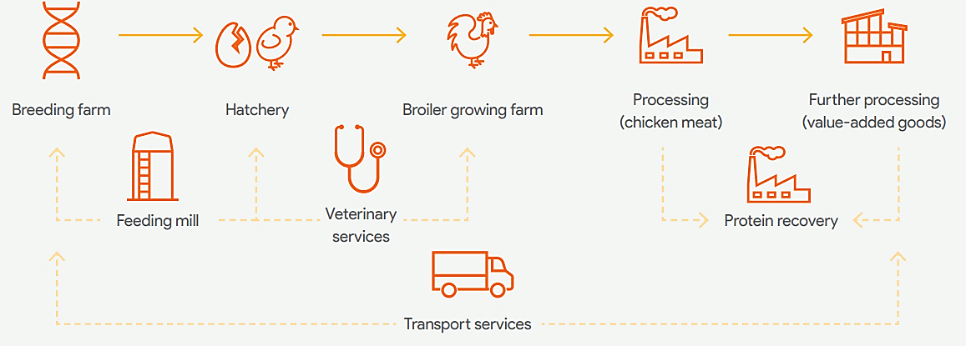
  - hatchery
- Hatchery Leads to
  - Broiler growing farm
- Broiler Growing Farm leads to
  - Processing (chicken meat)
- Processing (chicken meat) leads to
  - Protein recovery
  - Further processing (value added goods)
- Further Processing (Value Added Goods) leads to
  - Protein recovery
- Feeding mill leads to
  - Breeding farm
  - Hatchery
- Veterinary Services leads to
  - Hatcher
  - Broiler growing farm
- Transport Services leads to
  - Further processing (value added goods)
  - Breeding farm

Source: AgriFutures 2023, Australian chicken meat industry workforce strategy.

Vertically integrated supply chains are also evident in the egg and pig farming industries and beef cattle feedlots, though to a lesser extent than with chicken meat.

Workforce characteristics
Intensive Livestock is unique among agriculture sectors in that employment in labourer occupations (Poultry Farm Worker, Piggery Farm Worker) exceeds employment in the equivalent farm manager occupation (Poultry Farmer, Pig Farmer). For comparison, there are around six Grain, Oilseed, Pulse or Pasture Growers for every one labourer in the same commodity group. This illustrates the significantly different labour requirements that can exist across Food Production sectors.
Employer submissions called attention to business structures in intensive livestock operations which often have clearly defined hierarchies of skills and responsibilities. This can involve multiple managers, various managerial levels, supervisors and several team members each responsible for specific tasks. In part, the division of skills and responsibilities is driven by animal welfare requirements.
Among Farmer and Farm Manager occupations, Poultry Farmer and Pig Farmer stand out as the only two occupations where:
- over half of the occupation are employees; and
- less than 10% of the occupation are contributing family workers.
Table 1.11 also attests to above average representation of First Nations Australians in poultry farming, in farmer and labourer roles.
Table 1.11: Demographics of select occupations employed within Intensive Livestock
Occupations | Employed in Intensive Livestock | Female (%) | First Nations (%) | Australian Citizen (%)
Poultry Farm Worker | 1,870 | 39 | 4.9 | 81
Poultry Farmer | 1,820 | 30 | 2.5 | 89
Piggery Farm Worker | 820 | 31 | 2.0 | 73
Pig Farmer | 550 | 21 | 0.7 | 76
Senior Piggery Stockperson | 70 | 26 | 0.0 | 70
Source: ABS Census of Population and Housing 2021.

Workforce trends
Total payroll jobs in the Intensive Livestock sector have experienced a modest decline since 1 July 2021, down 290 jobs (or 2%) by 29 February 2024. At the detailed industry level, the most notable changes have included:
- the addition of 130 payroll jobs in Pig Farming (up 4%), and
- declining payroll jobs in Poultry Farming (Eggs) (down 320 payroll jobs or 13%).
Weekly payroll jobs indicate that Intensive Livestock industries exhibit little to no seasonal fluctuations in labour demand.


Aquaculture
The Aquaculture sector is characterised by the breeding, raising or farming of fish, molluscs and crustaceans in controlled conditions, distinct from wild-catch fishing. The sector directly employs over 5,300 people in their main job as at the 2021 Census. Table 1.12 shows for detailed industries within Aquaculture:
- the number of people directly employed in the industry as their main job in the 2021 Census, and
- the number of payroll jobs in the industry at the peak period nationally.
The difference between the Census and payroll data for Onshore Aquaculture may be driven at least in part by individual Census responses that did not provide enough information to classify the worker beyond Aquaculture (i.e. Census responses coded to Aquaculture, nfd).
Table 1.12: Snapshot of employment in the Aquaculture sector
Industry class | Census 2021 | Payroll jobs at peak month |  |  | Peak Month
Industry class | Census 2021 | 2021 | 2022 | 2023 | Peak Month
Offshore Longline and Rack Aquaculture | 2,230 | 2,370 | 2,480 | 2,470 | Dec
Offshore Caged Aquaculture | 1,270 | 890 | 940 | 1,010 | Nov
Aquaculture, nfd | 970 | - | - | - | -
Onshore Aquaculture | 910 | 2,370 | 2,420 | 2,460 | Apr
Total Aquaculture | 5,380 | 5,630 | 5,840 | 5,940 | Dec
Source: ABS Census of Population and Housing 2021; Australian Taxation Office, Single Touch Payroll (STP) data. Figures are rounded to the nearest 10. NFD refers to industries that are not further defined in ANZSIC.
Tasmania is home to the five highest employing Aquaculture regions in Australia (Figure 1.20), with 43% of Aquaculture employment found in this state. This concentration in Tasmania is closely associated with strong growth in salmon and trout production compared to relatively stable or declining production among other aquaculture products. Outside of Tasmania, other significant Aquaculture industries include tuna ranching in South Australia, prawn and barramundi farming in Queensland, pearl production in the Northern Territory and Western Australia, and oyster farming across multiple jurisdictions.
Figure 1.20: Geographical distribution of the Aquaculture workforce
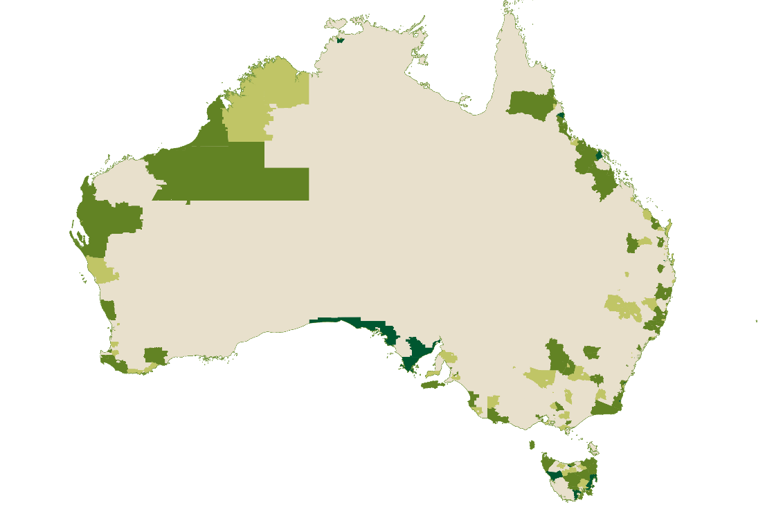
Low High
Source: ABS Census of Population and Housing 2021, Percentage of Total Aquaculture Industry Employment by Statistical Area 2 (SA2) and Place of Work (POWP).

Business characteristics
While there are comparatively few businesses in Offshore Caged Aquaculture, a high proportion of these businesses are medium-to-large employers with over 20 employees. Businesses predominantly engaged in Onshore Aquaculture and Offshore Longline and Rack Aquaculture are also more likely to be medium-to-large employers relative to all Australian businesses, albeit to a lesser degree than Offshore Caged Aquaculture. JSA also heard that many Aquaculture businesses will have both offshore and onshore operations.

Workforce characteristics
The share of First Nations people in the Aquaculture sector is high at 5.4%. Notably, the 6.8% share of First Nations employment among Aquaculture Farmers is significantly higher than the 1.1% share of all Farmers and Farm Managers and the 2.1% share of all managers across the Australian economy. Aquaculture also has a high proportion of First Nations people working in supervisor and worker roles.
Table 1.13: Demographics of select occupations employed within Aquaculture
Occupations | Employed in Aquaculture | Female (%) | First Nations (%) | Australian Citizen (%)
Aquaculture Farmer | 1,350 | 14 | 6.8 | 93
Aquaculture Worker | 650 | 15 | 7.5 | 88
Aquaculture Supervisor | 90 | 13 | 10.6 | 86
Aquaculture or Fisheries Technician | 270 | 28 | 1.5 | 85
Source: ABS Census of Population and Housing 2021.

Workforce trends
Total payroll jobs in Aquaculture experienced modest growth by 150 jobs (or 3%) from 1 July 2021 to 29 February 2024. The majority of this increase in payroll jobs was driven by Offshore Caged Aquaculture which grew by 100 payroll jobs (or 11%) (Figure 1.21).
Figure 1.21: Payroll jobs in Aquaculture

Source: Australian Taxation Office, Single Touch Payroll (STP) data.


Wild Catch
The Wild Catch sector is comprised of operations primarily engaged in wild-catch fishing. The sector encompasses the catching of ocean fish and seafood, prawns, rock lobsters, pearls, and finfish. The sector directly employs just under 5,000 people in their main job as at the 2021 Census. Table 1.14 shows for detailed industries within Wild Catch:
- the number of people directly employed in the industry as their main job in the 2021 Census, and
- the number of payroll jobs in the industry at the peak period nationally.
Around 60% of individuals working in Wild Catch did not provide enough information in the Census to be classified to their more detailed industry. At the detailed industry level, this is likely a key driver of the higher payroll jobs figure compared to the Census across Wild Catch industries.
Conversely, the higher count for total Wild Catch employment in the Census relative to payroll jobs is likely due to the high proportion of non-employing businesses and owner-manager employment in the Wild Catch sector
Table 1.14: Snapshot of employment in the Wild Catch sector
Industry class | Census 2021 | Payroll jobs at peak month |  |  | Peak Month
Industry class | Census 2021 | 2021 | 2022 | 2023 | Peak Month
Fishing, nfd | 2,930 | - | - | - | -
Rock Lobster and Crab Potting | 1,010 | 1,160 | 1,060 | 990 | Dec
Other Fishing | 430 | 550 | 670 | 660 | May
Prawn Fishing | 340 | 720 | 790 | 850 | Jun
Fishing, Hunting and Trapping, nfd | 110 | - | - | - | -
Fish Trawling, Seining and Netting | 60 | 570 | 550 | 610 | Apr
Line Fishing | 40 | 580 | 610 | 530 | Jul
Total Wild Catch | 4,920 | 3,580 | 3,680 | 3,640 | Dec
Source: ABS Census of Population and Housing 2021; Australian Taxation Office, Single Touch Payroll (STP) data. Figures are rounded to the nearest 10. NFD refers to industries that are not further defined in ANZSIC.
Compared to Aquaculture, Wild Catch employment is more widely dispersed with Western Australia, Queensland, South Australia, and New South Wales each home to approximately 20% of the workforce (Figure 1.20).
Figure 1.22: Geographical distribution of the Wild Catch workforce
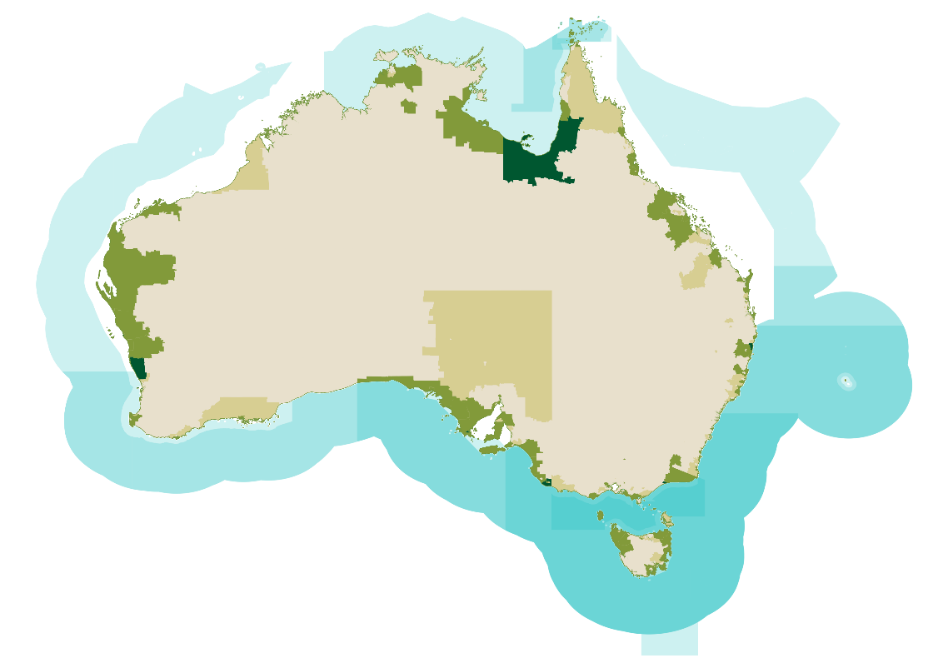
Low High
Source: ABS Census of Population and Housing 2021, Percentage of Total Wild Catch Industry Employment by Statistical Area 2 (SA2) and Place of Work (POWP). Blue areas represent some of Australia’s key fishery regions, with darker areas representing overlapping fishery types (fisheries are often defined by species).
There are a large number of significant fishery areas around Australia’s coastlines, some of which create employment in areas with minimal other Food Production. For example, there is a high proportion of workers around the Gulf of Carpentaria located near the Northern Prawn Fishery and the Gulf of Carpentaria Inshore Fin Fish Fishery.

Business characteristics
Alongside Dairy Farming, the Wild Catch sector has the lowest proportion of medium-to-large businesses at around 1%. While still typically small businesses, Prawn Fishing is unique among the Wild Catch sector in having a below national average proportion of non-employing businesses. JSA heard that the high proportion of non-employing and small businesses is the Wild Catch sector is in part driven by fishing quotas and other regulatory limits on allowable catch which reduce the opportunities and benefits of achieving scale through consolidation present in other Food Production sectors.

Workforce characteristics
The Wild Catch sector is comprised primarily of Australian citizens (Table 1.15). At 4.2%, the share of First Nations’ employment in the Wild Catch sector is well above average. This result is largely driven by First Nations Australians accounting for a high share of Fishing Hands, noting this occupation represents a substantial proportion of the total Wild Catch workforce. The Wild Catch sector also has relatively strong representation of First Nations Australians in higher skilled roles such as Diver, Fishing Leading Hand and Ship’s Master.
The Wild Catch sector is significantly underrepresented with regards to female employment, with female staff accounting for only 19% of the sector’s workforce. The employment of women in the Wild Catch sector occupations is concentrated in clerical and administrative roles rather than roles on the water.
Table 1.15: Demographics of select occupations employed within Fishing
Occupations | Employed in Fishing | Female (%) | First Nations (%) | Australian Citizen (%)
Fishing Hand | 2,160 | 5 | 5.7 | 94
Master Fisher | 430 | 2 | 2.5 | 96
Diver | 110 | 0 | 7.3 | 96
Fishing Leading Hand | 70 | 13 | 5.9 | 100
Ship's Master | 70 | 0 | 9.4 | 93
Source: ABS Census of Population and Housing 2021.

Workforce trends
Total payroll jobs in the Wild Catch sector remained broadly consistent between 1 July 2021 and 29 June 2023, declining by only 20 jobs (less than 1%). At the detailed industry level:
- growth in payroll jobs was evident in Prawn Fishing (up 100 jobs or 14%) and Other Fishing (up 80 jobs or 14%), and
- decreases in payroll jobs occurred within Line Fishing (down 90 jobs or 15%) and Rock Lobster (down 90 jobs or 10%).
The two largest employing Wild Catch industries exhibit clear seasonal fluctuations in labour demand, with Rock Lobster and Crab Potting peaking over summer and Prawn Fishing peaking in the winter months (Figure 1.23).
Figure 1.23: Payroll jobs in Rock Lobster and Crab Potting, and Prawn Fishing

Source: Australian Taxation Office, Single Touch Payroll (STP) data.

Food Production Support Services
The Food Production Support Services sector consists of firms mainly engaged in providing agricultural and fishing support services. The industries included in this profile are detailed in Table 1.16 and do not include support services industries which are clearly related to fibre rather than food (i.e. Cotton Ginning, Shearing Services).
The Food Production Support Services sector directly employed just over 16,000 people in their main job as at the 2021 Census. Table 1.16 shows for detailed industries within Food Production Support services:
- the number of people directly employed in the industry as their main job in the 2021 Census, and
- the number of payroll jobs in the industry at the peak period nationally.
The higher payroll jobs at peak month compared to the Census is likely driven by:
- seasonal peaks in the Food Production Support Services sector which are not captured in a Census undertaken in August, and
- high proportion of migrant employment in certain occupations in the sector, some of which will not be captured in the Census if the migrant indicated they would usually be resident in Australia for less than a year.
Table 1.16: Snapshot of employment in the Food Production Support Services sector
Industry class | Census 2021 | Payroll jobs at peak month |  |  | Peak Month
Industry class | Census 2021 | 2021 | 2022 | 2023 | Peak Month
Other Agriculture and Fishing Support Services | 15,340 | 21,390 | 22,640 | 20,550 | Dec
Agriculture and Fishing Support Services, nfd | 700 | - | - | - | -
Total Food Production Support Services | 16,040 | 21,390 | 22,640 | 20,550 | Dec
Source: ABS Census of Population and Housing 2021; Australian Taxation Office, Single Touch Payroll (STP) data. Figures are rounded to the nearest 10. NFD refers to industries that are not further defined in ANZSIC.
Figure 1.24 shows that employment in the Food Production Support Services sector is widely dispersed across Australia. Unsurprisingly, larger concentrations appear to occur in similar regions to high concentrations of other Food Production sectors such as Broadacre, Horticulture, and Intensive Livestock workforce.
Approximately 27% of employment in the Food Production Support Services sector is located in Queensland which is higher than its 23% share of all Food Production employment. This may indicate that the use of farm contractors and contract workers is relatively more common in this state.
Figure 1.24: Geographical distribution of the Food Production Support Services workforce
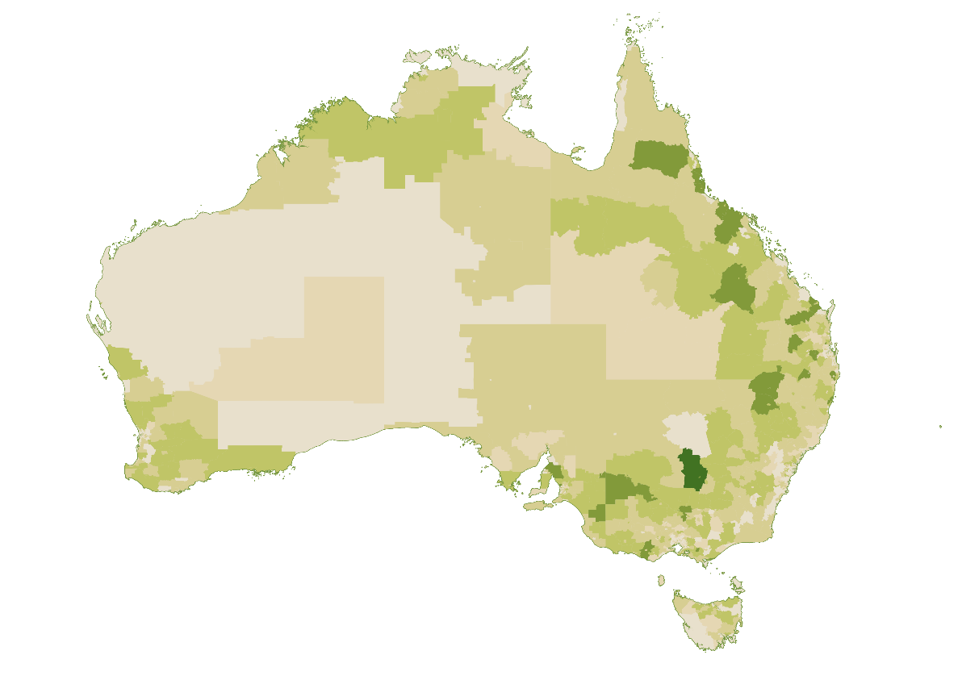
Low High
Source: ABS Census of Population and Housing 2021, Percentage of Total Food Production Support Industry Employment by Statistical Area 2 (SA2) and Place of Work (POWP).

Workforce characteristics
There are clear differences in the demographics of occupations within the Food Production Support Services sector between the occupations where a contractor may be hired:
- to provide specialist knowledge, skills or equipment for a specific task or job (e.g. Agricultural and Horticultural Mobile Plant Operator, Farrier), and
- to provide surge workforce capacity to meet time-limited labour demand in a role with few barriers to entry (e.g. Fruit Picker).
As Table 1.17 indicates, the first cohort is highly likely to be male and an Australian citizen while the latter cohort comprises a high proportion of migrant workers.
Table 1.17: Demographics of select occupations employed within Food Production Support
Major occupations | Employed in support services | Female (%) | First Nations (%) | Australian Citizen (%)
Agricultural and Horticultural Mobile Plant Operator | 1,370 | 6 | 3.1 | 94
Fruit Picker | 970 | 38 | 2.4 | 30
Farrier | 840 | 7 | 2.4 | 95
Fruit Farm Worker | 440 | 24 | 2.0 | 44
Fruit Grower | 440 | 28 | 0.7 | 73
Source: ABS Census of Population and Housing 2021.

Workforce trends
Total payroll jobs in Other Agriculture and Fishing Support Services grew by 430 (or 2%) in the two years from 1 July 2021 and 29 June 2023. As shown in Figure 1.25, the industry also exhibits seasonal fluctuations with payroll jobs typically peaking around November and December each year.
Figure 1.25: Payroll jobs in Other Agriculture and Fishing Support Services

Source: Australian Taxation Office, Single Touch Payroll (STP) data.

Emerging industries and occupations
The sectors profiled above are all well-established in Australia and will continue to play a critical role in Food Production in Australia. However, these sectors alone do not capture the full diversity of our Food Production activities. For instance, in the Inquiry into food security in Australia the House of Representatives Standing Committee on Agriculture observed:
‘[n]ew industries—such as alternative proteins, protected cropping and vertical farming—have the capacity to enhance food security while promoting economic development and increased employment.’
The labour and skills requirements in these new industries may vary in meaningful ways from more established Food Production sectors. For example, JSA heard that emerging industries such as alternative proteins will require a pipeline of skills in relevant areas such as synthetic biology, biomanufacturing, and food science.
Unlike the well-established sectors profiled above which can more readily be examined through official statistics coded to ANZSIC or ANZSCO, the emerging nature of these industries and any associated occupations makes this kind of analysis more difficult. While the ABS has committed to an ongoing process to update ANZSCO, it is important to note that not every emerging occupation will meet ABS criteria to be included as a discreet occupation.
There is an important role for JSCs in relation to these emerging industries in identifying skills and workforce needs, mapping career pathways, supporting collaboration between businesses and training providers, and acting as a source of intelligence on issues affecting their industries.
There may also be a role for a new, consistent approach to identifying and providing an evidence base on emerging occupations that could help governments incorporate emerging occupations into program design, without having to replace or change ANZSCO. This may be particularly relevant for government interventions in areas such as skilled migration and vocational education and training which often link eligibility criteria to occupations defined in ANZSCO.
For example, JSA’s report The Clean Energy Generation: Workforce needs for a net zero economy recommended that Government:
‘explore opportunities for a new mechanism to identify emerging occupations in the labour market that don’t meet ANZSCO criteria. A consistent and evidence-based approach could allow government systems, like migration and VET, to better respond to and acknowledge emerging roles without undermining the core principles of ANZSCO and the restructure work underway’.

Cross-cutting roles
While exploring the workforce of individual Food Production sectors is vital to understanding their unique dynamics, this sector-specific lens can also obscure the importance of cross-cutting roles that are spread across Food Production rather than being heavily concentrated in any one sector.
These cross-cutting roles may be common across a range of sectors throughout the economy (e.g. Bookkeepers) or may be professional, technical and trades roles that are more specific to Food Production (e.g. Agricultural, Agritech and Aquaculture Technicians) but not unique to specific sectors such as Broadacre. Table 1.18 lists the highest employing of these cross-cutting roles within Food Production.
Table 1.18: Major cross-cutting roles in Food Production by major occupation group
Managers
- Advertising, Public Relations and Sales Managers  - Chief Executives and Managing Directors  - Production Managers | - General Managers  - Finance Managers  - Retail Managers
Professionals
- Accountants | - Agricultural, Fisheries and Forestry Scientists
Technicians and Trades Workers
- Metal Fitters and Machinists  - Agricultural, Agritech and Aquaculture Technicians  - Metal Casting, Forging and Finishing Trades Workers | - Structural Steel and Welding Trades Workers  - Gardeners  - Arboriculture Workers
Sales Workers
- Sales Assistants (General) | - Other Sales Assistants and Salespersons
Clerical and Administrative Workers
- Bookkeepers  - General Clerks  - Office Managers | - Accounting Clerks  - Secretaries  - Purchasing and Supply Logistics Clerks
Machinery Operators and Drivers
- Agricultural and Horticultural Mobile Plant Operators  - Truck Drivers | - Storepersons  - Forklift Drivers
Labourers
- Product Quality Controllers | - Fencers
Source: ABS Census of Population and Housing 2021. Cross-cutting roles are included above if there are at least 500 people employed in the occupation unit group within Food Production sector.
The remainder of this section will delve deeper into the professional, technical and trades roles that are more specific to Food Production.

Agricultural, Fisheries and Forestry Scientists
Agricultural, Fisheries and Forestry Scientists advise farmers, primary industries and government on aspects of farming, fisheries, aquaculture and forestry, develop techniques for increasing productivity, and study and develop plans and policies for the management of land, fisheries and forest areas.
For this study, the key occupations in this unit group are Agricultural Consultant, Agricultural Research Scientist, Agronomist, and Aquaculture or Fisheries Scientist.
These professional roles are typically filled by Australian citizens, though there is also an important role for international research expertise. Table 1.19 also shows other notable demographic features of these occupations including:
- the underrepresentation of First Nations Australians. The exception to this is for Agricultural Consultants, where the higher share of First Nations employment may be related to relatively strong representation in Landcare Officer roles building on the importance of traditional knowledge for land and sea management.
- the underrepresentation of women. This is particularly the case for Agronomists who are typically employed within the Agriculture or Agricultural Product Wholesaling industries but is also true (albeit to a lesser degree) for the other professional occupations where employment is more likely to be found within the industries of Professional, Scientific and Technical Services, Public Administration and Tertiary Education.
Table 1.19: Demographics of select professional occupations
Occupations | Employed | Female (%) | First Nations (%) | Australian Citizen (%)
Agricultural Consultant | 2,010 | 32 | 2.3 | 92
Agronomist | 1,950 | 21 | 0.3 | 94
Agricultural Research Scientist | 1,910 | 41 | 0.8 | 86
Aquaculture or Fisheries Scientist | 280 | 33 | 0.0 | 94
Source: ABS Census of Population and Housing 2021.
Employment in Agricultural Scientist and Agricultural Consultant occupations grew by 5% and 10% respectively between 2011-12 to 2020-21 (Figure 1.26).
Figure 1.26: Employment stock in select professional occupations

Source: Jobs and Skills Australia (2023), Data on Occupation Mobility. This data is based on ANZSCO Version 1.3 prior to Agronomist, Agricultural Research Scientist and Aquaculture or Fisheries Scientist being created as new discrete occupations.
JSA has identified Agricultural Consultants, Agricultural Research Scientists and Agronomists as in shortage nationally and in each jurisdiction across all four iterations of the Occupation Shortage List to date covering the period 2021 to 2024. JSA also rated Aquaculture or Fisheries Scientist as in national shortage in 2023 and 2024.

Agricultural, Agritech and Aquaculture Technicians
Agricultural, Agritech and Aquaculture Technicians perform tests and experiments, and provide technical support to assist Agricultural and Fisheries Scientists, Agronomists and Farmers in areas such as research, crop and animal health, production, servicing and marketing.
The occupations in this unit group are:
- Agricultural and Agritech Technician
- Animal Husbandry Technician
- Aquaculture or Fisheries Technician
- Irrigation Designer
Notable demographic features of these roles include:
- First Nations Australians being well represented in the Aquaculture or Fisheries Technician occupation, consistent with their strong representation in the Aquaculture and Wild Catch sectors more broadly, and
- low or no representation of women and First Nations Australians in irrigation roles.
Table 1.20: Demographics of select technician and trade roles
Occupations | Employed | Female (%) | First Nations (%) | Australian Citizen (%)
Agricultural and Agritech Technician | 1,690 | 43 | 1.4 | 85
Irrigation Technician | 1,460 | 2 | 0.0 | 92
Aquaculture or Fisheries Technician | 420 | 29 | 2.4 | 87
Irrigation Designer | 170 | 8 | 0.0 | 92
Source: ABS Census of Population and Housing 2021.
Employment in the occupation of Agricultural Technician grew by 31% between 2011-12 to 2020-21 (Figure 1.27).
Figure 1.27: Employment stocks of Agricultural Technician

Source: Jobs and Skills Australia (2023), Data on Occupation Mobility. This data is based on ANZSCO Version 1.3 prior to Agricultural and Agritech Technicians, Animal Husbandry Technician, Aquaculture or Fisheries Technician and Irrigation Designer being created as new discrete occupations.


Workforce profiles

2. Food Manufacturing

Overview

Food Manufacturing is our largest employing manufacturing sector
Food Manufacturing is Australia’s largest employing manufacturing sector, accounting for nearly 30% of manufacturing jobs. Employment in Food Manufacturing is growing, with around 34,000 filled jobs being added over the last decade.
Illustrating the interdependency of Food Production and Food Manufacturing, the map below shows that Food Manufacturing employment is often concentrated in geographically smaller SA2s that represent regional centres of population, many of which are dotted throughout the Murray-Darling Basin. These regional centres often align with surrounding areas of high Food Production employment, often matching by commodity. For example, regions of high Meat Processing employment often occur near regions with high numbers of Livestock Farmers. There is also considerable Food Manufacturing employment in urban regions.
Figure 2.1: Geographical distribution of the Food Manufacturing workforce
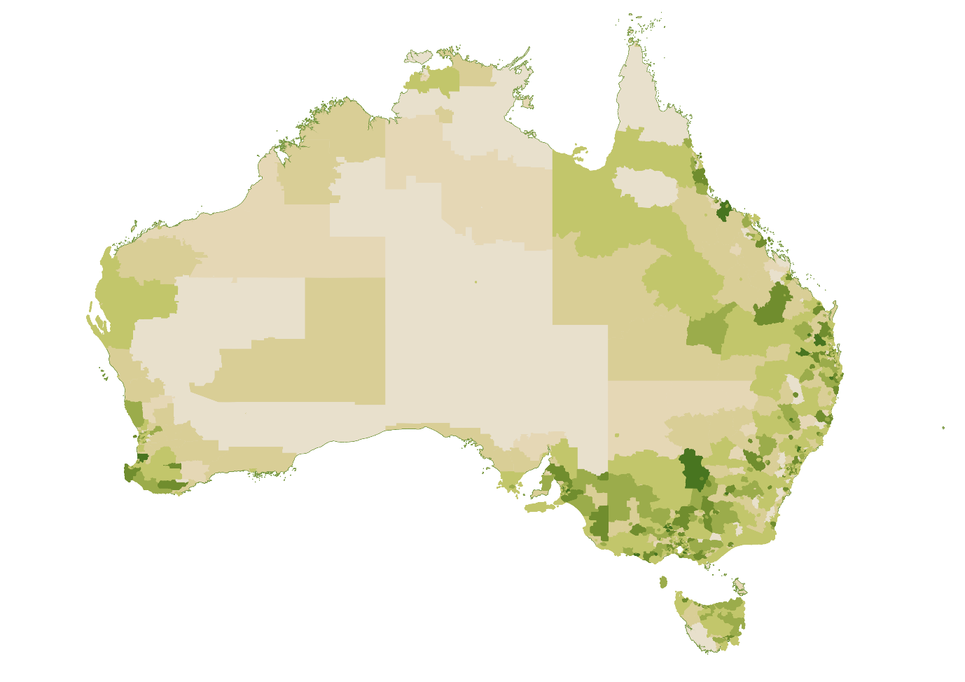
Low High
Source: ABS Census of Population and Housing 2021, Percentage of Total Food Manufacturing Employment by Statistical Area 2 (SA2) and Place of Work (POWP).
The distribution of the workforce by remoteness is not uniform across Food Manufacturing sectors. As Figure 2.2 highlights, workers in Bakery Product Manufacturing are the most likely to reside in major cities. In contrast, a greater proportion of the workforce in Meat and Meat Product Manufacturing, Dairy Product Manufacturing and Beverage Manufacturing live in inner or outer regional Australia. However, in overall terms a worker in Food Manufacturing is significantly more likely to live in regional areas relative to the average worker in manufacturing or the Australian labour market.
Figure 2.2: Proportion of workforce by remoteness and Food Manufacturing sector

Source: ABS Census of Population and Housing 2021.

Food Manufacturing firms are among the largest employers in many regional communities
Relative to all Australian businesses, Food Manufacturing businesses are more likely to be medium or large employers. This is particularly true for businesses in Dairy Product Manufacturing and Meat and Meat Product Manufacturing which have high proportions of businesses employing 20 or more employees.
Figure 2.3: Proportion of businesses by employee size in Food Manufacturing sectors

Source: ABS Counts of Australian Businesses, including Entries and Exits, June 2023.
Given the size and regional location of many Food Manufacturing firms, these firms often act as anchor employers in their local community. For example, in the town of Colac in Victoria’s south-west Ice Cream Manufacturing (6.7% of employment) and Meat Processing (6% of employment) account for a significant share of the local labour market.

Demographics of the Food Manufacturing workforce
A significant proportion of manufacturing activity within Food Manufacturing occurs at processing plants or factories. However, Food Manufacturing also includes businesses such as bakeries where products may be sold directly to the consumer on the same premises where they are manufactured.
This difference in worksite, in addition to the nature and timing of work in bakeries, may help explain the variance of Bakery Product Manufacturing from other parts of Food Manufacturing with respect to the average age, share of female workers and share of full-time workers (Table 2.1).
Albeit from different baselines, most Food Manufacturing sectors between the 2016 and 2021 Census exhibited:
- an in increase in the share of employment comprised by women, First Nations Australians and people with disability, and
- a decrease in the share of employment of Australian citizens and full-time workers.
Table 2.1: Workforce characteristics of Food Manufacturing sectors
 |   Meat Products |   Bakery |   Dairy Products |   Beverages |   Other Food | All  Industries
Directly Employed | 54,000+ | 51,300+ | 17,600+ | 31,800+ | 60,800+ | 11,522,000+
Average Age | 40 | 36 - | 43 | 42 - | 43 - | 41
Female Workers | 33% | 55% | 34% | 35% | 40% | 49%
First Nations Workers | 2.6% | 1.7% | 1.2% | 1.1% | 1.7% | 2.1%
Rate of needing assistance with core activities | 0.8% | 1.0% | 0.5% | 0.6% | 0.8% | 0.9%
Australian Citizen Workers | 68% | 81% | 84% | 88% - | 80% | 87% -
Full Time Workers | 77% | 45% | 75% | 71% | 72% | 59%
Source: ABS Census of Population and Housing 2021, 2016. Arrows indicate change from the 2016 Census.


Meat and Meat Product Manufacturing
The Meat and Meat Product Manufacturing sector encompasses businesses mainly engaged in processing meat or poultry as well as cured meat and smallgoods manufacturing. The industries included in this profile are detailed in Table 2.2.
Meat and Meat Product Manufacturing directly employed over 54,000 people in their main job as at the 2021 Census. Table 2.2 shows for detailed industries within Meat and Meat Product Manufacturing:
- the number of people directly employed in the industry as their main job in the 2021 Census, and
- the number of payroll jobs in the industry at the peak period nationally.
Table 2.2: Snapshot of employment in the Meat and Meat Product Manufacturing sector
Industry class | Census 2021 | Payroll jobs at peak month |  |  | Peak Month
Industry class | Census 2021 | 2021 | 2022 | 2023 | Peak Month
Meat Processing | 33,890 | 26,550 | 25,850 | 27,900 | Nov
Poultry Processing | 14,710 | 5,550 | 4,250 | 6,040 | Dec
Cured Meat and Smallgoods Manufacturing | 5,170 | 6,030 | 6,210 | 6,950 | Oct
Meat and Meat Product Manufacturing, nfd | 290 | - | - | - | -
Total Meat and Meat Product Manufacturing | 54,060 | 38,130 | 36,310 | 40,890 | Dec
Source: ABS Census of Population and Housing 2021; Australian Taxation Office, Single Touch Payroll (STP) data. Figures are rounded to the nearest 10. NFD refers to industries that are not further defined in ANZSIC.
As explored in the Intensive Livestock profile, the difference between Census and payroll jobs in Poultry Processing is largely explained by the complexities associated with vertically integrated businesses being coded into a single industry. Employment figures for Poultry Processing should therefore be considered alongside figures for Poultry Farming (Meat).
This same complexity appears to be evident between Meat Processing and Meat, Poultry and Smallgoods Wholesaling, where individual responses in the Census are more likely to be coded to Meat Processing whereas more businesses are likely to report their industry as Meat, Poultry and Smallgoods Wholesaling (Table 2.3).
Table 2.3: Snapshot of employment in select meat industries
Industry class | Census 2021 | Payroll jobs at peak month |  |  | Peak Month
Industry class | Census 2021 | 2021 | 2022 | 2023 | Peak Month
Meat Processing | 33,890 | 26,550 | 25,850 | 27,900 | Dec
Meat, Poultry and Smallgoods Wholesaling | 4,750 | 10,660 | 11,230 | 11,680 | Nov
Total | 38,640 | 37,210 | 37,080 | 39,580 | -
Source: ABS Census of Population and Housing 2021; Australian Taxation Office, Single Touch Payroll (STP) data. Figures are rounded to the nearest 10.
Meat and Meat Product Manufacturing employs over 54,000, with employment predominately concentrated in Queensland (29%), New South Wales (26%), and Victoria (25%) (Figure 2.4).
Figure 2.4: Geographical distribution of the Meat and Meat Product Manufacturing workforce

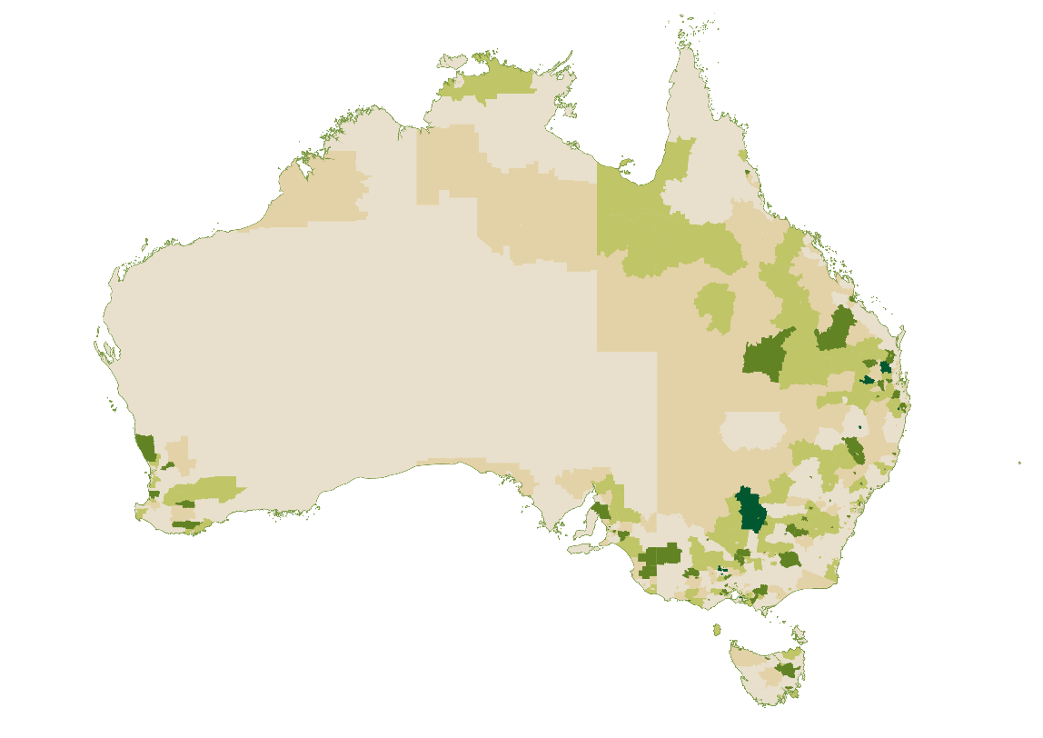
Low High
Source: ABS Census of Population and Housing 2021, Percentage of Total Meat and Meat Product Manufacturing Industry Employment by Statistical Area 2 (SA2) and Place of Work (POWP).
Employment in Meat Processing (the largest component of Meat and Meat Product Manufacturing) is concentred in inner and outer regional areas. In contrast, the distribution of employment in Poultry Processing and Cured Meat and Smallgoods Manufacturing more closely resemble the rest of the economy (Figure 2.5). In part, this reflects the location of livestock producers with intensive livestock operations such as pig and poultry farms typically being located closer to centres of population than beef cattle or sheep farms.
Figure 2.5: Proportion of Meat and Meat Product Manufacturing employment by industry and remoteness area (%)

Source: ABS Census of Population and Housing 2021.

Workforce characteristics
Similar to the Horticulture sector, major occupations in Meat and Meat Product Manufacturing are characterised by:
- a high share of non-Australian citizen employment, and
- a gender split between predominantly female packing roles and male dominated other roles.
The most male dominated occupations in Meat and Meat Product Manufacturing are the relatively higher skilled roles of Butcher or Smallgoods Maker, Slaughterer and Meat Boner and Slicer.
The occupation of Slaughterer has the lowest female representation of major roles in the sector at 5%. Business feedback indicated that this outcome is related to the tendency of Slaughterers who oversee religious slaughter (e.g. halal) to be male for cultural reasons.
Representation of First Nations Australians in major occupations within Meat and Meat Product Manufacturing typically equals or exceeds the representation of this cohort in the Australian labour market, although Poultry Process Worker is an exception to this (Table 2.4).
Table 2.4: Demographics of select occupations employed within Meat and Meat Product Manufacturing
Occupations | Employed in Meat and Meat Product Manufacturing | Female (%) | First Nations (%) | Australian Citizen (%)
Meat Process Worker | 8,560 | 25 | 3.5 | 64
Meat Packer | 8,110 | 64 | 2.3 | 54
Meat Boner and Slicer | 5,080 | 19 | 3.2 | 52
Poultry Process Worker | 5,050 | 40 | 1.5 | 62
Slaughterer | 1,610 | 5 | 4.8 | 62
Butcher or Smallgoods Maker | 1,600 | 8 | 2.1 | 68
Source: ABS Census of Population and Housing 2021.

Workforce trends
Total payroll jobs in the Meat and Meat Product Manufacturing industry grew by 1,120 jobs (or 3%) between 1 July 2021 and 29 February 2024. At the detailed industry level:
- Cured Meat and Smallgoods Manufacturing grew by 880 payroll jobs (or 16%), and
- Meat Processing grew by 20 payroll jobs (or 0.1%) (Figure 2.6).
Figure 2.6: Payroll jobs in Meat and Meat Product Manufacturing

Source: Australian Taxation Office, Single Touch Payroll (STP) data.
Part of the fluctuation in payroll jobs in the Meat Processing industry may relate to the use of daily hire employment.
Box 2.1: Daily hire in the meat processing industry
The Meat Industry Award allows meat processing establishments to employ daily hire employees. This type of employment is primarily intended to enable establishments to respond to fluctuations in livestock supply and throughput while providing greater commitment to continued engagement of the employee compared to casual employment.
Daily hire is a major type of employment in the meat processing industry, with a project commissioned by the Australian Meat Processing Corporation estimating that daily hire employees accounted for 57% of full-time equivalent employment in red meat processing in 2018-19.
A daily hire employee is employed by the day or shift, with the Award making a distinction between their employment (which terminates at the end of each day or shift) and their engagement which continues until terminated by either party.
In return for the flexibility provided to meat processing establishments to manage its day-to-day labour requirements, daily hire employees are paid a 10% loading on top of the rate for the classification in which they are employed.
An important distinction between daily hire and casual employment is that daily hire employees have access to paid public holidays, personal/carer’s leave and annual leave.


Bakery Product Manufacturing
The Bakery Product Manufacturing sector encompasses the manufacturing of bread, cakes, pastries, biscuits and other bakery products in factory and non-factory settings. In non-factory settings, the manufacture and sale of bakery products to consumers typically occurs from the same premises. The industries included in this profile are detailed in Table 2.5.
Bakery Product Manufacturing directly employed over 51,000 people in their main job as at the 2021 Census. Table 2.5 shows for detailed industries within the sector:
- the number of people directly employed in their main job in the 2021 Census, and
- the number of payroll jobs in the industry at the peak period nationally.
While the Census and payroll jobs paint a largely consistent picture regarding total Bakery Product Manufacturing employment, there are differences between the two sources on the distribution of employment between particularly Bread Manufacturing (Factory based) and Bakery Product Manufacturing (Non-factory based).
Table 2.5: Snapshot of employment in the Bakery Product Manufacturing sector
Industry class | Census 2021 | Payroll jobs at peak month |  |  | Peak Month
Industry class | Census 2021 | 2021 | 2022 | 2023 | Peak Month
Bread Manufacturing (Factory based) | 25,650 | 8,230 | 8,280 | 8,630 | Aug
Bakery Product Manufacturing  (Non-factory based) | 15,510 | 34,210 | 35,160 | 36,140 | Jul
Cake and Pastry Manufacturing  (Factory based) | 6,880 | 7,070 | 7,070 | 7,360 | Jul
Biscuit Manufacturing (Factory based) | 2,970 | 2,880 | 2,970 | 2,810 | Dec
Bakery Product Manufacturing, nfd | 320 | - | - | - | -
Total Bakery Product Manufacturing | 51,330 | 52,390 | 53,480 | 54,940 | Jun
Source: ABS Census of Population and Housing 2021; Australian Taxation Office, Single Touch Payroll (STP) data. Figures are rounded to the nearest 10. NFD refers to industries that are not further defined in ANZSIC.
Relative to other parts of Food Manufacturing, employment is more heavily concentrated in major cities (Figure 2.7).
Figure 2.7: Geographical distribution of the Bakery Product Manufacturing workforce

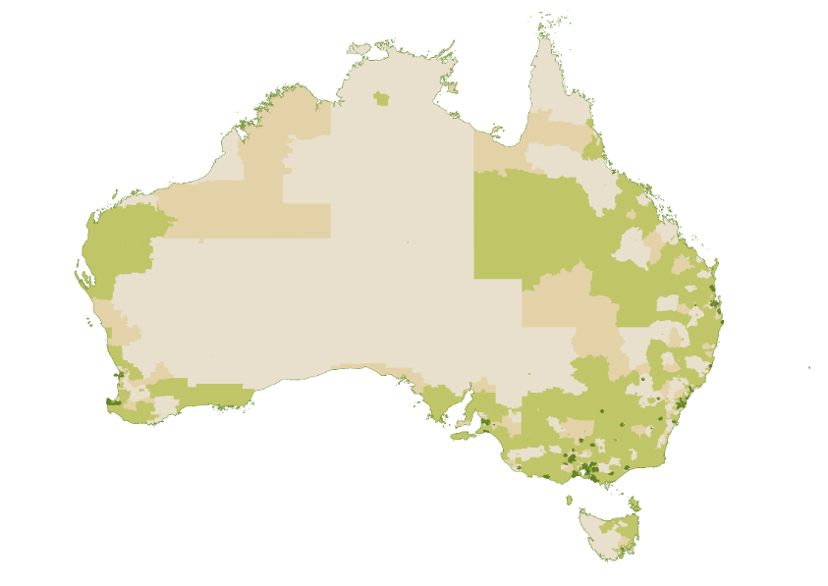
Low High
Source: ABS Census of Population and Housing 2021, Percentage of Total Bakery Product Manufacturing Industry Employment by Statistical Area 2 (SA2) and Place of Work (POWP).

Workforce characteristics
Notable demographic characteristics of major Bakery Product Manufacturing occupations include:
- greater female representation in pastrycook roles relative to baking roles, and
- relatively low proportion of employment of Australian citizens relative to the national average of 87% (albeit not as stark as some Food Manufacturing sectors such as Meat and Meat Product Manufacturing).
Table 2.6: Demographics of select occupations employed within Bakery Product Manufacturing
Occupations | Employed in Bakery Product manufacturing | Female (%) | First Nations (%) | Australian Citizen (%)
Baker | 10,730 | 25 | 2.1 | 77
Pastrycook | 2,830 | 62 | 1.0 | 74
Baking Factory Worker | 2,450 | 39 | 0.9 | 70
Pastrycook's Assistant | 1,460 | 50 | 2.2 | 77
Source: ABS Census of Population and Housing 2021.

Workforce trends
Total payroll jobs in the Bakery Product Manufacturing sector saw a decline of 4,470 jobs (8%) between 1 July 2021 and 29 February 2024. At the detailed industry level, most of this decline was driven by Bakery Product Manufacturing (Non-factory based) which dropped by 3,620 payroll jobs (or 10%). Payroll jobs in factory-based industries have remained relatively stable (Figure 2.8).
Figure 2.8: Payroll jobs in Bakery Product Manufacturing

Source: Australian Taxation Office, Single Touch Payroll (STP) data.

Dairy Product Manufacturing
The Dairy Product Manufacturing sector includes businesses engaged in milk and cream processing as well as the manufacturing of ice cream, cheese and other dairy products. The industries included in this profile are detailed in Table 2.7.
Dairy Product Manufacturing directly employed over 17,600 people in their main job as at the 2021 Census. Table 2.7 shows for detailed industries within Dairy Product Manufacturing:
- the number of people directly employed in the industry as their main job in the 2021 Census, and
- the number of payroll jobs in the industry at the peak period nationally.
Table 2.7: Snapshot of employment in the Dairy Product Manufacturing sector
Industry class | Census 2021 | Payroll jobs at peak month |  |  | Peak Month
Industry class | Census 2021 | 2021 | 2022 | 2023 | Peak Month
Cheese and Other Dairy Product Manufacturing | 11,770 | 9,260 | 9,750 | 9,530 | Dec
Milk and Cream Processing | 3,750 | 4,000 | 3,500 | 3,520 | Feb
Ice Cream Manufacturing | 1,730 | 1,290 | 1,440 | 1,600 | Oct
Dairy Product Manufacturing, nfd | 400 | - | - | - | -
Total Dairy Product Manufacturing | 17,650 | 14,550 | 14,690 | 14,650 | Dec
Source: ABS Census of Population and Housing 2021; Australian Taxation Office, Single Touch Payroll (STP) data. Figures are rounded to the nearest 10. NFD refers to industries that are not further defined in ANZSIC.
Similar to other industries, it appears that individual responses in the Census are more likely to be coded to Dairy Product Manufacturing whereas more businesses are likely to report their industry as Dairy Produce Wholesaling (Table 2.8). Collectively, Dairy Product Manufacturing and Dairy Produce Wholesaling appear to provide around 18,000 jobs.
Table 2.8: Snapshot of employment in select dairy industries
Industry | Census 2021 | Payroll jobs at peak month |  |  | Peak Month
Industry | Census 2021 | 2021 | 2022 | 2023 | Peak Month
Dairy Product Manufacturing | 17,650 | 14,550 | 14,690 | 14,650 | Dec
Dairy Produce Wholesaling | 970 | 3,410 | 3,890 | 3,840 | Sep
Total | 18,620 | 17,960 | 18,580 | 18,490 | -
Source: ABS Census of Population and Housing 2021; Australian Taxation Office, Single Touch Payroll (STP) data. Figures are rounded to the nearest 10.
Unsurprisingly, Figure 2.9 shows that Dairy Product Manufacturing employment is typically located near Dairy Farming regions with the majority of Dairy Product Manufacturing employment found in Victoria (56%).
Figure 2.9: Geographical distribution of the Dairy Product Manufacturing workforce
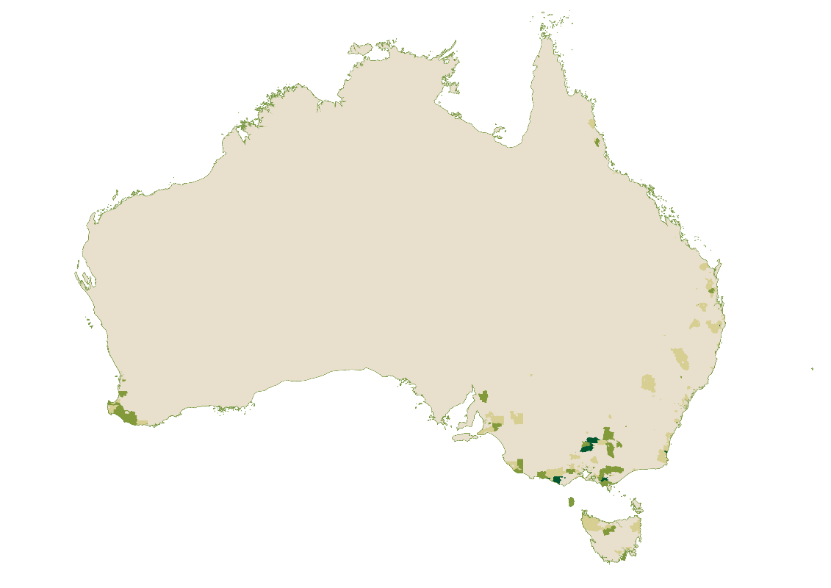
Low High
Source: ABS Census of Population and Housing 2021, Percentage of Total Dairy Product Manufacturing Industry Employment by Statistical Area 2 (SA2) and Place of Work (POWP).

Workforce characteristics
The Dairy Product Manufacturing industry is diverse, relying on a mix of dairy specific expertise and more general factory and production roles as shown in Table 2.9. These industries are predominately comprised of Australian citizens but do have a consistent proportion of non-Australian citizen workers of between 15 and 22% across some of its major occupations. At 1.9%, the share of First Nations’ employment in the occupation Dairy Products Maker is broadly comparable to the representation of First Nations Australians across the labour market (2.1%). Female representation is generally low among major occupations with the exception of Packers nec, where female representation is at 61%.
Table 2.9: Demographics of select occupations employed within Dairy Product Manufacturing
Occupations | Employed in dairy manufacturing | Female (%) | First Nations (%) | Australian Citizen (%)
Dairy Products Maker | 3,350 | 24 | 1.9 | 85
Forklift Driver | 840 | 3 | 1.2 | 87
Production Manager (Manufacturing) | 790 | 19 | 1.6 | 88
Packers nec | 730 | 61 | 1.1 | 78
Food and Drink Factory Workers nec | 630 | 33 | 1.1 | 80
Source: ABS Census of Population and Housing 2021. Nec refers to industries that are not elsewhere classified in ANZSCO but considered relevant to this sector.

Workforce trends
Total payroll jobs in Dairy Product Manufacturing declined by 1,130 jobs (8%) between 1 July 2021 to 29 February 2024 (from 14,470 to 13,340). At the detailed industry level, the changes included:
- Cheese and Other Dairy Manufacturing declining by 630 payroll jobs (or 7%)
- Ice Cream Manufacturing declining by 540 payroll jobs (or 14%), and
- Milk and Cream Processing increasing by 40 payroll jobs (or 3%).


Beverage Manufacturing
The Beverage Manufacturing sector encompasses the manufacturing of beer, spirits, wine and other alcoholic beverages as well as the manufacturing of aerated or carbonated soft drinks, mineral or purified waters, fruit drinks, concentrated cordials, syrups and non-alcoholic brewed beer or cider. The industries included in this profile are detailed in Table 2.10.
Beverage Manufacturing directly employed over 31,000 people in their main job as at the 2021 Census. Table 2.10 shows for detailed industries within Beverage Manufacturing:
- the number of people directly employed in the industry as their main job in the 2021 Census, and
- the number of payroll jobs in the industry at the peak period nationally
Table 2.10: Snapshot of employment in the Beverage Manufacturing sector
Industry class | Census 2021 | Payroll jobs at peak month |  |  | Peak Month
Industry class | Census 2021 | 2021 | 2022 | 2023 | Peak Month
Wine and Other Alcoholic Beverage Manufacturing | 16,650 | 15,770 | 15,920 | 16,380 | Mar
Soft Drink, Cordial and Syrup Manufacturing | 7,360 | 4,380 | 4,480 | 4,650 | Dec
Beer Manufacturing | 6,510 | 4,710 | 5,860 | 6,850 | Feb
Spirit Manufacturing | 810 | 480 | 720 | 860 | Oct
Beverage Manufacturing, nfd | 330 | - | - | - | -
Beverage and Tobacco Product Manufacturing, nfd | 230 | - | - | - | -
Total Beverage Manufacturing | 31,890 | 25,340 | 26,980 | 28,740 | Mar
Source: ABS Census of Population and Housing 2021; Australian Taxation Office, Single Touch Payroll (STP) data. Figures are rounded to the nearest 10.
The areas of high Beverage Manufacturing employment broadly map onto Australia’s wine regions, reflecting the status of Wine and Other Alcohol Beverage Manufacturing as the highest employing component of Beverage Manufacturing (Figure 2.10).
Figure 2.10: Geographical distribution of the Beverage Manufacturing workforce
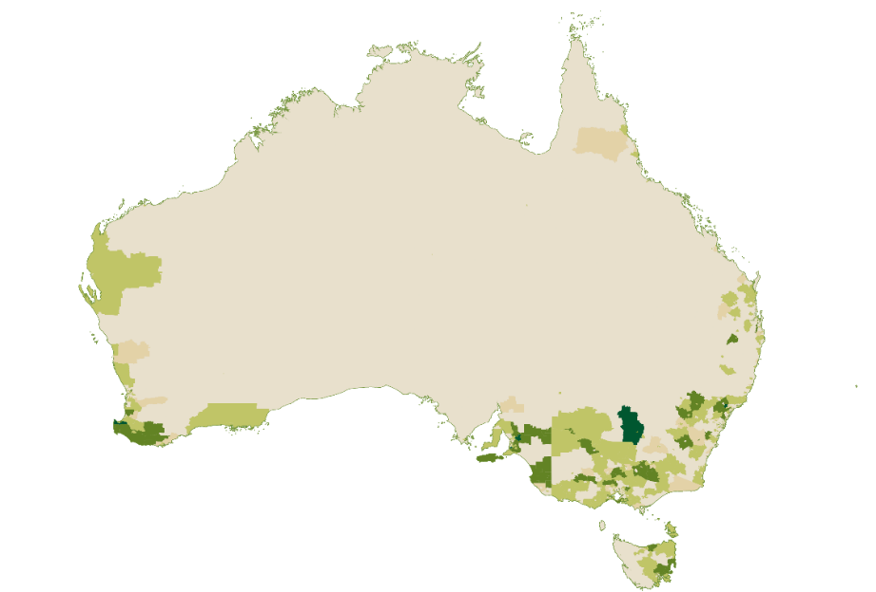
Low High
Source: ABS Census of Population and Housing 2021, Percentage of Total Beverage Manufacturing Industry Employment by Statistical Area 2 (SA2) and Place of Work (POWP).

Workforce characteristics
Most of the highest employing occupations in the Beverage Manufacturing sector relate to the Wine and Other Alcoholic Beverage Manufacturing industry, reflecting its status of the highest employing component of Beverage Manufacturing.
Beverage Manufacturing has among the highest shares of Australian citizen employment of any Food Manufacturing industry, second only to Sugar and Confectionery Manufacturing. Other notable demographic features of major Beverage Manufacturing occupations include relatively low representation of women and First Nations Australians (Table 2.11).
Table 2.11: Demographics of select occupations employed within Beverage Manufacturing
Occupations | Employed in Beverage Manufacturing | Female (%) | First Nations (%) | Australian Citizen (%)
Wine Maker | 1,690 | 22 | 0.5 | 91
Brewery Worker | 1,580 | 10 | 1.3 | 88
Winery Cellar Hand | 1,570 | 18 | 1.8 | 91
Vineyard Worker | 1,430 | 24 | 1.7 | 81
Wine Grape Grower | 1,230 | 18 | 1.2 | 91
Source: ABS Census of Population and Housing 2021.

Workforce trends
Total payroll jobs in Beverage Manufacturing increased by 3,030 jobs (or 13%) between 1 July 2021 and 29 February 2024. The most rapid growth at the detailed industry is evident in Spirit Manufacturing (up 55%, 290 payroll jobs) and Beer Manufacturing (up 28%, 1,420 payroll jobs).
Examining the patterns of payroll jobs in the Wine and Other Alcoholic Beverage Manufacturing and Grape Growing industries reveals a seasonal peak in labour demand during harvest, typically between February and April. That this seasonal pattern is reflected in both industries likely reflects the vertically integrated nature of many businesses in the wine industry (Figure 2.11).
Figure 2.11: Payroll jobs in select wine-related industries

Source: Australian Taxation Office, Single Touch Payroll (STP) data.
Comparing payroll jobs in Wine and Other Alcohol Beverage Manufacturing at the same point in the calendar shows that 720 payroll jobs were added in the industry over the two years from 1 July 2021 to 29 June 2023 (representing an increase of 5%).


Other Food Manufacturing
For the purposes of this study, the Other Food Manufacturing sector encompasses all Food Product Manufacturing industries not captured in one of the four profiles above. The full list of industries included in this profile are detailed in Table 2.12
The Other Food Manufacturing sector directly employs over 60,000 people in their main job as at the 2021 Census. Table 2.12 shows for detailed industries within Other Food Manufacturing:
- the number of people directly employed in the industry as their main job in the 2021 Census, and
- the number of payroll jobs in the industry at the peak period nationally.
Table 2.12: Snapshot of employment in the Other Food Manufacturing sector
Industry class | Census 2021 | Payroll jobs at peak month |  |  | Peak Month
Industry class | Census 2021 | 2021 | 2022 | 2023 | Peak Month
Food Product Manufacturing, nfd | 12,530 | - | - | - | -
Other Food Product Manufacturing nec | 10,460 | 21,130 | 21,550 | 22,920 | May
Fruit and Vegetable Processing | 8,850 | 8,480 | 9,080 | 8,310 | Jul
Confectionery Manufacturing | 8,360 | 5,100 | 5,230 | 5,290 | Dec
Prepared Animal and Bird Feed Manufacturing | 4,700 | 6,070 | 6,360 | 7,020 | Dec
Sugar Manufacturing | 4,400 | 2,860 | 2,760 | 2,760 | Jul
Cereal, Pasta and Baking Mix Manufacturing | 4,300 | 3,100 | 3,040 | 3,180 | Oct
Grain Mill Product Manufacturing | 2,850 | 2,640 | 2,790 | 3,340 | Oct
Potato, Corn and Other Crisp Manufacturing | 1,620 | 1,850 | 1,930 | 2,070 | Sep
Seafood Processing | 1,590 | 3,200 | 2,930 | 3,060 | Apr
Oil and Fat Manufacturing | 1,080 | 2,040 | 2,230 | 2,270 | Nov
Grain Mill and Cereal Product Manufacturing, nfd | 100 | - | - | - | -
Other Food Product Manufacturing, nfd | 30 | - | - | - | -
Sugar and Confectionery Manufacturing, nfd | 10 | - | - | - | -
Total Other Food Manufacturing | 60,880 | 56,470 | 57,900 | 60,220 | Oct
Source: ABS Census of Population and Housing 2021; Australian Taxation Office, Single Touch Payroll (STP) data. Figures are rounded to the nearest 10. NFD refers to industries that are not further defined in ANZSIC. NEC refers to industries that are not elsewhere classified in ANZSIC.

Workforce characteristics
In the examined occupations, packer roles tend to have higher-than-average female representation. Chocolate Packers lead with 76% female workers, followed by Food Technologists (69%), Fruit and Vegetable Packers (63%), and Seafood Packers (54%). In stark contrast, Grain Mill Workers and Sugar Mill Workers have very low female representation, with only 6 to 8% of these roles filled by women. These figures highlight a significant gender disparity across roles within the Food Manufacturing sector.
When it comes to First Nations representation, Grain Mill Workers (5.6%), Seafood Process Workers (3.2%), and Sugar Mill Workers (4.1%) exceed the national average of 2.1%.
The use of migrant labour is particularly prominent in some packing roles, especially for Seafood Packers and Fruit and Vegetable Packers where Australian citizens account for 45% and 57% of the workforce respectively.
Table 2.13: Demographics of select occupations employed within Other Food Manufacturing
Occupations | Employed in Other Food Manufacturing | Female (%) | First Nations (%) | Australian Citizen (%)
Food and Drink Factory Workers nec | 4,980 | 31 | 1.8 | 77
Production Manager (Manufacturing) | 2,730 | 22 | 1.3 | 84
Food and Drink Factory Workers nfd | 2,150 | 43 | 1.3 | 71
Forklift Driver | 2,150 | 6 | 3.2 | 84
Packers nfd | 2,050 | 63 | 1.7 | 59
Confectionery Maker | 1,700 | 42 | 1.2 | 85
Fruit and Vegetable Factory Worker | 1,060 | 40 | 2.7 | 76
Seafood Process Worker | 770 | 39 | 3.2 | 72
Sugar Mill Worker | 650 | 8 | 4.1 | 97
Grain Mill Worker | 650 | 6 | 5.6 | 90
Fruit and Vegetable Packer | 570 | 63 | 0.9 | 57
Food Technologist | 570 | 69 | 0.0 | 75
Chocolate Packer | 300 | 76 | 0.0 | 71
Seafood Packer | 180 | 54 | 0.0 | 45
Source: ABS Census of Population and Housing 2021. NEC refers to industries that are not elsewhere classified in ANZSIC.

Workforce trends
Total payroll jobs in Other Food Manufacturing industries remained relatively stable in aggregate terms between 1 July 2021 and 29 February 2024, adding only 240 payroll jobs. At a detailed industry level, notable changes include:
- Sugar Manufacturing payroll jobs declining by 700 jobs (down 25%).
- Grain Mill Product Manufacturing payroll jobs increasing by 280 jobs (up 11%).
- Seafood Processing payroll jobs declining by 280 jobs (down 10%).
- Oil and Fat Manufacturing payroll jobs increasing by 180 jobs (up 9%%) (Figure 2.12).
Figure 2.12: Payroll jobs in Other Food Manufacturing

Source: Australian Taxation Office, Single Touch Payroll (STP) data.

Cross-cutting roles
Food Manufacturing businesses provide employment opportunities across all eight major groups. These cross-cutting roles may be:
- common across a range of sectors throughout the economy (e.g. Advertising, Public Relations and Sales Managers)
- common across food and non-food manufacturing sectors (e.g. Manufacturers)
- professional, technical and trades roles that are more specific to Food Manufacturing (e.g. Food and Wine Scientists).
Additionally, some roles in businesses mainly engaged in Food Manufacturing may reflect vertical integration of multiple stages of the supply chain in one business (e.g. Livestock Farm Workers, Crop Farm Workers) or the act of manufacturing and selling food and beverages at the same premises (e.g. Retail Managers, Bar Attendants and Baristas).
Table 2.14 lists the highest employing of these cross-cutting roles within Food Manufacturing.
Table 2.14: Select cross-cutting roles in Food Manufacturing by major occupation group
Managers
- Production Managers  - Advertising, Public Relations and Sales Managers  - Retail Managers  - Other Specialist Managers  - Manufacturers  - Supply, Distribution and Procurement Managers | - Horticultural Crop Growers  - Chief Executives and Managing Directors  - Finance Managers  - Human Resource Managers  - General Managers
Professionals
- Chemists, and Food and Wine Scientists  - Accountants | - Advertising and Marketing Professionals
Technicians and Trades Workers
- Metal Fitters and Machinists  - Electricians  - Chefs | - Science Technicians
Community and Personal Service Workers
- Bar Attendants and Baristas  - Cafe Workers | - Waiters
Clerical and Administrative Workers
- Purchasing and Supply Logistics Clerks  - General Clerks  - Accounting Clerks | - Transport and Despatch Clerks  - Office Managers
Sales Workers
- Sales Assistants (General)  - Sales Representatives | - Models and Sales Demonstrators
Machinery Operators and Drivers
- Forklift Drivers  - Storepersons | - Truck Drivers  - Delivery Drivers
Labourers
- Commercial Cleaners  - Kitchenhands  - Crop Farm Workers | - Product Quality Controllers  - Food Trades Assistants  - Livestock Farm Workers
Source: ABS Census of Population and Housing 2021. Other occupations in Food Manufacturing with 1,000 or more workers.

Workforce profiles

3. Transport and Distribution

Overview

Transport and Distribution employment spans across Australia
The distribution of employment in different Transport and Distribution sectors by remoteness varies significantly depending on each sector’s role and stage in the supply chain process (Figure 3.1). For example, employment in the Agricultural Product and Machinery Wholesaling (Agricultural Wholesaling) sector which is mainly engaged in the wholesaling of inputs to agriculture is significantly more likely to be located in regional, rural and remote Australia than Grocery Wholesaling which trades in finished grocery products.
Figure 3.1: Proportion of workforce by remoteness and Transport or Distribution sector

Source: ABS Census of Population and Housing 2021.
It is important to note that the way industries are classified in ANZSIC does not always allow us to isolate employment related to the food supply chain. This is true for a range of Transport and Distribution sectors such as Freight Transport, Air and Space Transport, Transport Services and Warehousing (with the exception of Grain Storage Services). Nonetheless, these sectors remain worthy of attention in this study given their critical contribution to the effective operation of Australia’s food supply chain.

Demographics of the Transport and Distribution workforce
Albeit from different baselines, most Transport and Distribution sectors between the 2016 and 2021 Census exhibited:
- an in increase in the share of employment comprised by women, First Nations Australians and people with disability, and
- a decrease in the share of full-time workers (Table 3.1).
Table 3.1: Workforce characteristics of Transport and Distribution sectors
 |   Agricultural Wholesaling |   Grocery Wholesaling |   Warehousing |   Freight Transport |   Air & Space Transport |   Transport Services | All  Industries
Directly Employed | 33,700+ | 49,600+ | 46,800+ | 147,500+ | 37,500+ | 51,600+ | 11,522,000+
Average Age | 44 | 43 | 39 | 45 - | 43 | 44 - | 41
Female Workers | 31% | 37% | 28% | 16% | 36% | 28% | 49%
First Nations Workers | 1.7% | 1.3% | 1.7% | 2.5% | 1.3% | 1.7% | 2.1%
Rate of needing assistance with core activities | 0.7% - | 0.8% | 1.1% | 0.9% | 0.4% | 0.7% - | 0.9%
Australian Citizen Workers | 91% | 80% - | 77% | 87% | 90% | 86% | 87% -
Full Time Workers | 79% - | 67% | 68% | 75% | 57% | 76% | 59%
Source: ABS Census of Population and Housing 2021, 2016. Arrows indicate change from the 2016 Census.

Box 3.1: Gender diversity in Freight Transport
Of the sectors profiled across Food Production, Food Manufacturing and Transport and Distribution, Freight Transport has the lowest share of female employment with women accounting for only 16% of those working in the sector. Where women are employed in the industry, they are typically employed in clerical and administrative roles. In contrast, women only account for 2% of Truck Drivers (General) in the Freight Transport industry.
JSA heard about successful instances of government and industry collaboration in supporting women into heavy vehicle driver roles such as the Freight Industry Training for Jobseekers project. This project provided training to 175 people from underrepresented demographics in the freight industry and created 126 jobs across the heavy vehicle, forklift driving and warehousing sectors. While initiatives such as this one are positive, feedback emphasised the importance of overcoming structural barriers to increased female participation through:
- increasing access to flexible work
- creating inclusive and safe workplaces
- ensuring access to suitable facilities for female truck drivers, and
- shifting perceptions of the industry.
Low representation of women in key Road Freight Transport occupations such as Truck Driver (General) could be impacting shortages with JSA analysis showing that half of the occupations where men constitute at least 80% of the workforce are in shortage.


Transport
This section includes the transport of freight by road, rail, sea, or air as well as transport support services such as Stevedoring Services, Freight Forwarding Services, Customs Agency Services and Port and Water Transport Terminal Operations. The industries included in this profile are detailed in Table 3.2.
The importance of different modes of freight transport varies by commodity. Road freight plays a critical role for the broadest range of commodities across broadacre cropping, horticulture, livestock, and food and beverage products. However, a multimodal freight and logistics network also encompassing rail, water and air freight is essential to the effective operation of Australia’s food supply chain. For example,
- rail freight transport can be well suited for transporting bulk freight over longer distances than road freight and is commonly relied upon by the sugar and grains industries
- water freight transport can be well suited for bulk export (e.g. of grains, meat and dairy products) and is often used in the transportation of fertiliser as well as being integral for coastal shipping, which is a critical bulk transport link to Tasmania, and
- air freight transport can be well suited for transporting goods that are time sensitive, light, compact, perishable or highly valuable and is often utilised in the export of meat, seafood, fruit and vegetables.
The Transport industries below directly employed over 236,000 people in their main job as at the 2021 Census. Table 3.2 shows for these detailed industries:
- the number of people directly employed in the industry as their main job in the 2021 Census, and
- the number of payroll jobs in the industry at the peak period nationally.
Table 3.2: Snapshot of employment in the Transport sector
Industry class | Census 2021 | Payroll jobs at peak month |  |  | Peak Month
Industry class | Census 2021 | 2021 | 2022 | 2023 | Peak Month
Road Freight Transport | 135,340 | 159,470 | 154,320 | 149,560 | Sep
Air and Space Transport | 37,560 | 33,270 | 37,000 | 40,310 | Nov
Freight Forwarding Services | 23,140 | 16,250 | 16,430 | 17,990 | Jul
Other Transport Support Services nec | 16,400 | 11,240 | 12,350 | 13,450 | Jul
Rail Freight Transport | 9,990 | 12,500 | 12,230 | 14,540 | Mar
Port and Water Transport Terminal Operations | 7,970 | 6,440 | 6,350 | 6,970 | Dec
Stevedoring Services | 2,810 | 6,950 | 7,290 | 7,620 | Sep
Water Freight Transport | 2,250 | 2,670 | 2,970 | 3,190 | Nov
Customs Agency Services | 1,380 | 2,900 | 3,090 | 2,900 | Dec
Other Transport Support Services, nfd | 70 | - | - | - | -
Total Transport | 236,910 | 251,690 | 252,030 | 256,530 | Jul
Source: ABS Census of Population and Housing 2021; Australian Taxation Office, Single Touch Payroll (STP) data. Figures are rounded to the nearest 10.
Relative to the broader labour market, Queensland and Western Australia are slightly overrepresented with respect to the distribution of Transport employment by jurisdiction. This may in part reflect the industry mix in these jurisdictions and the status of these two jurisdictions as the two largest in Australia by landmass.
Figure 3.2 depicts the distribution of Truck Drivers (General)—the largest employing Transport occupation—by place of work. The highest concentrations of Truck Drivers are found in mining regions such as the Pilbara or near ports (e.g. the Port of Brisbane as shown in the inset). However, there are also areas of high Truck Driver employment in key food producing regions such as Griffith Surrounds in the Riverina region of NSW.
Figure 3.2: Geographical distribution of Truck Drivers across Australia (Brisbane inset)
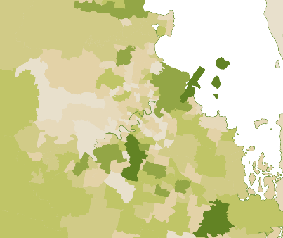
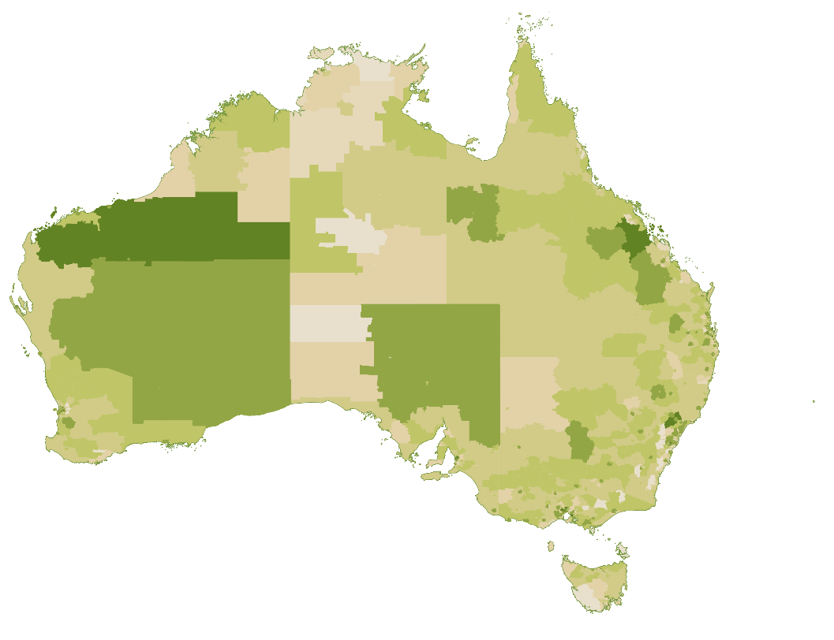
Low High
Source: ABS Census of Population and Housing 2021, Percentage of Total Truck Drivers (General) by Statistical Area 2 (SA2) and Place of Work (POWP). Note this excludes 6% Truck Drivers who did not indicate a fixed work address.
Box 3.2: Insights on freight transport and the food supply chain
The Commonwealth Scientific and Industrial Research Organisation (CSIRO) has developed the Transport Network Strategic Investment Tool (TraNSIT) to help users analyse Australia’s freight movements and supply chains. The TraNSIT tool captures over 185 commodities representing more than 25 million truck trips and 200,000 rail trips per annum. The tool does not capture freight transport by air or sea.
Insights from TraNSIT make it clear that, while secondary to the mining sector with respect to road and rail freight volumes, goods produced within the food supply chain account for the majority of road and rail freight by total travel distance and duration. This is due to the often vast distances required to transport produce, livestock and manufactured food and beverages to consumers from a farm or fishery via distribution centres, saleyards, processors, ports, retail outlets and other parts of the supply chain.
While it would be difficult to estimate with precision the proportion of freight transport jobs created by the food supply chain, it is clear that the proportion of freight transport employment related at least in part to the food supply chain would be considerable.

Business characteristics
There is significant diversity within Transport industries in the distribution of businesses by number of employees.
Figure 3.3 indicates that industries more closely associated with bulk freight (e.g. Rail Freight Transport and Port and Water Transport Terminal Operations) have the highest share of large employing businesses. In contrast, the Road Freight Transport industry has a high share of non-employing and small businesses which may be driven by prevalence of work as an independent contractor in the industry.
Despite constituting less than 1% share of all businesses in Road Freight Transport, the 75 businesses in the industry with 200 or more employees employ a significant proportion of the industry’s workforce.
Along with Road Freight Transport, Other Transport Support Services nec is one of the five industries with the highest number of active businesses in the Australian economy. While this industry encompasses some activities that are important to the food supply chain (e.g. container terminal operation, weighbridge operation), this industry also encompasses businesses providing road vehicle driving services (e.g. Uber drivers) who may account for the majority of total and non-employing businesses in this industry. As Figure 3.3 shows, excluding Other Transport Support Services nec materially increases the proportion of employing businesses among Transport industries.
Figure 3.3: Proportion of businesses by employee size in Transport industries

Source: ABS Counts of Australian Businesses, including Entries and Exits, June 2023.

Workforce characteristics
As identified above, female representation in Transport tends to be highest in clerical occupations such as Import-Export Clerk and Despatching and Receiving Clerk and lowest in driver occupations such as Truck Driver (General) and Forklift Driver (Table 3.3). First Nations Australians are relatively strongly represented in driver occupations, particularly as Train Drivers where they make up over 5% of employment in Transport sector.
Table 3.3: Demographics of select occupations employed within Transport
Occupations | Employed in Transport | Female (%) | First Nations (%) | Australian Citizen (%)
Truck Driver (General) | 63,490 | 2 | 2.7 | 86
Despatching and Receiving Clerk | 7,650 | 30 | 1.8 | 88
Forklift Driver | 7,230 | 3 | 2.2 | 82
Supply and Distribution Manager | 6,970 | 17 | 1.4 | 90
Train Driver | 4,090 | 10 | 5.1 | 97
Freight Handler (Rail or Road) | 3,160 | 11 | 2.3 | 83
Waterside Worker | 2,930 | 5 | 2.7 | 95
Import-Export Clerk | 2,860 | 43 | 0.5 | 86
Source: ABS Census of Population and Housing 2021.

Workforce trends
Total payroll jobs in Transport industries have declined by 4,640 jobs (or 2%) between 1 July 2021 and 29 February 2024. This decrease has been driven by the Road Freight Transport industry which declined by 19,340 payroll jobs (or 12%) across this period (Figure 3.4).
Figure 3.4: Payrolls jobs in Road Freight Transport

Source: Australian Taxation Office, Single Touch Payroll (STP) data.
Outside of Road Freight Transport, the number of payroll jobs in other Transport industries has trended upwards. In absolute terms, the largest increases have been seen in:
- Air and Space Transport (up by 7,820 payroll jobs or 24%)
- Other Transport Support Services n.e.c. (up by 1,840 payroll jobs or 17%)
- Freight Forwarding Services (up by 1,660 payroll jobs or 10%), and
- Rail Freight Transport increased (up by 1,570 payroll jobs or 12%).


Distribution
This section encompasses warehousing and storage as well as the wholesale trading of groceries, agricultural products and machinery. The industries included in this profile are detailed in Table 3.4.
The Distribution industries below directly employed over 130,000 people in their main job as at the 2021 Census.
Table 3.4 shows for detailed industries within Distribution:
- the number of people directly employed in the industry as their main job in the 2021 Census, and
- the number of payroll jobs in the industry at the peak period nationally.
Wholesaling industries consistently demonstrate a higher payroll job figure relative to the Census which is likely due at least in part to differences in how individuals describe their industry of employment in the Census compared to how businesses (particularly vertically integrated businesses) identify the industry in which they operate.
The same difference may apply in reverse in relation to Other Warehousing and Storage Services. In this case, the Census response of individuals working in a warehouse or storage facility may result in them being coded to this industry even where the industry of the employing business (i.e. where they earn the highest gross income or smallest loss) may differ. For instance, Warehouse Administrators are common across Wholesale Trade, Retail Trade and Manufacturing industry divisions in addition to Transport, Postal and Warehousing.
Table 3.4: Snapshot of employment in the Distribution sector
Industry class | Census 2021 | Payroll jobs at peak month |  |  | Peak Month
Industry class | Census 2021 | 2021 | 2022 | 2023 | Peak Month
Other Warehousing and Storage Services | 43,560 | 19,270 | 18,910 | 20,860 | May
Grain Storage Services | 3,000 | 6,550 | 6,300 | 5,400 | Dec
Warehousing and Storage Services, nfd | 250 | - | - | - | -
Agricultural and Construction Machinery Wholesaling | 14,370 | 17,940 | 19,150 | 20,430 | Nov
Other Agricultural Product Wholesaling | 13,190 | 16,110 | 16,540 | 19,520 | Feb
Industrial and Agricultural Chemical Product Wholesaling | 4,610 | 11,390 | 12,100 | 12,250 | Oct
Cereal Grain Wholesaling | 1,490 | 4,660 | 5,040 | 4,370 | Dec
Agricultural Product Wholesaling, nfd | 130 | - | - | - | -
Other Grocery Wholesaling | 19,980 | 38,980 | 40,950 | 41,940 | Jul
General Line Grocery Wholesaling | 9,000 | 4,240 | 4,650 | 4,410 | Dec
Fruit and Vegetable Wholesaling | 7,560 | 12,670 | 12,420 | 11,980 | Dec
Meat, Poultry and Smallgoods Wholesaling | 4,750 | 10,660 | 11,230 | 11,680 | Nov
Liquor and Tobacco Product Wholesaling | 4,350 | 7,550 | 8,030 | 7,850 | Dec
Fish and Seafood Wholesaling | 2,480 | 4,270 | 4,120 | 4,130 | Jul
Dairy Produce Wholesaling | 970 | 3,410 | 3,890 | 3,840 | Sep
Grocery, Liquor and Tobacco Product Wholesaling, nfd | 600 | - | - | - | -
Total Distribution | 130,280 | 157,700 | 163,330 | 168,660 | Dec
Source: ABS Census of Population and Housing 2021; Australian Taxation Office, Single Touch Payroll (STP) data. Figures are rounded to the nearest 10.
Geographically, employment in Distribution industries is predominately centred around New South Wales (32%) and Victoria (29%) (Figure 3.5).
Figure 3.5: Geographical distribution of the Distribution workforce
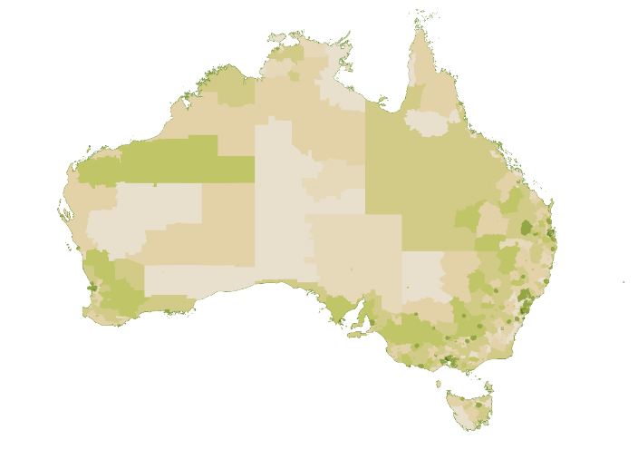
Low High
Source: ABS Census of Population and Housing 2021, Percentage of Total Distribution and Storage Employment by Statistical Area 2 (SA2) and Place of Work (POWP).

Business characteristics
Across the board, businesses within Distribution are more likely than average to employ 20 or more people (Figure 3.6). This is particularly the case for businesses in Wholesaling and Grain Storage Services.
Figure 3.6: Proportion of businesses by employee size in Distribution industries

Source: ABS Counts of Australian Businesses, including Entries and Exits, June 2023.

Workforce characteristics
Notable demographic features of occupations within Distribution include:
- an above average reliance on non-Australian citizen workers in major occupations including Storeperson and Forklift Driver
- underrepresentation of First Nations Australians across most occupations, and
- relatively low representation of women (Table 3.5).
Table 3.5: Demographics of select occupations employed within Distribution
Occupations | Employed in Distribution | Female (%) | First Nations (%) | Australian Citizen (%)
Storeperson | 23,000 | 26 | 2.1 | 73
Forklift Driver | 7,940 | 5 | 1.9 | 75
Truck Driver (General) | 3,720 | 3 | 1.9 | 81
Warehouse Administrator | 3,650 | 17 | 1.0 | 83
Sales and Marketing Manager | 3,580 | 27 | 0.8 | 87
Wholesaler | 2,690 | 23 | 0.5 | 88
Supply and Distribution Manager | 1,820 | 19 | 0.6 | 87
Stock and Station Agent | 850 | 10 | 1.4 | 99
Source: ABS Census of Population and Housing 2021.

Workforce trends
Total payroll jobs in Distribution industries have remained relatively stable between 1 July 2021 and 29 February 2024, growing by a 960 payroll jobs (or 0.6%). At the detailed industry level, the key driver of this growth was Agricultural and Construction Machinery Wholesaling which grew by 2,610 payroll jobs up 15%. In contrast, Other Agricultural Product Wholesaling, Fish and Seafood Wholesaling, Fruit and Vegetable Wholesaling and Liquor and Tobacco Product Wholesaling each declined by over 500 payroll jobs.
Payroll jobs in the Grain Storage Services industry exhibit a significant seasonal fluctuation. As Figure 3.7 demonstrates, the number of payroll jobs typically starts to rise around September each year as harvesting of major winter crops begins before peaking in December and remaining elevated over the summer. This seasonal peak requires the employment of a significant workforce of harvest casuals. For instance, JSA is aware of multiple grain receival sites with vacancies for more than 30 harvest casuals.
Figure 3.7: Payroll jobs in Grain Storage Services

Source: Australian Taxation Office, Single Touch Payroll (STP) data.


Part B:
Contributing workforces
Chapters 4 to 6 focus on parts of the food supply chain workforce that sit outside or cut across our 3 key segments. Specifically, these chapters cover Veterinary, Biosecurity and Labour Hire matters respectively.

Contributing workforces

4. Veterinary

Overview
In its contributions to Australia’s food supply chain, the veterinary workforce delivers a range of important benefits for businesses and the broader Australian community including:
- safeguarding the health and welfare of Australia’s production animals
- maintaining food safety, including by undertaking inspection activities to prevent food contamination in animal products
- managing biosecurity threats, including through surveillance, vaccination and emergency response
- protecting Australia’s access to trade markets and reputation as a supplier of safe food and disease-free livestock
- maximising productivity and profit by supporting improved animal husbandry practices and preventing animal injury, disease and mortality, and
- promoting public and environmental health through One Health approaches to better prevent, detect and respond to diseases impacting animals, humans and the environment.
Figure 4.1 shows that employment in the veterinary services industry tends to cluster around cities and regional population centres.
Figure 4.1: Geographical distribution of the veterinary industry workforce
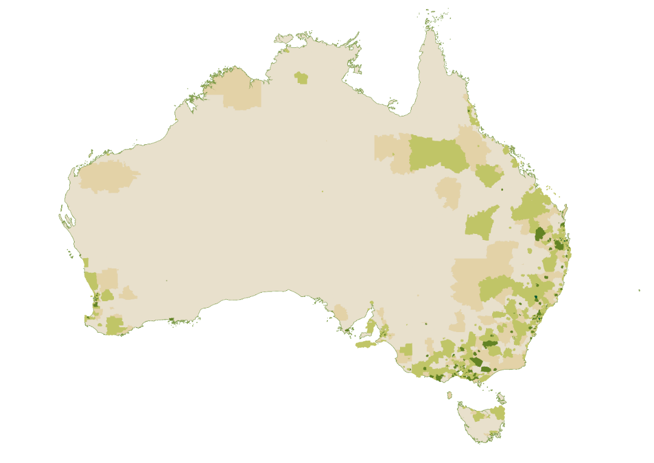
Low High
Source: ABS Census of Population and Housing 2021, Percentage of Total Veterinary Industry Employment by Statistical Area 2 (SA2) and Place of Work (POWP).
The industry mix of regional Australia, including the prevalence of food supply chain industries, may in part contribute to the relatively high share of Veterinarians employed in inner and outer regional Australia (36%) compared to the broader Australian population (26%) and similar professional occupations such as General Practitioners (20%). There is also evidence that regional and rural households are more likely to be pet-owning than their urban counterparts.

Workforce characteristics
The veterinary workforce comprises veterinarians and paraprofessionals such as veterinary nurses and veterinary technicians. From a food supply chain perspective, key roles within the veterinary workforce include:
- veterinarians directly employed by food supply chain businesses (e.g. poultry veterinarians in the chicken meat industry or aquatic veterinarians in aquaculture)
- veterinarians and veterinary nurses or technicians working in private large animal and mixed animal practices, particularly in regional, rural and remote Australia
- public sector veterinarians involved in policy, programs, research, regulation and advice related to animal health and welfare, biosecurity and veterinary medicines
- on-plant veterinarians who perform inspection of animals, meat and meat products and verify the compliance of registered abattoirs with export meat requirements
- accredited veterinarians who ensure the health and welfare of livestock before and during export, and
- other private sector veterinarians and veterinary nurses or technicians who contribute to surveillance and provide surge capacity in an emergency animal disease outbreak.
Results from the Australian Veterinary Association (AVA) Veterinary Workforce Survey 2023/24 indicate that around 85% of veterinarians work in clinical practice as their primary role, of which approximately one-in-five worked in a mixed practice or predominantly production animal practice. For those not employed in clinical practice, other fields of work included government, academia, industry, agriculture and laboratory work.
As Table 4.1 shows, the veterinary workforce is predominantly female. The proportion of Veterinarians who are female has increased from 46% in 2006 to 67% in 2021. This 21 percentage point increase ranks third out of 478 occupation unit groups for the greatest extent of feminisation between 2006 and 2021. In contrast, Veterinary Nursing has remained the 7th most feminised occupation through this period with fewer than one in every 20 veterinary nurses being male.
Table 4.1: Demographics of veterinary occupations
Occupations | Employment | Female (%) | First Nations (%) | Australian Citizen (%)
Veterinarian | 11,217 | 67 | 0.7 | 88
Veterinary Nurse | 13,012 | 96 | 1.8 | 93
Source: ABS Census of Population and Housing, 2021.
The proportion of Veterinarians working part-time has increased by around 8% between 2006 and 2021, compared to around 4% across all occupations. This increase of part-time work has a material impact on the supply of veterinarians required to meet demand for veterinary services.
Veterinarians in regional Australia are more likely to be owner-managers than their counterparts in major cities. As a result, the regional veterinary workforce is likely to be more exposed to financial viability pressures being experienced in the veterinary industry relating to rising delivery costs and salaries, the ability of the community to pay for care, and expectations to provide free or discounted care to wildlife and stray animals. Opportunities for veterinarians and veterinary students to develop their skills in running a successful business may be particularly beneficial for veterinarians in the regions.
JSA heard some commentary that increased self-sufficiency among livestock producers may also have contributed to reduced demand for large animal services relative to companion animal services. In turn, the AVA has indicated that the number of veterinarians willing and able to provide large animal services has declined to a point where even reduced demand for livestock veterinary services is not being met.
In the absence of any change, large animal veterinary skills and experience may be expected to further decline into the future as the older cohort of veterinarians working in large animal and mixed animal practices approaches retirement. According to the AVA’s Veterinary Workforce Survey 2021, 59% of veterinarians in mixed animal practices and 54% of those in farm animal practices graduated 20 years or more ago, compared to 41% in small animal practices.
Beyond Veterinarians and Veterinary Nurses, the Veterinary Services industry includes a range of other occupations including Receptionists, Practice Managers, and Animal Attendants and Trainers (Table 4.2). These occupations are also predominantly female and largely comprised of Australian citizens.
Table 4.2: Demographics of other occupations in Veterinary Services industry
Occupations | Employment in Veterinary Services | Female (%) | First Nations (%) | Australian Citizen (%)
Receptionists | 1,309 | 96 | 1.5 | 93
Practice Managers | 995 | 89 | 0.9 | 93
Animal Attendants and Trainers | 861 | 87 | 2.2 | 92
Source: ABS Census of Population and Housing, 2021.

Workforce trends
Payroll jobs in the veterinary services industry increased by 2,010 (or 7%) between 1 July 2021 and the 29 February 2024 (Figure 4.2).
Figure 4.2: Payroll jobs in veterinary services

Source: Australian Taxation Office, Single Touch Payroll (STP) data.
JSA has identified Veterinarians as in shortage nationally and in each jurisdiction across all four iterations of the Occupation Shortage List to date covering the period 2021 to 2024. Over the same period, the fill rate for Veterinarian vacancies (i.e. the percentage of advertised vacancies filled) has remained well below the 67% that generally means an occupation is in shortage. Veterinary Nurses have been rated in shortage nationally since the 2022 list.

Workforce planning and development considerations

How attractive is the work on offer?
There is a high degree of diversity in the employment contexts of the veterinary workforce, with potential impacts on the remuneration, conditions, nature and location of the work. JSA heard from multiple stakeholders about the importance of considering the attractiveness of the work on offer in relation to both new entrants to the profession and for supporting the career longevity of those already in place.
Reflecting on the attractiveness of public and private sector work, the Australian Government Department of Agriculture, Fisheries and Forestry (DAFF)—the largest public sector employer of veterinarians in Australia—observed that:
‘The public sector has traditionally been seen as an attractive career option for veterinarians for a range of reasons including diverse and meaningful career options, no or minimal after-hours duties, attractive remuneration and superannuation packages, leave entitlements, career progression and training and development opportunities.’
Nevertheless, DAFF have reported recently experiencing declining applications for veterinary officer roles which may reflect changes in the relative attractiveness of public service remuneration packages compared to parts of the private sector.
Within the private sector, JSA heard that recruitment difficulty is most acute in small veterinary clinics with stakeholders pointing to veterinarians’ desire to minimise the after-hours load they will carry and the potentially more limited peer support as reasons for this difficulty.

Salaries
Starting salaries for veterinary science graduates are relatively low on average considering the opportunity cost of the five to seven years of study required to become a registered practitioner and the high academic entry requirements. This is evident for those who completed the requirements of an undergraduate and postgraduate coursework award in Veterinary Science (Figure 4.3 and Figure 4.4).
Figure 4.3: Undergraduate median full-time salaries by study area, 2023 ($)

Source: Quality Indicators for Learning and Teaching, Graduate Outcomes Survey.
Figure 4.4: Postgraduate coursework median full-time salaries by study area, 2023 ($)

Source: Quality Indicators for Learning and Teaching, Graduate Outcomes Survey.
Median full-time salaries for veterinary science graduates remain among the lowest across all study areas despite evidence that salaries are increasing. The 2023 Graduate Outcomes Survey shows that median full-time salaries for veterinary science graduates grew at twice the average rate from 2022 to 2023, which may reflect the impact of veterinary workforce shortages and increasing demand for veterinary services. Lower starting salaries combined with high student loan debts accrued over five to seven years of study can be a significant barrier to attraction and retention to the veterinary profession.
The earning potential of Veterinarians across all career stages as evidenced by taxation statistics show that Veterinarians are near the middle of the road among professional occupations. Out of 104 professional occupation unit groups, Veterinarian ranks 47th for median salary or wage income and 42nd for median total income.
Reflecting in part the different business models in which they operate, there may also be differences in the salaries which can be offered by government, small independent practices, larger corporate entities, pharmaceutical companies and food supply chain businesses.
For Veterinary Nurses, outcomes data from VET National Data Asset (VNDA) show a median employee income of around $46,500 for those who completed a Certificate IV in Veterinary Nursing in 2018-19. Our analysis shows that this increased by around 4% to nearly $48,400 for those who completed a Certificate IV in Veterinary Nursing in 2019-20. As with the Veterinarian example above, this growth in median employee income may indicate increasing demand for Veterinary Nurses.

Hours worked, stress and burnout
In the week of the 2021 Census, 71% of Veterinarians in full-time employment worked 40 hours or more and 28% worked 50 hours or more. In addition to their long working hours, a recent New South Wales parliamentary inquiry into veterinary workforce shortages found that veterinarians are also suffering mental stress and burnout due to factors including client behaviour, workplace culture, and moral and ethical challenges particularly around ending the life of healthy or treatable animals.
JSA has heard that similar factors are at play for veterinary nurses, with the job satisfaction of veterinary nurses potentially also more likely to be negatively impacted by lower skill utilisation and autonomy at work.

Attractiveness of regional, rural and remote work
Results from the Survey of Employers who have Recently Advertised show that recruitment difficulty for Veterinarians has historically been higher in regional Australia, with the fill rate (i.e. the proportion of advertised vacancies filled) since 1 January 2021 nearly 20 percentage points lower for Veterinarian vacancies in the regions. This aligns with evidence from the AVA Veterinary Workforce Survey 2023/24 which indicated that 44% of vacancies in practices in regional areas were vacant for more than 12 months or still unfilled, compared to 28% in metropolitan areas.
JSA also heard suggestions that the true extent of recruitment difficulty for veterinarians in regional, rural and remote areas may be higher due to the impact of unrealised vacancies (i.e. jobs that employers were not actively trying to fill, for example due to a reluctance to advertise if suitable applicants are considered unlikely to be available). Previous JSA research has indicated that the proportion of businesses with unrealised vacancies increases with remoteness.
Many of the pressures facing the veterinary workforce are felt more acutely outside major cities. For example, the proportion of Veterinarians working over 50 hours increases with remoteness, rising from 25% in major cities to 32% in inner regional, 37% in outer regional and 42% in remote and very remote Australia. This is likely due at least in part to:
- the lower availability of dedicated after-hours emergency care in regional locations increasing pressures on regional veterinarians to be on call,
- increasingly likelihood with remoteness of undertaking circuit work, where a veterinarian travels and stays overnight or for multiple days to undertake a range of scheduled work in areas which have difficulty accessing regular services, and
- the higher proportion of veterinarians outside of major cities who are owner-managers of their own enterprise.
These long hours, potentially in combination with more limited peer and mentor support in regions that cannot support a large veterinary workforce, may lead to heightened stress, burnout and attrition in regional Australia.
In addition to challenges related to the veterinary workforce in particular, the attractiveness of regional and rural work is bound up with the attractiveness of the region, the lifestyle and the services it offers. These factors are explored in greater detail in Chapter 7.
While undertaking this study, JSA heard multiple proposals for attracting and retaining veterinary science graduates in regional and rural Australia. These proposals often identify initiatives to encourage health professionals to train and work in regional, rural and remote Australia as potential ideas for what could be done for veterinarians. Proposals received included:
- providing Higher Education Load Program (HELP) debt reduction for veterinarians who live and work in rural and remote Australia
- establishing a network of specialised rural veterinary practices that can provide teaching and government services in the regions similar to the Rural Health Multidisciplinary Training Program being used in the rural medical, dental and allied health fields
- providing a dedicated training pathway and additional training places for veterinarians working with large animals similar to the National Rural Generalist Pathway for rural general practitioners, and
- supporting regional and rural veterinarians or veterinary students through access to housing and childcare or increased professional development opportunities.
Efforts to ensure a sufficient veterinary workforce with the right skills in regional, rural and remote Australia are required and the proposals above are worthy of consideration. The example of Australia’s health workforce is instructive here. Australia’s efforts to address the distribution of health professionals across the country take the form of a package of initiatives underpinned by 10-year strategies such as the Stronger Rural Health Strategy and the National Medical Workforce Strategy.
To maximise the chances of success, any intervention to encourage or incentivise veterinary work in regional and rural areas should form part of a broader veterinary workforce strategy for producing a high-quality workforce in the locations and with the skills needed.

How do people enter, form skills and move through the sector?

Veterinarians
The requirements to be registered veterinarian are outlined in legislation at the state and territory level but generally involve:
- the completion of a veterinary science qualification recognised by the Australasian Veterinary Boards’ Council (AVBC) or, for overseas qualified veterinarians whose qualification is not generally recognised, by passing the Australasian Veterinary Examination,
- registration with the relevant veterinary board, and
- undertaking continuing professional development.
State and territory legislation also prescribes the restricted acts of veterinary science which only registered veterinarians may perform, subject to any exemptions provided for by the legislation.
There are currently seven veterinary schools in Australia providing courses leading to provisional registration as a veterinary practitioner. Additionally, Southern Cross University proposes to commence a new Bachelor of Veterinary Medicine (Honours) in 2025 at its Northern Rivers (Lismore) campus.

Domestic enrolments in courses leading to provisional registration as a veterinarian have declined in recent years and were around 8% lower in 2023 than the 2016 peak (Figure 4.5). Overtime this decline may start to flow through to the number of domestic completions, which peaked in 2021 and declined 16% by 2023.
Figure 4.5: Domestic student enrolments in courses leading to provisional registration as a veterinary practitioner, 2012-2023
Source: Department of Education, Higher Education Statistics.
The migration system makes a material contribution to the supply of Veterinarians, with permanent migrants accounting for 17% of Veterinarians in Australia as at the 2021 Census. These permanent migrants are a mix of overseas qualified veterinarians and those who completed their studies in Australia. The most common pathways for permanent migrants working as Veterinarians are transitioning from a student visa (32%), direct entry (31%) and from a temporary skilled visa (19%).

Veterinary Nurses and Technicians
Western Australia is currently the only jurisdiction to adopt veterinary nurse registration and title protection. The Veterinary Practice Board of Western Australia recognises the Certificate IV in Veterinary Nursing as the minimum education requirement to register and work as a veterinary nurse in Western Australia. Outside of Western Australia, there are no mandated minimum qualifications to work as a veterinary nurse or technician.
JSA is aware that the AVBC and the Veterinary Nurses Council of Australia (VNCA) have formed a working party on statutory regulation of veterinary nurses and technicians in Australia. This working party was established on the belief that statutory regulation is required to:
- ensure the highest standards of professionalism, competency and to protect the public and animal health and welfare, and
- improve delegation, accountability and autonomy of veterinary nurses and technicians to meet public expectations in the face of current workforce shortages and future challenges.
To remove barriers to workforce mobility and limit disruptions to the existing veterinary nurse workforce, any move towards regulation and title protection of veterinary nurse and technicians should consider the merits of a nationally consistent approach and supported pathways to current veterinary nurses who may lack sufficient formal qualifications. Consideration of a nationally consistent approach to veterinary nurse regulation could form part of a veterinary workforce strategy.
Currently, two-thirds of Veterinary Nurses hold a Certificate IV or higher as their highest level of educational attainment. Most commonly, this includes:
- 41% for whom a Certificate IV such as the Certificate IV in Veterinary Nursing is their highest qualification,
- 14% for whom a bachelor degree such as the Bachelor of Veterinary Technology is their highest qualification, and
- 9% for whom a diploma level qualification such as the Diploma of Veterinary Nursing is their highest qualification.
At the other end of the spectrum, 15% of Veterinary Nurses hold no post-secondary school qualifications.
Box 4.1: Outcomes from the Certificate IV in Veterinary Nursing
Outcomes data from VNDA reveal that those who complete the Certificate IV in Veterinary Nursing enjoy strong employment outcomes and median income uplift (Table 4.2). Compared to all Certificate IV completions in 2019-20, Veterinary Nurse students had higher than average employment rates and uplift. However, median income was about 20% lower than the Certificate IV average, although income uplift was significantly higher.
Table 4.2: Post-training outcomes from the Certificate IV in Veterinary Nursing
 | Certificate IV in Veterinary Nursing | Average across Certificate IV courses
Employment rate after completion | 96% | 88%
Change in employment rate (% points) | +12pts | +7pts
Median employee income | $48,400 | $60.400
Median employee income uplift | +$22,000 | +$8,700
Source: JSA, VET Student Outcomes – Top 100 courses, 2019-20 completions.
Table 4.3 depicts the most common occupation transitions into and out of Veterinary Nursing. It shows that the largest inflows of workers are from common occupations for young people in the labour market (e.g. Sales Assistant) or from lower-skill level occupations involving working with animals such as Animal Attendants and Trainers nec and Stablehands which likely represent a more specific career pathway for Veterinary Nurses. Meanwhile, the most common transitions out of Veterinary Nursing are career progression moves into roles such as Veterinarians and Veterinary Practice Managers (included in Practice Managers nec). Some transitions from animal to human health roles are also evident.
Table 4.3: Top 10 occupation transitions into and out of Veterinary Nurse, 2011-12 to 2020-21
Occupation inflows | Number of transitions | Focus occupation | Occupation  outflows | Number of transitions
Sales Assistant (General) | 1,185 | Veterinary Nurse | Veterinarian | 1,045
Animal Attendants and Trainers nec | 645 | Veterinary Nurse | Practice Managers nec | 510
Waiter | 630 | Veterinary Nurse | General Clerk | 480
General Clerk | 575 | Veterinary Nurse | Sales Assistant (General) | 360
Office Cashier | 400 | Veterinary Nurse | Animal Attendants and Trainers nec | 250
Receptionist (General) | 345 | Veterinary Nurse | Office Manager | 225
Bar Attendant | 315 | Veterinary Nurse | Receptionist (General) | 200
Sales Assistants and Salespersons nec | 295 | Veterinary Nurse | Registered Nurses nec | 175
Checkout Operator | 285 | Veterinary Nurse | Waiter | 140
Stablehand | 240 | Veterinary Nurse | Medical Receptionist | 125
Source: JSA, Data on Occupation Mobility.

Opportunities for reform

Funding arrangements for veterinary studies
Successive Transparency in Higher Education Expenditure reports commissioned by the Department of Education have shown that Veterinary Studies is the highest cost field of education to deliver per equivalent full-time student load (EFTSL) at the bachelor level. Alongside Veterinary Studies, other health science fields such as Dental Studies and Medical Studies are also among the highest cost fields of education with qualifications in these fields known to involve intensive teaching delivery, higher capital and material costs, and placement costs.
In their Rethinking Veterinary Education report, the Veterinary Schools of Australia and New Zealand (VSANZ) articulate the following as drivers of their high delivery costs:
- Low student to staff ratios: The AVBC Accreditation Standards for Veterinary Programs stipulate that the ratio of teaching staff to students is not less than 1 full-time equivalent (FTE) staff to 7.5 student EFTSL.
- High capital costs: Incurred by veterinary schools in order to provide space for small-group practical teaching and specialised plant and equipment for dissection, post-mortems, infectious disease control and animal handling.
- Differences to similar disciplines: Compared to medical and dental studies, VSANZ observe that:
  - veterinary schools are required to produce graduates who are ‘omnicompetent’ across major small and large animal species.
  - day one standards of competency for veterinary graduates are high compared to medical graduates who complete two years of postgraduate residency with governments sharing the costs of providing medical student internships.
  - veterinary education does not have the equivalent of a public hospital network to facilitate practical skills development, with veterinary schools needing to maintain teaching herds, run their own teaching hospitals and/or contract out clinical teaching.
There is evidence that the high cost of teaching a domestic veterinary student typically exceeds the base funding (student contribution plus Australian Government contribution) received for teaching them. The most recent available data indicates that the shortfall between the average teaching cost and base funding received per EFTSL is highest in Veterinary Studies among all fields of education (Figure 4.6).
Figure 4.6: Bachelor’s degree Level teaching cost and base funding by field of education, 2020

Source: Quality Indicators for Teaching and Learning, Transparency in Higher Education Expenditure.
This evidence supports the finding of the Australian Universities Accord Final Report which observed:
‘The lack of fidelity and accuracy in pricing means that small, expensive courses such as veterinary science… require significant and unsatisfactory cross-subsidy within universities.’
It is worth acknowledging that base funding amounts were revised as part of the Job Ready Graduates reforms from 2021, with the base funding amounts for studies in the Veterinary Science field increasing to $38,300. However, this increase only partially addresses the shortfall identified in Figure 4.8.
This reliance on cross-subsidisation and institutional patronage could impact Australia’s ongoing veterinary education capacity. There are currently seven veterinary schools in Australia accredited by the AVBC to offer qualifications that provide eligibility to apply for registration as a veterinarian. Multiple jurisdictions (Victoria, Western Australia, and South Australia) have only one veterinary school while others (Tasmania, the Northern Territory and the ACT have none). As such, the withdrawal of institutional patronage to a veterinary school by a university could significantly impact the pipeline of qualified veterinarians in Australia and in particular jurisdictions/regions. While by no means a guaranteed outcome, the withdrawal of institutional patronage is certainly a possible one. As VSANZ highlight:
‘The ongoing willingness of universities to cross-subsidise veterinary schools cannot be taken for granted. A fundamental duty of university leaders is to protect the sustainability of their university for future generations. Therefore, cross-subsidisation of veterinary schools will continue only to the degree financial resources allow and only if the veterinary school contributes more to the university and wider society than other areas of study that would benefit from additional financial support.’
Even in the absence of the closure of one or more veterinary schools, the gap between the cost of teaching a domestic student and the base funding received for teaching them may already be impacting the supply of domestic veterinary students. Enrolment data indicates the domestic student enrolments over the past decade peaked in 2016 while international student enrolments have continued to climb (Figure 4.7). This may indicate that taking on more domestic students is not financially attractive for universities, leading to a possible undersupply of places for these students.
Figure 4.7: Enrolments in courses leading to provisional registration as a veterinary practitioner by citizenship, 2012-22

Source: Department of Education, Higher Education Statistics.
In their Rethinking Veterinary Education report, VSANZ propose two mechanisms that could be considered to address the gap between the cost of teaching domestic veterinary students and the base funding received for teaching them, namely:
- increasing government grants to universities per veterinary student, and
- providing a veterinary clinical loading (similar to the medical student loading in the Commonwealth Grant Scheme).
The merits of these and other similar mechanisms could be explored as part of reconsidering funding arrangements for veterinary studies.
Recommendation 1
Reconsider funding arrangements for university-level veterinary science courses to minimise reliance on cross-subsidisation.

Veterinarians and the Commonwealth Prac Payment
Long mandatory unpaid placements can present a significant barrier for those seeking to commence and complete their studies to become a veterinarian. As the Australian Government Department of Agriculture, Fisheries and Forestry observes:
‘The large amount of unpaid practical work in veterinary courses limits educational accessibility… students required to undertake unpaid placements find it extremely difficult to find and maintain casual employment throughout such a degree. Additionally, few students are immune from spiralling cost of living pressures, the limited rental accommodation market and increasing higher education loan program (HELP) debts. All of these factors can be a severe barrier to students, especially those from underprivileged backgrounds or those from rural areas who may not have support networks near universities.’
The AVA reinforces this view, noting potential impacts of the exclusion of veterinarians from the Commonwealth Prac Payment on regional and rural veterinary practice:
‘“Placement poverty” affects veterinary students and prevents many students from undertaking practical work placements rurally and regionally due to the costs incurred. If provided with opportunities to see practice rurally, there is evidence that students will return to work in rural and regional locations.’
In the 2024-25 Budget, the Australian Government established a new Commonwealth Prac Payment for tertiary students undertaking supervised mandatory placements as part of their nursing (including midwifery), teaching or social work studies. This initiative is intended to relieve cost of living pressures for eligible students and invest in critical workforces.
There is a strong case for veterinarians to be included in any expansion of this initiative given it shares many of the below characteristics identified as part of the rationale for selecting nursing, teaching and social work.

Critical workforce
Veterinarians make essential contributions in a range of critical areas of public good such as animal health and welfare, food safety, biosecurity, and public health. The provision of veterinary services to companion animals is also highly valued by the estimated 69% of Australian households who own a pet.
Given the importance of their contributions, including veterinarians in scope for the Commonwealth Prac Payment would be consistent with the intent of investing in critical workforces.

Cost of living pressures due to lengthy placements
Students studying to become a veterinarian are required to undertake 52 weeks of mandatory placement as part of their program. This exceeds by a considerable margin the mandatory placement length for students currently eligible for the payment. It is likely the cost of living pressures and placement poverty risks associated with mandatory placements are heightened where the duration of placements is longer.

Declining completion rates
Placement poverty and cost of living pressures may be contributing to declining completion rates for veterinary students. Six-year completion rates show a significant increase among recent cohorts in the proportion of veterinary science students re-enrolling after their first year but later dropping out of their course (Figure 4.8). This timing aligns with the requirement to complete lengthy periods of placement which are typically concentrated towards the end of the course.
Figure 4.8: Commencing domestic bachelor veterinary science students who re-enrolled after the first year but dropped out (%)

Source: Department of Education, Completion Rates of Higher Education Students – Cohort Analysis, 2005-2022.

Enrolment of priority cohorts
The 2024-25 Women’s Budget Statement notes that the Commonwealth Prac Payment ‘will advance gender equality reducing barriers to the completion of qualifications and assisting in meeting skills shortages in highly feminised fields.’
As with nursing and midwifery, teaching and social work courses, women comprise a significant majority of veterinarian students. Indeed, across the last five years women have accounted for an average of 83% of commencements in veterinary studies. As described above, veterinarian has been also rated in shortage across each iteration of the Occupation Shortage List reinforcing the value of reducing barriers to completion in this area.
Recommendation 2
Include veterinarian students in any expansion of the Commonwealth Prac Payment initiative.

A national veterinary workforce strategy
The shortage of veterinarians in Australia is persistent and acute, with recruitment difficulty at its highest in regional, rural and remote locations.
Veterinary workforce shortages are concerning from the perspective of the food supply chain and the broader community given the important services this workforce provides. This includes services for the public good and private benefit in relation to animal health and welfare across production animals, companion animals, strays and wildlife, public health, food safety, productivity, and biosecurity, including emergency animal disease surveillance and response. Notably, the provision of services for the public good is not limited to public sector veterinarians but encompasses private sector veterinarians as well.
The veterinary workforce is a national one. Veterinary graduates are required to demonstrate a base level of competence across all major large and small animal species and are equipped to move between jurisdictions, regions and type of work. As a result, pressures and shortages in any one part of the profession are likely to have flow-on impacts on the whole.
JSA heard strong stakeholder support for a national veterinary workforce strategy to guide collective efforts to support a high-quality veterinary workforce in the locations and with the skills needed. Similar to the National Medical Workforce Strategy, such a strategy should identify practical actions and articulate how the agencies and organisations that fund, educate, train, employ, regulate and support the veterinary workforce will collaborate. This could include practical actions to:
- improve workforce planning and data,
- address the attraction, retention, and education and training barriers to resolving the national shortage of veterinarians,
- ensure a distribution of the veterinary workforce that supports the needs of the community and the economy,
- elevate the role of veterinary nurses and technicians within veterinary teams, and
- appropriately recognise the public good contributions of the veterinary workforce.
The scope of this strategy should explicitly consider workforce requirements of providing veterinary services in regional, rural and remote Australia and in support of Australia’s food supply chain.
The strategy could consider lessons learned from other sectors in Australia particularly the medical workforce as well as international good practice in developing a suitably skilled veterinary workforce distributed according to need.
Unlike the medical workforce which sits unambiguously within the health portfolio, the breadth of the veterinary workforce is not captured within a single portfolio. As such, the Government could consider appointing an expert panel to lead the development of the Strategy. With sufficient resourcing, JSA could also play a role in providing relevant workforce data and analysis.
The strategy would require the Australian Government working with state and territory governments and key stakeholders such as veterinary educators, professional veterinary associations, veterinary boards, veterinary students, employers, unions and other relevant stakeholders such as Skills Insight and Animal Health Australia.
Recommendation 3
Work with state and territory governments to develop a national veterinary workforce strategy in consultation with key stakeholders.
The strategy should:
- identify practical actions and articulate how the agencies and organisations that fund, educate, train, employ, regulate and support the veterinary workforce will collaborate to produce a high-quality workforce in the locations and with the skills needed.
- consider lessons learned from other sectors in Australia particularly the health workforce as well as international good practice in developing a suitably skilled veterinary workforce distributed according to need.
The scope of this strategy should explicitly consider workforce requirements of providing veterinary services in regional, rural and remote Australia and in support of Australia’s food supply chain.

Veterinary nursing skills standards
The AVBC and the VNCA are currently progressing work towards national registration of veterinary nurses and technicians. At present, mandatory registration applies in WA only.
The potential establishment of a national registration scheme necessitates a thorough review of qualifications and skill standards to ensure alignment and compliance with regulatory requirements. This could include an assessment of which skills/competencies are best delivered through work-integrated learning and classroom-based or virtual delivery.
If a national registration scheme with a minimum qualification requirement is to be implemented, it would also be timely to consider how to improve completion rates and the student experience in the relevant qualification/s to ensure the training pipeline is match-fit to meet potentially increased demand.
A national registration scheme with a minimum qualification requirement could also provide a basis for designing higher level qualifications targeting areas of specialisation that require evidence of competency to the minimum standard prior to entry.
Recommendation 4
Skills Insight should review the mapping of veterinary nursing skills standards in training products in light of potential mandatory registration for veterinary nurses.

Contributing Workforces

5. Biosecurity
Biosecurity is central to Australia’s food supply chain. It protects our plants, animals and ecosystems, enables us to generate high-quality primary produce, provides access to export markets and supports our trusted international reputation with trading partners. Biosecurity also goes hand in hand with food safety, which protects the health and wellbeing of people.
Biosecurity risks need to be managed at all stages of the supply chain, not just as food passes through Australia’s international borders. Incursions can impact all workers across Food Production, Processing, Manufacturing, Transportation and Trade. Therefore, identifying, mitigating and responding to biosecurity is everyone’s responsibility.
Without a capable and scalable biosecurity workforce, Australia’s food supply chain will be at significant risk. The National Biosecurity Strategy identifies this workforce as key priority for government:
‘We will develop and sustain the pipeline of biosecurity skills needed for the future, within government, industry and the community. We will ensure our people can be deployed when and where they are needed, and that they have the right skills by providing targeted capability and capacity building, education and training’.
With ever increasing levels of global trade, people, plant and animal movement, the risks and need for a resilient biosecurity system only grows. CSIRO reports that the annual number of interceptions of biosecurity risk materials at Australian borders rose by almost 50% between 2012 and 2017, stating that the ongoing management of established species coupled with the increasing risk of new incursions is placing growing strain on a system already experiencing resourcing challenges. Biosecurity risks, mitigations and regulations can also differ significantly between regions and commodities, requiring a different type of workforce expertise and response.
This chapter provides a high-level overview of the types of roles that Australia’s biosecurity system relies on and the current skilling pathways that exist. It supports the initial workforce actions identified in Australia’s first National Biosecurity Strategy:
- Investigate national skills to identify current and future needs in key areas, such as science, data, new technologies and regulatory capabilities, considering the findings of existing industry and government workforce strategies. | - Develop a national biosecurity workforce strategy to build, develop, retain and deploy capability across the system, including surge support for responses, taking into account regional needs across Australia.
- Build upon and expand existing cooperative and partnership arrangements to leverage the expertise and capability of biosecurity stakeholders to support system needs where there are mutual benefits. | - Strengthen professional development programs and exchanges between biosecurity stakeholders to facilitate knowledge and information sharing, improve skills and support workforce retention.

Roles and responsibilities
Biosecurity relies on a wide range of roles across the food supply chain (Table 5.1). These include dedicated biosecurity occupations, like Inspectors and Regulatory Officers, but also the day-to-day risk management undertaken by producers, processors and transporters.
There is also a surge workforce that governments draw on in times of emergency response, depending on the type of biosecurity risk or outbreak. This includes engagement of workers as government employees and contractors for different jurisdictions. Key occupations like veterinarians and veterinary nurses are often relied upon during Emergency Animals Disease outbreaks. As the Australian Chicken Meat Federation observed:
‘Veterinarians are in high demand due to their high level of experience and skills in animal health and biosecurity. Ensuring that there is an appropriate level of veterinary skills, specifically for industry to draw upon during times of crisis will be extremely important to maintain a high level of biosecurity among our supply chain. Veterinarians support the rapid detection, prevention and management of animal disease spread, their expertise and advice can mitigate the scale of an animal disease outbreak.’
Table 5.1: Indicative biosecurity roles and occupations
 | Inspectors and Regulatory Officers | Specialists | Producers, processors and transporters
Role | Ensuring Australia’s Food Production and trade is compliant with biosecurity requirements | Providing specialist expertise and services to governments, producers, processors and traders | Day-to-day risk management and implementation by food producers, processors and transporters
Occupations | Customs Officer  Water Inspectors  Fisheries Officers  Meat Inspectors  Biosecurity Officers  Invasive Pest, Weed and  Disease Inspectors  Food Safety Auditors/Officers  Primary Products Quality  Assurance Officers | Veterinarians and Veterinary Nurses  Agricultural, Biological,  Environmental and Life  Scientists (entomology and  epidemiology)  Customs Brokers  Chemistry and Life  Science Technicians  Agronomists  Agricultural Consultants  Aboriginal and Torres Strait Islander Land and Sea Rangers (Park Rangers) | Farm Managers and Workers  Aquaculture and Fishing Managers and Workers  Food and Meat Processors  Packers  Import-Export Clerks  Truck Drivers,  Storepersons and Waterside Workers  Food Technologists
Surge workforce
Providing additional capacity during an emergency biosecurity.
This section includes analysis of key inspector and regulatory occupations. Profiles for other occupations, including specialists, producers, processors and transporters are included in the preceding chapters.

Inspectors and Regulatory Officers
There are 8 key occupations within ANZSCO related to biosecurity inspection and regulation (Table 5.2). Many of these occupations also include specialisations, such as Primary Products Quality Assurance Officers having specialisations for Dairy Quality Assurance Officers and Meat Quality Assurance Officers. Australian Government Biosecurity Officers also sit across a number of functions, including cargo, traveller, mail and maritime.
The largest occupation is Environmental Health Officer, which is primarily focused on developing, enforcing and evaluating health policies, including food safety. Biosecurity Officer is another large occupation and involves the inspection of goods, plants, animals and the environment for biosecurity risk.
A number of inspector occupations, including meat and fisheries, have a large presence in non-metropolitan areas due to their co-location with primary producers. In comparison, Customs Officers and Biosecurity Officers have a large metropolitan presence, likely in close proximity to Australia’s major air and maritime ports.
The female share of these occupations varies significantly. Environmental Health Officer and Primary Products Quality Assurance Officer are the only occupations where females are a majority of workers. Conversely, Meat Inspector has a low share of female workers (15%) which is much lower than the broader Meat and Meat Product Manufacturing sector (33%).
Table 5.2: Inspectors and Regulatory Officers
Occupations | Employed | Female | Non-metro
Environmental Health Officer (Food Safety) | 4,350 | 55% | 37%
Biosecurity Officer | 1,580 | 44% | 24%
Customs Officer | 970 | 48% | 9%
Invasive Pest, Weed & Disease Inspector | 850 | 34% | 60%
Primary Products Quality  Assurance Officers | 510 | 55% | 48%
Meat Inspector | 500 | 15% | 67%
Fisheries Officer | 420 | 26% | 64%
Water Inspector | 290 | 34% | 51%
Source: ABS Census of Population and Housing, 2021. Employment counts have been rounded.
Inspectors and Regulatory Officers are employed by a mix of government and non-government businesses (Figure 5.1). While Customs and Biosecurity Officers are primarily employed by the Australian Government, occupations like Fisheries Officer and Water Inspector are mostly employed or contracted by state and territory governments. Meat Inspector is the only occupation predominantly employed by the private sector, with Meat Processing and Labour Hire being the most common sources of employment.
Figure 5.
1: Inspectors and Regulatory Officers

Source: ABS Census of Population and Housing 2021.
Since 2011, the proportion of Primary Product Inspectors employed by the Australian Government has significantly declined, from almost 50% to 21% in 2011 (Figure 5.2). The relative increase in private sector employment was largely driven by the part-privatisation of meat inspection roles from 2011, which were previously employed by the Department of Agriculture. The government also fully transitioned to the Australian Government Authorised Officer model across all export meat establishments, with the government no longer providing Food Safety Meat Assessors where the function could otherwise be provided by an AAO.
Figure 5.2: Primary Products Assurance and Inspection Officers, by sector

Source: ABS Census of Population and Housing, 2006-2021. Primary Products Assurance and Inspection Officers includes Fisheries Officer, Meath Inspector, Biosecurity Officer, and Quality Assurance Officer.

Private sector roles and responsibilities
Workers across Food Production, Processing, Transportation and Trade have an important role in biosecurity management. Below are some examples from the New South Wales Government of different biosecurity roles and responsibilities across the supply chain. These roles will vary significantly by industry and commodity and can also be influenced by different types of biosecurity outbreaks and emergencies.
Primary producers  - Identifying signs of pests, diseases and weeds  - Keeping crops, land and stock healthy  - Managing movement in and out of their property  - Reporting symptoms or other signs of disease  Veterinary practitioners  - Give expert advice to livestock owners and industry  - Provide a front-line response in emergencies affecting animals  - Educating employees and animal owners about good biosecurity practices | Long-distance drivers  - Meet quarantine and documentation requirements  - Check for live or dead animals, egg masses on any surface, holes in timber or frass, mosquito activity, lant matter, soil or mud  Abattoir, knackery and saleyard workers  - Participating in the National Livestock Identification System, traceability and market assurance programs  - Preventing the spread of disease by maintain good hygiene at saleyards and processing facilities  - Having the right licences, registrations and permits

Pathways and skilling

Tertiary education and training
There are a handful of dedicated biosecurity qualifications delivered in the higher education system. This includes a Bachelor of Biosecurity Science at the Box Hill Institute, a Masters of Biosecurity at Murdoch University and a Masters of Complex Systems (Biosecurity) at the University of Sydney. There are also a number of higher education institutions that offer units and electives in biosecurity, including within veterinary science at Charles Sturt University (CSU) and biological sciences at the Australian National University (ANU).
An Australian Research Council (ARC) Training Centre in Plant Biosecurity was recently established in collaboration with James Cook University, the University of Canberra and more than 20 partners from industry and government. The objectives of this centre include:
- Training the next generation of innovators and leaders in plant biosecurity to secure Australia’s agricultural, horticultural and environmental sectors from pests and diseases
- Innovate and develop novel approaches technologies for pest and disease surveillance, detection and identification through training-driven platforms
- Address the societal outcomes associated with transformational biosecurity changes through engagement with a new cohort of trained researchers and leaders, and
- Build an enhanced environment of interaction and collaboration between plant biosecurity stakeholders in industry, Government and universities.

Finally, higher education institutions make a critical contribution to the supply of technical expertise and specialists required for biosecurity management. This includes graduates across a number of fields like animal and plant pathology, taxonomy, veterinary science, epidemiology and entomology.
The VET system also provides a number of qualifications that are critical for biosecurity management. This includes recently added certificates, diplomas and skill sets in Public Safety: Biosecurity Emergency Response. Below is a non-exhaustive list of biosecurity-specific courses within the VET system and recent enrolment numbers (Table 5.3). Many of these courses are delivered primarily or exclusively by the NSW Government’s Tocal College.
Table 5.3: Key biosecurity-specific VET courses enrolments, 2023
Course title | Type | Enrolments
Biosecurity Emergency Responder | Skill set | 140
Biosecurity Infected Premises Supervisor | Skill set | 58
Public Safety  (Biosecurity Emergency Response Leadership) | Certificate IV | 37
Tropical Biosecurity | Certificate IV | 27
Biosecurity Field Surveillance | Skill set | 17
Public Safety  (Biosecurity Emergency Response Operations) | Certificate III | 15
Public Safety  (Biosecurity Emergency Response Management) | Diploma | 6
Biosecurity Movement Control | Skill set | 5
Source: NCVER, Total VET Activity program enrolments, 2023.
Certificates III and IV in Meat Safety Inspection are another critical regulatory pathway in the VET system, with around 150 enrolments each year. According to JSA’s occupation mobility data, a large number of Meat Inspectors were previously employed as Meat Process Workers, suggesting this qualification is used as a career pathway within industry.
There are also a number of biosecurity units available within the VET system for students undertaking Food Production, Processing, Transportation and Trade qualifications. One of the most common units in 2023 was Inspect and clean machinery, tools and equipment to preserve biosecurity, with almost 4,000 enrolments. The biosecurity-specific units are often undertaken as part of a Certificate II in Agriculture, Certificate II in Conservation and Land Management, and Certificate III in Rural Operations. There are also a large number of students enrolling in these units outside of a nationally recognised program.
While most of these units are delivered by the Agriculture, Horticulture and Conversation and Land Management Training Package, there are also relevant units delivered through other training packages, including:
- Transport and Logistics
- Seafood Industry
- Public Safety
- Animal Care and Management
- Australian Meat Processing
- Food, Beverage and Pharmaceutical

Other forms of training and development
There is a wide range of biosecurity skills development that sits outside of the formal tertiary system. These include short, unaccredited training designed to build expertise within the existing workforce through professional development. Below is a non-exhaustive list of these options.
- In 2022 the Australian Government established a new Biosecurity Training Centre in partnership with CSU. The centre provides core regulatory training for frontline officers and specialised programs in leadership and regulatory writing. It also offers capability building programs for Australia’s Indo Pacific neighbours.
- An On-Farm Biosecurity Basics Package is currently under development. This package will educate farmers on good biosecurity practices through face-to-face engagement. It will cover management plans, controlling movement, visitor management, animal control, and signage. Understanding the elements of on-farm biosecurity management would be beneficial to supply chain workers that access farm properties
- The Biosecurity Foundation Program is a 6-month national induction for Australian Government biosecurity officers. It is delivered at the Biosecurity Training Centre and provides foundational knowledge and skills essential for managing biosecurity threats.
- The National Biosecurity Training Hub is a centralised library of resources suited to different industries, levels and skill sets. It includes a number of pest and disease-specific offerings, like Foot-and-Mouth Disease training for veterinarians and Varroa Mite training for beekeepers, plus general Emergency Animal Disease response courses. These courses are delivered by a mix of government, private, vocational and higher education providers.
- Plant Export Authorised Officers are individuals appointed as Australian Government officials to perform a range of export functions and manage biosecurity risks. Job functions include export inspection of fruits, vegetables, grain and other goods which require completion of mandatory eLearning, facilitated training and/or competency-based assessment.
- The Indigenous Ranger Biosecurity Program partners with Indigenous Rangers in northern Australia to undertake biosecurity surveillance for exotic pests, diseases and weeds. The program includes a Ranger Forum that provides face-to-face delivery of biosecurity training, awareness and educational activities. It also includes a Certificate IV in Tropical Biosecurity and Biosecurity Fundamentals training.
- The Accreditation Program for Australian Veterinarians (APAV) is a national program designed to integrate private veterinary practitioners into the national animal health system. The APAV is administered by Animal Health Australia and includes modules on the animal health system, animal disease programs, responsibilities of an accredited veterinarian, emergency disease responsibilities of veterinarians, livestock welfare issues, and the use of veterinary laboratories.
- Plant Health Australia’s Biosecurity Online Training (BOLT) is a free platform for biosecurity related eLearning. This platform includes a variety of courses for growers and biosecurity response staff.
- Some state and territory governments also offer courses in biosecurity. For example, Agriculture Victoria delivers courses on biosecurity planning for livestock producers, EAD Response, and Foot-and-mouth Disease Awareness. The NSW Government’s Tocal Skills Training program was developed to meet the needs of farmers, primary industries, agribusiness and the community, and includes a chemical accreditation program.

National Biosecurity Workforce Strategy
The National Biosecurity Strategy includes an initial action to develop a National Biosecurity Workforce Strategy to build, retain and deploy capability. This offers a strong opportunity to improve our understanding of the skills and occupations required to effectively manage biosecurity risks. In developing the strategy, government should consider options to:
- draw on a greater and more sustainable pool of workers during biosecurity emergency responses
- support the critical expertise delivered by higher education institutions, including animal and plant pathology, taxonomy, veterinary science, epidemiology and entomology
- engage with JSCs on biosecurity VET units and qualifications to maintain consistency and quality across training packages
- undertake career pathway mapping, including roles within the private and public sector
- support short roles, complementary roles, side moves and upskilling opportunities that lead to biosecurity expertise
- support different models for delivering biosecurity skills across the labour market
- measure and monitor the size of Australia’s biosecurity workforce, including surge capacity.
Recommendation 5
Support the development of a National Biosecurity Workforce Strategy that improves our understanding of critical roles, skills and pathways.


Contributing workforces

6. Labour Hire

Overview

Labour hire arrangements can take many forms
In its most commonly understood form, labour hire work is characterised by a triangular arrangement where there is:
- an employment relationship between a worker and a labour hire firm, and
- a commercial arrangement between the labour hire firm and another business for the supply of the individual employee's labour (Figure 6.1).
Figure 6.1: Triangular labour hire arrangement
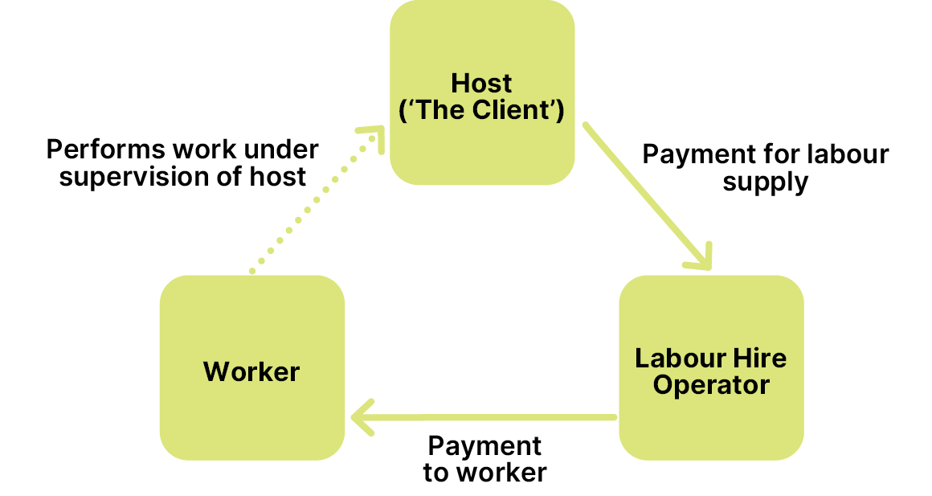
In some cases, labour hire arrangements can be more complex such as when a labour hire operator subcontracts out the supply of labour to another business resulting in a multi-tiered labour supply chain.
The definition of labour hire services can also encompass certain contractor management services and recruitment and placement services, as is the case under Victoria’s Labour Hire Licensing Act 2018. For example, this could include:
- businesses that recruit or place independent contractors, and then provide ongoing administration and payroll functions, or supervision or performance management functions for hosts (contract management services), and
- businesses that, in the course of providing recruitment or placement services, recruit or place one or more individuals to perform work in and as part of a host’s business and provide or procure accommodation for some or all of the period that the individuals are working for the host (recruitment and placement services).

Labour hire workers commonly work in the food supply chain
The ABS estimate that 416,500 people had a job in Labour Supply Services—the industry most closely associated with labour hire—in June 2024. The share of total employment comprised by Labour Supply Services is trending upward, increasing from 2% of total employment to 2.8% over the ten years to June 2024.
Reliable data on the employment patterns of labour hire workers at a granular level are limited. However, there is little doubt that labour hire workers represent a significant share of parts of the food supply chain workforce. For example:
- Evidence from the Linked Employer-Employee Dataset (LEED) suggests that Factory Process Workers—many of whom are engaged in processing, manufacturing and packaging food and beverages—is the most common occupation sub-major group in which labour hire workers are employed.
- ABARES survey data indicates that around 52,000 contract workers in Horticulture were employed through labour hire firms at the peak month in 2019-20 (representing over half of all contract workers).

Labour hire can play a constructive role in our food supply chain
There is a legitimate role for labour hire arrangements within the food supply chain workforce. Labour hire can provide an important mechanism for food supply chain businesses to manage seasonal fluctuations in labour demand, address labour supply challenges, and reduce their administrative burden.
JSA heard that labour hire arrangements can be particularly beneficial for small and medium enterprises:
‘Labour hire companies offer growers a range of benefits that make engaging their services a very pragmatic decision, particularly for small and medium businesses with limited capacity. Labour hire companies can take responsibility for recruiting workers, training and managing pay, insurances and any other entitlements. By taking over these duties, producers are able to spend more time on other aspects of their business.’
Labour hire firms also play a large role in connecting those looking for work with employment opportunities, especially newer participants in the Australian labour market. Relative to all employees, those born overseas (particularly those who arrived less than 10 years ago) are more likely to be a labour hire worker. For instance, 96 approved PALM scheme employers in July 2024 were labour hire firms with labour hire firms accounting for many of the largest employers in the scheme.

Labour hire firms are associated with a significant share of non-compliance
Recent inspections undertaken by the Fair Work Ombudsman (FWO) found that labour hire operators are associated with a significant proportion of non-compliance in the agriculture sector. For example, under their Agriculture Strategy the FWO has issued 98 Infringement Notices for pay slip and record-keeping breaches with employers fined a total of $316,860. The majority of Infringement Notices (86 out of 98) were to labour hire entities. As the FWO observe, ‘breaches of record-keeping and pay slips laws often indicate increased risks of underpaying workers as well as non-compliance with other Commonwealth laws.’
The non-compliance risks of labour hire arrangements are elevated where labour supply chains are more complex. As noted in its 2018 Harvest Trail Inquiry Report, the experience of the FWO is that:
‘…multiple levels of subcontracting increases the risk of non-compliance. As additional subcontractors enter the labour contracting chain, the increasing pressure of multiple players taking their profit can result in the legal employer of workers having insufficient funds to cover their full entitlements.’
Complex or multi-tiered labour supply chains may also be a deliberate feature of the work of some labour hire operators with the aim of making it harder for regulators to enforce compliance with the law.

Non-compliant labour hire arrangements harm workers and the industry
Non-compliant labour hire practices range from unintentional breaches through to intentionally operating an exploitative business model. The Report of the Migrant Workers’ Taskforce called attention to a range of common practices employed by non-compliant labour hire firms including:
- underpayment of wages and non-payment of the superannuation guarantee
- poor record keeping
- the use of vulnerable workers (including trafficked workers and those working illegally)
- not remitting PAYG tax and paying workers’ compensation premiums
- sham contracting arrangements
- sub-contracting arrangements that add little value to the supply or service
- liquidating businesses to avoid accrued employee obligations, and
- provision of over-priced, sub-standard accommodation.
While some individual employers and workers may seek to benefit by engaging with non-compliant labour hire firms (e.g. by lowering labour costs or avoiding tax through cash-in-hand payments), non-compliant labour hire arrangements are damaging for workers and employers in the food supply chain. The range of harmful impacts include but are not limited to:
- for workers whose vulnerability is directly exploited by unscrupulous labour hire operators, harms can include significant underpayments, extremely long hours of work, high rents for overcrowded and unsafe worker accommodation, discrimination and misclassification as contactors
- for other workers, impacts can include the creation of distorted or segmented labour markets where non-compliance puts downward pressure on wages and conditions by focusing competition on lowering labour costs, and
- for compliant employers and labour hire operators, damaging the reputation of the sector including in relation to its ability to attract new workers) and create an uneven playing field.

There are multiple factors contributing to non-compliance
The primary motivator for intentional non-compliance among labour hire operators is to lower labour and other associated costs in order to maximise their profit and gain a competitive edge over compliant operators.
In the context of this study, it is particularly relevant to note the range of risk factors for non-compliant labour hire arrangements that are present in parts of the food supply chain including:
- prevalence of intensive, low-skilled work where labour costs account for a significant share of total costs
- high demand for labour to be available at short notice
- challenges in securing a supply of labour in particular roles and locations
- a relatively large supply of more vulnerable workers, and
- low profit margins.

Labour hire firms are one of many labour market intermediaries
There are a wide range of public and private labour market intermediaries that connect individuals seeking work with food supply chain employers who are offering employment. In addition to labour hire firms, other common examples include:
- publicly funded employment services
- private employment and recruitment agencies
- migration agents
- online jobs boards and digital platforms, and
- accommodation providers such as working hostels.
These labour market intermediaries can play an important role in supporting a more efficient labour market and enabling informed choices. Labour market intermediaries can also provide an important layer of relational regulation. For instance, labour market intermediaries can act as a gatekeeper by not referring workers to employers with a reputation for non-compliance or mistreatment of workers and by referring workers with a complaint to relevant enforcement agencies.
However, the activities of unscrupulous labour market intermediaries can elevate workers’ vulnerability to exploitation. This can include instances where labour hire firms work closely with other labour hire intermediaries. For example, in relation to migration agents the Report of the Migrant Workers’ Taskforce observed:
‘Labour hire operators may use overseas migration agents in source countries to recruit workers and facilitate their visa for travel, work, accommodation and local transport (often with high charges, which may lead to debt bondage).’
Similarly, regarding accommodation providers, a recent report from the NSW Anti-Slavery Commissioner noted:
‘Accommodation providers often have close personal and/or corporate ties to labour hire companies, or also provide transportation to workers (for an additional fee), further deepening the dependence of the workers on them and raising the possibility of abuse of vulnerability.’

Opportunities for reform

National labour hire regulation
Effective reform to protect labour hire workers from exploitation and regulate the behaviour of labour hire entities is an essential component of ensuring fair, ethical and compliant employment practices in many parts of the food supply chain.
In the course of this study, JSA has heard considerable support from business and unions for the introduction of national labour hire regulation. We have also heard feedback about improvements stakeholders have observed in jurisdictions where labour hire licencing is already in place. For example, the Australasian Meat Industry Employees’ Union (AMIEU) observed:
‘the introduction of labour hire licensing in Queensland and Victoria did more to address worker exploitation in the meat processing industry than any other regulatory response over the last fifteen years.’
The AMIEU highlighted the importance of properly resourced compliance and enforcement activities in achieving this outcome. Similarly, from a business peak perspective, Berries Australia affirmed their support for national labour hire regulation noting:
‘clear evidence that the labour hire licensing scheme had made a significant impact on improving worker conditions in the Queensland berry industry.’
The introduction of national labour hire regulation has long been recommended across a range of reviews and inquiries including in the Report of the Migrant Workers’ Taskforce, the report of the Senate Select Committee on Job Security, and the National Agricultural Workforce Strategy.
The Australian Government has committed to establishing national labour hire regulation, which would ensure consistency of labour hire licensing laws across all jurisdictions, strengthening worker protections by improving accountability and compliance in the labour hire sector throughout Australia. The Commonwealth and Victoria are co-leading work to develop a harmonised national labour hire regulation scheme.
This work should be pursued and resourced as an immediate priority, including in light of evidence that labour hire firms are associated with a significant proportion of non-compliance in the food supply chain.
Data sharing arrangements under a national system of labour hire regulation will need to be established (or strengthened) between regulators, the FWO, Australian Border Force and the PALM scheme to generate visibility of non-compliant labour hire providers and to hold them to account for wrongdoing where appropriate in each jurisdiction.
There may also be an opportunity with national labour hire licensing to incorporate checks of Director Identification Numbers of relevant licensees or responsible officers to help prevent the use of false or fraudulent director identities by labour hire firms.
Recommendation 6
Deliver National Labour Hire Regulation as an immediate priority, including adequate resourcing for regulators to help detect and address cases of worker exploitation.

Accommodation providers
Accommodation providers have a critical role to play in enabling a successful labour market, particularly in relation to industries and regions where seasonal work is common.
In some cases, accommodation providers such as working hostels exercise a considerable degree of control over an individual’s access to work. This can include cases where an accommodation provider clearly acts as a labour hire firm by supplying workers paid by them to a host employer for a fee.
There are also cases where the nature of the accommodation providers role in supplying workers is less clear cut. For instance, some working hostels only permit people to stay if they are employed through their facilitation. This means that those who leave or lose their job can swiftly lose access to their accommodation. Certain farms may also only recruit workers who are staying at a certain hostel. While working hostels may not be responsible for paying wages in these arrangements, they clearly play a more active role than hostels that just provide advice or information about job opportunities.
The scope of national labour hire regulation will need to consider which activities of accommodation providers constitute a labour hire service and should or should not be subject to regulation. This distinction should be made abundantly clear so that all parties have a common understanding.
Beyond labour hire regulation, there could be benefits in commissioning further research into the experiences of temporary migrant workers interacting with accommodation providers in their search for work.
Accommodation providers serve a variety of roles in the supply of labour to the food supply chain, beyond providing a place to stay. This includes acting as a gatekeeper between workers and employers, providing transportation to worksites, and acting as a support service and information hub. Further research into the role of accommodation could reveal important insights regarding how to improve the experiences of temporary migrant workers and lift employment standards in the regions and industries in which they operate.
Recommendation 7
In relation to the role of accommodation providers in supporting the supply of labour to the food supply chain, government should:
• consider the activities of accommodation providers that should be captured within national labour hire regulation, and
• commission research into the experiences of temporary migrant workers interacting with accommodation providers in their search for work.

Data collection
Greater visibility of the employment patterns and experiences of labour hire workers has been identified by business and union stakeholders alike as a significant information gap. To a considerable extent, this is due to the complexities associated with collecting data on labour hire workers. As the ABS observe:
‘the multi-party nature of labour hire work makes it one of the more challenging arrangements to produce statistics on, compared with the more common employer-employee relationships and self-employment.’
Currently, the ABS brings together data from the multiple sources including the Labour Account, Jobs in Australia and Characteristics of Employment to produce a headline estimate of employment in the Labour Supply Services industry and insights into the socio-demographic characteristics and employment circumstances of labour hire workers.
While official statistics on labour hire workers such as those provided by the ABS provide useful information, some critical questions remain unanswered based on currently available data. These questions include:
- To which industries are labour hire workers on-hired? As the employment relationship of labour hire workers is with the labour hire firm, these workers are typically coded to the Labour Supply Services industry in official statistics with little to no visibility of the industry of the host employer to which they are on-hired.
- To which roles/occupations are labour hire workers on-hired? ABS statistics provide some insight into the broad occupation (e.g. Factory Process Workers, Farm, Forestry and Garden Workers) of those coded to the Labour Supply Services industry. However, these broad occupations capture a wide range of roles which industry intelligence suggests vary dramatically with respect to reliance on labour hire.
- What are the characteristics of labour hire workers in different industries and occupations? The absence of detailed occupation and industry data on labour hire workers prevents the cross-classifying of this information with other information collected in official statistics (e.g. sex, country of birth, visa characteristics).
Robust and contemporary evidence on labour hire workers with sufficient granularity would provide a range of potential benefits including enabling:
- improved policy-making and workforce planning in relation to the industries, occupations and visa pathways in which labour hire work is common
- greater understanding of changes in the use of labour hire in particular industries and occupations as a potential catalyst for more detailed analysis, and
- better targeting of information to labour hire workers and host employers.
Options for improving data collection and analysis on labour hire workers could include:
- commissioning new research and analysis leveraging existing administrative data assets (this could be included in a future JSA work plan)
- exploring ways to capture information through labour hire licensing processes and make deidentified data available for analysis, and
- establishing a dedicated data collection activity targeted at labour hire firms to collect information on the industries and roles to which labour hire workers are on-hired.
Recommendation 8
Improve data collection on labour hire workers, including the industries and roles to which labour hire workers are on-hired.

Complementary actions
There are a range of actions that could be undertaken to complement the recommendations above to improve understanding and compliance of labour hire arrangements. For instance, more granular data on the industries, occupations and characteristics of labour hire workers and host employers could support better targeted information to:
- labour hire workers, including vulnerable groups such as temporary migrant workers, about their workplace rights and entitlements, and
- host employers about their obligations and ways to ensure businesses they contract to provide labour are compliant with workplace laws.
Improved data on trends in reliance on labour hire workers in certain industries and occupations may provide a catalyst for more detailed analysis. However, qualitative research and consultation may be required to understand the drivers of the use of labour hire in particular parts of the labour market and its impact on labour hire and other workers.
Recommendation 9
To improve understanding and compliance of labour hire arrangements:
• provide targeted information to labour hire workers and host employers about workplace rights, entitlements and laws, and
• commission research into the drivers of labour hire use and its impact in parts of the workforce where labour hire arrangements are common.
Workforce Profiles

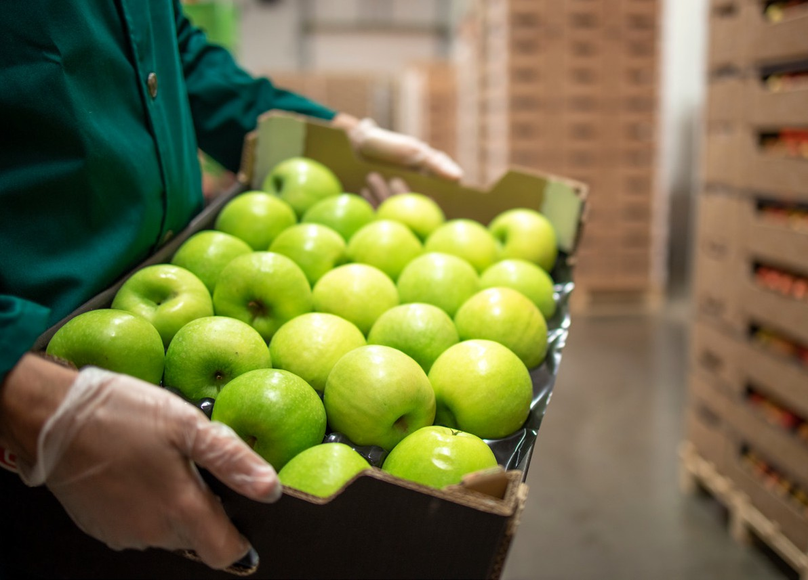

Part C:
The national
skills system
This section explores the role of higher education, vocational education and training, and migration.

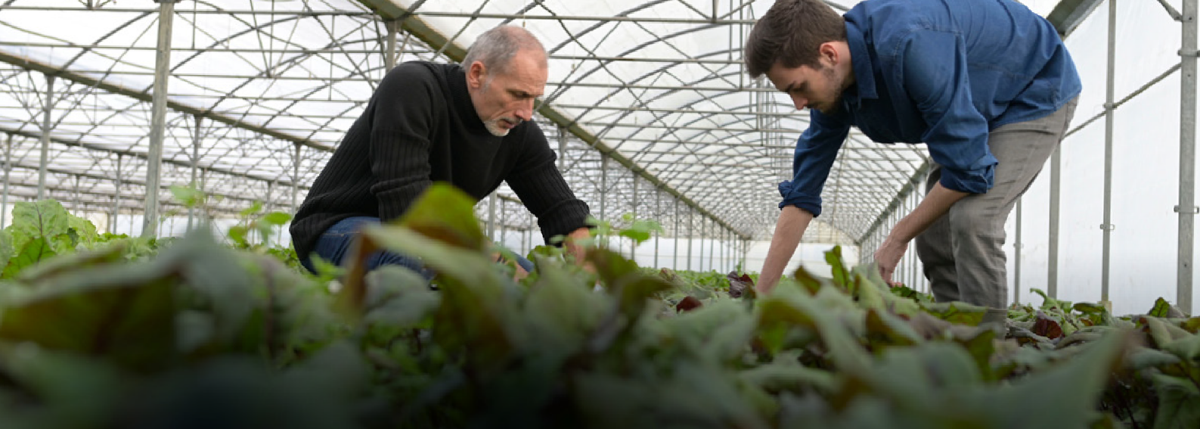
The National Skills System

7. Education and Training

A skilled workforce is essential
The role of post-secondary education is steadily increasing in the food supply chain, albeit from a relatively low base.
Lifelong learning is a key theme in the National Agricultural Workforce Strategy, which highlights that ‘in 21st century Australia, AgriFood faces stiff international competition, rapid technological development, and ever-increasing complexities. None of these can be handled without proper development of the capabilities of the people working in the sector’. The same can be said about Food Manufacturing and Transport industries, where disruptive technologies require a skilled and adaptive workforce.
In an increasingly skilled and qualified labour market, the food supply chain may also struggle to attract and retain workers in lower skill roles. Offering meaningful, attractive and rewarding career pathways was raised throughout this study as a prerequisite to attract and retain the next generation of workers.
The number of food supply chain workers with post-secondary qualifications has been steadily increasing (Figure 7.1). For example, 48% of workers in Food Production had a post-secondary qualification in 2021, up from around 36% in 2011. Despite this, the food supply chain continues to have a lower reliance on tertiary education and training compared with the broader economy.
Figure 7.1: Proportion of Food Supply Industries with a post-secondary qualification over time

Source: Census of Population and Housing, 2006-2021. Highest Level of Educational Attainment by Industry.
As shown in Figure 7.2, a large proportion of workers in the food supply chain hold no post-secondary qualifications. The greatest variance from the norm is in Food Production where only 16% of workers hold a bachelor’s degree or higher, compared with 30% of the general workforce. Certificate III and IV qualifications are also more common than bachelor level degrees across all food supply chain segments.
There is also a growing professional services sector that works within and in support of the food supply chain. These often highly skilled and educated workers may not be captured in this data where their industry of employment sits outside the food supply chain.
Figure 7.2: Proportion of Highest Level of Education of Workers in Food Supply Industries

Source: Census of population and housing, 2021. Highest Level of Educational Attainment by Industry. ‘Total Australia’ refers to all industries in the economy, not just the food supply chain.

Defining ‘skill’ in workforce data
Most workforce data by occupation is coded using ANZSCO. This classification includes a definition of skill level based on the range and complexity of tasks performed in a particular occupation. Operationally, the ABS measures skills by:
- the level or amount of formal education and training
- the amount of previous experience in a related occupation, and
- the amount of on-the-job training required to competently perform the set of tasks required for that occupation.
For example, occupations at skill level 1 are commensurate with a bachelor’s degree or higher qualification, or five years on-the-job training. While Farmers and Farm Managers are defined as skill level 1 (the highest level), fewer than half of these workers hold post-secondary qualifications. This reflects the significance of on-the-job training and traditional preferences for learning through experience rather than formal training. It may also reflect lack of access to formal education and training in regional, rural and remote Australia.
This type of skill level definition can be particularly problematic for industries in agriculture where inherited knowledge is common and formal qualifications are rarely required for an occupation. A mismatch between skill level and educational attainment may have a limiting impact on peoples’ transferability between occupations and industries. Stakeholders have also expressed concern that definitions of skill which emphasise formal qualifications may ignore the safety and risk profile of an occupation.
There are notable differences between Farmers who do and do not hold bachelor's level qualifications (Table 7.1). The starkest difference is in the female share of workers, which is much higher for Farmers with a bachelor’s level qualification or above. This is unsurprising given female students make up over half of undergraduate commencements in agriculture.
Table 7.1: Comparison of farmers with and without bachelor's level qualifications
 | Farmers without a  bachelor’s degree or higher | Farmers with a bachelor’s degree or higher
Employment size | 108,100 | 19,300
Female share | 25% | 42%
Under 50 years old | 35% | 45%
Owner managers with employees | 44% | 49%
Working fewer than 50 hours per week | 52% | 61%
Source: ABS Census of Population and Housing, 2021. Includes Farmers and Farm Managers in ANZSCO 2021.

In 2021, the ABS added several new middle management and supervisory occupations to ANZSCO for the first time. These included Senior Aquaculture, Crop and Forestry Workers, and Senior Livestock Farm Workers. The new occupations are classified as skill level 3 and sit between the existing ‘Farmer’ and ‘Farm Worker’ occupations (Table 7.2). While these new occupations seek to reflect the skilled nature of many food supply chain jobs, they might not resonate with the terminology and titles currently used within industry. As Skills Insight pointed out in their discussion paper response:
‘Many of the job titles associated with the food supply chain, such as farmhand and food processor, fail to adequately describe the nature, variety and technologies associated with those roles, giving the impression of staid occupations with limited opportunities for progression or interesting work experiences.’
Table 7.2: Comparison of livestock occupations in Australia
 | Livestock Farm Worker | Senior Livestock Farm Worker | Livestock Farmer
Skill level | 5 (low) | 3 | 1 (high)
Shortened description | Perform routine tasks in livestock, meat, milk, egg and wool production. | Perform a variety of skilled tasks in managing and supervising. | Plan, organise, control, coordinate and perform farming operations
Size | 28,100 | 1,600* | 66,000
Post-secondary qualifications | 37% | 60% | 48%
Source: ABS Census of Population and Housing. *Estimates for Senior Livestock Farm Worker are experimental.
The ABS has produced experimental estimates of how many workers would meet the definition of these new middle-manager roles. Compared to the previous iteration of ANZSCO, the 2021 update shows a small shift in the number of workers between skill level 1 and 3, likely Farm Managers now recorded as Senior Farm Workers (Figure 7.3). Additionally, there is a greater number of workers in skill level 4 roles across key agricultural industries. This reflects changes that were made by the ABS to the skill levels of multiple farm labourer occupations which were previously categorised as skill level 5.
Figure 7.3: Changes to agricultural workforce skill composition in Australia through ANZSCO updates

Source: ABS Census of Population and Housing, 2021.
The number of workers being captured as ‘middle managers’ is relatively low, with only around 5,000 workers across all industries. Stakeholder feedback indicates this is lower than industry expectations. This is supported by research suggesting that middle manager type roles are increasingly common in Food Production industries, such as Horticulture:
“As farms get larger, and as employed workers take on leadership and decision-making roles that in the past would have been the domain of family farm owner-managers, the role of the employed farm manager becomes increasingly important to the overall success of farms and industry sectors.”
There may be many reasons for this discrepancy, including the current coding method which requires individuals to include a specific phrase like ‘Senior Farmhand’ in their Census response. These job titles might not be common within industry, as the word ‘Farmer’ is often used to represent a wide range of roles.
One option to capture middle managers more effectively is through a targeted supplementary question in the next Census. This approach is already in use for nurses, administrative officers, cleaners, drivers and a range of other roles to seek additional detail from individuals responding to the Census to seek additional detail to support accurate coding.
For example, if a worker uses trigger words such as ‘Farmer’, ‘Farm Hand’ or ‘Farm Worker’ to describe their occupation, an additional question could then be asked to clarify the worker’s specific role (e.g. Dairy Herd Manager) via a list of pre-determined response options. This list of response options could be developed alongside business to ensure the options align with the terminology used by farmers in each commodity.
RECOMMENDATION 10
Include targeted supplementary questions for select occupations in the next Census of Population and Housing.

Education and training pathways
The food supply chain draws on a variety of education and training pathways, each of which provides opportunities for continuous learning and development (Table 7.3).
Table 7.3: Types of education and training
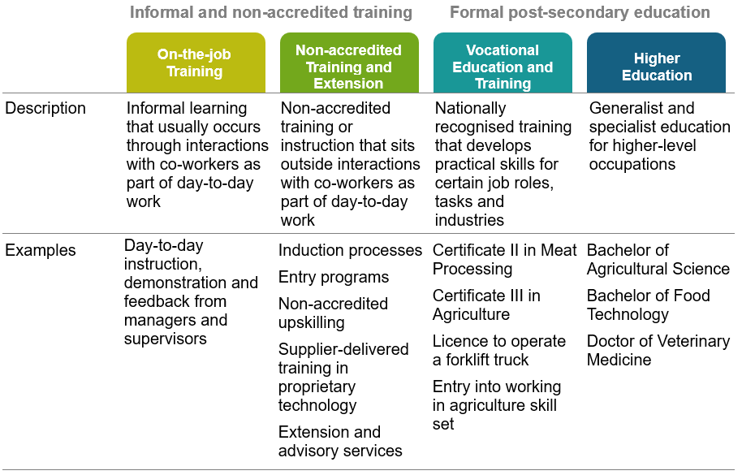

On-the-job training
On-the-job training plays an integral role in developing skills for the food supply chain workforce. On-the-job training may appeal for a range of reasons including the ability to tailor the content and timing of training to the specific needs of the business and role of the worker, the lower cost relative to engaging external training, and the potential inaccessibility of more formal education and training in more remote locations. As the NFF observed:
‘More than any other industry, farming is an “inherited” career with the traditional family business structures dominating the sector. That means many farmers and farm workers are introduced to the work at a very young age, consequently finding less utility in formal qualifications both in terms of obtaining employment and the actual performance of their duties’.
Skills development through on-the-job training might also be more accessible or attractive for some workers who have not previously engaged in formal post-secondary education and training.
The transfer of skills and knowledge from employer to employee, supervisor to worker or parent to child is a valid and vital form of learning in the food supply chain. However, a sustainable and resilient food supply chain workforce equipped to meet new challenges and harness new opportunities, practices and technologies in a highly competitive environment will likely require more than informal learning alone.

Non-accredited training and extension
Non-accredited training and extension also plays a large role in the food supply chain. Building on the role of on-the-job training, non-accredited pathways are more likely to:
- be structured or organised (may be organised in-house or by a third party)
- have learning and development as an explicit objective, and
- sit outside the day-to-day routine of work.
Non-accredited training can include inductions, entry-level programs and upskilling pathways. This type of training is often focused on acquiring competence or achieving best practice in a targeted technical, leadership or management skill, and can be delivered by a variety of organisations (Table 7.4). While this type of education and training may result in certificates or badges that are valued by employers, it does not lead to the attainment of a formal qualification or award.
Table 7.4: Examples of non-accredited training programs across Food Production
Training Program | Description
Australian Grain Leaders Program  Delivered by GrainGrowers | Professional development training to emerging industry leaders including coaching sessions, field visits, conferences and workshops.
EggStart  Developed by Australian Eggs and facilitated by 4 Up Skilling | Short form training opportunities for egg farm staff on biosecurity, egg-farm safety, multifactorial shed management and team/staff management.
Heifers for Profit  Delivered by Rural Industries Skill Training | Heifer management course involving six sessions over 15 months aimed at providing the skills to manage heifers’ nutrition, improve animal welfare, increase future reproductive success, optimise stocking rates, and increase farm profitability.
ProHand  Developed by the Animal Welfare Science Centre based at the University of Melbourne | Free online training for farm and abattoir stock people aiming to improve animal welfare and minimise handling stress. Training was developed with funding from Australian Pork Limited and the Australian Meat Processor Corporation.
Managing Listeria in Dairy Manufacture  Provided by Dairysafe | Webinar series and skills and knowledge evaluation aiming to increase awareness of Listeria risks and controls for staff in dairy processing businesses.
There may be merit in accrediting some of this essential training, including through micro-credentials. Accreditation can provide employers with greater certainty around training consistency and quality, while providing students with formal recognition of their skills. However, the low-cost, simplicity and flexibility of non-accredited pathways may outweigh these benefits, and consideration is required on a case-by-case basis.
The proposed National Skills Passport may also be a valuable opportunity to recognise non-accredited training and extension within the food supply chain workforce more effectively. Recognition of Prior Learning is another way that workers’ skills can be formalised, including those gained through non-accredited training, as noted by the Australian Beverages Council:
Within the non-alcoholic beverages industry, a significant amount of training is done onsite and within the business. The ABCL recommends that the government develop mechanisms to support and recognise the qualifications achieved through on-site training.

Box 7.1: Worker Safety Induction Pilot – Meat Industry
Safety regulations in the workplace are important to ensuring worker safety and a safe work environment for all. It is therefore important that appropriate measures are taken to ensure that all workers understand and uphold these regulations.
Skills Insight are currently in the process of researching and developing an effective safety training induction pilot program for workers entering the meat industry. The project aims to explore ways to design a program to ensure all workers have consistent safety training nationwide. Skills Insight aim to publish a report on their findings, which will most likely include a discussion on how similar safety induction programs could be established for other sectors.

Extension
Extension activities are an important bridge between research and development outputs and end-user practice change. Extension encompasses a broad range of methods and approaches which generally have as a key goal to improve productivity and/or sustainability (Table 7.5).
While historically the domain of state and territory governments, provision of agricultural extension in Australia is increasingly varied, comprising governments, research and development corporations (RDCs), independent fee-for-service advisers, input suppliers, and farmer groups. JSA heard from stakeholders that what extension looks like can vary by commodity and by location, as state and territory governments, RDCs and local farmer groups pursue different approaches. In some instances, governments will subsidise extension training in areas of public good, like carbon farming and water management.
Table 7.5: Typology of methods of agricultural extension methods
Extension method | Primary purpose
Facilitated groups/farmer-led groups/small-group learning | Provides a platform for social learning and can include focus farms, demonstrations
Technology development (multi-actor approach) | Collaborative approaches with farmers to address specific topics and problems such as application of a new technology or tools
Training | Enables the development of knowledge, skills and techniques as a foundation for change
Information provision | Facilitates access to relevant information
Consultancy (one-to-one, mentoring, coaching) | Provides individual support to make decisions about changes
E-extension | Uses information and communication technologies to provide information and extension support virtually/remotely
Co-innovation | Collaborative process that brings people together to negotiate and implement shared goals and outcomes
Best management-practice frameworks | A formalised process for self-assessing capacity and then responding to gaps or deficiencies
Social marketing | Aims to better understand and engage people to towards specific behaviour changes
Source: Nettle, R., et al. (2022) Selecting methods of agricultural extension to support diverse adoption pathways: a review and case studies, Animal Production Science, vol 64, pp. 1-25.

Vocational Education and Training
The VET system serves multiple purposes that are relevant to the food supply chain including providing training:
- to meet specific legislative, licensing or regulatory requirements for certain job roles or tasks
- to develop practical industry-relevant skills and capabilities in areas where vocational training is beneficial but not a requirement, and
- to develop basic functional knowledge and skills to undertake work and further learning.
The VET system delivers nationally recognised training for critical food supply chain roles. In 2023 there were around 18,000 program completions in key disciplines, with the most common qualifications being in Agriculture, Meat Processing and Supply Chain Operations (Figure 7.4).
Figure 7.4: Number of completions across select food supply disciplines in Australia 2023

Source: JSA analysis of NCVER Total VET Students and Courses, All Program Completions 2023. Program completions across different qualification levels aggregated into course content type, i.e. completions of Certificate I, II, III and IV in Agriculture are all counted as completions in Agriculture. Additionally, qualifications such as Certificates in Seafood Industry and Fishing Operations are combined to form ‘Seafood and Fishing’. Numbers are rounded to the nearest 10 due to data perturbation.
Enrolment levels in key food supply chain disciplines have trended downwards since 2015, with Driving Operations, Supply Chain Operations and Food Processing enrolments by 2023 all less than half their levels in 2015 (Figure 7.5). Enrolments in Agriculture and Meat Processing have partially recovered since their low point of 2020. However, compared to enrolments across all training packages, enrolments in these areas suffered a steeper decline and remain lower.
Figure 7.5: Index of enrolments by select food supply chain disciplines, 2015-2023

Source: NCVER Total VET Activity Data, 2024. *Includes Supply Chain Operations, Logistics, Warehousing, and Supply Chain Management courses.
VET is delivered by a wide range of providers which all make important contributions to the food supply chain workforce, including TAFEs, private providers, dual sector universities, schools, employer associations, and enterprise providers. Figure 7.6 shows that the relative contribution of different provider types varies across food supply chain disciplines.
Figure 7.6: Proportion of VET student completions in food supply chain disciplines by provider type, 2023 (%)

Source: NCVER TVA program completions 2015-2023, Year by Type of accreditation by Provider type, for 2023. Number of providers refers to how many providers had program completions in that discipline in 2023.
In 2023, private training providers were responsible for the majority of completions across a wide range of food supply chain disciplines. This includes some relatively higher volume areas such as Food Processing, Meat Processing, Driving Operations and Supply Chain Operations. Notably, courses in these areas have some of the highest shares of fee-for-service funding within the food supply chain. It also includes areas such as Poultry Production and Pork Production where training is delivered entirely or predominantly by private training providers which specialise in agribusiness and Food Production.
For relatively low volume qualifications, specialist providers may be better placed to prioritise the development of industry-specific expertise and relationships as well as bespoke training products compared to generalist providers for which relatively low volume qualifications will typically represent a smaller part of their operations.
In our recent RTO Typology, JSA classified 30 VET providers as ‘agribusiness and Food Production specialists’ who collectively enrolled around 14,000 students across 7 training packages in 2020. This means that around 14% of all students in those training packages were enrolled with specialist providers in that year, as defined by JSA. Without the contributions of these specialist providers, it is likely that training options for parts of the food supply chain would be materially constrained.
TAFEs make important contributions across most food supply chain disciplines, with VET completions in areas such as Viticulture, Wine Industry Operations, Veterinary Nursing, Seafood and Fishing, and Baking highly concentrated among TAFEs. Dual sector universities that provide higher education and VET programs are active in many of the similar disciplines to TAFEs.
Schools delivering VET to secondary school students are significant providers of VET, particularly regarding lower-level qualifications in areas such as Agriculture, Rural Operations and Production Horticulture.
Within the food supply chain, enterprise providers are most commonly represented in areas such as Agriculture, Meat Processing, Driving Operations and Maritime Operations. In part, these enterprise providers are private-sector organisations focused on delivering training to their own employees. However, this category also includes government enterprise providers. One of the main enterprise providers delivering training to the food supply chain workforce is Tocal College which specialises in training to rural industries and is operated by the NSW Department of Primary Industries and Regional Development. In 2023/24, Tocal College delivered training to over 3,500 participants in 76 locations across NSW.

Legislative, licensing and regulatory requirements
Legislative, licensing and regulatory requirements apply to a range of specific occupations, job roles and tasks in the food supply for reasons including ensuring the quality and safety of work where there are potential risks of harm (e.g. harm to people, animals or the environment). Where such requirements apply, they are a significant driver of training activity. For example, the Agricultural Chemical Skill Set which covers the units required to be eligible for agricultural chemical licences and permits in many jurisdictions is one of the ten most popular skill sets in Australia with over 3,000 enrolments in 2022.
Where an occupation or a critical task within an occupation is captured by licensing and registration requirements, levels of training activity can provide a strong indicator of the supply pipeline.
Some regulatory requirements may be imposed at a national level. For instance, a wide range of jobs roles and tasks in the Seafood sector are regulated by the Australian Maritime Safety Authority and require the completion of vocational education and training. However, occupational registration and licensing is the responsibility of each state and territory. This includes forklift operation licensing (discussed below), veterinarian registration, heavy vehicle licensing and agricultural chemical use.
Automatic Mutual Recognition of Occupational Registrations commenced on 1 July 2021 and allows workers to perform the same scope of work that is allowed in their home jurisdiction. Not all occupations are included in mutual recognition schemes, particularly occupations where there are concerns about the safety of workers and the community. Additionally, the scheme does not include Queensland.
With respect to training associated with legislative, licensing and regulatory requirements, key questions for evaluating effectiveness include:
- whether the mandatory training is an effective treatment of the potential risks of harm
- whether the regulatory burden imposed by mandatory training is proportionate to the risk
- whether or not there are opportunities to reduce regulatory burden without compromising on protections (e.g. automatic mutual recognition), and
- whether licencing requirements can be tailored to reflect the needs and risks across all relevant industries and use cases (e.g. graded licences).

Industry-relevant skills and capabilities
Even where undertaking VET is not a mandatory job requirement, it may still be a preferred option for employers and/or students to develop practical industry-relevant skills.
At different qualification levels, this training can aim to prepare individuals to:
- undertake mainly routine work (Certificate II)
- apply a broad range of knowledge and skills in varied contexts to undertake skilled work (Certificate III)
- apply a broad range of specialised knowledge and skills in varied contexts to undertake skilled work (Certificate IV)
- apply integrated technical and theoretical concepts in a broad range of contexts to undertake advanced skilled or paraprofessional work (Diploma), and
- apply specialised knowledge in a range of contexts to undertake advanced skilled or paraprofessional work (Advanced Diploma).
Figure 7.7 shows that courses at Certificate II and III levels account for the majority of VET enrolments across many key food supply chain disciplines.
In contrast, Agribusiness qualifications are pitched at Certificate IV and above noting the more specialised skills and higher-level of autonomy and decision-making expected of those involved in the administration and management of agricultural enterprises. There are also enrolments in Certificate IV and above VET qualifications in Supply Chain Operations, Meat Processing, Agriculture and Food Processing, Science and Technology reflecting the higher skilled roles in these industries.
Figure 7.7: Share of VET program enrolments in select food supply disciplines by qualification level, 2023

Source: NCVER Total VET Activity Data, 2024. * Includes Supply Chain Operations, Logistics, Warehousing, and Supply Chain Management courses. Meat processing includes Meat Safety Inspection.

Foundational knowledge and skills
The VET system has an important role for the VET system in providing second chance learning for adults seeking to develop foundation skills such as language, literacy, numeracy, digital literacy and employability skills. JSA heard that many employers in the agriculture sector are willing to take on workers without formal qualifications or experience in the industry and train them on-the-job. However, we heard that the current level of foundation skills of many job applicants creates a major challenge for this on-the-job learning. Effective take-up and delivery of foundation skills programs, including in rural, regional and remote areas, is likely to pay dividends for employers and workers in the food supply chain.
The VET system also plays a role in developing the English language skills of adult migrants including through the Australian Government’s Adult Migrant English Program. This role makes a valuable contribution to the food supply chain workforce, particularly given that Food Product Manufacturing (2nd highest) and Agriculture (7th highest) are major employing industries for permanent migrants in Australia who speak English not well or not at all.
Beyond broad-based foundation skills, the VET system also provides opportunities for students to develop basic knowledge and skills for a particular industry. This includes courses such as the Certificate I in Agriculture which covers the skills and knowledge required for individuals preparing for entry level work in the agriculture, and conservation and ecosystem management industries. This course is predominantly undertaken as part of VET for secondary student programs and has strong rates of progression to further VET.
Box 7.2: JSA Foundation Skills Study
JSA is currently undertaking a Foundation Skills Study which aims to form an up-to-date evidence base to assist researchers, policymakers and program managers improve services related to foundation skills. The Foundation Skills Study consists of:
- a new national survey of Australian adult literacy and numeracy skills
- a feasibility study into how best to collect the literacy, numeracy and digital literacy skills of First Nations people
- analysis of Commonwealth administrative and other data to gain insights into the skill levels for priority groups, and
- defining digital literacy and then piloting this with relevant groups to establish a national definition.

Higher education
The higher education system contributes to the food supply chain in three important ways:
- producing graduates for work in relevant professional occupations
- developing leadership and management skills for current and emerging industry leaders, and
- undertaking research and development.
Occupations that typically involve a university-level pathway include Agricultural Research Scientist, Agronomist, Veterinarian, Wine Maker and Food Technologist. There are also university-level qualifications in supply chain and logistics management.

Undergraduate qualifications
Australia’s higher education providers offer a range of undergraduate programs aimed developing the skills and knowledge required across different parts of the food supply chain including in fields such as:
- Agriculture, Agricultural Science and Agribusiness (including specialised degrees in areas such as Wine)
- Aquaculture and Marine Biology
- Food Science and Technology
- Supply Chain and Logistics Management
- Veterinary Science and Technology
- Biosecurity Science
- Business Management and Leadership.
These programs are predominantly delivered by universities but may also be delivered by non-university higher education providers such as Marcus Oldham College which was established as an Agricultural College in 1962.
Relevant occupations for which an undergraduate qualification is the most common highest qualification held include Veterinarians, Agronomists, Food Technologists, Wine Maker, Aquaculture or Fisheries Technician, Fisheries Officer, Agricultural Consultant, Agricultural and Agritech Technician, and Biosecurity Officer.
Albeit from a low base, the number of commencing domestic bachelor-degree students in Food Production-related fields of education increased by an average of 2% per year between 2006 and 2022 (Figure 7.8). Commencements in Food Production-related fields grew strongly from 2012 and 2017 by an average of 9.4% per year, compared to 3.6% per year across all commencing domestic bachelor students. This indicates that Food Production-related fields may have particularly benefited from the demand-driven funding model which operated from 2012 to 2017 and lifted previously imposed limits on domestic bachelor’s degree places at public universities.
Figure 7.8: Domestic bachelor-degree commencements in select Food Production-related fields of education

Source: Custom Department of Education microdata, courses in narrow field of education.
Similar to domestic bachelor-level commencements overall, commencements in Food Production-related fields of education have declined from their peak during the demand driven funding model despite a temporary lift during the early years of the pandemic (2020 and 2021).
Across the past 5 years, the Agriculture and Forestry study area has exhibited consistently above average undergraduate employment outcomes. For example, undergraduate employment for Agriculture and Fishing graduates in 2023 was 93%, placing Agriculture and Fishing in the top 10 out of the 45 study areas on this metric. This indicates that demand for graduates has remains high, raising concerns about the decline in domestic bachelor-degree commencements.

This data tallies with feedback JSA received from higher education sector and business that demand for higher education graduates is outstripping supply. In competing over a limited pool of graduates, we heard that many employers are engaging with students early in their studies through a range of activities, including:
- funding scholarships
- offering free guest lectures
- participating in careers events and other student-industry engagement activities, and
- providing subject matter for research projects.
JSA also heard that it is common for students to receive job offers well in advance of graduation, further limiting the pool of graduates for employers who may be less proactive in this space.
Beyond the Food Production-related fields of education referenced above, the food supply chain draws on graduates across a range of professional fields including science and technology, business and finance, accounting, legal and marketing services. In 2024, the Australian Government announced a Skilled Agricultural Work Liaison pilot program called AgConnections to attract a broader range of disciplines to the agriculture sector by overcoming pre-conceptions of the industry. Through a grant process, universities will collaborate with businesses to facilitate internships and work-based learning opportunities. It will also promote opportunities for students from priority cohorts, including First Nations people and women.

Postgraduate qualifications
Postgraduate qualifications encompass postgraduate coursework qualifications and higher degrees by research.
Relevant occupations for which a postgraduate qualification is the most common highest qualification held include Agricultural Research Scientist, Aquaculture or Fisheries Scientist, Biotechnologist, Entomologist, and Hydrogeologist.
Some of these occupations (e.g. Agricultural Research Scientist, Aquaculture or Fisheries Scientist and Hydrogeologist) have been rated as in national shortage by JSA across multiple years.
As explored in the Australian Universities Accord Final Report, increasing the availability of Commonwealth Supported Places at the postgraduate level in areas of need is one option worth considering to advance national priorities and address skills shortages.
The mix of Australia’s commencing domestic postgraduate students in Food Production-related fields of education has changed significantly since 2006. Most notably, there has been a considerable increase in postgraduate coursework programs (typically Masters Degrees) alongside a reduction in domestic higher degree by research students (Figure 7.9).
Figure 7.9: Domestic postgraduate coursework and higher degree by research commencements in select Food Production-related fields of education

Source: Custom Department of Education microdata, courses in narrow field of education.
Declining domestic higher degree by research commencements in Food-Production related fields is a concerning development which will need to be addressed to meet Australia’s future research workforce needs in this area. This will be explored further later in this chapter.
As Figure 7.10 shows, Doctorate by Research commencements in agriculture have declined significantly among domestic and international student cohorts. In contrast, Masters by Coursework commencements in agriculture have increased across both cohorts with particularly high growth in relation to international students who comprised around 70% of commencements in 2022.
Figure 7.10: Postgraduate commencements in agriculture, domestic and international

Source: Department of Education custom microdata, 2024.
JSA heard from higher education providers that many international students complete their undergraduate agricultural studies overseas prior to arriving in Australia. There were some concerns raised about the readiness of some international students to undertake their chosen postgraduate study in Australia, with academic staff often devoting considerable time to bridge knowledge and language gaps and deliver content typically provided at the undergraduate level. This may be indicative of shortcomings in university admissions processes and the assessment of overseas qualifications.

Research and development
Agricultural, Veterinary and Food Sciences is a significant field of research and development (R&D) for Australia’s higher education organisations. Nationally, Agricultural, Veterinary and Food Sciences (AVFS) accounted for 4.6% of Higher Education Expenditure on Research and Development (HERD) in 2022, up from around 3.8% in 2018 ($648m and $409m respectively). This makes AVFS the fifth highest field of research for HERD after Biomedical and Clinical Sciences, Engineering, Health Sciences and Biological Sciences.
The share of HERD devoted to in AVFS varies between institutions. For example, between 2002 and 2024, over 7.4% of ARC funding for the Regional Universities Network was devoted to AVFS. This compares to 1.8% across all universities. The priority afforded to AVFS by regional universities affirms the observation in the Australian Universities Accord Final Report that:
‘research by regional universities is often targeted and locally relevant, contributing to regional innovation and environmental sustainability, and it can also have broader national and global impact’.
At a jurisdictional scale, a similar pattern can be observed with the share of HERD devoted to AVFS highest in jurisdictions such as Tasmania where Food Production industries constitute a larger share of the economy (Table 7.7).
Table 7.7: Higher education expenditure on R&D in Agricultural, Veterinary and Food Sciences, 2022
 | NSW | Vic | Qld | SA | WA | Tas | NT | ACT | Total
HERD in AVFS | $182m | $137m | $190m | $46m | $54m | $28m | $4m | $9m | $648m
Share of HERD devoted to AVFS | 4% | 3% | 8% | 5% | 5% | 13% | 4% | 1% | 5%
Source: ABS Research and Experimental Development, Higher Education Organisations, Australia, May 2024.
While more difficult to isolate in HERD statistics, JSA is aware that the research activity of Australia’s universities is also important in relation to the transport and distribution of food. For example, the University of Sydney’s Institute of Transport and Logistics Studies undertakes basic and applied research in areas such as supply chain management and port and maritime logistics.
Higher education is not the only important source of expenditure on R&D relevant to the food supply chain. For example:
- Government Resources Devoted to Research and Experimental Development (GOVERD) in AVFS totalled $636 million in 2023, making AVFS the top field of research for GOVERD. This includes funding for the significant body of research and development work undertaken by the CSIRO across areas including agriculture and food, biosecurity and the environment.
- Business Expenditure on R&D in the Agriculture, Forestry and Fishing Industry in 2021-22 totalled $454 million.
- Rural Research and Development Corporations (RDCs) funds are in most cases drawn from a combination of industry levies and matching Australian Government contributions, captured above.

The higher education research sector, governments and business all play significant and complementary roles in Australia’s R&D system. For example, the higher education sector is responsible for most of Australia’s basic research whereas business and government expenditure on R&D tends to be more focused on applied research and experimental development. Higher education providers are also responsible for most of Australia’s research training as the only institutions that can award PhDs.
Box 7.3: Rural Research and Development Corporations
RDCs have helped drive innovation in Australia’s primary industries since 1989 by providing a mechanism for the Australian Government and primary producers to co-invest in R&D.
RDCs are predominantly funded by statutory levies on various commodities, with the Australian Government providing matching funding. These funds are distributed to the RDCs to undertake R&D and industry services. Levies for R&D are initiated at the request of industry.
An assessment of the collective impact of RDC investment in research, development and extension over five years to 2018 found that the total estimated value of benefits from the collective RDC investment over 30-years is approximately $5.50 for every $1.00 invested.

Secondary education and pathways
Tertiary education and training pathways build on the foundation of Australia’s school system. Schools can help students:
- gain an understanding of and interest in the food supply chain
- navigate pathways into education, training and employment, and
- develop foundation skills for work and further study.
Secondary schools play a particularly important role in supporting students into further education, apprenticeships and entry-level career pathways. For example, Certificates II in Agriculture and Food Processing are popular VET in Schools pathways, providing exposure and pathways into further post-secondary study or employment. Stakeholders observed that the extent of state, territory and school-level support for these programs can be uneven. Moreover, stakeholders noted that a particular problem is the accreditation of assessors in the school system, with retraining protocols being too rigid and short-term.
Programs work best when schools partner with business to build tangible career pathways. This includes both employer driven education and training, as well as support for direct linkages to employment following post-secondary education. There are also opportunities to build greater connections between broader school-level STEM education and Food Production. Contextual teaching could help improve student understanding of STEM careers within the food supply chain and build interest across a range of subjects. In its submission to this study, the NFF noted:
‘Perhaps the most troubling obstacle is the […perception] of agriculture and farm work as “old fashioned” with limited career pathways, remuneration, or social status. While the reality is very different — with much ag’ work highly skilled, well paid, and using cutting edge technologies.’

Box 7.4: PIEFA Food Fibre Education Resources
The Primary Industries Education Foundation Australia (PIEFA) is a not-for-profit company that supports the delivery of school-based learning programs that are directly linked to employment in food supply chain industries. PIEFA brings together business and education by partnering with key agricultural organisations and various high schools across Australia. The organisation aims to teach young Australians about food and fibre production by providing teaching resources for high school teachers, offering eLearning courses for students, and supporting school to career pathway programs like AgCAREERSTART.
PIEFA also supports school-based initiatives that give high school students the opportunity to develop food and fibre production skills through hands-on and experiential leaning. These school-based programs and PIEFA’s training and education resources are all linked to the Australian Curriculum. These effective programs therefore provide high school students with the chance to explore career options in agriculture and understand more about Food Production while also receiving formal credit for their involvement.

Challenges and opportunities

Supporting work-based learning
Work-based learning, including apprenticeships, traineeships and placements are invaluable means through which students can develop skills. By undertaking work-integrated learning, students can gain experiences that are highly relevant to employers and apply their theoretical learning. Models like apprenticeships also allow students to earn while they learn, which can be particularly attractive pathways for school leavers. As the Joyce Review observed:
‘Given the close linkages between VET and industry, incorporating more work-based training would allow students to develop the experience and competencies expected by employers, as well as making the sector more attractive and unique. This would give employers a greater role and ownership of the training being delivered and make sure it is relevant for today’s jobs.’
While there are multiple strong examples in the food supply chain, apprenticeships and traineeships are not widely used throughout much of the food supply chain (Figure 7.11). This is despite this workforce’s deep use of informal on-the-job learning and development. Some of the most common apprenticeships and traineeships include Certificates III in Agriculture, Aquaculture, Food Processing and Supply Chain Operations, and the Certificate II in Meat Processing (Abattoirs). Other qualifications, like the Certificate IV in Veterinary Nursing, include mandatory placements as a form of work-integrated learning.
Figure 7.11: Apprentice/trainee share of enrolments in select food supply disciplines, 2023

Source: Jobs and Skills Australia analysis of NCVER 2024, Total VET Activity Data. Share of all enrolments in training package qualifications. The number of apprentices/trainees has been rounded to the nearest 10.

The use of apprenticeships and traineeships also varies in each state and territory. For example, the Certificate III in Agriculture is much more likely to be delivered as a traineeship in Tasmania or the Northern Territory compared to Western Australia or New South Wales (Table 7.8).
Table 7.8. Proportion of enrolments delivered as traineeships by state and territory,
Certificate III in Agriculture, 2023
State and territory | Traineeship share
Tasmania | 80%
Northern Territory | 71%
Victoria | 53%
South Australia | 51%
Queensland | 48%
Australian average | 44%
New South Wales | 24%
Western Australia | 19%
Source: NCVER Total VET Activity Data, 2023 by delivery location. Note: The Certificate III in Agriculture is considered a traineeship by all states and territories and is not delivered as an apprenticeship. There were no enrolments in the ACT.
The distinction between apprenticeship and traineeship status also varies between jurisdictions, with the Certificate III in Driving Operations now available as an apprenticeship in Queensland and Tasmania, but not other jurisdictions.
Analysis produced by JSA found that graduates in some qualifications related to the food supply chain (for example, in Aquaculture, Meat Processing and Driving Operations) were much more likely to work in a relevant occupation if they had undertaken an employment-based pathway, such as an apprenticeship or traineeship. Income and employment outcomes were typically higher for this group as well.
There are a wide range of government supports available for apprentices and their employers. These include pre-commencement services, job-matching, pastoral care and in-training support to help individuals complete their apprenticeship. In addition, the Australian Apprenticeship Incentive System contains a wide range of supports to improve the participation, experiences and completions of priority cohorts.
The Universities Accord final report emphasised the importance of work-integrated learning in the higher education system. It recommended that work-integrated learning be promoted, alongside new models like degree apprenticeships that encourage an employment relationship as part of course design. Research by Universities Australia found that around 56.5% of students in agriculture, environmental and related subjects undertook work-integrated learning. This was the second highest field for work-integrated learning, only slightly behind health (57.7%). Therefore the challenge for the higher education sector is how to build and expand on this foundation in agriculture, rather than starting from scratch.
It is important to note that positive employment experiences are critical to the success of work-integrated learning, including apprenticeships and internships. Students expect varied work, good supervision, and a safe workplace among other considerations. While governments have a critical role in supporting work integrated learning, success is contingent on positive employer participation.
Below we explore a range of opportunities to improve the use and success of work integrated learning within the food supply chain, particularly within the Australian Apprenticeship System.

Box 7.5: Certificate III in Agricultural Mechanical Technology
The Certificate III in Agricultural Mechanical Technology is a prime example of an apprenticeship pathway within the food supply chain that delivers strong outcomes for students and employers. This qualification is a recognised Australian Apprenticeship pathway in all states and territories, offering students a chance to learn how to service and repair agricultural machinery and equipment through business and practical experience.
It was introduced as a standalone qualification in 2013 and has seen steady growth in commencements and completions (Figure 7.12).
Figure 7.12: Certificate III in Agricultural Mechanical Technology

Source: NCVER, Apprentices and Trainees 2024.
JSA data shows that the median income uplift for this qualification in 2019-20 was around $46,800, with the vast majority of students employed post-study. This makes it one of best performing qualifications in JSA’s analysis.
Units of competency offered directly reflect employer needs and teach students how to respond to customer enquiries, communicate effectively in the automative workplace, efficiently apply knowledge of automotive electrical circuits and wiring systems, and repair the heavy vehicles commonly used in large agricultural enterprises. These communication, mechanical and technical skills may also be transferrable to roles outside of Agriculture.

Australian Apprenticeship Incentive System eligibility
The Australian Apprenticeship Incentive System is designed to encourage take-up of apprenticeships in high-demand occupations that are relevant to the Australian economy now and into the future. This includes a number of food supply chain occupations like Veterinary Nurse, Meat Inspection, and Agricultural and Agritech Technician.
Incentives target qualifications and occupations listed on the Australian Apprenticeships Priority List (the priority list). The priority list is a point-in-time assessment of in-demand occupations where an apprenticeship is a required or preferred training pathway.
Operationally, the priority list is comprised of occupations:
- assessed by JSA as being in national shortage, and
- classified by the ABS under ANZSCO as Major Group 3 – Trades and Technicians, and Major Group 4 – Community and Personal Care Workers.
A range of food supply chain stakeholders have argued that the narrow criteria used in forming the priority list can result in the exclusion of some food supply chain qualifications and occupations that otherwise meet the primary objective of encouraging uptake of apprenticeships in high-demand occupations where an apprenticeship is a required or preferred training pathway.
Box 7.6: Truck Drivers and Apprenticeship Incentives
The occupation of Truck Driver (General) has been assessed by JSA as in national shortage for the last 3 years. However, the occupation of truck driver is currently ineligible for apprenticeship incentives on the basis that the occupation sits within ANZSCO Major Group 7 – Machinery Operators and Drivers.
While an apprenticeship pathway is not required to become a truck driver, JSA heard that it is increasingly the preferred pathway for many parts of the road freight sector. In 2023, around one-third of enrolments in the Certificate III in Driving Operations were undertaken as part of an apprenticeship or traineeship (the highest share on record).
JSA heard that the employer preference for an apprenticeship pathway is driven by the desire to support attraction to the occupation, bolster the professionalism of the industry, support the development of a broad set of skills, and minimise safety risks for all road users.
For the student, there is evidence of strong benefits of undertaking the Certificate III in Driving Operations as an apprenticeship. JSA analysis of people who completed their VET qualification in 2019-20 showed that the Certificate III in Driving Operations was among the top 10 courses with the biggest median income uplift associated with completing an apprenticeship pathway compared to non-apprenticeship pathway.
The use of ANZSCO Major Groups 3 and 4 as a proxy for whether an apprenticeship is a required or preferred training pathway should be reconsidered in determining eligibility for apprenticeship incentives. Tying eligibility for inclusion on the priority list to ANZSCO Major Groups 3 and 4 is a blunt mechanism and—in the case of Major Group 4 (Community and Personal Service Workers)—a poor indicator for whether an apprenticeship is the required or preferred training pathway.
In 2023, apprentices and trainees accounted for only 8% of program enrolments with Community and Personal Service Workers as the expected type of occupation for those completing the course. This is lower than Technicians and Trades Workers (38.6%), Sales Workers (24.8%), Machinery Operators and Drivers (19.5%), and Labourers (8.1%). As an alternative or supplement to the current approach, consideration could be given to:
- an elevated role for JSCs, states and territories in providing advice on whether an apprenticeship is a required or preferred training pathway for particular qualifications and occupations, and
- evidence on the difference in post-training outcomes (e.g. median incomes) for those who complete a qualification through an apprenticeship pathway compared with a non-apprenticeship pathway.
Other considerations in determining eligibility for apprenticeship incentives could include:
- integrating domestic training and migration considerations. As detailed further in our migration analysis, reliance on temporary migrants is persistently high across many parts of the food supply chain. This includes occupations such as Meat Boner and Slicer and Slaughterer which also have apprenticeships/traineeships as a common pathway for domestic workers. There may be value in apprenticeship incentives encouraging domestic worker uptake of apprenticeships as part of a broader strategy to address persistent reliance on temporary migration in some pockets of the labour market.
- balancing responsiveness and certainty. Feedback from businesses and training providers highlighted the importance of certainty with respect to incorporating initiatives such as apprenticeship incentives into their workforce strategies and business planning. At present, whether a qualification and occupation are eligible for apprenticeship incentives is subject to change at relatively short notice every year contingent on the national shortage rating of occupations in the annual JSA Occupation Shortage List. While responsiveness to the demands of the labour market is also important, consideration could be given to what the appropriate balance between responsiveness and certainty looks like for apprenticeship incentives. Options that could be considered include:
  - removing occupations from the priority list when assessed as not in shortage in consecutive years rather than in one single year, and
  - including occupations that relate directly to national priorities in the National Skills Agreement for the life of the Agreement.
RECOMMENDATION 11
Consider options to target eligibility for apprenticeship incentives more effectively.

Ag Trade Apprenticeship
Skills Insight has produced a report considering the feasibility of an Ag Trade Apprenticeship. This included developing an example qualification—the Certificate III in Agricultural Production—with 20 core units and 14 elective units associated with the preferred specialisation in either Broadacre Cropping, Dairy Production or Livestock Production.
Reflecting on survey responses received from potential employers and training providers, Skills Insight observed:
‘In the context of developing a skilled agricultural workforce, the data indicates that the apprenticeship model is widely seen as valuable, particularly for its comprehensive approach to skill development and emphasis on producing well-rounded, autonomous employees.’
A trade apprenticeship model would aim to develop a greater depth and breadth of skills than the Certificate III in Agriculture (currently available as a traineeship) which contains 2 core units and 14 elective units.
The survey of potential employers and training providers also canvassed a range of challenges that would need to be addressed in an effective trade apprenticeship model including:
- ensuring the qualification is relevant to the diverse needs and specialisations within the agriculture sector
- attracting apprentices and employers to participate in the apprenticeship model at sufficient scale
- employers having the skills to train and support apprentices, as well as having the time and resources to devote to this task during busy periods or seasonal production activities
- availability of accommodation for apprentices, and
- the availability of attracting and retaining qualified trainers and assessors to deliver the qualification.
JSA is also aware of some concerns about the higher costs associated with an expanded qualification and that an additional qualification pathway may risk saturating the market for agricultural skills training.
In addition to potential employers and training providers, a successful apprenticeship model would require the support of:
- potential apprentices, who would need to be convinced of the value of undertaking the apprenticeship with references to factors including enhancing their skills and workplace experience, access to work opportunities reserved for trade-qualified individuals as well as the income received as an apprentice and impacts on their future earning potential and career prospects, and
- state and territory governments, who are responsible for declaring whether a qualification can be delivered as an apprenticeship and who make decisions about the allocation of skills funding in their jurisdiction.
Given the potential benefits of the Ag Trade Apprenticeship model and strong levels of support from potential employers and training providers throughout the feasibility study, JSA considers that Skills Insight should continue to explore the case for an Ag Trade Apprenticeship subject to ongoing support from critical stakeholders. As identified by Skills Insight, next steps could include career pathway mapping and the development of an apprenticeship qualification and training materials to support its delivery.
JSA’s wide range of data assets and products could support some elements of this work, including VNDA and the National Skills Taxonomy project. For example, the data products could assist analyses of skills transferability, occupational pathways and positive employment outcomes for apprenticeships generally. It could also help improve our understanding of how the existing certificates in agriculture are used by different industries, jurisdictions and employers. If the outcome of the further work undertaken by Skills Insight is the trialling or implementation of the Ag Trade Apprenticeship model in one or more jurisdictions, outputs from VNDA could support the evaluation of the performance of the model and its outcomes for apprentices.
RECOMMENDATION 12
Skills Insight should continue exploring the case for an Ag Trade Apprenticeship.

Heavy Vehicle Driver Apprenticeship
The Heavy Vehicle Apprenticeship offers a new pathway for school leavers to start a career in the road freight sector. This is critical given the truck driver workforce is ageing and struggling to attract new entrants. Young people are limited in their ability to work within road freight due to licensing restrictions on higher class vehicles. As such, innovative approaches need to be considered to facilitate early engagement with the sector. As Industry Skills Australia highlighted:
‘Industry is increasingly seeking to utilise training to professionalise its workforce, which can in turn assist with attracting new workers, retaining existing workers by offering career pathway progression opportunities and to enhance community perceptions about careers in the [Transport and Logistics] sectors.’
Providing an apprenticeship pathway as a viable option for new entrants into the sector provides workers with confidence that they are gaining relevant skills and experience to build a long-term career pathway. The apprenticeship operates within the current licensing restrictions, where workers gradually upgrade both their skills and licence type over the duration of the qualification. It builds on the existing Certificate III in Driving Operations already on offer, providing greater access to formalised education and training.
While the apprenticeship is now on offer in Queensland and Tasmania, it has not been implemented by every state and territory training authority. The early impact in Queensland can be seen in Figure 7.13, with around 40% of enrolments in 2023 being apprenticeships.
Analysis produced by JSA also showed that students who undertook the Certificate III and IV in Driving Operations as apprentices and trainees had a substantially higher median income that those who did not.
Figure 7.13: Apprenticeship and traineeship enrolments in the Certificate III in Driving Operations, Queensland

Source: NCVER 2024, Total VET Activity data.
To become a nationally consistent pathway for heavy vehicle drivers, the apprenticeship would need to be implemented by all state and territory training authorities. As this apprenticeship pathway matures, Industry Skills Australia could consider sharing case studies and best practice examples to communicate positive employment outcomes for students, Registered Training Organisations (RTOs) and employers.
RECOMMENDATION 13
Industry Skills Australia should continue to support the professionalisation of the road freight workforce, including through advocacy for a Heavy Vehicle Driver Apprenticeship in all jurisdictions.

Supply chain ‘Earn While You Learn’ models
As the adoption of machine learning, data analytics and other digital technologies grows within the supply chain, it will be important that education and training pathways develop these skills. Australia’s higher education sector is at the forefront of many of these developments, although it sometimes lacks the models to deliver skills alongside business. New ‘earn while you learn’ models are being explored across several industries as an attractive alternative to traditional VET or higher education pathways in the transport and logistics industry. These models span a variety of Australian Qualifications Framework (AQF) levels, with some sitting outside of the apprenticeship system.
‘We must ensure that an education pathway exists to meet future industry needs. We must invest in developing the knowledge and skills to support freight and supply chains. This means greater emphasis on particular subjects, such as data analytics, the digital economy, automation and robotics. But it also means an improved education in general, and a greater support for STEM subjects…’
University level apprenticeships have recently been established in the United Kingdom in collaboration with business. As many of these UK companies also operate in Australia, there may be a strong opportunity to explore these models locally, provided there is sufficient student and employer interest. An alternative model is for the combined delivery of a higher education qualification and a VET qualification together as a single course of training.
RECOMMENDATION 14
Industry Skills Australia should investigate industry and student interest in ‘earn while you learn’ models for supply chain and logistics roles.

Group training models
Group training models could improve uptake of apprenticeships in Agriculture by supporting the placement of students with multiple businesses. This could be beneficial particularly for small and family-owned businesses in Food Production where the availability of work may not sustain a full apprenticeship throughout the year. The administrative burden under a group training model is also lower for the host employer which could be significant for small businesses. A group training model may address current training delivery issues arising from operating across jurisdictions and for low volume training programs providing critical skills.
‘Group training organisations (GTOs) provide support services as part of their role in employing apprentices, managing their training, and placing them with host employers. They are particularly helpful for small- to medium-sized businesses that face impediments (or do not have capacity) to hire and mentor apprentices.’
Group training also provides an opportunity to provide students a wider variety of experiences relative to what a single employer would be able to offer. Through a placement rotation model, students could gain exposure to different commodity types and practices before choosing to specialise in a particular area. It could also offer experiences across different stages of production and agribusiness activities.
RECOMMENDATION 15
Consider opportunities to encourage group training models within Food Production industries as a means of providing workable apprenticeship and traineeship pathways, particularly for small businesses.

Improving design and delivery

Viability of vocational pathways
In addition to broad-based qualifications, the food supply chain workforce draws on a range of niche, specialised and industry-specific training. Delivery of these smaller courses can be particularly challenging due to geographic and occupational thin markets.
As many current and prospective workers are located across regional, rural and remote Australia, providers face challenges in delivering this type of training to geographically dispersed students. One key challenge is the higher cost of regional delivery of education and training, which can disincentivise training provision and limit student access to key food supply chain qualifications. There are also higher costs related to training delivery, such as the care of animals, plants and equipment (including during teaching breaks) that require significant capital investment.
Limited student demand for some low-enrolment qualifications also impacts education delivery mechanisms and increases costs for providers. This creates a cyclical problem where students are discouraged from studying critical and relevant qualifications due to limited course options, and study options are in turn further limited by providers due to low student demand.
Several key courses across the food supply chain are only delivered by a small number of providers nationally. As seen in Figure 7.14, this applies to qualifications across many sub sectors of the food supply chain, including Pork and Poultry Production. Additionally, the number of providers delivering training in some larger disciplines, including food and meat processing, has declined significantly since 2015.
Figure 7.14: VET providers delivering courses across select Food Production disciplines

Source: Total VET Students and Courses, All Program Completions 2015 and 2023. Program completions across different qualification levels aggregated into course content type. This analysis only includes providers that had program completions in these disciplines. *Courses in Supply Chain Operations were only introduced in 2021 and supersede courses in Warehousing and Logistics (in 2015 Warehousing Operations had 176 providers, and Logistics had 88).
While a decline in provider numbers does not necessarily mean training availability or delivery has declined, it can be an important indicator of long-term precarity. As shown in Figure 7.15, the decline in Certificate II in Rural Operations completions has occurred alongside a gradual decline in the number of providers delivering this course. In other courses, a decline in provider numbers has resulted in provider concentration, with the same amount of training delivered by a smaller group of organisations.
Figure 7.15: Certificate II in Rural Operations, completions and providers

Source: NCVER Total Activity Data 2024. Data for 2023 is preliminary. ‘Providers’ includes all providers with at least 1 completion in that calendar year.
As shown in Figure 7.16, qualification completions within Pork Production are relatively low, with fewer than 100 completions in any given year from 2015 to 2022. This has remained steady, despite the number of providers declining (as shown in Figure 7.13). Notably, the distribution of provider types has shifted over this time frame, with TAFE delivery declining as private provider numbers increased.
Figure 7.16: Proportion of completions in Pork Production by provider type over time

Source: JSA analysis of NCVER 2024, Total VET Activity data. Enterprise providers and companies that deliver nationally recognised qualifications to their own workers.
JSA heard from a variety of education and training stakeholders about concerns for the long-term viability of niche courses, particularly where only a handful of private providers operate. The drivers of this precarity are complex, but should consider thin markets, delivery costs, capital investment and difficulty securing the teacher, trainer and assessor workforce.
JSA believes a project should be commissioned that evaluates, across the training system, delivery vulnerabilities in areas of national priority, as defined in the National Skills Agreement. This evaluation could build on the findings of Skills Insight’s current project examining demand and supply factors affecting training delivery viability and utilise JSA’s recent RTO Typology. With a data-driven approach to this analysis, interventions and supports then could be considered by governments and other stakeholders.
Similar consideration should be given to higher education pathways, such as agricultural and veterinary sciences, where there are concerns regarding long-term viability of these courses given the small number of institutions delivering them.
RECOMMENDATION 16
Explore mechanisms to improve the sustainability of small-scale qualification pathways that are critical to national priorities, including food security.

Specialised and broad-based training
Achieving a balance between industry-specific and broadly applicable training is a key challenge for many workforces. The food supply chain draws on many successful broad-based qualifications such as in Rural Operations, Food Processing and Supply Chain Operations. It also benefits from a wide range of commodity-specific units and qualifications like Beekeeping, Artisan Brewing, Livestock Transportation and Biosecurity, that are delivered in smaller numbers.
Broad-based courses lend themselves to economies of scale, service multiple industries and provide students with a wide range of employment opportunities. However, their generalised nature may mean employers consider the training has lesser value or relevance to their workplace. Meanwhile, specialised and niche courses can be particularly difficult to deliver and sustain given smaller student and employer demand.
‘Some industries and occupations would greatly benefit from a broader application of skills and knowledge across a number of roles or contexts, while others require these attributes to be more highly specified. Reform to VET qualifications needs to reflect this diversity, and allow for qualifications and skills development to be broad-based, or specific to a narrower range of tasks.’ – Qualification Reform Design Group
The Qualification Reform Design Group, which includes members from business, unions and state governments, proposes a new model to overcome the current one-sized-fits-all approach. The new model would differentiate qualifications according to three distinct purposes:
- Purpose 1 – qualifications leading to a specific occupation (for example a licenced trade)
- Purpose 2 – qualifications that prepare learners for multiple occupations within an industry
- Purpose 3 – qualifications that develop cross-sectoral or foundation skills and knowledge which may be applied across industries or lead to tertiary education and training pathways.
JSCs are currently undertaking demonstration projects for the Qualification Reform Design Group. This includes a review of the Certificate II in Rural Operations by Skills Insight. We believe there are prime candidates among other training products related to the food supply chain that would also make excellent demonstration projects, given their broad applicability to a range of industries. These include Certificates III in Food Processing and Supply Chain Operations.
JSA could also be commissioned to provide new occupation and industry outcomes data to inform these projects. These data would help JSCs analyse the occupations and industries that are served currently by these qualifications and identify where gaps exist.
RECOMMENDATION 17
Jobs and Skills Councils across the food supply chain should review broad-based qualifications to align with reform work underway.

Lower-level qualifications
Some occupations within the food supply chain require or use lower-level qualifications, including Certificates I and II. Government could explore options to support these entry-level qualifications where there is strong evidence of their positive impact for students and employers. For example, Certificates II in Aquaculture, Agriculture and Meat Processing (Abattoirs) are associated with high employment change and median income uplift after training.
Lower-level qualifications can also support workers and students who were previously unemployed or on a lower income. While the Diploma in Agriculture has the highest post-completion wage in Figure 7.17, this is off a relatively high base. Whereas the Certificates II and III in Agriculture see a substantial wage and employment uplift for students compared to their pre-completion circumstances. There are also positive rates of priority cohort participation in lower-level qualifications for some training pathways. On average, Certificates I and II within Agriculture, Environment and Related Studies have larger shares of First Nations students and people with disability than higher level qualifications in this field.
Figure 7.17: Employment rates and wages of VET agriculture students, 2019-20

Source: JSA VET National Data Asset, 2019-20.
Despite positive outcomes for students completing these qualifications, some critical roles such as meat process workers, slaughterers and meat boners and slicers, are filled to a considerable extent through temporary migrant labour. A more connected approach to the national skills system could see VET and migration systems more effectively complement each other for these low and middle skilled roles.
Support for lower-level qualifications could also include options to encourage greater enrolments and completions by priority cohorts in the food supply chain. While there is a range of government supports for priority cohorts at the higher skill level, more common entry-level pathways could be overlooked, including at the Certificate II level. For example, in male dominated industries it might be difficult to increase female participation at higher skill levels without first supporting the entry level pipeline.

RECOMMENDATION 18
Consider a broader suite of options to support entry-level qualifications where they act as a genuine career entry point and demonstrate strong employment outcomes for students.

Flexible learning options
JSA heard from a wide range of stakeholders that a lack of flexible training options impacts business and student engagement within the food supply chain. This is particularly difficult in dynamic environments where delivery needs to evolve to suit employer requirements.
Flexible and adaptive learning modes are also essential to increase the participation of key priority cohorts including First Nations people, people with disability, culturally and linguistically diverse (CALD) communities, female students, and those living in regional, rural and remote areas. Students with additional responsibilities, for instance those who work part-time or full-time hours to support themselves and/or others while at university, would also benefit from increased study flexibility.
There may be benefits in expanding the role of micro-credentials and short courses for the food supply chain workforce. Short courses and micro-credentials can be useful in targeting the practical and applicable skills needed over a worker’s lifetime, although they may vary in need for individual employers. As recognised by the ACMF:
‘The value of microcredentials also needs to be explored, particularly as industry faces challenges in the biosecurity space that will require rapid upskilling of staff. Generally, these courses are designed around the needs of students through flexible timetabling and remote learning offerings. These courses often deliver content within a shorter timeframe.’
Similarly, other short course or ‘taster’ programs across the VET sector can help facilitate a longer term and ongoing approach to education and training. For example, the NSW government funds the AgSkilled program which provides fully or partially subsidised funding in individual agriculture units or group of units, the purpose being to support workers upskill in a way that targets their skill gaps and individual needs. The NSW government also supports the TAFE NSW Start Your Future Program, an initiative that enables high school students to experience TAFE-style learning and try out multiple ‘taster’ programs in different industries to introduce them to various career options.
The benefits of short form courses and micro-credentials are, in part, contingent on industry recognition, support and investment in training programs/packages. Employers may wish to consider how they can support, foster and facilitate a lifelong approach to learning.

Female participation
The gender composition of food supply chain courses varies significantly. While females made up 94% of Certificate IV Veterinary nursing students in 2022, they were only 7% of Certificate III Irrigation Technology students (Table 7.9 shown over page). There has been some recent growth in the share of females undertaking heavy vehicle training, increasing from 6.4% in 2020 to 11.5% in 2022.
Table 7.9: Female share of enrolments, select pathways 2022
Level | Field | Female share
Certificate IV | Veterinary nursing | 94%
Bachelor’s degree | Veterinary sciences | 88%
Bachelor’s degree | Agricultural sciences | 62%
Postgraduate | Agricultural sciences | 61%
Certificate III | Dairy Production | 55%
Certificate III | Food Processing | 44%
Certificate II | Agriculture | 41%
Certificate II | Rural Operations | 38%
Certificate III | Pork Production | 36%
Certificate III | Supply Chain Operations | 23%
Certificate III | Wine Industry Operations | 21%
Certificate II | Meat Processing (Abattoirs) | 20%
Certificate III | Aquaculture | 17%
Certificate III | Driving Operations | 11%
Bachelor’s degree | Horticulture and Viticulture | 11%
Certificate III | Irrigation Technology | 7%
Source: NCVER Total VET Activity Data; Department of Education, custom microdata.
Given many of these qualifications act as an entry-point for food supply chain roles, there is clearly more work to be done to promoting these to a broader pool of students. This is particularly the case for qualifications in Driving Operations, Meat Processing, Aquaculture and Veterinary Sciences and Nursing where the gender-skew is over 80%. As noted by JSA’s 2023 Clean Energy Capacity Study:
For there to be genuine transformational change, women’s participation needs to be front of mind in every aspect of education and training programs and supports. It also requires a critical mass of women and girls in classrooms, on worksites, as teachers and trainers, and as employers and supervisors.
The same can be said for increasing the number of men in disciplines typically undertaken by women, such as veterinary nursing and sciences, where stigma, bias and other barriers may be limiting factors. JSA has also produced analysis that shows that occupations with a stronger gender imbalance are more likely to be in shortage. This is true for both male- and female-dominated occupations, and there a number of prominent examples within the food supply chain that are in national shortage:
  - Truck Drivers (96% male)
  - Veterinary Nurses (96% female)
  - Meat Boners and Slicers, and Slaughterers (83% male)
  - Agronomist (79% male).

Specialisation in livestock transport
Truck driving is a diverse occupation with skills requirements and on-the-job tasks sometimes varying based on the transported cargo. Currently, there are limited formal accreditation or licensing systems that demonstrate a driver’s ability to work with different commodity types. Often these skills are provided on the job so there is no consistency between employers.
JSA heard concerns from transport and agricultural stakeholders that there is little training or support for truck drivers working with livestock. While livestock transport units are available within the VET system, their uptake in the transport sector is low. This may be due to limited availability of RTOs who can deliver training in all aspects required for drivers in this sector.
By working with businesses and RTOs, Industry Skills Australia could explore options to deliver consistent livestock transport training as an accessible and attractive pathway. Industry Skills Australia has identified this as a potential project in its 2024 Transport and Logistics Workforce Plan. Given livestock loading, unloading and duty of care also involve farmers and meat processors, there is a strong case for this work to be undertaken with the support of Skills Insight, who have noted the importance of training on animal welfare standards related to livestock transportation.
Options for improving uptake of livestock transport training would need to consider:
- the availability of providers who could offer animal handling and transport components
- the level of employer support, demand and recognition for this training, and
- ways of delivering it through short, accredited courses or skillsets.
Future consideration could also be extended to other commodity types, such as dairy tanker driving, where short, accredited skilling may be an attractive model.
RECOMMENDATION 19
Industry Skills Australia should investigate options to improve the delivery and uptake of formal livestock transport training for truck drivers.

Investing in First Nations success
Equitable access to tertiary education is an essential pathway for supporting First Nations success and meeting Australia’s skills needs. This study finds that supportive scholarships and grant programs, culturally inclusive learning, flexible study options, and on-Country programs can all improve First Nations peoples’ access to and involvement in tertiary education. These recommendations alone, however, will not be enough to overcome the social and structural barriers still faced by First Nations peoples in Australia today. Meaningful inclusion of First Nations people in food supply chain sectors will need to include eliminating racism across industries, enhancing cultural awareness and safety in the workplace and wider recognition of traditional and cultural knowledges and practices. It will also require more First Nations involvement as employers, leaders and investors in the industry.

First Nations scholarships
First Nations employees are likely to have lower levels of higher education obtainment across all agricultural industries compared with the national average. This contributes to the underrepresentation of First Nations people employed in middle-management and senior-level roles. In 2019, CSU released a study showing that fewer than 5 agriculture graduates per year identified as First Nations across all Australian universities.
Stakeholders and current research both stress the importance of establishing multiple targeted scholarships and grant programs to increase First Nations participation in tertiary education and the agricultural workforce.
‘Scholarships are the groundbreaking thing so far. Scholarships do work (for example, law[yers], doctors). We need pathways and scholarships.’
‘The agricultural profession should perhaps consider establishing a scholarship or assistance mechanism that is directed towards encouraging some Indigenous students into the agriculture sector through higher education.’
As noted by stakeholders, other sectors have had great success attracting First Nations students by providing scholarships to support free or subsidised education and/or living expenses. This includes scholarships funded by Australian Government agencies for First Nations students. Targeted scholarship programs also increase visibility around potential career options, particularly at higher skill levels where First Nations participation is low.
Box 7.7: First Nations Agriculture Initiative Fund
CSU have successfully increased First Nations participation in agriculture through their recently established First Nations Agriculture Initiative scholarship program. The scholarship aims to attract more First Nations students into agriculture-related degrees, including animal science, and aims to encourage students to work towards a career in agriculture.
Although a relatively new program, stakeholders affirmed its quick success, stating that CSU now have 20 First Nations agriculture students relative to next to none in 2018. Moreover, stakeholders stated that scholarship-holders are currently working at more senior levels and acting as role models to future First Nations students.
As First Nations participation in agribusiness and higher paying agricultural science occupations is especially low, and businesses have expressed the increasing need for more highly skilled workers, a targeted grant program funding these study areas would benefit both parties. The targeted grant program should be established in partnership with employers and education providers to enhance the recruitment pipeline. This would ensure that First Nations students are supported and mentored all the way from enrolment to the completion of their degree and have direct pathways into the workforce following graduation.
Many First Nations people live in regional, remote and rural areas. The grant program should consider funding for students who need to relocate for study purposes, including transport, accommodation, and other living expenses.
Stakeholders noted that it is important to consider ways to attract and recruit First Nations youth into such programs, such as Agriculture specific recruitment plans. This might include university or business representatives visiting regional, remote and rural communities, attending events or travelling to schools with high proportions of First Nations students. On visits, representatives should inform community members, families, teachers, and primary school and high school students about the grant program and possible agricultural science and agribusiness career options. Stakeholders suggested that, where possible, this information should be provided by other First Nations people. Information sharing and recruitment plans will help students to have exposure to agricultural pathways from an early age.
With the rise of technology, recruitment increasingly occurs online. Job vacancies are often listed on websites and tertiary education scholarships are commonly advertised on university social media profiles. However, a recent academic journal article states:
“social media and broader agricultural media often fail to depict Indigenous involvement in the sector and therefore it is unlikely for First Nations peoples to see themselves in the industry or picture themselves being recruited.”
It is necessary for education institutions and businesses to consider how to effectively make use of these online platforms, including by highlighting diversity and stories of success, to advise available funding opportunities across the nation. Supporting First Nations students to complete higher education degrees in agribusiness, aquacultural sciences or agricultural science will increase this cohort’s employment options, including access to higher paying occupations. Higher education can also provide the skills to become employers and entrepreneurs within the sector. As this cohort has greater involvement in Aquaculture than many other food-related sectors, this scholarship could also help to retain First Nations aquaculture employees by providing an opportunity to upskill.
An undergraduate specific scholarship/grant program would also complement the Australian Universities Accord recommendation to provide dedicated PhD scholarships for First Nations students, as the former would provide a pathway to doctoral studies. By matching funding with industry, the investment would also support linkages between scholarship programs and tangible employment pathways, thereby addressing skill shortages.
RECOMMENDATION 20
Provide financial support for First Nations scholarships in agriculture, aquaculture and fisheries sciences and business. These should be co-funded by industry and include wrap around supports.

On-Country delivery
Relatively limited access to education and training facilities, programs and resources in regional, remote and rural areas is a barrier to greater economic participation and development of First Nations peoples and communities. To increase this cohort’s access to education and training and participation in food supply chain industries, is it essential to consider programs that can be offered within local communities and opportunities to learn on Country. These programs should also be available to those who live in cities.
Learning on-Country encourages the delivery of culturally appropriate education and training, enables First Nations peoples to maintain a distinctive cultural, physical and economic relationship with their land and waters. It can also help to overcome training access and delivery issues. Stakeholders noted that on-Country training programs can also encourage youth to learn about the food supply chain and how to grow and harvest crops more generally.
An example of a program that does this is the Food Ladder program, which sets up gardens in remote communities and teaches people how to grow fresh produce in hydroponic greenhouses. Stakeholders noted that this can kind of exposure to horticulture can have a flow on effect for other First Nations communities getting interested in growing fresh food and provides accessible, localised training in horticultural practices.
On-Country delivery of programs should be made available to further develop and practice skills related to both land-based agriculture and aquaculture, and should not be limited to regional, remote and rural areas. These programs could be non-accredited, but effort should be made for on-Country training programs to receive accreditation and be recognised by formal education and training institutions and employers. Consultation with Aboriginal Controlled RTOs will be important for the effective delivery of accredited on-Country programs and training relevant to supply chain sectors. First Nations Elders should also be involved in training development to ensure it is guided by cultural values, fostering a sense of belonging and improving engagement, which enhances programs chances of success.
These programs could also explore how more traditional, regenerative land and water management practices can have more of a place in present-day Australian agriculture, as it has been widely recognised that these practices are becoming increasingly important to building a resilient workforce.
RECOMMENDATION 21
Explore ways to support the delivery of on-Country training programs for First Nations peoples that facilitate flexible career pathways in the food supply chain.
Box 7.8: First Nations programs in action

Fisheries Research and Development Corporation (FRDC) projects
FRDC has shown a commitment to embedding and recognising First Nations perspectives in the Aquaculture sector. Guided by an Indigenous Reference group, FRDC has invested in 30 projects that support First Nations fisheries and advocate for traditional Sea Country management practices.
One of these research projects includes developing a Kimberley Aboriginal Mud Crab Fishery, mud crabs being identified as a key species for First Nations traditional owners. Throughout the project, FRDC has worked closely with local Balanggarra and Miriuwung Gajerrong rangers on Sea Country to collect data and survey potential areas for the location of the fishery. FRDC aims to provide First Nations people greater economic opportunities and engage with traditional knowledge systems. It is also a good example of building relationships with local First Nations communities and on-Country delivery.

The Indigenous Rangers Program
The Indigenous Rangers Program is an example of an on-Country program that enables First Nations people to work on, learn on, manage and protect Country in ways that align with traditional knowledges and cultural practices. Many aspects of this program develop skills needed in the food supply chain, including fire management, invasive species management, freshwater and sea Country management, and biosecurity monitoring. This on-Country program should continue to receive government and employer support.

On Country local cattle station program for First Nations youth
On his property near the MacDonnell Ranges/Tjoritja in Arrernte in the Northern Territory, a First Nations stockman runs a program called the All Rounder. The locally-run program teaches cattle rearing skills to First Nations youth, including those who have experienced hardship, addiction and juvenile detention, and gives them an opportunity to work outdoors and on-Country. The All Rounder program has strong benefits: it introduces First Nations youth to potential career options in agriculture, provides them with a chance to build internal industry connections, and enables younger generations to learn from and be inspired by a successful First Nations farm owner-manager.
First Nations-led programs such as All Rounder help to address and overcome access barriers faced by this cohort and support the development and economic growth of First Nations youth. Opportunities for First Nations youth to learn about agriculture from within their locality and from members of their own community on-Country are, as noted by a stakeholder, extremely beneficial to this cohort.

Culturally inclusive learning
Supporting culturally inclusive learning, including recognition of First Nations peoples’ historical and continued contribution to agriculture and land management, will support building mutually beneficial partnerships between First Nations groups, education providers and employers.
Stakeholders noted that getting multiple students from diverse backgrounds in the same classroom can help students understand different cultures and enable them to better connect with one another over shared interests. This, in turn, can positively impact workplace culture as graduates from various backgrounds enter the workforce with mutual respect.
First Nations-specific units improve First Nations students' tertiary and workforce attraction, retention and completion rates, as students can relate better to the course material when it refers to their own culture and context. CSU requires all agriculture students to complete the unit IKC101 First Nations Foundations: Knowing, Relating and Understanding Country.
Stakeholders noted that First Nations students often have additional familial and cultural commitments. The above recommended grant/scholarship program should consider implementing culturally appropriate assessments, tailored training and support materials, and offer wrap around support to students to ensure degree completion.
Stakeholders also stressed the importance of cultural awareness training for non-First Nations people who work in supply chain sectors. This could include introductory lessons on First Nations peoples’ culture and history, how to engage respectfully with First Nations people generally and in the workplace and raise awareness around cultural safety.
Box 7.9: garinga djimbayang Grant Program
Earlier in 2024, the Victorian Government established the garinga djimbayang Grant Program as part of the Agricultural College Modernisation Program. Designed alongside a First Nations working group, the garinga djimbayang program recognises the importance of building mutually beneficial partnerships between TAFEs and Registered Aboriginal Parties and the need to better integrate First Nations knowledges and practices into accredited agriculture qualifications. The program supports the development of more culturally inclusive learning in formal agriculture training settings and seeks to encourage more First Nations people to pursue a career in this field by providing eligible projects with significant funding. Options to establish similar grant programs nationwide should be considered.

Strengthening regional education
Regional, rural, and remote students face significant barriers to accessing and completing tertiary education. These challenges can include geographic isolation, socio-economic disadvantages, limited infrastructure, and difficulties attending work placements. As a result, educational attainment is lower for regional students compared to metropolitan peers, impacting regional workforces like the food supply chain.
We also heard from stakeholders that students often struggle to attend regional work placements, even when they are paid, due to difficulties in getting to these locations. Many young people do not have cars or the necessary transportation to travel to these regional areas. Those who manage to reach their work placement often report struggling to self-fund the experience, including covering and finding accommodation for the placement period.
While it is important to support regional-based education, metropolitan-based institutions are also critical for the food supply chain. Stakeholders have emphasised to JSA that the collective capacity of all tertiary education institutions will be required to provide the skills for this workforce at the pace required. This includes the important role that metropolitan based institutions play in providing education to students from regional areas, whether it be in-person or via distance education.

Regional institutions and campuses
Supporting regional delivery is particularly important for fields such as agriculture where many students come from regional, rural and remote areas. It is also important given many graduates in these fields are employed in regional and remote Australia post-study, given this is where many Food Production employers are located.
Figure 7.18: Bachelor degree and above holders, by field and remoteness 2021

Source: ABS Census of Population and Housing 2021.
There are several benefits of regionally delivered tertiary education:
- students who study in regional areas are more likely to remain and work regionally post-study. According to the Regional Universities Network (RUN), almost 70% of their bachelor-level graduates and 55% of their coursework postgraduates go on to work in regional Australia, demonstrating the critical role that regional universities play in supply skilled graduates to the regions.
- regionally based institutions and campuses can build strong connections to the industries that are concentrated in regional, rural and remote Australia. This can make it easier to offer work-integrated learning, placements and exposure to rural industries like agriculture.
- high quality and accessible regional education can minimise the need for relocation expenses while supporting more students to stay in their communities while studying. This could be particularly important for students from low SES backgrounds and those that have regional work commitments, including on family farms.
- regional providers can act as ‘anchor institutions,’ with some universities being the largest employers in their region. Student and university spending can also support economic activity and drive productivity growth through applied research.
While the Universities Accord report sets a clear target for lifting educational attainment of regional students, there is merit in setting a specific target for number or proportion of students that study at regional-based institutions or campuses. This could also consider opportunities to increase the number of practical placements undertaken in regional, rural and remote Australia by students from metropolitan areas.
RECOMMENDATION 22
Set a clear vision for the number of students studying at regional-based institutions or campuses.

Addressing high delivery costs
Regional institutions can experience higher costs of delivery due to a lack of scale that increases overheads and limits the distribution of costs. Many agricultural courses also require year-round management of resources, increasing costs for staff, land, and infrastructure, as noted by a 2012 inquiry:
‘The foremost factor put to the committee in explaining the decline of regional campuses is the costs associated with maintaining them… The move to a competitive, demand-driven, funding model was highlighted to the committee as a significant threat to the longevity of agricultural colleges which have higher funding requirements and comparatively low student numbers.’
As has been recognised in both the Napthine Review and Universities Accord report, regional institutions also have higher proportions of part-time, First Nations and low SES students, each of which can require greater resourcing to support. Regional institutions may struggle to attract high-value investments, philanthropy, or income from international student enrolments.
The Universities Accord report recommended a needs-based funding model to account for these expenses, including the high proportion of low socio-economic students in regional institutions. It will be important that any needs-based funding model considers the full range of factors that influence higher delivery costs in regional areas, including increased costs associated with disciplines like agriculture that have high capital investment requirements and operational costs.
RECOMMENDATION 23
In designing a needs-based funding model for higher education, ensure it recognises the high delivery costs in regional Australia and large share of low socio-economic areas within regional institutions.

Remote and distance education
JSA heard consistently about the importance of supporting remote learning that addresses the needs and preferences of students. There are strong examples of institutions offering remote learning, such as Tocal College which enables regional, remote, and rural students to complete the Diploma of Agriculture fully online. At Charles Sturt University, Agriculture, Agricultural Science, Horticulture and Agricultural Business Management are also offered remotely.
However, it is important to consider implications of online or alternative education and training delivery systems where students may not have in-home access to internet, study spaces and other resources that support education and training completion. It is also vital to ensure that students studying regionally, or through online mechanisms, have suitable access to ancillary support services and are not disadvantaged through lack of resourcing and engagement.
Several institutions raised examples of educational staff traveling to regional centres to provide face-to-face learning opportunities and outreach support for remote students. Provided there are enough students in a particular region, this can be a more cost-effective approach than having students travel to university campuses or RTOs. However, travel is often still required for students to undertake practical lessons and assessments.

The Regional University Study Hubs program has played a critical role in supporting students who cannot relocate. These hubs provide essential infrastructure, study spaces, internet access, and support services, allowing students to complete their courses remotely while remaining connected to their communities. Hubs bring together facilities and resources to support the remote delivery of over 1,000 courses to regional and remote students. The Department of Education currently funds 46 regional and remote University Study Hubs to support education and training in regional areas.
These Hubs allow students who choose to study remotely, without on-campus resources, to face less disadvantage. Additionally, where students are unable to relocate due to family and community factors, opportunities are still available for prospective students to engage in tertiary education which is shown to be a significant indicator of success in the labour market.
The Universities Accord Report highlighted the importance of these hubs, recommending their expansion to improve access to tertiary education. The government has committed $66.9 million to establish up to 20 new Regional University Study Hubs, as well as 14 Suburban University Study Hubs, acknowledging their crucial role in overcoming the barriers faced by students in isolated areas.
While study hubs must support all tertiary students, the primary aim of the current program is to increase participation and outcomes in higher education. Given the needs of VET and higher education students can vary, there is merit in ensuring the needs of remote-VET students are also catered for. Study hubs could also play a greater role in supporting successful regional placements by providing pastoral care and other support services.
RECOMMENDATION 24
In expanding the Regional University Study Hubs program, consider options to:
• provide facilities and services that address the needs of VET students studying remotely
• support students undertaking regional, rural and remote placements, and
• facilitate face-to-face group learning opportunities.

Investing in excellence

Research pathways
ABARES estimates that total funding for Australian agricultural R&D in 2022-23 amounted to $2.3 billion, with an average annual growth rate in funding for agricultural R&D around 2% from 2013-2014 to 2022-23. Developing the next generation of researchers is likely to be critical in maintaining and continuing to grow this research effort.
In this context in, the decline in the domestic Doctorate by Research commencements agriculture to nearly a third of their 2007 levels is concerning (Figure 7.19). The impacts of this decline will not only be felt in relation to the higher education sector’s research and development efforts, but also impact the supply of researchers moving into roles within industry and government.
Figure 7.19: Domestic Doctorate by Research commencements in agriculture in Australia

Source: Department of Education custom microdata.
JSA heard that making higher degrees by research an attractive option will require:
- an increased stipend which limits financial disincentives for high performing candidates to undertake a higher degree by research, and
- efforts to improve employment pathways for higher degree by research graduates.
Greater funding certainty for universities and longer grant periods are likely to be important in improving employment pathways for higher degree by research graduates. As the Decadal Plan for Australian Agricultural Sciences 2017-26 observed:
‘where research jobs exist, new graduates are very often on short-term funding arrangements. This three-year cycle is highly inefficient due to start up and wind down components, is demoralising for the postdoctoral scholars and eventually is wasteful of expertise as significant numbers leave the industry.’
The uncertain environment faced by higher degree by research graduates are reflected in the results of the Graduate Outcomes Survey. This survey indicates that, relative to undergraduate and postgraduate coursework graduates, postgraduate research graduates in the Agriculture and Forestry study area are less likely to be employed, with the gaps largest in relation to full-time employment in the short-term after graduating (Figure 7.20).
Figure 7.20: Employment outcomes for Agriculture and Forestry Students

Source: QILT Graduate Outcomes Survey, 2023.
As a counterweight to this greater uncertainty over securing employment, postgraduate research graduates in the Agriculture and Forestry study area tend to earn the highest median salary in the medium term (Table 7.10). This indicates that the expertise and skills of postgraduate research graduates are highly valued.
Table 7.10: Domestic Agriculture and Forestry graduate full-time median annual salary by study level, 2023
Study Level | Median full-time salary ($)
Postgraduate research | 110,000
Postgraduate coursework | 94,400
Undergraduate | 80,000
Source: QILT Graduate Outcomes Survey, 2023.
As the Australian Universities Accord Final Report identified, there are a range of avenues that could be considered to enhance collaboration between industry and the higher education research sector including:
- universities working closely with industry as end-users of research to ensure Australia’s research capability and capacity can be directed at solving major challenges
- reforming the tax treatment of stipends for part-time students which disincentivise those working in industry to undertake research without leaving their positions
- facilitating pathways for knowledge flow and job mobility between industry and academia, and
- encouraging individuals employed by industry being encouraged to undertake a PhD relevant to their firm.
The Australian Government has committed to establishing an Australian Tertiary Education Commission (ATEC) that would have responsibility for a number of these considerations, including allocating funding for research. It should consider the declining number of domestic postgraduate research commencements in agriculture and opportunities to improve outcomes for students, including through greater industry partnerships. This work should be extended to aquaculture and fisheries studies which are challenging to identify in higher education statistics.
RECOMMENDATION 25
Once established, the Australian Tertiary Education Commission should examine postgraduate research pathways in agriculture, fisheries and aquaculture, with a view to ensuring long term viability.

TAFE Centres of Excellence
Through the National Skills Agreement, the Australian Government has partnered with states and territories to establish nationally networked TAFE Centres of Excellence to help deliver a skilled workforce for strategically important industries to meet national challenges. TAFE Centres of Excellence will increase collaboration between TAFEs, through partnerships with employers, unions, universities and other stakeholders, and deliver the skills people need for good, secure work and careers.
Funding has been made available for TAFE Centres of Excellence in the priority area of developing Australia’s sovereign capability and food security. The Western Sydney Advanced Manufacturing Centre of Excellence was recently announced and will provide targeted training for food and beverage manufacturing.
An agricultural TAFE Centre of Excellence would be a valuable addition to address this national priority and could be well placed to leverage the research and analysis produced by JSA for this study. It would be important that any agricultural Centre of Excellence partner and network with a range of stakeholders including relevant employers, unions, universities, governments, Jobs and Skills Councils and other training providers.
Given the history of agricultural education in Australia has included a prominent role of agricultural colleges, non-TAFE public providers such as Tocal College may be well placed to deliver on the objective of the Centres of Excellence initiative of growing the skills needed by high-potential and strategically important industries and meet workforce challenges that demand a coordinated response from governments, industry and the tertiary sector. As such, it may be worth considering the eligibility of non-TAFE public providers to access funding under this initiative.
RECOMMENDATION 26
Encourage the establishment of a TAFE Centre of Excellence for agriculture to strengthen capability and capacity of the Vocational Education and Training system.

Workforce Systems

8. Migration
This chapter explores the role of migration in the supply of labour and skills to Australia’s food supply chain industries. The first part of this chapter provides an overview of the relative contribution of temporary and permanent migration to the food supply chain workforce and how this has changed over time. This overview will identify the visa pathways most relied upon in different parts of the food supply chain and explore the experiences of workers and employers using these pathways.
This second part of this chapter explores opportunities to build on recent reforms, including to the Australian Government’s Migration Strategy and the Pacific Australia Labour Mobility (PALM) scheme, to ensure the migration system is able to address genuine labour shortages while preventing migrant exploitation and the displacement of Australian workers with similar skills. The key areas of focus of this part of the chapter are to contribute to the evidence base on:
- the future design of the Working Holiday Maker program, including the specified work requirement for second- and third-year visas, and
- opportunities to enhance the benefits of participation in the PALM scheme for workers and approved employers.

The contribution of migrants
The workforce needs within Australia’s food supply chain industries are wide-ranging. Roles that food supply chain businesses aim to fill through migration may be:
- unskilled, low-skilled or skilled,
- highly seasonal, short-term or ongoing, and
- located in one of Australia’s largest cities, one of its most isolated regions or anywhere in between.
The range of temporary and permanent visa pathways used by participants in the food supply chain workforce reflects this diversity.

Temporary migration
Temporary migration enables people to stay in Australia for a range of purposes including but not limited to working holidays, temporary work, and study. Excluding visitors who do not have work rights, the main categories of temporary migrants are Working Holiday Makers, temporary skilled migrants, students, New Zealand citizens, and other temporary visa holders. Given their importance in the food supply chain, the other temporary visa holder category is further broken down to isolate the impact of the PALM scheme and the COVID-19 Pandemic Event visa. Bridging visas may also enable individuals to temporarily stay and work in Australia after their current substantive visa ceases while their new substantive visa application is being processed.
Figure 8.1 depicts the proportion of total employment comprised by temporary migrants across Food Production sectors as at the 2021 Census night. It shows that temporary migrants make up the highest proportion of total employment in Horticulture. In this sector, over one-in-four workers was a temporary migrant, most commonly one of a Working Holiday Maker, PALM worker, bridging visa holder or holder of the Pandemic Event visa. Figure 8.1 also highlights the higher share of temporary skilled workers employed in Intensive Livestock, Fishing and Dairy sectors relative to the average across all industries in Australia. This is also true for the Support Services industry, i.e. businesses who provide support services to production (e.g. farm contractors).
Figure 8.1: Temporary migrant share of employment by Food Production sector, 2021 (%)

Source: Australian Census and Temporary Entrants 2021; 2021 Census of Population and Housing.

It should be noted that the 2021 Census was held at a time when pandemic border closures prevented the arrival of a range of temporary entrants with the exception on PALM workers. Nevertheless, despite the disruptive impact of the pandemic, a comparison to 2016 figures reveals that the Food Production sectors which are most and least reliant on temporary migrants have remained consistent (Figure 8.2). This comparison also illustrates:
- a general uptick in reliance on temporary migrants in Food Production between 2016 and 2021,
- a significant expansion in the employment of Pacific workers in Horticulture, and
- temporary spikes in the number of bridging visa holders and holders of the Pandemic Event visa.
Figure 8.2: Temporary migrant share of employment by Food Production sector, 2016 (%)

Source: Australian Census and Temporary Entrants 2016; 2016 Census of Population and Housing.
Figure 8.3 shows the proportion of total employment comprised by temporary migrants across the largest Food Manufacturing sectors. Meat and Meat Product Manufacturing has the highest share of temporary migrant employment across most visa categories. The exception to this is student visa holders who are highly represented in Bakery Product Manufacturing.
Figure 8.3: Temporary migrant share of employment by select Food Manufacturing industries, 2021 (%)

Source: Australian Census and Temporary Entrants 2021; 2021 Census of Population and Housing.
Food Manufacturing sectors exhibit similar trends to Food Production with respect to an increase in the share of temporary migrant employment and expanded engagement of Pacific workers since 2016.
Figure 8.4 depicts the proportion of total employment comprised by temporary migrants across Transport and Distribution sectors. It shows that New Zealand citizens and, to a lesser extent, student visa holders are the most common temporary visa holders working in this part of the food supply chain. This has remained largely consistent between 2016 and 2021.
Figure 8.4: Temporary migrant share of employment by select Transport and Distribution industries, 2021 (%)

Source: Australian Census and Temporary Entrants 2021; 2021 Census of Population and Housing.
The remainder of this section will discuss three temporary visa pathways (the PALM scheme, the Working Holiday Maker program, and temporary skilled migration) in more detail.

The PALM scheme
The PALM scheme allows eligible Australian businesses to hire workers from nine Pacific countries and Timor-Leste when there are not enough local workers available. Eligible businesses can recruit workers for short-term placements of up to 9 months or long-term placements of one to 4 years in unskilled, low-skilled and semi-skilled positions.
The PALM scheme helps to fill labour gaps nationally for Agriculture and select agriculture-related Food Product Manufacturing sectors and in regional Australia for other sectors. It also allows Pacific and Timor-Leste workers to work in Australia, develop their skills and send income home. Reflecting the objective of deepening Australia’s international links with the Pacific and Timor-Leste, the PALM scheme sits within the Temporary Work (International Relations) visa.
In August 2024, there were nearly 31,000 PALM workers in Australia with around 14,000 in the short-term stream and over 17,000 in the long-term stream. The vast majority of PALM workers are employed within the food supply chain. Just under 17,000 PALM workers were employed in Agriculture, mostly in the short-term stream. Additionally, nearly 12,000 PALM workers are employed in Meat Processing which is the most common industry for long-term placements.

The two largest cohorts within the PALM scheme (short-term stream in Agriculture and long-term stream in Meat Processing) have trended in different directions over the past year. While long-term stream workers in Meat Processing have trended gradually upwards, short-term stream workers in Agriculture have declined by over 30% compared to a peak of 19,370 workers in June 2023 (Figure 8.5). Agriculture now represents 53% of all PALM employment, compared to 76% in April 2022.
Figure 8.5: PALM scheme workers by select industries and streams

Source: Department of Employment and Workplace Relations, PALM scheme data.
In addition to the uncapped PALM scheme, up to 1,000 Vietnamese nationals at a point in time may be engaged to undertake short or long-term work in primary industry sectors through the Vietnam Labour Mobility Arrangement. It should be noted that, while Vietnamese workers will be supported to come to Australia using the PALM scheme infrastructure, Vietnam will not be a participant of the PALM scheme.

Most PALM workers have a positive experience
The Pacific Labour Mobility Survey (PLMS), the first wave of which was conducted between November 2021 and March 2023, provides valuable new insights into Pacific workers’ experiences of labour mobility in Australia and New Zealand. A joint project between the ANU and the World Bank, the first wave of the PLMS included interviews with over 2,000 workers from Kiribati, Tonga and Vanuatu in addition to surveying labour-sending and non-labour sending households.
A key finding of the PLMS was that most workers are satisfied with their experience:
- 98% of workers expressed willingness to recommend the schemes to others,
- 92% of workers indicated they intend to work in the scheme again, and
- 79% of workers reported earning as much or more than expected.
Over eight out of ten workers also expressed satisfaction with their accommodation conditions.
High levels of worker satisfaction with the PALM scheme are an indicator of the effectiveness of PALM scheme assurance activities in facilitating a culture of compliance and safeguarding workers’ employment rights, welfare and wellbeing.
Notwithstanding the positive results at an aggregate level, some workers reported being dissatisfied with their experience with the most commonly reported reasons for dissatisfaction including earnings not meeting expectations, deductions being excessive or untransparent and inconvenient working hours. There are also reports of workers disengaging from the PALM scheme over mistreatment and exploitation concerns who are left in a precarious position with respect to access to income, food, shelter and healthcare.

Food supply chain employers value the PALM scheme though there are concerns about the high cost of participation
The benefits for employers of engaging with the PALM scheme are recognised by a range of food supply chain industries. For example, the Australian Fresh Produce Alliance observe:
‘The value of the PALM scheme to Horticulture sector cannot be understated, it enables workers to return to Australia year on year, offers opportunities for skills and training development, and delivers increased productivity to employers.’
The benefits of a productive, returning and reliable workforce are further underlined by two studies previously undertaken by ABARES comparing seasonal workers from the Pacific and Working Holiday Makers. These two studies indicate that the seasonal workers are on average around 20% more productive than Working Holiday Makers in performing fruit picking tasks. The more recent study also found that:
- returning seasonal workers are 15% more productive than new seasonal workers, and
- seasonal workers are generally viewed as a reliable workforce given their predictable, contracted employment term and motivation to maximise their earnings.
These findings have generated significant interest from stakeholders within and beyond government. This research was undertaken on farms across 2012/13 to 2015/16 financial years. A range of significant changes, including the creation of the current PALM scheme, have occurred since this period.
This research was also undertaken on fruit picking tasks only. Reflecting the diversity of workforce needs in the food supply chain, JSA has heard from a range of employer stakeholders that the costs and benefits of different labour sources play out differently across different tasks and commodities.
An updated and expanded evidence base on the impact of labour choice on farm productivity and profitability would play an important role in informing public policy and workforce planning at an industry and employer level. This expanded evidence base could include a broader range of tasks and commodities as well as labour choices (e.g. comparing PALM workers, Working Holiday Makers and domestic workers).
RECOMMENDATION 27
Commission and resource the Australian Bureau of Agricultural and Resource Economics and Sciences to update and expand its research on the impact of labour choice on farm productivity and profitability.
For employers considering whether to recruit workers through the PALM scheme, the benefits are weighed up against the costs of participation, the extent to which the PALM scheme can meet their workforce needs, and whether alternative options to meeting these needs are available.
The costs of recruiting and employing a worker through the PALM scheme are typically higher than recruiting an Australian worker, permanent resident or Working Holiday Maker across the following areas:
- administrative workload. The administrative and compliance workload associated with participation in the PALM scheme represents an increased cost relative to other sources of workers. For direct employers, this workload may necessitate hiring additional human resource capacity. Alternatively, those relying on approved labour hire companies will need to help manage this workload will incur costs associated with the profit margin of the labour hire firm.
- upfront costs. Employers incur a range of expenses on behalf of PALM workers that may be recovered over time through deductions from workers’ pay. Such costs include airfares for travel to and from Australia (beyond the first $300 which cannot be deducted), travel from port of arrival to the worker’s accommodation, visa application costs, a cash advance, accommodation, costs of transport to and from work, and health insurance for the worker. Meeting these upfront costs may present a cash flow barrier to participation in the PALM scheme, particularly for smaller businesses.
- non-wage labour costs. Employers of PALM workers also incur a range of non-wage labour costs that cannot be recovered through deductions. These include contributing $300 to the flight cost of each worker, meeting welfare and wellbeing costs, and administrative expenses related to participation in the scheme such as the use of a migration agent or time spent arranging briefings and community engagement for workers.
The ABARES study referred to above found that the average non-wage labour costs per seasonal worker from the Pacific was over 12 times higher than for a Working Holiday Maker during 2015-16. When factoring in the longer duration of employment of seasonal workers in this study (22 weeks compared to 5 weeks) and the higher number of hours worked per week (41 hours compared to 32 hours), the difference was reduced. It was, however, not eliminated with average non-wage labour costs adjusted for length of work remaining 2.3 times higher for seasonal workers. The same study found that the proportion of non-wage labour costs of total farm costs ranged from an average of 3.4% for small farms to 1.9% for large farms—a modest but potentially material proportion in a fine profit margin sector.
While unquantified, it is broadly accepted that the costs of participating in the PALM scheme have increased since this ABARES study was undertaken as a result of new requirements aimed at improving worker protections and welfare.
The significant uptake of the PALM scheme, particularly in Horticulture and Meat Processing sectors, indicates that many businesses consider the benefits of participating in the scheme outweigh the costs. However, there is also evidence that the cost-benefit equation is more favourable where the labour requirement is for a longer duration.
Opportunities to enhance the benefits of participation in the PALM scheme for workers and approved employers are explored in more detail in the second part of this chapter.

Working Holiday Maker (WHM) program
Australia’s WHM program was established in 1975 as a cultural exchange program to advance Australia’s international standing and bilateral links with partner countries and regions. The program was created to provide opportunities for young people to stay in Australia for up to 12 months and undertake short-term work or study to supplement their holiday experience.
Key developments in the WHM program since 1975 include:
- the expansion over time of partner countries from an initial grouping of the United Kingdom, Ireland and Canada to over 40 partner countries across the world
- the introduction in 2005 of the Work and Holiday (subclass 462) visa with additional eligibility requirements and annual visa caps, adding to the original Working Holiday (subclass 417 visa)
- the decision in 2005 to allow 417 visa holders to apply for a second-year visa if they completed 88 days of specified work (this was expanded to 462 visa holders in 2016),
- the creation of a third-year visa in 2019 which visa holders of both subclasses could become eligible for by completing 179 days of specified work, and
- the ability for UK passport holders to be granted up to 3 Working Holiday visas without having to meet any specified work requirements.
While the original cultural exchange intent of the WHM program remains relevant, specified work and second- and third-year visas were created with explicit labour market rationales.
What is specified work?
Specified work was introduced in 2005 to address labour needs of particular industries and locations. It allows WHMs to apply for an additional visa and stay in Australia for a further 12 months. To be eligible for a second-year visa, the WHM must perform 88 days of work in an industry and/or region specified by the Department of Home Affairs. As of 2019, a third-year visa became available for WHMs who complete a further 179 days of specified work. The settings for specified work have changed significantly since 2005, including an expansion of the industries, regions and visas eligible. As of 1 July 2024, UK WHMs are no longer required to undertake specified work to stay in Australia for up to three years.
The challenges of specified work are explored in the second half of this chapter.
WHMs are permitted to do any kind of work while in Australia and may work for the full duration of their 12-month visa. However, they are typically limited to no more than 6 months of work for the same employer by visa condition 8547. Some exemptions currently apply to this condition, including but not limited to exemptions for work in different locations for the same employer and in critical sectors, including agriculture, food processing, health, aged and disability care and childcare, tourism and hospitality, anywhere in Australia.
The experiences of employers and workers in the food supply chain in relation to the WHM program are explored in more detail in the second part of this chapter.

Temporary skilled migration
As articulated in the Government’s Migration Strategy, the purpose of Australia’s temporary skilled migration system is to address labour shortages and provide a pathway for potential future permanent residents.
Currently, the primary visa used to facilitate temporary skilled migration is the Temporary Skill Shortage visa (subclass 482, previously the subclass 457). This visa has three streams:
- Short-term stream: primarily a 2-year visa for occupations on the short-term skilled occupations list.
- Medium-term stream: primarily a 4-year visa for occupations on the Medium and Long-term Strategic Skills List or the Regional Occupation List
- Labour Agreement stream: for employers and workers who do not meet standard visa rules.
Through the Migration Strategy, the Government committed to develop a new 4-year Skills in Demand visa which will give workers more opportunity to move employers and provide clear pathways to permanent residence for those who want to pursue them. This will replace the current single employer sponsored Temporary Skill Shortage visa.

Some food supply chain occupations exhibit a high dependence on temporary skilled migrants
As at the 2021 Census, the five occupations with the highest proportion of temporary skilled migrants were all food supply chain occupations (Table 8.1).
Table 8.1: Top occupations by temporary skilled migrant share of employment, 2021 (%) – primary applicants
Occupation | Temporary skilled migrant share of employment
Slaughterer | 12%
Senior Piggery Stockperson | 11%
Piggery Farm Worker | 10%
Meat Boner and Slicer | 10%
Pig Farmer | 8%
Average – all occupations in Australia | 0.5%
Source: Australian Census and Temporary Entrants 2021; 2021 Census of Population and Housing.
Other food supply chain occupations with an above average share of temporary skilled migrants include Meat Inspector, Meat Process Worker, Butcher or Smallgoods Maker, Dairy Cattle Farmer, Dairy Cattle Farm Worker, Dairy Products Maker, Poultry Farmer, Apiarist, Baker, Pastrycook, Grain Mill Worker, Fishing Hand, Agricultural Scientist, Agricultural Consultant, Agricultural Technician, Food Technologist, Veterinarian, and Supply and Distribution Manager.

In some cases, this dependence is persistent and increasing
Meat Boners and Slicers, and Slaughterers is the clearest example of an occupation in which reliance on temporary skilled migrants is increasing over time from an already high base. As at the 2016 Census, Meat Boners and Slicers, and Slaughterers had the highest share of temporary skilled migrant employment of any of the 378 occupation unit groups. This has remained the case through to 2021, with Meat Boners and Slicers, and Slaughterers becoming more than twice as reliant on this type of migration than any other occupation unit group.
The pathway for temporary skilled migrants into Meat Boners and Slicers, and Slaughterer roles is through the Meat Industry Labour Agreement, which enables employers to sponsor skilled overseas workers in the occupation of 'skilled meat worker' as defined in the agreement, which covers the duties of ANZSCO occupations Slaughterer, and Meat Boner and Slicer.

Food supply chain industries are major users of labour agreements
Currently, where an employer accesses a temporary skilled migrant outside the standard visa rules, including for migration below the Temporary Skilled Migrant Income Threshold (TSMIT), they do so through labour agreements.
Food supply chain industries are major users of labour agreements. Of the temporary resident (skilled) visas granted in Australia under a labour agreement in 2023-24, Agriculture, Forestry and Fishing was clearly the most common sponsoring industry, accounting for 1,210 out of the 4,267 visas granted (or 28%). The Dairy, Fishing, Horticulture, Meat, and Pork industries are among those to have active industry labour agreements.
JSA has heard from a range of employer groups that labour agreements are critical for their industry. For example, Australian Pork Limited observed that the Pork Industry Labour Agreement and Meat Industry Labour Agreement:
‘…have been vital to fill local skills gaps and provide a pathway to permanent residency for important skilled team members.’
One of the benefits of labour agreements cited by business is the flexibility to negotiate access to migrants for roles not captured by the standard visa rules and occupation lists. As the Australian Fresh Produce Alliance noted, the Horticulture Industry Labour Agreement:
‘…provides employers access to critical roles that fall outside the standard 482 TSS visa program, including occupations such as Irrigation Manager, Truck Driver, Production Supervisor and others.’
JSA also heard concerns from union representatives around industry labour agreements and the extent to which these arrangements are used to address genuine shortages while preventing migrant exploitation and the displacement of Australian workers with similar skills.
Through the Migration Strategy, the Government outlined considering how best to regulate migration for lower paid workers with essential skills as an area for future reform. It noted that the development of an Essential Skills Pathway would be distinct from the Core Skills Pathway and the Specialist Skills Pathway and that arrangements would be:
- sector-specific
- capped
- embedded with stronger regulation and minimum standards, and
- subject to further advice from JSA and its tripartite mechanisms.
Given their significant current use of labour agreements, food supply chain industry peaks, employers and unions should be consulted extensively on any changes to migration for lower paid workers with essential skills.
There may also be merit in exploring how future labour agreements can contribute to integrating migration and domestic education and training more closely. For instance, there could be a role for relevant JSCs in working with employers and unions to investigate the factors contributing to labour supply pressures for particular roles and ensuring temporary migration facilitated through a labour agreement is part of a coherent strategy to addressing these pressures sustainably.

Permanent migration
The vast majority of Australia’s permanent migration program is comprised of the Skilled and Family streams. The objectives of the permanent migration program include:
- delivering economic benefits and supporting productivity growth by Australia’s ageing population, improving labour force participation, and helping businesses to source skills that are difficult to develop at short notice
- delivering social benefits through family reunification that strengthens social bonds by ensuring the unity of loved ones and promoting a sense of belonging and support amongst our multicultural communities, and
- supporting population planning, enabling Australia to plan for population growth and address specific demographic challenges.

The extent of reliance on permanent migrants across the food supply chain is mixed
Figure 8.6 depicts the proportion of total employment comprised by permanent migrants across Food Production sectors. It shows that the share of employment comprised by permanent migrants across all Food Production sectors is lower than the national average, while still exhibiting significant variation between individual sectors. For instance, industries with a higher reliance on employee labour such as Intensive Livestock and Horticulture are closer to the national average than industries such as Broadacre and Fishing which are characterised by high proportions on non-employing firms.
Figure 8.6: Permanent migrant share of employment by Food Production sectors, 2021 (%)

Source: Australian Census and Migrants 2021; 2021 Census of Population and Housing.
In contrast to Food Production, the permanent migrant share of employment in Food Manufacturing is broadly in line with the national average, albeit with a higher share of employment of permanent migrants arriving through the family stream (Figure 8.7).
Figure 8.7: Permanent migrant share of employment in Food Manufacturing sectors, 2021 (%)

Source: Australian Census and Migrants 2021; 2021 Census of Population and Housing.

Most permanent skilled migrants working in the food supply chain are sponsored migrants
Permanent skilled migrants working in Food Production are far more likely to have arrived under a sponsored visa (especially a sponsored visa from a subclass specific to regional Australia) than an independent visa (Figure 8.8). In contrast, just over half of permanent skilled migrants working in Australia that have arrived since 2000 did not have an employer sponsor.
Figure 8.8: Permanent skilled migrants by Food Production sector and visa type, 2021 (%) – primary applicants

Source: Australian Census and Migrants 2021.
Most permanent skilled migrants working in Food Manufacturing also arrived on a sponsored visa (Figure 8.9). This result is predominantly driven by the Meat and Meat Product Manufacturing industry. While still representing a material proportion of visas, sponsored visas specific to regional Australia are less prominent in Food Manufacturing compared to Food Production.
Figure 8.9: Permanent skilled migrants by Food Manufacturing sector and visa type, 2021 (%) – primary applicants

Source: Australian Census and Migrants 2021.
Where they are used, JSA heard that permanent skilled migrants are highly valued by business:
‘Successful skilled permanent migration in regional areas is a feature of the Australian pork industry and has delivered skills transfer and many other positive benefits to the industry and communities. The industry’s use of the migration system is small but crucial in terms of the significant flow-on benefits. It underpins business stability, growth and innovation potential, helping ensure individual employers and the industry can pursue further improvements and value-adding opportunities.’
While relatively modest in absolute terms, the reliance on permanent skilled migrants in the pork industry is highlighted across a range of major occupations in the industry (Table 8.2).
Table 8.2: Permanent skilled migration and select pork industry occupations – primary applicants
Occupation | Share of total employment in occupation (%)
Senior Piggery Stockperson | 35
Pig Farmer | 18
Piggery Farm Worker | 11
Average – all occupations in Australia | 6
Source: Australian Census and Migrants 2021; 2021 Census of Population and Housing.

Permanent migrants who arrive through the family stream are an important source of labour for many food supply chain occupations
Food supply chain occupations feature prominently among those in which permanent migrants through the family stream constitute the highest share of total employment (Table 8.3). This is particularly true of picker, packer, and factory process worker occupations in the food supply chain.
Table 8.3: Top occupations by permanent family migrant share of employment, 2021 (%) – min. 100 permanent family migrants employed
Occupation | Permanent family migrant  share of employment
Mushroom Picker | 31
Natural Remedy Consultant | 31
Massage Therapist | 21
Beauty Therapist | 20
Poultry Process Worker | 18
Translator | 16
Food and Drink Factory Workers nfd | 15
Meat Packer | 15
Commercial Housekeeper | 14
Seafood Packer | 14
Fruit and Vegetable Packer | 14
Baking Factory Worker | 14
Source: Australian Census and Migrants 2021; 2021 Census of Population and Housing.

Humanitarian program
Australia’s humanitarian program provides resettlement for those displaced as a result of persecution, conflict and human rights violations. Like other permanent migrants, humanitarian entrants make significant contributions to Australian society and its labour force.
Food supply chain industries provide significant employment opportunities to humanitarian entrants, with nearly 7% of employed humanitarian entrants working in Food Production or Manufacturing. In return, humanitarian entrants provide a valuable contribution to food supply chain enterprises. Notably, Poultry Processing, Cured Meat and Smallgoods Manufacturing, Meat Processing, Mushroom Growing and Berry Fruit Growing are all among the top 10 industries where humanitarian entrants make up the highest proportion of total employment.
Box 8.1: Humanitarian entrants in Poultry Processing
As at the 2021 Census, nearly one in every ten workers in Poultry Processing was a humanitarian entrant – the highest share of any industry employing over 1,000 humanitarian migrants. Perhaps the highest profile case study illustrating this reality is the settlement of Karen refugees from Myanmar in Nhill. These refugees resettled in Nhill after being connected via a settlement agency with jobs being offered to enable the expansion of the poultry processor Luv-a-Duck.
A 2015 report found that the impact of the Karen resettlement in Nhill included generating 70 full time equivalent jobs, adding $41.5 million to the local economy and supporting the viability of local services. The report also concluded that, alongside the necessary factor of available secure employment opportunities, factors that contributed to the success of the initiative included strong leadership in the host and resettling communities, a well-prepared host community, suitable accommodation being available, and support for the families of those recruited for work.

Opportunities for reform

Working Holiday Maker Program
The 2023 Migration Review recommended that Government return the WHM program back to its original intent, namely as a cultural exchange program. The Review of Regional Migration Settings Discussion Paper released by the Department of Home Affairs articulates the Government’s current thinking on the WHM program:
‘The Government is not considering limiting the Working Holiday Maker visa to one year as this would significantly damage local economies in regional Australia. However, it is clear that worker exploitation in the Working Holiday Maker program has existed unchecked for too long and the Government will consider a range of options to address this as part of this evaluation.’
In considering any changes to the WHM program, the Australian Government committed to an evaluation of the importance of the program in meeting labour shortages in regional Australia and industries such as Horticulture. To support this analysis, JSA was tasked with providing independent data, analysis, and advice through this study. This complements JSA’s legislated function to analyse workforce needs in relation to migration.
It is important to note that this study is focused solely on the labour market impacts of the WHM program and does not consider other factors such as cultural exchange, international obligations, the broader economic contribution of visitors to Australia, or the impacts on net overseas migration. The Study is also primarily concerned with industries in the food supply chain, including Food Production, Manufacturing and Transport. It does not explicitly consider the circumstances or needs in other industries like tourism and hospitality. Any changes to the program will need to consider these other issues alongside the advice provided by JSA.

Migration can be part of the solution where genuine workforce shortages exist
JSA heard broad agreement from business and union stakeholders representing employers and workers in the food supply chain that:
- migrant workers should be available at the right time and in the right location where there is a genuine workforce need, and
- any migration solution should be designed to prevent exploitation of migrant workers and complement the employment, skills and experience of local workers.
One of the central themes that JSA has heard throughout this study has been the diversity of workforce needs in the food supply chain. While not an exhaustive list, multiple distinct labour supply challenges that may result in a genuine workforce need for migration in the food supply chain are outlined below.
It should be noted upfront that a migration solution is not necessarily the appropriate response for all labour supply challenges.

Filling job vacancies in regional Australia
Employers in Australia’s food supply chain may encounter labour supply challenges associated with filling job vacancies in regional Australia. As the NFF observed:
‘Another factor greatly influencing demand is the need for workers to be willing and able to live in remote and regional communities, where there are often not enough local workers to fill job vacancies.’

JSA has also heard concerns that even when prospective workers may otherwise be willing to relocate, affordable and suitable housing and accommodation options are often not available to enable this employment. Where it may be possible to accommodate a temporary migrant worker, it might be particularly difficult to provide suitable long-term accommodation for Australians and their families.
It is important to note that labour market conditions and capacity can vary considerably within regional Australia and that the nature and extent of labour supply challenges will differ depending on the specific context of the region.

Meeting seasonal or short-term workforce needs
Australia’s food supply chain workforce includes a significant number of seasonal roles. As detailed in the workforce profiles, seasonal roles are prominent in parts of the Horticulture, Broadacre Cropping, Aquaculture and Fishing among other food supply chain industries. Livestock industries such as Beef and Dairy Cattle Farming also experience seasonal fluctuations in labour demand associated with busy periods such as mustering and calving seasons. The size and timing of seasonal labour demand in different industries and regions is contingent on a range of factors including the type of the commodity being produced or harvested, the production system employed, the size of the yield, climate, weather as well as domestic and export market conditions.
Labour supply challenges associated with filling seasonal vacancies can vary in nature and severity depending on the context. Two of the key contextual factors raised with JSA over the course of this study are regional and place-based dynamics and the duration of the seasonal labour demand.

Regional and place-based dynamics
Regional and place-based dynamics are an important part of seasonal labour markets and the extent to which a surge workforce is required. As the Australian Fresh Produce Alliance observed:
‘Some regions can sustain a high number of harvest workers all year round because of the type or diversity of crops, while other regions require a short surge in workers to meet demand, like Darwin and Katherine in Northern Territory where the mango harvest lasts only two months, with a peak of two weeks.’
The regional context may also impact how readily a surge workforce can be sourced if required. For instance, employers in coastal areas or near population centres may find it is easier to obtain a surge workforce for summer harvest jobs than those in more remote, inland locations.

Duration of the seasonal labour demand
JSA heard particularly from Horticulture stakeholders about the different labour supply challenges associated with meeting workforce needs for:
- short and stop-start seasonal work which may require significant surge capacity in a narrow and time-critical window of less than three months, and
- more predictable core seasonal or harvest workers that work through shoulder and peak seasons for a period typically more than three months but less than one year.
Figure 8.10 depicts some examples of short, intensive peaks in labour demand in the Horticulture sector. It also shows how the peak period for different commodities can often overlap.
Figure 8.10: Weekly payroll jobs in select Horticulture industries

Source: JSA analysis of linked Single Touch Payroll data.
Where short peak harvest seasons require a surge workforce at scale, this presents particular labour supply challenges. As one academic observed:
‘Most growers – apart from smaller family farms that draw just on family labour – find it difficult to meet peak seasonal demands for labour through recruitment of workers living in nearby areas, and they are obliged to rely on a “flexible” and mobile workforce. Attracting large groups of workers to fill short-term job vacancies across vast distances and at just the right time is a challenging task, riddled with risks.’
To some extent, the need for a mobile workforce could be met through itinerant workers who follow the harvest trail and combine periods of harvest work together in a way that more closely approximates year-round employment. However, the number of harvest workers required across the year is not constant (Figure 8.11). This acts as a constraint on meeting seasonal harvest labour needs solely through a cohort of itinerant workers of stable size who follow the harvest trail and indicates that a surge workforce is likely to be genuinely required.
Figure 8.11: Casual and contract workers in Australian Horticulture by month, 2021-22

Source: ABARES, Horticulture farm labour use.

Addressing skills gaps
Like other areas of the economy, food supply chain industries may encounter skills shortages for some roles. Drivers of skills shortages can include one or more of: a general lack of applicants, a lack of people obtaining the relevant qualifications (training gap); a lack of experienced applicants and/or a pool of applicants who do not have the broad skills requirements set by the employer (suitability gap); the location of work; and undesirable working conditions or pay scales (retention gap).

Australia relies on WHMs across a range of roles and industries
WHMs currently make a large contribution in roles essential to Australia’s food security at home and the strength of our exports abroad. Two important ways to conceptualise this contribution are to look at:
- the proportion of employed WHMs who work in the food supply chain, and
- the relative contribution of WHMs as a share of total employment in an occupation or industry.
In absolute terms, Agriculture (12% of employed WHMs) and Food Product Manufacturing (3% of employed WHMs) were both in the top ten industries in which WHMs were employed prior to the impact of pandemic border closures. A further 18% of employed WHMs were coded to Employment Services (e.g. labour hire) which we know is also drawn on heavily by parts of the food supply chain.
When looking at their share of employment in food supply chain roles and industries, the contribution of WHMs in the food supply chain becomes even more apparent. The top 10 occupations with the highest shares of WHM are all found in the food supply chain (Table 8.4). This contribution is most highly concentrated in key Horticulture occupations in which seasonal work is common but is also prominent across roles in other parts of the food supply chain including Meat Processing, Cropping and Dairy Farming.
Table 8.4: Occupations with the highest shares of WHMs, August 2021 (%), entire economy.
Occupation | WHMs as a share of employment
Fruit and Vegetable Packer | 17%
Fruit Picker | 15%
Vegetable Picker | 13%
Vegetable Farm Worker | 12%
Product Grader | 10%
Fruit Farm Worker | 9%
Meat Packer | 7%
Crop Farm Workers nec | 6%
Dairy Cattle Farm Worker | 5%
Meat Boner and Slicer | 4%
Average – all occupations in Australia | 0.2
Source: ABS Census and Temporary Entrants, 2021.
Note: Given this is point in time data, we would expect that these shares would vary considerably throughout the year and by region and employer. Particularly for Horticulture roles, where use of casual and contract labour is often highest in summer months.

Sector-level data reinforces that the concentration of WHMs is highest in the Horticulture sector while also being above average across a range of food supply chain industries. For instance, at the point when pandemic travel restrictions on foreign nationals were introduced WHMs directly employed by growers represented around 8% of the Horticulture workforce (Figure 8.12).
Notably, this data is only available at the national level, meaning seasonal peaks associated with peak production periods at a regional and detailed commodity level are smoothed out in this data. For instance, according to one survey of Horticulture growers, WHMs represent on average around half of casual workers during peak harvest.
Figure 8.12: WHMs as a share of employment in selected sectors, January-March 2020 (%)

Source: JSA analysis of linked migration, business and individual taxation statistics. Does not capture labour hire.
The figures above do not account for WHMs employed by labour hire firms and on-hired to businesses in the food supply chain. JSA heard that WHMs who are labour hire workers represent a significant source of labour in many parts of the food supply chain.
Box 8.2: Estimating share of WHM employment including labour hire workers
The Australian Census and Temporary Entrants dataset provides a point-in-time insight into labour hire workers in food supply chain occupations. This dataset allows us to consider the occupations WHMs are working in rather than just their industry of employment to obtain a more comprehensive picture of WHM contributions to particular sectors. For example, we can, with considerable confidence, assume that a WHM with the occupation of Fruit Picker is in fact working in Horticulture even if their industry of employment is Labour Supply Services.
This approach reveals that relying on industry codes alone is likely to underestimate the number of WHMs contributing to the food supply chain workforce. For example, of all WHMs working in Horticulture occupations in the Australian Census and Temporary Entrants 2021 only 64% were coded to Horticulture as their industry of employment. This may indicate that a better estimate of the share of WHM employment in Horticulture would be closer to 10% than 7.6% per Figure 9.11.

The impact of WHMs varies by region
Unsurprisingly, the most common areas of Australia where WHMs visit and work are our largest capital cities, Sydney, Melbourne and Brisbane. However, the share of these labour markets comprised by WHMs is very limited. By contrast, local labour markets with the highest share of WHMs tend to be located in regional Australia, often in Australia’s north (Figure 8.13). These regions often coincide with areas of high food supply chain employment. For example, Cattle Farming is a critical industry in the darker shaded areas in the top half of the NT which have high shares of WHMs.
The regional distribution of WHMs also varies throughout the year, particularly in regions with a high concentration of seasonal work. For instance, data from ABARES indicates that the number of WHMs and other contract overseas workers in Victoria’s northwest in the Horticulture sector alone could be over 2,000 workers more in the peak month of March relative to levels in August when the Census is conducted.
Figure 8.13: WHM as a proportion of the locally employed labour force
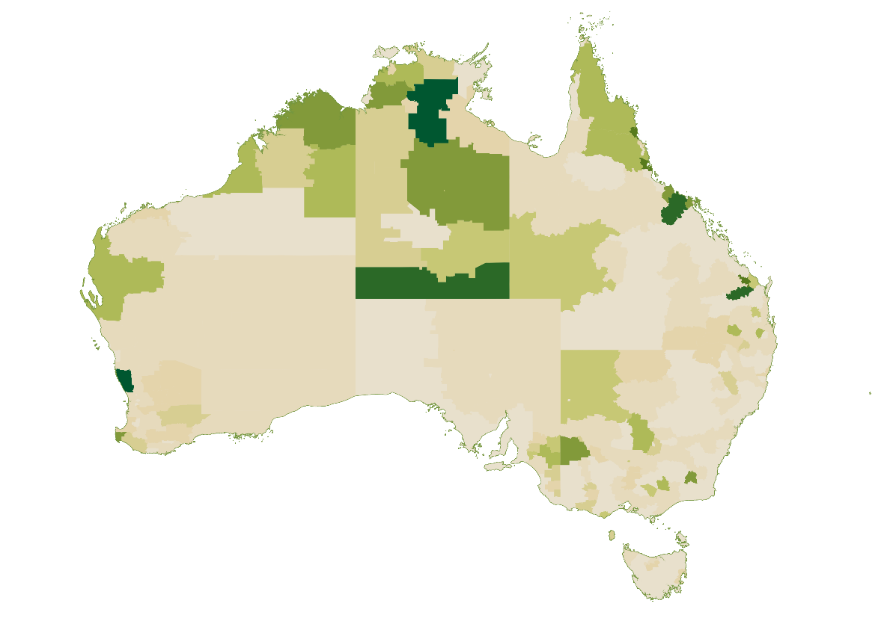
Low High
Source: ABS Census 2016, population and housing, and Australian Census and Temporary Entrants, 2016. Data aggregated from SA2 Place of Work to Working Zones. Darkest areas are approximately 11%, mid-range greens about 3%.
Work (including specified work) is a key reason why many regions share in the benefits of the WHM program. For example, research by Flinders University found:
‘The River Murray region in South Australia was a popular place for WHMs to seek work, with over 80% of visits to Renmark, Loxton, Murray Bridge and Waikerie designated for work purposes. Work was the focus for nine in ten visits to Shepparton Region-East in Victoria and the small numbers visiting Meekatharra in Western Australia. In Tasmania, Smithton was the most visited place for work, with three quarters of the WHMs who visited doing so for work-related purposes.’

The WHM program is used to meet diverse needs
The WHM program is viewed in many parts of the food supply chain as an effective solution to the labour supply challenges they face in relation to filling job vacancies in regional Australia, meeting seasonal workforce needs and/or addressing skills gaps.
Key factors enabling the diversity in how WHMs are used include that:
- WHMs are permitted to undertake any kind of work, and
- the WHM program is open to a diverse cohort from over 40 partner countries with a mix of languages, cultures, prior skills and experiences, and motivations for coming to Australia.
While not an exhaustive picture across the food supply chain, the examples below illustrate how different commodities engage with WHM program.

Berry Fruit Growing
Berry Fruit Growing has been consistently among the industries with the highest concentration of WHMs over the last decade. At its peak, WHMs directly employed by berry growers accounted for a peak of 18.5% of employment in the industry prior to the impacts of pandemic border closures taking hold (Figure 8.14). The share of WHM employment would likely be considerably higher taking labour hire workers into account.
Figure 8.14: WHM share of employment in berry fruit growing, Q3 2014 to Q1 2022 (%)

Source: JSA analysis of linked migration, business and individual taxation statistics. Does not include labour hire.
Our analysis shows around two-thirds of WHMs working in Berry Fruit Growing since July 2014 have been from north-east Asia. The two largest sources, Taiwan and South Korea, account for over 40% of WHMs in the industry.
JSA heard from business stakeholders that the high concentration of WHMs is a response to the variability of casual and contract labour demand across the year. Data from the Queensland Department of Agriculture and Fisheries illustrates the variability of labour demand in the berry industry in Moreton Bay – North region (Figure 8.15).
Figure 8.15: Maximum casual and contract labour demand (FTE) in the berry industry, Moreton Bay – North region

Source: Queensland Department of Agriculture and Fisheries.
At the individual business level, we heard that labour demand in the berry industry is often stop-start in nature. For example, labour demand on a Queensland strawberry farm may be punctuated by multiple short surge periods of different sizes associated with planting, pruning, shoulder seasons and peak harvest.
JSA heard that the flexibility of WHMs in providing surge capacity for short periods of elevated labour demand is highly valued by berry growers, with WHMs often complementing a core workforce of PALM workers who work across the shoulder and peak seasons.
The use of WHMs in this way aligns with the finding of a three-year project on the Horticulture labour market by researchers from the University of Adelaide and University of Sydney that:
‘Working Holiday Makers are an effective labour supply for growers with crops with short or stop-start seasons as these growers necessarily experience a high turnover of workers because of the nature of their crops.’
Several Horticulture employer groups have argued that the WHMs, and the specified work requirements that encourage WHMs to consider this kind of work, is not only an effective solution but the only workable solution currently available to growers with short, labour intense peaks and/or stop start seasonal labour requirements. In addition to berries, this type of labour requirement is also common in other Horticulture commodities such as mangoes and cherries. There are also commodities with more extended seasons or year-round production such as bananas that may be more easily able to meet their workforce needs through other labour supply options such as the PALM scheme.

Dairy Cattle Farming
As identified above, Dairy Cattle Farm Worker was one of the ten occupations with the highest reliance on WHMs. As at the 2021 Census, WHMs accounted for one in every 20 Dairy Cattle Farm Workers. According to one industry survey, the proportion of dairy farms employing WHMs has increased significantly from 6% in 2017 to 31% in 2024.
Our analysis shows that just under half of WHMs working in dairy farming since July 2014 have been from the United Kingdom and Ireland, with the remainder of WHMs in the industry mostly from other European countries (especially Germany, Italy and France) alongside limited representation from Argentina and Chile.
JSA heard from industry representatives that WHMs contribute to dairy farming in two important ways:
- supplementing local workers in hard-to-recruit roles and regions. Some of Australia’s major dairying regions are located in areas with limited spare labour market capacity. According to Dairy Australia, the Western Victoria dairy region made up the largest share of national production in 2023 at 22.7%. This dairy region broadly corresponds to the Warrnambool – South West statistical area which has the third lowest unemployment rate in Australia.
Feedback from business also indicated that WHMs play a critical role in:
  - easing recruitment difficulties where local workers are challenging to source due to factors including the demanding nature and times of work in the dairy industry.
  - providing contract labour for the dairy industry during busy periods such as the calving season.
- supporting improved productivity and skills transfer. We heard that many WHMs, particularly those from Ireland, bring relevant animal husbandry and equipment operation skills and experience to their work in the Australian dairy industry. Employer groups noted the contribution of this cohort of WHMs in boosting farm productivity and supporting skills transfer to local workers.

Meat Processing
Two of the most common occupations in the Meat Processing industry—Meat Packer and Meat Boner and Slicer—are among the ten occupations most reliant on WHMs. As at the 2021 Census, WHMs accounted for 7% of Meat Packers and 4% of Meat Boners and Slicers.
Our analysis shows around 80% of WHMs directly employed in Meat Processing since July 2014 have been from north-east Asia. The two largest sources, Taiwan and South Korea, account for over 70% of WHMs in the industry.
JSA heard from representatives of employers and unions that most WHMs in Meat Processing tend to remain in the industry throughout the duration of their time in Australia rather than for a period of specified work only. This is supported by the evidence that a cohort of WHMs are progressing to Meat Boner and Slicer roles. These roles tend not to be entry-level but rather a progression point for those identified as showing potential in entry-level labourer roles.
In the absence of substantial additional responsibilities or costs associated with employing a WHM, JSA heard from employer groups that hiring WHMs is viewed by employers as largely equivalent to hiring a local worker.

Grain growing and support services
Similar to the dairy industry, the vast majority of WHMs working in the grain industry are from Europe (particularly the UK, Germany, France and Ireland). JSA heard from industry representatives that some grain industry employers are using the WHM program as a de facto skilled visa to bring in workers with skills and experience in operating sophisticated heavy machinery to support grain sowing and harvesting.
In addition to those directly employed by grain farms, we also heard that the grain industry relies on a range of contracted agricultural support services. Outside of Horticulture, the Other Agriculture and Fishing Support Services industry consistently exhibits among the highest reliance on WHMs of any industry peaking at 5% of employment prior to the impacts of pandemic border closures taking hold (Figure 8.16).
Figure 8.16: WHM share of employment in Other Agriculture and Fishing Support Services, Q1 2014-15 to Q3 2021-22 (%)

Source: JSA analysis of linked migration, business and individual taxation statistics.
As outlined in the Food Production Support Services profile, this industry consists of businesses mainly engaged in providing agricultural and fishing support services including but not limited to crop spraying, crop harvesting, fruit and vegetable picking, seeding, irrigation and hay or sileage baling. This industry employs over 15,000 people and makes an important contribution to Australia’s food supply chain including providing farms with access to specialised expertise and equipment as well as seasonal services.

Specified work is an embedded solution for parts of the supply chain
Reliance on WHMs in Australia’s food supply chain has been reinforced through policy settings in place under successive governments since specified work was first introduced in 2005.
Specified work requirements to become eligible for an additional WHM visa are designed to increase the supply of labour to particular industries and locations. When first introduced in 2005, specified work and the second WHM visa applied only to the Working Holiday (subclass 417) visa and specified work was limited to seasonal work in regional Australia with definitions to be specified by the Minister. In announcing the introduction of a second Working Holiday visa, the then Minister for Immigration explained that the program ‘has been expanded to help growers get the seasonal harvest labour they need’.
The high concentration of WHMs in the food supply chain, particularly in highly seasonal commodities such as berries, indicates that specified work has to a considerable extent been effective in achieving this objective.
Although specified work is not the only reason a WHM may choose to work in the food supply chain, there is evidence that it is a motivating factor for many. For example, experimental outputs integrating migration and taxation data show a significant growth in second WHM visa holders working in Agriculture after 1 July 2019 once this employment could be counted as specified work towards the newly created third WHM visa (Figure 8.17).
Figure 8.17: Second WHMs directly employed in Agriculture

Source: JSA analysis of linked migration, business and individual taxation statistics.
This data aligns with anecdotal evidence that many, but certainly not all, WHMs work in Agriculture to meet these minimum 88 or 179-day requirements and not beyond. Multiple stakeholders also suggested that even where WHMs work in the food supply chain beyond the 88 or 179 days required, specified work requirements are often an important factor in WHMs’ initial openness to work in the regions.
That specified work has proved an effective instrument for influencing the supply of labour to particular industries and locations does not necessarily make it the optimal solution. As will be detailed further below, there are legitimate concerns about unintended consequences of the way this outcome is achieved.

Exploitation is multi-faceted and layered
WHMs have regularly been identified in government reports and academic literature as a cohort that is vulnerable to exploitation. This exploitation can take a range of forms including but not limited to underpayment or non-payment of wages, non-compliance with workplace health and safety requirements, bullying, sexual harassment, discrimination, unlawful deductions from wages, debt bondage, abusive living conditions, retention of identity documents, requiring upfront payments for a job, and misclassification of workers as independent contractors instead of employees.
This vulnerability of WHMs does not mean that all WHMs are exploited. A Flinders University Survey found that WHMs reported being satisfied or very satisfied with their jobs in over 70% of cases. There are many WHMs who have a highly positive experience working in Australia, including roles within the food supply chain. However, heightened vulnerability can contribute to environments where exploitation is more likely to occur and less likely to be reported.

Characteristics of the WHM cohort
Migrant workers are entitled to the same workplace rights and protections as Australian citizens, regardless of their visa status. However, relative to local workers who have security of residence and access to the social security system, the circumstances of temporary migrant workers are generally more precarious. This may result in temporary migrant workers being more likely to acquiesce to below minimum entitlements and less likely to report non-compliance and exploitative practices.
The characteristics of the migrant worker can also heighten their vulnerability. As the Migrant Workers’ Taskforce observed:
‘Migrant workers can be particularly vulnerable to exploitation due to language barriers, lack of awareness of Australian workplace laws, expectations informed by their experiences in other countries and, in some cases, visa conditions or migrant workers’ migration intentions.’
Each of the characteristics identified by the Migrant Workers’ Taskforce above are relevant for at least some WHMs.
- Language barriers. Despite being open to applicants from a range of non-English speaking countries, the Working Holiday (subclass 417) visa contains no minimum requirement around applicants’ level of English language. Poor English language skills are associated with lower awareness of workplace rights and elevated workplace health and safety risks.
- Lack of awareness of workplace laws. The Fair Work Ombudsman found that many 417 visa holders lacked knowledge or awareness of their workplace rights, with only 49% of visa holders indicating they knew the workplace rights quite well or very well. The same survey highlighted variation between countries of origin, with visa holders from Hong Kong and Taiwan the least likely to have felt they knew their workplace rights well.
- Expectations informed by their experiences in other countries. Differences in workplace cultures and high wage differentials between Australia and many partner countries in the WHM program will increase the likelihood that some WHMs may accept work for below minimum entitlements or below what would be expected by an equivalent Australian worker. Research also indicates that those from countries where wages are lower are more likely to work for longer hours and potentially take shortcuts which may result in a higher risk of injury.
These factors illustrate that WHM vulnerability to exploitation is layered, with those from less wealthy and/or non-English speaking backgrounds facing higher levels of vulnerability.

Key settings of the WHM program

Specified work
WHM are currently required to undertake 88 and 179 days of work in specified industries and locations to become eligible for the second and third WHM visa respectively. Plant and Animal Cultivation (including the immediate processing of animal products) and Fishing are approved industries for specified work in the food supply chain.
In a 2016 inquiry, the Fair Work Ombudsman identified ‘an increased power imbalance between the employer and the visa holder seeking employment during the 88-day specified work requirement of the 417 visa program’. The desire to stay longer in Australia is a powerful motivator for many WHMs. Since eligibility for a second or third visa is tied to the performance of specified work, WHMs may be more likely to persist in their job in spite of exploitative treatment. As one WHM from the United Kingdom who was interviewed in 2020 reflected:

‘This was all the worst part, the 88 day .... All the time there were people who have, you know, sort of your destiny in their hands. You have this like shining light at the end like ‘oh I get another year of all the fun roadtrip stuff if I can just get through this hell’. Umm so, you are willing to put yourself through so much extortion.’
WHMs completing specified work near the end of their visa may be especially vulnerable due to the time pressures associated with finding alternative eligible work without risking their desired outcome of applying for a subsequent visa.
JSA is aware of changes to the WHM program and the workplace relations system that have come into effect since the commencement of the Fair Work Ombudsman inquiry. While not an exhaustive list, some notable changes are outlined below:
- applicants for a subsequent WHM visa since 1 December 2015 are required to provide evidence that they were remunerated in accordance with the relevant Australian legislation and awards for any specified work.
- a minimum wage guarantee for pieceworkers in the Horticulture Award has come into effect since 28 April 2022.
- a prohibition on advertising jobs with rates of pay that would breach the Fair Work Act through the Fair Work Legislation Amendment (Secure Jobs, Better Pay) Act 2022, alongside enhancements to the small claims framework to provide a low-cost, faster and more informal means of resolving claims, such as those relating to underpayment.
- clarification that migrant workers are entitled to the protections of the Fair Work Act, regardless of their migration status through the Fair Work Legislation Amendment (Protecting Workers Entitlements) Act 2023.
- the introduction of a new criminal offence for intentional wage theft through the Fair Work Legislation Amendment (Closing Loopholes) Act 2023.
- increased maximum civil penalties for breaches of underpayment-related provisions of the Fair Work Act, for bodies corporate that are not small business employers, through the Fair Work Legislation Amendment (Closing Loopholes No. 2) Act 2024.
- the commencement of the Strengthening Reporting Protections Pilot in July 2024 which aims to encourage early reporting and resolution of workplace exploitation including by allowing eligible temporary migrants to extent their stay in Australia to pursue a workplace exploitation claim.
Businesses within the food supply chain have also made efforts to improve compliance with workplace laws and demonstrate fair and responsible employment practices. The Fair Farms program developed by Growcom in the Horticulture sector is one example.
These changes are likely to have had a positive impact but do not eliminate the risk of exploitation. For instance, the Fair Work Ombudsman observe that record keeping requirements including the provision of payslips to employees are often contravened by employers who are failing to meet their obligations to employees.
While the precise extent of exploitation associated with specified work is difficult to quantify, recent evidence of non-compliance (including piecework-related contraventions) from investigations under the Fair Work Ombudsman’s Agriculture Strategy indicate that risks of underpayment and other non-compliance with workplace laws remain.

Six-month work limitation
WHMs can do any kind of work over the course of their stay in Australia, however visa condition 8547 generally limits WHMs to a maximum of six months with any one employer. This limitation is intended to encourage WHMs to travel around Australia and limit displacement of Australian workers. Some exemptions to this condition currently apply such as for work in different locations for the same employer and for work in critical sectors which include Agriculture and food processing.
Recent research into the mobility of WHMs has found that limits on the timeframe WHMs may work with a single employer can restrict the employment opportunities available to them:
‘Many participants expressed that they had applied for numerous “good” and “stable” jobs at the beginning of their working holiday, only to find out that they could not secure an interview with most employers because they were not open to hiring someone who could only stay for six months.’
In tandem with specified work, the six-month work limitation likely contributes to:
- employers with seasonal vacancies being more likely to offer WHMs employment, and
- WHMs being more open to seasonal vacancies and/or work in regional locations.
This can have the effect of encouraging WHMs to work in industries and locations that present elevated exploitation risks due to risk factors including:
- prevalence of physically demanding, low-skilled work where labour costs represent a significant proportion of total business costs
- time sensitive work and high demand for labour to be available at short notice
- high concentration of vulnerable migrant workers
- the prevalence of labour hire arrangements and complex labour supply chains
- potentially remote or very remote work locations, and
- limited availability and choice of accommodation and transport services.
Many of these risk factors are inherent to the nature and location of the work in particular industries. The presence of these risk factors should not disqualify an industry from accessing migrant workers where other labour sources are insufficient. However, it is reasonable to consider how any settings which encourage vulnerable workers into high-risk industries and locations are accompanied by suitable regulation and other countervailing forces which mitigate against exploitation.

Role of labour hire and other intermediaries
Pre-pandemic, around one-in-six employed WHMs were coded to Labour Supply Services or Employment Placement and Recruitment Services industries. Indeed, Labour Supply Services and Employment Placement and Recruitment Services typically comprise two of the three most common industries of employment for WHMs alongside Cafes and Restaurants.
Our analysis highlights some notable demographic differences between the two cohorts including:
- overrepresentation of WHMs from the UK and Ireland among WHMs coded to Labour Supply Services, and
- overrepresentation of WHMs from Taiwan among WHMs coded to Employment Placement and Recruitment Services.
As outlined in the profile on labour hire workers, labour hire can play an important role in the food supply chain and in other parts of the economy including by:
- helping businesses fill short-term vacancies and manage seasonal fluctuations in labour demand, and
- connecting prospective workers, including WHMs, with job vacancies with reputable employers with a record of treating workers fairly.
However, complex labour supply chains can elevate the risk of non-compliance and make it harder for regulators to enforce compliance with the law.
The Fair Work Ombudsman’s Harvest Trail Inquiry also found cases of labour hire entities and providers of accommodation and Transport services entering into arrangements to their mutual advantage, but which infringed on the choices and mobility of workers including:
- charging job placement bonds
- restricting accommodation access to the use of specific labour hire entities
- offering over-crowded, substandard accommodation at above market rates, and
- requiring workers to use specific transport providers between accommodation and the workplace.

Labour market distortion and segmentation
Migrant worker exploitation is not the only potential unintended consequence of the current WHM program. The role of WHMs in parts of the food supply chain may contribute to labour market distortion or segmentation in ways that, while compliant with workplace laws, may be undesirable.
Settings such as the six-month work limitation and specified work that limit the employment opportunities of WHMs can contribute to a power imbalance between the employer and the worker. In part, this is due to the absence of an effective mechanism within the WHM program to align labour supply to a given industry or region according to genuine need. For instance, research on the Horticulture labour market found that certain popular regions can experience an oversupply of WHMs driven by the desire to complete specified work. Potential impacts of an oversupply of WHMs include reduced bargaining power and downward pressure on wages and conditions for all workers.
‘With workers requiring work to be eligible for a second visa, having limited time to attain the days required to qualify for a visa extension, and work being scarce, WHMs were forced to accept whatever wages and conditions were on offer. Many WHMs reported feeling that they were ‘easily replaceable’ because of the constant stream of WHMs looking for farm work to complete their 88 days.’
Where a range of labour supply options with different levels of regulation and worker vulnerability are available to address the same workforce need, there is a risk that more vulnerable workers ‘crowd-out’ the less vulnerable as businesses seek to attract and retain workers with the pay and conditions most favourable to the employer. In practice, this could look like the displacement of local labour or PALM workers by WHMs. Alternatively, this could involve selectively employing WHMs from countries with lower wage levels to mitigate against pressures to raise wages or improve working conditions. This substitution effect can also be seen between those with a right to work and those working illegally (e.g. visa overstayers or those working in contravention of their visa).

There are benefits to meeting workforce needs through a visa with work as a primary purpose
Where genuine workforce needs exist, there are benefits of addressing them through a visa with work as its primary purpose. This is consistent with a key principle of the Government’s Migration Strategy.
In principle, potential benefits include:
- combating worker exploitation by enabling the visa pathway to be appropriately regulated according to the risk profile of relevant industries and potential vulnerabilities of migrants
- addressing areas of genuine workforce shortages in a way that complements fair wages and conditions for all workers, and
- targeting workers who are likely to be productive, reliable and well-suited to the workforce need being addressed.
Realising these potential benefits is not automatic or guaranteed. Effective design and implementation is also integral to any efforts to achieve these benefits without giving rise to unintended consequences.
With respect to the intent of the government of the day in introducing specified work and additional WHM visas, it could reasonably be argued that at least the second and third WHM visa have work as a primary purpose. In addition to considering alternatives to the WHM program to meet specific workforce needs, consideration should be given to avenues to pursue these opportunities within the WHM program.

Changes to specified work could have far-reaching implications
The Government’s Migration Strategy outlined that its aim in undertaking a detailed consultation and research process into specified work requirements is to help inform the future design of the program with the aim of:
- combating worker exploitation
- improving young visitors’ experience of Australia, and
- ensuring temporary migration to Australia continues to support the need for essential skills in regional Australia.
Through its consultation for this study, JSA has heard a range of approaches that Government could consider in pursuing these objectives.
While not an exhaustive list, potential approaches discussed by stakeholders include:
- removing specified work requirements and allowing WHMs to stay in Australia for multiple years on a single visa
- removing specified work but limiting work rights on second and third visas to regional Australia
- retaining specified work and broadening eligible industries to include more, or indeed all, work in regional Australia, and
- retaining specified work and introducing other reforms to combat worker exploitation in the WHM program.
Potential approaches raised also referred to options for a differentiated approach by visa year, including:
- second- and third-year visas to be subject to greater regulation noting the more explicit labour market rationale for their creation, and
- a targeted work pathway for WHMs to transition into after their first year.

Potential consequences for food supply chain employers
WHMs completing their 88 days of specified work have been a significant source of labour for the food supply chain for nearly two decades. In 2018-19—the last full financial year prior to the pandemic—there were just under 3.2 million days (or around 12,000 full-time equivalent roles) of specified work undertaken in Agriculture by over 43,000 WHMs. A recent survey of farmers commissioned by the NFF suggests there are widespread concerns about a reduction in the supply of labour if specified work requirements are removed, with the most common business impacts predicted being longer hours and increased fatigue, pressure on worker and animal welfare, and reduced production.
Given the current reliance on WHMs across a range of essential roles in Australia’s food supply chain, it is important that any changes to specified work that may significantly reduce the supply of labour to food supply chain businesses are carefully considered. Consideration of any significant changes should have regard to the diversity of genuine workforce needs in the food supply chain and the ability to meet these needs through other labour supply options.
At a minimum, this will require consideration of the contribution of Australian citizens and permanent residents (encompassing local and itinerant workers), PALM workers and other temporary migrant workers alongside a continued contribution from some WHMs.
This may also include consideration of a role for the Essential Skills Pathway, to the extent that:
- there are genuine workforce shortages in essential lower-paid roles, and
- these shortages cannot be addressed effectively through the PALM scheme, noting the Government’s commitment to maintaining the primacy of Australia’s relationships with the Pacific.
As articulated in the Migration Strategy, any arrangements under the Essential Skills Pathway would need to be sector-specific, capped, embedded with stronger regulation and minimum standards and subject to further advice from JSA and its tripartite mechanisms.
Consideration could be given to a phased or differentiated approach by visa year to any significant changes to the WHM program that are likely to impact the supply of labour. From a food supply chain perspective, there would be merits to such an approach given:
- relative to second WHM visa, reliance on third visa across the food supply chain is more limited in scale and duration (meaning the impact of any unintended consequences will be less severe), and
- the third WHM visa may pose the highest risk of displacing local labour and more regulated visa types which offer greater protections.
Most specified work in Agriculture is undertaken by first WHM visa holders completing their 88 days to become eligible for a second visa (Figure 8.18). This has been true every year except in 2021-22 when pandemic-related border closures severely limited the number of first WHM visa holders in Australia.
Figure 8.18: Visas granted on the basis of specified work in Agriculture by visa year

Source: JSA analysis Department of Home Affairs program reports.
The third WHM visa, announced in 2019, is also significantly less embedded as a labour supply solution for the food supply chain relative to the second visa which was created in 2005.
Relative to first and second year, third WHM visa holders are highly concentrated from countries where wages are comparatively lower, such as Taiwan, Indonesia and Vietnam (Figure 8.19). This may indicate that Australia’s comparative wage-premium is acting as a key incentive for these migrants to extent their stay.
Figure 8.19. Proportion of WHM visa grants by source country and visa year, July 2023 to March 2024 (%)

Source: JSA analysis of Department of Home Affairs, WHM visas granted pivot table.
Experimental data suggests that employment in Food Product Manufacturing is a comparatively more common industry for third WHM visa holders compared to other cohorts. As Table 8.5 shows, Food Product Manufacturing ranks higher for employment of third-year WHM visa holders compared to first and second-year workers, as does Agriculture.
Table 8.5: Ranking of most common industries for WHM employment by visa year, Q1 2021-22
Visa | Food product manufacturing | Agriculture
First WHM visa | 11th | 8th
Second WHM visa | 7th | 3rd
Third WHM visa | 5th | 2nd
Source: JSA analysis of linked migration, business and individual taxation statistics.
There is no specified work in the third visa as no further WHM visas are available. As such, this pattern is not consistent with WHMs only working in Food Product Manufacturing to meet specified work requirements. Instead, we heard from business and union stakeholders that many WHMs in Food Product Manufacturing (particularly Meat Processing) arrive on day one with the intention of working in the industry for the full three years. This may involve working for the same employer in multiple locations or shifting between employers in the same industry.
As currently designed, the WHM program may not be the optimum solution to the workforce need of filling year-round roles in the Meat Processing sector over multiple years. Where sufficient local workers are not available to fill these roles, more regulated visa pathways such as the PALM scheme or skilled visas which provide greater protections for the migrant worker and for the wages and conditions of all workers may be preferable.

Potential consequences for workers
The power imbalance between employer and worker associated with specified work is likely to be starker where opportunities for a WHM to complete specified work are more limited.
In principle, changes in the direction of providing greater choice and mobility for WHMs should reduce this power imbalance and should be considered where consistent with other objectives including continuing to support regional Australia. Similarly, if changes to provide greater choice are not pursued or are only modest in scope then the importance of other reforms to strengthen countervailing forces mitigating against exploitation will increase.
It will be important to guard against any unintended consequences of any changes to provide greater choice and mobility for WHMs. For example, any decision to remove or amend specified work which results in a significant expansion of WHMs staying more than 12 months (in combination with the six-month work limitation) could in practice exacerbate the employer-worker power imbalance. This outcome could occur if any changes create increased competition between WHMs to fill vacancies with employers willing to hire workers limited to a six-month employment period (often those with seasonal and/or casual roles).
RECOMMENDATION 28
Address the need for specified work in the food supply chain by meeting genuine workforce demand through targeted pathways.
Any changes should carefully consider:
• the diverse workforce needs currently addressed by Working Holiday Makers
• the extent to which any changes would impact the supply of labour
• the extent to which other viable pathways are available or would be needed
• the implications for other labour supply options, including the PALM scheme
• the role of specified work in exacerbating the power imbalance between employers and Working Holiday Makers
• the range of other levers available to combat migrant worker exploitation and the drivers of non-compliance, and
• the merits of a phased or differentiated approach by visa year which could include exploring options to offer a targeted work pathway for Working Holiday Makers after their first year.
Where significant changes are made, these should be accompanied by rigorous monitoring and evaluation to ensure changes are having their desired impact and to identify and address any unintended consequences.

There are other opportunities to mitigate exploitation risks
There are a range of countervailing forces which mitigate against the exploitation of WHMs in the food supply chain and the broader economy. Those currently in place include but are not limited to:
- the role of the Fair Work Ombudsman in enforcing workplace laws as well as in providing information and education
- reporting protections for visa holders experiencing workplace exploitation
- the ability of workers to voice reasonable concerns with their employers, including through association with unions, and
- ethical sourcing, training and/or certification schemes aimed at ensuring fair employment practices.
Through the Migration Strategy, the Government committed to evaluate regional migration settings and the WHM program to ensure migration supports development objectives in regional Australia and does not contribute to the exploitation of workers. In addition to the commitment to undertake a detailed consultation and research process into specified work, this evaluation should also consider other opportunities to mitigate exploitation risks.
As discussed in the section on Labour Hire Workers, national labour hire regulation is a key opportunity to strengthen worker protections by improve accountability and compliance in the labour hire sector throughout Australia. Given the high proportion of WHMs employed via labour hire arrangements, this reform would likely be particularly beneficial for WHMs.
In addition to national labour hire regulation, other opportunities to mitigate exploitation risks are detailed below.

Employer registration
Under new legislation commencing from 1 July 2024, employers found to have seriously, deliberately or repeatedly broken the law may be prohibited from employing additional migrant workers for a period of time, depending on the nature and severity of the breach. Prohibition declarations can be made if an individual or business breaches parts of the Migration Act, Fair Work Act or sections of the Criminal Code that relate to treatment of temporary migrant workers.
Multiple stakeholders in the food supply chain have expressed interest in the idea of a register of employers of WHMs as a supplement to this prohibited employer approach, though there are different conceptions of what such a register could look like. The introduction of an employer register would represent a significant change to the WHM program which, unlike the PALM scheme, is not an employer sponsored pathway. Depending on the significance of the change associated with the model considered, an initial trial period may be warranted to allow to test and evaluate impacts and opportunities for refinement.
As outlined above, in designing the future WHM program the importance of reforms such as employer registration would increase if changes to specified work which provide WHMs with greater choice when seeking employment are not pursued or are only modest in scope.
Design work on an employer register should be informed by detailed tripartite consultation to leverage the insights and expertise of employer groups, unions, and government agencies such as the Fair Work Ombudsman. This design work would need to consider:
- scope: the broadest possible scope would require all employers of WHMs to be registered, similar to current requirements to register as an employer of WHMs for tax purposes. More limited scope options could include a register targeted to:
  - higher-risk sectors where employment of WHMs is common
  - employers offering employment that can be counted as specified work, or
  - employers hiring above a certain number of WHMs.
- cost and administrative burden: the costs and administrative burden of registration should not unreasonably disincentivise compliant employers, especially small and medium sized employers, from hiring WHMs. This is important not only for employers but also for WHMs given that any intervention that significantly reduces the employment options of WHMs is likely to contribute to a power imbalance between WHMs and employers.
- application for registration: to become an approved PALM scheme employer an applicant must demonstrate (among other requirements) that it:
  - is an eligible business registered and operating in Australia and has an Australian Business Number (ABN) and/or an Australian Company Number (ACN)
  - has good immigration practices and a history of compliance with immigration legislation (an immigration integrity check is conducted by the Department of Home Affairs)
  - has a history of compliance with Australian workplace relations, work health and safety legislation, and other relevant laws (a workplace compliance history check is prepared by the Fair Work Ombudsman)
  - can demonstrate that its directors or trustees have a history of compliance with the above laws
  - has or can obtain a labour hire license if applicable.
Requirements of the PALM scheme, particularly requirements relating to an applicant’s past conduct, could be a useful starting point for consideration of how an employer register could assist in screening out unscrupulous direct employers and labour hire operators.
Consideration should also be given to how to streamline processes where an employer seeks to be an approved PALM scheme employer and a registered employer for the purposes of hiring WHMs.
JSA is also aware of employer registers for hiring temporary migrant workers that operate internationally including in several provinces in Canada. Lessons that can be learned from international models of employer registration should also be considered as part of any move to require registration of WHMs in Australia.
- compliance and enforcement: compliance and enforcement would be critical to the success of any employer register. This would include:
  - detection and penalties for unregistered employers who hire WHMs in breach of registration requirements
  - ongoing compliance of registered employers, including mechanisms to review, suspend or cancel registration where there are reasonable grounds to believe the registered employer is not acting in accordance with the law.
- operation of the register: consideration would need to be given to who needs to interact with the public register and how this can best be facilitated. For example, the register should be easy to access and navigate for:
  - WHMs seeking to find registered employers or check whether a particular direct employer or labour hire firm is registered
  - employers checking whether a labour hire firm is registered.
RECOMMENDATION 29
Investigate options to trial an employer register in the Working Holiday Maker program.

English language requirements
The Work and Holiday (subclass 462) visa requires applicants to have at least a functional level of English. Operationally, this requirement is met if the applicant:
- is a citizen of and hold a valid passport issued by the United Kingdom, the United States of America, Canada, New Zealand or the Republic of Ireland
- is a citizen of and hold a valid passport issued by Israel and have successfully completed an English Bagrut exam in the level of 3 study units
- has completed a relevant approved English language test or assessment, or
- has undertaken relevant education.
In contrast, the Working Holiday (subclass 417) visa—which accounts for a significant majority of all WHMs—has no minimum level of English language.
The impact of the different requirements is shown in statistics on the self-assessed English language proficiency of WHMs who arrive through the two visa subclasses (Table 8.6). This is particularly evident in relation to WHMs from North-East Asia, where WHMs in Australia under the 417 visa subclass are the most likely cohort by far to report that they speak English ‘not well’ or ‘not at all’.
Table 8.6: WHM proficiency in spoken English by visa subclass and citizenship, 2021
 |  | Proficiency in spoken English
Region | Visa subclass | Not well (%) | Not at all (%)
North-East Asia | 417 | 43.4 | 4.2
North-East Asia | 462 | 18.3 | 0.7
North-West Europe | 417 | 0.6 | 0.1
North-West Europe | 462 | 0.0 | 0.0
Southern and Eastern Europe | 417 | 3.3 | 0.4
Southern and Eastern Europe | 462 | 0.6 | 0.0
Americas | 417 | 0.0 | 0.0
Americas | 462 | 1.6 | 0.0
South-East Asia | 462 | 9.2 | 0.0
North Africa and the Middle East | 462 | 0.0 | 0.0
Source: Australian Census and Temporary Entrants, 2021. Note: percentages exclude Overseas Visitor category whose proficiency in spoken English is not captured in the Census.
A Fair Work Ombudsman inquiry into 417 visa holders found that poor English language ability increases WHMs’ vulnerability to exploitation and exposure to workplace health and safety risks. In particular, the Fair Work Ombudsman observed that WHMs from non-English speaking backgrounds with significant cultural differences to Australia may be exposed to non-compliant employers seeking to reduce labour costs.
It is likely that the absence of at least a functional level of English would significantly constrain the employment opportunities available to a WHM in the Australian labour market. Such constraints may drive some WHMs to acquiesce to below minimum standards from a fear of losing the employment they depend on to support themselves.
As the citizenship patterns of WHMs employed in food supply chain industries differs, so too does levels of proficiency in spoken English. For example, WHMs working in the Meat Processing industry—who are predominantly from Taiwan and South Korea—are relatively more likely to report that they speak English ‘not well’ (47%) or ‘not at all’ (7%) than WHMs in general.
Given the high proportion of 417 visa holders particularly from North-East Asia with self-reported limited or no proficiency in spoken English, it is reasonable to question whether the absence of English language requirements from this entire visa subclass is appropriate. Nevertheless, it is reasonable for the minimum English language requirements to account for the risk profile of partner countries/jurisdictions and the layered vulnerability of WHMs. A risk-based approach should help to ensure that regulation does not impose unnecessary barriers or processing delays.
It should be acknowledged that not all WHMs come to Australia with the intention of working. According to a Flinders University survey, around three in five WHMs reported spending at least some time working in Australia. There is nothing inconsistent with the intent of the WHM program of a visa holder coming to Australia with the intention of improving their English skills, including through short-term study in English language courses.
Noting the labour market rationale for the introduction of specified work and second and third WHM visas, consideration could be given to mandating a minimum level of English language at least for those applying for an additional WHM visa.

RECOMMENDATION 30
Consider applying minimum English language requirements in the Working Holiday (subclass 417) visa.

Six-month work limitation
In principle, visa condition 8547—which limits WHMs to six months of work with any one employer—is a key mechanism to encourage WHMs to travel around Australia and reduce the likelihood of displacing local labour and PALM scheme workers. However, JSA has heard some stakeholder concerns about:
- the extent to which this visa condition is open to circumvention. Given the current limited real-time visibility on where WHMs are working, stakeholders have expressed concern about the enforceability of this visa condition in cases where it is breached. Some stakeholders also reflected on the ability of some employers (including labour hire entities) to circumvent the intent of the condition. For instance, we heard about instances of workers’ employment being transferred to another labour hire firm or between a labour hire firm and direct employer without the WHM changing worksites.
- the impact of the visa condition on WHMs. We heard concerns that by limiting the opportunities of WHMs to obtain more secure forms of employment, the six-month work limitation is one driver of the elevated exploitation risk.
- the impact of the visa conditions employers. Multiple employer groups have raised the benefits of reduced turnover, heightened productivity and improved skill development of WHMs being able to extend their employment beyond 6 months where it suits the employer and the worker to do so.
A review of the intent and operation of visa condition 8547 would be beneficial to inform the future design of the WHM program. This review could consider:
- the policy intent of the visa condition (and current exemptions) and the extent to which this intent is being achieved
- whether and to what extent this visa condition is being circumvented and options to improve enforcement
- the impact of this visa condition on WHMs, employers and the broader labour market.
There may be a strong opportunity to leverage Single Touch Payroll Phase 2 data which will contain more granular, high frequency information on the employment patterns of WHMs to inform this review.
RECOMMENDATION 31
Undertake a review of visa condition 8547 which limits Working Holiday Makers to a maximum of six months with a single employer.

PALM scheme
The Terms of Reference for this study include exploring opportunities to build on recent reforms, including the Migration Strategy and PALM scheme, to ensure this pipeline is able to address genuine shortages while preventing migrant exploitation and the displacement of Australian workers with similar skills.
The Government’s Migration Strategy highlights that the Pacific will be considered in the context of changes to other parts of the migration system. As such, consideration of the PALM scheme is in part necessary in the context of the future design of the WHM program. However, this study’s observations and recommendations relating to the PALM scheme are not contingent on any particular decisions respecting the future design of the WHM program.

Trialling worker-initiated movement
Evidence from the Pacific Labour Mobility Survey indicates there is demand among some PALM workers for greater worker agency. Nearly 40% of workers surveyed indicated they would prefer to work for a different employer within the scheme, with some PALM workers also disengaging from the scheme for reasons including finding a better job and dissatisfaction with the current employer. The survey also found that 36% of workers currently paying deductions would choose to take on responsibility for relevant expenditures themselves.
Recent analysis from the NSW Anti-slavery Commissioner also indicates that the inability of PALM workers to initiate a change of approved employer is a significant risk factor contributing to PALM worker disengagement. In turn, this disengagement heightens risks of vulnerability to exploitation and forced labour.
Greater worker agency through worker-initiated mobility has potential benefits for PALM workers and employers by:
- making it easier for PALM workers to move between approved employer to pursue a better job opportunity or to leave an exploitative environment, and
- reducing the administrative burden for employers in cases where PALM workers would prefer to take on responsibility for expenditures currently met by the employer on their behalf and recouped via deductions from wages.
Any worker-initiated movement to other approved employers within the PALM scheme should first be tested through a limited trial. Reliable access to workers is likely to be a significant motivating factor for many employers participating in the scheme and of their willingness to meet the upfront costs of recruiting a PALM worker. Ensuring continued employer demand for PALM workers is an integral part of the success of the scheme and of providing continued benefits for Pacific workers and their communities, along with ensuring the welfare and wellbeing of Pacific workers.
Movement settings would need to ensure the standard level of worker protections and supports are not compromised, and risks to employers are managed. Managing risks to employers could include worker-initiated movement occurring after relevant upfront costs have been recovered through deductions and/or a mechanism for these costs being transferred to the gaining approved employer.
A limited trial could be focused on experienced PALM workers in the first instance. Due to their greater familiarity with Australia, its labour market as well as with particular industries or employers, experienced PALM workers may be best placed to exercise worker-initiated movement. A trial could also be focused on particular industries and/or regions where relevant stakeholders are committed to supporting such a trial.

RECOMMENDATION 32
Explore options to trial worker-initiated mobility for a limited number of experienced PALM workers, within select industries and/or regions.

Better planning and coordination
Our research points to reliance on WHMs being highest for picking and packing roles in parts of the Horticulture sector with short and/or stop-start seasonal labour demands. We have heard from Horticulture employer groups that WHMs are often employed as a surge workforce where the demand for labour is often for three months or less and subject to last minute fluctuation due to weather conditions and the timing of harvest. As discussed above in the context of the WHM program, this workforce need broadly aligns with the short-term employment expectation of WHMs motivated to meet minimum specified work requirements.
Provision is made within the PALM scheme for a range of portability arrangements including:
- offshore portability arrangements: where placements across different approved employers are pre-arranged prior to the worker travelling to Australia
- onshore portability arrangements: where a new arrangement is made while the worker is onshore in Australia, and
- temporary portability: an unplanned, short-term transfer to a host organisation or another approved employer.
Notwithstanding these provisions, we heard that PALM workers are not typically used to fill these very short-term or stop-start roles. In part, this may be due to the availability of a lower cost, more flexible alternative in WHMs seeking to complete specified work. However, it is also clear there are additional complexities associated with engaging with the PALM scheme to meet surge workforce needs for short periods (particularly where the precise timing of the workforce need is difficult to predict).
An elevated role for Government in supporting planning and coordination at the regional and/or industry level could assist in managing these additional complexities. Quality planning and coordination is likely to play a key role in:
- maximising the potential of existing portability arrangements to meet the needs of multiple approved employers
- ensuring PALM workers participating in portability arrangements have sufficient work and suitable accommodation available to them throughout their time in Australia
- ensuring costs are fairly distributed between employers and sustainably deducted, and
- building and maintaining community links and supports for a more mobile cohort of workers.
This could require additional resourcing for Australian Government departments responsible for administering the program and dedicated resourcing to support a mechanism to facilitate improved planning and coordination support at the region and/or industry level.
JSA notes that Horticulture employer groups have expressed doubts about the capacity of the PALM scheme to prove the short-term surge capacity demanded by the nature of production for certain commodities such as berries, cherries and mangoes. If the PALM scheme is not considered suitable and WHMs completing specified work is not a preferred option, consideration could be given to a targeted, capped visa pathway to respond to the genuine short-term surge workforce needs in parts of the Horticulture sector.

RECOMMENDATION 33
Elevate the Australian Government’s role in supporting the planning and coordination of portability within the PALM scheme

Reducing costs for employers and increasing benefits for PALM workers
It is reasonable that visa pathways are embedded with stronger regulation and safeguards for workers where they are designed to address shortages in contexts where exploitation is a greater risk. As evident in the PALM scheme, a by-product of this stronger regulation can be increased costs for participating employers.
Where the higher costs of using a more regulated pathway are not offset by productivity gains, potential impacts include:
- higher costs for domestic consumers
- reduced international competitiveness for export-oriented industries
- increased pressures on industry viability.
These impacts are likely to be most concentrated in industries where labour costs represent the highest proportion of total costs of production.
It is also important to recognise that wider gaps between the costs associated with regulated and unregulated labour supply options create greater incentives to pursue the unregulated pathways. In the absence of other interventions, changes to WHM program settings are unlikely to address the problem of illegal work in some food supply chain industries. As such, issues around exploitation of this cohort and uneven playing fields for compliant businesses will likely persist.
The Government should explore options to reduce the costs for employers of engaging with the PALM scheme where they are consistent with the integrity and objectives of the scheme. Reducing the costs for employers could promote greater uptake of the scheme which in turn will maximise its benefits for the Pacific and help address the conditions in which illegal work may be likely to increase.
One option that could be considered is waiving visa applications costs which would:
- reduce the upfront cost for approved employers,
- increase the take home wage for workers as this cost would no longer need to be recovered through deductions, and
- address one potential barrier to the increased flexibility for workers to move between approved employers within the PALM scheme.
Stakeholder feedback suggests that PALM workers often face barriers in accessing their superannuation upon the completion of their placements. This may be due to factors such as limited understanding of the requirements to claim superannuation and limited internet connectivity. JSA is also aware of calls for superannuation settings for PALM workers to be changed to ensure these settings (including how superannuation is taxed) are appropriate given the development objectives of the PALM scheme. These matters are worthy of Government consideration.
RECOMMENDATION 34
Consider appropriate options to reduce costs for employers and increase benefits for workers in the PALM scheme, so long as these options maintain the integrity and objectives of the scheme.

Monitoring the capacity of the PALM scheme
There are multiple plausible scenarios in which demand for PALM workers increases over the coming years including as a result of:
- increased demand from within the food supply chain
- including continued growth in demand from more recent entrants to the PALM scheme such as the Health Care and Social Assistance and Accommodation sectors, and
- any future expansion the PALM scheme into new sectors.
As part of ongoing monitoring and evaluation of the PALM scheme, the Government should continue to monitor the:
- capacity of labour sending countries to provide work-ready participants in sufficient numbers
- impact of an expanded PALM scheme on the availability of skills and labour within Pacific countries, and
- capacity of Australian government agencies with a role in administering or supporting delivery of the scheme, including in relation to compliance and enforcement of relevant Commonwealth laws.
RECOMMENDATION 35
Continue to monitor the capacity of labour sending countries and Australian government agencies that administer or support the delivery of the PALM scheme.

Worker housing and accommodation
The effective operation of the PALM scheme and WHM program is contingent on the availability, affordability and quality of worker housing and accommodation.
There are important differences between the WHM program and the PALM scheme with respect to accommodation. Under the PALM scheme, approved employers must provide or arrange suitable accommodation and have this accommodation approved by the department as meeting prescribed minimum standards. PALM workers may also choose to arrange their own accommodation. In contrast, there are no equivalent minimum standards and prior approval process for accommodating WHMs.
The interaction between these different requirements has important implications in regions where both PALM workers and WHMs are commonly employed. In some cases, we heard that the need to meet the minimum standards of the PALM scheme has prompted some working hostels to upgrade their facilities. This is a positive outcome for the stock of quality worker accommodation in the region. However, we have also heard there have been unintended consequences for WHMs arising from the growth of the PALM scheme and its higher accommodation requirements. These consequences include:
- the existing stock of quality worker accommodation (e.g. working hostels) increasingly being reserved for PALM workers, leaving WHMs with fewer or in some cases no suitable accommodation options. This includes cases where accommodation reserved for PALM workers in accordance with the requirements of the scheme was left empty due to the worker electing to arrange their own accommodation or the approved employer requiring fewer PALM workers than anticipated.
- working hostels that were previously used by WHMs for short-stay harvest work pivoting to a business model catering to PALM workers whose longer stays and in-advance bookings may provide a more stable source of business than high-turnover WHMs.
In the context of tight rental markets in many regions, WHM options may be increasingly limited across the two most common accommodation types for WHMs: hostels and rental properties.
The scarcity or absence of suitable accommodation poses risks to WHM safety and wellbeing. It is also a driver of heightened vulnerability to exploitation. For instance, as continued residence at many working hostels is contingent on ongoing employment, lack of accommodation security can be a barrier to WHMs exiting substandard or exploitative employment.
A more concerted effort from all levels of government to increase the stock of suitable worker accommodation in key regions would support the expansion of PALM while also addressing issues around the displacement of WHMs from accommodation that has historically been used for short-stay work.
RECOMMENDATION 36
Prioritise efforts to increase the stock of suitable worker accommodation in key food supply chain regions to support the effective operation of the PALM scheme and Working Holiday Maker program.



Part D:
Looking forward
This section looks ahead to the opportunities available for this essential workforce, including ways to improve workforce planning and data.


Looking forward:

9. Workforce planning

Elevating food as a national priority
Australia’s food supply chain industries and workforce interface with a range of national priorities including:
- food security
- regional development
- sovereign capability and value-adding
- trade and exports
- Pacific development, and
- decarbonisation and the net zero transformation.
While the food supply chain is identified as a priority area across multiple initiatives such as the National Skills Agreement and National Reconstruction Fund, this is not necessarily underpinned by a comprehensive food strategy to guide collective effort and investment.
In their inquiry into food security in Australia, the House of Representatives Standing Committee on Agriculture recommended that the Australian Government, in consultation and cooperation with state and territory governments, business and the community, develop a comprehensive national food plan for the food security of the nation and its people.
The Committee found that all areas of government policy must be able to be seen through a food policy lens, with the impact of food policy on other areas of government and the impact of other policies on the food system needing to be identified and acknowledged.
While a national food plan would necessarily encompass a broad range of matters, workforce is an important area in which the impact of food policy on the national skills system and vice-versa is worthy of ongoing attention and evaluation.
Recommendation 37
In response to the Australian Food Story: Feeding the Nation and Beyond report, consider the merits of developing a national food plan or strategy. The objectives of such a national plan could have implications for workforce planning and policy.

Developing a shared workforce vision
The importance of the food supply chain workforce is widely recognised by governments, employers, unions and the broader community. However, there is currently no shared vision that unites these different groups and the many industries that make up the food supply chain. The Agricultural Workforce Forum suggested that this study could help lay the foundations for a shared vision through our research and consultation.
A shared vision could be an aspirational statement that sits across the food supply chain and defines the collective ambition of all parties. The development of a shared vision need not be contingent on a national food plan. However, if a national food plan is developed, a shared workforce vision could be an important pillar of the plan by:
- outlining what is required for workforce to be an enabler of—rather than a barrier to—achieving the objective of a food secure Australia with strong export industries, and
- contextualising the contribution the food supply chain can make to realising the vision and objectives for the labour market expressed in the Australian Government’s White Paper on Jobs and Opportunities.
Collectively, a national food plan and shared workforce vision could define the outcomes we are seeking for the food supply chain and its workforce.
A shared vision could also guide workforce planning activities at a more detailed industry or regional levels and be expanded to reflect specific needs and contexts. This detailed workforce planning could be undertaken by JSCs, employer groups, RDCs and/or individual businesses. These workforce planning activities would have a critical role to play in translating the vision to reality, alongside the policies, programs and systems put in place by governments. In other words, how the outcomes we are seeking can be achieved.
Figure 9.1 depicts what a workforce planning architecture could look like for the food supply chain, with all stages of the process informed and underpinned by the improved workforce data recommended later in this chapter.
Figure 9.1: Potential workforce planning architecture for the food supply chain
National Food Plan
Sets a comprehensive plan for the food security of the nation and its people
Food Supply Chain Workforce Vision
Outlines tripartite principles for the food supply chain workforce
Industry-specific workforce planning
Detailed workforce planning activities undertaken and owned by industry
Supported by better workforce data
While the industries, regions and specific workforce needs of the food supply chain are highly diverse, on the basis of the consultation and research undertaken for this study JSA believes there are common principles that could unite all parties.
Figure 9.2 details the 6 overarching principles that could guide the development of a shared workforce vision.
Figure 9.2: Principles for a food supply chain workforce vision
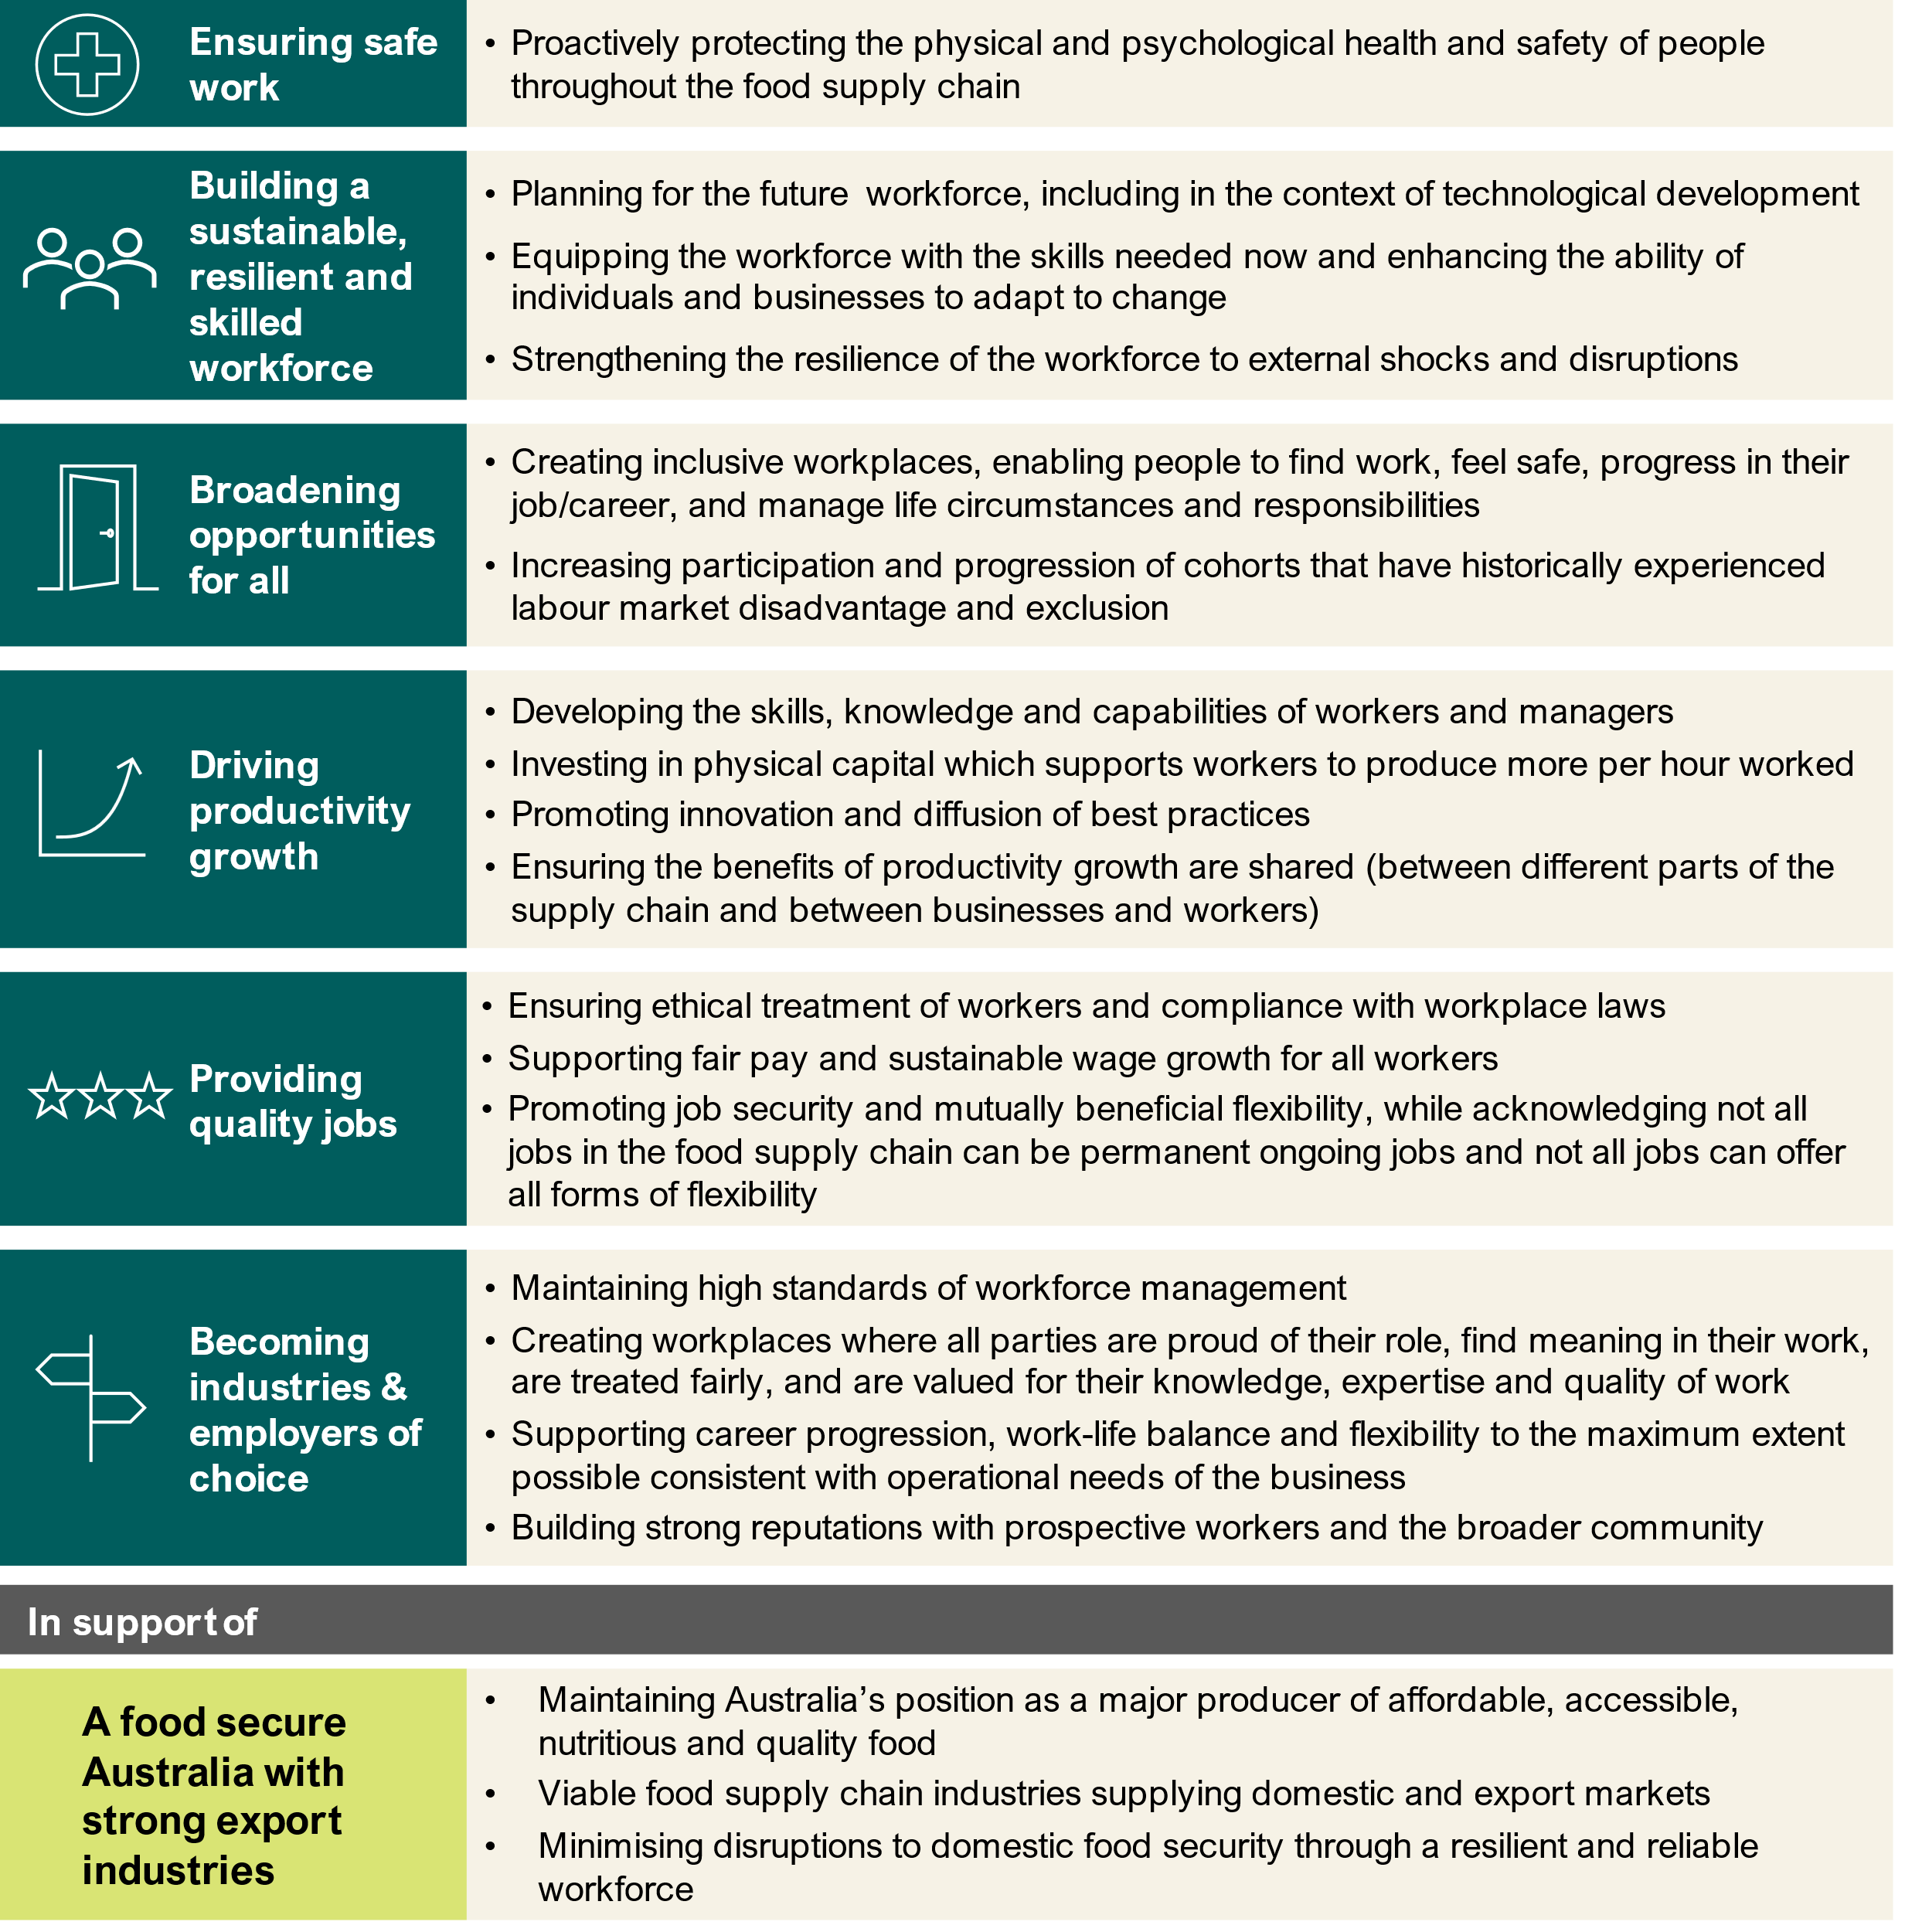
With appropriate resourcing, Skills Insight, the Agribusiness JSC, could be well placed to oversee further development of the shared workforce vision in partnership with the tripartite Agricultural Workforce Forum and other stakeholders.
Recommendation 38
Continue the development of a tripartite workforce vision with the Agricultural Workforce Forum.

Committing to partnerships and tripartism
A commitment to tripartism has been central to the delivery of this report and has a vital part to play in the implementation of our recommendations.
The Australian Government has established 10 JSCs that bring together employers, unions and governments in a tripartite arrangement to find solutions to workforce challenges. This study has strongly benefitted from the industry expertise and stewardship of JSCs across the food supply chain, including:
- Skills Insight – Agribusiness
- Manufacturing Industry Skills Alliance (MISA) – Manufacturing
- Industry Skills Australia – Transport and Logistics
These JSCs, and others, have a critical role in supporting workforce planning and development for the food supply chain. Given the raft of opportunities and challenges that cut across their industries, continuing to forge and deepen collaboration and partnerships between JSCs will be important. This is particularly the case in cross-cutting areas such biosecurity where relevant skills are required across multiple industries.
The study also recognises the continued importance of the Agricultural Workforce Forum, successor of the tripartite Agricultural Workforce Working Group established by then Minister of Agriculture, Fisheries and Forestry, Senator the Hon Murray Watt following the 2022 Jobs and Skills Summit. JSA has appreciated the active engagement of the forum and its members throughout the study and welcomes its ongoing role in facilitating tripartite work to pursue solutions for the agriculture and food processing workforce.

A joined-up national skills system
The need for a coordinated approach to meeting workforce needs across higher education, VET and migration systems has been widely recognised, including through the Australian Government’s White Paper on Jobs and Opportunities, the Migration Strategy and the Australian Universities Accord Final Report.
This importance of this work is typified in a range of areas within the food supply chain. As the Migration Strategy observes:
‘The purpose of Australia’s temporary skilled migration system is to address labour shortages and provide a pathway for potential future permanent residents.’
The high and persistent reliance on temporary skilled migrants exhibited by several occupations in the food supply chain indicates that more could be done to coordinate and align skills settings in a way that puts us on a genuine path to addressing shortages. For example, this study notes there could be a role for relevant JSCs in working with employers and unions to investigate the factors contributing to labour supply pressures for particular roles and ensuring temporary migration facilitated through a labour agreement is part of a coherent strategy to addressing these pressures sustainably.
There are also opportunities for greater harmonisation of VET and higher education to leverage the strengths of both systems and ensure students can navigate how to best obtain the skills needed by business and the economy across their career.

An open-minded approach
Australia’s food supply chain industries have a long history of innovation which has been critical to their ability to survive and thrive in the 21st century. As the workforce needs of the food supply chain continue to evolve, it will be important that workforce systems and solutions keep pace.
An open-minded approach to trialling new ideas should be encouraged, particularly in areas where persistent workforce pressures have proved difficult to address. This open-mindedness should be accompanied by a commitment to monitoring and evaluating impacts across both new and long-established approaches to ensure they are delivering positive outcomes for employers, workers, students and the broader public.

Placed-based workforce solutions
Employment in the food supply chain is heavily concentrated in regional and rural Australia, with Food Production and Manufacturing acting as anchor industries for many regional communities. Australia’s regions are incredibly diverse, and a range of place-based dynamics impact the attraction, retention and experiences of workers in the food supply chain.
While no two regions are the same, there are some common dynamics that are experienced by many food producing regions. These include:
- Accommodation and housing. The affordability and availability of housing is a major challenge and has worsened in many regions (explored further below). Poor planning, underinvestment and workforce shortages have also contributed to a general undersupply of new housing. Temporary worker accommodation is particularly important to the food supply chain, including hostels and on farm accommodation, and presents its own challenges around regulation, quality and safety.
- Transportation and connectivity. Remoteness, limited transport options, social isolation and poor internet connectivity can make it difficult to access and attract workers in some parts of the food supply chain.
- Essential services. Access to high quality education, childcare and healthcare varies significantly in regional areas. In some of Australia’s most remote communities, the reliable supply of food, water and electricity is also a challenge.
- Population change. While generally lower than in metropolitan areas, population growth in regional Australia is very uneven. Regional cities have experienced very strong population growth in recent years, while many small regional areas are in longer-term decline.
- Labour availability. Regional communities are home to some of the highest and lowest rates of unemployment across Australia. On average, regional labour markets have lower vacancy rates and fewer applicants per vacancy than metropolitan areas. Qualification and suitability gaps are also higher. Employment opportunities can be volatile in some regions and impacted by factors including droughts and seasonal fluctuations in labour demand.
To ensure the long-term viability and growth of these regions, it is essential to analyse the specific barriers which individual regions encounter. JSA has produced some regional level analysis in Appendix B – Regional Profiles which is complemented by our broader range of regional data, tools and projects – including an upcoming Regional Jobs and Skills Roadmap.
Recommendation 39
All levels of government should address significant barriers to supplying suitable and sustainable housing and accommodation for workers and students.
Recommendation 40
Given the significant diversity that exists between primary producing regions, explore options to better tailor workforce programs and policies to local circumstances.
This would require greater investment in regional data, and an elevated role for regional stakeholders in workforce planning activities.

Opportunities in urban areas
While regional, rural and remote Australia is critical to the food supply chain, there is also considerable agricultural production value generated in and around our greater capital city areas. Three of Australia’s state capital cities are in the top 10 regions by total value of agricultural production, including Melbourne, Adelaide and Brisbane surrounds. The majority of this value tends to come from the outer periphery of cities, diminishing closer to the city centre.
This urban and peri-urban fringe presents a unique set of location barriers compared to regional areas, including planning, urban sprawl, housing and transportation issues. For example, as Australia’s major cities grow, production activities are often pushed out in favour of urban development, with housing and other city-focused activities taking precedence.
Despite these challenges, production that takes place closer to cities can circumvent some of the location barriers facing the regional food supply workforce. Benefits of proximity for food supply chain businesses and workers can include:
- access to a larger pool of potential workers
- education and training being more accessible and less likely to be impacted by
diseconomies of scale
- greater exposure of people from urban areas to careers in the food supply chain,
including through work placements that may not require relocation, and
- greater access to the infrastructure and services available in Australia’s major cities.
There is also a growing professional services sector that works within and in support of the food supply chain. It employs high skilled workers across business consultancy, science, data and technology, financial services and many more areas that rely on Australia’s tertiary education system. Many of these roles can be and are performed from anywhere, providing rewarding food supply chain careers closer to major population centres.

Investing in better data

The data challenge
The collection, dissemination and analysis of data on the food supply chain workforce is a longstanding challenge, especially in relation to Food Production industries such as Agriculture, Aquaculture and Wild Catch which encounter additional workforce data gaps that are not present in other sectors.
A selection of these challenges is summarised below.
- Food Production industries are heterogeneous and geographically dispersed. Data at broad industry levels (often the most granular available from national surveys) may fail to capture labour market dynamics at play in particular sectors, commodities or regions.
- In turn, targeted surveys aimed at generating the highly granular insights on sub-populations at commodity or regional level may impose a high respondent burden on that sub-population and/or experience low response rates.
- Parts of the food supply chain experience significant seasonal fluctuations in labour demand, have a high reliance on temporary migration and/or commonly engage workers through labour hire. Patterns of labour use in these industries may not be fully captured in official statistics like those from the Census which are point-in-time, do not capture employment outside an individual’s main job or of those usually resident in Australia for less than one year, or the industry to which labour hire workers are on-hired.
- Recruitment activity in Food Production is less likely to occur through online jobs boards compared to most industries. Instead, recruitment activity is more likely to involve methods such as word-of-mouth or social media that are difficult to capture and compile to present a comprehensive and contemporary picture of labour demand.
- The Agriculture, Forestry and Fishing industry is currently excluded from the scope of ABS labour-related business surveys in line with an International Labour Organisation Resolution that since "hired labour constitutes only a minor part of total labour input” in this industry, it would be disproportionately costly to survey enough of these businesses to obtain a sample of employees to adequately represent this industry. These business surveys are the primary source of labour costs, earnings, job vacancies and industrial disputes, all of which provide insight into the demand for labour in the Australian labour market.
The mix of these and other challenges means that the Agriculture, Forestry and Fishing industry is either excluded from or poorly represented in several data collections that typically inform our understanding of Australia’s labour market. This was a point consistently emphasised by employer groups, unions and other stakeholders throughout the course of this study.
Overcoming these gaps is critical for policy and workforce planning, as noted by then Minister for Agriculture, Fisheries and Forestry, Senator the Hon Murray Watt:
‘To sustainably increase productivity, agriculture and the food supply chain will need a workforce with the right skills, in the right place, and at the right time – and that means having the best data and evidence available.’

A long-term investment in data
The National Agricultural Workforce Strategy found that there is merit to a more strategic and systematic approach to food supply chain workforce data collection and analysis to maximise the efficiency of current efforts and investments. Such a strategic and systematic approach would need to consider:
- the respective roles of government, business and other contributors to the collection, dissemination and analysis of food supply chain workforce data, including with reference to the extent of public and private benefit, and
- the capabilities and resourcing required to support the preferred approach.
There are opportunities to enhance the evidence base on the food supply chain workforce through the use of administrative data (e.g. data from taxation, migration, education and training, and other systems) and integrated datasets which link this information with other data collected by the ABS. This study provides several examples of how administrative data can be leveraged to produce new insights including:
- weekly payroll jobs by detailed industry (Workforce Profiles)
- experimental estimates of WHM employment by industry and quarter (Migration)
- real world occupation-to-occupation transitions (Workforce Profiles), and
- income and employment outcomes from VET training (Education and Training).
While the ABS, JSA and others produce a wide range of labour market data products and analysis, these releases typically have a whole-of-economy and national focus and may not provide the granularity of insights food supply chain stakeholders are seeking to reflect their diverse and geographically dispersed industries. As explored above, these releases may also rely on data collections which exclude Agriculture, Forestry and Fishing in their entirety.
In recognition of the unique workforce data and information gaps relating to this essential workforce, JSA believes that investment in dedicated, ongoing workforce data capability for the food supply chain workforce is warranted.
A dedicated workforce unit could harness administrative data to bridge major data and information gaps in areas of high public value and interest. This capability has the potential to improve policymaking and evaluation significantly and to support industry workforce planning. Such a unit could also provide a stewardship function and help to lift the consistency, quality and use of workforce data collected by other stakeholders such as employer groups and RDCs. As pointed out by the NFF, this will be important to ensure that a more comparable and comprehensive picture of the workforce can emerge:
‘data sources need to “speak to each other” to the extent possible. That is, if data is collected about the labour needs/make-up of, e.g., a dairy farm in Southern NSW, the collection and type of data should be consistent with that which is collected regarding dairy (or even chicken, berry, or cattle) farms in Northern Tasmania.’

With sufficient resourcing, ABARES would be well placed to lead this work given its strong connections to industry and expertise within the sector. Consistent with ABARES’ definition of the agricultural workforce, it is anticipated that the workforce unit would also produce data and insights relevant to agricultural support, processing, distribution and storage in addition to primary production.
Consideration could also be given to the supporting role JSA could play during the establishment phase of this new function by sharing its expertise and experience in administrative data projects.
Recommendation 41
Establish a workforce data unit within the Australian Bureau of Agricultural and Resource Economics and Sciences.

Supporting better policy
This dedicated investment in workforce data would complement other data opportunities identified throughout this report, many of which would support implementation of our recommendations. These opportunities include:
- Understanding the industry and occupation outcomes of formal training. This would support qualification reform activities to ensure qualifications meet the needs of industry and students (Recommendation 17)
- Mapping the biosecurity workforce across public and private sectors (Recommendation 5)
- Improving collection of middle-manager occupation data in Census through targeted supplementary questions (Recommendation 10)
- Improving data collection on labour hire workers, including the industries and roles to which labour hire workers are on-hired (Recommendation 8)
- Monitoring the employment patterns of WHM and PALM workers with Single Touch Payroll data (Recommendation 27)
- Identifying precarious training pathways that require policy interventions (Recommendation 16)
- Providing granular workforce data and meaningful regional definitions for workforce policy and programs (Recommendation 41)
- Analysing the length of employment for WHMs to inform a review of 6-month work limitations (Recommendation 31)
- Researching the impact of labour choice on farm productivity and profitability, including PALM and WHM workers (Recommendation 28)
- Commissioning analysis of the veterinary workforce to understand pressure points and trends (Recommendation 3)



Recommendations
This report includes 41 recommendations for the Australian Government to consider. These are grouped into 8 overarching themes and target the Commonwealth’s role in workforce planning through the national skills system (Table 9.1). Any responses to these recommendations should be genuinely tripartite and consider the perspectives of all relevant stakeholders.
Table 9.1: Overarching recommendation themes
Support apprenticeships and traineeships for critical roles
Improve the relevance and delivery of tertiary education and training
Invest in sustainable veterinary and biosecurity workforce pathways
Combat worker exploitation and ensure migration continues to support regional Australia
Harness opportunities within the PALM scheme
Improve labour hire practices, enforcement and information
Facilitate better planning of the food supply chain workforce
Address barriers in regional, rural and remote Australia
These recommendations are complemented by the data, evidence and findings presented throughout this report which act as a resource for all stakeholders including business, unions, training providers and state and territory governments. This may be particularly important for challenges around attraction, retention and career development that require employer-led solutions.
JSA has only made recommendations where an issue or opportunity was clearly identified, the case for a particular action was strong, and where consideration of the issue or opportunity aligned with our organisation’s remit and expertise. There are many other ideas and opportunities that are not canvassed by this study but may warrant further consideration, including at an industry, state or regional level. An open-minded approach by all stakeholders, including governments, will be essential to seize these opportunities and keep pace with the changes occurring within the food supply chain.
In the following section we have mapped each recommendation to the workforce vision principles identified in Chapter 10 to articulate actions the Australian Government could take to support progress towards the vision.
Principles of a share workforce vision:
- Ensuring safe work
- Building a sustainable, resilient and skilled workforce
- Broadening opportunities for all
- Driving productivity growth
- Providing quality jobs
- Becoming industries & employers of choice

Support apprenticeships and traineeships for critical roles
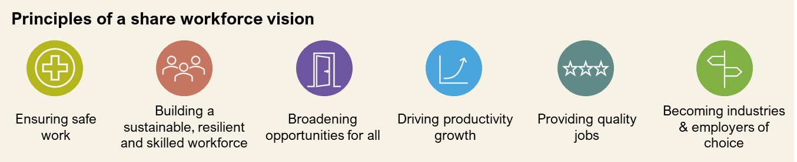
There are strong opportunities in the food supply chain to develop and support work-based learning, including apprenticeships and traineeships. For these to be successful, supports must be fit-for-purpose and employer buy-in is essential. Within the higher education system, work-integrated learning already plays an important role in areas like agricultural and veterinary sciences, but there is room for deeper partnerships, particularly for research pathways.
 | RECOMMENDATION 11  Consider options to target eligibility for apprenticeship incentives more effectively. | 
 | RECOMMENDATION 12  Skills Insight should continue exploring the case for an Ag Trade Apprenticeship. | 
 | RECOMMENDATION 13  Industry Skills Australia should continue to support the professionalisation of the road freight workforce, including through advocacy for a Heavy Vehicle Driver Apprenticeship in all jurisdictions. | 
RECOMMENDATION 14
Industry Skills Australia should investigate industry and student interest in ‘earn while you learn’ models for supply chain and logistics roles.
RECOMMENDATION 15
Consider opportunities to encourage group training models within Food Production industries as a means of providing workable apprenticeship and traineeship pathways, particularly for small businesses.

Improve the relevance and delivery of tertiary education and training
It is important that food supply chain qualification pathways remain viable in the long-term, particularly small-scale and specialised courses where only a small number of providers operate. There are also opportunities to improve the relevance of formal education and training pathways, ensuring they deliver meaningful skills for employers and tangible outcomes for students. This is critical at all levels across VET and higher education.
RECOMMENDATION 16
Explore mechanisms to improve the sustainability of small-scale qualification pathways that are critical to national priorities, including food security.
RECOMMENDATION 17
Jobs and Skills Councils across the food supply chain should review broad-based qualifications to align with reform work underway.
 | RECOMMENDATION 18  Consider a broader suite of options to support entry-level qualifications where they act as a genuine career entry point and demonstrate strong employment outcomes for students. | 
RECOMMENDATION 19
Industry Skills Australia should investigate options to improve the delivery and uptake of formal livestock transport training for truck drivers.
RECOMMENDATION 20
Provide financial support for First Nations scholarships in agriculture, aquaculture and fisheries sciences and business. These should be co-funded by industry and include wrap around supports.
RECOMMENDATION 21
Explore ways to support the delivery of on-Country training programs for First Nations peoples that facilitate flexible career pathways in the food supply chain.
RECOMMENDATION 25
Once established, the Australian Tertiary Education Commission should examine postgraduate research pathways in agriculture, fisheries and aquaculture, with a view to ensuring long term viability.
RECOMMENDATION 26
Encourage the establishment of a TAFE Centre of Excellence for agriculture to strengthen capability and capacity of the Vocational Education and Training system.

Invest in sustainable veterinary and biosecurity workforce pathways
Given the critical role played by the veterinary workforce, it is important that post-secondary pathways are sustainable for students and education institutions. While JSA has recommended several initial actions that could be taken, a more substantial piece of work is required across levels and areas of government to address these challenges.
There is also important work required to better define biosecurity roles, responsibilities and skills needed within industry and the public sector. This includes developing different models of skills development and securing surge capacity during emergency responses.
RECOMMENDATION 1
Reconsider funding arrangements for university-level veterinary science courses to minimise reliance on cross-subsidisation.
RECOMMENDATION 2
Include veterinarian students in any expansion of the Commonwealth Prac Payment initiative.
 | RECOMMENDATION 3  Work with state and territory governments to develop a national veterinary workforce strategy in consultation with key stakeholders. | 
RECOMMENDATION 4
Skills Insight should review the mapping of veterinary nursing skills standards in training products in light of potential mandatory registration for veterinary nurses.
RECOMMENDATION 5
Support the development of a National Biosecurity Workforce Strategy that improves our understanding of critical roles, skills and pathways.

Combat worker exploitation and ensure migration continues to support regional Australia
Australia’s food supply chain currently relies on Working Holiday Makers across a range of roles and industries. This reliance has been reinforced through policy settings in place under successive governments since specified work was first introduced in 2005, with legitimate concerns about unintended consequences. There are opportunities to combat worker exploitation, improve young visitors’ experience of Australia and ensure temporary migration continues to support the workforce needs of regional Australia, though careful consideration will be required noting the potentially far-reaching implications of changes to Working Holiday Maker program settings.
RECOMMENDATION 28
Address the need for specified work in the food supply chain by meeting genuine workforce needs through targeted pathways with work as a primary purpose.
Any changes should carefully consider:
- the diverse workforce needs currently met by Working Holiday Makers
- the extent to which any changes would impact the supply of labour
- the extent to which other viable pathways are available or would be needed
- the implications for other labour supply options, including the PALM scheme
- the role of specified work in exacerbating the power imbalance between employers and Working Holiday Makers
- the range of other levers available to combat migrant worker exploitation and the drivers of non-compliance, and
- the merits of a phased or differentiated approach by visa year. This could include exploring options to offer a targeted work pathway for Working Holiday Makers after their first year.
Any significant changes should include rigorous monitoring and evaluation to ensure they are having the desired impact.
RECOMMENDATION 29
Investigate options to trial an employer register in the Working Holiday Maker program.
RECOMMENDATION 30
Consider applying minimum English language requirements in the Working Holiday (subclass 417) visa.
RECOMMENDATION 31
Undertake a review of condition 8547 which limits Working Holiday Makers to a maximum of six months with a single employer.

Harness opportunities within the PALM scheme
The food supply chain, particularly in the Horticulture and Meat Processing sectors, provides employment for the majority of PALM workers in Australia. While the PALM scheme delivers important benefits for employers and workers in the food supply chain, there are opportunities to enhance the scheme. This includes providing greater mobility, better planning and addressing concerns around the experiences of workers and employers.
RECOMMENDATION 27
Commission and resource the Australian Bureau of Agricultural and Resource Economics and Sciences to update and expand its research on the impact of labour choice on farm productivity and profitability.
RECOMMENDATION 32
Explore options to trial worker-initiated mobility for a limited number of experienced PALM workers, within select industries and/or regions.
RECOMMENDATION 33
Elevate the Australian Government’s role in supporting the planning and coordination of portability within the PALM scheme.
RECOMMENDATION 34
Consider appropriate options to reduce costs for employers and increase benefits for workers in the PALM scheme, so long as these options maintain the integrity and objectives of the scheme.
RECOMMENDATION 35
Continue to monitor the capacity of labour sending countries and Australian Government agencies that administer or support the delivery of the PALM scheme.
RECOMMENDATION 36
Prioritise efforts to increase the stock of suitable worker accommodation in key food supply chain regions to support the effective operation of the PALM scheme and Working Holiday Maker program.

Improve labour hire practices, enforcement and information
While labour hire plays a critical role in the food supply chain, there are genuine concerns around unscrupulous firms and the exploitation of workers. Effective reforms to regulate the behaviour of labour hire entities would have significant flow-on benefits for workers, including temporary migrants. Visibility of labour hire work is also extremely limited and should be a priority area for investments in data collection and research.
RECOMMENDATION 6
Deliver national labour hire regulation as an immediate priority, including adequate resourcing to help detect and address cases of worker exploitation.
RECOMMENDATION 7
In relation to the role of accommodation providers in supporting the supply of labour to the food supply chain, government should:
- consider the activities of accommodation providers that should be captured within national labour hire regulation, and
- commission research into the experiences of temporary migrant workers interacting with accommodation providers in their search for work.
RECOMMENDATION 8
Improve data collection on labour hire workers, including the industries and roles to which labour hire workers are on-hired.
RECOMMENDATION 9
To improve understanding and compliance of labour hire arrangements:
- provide targeted information to labour hire workers and host employers about workplace rights, entitlements and laws, and
- commission research into the drivers of labour hire use and its impact in parts of the workforce where labour hire arrangements are common.

Facilitate better planning of the food supply chain workforce
Despite being a national priority, more work needs to be done to clarify our shared vision and ambition for the food supply chain. The national skills system should reflect the food supply chain’s role in sovereign capability and economic security, and a long-lasting investment in workforce data is required to improve policy design.
RECOMMENDATION 10
Include targeted supplementary questions for select occupations in the next Census of Population and Housing.
RECOMMENDATION 37
In response to the Australian Food Story: Feeding the Nation and Beyond report, consider the merits of developing a national food plan or strategy. The objectives of such a national plan could have implications for workforce planning and policy.
RECOMMENDATION 38
Continue the development of a tripartite workforce vision with the Agricultural Workforce Forum.
RECOMMENDATION 41
Establish a workforce data unit within the Australian Bureau of Agricultural and Resource Economics and Sciences.

Address barriers in regional, rural and remote Australia
Regional, rural and remote labour markets are experiencing acute skill shortages and face complex challenges around accommodation and housing, transportation, and the availability of services, including education and training. Workforce policies and programs need to reflect the scale of these challenges, but also the placed-based dynamics unique to each region.
RECOMMENDATION 22
Set a clear vision for the number of students studying at regional-based institutions or campuses.
RECOMMENDATION 23
In designing a needs-based funding model for higher education, ensure it recognises the high delivery costs in regional Australia and large share of students from low socio-economic areas within regional institutions.
RECOMMENDATION 24
In expanding the Regional University Study Hubs program, consider options to:
- provide facilities and services that address the needs of VET students studying remotely
- support students undertaking rural and remote placements, and
- facilitate face-to-face group learning opportunities.
RECOMMENDATION 39
All levels of government should address significant barriers to supplying suitable housing and accommodation for workers and students.
RECOMMENDATION 40
Given the significant diversity that exists between primary producing regions, explore options to better tailor workforce programs and policies to local circumstances.

Conclusion
Our study supports an essential food supply chain workforce that can:
- sustain regional Australia. Employment in the food supply chain is heavily concentrated in regional and rural Australia, with Food Production and Manufacturing acting as anchor industries for many communities.
- strengthen the economy. Industries throughout the food supply chain make a significant contribution to the Australian economy. Without an adequate and sustainable workforce, the viability of these sectors—and the regional economies they sustain—will be at risk.
- maintain food security and export industries. Access to labour and skills has been widely recognised as a risk to Australia’s food security. While awareness of this risk was heightened by the COVID-19 outbreak and the particular challenges it posed, workforce pressures in Australia’s food supply chain pre-date the pandemic.
- overcome challenges. Australia’s food supply chain will need to navigate multiple interacting changes over the coming years, including managing high levels of market and climate variability while unlocking opportunities from disruptive technologies.
Through our recommendations, findings and analysis, we seek to progress a number of opportunities for the food supply chain. These include improvements in education, training, migration and other system settings to lift outcomes for students, workers and employers. However, many of the challenges around attraction, retention and career development will require industry-led solutions.
This study alone is unable to resolve all underlying challenges facing this essential workforce, and invaluable opportunities cannot be realised by working in isolation. Concerted effort is required by all parties, including governments, employer groups and unions, to ensure the continuation of this important work. A fit-for-purpose workforce requires:
- a shared vision that unites the different industries and components that make up the food supply chain. Collective advocacy and action can have a greater impact than piecemeal approaches.
- a sustained commitment to tripartite consultation and policy development, supported by the Agricultural Workforce Forum and JSCs.
- elevating food as a national priority in workforce policy and development. The national skills system should reflect the food supply chain’s role in sovereign capability and economic security.
- a joined-up approach to the national skills system so that we can tackle workforce challenges with the best mix of solutions.
- an open-minded approach to trialling new ideas and a commitment to monitoring and evaluating new and established approaches to ensure they are fit for purpose. As the food supply chain continues to evolve, it is important that our workforce systems keep pace as a set and forget approach is unlikely to be effective.
- Greater investment in workforce data and analysis. The food supply chain workforce is poorly supported by existing labour market data products and requires new solutions to improve our visibility of workforce pressures.
With the right investments and partnerships, Australia can have a resilient food supply chain that provides rewarding employment opportunities right across the country and supports highly productive industries.



Appendix A: Regional and place-based dynamics
Employment in the food supply chain is heavily concentrated in regional and rural Australia, with Food Production and Manufacturing acting as anchor industries for many regional communities. Australia’s regions are incredibly diverse, and a range of place-based dynamics impact the attraction, retention and experiences of workers in the food supply chain. To ensure the long-term viability and growth of these regions, it is essential to analyse the specific barriers which individual regions encounter.

Setting the scene
The challenges and opportunities facing regions across Australia vary considerably, often influenced by factors such as geography, population trends, and connectivity. Some regions, for example the Sunshine Coast and Greater Geelong, are experiencing significant population influxes, largely due to their proximity to urban centres. Favourable geographic factors, like coastal locations, a warmer and wetter climate, and connectivity via railways, roads, and airports, can also contribute to this growth. Additionally, lower dwelling prices and improved internet access can further encourage former city residents to move to regional areas.
Population growth can bring economic benefits, such as increased job opportunities, a boost in local businesses, and improved infrastructure to meet new demands. However, it can also create service and infrastructure pressures, particularly in areas where rapid growth exceeds the capacity of local services, such as the health and care sector and housing.
In contrast, many remote areas face declining populations, which can impact the viability of provision of services. Limited access to healthcare, education, and other services means residents often travel long distances for basic services, creating a barrier to attracting and retaining workers in these regions.
Some areas also struggle with migration away from regional and remote communities to cities. While this remains a significant issue, recent increases in overseas migration post-COVID-19 have provided some relief to select regions, particularly in well-connected areas such as parts of regional Victoria and New South Wales. However, the advantages experienced by benefiting regions are not shared by more isolated, remote areas, where ageing populations and limited job opportunities further challenge economic viability.
These differences underline the importance of a place-based approach to workforce planning and policy. Tailored solutions are necessary to ensure regional, rural, and remote Australia continues to support the food supply chain and thrive into the future.

Location-based workforce challenges

Labour availability and recruitment difficulty
On average, regional Australia has lower applicants and qualified applicants per vacancy and face lower fill rates than capital cities. Recruitment difficulty rates also tend to be higher in regions that are further away from large population hubs.
Higher recruitment difficulty rates in more remote areas can be explained to some extent by tighter labour market conditions, as employers encounter greater challenges finding suitably qualified staff. This can be further exacerbated in some areas because of a narrower industry composition, with a focus on mining or agriculture for example, and the consequent need for specialised skills. The demand for labour can also be volatile in some regions, impacted by seasonality, growing conditions and drought.
The food supply chain workforce, heavily concentrated in these regions, faces the same challenges in attracting and retaining workers. As noted by the NFF:
‘The remoteness of many farm jobs has also greatly affected supply of workers, as many remote communities, where farms are located, are not large enough to fill job vacancies.’
In fact, job location often holds more importance than the role itself, as the availability of labour in rural and regional areas depends largely on the liveability of these regions. Without sufficient regional development, issues like limited accommodation, housing, transportation, and access to essential services create obstacles to attracting and retaining local and migrant workers at all skill levels.

Accommodation and housing
The food supply chain workforce relies on a variety of accommodation and housing options, including owner-occupied homes, long-term rentals, short-term rentals and hostels, and on-farm accommodation. Generally, insecure housing and limited accommodation options in regional communities make it harder to attract and retain workers in the food supply chain. In their response to this study’s discussion paper the NFF highlighted:
‘Without adequate accommodation options, many actual and potential workers cannot viably sustain or consider a life in regional and remote communities.’
In regional areas, where food supply chain workers are often based, housing stock has been inconsistent, vacancy rates are at record lows, and asking rents have surged. Furthermore, since the onset of the COVID-19 pandemic, migration patterns have shifted, with more people moving from capital cities to regional areas than before the pandemic. In some regions this increased demand has likely had an impact on property prices and reduced rental availability. Overall, rental affordability outside capital cities has fallen by at least 5% per annum since 2020.
JSA consistently heard from industry and unions about the challenges posed by the shortage of suitable accommodation and housing for workers across the food supply chain, which ‘is making it more difficult for employers to attract good workers.’ We heard that in certain areas, regulatory and planning restrictions prevent farm owners from building or providing on-site accommodation. Additionally, students have been impacted by these shortages and may be prevented from undertaking placements in regional locations due to insufficient accommodation and/or the costs of relocation. Employers, in turn, face rising costs as they are frequently left to fill accommodation gaps themselves. Some employers are turning to a range of options in the face of limited accommodation and going to great lengths in order to retain their workforce, with firms such as the WA Meat Marketing Co-Operative purchasing a local motel to house its workers.
Box B.1: Regional Housing Typologies
The housing crisis has impacted each region differently, due to variability in local conditions. The Regional Australia Institute’s typology of housing markets, outlined in its report Building the Good Life: Foundations of Regional Housing, offers a useful breakdown of these dynamics. It classifies Australian regions based on various factors including population, housing, and rental price trends into six key categories: Stalled, Volatile, Stable, Coastal, Growth Zone, and Most Expensive.
Figure B.1: Regional Housing Typologies and predominant food employment regions
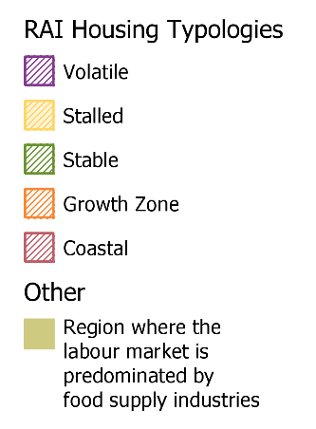
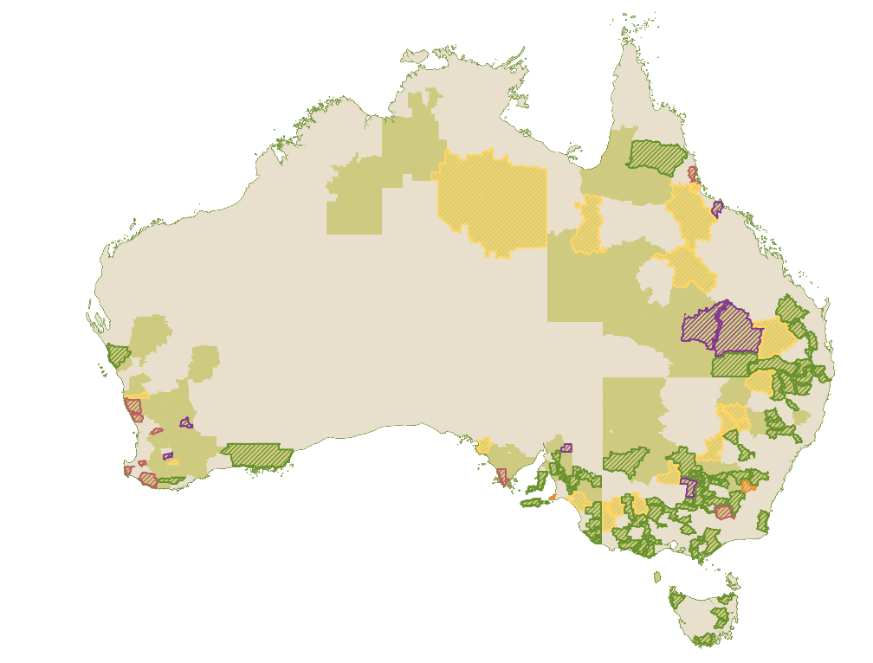
Source: ABS Census 2021, and Regional Australia Institute’s Housing Typologies (Local Government Areas).
As shown in Figure B.1, many regions where food supply chain employment is prevalent, particularly those in the Murray-Darling Basin, are considered stable. This category is characterised by property values that are relatively cheaper, stable and steadily growing. While providing stability for those already in the housing market, low vacancy rates and limited diversity in the housing mix in stable regions may disproportionately impact the choices of younger workers and the ability of these regions to attract new residents.
Other regions where food supply chain employment is common, particularly areas that are further inland, fall into the categories of stalled or volatile. These regions are characterised by small populations, low proportion of renters, low development activity and property values that are either stagnant or declining (stalled) or highly fluctuating (volatile). Low development activity in these markets may arise from the scale of local demand being insufficient to maintain a local building and development industry and construction costs exceeding the value of local housing. As such, these markets may benefit from modular, offsite and lower-cost construction options.
As explored further in the Migration Chapter, accommodation and housing pressures can heighten safety and exploitation risks for workers.
Access to affordable and quality accommodation and housing for workers in regional Australia is a critical enabler of the food supply chain. While there is no one-sized fits all solution, all levels of government must work together to address these significant barriers and target policy responses to local conditions. This includes addressing:
- long-term housing and rental availability to support workforce attraction and retention, including for workers that provide essential services to communities.
- the need for suitable temporary worker accommodation, including quality hostels and on-farm accommodation, and
- accommodation to support students to study and undertake placements in regional, rural and remote areas.
As will be further explored in the regional and industry profiles in this Appendix, coordinated action from all levels of government is essential to implement place-based solutions that address housing and planning constraints.

Services and infrastructure
Access to quality services and infrastructure can differ significantly across Australia. While smaller cities and regional centres act as service hubs for neighbouring regions, the quality of services and infrastructure in small towns, rural communities, and remote areas often does not meet the standards that Australians expect. This can encompass limited, patchy or substandard services and infrastructure across a range of areas including childcare, schools, health and aged care, leisure facilities, specialised stores, and telecommunication services. These factors can significantly impact the attractiveness of living and working in the region and impact efforts to recruit and retain workers in the food supply chain.
Importantly, these impacts go beyond the current or prospective worker and encompass all members of their household. JSA heard that some regional employers face recruitment difficulty due to a lack of employment, educational and recreational opportunities for a prospective worker’s partner and children. Moreover, digital infrastructure in these areas is often underdeveloped, making remote work and access to digital services more difficult. As noted by DAFF:
‘Regional housing pressures as well as lack of infrastructure in regional areas (childcare, jobs for spouses etc) add to difficulty in attracting people to roles in agriculture.’
With regional areas typically offering fewer affordable and accessible organised leisure options than urban areas, some employers have developed extensive packages and benefits to entice workers. This can include employers organising bus trips, movie nights and sport teams for their workers or offering boarding school packages for their employee’s children to try and remove location barriers to workforce attraction.

Transportation
Lack of affordable and reliable transport options to get employees to and from work in regional areas is a significant barrier to increased workforce participation. With a large proportion of the food supply chain workforce living outside of Australia’s major cities, the food supply chain is disproportionately impacted by poor road infrastructure and limited or no access to public transport networks. In addition to contributing to recruitment difficulties, solutions attempted by some employers such as buying or hiring private transportation for their employees can have an impact on labour costs.
As explored in 7. Education and Training, transport options and travel requirements can also be a major challenge for students wanting or needing to undertake industry placements, work experience or employment during their studies. Relocation can also be a major barrier to accessing tertiary education for regional, rural and remote students.

Social and cultural wellbeing
Social and cultural wellbeing barriers significantly impact workforce attraction and retention in Australia’s food supply chain, particularly in regional, rural, and remote areas. Manifesting in a variety of ways across Australia’s regions these include issues of isolation, feeling a sense of belonging, community development and cultural growth.
Access to cultural support organisations and community networks is crucial for supporting employees living far from friends and family across a range of situations including older individuals living in small towns, youth on remote stations, and workers from non-English speaking backgrounds who have relocated for work. However, JSA has heard these resources can be scarce in many regional, rural and remote areas, leaving workers without support, creating a key barrier to retention, as many workers report feelings of loneliness and dissatisfaction.
Many of these small and remote regions are facing ongoing demographic shifts, caused by factors including but not limited to an outflow of youth to cities and urban centres, migration patterns of overseas workers, and inflows of urban workers following housing price changes. In some cases, this is causing aging regional communities, slowing an area’s social and economic development and affecting general social and cultural wellbeing of those who remain.
Furthermore, overseas workers in remote areas often face additional challenges, such as difficulty accessing suitable places of worship or specific food, like halal options. This can further contribute to dissatisfaction, making it harder for these workers to have a positive work experience.
While regional, rural and remote Australia faces many challenges, it is important to acknowledge the many benefits of living outside of our major population centres. Strong communities, access to the natural environment and comparatively lower cost of living are just some of the factors that can encourage people to live, study and work right across Australia.

Food employment regions & place-based solutions
This section takes a closer look at different regional characteristics that drive employment patterns. It is followed by a series of industry profiles that explore these patterns in more depth, focusing on industry employment clusters. As this section shows, labour needs vary significantly across the food supply chain and between regions. In this context, there are opportunities to better tailor government programs, including those within employment services, to meet the specific needs of different regions.
The recent House of Representatives inquiry into Workforce Australia highlighted the critical need for place-based solutions in employment services, advocating for tailored and localised approaches rather than a one-size-fits-all model. While some programs, like the Local Jobs Program, are already targeted to local needs, more could be done across government to address local workforce challenges.
Some definitions of regional Australia used to target policies and programs are very broad, such as the definition of regional migration purposes referring to all areas outside of Sydney, Melbourne, and Brisbane. It is reasonable to question whether such broad definitions offer the level of detail and differentiation needed to address the unique circumstances of each region.

Box B.2: Working zones
Regional workforce analysis typically uses the Australian Statistical Geography Standard (ASGS) which partitions Australia’s population into consistent sizes for statistical analysis. Generally rural statistical areas have smaller populations but cover larger geographic areas than urban ones. These boundaries are not always ideal when doing spatial analysis of economic, social and policy issues. For example, the most common reasons for moving are a housing or relationship change, which might cause an individual to move statistical areas but not change their job or overall labour market. This creates noise when looking at internal migration, distracting from actual regional movements.
In response to this, the Bureau of Infrastructure and Transport Research Economics (BITRE) has developed Working Zones, which are ‘mutually exclusive regions delineated to reflect the commuting patterns of Australian workers.’ They are based on analysis of place of work and place of usual residence data by Statistical Area 2 (SA2) in the census. These zones reflect more realistic labour market regions that are not defined by arbitrary political or administrative boundaries. For many regional and remote SA2s, this is often equivalent to the SA2 itself, with additional useful outcomes including:
- Township SA2s often join with their surrounding regions into larger economic areas.
- SA2s within major cities join to form the single labour market that a city represents.
- Large sections of regional and remote Australia do not join when they are realistically too far away to represent the same labour markets.
As a result, working zones can more realistically reflect regional labour markets.


Predominant food employment regions
Figure B.2: Where food supply chain sectors are predominant in the local labour market
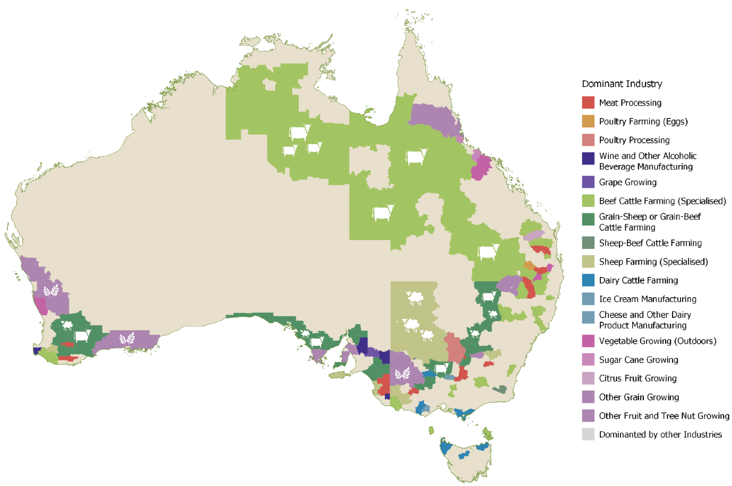
Source: ABS Census 2021. Place of work (SA2) by industry at the 4-digit level, aggregated to Working Zones. Note: Working zones reflect areas where the majority of workers both live and work without leaving the region’s boundaries. For many regions this is equivalent to an SA2 or combines a small town SA2 with its surroundings.
Figure B.2 shows regions that have been identified as areas where Food Production and Food Manufacturing employment is predominant in the local labour market. A region has been included where:
- the largest industry by employment size is in-scope, or
- at least two of the top three industries by employment are in scope.
This figure shows that food employment regions are often clustered together, forming areas of similar production such as the Beef Cattle Farming trail through the Northern Territory and Queensland, or clusters of Dairy employment predominant in Victoria and Northern Tasmania. Additionally, regions that are predominated by various Food Manufacturing industry workforces cluster near the Food Production of their relevant commodities, such as the clustering of Ice Cream or Cheese Production near Dairy Cattle Farming, or Meat Processing near Beef and Sheep Farming regions.
These regions where the food supply workforce plays an especially large part in a local labour market may warrant particular policy attention or specific place-based solutions. The high share of food supply chain employment in a local labour market can also be usefully considered alongside the region's industrial diversity, regional migration, and total gross value of agricultural production.


Industrial diversity
Figure B.3: The industrial workforce diversity of predominant food supply regions
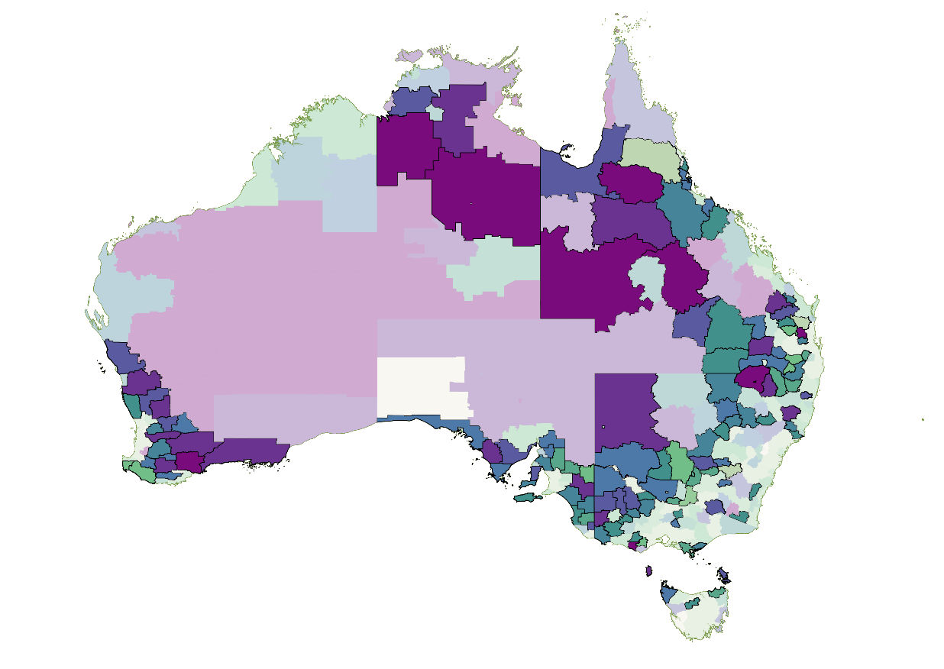
High Diversity Low Diversity
Source: ABS Census 2021. Place of work (SA2) by industry at the 4-digit level, aggregated to Working Zones. HHI derived by summing the square of each industry’s share of the workforce for each Working Zone.
Industrial diversity is a simple measure of regional stability that can provide a quick way to identify areas that may be at risk due to economic downturns, climate change and subsequent changes in land productivity, a major biosecurity emergency or other factors that might drive changes in the region’s labour market. Higher industrial diversity is also associated with lower unemployment rates in regional economies.
Figure B.3 shows an industrial diversity index known as the Herfindahl-Hirschman Index (HHI). It is relatively simple method of measuring economic concentration, where large values suggest very little industrial diversity (known as high specialisation) and small values suggest a very diversified region. For this analysis the industrial diversity is based on the number of workers in each industry at the 4-digit ANZSIC level. The HHI does not rely on a comparison to an average, instead simply evaluating how many sectors the working population in an area is spread across.
As shown in this figure, many of Australia’s food employment regions are diverse, incorporating a mix of sectors, particularly closer to the coast, as well as through regional NSW and Victoria. Coastal areas and urban centres tend to have much more diverse scores, reflecting Australia’s coastal population. In contrast, the more rural or regional areas are likely to be highly specialised, with some very remote regions having scores more than 20 times higher than major cities. Very high scores suggest that these regions rely on a few concentrated sectors to support their populations, particularly in the beef, sheep and grain farming regions noted in Figure B.2 on page 221. In these regions, changes in population can have large effects on the workforce numbers and industry compositions, as well as employers’ ability to find and hire workers.

Internal Migration
Figure B.4: Regional migration as a proportion of population in predominant food regions
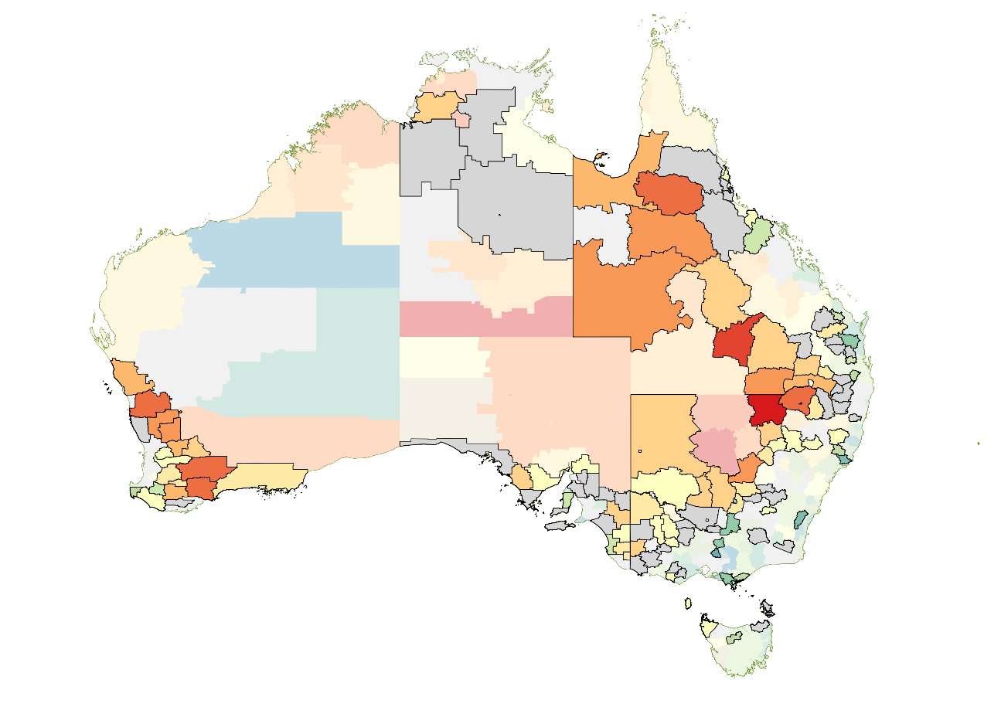
Negative Positive
Net Migration Net Migration
Source: ABS Census 2021. Usual residence at SA2 level in 2021 by usual residence 5 years ago (2016) at SA2 level, aggregated to Working Zones. Colours reflect net migration as a proportion of the population. Grey indicates less than 2% migration in either direction.
As Figure B.4 depicts the extent of the impact of net migration (considering natural increase plus movements in and out of the region) between 2016 and 2021. It shows that positive net migration to regional areas is mainly occurring along the coast, or very close to more largely populated farming areas of Victoria and NSW. Elsewhere, few food employment regions appear to be benefitting from increased population numbers with many rural areas suffering from negative net migration.
Research indicates that changes levels of regional migration and changes in the participation rate (e.g. due to an ageing population) can have significant effects on employment in a region. This may be due to a cycle in which reduced consumption inhibits the creation of new employment and business opportunities which in turn contributes to future negative net regional migration as individuals and families seek opportunities elsewhere.
Where regions are predominated by food employment, highly specialised, and suffering from net population loss, this may suggest a particular set of concerns from a food supply chain perspective. Understanding which of these regions also contribute significant agricultural value will further identify areas that are both very important and potentially quite fragile.

Agricultural Production Value
Figure B.5: Total Agricultural Production Value in predominant food regions
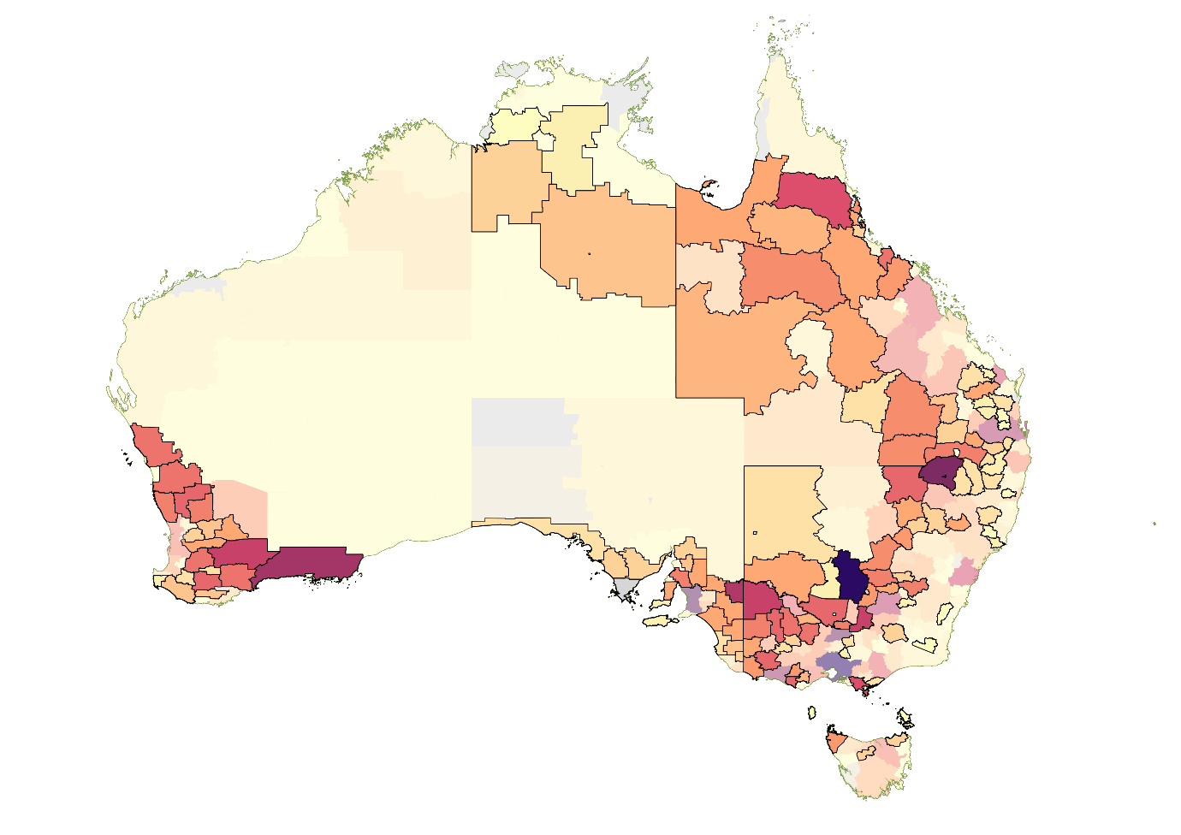
Low High
Source: ABS Data by Region, Economy and Industry, Agricultural Production – Total Gross Value by SA2 aggregated to Working Zones.
Figure B.6: Crops (left) and Livestock (right) value by predominantly food regions
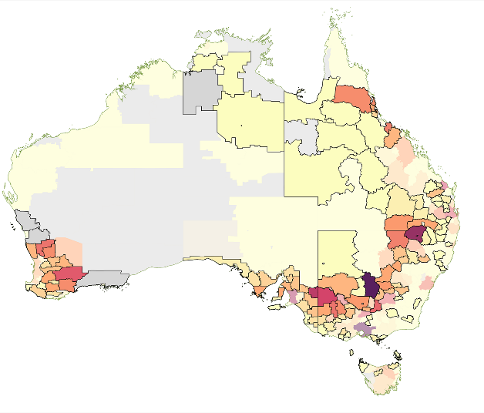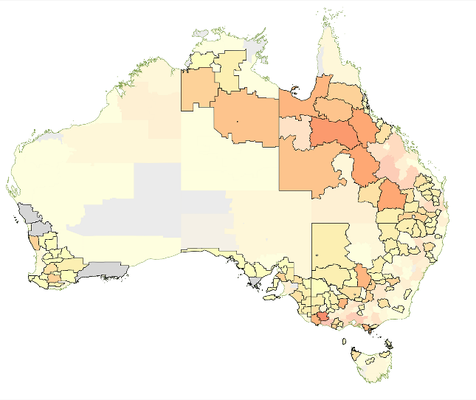
Low High
Source: ABS Data by Region, Economy and Industry, Crops – Total Gross Value (left) and Livestock slaughtered and other disposals – Total Gross Value (right) by SA2 aggregated to Working Zones.
The Value of Agricultural Production (Figure B.5) reflects the broader contribution of various regions to agricultural economic output spread across Australia. As in Figure B.6, this can be broken down further to distinguish between crop and livestock value. A number of Southern regions contribute significant value through crops, particularly Griffith in southwest NSW. Meanwhile, significant livestock value is clustered in the north of Australia corresponding with major beef regions, as well as some Southern pockets of sheep and lamb.

Industry and Regional Profiles

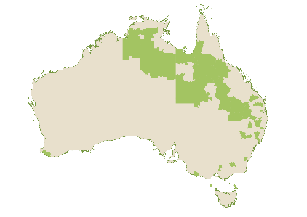
Northern beef cattle trail
Beef Cattle Farming occurs across many regions, however, as shown in Figure B.2, there is a clear and significant region across the North of Australia where it the dominant industry of employment. This aligns with beef herd accounts, with Queensland accounting for nearly half of Australia’s total beef cattle herds.
Across these northern regions, employment in the Beef Cattle Farming (Specialised) industry ranges from between 9% to 36% of local employment. Many of these regions also have very high industry concentration scores, with the second and third-largest sectors in the region often being Local Government Administration or relating to essential goods and services such as schools, hospitals and grocery stores which service a population anchored by Beef Cattle Farming as a key industry (Figure B.7). There are also multiple regions with high shares of Beef Cattle Farming employment where mining industries are also prominent.
Figure B.7: Predominant sectors in the top 10 dominant beef cattle employing regions

Source: ABS Census 2021. Place of work (SA2) by industry at the 4-digit level, aggregated to Working Zones. Values are the proportion of workers in that region employed in the industry.
Much of this this farming appears to occur specifically on big cattle stations, due to the larger tracts of otherwise less-productive land available in these areas. Cattle are raised in larger stations and then progress towards more urban centres where abattoirs and meat processing establishments are more likely to be located.

Accommodation and Living on Farm
Cattle stations have long been required to provide housing to workers, mainly due to the remote locations that are often involved. Station work requires skilled people who are also willing to encounter the isolated conditions that it poses. Workers live closely with each other for long periods of time, with stations often required to be largely self-sufficient due to the long distances that can exist between towns and regional centres in these very remote regions.

Mental health and wellbeing
Feedback from producers operating in this region suggested that while it was possible to attract staff to the roles, it was often very difficult to retain them, particularly entry-level workers, for whom the realities of station life may not live up to the expectations. They found that workers who originated in regions were more adapted to the lifestyle, and this hampered their ability to recruit from much larger pools of urban-born individuals.
We also heard about the importance of mental health and wellbeing supports in human resources practices and within the education and training system. Producers also noted that they were introducing similar training in-house to improve station cultures.

Transportation
The large expanse of land often required for beef cattle grazing means that many stations are located in very remote and difficult to reach locations. These regions often offer lower-quality transport infrastructure and are far from cities and towns.
Stakeholders noted that it is important for workers to have a driver's licence insofar as they allow workers to access the nearest towns on off-days. The ability to drive (e.g. to drive a side-by-side vehicle) or ride or a horse was also considered critical for undertaking station work such as mustering.

Data issues for remote areas
While we heard from stakeholders about workforce and occupation issues affecting industries in very remote regions, data in these very regional and remote areas is often supressed due to the small population numbers. While it is important to respect the privacy of individuals living and working in these regions, this can limit the visibility of these workers and the issues they face to policymakers and program managers. Working directly with small regions or industry participants may allow alternate qualitative or quantitative data collection that can be used to inform policy without compromising privacy concerns.

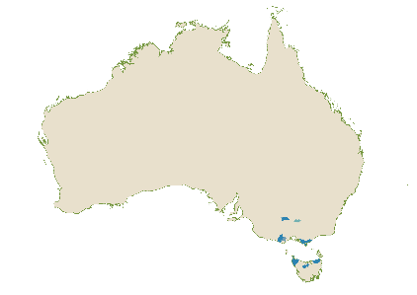
Southern Dairy
Southern Dairy regions are highly clustered through Victoria and Northern Tasmania, with Victoria home to around two thirds of the Australian Dairy Cattle Herd. While Dairy Farming and related sectors in Dairy Product Manufacturing or other livestock farming tend to cluster together, individual regions show a mix of both diversified and highly specialised industrial diversity as shown in Figure B.8.
Figure B.8: Predominant sectors in the top 10 dominant dairy employing regions
Source: ABS Census 2021. Place of work (SA2) by industry at the 4-digit level, aggregated to Working Zones. Values are the proportion of workers in that region employed in the industry.
It is also worth noting that a number of additional surrounding regions in Victoria place Dairy Cattle Farming within their top three employing industries but are more largely populated and as a result have a wider mix of industries. For example, the top industries by workforce in Warrnambool and surrounds are Hospitals, Dairy Cattle Farming and Aged Care Residential Services, and it was also estimated to have the have the largest dairy cattle herd in 2021.

Housing and Social Wellbeing
Figure B.9: Locations of Camperdown and Toora

The joint case studies of Camperdown and Toora in southwest and southeast Victoria shed light on the different ways in which workers respond to employment disruptions. In 2000, Bonlac closed dairy processing factories in both towns. Camperdown, where the jobs losses equated to 3% of the town’s workforce, remained the 9th most predominantly employing dairy region in 2021 (as shown in Figure B.8) and is located to the West of Melbourne and clustered with Corangamite-South and Colac. Toora, located to the East of Melbourne in Leongatha and Surrounds, next to Yarram, had experienced job losses equivalent to 42% of the town’s workforce.
In Toora, residents reported a shift in social demographics following the closures, and analysis of the housing market further suggested that many of the skilled workers who had lost their jobs moved away. In their place, a large number of individuals on fixed incomes had moved in from Melbourne due to the cheaper housing vacancies left by the dairy workers. This was reflected in changes to the income distribution of the town. This was further compounded by Toora’s closeness to other preferable housing locations, which allowed the higher skilled dairy professionals to remain detached from the town, living further away and commuting as necessary, straining the community fabric.
In contrast, Camperdown’s larger population provided it with a safety buffer post-closure. Workers here illustrated that out-migration can be only a small part of the response to shocks and that ‘if commuting is a viable alternative, then this is often a preferred option’. Camperdown’s larger nearby dairy industries were able to absorb the workers who lost their jobs, and its roads and infrastructure made it possible without workers needing to relocate, minimising disruption to the community. The larger and more diverse town also had other ways to maintain itself, its hospitals and services make it an attractive retirement town, while its connectivity to major hubs such as Melbourne allowed it to attract tourist visitors as well.
Both towns remain within strong dairy regions to this day. Of note, however, is that Toora appears to have pivoted to new forms of industry, in particular a large renewable wind farm, and a focus on local tourism.

Technology
Of further note, the Camperdown factory was later refurbished and opened under a new firm, but with a much lower workforce requirement. This indicates that ‘technology is a double-edged sword for communities – it maintains competitiveness of the enterprise but usually at the expense of jobs.’ As technology improves and works to increase the productivity of regional food supply work, sectors are likely to require less and less labour, potentially straining regional community populations, and reducing employment opportunities.

Transferrable skills & local industry competition
As shown in Figure B.8, Dairy employment tends to occur in regions alongside strong employment in Beef Cattle Farming and Meat Processing. Analysis of JSA’s Data on Occupation Mobility shows that workers in occupations specific to these industries, such as Beef Cattle Farmer and Meat Process Worker often exhibit mobility into out and of Dairy Cattle Farm Worker and Farmer roles. While it is unclear if this movement causes, or is the result of, co-location, the result is that Beef Cattle Farming and Meat Processing are likely to be engaging in competition for the same workers. By co-locating, this allows for a larger pool of available labour who share the skills and experience for managing and handling cattle, but also puts added pressure on industry to attract and retain workers.

Observation: High quality access, in the form of infrastructure and roads, can be a critical factor in helping regional communities maintain economic links with larger nearby hubs.

Observation: Policy work to address regional issues would benefit from collaboration with local and state governments to ensure approaches factor in the unique characteristics of each region.

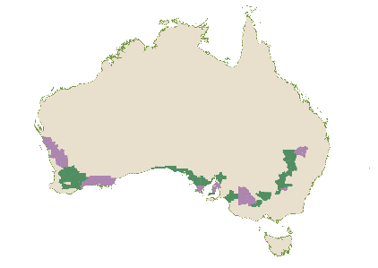
Grains and Mixed Livestock
Broadacre farming is the predominant employing sector in thirty-eight regions running along Australia’s Southern higher quality arable land. This overlaps with the Western Australian Wheatbelt, and the inland regions of NSW and Victoria, running down across South Australia. Many of these regions produce significant value from cropping.
Figure B.10: Predominant industries in the top 10 dominant grain/livestock employing regions

Source: ABS Census 2021. Place of work (SA2) by industry at the 4-digit level, aggregated to Working Zones. Values are the proportion of workers in that region employed in the industry.
Figure B.10 shows that Mixed Grain, Sheep and Beef Farming and Other Grain Farming often occur together to form dominant broadacre regions. These regions are geographically very large, with relatively small populations ranging from around 2,000 to 9,500, resulting in very low population densities.

Services and remoteness
Access to childcare services can be important in attracting and retaining workers. A lack of services can reduce the ability of parents to work and therefore impact businesses’ access to suitable workers, particularly in regions with already small labour pools. Due to the small and spread-out nature of towns, many childcare providers travel long distances to offer services.
Recognising this issue, the Western Australian Government introduced the Attraction and Retention Packages for Regional Child Care Workers Program to help local councils to address the specific barriers facing childcare education workers within their regions. The program delivered more than $250,000 in funding to ten local governments across regional Western Australia, with multiple shires in the Great Southern region receiving funding in 2024. The Shire of Gnowangerup received $20,798.05 to help subsidise the travel costs of educators, while the Shires of Dumbleyung, Broomehill-Tambellup and Denmark received funds to support specific daycare locations. The distinct solutions proposed by the different shires reflect the distinct location barriers faced by each in addressing this issue.
Observation: Placed-based programs can support local governments to address local challenges.

Isolation and mental health
Over 75% of all working zones have a population density of 10 or fewer people per square kilometre, making remoteness a key factor behind loneliness and isolation among the regional workforce. Around 1,700 of Australia’s cities and towns have fewer than 1,000 residents, with approximately 760 housing less than 200 people. This remoteness often coincides with ageing populations and significant social wellbeing challenges.
In areas like the Yorke Peninsula, many elderly residents live alone after losing a spouse or partner. And, as younger generations move away, nearby family support becomes less reliable, increasing residents’ dependence on friend networks. Elderly individuals whose children and grandchildren have relocated face barriers to maintaining contact, such as limited affordable transport, difficulty driving long distances, and family members living apart. In contrast, those with family members nearby or who have returned to the region report more frequent social contact and assistance with everyday tasks, like childcare, home maintenance, financial help, and driving.
A strong sense of community is vital for maintaining these regions and mitigating the negative effects of isolation. Research shows that wellbeing issues are widespread among farmers in Australia, with 45% reporting experiencing depression in recent years and 64% dealing with anxiety. Around 27% of farmers attribute these struggles to loneliness, isolation, and limited access to mental health services. Initiatives like the farmer-to-farmer lifeline phone service provide crucial support, offering farmers the change to speak with trained counsellors from farming backgrounds, who are uniquely placed to offer support and understanding.
Observation: Populations that are dispersed will have larger difficulties in accessing key services, such a childcare, which can further impede attraction and retention of the food supply workforce.

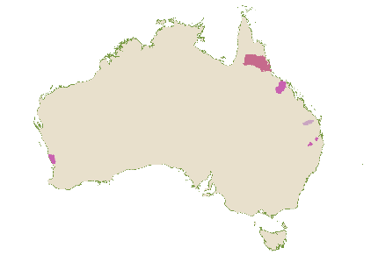
Vegetables and Fruits
Vegetable and fruit growing enterprises encompass a wide variety of commodities requiring different conditions, resulting in a diverse geographic arrangement of growing areas. Many fruits grow better in tropical regions, reflecting the clusters that appear in North Queensland.

Figure B.11: Predominant industries where vegetable/fruit are leading employers

Source: ABS Census 2021. Place of work (SA2) by industry at the 4-digit level, aggregated to Working Zones. Values are the proportion of workers in that region employed in the industry.
As Figure B.11 shows, fruit and vegetable regions do not show a consistent pattern beyond some co-location with either Beef Farming or Sugar Growing. Given Horticulture is often seasonal, it may have a smaller number of year-round employees accounted for in the Census, relying on a large surge workforce at peak periods such as harvest. This makes it less likely to be a predominant sector in a large region on the Census night.

Housing a seasonal workforce
JSA heard that in certain regions, harvests occur during peak holiday seasons, leading to workers competing with tourists for accommodation. This can prompt many producers to explore building accommodation on their own properties. However, as AUSVEG observed:
‘Growers have struggled to build accommodation on their own properties due to a range of issues including local council planning regulations, costs, and feasibility. This has forced growers to buy houses, hotels, and caravan parks to secure housing for workers.’
Horticulture stakeholders identified the need for nuanced solutions to deliver scaled, affordable and fit-for-purpose accommodation which can overcome challenges to increasing the stock of accommodation including planning regulations, infrastructure to support increased accommodation in regional areas and services to support increased populations.

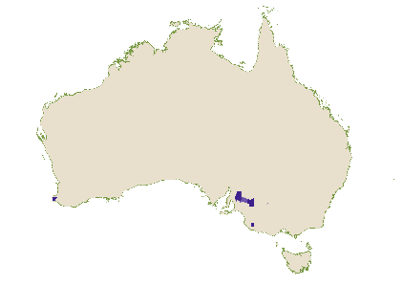
Wine and Grape Production
While wine and grape production occurs in many regions across Australia, there are a few select regions where these sectors are the predominant industry. These are mainly in South Australia, to the north-west of Adelaide, with a few pockets south-west of Adelaide, and in the Margaret River wine region.
Figure B.12: Predominant industries where wine & alcohol enterprises are leading employers
Source: ABS Census 2021. Place of work (SA2) by industry at the 4-digit level, aggregated to Working Zones. Values are the proportion of workers in that region employed in the industry.
Compared with other food predominant regions, most of the regions with high numbers of wine-related industry employment exhibit high industrial diversity, except for Robinvale and Penola. These two regions are relatively small both geographically and by population.
The larger regions represented in Figure B.12, such as Clare and Surrounds are predominant in wine making or grape production employment by only small margins, with only around 6% of workers employed in those industries. Additionally, their next two top industries are less likely to be focused on wine production. In the case of Margaret River and Augusta, the next two highest employing industries are accommodation and cafes/restaurants, which reflects the region’s nature as a tourism destination which is in part driven by agritourism.

Housing Stress, Rents and Migration
While some high producing and well-known wine regions are located closer to urban centres, the majority are more regional and require workers to live locally. This is posing an increasing challenge to winemakers and industry employers with ‘housing availability and costs [becoming] increasingly challenging in regional locations and now having an impact on employers and their capacity to meet labour needs’.
Wine producers in rural and regional South Australia in particular are experiencing hardships attracting workers of all skill levels, with regions further away from metropolitan centres generally struggling to fill staff vacancies. These difficulties are in part due to the broader changes in Australia’s housing market and migration toward the cities, but also follows from servicing and access issues. Employers are reporting that ‘access to public services, including health care and good quality education are also important’.

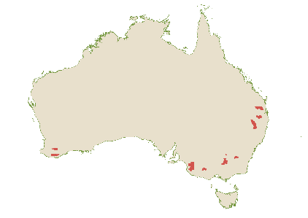
Meat Processing hubs
Figure B.2 on page 221 highlights regions dominated by the Meat Processing Workforce (marked in red). These regions form an interesting geospatial pattern, tracing an almost evenly spread line along the inland highway routes from South-East Queensland to South Australia. This likely reflects convenient access to both primary producers and major cities for distribution. Figure B.13 further shows that where Meat Processing is the largest employer, livestock production typically ranks second and/or third.
Figure B.13: Predominant industries in the top 10 Meat Processing employment regions

Source: ABS Census 2021. Place of work (SA2) by industry at the 4-digit level, aggregated to Working Zones. Values are the proportion of workers in that region employed in the industry.
Almost all Meat Processing regions have moderate industry diversity. The exception is Kilcoy, where approximately 38% of the workforce is engaged in Meat Processing, having risen from 32% of workers in 2016.
These regional employment areas are experiencing difficulties, with challenges filling roles due to location barriers and rising living costs. Feedback from the Australian Meat Industry Council (AMIC) indicates that ‘housing is difficult to obtain close to plants’, and subsequently transportation of workers is a looming issue. AMIC observed that:
‘There needs to be increased local initiatives which need to be fostered and actioned with milestones for the short-term and support a longer-term solution. It should not be an expectation that businesses be left to manage the housing crisis on their own.’


Griffth and Region (NSW)
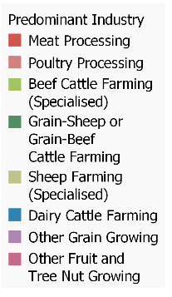
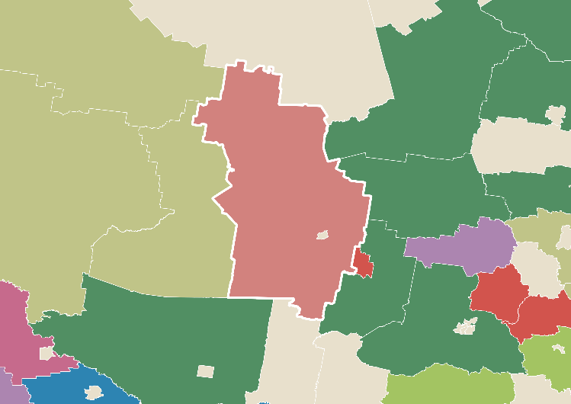
Of the in-scope food predominant regions, Griffith (NSW) and Griffith Surrounds had the highest agricultural production (by total gross value) in 2021, at over $1.5 million. A large amount of this value (around 80%) is estimated to come from the total gross value of crops, with the remainder from livestock value. The substantial production value of crops likely can be partially attributed to this region and its surrounds forming part of the Murrumbidgee Irrigation Area (MIA). which runs West from Narrandera.
Griffith
Narrandera
Source: ABS Census 2021. Place of work (SA2) by industry at the 4-digit level.
Figure B.14: Predominant Industries around Griffith
The region is an industrially diverse and robust region with a mix of both food-related economic activity and other industry activities. Approximately 36% of the workforce is employed in food supply related segments, with around 16% and 14% of the workforce employed in Food Production and Food Manufacturing, respectively.
The highest employing industry is Poultry Processing, at 6.5% of the workforce, followed closely by Wine and Other Alcohol Beverage Manufacturing (5.3%) and Hospitals (Excluding Psychiatric) (3.4%). This aligns with the fact that Griffith had the largest meat chicken flock in the country in 2021, one of two areas in the top 5 regions that are not in capital cities. The other regional area with large poultry flock numbers was Narrandera, located just South-East of Griffith as shown in Figure B.14.
The region sits at the cross-section of a varied agricultural production belt. The surrounding regions are predominated by a mix of employment in the grain-sheep and grain-beef farming, sheep farming, general grains, and beef farming industries. Many of these regions, whilst predominantly food regions, can also be considered reasonably diverse, with most scoring low to medium index scores.
Despite this, Griffith and surrounds, much like the rest of regional Australia, is facing workforce shortages across the region. Essential services, such as healthcare, in Griffith, have been struggling to attract and retain staff, with follow-on effects for a sustainable food supply workforce. As noted by the Australian Chicken Meat Federation (ACMF):
‘supply of labour is influenced by the liveability of rural and regional areas. Industry workforce entry and retention rates are influenced by factors such as access to affordable housing and the availability of quality schools, medical services, and public transportation.’
Even for thriving regions, it is important to ensure ongoing awareness of the challenges faced by smaller populations, and any supports they may need to maintain their liveability into the future.

Food Supply Work in Urban Regions
The previous regional profiles mostly explored large rural regions with smaller populations and vast geospatial areas. This analysis excluded cities and regional metropolitan areas from the analysis because, at an aggregate level, these areas are more diverse and populated economies.
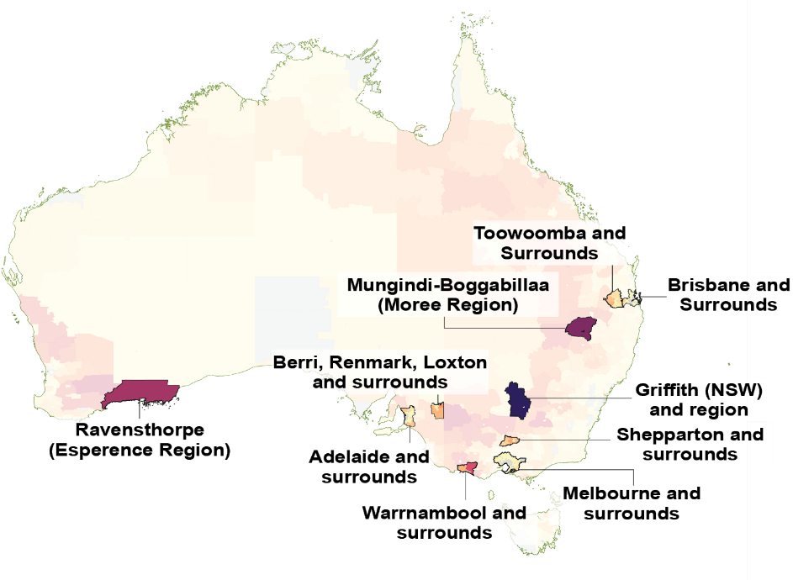
These centralised and aggregated regions represent key points on the food supply chain, creating economic and social benefit zones, which allow ‘greater choice of lifestyles through easier access to entertainment, social events, community organisations etc’.
Figure B.15: Top Regions by Agricultural Production Value
Figure B.15 and Figure B.16 show that three of Australia’s urban capital cities are considered in the top 10 regions when ranked by total agricultural production value, and the top region overall is Melbourne and Surrounds. Many of Australia’s major regional cities also feature.
Source: ABS Data by Region 2021, Economy and Industry Agricultural Production – Total Gross Value by SA2 aggregated to Working Zones.
Figure B.16: Crop and Livestock production value, by region

Source: ABS Data by Region, Economy and Industry 2021, Regions ordered by Agricultural Production – Total Gross Value by SA2 aggregated to Working Zones. Note: The Ravensthorpe SA2s included data relating to total gross value of agricultural production but did not include standalone values for crop and livestock breakdowns.
Of the top 10 regions by agricultural value, only four fall into the predominant food industry categorisation defined earlier (see page 221). They are Griffith, Mungindi-Boggabillaa, Ravensthorpe and Berry, Renmark, Loxton and Surrounds.

Melbourne and surrounds
Figure B.17: Agricultural production – Total Gross Value by SA2 (left) and top predominant food SA2s (right) within Melbourne and Surrounds
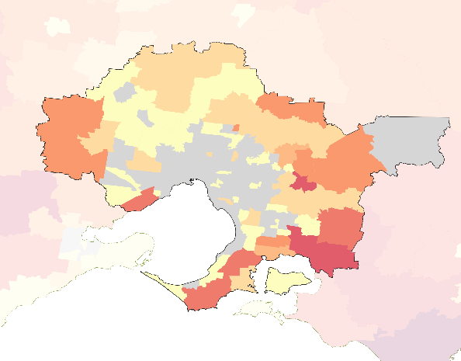  High  Low | Place of Work | Predominant Employing Food Industry
 | Cobblebank - Strathtulloh | Meat Processing
 | Cranbourne South | Vegetable Growing (Outdoors)
 | Doreen - North | Mushroom Growing
 | French Island | Beef Cattle Farming (Specialised)
 | Kinglake | Poultry Farming (Eggs)
 | Lalor - West | Fruit and Vegetable Wholesaling
 | Mickleham - Yuroke | Cured Meat and Smallgoods Manufacturing
 | Moorabbin Airport | Fruit and Vegetable Processing
 | Somerville | Poultry Processing
Source: ABS Data by Region, Economy and Industry 2021 and ABS Census 2021, Place of Work by SA2.
Figure B.17 shows that much of the total agricultural production value produced in Melbourne and Surrounds comes largely from food producing regions located towards the outer edges of the city. The dominant food supply industries tend to be a mix either of Meat or Poultry Processing, and Horticulture-focused activities.

Adelaide and surrounds
Figure B.18: Agricultural production – Total Gross Value by SA2 (left) and top predominant food SA2s (right) within Adelaide and Surrounds
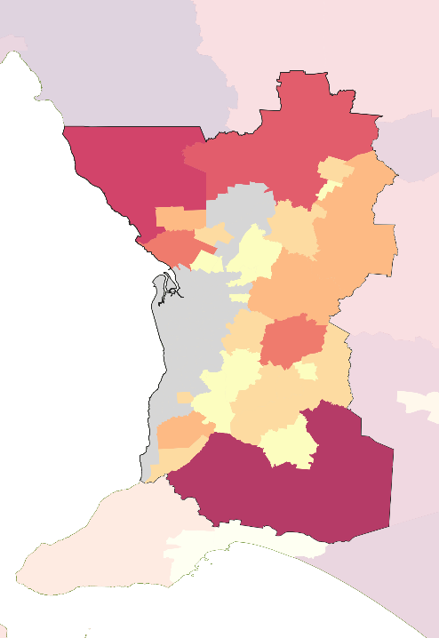  High  Low | Place of Work | Predominant Employing Food Industry
 | Barossa - Angaston | Wine and Other Alcoholic Beverage Manufacturing
 | Lewiston - Two Wells | Vegetable Growing (Outdoors)
 | Light | Wine and Other Alcoholic Beverage Manufacturing
 | Lobethal - Woodside | Meat Processing
 | Lyndoch | Wine and Other Alcoholic Beverage Manufacturing
 | Mallala | Vegetable Growing (Outdoors)
 | McLaren Vale | Wine and Other Alcoholic Beverage Manufacturing
 | Mount Barker Surrounds | Beef Cattle Farming (Specialised)
 | Nuriootpa | Wine and Other Alcoholic Beverage Manufacturing
 | Strathalbyn Surrounds | Wine and Other Alcoholic Beverage Manufacturing
 | Tanunda | Wine and Other Alcoholic Beverage Manufacturing
 | Virginia - Waterloo Corner | Vegetable Growing (Outdoors)
 | Windsor Gardens | Cereal, Pasta and Baking Mix Manufacturing
Source: ABS Data by Region, Economy and Industry 2021 and ABS Census 2021, Place of Work by SA2.

Adelaide and surrounds, like Melbourne, produces most of its total agricultural production value largely from Food Production and Manufacturing in the outer edges in the city. The most dominant food supply industry in this region is Wine and Other Alcoholic Beverage Manufacturing. South Australia’s wine and grape industries account for almost 80% of Australia’s premium wine, generating $1.9 billion for South Australia in 2022-23.

Brisbane and Toowoomba
As shown in Figure B.15 on page 235, Brisbane and Toowoomba, and their respective surrounds, are both members of the Top 10 largest value producing regions. These two regions sit adjacent to one another and are joined by the Lockyer Valley.
Figure B.19: Agricultural production – Total Gross Value by SA2 (map) and top predominant food SA2s (table) within Brisbane and Toowoomba and their respective Surrounds
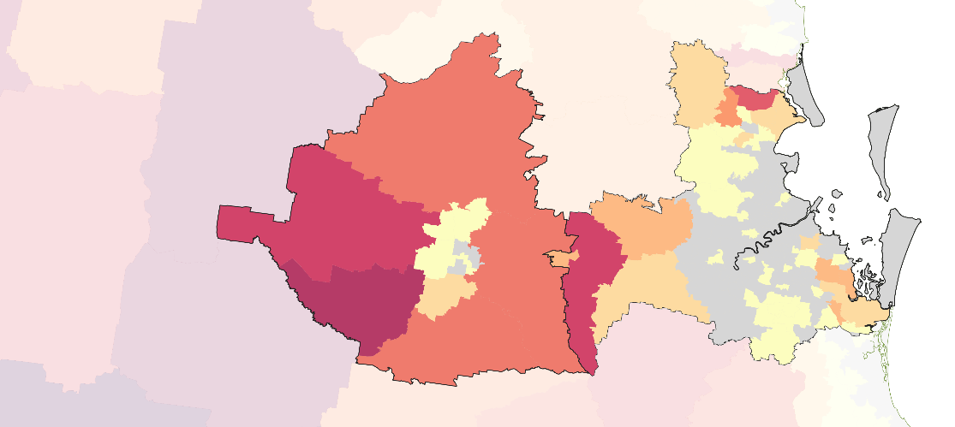
High
Low
Toowoomba-based Place of Work | Predominant Employing  Food Industry | Brisbane-based  Place of Work | Predominant Employing  Food Industry
Clifton - Greenmount | Beef Cattle Farming (Specialised) | Crestmead | General Line Grocery Wholesaling
Crows Nest - Rosalie | Beef Cattle Farming (Specialised) | Edens Landing - Holmview | Meat Processing
Jondaryan | Meat Processing | Elimbah | Berry Fruit Growing
Lockyer Valley - West | Meat Processing | Inala - Richlands | Soft Drink, Cordial and Syrup Manufacturing
Pittsworth | Poultry Farming (Eggs) | Jacobs Well - Alberton | Sugar Cane Growing
 |  | Lockyer Valley - East | Vegetable Growing (Outdoors)
 |  | Lowood | Meat Processing
 |  | Murarrie | Poultry Processing
 |  | Riverview | Meat Processing
 |  | Sheldon - Mount Cotton | Poultry Processing
 |  | Tingalpa | Potato, Corn and Other Crisp Manufacturing
 |  | Wamuran | Berry Fruit Growing
Source: ABS Data by Region, Economy and Industry 2021 and ABS Census 2021, Place of Work by SA2.
Food Production value in Brisbane and surrounds is located on the edges of the city, generally increasing in production value as the distance from the CBD increases. Food Production and Manufacturing is very diverse in this region and includes Meat and Poultry Processing, Beef Cattle Farming, Poultry Farming, Berry Fruit Growing, Sugar Cane Growing, Soft Drink, Cordial and Syrup Manufacturing, and Potato, Corn and Other Crisp Manufacturing.
Most of these food supply chain enterprises and industries that seem able to co-locate close to urban centres are those that take up smaller footprints. For example, when exploring working zone regions by the size of meat chicken flocks, most of the major cities and their surrounds lay claim to some of the largest flocks. This likely reflects the narrower footprint of Poultry Farming as an intensive farming enterprise. Vegetables as a commodity also demonstrates a similar relationship, with cities and their surrounding regions laying claim to some of the largest vegetable regions by hectare. This is reflected in the predominance of Vegetable Growing (Outdoors) employment in all three of the cities explored above.

Benefits of Urban Food Supply Work
The peri-urban areas on the fringes of our major cities act as important connective points in the food supply chain, where more rural production interacts with city-based food supply work. Food Production and Manufacturing that takes place closer to cities can bridge some of the workforce barriers faced in more regional locations. The advantage of cities as a social arrangement is in their ability to act as extremely large labour markets in a single place. This allows food supply chain firms access to a larger pool of workers in these regions with several subsequent benefits.
Benefits of proximity for food supply chain businesses and workers can include:
- reduction in costs to employers due to closer co-location of production and manufacturing
- lower transportation distances to consumers and export facilities
- education and training are more accessible and less likely to be impacted by diseconomies of scale
- greater exposure of people from urban areas to careers in the food supply chain, including through work placements that may not require relocation
- greater access to the infrastructure and services available in Australia’s major cities, and
- a greater number of opportunities for workers’ families.
For firms able to operate within the often smaller profile of land available in cities, there are clearly several workforce advantages. This is predicated on the ability to adapt food supply work to more urban environments, such as through intensive livestock, processing and protected cropping.
Box B.3: National Protected Cropping Centre
Vegetable Growing (Under Cover), a rough proxy for protected cropping, has expanded rapidly over the past decade, growing from around 200-300 workers in the 2000s to more than 1,200 in 2021. The majority of these workers (93%) are based in our Major Cities or Inner Regional areas. While industries like this may not appear amongst predominantly food employing regions due to their proximity to urban centres, and more efficient scale and footprints, they are important emerging industries.
In 2017, Western Sydney University and Hort Innovation launched the nation’s first National Vegetable Protected Cropping Centre at the university’s Hawkesbury campus. Due to its intensive nature, protected cropping can offer higher financial yields than other farming options, making it a viable contender for limited high-value land on the urban fringe. Additionally, it gives Food Production segments opportunities to employ from urban areas' larger population pool.
The centre features eight temperature-controlled research bays and one large-scale teaching bay. Using cutting-edge climate control technology, the centre enables researchers to produce the highest possible commercial yields with minimal labour, water, energy, and nutrient inputs. As an education and research facility for Australia’s protected cropping specialists, the centre, with its advanced technology and location on campus, may also offer an opportunity to the industry by attracting new entrants to the Horticulture sector.
The House Standing Committee on Agriculture highlighted the benefits of urban food supply chain work and recommended ‘the Australian Government, in conjunction with State and Territory Governments and local government, explore options for the development of urban agriculture, in particular as a means for developing skills and encouraging careers in agriculture.’

Clash with Urban Sprawl and City Growth Patterns
Despite their advantages, peri-urban farming is often challenged by urban growth patterns. Research has shown that farming activities are often consistently pushed out in favour of urban development, with housing and other city-focused activities taking precedence. Food supply chain industries in cities need to compete much more directly for resources like land, which are often much more expensive than non-capital city areas due to the increased demand.
Zoning systems across our major cities often limit ‘the amount of housing built close to the CBD’, forcing much of the population into the middle and outer rings. This is likely to result in higher commuting and time costs for workers in addition to the strain already caused by housing and accommodation costs across Australian cities. It also pushes firms and workers across multiple industries to compete for land.
The Victorian Government has taken steps this year to further protect land considered to be in its ‘green wedges’. These are regions within 100km of the city that are non-urban and lie outside the urban growth boundary. The Action Plan outlines a number of key measures relating to planning schemes in this area, with the aim of planning for future farming opportunities, stronger protections for non-urban uses, and tighter controls around urban uses of the land.
Protecting these important regions in the face of urban growth is important to preserve the role these regions play in supporting a strong and cohesive food supply chain workforce.
Observation: Programs that support peri-urban farming could be vital to protecting and ensuring the continued growth and presence of high-value Food Production activities near major population centres.

Food Manufacturing and Urban Movement Patterns
There is also a wealth of Food Manufacturing that occurs within cities. Just under 60% of workers employed in Food Manufacturing live within our major cities, working in processing centres that tend to be dotted around the mid to outskirts of city areas.
Figure B.20: Where Food Manufacturing workers work in Melbourne, Adelaide, and Brisbane
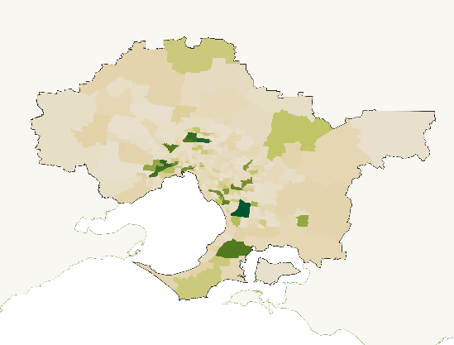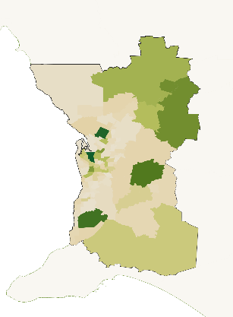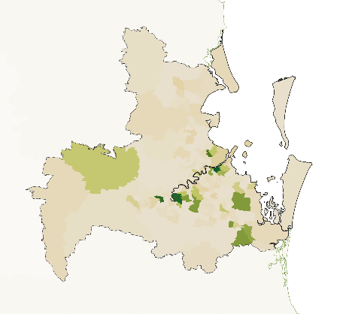
Source: ABS Census 2021, Place of Work by SA2, Aggregated to Working Zones.
This continues the trend seen in the Meat Processing Hubs profile, wherein Food Manufacturing tends to be concentrated in specific hubs. They often occur outside of the city centre, but not necessarily all the way to the city boundaries, and along major transport routes. In addition to this, there is some concentration around the port areas of cities such as Brisbane and Melbourne.
When looking at these workers’ place of residence relative to where they work, consistent commuting patterns occur. Where a given SA2 region appears to be a hub for Food Manufacturing activity, the individuals who work there tend to live clustered around that spot within the city. It is rare for workers to travel from their usual residence on the other side of the city to a place of work.
In major cities across Australia, average travel times are increasing, with the average now more than one hour per day. This increase in travel times has occurred as more people move out of metropolitan areas to regional locations due to high house prices and cost-of-living pressures. We have received feedback that Queensland beef cattle industry workers in city locations have been pushed away from living near their central office locations, leading to increased commute times overall.
Longer commute times carry health implications, including poorer mental health outcomes, stress, and increases in road rage incidents. Long commutes also impact work-life balance, ultimately leading to less time with family and friends, partaking in voluntary work, and participating in sporting groups and other community organisations. Research indicates that inflation and rising cost of living concerns are also beginning to impact Australian commuters' finances, with the average daily commute costing $20 per person, or $4,003 per year.

Cross-cutting and professional service roles
As explored in the Food Production profile, there is a growing professional services sector that works within and in support of the food supply chain. It employs high skilled workers across business consultancy, science, data and technology, financial services and many more areas that rely on Australia’s tertiary education system. Many of these roles can be and are performed from anywhere, providing rewarding food supply chain careers closer to major population centres.
Figure B.21: Proportion of agricultural scientists and technicians by remoteness areas

Source: ABS Census 2021, Population and Housing.
As shown in Figure B.21 most Agricultural and Fisheries Scientists and Technicians reside in major cities or inner regional areas, with exceptions such as Agronomists and Aquaculture or Fisheries Technician, who are more likely to be based in regions where on-site work is essential. This proximity to production is also seen in animal husbandry technicians, who are often drawn to rural areas for hands-on work.
Observation: The growing skilled food supply chain workforce, including professional and for-service roles, offers an opportunity to attract and retain workers in our major cities.

Appendix B: ANZSIC Industry Mapping

Food Production

ANZSIC Code | ANZSIC 4-Digit Class |  | ANZSIC Code |  |  | ANZSIC 4-Digit Class
Broadacre |  |  |  | Horticulture
A0140 | Sheep, Beef Cattle and Grain Farming, nfd |  |  | A0120 |  |  | Mushroom and Vegetable Growing, nfd
A0141 | Sheep Farming (Specialised) |  |  | A0121 |  |  | Mushroom Growing
A0142 | Beef Cattle Farming (Specialised) |  |  | A0122 |  |  | Vegetable Growing (Under Cover)
A0144 | Sheep-Beef Cattle Farming |  |  | A0123 |  |  | Vegetable Growing (Outdoors)
A0145 | Grain-Sheep or Grain-Beef Cattle Farming |  |  | A0130 |  |  | Fruit and Tree Nut Growing, nfd
A0146 | Rice Growing |  |  | A0131 |  |  | Grape Growing
A0149 | Other Grain Growing |  |  | A0132 |  |  | Kiwifruit Growing
A0150 | Other Crop Growing, nfd |  |  | A0133 |  |  | Berry Fruit Growing
A0151 | Sugar Cane Growing |  |  | A0134 |  |  | Apple and Pear Growing
A0159 | Other Crop Growing nec |  |  | A0135 |  |  | Stone Fruit Growing
A0180 | Deer Farming |  |  | A0136 |  |  | Citrus Fruit Growing
A0193 | Beekeeping |  |  | A0137 |  |  | Olive Growing
A0199 | Other Livestock Farming nec |  |  | A0139 |  |  | Other Fruit and Tree Nut Growing
Intensive Livestock |  |  |  | Dairy Farming
A0143 | Beef Cattle Feedlots (Specialised) |  |  | A0160 |  |  | Dairy Cattle Farming
A0170 | Poultry Farming, nfd
A0171 | Poultry Farming (Meat) |  |  | Aquaculture
A0172 | Poultry Farming (Eggs) |  |  | A0200 |  |  | Aquaculture, nfd
A0190 | Other Livestock Farming, nfd |  |  | A0201 |  |  | Offshore Longline and Rack Aquaculture
A0192 | Pig Farming |  |  | A0202 |  |  | Offshore Caged Aquaculture
A0143 | Beef Cattle Feedlots (Specialised) |  |  | A0203 |  |  | Onshore Aquaculture
Wild Catch |  |  |  | Food Production Support Services
A0400 | Fishing, Hunting and Trapping, nfd |  |  | A0520 |  |  | Agriculture and Fishing Support Services, nfd
A0410 | Fishing, nfd |  |  | A0529 |  |  | Other Agriculture and Fishing Support Services
A0411 | Rock Lobster and Crab Potting
A0412 | Prawn Fishing |  |  | Agriculture not further defined
A0413 | Line Fishing |  |  | A0100 |  |  | Agriculture, nfd
A0414 | Fish Trawling, Seining and Netting
A0419 | Other Fishing

Food Manufacturing

ANZSIC Code | ANZSIC 4-Digit Class |  | ANZSIC Code | ANZSIC 4-Digit Class
Meat and Meat Product Manufacturing |  |  | Dairy Product Manufacturing
C1110 | Meat and Meat Product Manufacturing, nfd |  | C1130 | Dairy Product Manufacturing, nfd
C1111 | Meat Processing |  | C1131 | Milk and Cream Processing
C1112 | Poultry Processing |  | C1132 | Ice Cream Manufacturing
C1113 | Cured Meat and Smallgoods Manufacturing |  | C1133 | Cheese and Other Dairy Product Manufacturing
Bakery Product Manufacturing |  |  | Beverage Manufacturing
C1170 | Bakery Product Manufacturing, nfd |  | C1200 | Beverage and Tobacco Product Manufacturing, nfd
C1171 | Bread Manufacturing (Factory based) |  | C1210 | Beverage Manufacturing, nfd
C1172 | Cake and Pastry Manufacturing (Factory based) |  | C1211 | Soft Drink, Cordial and Syrup Manufacturing
C1173 | Biscuit Manufacturing (Factory based) |  | C1212 | Beer Manufacturing
C1174 | Bakery Product Manufacturing (Non-factory based) |  | C1213 | Spirit Manufacturing
 |  |  | C1214 | Wine and Other Alcoholic Beverage Manufacturing
Other Food Manufacturing
C1100 | Food Product Manufacturing, nfd
C1120 | Seafood Processing
C1140 | Fruit and Vegetable Processing
C1150 | Oil and Fat Manufacturing
C1160 | Grain Mill and Cereal Product Manufacturing, nfd
C1161 | Grain Mill Product Manufacturing
C1162 | Cereal, Pasta and Baking Mix Manufacturing
C1180 | Sugar and Confectionery Manufacturing, nfd
C1181 | Sugar Manufacturing
C1182 | Confectionery Manufacturing
C1190 | Other Food Product Manufacturing, nfd
C1191 | Potato, Corn and Other Crisp Manufacturing
C1192 | Prepared Animal and Bird Feed Manufacturing
C1199 | Other Food Product Manufacturing nec
C1100 | Food Product Manufacturing, nfd

Transport and Distribution
ANZSIC Code | ANZSIC 4-Digit Class |  | ANZSIC Code | ANZSIC 4-Digit Class
Transport |  |  | Distribution
Freight Transport |  |  | Agricultural Wholesaling
I4610 | Road Freight Transport |  | F3310 | Agricultural Product Wholesaling, nfd
I4710 | Rail Freight Transport |  | F3312 | Cereal Grain Wholesaling
I4810 | Water Freight Transport |  | F3319 | Other Agricultural Product Wholesaling
 |  |  | F3323 | Industrial and Agricultural Chemical Product Wholesaling
Air and Space Transport |  |  | F3411 | Agricultural and Construction Machinery Wholesaling
I4900 | Air and Space Transport
 |  |  | Grocery Wholesaling
Transport Services |  |  | F3600 | Grocery, Liquor and Tobacco Product Wholesaling, nfd
I5211 | Stevedoring Services |  | F3601 | General Line Grocery Wholesaling
I5212 | Port and Water Transport Terminal Operations |  | F3602 | Meat, Poultry and Smallgoods Wholesaling
I5290 | Other Transport Support Services, nfd |  | F3603 | Dairy Produce Wholesaling
I5291 | Customs Agency Services |  | F3604 | Fish and Seafood Wholesaling
I5292 | Freight Forwarding Services |  | F3605 | Fruit and Vegetable Wholesaling
I5299 | Other Transport Support Services nec |  | F3606 | Liquor and Tobacco Product Wholesaling
 |  |  | F3609 | Other Grocery Wholesaling
 |  |  | Warehousing
 |  |  | I5300 | Warehousing and Storage Services, nfd
 |  |  | I5301 | Grain Storage Services
 |  |  | I5309 | Other Warehousing and Storage Services

References

Capel, L. (2024) Defining the agricultural workforce, ABARES, Australian Government, Australia.
House of Representatives Standing Committee on Agriculture (2023) Australian Food Story: Feeding the Nation and Beyond: Inquiry into food security in Australia, Parliament of Australia, Australian Government, Australia.
ABARES (2023) Snapshot of Australia’s agricultural workforce, ABARES, Department of Agriculture, Fisheries and Forestry (DAFF), Australian Government, Australia.
Jobs and Skills Australia (JSA) (2024) JSA-led stakeholder consultation meeting: Discussion on First Nations people in the food supply chain workforce, JSA, August 2024.
ABS (2021) Census of Population and Housing, ABS, Australian Government.
Closing the Gap (2024) Closing the gap targets and outcomes, Closing the Gap, accessed August 2024.
National Farmers Federation (NFF) & KPMG (2023) Realising the opportunity: Enhancing and strengthening Indigenous engagement as part of the growth of Australia agriculture, May 2023, NFF & KPMG, Australia.
Diversity Council Australia/Jumbunna Institute (2020) Gari Yala (Speak the Truth), Diversity Council Australia/Jumbunna Institute, accessed August 2024.
Diversity Council Australia/Jumbunna Institute (2020) Gari Yala (Speak the Truth), Diversity Council Australia/Jumbunna Institute, accessed August 2024.
NFF (2024) Jobs and Skills Australia Food Supply Chain Discussion Paper Response, NFF, Australia.
JSA (2024) JSA-led stakeholder consultation meeting: Discussion on First Nations people in the food supply chain workforce, JSA, August 2024.
JSA (2024) JSA-led stakeholder consultation meeting: Discussion on First Nations people in the food supply chain workforce, JSA, August 2024.
Indigenous Land and Sea Corporation (ILSC) Discussion Paper: Bushfoods, ILSC, Australian Government, Australia.
JSA (2024) JSA-led stakeholder consultation meeting: Discussion on First Nations people in the food supply chain workforce, JSA, August 2024.
Australian Bureau of Statistics (ABS) (2021) Census of Population and Housing, ABS, Australian Government.
ABS (2021) Census of Population and Housing, ABS, Australian Government.
ABS (2021) Census of Population and Housing, ABS, Australian Government.
Azarias, J., Nettle, R., & Williams, J. (2020) National Agricultural Workforce Strategy: Learning to excel, National Agricultural Labour Advisory Committee, Canberra, December.
ABS (2021) Census of Population and Housing, ABS, Australian Government.
Azarias, J., Nettle, R., & Williams, J. (2020) National Agricultural Workforce Strategy: Learning to excel, National Agricultural Labour Advisory Committee, Canberra, December.
Boult, C., & Chancellor, W. (2020) Productivity of Australian broadacre and dairy industries, 2018-19, ABARES, DAFF, Australian Government, Australia.
Barr, N., & Kancans, R. (2020) Trends in the Australian Agricultural Workforce: What can data from the Census of Population and Housing tell us about changes in agricultural employment?, ABARES, DAFF, Australian Government, Australia.
ABS (2006) Census of Population and Housing, ABS, Australian Government; ABS (2021) Census of Population and Housing, ABS, Australian Government.
Australian Farm Institute (2013) Farmers are getting older but its not a problem, Australian Farm Institute, accessed August 2024.
ABS (2021) Census of Population and Housing, ABS, Australian Government.
ABARES (2024) ABARES Farm Data Portal, Farm Performance by Size, Labour and Age of owner manager, ABARES, DAFF, accessed July 2024.
ABS (2024) Single Touch Payroll Data, ABS, Australian Government.
ABS (2021) Census of Population and Housing, ABS, Australian Government.
Downham, R., & Litchfield, F. (2022) Labour use in Australian agriculture: Analysis of survey results, 2021-22, ABARES, DAFF, Australian Government, Australia.
Azarias, J., Nettle, R., & Williams, J. (2020) National Agricultural Workforce Strategy: Learning to excel, National Agricultural Labour Advisory Committee, Canberra, December.
Downham, R., & Litchfield, F. (2022) Labour use in Australian agriculture: Analysis of survey results, 2021-22, ABARES, DAFF, Australian Government, Australia.
Azarias, J., Nettle, R., & Williams, J. (2020) National Agricultural Workforce Strategy: Learning to excel, National Agricultural Labour Advisory Committee, Canberra, December.
Litchfield, F., Weragoda, A., Frilay, J., & Thompson, T. (2019) Australian vegetable-growing farms: An economic survey, 2017-18 and 2018-19, ABARES, DAFF, Australian Government, Australia.
ABS (2024) Single Touch Payroll Data, ABS, Australian Government.
ABS (2021) Census of Population and Housing, ABS, Australian Government.
ABS (2021) Census of Population and Housing, ABS, Australian Government.
Azarias, J., Nettle, R., & Williams, J. (2020) National Agricultural Workforce Strategy: Learning to excel, National Agricultural Labour Advisory Committee, Canberra, December.
Boult, C., & Jackson, T. (2019) Disaggregating farm performance statistics by size, 2017-18, Agricultural Commodities: March quarter 2019, ABARES, DAFF, Australian Government, Australia.
Azarias, J., Nettle, R., & Williams, J. (2020) National Agricultural Workforce Strategy: Learning to excel, National Agricultural Labour Advisory Committee, Canberra, December.
ABS (2024) Single Touch Payroll Data, ABS, Australian Government.
ABS (2021) Census of Population and Housing, ABS, Australian Government.
ABS (2021) Census of Population and Housing, ABS, Australian Government.
NFF (2024) Submission to Jobs and Skills Australia Food Supply Chain Capacity Study, NFF, Australia.
ABS (2021) Census of Population and Housing, ABS, Australian Government.
ABS (2024) Single Touch Payroll Data, ABS, Australian Government.
ABS (2021) Census of Population and Housing, ABS, Australian Government.
ABARES (2023) Agricultural commodities: December quarter 2023 – Statistical tables, ABARES, DAFF, Australian Government, accessed July 2024.
ABARES (2023) Australian fisheries and aquaculture statistics 2022, ABARES, DAFF, Australian Government.
ABS (2021) Census of Population and Housing, ABS, Australian Government.
ABS (2021) Census of Population and Housing, ABS, Australian Government.
ABS (2024) Single Touch Payroll Data, ABS, Australian Government.
ABS (2024) Single Touch Payroll Data, ABS, Australian Government.
ABS (2021) Census of Population and Housing, ABS, Australian Government.
Australian Fisheries Management Authority (AFMA) (2024) Northern Prawn Fishery, AFMA, accessed August 2024; Queensland Government (2019) Queensland Gulf of Carpentaria Inshore Fin Fish Fishery: Status report for reassessment and approval under protected species and export provisions of the Environment Protection and Biodiversity Conservation Act 1999, Queensland Government, June 2019, Queensland.
ABS (2021) Census of Population and Housing, ABS, Australian Government.
ABS (2021) Census of Population and Housing, ABS, Australian Government.
ABS (2024) Single Touch Payroll Data, ABS, Australian Government.
ABS (2021) Census of Population and Housing, ABS, Australian Government.
ABS (2021) Census of Population and Housing, ABS, Australian Government.
House of Representatives Standing Committee on Agriculture (2023) Australian Food Story: Feeding the Nation and Beyond: Inquiry into food security in Australia, Parliament of Australia, Australian Government, Australia.
Food Frontier (2024) Jobs and Skills Australia Food Supply Chain Capacity Study Terms of Reference Response, Food Frontier, Australia.
JSA (2023) The Clean Energy Generation: Workforce needs for a net zero economy, JSA, Australian Government, Australia.
ABS (2021) Census of Population and Housing, ABS, Australian Government.
JSA (2024) Occupation Shortage List, JSA, accessed August 2024.
ABS (2024) Labour Account Australia, Final Quarterly Balanced: Subdivision, Division and Total All Industries, Q3 2014 – Q2 2024, ABS, Australian Government.
ABS (2021) Census of Population and Housing, ABS, Australian Government.
ABS (2021) Census of Population and Housing, ABS, Australian Government.
ABS (2021) Census of Population and Housing, ABS, Australian Government.
ABS (2021) Census of Population and Housing, ABS, Australian Government.
SG Heilbron Economic & Policy Consulting (2020) Evaluating the socio-economic benefit of the red meat processing industry in regional Australia, Report prepared for Australian Meat Processor Corporation (AMPC), Australia.
ABS (2021) Census of Population and Housing, ABS, Australian Government.
ABS (2021) Census of Population and Housing, ABS, Australian Government.
ABS (2024) Single Touch Payroll Data, ABS, Australian Government.
ABS (2021) Census of Population and Housing, ABS, Australian Government.
ABS (2021) Census of Population and Housing, ABS, Australian Government.
ABS (2021) Census of Population and Housing, ABS, Australian Government.
ABS (2021) Census of Population and Housing, ABS, Australian Government.
ABS (2024) Single Touch Payroll Data, ABS, Australian Government.
ABS (2021) Census of Population and Housing, ABS, Australian Government.
ABS (2021) Census of Population and Housing, ABS, Australian Government.
ABS (2024) Single Touch Payroll Data, ABS, Australian Government.
ABS (2024) Single Touch Payroll Data, ABS, Australian Government.
ABS (2021) Census of Population and Housing, ABS, Australian Government.
ABS (2021) Census of Population and Housing, ABS, Australian Government.
ABS (2024) Single Touch Payroll Data, ABS, Australian Government.
ABS (2021) Census of Population and Housing, ABS, Australian Government.
Victorian Government (2024) Heavy Vehicle Training Program, Victoria Government, accessed August 2024.
JSA (2024) 2024 Occupation Shortage List: Key Findings and Insights Report, JSA, Australian Government, Australia.
Commonwealth Scientific and Industrial Research Organisation (CSIRO) (2024) Supply Chain Transport and Logistics Dashboard: TraNSIT, CSIRO, accessed August 2024.
Bureau of Infrastructure, Transport and Regional Economics (BITRE) (2014) Freightline I – Australian freight transport overview, Department of Infrastructure and Regional Development, Australian Government, Australia; Commonwealth Scientific and Industrial Research Organisation (CSIRO) (2024) Supply Chain Transport and Logistics Dashboard: TraNSIT, CSIRO, accessed August 2024; The Department of Infrastructure, Transport, Regional Development, Communications and the Arts (DITRDCA) Supporting papers for the Inquiry into National Freight and Supply Chain Priorities, DITRDCA, Australian Government, accessed August 2024; DITRDCA (2024) Factsheet: Coastal Shipping Reform, DITRDCA, Australian Government, accessed August 2024.
ABS (2021) Census of Population and Housing, ABS, Australian Government.
ABS (2021) Census of Population and Housing, ABS, Australian Government.
CSIRO (2024) Supply Chain Transport and Logistics Dashboard: TraNSIT, CSIRO, accessed August 2024.
CSIRO (2024) Supply Chain Transport and Logistics Dashboard: TraNSIT, CSIRO, accessed August 2024.
ABS (2024) Counts of Australian Businesses, including Entries and Exits, June 2019 to June 2023, ABS, Australian Government.
ABS (2024) Single Touch Payroll Data, ABS, Australian Government.
ABS (2021) Census of Population and Housing, ABS, Australian Government.
ABS (2021) Census of Population and Housing, ABS, Australian Government.
ABS (2021) Census of Population and Housing, ABS, Australian Government.
ABS (2024) Single Touch Payroll Data, ABS, ABS, Australian Government.
ABS (2021) Census of Population and Housing, ABS, Australian Government.
Animal Medicines Australia (2022) Pets in Australia: A national survey of pets and people, Animal Medicines Australia, Canberra.
AVA (2024) Veterinary Workforce Survey 2023/24, AVA, accessed October 2024.
ABS (2006) Census of Population and Housing, ABS, Australian Government; ABS (2021) Census of Population and Housing, ABS, Australian Government.
New South Wales Legislative Council (2024) Veterinary workforce shortages in New South Wales, June 2024, Report 58, Parliament of New South Wales.
AVA (2023) Inquiry into Veterinary Workforce Shortages in New South Wales: Submission 144, AVA, Australia.
AVA (2021) Workforce survey salary integration, AVA, PowerPoint, accessed August 2024.
JSA (2024) Occupation Shortage List, JSA, accessed August 2024.
Social Research Centre (2024) Survey of Employers who have Recently Advertised (SERA), Social Research Centre, report prepared for JSA, Australia.
DAFF (2023) Inquiry into Veterinary Workforce Shortages in New South Wales: Submission 193, DAFF, Australia.
Quality Indicators for Learning and Training (QILT) (2023) Graduate Outcomes Survey (GOS), QILT, Australian Government, Australia.
Australian Taxation Office (ATO) (2021) Taxation Statistics 2020-21 Individuals: Average and median taxable income, salary or wages, and total income, by occupation unit group and sex, JSA analysis, ATO, Australia.
JSA (2023) VET Outcomes Data 2018-19, JSA, Australian Government, Australia.
JSA analysis of linked VET activity and individual taxation statistics.
ABS (2021) Census of Population and Housing, ABS, Australian Government.
New South Wales Legislative Council (2024) Veterinary workforce shortages in New South Wales, June 2024, Report 58, Parliament of New South Wales.
Veterinary Nurses Council of Australia (VNCA) (2023) Inquiry into Veterinary Workforce Shortages in New South Wales: Submission 201, VNCA, Australia; The Veterinary Nursing Research Group (2023) Inquiry into Veterinary Workforce Shortages in New South Wales: Submission 152, The Veterinary Nursing Research Group, Australia; Deacon, R., & Brough, P. (2017) Veterinary nurses’ psychological well-being: The impact of patient suffering and death, Australian Journal of Psychology, Vol. 69 (2), pp. 77–85. https://doi.org/10.1111/ajpy.12119.
JSA (2024) Survey of Employers who have Recently Advertised, JSA, Australian Government, Australia.
AVA (2024) Veterinary Workforce Survey 2023/24, AVA, accessed October 2024.
JSA (2023) Recruitment Spotlight: Employers’ unrealised vacancies, JSA, Australian Government, Australia.
ABS (2021) Census of Population and Housing, ABS, Australian Government.
ABS (2021) Australian Census and Migrants Integrated Dataset (ACMID), ABS, Australian Government.
VNCA (2024) Terms of Reference for the Working Party on Statutory Regulation of Veterinary Nurses and Technicians in Australia, VNCA, Australia.
ABS (2021) Census of Population and Housing, ABS, Australian Government.
QILT (2022) Transparency in Higher Education Expenditure, QILT, accessed August 2024.
Deloitte (2022) Transparency in Higher Education Expenditure, Deloitte, report produced for the Department of Education, Skills and Employment, Australian Government, Australia.
Australian Veterinary Boards Council (AVBC) (2024) AVBC Accreditation Standards for Veterinary Programs, AVBC, Melbourne.
Veterinary Schools of Australia and New Zealand (VSANZ) (2023) Rethinking Veterinary Education, VSANZ, Australia and New Zealand.
VSANZ (2023) Rethinking Veterinary Education, VSANZ, Australia and New Zealand.
Department of Education (2024) Australian Universities Accord: Final Report, Australian Government, Australia.
Department of Education (2024) 2021 Indexed Rates, Department of Education, Australian Government, accessed October 2024.
VSANZ (2023) Rethinking Veterinary Education, VSANZ, Australia and New Zealand.
DAFF (2023) Inquiry into Veterinary Workforce Shortages in New South Wales: Submission 193, DAFF, Australian Government, Australia.
AVA (2024) Essential nature of veterinarian’s work ignored by Federal Government, AVA, accessed August 2024.
Department of Education (2024) Commonwealth Prac Payment, Department of Education, Australian Government, accessed August 2024.
Animal Medicines Australia (2022) Pets in Australia: A national survey of pets and people, Animal Medicines Australia, Canberra.
Australian Government (2024) Budget 2024-25: Women’s Budget Statement, Australian Government, Australia.
Department of Education (2024) Higher Education Statistics, JSA analysis, Department of Education, Australian Government, Australia.
DAFF (2022) National Biosecurity Strategy, DAFF, Australian Government, Australia.
DAFF (2022) National Biosecurity Strategy, DAFF, Australian Government, Australia.
CSIRO (2020) Australia’s Biosecurity Future: Unlocking the next decade of resilience (2020-2030), CSIRO, Australia.
Australian Chicken Meat Federation (ACMF) (2024) Jobs and Skills Australia Food Supply Chain Discussion Paper Response, ACMF, Australia.
Department of Agriculture, Water and the Environment (2021) Australian Export Meat Inspection System (AEMIS): Post-mortem inspection roles of the Food Safety Meat Assessor (FSMA) in red meat processing establishments, Australian Government, Australia.
NSW Government (2024) Your role in Biosecurity: Primary producers, NSW Government, accessed August 2024.
Labour Hire Authority (2024) Key industries, Labour Hire Authority, Victoria Government, accessed August 2024.
ABS (2024) Labour hire workers, ABS, Australian Government, accessed August 2024.
ABS (2024) Jobs and Income of Employed Persons, 2020-21, ABS, Australian Government.
Downham, R., & Litchfield, F. (2022) Labour use in Australian agriculture: Analysis of survey results, 2021-22, ABARES, DAFF, Australian Government, Australia.
Howe, J., Clibborn, S., Reilly, A., Van den Broek, D., & Wright, C. (2019) Towards a Durable Future: Tackling Labour Challenges in the Australian Horticulture Industry, The University of Adelaide, Australia.
Australian Fresh Produce Alliance (AFPA) (2024), Jobs and Skills Australia Food Supply Chain Discussion Paper Response, AFPA, Australia.
ABS (2024) Labour hire workers, ABS, Australian Government, accessed August 2024.
Fair Work Ombudsman (2023) Fair Work Ombudsman finds a mixed bag as Ag sector inspections continue, Fair Work Ombudsman, Australian Government, accessed August 2024.
Fair Work Ombudsman (2023) Fair Work Ombudsman finds a mixed bag as Ag sector inspections continue, Fair Work Ombudsman, Australian Government, accessed August 2024.
Fair Work Ombudsman (2018) Harvest Trail Inquiry: A report on workplace arrangements along the Harvest Trail, Fair Work Ombudsman, Australian Government, Australia.
Department of Employment and Workplace Relations (DEWR) (2019) Report of the Migrant Workers’ Taskforce, DEWR, Australian Government, Australia.
DEWR (2019) Report of the Migrant Workers’ Taskforce, DEWR, Australian Government, Australia.
Fair Work Ombudsman (2015) Statement of Findings – Baiada Group, Fair Work Ombudsman, Australian Government, accessed August 2024; Howe, J., Clibborn, S., Reilly, A., Van den Broek, D., & Wright, C. (2019) Towards a Durable Future: Tackling Labour Challenges in the Australian Horticulture Industry, The University of Adelaide, Australia; DEWR (2019) Report of the Migrant Workers’ Taskforce, DEWR, Australian Government, Australia.
DEWR (2019) Report of the Migrant Workers’ Taskforce, DEWR, Australian Government, Australia.
DEWR (2019) Report of the Migrant Workers’ Taskforce, DEWR, Australian Government, Australia.
Clibborn, S., & Wright, C. (2018) Employer theft or temporary workers’ wages in Australia: Why has the state failed to act?, The Economic and Labour Relations Review, Vol. 29 (2), pp. 207-227.
DEWR (2019) Report of the Migrant Workers’ Taskforce, DEWR, Australian Government, Australia.
Office of the NSW Anti-slavery Commissioner (2024) Be Our Guests: Addressing urgent modern slavery risks for temporary migrant workers in rural and regional New South Wales, Office of the NSW Anti-slavery Commissioner, NSW Government, Australia.
Australasian Meat Industry Employers Union (AMIEU) (2024) Jobs and Skills Australia Food Supply Chain Discussion Paper Response, AMIEU, Australia.
Berries Australia (2024) Berries Australia Submission into the Review of Regional Migration Settings, Berries Australia, Australia.
Barry, K. (2020) Momentarily immobile: Backpacking, farm work, and hostels in Bundaberg, Australia, Geographical Research, Vol. 59 (1), pp. 46-55.
Clibborn, S., & Wright, C. (2018) Employer theft or temporary workers’ wages in Australia: Why has the state failed to act?, The Economic and Labour Relations Review, Vol. 29 (2), pp. 207-227.
Barry, K., Azeredo, R., & Balle-Bowness, A. (2023) Turbulent Times: The State of Backpacking and Seasonal Farm Work in Australia, Griffith University, Brisbane.
ABS (2024) Labour hire workers, ABS, Australian Government, accessed August 2024.
Azarias, J., Nettle, R., & Williams, J. (2020) National Agricultural Workforce Strategy: Learning to excel, National Agricultural Labour Advisory Committee, Canberra.
ABS (2011 & 2021) Census of Population and Housing, ABS, Australian Government.
Skills Insight (2024) Workforce Plan 2024, Skills Insight, Australia.
Skills Insight (2024) Jobs and Skills Australia Food Supply Chain Discussion Paper Response, Skills Insight, Australia.
Santhanam-Martin, M., & Cowan, L. (2018) Making “middle managers”: Workforce development for agricultural industries in transition, 13th European IFSA Symposium, 1-5 July 2018, Chania, Greece.
NFF (2022) Inquiry into the Perceptions and Status of Vocational Education and Training — NFF Submission, NFF, Australia.
Skills Impact (2019) Submission to the inquiry of the Agriculture and Water Resources Committee on growing Australian agriculture to $100bn by 2030, Skills Impact, Australia.
White, I., De Silva, N., & Rittie, T. (2018) Uncredited training: why employers use it and does it meet their needs?, National Centre for Vocational Education Research (NCVER), Commonwealth of Australia.
White, I., De Silva, N., & Rittie, T. (2018) Uncredited training: why employers use it and does it meet their needs?, NCVER, Commonwealth of Australia.
Australian Beverages Council (2024) Jobs and Skills Australia Food Supply Chain Discussion Paper Response, Australian Beverages Council, Australia.
Skills Insight (2024) Worker Safety Induction Pilot, Skills Insight, accessed October 2024.
Skills Insight (2024) Worker Safety Induction Pilot, Skills Insight, accessed October 2024.
Skills Insight (2024) Worker Safety Induction Pilot, Skills Insight, accessed October 2024.
Skills Insight (2024) Worker Safety Induction Pilot, Skills Insight, accessed October 2024.
Nettle, R., La, N., & Smith, E. (2018) Research Report B: Supply of farm advisory and extension services, prepared for: Stimulating private sector extension in Australian agriculture to increase returns from R&D, A project of the Department of Agriculture and Water Resources Rural R&D for profit program, University of Melbourne, Melbourne, Australia.
NCVER (2024) Total VET Activity Data, NCVER, Australia.
Department of Primary Industries (2024) Total College 2023/24 score card, Department of Primary Industries, NSW Government, accessed October 2024.
NCVER (2024) Total VET Activity Data, NCVER, Australia.
Australian Qualifications Framework (AQF) (2024) AQF qualifications, AQF, accessed October 2024.
ABS (2021) Australian Census and Migrants 2021, ABS, Australian Government.
ABS (2021) Census of Population and Housing, ABS, Australian Government.
Custom Department of Education microdata (2024) courses in narrow field of education, Department of Education, Australian Government; Department of Education, Skills and Employment (2024) uCube – Higher Education Statistics, Department of Education, Skills and Employment, Australian Government.
Department of Education (2024) Key findings from the 2023 Higher Education Statistics, Department of Education, accessed October 2024.
QILT (2023) Graduate Outcomes Survey 2023, QILT, Australia.
Newsome, L., & Sheridan, A. (2018) The Professional Agricultural Services Sector, Australasian Agribusiness Review, Vol. 26, ISSN: 1442-6951.
ABS (2021) Census of Population and Housing, ABS, Australian Government.
JSA (2024) Occupation Shortage List, JSA, accessed October 2024.
Department of Education (2024) Australian Universities Accord, Department of Education, Australian Government, Australia.
ABS (2024) Research and Experimental Development, Higher Education Organisations, Australia, ABS, Australian Government, accessed August 2024; ABS (2020) Research and Experimental Development, Higher Education Organisations, Australia, ABS, Australian Government, accessed August 2024.
Australian Research Council (2024) NCGP Trends: Adreas of Research, Australian Research Council, Australian Research Council, accessed August 2024.
Department of Education (2024) Australian Universities Accord, Department of Education, Australian Government, Australia.
ABS (2024) Research and Experimental Development, Government and Private Non-Profit Organisations, Australia, ABS, Australian Government, accessed August 2024.
ABS (2024) Research and Experimental Development, Businesses, Australia, ABS, Australian Government, accessed August 2024.
ABS (2024) Research and Experimental Development, Higher Education Organisations, Australia, ABS, Australian Government, accessed August 2024; ABS (2024) Research and Experimental Development, Businesses, Australia, ABS, Australian Government, accessed August 2024; ABS (2024) Research and Experimental Development, Government and Private Non-Profit Organisations, Australia, ABS, Australian Government, accessed August 2024.
Department of Education (2024) Australian Universities Accord, Department of Education, Australian Government, Australia.
Agtrans Research and Consulting (2019) Cross-RDC Impact Assessment 2019: A Cross-RDC Impact Assessment for the Five-Year Period 1 July 2013 to 30 September 2018, Agtrans Research and Consulting, report prepared The Council of Rural Research and Development Corporations, Australia.
JSA (2024) Jobs and Skills Australia Food Supply Chain Technical and Further Education (TAFE) Roundtable, JSA, Australia.
Primary Industries Education Foundation Australia (PIEFA) (2022) Room to Grow: Challenges for the future of food and fibre education in Australia, PIEFA, Australia.
NFF (2024) Jobs and Skills Australia Food Supply Chain Capacity Study Discussion Paper Response, NFF, Australia.
Department of Prime Minister and Cabinet (2019) Strengthening Skills: Expert Review of Australia’s Vocational Education and Training, Department of Prime Minister and Cabinet, Australian Government, Australia.
Universities Australia (2022) 2022 Higher Education Facts and Figures, Universities Australia, Australia.
Productivity Commission (2020) National Agreement for Skills and Workforce Development Review, Study Report, Productivity Commission, Australian Government, Australia.
JSA (2024) VET National Data Asset (VNDA), 2019-20 data, JSA, Australian Government.
DEWR (2024) Strategic Review of Australian Apprenticeships Incentive System: Background Paper, DEWR, Australian Government, Australia.
NCVER (2024) VOCSTATS, TVA program enrolments, 2015-2023, NCVER, Australia.
Industry Skills Australia (2024) Submission to the Strategic Review of the Australian Apprenticeship Incentive System, Industry Skills Australia, Australia.
JSA (2024) VET National Data Asset (VNDA), 2019-20 data, JSA, Australian Government.
NCVER (2024) VOCSTATS, TVA program enrolments, 2015-2023, NCVER, Australia.
Skills Insight (2024) Ag Trade Apprenticeship Feasibility Report, Skills Insight, Australia.
Skills Insight (2024) Ag Trade Apprenticeship Feasibility Report, Skills Insight, Australia.
Skills Insight (2024) Detailed Research and Methodology and Key Data: Ag Trade Apprenticeship Supplementary Report 1, Skills Insight, Australia.
Skills Insight (2024) Ag Trade Apprenticeship Project, Skills Insight, accessed October 2024.
Industry Skills Australia (2024) Submission to the Strategic Review of the Australian Apprenticeship Incentive System, Industry Skills Australia, Australia.
DITRDC (2018) Inquiry into National Freight and Supply Chain Priorities, DITRDC, Australian Government, Australia.
Productivity Commission (2020) National Agreement for Skills and Workforce Development Review, Study Report, Productivity Commission, Australian Government, Australia.
VET Qualification Reform Design Group (2024) Unlocking the potential of VET: improving the relevance and transferability of vocational education and training qualifications, DEWR, Australian Government, Australia.
JSA (2024) VET National Data Asset (VNDA), 2019-20 data, JSA, Australian Government.
JSA (2024) VET National Data Asset (VNDA), 2019-20 data, JSA, Australian Government.
JSA (2023) Towards a National Jobs and Skills Roadmap: Annual Jobs and Skills Report 2023, JSA, Australian Government, Australia.
TAFE NSW (2024) Jobs and Skills Australia Food Supply Chain Capacity Study Discussion Paper Response, TAFE NSW, Australia.
ACMF (2024) Jobs and Skills Australia Food Supply Chain Discussion Paper Response, ACMF, Australia.
Industry Skills Australia (2024) Transport and Logistics Industry: 2024 Workforce Plan, Industry Skills Australia, Australia.
JSA (2023) The Clean Energy Generation: Workforce needs for a net zero economy, JSA, Australian Government, Australia.
JSA (2023) Towards a National Jobs and Skills Roadmap: Annual Jobs and Skills Report 2023, JSA, Australian Government, Australia.
ABS (2021) Census of Population and Housing, ABS, Australian Government.
Department of Education (2024) Australian Universities Accord, Department of Education, Australian Government, Australia.
ABS (2021) Census of Population and Housing, ABS, Australian Government.
Pratley, J. (2019) Indigenous students do not choose agriculture at university, 19th Australian Agronomy Conference 2019, Australian Society of Agronomy, Wagga Wagga.
JSA (2024) JSA-led stakeholder meeting, JSA, Australian Government, Australia.
Pratley, J. (2019) Indigenous students do not choose agriculture at university, 19th Australian Agronomy Conference 2019, Australian Society of Agronomy, Wagga Wagga.
Charles Sturt University (CSU) (2023) Eurofins First Nations Agriculture Scholarship, CSU, accessed September 2024.
Gilbert, J., Pratley, J., Prenzler, P., & McCormick, J. (2024) indigenous Employment in Australian Agriculture, International Journal of Regional, Rural and Remote Law and Policy, Vol. 11 (1).
Gilbert, J., Pratley, J., Prenzler, P., & McCormick, J. (2024) indigenous Employment in Australian Agriculture, International Journal of Regional, Rural and Remote Law and Policy, Vol. 11 (1).
Closing the Gap (2024) Closing the Gap Targets and Outcomes, Closing the Gap, accessed October 2024.
National Indigenous Land and Sea Strategy (NILSS) (2022) Agribusiness Factsheet, Indigenous Land and Sea Corporation (ILSC), Australian Government.
Fisheries Research and Development Corporation (FRDC) (2024) New Group to shape Indigenous use of living aquatic resources for fishing and aquaculture, FRDC, accessed August 2024.
FRDC (2024) New Group to shape Indigenous use of living aquatic resources for fishing and aquaculture, FRDC, accessed August 2024.
Government of Western Australia (2024) Kimberley Aboriginal mud crab surveys set to expand, Government of Western Australia, accessed August 2024.
FRDC (2023) Developing a Kimberley Mud Crab fishery, FRDC, accessed August 2024.
FRDC (2023) Developing a Kimberley Mud Crab fishery, FRDC, accessed August 2024; FRDC (2024) New Group to shape Indigenous use of living aquatic resources for fishing and aquaculture, FRDC, accessed August 2024.
National Indigenous Australians Agency (NIAA) (2024) Indigenous Rangers, NIAA, Australian Government, accessed August 2024.
Silberstein, E. (2024) Indigenous stockmen's tough love helps youth detainees, people with drug addictions via All Rounder program, ABC, accessed August 2024.
Silberstein, E. (2024) Indigenous stockmen's tough love helps youth detainees, people with drug addictions via All Rounder program, ABC, accessed August 2024.
Gwynne, K., Rojas, J., Hines, M., Bulkeley, K., Irving, M., McCowen, D., & Lincoln, M. (2020) Customised approaches to vocational education can dramatically improve completion rates of Australian Aboriginal students, Australian Health Review, Vol. 44 (1), pp. 7-14.
Open Universities Australia (2023) Why should I complete Indigenous cultural awareness training?, Open Universities Australia, accessed October 2024.
Agriculture Victoria (2024) garinga djimbayang Grants Program Guidelines: Support for Registered Aboriginal Parties and TAFE partnerships to embed Aboriginal traditional practices in accredited agriculture training, Department of Energy, Environment and Climate Action (DEECA), Victoria State Government, Australia.
Agriculture Victoria (2024) garinga djimbayang Grants Program Guidelines: Support for Registered Aboriginal Parties and TAFE partnerships to embed Aboriginal traditional practices in accredited agriculture training, DEECA, Victoria State Government, Australia.
JSA (2024) Jobs and Skills Australia Food Supply Chain Higher Education Roundtable, JSA, Australia.
JSA (2024) Jobs and Skills Australia Food Supply Chain Higher Education Roundtable, JSA, Australia.
Mackey, W. (2019) More regional Australians are moving to the city to study. Few return when they’ve finished, Grattan Institute, accessed October 2024.
Department of Education (2024) Australian Universities Accord, Department of Education, Australian Government, Australia.
Nous (2021) The economic impact of the Regional Universities Network, Nous, Australia..
Department of Education (2024) Australian Universities Accord, Department of Education, Australian Government, Australia.
Regional Education Commissioner (2023) Annual Report, Regional Education Commissioner, Australian Government, Australia.
Education, Employment and Workplace Relations Reference Committee (2012) Higher education and skills training to support agriculture and agribusiness in Australia, Parliament of Australia, Australian Government, Australia.
Department of Education (2024) Australian Universities Accord, Department of Education, Australian Government, Australia.
Department of Education (2024) Australian Universities Accord, Department of Education, Australian Government, Australia.
Tocal College (2024) Advanced studies in Agriculture, Tocal College, NSW Government, accessed October 2024.
CSU (2024) Bachelor of Agricultural Business Management, CSU, accessed October 2024; CSU (2024) Bachelor of Agricultural Science, CSU, accessed October 2024.
Department of Education (2024) Australian Universities Accord, Department of Education, Australian Government, Australia; Regional Education Commissioner (2023) Annual Report, Regional Education Commissioner, Australian Government, Australia.
Department of Education (2024) Australian Universities Accord, Department of Education, Australian Government, Australia; Regional Education Commissioner (2023) Annual Report, Regional Education Commissioner, Australian Government, Australia.
Regional Education Commissioner (2023) Annual Report, Regional Education Commissioner, Australian Government, Australia.
Department of Education (2024) Australian Universities Accord, Department of Education, Australian Government, Australia; Regional Education Commissioner (2023) Annual Report, Regional Education Commissioner, Australian Government, Australia.
Department of Education (2024) Australian Universities Accord, Department of Education, Australian Government, Australia.
ABARES (2024) Agricultural research and development investment in Australia - 2022-2023 update, ABARES, DAFF, Australian Government, accessed October 2024.
National Committee for Agriculture, Fisheries and Food (2017) Grow. Make. Prosper. The decadal plan for Australian Agricultural Sciences 2017-26, National Committee for Agriculture, Fisheries and Food, Australian Academy of Science, Australia.
Department of Education (2024) Australian Universities Accord, Department of Education, Australian Government, Australia.
PALM (2024) PALM Scheme Data, DEWR, Australian Government, accessed October 2024.
Doan, D., Dornan, M., & Edwards, R. (2023) The Gains and Pains of Working Away from Home: The Case of Pacific Temporary Migrant Workers in Australia and New Zealand, World Bank Group and Australian National University, Australia.
Office of the NSW Anti-Slavery Commissioner (2024) Be Our Guests: Addressing urgent modern slavery risks for temporary migrant workers in rural and regional New South Wales, Report under section 19(4) of the ‘Modern Slavery Act 2018 (NSW), Office of the NSW Anti-Slavery Commissioner, New South Wales.
AFPA (2024), JSA Food Supply Chain Capacity Study Discussion Paper Response, AFPA, Australia.
Zhao, S., Binks, B., Kruger, H., Xia, C., & Stenekes, N. (2018) What difference does labour choice make to farm productivity and profitability in the Australian Horticulture industry? A Comparison between seasonal workers and working holiday makers, ABARES, Department of Agriculture and Water Resources, Australian Government, Australia; Leith, R., & Davidson, A. (2015) Measuring the Efficiency of Horticultural Labour: Case Study on Seasonal Workers and Working Holiday Makers, Farm Policy Journal, Vol.12 (2), pp. 47-52.
Zhao, S., Binks, B., Kruger, H., Xia, C., & Stenekes, N. (2018) What difference does labour choice make to farm productivity and profitability in the Australian Horticulture industry? A Comparison between seasonal workers and working holiday makers, ABARES, Department of Agriculture and Water Resources, Australian Government, Australia.
Zhao, S., Binks, B., Kruger, H., Xia, C., & Stenekes, N. (2018) What difference does labour choice make to farm productivity and profitability in the Australian Horticulture industry? A Comparison between seasonal workers and working holiday makers, ABARES, Department of Agriculture and Water Resources, Australian Government, Australia.
Department of Home Affairs (2024) BP0014 Temporary Work (skilled) visas holders pivot table report, Department of Home Affairs, Australian Government, Australia.
Australian Pork Limited (2024), JSA Food Supply Chain Capacity Study Discussion Paper Response, Australian Pork Limited, Australia.
AFPA (2024), JSA Food Supply Chain Capacity Study Discussion Paper Response, AFPA, Australia.
Australian Pork Limited (2024), Jobs and Skills Food Supply Chain Capacity Study Discussion Paper Response, Australian Pork Limited, Australia.
Australian Pork Limited (2024), JSA Food Supply Chain Capacity Study Discussion Paper Submission, Australian Pork Limited, Australia.
ABS (2021) Census of Population and Housing, ABS, Australian Government.
AMES Australia & Deloitte Access Economics (2016) Small towns Big returns: Economic and social impact of the Karen resettlement in Nhill, AMES Australia & Deloitte Access Economics, Australia.
Department of Home Affairs (2024) Supporting strong and sustainable regions: review of Migration Settings, Discussion Paper, Department of Home Affairs, Australian Government.
NFF (2024), JSA Food Supply Chain Capacity Study Discussion Paper Response, NFF, Australia.
AFPA (2024), JSA Food Supply Chain Capacity Study Discussion Paper Response, AFPA, Australia.
Campbell, I. (2019) Harvest Labour Markets in Australia: Alleged Labour Shortages and Employer Demand for Temporary Migrant Workers, Journal of Australian Political Economy, Vol. 82, pp. 46-88.
JSA (2023) Towards a National Jobs and Skills Roadmap: Annual Jobs and Skills Report 2023, JSA, Australian Government, Australia.
ATO (2021) Taxation Statistics 2020-21: Q3 2019-20, JSA analysis of linked migration, business and individual taxation statistics, Australian Government.
Ernest & Young (2020) Seasonal Horticulture labour demand and workforce study: Public report, Ernest & Young, Australia.
Downham, R., Litchfield, F. (2024) Labour use in Australian Agriculture: Analysis of survey results. 2021-22, ABARES, DAFF, Australian Government, accessed August 2024.
Hordacre, A., Moretti, C., Gamble, H., & Crossman, S. (2021) The Australia experience. Perceptions of Australia’s Working Holiday Maker (WHM) program, 2019-2020, Australian Industrial Transformation Institute, Flinders University of South Australia, Adelaide.
ABS (2024) linked migration, business and individual taxation statistics, JSA analysis, ABS, Australian Government.
Howe, J., Clibborn, S., Reilly, A., Van den Broek, D., & Wright, C. (2019) Towards a Durable Future: Tackling Labour Challenges in the Australian Horticulture Industry, The University of Adelaide, Australia.
Australian Dairy Farmers (ADF) (2024), JSA Food Supply Chain Capacity Study Submission, ADF, Australia.
ABS (2024) linked migration, business and individual taxation statistics, JSA analysis, ABS, Australian Government.
Dairy Australia (2024) Our Regions, Dairy Australia, accessed August 2024.
JSA (2024) Regional Labour Market Indicator (RLMI), JSA, Australian Government, accessed August 2024.
ABS (2024) linked migration, business and individual taxation statistics, JSA analysis, ABS, Australian Government.
ABS (2024) linked migration, business and individual taxation statistics, JSA analysis, ABS, Australian Government.
House of Representatives (2005) Migration Amendment (Detention Arrangements) Bill 2005, No. 9, Parliament of Australia, Australian Government, Australia.
Senator Amanda Vanstone Minister for Immigration and Multicultural and Indigenous Affairs (2005) Employers and students to gain from changes to visas, Parliament of Australia, Australian Government, 31 October 2005, accessed August 2024.
Fair Work Ombudsman (2016) Statement on 417 visa-holders, Fair Work Ombudsman, Australian Government, accessed August 2024; Office of the NSW Anti-slavery Commissioner (2024) Supporting strong and sustainable regions by addressing modern slavery risks: Submission to the Department of Home Affairs by the NSW Anti-slavery Commissioner, Office of the NSW Anti-slavery, 26 July 2024, Australia.
Hordacre, A., Moretti, C., Gamble, H., & Crossman, S. (2021) The Australia experience. Perceptions of Australia’s Working Holiday Maker (WHM) program, 2019-2020, Australian Industrial Transformation Institute, Flinders University of South Australia, Adelaide.
DEWR (2019) Report of the Migrant Workers’ Taskforce, DEWR, Australian Government, Australia.
Fair Work Ombudsman (2016), Inquiry into the wages and conditions or people working under the 417 Working Holiday Visa Program, Fair Work Ombudsman, Australian Government, Australia.
Fair Work Ombudsman (2016), Inquiry into the wages and conditions or people working under the 417 Working Holiday Visa Program, Fair Work Ombudsman, Australian Government, Australia.
Howe, J., Clibborn, S., Reilly, A., Van den Broek, D., & Wright, C. (2019) Towards a Durable Future: Tackling Labour Challenges in the Australian Horticulture Industry, The University of Adelaide, Australia.
Underhill, E. and Rimmer, M. (2016) Layered vulnerability: Temporary migrants in Australian Horticulture, Journal of Industrial Relations, pp. 608-626.
James, D. (2024) Precarious labour geographies of working holiday makers: querying sustainability, Tourism Geographies, pp. 1-19.
ABS (2024) linked migration, business and individual taxation statistics, JSA analysis, ABS, Australian Government.
James, D. (2024) Precarious labour geographies of working holiday makers: querying sustainability, Tourism Geographies, pp. 1-19.
Fair Work Ombudsman (2016), Inquiry into the wages and conditions or people working under the 417 Working Holiday Visa Program, Fair Work Ombudsman, Australian Government, Australia.
Fair Work Ombudsman (2023) Fair Work Ombudsman finds a mixed bag as Ag sector inspections continue, Fair Work Ombudsman, Australian Government, accessed August 2024.
James, D. (2024) Precarious labour geographies of working holiday makers: querying sustainability, Tourism Geographies, pp. 1-19.
DEWR (2019) Report of the Migrant Workers’ Taskforce, DEWR, Australian Government, Australia.
ABS (2024) Single Touch Payroll data, ABS, Australian Government; ABS (2024) Person Level Integrated Data Asset, ABS, Australian Government.
ABS (2024) linked migration, business and individual taxation statistics, JSA analysis, ABS, Australian Government.
DEWR (2019) Report of the Migrant Workers’ Taskforce, DEWR, Australian Government, Australia.
Fair Work Ombudsman (2018) Harvest Trail Inquiry: A report on workplace arrangements along the Harvest Trail, Fair Work Ombudsman, Australian Government, Australia.
Howe, J., Clibborn, S., Reilly, A., Van den Broek, D., & Wright, C. (2019) Towards a Durable Future: Tackling Labour Challenges in the Australian Horticulture Industry, The University of Adelaide, Australia.
Campbell, I. (2020) Harvest labour markets in Australia: Alleged labour shortages and employer demand for temporary migrant workers, Journal of Australian Political Economy, No. 84, pp. 46-88.
Howe, J., Clibborn, S., Reilly, A., Van den Broek, D., & Wright, C. (2019) Towards a Durable Future: Tackling Labour Challenges in the Australian Horticulture Industry, The University of Adelaide, Australia.
Department of Home Affairs, JSA analysis of Home Affairs Working Holiday Maker Program Reports, Department of Home Affairs, Australian Government.
Aither (2024) Regional Impacts of Working Holiday Makers: A Final Report prepared for National Farmers’ Federation, Australian Tourism Export Council and Backpacker & Youth Tourism Advisory Panel, Aither, Australia.
Department of Treasury (2023) Working Future: The Australian Government’s White Paper on Jobs and Opportunities, Department of Treasury, Australia; Campbell, I. (2020) Harvest labour markets in Australia: Alleged labour shortages and employer demand for temporary migrant workers, Journal of Australian Political Economy, No. 84, pp. 46-88.
International Labour Organization (2023), Comparative analysis of the standards and procedures on recruitment and placement of foreign temporary workers, International Labour Organization, San Jose.
Fair Work Ombudsman (2016), Inquiry into the wages and conditions or people working under the 417 Working Holiday Visa Program, Fair Work Ombudsman, Australian Government, Australia.
Fair Work Ombudsman (2016), Inquiry into the wages and conditions or people working under the 417 Working Holiday Visa Program, Fair Work Ombudsman, Australian Government, Australia.
ABS (2021) Australian Census and Temporary Entrants, ABS, Australian Government.
Hordacre, A., Moretti, C., Gamble, H., & Crossman, S. (2021) The Australia experience. Perceptions of Australia’s Working Holiday Maker (WHM) program, 2019-2020, Australian Industrial Transformation Institute, Flinders University of South Australia, Adelaide.
Department of Home Affairs (2023) Migration Strategy: Getting migration working for the nation. For workers. For businesses. For all Australians., Department of Home Affairs, Australian Government, Australia.
Doan, D., Dornan, M., & Edwards, R. (2023) The Gains and Pains of Working Away from Home: The Case of Pacific Temporary Migrant Workers in Australia and New Zealand, World Bank and Development Policy Centre, Crawford School of Public Policy, Australian National University.
Office of the NSW Anti-Slavery Commissioner (2024) Be Our Guests: Addressing urgent modern slavery risks for temporary migrant workers in rural and regional New South Wales, Report under section 19(4) of the ‘Modern Slavery Act 2018 (NSW), Office of the NSW Anti-Slavery Commissioner, New South Wales.
Australian Government (2023) Pacific Australia Labour Mobility scheme: Approved Employer Guidelines, Australian Government, Australia.
Curtain, R., Dornan, M., Howes, S., & Sherrell, H. (2018) Pacific seasonal workers: Learning from the contrasting temporary migration outcomes in Australian and New Zealand Horticulture, Special Issue: The Pacific islands in the twenty-first century, 5(3), pp. 462-480, https://doi.org/10.1002/app5.261.
Office of the NSW Anti-Slavery Commissioner (2024) Be Our Guests: Addressing urgent modern slavery risks for temporary migrant workers in rural and regional New South Wales, Report under section 19(4) of the ‘Modern Slavery Act 2018 (NSW), Office of the NSW Anti-Slavery Commissioner, New South Wales.
Collins, J. (2024) Australia’s superannuation rules leave Pacific workers out of pocket, The Interpreter, accessed October 2024.
Barry, K., Azeredo, R., Balle-Bowness, A. (2023) Turbulent Times: The State of Backpacking and Seasonal Farm Work in Australia, Griffith University, Brisbane.
Hordacre, A., Moretti, C., Gamble, H., & Crossman, S. (2021) The Australia experience. Perceptions of Australia’s Working Holiday Maker (WHM) program, 2019-2020, Australian Industrial Transformation Institute, Flinders University of South Australia, Adelaide.
Barry, K. (2020) Momentary immobile: Backpacking, farm work, and hostels in Bundaberg, Australia, Geographical Research, 59(1), pp. 46-55.
Department of Treasury (2023) Working Future: The Australian Government’s White Paper on Jobs and Opportunities, Department of Treasury
Department of Home Affairs (2023) Migration Strategy: Getting migration working for the nation. For workers. For businesses. For all Australians., Department of Home Affairs, Australian Government, Australia.
Skills Insight (2024) Jobs and Skills Australia Food Supply Chain Discussion Paper Response, Skills Insight, Australia.
ABS (2023) Labour Statistics: Concepts, Sources and Methods, ABS website, accessed March 2024.
Australian Government (2023) Building a stronger workforce for a stronger industry, Australian Government, 15 September 2023, accessed October 2024.
Azarias, J., Nettle, R., and Williams, J. (2020) National Agricultural Workforce Strategy: Learning to excel, National Agricultural Labour Advisory Committee, Canberra, December.
NFF (2024) Jobs and Skills Australia Food Supply Chain Discussion Paper Response, NFF, Australia.
Capel, L. (2024) Defining the agricultural workforce, ABARES, Australian Government, Australia.
Skills Insight (2024) Jobs and Skills Australia Food Supply Chain Discussion Paper Response, Skills Insight, Australia.
Productivity Commission (2017) Transitioning Regional Economies: Productivity Commission Study Report, Australian Government, Australia; Regional Australia Institute (2023) Regional Movers Index: September 2023 Quarter Report, Regional Australia Institute, Commonwealth Bank, Australia.
Australian Housing and Urban Research Institute (AHURI) (2024) Policy Evidence Summary: Regional city populations change due to locally-specific reasons, AHURI, Australia.
AHURI (2024) Policy Evidence Summary: Regional city populations change due to locally-specific reasons, AHURI, Australia.
Day, C. (2023) Population growth and the economy: A mixed blessing?, The University of Sydney Business School, accessed October 2024.
Day, C. (2023) Population growth and the economy: A mixed blessing?, The University of Sydney Business School, accessed October 2024.
Productivity Commission (2017) Transitioning Regional Economies: Productivity Commission Study Report, Australian Government, Australia; Regional Australia Institute (2023) Regional Movers Index: September 2023 Quarter Report, Regional Australia Institute, Commonwealth Bank, Australia.
Australian Institute of Health and Welfare (AIHW) (2024) Rural and remote health, AIHW, accessed October 2024; AUSVEG (2024) Jobs and Skills Australia Food Supply Chain Discussion Paper Response, AUSVEG, Australia.
Centre for Population (2024) Regional Population, 2022-23, Centre for Population, Australian Government, accessed May 2024.
Centre for Population (2024) Regional Population, 2022-23, Centre for Population, Australian Government, accessed May 2024.
ABS (2021) Census of Population and Housing, ABS, Australian Government; Department of Home Affairs (2024) Living and working in regional Australia, Department of Home Affairs, Australian Government, accessed October 2024.
JSA (2024) Regional, rural and remote Australia – a jobs and skills roadmap, JSA, Australian Government, Australia.
JSA (2024) Regional, rural and remote Australia – a jobs and skills roadmap, JSA, Australian Government, Australia.
JSA (2024) Regional, rural and remote Australia – a jobs and skills roadmap, JSA, Australian Government, Australia.
NFF (2024) Jobs and Skills Australia Food Supply Chain Discussion Paper Response, NFF, Australia.
Skills Insight (2024) Jobs and Skills Australia Food Supply Chain Discussion Paper Response, Skills Insight, Australia; ACMF (2024) Jobs and Skills Australia Food Supply Chain Discussion Paper Response, ACMF, Australia.
Multiple submissions (2024), Jobs and Skills Australia Food Supply Chain Discussion Paper Responses
NFF (2024) Jobs and Skills Australia Food Supply Chain Discussion Paper Response, NFF, Australia.
Coates, B., & Moloney, J. (2022) The housing crisis has spread to the regions, Grattan Institute, accessed July 2024.
Centre for Population (2020) Migration between cities and regions: A quick guide to COVID-19 impacts, Centre for Population, Australian Government, Canberra.
Mccrindle (2021) The rise of the regions, Mccrindle, accessed May 2024.
SGS Economics and Planning, National Shelter, Beyond Bank, & Brotherhood of St Laurence (2023) Rental Affordability Index, SGS Economics and Planning Pty Ltd, Australia.
AUSVEG (2024) Jobs and Skills Australia Food Supply Chain Discussion Paper Response, AUSVEG, Australia.
Johnson. S. (2023) WA abattoir plans to build worker camp, expand plant and staff members to fight backlog of sheep orders, Australian Broadcasting Corporation (ABC), accessed October 2024.
Regional Australia Institute (2022) Building the good life: Foundations for regional housing, Regional Australia Institute, Canberra, Australia.
Regional Australia Institute (2022) Building the good life: Foundations for regional housing, Regional Australia Institute, Canberra, Australia.
Regional Australia Institute (2022) Building the good life: Foundations for regional housing, Regional Australia Institute, Canberra, Australia.
Infrastructure Australia (2019) An Assessment of Australia’s Future Infrastructure Needs: The Australian Infrastructure Audit 2019, Australian Government, Australia.
AUSVEG (2024) Jobs and Skills Australia Food Supply Chain Discussion Paper Response, AUSVEG, Australia; DITRDCA (2012) 2021 Regional Telecommunications Review – A step change in demand, DITRDCA, Australian Government, Australia.
AUSVEG (2024) Jobs and Skills Australia Food Supply Chain Discussion Paper Response, AUSVEG, Australia.
Bai Communications (2023) Addressing the rural digital divide, Bai Communications, accessed October 2024.
DAFF (2024) Jobs and Skills Australia Food Supply Chain Discussion Paper Response, DAFF, Australia.
AUSVEG (2024) Jobs and Skills Australia Food Supply Chain Discussion Paper Response, AUSVEG, Australia.
AUSVEG (2024) Jobs and Skills Australia Food Supply Chain Discussion Paper Response, AUSVEG, Australia.
AUSVEG (2024) Jobs and Skills Australia Food Supply Chain Discussion Paper Response, AUSVEG, Australia.
Australian Institute of Health and Welfare (2024) Profile of Australia’s population, Australian Government, accessed May 2024; Wu, W., Dawson, D., Fleming-Muñoz, D., Schleiger, E., & Horton, J. (2019) The future of Australia’s agricultural workforce, CSIRO, Data 61, Australia.
AUSVEG (2024) Jobs and Skills Australia Food Supply Chain Discussion Paper Response, AUSVEG, Australia.
Parliament of Australia (2023) Rebuilding Employment Services Final report on Workforce Australia Employment Services, Australian Government, Australia.
Parliament of Australia (2023) Rebuilding Employment Services Final report on Workforce Australia Employment Services, Australian Government, Australia.
Department of Home Affairs (2024) ‘Supporting strong and sustainable regions Discussion Paper’, Review of Regional Migration Settings, Department of Home Affairs, Australian Government, accessed 17 October 2024.
Department of Home Affairs (2024) ‘Supporting strong and sustainable regions Discussion Paper’, Review of Regional Migration Settings, Department of Home Affairs, Australian Government, accessed 17 October 2024.
ABS (2021) Statistical Area Level 2, ABS, Australian Government, accessed July 2024.
Centre for Population (2024) Why do people move? A quick guide to understanding internal migration in Australia, Centre for Population, Australian Government, accessed July 2024.
Department of Infrastructure, Regional Development and Cities (2018) Working Zones 2016, Australian Government, Commonwealth of Australia, Australia.
Department of Infrastructure, Regional Development and Cities (2018) Working Zones 2016, Australian Government, Commonwealth of Australia, Australia.
Bertaud, A. (2015) Cities as Labour Markets, International Transport Forum, 2-3 July 2015, Beijing, China.
Mason, S., & Howard, D. (2010) Regional industry diversity and its impact on regional unemployment, Proceedings of 12th Path to Full Employment/17th National Unemployment Conference, 2-3 December 2010, Newcastle, NSW.
DITRDCA & Bureau of Communications, Arts and Regional Research (BCARR) (2023) Understanding regional data: industry – Marsh 2023, DITRDCA & BCARR, Australia.
Mason, S., & Howard, D. (2010) Regional industry diversity and its impact on regional unemployment, Proceedings of 12th Path to Full Employment/17th National Unemployment Conference, 2-3 December 2010, Newcastle, NSW.
IbisWorld (2024) Beef Cattle Farming in Australia – Market Size, Industry Analysis, Trends and Forecasts (2024-2029), IbisWorld, accessed July 2024.
Adams, V., & Engert, J. (2023) Australian agricultural resources: A national scale land capability map, Data in Brief, Vol. 46, pp. 1-15.
Ernst and Young (EY) & Australia Operations Pty Limited (2018) The Queensland Beef Supply Chain, Queensland Government, Australia; Skills Insight (2024) Queensland Beef Producers engagement session, Skill Insight, 17 April 2024, Brisbane, Australia; JSA (2024) Jobs and Skills Australia food supply chain advisory group, JSA, Australian Government, Australia.
Skills Insight (2024) Queensland Beef Producers engagement session, Skill Insight, 17 April 2024, Brisbane, Australia; JSA (2024) Jobs and Skills Australia food supply chain advisory group, JSA, Australian Government, Australia.
Skills Insight (2024) Queensland Beef Producers engagement session, Skill Insight, 17 April 2024, Brisbane, Australia.
Skills Insight (2024) Queensland Beef Producers engagement session, Skill Insight, 17 April 2024, Brisbane, Australia.
Skills Insight (2024) Queensland Beef Producers engagement session, Skill Insight, 17 April 2024, Brisbane, Australia.
ABS (2021) Census of Population and Housing, Data by Region, Economy and Industry – Agricultural Commodities – year ended 30 June, ABS, Australian Government.
ABS (2021) Census of Population and Housing, Data by Region, Economy and Industry – Agricultural Commodities – year ended 30 June, ABS, Australian Government.
Mckenzie, F. (2012) Trajectories of change: How regional communities adapt to the closure of major industry, ANZRSAI Conference 2012 Refereed Proceedings.
Mckenzie, F. (2012) Trajectories of change: How regional communities adapt to the closure of major industry, ANZRSAI Conference 2012 Refereed Proceedings.
Mckenzie, F. (2012) Trajectories of change: How regional communities adapt to the closure of major industry, ANZRSAI Conference 2012 Refereed Proceedings.
Transfield Services (2007) ASX Statement/Media Release: TSI fund acquires five wind farms, Transfield Services, 29 November, accessed July 2024; South Gippsland Shire Council (2013) Toora, South Gippsland Shire Council, South Gippsland.
McKenzie, F. (2012) Trajectories of Change: How Regional Communities Adapt to the Closure of a Major Industry, ANZRSAI Conference 2012 Refereed Proceedings.
JSA (2024) DOM, JSA, Australian Government.
ABS (2021) Census of Population and Housing Data by Region, Economy and Industry – Agricultural Commodities – year ended 30 June, aggregated from SA2 to Working Zones, ABS, Australian Government. Skills Insight (2024) Jobs and Skills Australia Food Supply Chain Discussion Paper Response, Skills Insight, Australia.
ABS (2021) Census of Population and Housing, ABS, Australian Government.
Shire of Gnowangerup (2023) Agenda: special meeting of council 25 January 2023, Gnowangerup Western Australia.
Inside Local Government (2024) 10 WA councils to share child care worker retention funding, Inside Local Government, accessed July 2024.
ABS (2021) Census of Population and Housing, ABS, Australian Government.
Bureau of Infrastructure, Transport and Regional Economics (BITRE), An introduction to where Australians live, Information sheet 96, BITRE, Canberra
Council on aging South Australia (2020) Ageing in country South Australia, Council on aging South Australia, Adelaide.
Council on aging South Australia (2020) Ageing in country South Australia, Council on aging South Australia, Adelaide.
Council on aging South Australia (2020) Ageing in country South Australia, Council on aging South Australia, Adelaide.
NFF (2023) Farmers in Crisis: Depression and anxiety rife among Aussie farmers, NFF, accessed September 2024.
Lifeline Queensland (2023) A new farmer and number for Farmer to Lifeline Farmer, Lifeline Queensland, accessed September 2024.
AUSVEG (2024) Jobs and Skills Australia Food Supply Chain Discussion Paper Response, AUSVEG, Australia.
AFPA (2024) Jobs and Skills Australia Food Supply Chain Discussion Paper Response, SAWI, Australia.
South Australian Wine Industry (SAWI) (2024) Jobs and Skills Australia Food Supply Chain Discussion Paper Response, SAWI, Australia.
SAWI (2024) Jobs and Skills Australia Food Supply Chain Discussion Paper Response, SAWI, Australia.
SAWI (2024) Jobs and Skills Australia Food Supply Chain Discussion Paper Response, SAWI, Australia.
SAWI (2024 Jobs and Skills Australia Food Supply Chain Discussion Paper Response, SAWI, Australia.
ABS (2016) 2016 Census - Counting Employed Persons, Place of Work (POW), ABS, Australian Government.
AMIC (2024) Jobs and Skills Australia Food Supply Chain Discussion Paper Response, AMIC, Australia.
AMIC (2024) Jobs and Skills Australia Food Supply Chain Discussion Paper Response, AMIC, Australia.
ABS (2021) Census of Population and Housing, Data by Region, Economy and Industry – Agricultural Commodities – year ended 30 June, aggregated from SA2 to Working Zones, ABS, Australian Government.
Murrumbidgee Irrigation (2022) The Murrumbidgee Irrigation Area Fact Sheet: July 2022, Murrumbidgee Irrigation, accessed July 2024.
ABS (2021) Census of Population and Housing, ABS, Australian Government.
ABS (2021) Census of Population and Housing, ABS, Australian Government.
ABS (2021) Census of Population and Housing, Data by Region, Economy and Industry, Agricultural commodities - Meat chickens - total (no.), ABS, Australian Government.
ABS (2021) Census, Place of work (SA2) by industry at the 4-digit level, aggregated to Working Zones. HHI derived by summing the square of each industry’s share of the workforce for each Working Zone, ABS, Australian Government.
Lucas, F. (2022) As oranges rot in the orchard, Griffith NSW has become a symbol of the ECEC crisis, The Sector, accessed July 2024.
ACMF (2024) Jobs and Skills Australia Food Supply Chain Discussion Paper Response, ACMF, Australia.
Skills Insight (2024) Jobs and Skills Australia Food Supply Chain Discussion Paper Response, Skills Insight, Australia.
Department of Primary Industries and Regions (2024) Grape and wine, Department of Primary Industries and Regions, Government of South Australia, accessed June 2024.
Regional Development Australia (2024) Brisbane: Food & Beverage, Regional Development Australia, Australian Government, accessed July 2024.
Millar, J., & Roots, J. (2012) Changes in Australian agriculture and land use: implications for future food security, International Journal of Agricultural Sustainability, Vol 10 (1), pp. 25-39; ABS (2021) Census of Population and Housing, Data by Region, Economy and Industry 2021, ABS, Australian Government.
Bertaud, A. (2015) Cities as Labour Markets, International Transport Forum, 2-3 July 2015, Beijing China.
ABS (2006, 2011, 2016 & 2021) Census of Population and Housing, ABS, Australian Government.
Western Sydney University (2024) National Vegetable Cropping Centre, Western Sydney University, accessed July 2024.
Agrology (2018) Production Possibilities: Western Sydney Airport Agribusiness Precinct, Agrology, Australia.
Roddick, D. (2017) New high-tech facility to help meet Australia’s growing demand for fresh food, Western Sydney University, accessed July 2024.
Western Sydney University (2024) National Vegetable Cropping Centre, Western Sydney University, accessed July 2024; Roddick, D. (2017) New high-tech facility to help meet Australia’s growing demand for fresh food, Western Sydney University, accessed July 2024.
House of Representatives Standing Committee on Agriculture (2023) Australian Food Story: Feeding the Nation and Beyond: Inquiry into food security in Australia, Parliament of Australia, Australian Government, Australia.
Lawton, A., & Morrison, N. (2022) The loss of peri-urban agricultural land and the state-local tensions in managing its demise: The case of Greater Western Sydney, Australia, Land Use Policy, Vol.120, Doi: https://doi.org/10.1016/j.landusepol.2022.106265.
Australian Institute of Health and Welfare (2024) Housing affordability, Australian Government, accessed October 2024; Witte, E., & Ratnam, K. (2023) New Rental Affordability Index exposes nationwide record-low rental affordability, SGS Economics & Planning, accessed October 2024.
Reserve Bank of Australia (2011) Urban Structure and Housing Prices: Some Evidence from Australian Cities Research Discussion Paper, Reserve Bank of Australia, Australia.
Department of Transport and Planning (2024) Green Wedges, Victoria State Government, accessed July 2024.
ABS (2021) Census of Population and Housing, ABS, Australian Government.
Wilkins, R., Laß, I., Butterworth, P., & Vera-Toscano, E. (2019) The Household. Income and Labour Dynamics in Australia Survey: Selected Findings from Waves 1 to 17, The 14th Statistical Report of the HILD Survey, Melbourne Institute: Applied Economic & Social Research and The University of Melbourne, Melbourne.
Regional Australia Institute (2024) Metro to regional movers multiple, with millennials leading the march, Regional Australia Institute, accessed July 2024.
Skills Insight (2024) Queensland Beef Producers engagement session, Skill Insight, 17 April 2024, Brisbane, Australia
Nuttman, S. (2022) How a long commute to work affects your health and wellbeing, Deakin University, accessed July 2024.
Nuttman, S. (2022) How a long commute to work affects your health and wellbeing, Deakin University, accessed July 2024; Shitova, Y. (2024) The impact of long-distance travel to work on the health of commuting labour migrants: a literature review, Population and Economics, 8(1), pp. 37-51.
Real Insurance (2022) The Real Australian Commute Report, Real Insurance, Australia.

