

Occupation Shortage Report

June quarter 2024

**August 2024**

Contents

About the Occupation Shortage Report 2

National results 3

Fill rates continue their gradual rise 3

Results by region 6

Metropolitan area 6

Regional area 7

Results by skill level 9

Results by major group 11

Spotlight analysis: examining fill rates and hourly earnings of occupations 14

Patterns of fill rates and wages among major groups 14

Explanatory notes 18

Definitions of metrics 18

# About the Occupation Shortage Report

The Occupation Shortage report offers analysis on occupations that may be in shortage or are experiencing shortage pressures. The insights are based on the percentage of advertised vacancies filled by occupation (fill rate), which is drawn from the Jobs and Skills Australia Survey of Employers who have Recently Advertised (SERA). Some background on the fill rate and other metrics used in the report and their definitions are provided in the explanatory notes section.

Box 1: Jobs and Skills Australia’s occupation shortage definition

|  |
| --- |
| An occupation is in shortage when employers are unable to fill or have considerable difficulty filling vacancies for an occupation or cannot meet significant specialised skill needs within that occupation – at current levels of remuneration and conditions of employment, and in reasonably accessible locations.  Based on this definition, the fill rate is the key proxy measure of shortages. This metric has a simple intuition: if the fill rate is high, the likelihood of an occupation being in shortage or having high shortage pressures is low. In contrast, if the fill rate is low, the opposite is likely to be true.  Higher probability of No shortage  Higher probability of  Shortage  High  Low  Fill rate |

# National results

## Fill rates continue their gradual rise

Table 1: National snapshot

|  |  |  |  |
| --- | --- | --- | --- |
|  | June quarter 2024 | Change over the quarter | Change over 12 months |
| Vacancy fill rate (%) | 66.2% | ↑1.7% pts | ↑4.8% pts |
| Applicants per vacancy (no.) | 24.1 | ↑3.0 | ↑8.1 |
| Qualified applicants per vacancy (no.) | 7.5 | ↑0.6 | ↑1.9 |
| Suitable applicants per vacancy (no.) | 3.0 | ↑0.1 | ↑0.4 |
| Suitability gap (%) | 60.7% | ↑1.8% pts | ↑7% pts |

Source: Jobs and Skills Australia, Survey of Employers who Recently Advertised (SERA).  
Note: The change from previous quarter refers to the change from March quarter 2024 to June quarter 2024. The change from the previous year refers to the change from June quarter 2023 to June quarter 2024.

The fill rate across all occupations increased by 1.7 percentage points to 66.2% over the June quarter 2024 (Table 1 and 1).[1] It increased by 4.8 percentage points over the last 12 months to the current quarter. This is underpinned by increases in the total number of applicants, qualified applicants, and suitable applicants per vacancy over the quarter and the year to June quarter 2024.

In June quarter 2024, the suitability gap increased by 1.8 percentage points to 60.7%.[2] The suitability gap captures the percentage of applicants who have the required qualifications but are deemed unsuitable by employers for the job advertised.[3] The gap increased from 53.8% in June quarter 2023 to 60.7% in June quarter 2024. This is a 7 percentage points increase. The increase in suitability gap may indicates that employers have more choice and can scrutinise qualified applicants more during recruitment. During tighter labour market conditions last year, the suitability gap was much narrower.

Figure 1: National Fill rate (%); average total, qualified and suitable applicants per vacancy (no.)[4]

Source: Jobs and Skills Australia, Survey of Employers who Recently Advertised

Increases in the fill rate indicate that employers fill vacancies, relatively, more easily. The rise in the fill rates is consistent with movement in other labour market indicators, which are signalling softening labour market conditions.

The recent June Labour Force survey data from the Australian Bureau of Statistics shows that the unemployment has increased by 0.5% pts to 4.1 percent over the 12 months to June 2024. The number of internet vacancies, as measured by Jobs and Skills Australia’s Internet Vacancy Index (IVI), and the recruitment difficulty rate from Jobs and Skills Australia’s Recruitment Experiences and Outlook Survey (REOS) have both been trending down since March quarter 2023, generally. Further, they are both lower than a year ago (Figure 2).

Rising fill rates and easing labour market conditions does not necessarily mean employers are not experiencing challenges finding suitably skilled workers to fill vacant positions. The average number of suitable applicants per vacancy has increased more modestly over the course of the year compared to total number of applicants per vacancy and qualified applicants per vacancy.

Figure 2: National fill rate (%) and monthly recruitment difficulty rate (%) (left axis), and monthly internet vacancy index (right), by national

Source: Jobs and Skills Australia: Survey of Employers who Recently Advertised; Recruitment Experiences and Outlook Survey; and Internet Vacancy Index (seasonally adjusted).

# Results by region

## Metropolitan area

Table 2: Metropolitan snapshot

|  |  |  |  |
| --- | --- | --- | --- |
|  | June quarter 2024 | Change over the quarter | Change over 12 months |
| Vacancy fill rate (%) | 68.0% | ↑1.8% | ↑5.4% |
| Applicants per vacancy (no.) | 28.0 | ↑3.7 | ↑9.8 |
| Qualified applicants per vacancy (no.) | 8.9 | ↑0.8 | ↑2.4 |
| Suitable applicants per vacancy (no.) | 3.3 | ↑0.2 | ↑0.5 |
| Suitability gap (%) | 62.4% | ↑1.8% | ↑6.2% |

Source: Jobs and Skills Australia, Survey of Employers who Recently Advertised

The national metropolitan (metro) area fill rate increased by 1.8 percentage points to 68% over the June quarter 2024, and 5.4 percentage points over the year (Table 2). This is supported by the increases in the total number of applicants, qualified applicants, and suitable applicants per vacancy, over the June quarter 2024 and in the last 12 months (Figure 3). In June quarter 2024, the suitability gap for metro increased by 1.8 percentage points to 62.4% and by 6.2 percentage points from 56.2% in June quarter 2023.

Figure 3: Fill rate (%) and suitability gap (right axis), total applicants, qualified, and suitable applicants per vacancy (no.) (left axis), by metro areas.

Source: Jobs and Skills Australia, Survey of Employers who Recently Advertised

## Regional area

Table 3: Regional Snapshot

|  |  |  |  |
| --- | --- | --- | --- |
|  | June quarter 2024 | Change over the quarter | Change over 12 months |
| Vacancy fill rate (%) | 61.3% | ↑1.5% | ↑3.3% |
| Applicants per vacancy (no.) | 14.6 | ↑1.7 | ↑4.3 |
| Qualified applicants per vacancy (no.) | 4.6 | ↑0.4 | ↑1.1 |
| Suitable applicants per vacancy (no.) | 2.1 | ↑0.1 | ↑0.1 |
| Suitability gap (%) | 54.9% | ↑1.9% | ↑12.0% |

Source: Jobs and Skills Australia, Survey of Employers who Recently Advertised

The national regional fill rate increased by 1.5 percentage points to 61.3% in June quarter 2024 and by 3.3 percentage points compared to a year ago (Table 3 and Figure 4).

Total applicants, qualified applicants and suitable applicants have also increased in regional areas. In June quarter 2024, the suitability gap in regional areas increased by 1.9 percentage points to 54.9% and over the year, it increased 12 percentage points to 54.9% from June quarter 2023.

Figure 4: Fill rate (%) and suitability gap (right axis), total applicants, qualified, and suitable applicants per vacancy (no.) (left axis), by regional areas.

Source: Jobs and Skills Australia, Survey of Employers who Recently Advertised

However, in regional areas, the fill rates remained well below those of metropolitan areas. The average difference in fill rates between the two areas has widened over time from 1.1 percentage points in 2022 to 6.8 percentage points in 2024, indicating shortage pressures in regional areas have become more pronounced relative to metro areas.

Further, the much higher level of total applicants, qualified applicants and suitable applicants in metro areas is a product of larger pools of workers in those areas compared to regional areas.

In both metro and regional areas ‘lacking work experience’, and ‘lacking relevant qualifications’ were the two most common reasons applicants to vacancies were found unsuitable. However, in metro areas, lacking specific skills or experience was third most common reason applicants are deemed unsuitable for employment. On the other hand, in regional areas, lacking working rights was the third most common reason.

# Results by skill level

In the current quarter and in over the past 12 months, fill rates improved across all Skill Level 1 to 4 occupations. This is supported by increases in the total number of applicants, qualified applicants, and suitable applicants per vacancy for all these skill level occupation groups (Figure 5).

Improvements in fill rates and suitable applicants per vacancy appear to have slowed for Skill Level 2 occupations, although their fill rate remains higher than for the other skill levels analysed. Over the last two quarters these metrics were largely unchanged. Further, there has only been a 1 percentage point increase in the fill rate since the December quarter 2023.

The largest improvements have been for Skill Level 3 and 4 occupations, where the fill rates for both increased by 2.1 percentage points over the quarter.

Despite the increase in fill rates for Skill Level 3 occupations, the fill rates remain very low at 51.9%, which is significantly below the fill rates of the other skill levels analysed. The June quarter 2024 is the first time, since September quarter 2021, the average fill rate has risen above 50% for Skill Level 3 occupations. The result suggests that while there is ongoing improvement in the fill rate, skill shortage pressures remain acute for Skill Level 3 occupations.

Skill Level 3 occupations are generally those with Vocational Education and Training as the primary pathway to the labour market. These occupations typically require a Certificate III/IV.

Figure 5: Fill rate (%), total applicants, qualified and suitable applicants per vacancy (no.), by Skill Level

Source: Jobs and Skills Australia, Survey of Employers who Recently Advertised

# Results by major group

Table 4: ANZSCO[5] Major group snapshot

| Major group |  | June quarter 2024 | Change over the quarter | Change over 12 months |
| --- | --- | --- | --- | --- |
| Managers | Vacancy fill rate (%) | 81.9% | ↑2.4% | 5.0% |
| Applicants per vacancy (no.) | 32.6 | ↑3.1 | ↑8.1 |
| Qualified applicants per vacancy (no.) | 10.5 | ↑0.6 | ↑1.6 |
| Suitable applicants per vacancy (no.) | 3.9 | ↑0.3 | ↑0.3 |
| Suitability gap (%) | 62.8% | ↓-0.4% | ↑3.1% |
| Professionals | Vacancy fill rate (%) | 64.9% | ↑1.1% | ↑3.4% |
| Applicants per vacancy (no.) | 24.7 | ↑3.5 | ↑8.0 |
| Qualified applicants per vacancy (no.) | 9.3 | ↑0.8 | ↑2.4 |
| Suitable applicants per vacancy (no.) | 2.7 | ↑0.1 | ↑0.1 |
| Suitability gap (%) | 70.6% | ↑2.1% | ↑8.3% |
| Technicians and Trades Workers | Vacancy fill rate (%) | 51.9% | ↑2.2% | ↑4.1% |
| Applicants per vacancy (no.) | 17.2 | ↑1.5 | ↑5.2 |
| Qualified applicants per vacancy (no.) | 4.5 | ↑0.2 | ↑0.9 |
| Suitable applicants per vacancy (no.) | 1.9 | 0.0 | ↑0.1 |
| Suitability gap (%) | 57.9% | ↑1.4% | ↑6.4% |
| Community and Personal Service Workers | Vacancy fill rate (%) | 72.6% | ↑1.5% | ↑6.5% |
| Applicants per vacancy (no.) | 18.7 | ↑2.2 | ↑7.2 |
| Qualified applicants per vacancy (no.) | 5.7 | ↑0.6 | ↑1.7 |
| Suitable applicants per vacancy (no.) | 2.9 | ↑0.1 | ↑0.6 |
| Suitability gap (%) | 48.2% | ↑4.2% | ↑7.6% |
| Clerical and Administrative Workers | Vacancy fill rate (%) | 80.8% | ↑1.5% | ↑5.4% |
| Applicants per vacancy (no.) | 45.6 | ↑5.0 | ↑16.6 |
| Qualified applicants per vacancy (no.) | 8.9 | ↑0.3 | ↑2.3 |
| Suitable applicants per vacancy (no.) | 5.8 | ↑0.1 | ↑1.4 |
| Suitability gap (%) | 34.5% | ↑1.0% | ↑2.2% |
| Sales Workers | Vacancy fill rate (%) | 69.8% | ↓-1.1% | ↓-1.3% |
| Applicants per vacancy (no.) | 21.5 | ↑2.2 | ↑6.0 |
| Qualified applicants per vacancy (no.) | 3.8 | 0.0 | ↑0.3 |
| Suitable applicants per vacancy (no.) | 2.8 | ↑0.4 | ↑0.5 |
| Suitability gap (%) | 25.3% | ↓-11.2% | ↓-6.6% |
| Machinery Operators and Drivers | Vacancy fill rate (%) | 70.0% | ↑1.1% | ↑8.0% |
| Applicants per vacancy (no.) | 24.7 | ↑3.5 | ↑10.7 |
| Qualified applicants per vacancy (no.) | 9.4 | ↑1.0 | ↑3.8 |
| Suitable applicants per vacancy (no.) | 3.4 | ↑0.2 | ↑0.5 |
| Suitability gap (%) | 64.0% | ↑1.6% | ↑15.0% |
| Labourers | Vacancy fill rate (%) | 56.6% | ↓-0.9% | 1.6% |
| Applicants per vacancy (no.) | 10.2 | ↑1.8 | ↑4.0 |
| Qualified applicants per vacancy (no.) | 3.1 | ↓-0.1 | ↑0.6 |
| Suitable applicants per vacancy (no.) | 2.0 | ↑0.2 | ↑0.6 |
| Suitability gap (%) | 35.5% | ↓-8.2% | -6.0% |

Source: Jobs and Skills Australia, Survey of Employers who Recently Advertised

In June quarter 2024 and over the past 12 months, the fill rates and the total, qualified and suitable applicants per vacancies improved, generally. However, for Sales Workers, the fill rate fell by around 1 percentage point in the current quarter and over the year (Table 4).

The largest improvements in the quarter have been for Managers and Technicians and Trades Workers, where the fill rates have increase by 2.4 and 2.2 percentage points over the quarter, respectively.

Over the past 12 months, Community and Personal Services Workers, Clerical and Administrative Workers, and Machinery Operators and Drivers, had the largest improvements in fill rates.

The fill rate for Technicians and Trades Workers, at 51.9%, remains the lowest of all major groups. This indicates acute shortage pressures for occupations within this major group.

The fill rates for Managers and Clerical and Administrative Workers remain high, at above 80% in recent quarters.

# Spotlight analysis: examining fill rates and hourly earnings of occupations

In this spotlight piece, we explore the relationship between hourly earnings and fill rates of occupations. Doing so, we unpack some insights on traits that are similar and different across the various occupation groups.

## Patterns of fill rates and wages among major groups

Figure 6 shows the distribution of occupations categorised into four groups, based on the relationship between fill rates and hourly earnings in the period from 2021 to 2023.[6]

* Quadrant One (top left) contains occupations with below average fill rates and above average hourly earnings.
* Quadrant Two (top right) contains occupations with above average fill rates and above average hourly earnings.
* Quadrant Three (bottom right) contains occupations with above average fill rates and below average hourly earnings.
* Quadrant Four (bottom left) contains occupations with below average fill rates and below average hourly earnings.

As the data is standardised, above average values of fill rates and hourly earnings are represented by positive values along the horizontal and vertical axis, respectively. Similarly, below average values of fill rates and hourly earnings are represented by negative values along the horizontal and vertical axis, respectively.

When the data is grouped in the above manner, some notable similarities and differences between some major occupation groups are apparent:

* Quadrant two, which has above average fill rates and above average hourly earnings, is dominated by occupations within the Managers and Professionals major groups. In the top righthand segment of this quadrant lie Business, Human Resource and Marketing Professionals; and Finance Managers, General Managers, ICT Managers, Policy and Planning Managers and Production Managers.
* Quadrant four, which has below average fill rates and below average hourly earnings, is dominated by occupations within Technicians and Trades Workers. Plumbers, Bricklayers and Stonemasons, Plasters, Painters, and Cabinet Makers, lie on the extremes of this quadrant.

Figure 6: Standardised hourly earnings and fill rates at 4-digit ANZSCO, by major occupation group, 2021-23

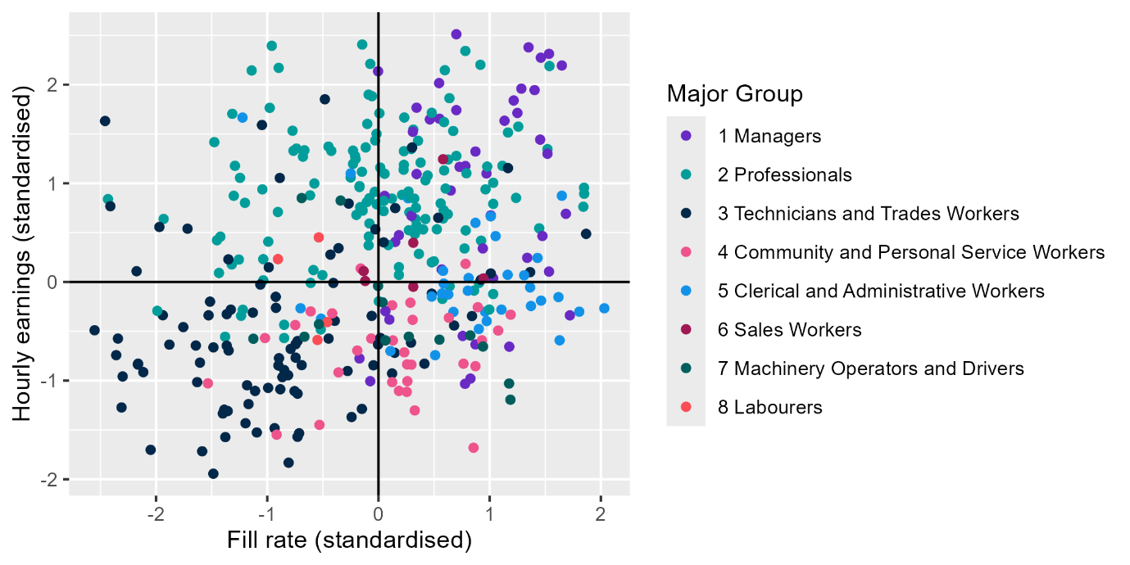  
Source: Jobs and Skills Australia, Survey of Employers who Recently Advertised (SERA), 2021-23 financial year; Australian Bureau of Statistics, Characteristics of Employment, August 2023, TableBuilder.

Some other observations include the following:

* There is a cluster of Professionals major group occupations in Quadrant one and are within -1 standard deviation of the average fill rate but above one standard deviation of average hourly earnings. That is, there is a group of occupations with below average fill rates but quite high hourly earnings. This characteristic belongs to Health Professional sub-majors such as Midwives, Medical Imagining Professionals, and General Practitioners and Medical Resident Officers. These are high skilled occupations with long lead times for training and require a lot of experience.
* Occupations with high fill rates but low earnings (Quadrant three) include a mix of all major groups, though occupations within Clerical and Administrative Workers, and Community and Personal Service Workers appear the most frequently.

Time series analysis of hourly earnings and fill rates reveals additional insights. Figure 7 shows the standardised annual average fill rate and hourly earnings of ANZSCO major groups 1 to 4 from 2014-23.[7]

Since 2014, Managers and Professionals have had above average hourly earnings which have increased over time, particularly for Professionals. The fill rates of Managers have remained above the average and have been relatively stable from 2020. However, for Professionals, fill rates have fallen over time and have remained well below the average since 2021. The fall in fill rates coincides with the time labour market conditions significantly tightened post-COVID pandemic.

Figure 7: Standardised fill rate and hourly earnings by major occupation groups 1-4, 2014-23.

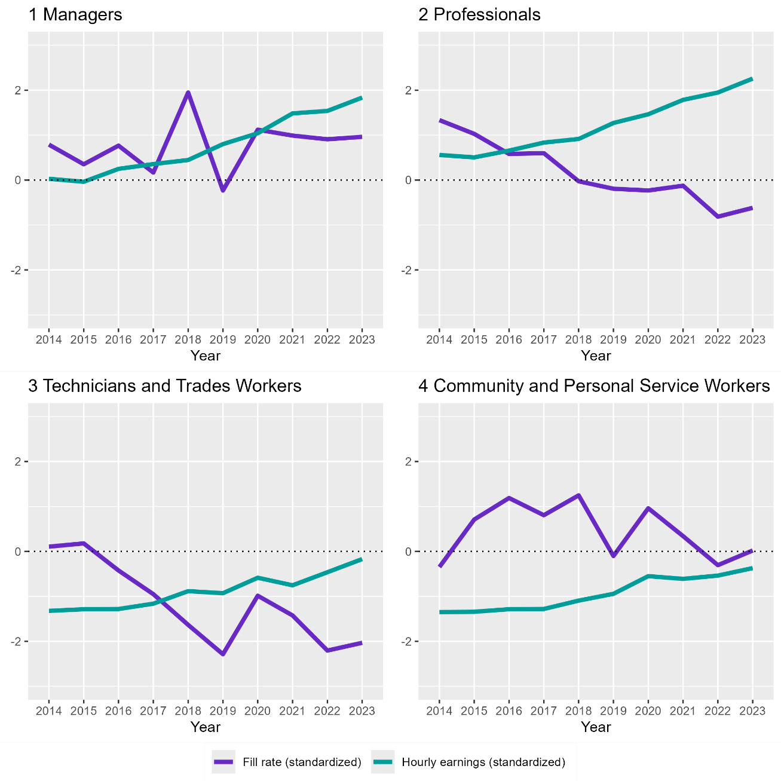  
Source: Jobs and Skills Australia, Survey of Employers who Recently Advertised (SERA), 2014-23 financial year; Australian Bureau of Statistics, Characteristics of Employment, August 2023, TableBuilder.

Meanwhile for occupations in major groups 3 and 4, hourly earnings have been steadily rising but still remain below the average. But despite the steady rising in earnings, fill rates for Technicians and Trades Workers remain acutely low.

Figures 6 and 7 suggest that Technicians and Trades Workers may be impacted by constraints in the labour supply pipeline more so than the other major groups. That is, even though there has been steady rise in hourly earnings, fill rates for Technicians and Trade Workers remain largely unaffected.

The findings may also suggest that for occupations with below average hourly earnings, marginal increases in wages may not be enough to impact the falling fill rates over time.

Figure 7 suggests that hourly earnings and fill rates of occupations are negatively correlated. This creates a hypothesis that, over time, employers respond to low fill rates with wage increases that are above the economy-wide average

In Figure 8, we explore the correlation between fill rate and annual wage changes in the years from 2021-23 by Major Groups 1 to 3, to test the hypothesis of a significant wage adjustment by employers in response to low fill rates.[8]

Figure 8. Correlation of annual wage change vs fill rates (1-year lag) at ANZSCO 4 digit, by major occupation group 1-3, 2021-23

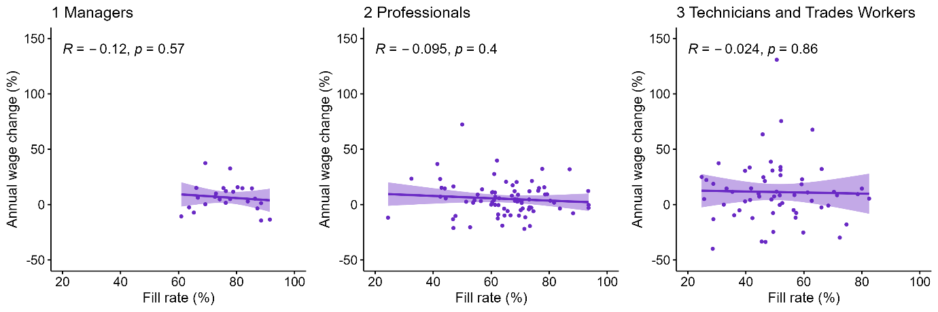  
Source: Jobs and Skills Australia, Survey of Employers who Recently Advertised (SERA), 2021-23 financial year; Australian Bureau of Statistics, Characteristics of Employment, August 2023, TableBuilder.

The fill rates are lagged by one year, due to studies and analysis demonstrating that employers do not immediately respond to skill shortages or unfilled vacancies by raising wages.

Figure 8 shows that the correlations are negative but weak and statistically insignificant for all three major groups. For Managers, the spread of fill rates and wage changes are much narrower compared to Professionals and Technicians and Trades Workers.

The gradient of the line of best fit is marginally steeper for Managers and Professionals compared to Technicians and Trades Workers, which is almost flat.

The correlation analysis reinforces SERA data, which show that employers rarely make significant adjustments to wages to fill vacancies. It further aligns with current research which shows limited evidence that firms raised wages in response to skill shortages.[9],[10] A much stronger and statistically significant relationship would suggest otherwise.

# Explanatory notes

The Survey of Employers who have Recently Advertised (SERA) is designed for the specific purpose of assessing occupational shortages for skilled occupations and provides a direct measure of the employer experience when recruiting. The survey receives around 2,000 responses each quarter from employers who have advertised vacancies online. Only those occupations with a sufficient quarterly sample size are included for analysis in this report to ensure data changes are more reflective of labour market developments.

The survey covers occupations, as defined by [Australian and New Zealand Standard Classification of Occupations](https://www.abs.gov.au/statistics/classifications/anzsco-australian-and-new-zealand-standard-classification-occupations/latest-release), generally requiring a university degree, trade apprenticeship or Certificate III or Certificate IV. As a result, the survey outcomes are reflective of occupations requiring post-school education and training.

The fill rate is used as a proxy for identifying occupations that may be in shortage: lower fill rates generally imply greater employer difficulties filling vacant positions. In contrast, higher fill rates suggest fewer challenges and in general, imply a lower likelihood of shortage.

Additional metrics collected in SERA include applicants on a per vacancy basis; the average number of total applicants; qualified applicants; suitable applicants; and the average years of labour market experience sought by employers (for definitions, refer to the following section). Movements in these variables add context to changes in fill rates over time.

Data found in Occupation Shortage Report is not an indicator of occupations in shortage in upcoming Occupation Priority Lists, formerly known as the Skills Priority List.

Caution should be exercised when interpreting data for Tasmania, the Northern Territory and the Australian Capital Territory given lower sample sizes.

## Definitions of metrics

**The fill rate** is the percentage of vacancies employers advertised that were filled. The metric is calculated by dividing the number of filled vacancies by total advertised vacancies.

**The average number of applicants per vacancy** is calculated as the sum of the number of applicants divided by the sum of advertised vacancies.

**The average number of qualified applicants per vacancy** is calculated as the sum of the number of qualified applicants divided by the sum of advertised vacancies. Qualified applicants are the applicants who are assessed by employers as meeting the required qualification criteria of an advertised vacancy.

**The average number of suitable applicants per vacancy** is calculated as the sum of the number of suitable applicants divided by the sum of advertised vacancies. Suitable applicants are those who are deemed by employers to be suitable for the job advertised.

**The average years of labour market experience** sought by employer is the average number of years that employers require applicants to have spent in relevant occupations and is calculated as the mean of the years required per employer.

**Metropolitan area** refers to Capital City, while **Regional area** refers to Rest of State locations. Capital City and Rest of State areas are defined by the [Australian Statistical Geography Standard (ASGS): Volume 1 – Main Structure and Greater Capital City Statistical Areas](https://www.abs.gov.au/ausstats/abs@.nsf/mf/1270.0.55.001), July 2016.

**Suitability gap** is the difference between the average number of qualified applicants per vacancy and the average number of suitable applicants per vacancy. A suitability gap greater than zero would mean that there are fewer suitable applicants than qualified applicants.

For more information, contact [OccupationShortageList@jobsandskills.gov.au](mailto:OccupationShortageList@jobsandskills.gov.au).

1. The fill rate and other metrics in the table are based on using 12 months of data leading to the latest quarter. Using a rolling annual period, as opposed to the latest quarter itself, removes the impact of data volatility attributable to SERA sampling, whereby concentrations of sampling with respect to different occupational major groups can occur at different times of a year.
2. The suitability gap is the difference between the number of qualified applicants per vacancy and suitable applicants per vacancy, as a percentage of the number of qualified applicants per vacancy.
3. The metric has several interpretations. A wide or widening gap may indicate that qualifications of applicants may not be equipping them with all skills and experiences needed, including the need for greater work experience and/or other soft or hard skills. It could also suggest slack in the labour market, allowing employers greater scrutiny of candidates that apply for vacant roles.
4. The difference in suitable applicants per vacancy between June quarter 2024 and March quarter 2024 appears to be 0.2. However, the difference is actually 0.129 and 0.1 when rounded down. This is because the unrounded suitable applicants per vacancy in June quarter is 2.961 and 2.832 in the previous quarter.
5. Australian and New Zealand Standard Classification of Occupations
6. We analysed the relationship between fill rates and wages by linking annual fill rates from SERA with the annual average weighted hourly earnings of employee’s main jobs from the Australian Bureau of Statistics Characteristics of Employment at ANZSCO 1-4 digits levels respectively, over the period 2014-2023. The linked dataset is limited to occupations at Skill levels 1-4. Bulk rounds recruitments from SERA are also excluded from the dataset to exclude the impact of outliers. Observations with high RSE (more than 20) are excluded to ensure the data quality.
7. Due to data limitations with respect to fill rates, time series analysis on these four major groups are provided only.
8. Due to data limitations, the correlation analysis was limited to major groups 1 to 3.
9. RBA (Reserve Bank of Australia), ‘Firm-Level Insights into Skills Shortages and Wages Growth’, Bulletin, March 2019
10. Agarwal & Bishop, ACE Conference 2023, Brisbane