

Australian Labour Market for Migrants

The Australian Labour Market for Migrants publication provides information on the Australian labour market. It is intended to inform recent migrants to Australia, people interested in working in Australia on a temporary or permanent basis, and organisations providing services to migrants and potential visa applicants.
The Australian labour market continues to perform well but a recent slowdown in economic activity has seen conditions ease. While the unemployment rate remains well below pre-pandemic levels and near record lows, the rate has edged higher in recent months. See the Jobs and Skills Australia website for recent labour market data and analysis.
Unless otherwise stated, data in this publication are from the Australian Bureau of Statistics (ABS) Labour Force Survey, May 2024.

Employment
Over the 12 months to May 2024, employment opportunities and growth varied widely across industries.
Figure 1 shows that the largest increases in trend employment occurred in Health Care and Social Assistance (up by 116,700), Education and Training (up by 46,800) and Construction (up by 45,900). The largest decreases in employment occurred in Mining (down by 1,500), Retail Trade (down by 12,500) and Financial and Insurance Services (down by 21,500).
The strongest rates of employment growth were in Electricity, Gas, Water and Waste Services (up by 6.8%), Arts and Recreation Services (up by 6.5%) and Health Care and Social Assistance (up by 5.4%).
Figure 1: Employment growth by industry (’000s persons) — May 2023 to May 2024

Source: ABS, Labour Force, Australia, Detailed, May 2024 (Table 04: Employed persons by Industry division of main job (ANZSIC)), released 20 June 2024. Data trended by Jobs and Skills Australia.

Occupation by state/territory

Figure 2 shows that in May 2024 (trend data), the Australian Capital Territory (ACT) had the highest share (61.2%) of employment in the selected occupation groups (i.e. Managers, Professionals, and Technicians and Trade Workers), followed by Victoria (54.9%) and New South Wales (NSW, 53.8%).
In the 12 months to May 2024, the share of workers employed in these selected occupation groups increased in all states and territories except for NSW (down by 0.1pp) and Queensland (down marginally by 0.01 pp). The largest increases were in the ACT (up by 1.0pp), Western Australia (WA, up by 0.5pp) and Tasmania (up by 0.4pp). Increases were also estimated for Northern Territory (NT, up by 0.2pp), South Australia (SA) and Victoria (both up by 0.1pp).
Figure 2: Share of employment in selected occupation groups# by state/territory, May 2023 to May 2024

# Selected occupation groups include ANZSCO Major Groups 1 to 3 (i.e. Managers, Professionals, Technicians and Trades Workers).
Source: ABS, Labour Force, Australia, Detailed (Table EQ08: Employed persons by Occupation unit group of main job (ANZSCO, Sex, State and Territory), May 2024, released 20 May 2024. Data trended by Jobs and Skills Australia.

Unemployment
The trend unemployment rate in Australia was 4.0% in May 2024, up from 3.6% in May 2023.
Over the 12 months to May 2024, the unemployment rate decreased in SA (4.0% to 3.9%), Tasmania (4.1% to 4.0%) and NT (4.4% to 4.0%); while remaining at 3.6% in WA. The unemployment rate rose in NSW (3.3% to 3.8%), Victoria (3.7% to 4.3%), Queensland (3.9% to 4.1%) and the ACT (3.2% to 3.8%).
Figure 3 shows that WA recorded the lowest unemployment rate at 3.6% and Victoria the highest at 4.3%.
Figure 3: Unemployment rates (%) by state/territory — May 2024

Source: ABS Labour Force, Australia, May 2024 (Table 12: Trend unemployment rate), released 13 June 2024.

Migrant employment
Australian-born people represent the highest share of employed people in Tasmania (82.5%) and the lowest share in WA (58.8%). The share of employed people born in other than main English-speaking countries (OTMESC) is highest in Victoria, NT and the ACT (30.7%, 29.6% and 29.5% respectively). See Figure 4.
Figure 4: Share of employment by state/territory and place of birth, May 2024

Source: ABS, Labour Force, Australia, Detailed, May 2024, (Table LM7: Labour force status by elapsed years since arrival, main English-speaking countries, sex, state and territory), released 20 June 2024.

Migrant unemployment
The unemployment rates for people who migrate to Australia vary appreciably. Several factors influence migrant unemployment rates including skill level, age, English language proficiency, recent and relevant work experience and the period since arrival in Australia. Data consistently shows that recently arrived migrants have a higher unemployment rate on average than those who have lived in Australia for some years.
Figure 5 shows the participation and unemployment rates of the Australian-born and migrants by broad country of birth groups and period of residence in Australia (average of the last 12 months to May 2024).

Figure 5: Labour force participation rate and unemployment rate, by years since arrival in Australia for broad country of birth groups — 12 months to May 2024 average

Source: ABS Labour Force, Australia, Detailed, May 2024 (Table LM7: Labour force status by elapsed years since arrival, main English-speaking countries, sex, state and territory), released 20 June 2024.

Figure 6 shows average unemployment rates for the 12 months to May 2024 for people resident in Australia by their major birth country groups (by subcontinent). People born in North-West Europe had the lowest unemployment rate (at 2.6%), while the unemployment rate for people born in North Africa and the Middle East (7.3%) was relatively high (possibly reflecting English language proficiency and period of residence in Australia).

Figure 6: Unemployment rate by broad country of birth groups — 12 months to May 2024 average

Note: Australia (includes External Territories)’ is within ‘Oceania and Antarctica’.
Source: ABS Labour Force, Australia, Detailed, May 2024 (Table LM5: Labour force status by age, major country group (subcontinent) of birth (SACC) and sex; and Table LM7: Labour force status by elapsed years since arrival, main English-speaking countries, sex, state and territory), released 20 June 2024.

Employment by occupation
Over the 12 months to May 2024, the largest increases in employment (trend data) occurred for Professionals (up by 116,100), Community and Personal Service Workers (up by 100,300) and Technicians and Trades Workers (up by 66,400). The smallest increase occurred for Sales Workers (up by 500). Employment growth for the major occupation groups is shown in Table 1.
Table 1: Trend employment growth by occupation — 12 months to May 2024
Occupational Group | 1 Year Change  (‘000 persons) | 1 Year Change  (%)
Managers | 34.8 | 1.9
Professionals | 116.1 | 3.2
Technicians and Trades Workers | 66.4 | 3.5
Community and Personal Service Workers | 100.3 | 6.4
Clerical and Administrative Workers | 36.3 | 2.0
Sales Workers | 0.5 | 0.0
Machinery Operators and Drivers | 24.9 | 2.8
Labourers | 10.0 | 0.8
Source: ABS, Labour Force, Australia, Detailed (Table EQ08: Employed persons by Occupation unit group of main job (ANZSCO, Sex, State and Territory), May 2024, released 20 June 2024. Data trended by Jobs and Skills Australia.

Additional information on occupational groups is provided in the following section on internet vacancy data.

Internet Vacancy data
Jobs and Skills Australia produces the monthly Vacancy Report which contains the Internet Vacancy Index (IVI). See Figure 7.
Over the year to May 2024, the trend vacancies decreased for all occupation groups but remained high compared to pre-pandemic levels: Labourers (down by 22.8%), Professionals (down by 19.2%), Community and Personal Service Workers (down by 18.6%), Machinery Operators and Drivers (down by 17.7%), Technicians and Trades Workers (down by 16.7%), Clerical and Administrative Workers (down by 16.5%), Managers (down by 12.9%) and Sales Workers (down by 11.3%).
At the more detailed occupation level, trend vacancies decreased in all 48 occupation clusters over the year to May 2024. The largest decreases were for Protective Service Workers (down by 34.0%), Hospitality Workers (down by 30.7%) and Food Preparation Assistants (down by 29.1%).
Over the year to May 2024, trend vacancies fell in all states and territories, decreasing in Victoria (down by 24.1%), NSW (down by 20.6%), the ACT (down by 18.3%), WA (down by 11.9%), Queensland (down by 10.0%), SA (down by 8.6%), NT (down by 4.5%) and Tasmania (down by 1.9%). For a full list of occupations and their recent growth in vacancies, see the Vacancy Report and supporting datafiles.
Figure 7: Internet Vacancy Index, January 2006 to May 2024

Source: Jobs and Skills Australia, Internet Vacancy Index, (ANZSCO2 Occupations, States and Territories, Trend), June 2024, released 17 July 2024.

Hot Topic: Pathways to permanent skilled migration and related labour market outcomes

This Hot Topic uses the 2021 Australian Census and Migrants Integrated Dataset (ACMID) to analyse pathways to permanent skilled migration and related labour market outcomes. ,
The 2021 ACMID shows that in August 2021 there were just under half a million or approximately 464,600 migrants who had entered Australia between 2012 and 2021 under one of four main Skill Stream visa programs.
A key finding of the analysis is that temporary skilled visa holders had shorter pathways to permanency than those who first arrived on a student or working holiday visa. Importantly, it finds these same migrants had better labour market outcomes than those of any other permanent visa pathway.

Pathways to permanent skilled migration
Figure A maps visa pathways of migrants from first visa grant to Skill Stream category.
The left-hand side of Figure A indicates that while 41.2% were granted their Skill Stream visa offshore (i.e. the most direct step to permanency), a majority (58.8%) first entered Australia on a temporary visa. Most of these migrants started out on either a temporary skilled or student visa (30.2% and 21.9% respectively) with a relatively small proportion being first holding a working holiday visa (6.7%).
The right-hand side of Figure A shows which Skill Stream category migrants ended up in. A third were granted a Skilled Independent visa (33.4%) with nearly as many granted an Employer-Sponsored visa (28.9%) and a further quarter a State-Territory Nominated visa (24.4%). A relatively small proportion were granted skilled regional visas (13.3%).
Figure A: Pathways to permanent skilled migration from first visa grant to Skill Stream category
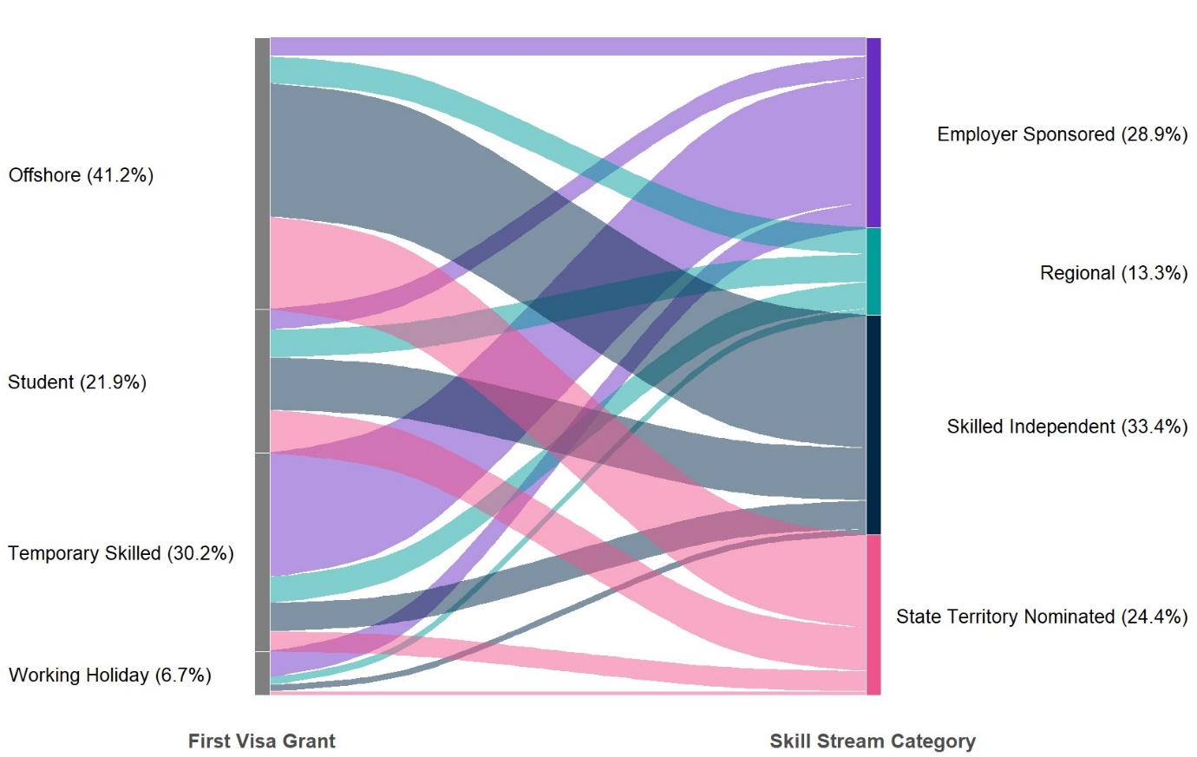
Source: ABS, 2021 Australian Census and Migrants Integrated Dataset, released 18 December 2023

A third feature of Figure A is that it illustrates the size of the flows from first visa grant to Skill Stream category, highlighting the most common pathways to permanent skilled migration. Taking the number of migrants in each flow as a proportion of all the Skill Stream migrants in scope, the figure shows that for two-thirds of the cohort, there were five main pathways to permanency:
- Offshore to Skilled-Independent (20.3%)
- Temporary Skilled to Employer-Sponsored (18.9%)
- Offshore to State-Territory-Nominated (14.2%)
- Student to Skilled-Independent (7.9%)
- Student to State-Territory-Nominated (6.6%)

Number of steps and transition time to permanency
Figure B provides data on the number of steps and time taken to transition to permanent residence for all Skill Stream migrants who arrived in Australia between 2012 and 2021 after first entering on either a temporary skilled, student or working holiday visa. It shows that:
- those who first arrived on a temporary skilled visa made the most seamless and shortest transition to permanency with the large majority making the transition in one step (85.8%) and an average time span of just under 3 years,
- relatively few of those who first arrived on a student visa, made the transition in one step (16.1%) with most transitioning in two or three steps (73.3%) and in an average time span of 4½ years,
- few of those who first arrived on a working holiday visa made the transition in one step (11.9%), with most again transitioning in two to three steps but in slightly less time than students. at an average timespan of just under 4½ years.
Figure B: Skill Stream visa holders, granted visa onshore by proportion of first temporary visa grant (including timespan of transition) and number of temporary visas granted

Source: ABS, 2021 Australian Census and Migrants Integrated Dataset, released 18 December 2023

Labour market outcomes
Table A provides key labour market indicators, including unemployment and participation rates, for primary Skill Stream visa holders, aged 15 years and over, by first visa grant and Skill Stream category.
Table A: Key labour market indicators for primary Skill Stream visa holders, by first visa grant by Skill Stream category
Labour market indicator | Employer-Sponsored | Skilled Independent | State-Territory Nominated | Regional
Unemployment rate (%) | 1.5 | 2.2 | 3.0 | 2.3
Offshore | 2.5 | 2.3 | 3.4 | 3.1
Temporary Skilled | 1.4 | 0.7 | 0.9 | 1.2
Student | 2.0 | 2.7 | 3.2 | 2.6
Working Holiday | 1.5 | 0.8 | 2.3 | 1.9
Participation rate (%) | 95.6 | 96.4 | 95.6 | 94.8
Offshore | 90.3 | 96.9 | 95.5 | 94.7
Temporary Skilled | 96.5 | 98.2 | 98.5 | 95.7
Student | 93.2 | 95.1 | 94.9 | 94.6
Working Holiday | 95.8 | 96.9 | 95.4 | 93.9
Source: ABS, 2021 Australian Census and Migrants Integrated Dataset, released 18 December 2023
Of the five most common pathways to permanency, the Temporary Skilled to Employer-Sponsored pathway had the best labour market outcomes with the lowest unemployment and highest participation rates.
Those who first arrived on a temporary skilled visa had the best labour market outcomes of any pathway. While migrants in the offshore and student pathways to state-territory nominated visas did not do as well, their outcomes were better than for the Australian-born population as a whole.

Further information
Queries on the Australian Labour Market for Migrants publication, including requests for inclusion on the distribution list and copies of Hot Topics attached to previous editions, should be emailed to migration@jobsandskills.gov.au.

Statistics on employment by industry and occupation in this publication are based on data trended by Jobs and Skills Australia using ABS Labour Force, Australia, Detailed data for May 2024, released 20 June 2024. Previous editions of this publication used seasonally adjusted data due to a break in the trend time series.
“pp” means percentage points.
Main English-speaking countries (MESC) are the United Kingdom, the Republic of Ireland, South Africa, Canada, the United States of America and New Zealand.
See Jobs and Skills Australia, Internet Vacancy Index (June 2024, released 17 July 2024). The IVI is based on a count of online job advertisements newly lodged on SEEK, CareerOne and Workforce Australia during the month. Duplicate advertisements are removed before IVI vacancies are coded by Jobs and Skills Australia to occupations based on ANZSCO. The data are seasonally adjusted and trended, then indexed (January 2006=100).
The analysis in this Hot Topic does not represent the views of the ACMID data custodians (i.e. the Australian Bureau of Statistics and Department of Home Affairs). The authors are responsible for any errors or omissions.
ACMID links unit record files from the Settlement Database administered by the Department of Home Affairs, with results from the Census of Population and Housing (see Australian Bureau of Statistics (ABS) Permanent migrants in Australia methodology, released 29 March 2023). Compared with the 2011 and 2016 releases, the 2021 ACMID contains additional information on past visa history, making it possible to examine labour market outcomes based on visa pathways (see ABS (2023) Pathways to permanency: Visa pathways and characteristics of permanent migrants, released 1 December 2023).
The analysis excludes Talent and Business Investor categories, focusing on Skill Stream visas in operation since 2012: Employer-Sponsored (subclass 186) visa, the Skilled Independent (subclass 189) visa, the State-Territory Nominated (subclass 190) visa and the Regional (which for this analysis includes subclasses 187, 489, 491 and 494) visas.
The unemployment rate for the Australian-born population in August 2021 was 4.8% and the participation rate was 66.3%.

