

**Labour Market Update**

March 2024

Contents

Executive summary 1

Overview of the Australian labour market 3

The national scene 3

Demand for labour 6

Vacancy rates 7

Ease of filling jobs nationally 8

Views from employers 10

In focus: Is gender inequality impacting fill rates? 11

How are the states and territories faring? 14

State and territory labour market outcomes 14

The regions 16

Recruitment difficulty in the regions 17

In focus: Assessing the long-term performance of regional labour markets 20

Labour market conditions across industries and occupations 22

Employment by industry 22

Recruitment difficulty among industries 23

Skill levels 24

Occupational breakdown 26

Internet vacancies by occupation 26

Recruitment difficulty by occupation 27

In focus: BLACK, WHITE and RED ALL OVER - The tipping point for Journalists and Other Writers 29

Jobs and Skills Australia resources 31

*The data in this document largely reflect the latest March month and quarter and were current as of 31 March 2024.*

# Executive summary

Against the backdrop of robust population growth, the Australian labour market displayed remarkable resilience over the March quarter 2024 with the pace of employment growth increasing more than initially anticipated earlier in the year. Despite the improvement over the *quarter*, labour market activity has clearly eased over the last *year*. A number of partial indicators suggest that the labour market will soften further in the coming months, with the unemployment rate expected to drift higher in the period ahead. In this regard, forecasts from Treasury’s *2024‑25 Budget* are for the unemployment rate to edge up to 4% in the June quarter 2024, before increasing further to 4½% in the June quarter 2025.

A number of partial indicators of labour market activity are also consistent with a somewhat softer outlook. For instance, Jobs and Skills Australia’s *Recruitment Experiences and Outlook Survey* results show a 6 percentage point fall in the recruitment rate over the year, suggesting that labour demand will ease over the period ahead. Similarly, Jobs and Skills Australia’s *Internet Vacancy Index* data show that job advertisements decreased by 35,300 (or 12.4%) over the year to March 2024 – although they remain significantly elevated compared with pre-COVID levels.

Despite the recent fall in both the number of internet vacancies and recruitment difficulty, data from Jobs and Skills Australia’s *Survey of Employers who have Recently Advertised* show that employers are still experiencing challenges finding suitably skilled workers to fill vacant positions. Indeed, there has only been a slight increase in the average number of suitable applicants per vacancy over the year, from 2.4 in the March quarter 2023, to 2.8 in the March quarter 2024, suggesting that there is still shortage pressure evident in the labour market.

There also continues to be some variation in recruitment activity at the regional level. For instance, the recruitment rate fell by 9 percentage points in capital cities over the year, to 46% in March 2024, while it only fell by 3 percentage points in rest of state areas, to 53% (although it remains low compared with the rates recorded throughout 2022). Internet vacancies in capital cities have also decreased at a faster rate than their rest of state counterparts, falling by 20.6% in the former since the peak recorded in October 2022. This compares with a decline of 13.2% in rest of state areas over the same period.

Recruitment difficulty rates also tend to be higher in regions that are further away from large population hubs, with employers facing greater challenges finding qualified staff to fill their vacancies, due, at least in part, to the relatively tighter labour market conditions in these areas. This is likely to be further exacerbated in some regions, due to their industry composition. For example, some regions have a focus on mining or agriculture and, accordingly, have a need for people with more specialised skills.

With respect to industry developments at the national level, the Health Care and Social Assistance industry made the largest contribution to employment growth over the year, more than double of the next largest contributing industry (Education and Training). Notable employment growth in Construction; Professional, Scientific and Technical Services; Manufacturing; and Public Administration and Safety was also recorded over the year.

The shift towards employment in higher skilled occupations in recent years is a continuation of a long-term trend. While recruitment difficulty has fallen across both higher and lower-skilled occupations over the year, employers continued to encounter greater difficulty recruiting for higher skilled occupations (62% experienced difficulty recruiting for Skill Level 1 to 3 occupations in March 2024), than those with vacancies for lower-skilled occupations (39% for Skill Level 4 and 5 occupations). Moreover, internet vacancies have declined across most major occupation groups in the March quarter 2024, with Professionals and Technicians and Trades Workers recording the largest decreases over the period (down by 7.0% and 6.7% respectively), compared with smaller declines for Clerical and Administrative Workers and Labourers (down by 0.4% and 1.3% respectively). Despite these declines, the ratio of internet vacancies to employment were lowest among lower skilled occupation groups.

# Overview of the Australian labour market

Against the backdrop of robust population growth, the Australian labour market displayed remarkable resilience over the March quarter 2024 with the pace of employment growth increasing a little more strongly than initially anticipated earlier in the year. The vast majority of the rise in employment over the March quarter occurred in February, reflecting, in large part, the greater than usual number of people who were waiting to start (or return to) a job in December 2023 and January 2024. Despite the improvement over the *quarter*, labour market activity has clearly eased over the last *year*. In particular, the pace of full-time employment growth (and aggregate hours worked) has weakened considerably over the period, compared with much stronger growth in part-time jobs, reflecting the changing composition of employment. A number of partial indicators suggest that the labour market will soften further, albeit gradually, in the coming months, with the unemployment rate expected to drift higher in the period ahead. In this regard, forecasts from Treasury’s *2024‑25 Budget* are for the unemployment rate to edge up to 4% in the June quarter 2024, before increasing further to 4½% in the June quarter 2025.

Table 1: Key labour market indicators, March 2024 and change since December 2023

|  |  |  |  |  |  |  |  |
| --- | --- | --- | --- | --- | --- | --- | --- |
| Employment | Full-time employment | | Part-time employment | Hours worked | Underemployment rate | Unemployment rate | Participation rate |
| 14,259,900 | | 9,853,800 | 4,406,100 | 1,956.1 million hours | 6.5% | 3.8% | 66.6% |
| á0.9% | | á1.3% | â0.1% | á1.9% | â0.1% pts | â0.1% pts | Steady |

Source: Australian Bureau of Statistics (ABS), Labour Force, Australia, March 2024, seasonally adjusted data.

## The national scene

ABS *Labour Force Survey* data show that seasonally adjusted **employment** increased by a robust 122,300 (or 0.9%) over the March quarter 2024, up from the growth of 0.4% recorded in the previous quarter. Consistent with the moderate lift in the pace of jobs growth over the quarter (due, in large part, to the substantial boost in the month of February), employment rose by 336,900 (or 2.4%) over the *year to* March 2024 and is currently above the decade average annual growth rate of 2.1%.

* That said, the *trend* estimates (which abstract from the monthly volatility inherent in the seasonally adjusted data and provide a better indication of underlying labour market conditions) continue to point to a gradual easing in labour market activity. For instance, the pace of trend employment growth has slowed notably over the last year, from a recent peak of 43,700 jobs per month in March 2023, to its current pace of 28,500 in March 2024.

The increase in employment over the March quarter was due, entirely, to a strong rise in full‑time employment (up by 125,900 or 1.3%), while part-time employment fell slightly over the March quarter (by 3,700 or 0.1%).

That said, and despite the pick-up in full-time employment growth over the *quarter*, full-time jobs growth has been relatively weak over the last *year*, increasing by just 89,900 (or 0.9%). Part-time employment, by contrast, has surged over the period, by 247,100 (or 5.9%).

The number of **hours worked** by employed people also increased over the quarter, by 36.4 million hours (or 1.9%). While the aggregate hours worked series can be volatile, the *annual* rate of growth in hours worked has eased considerably, from its recent peak of 10.4% in January 2023 (significantly higher than the 3.8% increase in employment at that time), to its current rate, of just 1.7% (*below* the annual employment growth rate, of 2.4%).

Figure 1: Annual change in employment and aggregate hours worked, March 2019 to March 2024

Source: ABS, Labour Force, Australia, March 2024, seasonally adjusted data.

Reflecting the increase in hours worked over the quarter, the **underemployment rate** decreased marginally over the period, to 6.5% in March 2024, although it remains 0.6 percentage points above its recent trough, of 5.9% recorded in February 2023 (Figure 2). This equates to an additional 114,300 people joining the underemployment pool since February 2023, reflecting the compositional shift in employment, away from full-time jobs towards part-time positions.

Figure 2: Unemployment rate and underemployment rate, March 1984 to March 2024

Source: ABS, Labour Force, Australia, March 2024, seasonally adjusted data.

The **unemployment rate** decreased slightly over the quarter, from 3.9% in December 2023, to 3.8% in March 2024, while the **participation rate** was unchanged over the period, at 66.6%.

Labour market conditions for both **women** and **men** have remained resilient over the March quarter 2024. For instance, employment for women increased by 56,300 (or 0.8%) over the period, due, entirely, to strong growth in full-time employment, up by 84,000 (or 2.2%), while part-time employment fell by 27,800 (or 0.9%).

Employment for men also rose over the quarter, up by 66,000 (or 0.9%), with full-time employment accounting for the majority of the increase in employment (up by 41,900 or 0.7%), while part-time employment increased by 24,100 (or 1.7%).

While the unemployment rate for women fell slightly over the quarter, by 0.1 percentage points, to 3.8% in March 2024, it remains above the 3.4% recorded in March 2023. The unemployment rate for men also fell over the quarter, from 4.0% in December 2023, to 3.9% in March 2024, but remains 0.2 percentage points above the rate recorded a year ago.

The fall in the female unemployment rate over the quarter occurred in conjunction with a 0.1 percentage point decrease in the participation rate for women, which fell to 62.6% in March 2024 and is now just below the 62.7% recorded a year ago. While the participation rate for men was steady over the quarter, at 70.6% in March 2024, it remains below the 70.8% recorded in March 2023.

Reflecting the overall improvement in the labour market activity over the quarter, conditions for **young people** also strengthened over the period, with the number of 15-24 year olds in employment increasing by 28,300 (or 1.3%). While full-time employment for the youth cohort rose strongly over the quarter (up by 9,600 or 1.0%), it is important to note that this follows on from two sizeable declines (totalling 57,600) recorded in the September and December quarters, respectively, in 2023. Moreover, the number of young people in full-time work has declined by 28,500 (or 2.9%) over the *year* to March 2024.

The youth unemployment rate was unchanged over the quarter, at 9.6% in March 2024, although it has risen by 1.8 percentage points over the *year*. The participation rate for young people decreased by 0.3 percentage points over the quarter, to 70.3% in March 2024, and is below the 71.3% recorded in March 2023.

The number of people who were **long-term unemployed** increased over the 3 months to March 2024, by 3,500 (or 3.2%), to stand at 110,200, and is 22,200 (or 25.3%) above the recent trough, of 88,000 recorded in April 2023 (Figure 3).

* The level of long-term unemployment for women increased by 2,600 (or 5.5%) over the March quarter 2024, to stand at 49,300, while long-term unemployment for men also rose over the period, by 900 (or 1.4%), to 61,000.

Given that labour market activity is expected to ease over the coming months, there may be greater inflows of people from short-term unemployment, into the long-term unemployment pool, in the coming year. Similarly, softer labour market conditions will make it increasingly difficult to achieve sizeable exits from the pool, which is likely to result in an increase in the number of long-term and very long-term unemployed people in the period ahead.

Figure 3: Long-term unemployment and annual change in employment, March 2004 to March 2024

Source: ABS, Labour Force, Australia, Detailed, March 2024 for long-term unemployment; ABS, Labour Force, Australia, March 2024 for annual change in employment. All data are seasonally adjusted.

## Demand for labour

Results from Jobs and Skills Australia’s March 2024 *Recruitment Experiences and Outlook Survey (REOS)* confirm that labour market conditions remain softer than a year ago. The REOS **recruitment rate** is the proportion of employers who were recruiting at the time of the survey. The rate is a robust indicator of the demand for workers and an indicator of employers’ confidence in business conditions. The recruitment rate declined sharply between the March and September quarters in 2023 and has been relatively flat since. The rate is 6 percentage points lower than 12 months ago and is now 9 percentage points lower than the peak of 58% recorded in the June quarter of 2022 (Figure 4).

Figure 4: Recruitment rate (proportion of employers currently recruiting or who recruited in the past month), March quarter 2021 to March quarter 2024

Source: Jobs and Skills Australia (JSA), Recruitment Experiences and Outlook Survey, March 2024

Monthly **job advertisements** have also been gradually declining and are below their mid‑2022 peak. Indeed, Jobs and Skills Australia’s *Internet Vacancy Index (IVI)* shows that there has been an overall decrease in recruitment activity over the quarter to March 2024, with job advertisements declining further, by 4.1% (or 10,600 job advertisements) over the period (Figure 5). Internet job advertisements decreased by 35,300 (or 12.4%) over the year to March 2024, although they remain significantly elevated compared with their pre‑COVID levels.

Figure 5: IVI job advertisements and unemployment rate, March 2006 to March 2024

Source: ABS, Labour Force, Australia, March 2024, seasonally adjusted data; JSA, Internet Vacancy Index, March 2024, seasonally adjusted data.

Recent trends in the ABS *Job Vacancies Survey* data reflect declines in recruitment activity. Latest available ABS data show job vacancies fell by 23,600 (or 6.1%) over the quarter, to 363,800 in February 2024, and are 78,500 (or 17.7%) below the level recorded a year ago. While ABS job vacancies are below their series peak in mid-2022, they remain high by historical standards, 59.8% higher than February 2020.

## Vacancy rates

The **vacancy rate** (job vacancies as a share of employment) can be a useful indicator of underlying labour market dynamism. As illustrated in Figure 6, the IVI vacancy rate can be a sensitive leading indicator of future labour market conditions, with declines preceding the Global Financial Crisis, the end of the mining boom and the first COVID-19 shock (including the subsequent Delta wave), as well as heralding changes in the unemployment rate. It is worth noting that the 2 series have converged and are tracking closely, which is in line with Treasury’s forecast for the unemployment rate in the period ahead. That said, the IVI vacancy rate remains high, at around 1.7% in March 2024, and is well above the low of 0.5% recorded in April 2020.

Figure 6: IVI vacancy rate and unemployment rate, March 2006 to March 2023

Source: ABS, Labour Force, Australia, March 2024, seasonally adjusted data; JSA, Internet Vacancy Index, March 2024, seasonally adjusted data.

## Ease of filling jobs nationally

Jobs and Skills Australia’s *Survey of Employers who have Recently Advertised (SERA)* shows that the **fill rates** of advertised vacancies are rising but remain low. The vacancy fill rate increased slightly, by 0.9 percentage points, to 64.3% over the March 2024 quarter. Moreover, based on a per vacancy basis, the average number of applicants, qualified applicants and suitable applicants all increased in the 2024 March quarter (Table 2).[1]

Table 2: National snapshot of recruitment experiences

|  |  |  |  |  |
| --- | --- | --- | --- | --- |
|  | Fill rate (%) | Applicants per vacancy (no.) | Qualified applicants per vacancy (no.) | Suitable applicants per vacancy (no.) |
| **March 2024 quarter** | **64.3** | **20.6** | **6.8** | **2.8** |
| Change since December 2023 quarter | ↑ 0.9 pts | ↑ 2.3 | ↑ 0.6 | ↑ 0.2 |

Source: JSA, Survey of Employers who have Recently Advertised, 2024, 12-month averages.

The easing of labour market conditions at the national level, however, is yet to fully materialise to higher fill rates. This may suggest that difficulty in filling vacancies continues. Despite recent falls in the number of internet vacancies and recruitment difficulty, employers are still experiencing challenges of finding suitable skilled workers to fill vacant positions (Figure 7).

Figure 7: Fill rate, recruitment difficulty rate and internet vacancies, December 2021 to December 2023

Source: JSA, Survey of Employers who have Recently Advertised; JSA, Recruitment Experiences and Outlook Survey; JSA, Internet Vacancy Index.

While the average number of applicants per vacancy has generally been increasing over the last year (from 14.7 in the March quarter 2023 to 20.6 in the March quarter 2024), there has only been a marginal increase in the average number of suitable applicants per vacancy over the same period (from 2.4 to 2.8), suggesting shortage pressure persist in the labour market (Figure 8).

Figure 8: Quarterly fill rate, applicants and suitable applicants per vacancy

Source: JSA, Survey of Employers who have Recently Advertised, 2024

## Views from employers

While most of the information collected through Jobs and Skills Australia’s *Recruitment Experiences and Outlook Survey* is quantitative in nature, useful qualitative information is also collected. See below for a selection of employer quotes from various industries recruiting for a variety of occupations. While these are not necessarily representative, by industry or by location, they do provide some insight into recent recruitment experiences and employer sentiment.

**Construction, Greater Adelaide, March 2024**

“For a small business, the operating costs have gone through the roof. It’s too expensive to put anyone on…Any staffing we would have had, we subcontract because it’s easier.”

**Manufacturing, Greater Melbourne, January 2024**

“We put on one apprentice. We were hoping for a fully qualified cabinet maker, but we can’t find any, so we’re basically taking anyone we can get… We’ve got so much work that we can’t keep up.”

**Wholesale Trade, Australian Capital Territory, January 2024**

“The reliability isn’t there you know, the commitment to work isn’t there. That’s why I’m here now. I’ve got two people but none of them are available. You hire people to make your job easier but in the end you have to fit around them.”

**Retail Trade, Rest of South Australia, February 2024**

*“We’re always looking for workers and I actually can’t place ads because our town doesn’t have accommodation for new people to come into the town so it’s sort of like a catch 22.”*

**Professional, Scientific and Technical Services, Rest of New South Wales, March 2024**

*“In this field there’s a massive shortage of estimators. We had some experienced people retire so it took us probably a year to get back to where we needed to be and then those two people left a year ago.”*

**Education and Training, Rest of Victoria, March 2024**

*“Most of them (8) were international teachers. I wasn't able to source Australian teachers. There's a shortage of teachers. There just aren't enough in the system and I think it's become a very very competitive market. You need to be able to offer incentives and bonuses for people to even consider a teaching position, particularly in regional and rural areas.”*

Source: JSA, Recruitment Experiences and Outlook Survey, 2024.

## In focus: Is gender inequality impacting fill rates?

This section expands on the gender analysis featured in the [2023 SPL Key Findings Report](https://www.jobsandskills.gov.au/sites/default/files/2023-10/2023%20SPL%20Key%20Findings%20Report.pdf) by examining whether gender inequality is contributing to employer difficulty in filling job vacancies.[2]

Occupations are categorised into female or male dominated occupations if the gender share of employment of either is more than 50%. The gender inequality metric takes the value of 0 when an occupation has a perfect gender balance, and 1 when an occupation is fully occupied by either female or male workers.[3]

From 2016 to 2023, in female dominated occupations, the relationship between fill rates and gender inequality is weak and not statistically significant (see the left-hand side of Figure 9). Therefore, the chance of a female dominated occupation being in shortage due to gender inequality is low. In contrast, there is a much clearer statistically significant downward trend for male dominated occupations (right-hand side of Figure 9). It indicates that the higher the gender inequality with dominance of male workers in an occupation, the lower the fill rate.

Figure 9: Gender inequality (%) and fill rate (%) in female and male dominated occupations, 2016–2023

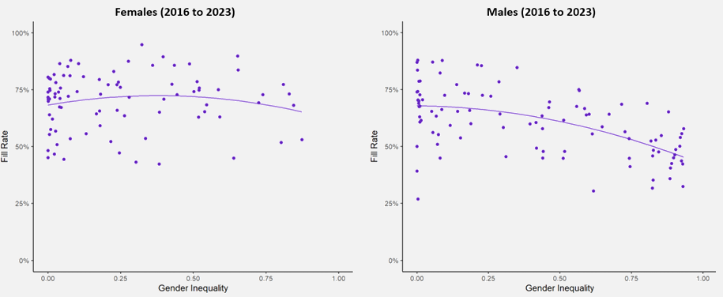

Source: ABS, Census of Population and Housing 2016 and 2021; JSA, Survey of Employers who have Recently Advertised (SERA).

This is particularly true when looking at fill rates by sub-major occupation groups. In Figure 10, each box plot represents a range of fill rate values for each occupation group. The colour range (from light to dark purple) represents gender inequality: the darker the colour, the more gender skewed an occupation is.

Male dominated sub-major occupation groups (right hand side of Figure 10) tend to have a lower fill rate, indicating that it is more likely to be in a skills shortage. For example, among male dominated occupations, those with above 90% male workers such as Automotive and Engineering Trades Workers, Construction Trades Workers, and Electrotechnology and Telecommunications Trade Workers, have the lowest fill rate ranges. This result indicates that these occupations have a high chance of being in shortage. The 2023 SPL also showed that occupations in these sub-major groups tended to be in shortage.

The link between gender inequality and fill rates, however, is weaker for female dominated sub-major occupations (left hand side of Figure 10). For instance, highly female dominated General Clerical Workers, Inquiry Clerks and Receptionists, and Numerical Clerks have high fill rates at more than 75%, while Carers and Aides, which are also dominated by females, have lower fill rates at around 50%.

**Figure 10: Fill rate (%) in female and male dominated occupations, by sub-major group, 2021 to 2023**

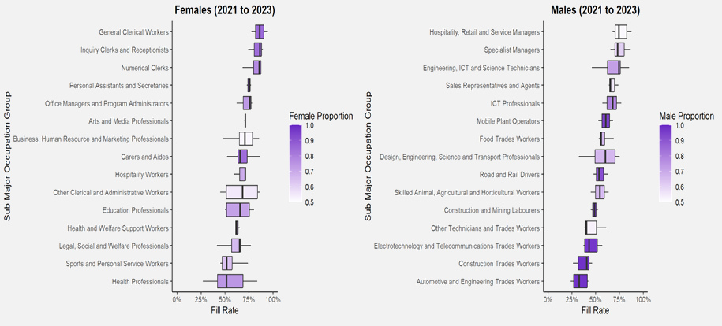

Source: ABS, Census of Population and Housing, 2021; JSA, Survey of Employers who have Recently Advertised (SERA).   
Note: The width of the box indicates the fill rates between the 1st and 3rd quartiles for each sub-major group. The central line represents the median or middle value. The box’s colour gradient, from light to dark purple, represents the gender distribution within that sub-major occupation, with the darker shades indicating gender skewed towards female (left hand side) or male (right hand side). The lines to either side of the box represent the minimum and maximum values of fill rates for occupations within the group.

Improving the inflow of women into male dominated occupations is a complex proposition, requiring changes to societal norms, workplace culture and conditions as well effectively encouraging more women to pursue trade–based VET qualifications. Given the weaker link between fill rates and gender inequality among female dominated occupations, the analysis suggests a set of solutions pertaining to general worker (either male or female) attraction and retention to alleviating skill shortage pressures.

#### Fill rates between 2006 and 2023

The relationship between gender inequality and fill rates in male dominated occupations has changed over time. During the 2006 and 2015 period, the relationship at high levels of inequality is positive and statistically significant (left hand side of Figure 11). This could be attributable to the impact of the mining boom and large skilled migration over that time.

While the mining industry employs a wide variety of low and high skilled occupations, occupations are generally heavily skewed towards males. During the boom, high wage growth supported rapid growth in employment in the industry. In turn, fill rates rose. During this period, skilled migration also increased and peaked around 2016, assisting employers to fill vacancies. It is possible that these developments masked the true relationship between gender inequality and fill rates among male dominated occupations, which reverted to their true (negative) relationship once the mining boom ended and skilled migration started easing (right hand side of Figure 11).

**Figure 11: Fill rate and gender inequality in male dominated occupations in 2006–2015 versus 2016–2023**

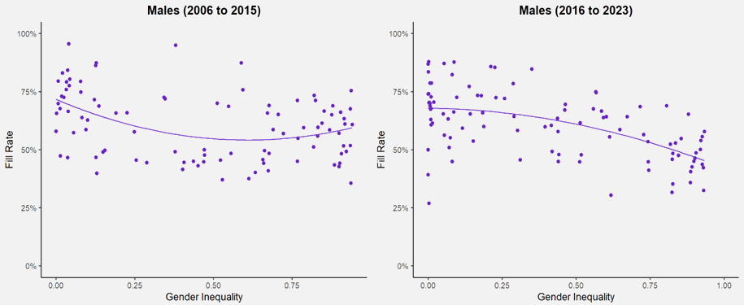

Source: ABS, Census of Population and Housing, 2006, 2011, 2016 and 2021; JSA, Survey of Employers who have Recently Advertised (SERA).

# How are the states and territories faring?

## State and territory labour market outcomes

Employment rose in 6 out of 8 jurisdictions over the March quarter 2024, with the largest increase occurring in Victoria (up by 40,900 or 1.1%), followed by Western Australia (up by 30,600 or 1.9%) — see Table 3.

Six jurisdictions recorded an unemployment rate below 4.0% in March 2024, with the lowest rate recorded in the Australian Capital Territory (of 2.9%), followed by Western Australia (of 3.4%). Victoria and Queensland recorded the equal highest unemployment rate in March 2024 (of 4.1%).

The Northern Territory recorded the highest participation rate, of 73.5% in March 2024, while Tasmania recorded the lowest participation rate, of 61.0%.

Table 3: Key labour market indicators by state and territory, March 2024

|  |  |  |  |  |  |  |  |
| --- | --- | --- | --- | --- | --- | --- | --- |
|  | Employment ('000) | | | Unemployment | | Participation | |
| rate (%) | | rate (%) | |
| Mar-24 | Quarterly change | | Mar-24 | Quarterly change | Mar-24 | Quarterly change |
| (‘000) | (%) | (% pts) | (% pts) |
| New South Wales | 4,433.3 | 24.1 | 0.5 | 3.8 | 0.3 | 66.1 | 0.1 |
| Victoria | 3,706.6 | 40.9 | 1.1 | 4.1 | 0.0 | 67.3 | 0.2 |
| Queensland | 2,901.2 | 24.3 | 0.8 | 4.1 | -0.2 | 66.6 | -0.1 |
| South Australia | 939.2 | 0.0 | 0.0 | 3.9 | 0.0 | 62.7 | -0.4 |
| Western Australia | 1,602.6 | 30.6 | 1.9 | 3.4 | -0.6 | 69.0 | 0.2 |
| Tasmania | 282.5 | -4.2 | -1.5 | 3.8 | 0.2 | 61.0 | -0.9 |
| Northern Territory | 139.7 | 2.2 | 1.6 | 3.8 | -0.8 | 73.5 | 0.2 |
| Australian Capital Territory | 267.9 | 2.9 | 1.1 | 2.9 | -1.1 | 71.6 | -0.6 |
| **Australia** | **14,259.9** | **122.3** | **0.9** | **3.8** | **-0.1** | **66.6** | **0.0** |

Source: ABS, Labour Force, Australia, March 2024, seasonally adjusted data.

Results from the *Recruitment Experiences and Outlook Survey* show that quarterly **recruitment activity** has decreased in all states (except Tasmania) over the year to the March quarter 2024 (Figure 12).

For instance, in the March quarter 2024, New South Wales, Victoria, and South Australia recorded a decrease in recruitment rates. Queensland, Western Australia, and Tasmania recorded an increase in recruitment rates. New South Wales recorded the largest annual and quarterly decline in its recruitment rate (12 percentage points since March quarter 2023 and 4 percentage points since December quarter 2023). Queensland has been the most resilient over the last year and recorded the highest quarterly recruitment rate (56%).

Figure 12: Recruitment rate (proportion of employers currently recruiting or who recruited in the past month) by state, March quarter 2023 to March quarter 2024

Source: JSA, Recruitment Experiences and Outlook Survey, March 2024.  
Note: Data for Australian Capital Territory and Northern Territory are unavailable on quarterly basis, due to small sample sizes.

Quarterly r**ecruitment difficulty** has also decreased in all states over the year (Figure 13). Queensland recorded the highest level of recruitment difficulty at 56% for the March quarter 2024 while South Australia and Tasmania both recorded the lowest difficulty rate (both 51%). The largest decline occurred in Western Australia, down 19 percentage points over the year, to stand at 54% in the March quarter 2024.

Figure 13: Recruitment difficulty rate by state, March quarter 2023 to March quarter 2024

Source: JSA, Recruitment Experiences and Outlook Survey, March 2024.  
Note: Data for the Australian Capital Territory and the Northern Territory are not available on a quarterly basis, due to small sample sizes.

*Interpret with caution due to low sample size.

## The regions

Employment growth was moderate in rest of state areas over the March quarter 2024 (up by 11,500 or 0.3%), outpacing the marginal increase recorded in the capital cities (of 4,500 or 0.0%[4]) over the period.

The unemployment rate rose by 0.4 percentage points in capital cities, to 4.2% in March 2024, while it increased by 0.3 percentage points in rest of state areas, to 3.9%. The participation rate decreased by 0.3 percentage points in the capital cities over the period, to 68.6%, while the participation rate declined by 0.1 percentage points in rest of state areas, to 63.4% in March 2024 (Table 4).

Table 4: Key labour market indicators by capital cities and rest of state areas, March 2024

|  |  |  |  |  |  |  |
| --- | --- | --- | --- | --- | --- | --- |
|  | Capital cities | | | Rest of state areas | | |
| Mar-24 | Quarterly change | | Mar-24 | Quarterly change | |
| (‘000) | (%) | (‘000) | (%) |
| Employment (‘000) | 9,837.5 | 4.5 | 0.0* | 4,448.1 | 11.5 | 0.3 |
| Unemployment rate (%) | 4.2 | - | 0.4 pts | 3.9 | - | 0.3 pts |
| Participation rate (%) | 68.6 | - | -0.3 pts | 63.4 | - | -0.1 pts |

Source: ABS, *Labour Force, Australia, Detailed*, March 2024, table MRM1 - Modelled estimates of labour force status, by SA4.

* Please note that more detailed data show that employment increased by 0.045% over the March quarter 2024.

Employers in rest of state areas tend to recruit more frequently than their capital city counterparts. Figure 14 shows that the monthly recruitment rate for rest of state areas peaked at 62% in July 2022, compared with a high of 58% in October 2022 for the capital cities.

Figure 14: Monthly recruitment rate (proportion of employers currently recruiting or who recruited in the past month) by capital cities and rest of state areas, September 2020 to March 2024

Source: JSA, Recruitment Experiences and Outlook Survey, March 2024.   
Notes: Disaggregated data are not published for January of each year and relevant data points have been joined by a dotted line. A Henderson smoothed line has been included in the charts to reduce month-to-month volatility and illustrate long-term patterns.

The recruitment rate for capital cities continues to trend down, sitting at 46% in March 2024. This is a drop of 1 percentage point from the previous month and 9 percentage points lower compared to 12 months ago. By contrast, the recruitment rate for rest of state areas stood at 53% in March 2024 and is 3 percentage points lower than it was in March 2023.

Significant growth in internet vacancies was recorded in capital cities and rest of state areas between June 2020 and October 2022. Figure 15 shows that recruitment activity in capital cities increased, by 248.2% (or 158,500 job advertisements) from the low observed in June 2020, and by 215.5% (or 55,400) in rest of state areas, to peak in October 2022. While vacancies have declined from their series highs in rest of state areas and capital cities over the past 18 months, advertisements in rest of state areas have remained more buoyant than their capital city counterparts. Since the peak in late 2022, recruitment activity has decreased, by 20.6% (or 45,700) in capital cities, and by 13.2% (or 10,700) in rest of state areas. Results over early 2024 across the two jurisdictions indicate increasing recruitment activity, although the declines in aggregate seasonally adjusted vacancy figures (see Figure 5) suggests this is largely attributable to typical start-of-year ramp ups. The recent increases in recruitment activity appear weaker than the same period in 2023.

Figure 15: Online job advertisements in capital cities and rest of state areas, March 2019 to March 2024

Source: JSA, Internet Vacancy Index, March 2024, 3-month average data.

### Recruitment difficulty in the regions

Record high levels of recruitment difficulty occurred in both capital cities and rest of state areas during mid-2022 (Figure 16). Recruitment difficulty peaked in rest of state areas, at 77% in July 2022, while in capital cities, the monthly recruitment difficulty rate peaked at 75% of recruiting employers in August 2022.

While the recruitment difficulty rate has eased for all employers since the mid-2022 peak, it has declined more sharply in capital cities, dropping 19 percentage points over the past 12 months to sit at 46% in March 2024. This is the lowest difficulty rate experienced by employers within capital cities since May 2021. In contrast, over recent months there has been a tightening in the difficulty rate within rest of state areas which currently sits at 58% for the month of March 2024. This is an increase of 1 percentage point compared to last month and an increase of 2 percentage points compared to December 2023.

Figure 16: Monthly recruitment difficulty rate (proportion of recruiting employers) by region, September 2020 to March 2024

Source: JSA, Recruitment Experiences and Outlook Survey, March 2024.   
Notes: The recruitment difficulty rate is the proportion of recruiting employers who report having difficulty filling advertised roles. Disaggregated data are not published in January of each year. Accordingly, relevant data points have been joined by a dotted line. A Henderson smoothed line has been included in the charts to reduce month-to-month volatility and illustrate long-term patterns.

It is also worth noting that the relationship between the amount of recruitment (as seen in recruitment rates) and recruitment difficulty varies within individual capital cities and rest of state areas. Figure 17 shows these regional variations observed over the past 12 months to March 2024. In general, at similar rates of recruitment, rest of state areas tend to experience higher levels of difficulty. For example, Rest of Victoria is a relatively low recruiter (47%) and has high recruitment difficulty (65%), while Greater Melbourne has a lower difficulty rate (56%) at a similar rate of recruitment (45%). A similar pattern is observed between other capital cities and their respective rest of state counterparts.

Figure 17: Rates of recruitment and recruitment difficulty by region (12 months to March 2024)

Source: JSA, Recruitment Experiences and Outlook Survey, March 2024.

Recruitment difficulty rates generally tend to be higher in regions that are further away from large population hubs. Figure 18 shows recruitment difficulty recorded in the 12 months to March 2024, for each Statistical Area Level 4 region and Greater Capital City area. The higher recruitment difficulty rates in more remote areas can sometimes be explained by tighter labour market conditions, as employers encounter greater challenges finding suitably qualified staff. This can also be further exacerbated in some areas as a result of a narrower industry composition, with a focus on mining or agriculture for example, and the consequent need for specialised skills.

Figure 18: Recruitment difficulty rates, 12 months to March 2024 – heatmap of SA4 regions and Greater Capital City areas

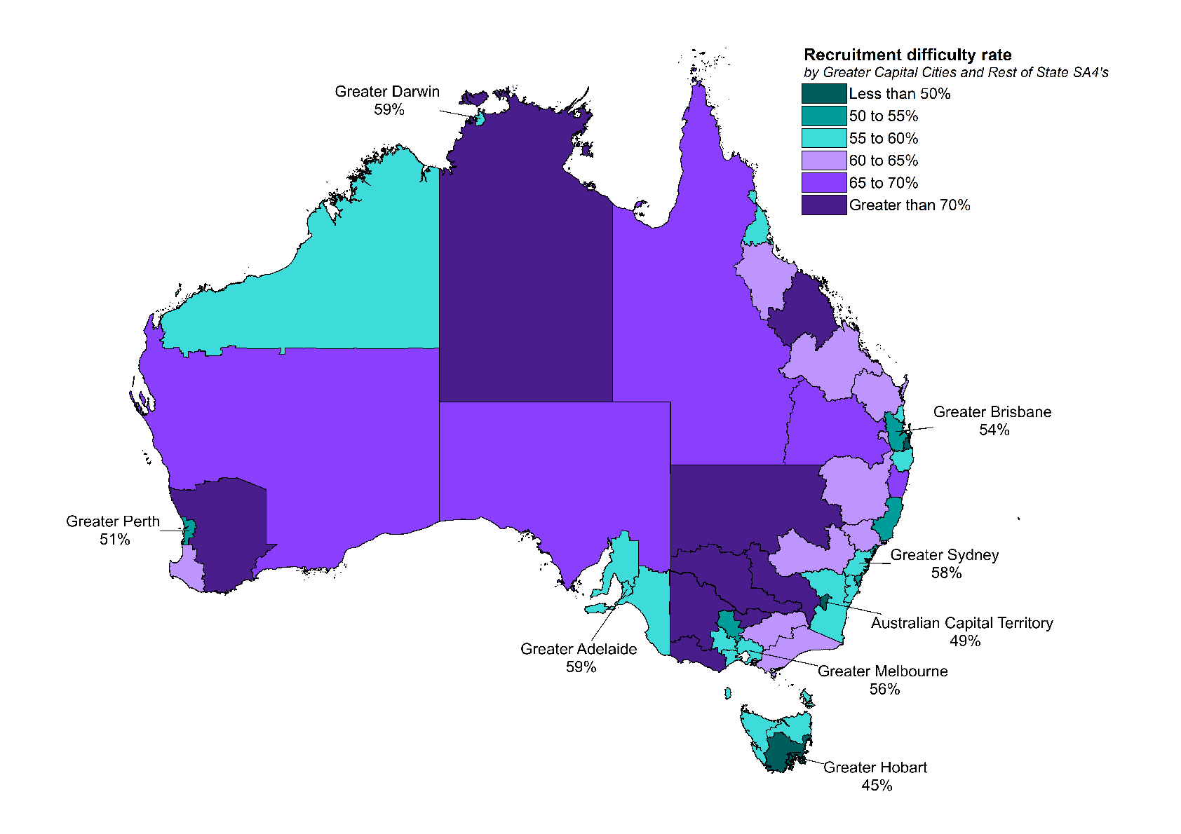

Source: JSA, Recruitment Experiences and Outlook Survey, March 2024.   
Note: Results for rest of state SA4s are indicative only, due to small sample sizes for some regions.

## In focus: Assessing the long-term performance of regional labour markets

Jobs and Skills Australia’s *Regional Labour Market Indicator* (RLMI)[5] can help to identify trends in region-specific labour market performance. Comparing a region’s long-term rating of labour market strength with the current rating can identify regions with changed conditions. Changes may arise from short-term fluctuations in the business cycle or long-term and persistent region-specific shifts. Identifying whether a region’s labour market performance is driven by short-term cyclical fluctuation or long-term structural shift can help target appropriate policy responses.

The RLMI results illustrate a high degree of labour market persistence. For many regions, conditions vary little from their long-term trend (see Figure 19). For instance, current labour market conditions are similar to their long-term trend (relative to the national average) for around 80% of regions (or 71 SA4’s). This has important implications for labour market policy. Many regions with persistently poor conditions are in regional and remote areas. Policy focus for such regions should be on addressing structural sources of labour underutilisation that increase the risk of disadvantage becoming entrenched.

For a number of regions, however, current labour market conditions vary considerably from their long-term trend. This is not entirely surprising given regions, at points in time, are exposed to different economic and labour market developments. This can depend on their geographical dispersion and other characteristics, such as industry composition, availability of natural resources and location.[6]

**Figure 19: Long-term and current ratings of regional labour market strength**

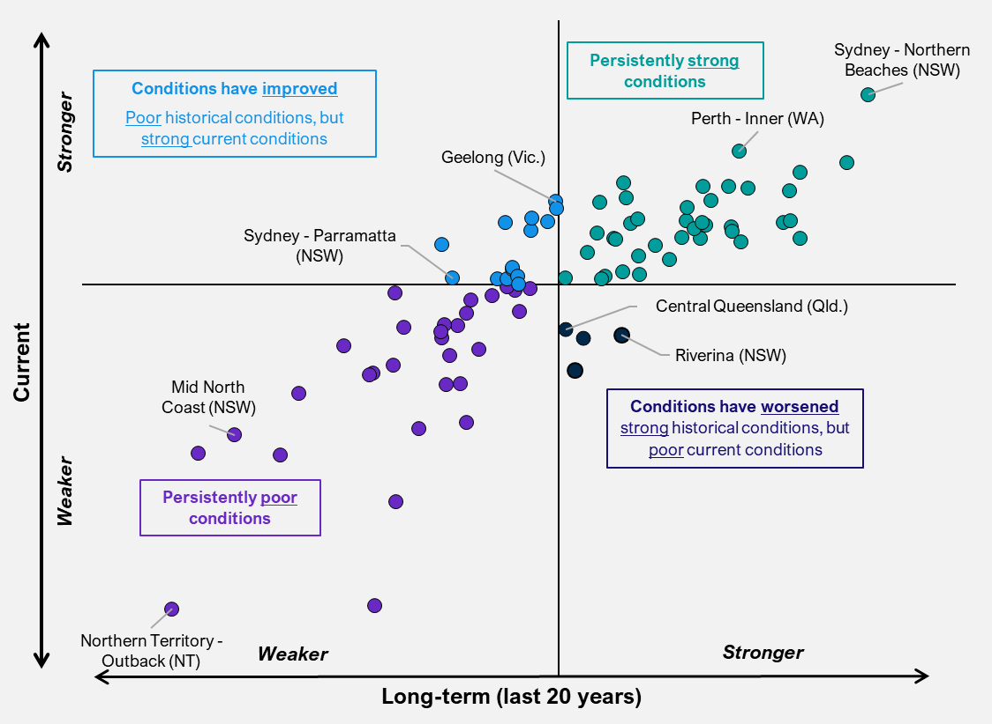

Source: JSA, *Regional Labour Market Indicator (RLMI)*, January 2024

#### Region in focus: Central Queensland

The relative strength of the labour market in **Central Queensland** has declined from its long-term trend as a number of partial indicators of spare labour market capacity have recently softened, with the region’s working age employment rate falling over the past 12 months. This has been accompanied by an increase in the unemployment rate, while the proportion of the working age population in receipt of JobSeeker income support remains well above the national average.

While the change in labour market conditions may be, at least partially, the result of a short-term cyclical variations, there are a number of economic and labour market factors that have likely contributed to weaker conditions in Central Queensland. One such factor is the net zero transformation, which represents a significant structural shift for the region. While this presents both challenges and opportunities for the Australian labour market, Central Queensland’s labour market is more exposed than most due to its high share of employment in transitioning sectors[7]. For instance, of the 5 regions across Australia where workers in transitioning industries make up more than 10% of local employment, 3 regions are in (or close to) Central Queensland (Central Highlands – 15% of local employment, Biloela – 11% and Bowen Basin – North – 21%).[8]

Other factors also likely contributing to weakening conditions in the region, are the ongoing recruitment challenges, particularly for skilled workers. For instance, the vacancy ratio[9] for Occupational Therapists and Mining Engineers in the region is above 10%, whilst the vacancy ratio for General Practitioners and Resident Medical Officers has increased sharply, from just under 3% in 2020, to more than 8% in 2024. Recruitment challenges in the region have likely been made more difficult due to the lower skill level of the region’s workforce (just 56% of the workforce have attained a Certificate III or above, well below the national average of 65%), as well as stagnant population growth over the past few years.

#### Region in focus: Newcastle and Lake Macquarie

By contrast, the relative strength of the labour market in **Newcastle and Lake Macquarie** has improved from its long-term trend as a number of partial indicators of spare labour market capacity have recently strengthened, with the working age employment rate rising considerably over the past few years, while the unemployment rate remains below the national average. Encouragingly, the working age JobSeeker income support rate has also fallen steadily over the past few years and is below the national average.

Like many coastal cities, Newcastle and Lake Macquarie has become an increasingly attractive place to live post-COVID (particularly for those from major capital cities, such as Sydney) and as a result has experienced particularly strong population growth in recent years, with the region’s population increasing by 3% over the last year, and by more than 7% since the onset of COVID-19 in March 2020. This surge in population has led to a large rise in employment across a range of sectors including for health, education and tourism.

# Labour market conditions across industries and occupations

Note: The industry, occupation and skill level employment data in the analysis below are sourced from ABS, Labour Force, Australia, Detailed, February 2024 and trended by Jobs and Skills Australia, while total employment data have been trended by the ABS.

## Employment by industry

Employment increased in 14 industries and declined in 5 over the year to February 2024. Health Care and Social Assistance; Education and Training; and Construction made the largest contributions to employment growth over the year. The largest falls in employment over the year were recorded in Accommodation and Food Services; Financial and Insurance Services; and Administrative and Support Services.

Figure 20: Employment change by industry (Jobs and Skills Australia trend series), February 2023 to February 2024

Table 5: Employment by industry[10]

|  |  |  |  |  |  |  |
| --- | --- | --- | --- | --- | --- | --- |
| Industry | Employment | | Annual change to Feb-24 | | 5-year change to Feb-24 | |
| Feb-24 | Feb-23 |
| (‘000) | (‘000) | (‘000) | (%) | (‘000) | (%) |
| Agriculture, Forestry and Fishing | 311.2 | 311.4 | -0.2 | -0.1 | -19.7 | -6.0 |
| Mining | 311.1* | 304.6 | 6.5 | 2.1 | 57.0 | 22.5 |
| Manufacturing | 912.8 | 879.9 | 32.9 | 3.7 | 14.0 | 1.6 |
| Electricity, Gas, Water and Waste Services | 166.0* | 161.7 | 4.2 | 2.6 | 16.9 | 11.4 |
| Construction | 1,332.5* | 1,296.2 | 36.3 | 2.8 | 161.1 | 13.8 |
| Wholesale Trade | 383.9 | 372.6 | 11.3 | 3.0 | 6.5 | 1.7 |
| Retail Trade | 1,338.1* | 1,332.4 | 5.6 | 0.4 | 72.1 | 5.7 |
| Accommodation and Food Services | 913.2 | 931.3 | -18.0 | -1.9 | 19.9 | 2.2 |
| Transport, Postal and Warehousing | 727.5* | 708.1 | 19.3 | 2.7 | 76.7 | 11.8 |
| Information Media and Telecommunications | 186.7 | 188.9 | -2.2 | -1.2 | -17.7 | -8.7 |
| Financial and Insurance Services | 544.5 | 551.1 | -6.6 | -1.2 | 101.7 | 23.0 |
| Rental, Hiring and Real Estate Services | 219.2* | 218.8 | 0.4 | 0.2 | 7.5 | 3.5 |
| Professional, Scientific and Technical Services | 1,322.6* | 1,287.3 | 35.3 | 2.7 | 220.6 | 20.0 |
| Administrative and Support Services | 419.7 | 422.1 | -2.4 | -0.6 | -3.9 | -0.9 |
| Public Administration and Safety | 928.9* | 897.0 | 31.9 | 3.6 | 93.2 | 11.1 |
| Education and Training | 1,200.9* | 1,149.0 | 51.9 | 4.5 | 163.4 | 15.8 |
| Health Care and Social Assistance | 2,224.4* | 2,116.4 | 108.0 | 5.1 | 530.3 | 31.3 |
| Arts and Recreation Services | 257.0* | 247.0 | 10.0 | 4.1 | 17.0 | 7.1 |
| Other Services | 524.5 | 519.8 | 4.7 | 0.9 | 21.9 | 4.4 |
| **TOTAL EMPLOYMENT** | **14,307.6** | **13,895.6** | **412.1** | **3.0** | **1,558.3** | **12.2** |

*Denotes a record high in the November quarter 2023.

Reflecting continued economic growth and a relatively tight labour market, employment in 11 of the 19 broad industry groups reached record highs in the February 2024 quarter (Table 5).[11]

### Recruitment difficulty among industries

Over the year to the March quarter 2024, recruitment difficulty fell in all major industry divisions (Figure 21). Accommodation & Food Services recorded the lowest difficulty rate at 36% for the March quarter 2024 while Manufacturing recorded the highest at 61%. Employers in the Wholesale Trade industry experienced the greatest decrease in recruitment difficulty, down by 23 percentage points over the year, to 47% of recruiting employers. Most major industry divisions also experienced a decline in recruitment difficulty compared to the previous quarter, the only exception being the Retail Trade industry which experienced an increase of 5 percentage points to 52% in the March quarter 2024.

Figure 21: Quarterly recruitment difficulty rate (proportion of recruiting employers) by industry, March quarter 2023 to March quarter 2024

Source: JSA, Recruitment Experiences and Outlook Survey, March 2024.  
*Interpret with caution due to low sample size.

## Skill levels

Employment increased in all 5 Skill Level groups over the year to February 2024. Skill Level 4 occupations (commensurate with a Certificate III or II) recorded the largest increase in employment over the year (up by 166,200 or 5.0%). Skill Level 1 occupations (commensurate with a Bachelor Degree or higher) recorded the second largest increase (up by 160,700 or 3.3%), followed by Skill Level 2 occupations (commensurate with an Advanced Diploma or Diploma) (up by 48,600 or 2.9%), Skill Level 3 occupations (commensurate with a Certificate IV or III) (up by 17,200 or 0.8%), and Skill Level 5 occupations (commensurate with a Certificate I or secondary education) (up by 2,300 or 0.1%).

Table 6: Employment by skill levels[12]

|  |  |  |  |  |  |  |
| --- | --- | --- | --- | --- | --- | --- |
| Skill Levels | Employment | | Annual change to Feb-24 | | 5-year change to Feb-24 | |
| Feb-24 | Feb-23 |
| (‘000) | (‘000) | (‘000) | (%) | (‘000) | (%) |
| Skill Level 1 Occupations | 4,971.6 | 4,810.9 | 160.7 | 3.3 | 932.6 | 23.1 |
| Skill Level 2 Occupations | 1,749.1 | 1,700.5 | 48.6 | 2.9 | 176.9 | 11.2 |
| Skill Level 3 Occupations | 2,081.5 | 2,064.3 | 17.2 | 0.8 | 71.9 | 3.6 |
| Skill Level 4 Occupations | 3,487.9 | 3,321.8 | 166.2 | 5.0 | 356.3 | 11.4 |
| Skill Level 5 Occupations | 2,001.9 | 1,999.6 | 2.3 | 0.1 | 4.2 | 0.2 |
| **TOTAL EMPLOYMENT** | **14,307.6** | **13,895.6** | **412.1** | **3.0** | **1,558.3** | **12.2** |

The shift towards higher skill levels in recent years is a continuation of a long-term trend, as the workforce has become more highly educated and employment has transitioned towards services-based industries. Over the 5 years to February 2024, the share of total employment accounted for by Skill Level 1 occupations increased by 3.1 percentage points to 34.7% in February 2024, while the share of total employment accounted for by Skill Level 5 occupations fell by 1.7 percentage points to 14.0%.

In addition, Figures 22 and 23 show that, in March 2024, more employers had difficulty recruiting for higher skilled occupations (62% for Skill Level 1 to 3 occupations) than for lower skilled occupations (39% for Skill Level 4 and 5 occupations). The recruitment difficulty experienced by employers filling lower skilled vacancies fell by 18 percentage points over the year, to the lowest rate since March 2021. In comparison, there was a 10 percentage point reduction in difficulty experienced by employers recruiting for higher skilled jobs over the same period.

Figure 22: Monthly recruitment difficulty rate and Internet Vacancy Index job advertisements, higher skill level occupations, December 2020 to March 2024

Figure 23: Monthly recruitment difficulty rate and Internet Vacancy Index job advertisements, lower skill level occupations, December 2020 to March 2024

Source: JSA, Recruitment Experiences and Outlook Survey, March 2024; JSA, Internet Vacancy Index, March 2024.   
Note: Disaggregated data are not published in January of each year. Accordingly, relevant data points have been joined by a dotted line.

## Occupational breakdown

Employment increased in all 8 major occupation groups over the *year* to February 2024. Over the 5 years to February 2024, however, employment rose in 7 major occupation groups and declined in one (Table 7).

Over the year to February 2024:

* The largest increases in employment were recorded for Professionals (up by 152,500 or 4.2%), Clerical and Administrative Workers (up by 86,600 or 4.8%), and Community and Personal Services Workers (up by 84,100 or 5.5%).

Over the 5 years to February 2024:

* The largest increases in employment were recorded for Professionals (up by 696,300 or 22.7%), Managers (up by 290,000 or 18.9%), and Community and Personal Service Workers (up by 257,200 or 18.8%).

Table 7: Employment by major occupation group[13]

|  |  |  |  |  |  |  |
| --- | --- | --- | --- | --- | --- | --- |
| Occupation | Employment | | Annual change to Feb-24 | | 5-year change to Feb-24 | |
| Feb-24 | Feb-23 |
| (‘000) | (‘000) | (‘000) | (%) | (‘000) | (%) |
| Managers | 1,823.8 | 1,822.8 | 1.1 | 0.1 | 290.0 | 18.9 |
| Professionals | 3,766.3 | 3,613.8 | 152.5 | 4.2 | 696.3 | 22.7 |
| Technicians and Trades Workers | 1,919.3 | 1,893.2 | 26.2 | 1.4 | 108.8 | 6.0 |
| Community and Personal Service Workers | 1,626.9 | 1,542.8 | 84.1 | 5.5 | 257.2 | 18.8 |
| Clerical and Administrative Workers | 1,884.9 | 1,798.3 | 86.6 | 4.8 | 121.5 | 6.9 |
| Sales Workers | 1,113.6 | 1,113.2 | 0.4 | 0.0 | 7.8 | 0.7 |
| Machinery Operators and Drivers | 916.7 | 891.8 | 24.9 | 2.8 | 52.0 | 6.0 |
| Labourers | 1,207.7 | 1,205.4 | 2.3 | 0.2 | -10.0 | -0.8 |
| **TOTAL EMPLOYMENT** | **14,307.6** | **13,895.6** | **412.1** | **3.0** | **1,558.3** | **12.2** |

### Internet vacancies by occupation

Over the 3 months to March 2024, recruitment activity decreased across almost all major occupation groups. Vacancies for Sales Workers was the lone increase over the quarter (up by 0.5%).

Professionals and Technicians and Trades Workers recorded the largest decreases in internet vacancies over the quarter (down by 7.0% and 6.7% respectively). The declines recorded among Community and Personal Service Workers and Machinery Operators and Drivers were somewhat smaller (down by 3.9% and 3.7%). Demand for Managers, Labourers and Clerical and Administrative Workers recorded the smallest declines over the quarter (with vacancies in those occupations down by 1.7%, 1.3% and 0.4% respectively) – see Table 8.

Despite the decline over the quarter, vacancies remain at relatively high levels at the national level. As at March 2024, the number of internet advertisements captured by the Internet Vacancy Index (IVI) remains at a level not seen in Australia since prior to the Global Financial Crisis in 2008.

The February occupational IVI vacancy ratio indicates a softening in, and narrowing of, demand relative to employment, with only Professionals, Technicians and Trades Workers, and Clerical and Administrative Workers recording values above the all-occupation average for March 2024 (1.7%). The IVI vacancy rate remains high and is well above the recent low of 0.5% recorded in April 2020. It also remains above the average recorded over the decade preceding the pandemic (1.5%).

Table 8: Change in internet advertisements, and IVI vacancy ratios, for major occupation groups (online job advertisements as a proportion of employment)[14]

|  |  |  |  |  |
| --- | --- | --- | --- | --- |
|  | Mar-23  (no.) | Quarterly change (no.) | Quarterly change  (%) | IVI vacancy ratio  Feb-24  (%) |
| Managers | 29,300 | -500 | -1.7% | 1.6% |
| Professionals | 78,200 | -5,400 | -7.0% | 1.9% |
| Technicians and Trades Workers | 36,600 | -2,400 | -6.7% | 1.8% |
| Community and Personal Service Workers | 29,700 | -1,100 | -3.9% | 1.6% |
| Clerical and Administrative Workers | 38,600 | -150 | -0.4% | 2.0% |
| Sales Workers | 19,100 | 90 | 0.5% | 1.7% |
| Machinery Operators and Drivers | 13,900 | -510 | -3.7% | 1.4% |
| Labourers | 15,200 | -200 | -1.3% | 1.2% |
| **ALL OCCUPATIONS** | **249,000** | **-10,600** | **-4.1%** | **1.7% *(Mar-24)*** |

Source: ABS, Labour Force, Australia, Detailed, February 2024, original data; ABS, Labour Force, Australia, March 2024, seasonally adjusted data; JSA, Internet Vacancy Index, March 2024, seasonally adjusted data.

### Recruitment difficulty by occupation

The recruitment difficulty experienced by employers looking to fill different occupations fell across most categories between March quarter 2023 and March quarter 2024 (Figure 24). Technicians and Trade Workers was the only occupation group to experience an increase in recruitment difficulty over the year to March 2024, rising by 2 percentage points to 71%.

The largest decrease in recruitment difficulty over the year to the March quarter 2024 was experienced by employers seeking Labourers (down 23 percentage points to 38%) followed by employers seeking Clerical and Administrative Workers (down 19 percentage points to 33%).

Recruitment of Technicians and Trades Workers continues to be challenging with 71% of employers experiencing difficulty in the March quarter 2024 — the highest across all occupations. Historically, employers advertising for Technicians and Trades Workers would experience the highest recruitment difficulty across all major occupation groups and is still the case for the March quarter 2024. The occupation group experiencing the lowest level of recruitment difficulty was Clerical and Administrative Workers at 33%.

Figure 24: Quarterly recruitment difficulty rate (proportion of recruiting employers) by major occupation group, March quarter 2023 to March quarter 2024

Source: JSA, Recruitment Experiences and Outlook Survey, March 2024.

## In focus: BLACK, WHITE and RED ALL OVER - The tipping point for Journalists and Other Writers

Journalism and the news media sector have faced successive disruptions in recent years. Digital technology’s upending of the advertising-driven business model is now coupled with the uncertain role of artificial intelligence, following the recent proliferation of large language models and their deployment in newsrooms.[15] Recognising the potential for dramatic change in this sector, Jobs and Skills Australia analysed labour market conditions for Journalists and Other Writers, with this occupation covering journalists, copywriters, and editors across both print (physical and online media), radio and television.[16] This occupation appears to be at the apex of a tipping point as the sector grapples with a maelstrom of disruption.

Vacancy numbers for Journalists and Other Writers remain at relatively high levels. Over the 5 years to February 2024, internet vacancies have increased by 47.5% (compared with a 39.4% increase for all occupations).[17] Since the series high recorded in March 2023 however, internet vacancies have declined by 31.0% (compared with a 21.7% decline for all occupations). This drop in demand has yet to be reflected in the occupation’s employment numbers.

The number of Journalists and Other Writers employed in Australia was stable over the February quarter, growing by 0.6% to around 25,000.[18] This is consistent with recent trends for the occupation, with employment remaining relatively unchanged over the past decade, increasing by just 1.6% over this period.[19]

Employment data showing innocuous stability for a sector experiencing successive disruptions may mask more concerning dynamics. Administrative occupation mobility data indicates a negative net average annual inflow (-1.0%) of workers into Journalists and Other Writer occupations between 2011 and 2020, with the last substantial annual net inflow occurring in the 2011-12 financial year.[20] The bulk of the outflows have come from the subcategory of Print Journalist.[21] This indicates that, since 2011-12, outflows of journalists from the profession have been greater than inflow, though data is not currently available covering the post-pandemic period.

Media organisations are responding to the upheavals. Highly publicised redundancies occurred at major Australian media organisations during 2023. News Corp Australia reportedly made 200 workers redundant amid the organisation’s worldwide personnel reduction.[22] Also, the Australian Broadcasting Corporation made 120 roles redundant.[23] Technological advancements are also being utilised as a cost saving measure. News Corp Australia’s executive chair revealed in August 2023 that the media giant has been producing a staggering 3,000 news articles a week through generative artificial intelligence.[24] Since

these revelations, almost 5% of job advertisements for Journalists and Other Writers have included references to using these technologies.[25]

Perhaps indicative of the increase in precarious employment reported elsewhere, self-employment in this occupation is increasing. In 2021, almost one in five Journalists and Other Writers indicated they were self-employed (an increase of around 3 percentage points compared to 2016). [26]

This labour market presently represents the intersection of disruptive innovation and changing consumer habits. The consequences of these shifts are important due to the sector’s critical role for the wellbeing of Australian society and communities. The apparent torpor in this segment of the labour market has enriched others.[27] This is evident, for example, in the robust employment growth among Public Relations Professionals and their managers.[28] However, such occupations provide a different type of social value. Some new technologies appear potentially facilitative to the news media’s indispensable work. However, it remains to be seen whether the way it is deployed aids journalists to deliver the value Australians have come to expect and for which they have shown a readiness to pay.[29] With softening economic conditions forecasted for 2024 and the uptake of new generative tools in newsrooms proceeding rapidly here and internationally, 2024 may see a tipping point for this occupation.

# Jobs and Skills Australia resources

Key data, resources and reports can be found on the Jobs and Skills Australia website: <https://www.jobsandskills.gov.au/>

|  |  |
| --- | --- |
| **Resource** | **Publication notes** |
| [Internet Vacancy Index](https://www.jobsandskills.gov.au/data/internet-vacancy-index)  The Internet Vacancy Index (IVI) is a monthly count of online job advertisements compiled by Jobs and Skills Australia. | The Vacancy Report is published on the third Wednesday of the month. |
| [Recruitment Experiences and Outlook Survey](https://www.jobsandskills.gov.au/data/recruitment-experiences-and-outlook-survey)  Survey of at least 1000 employers each month to find out about their experience when recruiting staff. | The Recruitment Insights Report is published on the third Tuesday of the month, while regular special topic Spotlight reports are also published monthly. |
| [Skill Shortages Analysis](https://www.jobsandskills.gov.au/data/skills-shortages-analysis)  Skills shortage analysis including the annual Skills Priority List (SPL) and reports on Skills Shortages. | The SPL is released annually (around September), while the Skills Shortage Quarterly provides quarterly insights. |
| [Small Area Labour Markets (SALM)](https://www.jobsandskills.gov.au/data/small-area-labour-markets)  Estimates of unemployment and the unemployment rate at the Statistical Area Level 2 (SA2) and Local Government Area (LGA) level. | SALM data are released quarterly. |
| [Jobs and Skills Atlas](https://www.jobsandskills.gov.au/data/jobs-and-skills-atlas)  Provides an overview of the labour market at national, state and regional level by occupations, skills and industries. | Atlas will be updated with the data for the previous month, by the last Friday of every month. |
| [Employment Region Dashboards and Profile](https://www.jobsandskills.gov.au/data/employment-region-dashboards-and-profiles)  Monthly Labour Market Dashboards, Recruitment Trends and Employer Needs Profiles, and Industry Profiles. |  |
| [Nowcast of Employment Region and Occupation (NERO)](https://www.jobsandskills.gov.au/data/nero)  Experimental dataset providing information on employment in 355 occupations across 88 regions in Australia. | NERO data will be updated monthly. |
| International Labour Market Update  Provides key labour market data for Australia and selected overseas countries and country groups. | The [February 2024 report](https://www.jobsandskills.gov.au/news/international-labour-market-update-february-2024-released) is currently available. |
|  |  |

1. Note that in this report, Jobs and Skills Australia has updated the methodology in calculating the fill rate and other metrics, such as applicants, qualified applicants and suitable applicants per vacancy. Jobs and Skills Australia is now using a rolling annual period of 12 months leading to the latest quarter, instead of using the latest quarter itself. This change has been made to eliminate the impact of data volatility attributable to SERA sampling, where concentrations of sampling, with respect to different occupational major groups, can occur at different times of the year.
2. The analysis uses SERA fill rates at the 4-digit ANZSCO level from September 2006 to June 2023, and Census data over each of the 5-year Census periods from 2006 to 2021 to determine the gender splits. The gender splits are used for the years after each census year until the next Census is available. For example, the gender split for the years 2006 to 2010 uses the 2006 Census, 2011 to 2015 using the 2011 Census and so on. The SERA data is aggregated over each of the 5-year period.
3. The inequality metric is measured by one minus entropy. Entropy is a concept commonly associated with a state or disorder, randomness or uncertainty. Taking each gender as a distinct state, entropy returns the value of 1 for a 50-50 split (perfect disorder) between males and females but 0 for a 100-0 split (perfectly ordered) for either males or females. To get the required form, 1 minus entropy is taken. It functions like a Gini index but is more sensitive to higher proportions on either end; The formula for gender inequality is: $Gender Inequality= 1+ male proportion*\log_{2}\left(male proportion\right)+female proportion*\log_{2}\left(female proportion\right)$. Using a logarithm with base 2 results in the required functional form.
4. Please note that more detailed data show that employment increased by 0.045% over the March quarter 2024.
5. The RLMI, a composite indicator, brings together several partial indicators of spare labour market capacity to assess a region’s (SA4) current labour market strength, relative to the national average. A strong labour market is characterised by a high rate of employment, where employment opportunities are extended to all who want them.
6. RBA, [*Regional Variation in Economic Conditions*](https://www.rba.gov.au/publications/bulletin/2020/mar/regional-variation-in-economic-conditions.html), 2020, accessed April 2024.
7. Fossil-fuel related groups which will decline and transform substantially as a result of decarbonisation.
8. JSA, [*Clean Energy Capacity Study*](https://www.jobsandskills.gov.au/studies/clean-energy-capacity-study), 2023.
9. The vacancy ratio measures the share of online job ads as a proportion of employment.
10. Industry employment data are trended by JSA, while total employment data are trended by the ABS. JSA and the ABS use different trending methodologies, and industry employment data do not sum to total employment figures.
11. JSA trended quarterly industry employment data are available for the August 1986 quarter onwards.
12. Skill Level data are trended by Jobs and Skills Australia. Total employment data are trended by the ABS. Jobs and Skills Australia and ABS use different trending methodologies, and Skill Level data do not sum to total employment figures.
13. Occupation group data are trended by Jobs and Skills Australia. Total employment data are trended by the ABS. Jobs and Skills Australia and ABS use trending methodologies, and occupation group data do not sum to total employment figures.
14. Online job advertisements can be slightly biased towards higher skilled positions. Employers with lower skilled vacancies are more likely to use informal recruitment methods, such as social media or word of mouth.
15. L Taylor, ‘[News Corp using AI to produce 3,000 Australian local news stories a week](https://www.theguardian.com/media/2023/aug/01/news-corp-ai-chat-gpt-stories)’, *The Guardian Australia*, 1 August 2023.
16. Please note, authors, television presenters or talk back radio hosts are categorised elsewhere in the Australian and New Zealand Standard Classification of Occupations and are not covered in this analysis.
17. Jobs and Skills Australia (JSA), ‘[Internet Vacancy Index](https://www.jobsandskills.gov.au/data/internet-vacancy-index)’, 3-month averaged data, February 2023.
18. ABS, ‘Labour Force, Australia, Detailed’, February 2024, trend data by Jobs and Skills Australia.
19. ABS, ‘Labour Force, Australia, Detailed’, February 2024, trend data by Jobs and Skills Australia.
20. JSA, ‘[Data on Occupation Mobility](https://www.jobsandskills.gov.au/publications/data-occupation-mobility-unpacking-workers-movements)’, 2023.
21. JSA, ‘Data on Occupation Mobility’.
22. S Buckingham-Jones, ‘[Up to 200 jobs likely to go at News Corp amid strategy shift](https://www.afr.com/companies/media-and-marketing/up-to-200-jobs-likely-to-go-at-news-corp-amid-strategy-shift-20230310-p5cr65)’, *The Australian Financial Review*, 13 March 2023.
23. Australian Broadcasting Corporation, ‘[ABC to cut 120 jobs as major changes are announced](https://www.abc.net.au/news/2023-06-16/abc-director-of-news-decision-to-cut-120-jobs/102485864)’, *ABC News*, 16 June 2023.
24. L Taylor, ‘News Corp using AI to produce 3,000 Australian local news stories a week’.
25. Lightcast, ‘Australian Online Job Advertisements Data’, 2024.
26. ABS, ‘[Journalists and Other Writers (OCCP) by Status in Employment (SIEMP) 2016 and 2021](https://www.abs.gov.au/statistics/microdata-tablebuilder/tablebuilder)’ [Census of Population and Housing, TableBuilder], 2021; N Dawson, S Molitorisz, MA Rizoiu and P Fray, ‘[Layoffs, inequity and COVID-19: A longitudinal study of the journalism jobs crisis in Australia from 2012 to 2020](https://sharedservicescentre-my.sharepoint.com/personal/christopher_mcloughlin_jobsandskills_gov_au/Documents/Documents/Tasks/IVI/Briefs%20&%20ad%20hoc%20requests/LMUs/2024/LMU%20Mar%2024%20IVI%20contribution/Layoffs,%20inequity%20and%20COVID-19:%20A%20longitudinal%20study%20of%20the%20journalism%20jobs%20crisis%20in%20Australia%20from%202012%20to%202020)’, *Journalism*, 2023, 24(3), 531-559, doi: 10.1177/1464884921996286.
27. Dawson, et al., ‘Layoffs, inequity and COVID-19: A longitudinal study of the journalism jobs crisis in Australia from 2012 to 2020’.
28. ABS, ‘Labour Force, Australia, Detailed’, February 2024, trend data by Jobs and Skills Australia.
29. S Park, K McGuinness, C Fisher, J Lee, K McCallum, X Cai, M Chatskin, L Mardjianto and P Yao, ‘[Digital News Report: Australia 2023](https://www.canberra.edu.au/research/faculty-research-centres/nmrc/digital-news-report-australia)’, News and Media Research Centre, University of Canberra, 2023, doi: 10.25916/v0mt-9k87.