

Australian Labour Market for Migrants

The Australian Labour Market for Migrants publication provides information on the Australian labour market. It is intended to inform recent migrants to Australia, people interested in working in Australia on a temporary or permanent basis, and organisations providing services to migrants and potential visa applicants.
The Australian labour market continues to perform well with a low unemployment rate. However, international uncertainty and other forward indicators, suggest that the Australian labour market is softening and may experience subdued conditions over the period ahead. See the Jobs and Skills Australia website for recent labour market data and analysis.
Unless otherwise stated, data in this publication are from the Australian Bureau of Statistics (ABS) Labour Force Survey, November 2023.

Employment
Over the 12 months to November 2023, employment opportunities and growth varied widely across industries. The largest increases in trend employment occurred in Health Care and Social Assistance (up by 127,400), Construction (up by 67,800) and Manufacturing (up by 49,400). The largest decreases in employment occurred in Accommodation and Food Services (down by 18,200), Agriculture, Forestry and Fishing (down by 6,600) and Rental, Hiring and Real Estate Services (down by 4,300).
Changes in employment by industry are shown in Figure 1. The strongest rates of employment growth were in Arts and Recreation Services (up by 7.5%), Health Care and Social Assistance (up by 6.1%) and Manufacturing (up by 5.6%).
Figure 1: Employment growth by industry (’000s persons) — November 2022 to November 2023

Source: ABS, Detailed Labour Force Survey, November 2023 (Table 04). Data trended by Jobs and Skills Australia.
Occupation by state/territory
Figure 2 shows that in November 2023 (trend data), the Australian Capital Territory (ACT) had the highest share (59.9%) of employed workers in selected occupation groups (i.e. Managers, Professionals, and Technicians and Trade Workers), followed by Victoria (54.8%) and New South Wales (NSW, 53.9%).
In the 12 months to November 2023, the share of workers employed in these selected occupation groups increased in all states and territories except for NSW (down by 0.3pp). The largest increases were in the Australian Capital Territory (ACT, up by 0.8pp), Tasmania (up by 0.7pp) and Northern Territory (NT, up by 0.7pp). Increases were also estimated for the remaining states, South Australia (SA, up by 0.5pp), Queensland (up by 0.4pp) Western Australia (WA, up by 0.3pp) and Victoria (up by 0.2pp).
Figure 2: Share of employment in selected Occupation Groups by state/territory, November 2022 and November 2023

Source: ABS, Detailed Labour Force Survey (Table EQ08), November 2023. Data trended by Jobs and Skills Australia.

Unemployment
The trend unemployment rate in Australia was 3.8% in November 2023, compared with 3.5% in November 2022.
Over the 12 months to November 2023, the unemployment rate decreased in SA (4.0% to 3.7%). The unemployment rate rose in NSW (3.2% to 3.4%), Victoria (3.7% to 3.9%), Queensland (3.6% to 4.3%), WA (3.6% to 3.7%), Tasmania (3.9% to 4.1%), NT (3.7% to 4.4%) and the ACT (2.9% to 3.7%).
Figure 3: Unemployment rates (%) by state/territory — November 2023

Source: ABS Labour Force, Australia, December 2023. Table 12: trend unemployment rate. Retrieved December 18, 2023. https://www.abs.gov.au/statistics/labour/employment-and-unemployment/labour-force-australia/nov-2023.

Migrant employment
Australian-born people represent the highest share of employed people in Tasmania (84.6%) and the lowest share in WA (59.7%). The share of employed people born in other than main English-speaking countries (OTMESC) is highest in Victoria, NSW and the NT (29.8%, 27.7% and 27.5% respectively). See Figure 4.

Figure 4: Share of employment by state/territory and place of birth, November 2023

Source: ABS, Labour Force, Australia, Detailed, November 2023. Table LM7: Labour force status by elapsed years since arrival, main English-speaking countries, sex, state and territory. Retrieved December 21, 2023. https://www.abs.gov.au/statistics/labour/employment-and-unemployment/labour-force-australia-detailed/nov-2023

Migrant unemployment
The unemployment rates for people who migrate to Australia vary appreciably. Several factors influence migrant unemployment rates including skill level, age, English language proficiency, recent and relevant work experience and the period since arrival in Australia. Data consistently shows that recently arrived migrants have a higher unemployment rate on average than those who have lived in Australia for some years.
Figure 5 shows the participation and unemployment rates of the Australian-born and migrants by broad country of birth groups and period of residence in Australia (average of the last 12 months to November 2023).
Figure 5: Labour force participation rate and unemployment rate, by years since arrival in Australia for broad country of birth groups — 12 months to November 2023 average

Source: ABS Labour Force, Australia, November 2023. Table LM7: Labour force status by elapsed years since arrival, main English-speaking countries, sex, state and territory. Retrieved December 21, 2023.
https://www.abs.gov.au/statistics/labour/employment-and-unemployment/labour-force-australia-detailed/nov-2023

Figure 6 shows unemployment rates (average of the last 12 months to November 2023 for people resident in Australia by their major birth country groups (by subcontinent). People born in North-West Europe had the lowest unemployment rate (at 2.3%), while the unemployment rate for people born in North Africa and the Middle East (7.3%) was relatively high (possibly reflecting English language proficiency and period of residence in Australia).

Figure 6: Unemployment rate, by years since arrival in Australia by broad country of birth groups — 12 months to November 2023 average

Source: ABS Labour Force, Australia, Detailed, November 2023. Table LM5: Labour force status by age, major country group (subcontinent) of birth (SACC) and sex; and Table LM7: Labour force status by elapsed years since arrival, main English-speaking countries, sex, state and territory. Retrieved December 21, 2023.
https://www.abs.gov.au/statistics/labour/employment-and-unemployment/labour-force-australia-detailed/nov-2023

Employment by occupation
Over the 12 months to November 2023, the largest increases in employment (trend data) occurred for Professionals (up by 162,100), Clerical and Administrative Workers (up by 105,200), and Community and Personal Service Workers (up by 71,900). The smallest increase occurred for Sales Workers (up by 8,200). Employment growth for the major occupation groups is shown in Table 1.
Table 1: Trend employment growth by occupation — 12 months to November 2023
Occupational Group | 1 Year Change  (‘000 persons) | 1 Year Change  (%)
Managers | 10.1 | 0.6
Professionals | 162.1 | 4.5
Technicians and Trades Workers | 45.2 | 2.4
Community and Personal Service Workers | 71.9 | 4.7
Clerical and Administrative Workers | 105.2 | 5.9
Sales Workers | 8.2 | 0.7
Machinery Operators and Drivers | 18.6 | 2.1
Labourers | 9.3 | 0.8
Additional information on occupational groups is provided in the following section on internet vacancy data.

Internet Vacancy data
Jobs and Skills Australia produces the monthly Vacancy Report which contains the Internet Vacancy Index (IVI). Over the year to November 2023, the trend IVI decreased for all occupation groups but remained high compared to pre-pandemic levels: Labourers (down by 26.6%), Sales Workers (down by 11.2%), Clerical and Administrative Workers (down by 10.7%), Machinery Operators and Drivers (down by 8.8%), Community and Personal Service Workers (down by 8.2%), Managers (down by 3.2%), Technicians and Trades Workers (down by 1.8%) and Professionals (down by 0.1%). See Figure 7.
At the more detailed occupation level, trend vacancies increased in 9 of the 48 occupation clusters over the year to November 2023, with the strongest increases for Health Diagnostic and Therapy Professionals (up by 24.6%), Medical Practitioners and Nurses (up by 18.6%) and Education Professionals (up by 16.9%). The largest decreases were for Food Preparation Assistants (down by 45.1%), Factory Process Workers (down by 31.0%) and ICT Professionals (down by 29.5%).

Over the year to November 2023, trend vacancies increased in the NT (up by 12.1%), Tasmania (up by 10.9%), WA (up by 4.2%) and SA (up by 1.9%). Vacancies fell in Victoria (down by 14.1%), NSW (down by 10.0%), the ACT (down by 9.6%) and Queensland (down by 2.5%). For a full list of occupations and their recent growth in vacancies, see the Vacancy Report and supporting datafiles.
Figure 4: Internet Vacancy Index, January 2006 to November 2023

Further information
Queries on the Australian Labour Market for Migrants publication, including requests for inclusion on the distribution list and copies of Hot Topics attached to previous editions, should be emailed to migration@jobsandskills.gov.au.

Hot Topic: Temporary skill visas and Australia’s regional labour market
This Hot Topic provides an overview of the number of primary temporary skill shortage (TSS, Subclass 482) and temporary work skilled (Subclass 457) visas granted to overseas workers to help meet workforce needs in Australia.
This analysis, which covers the five years 2018-19 to 2022-23, identifies the skilled occupations that are highly demanded by approved employers in the Australian regions.

In demand occupations
The demand by approved employers to recruit overseas workers to positions as information and communications technology (ICT) professionals was greater in Major Cities where Software Engineers, ICT Business Analysts and Developer Programmers accounted for 16% of the total number of primary temporary skilled visas granted over the five-year period.
Appendix A to this Hot Topic provides information on the number of primary temporary skilled visas granted for the five most in demand occupations for each regional classification during the five-year period. This analysis also shows that:
- Demand by employers for health professionals was highest for Resident Medical Officers, which represented 9% of visas granted for Inner Regional areas, 7% for Outer Regional areas and 4% for each of the other regions (Major Cities, Remote and Very Remote).
- Chefs (4%) and Cooks (2%) were in demand by employers in all regions, accounting for a total of 6% of total primary temporary skilled visas granted over the five-year period.
- Demand for Diesel Motor Mechanics was greater in Remote and Outer Regional areas with 10% and 4% respectively of the primary temporary skilled visas granted for these regions. Demand for Fitter (General) was greater in Remote areas accounting for 7% of the visas granted for these regions.
- The occupation profile for Very Remote areas reflects the main employing sectors and included Mining Engineers (9%), Geotechnical Engineers (4%) and Deck Hands (4%).

Occupations with highest growth in demand for temporary skilled visas
A comparison of the number of primary temporary skilled visas granted before (2018-19) and after (2022-23) the COVID-19 pandemic, shows that the occupations with the highest growth in demand for these skilled visas by region were: Medical Practitioners in Major Cities (up by 556%), University Lecturer in Inner Regional areas (up by 583%), Registered Nurse (Critical Care and Emergency) in Outer Regional areas (up by 330%), Mining Engineers in Remote areas (up by 276%) and Registered Nurse (Medical) in Very Remote areas (up by 345%).
See Table 1 for the five fastest growing occupations of each region over the five-year period.
Table 1: Top five occupations for TSS visa grants growth by Remoteness Area between financial years 2018-19 and 2022-23
 | Occupation | Growth (%)
Major Cities of Australia | Medical Practitioners (nec) | 556
Major Cities of Australia | Network Analyst | 550
Major Cities of Australia | Social Worker | 363
Major Cities of Australia | Cabler (Data and Telecommunications) | 357
Major Cities of Australia | University Lecturer | 300
Inner Regional Australia | University Lecturer | 583
Inner Regional Australia | Social Worker | 390
Inner Regional Australia | Building and Engineering Technicians (nec) | 357
Inner Regional Australia | Registered Nurse (Perioperative) | 311
Inner Regional Australia | Minister of Religion* | 194
Outer Regional Australia | Registered Nurse (Critical Care and Emergency) | 330
Outer Regional Australia | Medical Practitioners (nec) | 283
Outer Regional Australia | Registered Nurse (Medical) | 205
Outer Regional Australia | Panelbeater | 180
Outer Regional Australia | Metal Machinist (First Class) | 160
Remote Australia and Very Remote Australia | Registered Nurse (Medical) | 345
Remote Australia and Very Remote Australia | Construction Project Manager | 180
Remote Australia and Very Remote Australia | Metallurgical or Materials Technician | 160
Remote Australia and Very Remote Australia | Retail Supervisor | 160
Remote Australia and Very Remote Australia | Production Manager (Mining) | 140
* Occupation is part of a Labour Agreement developed by the Australian Government.
Notes: growth was calculated for occupations with a minimum of 5 visa grants for each of the 2018-19 and 2022-23 Financial years. Occupations from Very Remote areas merged with Remote areas due to small size.
Source: Department of Home Affairs (June 2023)

Industry growth
There was variation in the use of the temporary skill visa programs across industries and regions over the five-year period covered by this analysis (see Table 2 for details). Industries that showed growth in visa grants for all regions were:
- Manufacturing, noting that this industry presented the highest growth of all industries in Remote and Very Remote areas (82%);
- Health Care and Social Assistance, particularly in Remote and Very Remote areas (51%);
- Construction where Outer Regional areas had the highest growth (71%);
- Retail Trade with substantial growth in Inner Regional (48%), Outer Regional (49%) and Remote and Very Remote areas (55%);
- Mining where Outer Regional areas had the highest growth for this industry (56%); and
- Accommodation and Food Services, Other Services and Professional, Scientific and Technical industries had moderate growth in all regions, varying between 12% and 31%.
Industries where there was a decline in primary temporary skilled visa grants included:
- Education and Training industry where there was a decline in Major Cities (4%). However, there was growth in Inner Regional (10%), Outer Regional (33%) and Remote and Very Remote (43%) areas.
- Agriculture, Forestry and Fishing which was the only industry that showed a decline in visa grants in Remote and Very Remote areas (9%). However, there was growth in visa grants for this industry in Inner Regional (30%) and Outer Regional (34%) areas.
- Electricity, Gas, Water and Waste Services was the only industry that had a decline in visa grants in Outer Regional areas (9%), compared to growth in Major Cities (8%) and Inner Regional (84%) areas.
Table 2: Industries’ average year on year growth in primary TSS visa grants by Remoteness Area, financial year 2018-19 to 2022-23
Industry Type | Major Cities | Inner Regional | Outer Regional | Remote and Very Remote
Accommodation and Food Services | 11% | 24% | 21% | 24%
Administrative and Support Services | 38% | N/A | N/A | N/A
Agriculture, Forestry and Fishing | 1% | 30% | 34% | -9%
Arts and Recreation Services | 9% | 16% | N/A | N/A
Construction | 16% | 43% | 71% | 29%
Education and Training | -4% | 10% | 33% | 43%
Electricity, Gas, Water and Waste Services | 8% | 84% | -9% | N/A
Financial and Insurance Services | 7% | N/A | N/A | N/A
Health Care and Social Assistance | 14% | 21% | 15% | 51%
Information Media and Telecommunications | 5% | 33% | 32% | N/A
Manufacturing | 25% | 40% | 20% | 82%
Mining | 17% | 36% | 56% | 35%
Other Services | 23% | 22% | 31% | 26%
Professional, Scientific and Technical | 12% | 25% | 22% | 28%
Public Administration and Safety | -11% | N/A | N/A | N/A
Rental, Hiring and Real Estate Services | 41% | N/A | N/A | N/A
Retail Trade | 23% | 48% | 49% | 55%
Transport Postal and Warehousing | 32% | 33% | 16% | N/A
Wholesale Trade | 10% | 298% | N/A | N/A
All Industries | 9% | 24% | 23% | 21%
Notes: N/A indicates insufficient data available to calculate the average growth year on year for that industry and region. Occupations from Very Remote areas were merged with Remote areas due to small size.
Source: Department of Home Affairs (June 2023).

Location of sponsored workers
Employers in Regional and Very Remote areas sponsored a higher proportion of primary temporary skilled workers, with most applicants being offshore (Very Remote, 66%, Inner Regional, 56% and Outer Regional, 54%).
In comparison, employers in Major Cities and Remote areas were more likely to sponsor primary temporary skilled workers who were already in Australia with 55% of Major Cities’ temporary skilled visas granted and 54% of Remote areas’ workers recruited onshore.
Figure 1: Percentage of primary temporary skill visa grants by Remoteness Areas of Australia and location at the time of visa grant, pooled financial year 2018-19 to 2022-23

Source: Department of Home Affairs (June 2023).

Appendix
Figure 2: Occupations with high visa demand by Remoteness Areas of Australia and location at time of primary temporary skill visa grant, financial year 2018-19 to 2022-23

Notes: Figures with less than 5 visa grants were supressed. Occupations from Very Remote areas were not included due to small size.
Source: Department of Home Affairs (June 2023).

Figure 3: Statistical Area Level 4 (SA4)—Australia, remoteness concordance
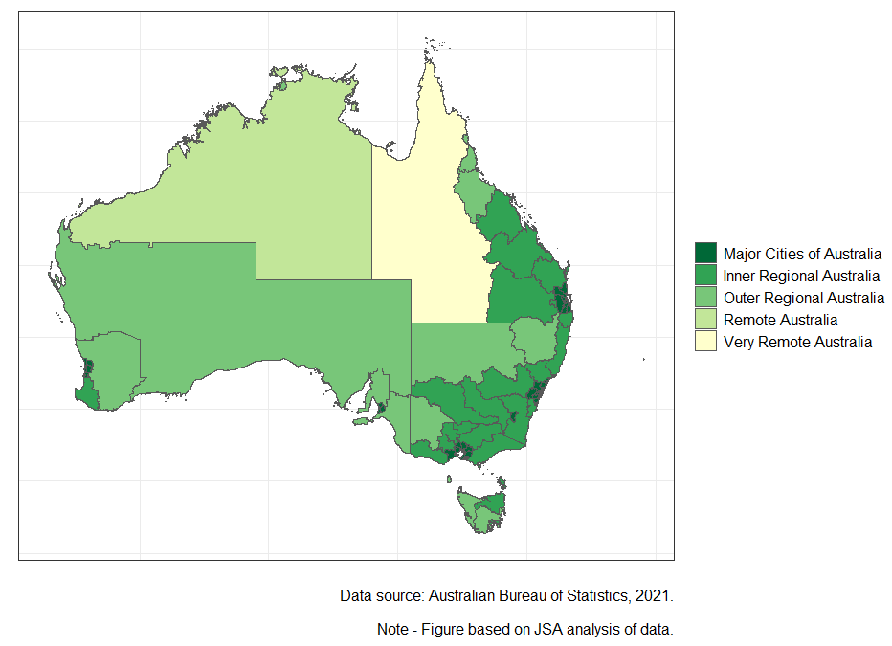

The first paragraph of the Employment section and the Unemployment section use data trended by Jobs and Skills Australia for November 2023 from the ABS’ Labour Force, Australia, December 2023 release. Previous editions of this publication used seasonally adjusted data due to a break in the trend time series.
ABS, Detailed Labour Force Survey, November 2023 (Table 04). Data trended by Jobs and Skills Australia.
ABS, Detailed Labour Force Survey, November 2023 (Table EQ08). Data trended by Jobs and Skills Australia.
“pp” means percentage points.
Selected occupation groups include ANZSCO Major Groups 1 to 3 i.e. Managers, Professionals, Technicians and Trades Workers.
Main English-speaking Countries (MESC) are the United Kingdom, the Republic of Ireland, South Africa, Canada, the United States of America and New Zealand.
In Figure 6, ‘Australia (includes External Territories)’ is within ‘Oceania and Antarctica’.
Data trended by Jobs and Skills Australia.
This section is based on November 2023 Jobs and Skills Australia trend data derived from ABS Labour Force Survey data. Occupational Groups are based on the ABS Australian and New Zealand Standard Classification of Occupations (ANZSCO).
See Internet Vacancy Index (IVI) | Jobs and Skills Australia (November 2023). The IVI is based on a count of online job advertisements newly lodged on SEEK, CareerOne and Workforce Australia during the month. Duplicate advertisements are removed before IVI vacancies are coded by Jobs and Skills Australia to occupations based on ANZSCO. The data are seasonally adjusted and trended, then indexed (January 2006=100). November 2023 trend index data are used in Figure 7 to be consistent with all other data used in this publication.
The analysis in this Hot Topic does not represent the views of the data custodians (i.e. the Department of Home Affairs and the Australian Bureau of Statistics (ABS)). The authors are responsible for any errors or omissions.
Visa grants refer to primary visas only (i.e. excluding visas granted to members of the family unit of overseas workers).
The division of regions is based on the ABS definition of Remoteness Areas (RA) adjusted to Statistical Area Level 4. Under the definition of Remoteness Areas of Australia used in this analysis, Darwin is categorised as part of Northern Territory’s Outer Regional area and Hobart as part of Tasmania’s Inner Regional area. Refer to the Australian map by SA4 levels in the Appendix to this Hot Topic for a visualisation.

