

Data on Occupation Mobility

Unpacking Worker Movements

**January 2024**

Contents

Introduction 2

Workers’ Transitions 2

Where do workers go? 2

Most do not change occupations 2

Others experience multiple moves 2

What can we say about attraction and retention of workers by skill level? 4

Case Studies 9

Aged or Disabled Carer – a retention gap shortage occupation 9

Electrician (General) – a long training pathway shortage occupation 11

Conclusion 12

**Figures**

Figure 1: Top 10 occupations with the largest inflow of workers, 2020-2021 3

Figure 2: Top 10 occupations with the largest outflow of workers, 2020-2021 4

Figure 3: Percentage share of occupation transitions by skill level, 2020-2021 6

Figure 4: Top 10 occupation pathways with largest number of workers transitioning into same-skilled occupations, 2020-2021 7

Figure 5: Top 10 occupation pathways with largest number of workers transitioning into higher-skilled occupations, 2020-2021 8

Figure 6: Top 10 occupation pathways with largest number of workers transitioning into lower-skilled occupations, 2020-2021 8

Figure 7: Net flow of Aged or Disabled Carer 2011-2012 to 2020-2021 9

Figure 8: Top 10 occupation transitions into and out of Aged or Disabled Carer, 2020-2021 10

Figure 9: Top 10 occupation transitions into and out of Electrician (General), 2020-2021 11

Figure 10: Top 10 occupation transitions into and out of Electrician (General), 2020-2021 12

## Introduction

Jobs and Skills Australia (JSA) develops products that can help inform Australia’s current and future skills needs. The 2023 Skills Priority List (SPL)[1] shows that 36% of occupations assessed were in national shortage. JSA adopted a typology of skills shortages that provides a simple approach to a complex set of labour market dynamics and a helpful starting point for both analysing the causes and potential solutions to skills shortages.

This insights report adds a new layer of intelligence to SPL to assist our understanding of how workers move between occupations in the labour market. Its purpose is to demonstrate potential use cases of the Data on Occupation Mobility (DOM)[2] by exploring how workers change occupations at a broad level and using case studies to investigate attraction and retention of workers in certain occupations.

## Workers’ Transitions

### Where do workers go?

If there is no hindrance to workers moving occupations and wages can adjust to encourage workers to move into an occupation experiencing a shortage, skill shortages could technically be resolved. In practice this is not the case because there are many factors contributing to why workers do not change occupations, such as skills recognition and transferability and the costs of transferring relative to the wage gain.

The discussion in this insights report shows examples of granular occupation transitions and their characteristics to shed light on some of these factors.

### Most workers do not change occupations

In general, most workers do not change occupations. Data on individuals’ Income Tax Returns from the Australian Taxation Office indicates that over the ten-year period   
2011-2012 to 2020-2021 the percentage of people who remained in the same occupation varied between 83% and 92%. The highest proportion of workers who remained in the same occupation occurred in 2019-2020 and 2020-2021. While this could reflect labour market uncertainties or lack of new job opportunities during COVID, there has been a gradual increase in the number of workers remaining in the same occupation since 2016-2017. This finding is consistent with ABS job mobility data, where annual rates of job mobility have shown a long-run decline, prior to a slight increase in 2022 that was subsequently maintained in 2023.[3] This ‘*stickiness’* of occupation transitions (e.g., due to licensing and registration requirements) is an interesting factor to consider for skills shortages.

### Others experience multiple moves

The top 10 occupations that have experienced the largest net inflow and the largest net outflow of workers[4] (as defined by total number of workers in that occupation) in 2020-2021 are shown in Figures 1 and 2, respectively. Data for 2019-2020 show that occupation mobility in 2020-2021 are not necessarily COVID driven. Indeed, most of the top 10 occupations experiencing the largest net inflow and outflow of workers in 2020-2021 were also evidenced in 2019-2020.

The occupations that have attracted more workers than they have lost included Chief Executive or Managing Director, Aged or Disabled Carer, Corporate General Manager and Community Worker. Occupations that have lost more workers than they have attracted included Waiter, Sales Assistant (General), Fast Food Cook and Kitchenhand. This is not surprising since these occupations are typically filled by casual workers such as students as they undertake study.

Data from Census 2021 shows that for the top three net outflow occupations, 40% of Sales Assistants (General), 57% of Waiters and 65% of Fast Food Cooks were students (full-time or part-time).

Figure 1: Top 10 occupations with the largest inflow of workers, 2020-2021

*Source: Jobs and Skills Australia (Person Integrated Data Asset (PLIDA) Income Tax Return (ITR) Data 2011-2012 to 2020-2021).*

Figure 2: Top 10 occupations with the largest outflow of workers, 2020-2021

*Source: Jobs and Skills Australia (PLIDA ITR data 2011-2012 to 2020-2021).*

It is possible that the largest inflow and outflow of workers simply represents the sheer number of people employed in these occupations. To test this, the inflow and outflow of workers was explored as a percentage of the total number of people employed in the occupation. This resulted in the largest percentage changes being heavily skewed towards small and sometimes relatively obscure occupations (e.g., Trekking Guide, Civil Celebrant, Street Vendor). This is not unexpected because for small employing occupations, any change will have a pronounced effect (in percentage terms) compared to larger occupations.

To mitigate this, we restricted the analysis to occupations employing at least 3,000 workers (about 0.02% of the total labour force) and occupations employing at least 7,000 workers (about 0.05% of the total labour force). The results were similar between these two restrictions and fairly consistent to Figures 1 and 2. Occupations with the largest inflow (in both numbers of workers and percentage terms) included Disability Services Officer and Community Worker, while the equivalent analysis for occupations with large outflows highlighted Waiter, Fast Food Cook, Kitchenhand and Commercial Housekeeper.

It is worth noting that occupations with the smallest net inflow and outflow tend to be those with a smaller workforce and/or very specialised skills. This may be because there could be less job opportunities in a smaller workforce and/or these skills are harder to transfer among occupations. For example, the top 10 occupations that experienced the lowest net outflow of workers include Teacher of the Sight Impaired, Environmental Scientists not elsewhere classified, Bookmaker, Watch and Clock Maker and Repairer and Refugee Worker. The top 10 occupations with the lowest net inflow include Land Economist, Electronic Engineering Draftsperson, Metal Polisher and Plastic and Reconstructive Surgeon. These occupations top the list of those experiencing less people changing occupations over the two financial years, 2019-20 and 2020-21.

### What can we say about attraction and retention of workers by skill level?

#### Occupation transitions can be examined in relation to skill level[5] to shed some light on different types of skills shortages. Jobs and Skills Australia has adopted a typology of skills shortages to categorise occupations on the SPL into four groups, namely longer training gap, shorter training gap, suitability gap and retention gap.[6]

For workers who have transitioned into a new occupation in 2020-2021, Figure 3 shows the percentage share of the total worker transitions by skill level. There are three categories of occupation transitions. Sideway transitions capture those who have moved into new occupations at the same skill level. Down-skill transitions capture those who have moved into lower-skilled occupations. Up skill transitions capture those who have moved into higher-skilled occupations.

Looking at skill level 1 occupations (Managers and Professionals), 66% of those who changed occupations moved into occupations that share the same skill level and the remaining 34% moved into occupations with lower skill levels. For these occupations it would seem there is a high retention of skills within the broad occupation groups. For lower-skilled occupations such as skill levels 4 and 5 (e.g., Community and Personal Service Workers, Clerical and Administrative Workers, Sales Workers, Machinery Operators and Drivers, Labourers), the data show a higher proportion of the occupation transitions into higher skill levels.

At face value the data suggest possible lower retention of workers in skill level 2 occupations (Technicians and Trades Workers, Community and Personal Service Workers and Clerical and Administrative Workers) compared to occupations in other skill levels. 45% of workers at skill level 2 experience a down skill transition. This is not a good sign when persistent shortages exist in this skill level, particularly for Technician and Trade Workers.

Unsurprisingly, for middle skill occupations (skill level 3), the share of the three transition categories is more or less similar.

Figure 3: Percentage share of occupation transitions by skill level, 2020-2021

*Source: Jobs and Skills Australia (PLIDA ITR data 2011-2012 to 2020-2021).*

The movement of workers into different skill level occupations could be due to several factors including employment opportunities driven by demand, degree of skills transferability and economic gains from changing occupations. Hence, there is a need to look at more granular level of occupation transitions to unpack some of the issues around the retention of workers and retention gap shortages.

The top 10 occupations with the highest total number of workers who did change occupation in 2020-2021 are typically those with a large workforce size that also experienced considerable movement into and out of these occupations. The occupations include Sales Assistant (General), General Clerk, Corporate General Manager, Office Manager, Chief Executive or Managing Director and Primary School Teacher, Program or Project Administrator, Secondary School Teacher, Sales and Marketing Manager and Truck Driver (General). However, when we look at the percentage of workers who did not change occupations, the main ones include Homoeopath, Cartographer, Vascular Surgeon, Travel Consultant, Toolmaker, Wool Buyer, Custom Officer, Small Offset Printer, Meteorologist and Librarian. Some of these occupations appear to have very specialised skills which could contribute to limited skills transferability. For example, there are only a handful of occupations that share similar skills to Meteorologist such as Physicist, Geologist, Geophysicists and Hydrogeologist. DOM gives a sense of magnitude of occupation transitions so these types of issues can be brought into the discussion on worker retention. In addition, as previously shown, different measures of occupation transitions can produce different outcomes to those shown here.

For workers who have moved occupations, there are many new occupations they could transition to. As a way of narrowing down all the possibilities for each occupation transition, we focus on the top 10 pathways with the highest number of transitions between occupations of the same skill level. Figures 4, 5 and 6 categorise pathways into sideway,   
up-skill and down-skill transitions, respectively. For each of these figures, the top 10 pathways are selected in descending order of the number of workers from a source occupation (Previous occupation column) and the occupations that have the highest take up (New occupation column). Therefore, not all possible pathway transitions are captured here but only those with the highest transitions. As an example of how to read the graph, from Figure 4, the Program or Project Administrator occupation has the highest number of workers transitioning to Office Manager which is at the same skill level. Fast Food Cook and Kitchenhand have the third and eighth highest number of workers transitioning to Sales Assistant (General).

Figure 4: Top 10 occupation pathways with largest number of workers transitioning into same-skilled occupations, 2020-2021

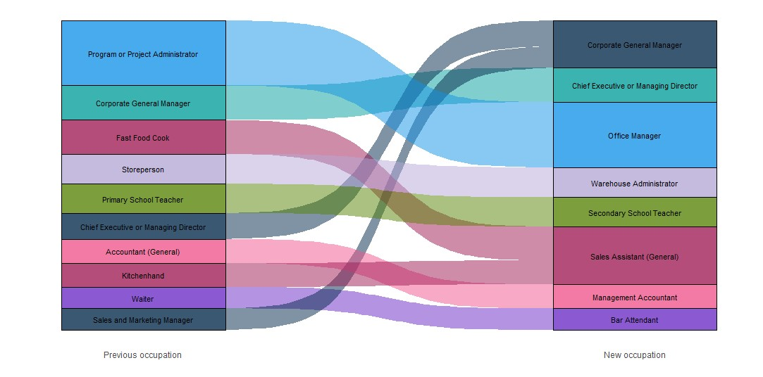*Source: Jobs and Skills Australia (PLIDA ITR data 2011-2012 to 2020-2021).*

Examples of the most popular side-way transitions (Figure 4) include Program or Project Administrator to Office Manager, Storeperson to Warehouse Administrator, Primary School Teacher to Secondary School Teacher and Waiter to Bar Attendant. These transitions suggest that workers tend to move into occupations that share similar skills. This could reflect the ease of finding employment and/or the lower costs of investing in additional skills to change occupations. While the data suggest there is retention of skills across occupations, Figure 2 shows that, Waiter, Fast Food Cook and Kitchenhand are among the top 10 occupations with the largest net outflow of workers. This brings up a potential conflict between transferable skills across occupations and employers’ desire to retain workers in the same occupation. Skills retention across occupations and worker retention in a particular occupation could lead to different outcomes. How this feeds into skill shortages is not clear cut. For instance, on the one hand skills transferability could reduce training time and help address longer training gap shortages, on the other hand frequent loss of workers could create retention gap shortages.

Figure 5: Top 10 occupation pathways with largest number of workers transitioning into higher-skilled occupations, 2020-2021

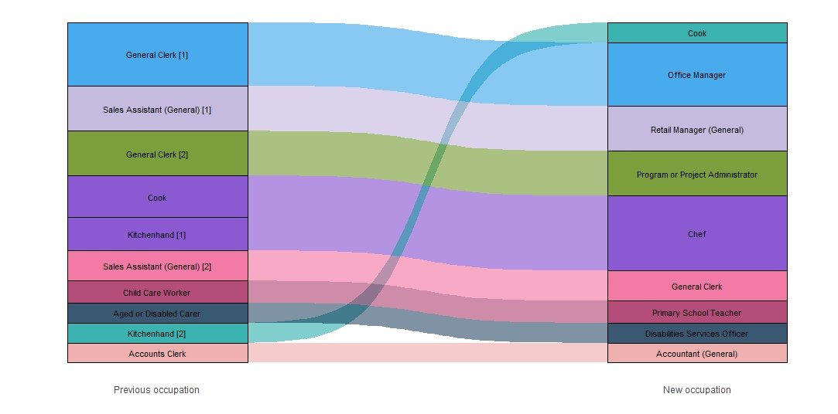*Source: Jobs and Skills Australia (PLIDA ITR data 2011-2012 to 2020-2021).*

Figure 5 shows examples of the most popular occupation pathways of those who have moved into a higher skilled occupation which tend to represent a step-up in their career, such as General Clerk to Office Manager or Program or Project Manager, as well as Cook or Kitchenhand to Chef. Due to workers seeking upskilling opportunities that may be economically driven, the high number of net flow of workers out of some of these occupations could create retention gap shortages.

**Figure 6:** **Top 10 occupation pathways with largest number of workers transitioning into lower-skilled occupations, 2020-2021**

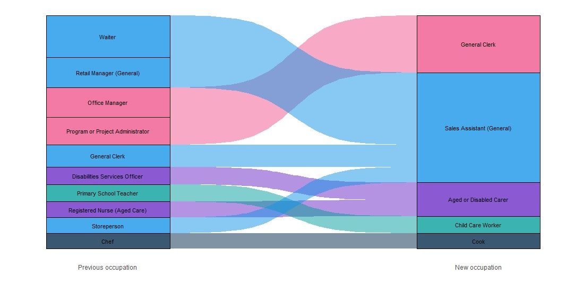*Source: Jobs and Skills Australia (PLIDA ITR data 2011-2012 to 2020-2021).*

As Figure 6 shows, where workers transition into lower-skilled occupations from a higher skilled occupation, they tend to be similar or entry level roles with higher rates of casualisation, such as General Clerks, Sales Assistants and Cooks. This could be related to factors such as a desire to take more flexible job opportunities as well as high demand for these careers.

## Case Studies

### Aged or Disabled Carer – a retention gap shortage occupation

The Aged and Disabled Carer occupation has been identified as experiencing retention gap shortages, as it has a relatively higher rate of job mobility compared to other occupations. Figure 7 shows the net flow of workers in the Aged or Disabled Carer occupation over the past 10 years. The column chart shows the annual number of workers entering and leaving Aged or Disabled Carer. The line chart shows the number of entries into and exit out of Aged or Disabled Carer as a percentage of the previous year’s total number of workers. The data suggest there are many dimensions to the story. In absolute terms, this occupation has experienced a greater inflow of workers than outflow of workers with the difference widening during Covid between 2019-2020 and 2020-2021. Having data beyond 2020-2021 could shed more light on the post-Covid effects. While the data show the occupation has attracted more workers than it has lost, and that the rate of outflow is reducing, continued shortage of workers indicate demand is still outstripping supply. In particular, the loss of workers over time as shown in this graph could affect the retention of experienced workers.

The ability to meet rising demand can be highlighted by comparing the inflow and outflow as a percentage of previous year’s stock. The difference in the inflow over the past five years is around 3.5 percentage points. Over the same period, the difference in the loss of workers is around 3.1 percentage points. Given the modest difference between the percentage change in inflow and outflow, the data suggest the increase in supply to meet demand for this occupation has remained relatively flat.

Figure 7: Net flow of Aged or Disabled Carer 2011-2012 to 2020-2021

*Source: Jobs and Skills Australia (PLIDA ITR data 2011-2012 to 2020-2021).*

Delving into the data, the top 10 largest inflows of workers[7] into the Aged or Disabled Carer occupation were from entry level or other care industry roles such as Sales Assistant (General), Commercial Cleaner, Disabilities Services Officer and Community Worker. Workers who left the Aged or Disabled Carer occupation most often went on to become Disabilities Services Officers, Registered Nurses (Aged Care)[8], Community Workers and Personal Care Assistants. From these transitions, it is reasonable to generalise that workers who have left the Aged or Disabled Carer occupation tended to move into higher skilled occupations in similar areas of work (Figure 8).[9]

Figure 8: Top 10 occupation transitions into and out of Aged or Disabled Carer, 2020-2021

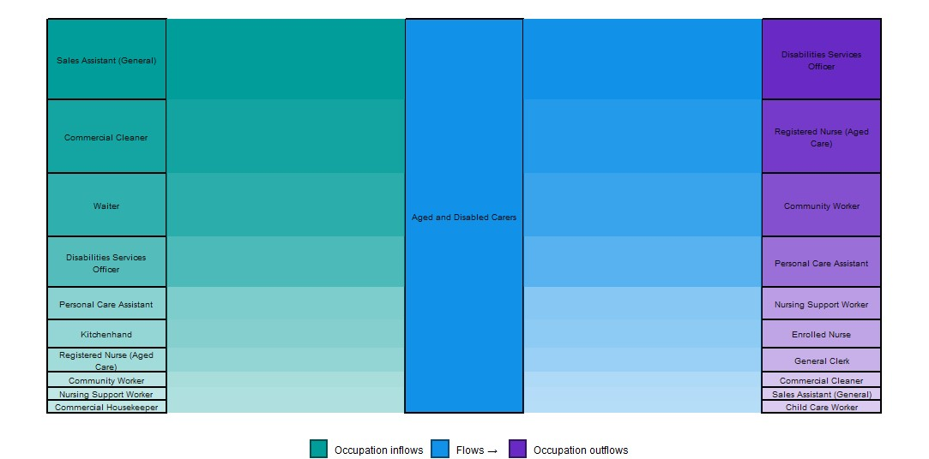

*Source: Jobs and Skills Australia (PLIDA ITR data 2011-2012 to 2020-2021).*

In terms of the transitions into and out of the Aged or Disabled Carer occupation, it is useful to see the similarities between the occupations based on their underlying skills. The similarity scores are from Jobs and Skills Australia’s Skills Transition dataset, which uses the Australian Skills Classification to quantify the degree of similarity between occupations based on their underlying skills.[10]

Figure 8 shows that half of the occupations held by workers prior to transitioning into Aged or Disabled Carer were not from highly similar occupations (e.g., Kitchenhand, Waiter, Sales Assistant (General)). As these tend to be entry level jobs, these workers may have been in these occupations while they were undertaking training to become an Aged or Disabled Carer. The high number of vacancies for Aged and Disabled Carer also could have attracted workers to transition into this occupation of high demand.

In comparison, Aged or Disabled Carers tend to move into other occupations (e.g., Registered Nurse (Aged Care), Nursing Support Worker) that share a medium to high similarity scores, therefore these workers build on their skills for other high-demand opportunities in their sector. This could in turn affect the retention of experienced workers in the occupation and contribute to retention gap shortages.

### Electrician (General) – a long training pathway shortage occupation

Electricians are identified as experiencing shortages arising from a long training pathway, such as requiring a successful apprenticeship. Figure 9 shows the inflow and out flow of Electrician (General) over the past 10 years. Overall, more workers are becoming Electricians (General) than leaving the occupation over time and this gain has increased during the pandemic period. However, the rate of inflow over the last 5 years has been flat despite the rise in demand for Electricians. The percentage of workers leaving the occupation also has declined by 3.9 percentage points over the past five years. This reinforces the idea that the shortage for Electricians is not driven by retention of workers, but arising from the gap in demand for these workers and the supply of workers associated with long training gaps.

Figure 9: Top 10 occupation transitions into and out of Electrician (General), 2011-2012 to 2020-2021

*Source: Jobs and Skills Australia (PLIDA ITR data 2011-2012 to 2020-2021).*

Among the top 10 occupations (Figure 10) that workers held prior to transitioning into Electrician (General), most have high similarities, such as Electrical Linesworker, Electrical Engineering Technician, Electrical Engineer, Electrical or Telecommunications Trades Assistant and Automotive Electrician. However, the data also show there is movement from Electrician (General) back into these occupations. This suggests the long training gap associated with the attainment of electrical skills is driving the shortage. The data also provide insights into potential skills recognition pathways associated with becoming an Electrician and Electrical Engineer, enabling better availability of skills as the transition to a net zero economy is expected to further increase demand for skilled workers in electrical trades.

Figure 10: Top 10 occupation transitions into and out of Electrician (General), 2020-2021

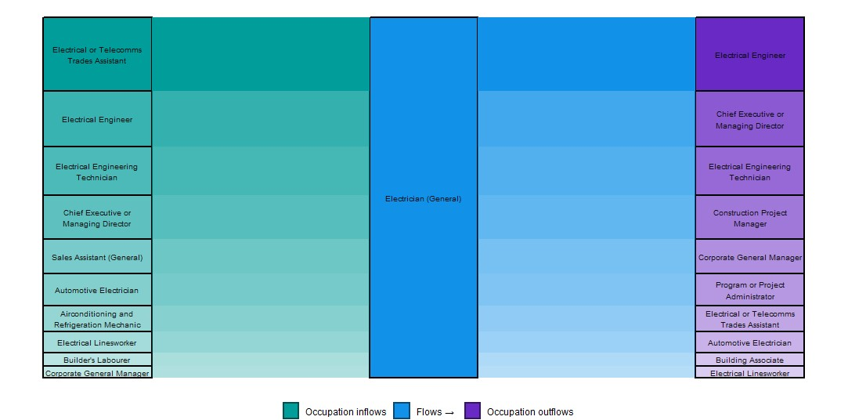

*Source: Jobs and Skills Australia (PLIDA ITR data 2011-2012 to 2020-2021).*

## Conclusion

As shown here, unpacking skills shortages is complex and having access to granular occupation data is important to gain insights into labour market mobility at the occupation level and how these change over time. The case studies provide insights to assist in categorising occupations into skills shortage types and to gain a more nuanced picture of the extent of shortages. DOM can also be combined with demographics data to provide in-depth analysis of retention and attraction of workers at the occupation level.

Jobs and Skills Australia is already using the DOM to contribute to the methodology for the 2024 SPL and for various sector and workforce specific capacity studies.

From the policy perspective DOM can help diagnose the policy problem, confirm the pathways people are actually taking into occupations in demand and help target an efficient training solution to address shortages for particular shortage types.

1. Jobs and Skills Australia (2022). *2022 Skills Priority List: Key Findings Report*.
2. DOM is derived from administrative data on individuals’ Income Tax Returns from the Australian Taxation Office.
3. Australian Bureau of Statistics (February 2023). *Job Mobility*, ABS Website, accessed November 2023.
4. Net inflow indicates there are more workers entering the occupation than leaving. Net outflow indicates there are more workers leaving than entering the occupation.
5. Skill level is measured in the Australian and New Zealand Standard Classification of Occupations (ANZSCO) and reflects the skills needed to competently perform the set of tasks required for that occupation. These skills are captured from the level or amount of formal education and training, amount of previous experience in a related occupation and amount of on-the-job training. There are five skill levels covering eight ANZSCO major groups (see <https://www.abs.gov.au/statistics/classifications/anzsco-australian-and-new-zealand-standard-classification-occupations/2022/anzsco%202022%20structure%20062023.xlsx>).
6. Jobs and Skills Australia (2023). *Towards a National Jobs and Skills Roadmap: Annual Jobs and Skills Report 2023*, October 2023.
7. Defined by the number of workers. The occupations are ranked in descending order of size.
8. The transition from Registered Nurse (Aged Care) into Aged or Disabled Carer could be a genuine transfer or it could be a coding factor with ATO data. Further investigation of the data is needed to untangle this transition.
9. The occupations are in descending order by employment size.
10. The similarity scores consider the text-based and numeric components of occupations. The scores are calculated for any given occupation against all other occupations. For a given occupation, the similarity to all other occupation is ranked and the similarity score is converted into bands of ‘high’, ‘medium’ and ‘low’ (see Jobs and Skills Australia (2022). *The Australian Skills Classification release 2.1, November*).