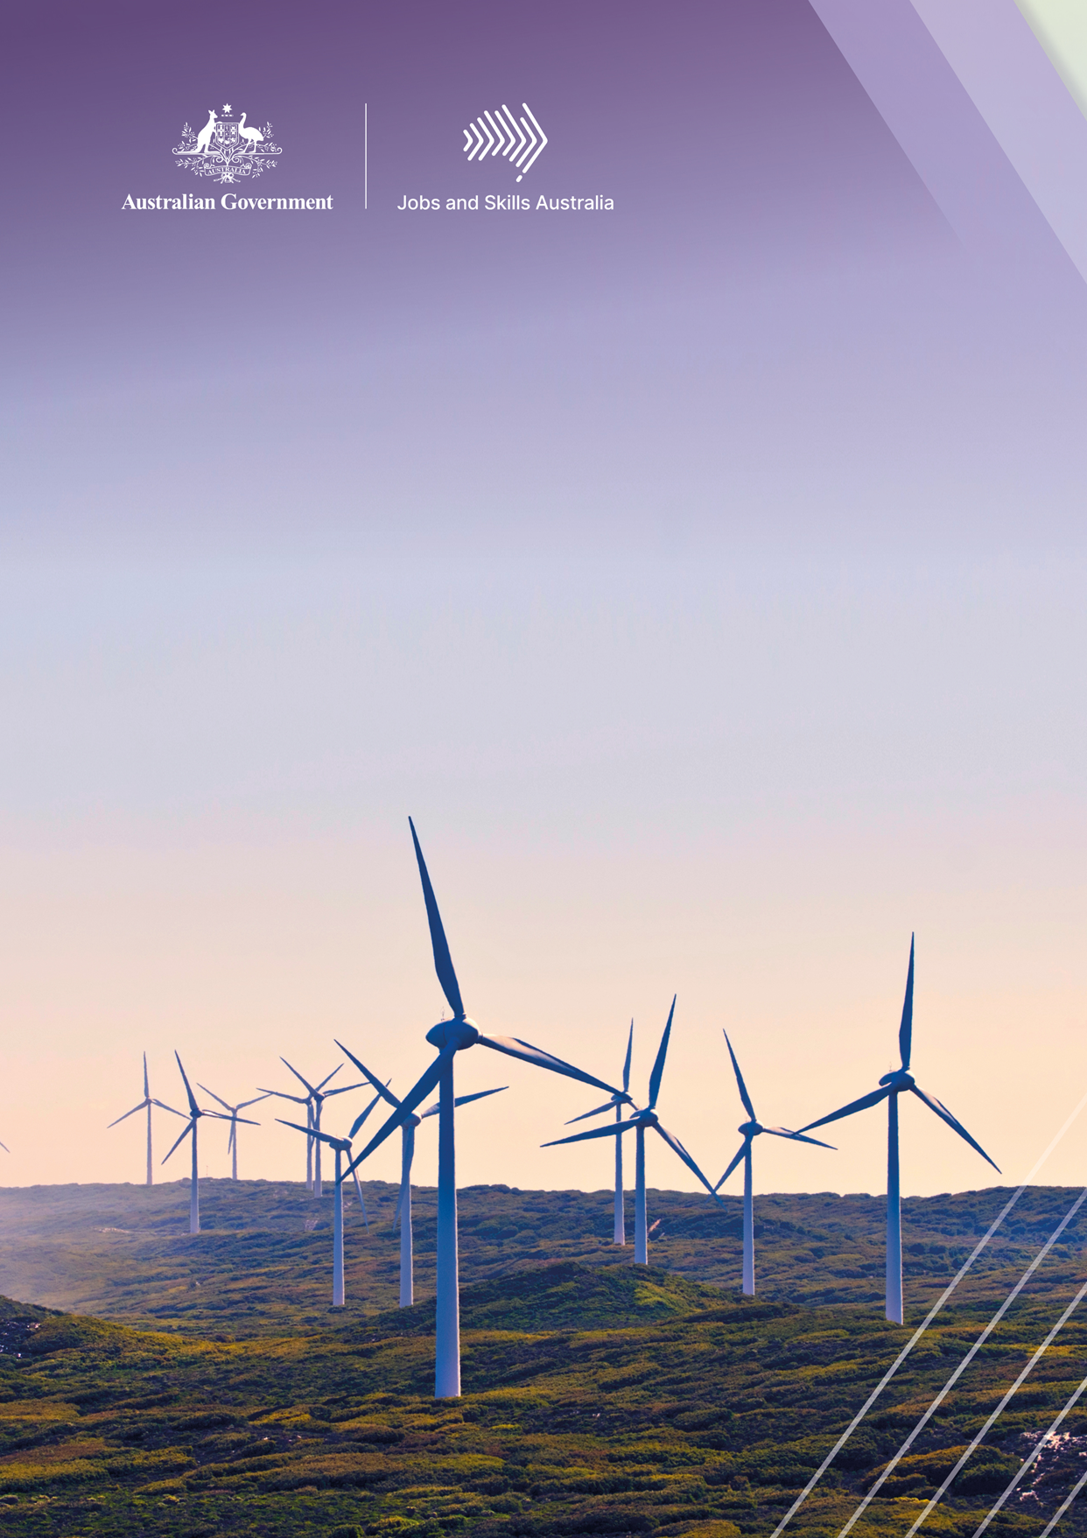

The Clean Energy
Generation

Workforce needs for a net zero economy

Contents

Glossary 4
Commissioner’s Foreword 6
Executive summary 7
Chapter 1: The study 19
1a. Background 20
1b. Drivers of change 27
1c. How do we currently use energy? 35
1d. Roles and responsibilities 38
Chapter 2: Defining ‘clean energy’ 41
2a. Our definition 42
2b. Industries 44
2c. Critical occupations 57
2d. Data limitations 63
Chapter 3: The current workforce 64
Introduction 65
3a. Worker characteristics 66
3b. Firm characteristics 86
Chapter 4: Workforce pathways 101
4a. The pathways 102
4b. Education and training 103
4c. Migration 132
4d. Workforce transitions 137
Chapter 5: Future states 148
Introduction 149
5a. The central and other scenarios 151
5b. Workforce demand 156
5c. Workforce supply and shortfalls 163
Chapter summary 171

Chapter 6: Emerging and transforming sectors 174
New skills and new contexts 175
6a. Fuels and storage 176
6b. Transport 186
6c. Energy performance 191
6d. Manufacturing and processing 193
6e. Land use and the circular economy 197
Chapter 7: Education and training reform 201
Overview 202
7a. System design 203
7b. Funding and program design 208
7c. Student pipeline 213
Chapter 8: Workplaces and communities 223
Overview 224
8a. Participation and attraction 225
8b. Maturing the clean energy sector 236
8c. Hiring and retention 244
8d. Transitioning workers and communities 246
Chapter 9: Findings and opportunities 255
Overview 256
References 272

Glossary
Abbreviation | What it stands for
AASN | Australian Apprenticeship Support Network
ABS | Australian Bureau of Statistics
ACCU | Australian Carbon Credit Unit
ACES | ARC Centre of Excellence for Electromaterial Science
ADR | Automatic Deemed Registration
AEER | Australian Energy Employment Report
AGEC | Australian Gender Equality Council
AEMO | Australian Electricity Market Operator
AHC | Australian Hydrogen Council
AGN | Australian Gas Networks
Ai Group | Australian Industry Group
AMR | Automatic Mutual Recognition
ANU | Australian National University
ANZSCO | Australian and New Zealand Standard Classification of Occupations
ANZSIC | Australia and New Zealand Standard Industry Classification
APEA | Association of Professional Engineers Australia
AQF | Australian Qualifications Framework
ARC | Australian Research Council
ARENA | Australian Renewable Energy Agency
ASbA | Australian School-based Apprenticeship
ASU | Australian Services Union
ATAR | Australian Tertiary Admission Rank
AWU | Australian Workers Union
BEV | Battery Electric Vehicle
CALD | Culturally and linguistically diverse
CCUS | Carbon capture, utilisation and storage
CEC | Clean Energy Council
CEDA | Committee for Economic Development of Australia
CFMEU | Construction Forestry Maritime Mining Energy Union
CGE | Computable general equilibrium
CIT | Canberra Institute of Technology
CRC | Cooperative Research Centre
CSIRO | Commonwealth Scientific and Industrial Research Organisation
DAE | Deloitte Access Economics
DCCEEW | Australian Government Department of Climate Change, Energy, the Environment and Water
DEWR | Australian Government Department of Employment and Workplace Relations
EAP | Employee Assistance Programs
EBA | Enterprise Bargaining Agreements
EEC | Energy Efficiency Council
ETU | Electrical Trades Union of Australia
EV | Electric Vehicle
FISO | Financial Information Services Officers
FTE | Full-Time Equivalent
G7 | Group of 7
GATEAP | Green Apprenticeships and Technical Education Advisory Panel
GVA | Gross Value Added
GTO | Group Training Organisation
GW | Gigawatt
GWO | Global Wind Organisation
IEA | International Energy Agency
IfATE | Institute for Apprenticeships and Technical Education
ILO | International Labour Organisation
IPP | Commonwealth Indigenous Procurement Policy
IRENA | International Renewable Energy Agency
ISF | Institute of Sustainable Futures
ISLP | Infrastructure Skills Legacy Program
ISP | Integrated System Plan
JSA | Jobs and Skills Australia
JSC | Jobs and Skills Councils
LEAP | Leadership and Excellence in Aboriginal People
LETDF | Low Emissions Technology Demonstration Fund
NAAA | National Australian Apprenticeships Association
NABERS | National Australian Built Environment Rating System
NatHERS | Nationwide House Energy Rating Scheme
NCVER | National Centre for Vocational Education Research
NEM | National Electricity Market
NOC | National Occupation Classification
NSC | National Skills Commission
OECD | Organisation for Economic Co-operation and Development
PALM | Pacific Australia Labour Mobility
PHES | Pumped hydro energy storage
PV | Photovoltaic
REDEI | Renewable Energy Design Engineering and Integration
REZ | Renewable Energy Zones
RMIT | Royal Melbourne Institute of Technology
RPL | Recognition of Prior Learning
RTO | Registered Training Organisation
SAF | Sustainable Aviation Fuel
SOTS | Star of the South
SSP | Shared Socioeconomic Pathway
STEM | Science, Technology, Engineering and Mathematics
TAFE | Technical and Further Education
UNCTAD | United Nations Conference on Trade and Development
UNSW | University of New South Wales
UOW | University of Wollongong
UTS | University of Technology Sydney
VET | Vocational Education and Training
WGEA | Workplace Gender Equality Agency

Commissioner’s Foreword
I am delighted to present Jobs and Skills Australia’s (JSA) first workforce capacity study, The Clean Energy Generation: workforce needs for a net zero economy.
This report finds that the clean energy workforce is at the intersection of two major transformations. A transformation of how we generate, use and export energy in order to decarbonise our economy, and a transformation of how we deliver skills through higher education, VET, migration and on-the-job training to grow our workforce. There are also substantial changes to how we expect job opportunities to be shared with all Australians, particularly those who have been traditionally underutilised or excluded.
This report presents an extensive analysis of the current and future clean energy workforce to support both workforce planning and guide policy makers and education and training providers. It includes analysis on future skills needs, transition challenges, and opportunities for innovation in our education and training system, to support a successful clean energy transformation.
Australia has a once in a generation opportunity to reshape our economy through a rejuvenated, harmonised approach to skilling. This means moving beyond coordination and collaboration and instead pursuing genuine partnerships within and among systems. The clean energy workforce could be a unique testbed to explore innovative models of education and training and should be used to the fullest.
This study comes at a time of major change. Each element of our labour market and skills system is undergoing reform, with the Working Future White Paper just released and a new National Skills Agreement, Migration Strategy, and Universities Accord in train. This report acknowledges the monumental work underway, and makes the most of this unique timing. In this context, we have made 50 recommendations to help governments focus their efforts and back in good ideas.
This study also represents a step change in how Australians can work together. JSA has partnered with unions, industry, higher education institutions, VET providers and state and territory governments to deliver this report. We thank each of these partners for the contributions they’ve made to this study and to Australia’s skilling future. This is an excellent example of the tripartite effort needed to make lasting contributions.
I am confident that this report, and the policy reform and innovations that follow out of it, will help ensure Australia is well positioned to pursue a prosperous net zero future. If done right, the workforce dividends of a clean energy transformation can create generations of high-quality jobs for all Australians.
Professor Peter Dawkins AO
Acting Commissioner
Jobs and Skills Australia

Executive summary
Reaching the Australian Government’s net-zero emissions target by 2050 will require a workforce transformation that is substantial but not unprecedented. Like the post-war industrial transformation and the digital transformation of the late twentieth century, a new generation of workers will be required, both from existing energy sectors and through new pathways into clean energy. New jobs, skills, qualifications, training pathways, technologies and industries will emerge over the next 30 years.
Australia will need to consider the full range of levers across the education, training, migration, procurement, and workplace relations systems to ensure a sustainable and equitable path towards net zero. This report analyses the opportunities, risks and reforms that are needed for a successful transformation of our workforce, and:
- offers an Australian-first definition of the clean energy workforce, what it currently looks like and what it needs to look like to ensure the workforce grows at the pace and scale required. It finds we have enough workers overall and most likely enough university graduates but outlines the risk of a shortfall of Vocational Education and Training (VET) qualified workers, especially amongst electricians and other trades.
- identifies both the emerging skills gaps in regional Australia as well as the opportunities for growth in the regions where new clean energy industries will emerge.
- offers opportunities for a tertiary skills, training and qualifications system that is fit-for-purpose to keep pace with rapidly changing technologies and emerging occupations, recommending innovative solutions to on-the-job skilling and all types of industry-led training, from Technical and Further Education (TAFE) Centres of Excellence to industry accredited microcredentials.
- tackles the barriers and challenges that women, First Nations people and migrants face in participating in the sector, and the skills and talent the economy currently misses out on.
- offers a worker-centred approach to support transitioning communities, acknowledging that competition for skilled migrants is high and while workers with clean energy skills are heavily concentrated in our regions, we have been slow to attract and support them.

The net zero challenge
The net zero transformation presents an unprecedented opportunity to revitalise the Australian education and training sector, working with industry to develop a more diverse workforce and create sustainable employment for generations to come. This includes opportunities for our regional labour markets and industries that have long been in decline. With the right investment we can offset the jobs at risk in areas like coal-fired power and ensure these workers and their communities are given the support they need to transition and find new opportunities.
However, the transformation also presents a major challenge. If we don’t fine tune our workforce pipelines, skill shortages could prevent us from reaching net zero by 2050, and opportunities to broaden our industrial base will be missed. We also need to make sure that the jobs created are accessible and shared with all Australians, particularly underrepresented cohorts and workers in transitioning sectors.
Ambitious net zero targets will need to be matched with ambitious workforce and skills policy. It will also require cohesive, collective action across all levels of government and better collaboration with industry, unions and the education and training sectors. This report assesses what is needed to reach net zero by 2050 and how to get there. It is guided by three overarching objectives which should inform all workforce planning for this sector:
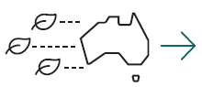 | Objective one: the energy transition isn’t hindered by skill shortages. Australia has the workforce it needs to meet and exceed our clean energy ambition.
 | Objective two: workforce opportunities are sustainable and equitably shared with all Australians, particularly communities impacted by decarbonisation and disadvantaged groups that were underutilised in traditional energy.
 | Objective three: people in transitioning sectors and their communities are given the support they need to access new employment opportunities that work for them.

DEFINING THE CLEAN ENERGY WORKFORCE
In an Australian first, we have defined the jobs and industries that make up our clean energy workforce. Rather than viewing clean energy as an isolated segment of the economy, we have acknowledged the role that every industry plays in one way or another. This means clean energy jobs are found right across the workforce, extending well beyond obvious sectors like wind, solar and hydroelectricity into parts of construction and research and development, amongst others.
Based on feedback from our Discussion Paper and engagement with the Project Steering Group, JSA workforce mapping has been applied against the definition of clean energy to describe what constitutes the clean energy workforce and related sectors. These industry segments span energy supply, energy demand, enabling clean energy workforce, the workforce associated with the carbon lifecycle, emissions-intensive sectors and the workforce from transitioning sectors.
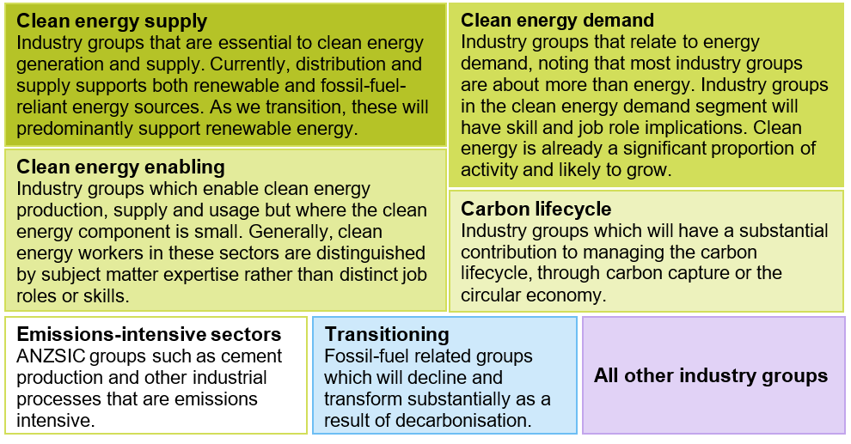

While there are many occupations that form part of the clean energy workforce, the most critical are found within trades, technical occupations and engineering professionals, where training times and licensing and accreditation requirements impose justified barriers to entry. The study identifies 38 occupations that are critical to at least one segment of this workforce:
Technicians and Trades Workers  - Architectural, Building and Surveying Technicians  - Civil Engineering Draftspersons and Technicians  - Electrical Engineering Draftspersons and Technicians  - Other Building and Engineering Technicians  - Automotive Electricians  - Motor Mechanics  - Aircraft Maintenance Engineers  - Metal Fitters and Machinists  - Structural Steel and Welding Trades Workers  - Plumbers  - Electricians  - Airconditioning and Refrigeration Mechanics  - Electrical Distribution Trades Workers  - Chemical, Gas, Petroleum and Power Generation Plant Operators  - Telecommunications Trades Workers  - Electronics Trades Workers | Professionals  - Marine Transport Professionals  - Architects and Landscape Architects  - Urban and Regional Planners  - Chemical and Materials Engineers  - Civil Engineering Professionals  - Electrical Engineers  - Industrial, Mechanical and Production Engineers  - Mining Engineers  - Other Engineering Professionals  - Agricultural and Forestry Scientists  - Chemists, and Food and Wine Scientists  - Environmental Scientists  - Geologists, Geophysicists and Hydrogeologists  - University Lecturers and Tutors  - Vocational Education Teachers  - Occupation and Environmental Health Professionals
Managers  - Policy and Planning Managers  - Research and Development Managers  - Construction Managers  - Engineering Managers  - Production Managers | Labourers  - Structural Steel Construction Workers

Australia’s clean energy workforce is:
- Predominantly male. A higher proportion of women work in white collar segments (education, training, research etc). Where women are represented in clean energy, they dominate in roles like general clerks, office managers, accounting clerks, commercial cleaners and interior design, rather than trade-qualified and engineering roles.
- On par with transitioning sectors for age of the workforce. The segments with the youngest workforce are energy usage and performance, while the oldest are transport and some enabling segments.
- More highly qualified than transitioning sectors. In general, the clean energy workforce contains higher proportions of VET-qualified workers than the broader labour force. The clean energy supply segment comprises a larger proportion of workers with higher education qualifications than the transitioning segment which includes workers in coal-fired power stations.
- Underrepresented among First Nations people. A smaller proportion of First Nations people work in clean energy than the broader labour force. Notably, a higher proportion work in the transitioning segment, including coal mining.
- Underrepresented among migrants. Around 26% of the clean energy workforce were born overseas, with some of the enabling segments having the highest proportions (over 30%). Workers come from all around the world, but the largest group are from Southern Asia, followed by North-West Europe.
- Typically paid less than transitioning sectors. In general, clean energy sectors lag behind the pay and conditions available in more established sectors.
- Predominantly employed in the construction phase. Unlike traditional energy employment, there can be a higher degree of variability and project-based work in clean energy. For example, large-scale solar farms are a project-based industry where businesses may lack certainty while waiting to win contracts, secure finance or gain approvals. Workforce needs are also typically front-ended (during construction phases), meaning there are fewer long-term employment opportunities.
- Employed across Australia. Regional differences mean different locations are better suited to certain technologies and therefore attract different types of workers. Tasmania has a high concentration of clean energy supply workers working in hydroelectricity, whereas parts of regional Queensland and NSW have a relatively higher share of workers in transitioning sectors. Workers are often needed in regional and remote areas away from sources of labour supply. In some instances, this requires short-term moves or fly-in-fly-out work, which can be inaccessible for apprentices, particularly in their first year.

Education and Training
The clean energy transformation in Australia will require a big contribution from the education and training sector working closely with industry. This will require significant investment and reform.
Tertiary education will continue to deliver the fundamental skills needed for this workforce. There are three key elements of clean energy education and training pathways:
- existing broad-based qualifications, like the Certificate III in Electrotechnology and Bachelor of Electrical Engineering. They provide the fundamental skills for a range of roles, including but not limited to clean energy.
- clean energy top-up and electives, including post-trade and post-graduate qualifications, allow workers and students to gain specific clean energy skills and specialise. However, the availability of these is limited.
- new qualifications targeted to emerging sectors, such as the Bachelor of Renewable Energy and Certificate III in Electric Vehicles, are beneficial where new technologies require a larger suite of specialised skills.
The tertiary sector will need more support, more collaboration and more innovation to meet the needs of net zero. We’ve identified three priority areas for attention:
  - System design
    - frameworks for deeper collaboration between VET, higher education and industry
    - new models for course delivery to better align graduates with emerging needs
    - clearer pathways for students to navigate and access
    - a cohesive and connected tertiary education system with fewer obstacles
    - consistent approaches to occupational licencing.
  - Funding and program design
    - new and responsive curriculum development for emerging needs
    - servicing thin markets and regions through competitive models
    - minimising capital constraints through better collaboration
    - incentivising employer involvement in education and training.
  - Student pipeline
    - increasing student participation in STEM
    - growing and supporting the trainer, teacher and researcher workforce
    - doubling down on efforts to get women into trades
    - supporting more First Nations people into education and training
    - better targeting of incentives and supports for apprentices.
Despite a proven need to increase the number of apprenticeships in relevant trades and recent efforts by governments, there is still a significant underinvestment in this pipeline by industry. Leveraging government procurement and financing is a way to set standards regarding apprenticeship uptake, workplace gender equality and secure employment. This idea is incorporated in the Australian Skills Guarantee, which will introduce new national targets to ensure one in 10 workers on Australian Government-funded major projects is an apprentice, trainee or paid cadet.
Migration
The 2023 Review of the Migration System identified that while migration alone will not address the challenges of transitioning to a clean energy economy, a well-designed and fit-for-purpose skilled migration program is part of the solution. In an increasingly competitive and global market for skills, Australia will need to position itself as a destination of choice to attract and retain workers in critical roles.
International students are already an important pipeline of skilled workers in Australia and will continue to be. However, there are many international students that would like to remain in Australia but can’t or do stay but struggle to find employment related to their field of study. Ensuring these students are set up for success during and after their studies will be key.
Industry transitions
While new employment opportunities will be created from the net zero transformation, jobs will also be lost in sectors that are emissions intensive, particularly coal-fired power. Australia’s remaining coal-fired power stations will gradually close over the coming 30 years, impacting workforces which are concentrated in a handful of regions, including Latrobe Valley (VIC), the Hunter region (NSW), Collie (Southwest WA), and Central Queensland.
Transitioning industries employ a diverse range of workers. Many generalist occupations, like accountants and truck drivers, are also employed in high numbers in growing industries. Other occupations, like Power Generation Plant Operator, have limited employment prospects outside transitioning industries and are therefore at greater risk. Common transition pathways, identified using historical real-world transitions data and skills similarity analysis, include into occupations like Earthmoving Plant Operators, Electrical Linesworkers and Fire Protection Equipment Technicians.
While some transitioning workers will move into clean energy jobs, this isn’t the only (or necessarily the best) outcome. Policy analysts are often keen to use modelling exercises that map transitioning workers to new opportunities at a macro level, but this is only a conceptual exercise and can undervalue the circumstances of individuals and the barriers they face. Mismatches in skills, location, timing and preferences are just some of these considerations. Targeted, localised and individualised supports will be needed to drive successful outcomes for workers and their communities.
PROJECTED Workforce demand & Shortfalls
Our study includes preliminary economic modelling of three possible future scenarios with the central scenario being broadly aligned with Government climate and energy policy. The preliminary modelling of the employment implications of these scenarios are outlined in Chapter 5 of the report.
The preliminary modelling suggests that under the central scenario we will need close to two million workers in building and engineering trades by 2050, an increase of around 40%. Occupations with the highest growth rates (2023-2030) include Telecommunications Trades Workers, Electronics Trades Workers, Electrical Engineering Draftspersons and Technicians, Structural Steel Construction Workers, Construction Managers, Plumbers and Electricians.

Depending on different policy approaches to electrifying the National Energy Market (NEM) and reaching our renewable energy goals, the preliminary modelling shows we will need approximately 26,000 to 42,000 more electricians in the next seven years, and the clean energy supply workforce will likely need to grow from approximately 53,000 workers today to 84,000 by 2050.
There is strong growth in trades and technical occupations, particularly for occupations that are critical to clean energy such as Electricians, Metal Fitters and Machinists, and Plant Operators. However, our supply forecasts strongly suggest there is insufficient capacity in the training and migration pipelines to meet this demand. We will likely need close to two million workers in building and engineering trades by 2050 as labour and capital will be needed to prepare Australia’s energy grid and industrial base for net zero.
Growth in these occupations is also likely to be concentrated in regional Australia, presenting a great opportunity, as clean energy will continue to provide well paid employment that might otherwise be lost as global demand for fossil fuels decreases. However, the concentration of growth in trades and technical employment in regional Australia will require an even more substantial uplift in education and training to ensure that job opportunities can be accessed by local workers.
With active investment and clear policy direction to ensure all emissions-intensive sectors have the incentives to transition to lower emissions technology, Australia can achieve more employment growth, industrial diversity and productivity while still decarbonising the domestic economy. When coupled with a higher level of ambition and investment, Australia can also expand its production of low-emissions goods to create an export market that replaces what we can expect to lose from fossil fuels.
Demand for critical clean energy occupations, to 2050
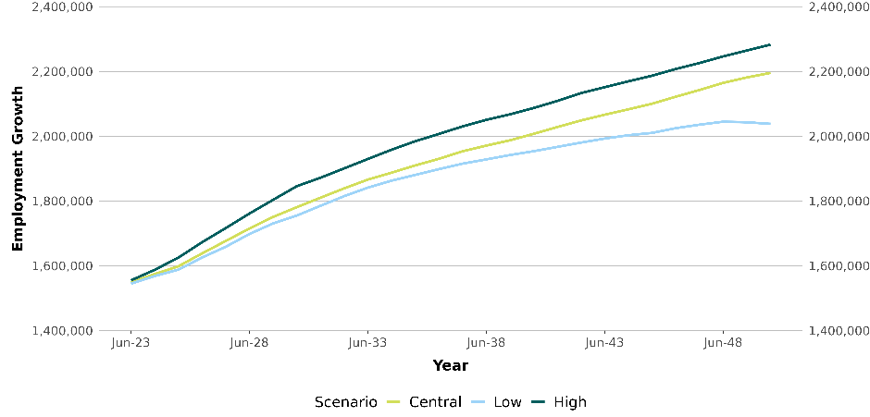
Source: Deloitte Access Economics 2023.

Demand for Electricians, to 2050
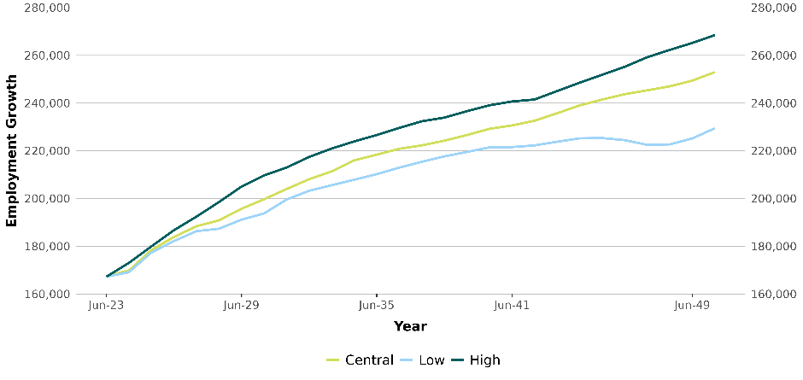Source: Deloitte Access Economics 2023.
EMERGING AND TRANSFORMING SECTORS
Workforce change means more than just the number of jobs that will be created or lost. While it’s easy to assume that the biggest impact will be in the sectors that need to grow the most, this is not necessarily the case. Increasingly over the next 30 years, the skills and roles of existing occupations will change in response to decarbonisation, even if overall demand does not increase. New occupations are also emerging which, even in small numbers, can be particularly difficult to grow, including in:
New fuels and storage. For example, the bioenergy sector provides opportunities for skilled employment growth in regional areas and additional revenues streams to support employment in agriculture. This could see demand for new skills in agricultural science and chemical engineering.
Transport will see major skills change as internal combustion engines are replaced with electric vehicles (and vehicles that use alternative fuels). Demand for specialist electric vehicle mechanics will increase, as will the demand for mechanics to work across both vehicle types.
Energy performance. An energy auditor is an example of an emerging role, while facility managers and air conditioning and refrigeration mechanics will likely experience changed skill and knowledge requirements.

BARRIERS FOR WORKERS AND COMMUNITIES
Women. The clean energy sector cannot grow at the scale required without the participation of half of Australia’s population, but this won’t happen without addressing significant barriers that exist. Many female engineers report experiencing gender discrimination and bullying in the workplace and do not feel they have equal access to career progression opportunities, salary advancement or mentoring. The energy sector also has the third highest incidence of workplace sexual harassment, with 71% of women having experienced sexual harassment in the last 5 years.
First Nations people. The transitioning energy sector, particularly coal mining, has been a major employer of First Nations people (3.4%). The emerging clean energy sector is yet to reach these levels, with First Nations employment levels around 1.9%. Growing the supply of First Nations tertiary graduates will take time but is critical to ensuring First Nations employment in the clean energy sector does not mimic the trends of the transitioning sector in concentrating First Nations employment at the lower skilled and lower paid operational level of the workforce.
Safety culture. Working with clean energy infrastructure can be high risk, as is handling materials like hydrogen, ammonia and biofuels. A safety culture is vital and must consider remoteness, new technologies and processes, and regulation inconsistencies.
Hiring and retention. The Clean Energy Council outlines several factors that exacerbate skill shortages within the sector, including:
- Visibility – occupations within the clean energy sector and entry pathways are poorly understood as most workers enter the sector by side-stepping from other industries
- Location – the regional location of most employment opportunities is a significant impediment to attracting qualified individuals, such as graduates
- Mobility and entitlements – workers can experience challenges transitioning from one project to another.
Findings and opportunities
Alignment across all sectors of the economy is needed to drive long-term change. Coordination between businesses, workers and all levels of government will be needed to overcome the structural changes arising from climate change and environmental degradation. Long term policy guidance from governments can catalyse the necessary investments in our industries and regions.
Strategies need to look beyond state and territory borders, and be regularly updated to reflect both new and revised policy settings, in alignment with rapidly changing technologies. Developing this workforce should also be a national effort, with consistency and coordination the objective.
Many of the skills needed to decarbonise already exist in our economy. This means that our education and training sectors are already set up to deliver many of the skills we need. The challenge will be scaling the delivery of these skills, and developing top-up pathways for workers to bridge gaps and specialise. Innovative and agile course design approaches will help education and training sectors respond faster to emerging skills needs.
A harmonised education, training and migration system with a step change in how we train trades and technical workers is a priority. As skills needs continue to transcend VET and higher education sectors, the value and potential for greater collaboration is high. The clean energy sector is primed to be a test case for new approaches to collaboration.
A shared responsibility for inclusive pathways. We can’t grow the workforce at the pace and scale required if large groups of the population are excluded, including women, First Nations people, people with disability, and recent migrants whose skills’ potential are underutilised. The net zero transformation requires a shared commitment between industry, government, and communities to share the benefits of clean energy work, through foundational and pre-vocational training, clear diversity targets, and a transition framework built around the individual worker.
Australia will likely need 32,000 more electricians in the next seven years and close to 2 million workers in building and engineering trades by 2050. Preliminary modelling suggests significant shortages of electrical, building, and engineering VET qualified trade roles are likely, partly due to the construction required for transitioning to renewable energy, not just the growth in new technologies and industries. The preliminary modelling also shows a steady supply of engineers is likely but there will likely be smaller shortfalls amongst some scientists needed for the transition.
Regional Australia can benefit from the net zero transformation. The implications of the workforce transformation at the local level will be more significant in some parts of Australia, particularly those with a relatively high proportion of employment based on fossil-fuels. Overall economic growth and development provides good prospects for supporting these communities, provided there is local investment in new industries and impacted workers receive targeted training and other forms of support to transition into roles that build on their existing skills. The preliminary modelling indicates there will also be new opportunities in the regions as clean energy industries emerge. For example, in Northern NSW and Eastern Victoria.
Supporting workers and communities undergoing transition. The most positive and sustainable outcomes for workers and employers are individualised ones. Local support networks play a crucial role in this as does timing, especially for workers at different stages of their career and local support. The new Net Zero Authority will have a critical role driving consistency and coordination of these supports.
A higher ambition? Australia can be a renewable energy superpower, but it will require significant effort. There is a potential path for Australia to take even fuller advantage of decarbonisation, expanding its production of renewable energy beyond what is our current domestic requirement. This would see Australia exporting renewable energy to the world, in the form of hydrogen, as well as extending further along the minerals value chain to process and refine more iron, aluminium, and critical minerals such as lithium here in Australia. Given proper planning, this transformational change could create generations of new employment opportunities for our regions.

CONCLUSIONS for workers
For the 50-year-old working today in a coal-fired power station, this report sets out a framework to guide the supports they need for the next phase of their life.
For the 38-year-old mid-career electrician who wants to enter the VET teaching workforce or specialise in clean energy technologies, this report highlights the training options, funding and incentives that should be explored.
For the 22-year-old female electrical apprentice, there is recognition of the barriers she faces in the trades and explores ideas for how classrooms and worksites can become more inclusive and accessible for everyone.
For the 17-year-old school leaver, we detail the rewarding, priority career pathways that will provide jobs, shape our future economy and make a difference across the clean energy value chain.
For the primary school student in regional Australia still ten years from full-time working life, there is a commitment that their schooling and post-school education matters – not just for them and a more equal Australia, but for realising the economic possibilities of a decarbonised economy.



Chapter 1:
The study

Provides the study’s purpose, approach and contextual information. Outlines the domestic and international policies driving the energy transition.
Chapter 1
The study
Provides the study’s purpose, approach and contextual information. Outlines the domestic and international policies driving the energy transition.

1a. Background

Purpose of the study
Australia is reshaping the way we generate, use and export our energy. Significant investments in clean energy generation and the electrification of our houses, vehicles and industries will help reduce emissions and cut power costs.
However, this transition will only be possible with a workforce that is equipped with the right skills. New technologies mean new jobs, new skills and new industries. This report assesses the who, what, when, where and how of meeting the growing demand for clean energy skills. Just like any other element of the energy transition, our investment in workforce and skills development will take time and proper planning.
Coordination will also be needed across education, training, migration and industry, which has proved challenging to this point. This independent report initiates these efforts by offering new evidence, data and insights to inform the Australian Government’s decisions about the future clean energy workforce.

Scope of this study
The final Terms of Reference (Figure 1.1) for the study were published on 4 April 2023 and incorporate feedback from state and territory governments, industry, unions, and the education and training sector. Our mandate was to:
- help clarify what jobs and industries make up our clean energy workforce
- understand how different transition scenarios affect future workforce needs
- explore how the workforce opportunities created by clean energy can be shared across regions and with First Nations people, women, people with disability and Australians from culturally and linguistically diverse (CALD) backgrounds
- identify the education, training and migration pathways that we should be developing, and the underlying system settings needed to enable those pathways.
The study does not examine the merits of particular technologies, projects nor investments, nor the non-workforce impacts of the clean energy transition.

Figure 1.1. The study’s terms of reference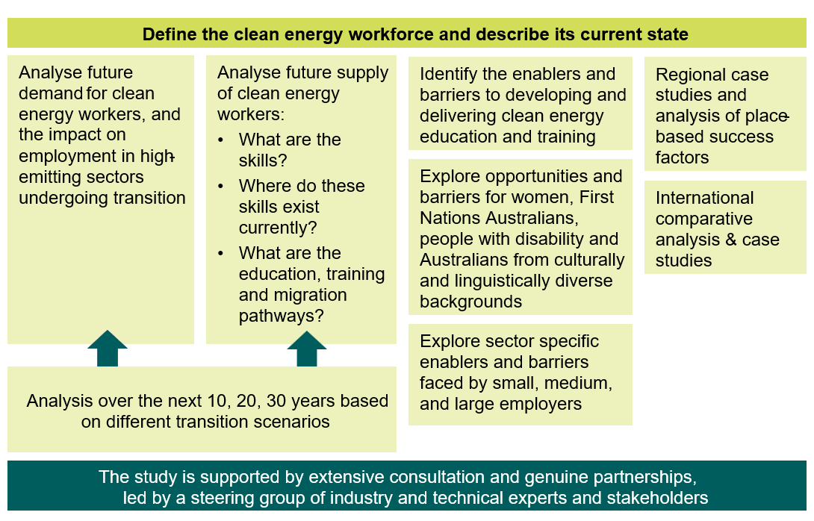

The structure of this report
This report is organised into 9 chapters that explore different elements of the study.
Chapter 1: The study. Provides the study’s purpose, approach and contextual information. Outlines the domestic and international policies driving the clean energy transition.
Chapter 2: Defining ‘clean energy workforce’. Defines the clean energy workforce using industries and occupations. Includes background information and data limitations.
Chapter 3: The current workforce. Explores the size and composition of the clean energy workforce. Includes demographic, geographic and employment characteristics.
Chapter 4: Workforce pathways. Details the pathways into clean energy employment from VET, higher education, migration and industry transitions.
Chapter 5: Workforce futures. Workforce estimates over 10, 20 and 30 years. Identified areas of pressure and contextualises different transition scenarios.
Chapter 6: Emerging and transforming sectors. Explores future workforce needs of sectors that will emerge or be transformed through decarbonisation.
Chapter 7: Barriers: Education and training reform. Explores opportunities to address barriers faced by students and providers of education and training.
Chapter 8: Barriers: Workplaces and communities. Explores opportunities to address barriers faced in workplaces and communities.
Chapter 9: Findings and Opportunities. Learnings from what is working well and innovative approaches to workforce development.

What is Jobs and Skills Australia’s role?
Jobs and Skills Australia’s (JSA) purpose is to be a catalyst in activating Australia’s human capital potential to meet present and future skills needs.
Our role is to engage, advise and assist the Australian Government and other stakeholders in decision-making on the current, emerging and future skills and workforce needs of the Australian economy. This includes in regional, rural and remote Australia, and on the development of new industries and new technologies.
To do this, JSA provides high quality data, analysis, and insights to better understand Australia’s skills and labour shortages across the economy. Providing advice on the effectiveness of Australia’s VET, higher education, and migration systems to meet Australia’s future skills and workforce needs is also a priority for us.
JSA’s capacity studies assess the current and future demand for, and supply of, labour and skills in a critical area of the economy. They also make recommendations on how skill shortages (or surpluses) can be averted, within set time, resource and legislative constraints and government objectives.
JSA has established an ongoing capacity study function which will:
- bring together subject matter experts, data specialists and people with stakeholder engagement expertise
- be informed by Project Steering Groups, with key stakeholders directly represented
- provide a detailed assessment of labour and skills supply and demand, employment arrangements, and education, training and migration pathways
- produce long-term modelling of future workforce demand and supply.
This first capacity study is focused on a specific sector – clean energy – however, future studies may come from the perspective of a particular occupation, region or cohort. The topic of future studies will be decided through JSA’s annual workplan.

Our approach
Ambitious net zero policy must be matched with ambitious workforce and skills policy. While Australia has a clear net zero objective, it’s also important that we have clear objectives for our workforce. JSA has identified three overarching objectives to guide workforce planning and policy:
Objective one: the energy transition isn’t hindered by skill shortages. Australia has the workforce it needs to meet and exceed our clean energy ambition.
Objective two: workforce opportunities are sustainable and equitably shared with all Australians, particularly communities impacted by decarbonisation and disadvantaged groups that were underutilised in traditional energy.
Objective three: people in transitioning sectors and their communities are given the support they need to access new employment opportunities that work for them.

The contribution of this report
While this isn’t the first report to look at the Australian clean energy workforce, it provides several new and unique contributions that others don’t. The study:
- Defines the clean energy workforce. For the first time, a comprehensive definition of the clean energy workforce has been produced. Every industry in the economy is categorised and grouped based on its role in meeting net zero.
- Examines the supply of workers. Unlike other studies, we have had to consider where the supply of workers will (or won’t) come from. With a finite number of workers in Australia, this element is important to understand whether workforce demand can be met.
- Takes a holistic view. By taking a whole-of-economy view, this study considers the broader impacts of the net zero transition. We also take a collective view of higher education, VET and migration systems to supply workers.
- Uses new data. JSA has pioneered the use of new data and techniques to analyse the clean energy workforce using unit record data to let us explore characteristics of workers and examine the real-world pathways they take into new roles.
- Provides gap analysis. Our supply and demand modelling shows when and where workforce gaps will likely arise, helping government to pre-empt and mitigate skill shortages. This includes gap analysis across a range of scenarios and sensitivities.

We have designed our work to align with existing plans and strategies. In particular, this report leverages the Australian Electricity Market Operator’s (AEMO) Integrated System Plan (ISP) to build on what is already known and understood across the sector. This has been extended beyond the NEM to look at the contribution of all regions and sectors to decarbonisation.
We also leverage the large volume of work led by agencies across all levels of government, as well as the pioneering research from industry groups and research bodies.
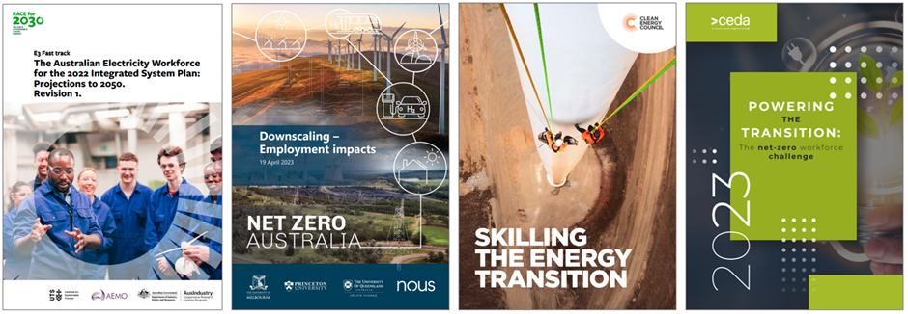

Whole of economy view
This report examines Australia's current clean energy workforce and identifies the workforce needed to achieve net-zero emissions by 2050. That means examining the industries and occupations with direct and indirect contributions to generating, using and managing clean energy, as well as the pathways.
This analysis was undertaken at a time of record low unemployment and increased workforce shortages (Figure 1.2). In these tighter labour market conditions, clean energy employers may find it increasingly difficult to attract and retain skilled workers. While the clean energy sector has a unique value proposition, it is competing with several other large and growing sectors like construction and defence.
We also examine where workers, who are a finite but very important resource, will come from. This is particularly important as Australia’s students are being pulled in many directions across VET, higher education and the labour market. As such, our advice reflects the total workforce impact of clean energy and the cumulative needs of our education, training and migration systems.

Figure 1.2. Job advertisements and the unemployment rate, 2006 – 2023
Source: ABS Labour Force Survey July 2023; JSA Internet Vacancy Index July 2023

Partnering with stakeholders
Engagement is central to the way we work and achieve our priorities. JSA is committed to working with others in determining what we do and how we do it. This study has been informed by extensive engagement and partnerships with governments, industry, unions, universities, training providers, research bodies and subject matter experts. Key activities included:
- public consultation on the study’s Terms of Reference
- a 19-member Project Steering Group that met regularly throughout the project to inform the design of the modelling, stakeholder engagement and final report
- a Discussion Paper that was publicly released on 4 April 2023, to which we received 35 submissions
- roundtables and workshops with union representatives, educators from universities, TAFEs and other education and training providers, and businesses
- monthly forums with states and territories to share learnings and ensure strategies, initiatives and perspectives from all jurisdictions were captured in the analysis
- international engagements, including with Skills Future Singapore
- consultations with the First Nations Clean Energy Network, Aboriginal Housing Northern Territory, the Central Land Council and energy providers and workers in remote areas.

Future workforce estimates
JSA partnered with Deloitte Access Economics (DAE) to produce workforce estimates for the Australian economy out to 2050, covering a number of scenarios where we meet, exceed, and fall short of net zero (see Chapter 5). These scenarios were developed in close consultation with our Project Steering Group and other experts across government.
JSA and DAE have also looked at the likely pipeline of future workers over this thirty-year period, to assess where changes to existing education, training and migration settings may be needed and where the greatest opportunities to support workers impacted by decarbonisation may be. By working with a range of different scenarios, we can identify what is likely and how we might respond. This also includes the impacts of international policy on Australia’s workforce needs, which will occur regardless of domestic policy.
However, no economic or workforce forecasts can predict with certainty, especially over a thirty-year period. Australia’s clean energy future will be heavily influenced by uncertain changes in technology, consumer preferences and global demand for energy. The scenarios are intended to guide and inform decision-making alongside quantitative and qualitative analysis. Between now and 2050, this type of modelling exercise will need to be repeated and supplemented with better data collection activities and frequent consultation.

1b. Drivers of change

What determines our future workforce needs?
The size and composition of the clean energy workforce is driven by the level and direction of investment into the generation, transmission, distribution, and use of energy (Figure 1.3). The demand for energy and the development of new technologies guides this investment. Investment is also influenced by government policy, export markets and international commitments.
Each of these drivers has the potential to drastically change when, where, and how many workers we need. This can create uncertainty, which is a key reason why our clean energy workforce (and education, training and migration system) needs to be agile and adaptable. During the course of this study, a number of new announcements have been made that will impact this workforce, with more likely to come in response to the US Inflation Reduction Act:
“… the green hydrogen head start is a down payment on our response to the Inflation Reduction Act. As down payments go, $2 billion isn’t bad, I’m quite pleased with it, but it’s a down payment, in terms of what else we need to do later in the year, and beyond to respond.”
– The Hon Christopher Bowen MP, Minister for Climate Change and Energy.
Figure 1.3. Influencers of workforce demand
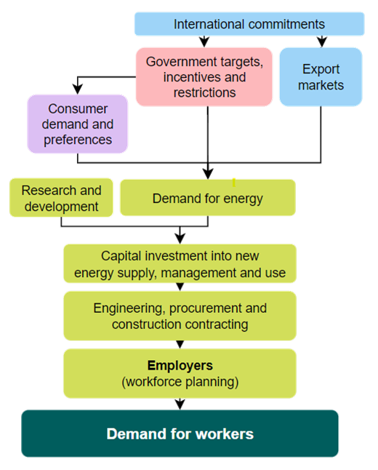

Government targets
The Australian Government has committed to a faster, more ambitious net zero trajectory for Australia. Three key targets are driving this increased scale and pace:
- a net-zero emissions target by 2050, which has been enshrined in law with the Climate Change Act 2022, per commitments made under the Paris Agreement
- an emissions reduction target of 43% by 2030, with 2035 targets in active development
- a Renewable Energy Target of 82% by 2030 for small and large-scale generation. The large-scale target encourages investment in large-scale renewable power stations to generate renewable electricity, whilst the small-scale scheme supports the installation of small-scale renewables, such as rooftop solar and solar hot water systems.
Australia is also working with Pacific Island Nations, as well as New Zealand and the United States, on a range of energy and climate strategies and policies like the Quad Clean Energy Supply Chain Diversification Program and the Australia-United States Climate, Critical Minerals and Clean Energy Transformation compact.
To reach net zero by 2050, Australia’s pace of emissions reduction needs to more than double. This means a much larger pipeline of renewable projects is required, many of which will be significantly larger in scale. It also means that expansion in renewable electricity will need to be complemented by initiatives to improve energy performance and reduce emissions from transport, buildings and industry. A larger pipeline of projects means a larger workforce.

Ambition
Beyond targets and carbon limits, the Australian Government has committed to a bolder ambition for our clean energy future:
“Australia is among the countries best positioned to benefit from this transformation. Our abundance of sun, wind and land means Australia can generate large volumes of cheap electricity to power our homes and industries, and to export. Our unique endowment of critical minerals means Australia will also play a key role in supply chains for net zero technologies like batteries.
Australia can convert these natural advantages into broad growth opportunities across industries to drive sustainable growth from our regions and make Australia a renewable energy superpower”
– Australian Federal Budget 2023-24.

This ambition cuts across multiple government objectives:
- generating renewable energy for export markets (including hydrogen)
- improving the energy performance of homes, businesses and industry
- onshoring more processing and manufacturing, including critical minerals
- supporting a faster transition to Electric Vehicles (EVs) for individuals and businesses.
Australia is also working with Pacific Island Nations, as well as New Zealand and the United States, on a range of energy and climate strategies to support the transition in our region.

Investment and incentives
The 2023-24 budget invested a further $4 billion in its plan to become a renewable energy superpower, lifting the Government’s total investment in this plan to over $40 billion. The establishment of Rewiring the Nation program under the 2022-23 Commonwealth Budget provides $20 billion in low-cost financing to capitalise and modernise our electricity grid and infrastructure, with more than $12 billion being allocated to priority transmission projects since September 2022. Each of these measures will have an impact on the demand for workers.
Selected measures include:
- The Powering the Regions Fund supports regional Australia to reduce emissions in existing industries, foster new clean energy industries, and develop associated workforces through $1.4 billion in competitive grant programs
- Hydrogen Headstart program, provides $2 billion of revenue support for large-scale renewable hydrogen projects to accelerate the development of Australia’s hydrogen industry
- National Reconstruction Fund has an announced investment target of up to $3 billion of finance to support the development of renewables and low emissions technologies
- The National Electric Vehicle Strategy will support the increased uptake of EVs across Australia, including the $345 million Electric Car Discount Bill and the $500 million Driving the Nation Fund to help reduce transport emissions, including EV charging infrastructure and hydrogen highways
- $1.3 billion to enhance our energy performance. This includes the Household Energy Upgrades Fund, with $1 billion being provided to the Clean Energy Finance Corporation to partner with banks and financial institutions to invest in household energy upgrades.

The clean energy transformation is a national effort that involves employers, employees and networks operating across state and territory borders. However, energy policy is predominantly the domain of state and territory governments, with the Australian Government supporting national arrangements, oversight and funding.
Each state and territory is pursuing its own energy investments and developments that cater to individual strengths and priorities. For example, Tasmania tailors its policies to hydroelectricity and offshore wind, while Western Australia is looking to transition its coal power plants and develop a new hydrogen industry. There are also major differences in the energy networks, with a mix of public and private ownership across Australia, and a NEM that excludes Western Australia and the Northern Territory.
The National Energy Transformation Partnership provides a framework for national alignment and cooperative action to support Australia’s energy sector transformation to net zero. At the same time, the Partnership acknowledges the individual needs and circumstances of each jurisdiction:
“[the Partnership] recognises the importance of working together to maintain energy security, reliability and affordability as Australian energy markets face unprecedented change and global challenges. It also recognises that each jurisdiction can pursue its own policies on energy transformation according to individual needs and circumstances but will work collaboratively to deliver the best outcomes at a national level”.
– National Energy Transformation Partnership.

Energy consumers
Residential, commercial, and industrial energy consumers also influence Australia’s energy use and therefore workforce needs. Decisions to reduce emissions (through electrification), lower costs (through energy efficiency), and improve energy independence (through distributed generation) will result in a higher demand for workers in population centres. Household solar and battery installation have been growing strongly in Australia, a trend now followed by business installations (Figure 1.4).
Figure 1.4. Distributed energy in Australia, rated capacity (kVA)
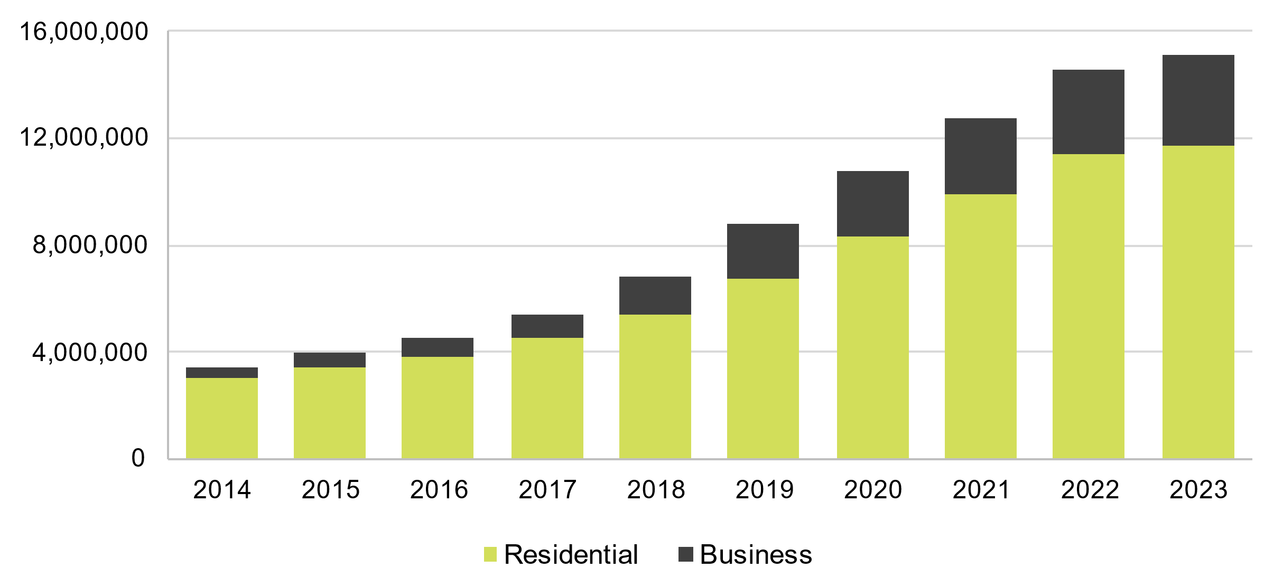
Source: Australian Energy Market Operator, Distributed Energy Resource Register, July 2023.
We are also seeing industry investment in clean energy technologies to diversify their business. For example, steel manufacturers are looking to power new electric arc furnaces with renewable energy to produce green steel. These new and changing industries are explored in Chapter 6.
Most of Australia’s energy is exported (around 81% in 2020-21. See Figure 1.5), mainly as black coal, liquefied natural gas and crude oil. As export markets continue to decarbonise, the amount and type of energy Australia produces will change. This will substantially affect employment in traditional energy sectors and create opportunities for new ones, like hydrogen.
Australia also imports a lot of energy, mostly refined fuels like diesel and petroleum, but also crude oil. How these imports are produced overseas, transported, and used in Australia will also evolve.

Figure 1.5. Australian energy balance
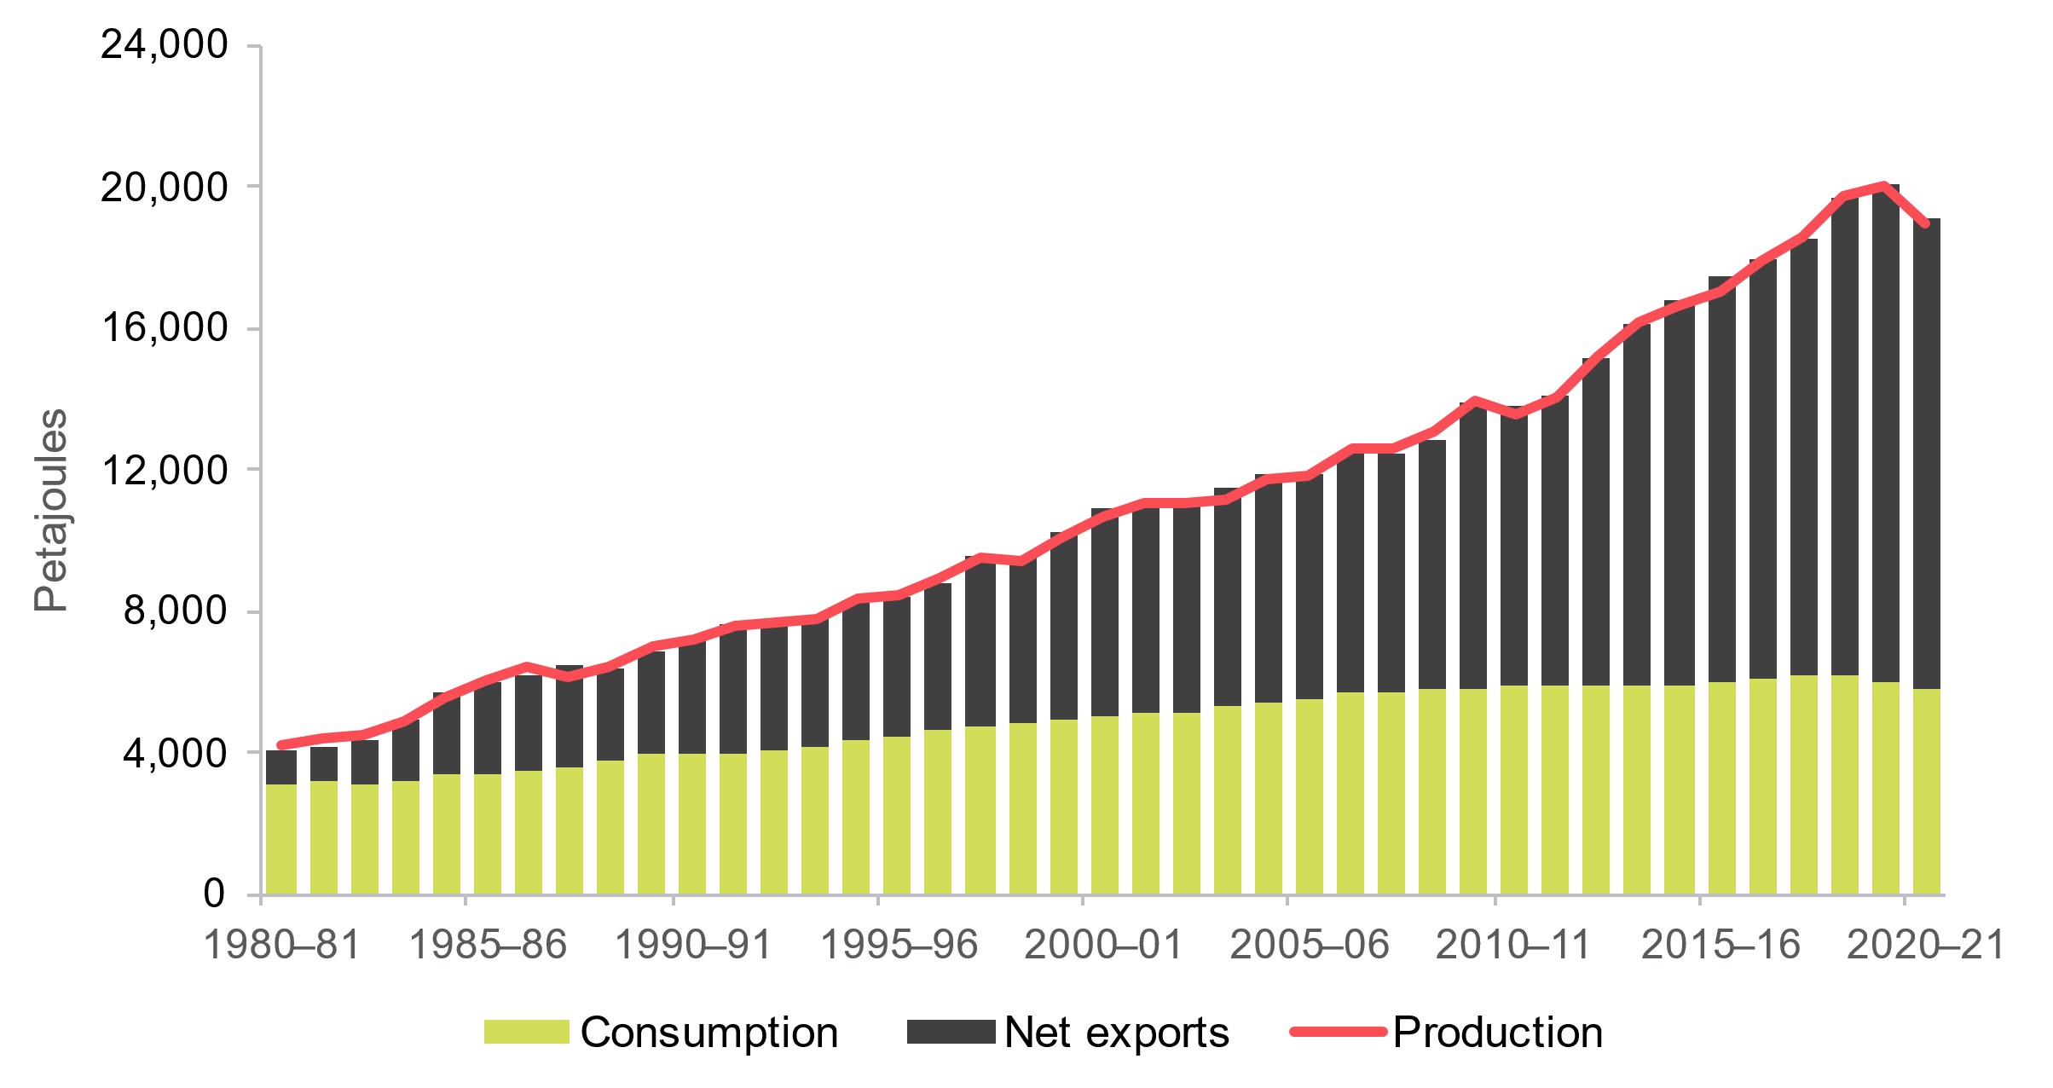
Source: Department of Climate Change, Energy, the Environment and Water (DCCEEW) (2022), Australian Energy Statistics, Tables C, J.

Technology development
To date, most emissions reduction has centred around decarbonising the electricity grid with renewable energy. This attention is starting to shift as new priorities and technologies emerge. The Australian Government has already committed to new targets, investments and strategies across many emerging sectors, including:
- Transport makes up around one-fifth of Australia’s total emissions, while EVs only account for 3.8% of light vehicle sales in 2022. The new National Electric Vehicle Strategy looks to increase the number EVs on our roads and the amount of supporting charging infrastructure. Focus is also starting to turn to decarbonising road, rail, maritime and air freight.
- Energy performance will help Australia reduce its demand for energy and decarbonise faster through electrification and efficiency. The Australian Government is developing a National Energy Performance Strategy to accelerate these activities across residential, commercial and industrial settings. The 2023-24 budget included several initiatives for households and businesses to improve their energy performance.
- Hydrogen production, use and export are all being explored for Australia. This includes opportunities to use hydrogen as an alternate fuel in manufacturing and heavy transport as well as scaling its potential for storing energy produced from renewable sources. The Government’s recent $2bn Hydrogen Headstart Program aims to help grow local production of large-scale electrolysers.

- Offshore wind has the potential to meet a large part of Australia’s energy needs, with Victoria setting ambitious targets of at least 2 GW of capacity by 2032, 4 GW by 2035 and 9 GW by 2040. This will involve a complex mix of fabrication, installation, undersea cabling and maintenance activities.
- Manufacturing renewables and low emissions technologies is a priority area of the Australian Government’s National Reconstruction Fund that aims to diversify and transform Australia’s industrial base. It includes a $3bn allocation for green metals (steel, alumina and aluminium), clean energy component manufacturing, hydrogen electrolysers and fuel switching, agriculture methane reduction and waste reduction.
- Battery storage will be a critical feature of Australia’s future energy supply, both at grid-scale to support transmission but also in houses and businesses in tandem with small-scale solar. The government is delivering a National Battery Strategy to boost investment across the battery value chain.
- Critical minerals are essential inputs for a wide range of clean energy technologies. The Critical Minerals Strategy 2023-2030 will support Australia to unlock our vast potential as a major supplier of the critical minerals needed to decarbonise the global economy.
New technology has the potential to radically change the way we generate and use energy in Australia, which will ultimately impact the type of workforce we need. These new technologies and their potential impacts are explored in Chapter 6.

International competition and commitments
More than 150 countries have committed to achieving a net zero target, a significant milestone representing around 90% of global population. The energy transition will require a coordinated effort from all regions and nations, but the scale and pace of transformation will largely be driven by the major energy powers: China, the United States and the European Union. Collectively, these regions account for the majority of global energy supply and demand and are the three highest carbon emitters.
The policy settings and fiscal incentives of these major powers (and countries like Japan and India) will heavily influence the flow of capital for clean energy projects. Therefore it’s important to note that regardless of Australia’s domestic policies, our energy workforce needs will radically change.
With many nations looking to transition their economies, secure energy supply, and develop new industries, the competition for workers will grow. As a result, Australia will likely find it harder to attract skilled migrants and retain local workers.
“A clean-tech race is in full swing. The largest economies in the world – from the United States to India, from China to Japan – have all started to invest massively in green innovation. While this can only be good news for our planet, it is of course a lot of pressure on the EU’s own clean transition.”
– The European Commission.
Understanding the clean energy policy settings and fiscal incentives of the major energy powers will be critical to ensuring Australia is competitive, resilient and responsive to the shifting landscape of the international energy market.
- China has ratified the Paris Agreement, which centres on a commitment to reduce emissions, limit global temperature increases and mitigate the impacts of climate change. China is considered a developing country by the United Nations and is accordingly held to more lenient ratification requirements than highly developed countries. In 2020, China committed to achieving carbon neutrality by 2060.
- The U.S. is a party to the Paris Agreement and upon re-joining the Paris Agreement in 2021, the US set an emissions reduction target of 50-52% on 2005 levels by 2030 and has committed to achieving carbon neutrality by 2050.
- The Inflation Reduction Act (2022) was designed to ensure that the United States remains a global leader in clean energy technology, manufacturing, and innovation. The IRA earmarks AU$520 billion for clean energy investments across a range of sectors, with a view to strengthen the U.S. economy, job market and supply chains as well as conserve and restore the natural environment. This transformational investment is expected to create around 9 million jobs.
- The EU is a party to the Paris Agreement and has committed to achieve carbon neutrality by 2050. Each of the EU’s 27 Member States are required to develop their own national strategies in support of these shared aims.
The nationally determined nature of a country’s emissions targets factors in the various starting positions of each country and their capacity to contribute to overarching global climate change objectives.

1c. How do we currently use energy?
Energy is more than just electricity. It includes the fuel we use to heat our homes, fuel our vehicles and power our industries. Most of Australia’s energy consumption comes from fossil fuels – about 92% in 2020-21 (Figure 1.6). Oil is the largest fuel source (mostly for transport), followed by coal and gas used to generate electricity and in heavy industry. The renewable share has grown from around 5% in 2010-11 to 8% in 2020-21. Chapter 5 explores how our workforce needs may need to change considering different scenarios based on how the energy mix may change overtime.
Figure 1.6. Australian energy consumption, by fuel type
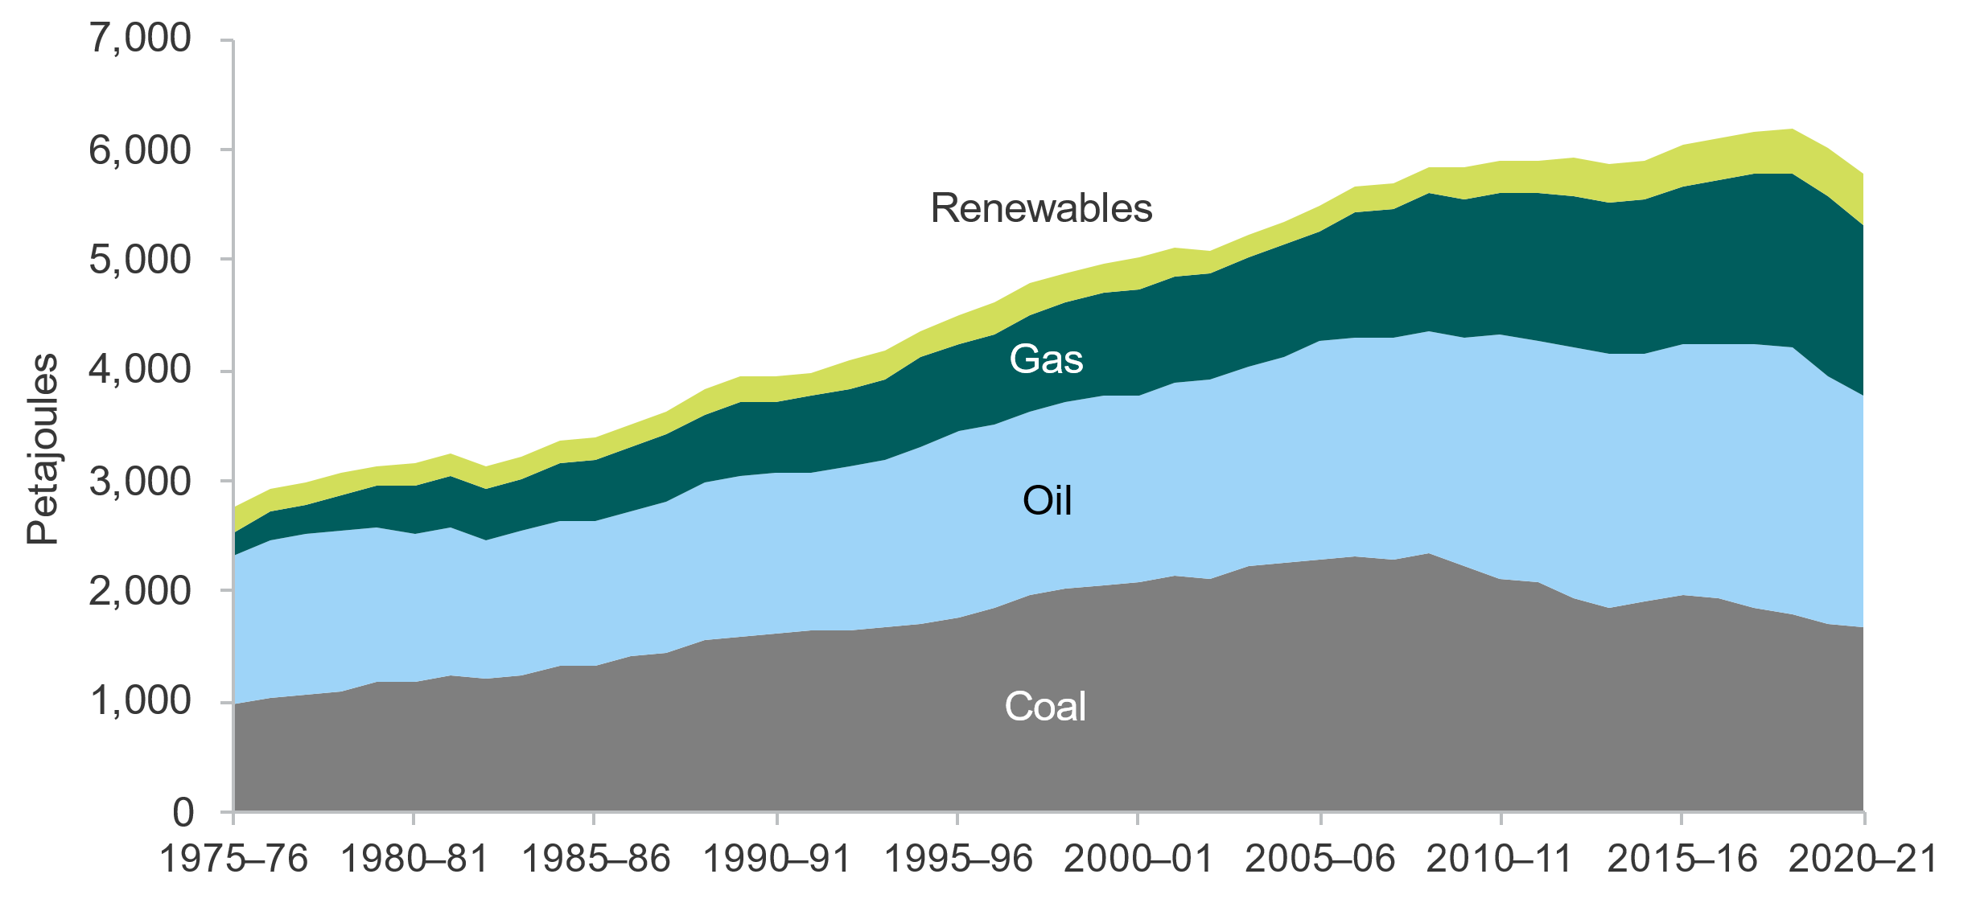
Source: DCCEEW (2022), Australian Energy Statistics, Table C.
Energy consumption varies substantially by state and territory, although oil use is largely consistent (Figure 1.7). Tasmania has the largest share of renewable energy, mostly sourced from hydroelectricity. South Australia uses renewables for electricity generation; however, gas and coal are still commonly used in industry, cooking and heating.
Figure 1.7. Australian energy mix, by state and territory, 2020-21
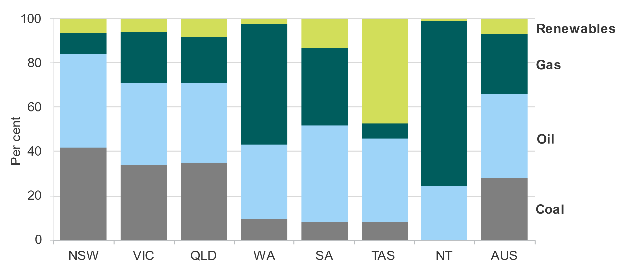
Source: DCCEEW (2022), Australian Energy Statistics, Table C. Note, this is total energy use, and includes energy used directly by industry (like coal and gas in manufacturing) and for heating. ACT is included in NSW.
The main uses of energy in Australia are electricity supply (25%), transport (25%) and manufacturing (18%) (Figure 1.8). In 2021:
- just over half of all electricity was generated using coal (mostly black coal), followed by renewables (29%) and natural gas (18%)
- around 80% of transport energy use was for road transport, followed by air (9%) and rail (5%). Diesel was the most common fuel used, followed by petrol and aviation fuel
- in manufacturing, the largest energy consumption was for non-ferrous metals (like aluminium and copper), followed by chemicals, food, beverages and tobacco.
Figure 1.8. Australian energy consumption, by sector 2020-21
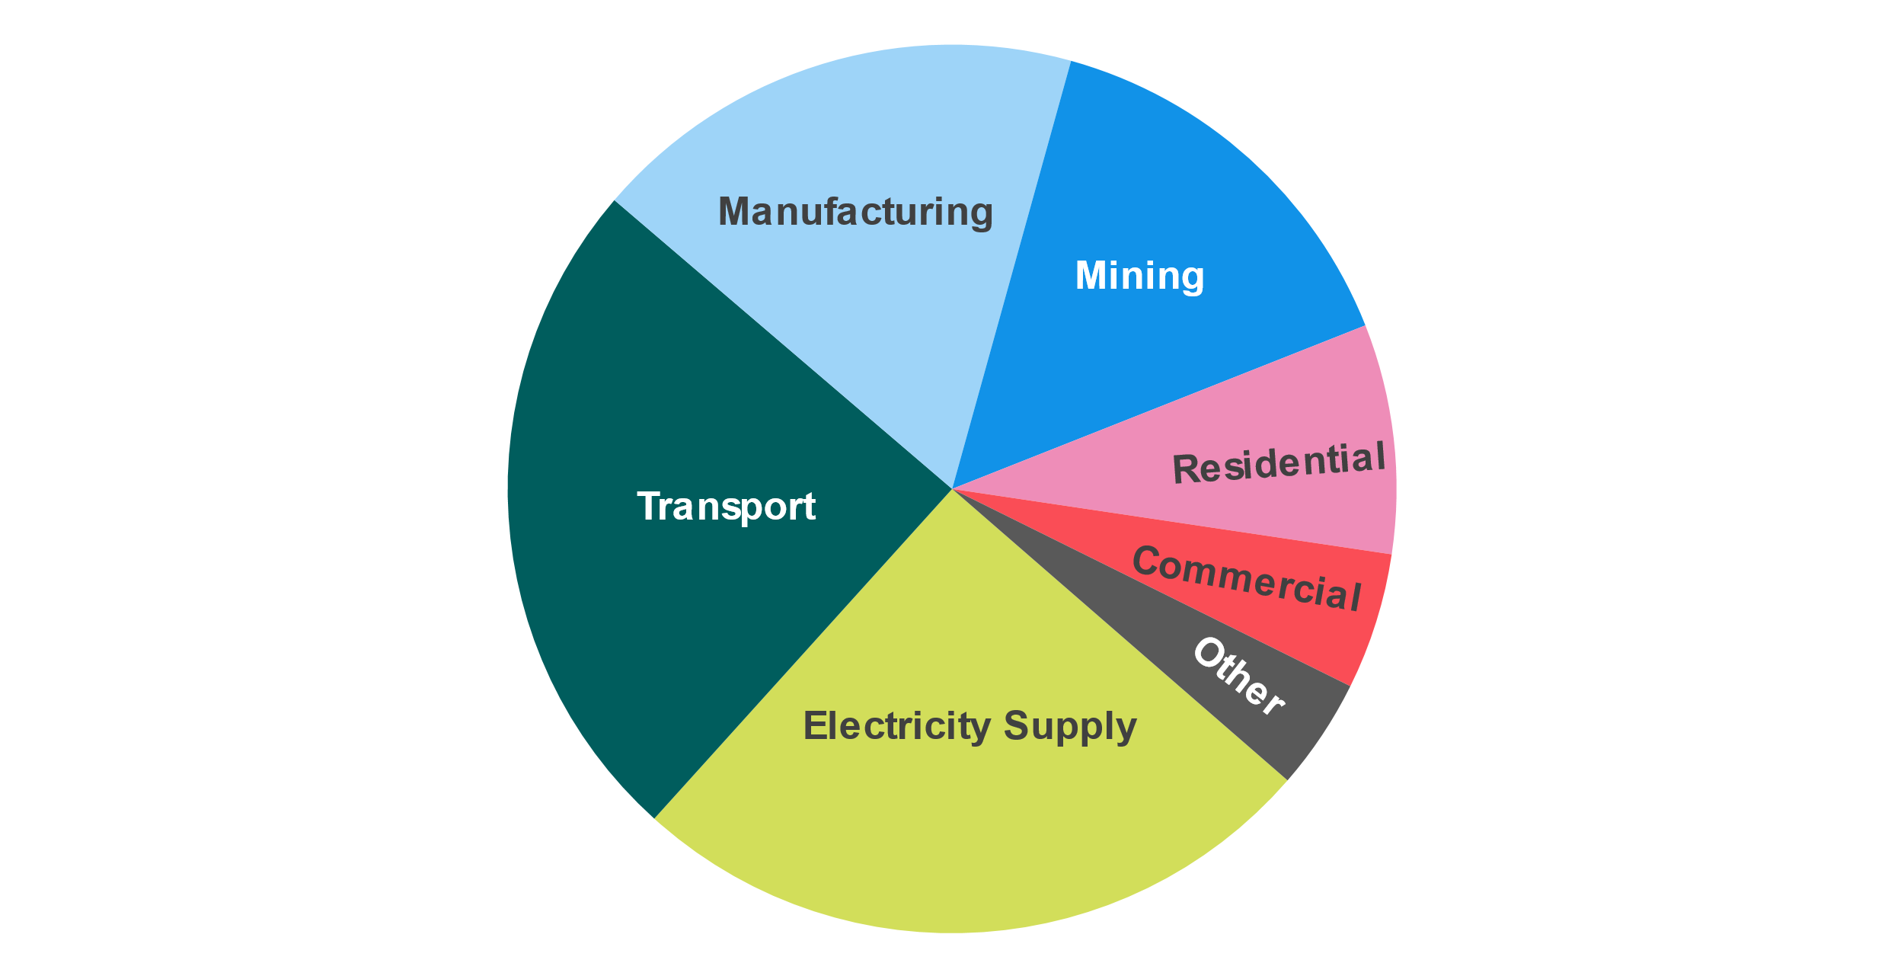Source: DCCEEW (2022), Australian Energy Statistics, Table E. Electricity supply includes renewable and non-renewable electricity generation.
Australia’s renewable energy mainly comes from solar and wind electricity generation (Figure 1.9), which have grown rapidly over the past decade. While hydroelectricity makes a sizeable contribution (predominantly from Tasmania and NSW), it’s been at roughly the same levels for several decades.
Figure 1.9. Australian renewable energy consumption, by fuel type, 2020-21
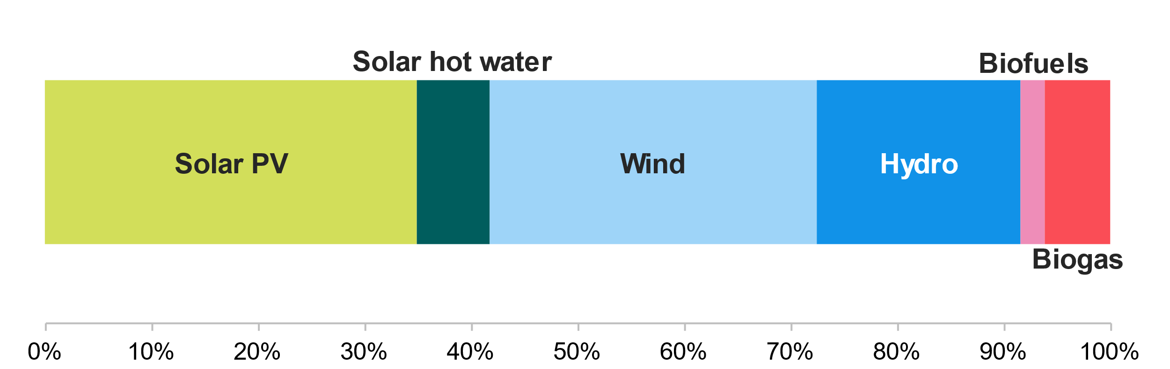
DCCEEW (2022), Australian Energy Update. Excludes biomass (wood, waste, charcoal, etc.).

Winding down fossil fuel generation
The future of Australia’s energy workforce will also be impacted by the declining use of fossil fuels. While this will impact many industries, like transport and manufacturing, the most immediate impact will be coal-fired power generation. Some power stations, like Hazelwood and Liddell (in 2017 and 2023 respectively), have already ceased operation, impacting local workforces. Figure 1.10 shows the expected closure timeline for Australia’s remaining coal-fired plants, with six expected to close by 2030. Chapter 4 of this report explores the transition options for workers in these industries and others, while Chapter 8 explores the barriers and enablers for a successful transition.
Figure 1.10. Timeline of expected coal-fired power plant closures
Source: AEMO, Generating united expected closure year, July 2023.

1d. Roles and responsibilities

Clear and coordinated action by government
The clean energy workforce challenge can’t be solved by one area of government, let alone one initiative or program. The implications of this study will require action across a range of portfolios, including energy, employment, education, skills and training and migration. There are already major reforms underway across each of the workforce pipelines, which will greatly impact this sector (Figure 1.11). The Australian Government has also announced several initiatives to support the clean energy transition, like the New Energy Apprenticeships Program, that seek to boost the supply of workers.
Figure 1.11. The Australian Government’s key energy workforce activities
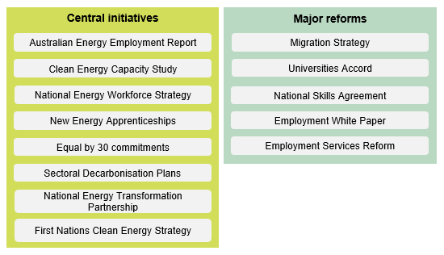
An effective whole-of-government approach will be critical to ensure initiatives are designed and delivered in collaboration. There are at least six government strategies for energy sectors, all impacting the workforce. These will soon be joined by a National Energy Workforce Strategy and six net zero sectoral plans individually led by each responsible portfolio minister. The strategy will provide a national framework for this workforce, while the sectoral plans will guide the decarbonisation of key sectors like energy, agriculture and transport in support of the 2050 Net Zero Plan.
A new Net Zero Authority (NZA) within the Department of Prime Minister and Cabinet will also be legislated to:
- Support workers in emissions-intensive sectors to access new employment, skills and support as the net zero transformation continues.
- Coordinate programs and policies across government to support regions and communities to attract and take advantage of new clean energy industries and set those industries up for success.
- Help investors and companies to engage with net zero transformation opportunities.
Jobs and Skills Councils (JSC), led from the Department of Employment and Workplace Relations (DEWR), have also been tasked with developing workforce plans for their sectors, which include energy, transport and other relevant areas. This department also delivers employment services and retrenchment supports for workers impacted by structural adjustments, including coal-fired power station closures.
Governments also have an important role in shaping markets through public investment. For example, the $15 billion National Reconstruction Fund will provide loans, guarantees and equity to support projects that create secure, well-paid jobs and diversify Australia’s economy. Likewise, the Clean Energy Finance Corporation (CEFC) acts as a specialist investor to spur substantial investment where it will have the greatest impact. Chapters 7 and 8 explore how government procurement can and does influence the development of our workforces.
Unclear and overlapping responsibilities make it hard for government entities to align their activities and combine efforts, while also being difficult for stakeholders and communities to navigate. Each of these initiatives and roles are promising, but need to be carefully managed to avoid overcrowding and duplication.

A national effort
The transition to net zero is a shared responsibility between governments, industry, workers, and communities. Australia’s state and territory governments are all developing their own strategies and plans to grow their workforces; however, there is little consistency or collaboration. A complete mapping of these initiatives is available at Attachment A. States and territories also have different registration requirements that can lead to differences in training and limit mobility opportunities for workers.
There is an appetite for the Australian Government to provide greater coordination and stewardship for the clean energy workforce. The National Energy Transformation Partnership offers a framework for national alignment and cooperative action by governments to support energy transformation. As workforce is one of the key priorities for this partnership, the Australian Government should consider how its wide range of initiatives could contribute under the Partnership framework. Greater collaboration between the Australian Government and states and territories could also be supported through the National Energy Workforce Strategy, Net Zero Authority and JSCs.
“State governments should coordinate their workforce needs by sharing information and harmonising their requirements for local employment, apprentices and local supply chain through the REZs [renewable energy zones], rather than competing. The Federal Government could play a role in brokering such an arrangement”.
– Clean Energy Council.

Recommendation 1.1

The upcoming National Energy Workforce Strategy should be empowered to provide a coordinated, whole-of-government and whole-of-sector approach for this workforce, serving as a singular, coherent voice.
Recommendation 1.2

The National Energy Workforce Strategy should involve all states and territories, leverage the National Energy Transformation Partnership and pursue genuine collaboration and consolidation opportunities.
Recommendation 1.3

Clearly identify, differentiate and communicate the roles of the Net Zero Authority and existing government agencies to avoid confusion and duplication of effort.


Chapter 2:
Defining
‘clean energy’

Defines the clean energy workforce using industries, occupations and skills. Includes background information and data limitations.

2a. Our definition

The approach
In this chapter, we define the clean energy workforce, using the Australia and New Zealand Standard Industrial Classification (ANZSIC). This is an exhaustive process, to show how the clean energy workforce fits within the whole Australian labour market and economy.
This report provides estimates of how large the clean energy workforce is, noting that in some sectors the number of workers directly involved in clean energy activities is small (and not easily measured), but which we know will grow substantially as we head toward net zero by 2050.
We then identify the critical occupations for clean energy, as classified in ANZSCO. An occupation is considered to be critical to the industry where:
- it is commonly occurring in a clean energy segment, and/or
- a relatively large proportion of workers in the occupation may be found in clean energy segments rather than in other segments, but this may not necessarily be the case
- it takes a long time to train this occupation (whether through higher education, VET or on the job), and
- to be able to work in clean energy requires specific additional skills or expertise.

Activities covered
JSA research and consultation within government highlighted that the lack of an evidence base and universal definition of the clean energy workforce was the result of two facts.
Firstly, there are contested views on what should constitute “clean energy” and the “clean energy impacted workforce” – and secondly because every worker will be impacted by decarbonisation to some extent. In practice this means government agencies were trying to achieve definitions that combined two lines of argument that at times conflicted.
Various government agencies (and the many industry groups, research agencies and others to have done similar work) have used a wide range of data (ANZSCO, O*NET, former National Skills Commission (NSC) research and a new Australian Energy Employment Report or AEER) to infer a contested concept or concepts (“green”, “clean”, “efficiency”, “new energy”), at the same time as being asked to define and identify new concepts such as “new energy apprenticeships” or the “energy performance workforce”. This resulted in multiple, overlapping definitions.

The definition
The following definition has been refined based on extensive feedback and collaboration across government and industry, and is the definition adopted for the study. Within this definition there are 7 industry segments which are divided into 16 sub-segments:
The clean energy workforce includes the workers involved in:
- designing, developing, constructing and operating the infrastructure for generating, storing, transmitting and distributing energy from renewable, zero or low emissions energy sources* (‘clean energy supply’),
- reducing or managing the energy required to deliver energy services (energy efficiency, energy management, and demand management), and
- installing and maintaining the technology that uses clean energy rather than fossil fuels (‘clean energy).
This spans energy needed to be consumed by businesses and housing, transport and industrial processes. When considering the clean energy workforce, all workers contributing to that activity will be in scope. For some components of the study (e.g. examining the barriers and enablers of the education and training pipeline), the scope will be restricted to those workers who require skills specific to adopting, developing, distributing and supplying energy generated from renewable sources. For example, this would mean considering the skills required by wind turbine technicians, but not the accountant who works for a renewable energy business.
*In addition to renewable electricity, zero and low-emission alternatives include low carbon liquid fuels (e.g. hydrogen and biomethane) which will be important to transition hard to-switch sectors. Some low carbon liquid fuels and renewable gasses also offer an opportunity to help transition these industries without requiring significant infrastructure upgrades. Our definition includes workers involved in these types of activities.

2b. Industries
Based on feedback from our Discussion Paper and engagement with the Project Steering Group, the current JSA mapping of workforce against the definition of clean energy’s 7 segments and 16 sub-segments, describe what constitutes the clean energy workforce and related sectors. The industry categories span energy supply, energy demand, enabling clean energy workforce, the workforce associated with the carbon lifecycle and the workforce from transitioning sectors.
Adopting this approach, approximately 30% of the Australian workforce potentially has some direct exposure to the transition to clean energy, though based on the segments where we have estimated the current proportion actually in clean energy roles, the clean energy workforce would likely be less than 5% at present.
This leaves around 60-70% of the Australian workforce without direct or substantial connection to clean energy. As a predominantly service based economy, this is not surprising. However, we acknowledge that most industries will have some contribution. Further, there will be many industry groups that will experience a change in demand and various skill impacts because of decarbonisation and climate change.
Figure 2.1 provides an overview of our industry categories and their relative sizes. We have published a full ANZSIC mapping of these segments, including employment counts, on our website. This mapping was produced within the constraints of ANZSIC and the significant data and information gaps that exist for this workforce. With new data collection activities like the AEER we hope that this kind of activity could be improved upon in the future.

Overview of the segments
We have identified a clean energy supply workforce. These are the business units that are essential to clean energy generation, transmission and distribution. We’ve included the supporting infrastructure for energy supply and distribution (focused on electricity given sustainable fuels are at a much earlier stage of development), reflecting that as we transition to renewable sources, these components will become more identifiably ‘clean energy’ and the transition will require investment in these components as they transform. This category is small in terms of the total Australian workforce (approximately 0.4%) but it will need to grow substantially and transform.
We have proposed a separate segment we have called clean energy demand. This category captures the activities that directly relate to energy usage and energy performance, with energy for transport as its own sub-category. An important difference between this category and the clean energy supply category, is that clean energy demand activities exist within established ANZSIC groups where energy demand is not the main or originating activity but are nonetheless central to the transition. This category corresponds to around one in 12 Australian workers overall (8%), but we have estimated that for most activities clean energy activities only currently account for up to 20% of employment in the relevant ANZSIC groups.
The third category we have called clean energy enablers. Enablers do not directly result in the transition to clean energy, but they are nonetheless critical to creating clean energy supply and shifting to clean energy consuming products. Broadly, there are enabling services and enabling goods. The enabling services such as clean energy research, training, and regulation are only a small portion of the host industry groups (we’ve estimated
3% at most for each of these industries). The proportion of the engineering, procurement and construction workforce that is working on clean energy projects is likewise small at present, but likely to grow substantially.
The supply chain enabling activities include steel and fabrication for wind turbine generation as well as critical mineral mining and processing for battery development. At present the proportion of these workers within these segments in clean energy roles is very small with only limited onshore manufacturing for clean energy components occurring. However, it will grow over the period to 2050, especially if ambitions to expand Australia’s role along the value chain are realised.
A further enabling sub-segment captures the production of, and trade in, vehicles and equipment such as agricultural and industrial machinery.
The carbon lifecycle category includes industries which will have a substantial contribution to managing the carbon lifecycle, such as through carbon capture or the circular economy (which includes the reuse and regeneration of materials and products). We’ve estimated this adds 0.5% of the Australian workforce.
Based on the 2021 Census, around 1.1% of Australia’s workforce is in transitioning sectors – coal fired power, coal mining, oil and gas exploration and production, and downstream activities linked to fossil fuels, such as fuel retailing. Regionally, we know that the proportion is much higher in some areas and the transition will impact other jobs through supply chains and local communities.
Around 4% of Australia’s workforce is in emissions intensive sectors. Less than a quarter of this is in direct emissions-intensive sectors like metals, cement and chemicals manufacturing. A much larger proportion work in indirect emissions-intensive sectors that are high energy users like food and paper manufacturing.

Figure 2.1. Estimated proportion of the workforce by clean energy segment
Segment, Description & Sub-segment | Share of Australia’s  total workforce |  |  | Estimated proportion working in clean energy
Clean energy supply |  |  | 0.4%
Industry groups that are essential to clean energy generation and supply. Currently, distribution and supply supports both renewable and fossil-fuel-reliant energy sources. As we transition, these will predominantly support renewable energy.
Supply – generation |  |  | 0.03% | 100%
Supply – distribution |  |  | 0.3% | 35%
Clean energy demand |  |  | 8.0%
Industry groups that relate to energy demand, noting that most industry groups are about more than energy. Industry groups in the clean energy demand segment will have skill and job role implications. Clean energy is already a significant (albeit minority) proportion of activity and likely to grow.
Demand – energy usage |  |  | 1.1% | 20%
Demand – energy performance |  |  | 3.7% | 15% - 20%
Demand – transport |  |  | 3.2% | < 5% - 8%
Clean energy enabling |  |  | 17.1%
Industry groups which enable clean energy production, supply and usage but where the clean energy component is small. Generally, clean energy workers in these sectors are distinguished by subject matter expertise rather than distinct job roles or skills.
Enabling – education, training, research & technology |  |  | 2.2% | 4% - 5%
Enabling – finance, legal, business |  |  | 4.4% | < 1%
Enabling – engineering, procurement & construction |  |  | 2.1% | 10%
Enabling – regulatory |  |  | 3.9% | 4%
Enabling – supply chain |  |  | 1.7% | < 1%
Enabling – vehicle & equipment production, trade & maintenance |  |  | 2.7% | Up to 8%
Carbon lifecycle |  |  | 0.5%
Industry groups which will have a substantial contribution to managing the carbon lifecycle, through carbon capture or the circular economy.
Transitioning |  |  | 1.1%
Fossil-fuel related groups which will decline and transform substantially as a result of decarbonisation.
Emissions-intensive sectors |  |  | 4.0%
ANZSIC groups such as cement production and other industrial processes that are emissions intensive.
Direct emissions-intensive sectors |  |  | 0.6%
Indirect emissions-intensive sectors (high energy users) |  |  | 3.4%
All other industry groups |  | 61.6%
All other ANZSIC groups. No substantial contribution to clean energy generation or energy performance or direct contribution to decarbonisation, though there may be some specialised contributions and/or more general job demand and skill impacts because of decarbonisation and climate change.
Unallocated | 7.6%
Due to use of census data, there is an unallocated category where responses had missing information or insufficient detail.
Source: JSA ANZSIC mapping, 2021 ABS Census of Population and Housing.

Clean energy supply
Estimate of approximately 17,700 workers in clean energy
Industry groups that are essential to clean energy generation, supply or distribution.
The core generation and distribution is supporting infrastructure currently split between distributing and supplying renewable and fossil-fuel-reliant energy sources. As we transition, these will predominantly support renewable energy.

Industries in the Clean Energy Supply
The major industry groups currently operating in the clean energy core workforce are hydroelectricity generation and, other electricity generation such as wind and solar. Electricity transmission and distribution, and on-selling electricity and electricity market operation are also integral parts of the supply of renewable energy. At present, approximately 36% of electricity generated in Australia is from renewable sources.

Existing estimates and research
While clean energy generation (the industries captured in clean energy core - current) is a relatively small workforce, the most recent estimates from the Australian Bureau of Statistics (ABS) put renewable generation employment at 26,850, with around half of this employment in roof-top solar:

- Roof-top solar PV (including hot water) – 13,070
- Solar PV large – 4,740
- Wind – 3,240
- Hydroelectricity – 3,060
- Biomass – 1,580
- Govt/Non-Profit Institution – 1,120
- Geothermal - 40

This is a much larger number than our estimate for the clean energy supply and reinforces our view to treat our analysis as indicative only. Many of the roles captured in the ABS report would be captured in other industry categories in the Census data, such as electrical services (discussed below). It also includes construction and installation activities which sit in our other segments. Additionally, these experimental ABS figures are also using an employment factor approach which only provides indicative estimates.
The Institute of Sustainable Futures (ISF) was commissioned to produce workforce projections for the Australian Energy Market Operator’s (AEMO) 2022 Integrated Systems Plan, which covers the NEM. ISF used an employment factor (full-time-equivalent job years per megawatt of installed capacity) based on current workforce estimates and projected this forward for each scenario. Due to information constraints, this work does not consider energy efficiency, demand-side energy management, electrification or renewable hydrogen production and is also limited by the likelihood that workforce composition and requirements will change over time.
Under AEMO’s step change scenario, ISF projects that employment will grow from 19,000 in 2023 to a peak of 81,000 in 2049. Around 30% of employment is for onshore wind generation, 25% for rooftop solar and 18% for batteries, with NSW having the greatest share of employment, followed by Queensland, Victoria, South Australia and Tasmania. Trades and technicians are by far the largest occupation group, with electricians and mechanical trades and technicians in particularly high demand.

Clean energy demand

Estimate of up to 146,000 workers within clean energy
Industry groups that are essential to creating or moderating the demand for clean energy. This covers the activities that will electrify energy demand in homes, the commercial sector and the industrial sector (energy usage), activities that will improve energy efficiency to moderate overall demand (energy performance) and activities that will create demand for clean energy in transport (transport).

Industries in Clean Energy Demand

ENERGY USAGE:
- Energy usage relates to the installation of small scale (residential) solar electricity generation and the role of electrification in decarbonising energy use, electrical services and air conditioning and heating services (which are in the Construction industry division). This group will be central to electrification, as well as capturing some current rooftop solar installation.
- Estimating the current proportion of these industry groups working on clean energy is difficult. The ABS Employment in Renewable Energy Activities, Australia estimated that in financial year 2018-19, there were 13,070 jobs in roof-top solar PV systems and that growth had been approximately 30% a year since 2015-16. On that basis, it is likely to account for approximately 20% of the total electrical services workforce of approximately 84,000 based on the 2021 Census.
- This industry group will be the one that will need to respond to additional demand for electrification (alongside plumbing). It is also where a large proportion of current electricians are employed, and so is critical to consider in terms of potential sources of labour for the clean energy core workforce.

ENERGY PERFORMANCE:
- Energy performance relates to reducing energy demand and includes energy efficiency, energy management and demand management. This sub-segment includes the industry groups that directly contribute to improving energy efficiency in residences and other buildings (e.g. house construction, carpentry services, glazing services, plumbing services), supporting industry groups in the value chain (e.g. glass and glass product manufacturing) and the various road, rail, aviation and maritime transport sectors. We have estimated that the clean energy component is approximately 15-20% in construction (based on the distribution of spending for alterations and additions to existing residential buildings), and between 5-8% in transport (based on the occupations within the industry that would be most impacted by conversion from combustible engines).

TRANSPORT:
- We have created a separate sub-segment for transport, given its crucial contribution to reaching net zero but at the same time recognising that at this point it is less advanced in the transition to clean energy sources.
- This sub-segment includes all modes of transport from the Transport and Distribution industry division, as well as automotive repair.
- We have focused on the proportion of the workforce that will be impacted by the change in engine technology in terms of skills they will need to do their jobs. Therefore, we’ve included motor mechanics rather than drivers or supporting clerical workers, to identify a proportion of around 1% for those industry groups.
- For automotive repair, we have considered the proportion of vehicles that are currently electric or hybrid. We have chosen an upper range figure – 16.6% of new vehicle sales in June 2023 were electric or hybrid. The proportion of all operational vehicles is obviously lower but increasing rapidly.

Clean energy enabling segments
Estimate of up to 90,500 workers within clean energy
Industry groups which enable clean energy production, supply and usage but where the clean energy component is small. It is further divided into six sub-segments.
- Enabling – education, training, research & technology. Provides the skills and the technology needed to produce the clean energy sector and workforce.
- Enabling – finance, legal, business. Develops the specialist financial products and expertise and legal instruments to support investment in clean energy.
- Enabling – engineering, procurement and construction. Responsible for the commissioning and construction of large-scale new renewable electricity generation sites.
- Enabling – regulatory. Provides the legislative basis for the growth of the clean energy sector and rules of operation.
- Enabling – supply chain. These are the industry groups that provide the inputs to the technologies that are transitioning to clean energy (as distinct from the technology that produces clean energy).
- Enabling – vehicle and equipment production, trade and maintenance. This captures manufacturing of vehicles and industrial machinery and equipment that is either currently electric-powered or will likely transition at some point from fossil-fuel based to electricity or sustainable fuels.

Education, training, research and technology:
Industries in this sub-segment include higher education; technical and VET; scientific research services, other professional, scientific, and technical services. In total, this segment comprises approximately a quarter of a million workers, but the proportion of workers in these industry groups connected with clean energy is quite small – approximately 4 or 5%.
A 2014 ARENA report found 1-3% of indexed journal articles attributed to CSIRO and Australian universities were related to renewables, with the total number increasing each year since 2005. JSA analysis shows that 3.9% of enrolments in VET are in training products mapped to the Powering Skills Organisation (Jobs and Skills Council).

Finance, legal and business:
Industries in this sub-segment are financial and insurance services, and the following from professional scientific and technical services: legal services, accounting services, and management advice and related consulting services. Like education, training, research and technology, the overall size is quite significant (approximately half a million workers), but the proportion of workers in these industry groups connected with clean energy is quite small.
The International Energy Agency (IEA) estimates professional services (including legal, accounting, engineering design, and others) at around 5% of the clean energy workforce. This aligns with the ISF analysis, which has finance, business, legal and planning occupations at 4.5% for Australia.

Engineering, procurement and construction:
This sub-segment contains a combination of professional services (engineering design and consulting, architectural services, scientific testing and analysis services) and the group of heavy and civil engineering construction that covers electricity infrastructure.
Based on Race for 2030 workforce modelling, which provided separate workforce estimates and forecasts for the construction phase of renewable electricity projects, we have estimated that renewable energy currently accounts for approximately 10% of employment in this segment.
One additional area of activity for the engineering, procurement and construction workforce is in decommissioning depleted oil and gas reserves, coal mines and coal fired power stations.

Regulatory:
Industries in this sub-segment are central government administration, state government administration, local government administration. As for the above two sub-segments, the proportion of workers in these industry groups connected with clean energy is quite small. Energy Assessor is an example of a regulatory related role in clean energy, as are small generation unit inspectors appointed by the Clean Energy Regulator.
Data from the Australian Public Service Commission indicates that in 2022, approximately 4% of Australian Public Service employees were working in agencies within the Climate Change, Energy, the Environment and Water portfolio (including the Bureau of Meteorology, the Clean Energy Regulator, the Climate Change Authority, the Great Barrier Reef Marine Park Authority, the Murray-Darling Basin Authority and the North Queensland Water Infrastructure Authority).

Supply chain:
This sub-segment includes critical mineral mining and processing (as well as supporting sectors such as mineral exploration and mining support services) and manufacturing and construction activities that support renewable energy infrastructure, such as electric cable and wire manufacturing and heavy and civil engineering construction. Also in this sub-segment are:
- iron ore and silver-lead-zinc ore mining
- iron and steel manufacturing, forging, and fabrication
- product manufacturing like space heating, cooling and ventilation equipment.
As a share of the total industry groups included in this sub-segment, the proportion of workers with some direct connection to clean energy or its supply chain components is small. Employment in this sub-segment is dominated by iron ore and gold mining, for example, whereas the proportion connected with lithium mining is less 5% of those larger industry groups. Likewise, there is some manufacturing of wind turbine components in Victoria, but current employment levels are measured in the hundreds or low thousands, against the approximately 50,000 workers employed in various stages of steel product manufacturing in Australia.

Vehicle and equipment production, trade and maintenance:
This sub-segment includes manufacturing vehicles as well as other machinery and equipment that is likely to transition from using fossil fuels as an energy source to electric power or sustainable fuels. This sub-segment also includes wholesale and retail trade for vehicles as well as machinery and equipment, and repair and maintenance of machinery and equipment not captured elsewhere.
We included automotive repair with the “Energy demand – transport” sub-segment, because of its significance and more direct connection with clean energy skills.

Carbon lifecycle
Estimate of approximately 55,000
Industry groups which will have a substantial contribution to managing the carbon lifecycle, such as through carbon capture or the circular economy.
- From Agriculture, Forestry and Fishing: Forestry, Logging and Forestry Support Services
- From Electricity, Gas, Water and Waste Services: Waste Treatment and Disposal Services; and Waste Remediation and Materials Recovery Services
- From Arts and Recreation Services: Nature Reserves and Conservation Parks Operation.
The carbon lifecycle segment has two distinct parts. The National Waste Policy Action Plan 2019 (updated in 2022) provides national direction to reduce the total amount of waste generated in Australia, increase the recovery rate from all waste streams, and significantly increase the use of recycled content. The mapping here concentrates on the final stage Waste Treatment and Disposal Services and Waste Remediation and Materials Recovery Services. While other industries make an important contribution to circular economy initiatives, such as the clothing manufacturing and retailing sectors, we have concentrated on those parts where waste management is the primary activity.
The second part focuses on the contribution that our land mass can make to progress toward net zero through sequestering carbon in soil as well as living biomass and forest. By 2022, nature-based sequestration technologies had produced 12.39 million Australian Carbon Credit Units, with the CSIRO estimating that there is the potential to capture over 1,100 megatons of carbon per year across permanent plantings, plantation and farm forestry, and soil carbon. For this part, we have allocated the industry groups Forestry, Logging and Forestry Support Services and Nature Reserves and Conservation Parks Operation. Arguably Agriculture could also be included here as operations across farms, from soil management, feedstock, and land clearing make a substantial impact on Australia’s emissions. However, we have left them out of the carbon lifecycle segment based on the ‘primary activity’ test.

Transitioning segments
Estimate of approximately 129,000
Fossil-fuel related groups which will decline or transform substantially as a result of decarbonisation. None are expected to completely disappear by 2050 based on existing policy targets and settings but there will be substantial change:
- Coal mining to service domestic electricity generation will substantially reduce, while the current policy settings have less of an impact on coal mining for industrial purposes (metallurgical coal) and for export.
- Oil and gas extraction and petroleum exploration is in a similar situation.
- Gas supply and pipeline transport (predominantly involving gas transport at present) will likely see change, though the extent of change will depend on whether hydrogen becomes a viable replacement for the current industrial, domestic and transport applications of natural gas.
- There will likely be continued if reduced demand for petroleum refining, petroleum fuel manufacturing (and manufacturing of other petroleum and coal products), petroleum product wholesaling and fuel retailing. These sectors will increasingly be directed toward producing and distributing sustainable fuels.
- Most of Australia’s coal powered electricity generators are expected to close by 2050 but it is expected there will be an ongoing role for gas-fired electricity generation as part of load management.
The major transitioning industry groups are:
- Mining: Coal mining, oil and gas extraction, petroleum exploration
- Manufacturing: Petroleum Refining and Petroleum Fuel Manufacturing and Other Petroleum and Coal Product Manufacturing
- Electricity, Gas, Water and Waste Services: Fossil Fuel Electricity Generation and Gas Supply
- Wholesale and Retail Trade: Petroleum Product Wholesaling and Fuel Retailing.
Coal mining is the largest industry group in this segment, with approximately 50,000 workers (about one third of the 130,000 transitioning workforce), while fuel retailing is the next largest with approximately 35,000.

Emissions intensive segments
Estimate of approximately 477,000
The emissions-intensive segment comprises industry groups that have high atmospheric emissions. This segment is further segmented into:
- Direct emissions-intensive sectors, which involve the release of emissions as a result of their industrial processes
- Indirect emissions-intensive sectors, which are high users of energy (electricity or other fuels).

Direct emissions-intensive sub-sector
The following industry groups have been identified using data on scope 1 emissions by ANZSIC subdivision, released by the Clean Energy Regulator. Scope 1 emissions are emissions that a company makes directly — for example, burning fuels in a furnace. As this data is only available by subdivision, all industry groups within that subdivision have been allocated to the direct emissions-intensive sector.
Any industry group that had already been allocated to one of the preceding sectors (Clean energy core, clean energy contributing, clean energy enabling, carbon lifecycle, transitioning) has been left in their initial segment. This means that the industry groups in the largest emitting industry subdivisions (Electricity supply, Coal mining) are captured elsewhere.
- From Primary Metal and Metal Product Manufacturing: Basic Non-Ferrous Metal Manufacturing, Alumina Production, Aluminium Smelting, Copper, Silver, Lead and Zinc Smelting and Refining, Other Basic Non-Ferrous Metal Manufacturing
- From Basic Chemical and Chemical Product Manufacturing: Basic Organic Chemical Manufacturing, Basic Inorganic Chemical Manufacturing, Synthetic Resin and Synthetic Rubber Manufacturing, Other Basic Polymer Manufacturing, Fertiliser Manufacturing, Pesticide Manufacturing, Human Pharmaceutical and Medicinal Product Manufacturing, Veterinary Pharmaceutical and Medicinal Product Manufacturing, Cleaning Compound Manufacturing, Cosmetic and Toiletry Preparation Manufacturing, Photographic Chemical Product Manufacturing, Explosive Manufacturing, Other Basic Chemical Product Manufacturing n.e.c.
- From Non-Metallic Mineral Product Manufacturing: Clay Brick Manufacturing, Other Ceramic Product Manufacturing, Cement and Lime Manufacturing, Plaster Product Manufacturing, Ready-Mixed Concrete Manufacturing, Concrete Product Manufacturing.
This captures all industry subdivisions accounting for at least 1% of Australia’s total Scope 1 emissions.

Indirect emissions-intensive sub-sector (high energy users)
Indirect emissions-intensive sub-sectors were identified in a similar manner to the direct subsector. The data source was Table 4.1 of Energy Account, Australia, 2020-21, which records electricity usage by industry. In some cases, only data at the division level is available, while for some industries it is provided for particular subdivisions or groups of subdivisions. Electricity consumption as a proportion of total consumption was compared to each industry’s proportion of Gross Value Added (GVA) and, as a secondary measure, total employment. As for direct emissions, industry categories already captured in earlier sectors were not moved (this included electricity supply, water and waste services, coal mining, oil and gas extraction, most of other mining, most of petroleum and chemical product manufacturing, iron and steel manufacturing and non-ferrous metals manufacturing).
On this basis, the following industry groups were allocated to indirect emissions-intensive sub-sector:
- Food, beverages, textiles manufacturing
- Wood and paper product manufacturing and printing
- Gravel and sand mining from Other mining (all other mining categories were captured elsewhere)
- Polymer Product and Rubber Product Manufacturing from Petroleum and chemical products.
The proportion of electricity consumption was similar to GVA for three further industry divisions: Accommodation and Food Services, Retail Trade, and Rental, Hiring and Real Estate Services. For Rental, Hiring and Real Estate Services, the proportion of electricity usage was similar to GVA and larger than employment (2.8% electricity usage vs 2.9% GVA vs 1.6% employment). JSA has included property operators (both residential and non-residential) within the indirect emissions-intensive segment while excluding the other categories within this industry division.
However the decision was made not to include Retail trade or Accommodation and Food Services as while their share of electricity usage was similar to or larger than their share of GVA (4.3% vs 4.3% for Retail trade, 3.2% vs 1.9% for Accommodation and food services), the ratio between electricity usage and employments were both much lower (4.3% vs 9.1% for Retail trade, 3.2% vs 6.5% for Accommodation and Food Services). We acknowledge that there will be roles within both industries directed toward reducing electricity consumption, which we will come back to in the occupational profiles.

2c. Critical occupations
This report also identifies the critical occupations Australia will need to develop and grow to support the transition. Identifying critical occupations is important for the purposes of the study because it provides a range of insights into:
- understanding the extent to which people can transition between the industry categories is a critical objective of the study.
- the retraining or reskilling need is different for people transitioning between industries within the same occupation compared to changing occupation as well as industry.
- understanding more the barriers that prevent the supply pipeline meeting demand can inform the analysis in the study.
JSA identified critical occupations through an iterative process of desktop research, analysis of Census data, and feedback from stakeholders. The start of the approach was to examine those occupations that occurred commonly within the clean energy segments (the 50 most common occupations in each segment) and then considering if:
- a relatively large proportion of workers in the occupation may be found in clean energy segments rather than in other segments (but this may not necessarily be the case)
- it takes a long time to train this occupation (whether through higher education, VET or on the job), and
- to be able to work in clean energy requires specific additional skills or expertise (for example, a university lecturer requires specialist knowledge to enable clean energy education and training, but this is not true to the same extent for an accountant or solicitor).
In total 38 critical occupations have been identified (profiles for each follow this section). Figure 2.2 shows how these occupations (grouped based on the Australian and New Zealand Standard Classification of Occupations ANZSCO) occur across segments. As would be expected, Electricians and Electrical Engineers recur across multiple segments but so do engineering trades such as Metal Fitters and Machinists, engineering roles such as Industrial, Mechanical and Production Engineers, and managerial occupations such as Production Managers and Construction Managers. Our analysis of skill pathways and future supply will focus on these critical occupations.
The full occupation to industry segment mapping is available to download on the JSA website.
There is also a wide range of labourer occupations that are critical to the clean energy workforce. These include Construction and Plumbing Labourers, Concreters, and Insulation and Home Improvement Labourers. While these roles don’t meet our above criteria, this doesn’t underplay play their continued contribution to the clean energy sector, including in construction, energy performance, manufacturing, mining and installation. Machinery operators and drivers are also critical, particularly to projects that require large-scale civil engineering activity, such as hydroelectricity.
Figure 2.2. Critical occupations by segments
Occupation | Generation | Distribution & supply | Energy usage | Energy performance | Transport | Education, training, res & tech | Finance, legal and business | Engineering and procurement | Regulatory | Supply chain | Vehicle and equip. prod. & trade | D - Carbon lifecycle | Transitioning | Direct emissions | Indirect emissions | Number of segments
Technicians and Trades Workers
Architectural, Building & Surveying Tech. | ✓ | ✓ | ✓ | ✓ |  |  |  | ✓ |  |  |  |  |  |  |  | 5
Civil Engineering Draftspersons & Tech. |  |  |  |  |  |  |  | ✓ |  |  |  |  |  |  |  | 1
Electrical Engineering Draftspersons & Tech. | ✓ | ✓ | ✓ |  |  |  |  |  |  | ✓ |  |  | ✓ |  |  | 5
Other Building and Engineering Tech. |  |  |  |  |  |  |  | ✓ |  | ✓ |  |  | ✓ | ✓ |  | 4
Automotive Electricians |  |  |  |  | ✓ |  |  |  |  |  |  |  |  |  |  | 1
Motor Mechanics |  |  |  |  | ✓ |  |  |  |  |  | ✓ | ✓ | ✓ |  |  | 4
Aircraft Maintenance Engineers |  |  |  |  | ✓ |  |  |  |  |  | ✓ |  |  |  |  | 2
Metal Fitters and Machinists | ✓ | ✓ |  |  | ✓ |  |  | ✓ |  | ✓ |  | ✓ | ✓ | ✓ | ✓ | 9
Structural Steel and Welding Trades Workers |  |  |  | ✓ | ✓ |  |  | ✓ |  | ✓ | ✓ | ✓ | ✓ | ✓ |  | 8
Plumbers |  |  | ✓ | ✓ |  |  |  | ✓ |  |  |  |  | ✓ |  |  | 4
Electricians | ✓ | ✓ | ✓ | ✓ | ✓ |  |  |  |  | ✓ | ✓ |  | ✓ | ✓ | ✓ | 10
Airconditioning and Refrigeration Mechanics |  |  | ✓ |  |  |  |  |  |  |  | ✓ |  |  |  |  | 2
Electrical Distribution Trades Workers |  | ✓ | ✓ |  |  |  |  |  |  |  |  |  |  |  |  | 2
Electronics Trades Workers |  |  | ✓ |  |  |  |  |  |  |  |  |  |  |  |  | 1
Telecommunications Trades Workers |  |  | ✓ |  |  |  |  |  |  |  |  |  |  |  |  | 1
Chemical, Gas, Petroleum and Power Generation Plant Operators | ✓ | ✓ |  |  |  |  |  |  |  |  |  |  | ✓ | ✓ |  | 4
Labourers
Structural Steel Construction Workers |  |  |  |  |  |  |  | ✓ |  | ✓ |  |  |  |  |  | 2
Professionals
Marine Transport Professionals |  |  |  |  | ✓ |  |  |  |  |  |  |  |  |  |  | 1
Architects and Landscape Architects |  |  |  |  |  |  |  | ✓ |  |  |  |  |  |  |  | 1
Urban and Regional Planners |  |  |  |  |  |  |  | ✓ |  |  |  |  |  |  |  | 1
Chemical and Materials Engineers |  |  |  |  |  |  |  |  |  |  |  |  |  | ✓ |  | 1
Civil Engineering Professionals | ✓ |  |  |  |  |  |  | ✓ |  | ✓ |  |  |  |  |  | 3
Electrical Engineers | ✓ | ✓ | ✓ |  |  |  |  | ✓ |  | ✓ |  |  | ✓ |  |  | 6
Industrial, Mech. & Production Engineers | ✓ | ✓ | ✓ |  |  |  |  | ✓ |  | ✓ | ✓ |  | ✓ | ✓ |  | 8
Mining Engineers |  |  |  |  |  |  |  | ✓ |  | ✓ |  |  | ✓ |  |  | 3
Other Engineering Professionals |  |  |  |  |  |  |  | ✓ |  |  |  |  |  |  |  | 1
Agricultural and Forestry Scientists |  |  |  |  |  |  |  |  |  |  |  | ✓ |  |  |  | 1
Chemists, and Food and Wine Scientists |  |  |  |  |  |  |  |  |  |  |  |  |  | ✓ | ✓ | 2
Environmental Scientists | ✓ |  |  |  |  |  | ✓ | ✓ |  |  |  | ✓ |  |  |  | 4
Geologists, Geophysicists & Hydrogeologists |  |  |  |  |  |  |  |  |  | ✓ |  |  | ✓ |  |  | 2
University Lecturers and Tutors |  |  |  |  |  | ✓ |  |  |  |  |  |  |  |  |  | 1
Vocational Education Teacher |  |  |  |  |  | ✓ |  |  |  |  |  |  |  |  |  | 1
Occupational & Environmental Health Prof. | ✓ |  |  |  |  |  |  | ✓ |  | ✓ |  |  | ✓ |  |  | 4
Managers
Policy and Planning Managers | ✓ |  |  |  |  |  |  |  | ✓ |  |  |  |  |  |  | 2
Research and Development Managers | ✓ |  |  |  |  |  |  |  |  |  |  |  |  |  |  | 1
Construction Managers | ✓ | ✓ | ✓ | ✓ |  |  |  | ✓ |  |  |  | ✓ |  |  |  | 6
Engineering Managers | ✓ | ✓ |  |  |  |  |  | ✓ |  |  | ✓ |  | ✓ |  |  | 5
Production Managers | ✓ |  |  |  |  |  |  |  |  | ✓ |  | ✓ | ✓ | ✓ | ✓ | 6
 | 15 | 10 | 11 | 5 | 7 | 2 | 1 | 18 | 1 | 13 | 7 | 7 | 15 | 9 | 4
There are a number of occupations that are common to clean energy and transitioning segments, including Electricians, Metal Fitters and Machinists, and Chemical, Gas and Petroleum and Power Generation Plant Operators. Figure 2.3 shows 10 large occupations in the transitioning segment and their commonality with two clean energy segments. Chapter 4d explores workforce transitions in greater detail.
Figure 2.3. Common occupations for clean energy and transitioning sectors
Largest occupations in the transitioning segment | Clean Energy  Generation | Clean Energy  Supply Chain
Drillers, Miners and Shot Firers | û | ü
Service Station Attendants | û | û
Metal Fitters and Machinists | ü | ü
Other Building and Engineering Technicians | û | ü
Truck Drivers | ü | ü
Electricians | ü | ü
Chemical, Gas, Petroleum and Power Generation Plant Operators | û | ü
Production Managers | ü | ü
Occupations meeting the “critical” criteria are bolded.

Emerging occupations and industries
There are a growing number of new and emerging occupations that are not well captured by existing structures like ANZSCO. However, there is an important distinction between a new occupation, which has substantially different skill needs, and a specialisation or alternate title which is an existing occupation but in a new context.
While the ABS is in the process of updating ANZSCO, it is important to note that not every emerging occupation will meet the ABS’ criteria to be included as a discreet occupation (ANZSCO 6-digit code). For example, in 2022 the ABS added Solar Installers as a specialisation of Electricians, rather than having it as its own occupation with a different code, meaning it is not able to be measured separately. Wind Turbine Technicians is another occupation that while identified by the National Skills Commission (NSC) in 2020, did not meet the ABS’ criteria for inclusion.
This is particularly challenging for government policy interventions in occupations defined under the areas of skilled migration and vocational education that often link eligibility criteria to occupations defined in ANZSCO, meaning emerging occupations are often unable to be included or individually targeted. A new, consistent approach to identifying and reporting on emerging occupations could help governments incorporate emerging occupations into program design, without having to replace or change ANZSCO.

Recommendation 2.1
In consultation with stakeholders, JSA and the ABS should explore opportunities for a new mechanism to identify emerging occupations in the labour market that don’t meet ANZSCO criteria. A consistent and evidence-based approach could allow government systems, like migration and VET, to better respond to and acknowledge emerging roles without undermining the core principles of ANZSCO and the restructure work underway.

Exploratory analysis produced by the NSC in 2020 highlighted four key emerging occupations related to clean energy: Solar Installers (mapped to Electricians), Wind Turbine Technicians (mapped to Power Generation Plant Operator), Energy Auditors and Energy Efficiency Engineers. JSA has since taken carriage of this work, with Figure 2.4 showing how job advertisements for these roles have grown.
Figure 2.4. Job posting counts for emerging occupations
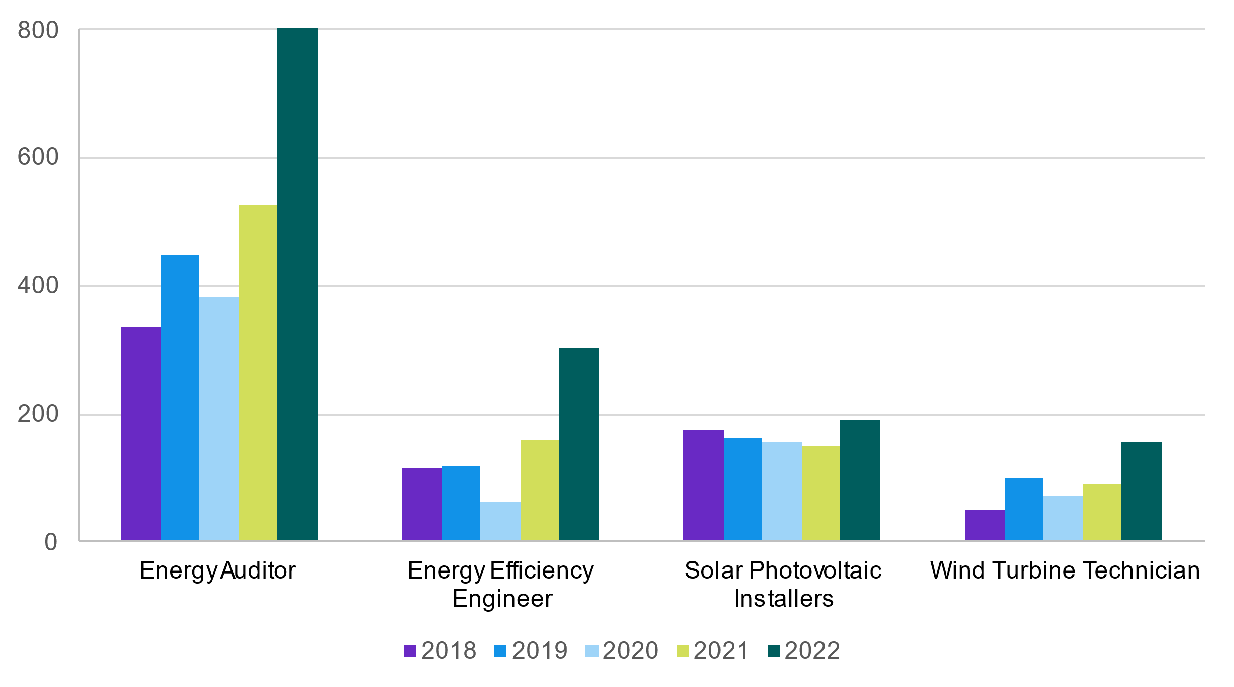
Source: JSA 2023, Lightcast
The data analytics function within JSA is currently researching a range of new and emerging occupations, with some occupations having relevance to the clean energy sector. Exploratory analysis has identified the following list of occupations, including:
- EV Mechanic
- Climate Change Analyst
- Recycling Coordinator
- Energy Broker
- Solar Energy Systems Engineer
- Weatherisation Installers and Technicians.
During the course of this study, stakeholders have also raised a range of other potential emerging occupations, including:
- Carbon capture and storage specialists
- Hydrogen fuel cell technicians
- Battery design specialists (grid and residential)
- Battery recycling specialists
- Blade engineers.

Figure 2.5. Job posting counts for potential emerging occupations
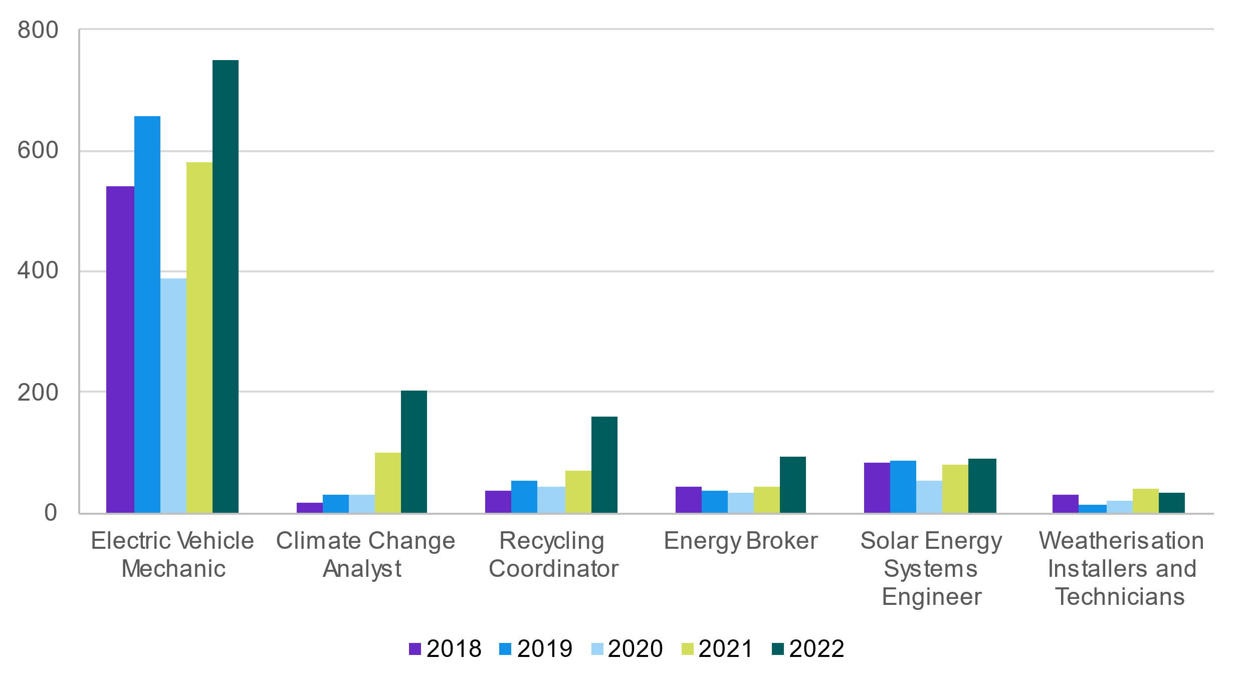
Source: JSA 2023, Lightcast job advertisement data.

2d. Data limitations
While this study addresses a number of information gaps, longer-term solutions will be needed to truly improve the data landscape for this critical sector.
Earlier this year, the Australian Government launched the first AEER survey to provide a sample data of the energy workforce. Unfortunately, due to a low response rate and non-random sample, the survey produced limited quantitative results.
JSA will work with DCCEEW to develop a business case to build on the capability of the AEER and broaden its data collection in future years. A well-developed AEER would support many areas of government, industry and the education and training sector to effectively manage the clean energy transformation.
Recommendation 2.2

The Australian Government could commission a comprehensive and regular AEER.
This will be critical to address data gaps limiting Australia’s ability to identify and project future needs, especially in emerging sectors and energy-focused roles in industries outside core sectors. The AEER should build on the whole-of-labour-market mapping initiated by this study to provide a consistent approach for identifying and measuring the workforce.
In 2020, the ABS published a data set called Employment in Renewable Energy Activities. This series provided annual employment estimates for renewable energy activities in Australia, from 2009-10 to 2018-19. Unlike other data, this series can be disaggregated by type of renewable activity (e.g. solar, wind), giving us a rare insight into the current day employment of these sectors. This type of product can provide regular, consistent time series of employment and allow government to track the progress of the clean energy transition. The Australian Government should consider supporting the ABS to renew this product to complement the more extensive AEER.

Recommendation 2.3
The ABS could be supported to re-run the Employment in Renewable Energy Activities series on an annual basis. A consistent, regular release of data is critical for governments to monitor the workforce’s progress.


Chapter 3:
The current
workforce
Explores the size and composition of the clean energy workforce. Includes demographic, geographic and employment characteristics.

Introduction
In the first part of this chapter, we look at the characteristics the workers in clean energy, using the segments presented in Chapter 2. Our analysis relies on Census data, and other data sources, as a baseline for consistent analysis of:
- demographic characteristics, including gender, age, highest level of education, Aboriginal and Torres Strait Islander status, country of birth, and disability status.
- spatial characteristics, namely where workers live and work.
- employment characteristics, including working hours, income, work travel patterns, forms of employment and union membership.
This analysis is illustrative for some industry segments and occupations, as we can only analyse those employed in the whole industry groups related to the clean energy segments or whole critical occupation identified in Chapter 2, and not the specific clean energy workers within these.
In the second part, we examine the characteristics of firms in clean energy, again considered segment by segment. This includes consideration of the following, wherever relevant:
- firm size and age
- ownership structure (public vs private)
- activities and involvement in other economic sectors, with a particular focus on the transitioning sector and the clean energy supply chain.
- business models
- role of employer associations and peak bodies, engagement with trade unions, First Nations groups and communities.
The rationale for examining these characteristics is to better understand how workers are engaged and labour deployed in these firms – this will reveal (hopefully) potential mutual interests and levers for positive workforce development.

3a. Worker characteristics

Demographic characteristics

Gender
Women are underrepresented within the clean energy workforce, particularly in higher skill-level occupations, clean energy critical occupations, and senior positions. Overall, 65% of the clean energy workforce is male but this varies across the clean energy demand, enabling and supply segments (84%, 56%, 74% respectively). Looking at the distribution of women by clean energy sub-segments, Figure 3.1 shows that the lowest levels of female participation are in clean energy demand (energy performance, energy usage and energy transport) (predominantly in the Construction industry) and clean energy enabling (supply chain and vehicle and equipment production, trade and maintenance). There are slightly higher levels in clean energy supply (distribution and generation).
The three more white collar clean energy enabling sub-segments (education, training, research and technology, finance, legal and business, and regulatory) are the only clean energy segments with majority female workers. In comparison, other industry groups have more than 50% female participation. Occupationally, the gender segregation is even more apparent, especially amongst the Technicians and Trades occupations (Figure 3.2).
Figure 3.1. Female representation by Clean Energy Sub-segment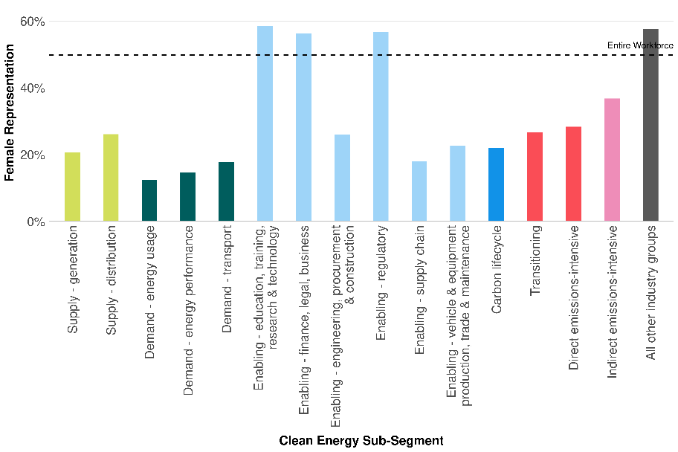
Source: ABS Census of Population and Housing, 2021

Figure 3.2. Female participation across the critical occupations in clean energy
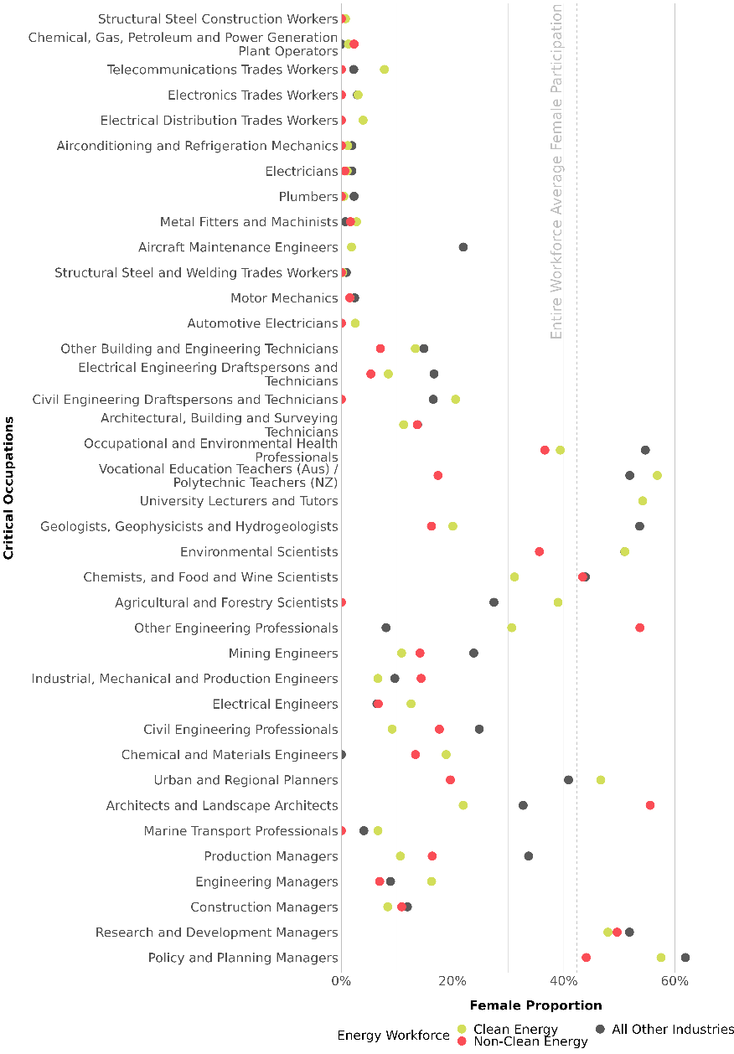
Source: ABS Census of Population and Housing, 2021

The CEC’s survey found the representation of women decreased as roles became senior leadership roles or board positions.
Across all three sectors of clean energy, transitioning and emission intensive, women are more likely to work in on-selling electricity and fuel retailing than in energy generation, gas supply and electricity distribution transmission. Where women are working in clean energy, they are in roles such as general clerks, office managers, accounting clerks, commercial cleaners and interior design whereas female representation in trade qualified roles and engineering roles is very low.
The barriers to women’s participation in the clean energy workforce including issues around the gender pay gap; workplace safety in particular high rates of sexual harassment and basic issues like suitable workplace amenities is discussed in Chapter 8. Increasing women’s participation is key to scaling up the workforce that we need for the net zero transition so opportunities to do this including the Smart Energy Council’s Gender Action Plan are also highlighted in Chapter 8.

Age
The average age of the clean energy workforce is 42, which is on par with the average age of the workforce in emissions-intensive and transitioning segments. It is slightly older than the wider Australian labour force which has an average age of 40. Across all sub-segments, the average age ranges from 37 to 44 (Figure 3.3). The clean energy demand workforce is younger than the other segments, especially amongst the energy usage and performance sub-segments. The emissions-intensive, demand transport and enabling regulatory workforces are slightly older with an average age ranging 43 to 44. Several of the technical occupations and professional roles within environmental science and engineering are also younger than the transitioning and emissions sectors, which have a higher proportion of workers approaching retirement age.
Figure 3.3. Average Age by Clean Energy Sub-segment
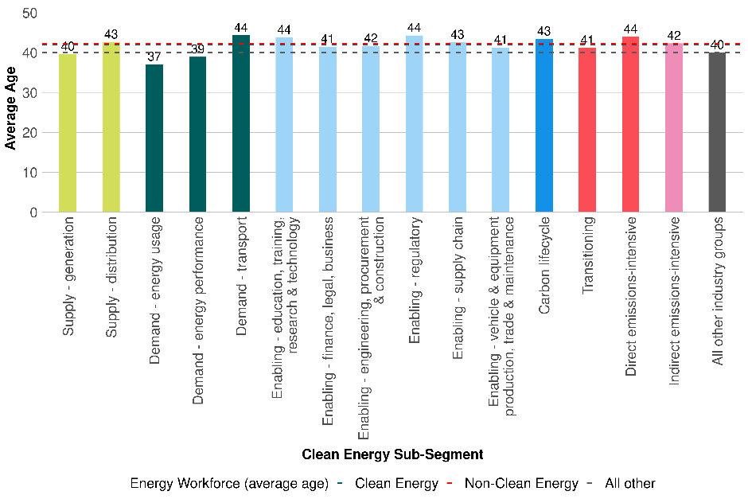
Source: ABS Census of Population and Housing 2021

Highest level of education
The level of qualifications differs significantly across the clean energy segments. In general, clean energy workforce segments contain a larger proportion of VET-qualified workers than the overall economy (Figure 3.4). There are exceptions: in the enabling sub-segments of education, training, research; finance, legal, business, as well as clean energy regulation where there are higher levels of degree-qualified workers. Of the clean energy segments, the transport and carbon lifecycle segments have the largest proportion of workers without a post-school qualification at Certificate level III or higher.
A notable finding is that the clean energy supply segment comprises a larger proportion of workers with higher education (undergraduate and postgraduate qualifications) than the transitioning segment which has workers in coal-fired power stations.
Figure 3.4. Highest Level of Education proportion by Clean Energy Sub-Segment
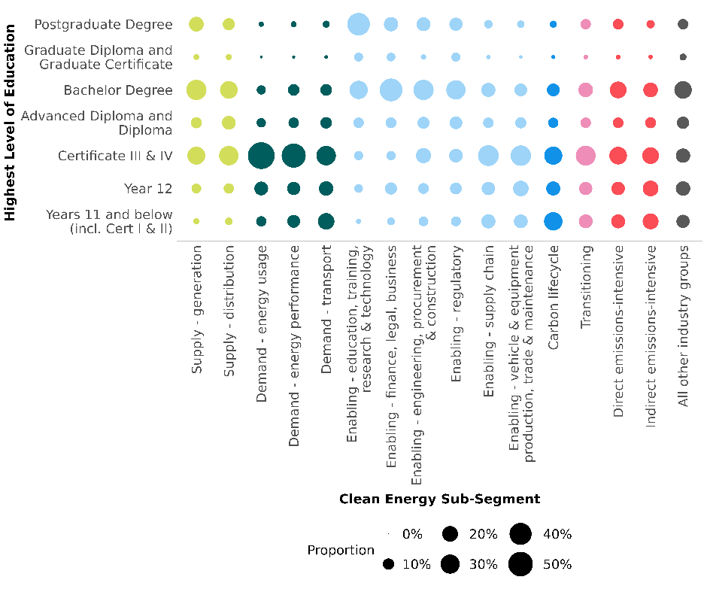Source: ABS Census of Population and Housing 2021

First Nations status
The proportion of First Nations people working in the clean energy workforce is typically lower than the proportion working in transitioning industries. It is also lower than the labour force average. As Figure 3.5 shows, the highest proportion of First Nations people in the clean energy sector is in the carbon lifecycle sub-segment, which is discussed further in Chapter 8.
Figure 3.5. First Nations representation by Clean Energy Sub-Segment
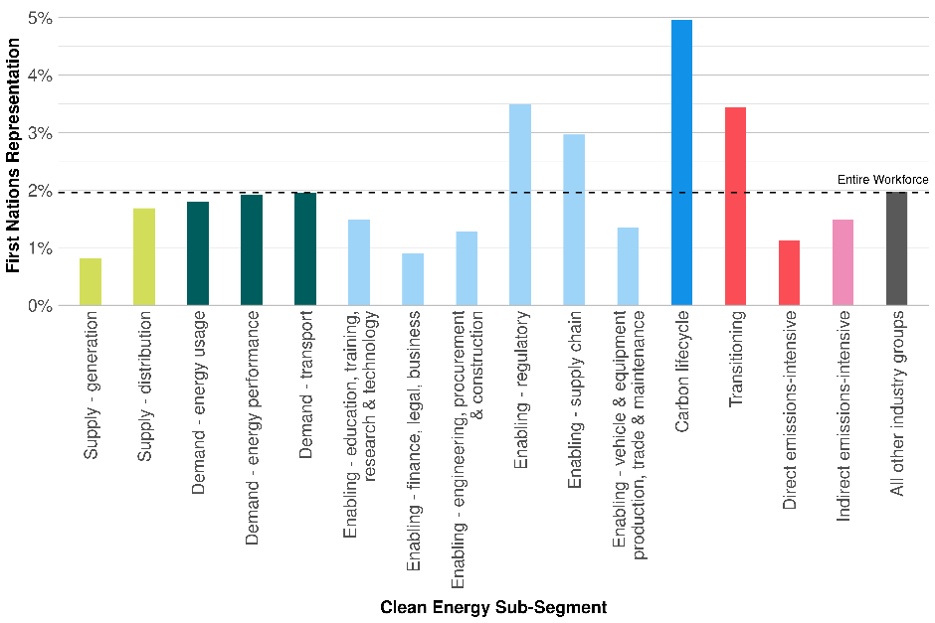
Source: ABS Census of Population and Housing 2021

Country of birth
Around 26% of the Clean Energy workforce are overseas born workers, with the enabling segments having the highest proportion of overseas born workers (over 30%). Clean energy supply segments are broadly similar to the transitioning segment, and are below the labour market average (Figure 3.6).
Figure 3.6. Workers born overseas by Clean Energy Sub-Segment 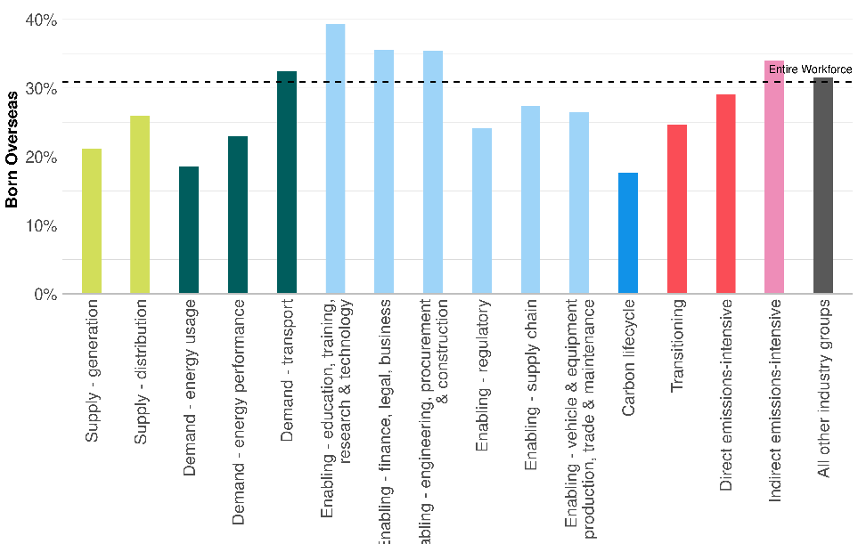
Source: ABS Census of Population and Housing 2021

Of the 38 critical clean energy occupations, engineering professions have the highest proportion of overseas born workers (Figure 3.7). In 2021, over half of Australia’s Electrical Engineers were born overseas. Conversely, critical trade occupations, including Electricians, had a very low share of overseas born workers (less than 20%) despite being in high demand. This highlights the fact that Australia’s migration system has had an uneven impact on the labour market, skewing towards higher skill level professions. A similar observation can be made of Australia’s international education market, where higher education receives a larger share of enrolments than VET.
Figure 3.7. Workers born overseas by critical occupation
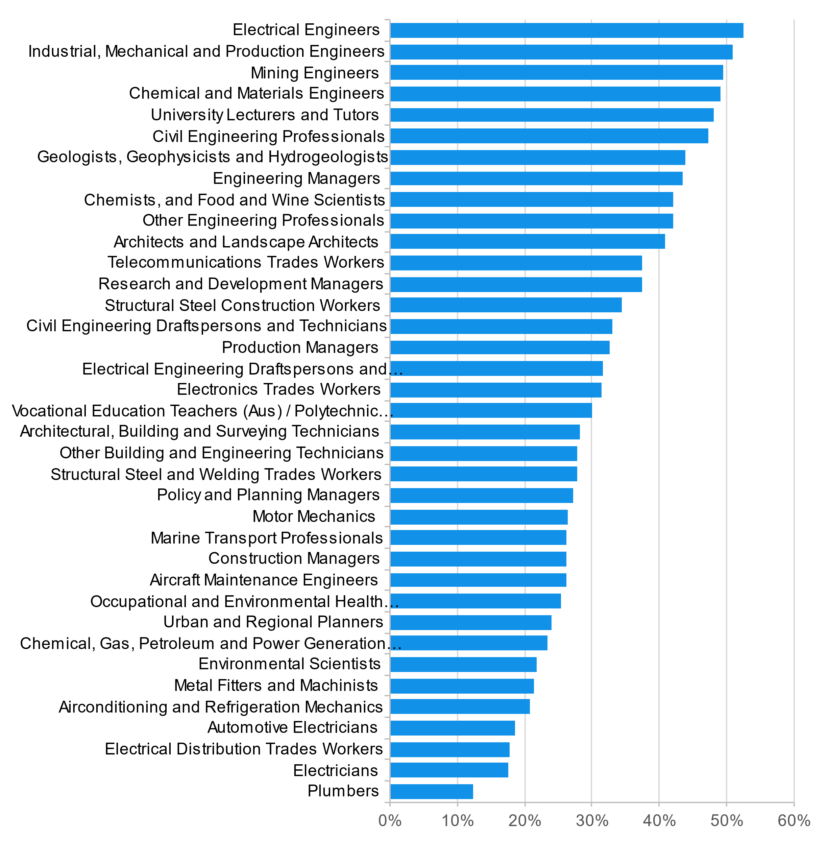
Source: ABS Census of Population and Housing 2021

Within clean energy, overseas born workers come from around the world, with Southern Asia being the largest source region (Figure 3.8). Countries of birth were broadly consistent across most sub-segments and with the broader labour market.
Figure 3.8. Country of birth for workers born outside of Australia
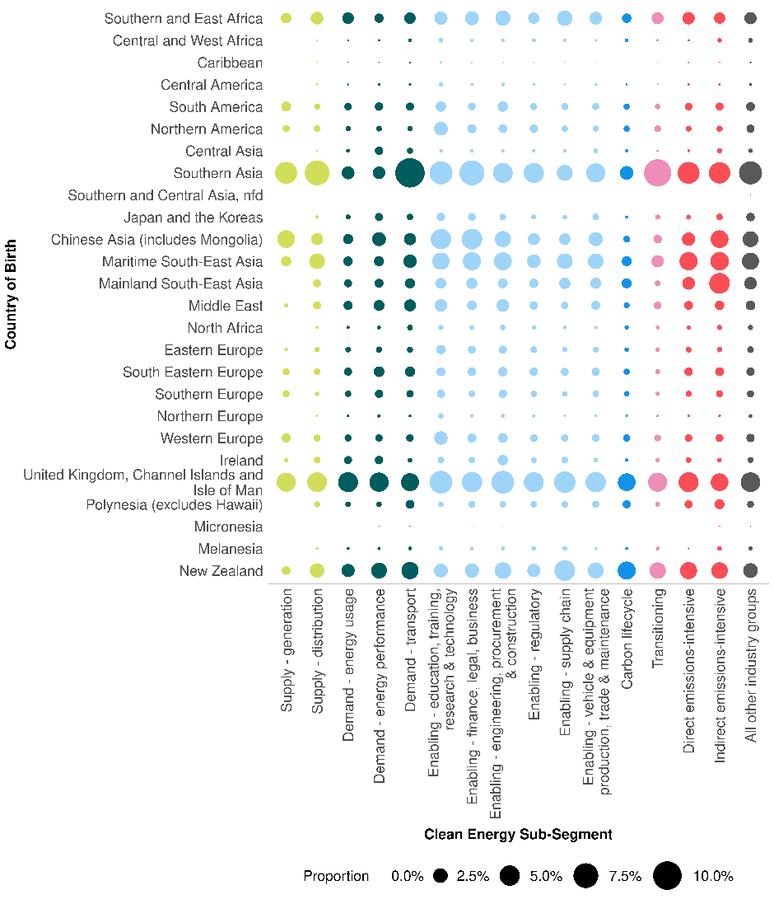
Source: ABS Census of Population and Housing 2021

Disability and health status
Based on the limited data available, rates of long-term health conditions (a proxy indicator for disability status in the Census) are somewhat lower than the general workforce (Figure 3.9). Where higher rates are observed, these are in the enabling sub-sectors (education, training, regulatory, and research and technology), which may be reflective of these broader industries than clean energy specifically.
Figure 3.9. Long-term health conditions by Clean Energy sub-segment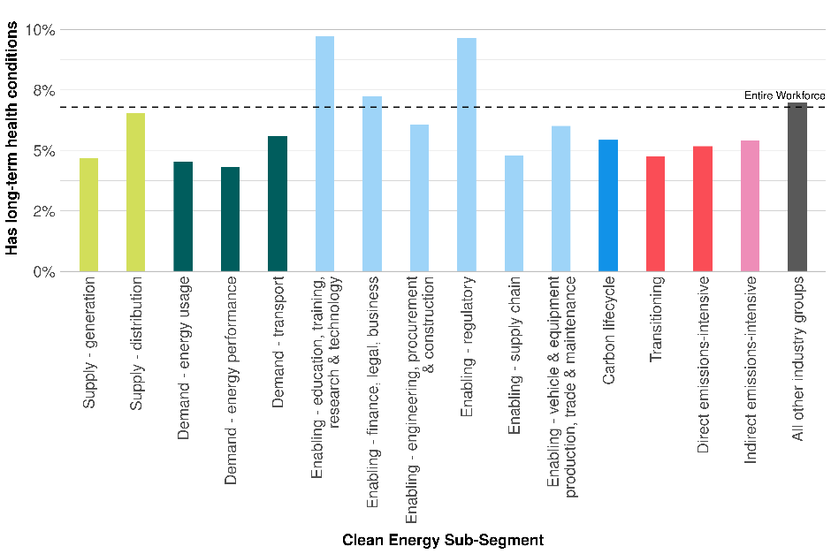
Source: ABS Census of Population and Housing, 2021

Regional characteristics
The clean energy generation and distribution workforce is located across Australia, with large proportions in metropolitan areas, potentially reflecting white collar professions in this workforce (Figure 3.10). Regional areas of Tasmania and in Snowy Mountains also have large concentrations of clean energy generation workers, reflecting hydroelectricity employment. The transitioning segment has a larger workforce presence in regional areas, particularly in Queensland and NSW.
Figure 3.10. Place of Work (SA3) by Clean Energy sub-segments
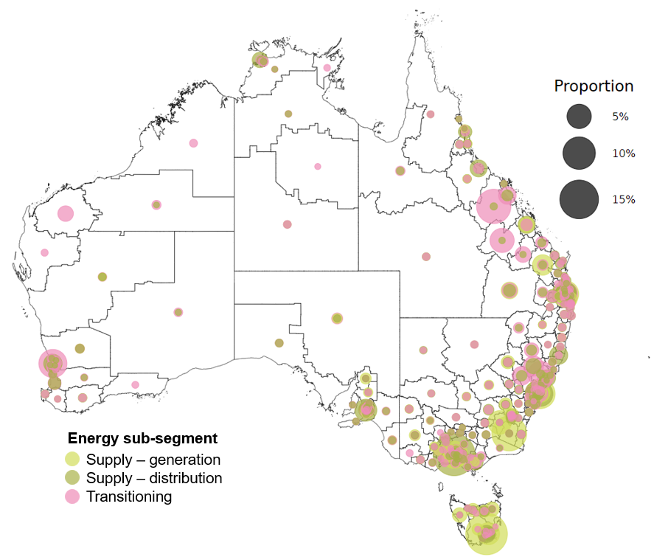
Source: ABS Census of Population and Housing 2021

There are a number of regions across Australia with high proportions of transitioning employment in their labour markets (Figure 3.11). We’ve identified 12 regions where workers in transitioning industries make up more than 2% of local employment. As these regions are more exposed to transitioning industries, their labour markets may experience the greatest impact of decarbonisation. For example, in Bowen Basin-North (Queensland), around 21% of workers are in a transitioning industry. In stark contrast, there are only five regions where clean energy supply workers (generation and distribution) make up over 1% of their local labour market. This highlights the differences between the two segments, with clean energy work typically being less concentrated and labour intensive than transitioning work.
Figure 3.11. Regions (SA3) where transitioning workers are a high proportion (>2%) of local employment
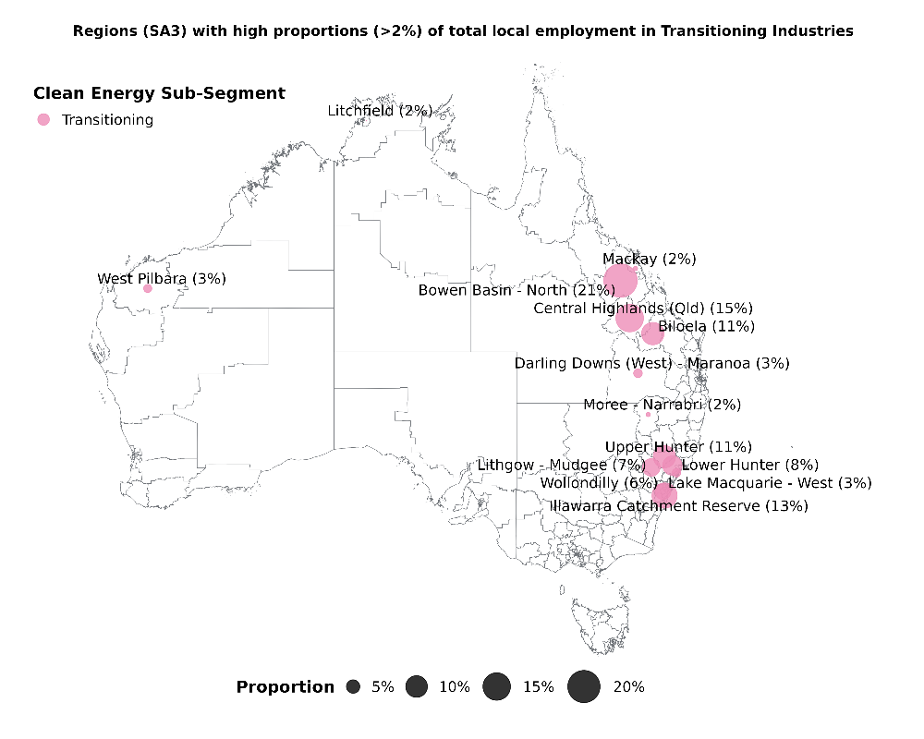
Source: ABS Census of Population and Housing 2021

Employment characteristics

Working hours
Workers in clean energy segments are more likely to work full-time than the rest of the workforce. The clean energy generation and distribution sub-segments have very low proportions of part-time workers (11% and 9% respectively), less than half the rate of the transitioning segment. All energy sub-segments have lower rates of part-time employment than other industry groups (Figure 3.12).
Figure 3.12. Working hours (full-time/part-time status) by Clean Energy Sub-Segment
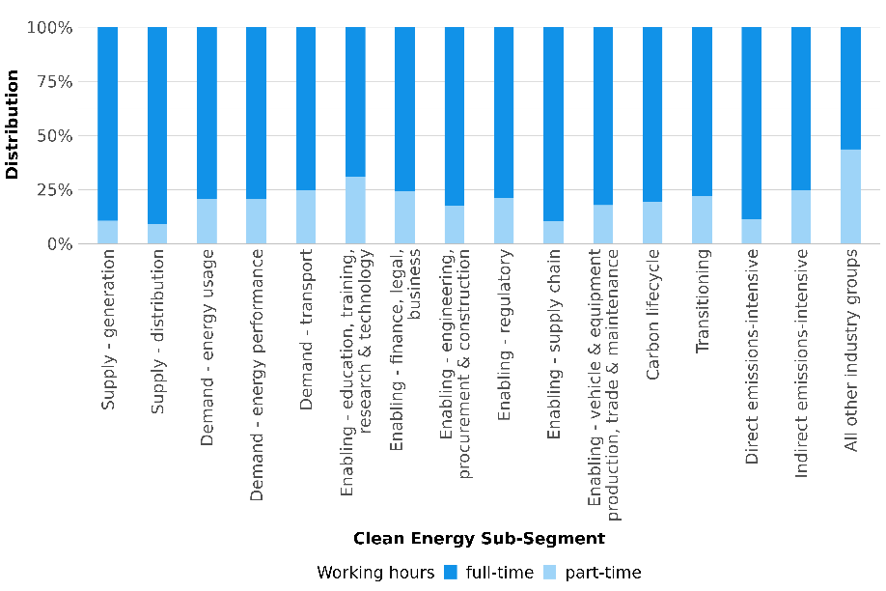
Source: ABS Census of Population and Housing 2021
Given the low levels of female participation in most of the clean energy workforce segments, and the gendered distribution of part-time work in the Australian workforce in general, it is not surprising to see that women are much more common in part-time roles in the clean energy segments, if not always the majority of part-time workers (Figure 3.13).

Figure 3.13. Gender distribution for part-time working hours by sub-segment
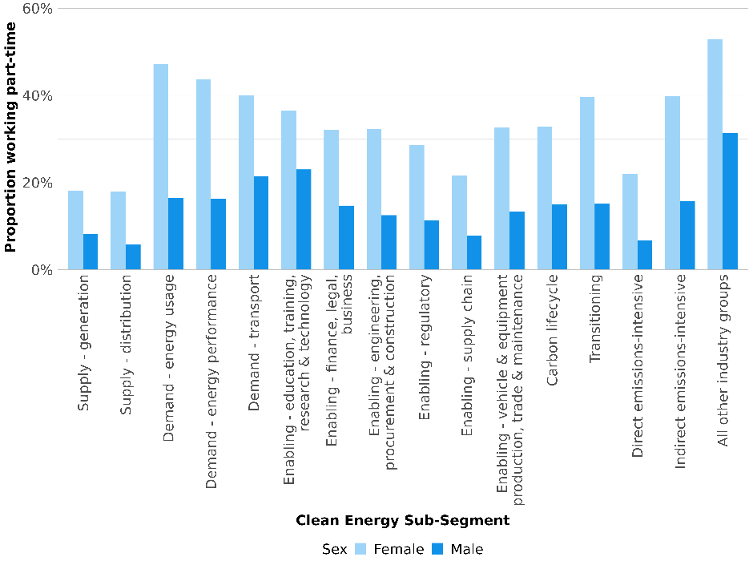
Source: ABS Census of Population and Housing 2021

Remuneration
In general, remuneration in clean energy (including renewable energy generation, hydrogen production, critical minerals extraction) lags behind the remuneration in non-clean energy. This can be seen when comparing average incomes for the 38 critical occupations (Figure 3.14). In many, but not all cases, both groups of energy workers earn more on average than other workers. Some of the reasons behind this disparity are explored in Chapter 8.
Remuneration for non-clean energy activities may be skewed by the mining sector, which has typically provided some of the highest renumeration in the labour market. Power Operators, which are employed in fossil-fuel generation and hydroelectricity, earn more in clean energy than non-clean energy. This might suggest that clean energy wages are more competitive when comparing roles in more similar settings.

Figure 3.14. Average annual personal income for critical occupations by segment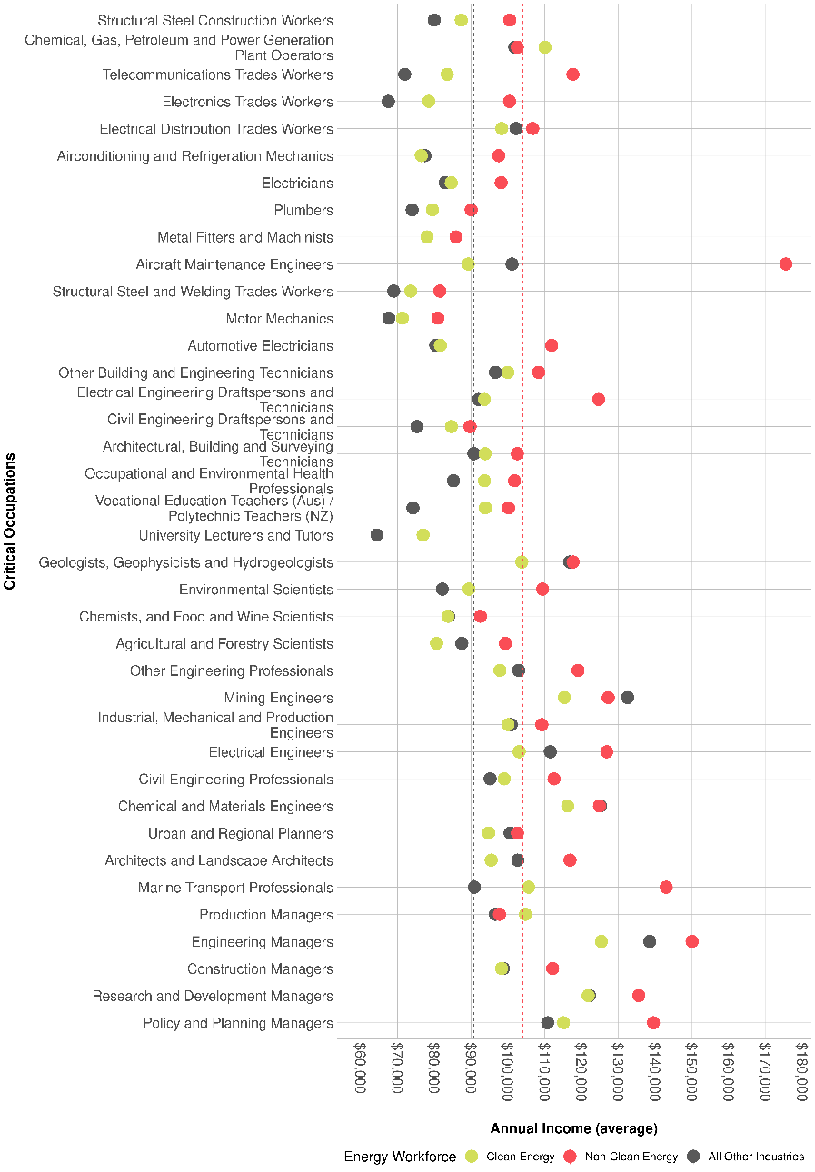
Source: ABS Census of Population and Housing 2021

As in the broader economy, incomes in clean energy vary between males and females (Figure 3.15). In 2021, females earned substantially less than their male counterparts across critical occupations like Electricians and Electrical Engineers, with the largest gap being for Electrical Distribution Trades Workers. Because these are annual incomes, some of this gap may be driven by differences in full-time and part-time arrangements, which are more common among females in this workforce. A similar income gap is observed for First Nations people (Figure 3.16).
Figure 3.15. Female Average Income gap for selected Critical Occupations in the Clean Energy Workforce
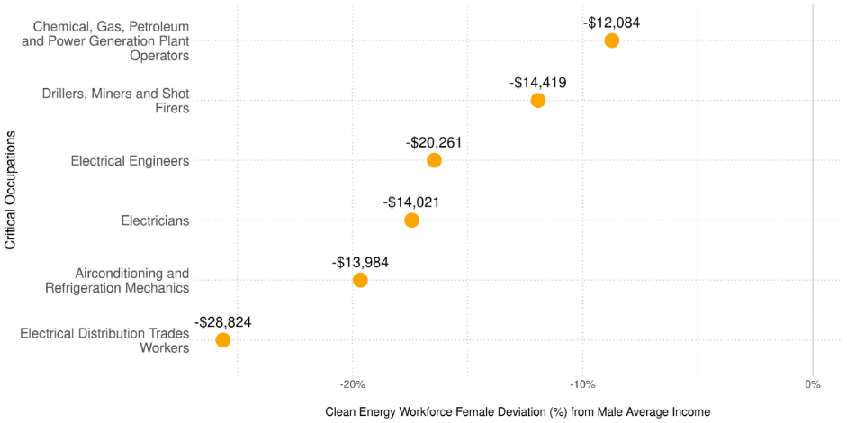Source: ABS Census of Population and Housing 2021
Figure 3.16. First Nations Average Income gap for selected Critical Occupations in the Clean Energy Workforce
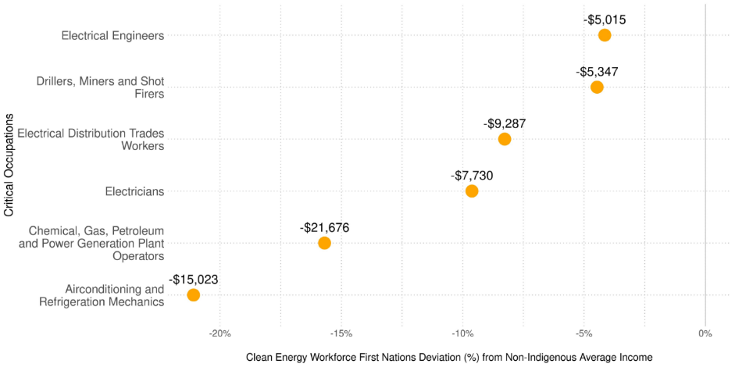Source: ABS Census of Population and Housing 2021

Box 3. Wages of electrical apprentices

Most Electricians, including apprentices, have their wages set through individual agreements with their employer (Figure 3.17). However, around a third of electrical apprentices are paid according to their modern award, which sets the minimum wages and conditions for the trade.
Figure 3.17. Method of pay setting, Electricians 2021 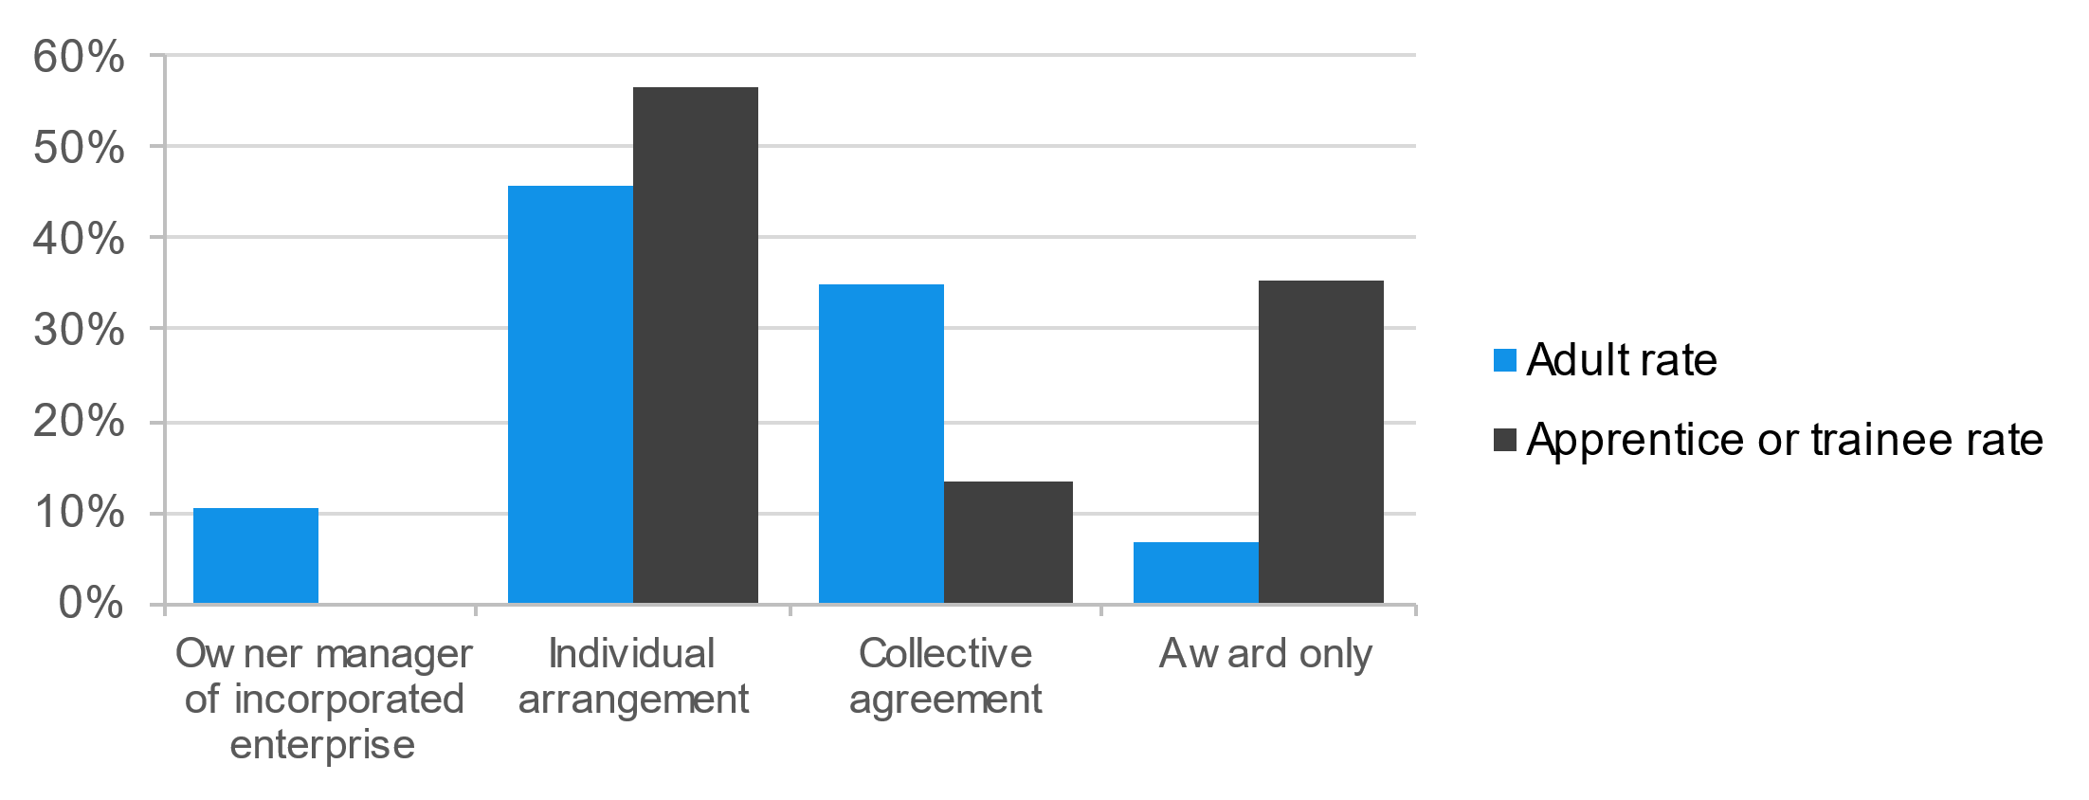
Source: ABS Employee Earnings and Hours 2021
Minimum pay rates in the Electrical Award varies for apprentices who have not completed year 12, those who have, and adult apprentices aged 21 years and over (Figure 3.18). Pay rates also increase in each year of the apprenticeship, except for adult apprentices who have the same minimum in 2nd, 3rd and 4th years.
Figure 3.18. Minimum weekly wage rates for electrical apprentices
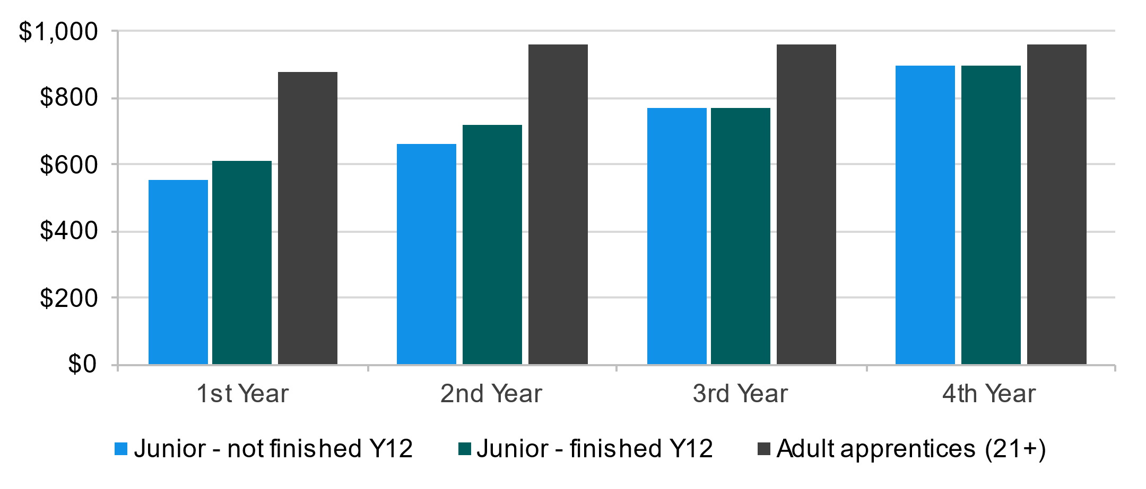
Source: Fair Work Ombudsman
Electrical apprentices earn around 48% of what their fully qualified counterparts do per year, and around 72% of the average Australian worker (Figure 3.19). These proportions have seen little change in the past decade, which suggests that the comparative earnings of electrical apprentices have not changed.
Figure 3.19. Electrical apprentices’ annual salary comparison.
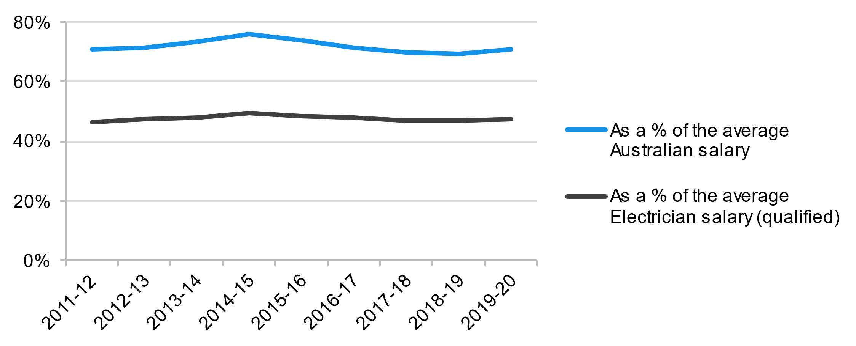
Source: Australian Taxation Office, Taxation Statistics: individuals

Work travel patterns
Workers in transitioning industries are more likely to travel longer distances than those in clean energy industries or the broader labour market (Figure 3.20). This reflects the higher occurrence of fly-in-fly-out work in transitioning industries and the remote locations of many worksites.
Figure 3.20. Distance to Work by Clean Energy Sub-Segment
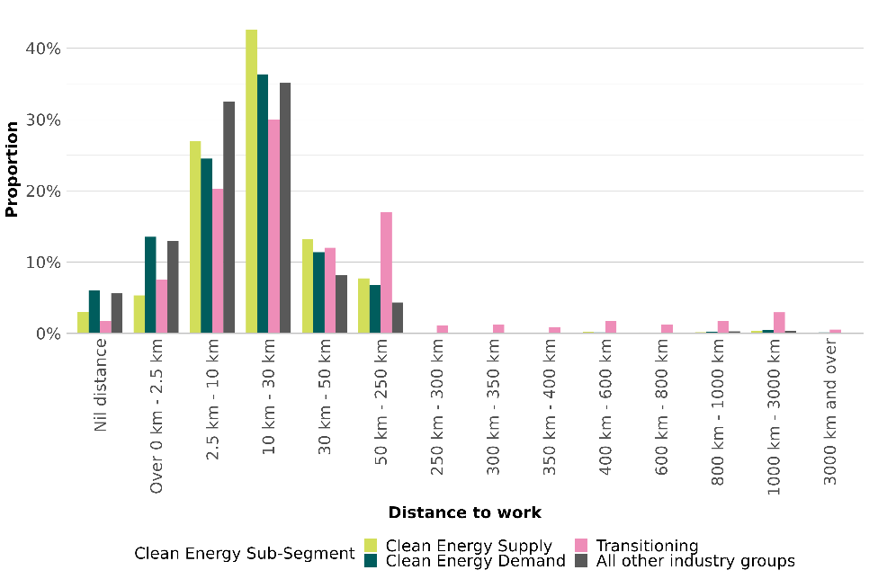
Source: ABS Census of Population and Housing 2021

Forms of employment
Data on forms of employment are not as widely available as the characteristics already discussed, so it is not possible to be as precise. The best available source is through the ABS Characteristics of Employment survey. This restricts us to ANZSIC 2-digit (sub-division) and ANZSCO 3-digit (minor group) results, so we will focus on a subset of industries and occupations as most relevant to clean energy generation and the procurement, construction and engineering enabling segment. The Characteristics of Employment survey lets us examine the proportion of workers who are permanent or casual (defined by the ABS for this survey as without paid leave entitlements), and those who are not defined as employees – this includes owner managers (whether they have employees or not) and contributing family workers.

In general, we observe higher levels of permanent employment and lower levels of casual employment in the selected clean energy industries and occupations than for the overall Australian workforce. The electricity supply industry (which covers generation and distribution) has a very a low level of self-employment (4% and 1% respectively). This pattern also holds for the selected occupations, except electricians, where there is a higher level of self-employment. Rates of casual employment are also very low among selected industries and occupations (Table 3.1).
Table 3.1. Forms of employment for selected clean energy industries and occupations
Selected Clean Energy Industries | Permanent (%) | Casual (%) | Not an employee (%)
Electricity supply | 91.6 | ** | **
Heavy and Civil Engineering Construction | 72.2 | 11.7 | 16.1
Selected Clean Energy Occupations
Electricians | 75.6 | 2.9* | 21.5
Mechanical Engineering Trades Workers | 83.1 | 8.5 | 8.4
Engineering Professionals | 87.8 | 5.1* | 7.1
All Australian workforce | 64.4 | 19.6 | 16.0
Source: Characteristics of employment, August 2022
Note: industry and occupation based on main job.
# includes owner managers of incorporated enterprises, owner managers of unincorporated enterprises, contributing family workers. The ABS classes some independent contractors as employees. For further detail see Employment arrangements | ABS (abs.gov.au)
* Estimate has a relative standard error of 25% to 50% and should be used with caution
** Estimate has a relative standard error greater than 50% and is considered too unreliable for general use

Union membership and method of pay setting
As for forms of employment, JSA is reliant on survey data to examine levels of union membership and methods of pay setting. For consistency, we have used the same industry and occupational categories as above, again relying on data from the ABS Characteristics of Employment survey.
The electricity supply industry has a higher level of trade union membership than the overall Australian workforce, as well as a much higher levels of collective agreement coverage (Table 3.2). The level of trade union membership in heavy and civil engineering construction is also higher than the Australian average, but the industry sector has a lower level of collective bargaining coverage. When examined by occupation, electricians have a substantially higher level of union membership than the Australian workforce overall, as do mechanical engineering trades workers. Levels of collective bargaining coverage for both trade occupation groups reflect the Australian average, with the slightly lower figure for electricians influenced by the higher level of self-employment (see above). Engineering professionals have a lower level of union membership and collective bargaining coverage but may be more likely to be members of a professional association.
There are several trade unions representing workers in the clean energy workforce, with coverage variously defined by occupation and industry. The Electrical Trades Union of Australia (ETU) represents more than 60,000 Electricians, apprentices and electrical workers around Australia. The Australian Manufacturing Workers Union (AMWU) would typically represent mechanical engineering trades workers in most workplaces, including in Electricity Supply and Heavy and Civil Engineering Construction. Depending upon their role, Electrical Engineers may be eligible for membership with the Association of Professional Engineers Australia (APEA), Engineers Australia, or the ETU, which represents their members in the clean energy generation electrician’s workforce.
Regarding other occupational categories in the clean energy workforce, electrical distribution trade workers can work across several industries including electricity, gas and trades services, construction, public administration and safety. They may be eligible to join unions including the Australian Workers Union (AWU), the Construction Forestry Maritime Mining Energy Union (CFMEU) and the ETU. There is no one union for Chemical, Gas, Petroleum and Power Generation Plant Operators. Workers from this industry may be eligible to join unions including the AWU, the Australian Services Union (ASU)​ or the United Workers Union (UWU).
Table 3.2. Proportion of workers belonging to a trade union and covered by a collective agreement, selected clean energy industries and occupations
Selected Clean Energy Industries | Trade union member (%) | Collective agreement coverage (%)
Electricity supply | 27.5 | 77.0
Heavy and Civil Engineering Construction | 15.0 | 28.4
Selected Clean Energy Occupations
Electricians | 24.5 | 29.9
Mechanical Engineering Trades Workers | 21.1 | 36.9
Engineering Professionals | 4.0 | 20.8
All Australian workforce | 11.7 | 35.1
Source: Characteristics of employment, August 2022

3b. Firm characteristics

Clean energy supply

Renewable electricity generation
Firms within the renewable energy market build and maintain the renewable infrastructure, provide utility-scale energy generation and distribution, and install small-scale renewable energy (for example household solar). Renewable electricity generation is best understood by energy source and scale (utility solar, rooftop solar, onshore wind, offshore wind, hydroelectricity).

Solar
The CEC’s Empowering Everyone survey found nearly 50% of utility-scale renewable energy businesses had 200 employees or more compared to 31% of smaller scale renewable organisations. Analysis of the membership available on the CEC shows several small-scale solar rooftop installers. Small-scale renewable energy generation now accounts for a quarter of renewable energy generation with storage expected to increase as the costs of batteries reduce. The small-scale renewable energy market provides significant employment to businesses, including small business and sole traders, providing roof top solar installation, solar panel cleaning, battery systems installation and energy management advisory services. The CEC has accredited nearly 9,000 installers and designers. Many of these businesses provide additional electrical services, and as noted in Chapter 2 are counted in the Electrical Services ANZSIC group.
The commercial solar market is mature and relatively well diversified. At present, the largest utility-scale solar electricity generators are Neoen Australia, FRV Australia, Wirsol Energy, AGL and Enel Green Power (Figure 3.21).

Figure 3.21. Major firms in solar generation
Neoen Australia  Estimated market share: 12%  Primary generation sites:  - Colembally (NSW, 150 MW)  - Western Downs (Qld, 460 MW_{p})  - Numurkah (Vic, 128 MW)  - Griffith (NSW, 36 MW)  History: established in Australia 2012  Ownership structure:  Neoen is the leading French independent producer of renewable energy.  Other activities:  Neoen also has wind projects in Australia and built or is contracted to build a number of big batteries, Blyth (SA), Hornsdale (SA), Geelong (Vic), ACT and Western Downs (Qld)  Neoen operates in 17 countries. | FRV Australia  Estimated market share: 12%  Primary generation sites:  - Royalla (ACT, 20 MW_{ac})  - Clare (Qld, 100 MW_{ac})  - Lilyvale (Qld, 100 MW_{ac})  - Moree (NSW, 56 MW_{ac})  - Goonumbla (NSW, 68.7 MW_{ac})  - Sebastapol (NSW, 90 MW_{ac})  - Winton (Vic, 85 MW_{ac})  Ownership structure:  Owned by Dubai and Saudi Arabia-based Abdul Latif Jameel Energy.  Other activities:  Fotowatio Renewable Ventures (FRV) specialises in renewable activities and is present in Australia, Asis, the Middle East, Africa, Europe and Latin America.
Wirsol Australia  Estimated market share: 6%  Primary generation sites:  - Whitsunday (Qld, 69 MW_{p})  - Hamilton (Qld, 69 MW_{p})  - Clermont (Qld, 89 MW)  - Gannawarra (Vic, 60 MW_{p})  - Wemen (Vic, 110 MW_{p})  - Glenrowan (Vic, 149 MW_{p})  History: established in 2017.  Ownership structure: Owned by Malaysian clean energy company Gentari  Other activities: | AGL  Estimated market share: 5.3%  Primary generation sites:  - Broken Hill (NSW, 53 MW)  - Nyngan (NSW, 102 MW)  History: founded as Australian Gas Light Company in 1837.  Ownership structure: Private company listed on ASX.  Other activities:  AGL is Australia’s largest electricity generator. AGL has activities across natural gas and electricity generation from a range of sources as well as substantial electricity and gas retailing.
Enel Green Power
Estimated market share: 5.1%
Primary generation sites:
- Cohuna (Vic, 34 MW)
- Bungala 1 & 2 (SA, 220 MW_{p})
- Girgarre (Vic, 88 MW)

Ownership structure: Joint venture between Italian energy concern Enel, formerly publicly owned, and Japanese company INPEX.
Other activities:
Enel is developing wind projects (Flat Rocks, WA, 75.6 WM).
Sources: see endnotes.

Wind
Electricity generation from wind energy in Australia is currently quite dispersed, despite lacking the small-scale generation options that rooftop solar provides. The three largest generators only account for approximately a third of current output (Figure 3.22). However, further concentration is likely into the future, as planned offshore wind projects have significantly greater generating capacity. As of now, the onshore wind market in Australia is more established than the offshore market which is only starting to emerge.
Wind electricity generators are more concentrated in Victoria, New South Wales and South Australia. Further wind power investment in Victoria is planned with Westwind Energy constructing a $3 billion Golden Plains Windfarm, located near Geelong. Once online, Iberdrola’s Mount James windfarm in North Queensland will be Australia’s biggest onshore windfarm. While they have fewer wind assets in absolute terms, on a population basis, Tasmania and Western Australia have more establishments per capita than New South Wales.
Figure 3.22. Major firms in wind generation
AGL  Estimated market share: 15%  Primary generation sites:  - Macarthur (Vic, 420 MW)  - Wattle Point (Qld, 69 MW_{p})  - Coopers Gap (Qld, 89 MW)  - Hallet (SA, 351 MW)  - Oaklands Hill (Vic)  - Coopers Gap (Qld, 149 MW_{p})  - Silverton (NSW)  History: founded as Australian Gas Light Company in 1837.  Ownership structure: Private company listed on ASX.  Other activities:  AGL is Australia’s largest electricity generator. AGL has activities across natural gas and electricity generation from a range of sources as well as substantial electricity and gas retailing. | Iberdola Australia Trust  Estimated market share: 12%  Primary generation sites:  - Bodangora (NSW, 113.2 MW)  - Capital (NSW, 140.7 MW)  - Lake Bonney 2 (Qld, 159 MW)  - Port Augusta (SA, 217 MW)  - Walkway (WA 89.1 MW)  Ownership structure: Part of the international Iberdrola group, a Spanish group with history extending back to 1901. It has projects throughout Europe, the US and Australia.  Other activities:  Port August Renewable Energy Park also includes 110 MW of solar.
Pacific Blue  Estimated market share: 7%  Primary generation sites:  - Codrington (Vic, 18.2 MW)  - Challicum Hills (Vic, 52.5 MW)  - Clements Gap (SA, 57 MW)  - Portland (Vic 179 MW)  - Taralga (NSW, 106.8 GW)  History: founded 1992  Ownership structure: Owned by State Power Investment Corporation (China).  Other activities:  Pacific Blue also operates hydroelectric projects at Eildon Pondage, Lake Glenmaggie, Ord River, The Drop and William Hovell. | Squadron energy  Primary generation sites:  - Bango (NSW, 244 MW)  - Crudine Ridge (NSW, 134 MW)  - Murra Warra I and II (Vic, 435 MW)  - Sapphire Wind (NSW, 270)  Ownership structure: Some projects previously CWP Renewables. Owned by Fortescue Future Industries (FFI).  Other activities:  Squardon has approval to develop the Sapphire Solar Farm (NSW, 180 MW_{ac}) as well as a number of other wind projects. FFI is investing in a number of hydrogen projects.
Sources: see endnotes

Hydroelectricity
This section includes hydroelectric power and pumped hydro storage, as the infrastructure and ownership structures overlap, even though they play very different roles in the system.
Most of Tasmania’s electricity generation comes from hydroelectricity. The hydroelectricity generation industry is highly concentrated because of high set-up and ongoing maintenance costs, and the requirements for an abundance of water. New South Wales is expanding the Snowy Mountains Hydroelectric scheme which will increase the renewable power as coal-fired plants close. New South Wales, Queensland and Western Australia have smaller scale hydroelectric facilities (Figure 3.23).
Figure 3.23. Major firms in hydroelectric generation and pumped hydro storage
Hydro Tasmania  Estimated market share: 48%  Primary generation sites:  - Gordon (Tas, 432 MW)  - Poatina (Tas, 300 MW_{p})  - Reece (Tas, 231.2 MW)  - John Butters (Tas, 144 MW)  - Tungatinah (Tas, 125 MW)  & other smaller power stations  Ownership structure: Publicly owned by Government of Tasmania.  Other activities:  Hydro Tasmania operates a gas turbine power station in the Tamar Valley and wind farms at Huxley Hill, Musselroe and Woolnorth. | Snowy Hydro  Estimated market share: 12%  Primary generation sites:  - Tumut 1, 2 and 3 (NSW, 2116 MW)  - Murray 1 and 2 (NSW, 1500 MW_{p})  - Blowering (NSW, 80 MW)  Ownership structure: owned by Government of Australia.  Other activities: The Snowy Pumped Hydro project is underway. Snowy Hydro also operates gas fired and diesel power stations in Victoria, NSW and South Australia and owns two electricity retailing business.
AGL  Estimated market share: 5.6%  Primary generation sites:  - Kiewa Scheme (Vic, 395 MW)  - Dartmouth (Vic, 185 MW_{p})  - Eildon (Vic, 120 MW)  History: founded as Australian Gas Light Company in 1837.  Ownership structure: Private company listed on ASX.  Other activities:  AGL is Australia’s largest electricity generator. AGL has activities across natural gas and electricity generation from a range of sources as well as substantial electricity and gas retailing. | Queensland Hydro  Estimated market share: N/A  Primary storage sites (planned):  - Pioneer-Burdekin (Qld)  - Borumba (Qld)  Ownership structure: Publicly owned by Government of Queensland.  Other activities: N/A

Electricity transmission and distribution
Historically, electricity transmission and distribution infrastructure across Australia was publicly owned and this remains the case in a number of states and territories. Figures 3.24and 3.25 summarise the current transmission and distribution firms respectively.
Figure 3.24. Major firms in electricity transmission
 | States & Territories | Ownership structure
Transgrid | NSW & ACT | UTA Power Networks Trust
Powerlink Queensland | Qld | Queensland Government
ElectraNet | SA | Aus Utilities, State Grid Corp of China
AusNet Services | Victoria | Brookfield Corporation
Western Power and Horizon Power | WA | Government of Western Australia
Power and Water Corp | NT | Northern Territory Government
TasNetworks | Tas | Tasmanian Government

Figure 3.25. Major firms in electricity distribution
 | Region | Ownership structure
AusNet Services | Victoria | Brookfield Corporation
Essential Energy | NSW | NSW Government
Endeavour Energy | NSW | Consort led by Macquarie (50.4%), NSW Gov
Energex | SE Qld | Queensland Government
Ergon Energy | Regional Qld | Queensland Government
Powercor Australia | Central & Western Vic | Spark Infrastructure, Cheung Kong Infrastructure Holdings, Victoria Power Networks (Finance) Pty Ltd
United Energy | SE Melb & Mornington Peninsula | Consortium led by CK Infrastructure
CitiPower | Inner Melbourne | Spark Infrastructure, Cheung Kong Infrastructure Holdings, Victoria Power Networks (Finance) Pty Ltd
SA Power Networks | SA | Cheung Kong Infrastructure Holdings, Spark Infrastructure
Western Power and Horizon Power | Regional and remote WA | Government of WA
Evoenergy | ACT | ActewAGL Distribution
Power and Water Corp | NT | Northern Territory Government
TasNetworks | Tas | Tasmanian Government
Jemena | NSW, Vic, Qld | State Grid Corp of China, Singapore Power

Clean energy demand

Energy usage – electrification
Electrification will be driven by electrical services firms with a wide distribution across Australia throughout metropolitan and regional areas. There is a high concentration of small businesses, with no particularly dominant firms.

Energy usage – hydrogen
The Australian Hydrogen sector remains in its developmental phase, with a number of demonstration and pilot projects underway. Often these involve collaborations between commercial entities and universities, the CSIRO or other research organisations.
- Australian Gas Networks (AGN) is developing the Hydrogen Park South Australia (HyP SA). This project is targeting the development of renewable blended gas for domestic consumption. AGN is part of the Australian Gas Infrastructure Group.
- Hydrogen Engineering Australia is partnering with a number of other firms, including AGL and Japanese energy users, to pilot the production of hydrogen from coal gas in the Latrobe Valley, transport it to Hastings, and then liquify it for transport to Japan.
- Engie, Mitsui and Yara Fertilisers are seeking to produce green ammonia from a 10MW electrolyser using electricity from onsite solar production in Karratha (Yuri renewable hydrogen to ammonia project).
The NSW Government has invested in developing a hydrogen hub in the Hunter (as well as Illawarra) with several projects at the exploration, feasibility or development stage:
- Hunter Energy Hub led by AGL Energy and Fortescue Future Industries is seeking to develop a large scale hydrogen production facility (min. 150 MW).
- Origin Energy and Orica are seeking to produce hydrogen primarily for industrial processes with a 55 MW electrolyser.
- The Port of Newcastle together with Macquarie Green Investment has completed a feasibility study for a 40 MW electrolyser for domestic use initially.
Similarly, projects are at various stages in Queensland.
- The Central Queensland Hydrogen Project (CQ-H2) is under development, led by Stanwell Corporation Limited, Iwatani Corporation, Marubeni Corporation, Kansai Electric Power Company, and Keppel Infrastructure. This project is targeting liquid hydrogen export potential, as well as domestic applications, with production to scale up in the late 2020s.
With most projects not advanced beyond pilot stage, employment overall remains low and biased towards scientific, technical and research roles, with fewer trades and manual roles, however these are expected once production reaches commercial scale.

Energy performance
Most of the activity in energy performance will be carried out by firms operating in the construction industry, installing (including retrofitting) more energy efficient forms of building materials such as glass, floor and wall coverings, roofing and insulation, etc., as well as more energy efficient electrical devices.
There will also be specialist professional services consulting firms offering energy audits and to manage the implementation of energy performance programs and technologies, and energy performance roles within firms with large energy demand, such as commercial property managers, large retailers and accommodation sites, and manufacturing facilities.

Transport
The transport firms most involved in clean energy at present include:
- Public transport firms, especially those with large bus networks pursuing electrification
- Firms selling EVs for private and commercial use in the Australian market
- Firms servicing EVs (often with strong links to firms selling EVs).

Public transport
- Transit Systems operates bus services in Queensland, Western Australia, New South Wales, South Australia, Victoria, Northern Territory as well as locations overseas and is reportedly Australia’s largest operator of zero-emissions bus and coach assets.
- Other large public transport operators, including Veolia Transdev and Brisbane Transport are also extending their EV fleet.
This has implications primarily for the maintenance workforce, with firms needing to retrain existing mechanics and source new tradespeople to work on EVs.

Electric vehicle sales and servicing
Battery electric vehicles (BEV) in Australia accounted for 8.8% of sales in June 2023. Tesla and BYD remain the dominant brands although this could shift as traditional automakers such as Toyota, Volkswagen, Volvo, Subaru, Peugeot and Renault are all releasing EV models on to the Australian market. As relatively new vehicles, most EV servicing occurs through dealers aligned with the automakers. As EVs become more widespread, overall demand for vehicle servicing may decline somewhat.
Rail and road-freight businesses will also be considering how they can reduce their fleet emissions. Airlines are also involved in efforts to reduce emissions, through supporting the development of more fuel efficient aircraft as well as the development of Sustainable Aviation Fuel (SAF) – this is discussed further in ‘transitioning’ below.

Clean energy enabling

Engineering, procurement and construction
Engineering, procurement and construction is probably the most crucial segment after the two clean energy supply segments. There are a number of firms that are specialising in the construction of utility solar, onshore and offshore wind, and pumped hydro storage. The firms in Figure 3.26 have been identified through various sources.
Figure 3.26. Major firms in renewable energy engineering, procurement and construction projects
Utility solar | Wind | Storage
Gransolar  Sterling and Wilson  PCL | Vestas  Goldwind  Acciona | FutureGeneration  Consolidated Power Projects  UGL

For wind, Siemens (Germany), Vestas (Denmark) and GE (US) (along with a few other firms) also play a significant role in the construction phase as the globally dominant firms manufacturing, installing and servicing wind turbine technology. This has implications for skills development (see Chapter 7).

Education, training, research and technology
Many universities, TAFEs and other education and training providers are involved in the delivery of clean energy courses - these are more extensively covered in Chapter 4.
A large focus of the Commonwealth Science and Industry Research Organisation (CSIRO) is directed toward research on decarbonisation, including carbon removal technologies, low emissions technologies, renewable and energy storage technologies, and improving energy efficiency.

Finance, legal and business
Australia’s banking and superannuation sectors, as large investors, have significant influence over our path to net zero. Already by 2019, more than half of Australia’s twenty largest banks had committed to net zero by 2050 and a quarter had established emissions targets to cover their operations and investment activities. Superannuation funds were less likely to have established targets for net zero though three (Cbus, HESTA and UniSuper) had committed to reaching net zero across all activities.
Finance sectors require investment analysts and other finance specialists with expertise in emissions accounting to monitor their progress against net zero commitments and assess climate change risk.
Similarly, legal services firms have opportunities to specialise in assisting clients involved in clean energy projects as well as complying with emissions obligations, including under the Safeguard mechanism.

Clean energy policy and regulation
At the federal level there are a number of agencies with oversight of some aspects of clean energy policy and regulation:
- Department of Climate Change, Energy, the Environment and Water (DCCEEW) – overall policy responsibility for Australia’s response to climate change and decarbonisation.
- Australian Renewable Energy Agency (ARENA) - improve the competitiveness of renewable energy technologies and increase the supply of renewable energy in Australia.
- Climate Change Authority - an independent statutory body established to provide expert advice to the Australian Government on climate change mitigation initiatives.
- Clean Energy Finance Corporation (CEFC) - mobilises capital investment in renewable energy, low-emission technology and energy efficiency projects in Australia.
- Clean Energy Regulator - administrative responsibilities for the National Greenhouse and Energy Reporting scheme, Emissions Reduction Fund, Australian National Registry of Emissions Units, Safeguard Mechanism and Renewable Energy Target.
- Australian Energy Market Operator (AEMO), Australian Energy Regulator (AER), and Australian Energy Market Commission (AEMC) - national regulatory bodies responsible for energy markets and systems in Australia.
- Net Zero Authority - responsible for promoting orderly and positive economic transformation as the world decarbonises, to ensure Australia, its regions and workers realise and share the benefits of the net zero economy.
Many other Australian Government departments also have dedicated Net Zero Units or other sections working on portfolio responsibilities with implications for clean energy, including the Department of Industry Science and Resources, the Department of Agriculture, Forestry and Fisheries, and the Department of Infrastructure, Transport, Regional Development, Communications and the Arts.

Within State and Territory governments, there are similar agencies and units involved in managing the transition to renewable electricity, sponsoring new technologies and industries such as hydrogen, and developing and implementing other policies to support net zero, such as vehicles and gas.
Although not mapped as part of the clean energy workforce in Chapter 2, workplace relations and safety regulators such as Safe Work Australia together with licensing bodies also have an important role to play in regulating the clean energy workforce. This is discussed further in Chapter 8.

Clean energy supply chain
At present, the workforce in the relevant industry groups directly relevant to the clean energy supply chain are primarily in critical minerals extraction and processing, with some wind turbine components assembled and manufactured in Victoria.

Critical minerals
The Australian Government’s critical minerals strategy outlines opportunities to expand extraction and processing of critical minerals, including lithium, cobalt, manganese, rare earth minerals, tungsten and vanadium. These minerals are key to decarbonisation, including in the production of things like batteries (see Chapter 6). Processing plants are under construction or development for purified spherical graphite (EcoGraf, Kwinana, WA; Renascor Resources), nickel-manganese-cobalt (Pure Battery Technologies, Kalgoorlie WA) and rare earth minerals (Lynas, Kalgoorlie WA; Iluka Resources, Eneabba WA).
The world’s largest lithium mine by production is in Western Australia, co-owned by Albermarle and TLEA (itself a joint venture between Tianqi Lithium and IGO). Lithium will continue to be critical to decarbonisation as its needed in many small and large-scale batteries. The next largest lithium mines in Australia are:
- Pilangoora (Pilbara Minerals)
- Mt Marion (Mineral Resources and Jianxi Ganfeng Lithium)
- Wodinga (Mineral Resources and Albermarle)
- Mt Cattlin (Allcem)
- Finniss (NT, Core Lithium)
Lithium hydroxide is refined by Tianqi Lithium and IGO at a refinery in Kwinana, Western Australia. A second refinery at Kemerton (Albermarle and Mineral Resources) is close to commercial production and a third refinery, also at Kwinana (Wesfarmers and SQM), is under construction.

Wind turbine manufacturing
Global wind turbine manufacturer Vestas has partnered with local firm Marand Precision Engineering to assemble wind turbine tower components at a facility on the site of the former Ford factory in Geelong. Other state governments are also pursuing local manufacturing of wind turbine components as part of the development of their wind energy capacity.

Vehicle and equipment production, trade and maintenance
There are a variety of trade and maintenance firms responsible for the production, trade and maintenance of industrial, mechanical and agricultural equipment. The impact of the transition to clean energy will be relatively gradual for this sector given investment cycles for business and the potential for sustainable fuel technologies to permit the ongoing use of existing equipment.
One prominent area where there is already substantial activity is the local manufacturing of electric buses. Volgren and BusTech are two Australian firms producing electric buses in partnership with original equipment manufacturers such as Volvo.

Carbon lifecycle

Recycling, waste reuse and energy recovery
The 2022 National Energy Waste Report identifies activities at various stages of waste management including waste reuse (such as tip shops as well as soils and ash) and energy recovery. Energy recovery includes the following methods: landfill gas, waste-derived fuels, anaerobic digestion, and thermal energy-from-waste facilities. Landfill gas collection accounts for about 83% of energy recovery, though its contribution to the total energy derived from natural gas is small – about 0.2%. Local governments and waste management specialists are the dominant employers here, including Veolia (involved in the Kwinana waste to energy plant under development). A number of other waste-to-energy projects are under development with assistance from the ARENA.

Forestry and agriculture
Firms in the forestry and agriculture sector are also involved, with timber residues and agricultural by-products such as chaff providing feedstock for biofuels. Rapid growing tree species could also provide a cost effective, renewable biomass feedstock. However, climate outcomes for biofuels depend on the feedstock and renewable production process, as not all biofuels are low or zero carbon.

Transitioning and emissions intensive sectors

Transitioning sector
Figure 3.27 provides a summary of the main employers involved in coal and gas-fired power generation. Many of those firms have begun to diversify into renewable power generation.
It is a similar situation in the natural gas and petroleum refining and wholesale sectors. A number of firms involved in natural gas and petroleum, such as Origin Energy and Orica, have already been mentioned as actively involved in hydrogen projects.
Prominent petroleum refiners and distributors are likewise involved in sustainable fuel projects focused on road transport, aviation and the resources industry. For example, BP’s Kwinana’s refinery is one of five sites globally developing projects for SAF and renewable diesel. If these efforts are successful, such firms will be able to continue (and potentially expand) Australian production using existing capital and workforce.
Figure 3.27. Major firms in coal and gas fired power generation
Firm | Activities
AGL Energy - | AGL Energy is one of the largest power generators and retailers in Australia, operating a diverse portfolio of power plants including coal, gas, and renewable energy facilities.  - AGL Loy Yang A (Latrobe Valley, Victoria). Coal fired, 2,210 MW. Loy Yang A scheduled for closure 2035.  - AGl Macquarie (Bayswaster) (Hunter Valley, NSW). Coal fired, 2715 MW. Scheduled for closure 2030-2033.  - AGL Torrens (Adelaide SA). Gas-fired. Last remaining station (Torres Island B) to close on 30 June 2026.  - AGL Somerton (Melbourne Vic). Peak gas turbine generator.  - AGL Kwinana (Kwinana WA). Peak dual fuel 120MW station.  AGL is also developing gas-fired plants at Barker Inlet (SA), Tomago (Newcastle NSW) and Tarrone (Vic).
Origin Energy | Origin Energy is an integrated energy company involved in power generation, retail, and exploration and production of natural gas. They operate a range of power plants including gas-fired, coal-fired, and renewable energy facilities.  - Eraring Power Station (New South Wales): Lake Macquarie, NSW. 2,880 megawatts (MW). Scheduled closure 2025.  - Darling Downs Power Station (Dalby, Queensland): 630 MW. Combined-cycle gas-fired power station.  - Mortlake Power Station (Victoria): Gas-fired peaking power station, 566 MW  - Ladbroke Grove Power Station (Taralgon, Victoria): gas-fired peak station. 320 MW  - Quarantine Power Station (South Australia): 210MW gas-fired peaking station.
Energy Australia | Subsidiary of China Light and Power Company (CLP) with interests in electricity generation and electricity and gas retailing.  - Yallourn Power Station (Latrobe Valley, Vic, coal-fired, 1450 MW, Scheduled closure 2028)  - Mt Piper Power Station (Hunter Valley NSW, coal-fired, 1400 MW, scheduled closure 2040)  - Tallwarra Power Station (Illawarra, NSW, gas-fired, 435 MW)  - Hallett Power Station (SA, gas fired, 235 MW)  - Newport Power Station (Melbourne, SA, gas-fired, 510 MW)  - Jeeralang Power Station (Latrobe Valley Vic, gas-fired peaking, 450 MW)  Energy Australia also operates Cathedral Rocks Wind Farm (SA).
Stanwell | Stanwell Corporation operates several coal-fired power stations in Queensland, supplying electricity to the state's grid.  - Stanwell (Qld, coal-fired, 1445 MW, scheduled closure 2046)  - Tarong (Qld, coal-fired, 1400 MW, scheduled closure 2037)  - Tarong North (Qld, coal-fired, 443 MW, scheduled closure 2037)
CS Energy | CS Energy is a Queensland-based energy company that owns and operates a portfolio of coal and gas-fired power stations in the state.  - Callide Bl (Qld, coal-fired, 700 MW, scheduled closure 2028)  - Callide C (Qld, coal-fired, 810 MW, not scheduled for closure)
Alinta Energy | Alinta Energy operates a diverse range of power generation assets across Australia, including gas-fired, coal-fired, and renewable energy facilities.
ENGIE Australia and New Zealand | ENGIE Australia & New Zealand - ENGIE operates a number of power plants in Australia, including gas-fired and renewable energy facilities.
EDL (Energy Developments Limited) | EDL (Energy Developments Limited) specializes in developing, owning, and operating landfill gas, waste coal mine gas, and natural gas power generation projects in Australia.
Power and Water Corp | Runs the power generation in the NT in Darwin, Katherine, Tenant Ck and Alice Springs and Yulara.
Sources: see endnotes

Emissions-intensive sectors
The Safeguard mechanism identifies the largest sites responsible for direct emissions (excluding electricity generation). These sites (and the firms that operate them) map to various segments adopted in this report, including transitioning (e.g. Adani Mining Pty Ltd, Anglo Coal, Centennial), demand – transport (Virgin Australia, Qantas, Aurizon, Toll Holdings), enabling supply chain (aluminium and steel products such as BlueScope and Alcoa) and carbon lifecycle (Veolia). The firms and facilities captured by the safeguard mechanism that align with the emissions intensive sectors are shown in Figure 3.28. They cover cement, fertiliser, paper polymer and starch production.
Figure 3.28. Safeguard mechanism sites and firms (selection) by clean energy segment
Responsible emitter | Facility name | State
ADBRI LIMITED | Angaston Operations | SA
ADBRI LIMITED | Birkenhead Operations | SA
ADBRI LIMITED | Cockburn Operations | WA
ADBRI LIMITED | Dongara Operations | WA
CEMENT AUSTRALIA (GOLIATH) PTY LIMITED | Railton | TAS
CEMENT AUSTRALIA (QUEENSLAND) PTY LIMITED | Fisherman's Landing | QLD
Kimberly-Clark Australia Pty. Limited | Millicent Mill | SA
Norske Skog Paper Mills (Australia) Limited | Norske Skog Boyer Mill | TAS
ORICA AUSTRALIA PTY LTD | Yarwun Nitrates | QLD
PAPER AUSTRALIA PTY LTD | Opal Australian Paper Maryvale Mill | VIC
QENOS PTY LTD | Qenos Altona Manufacturing | VIC
QENOS PTY LTD | Qenos Botany Manufacturing | NSW
Queensland Nitrates Pty Ltd | Queensland Nitrates Ammonium Nitrate Plant | QLD
Shoalhaven Starches Pty Ltd | Nowra Plant | NSW
Yara Pilbara Fertilisers Pty Ltd | YPF AMMONIA PLANT | WA

Coordination across segments

Industry associations
Many of the clean energy firms identified in this chapter are active participants in industry associations. These associations play an important role in:
- increasing the profile of clean energy
- coordinating across industry segments
- sponsoring strategies to develop a sustainable and diverse clean energy workforce
- fostering training pathways and workforce development approaches, including accrediting courses.
A selection of active industry associations are captured in Figure 3.29.
Figure 3.29. Clean energy industry associations
Broad membership | Clean energy focused | Sector focused
Open to membership across multiple industry segments but promoting decarbonisation | Specifically focused on clean energy | Focused on decarbonization aspects of specific segments or sectors.
- Business Council of Australia  - Ai Group  - Australian Chamber of Commerce and Industry | - Clean Energy Council  - Smart Energy Council | - Hydrogen Council  - Electric Vehicle Council  - Bioenergy Australia  - Circular Australia

LinkedIn data indicates there are over 35,000 workers in
Australia’s ‘Renewables and Environment’ industry

LinkedIn Talent Insights is a database based on the professional networking site’s 930 million members worldwide and provides ‘real-time’ insights on skills, employers, job titles and industries. The database has some shortcomings when compared with survey or administrative data - it is skewed towards professional roles and is self-reported. However, it is a useful tool to understand the growth of job roles in new industries like clean energy. For example, this year LinkedIn identified the emergence and growth of green skills based on over 160 ‘green skills’. Our analysis focuses on a smaller list of 9 skill areas: Engineering (Renewables & Environment Industry), Batteries, Hydrogen, Solar, Wind, Land Use, Energy performance, Biofuels, and Circular Economy.
In 2023, there are over 35,000 LinkedIn members based in Australia listed as working in Renewables and Environment Industry. Over 290,000 Australian users listed at least one green skill on their profile; and over 111,000 have one or more of the green skills groups listed. ‘Energy performance’ was the biggest skill group for members based in Australia, with almost 19% of green talent holders listing at least one of these skills. Over 5% hold at least one skill in the ‘solar’ skill group.
Green skills more broadly are on the rise, up by 8% in the last 12 months (9% worldwide) and hiring demand is high or very high for all groups. The skills groups with the most growth were hydrogen (72%) and batteries (31%), reflecting the increased investment in these technologies.
The strongest growth in employment for ‘green skills’ over the last 12 months was in Information Technology & Services (10%), Renewables & Environment (9%) and Civil Engineering (9%). This is despite enabling parts of the clean energy sector like Government Administration, Higher Education and Environmental Services being the largest employing industries.
The LinkedIn ‘clean energy’ cohort had a high proportion of male workers (73%), but did differ depending on the skills group. For example, 86% of members with skills in Batteries were male, compared to only 60% of members with skills in the Circular Economy.
The data also shows that the strongest net migration of talent with these skills was from India, with a net increase of almost 270 workers. While a direct comparison cannot be made, it shows some consistency with ABS data which indicates that most overseas born workers in clean energy jobs were born in Southern and Central Asia regions. This is true for most of the skills groups except for Wind skills. Most of these workers have migrated from the United Kingdom where there has been a strong focus on wind energy.
The most common green skills groups were Engineering, Sustainability and Renewable Energy. The fastest growing job titles include Principal Electric Engineer (Engineering), Engineering Manager (Hydrogen), Sustainability Consultant (Energy Performance), Service Engineer (Solar) and Policy Officer (Circular Economy).
LinkedIn Talent Insights data is derived by aggregating profile data voluntarily submitted by LinkedIn members. As such, LinkedIn cannot guarantee the accuracy of LinkedIn Talent Insights data.


Chapter 4:
Workforce pathways

Details the pathways into clean energy employment from VET, higher education, migration and industry transitions.

4a. The pathways
This section examines the pathways into critical clean energy roles. We have grouped them into three main pathways: tertiary education (including VET and higher education), migration, and transitions from other industries (Figure 4.1). This includes a particular focus on industry sectors impacted by decarbonisation and other sectors and job roles likely to experience structural adjustment.
Each of these pathways is vital to the supply of clean energy workers and will need to be scaled and better targeted. Chapters 7 and 8 explore the barriers impacting these pathways and identifies opportunities to overcome them. These pathways also interconnect and overlap to a great extent and will continue to do so.
Figure 4.1. Pathways to the clean energy workforce
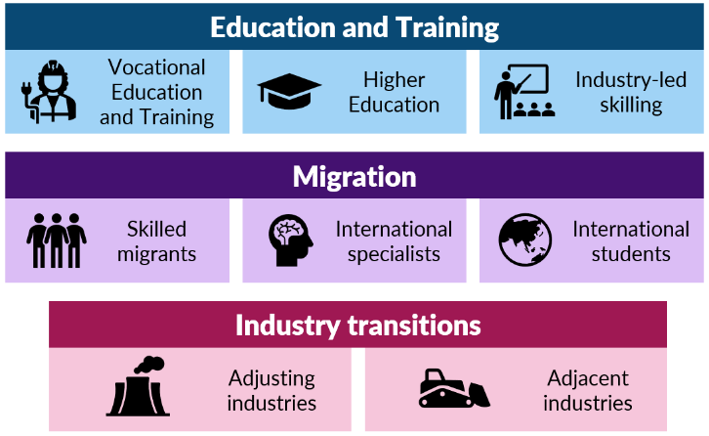
The Australian Government is currently examining the policy frameworks for each of these pathways through significant reform initiatives:
- the Universities Accord Review Panel, due to report by the end of 2023, is considering recommendations to reform Australian higher education system, including opportunities to support greater connections with the VET sector
- negotiations with States and Territories for a new National Skills Agreement that strengthens the VET sector
- a new Migration Strategy due to be released later in 2023, informed by the recent Migration Review, will consider skilled migration pathways for in-demand industries
- the establishment of a Net Zero Economy Authority to ensure that regions and workers across Australia realise and share the benefits of the net zero economy.
This study is well-timed to inform these wide-ranging reforms and ensure Australia has the workforce it needs to decarbonise. Also, following the 2022 Jobs and Skills Summit, Treasury developed and recently released an Employment White Paper that provides a roadmap for Australia’s future workforce.

4b. Education and training

Education and training is a shared responsibility
The clean energy workforce draws heavily on Australia’s higher education and VET systems. Both systems provide many diverse pathways into clean energy, including through upskilling. Our modelling shows that the vast majority of clean energy jobs over the next 30 years will require tertiary-level qualifications. Tertiary pathways rely on Australian schools, career guidance and informal experiences where young people gain interest and exposure in different fields and careers.
Table 4.1. Types of education and training pathways
Vocational Education | Higher Education | Industry-led
Developing practical skills for a particular job function or trade | Generalist education  Training for highly specialised professional occupations | Industry delivers on-the job, firm specific training. Helps workers specialise with particular technologies and practices.
Certificates I-IV  Diplomas  Advanced Diplomas  Graduate Certificates and Diplomas | Higher education diplomas  Undergraduate degrees  Postgraduate certificates and degrees | Unaccredited training  Industry placements and work experience
Trades like electricians and automotive mechanics | Professionals like electrical engineers and environmental scientists | Job role specialisation
Industry involvement
Not all skills can (or should) be provided by formal training. Industry-led informal training is an important bridge between tertiary qualifications and the specific, in-house skills needs of employers. Informal training, typically undertaken on the job, can still be rigorous and may provide a pathway to formal qualifications through Recognition of Prior Learning (RPL). Some industry-led training can align with international standards, which is an important consideration in sectors such as wind energy, where firms and workers are globally mobile.
“Training and certification delivered by industry groups is currently critical to enabling parts of the transition. For example, the EEC’s Certified Insulation Installer program is underpinning state and territory government initiatives to deploy insulation to buildings, improving thermal performance and reducing energy system emissions associated with heating and cooling buildings”.
– Energy Efficiency Council (EEC).
Industry also has a vital role in providing students with work experience and exposure to business practices and technology. In VET, this relationship is built-in through the apprenticeship model. However, apprentices can’t gain exposure to every element of clean energy through a single employer. Industry has an important role in providing Registered Training Organisations (RTOs) and students with access to a range of technology and worksites, like wind turbines, that are difficult to replicate in a classroom environment.
For higher education students, exposure to industry is often less formal and not always guaranteed. Some universities, like the University of New South Wales (UNSW), provide third and fourth-year students the opportunity to undertake internships within a chosen field as part of their studies, lasting anywhere between one to six months. Without these industry familiarisation opportunities, it’s unrealistic to assume students can enter the workforce with all the skills and experience employers need.
Tertiary alignment
While VET and higher education are two distinct sectors, there is growing interest and opportunity for a more aligned tertiary system. This is particularly so for an emerging workforce like clean energy, with potential to move away from the linear, siloed approach to tertiary pathways.
“We need to encourage innovative methods of course delivery, particularly in areas of national priority such as health care, clean energy and defence. Industry providers should be engaged in course design with VET and higher education providers to identify key learning requirements across both sectors”.
– Australian Universities Accord: Interim Report.
Some of Australia’s dual-sector universities are already looking to bridge the gap between the two distinct sectors through initiatives like degree apprenticeships. For example, the Ai Group is seeking to establish a pilot to combine a degree in electrical engineering with a Certificate III electrical trade, delivered as an apprenticeship. Chapter 7 explores some of the challenges and opportunities with tertiary alignment from a clean energy perspective.

Elements of tertiary pathways
The clean energy workforce builds on a deep knowledge base provided by the existing tertiary system. This pipeline has and will continue to deliver the fundamental skills needed for the sector. This is true for electro-technology (the primary field of interest) and other roles in engineering, construction and automotive technology.
There are a growing number of clean energy-specific skills, like managing energy efficiency, which are also important to the workforce. However, for the most part these skills are extensions or ‘top ups’ that build on the skillsets provided by existing training packages and undergraduate degrees.
JSA has identified three key elements of clean energy education and training pathways:
- existing broad-based qualifications
- clean energy top-up and electives
- new qualifications targeted to emerging sectors.
These elements are explored in Figure 4.2 with example courses.
Figure 4.2. Illustrative tertiary education pathways for the clean energy workforce
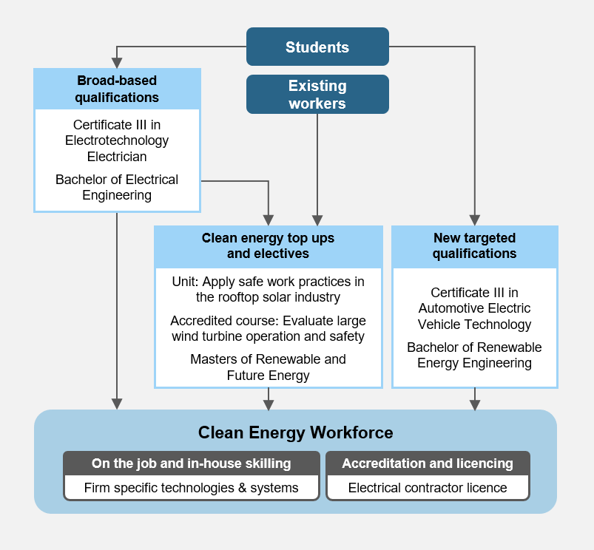
Note: existing workers (including those within clean energy, transitioning industries, or any other sector of the economy) can also benefit from targeted and broad-based qualifications where major upskilling or reskilling is required.

Broad based qualifications are key
Types of qualifications
Broad-based qualifications include common pathways like a Certificate III in Electrotechnology (VET) and Bachelor of Electrical Engineering (Higher Education). These existing qualifications provide the fundamental skills required across a wide range of roles, including clean energy. These qualifications are already delivered in large numbers across Australia and are key to ensuring everyone has the knowledge, skills and competencies needed to thrive in a variety of work settings (Table 4.2).
Increasing the capacity of education and training providers to scale these courses will be a key challenge going forward. In the short-term, many graduates with these qualifications will work in larger, adjacent sectors such as construction, mining and manufacturing. But as the demand for clean energy workers grows, the early investment in these skills pipelines will pay dividends, as these broad-based qualifications will be highly transferable and relevant into the future.
Table 4.2 Example broad-based qualifications
Certificates III and IV and Diplomas | Bachelor’s and Master’s degrees
Metal and Engineering  - Engineering – Electronic Trade  - Engineering – Mechanical Trade  - Engineering – Fabrication Trade  - Engineering Drafting  Electrotechnology  - Electrotechnology electrician  - Switchgear and Controlgear  - Electrical Fitting  - Airconditioning and Refrigeration  Electrical Supply Industry  - Transmission Overhead  - Network Systems  - Generation  Automotive Industry Service and Repair  - Light Vehicle Mechanical  - Automotive Electrical Technology | Engineering  - Electrical  - Civil  - Industrial, Mechanical and Production  - Electronic  - Chemical  Natural and physical sciences  Biological sciences  Social sciences  Economics
Undergraduate degrees
Most undergraduate students in Australia must complete secondary education and receive an Australian Tertiary Admission Rank (ATAR) or equivalent. Entrance requirements vary considerably for broad-based degrees, ranging from anywhere between an ATAR of 75 to the mid 90’s. It’s very common for engineering courses to include prerequisites. Just over half of all undergraduate engineering courses have a maths prerequisite, more than any other discipline, and 24% require at least one science subject.
Undergraduate engineering students typically choose their practice area (like mechanical or civil engineering) at enrolment. However, many engineering programs share similar core subjects in their first years, allowing students to change disciplines.
Despite strong growth in Australia’s higher education sector, the number of domestic students studying engineering has barely changed in the past decade (Figure 4.3). In 2021, there were around 15,500 domestic higher education commencements in the field of engineering. Of these, only around 10.5% were studying Electrical and Electronic Engineering and Technology.
Figure 4.3. Domestic commencements in Electrical and Electronic Engineering and Technology (bachelor’s degrees)
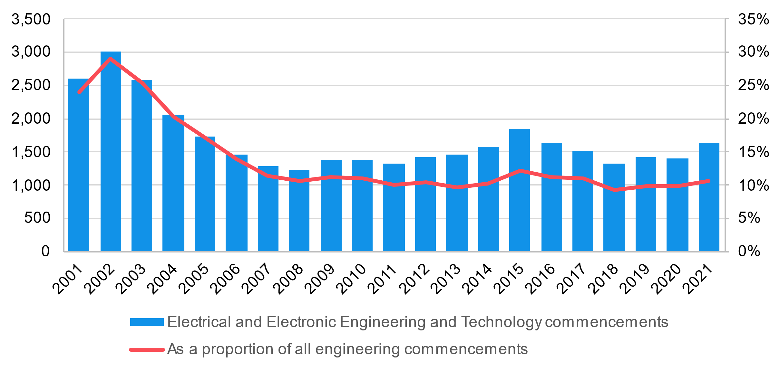
Source: Custom Department of Education microdata.
Trade apprenticeships
Trade qualifications are predominantly delivered at the Certificate III/IV level and as Australian Apprenticeships. The number of apprenticeship commencements in relevant fields have also remained largely steady in recent years, although there was notable growth in 2020 and 2021, likely as a result of large wage subsidies during COVID-19 (Figure 4.4). Whether this growth in commencements continues is not yet known. Around 15,700 apprentices commenced in Electrical and Electronic Engineering and Technology in 2021.
Figure 4.4. Apprenticeship commencements by field of education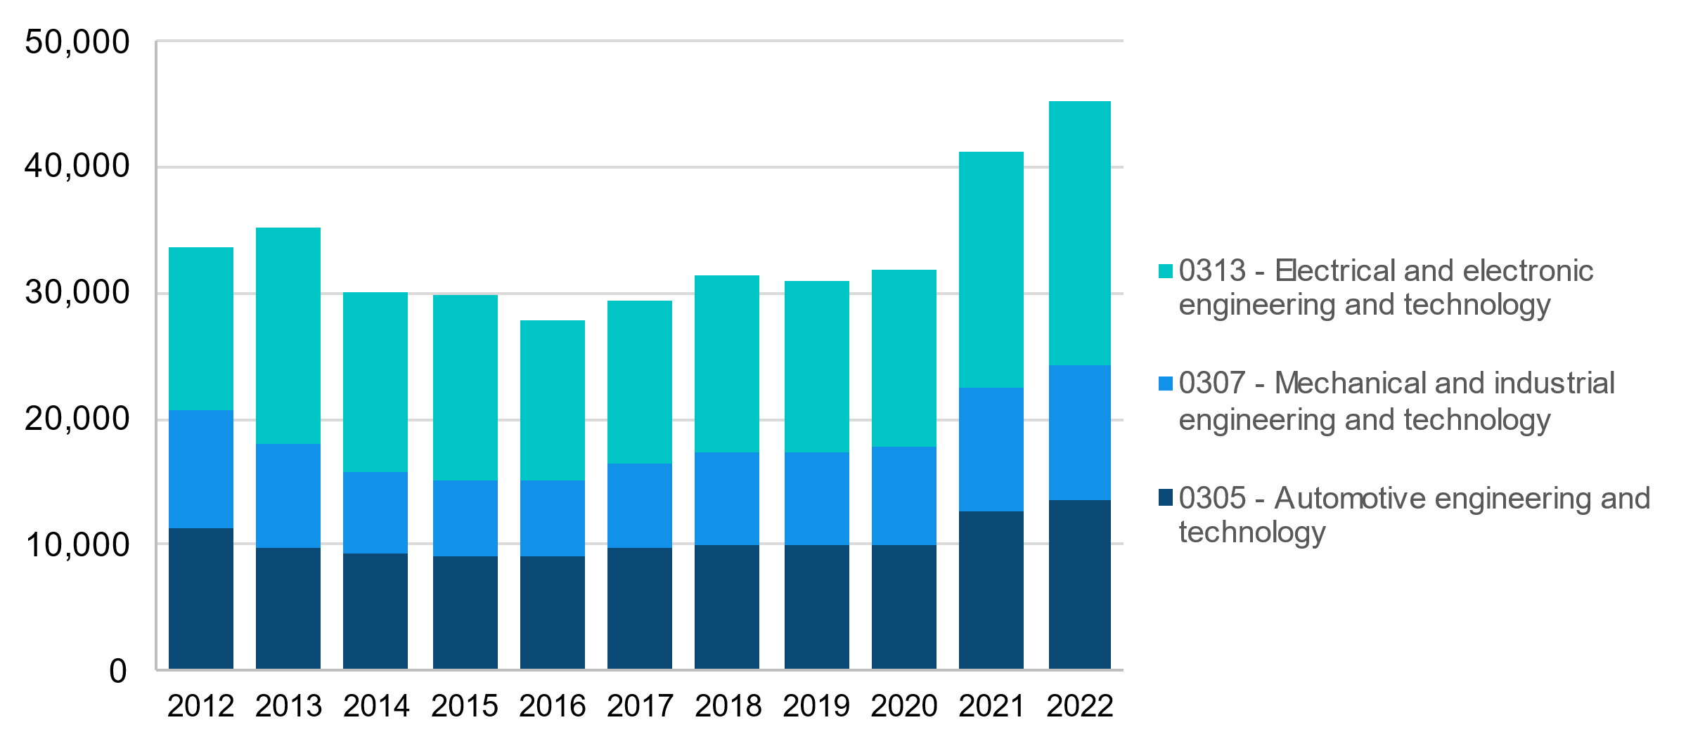
Source: NCVER Apprentices and Trainees, December 2022.

BOX 1: How do Australian Apprenticeships work?
Australian Apprenticeships are a popular way to gain a nationally recognised VET qualification through hands-on learning and while earning an income. Apprenticeships in trade occupations, typically take 3-4 years to complete full-time, and start from the certificate III level.
State and Territory Training Authorities determine which qualifications are delivered as an apprenticeship or traineeship, and some states offer different funding based on this classification. The Fair Work Ombudsman is responsible for providing information, resources and advice on wages and entitlements for different apprenticeships.
Apprentices enter into a Training Contract with their employer through an Australian Apprenticeship Support Network (AASN) provider. These contracts outline:
- each party’s responsibilities in the apprenticeship
- the employment arrangements
- the relevant industrial award
- what qualification the apprentice will get, and
- which RTO will deliver the training.
Apprentices can also be employed by Group Training Organisations (GTO) which place them with host employers on a short or long-term basis. This model can make it easier for employers to take on apprentices and help provide continuity of employment and training for the apprentice.
The Australian Government partnered with state and territory governments to establish a 12-month Skills Agreement to deliver 180,000 Fee-Free TAFE and vocational education places in areas of national priority, including technology and sovereign capability. Fee-Free TAFE will be prioritised for several priority groups, including First Nations people, young people and women undertaking study in non-traditional fields.
The Australian Apprenticeships Incentive System (Incentives System), commenced on 1 July 2022, is designed to target skills, and offers a range of financial incentives for employers and apprentices including:
- The New Energy Apprenticeships Program was established in 2022-23 to encourage more Australians to consider careers in the clean energy sector. The program delivers direct financial assistance to eligible apprentices, with the aim of supporting 10,000 completions. It is complemented by the New Energy Skills Program which includes funds for specialist mentoring supports. Only apprentices who started on or after 1 January 2023 are eligible.
- The Priority Wage Subsidy aims to improve commencement and completion rates in priority occupations on the Australian Apprenticeships Priority List. Eligible employers can claim a subsidy of 10% of wages paid for the first and second year, and 5% of wages for the third year (up to a maximum of $15,000), to help offset the cost of taking on an apprentice.
- The Australian Apprenticeship Training Support Payment, providing direct financial support to apprentices and trainees in priority occupations, set at $1,250 and paid at every six-months for the first 2 years of the apprenticeship, up to a maximum of $5,000.
- Australian Apprenticeship Support Loans of up to $24,492 over the course of an apprenticeship to cover everyday expenses. These loans are interest free but indexed annually.
- A Hiring Incentive of $3,500 for all employers of apprentices and trainees in occupations not listed on the Priority List paid in two six-month instalments.
- Targeted financial support for both apprentices and employers, under the Living Away from Home Allowance (LAHFA) for apprentices that move away from home to take up or remain in an apprenticeship, and the Disabled Australian Apprentice Wage Support (DAAWS) Program, for employers of apprentices with a disability.

BOX 2: Who employs clean energy apprentices?

`
The vast majority of trade apprentices in clean energy are now employed by the private sector. This has changed over time, as the number of clean energy apprentices employed by government enterprises has declined. Around 10% are employed directly by state and territory governments (Figure 4.5).
Figure 4.5. In-training trade apprentices by employer type (clean energy supply)
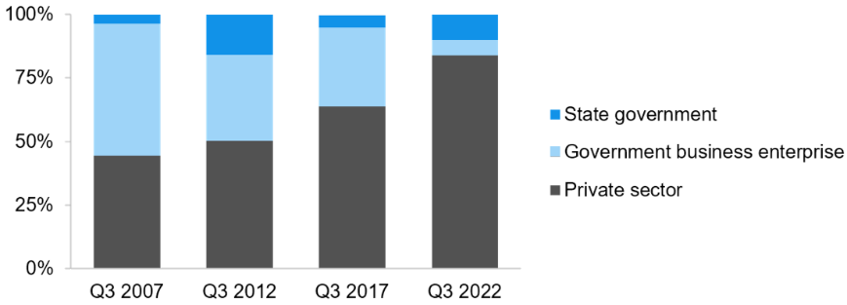
Source: NCVER apprentices and trainees, September 2022. Data is for trade apprentices employed in a clean energy supply industries. A small proportion (less than 1%) are employed by local governments.
GTOs also employ a large number of apprentices, although this has declined overtime. In Q3 2022, almost 11% of all electrical apprentices (not just in clean energy) were employed by a GTO. This is higher than the all-trade average of 7.5% (Figure 4.6).
Figure 4.6. In-training trade apprentices employed by GTOs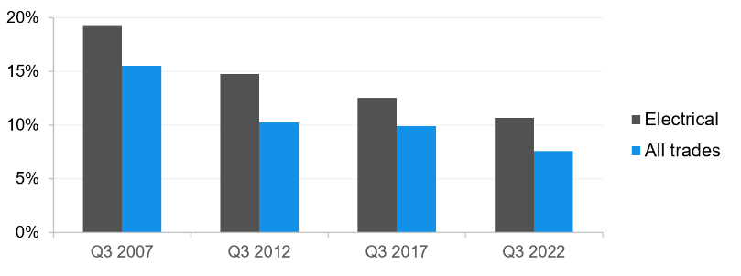
Source: NCVER apprentices and trainees, September 2022.
Unlike most other industries, apprentices in clean energy supply are predominantly employed by very large employers (Figure 4.7). However, this most likely excludes a large number of smaller employers that work across electrical services, like rooftop solar, that are not captured as renewable generation businesses. For example, according to DEWR’s program data, over half of New Energy Apprentice Support Payment recipients work for a small business, mostly in the Electrical Services industry, which includes rooftop solar.
Figure 4.7. In-training trade apprentices by employer size (clean energy supply) 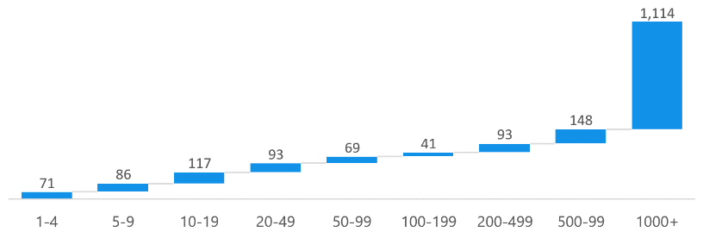
Source: NCVER apprentices and trainees, September 2022.
Dual qualifications
The increasing popularity of double degrees through a multidisciplinary approach has led to universities offering flexibility for students to be qualified in different academic disciplines. The perspective of developing a multidisciplinary approach is related to the ever-fluctuating market conditions and transferrable job skills as prospective students seek to diversify themselves prior to entering the workforce. For example, RMIT offers a Bachelor of Environmental Science and Bachelor of Engineering as a double degree: “as a double degree graduate, you will be uniquely placed to work in a variety of industries and roles, with a combined understanding of the science and the ability to design technical solutions”.
Dual-trade apprenticeships are a recent concept that allows apprentices to train for two trade qualifications concurrently. The National Electrical and Communications Association (NECA) established Australia’s first pilot program in 2021, combining electrical and refrigeration/air conditioning qualifications, to meet the sector’s demand for technicians with broader skill sets and to increase job security for apprentices.
Students in this pilot will complete two apprenticeships within five years, reducing the time required for completing both apprenticeships separately (up to eight years). To develop the program, experts identified overlapping units from both qualifications, and then streamlined the units into a single pilot program.
The automotive industry may also benefit from dual trade apprenticeships as the industry goes through rapid technological advancement. BMW Group developed a dual apprenticeship program in 2021, offering students to undertake light vehicle mechanical technology and automotive electrical apprenticeships within four years. Under this program, apprentices will be trained on all types of vehicles, from petrol fuelled to EVs.

Recommendation 4.1
Jobs and Skills Councils should explore and advise on mechanisms for dual-trade pathways that harness existing training packages and training capacity for emerging roles. Delivery models will need to be sustainable for employers, apprentices and RTOs, which may require funding changes by governments.
Recommendation 4.2

Explore funding, incentives and support mechanisms for the tertiary sector to develop, and students to complete, higher and dual sector apprenticeships in clean energy.

Electives and top-up skilling
Clean energy top-ups and electives, including post-trade and post-graduate courses, allow workers to build on their broad-based qualifications, gain specific clean energy skills and specialise.
Electives
Training package electives are nationally recognised and can be delivered by many RTOs. Several training package electives are already available for electrical apprentices to gain skills in areas like solar and battery installation during their apprenticeship. However, the availability of these electives is not always widespread, particularly for emerging technologies. Table 4.3 lists a wide range of electives in the Electrotechnology Training Package that are particularly relevant to renewables (a complete list is at Attachment B).
Table 4.3. Electrician Training Package electives relevant to renewables, 2022
Training Package elective | RTOs | Enrolments | Superseded
UEEEL0069 - Select and arrange equipment for special LV electrical installations | 70 | 19 | UEENEEG120A
UEERE0081- Install photovoltaic systems to power conversion equipment | 72 | 1,766* | UEERE0016
UEEEC0075- Troubleshoot single phase input d.c power supplies | 84 | 191 | UEENEEH111A
UEEAS0007- Assemble, mount and connect control gear and switchgear | 68 | 36 | UEENEEA110A
UEEEL0055 - Overhaul and repair major switchgear and control gear | 68 | 112* | UEENEEG129A
UETDRIS033 - Solve problems in network protection | 70 | 4,222* | UETTDRIS68
UEERE0077- Install battery storage equipment power conversion equipment to grid | 70 | 4,905* | UEERE4001
UEEAS0009 - Mount and wire control panel equipment | 68 | 489 | UEENEEA113A
UEERE0049 - Apply safe work practices in the rooftop solar industry | 69 | 14 | New
UEEEL0016 - Provide advice on effective and energy efficient lighting products | 69 | 57 | UEENEEG181A
UEERE0078 - Install battery storage to power conversion equipment | 70 | 4,905* | UEERE4001
UETDRSB007 - Install and maintain substation direct current systems | 66 | 4 | UETTDRSB23
UEERA0049 - Install and start up single head split air conditioning and water heating heat pump systems | 86 | 1,239 | UEENEEJ105A
UEERE0080 - Install photovoltaic power conversion equipment to grid | 72 |  | New
UEERE0054 - Conduct site survey for grid-connected photovoltaic and battery storage systems | 73 |  | New
UEEIC0024 - Plan the electrical installation of integrated systems | 79 | 5 | UEENEEI140A
Source: Training.gov.au; NCVER 2023 Total VET Activity Data on 13 September 2023. *indicates that enrolment numbers are for superseded course.
There are now several new electives for automotive apprentices to gain competencies in maintaining EVs (Table 4.4). These electives are starting to grow in scale, with almost 3,000 subject enrolments in 2022. However, this only accounted for 0.33% of all automotive enrolments that year, indicating there is still substantial growth needed.
Unit description | Enrolments | Automotive electrician | Motor Mechanic | RTOs
AURETH102 - Inspect and maintain battery electric vehicles | 672 | Training package elective | Training package elective | 185
AURETH101 - Depower and reinitialise battery electric vehicles | 2,332 | Training package elective | Training package elective | 188
AURETH015 - Diagnose, remove and replace heavy electric vehicle rechargeable energy storage systems | 27 | Training package elective | - | 70
Table 4.4. Electric vehicle electives in traditional automotive apprenticeships
Source: Training.gov.au; Certificate III in Automotive Electrical Technology and Certificate III in Light Vehicle Mechanic on 13 September 2023.
Note: “RTOs” indicates the number of RTOs with the units of competency on their scope of delivery. This does not imply active enrolments in these courses at all of these RTOs.
Higher education
Unlike the VET sector, higher education electives are designed by individual universities, meaning there is no consistent approach to their development or delivery. However, this enables respective universities to specialise their offerings and target particular technologies or industries at a more sustainable scale.
By enrolling in broad-based engineering qualifications, students can tailor their specialisations and select courses relevant to the clean energy sector. Some of the qualifications that are being offered by universities in Australia to select a specialisation as part of their undergraduate programme are shown below. The full list of specialisation units for undergraduate and postgraduate pathways can be found in Attachment B.
Table 4.5. Example of additional specialisation units delivered by Universities
Tech | Unit name | Unit Description | University
Solar | Solar Energy | Provides concepts associated with the solar energy industry, including the characteristics of solar radiation and solar collectors. | Monash University
Solar | Solar Thermal Energy Design | Provides an engineering perspective of the solar technologies used to meet these demands and how the technologies can be integrated into systems including control, circulation and storage. | UNSW
Solar | Photovoltaic Stand-alone System Design and Installation | Enables students to obtain their Business Council for Sustainable Energy (BSCE) provisional accreditation to design and install stand-alone power systems. | UNSW

 | Photovoltaic Systems Design | Provide an understanding on the technical and economic issues with respect to the design, installation and operation of photovoltaic energy systems.
Battery | Energy Storage | Learn the basic principles of electrochemical technologies in energy storage engineering: rechargeable batteries, flow batteries, supercapacitors, fuel cells, electrolysers, photo-electrochemical reactions. | UNSW
Hydroelectricity | Hydroelectricity | This unit covers all aspects of hydropower, including the fundamental physics behind energy storage in potential energy, design of hydropower systems (dam walls and reservoirs, penstock piping and tunnelling, powerhouse design (turbine and generator), tailrace and electrical connection). | Monash University
Wind | Wind engineering* | Introduction to the fundamentals of the wind environment, and how the wind interacts with both turbines to generate power, and structures to cause loads. Gain an understanding of wind turbines, including turbine performance, analysis methods, wind turbine siting, and blade/component loading aerodynamics of wind turbines. | Monash University
Wind | Wind Energy | The course covers the full spectrum of wind energy from the underlying physics of wind and wind generation technologies, delivered in collaboration between ANU Energy academics and Windlab. | ANU
Hydrogen | Renewable Energy and Hydrogen Technologies** | Introduction to the underlying fundamentals as well as application of various renewable and hydrogen-based energy technologies, with a particular focus on solar thermal, photovoltaic, wave energy, wind energy and hydrogen production and tech principles; as well as the design of these energy systems. | Swinburne University of Technology
Hydrogen | Hydrogen and Energy Storage | Introduction to the principles of energy storage systems and in-depth knowledge on the operation and implementation of energy storage system in current power domain. | Swinburne University of Technology
Source: Non-exhaustive list of specialisation units obtained from selected universities. Accurate as of 31 August 2023.
* This unit is not being offered in 2023, but has been offered in previous years
** Note that this course is a new unit to be delivered from 2024

Recommendation 4.3
Through the Universities Accord, explore opportunities for the Australian Government to incentivise higher education providers to design and deliver specific courses in identified areas of shortage and national priority, including clean energy.

CASE STUDY: Enrolments in clean energy units increasing by over 500% since 2015

JSA examined enrolments in a range of clean energy-related VET units. This list was prepared based on the units associated with CEC accreditation for solar installers and solar planners, but some units are broader and can be taken on a standalone basis.
Enrolments in clean energy related VET units have increased substantially since 2015 from 1,016 in 2015 to 6,406 in 2021 – a 531% increase (Figure 4.8). A full list of the training units is in Attachment B, and range from planning and managing renewable energy projects and targeted units on micro-hydro systems, batteries and solar. Demographically, the overwhelming number of students identified as male (almost 97%) and the average age of students enrolling is dropping fast. For example, the average age dropped almost four years from 35.2 years in 2019 to 31.6 in 2021. Most likely, this reflects the point at which apprentices began to undertake these units in larger numbers.
Figure 4.8. Number of enrolments and average age of students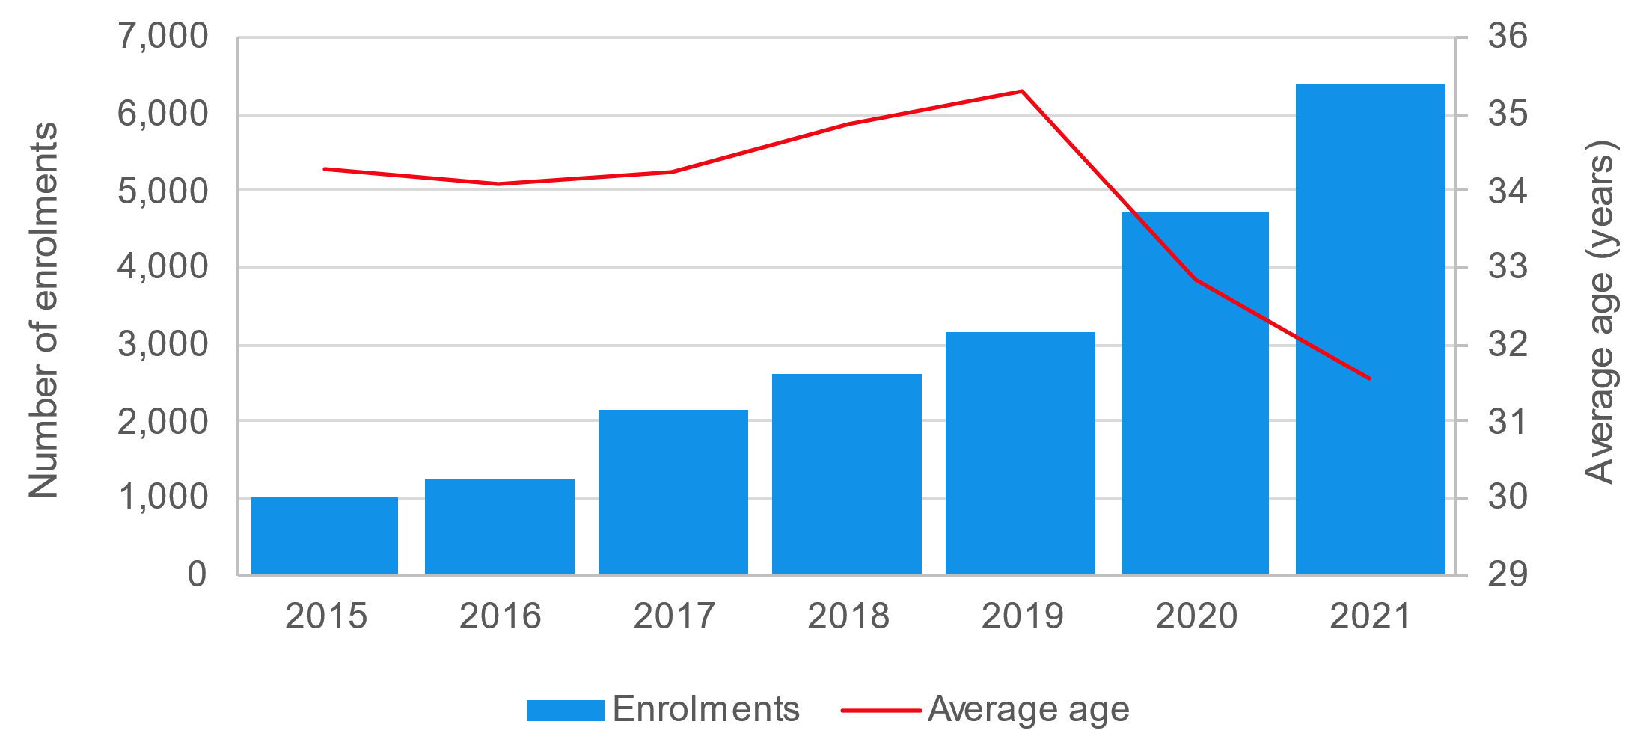
Source: ABS (2023) Microdata: Total VET Activity (2015 to 2021)
Electricians most likely to enrol in clean energy units
On average almost 60% of training students were classified as qualified Electricians. The next most common group - 15% of students were Electrical Apprentices (Table 4.6).
Table 4.6. Most common occupations on enrolments
Occupation | Average Pre-training %
341111 Electricians | 59.90%
934101 Electrical apprentice/Trainee | 15.10%
233311 Electrical Engineer | 2.70%
111111 Executive Officer/Managing Director | 2.50%
899914 Electrical trades assistant/labourer; Electrician’s assistant; Labourer - electrical; Telecommunications trades assistant | 1.60%
Other occupations | 19.70%
Before enrolling, most clean energy students had completed a Certificate III or IV, with many completing Year 12 (41.6% and 23.2% respectively in 2021). Overall, while the proportions for the highest education attainment prior to enrolment have remained broadly constant since 2015, it should be noted that the aggregate numbers for educational attainment have increased tremendously (Certificate III up 581%, Certificate IV up 559% and Bachelor degree up 581%).

Post-trade and postgraduate qualifications
Accredited courses and post-graduate qualifications are starting to emerge that can provide additional ‘top-up’ skills for workers after completing their core qualifications. These top-up skilling opportunities are not just for recent graduates – a large pool of qualified workers in areas like construction could move into clean energy if short, accessible and affordable training were available. These could prove particularly important for workers in transitioning industries, like coal-fired power generation, who would benefit from short skilling pathways that can bridge gaps to new opportunities.
Post-trade qualifications like the Certificate IV in Electrical - Renewable Energy are a way to specialise and gain new skills after an apprenticeship. These formal qualifications typically take several years to attain and are at the Certificate IV, Diploma or Advanced Diploma levels. Figure 4.9 shows four post-trade qualifications for Electricians that can be completed as standalone qualifications or as apprenticeships in some states and territories.
Figure 4.9. Post-trade qualification pathways for Electricians
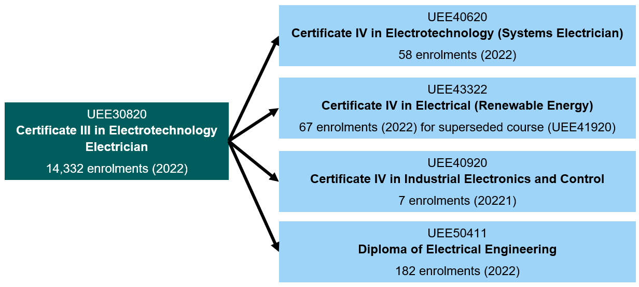
Source: NCVER, 2023, Total VET activity data
Postgraduate degrees can act as a conversion course, allowing prospective students to change their direction of studies. Postgraduate courses also provide students with an alternative path for career progression, through conducting research in a field of interest and contributing to institutional change.
Prospective students seeking to enrol in a postgraduate qualification can either pursue the research or coursework pathway. Postgraduate coursework programs deliver content through a specified program (similar to an undergraduate Bachelor’s Degree), but at a more advanced level, allowing students to deepen their knowledge within a discipline.
On the other hand, postgraduate research programs (or Higher Degree Research) allow students to develop their knowledge and experience within the chosen field by completing a major research project under the supervision of an academic, with postgraduate research degrees, including Master’s by research or Doctorate (PhD) programs. The following table below provides a snapshot of the current postgraduate pathways in Australia in the engineering field, with a specific focus on renewable energy. The full list of postgraduate pathways can be found in Attachment B.
Table 4.7. List of postgraduate pathways in renewable energy
University | Course Title | Full-time duration
The University of Western Australia | Masters of Renewable and Future Energy | 1.5 to 2 years
UNSW | Master of Engineering (Renewable Energy) | 2 years
UNSW | Master of Engineering Science (Renewable Energy) | 1.5 to 2 years
Murdoch University | Master of Renewable and Sustainable Energy | 2 years
ANU | Master of Engineering in Renewable Energy | 2 years
Queensland University Technology | Master of Renewable Energy | 1.5 years
Source: Non-exhaustive list of postgraduate pathways in the renewable energy sector. Courses are accurate as of 31 August 2023
The number of students commencing a masters in electrotechnology (coursework) has steadily grown over the past decade, although declined following COVID-19 (Figure 4.10). The vast majority of these students are international students (93% in 2018). The number of domestic commencements was actually lower in 2018 than it was in 2008 (80 vs 113).
Figure 4.10. Electrical and Electronic Engineering and Technology commencements (masters by coursework)
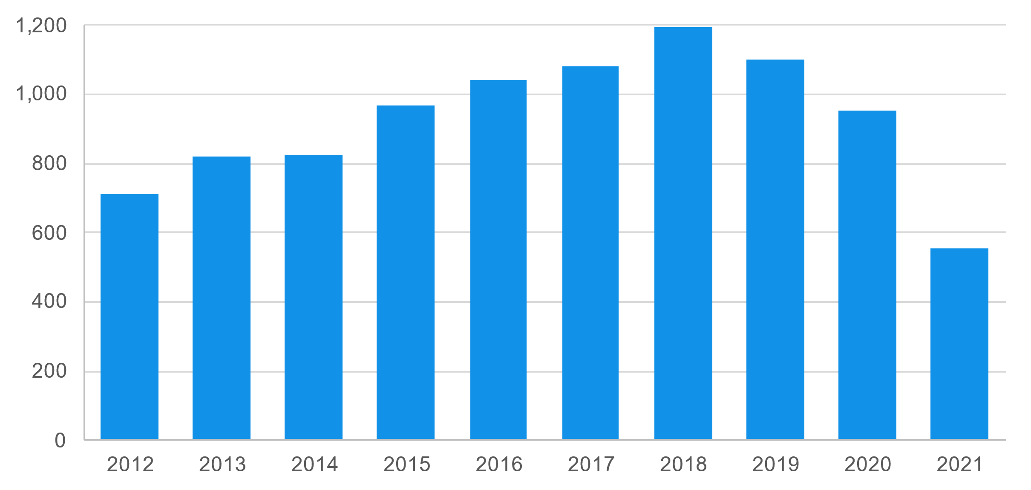
Source: Department of Education data
Developing specialist knowledge through postgraduate studies can position students to be experts in the relevant field, boosting future employment prospects and remaining versatile in the current labour market.

Other top-up pathways
Unaccredited courses can be a fast, low-cost option to address smaller skills gaps. For example, TAFE Queensland offers an unaccredited three-day course to gain experience with solar and heat pump water systems. Unaccredited courses can also be faster to develop and roll out than qualifications under the nationally recognised training system.
TAFE NSW also offers various unaccredited renewable energy microcredentials, including Grid Connected Solar PV Systems Design, Wind Energy Conversion Systems, Energy Storage Systems, Foundation Studies in Renewable Energy and Sustainability, Principles of Electrical Engineering and Sustainable Strategies. Some of these courses are industry accredited by the CEC.
The currency of the modern-day career portfolio is skills. As the job market becomes increasingly competitive, developing an effective culture of lifelong learning is key to ensuring that everyone has the knowledge, skills and competencies needed to thrive in both their personal and professional lives through microcredentials.
The role of micro-credentials in the higher education sector acts as a bridge between complementary courses. Prospective students might commence in an undergraduate degree followed by enrolling in specific courses for specialisation. The flexibility of the delivery mechanism under microcredentials allows individuals to regularly reskill and upskill, meeting the needs of employers and industries.
The announcement of the microcredentials pilot in the higher education sector in June 2023 will support the design and delivery of up to 28 micro credential courses from 18 universities to help meet skills needs in priority industries at the cost of $18.5 million, with a further announcement for the second phase of the program to commence from 2024 onwards. The following table below provides a snapshot of the microcredentials pilot in the field of renewable energy.
Table 4.8. Microcredentials pilot in the renewable energy sector
University | Course Title | Course duration in EFTSL
Curtin University | Net Zero Engineering Fundamentals | 0.25
University of New South Wales | Hydrogen Production for Electrical Engineers | 0.25
Western Sydney | Foundations of Environmental Sustainability | 0.25
Murdoch University | Certificate in Strategic Decarbonisation Management | 0.25
Source: Microcredentials Pilot in Higher Education, Department of Education
In 2023, Federation University will begin delivering a globally recognised post-trade turbine technician training course developed by the German industry network BZEE. The six-month intensive course for electricians, mechanical fitters, and automotive technicians includes an internship with wind turbine manufacturers and service organisations, covering electrical, mechanical, and hydraulic systems training.

Recommendation 4.4

Where appropriate, support unaccredited and industry accredited courses, including microcredentials, as fast, low-cost options to bridge skills gaps for emerging roles and for workers with existing qualifications. This includes exploring appropriate and stable funding mechanisms and expedited quality assurance and recognition. Training should be agnostic as to sector of delivery and pilot innovative collaborations.

Case Study: Australia’s rooftop solar success

Australia is one of the largest producers of solar PV electricity. It accounted for 15.7% of all consumption in 2022, behind only Spain, Greece, Chile and Jordan. On a per-capita basis, Australia has the highest capacity of solar energy (International Renewable Energy Agency, 2022).
Most of Australia’s PV power is distributed, typically on rooftops, rather than utility-scale. Unlike other power sources, rooftop solar is located across Australia and in population centres (Figure 4.11). This means that demand for installation services has mostly occurred in places where there are large existing workforces and training organisations.
Because much of the work locating, mounting and fixing unconnected solar panels can be undertaken by skilled labourers, the workforce has been able to scale with relative ease. Similarly, in most cases solar panels can be connected by workers with a general electrical licence, rather than a bespoke qualification or licence, allowing electricians to add solar to their scope of services without having to specialise.
In response to growing consumer demand, employment in roof-top solar almost doubled from around 6,900 in 2009-10 to 13,070 in 2018-19. This includes site preparation, roof modifications, preparation of power boards and meters, installation of solar panels and other infrastructure, and testing systems once initial installation is complete.
Figure 4.11. Percentage of dwellings with roof-top solar PV, 30 June 2023
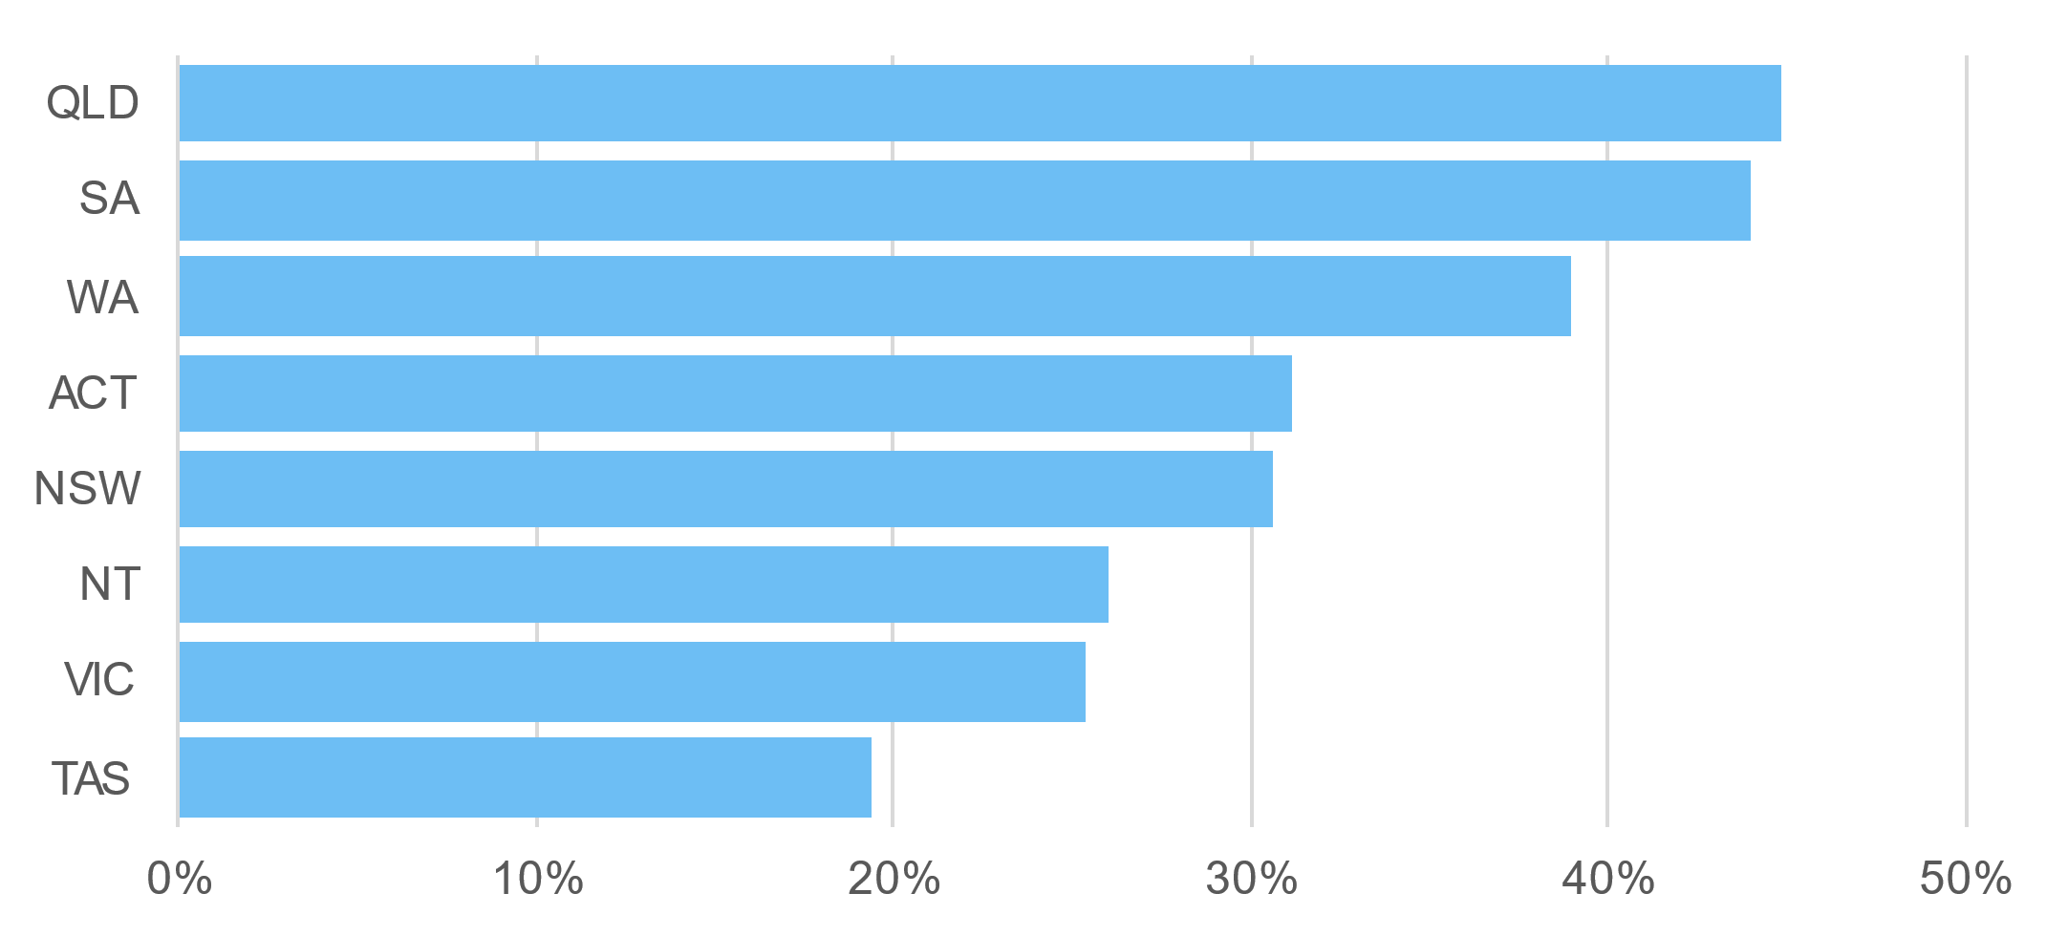
Source: Australian PV Institute (APVI) Solar Map, funded by the Australian Renewable Energy Agency, accessed from pv-map.apvi.org.au on 20 September 2023.

New specialised qualifications
There will also be a need to develop new qualifications with industry where technologies require a larger suite of specialised units. For example, in 2023 Canberra Institute of Technology (CIT) launched its first EV apprenticeship pathway under a new Certificate III in Electrical Vehicle Technology. While there is overlap between this qualification and the existing Certificate III in Light Vehicles, the new qualification includes a longer list of EV-specific units, many of which are core requirements. Examples of new specialised VET qualifications include:
- CPP41119 - Certificate IV in Home Energy Efficiency and Sustainability (3 RTOs)
- AUR32721 - Certificate III in Automotive Electric Vehicle Technology (13 RTOs)
- 52859WA - Graduate Certificate in Renewable Energy Technologies (1 RTO)
Scaling these new qualifications requires a critical mass of students able and willing to enrol and enough employers that recognise the qualification as a suitable pathway into the industry before RTOs may be willing to make the upfront investment in course materials, capital and equipment. This has proved difficult in some regions and sectors.
The growing demand for engineering graduates in the field of renewable energy has led to universities establishing new undergraduate pathways to meet the current skills gap that persists within the labour market. As an example, the successful development of the new Bachelor in Renewable Energy Engineering program at the University of Newcastle saw the first cohort of graduates all securing a local renewable job. Table 4.9 provides a snapshot of the current undergraduate pathways in Australia that are in the field of engineering, with a specific focus on renewable energy. The full list of specialist undergraduate pathways can be found in Attachment B.
Table 4.9. Example specialist undergraduate pathways
University | Course Title | Full-time duration | Degree type
UNSW | Bachelor of Engineering (Honours) (Photovoltaics and Solar Energy) | 4 years | Undergraduate
UNSW | Bachelor of Engineering (Honours) (Renewable Energy) | 4 years | Undergraduate
University of Newcastle | Bachelor of Renewable Energy Engineering (Honours) | 4 years | Undergraduate
Queensland University Technology | Bachelor of Engineering (Honours) (Electrical and Renewable Power) | 4 years | Undergraduate
Queensland University Technology | Bachelor of Engineering (Honours)/Master of Renewable Energy | 5 years | Undergraduate followed by Postgraduate
Edith Cowan University | Bachelor of Engineering (Electrical and Renewable Energy Honours) | 4 years | Undergraduate
Source: Non-exhaustive list of postgraduate pathways in the renewable energy sector. Courses are accurate as of 31 August 2023
The involvement of employers directly engaged in particular skills and job roles is critical to the success of new qualifications. A Certificate IV of Large-Scale Wind Generation – Electrical was developed; however, some employers did not recognise the qualification as a pathway to becoming a wind turbine technician. A Certificate IV in Wind Power Generation has now superseded it, aligning with new technologies and current work practices. This demonstrates how bespoke qualifications can quickly become outdated and limit RTOs’ abilities to gain momentum in new technologies.

Case Study: Green Apprenticeships in the UK

The UK has demonstrated a firm commitment to reaching net zero emissions by 2050, having cut emissions by 48% between 1990 and 2021, and is decarbonising faster than any other Group of 7 (G7) country. One feature of this success has been well-coordinated efforts and investments in greening the domestic workforce and economy. Building on the work of the Green Jobs Taskforce (2020-2021), the Net Zero Strategy (2021) and the Net Zero Growth Plan (2023), the Institute for Apprenticeships and Technical Education (IfATE) is working to identify and map the progress of 'green occupations' and ‘green apprenticeships’ to support employers, workers and students to better understand which apprenticeships and technical qualifications support a ‘green career’.
Some of the ‘green occupations’ already captured in the UK apprenticeship program include sustainability business specialists, smart meter installers, ecologists, metal recycling technical managers and forest craftspersons. IfATE are currently developing two others: low carbon heating technician and battery manufacturing technician, under the guidance of the Green Apprenticeships and Technical Education Advisory Panel (GATEAP). These fall into the ‘emerging occupations’ zone of JSAs clean energy occupation mapping.
It is important to note that the UK apprenticeship system has lower barriers to entry than the Australian system, due to the implementation of an apprenticeship levy on businesses in 2017 which spurred a high number of ‘apprenticeships’ which span the traditional trades into areas that Australian states and territories and the IR system would still consider ‘traineeships’ or higher education pathways into professions. This has led to some criticism of poor quality, particularly in the formal qualifications awarded as part of the apprenticeship. However, formal evaluation found a net-positive impact of the levy on commencements over the period 2015-16 to 2018-19 with no associated decrease in other forms of training.

Research pathways
The research and development workforce is critical to Australia’s clean energy future. Universities make up over a third of all research and development expenditure, while also training Australia’s PhDs across a wide range of disciplines. A major source of research funding comes from the Australian Research Council (ARC), which provided $10 million to Electrical and Electronic Engineering research in 2022 (Figure 4.12).
Figure 4.12. ARC funding for Electrical and Electronic Engineering research
UNSW granted $19.375 million
for ARC Centres of Excellence
UOW granted $5 million for
Industrial Transformation
Training Centres
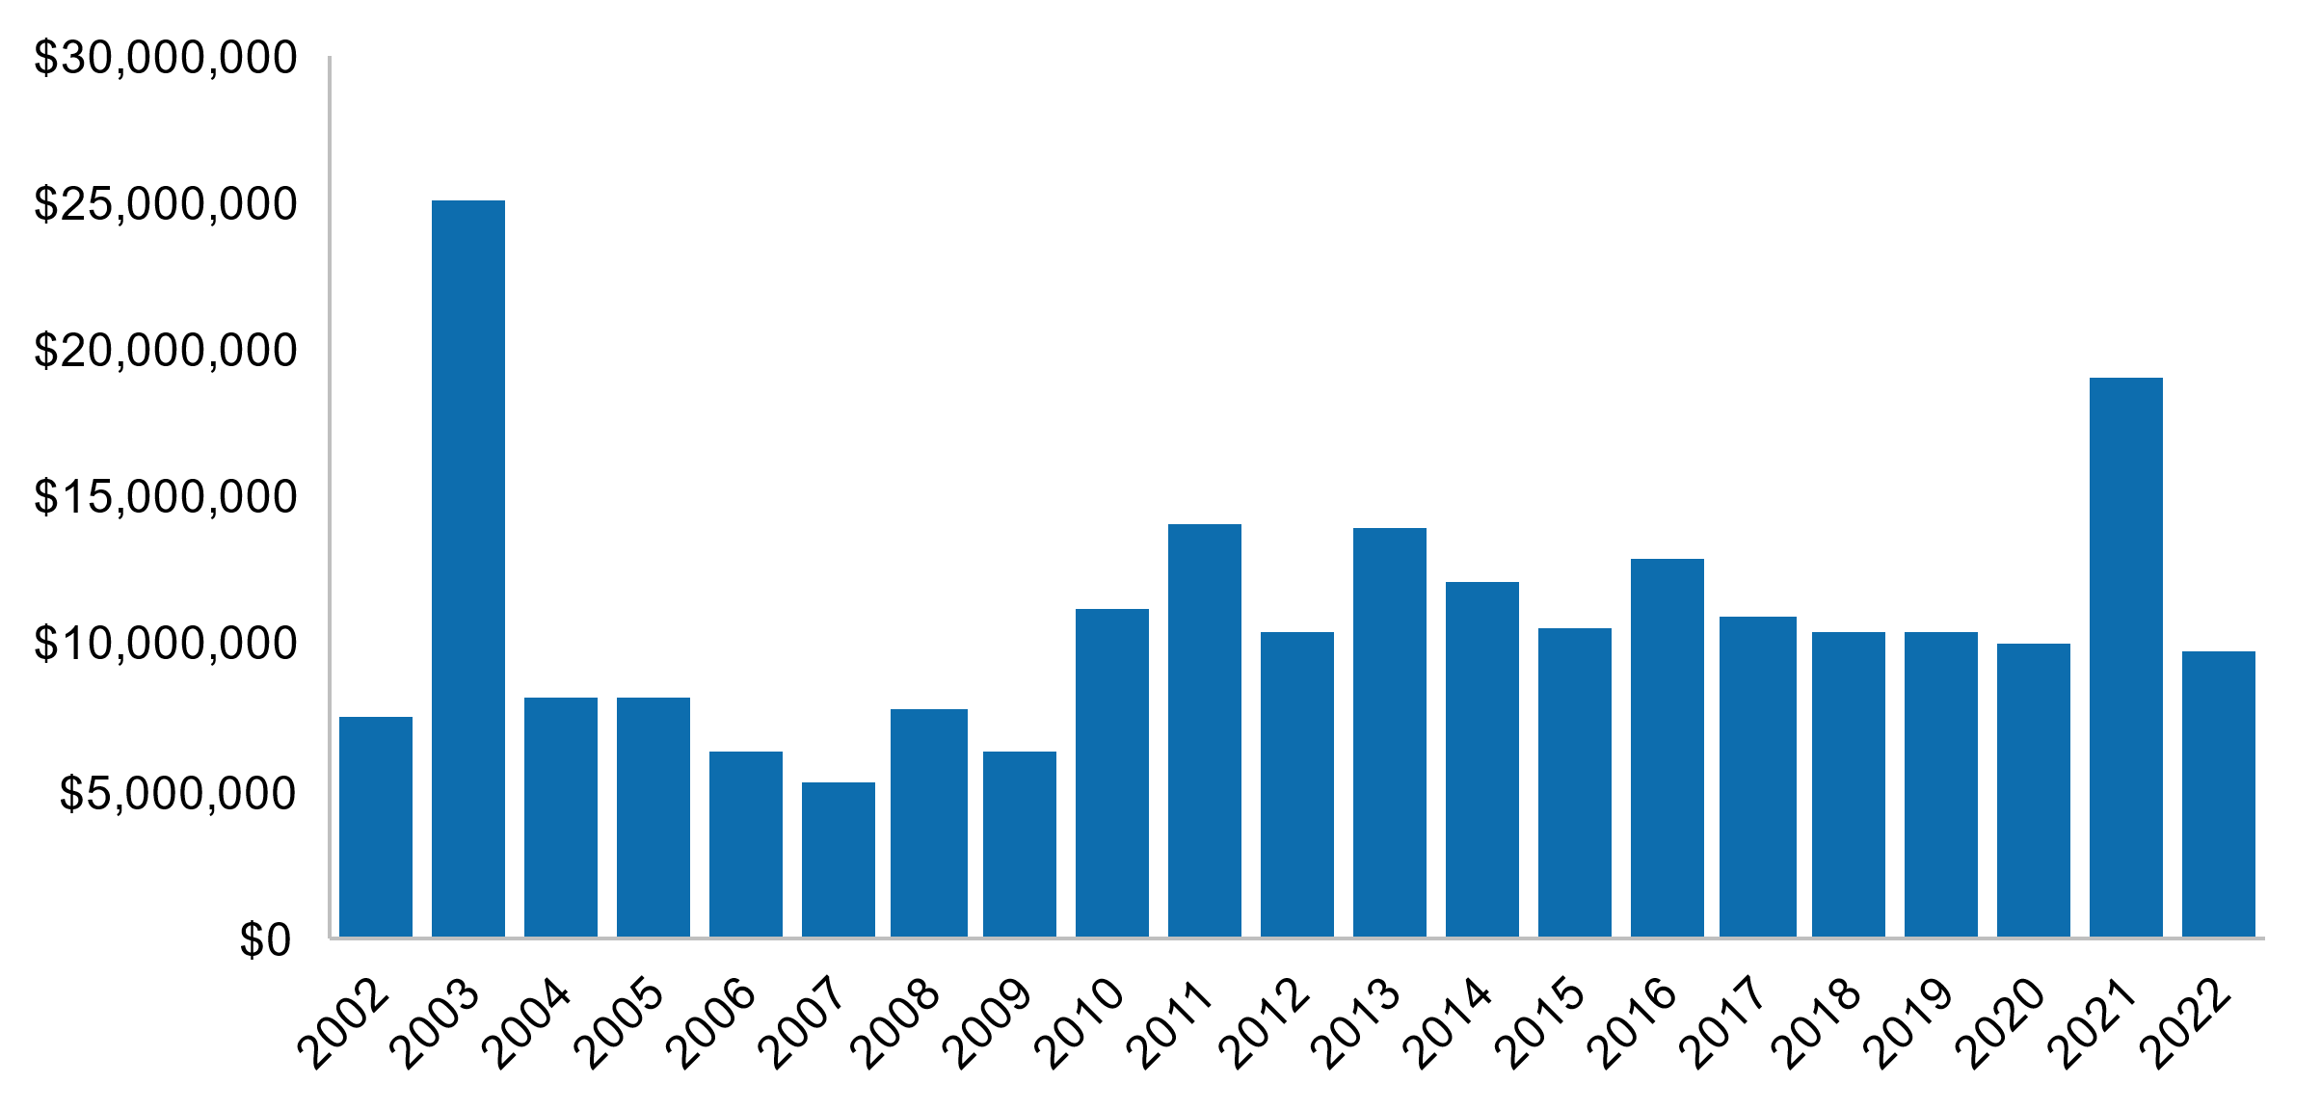
Source: ARC 2023, Grants Dataset
The ARENA also provides research funding for clean energy projects, with $2.25 billion invested across 663 projects in Australia to date. This grant funding sits across three main priorities:
- Optimising the transition to renewable electricity
- Commercialising clean hydrogen
- Supporting the transition to low-emissions metals
Funding backs early-stage research to large-scale deployment, supporting universities, start-ups and established companies.
The 2022 announcement of the Trailblazer Universities Program seeks to foster leaders in research commercialisation, with dedicated investment in priority areas and will be led by six Australian Universities. Through this initiative, the federal government is committed to building additional capacity to focus on the problems that matter to the nation by driving research excellence to address real-world impacts. Each Trailblazer university will receive $50 million, which will be matched by university and industry partner contributions. Table 4.10 below provides a snapshot of the trailblazer projects with universities in the clean energy sector.

Table 4.10. Trailblazer participation for universities within the clean energy sector
Trailblazer topic | Project Lead | In collaboration with
Resources Technology for Critical Minerals Trailblazer | Curtin University | - The University of Queensland  - James Cook University
Trailblazer for Recycling and Clean Energy | University of New South Wales | - University of Newcastle
Recycling and Clean Energy Commercialisation Hub | Deakin University | - University of Southern Queensland  - Federation University
Source: Trailblazer Universities Program, 2023, Department of Education. Accurate as at 10 July 2023
Several hundred students commence each year in either a master’s or PhD by research pathway for Electrical and Electronic Engineering and Technology (Figure 4.13). In 2021, over two thirds of these PhD commencements were international students.
Figure 4.13. University research commencements in Electrical and Electronic Engineering and Technology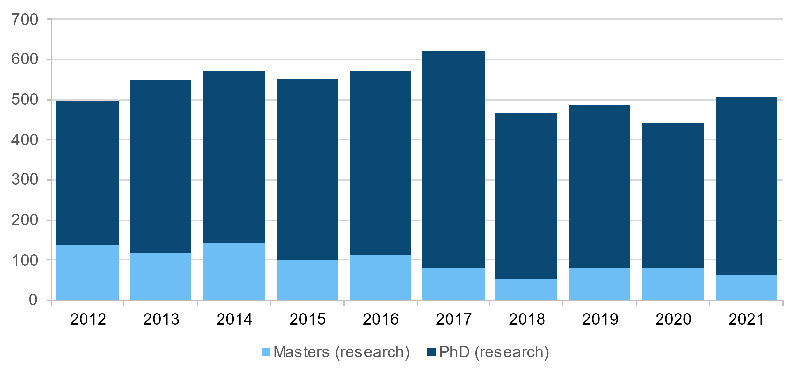
Source: Department of Education higher education unit record data

CASE STUDY: Low-cost green hydrogen research

Researchers from the University of Wollongong and ARC Centre of Excellence for Electromaterials Science (ACES) have developed an innovative electrolyser technology, enabling low-cost renewable hydrogen production in Australia. The research was funded by the ARENA, the ARC, and the Australian National Fabrication Facility. A spin out company, Hysata, was established by the University of Wollongong to commercialise the new technology in 2021.
Renewable hydrogen has a potential to decarbonise hard to abate sectors such as heavy transport and metal and chemical production. However, producing renewable hydrogen costs significantly more compared to hydrogen produced from fossil fuels (US$3.00-$8.00 per kg and US$0.50–$1.70 per kg respectively).
Hysata’s new electrolyser operates at 95% system efficiency compared to existing electrolysers at around 75% efficiency. Their simple and energy efficient electrolyser will bring down the cost of green hydrogen production to below US$1.50 per kg, making it cost competitive with fossil fuel hydrogen.
“Electrolysers have been around for 200 years, however the large amounts of renewable electricity required to produce green hydrogen and the overall cost of electrolysers today has prevented large-scale uptake of green hydrogen,” said Professor Swiegers, Chief Technology Officer at Hysata.
“Green hydrogen is forecast to be a trillion-dollar industry with the backbone of this industry being the electrolyser. Given the urgency to reach net zero, we are gearing up to scale up as quickly as possible. The elegant design of our electrolyser is perfectly suited to mass production,” said Paul Barrett, Hysata CEO.

Secondary education
Both tertiary sectors rely on the output of Australia’s school system; not just the number of students but how they are supported. Schools help students:
- gain an understanding of and interest in clean energy roles
- navigate different tertiary pathways
- acquire prerequisite skills for tertiary education.
Labour market outcomes are substantially lower for people who have not completed Year 12 (Figure 4.14). Concerningly, secondary education attainment is also much lower in regions that are reliant on transitioning industries, like Gippsland and the Hunter Valley (Figure 4.15). This may limit the ability of some regions to grow new and energy sectors which have higher skill requirements.
Figure 4.14. Labour market outcomes by highest level of education attainment
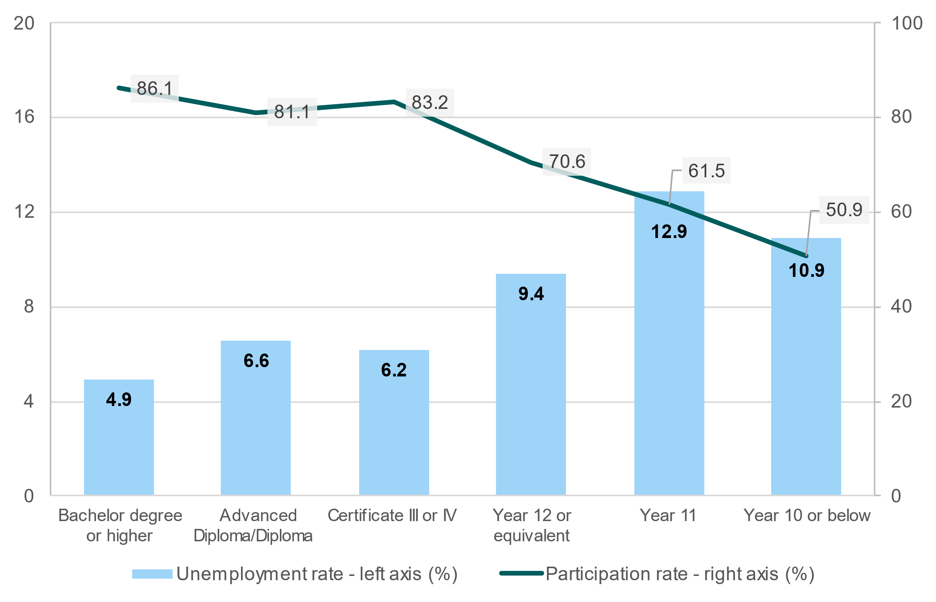Source: ABS Census of Population and Housing, 2021
In many ways, clean energy careers might not seem as straightforward or recognisable as careers in other industries. As there aren’t jobs specifically labelled as 'clean energy’, it may be challenging to see how traditional roles, such as engineering and trades, can align with the growing clean energy sector.

Figure 4.15. Proportion of population with highest level of educational attainment below Year 12 (aged 15+), selected regions, 2021.
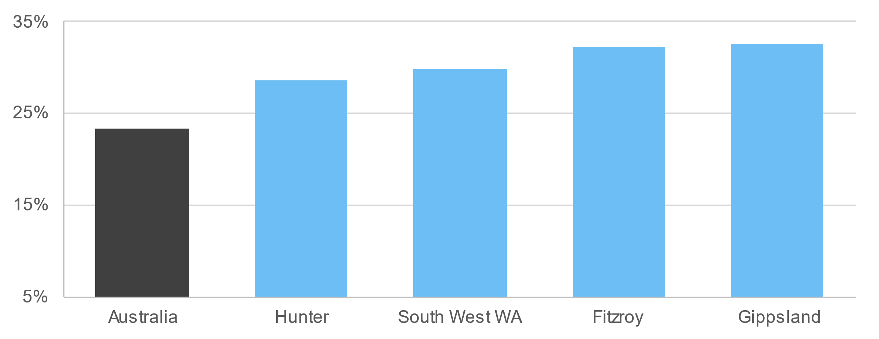
Source: ABS Census of Population and Housing, 2021
Note: Employment regions at the ABS Statistical Area 4 (SA4) detailed below.
Hunter: Hunter Valley excluding Newcastle and Newcastle and Lake Macquarie combined SA4s, South West Western Australia: Bunbury SA4, Fitzroy: Central Queensland SA4, Gippsland: Latrobe Gippsland SA4
STEM skills
While STEM subjects are certainly not the only subjects relevant to clean energy occupations, they are crucial to a variety of critical clean energy occupations. Despite this, the proportion of Year 12 students studying advanced mathematics has gradually declined, as has performance. Australian schools are also experiencing severe teacher shortages, with many STEM subjects being taught by out-of-field teachers in 2020. Without school level courses and teachers to inspire students, Australia won’t be able to increase commencements in critical fields.
In 2021, over 60% of students said that studying STEM wasn’t related to their desired career. This indicates students’ lack of understanding of STEM skills linked to jobs in clean energy sector, as green jobs attract strong interest from young people globally — 77% of young people aspire to get a green job within next 10 years. Early career guidance to school students could be beneficial to raise awareness of diverse career opportunities that apply STEM skills in the clean energy sector.
Lower participation in STEM fields of education is more profound amongst diverse groups. In 2021, women comprised 37% of university STEM related course enrolments and only 17% of VET STEM enrolments. STEM enrolments also vary significantly by discipline, with women comprising 70% of health enrolments but only 9% of engineering. Trade apprenticeships had even lower female representation — only 5.6% of electrical apprenticeship commencements were female in 2021. Key influencing factors for not studying STEM include lack of interest and confidence. Support for school-aged girls is important as girls’ interest in STEM subjects decreases as they age, and positive experiences can influence their career aspirations and STEM subject decisions.
The importance of capturing and encouraging the interest of underrepresented groups in STEM education from early ages was stressed by both the National Careers Institute and DISR’s STEM Equity Monitor at the second Women in Energy national roundtable hosted by DCCEEW.

Supported entry pathways
Supported pathways are a way of providing accessible entry into education and training. For example, in higher education this can include preparation courses for students who haven’t engaged in study for a long period, or lack certain prerequisites. Supported pathways can also offer low commitment opportunities for prospective students to explore pathways before committing, which may be particularly beneficial for underrepresented groups like women:
“young women need low-stakes opportunities to “taste” and experience a wider range of career options prior to and during their senior secondary years of schooling. These taster opportunities are an important chance for young women to “try before they buy”, and were generally seen as crucial to “demystifying” some of the gendered perceptions of male-dominated apprenticeships and a career in the trades. These “taster” opportunities also included work experience and work placement opportunities, which enabled “female-friendly engagements”.
Women in Adult and Vocational Education and the
Centre for Vocational and Educational Policy.
School-based Apprenticeships
An Australian School-based Apprenticeship (ASbA) combines secondary school subjects, paid work and on-or-off the job vocational training. These can be undertaken in a traditional trade or other occupations at Certificate or Diploma level. Only around 2,300 students commenced a school-based apprenticeship in clean energy relevant training packages in 2022 (Table 4.11). There were no school-based apprentices in Transmission or Distribution qualifications.
Table 4.11. Trade commencements in school-based apprenticeships
Training Package | School based commencements | Share of all commencements
Electrotechnology | 664 | 3.8%
Metal and Engineering | 666 | 6.0%
Automotive Industry Retail, Service and Repair | 956 | 5.9%
Source: NCVER 2023, Apprenticeships and Trainees
Pre-apprenticeships
A pre-apprenticeship is entry-level training that can provide a pathway into an apprenticeship. The main pre-apprenticeship pathway for clean energy is a Certificate II in Electrotechnology, which can lead to a full Australian Apprenticeship. The number of enrolments in this program has grown steadily over the past five years, with almost 14,000 enrolments in 2022 alone. Early school leavers often take pre-apprenticeship pathways to bridge gaps in their studies. While over two-thirds of electrical apprentices completed year 12, less than one-third of electrical pre-apprentices had. Pre-apprentices are also slightly more likely to be female (5.0% vs 3.2%) and have a disability (5.5% vs 2.5%).

International students
International students make up a growing proportion of Australia’s higher education commencements. In 2017, the number of international engineering commencements overtook domestic commencements, up until the COVID-19 pandemic (Figure 4.16). While international students do study in the VET system, comparatively few undertake trade qualifications. This is largely because only Australian citizens and permanent residents can undertake an Australian Apprenticeship.
International students as trade apprentices?

During our consultation, we heard from industry, training providers, and union stakeholders that apprenticeship pathways for international students could be worth exploring, considering the significant shortfalls for VET qualified workers. Given the impact that international education has had on Australia’s labour market and higher education sector, it is certainly an area that could be explored to fill existing skills gaps for clean energy occupations. However, there are several issues to consider, including exploitation and safety concerns across all sectors, particularly in high-risk settings like electrotechnology and construction.
International students, employer-sponsored skilled migrants and domestic apprentices alike are already vulnerable to heightened exploitation and safety risks in the Australian labour market. International students are typically required to be approved for study before they can get a visa, and as apprenticeships are inherently employment based, students would need to find an employer willing to support their apprenticeship and an RTO to deliver their training prior to visa approval. Any changes to existing restrictions and policy settings would require careful consideration of these risks and significant investment and collaboration on the development of appropriate safeguards.
For example, international student apprentices would need visas with full working rights in what is effectively a low-skilled and low-paid role until they’ve successfully completed their apprenticeship. Achieving this would require significant structural changes and collaboration across state and Commonwealth levels to support international student apprentices.
From a training perspective, wait times for electrical apprenticeships (anecdotally up to 18 months in some locations like Victoria) also need to be considered. An influx of international student apprenticeship commencements would not increase the supply of qualified trades, at least in the medium-term due to these training wait times.
Pathways to permanent residence post-apprenticeship would also need to be considered, without which it is difficult to see how either apprentices or employers would see the investment of time, money and effort in completing an Australian apprenticeship as worthwhile. Further considerations would also be needed to ensure appropriate access to housing, transport and healthcare, and matters and some of the barriers international students from CALD backgrounds face as discussed in Chapter 8.
However, this idea could be further considered and is an example of the intersecting policy challenges in this space and the collaborative and innovative ways needed to shore up the clean energy workforce. In light of the existing barriers and challenges in current system settings, governments could collaborate with stakeholders to explore the prospect of expanding apprenticeships to international students to fill urgent net zero skills shortages. If pursued, this idea would require carefully considered piloting.

Recommendation 4.5
Governments could explore the possibility of allowing international students to undertake an electrical apprenticeship in Australia, to enhance the supply of electricians. This would require an adjustment to rules for international students on hours of work they can undertake while studying.
Figure 4.16. Higher education engineering commencements, by student type
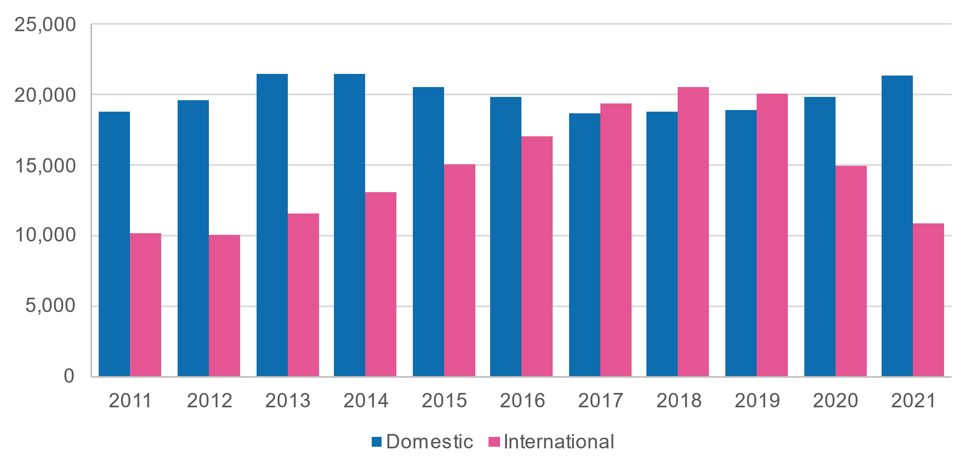
Source: Department of Education higher education unit record data
International students in related fields like Electrical and Electronic Engineering represented around 40% of commencements before COVID-19 (Figure 4.17).
Figure 4.17. Bachelors engineering commencements by student type and field, 2019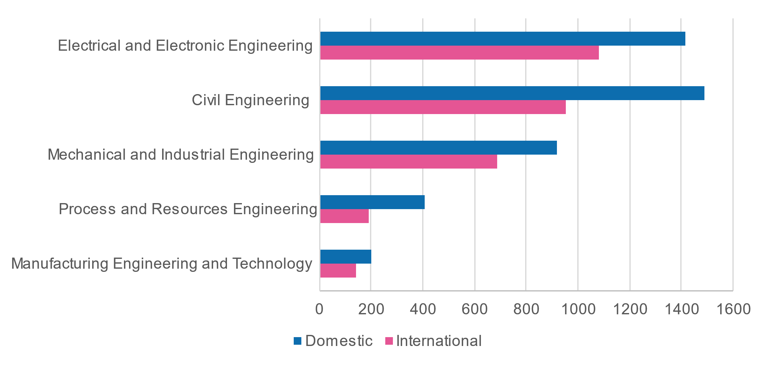Source: Department of Education higher education unit record data
The largest source country for higher education engineering students is China, followed by India and Sri Lanka. Whilst China is inarguably the world leader in clean energy employment and activity more broadly, India also occupies a significant position and has made solid progress and bold commitments towards decarbonisation.
If Australia is to retain high levels of Chinese and Indian student enrolments in the face of their respective domestic tertiary sectors, whilst improving the quality and cache of their offerings, it will need to provide tailored, high-quality clean energy education and training products.
Meanwhile, efforts to diversify Australia’s international student talent pool by way of greater outreach efforts in non-Asian markets, particularly in African and South America, have seen modestly increasing enrolments, but not yet at a scale that can offset recent declines in Chinese enrolments.
Figure 4.18. Higher Education enrolments in Engineering and Related Technologies by nationality (10 top), September 2021
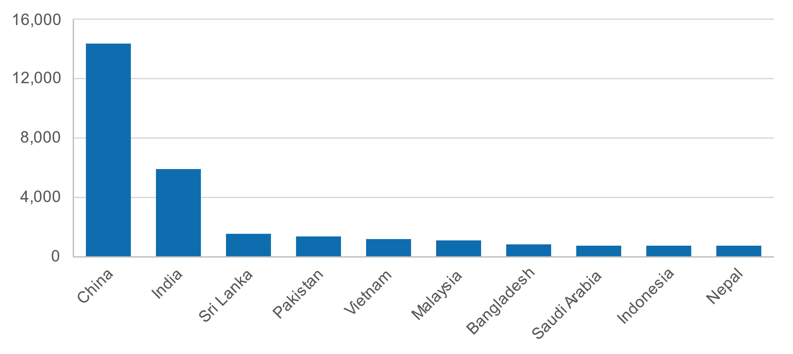
Source: Department of Education, International students studying in Australia, September 2021
Post-study pathways for international students
Of over 10,000 recent international higher education graduates surveyed by the Department of Education, over 40% expressed a preference to remain and work in Australia post-graduation. For many, this preference is driven by the professional and economic opportunities available in Australia. For others, this preference can be driven by social acceptance and mobility not available in their home country.
This demonstrates that Australia’s appeal as a diverse, equitable and multicultural society will benefit efforts to attract, educate and retain a highly skilled workforce. However, current migration settings have not fully supported the retention of these skills, and only around 16% of international students remain in Australia post-study.
As of July 2023, international higher education graduates with eligible qualifications will have the option to extend their stay in Australia with an additional two years of post-study work rights. This extension has not been made available to international VET graduates.

4c. Migration

The international context
High competition for skilled migrants
Governments around the world are working to meet their own energy needs, achieve decarbonisation commitments and develop lucrative clean energy export opportunities. Australia is not alone in its dependence on skilled migration to support the transition to a clean energy economy. As such, competition for skilled migrants with the requisite skills, qualifications and experience is high.
At the September 2022 Jobs and Skills Summit, the Hon Clare O’Neil MP, Minister for Home Affairs, acknowledged that “for the first time in our history, Australia is not the destination of choice for many of the world’s skilled migrants. Those best and brightest minds on the move are instead looking to live in countries like Canada, Germany and the UK”. This sentiment is affirmed by a 2021 analysis from Boston Consulting Group, which ranked Australia the third most appealing destination to migrant workers behind Canada and the US, noting that it was less attractive to highly educated respondents. However, Australia was ranked most appealing by respondents in the Asia-Pacific region. Australia is a similarly highly attractive destination by the OECD Talent Attractiveness measure, though outperformed in the Pacific by New Zealand.
The IEA estimates the global energy workforce at around 65 million, with just over 50% employed in clean energy-related activities. The largest and fastest growing clean energy workforce is in China, at over 10 million (Figure 4.19).
Figure 4.19. Energy employment in fossil fuel and clean energy sectors by region, 2019, in thousands of employees
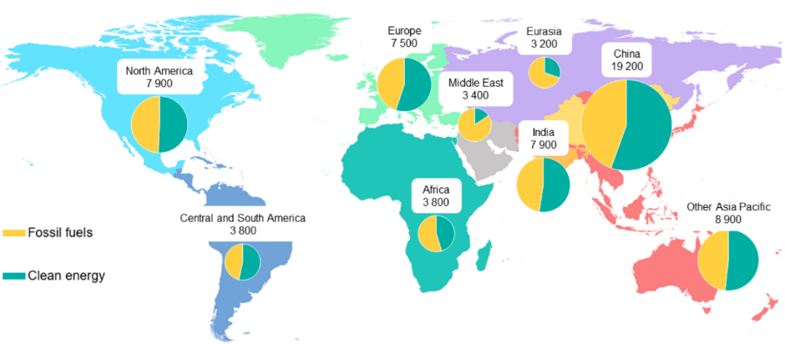Source: World Energy Employment 2022, International Energy Agency
Incentives for skilled migrants
Non-exhaustive desktop research has not identified any exclusively targeted clean energy migration incentives internationally (for example, a clean energy-specific visa pathway). Rather, in many cases, similar to the Australian approach, incentives to attract clean energy skills have been incorporated into existing skilled migration incentive programs. Below are some examples of similar tactics being deployed internationally.
The EU Blue Card Directive works to attract highly skilled workers to the EU to work in occupations with critical labour market needs, including those supporting renewable energy projects, with flexible admission conditions, enhanced rights and the possibility to move and work more easily between EU Member States.
Canada’s Federal Skilled Trades Program (Express Entry) provides fast-tracked visa processing and stable pathways to permanent residence for skilled migrants with a trades qualification relevant to identified groups within the National Occupation Classification (NOC), which includes several relevant to clean energy (subject to additional eligibility requirements).
Whilst wages and cost of living are key considerations for skilled migrants in selecting a destination country, these are not the only influential factors and the overall migration experience and social outcomes upon arrival are equally important. This sentiment is reflected in the OECD Indicators of Talent Attractiveness, which ranks nations across seven markers of attractiveness to highly skilled migrants spanning quality of opportunities, income and tax, future prospects, family environment, skills environment, inclusiveness, and quality of life.
Australia ranks generally favourably in this index (Figure 4.20), although in 2023 its profile is less appealing to highly skilled (university-educated) migrants and migrants with partners and children.
Figure 4.20. Attractiveness of OECD countries for migrants: highly educated workers
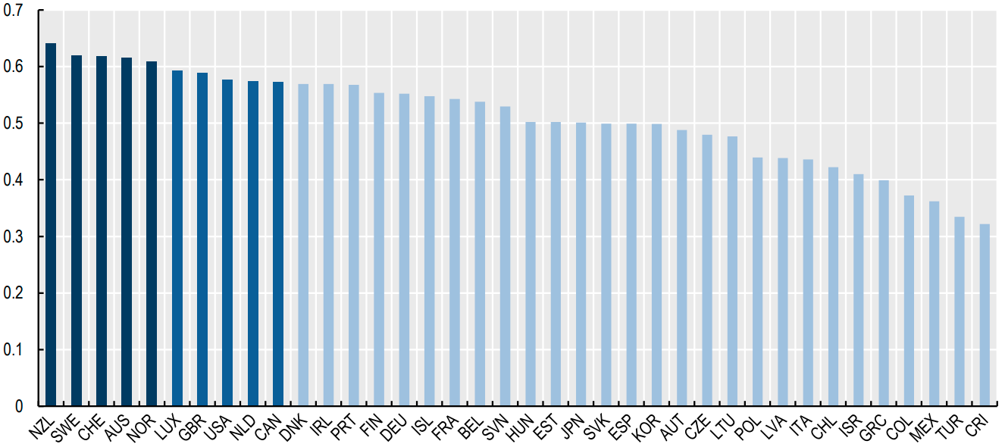
Source: OECD 2023, What is the best country for global talents in the OECD?
Note: Values closer to 1 represent higher attractiveness. The ranking is based on default equal weights across dimensions and does not include the health system performance dimension. Top-ten countries are highlighted to facilitate comparison.

Skilled migration
Whilst efforts to skill, upskill and reskill the domestic population will drive the net zero transformation, it will also be heavily reliant on effective migration settings to assist in addressing existing and anticipated skills gaps and support the growth of the clean energy workforce. Skilled migration also provides skills and knowledge transfers to local workers, which is particularly important in specialist fields and emerging sectors where Australia is starting from a low base.

Australia’s skilled migration program
Australia’s skilled migration program is designed to attract migrants who can fill positions and help to address critical workforce needs where the domestic labour force and efforts to skill Australians are unable to meet the scale and pace of industry demand. The 2023 Review of the Migration System identified that while migration alone will not address the challenges of transitioning to a clean energy economy, a well-designed and fit for purpose skilled migration program is part of the solution.
Complex and costly
The migration review has declared that Australia’s current migration program is unfit for purpose and fails to attract the skilled workers we need. Among the many recommendations and findings to come out of the review, there is an overwhelming sense that significant reforms towards crafting a more fair and efficient system centred on creating more pathways to permanent residence will be required in the coming years if Australia remains competitive in attracting skilled migrants.
Currently, there are 22 working and skilled visas available to inbound migrants to Australia, which range from short-term temporary stays extending up to two years for permanent residence. However, the migration review has identified that the current system has resulted in many migrants residing in Australia on a ‘permanently temporary’ basis, including skilled visa holders, changing between temporary visa types to extend their stay and pursue permanent residence.
In recent years the COVID-19 pandemic and subsequent border closures have also demonstrated the vulnerability of the migration system to economic and geopolitical shocks. Whilst inbound skilled migration to Australia is now rebounding to pre-pandemic levels, it cannot be assumed that the next 30 years will be free of similar shocks.
Recognition of foreign qualifications
The permanent skilled migration program requires most primary applications to undergo an assessment of their skills, qualifications and work experience to ensure they meet the standards needed for employment in Australia. The nature of these assessments varies by occupation and origin country, ranging from straightforward document verification to more complex assessment procedures.
As shown in Figure 4.21, a significant proportion of clean energy workers in Australia received their highest qualification overseas. However, having these qualifications recognised for the purposes of gaining employment in Australia is not always a streamlined process.
Figure 4.21. Proportion of workers who received their highest qualification overseas
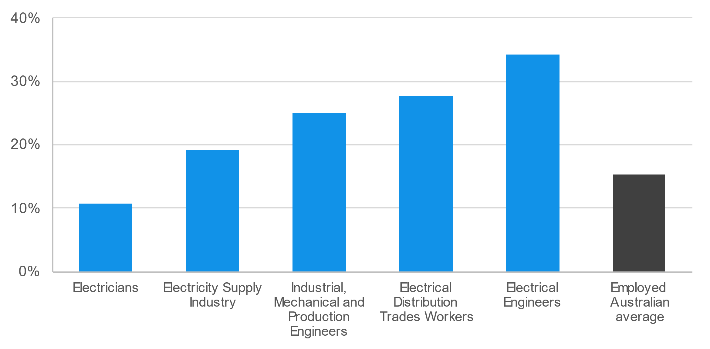
Source: ABS 2021, Qualifications and Work.
For example, Australia is a full signatory to the 1989 Washington Accord, which is a multi-lateral agreement between bodies responsible for accreditation or recognition of tertiary-level engineering qualifications. Therefore, under the accord, qualifications accredited or recognised by other signatories are recognised by each signatory as being substantially equivalent to accredited or recognised qualifications within its own jurisdiction. There are 23 full signatories and six provisional signatories to the accord, meaning that many engineering professionals receive expedited recognition when migrating to Australia.
For other clean energy core occupations, like electricians, skilled migrants are required to undergo a skills assessment, regardless of where their qualifications were obtained, with the exception of New Zealanders whose qualifications are recognised under the Trans-Tasman Mutual Recognition Act 1997.
Recommendation 4.6

As committed through the Migration System Review, ensure that skilled migration genuinely targets areas of shortage and national priority. Jobs and Skills Australia will have an important role going forward to identify skill shortages from a whole of economy perspective and consider their relative impacts. In relation to clean energy specifically this report recommends:
- Parity of treatment between higher education graduates and VET graduates in the identified critical clean energy occupations
- Regular assessment to ensure that Australian clean energy employers are not disadvantaged globally by specific visa pathways such as Canada’s Federal Skilled Trades Program (Express Entry) and the EU Blue Card Directive
- Expedited recognition of foreign qualifications relevant to clean energy
- Efficient processing of international organisations sponsoring workers internally
- Ensuring that employers utilising migration are also investing in domestic training for the same skills and job roles.

Regional labour mobility schemes
The Pacific Australia Labour Mobility (PALM) scheme supports eligible Australian businesses to hire workers from nine Pacific Island nations and Timor-Leste when not enough local workers are available. The PALM workers are typically employed in unskilled, low-skilled and semi-skilled occupations, largely concentrated in agriculture.
An opportunity may exist to support greater participation and upskilling of seasonal workers from Pacific Island nations and Timor-Leste in clean energy occupations under the PALM scheme as part of the government’s commitment to expanding and reforming the scheme to strengthen energy security in the region, particularly the Pacific and Timor-Leste. By supporting the participation of PALM workers in the clean energy sector, Australia would be supporting the development of clean energy skills and critical knowledge transfer in nations for which energy security is precarious and the impacts of climate change are high.
However, this would require significant changes to the program settings and levels of investment in the scheme, as clean energy skills are necessarily more complex and expensive to deliver than current training under PALM. One option that could be explored would be programs for Australian education and training providers to deliver initial training to Australian standards overseas prior to workers securing a visa pathway.
An alternative model would be for foreign workers to come to Australia for the purposes of undertaking an apprenticeship. As explored earlier, this would present many challenges and risks, including of exploitation and safety, and the value proposition for employers and workers would need to be clear. Changes would also need to be made to employment restrictions for international students and appropriate supports, oversights and safeguards put in place.

4d. Workforce transitions

What do we mean by transitions?
A transition is when a worker changes their job voluntarily or because of industry adjustment or retrenchment (Table 4.12). Chapter 5 provides estimates for where jobs will likely be created and lost over the next 10, 20 and 30 years. It also shows the occupations and regions that will see new employment opportunities because of the clean energy transition. This section examines the likely transition pathways for workers at short-term risk of involuntary transition, although some of these pathways are also relevant for those who voluntarily transition. Chapter 8 explores the barriers and enablers to a successful transition.
Table 4.12. Types of involuntary transitions
Type of transition | Extent of change | Example | Type of supports
Changing work type | Same employer and occupation, but the focus shifts. | Petroleum refining moving towards biofuels. | In-house people management. Minor upskilling and familiarisation.
Changing worksite | Worksite closes but similar opportunities exist with same employer. Requires relocation. | Individual coal mine or power station closures. | In-house people management. Relocation support.
Changing employer | Employer retrenches staff due to changing needs. Requires job searching for same role. | Individual coal mine and power station closures but others exist. | Retrenchment supports to find new job.
Changing industry | Limited opportunities within same industry, or wanting to learn about new markets and trends. Can apply majority of skills to new industry. | Electrician moving from coal power station to renewables. | Retrenchment supports to find job in new industry. Upskilling likely.
Changing occupation | Limited opportunities within same occupation. Requires major reskilling or upskilling. | Power plant operator. | Retrenchment supports and major reskilling.
Exiting the labour force | Leaving employment. | Unemployment, unplanned early retirement, full-time study or short-term breaks from employment. | Specialist financial advice for workers. Employment services for partners.
Broader employee assistance programs (EAP) and supports like counselling, financial advice and return to work mechanisms are relevant for workers undergoing all types of transitions.

Workers that may need to transition

Impacted industries
As explored in Chapter 2, the primary industry that will be impacted in the short term is fossil fuel power generation, particularly coal-fired power. The Australian Government has committed to support workers in emissions intensive sectors to access new employment, skills and support as the net zero transformation continues.
Fossil-fuel-related groups will decline or transform substantially as a result of decarbonisation (Table 4.13). None are expected to completely disappear by 2050 based on existing policy targets and settings, but there will be substantial change:
- Coal mining to service domestic electricity generation will substantially reduce, while the current policy settings have less of an impact on coal mining for industrial purposes (metallurgical coal) and export.
- Oil extraction and petroleum exploration are in a similar situation.
- Gas supply and pipeline transport (predominantly involving gas transport at present) will likely see change. However, the extent of change will depend on whether hydrogen becomes a viable replacement for the current industrial, domestic and transport applications of natural gas. The Australian Government is developing a Future Gas Strategy that will outline an approach to managing gas through the energy transformation.
- There will likely be continued reduced demand for petroleum refining, petroleum fuel manufacturing (and manufacturing of other petroleum and coal products), petroleum product wholesaling and fuel retailing. These sectors will increasingly be directed toward producing and distributing sustainable fuels.
- Most of Australia’s coal-powered electricity generators are expected to close by 2050 (see Chapter 1), but it is expected there will be an ongoing role for gas-fired electricity generation as part of load management.
As explored earlier in Chapter 1, the Australian Government is committed to support workers in emissions-intensive sectors to access new employment, skills and support as the net zero transformation continues.

Table 4.13. Major industries groups that will transition and employment size, 2021
Mining |  | Manufacturing |  | Electricity, Gas, Water & Waste |  | Wholesale and Retail Trade
Coal mining | 49,616 | Petroleum Refining and Petroleum Fuel Manufacturing | 1,475 | Fossil Fuel Electricity Generation | 6,630 | Petroleum Product Wholesaling | 7,115
Oil and gas extraction | 18,693 | Other Petroleum & Coal Product Manufacturing | 938 | Gas Supply | 5,104 | Fuel Retailing | 35,761
Petroleum Fuel Manufacturing | 1,114 | Petroleum and Coal Product Manufacturing | 31 |  |  | Pipeline Transport | 2,089
Total | 69,423 | Total | 2,444 | Total | 11,734 | Total | 44,965
Source: ABS Census 2021, JSA analysis

Impacted regions
Fossil fuel electricity generation employment is located across Queensland (31%), Western Australia (21%), NSW (20%) and Victoria (19%). Conversely, coal mining employment is heavily concentrated in Queensland (52%) and New South Wales (42%) (Table 4.14). Many of the key impacted regions, including Latrobe and Hunter Valley, are key focus areas of the new Net Zero Authority established by the Australian Government.
Table 4.14. Regions with high employment in emissions intensive industries (SA3)
Fossil Fuel Electricity Generation |  |  | Coal Mining
VIC | Latrobe Valley | 664 | QLD | Bowen Basin - North | 11,074
QLD | Brisbane Inner | 498 | NSW | Lower Hunter | 6,095
QLD | Gladstone | 322 | QLD | Central Highlands | 5,495
WA | Canning | 321 | NSW | Upper Hunter | 3,274
QLD | Biloela | 260 | NSW | Lithgow - Mudgee | 2,641
VIC | Melbourne City | 227 | QLD | Brisbane Inner | 2,231
NSW | Wyong | 213 | QLD | Mackay | 2,224
WA | Bunbury | 209 | WA | Biloela | 1,450
QLD | Rockhampton | 196 | NSW | Wollondilly | 1,400
QLD | Burnett | 191 | NSW | Tamworth - Gunnedah | 1,207
WA | Perth City | 171 | NSW | Lake Macquarie - West | 1,202
NSW | Upper Hunter | 150 | QLD | No Fixed Address (Qld) | 986
NSW | Sydney Inner City | 129 | NSW | Dapto - Port Kembla | 752
QLD | Darling Downs West | 118 | NSW | Newcastle | 720
NSW | Lake Macquarie - West | 117 | WA | Bunbury | 659
NSW | Lithgow - Mudgee | 116 | NSW | Wollongong | 542
SA | Port Adelaide - West | 105 | NSW | Maitland | 496
QLD | Darling Downs - East | 101 | NSW | Moree - Narrabri | 476
NT | Darwin Suburbs | 75 | NSW | No Fixed Address (NSW) | 380
WA | East Pilbara | 73 | WA | Perth City | 378
Source: ABS Census 2021, JSA analysis

Impacted occupations
Fossil Fuel Electricity Generation and Coal Mining employ a diverse range of occupations. Many generalist occupations, like Accountants and Truck Drivers, are also employed in high numbers outside of these industries. Other occupations, like Power Generation Plant Operator, have limited employment prospects outside these industries and are therefore at greater risk (see Table 4.15).
Table 4.15. Occupations and their concentration in impacted industries
Fossil Fuel Electricity Generation |  |  | Coal Mining
Occupation | # | % | Occupation | # |  | %
Power Generation Plant Operator | 705 | 33.7 | Miner | 14,808 |  | 36.5
Electrician (General) | 528 | 0.4 | Fitter (General) | 5,983 |  | 8.7
Fitter (General) | 344 | 0.5 | Electrician (General) | 2,639 |  | 2.1
Electrical Engineer | 237 | 1.3 | Truck Driver (General) | 2,369 |  | 1.2
Specialist Managers nec | 186 | 0.6 | Mine Deputy | 2,051 |  | 27.8
Program or Project Administrator | 172 | 0.2 | Production Manager (Mining) | 1,479 |  | 13.5
Mechanical Engineer | 138 | 0.6 | Metal Fabricator | 939 |  | 2.2
Metal Fabricator | 114 | 0.3 | Mining Engineer | 929 |  | 15.8
Accountant (General) | 106 | 0.1 | Maintenance Planner | 641 |  | 7.7
Electrical Engineering Technician | 101 | 1.5 | Driller | 565 |  | 7.0
General Clerk | 99 | 0< | Shot Firer | 528 |  | 20.3
Source: ABS Census 2021, JSA analysis. # is the total number of workers in this industry and occupation. % is the proportion of the entire occupation that works within this one industry. Red indicates occupations with a high reliance on transitioning industries for employment, while green indicates a low reliance (and therefore lower risk).

What are the viable transition pathways?
JSA has identified potential transition pathways for fossil fuel power generation workers using three methods:
- Finding the industries that employ the same occupations in large numbers. For example, Power Generation Plant Operators are also commonly employed in:
  - On Selling Electricity and Electricity Market Operation
  - Electricity Distribution
  - Alumina Production
  - Hydroelectricity Generation
  - Other Electricity Generation (e.g. solar and wind).
However, it’s important to acknowledge that occupations can have different skills needs or experience requirements in different industries. For example, it is unlikely that an electrician who worked exclusively in coal-fired power will have the experience they need to work with a large scale battery installation.

Recommendation 4.7
Jobs and Skills Councils should explore accessible familiarisation training for qualified trade workers to gain exposure and experience with clean energy technologies and practices. This will be particularly important for supporting and encouraging workers in transitioning sectors to access clean energy jobs.
- Finding the real-world occupation to occupation transitions that have occurred in the past. For example, between 2011-12 and 2020-21, over 250 Power Plant Operators became Earthmoving Plant Operators (see Figure 4.22).
Figure 4.22. Occupation transitions for Power Plant Operators
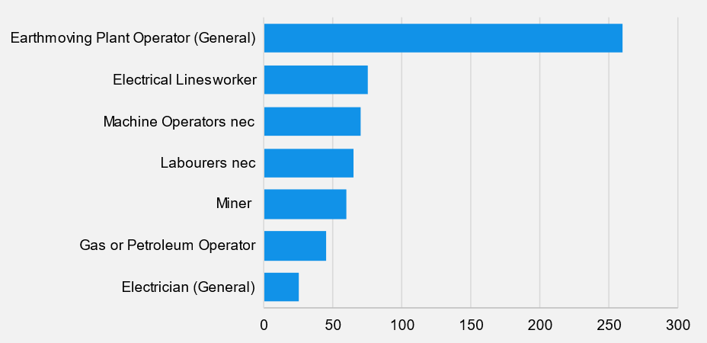
Source: JSA analysis of unit record taxation statistics, covers transitions from 2011-12 to 2020-21.

CASE STUDY: Real world transitions

Alongside the skill similarity analysis of occupations, we can analyse the actual transitions of six critical occupations in the clean energy and fossil-fuel sectors over the four years to 2021, using new multi-agency government data.
The six core occupations analysed were:
- Electricians
- Electrical Engineers
- Drillers, Miners and Shot Firers
- Airconditioning and Refrigeration Mechanics
- Chemical, Gas, Petroleum and Power Generation Plant Operators; and,
- Electrical distribution trades workers.
Workers in these occupations were much more stable than the average for Australia. We found that most workers did not change occupations in the four-year period, potentially reflecting the short time frame as well as the high retention in these occupations (between 85.8% to 91.6% across all six). Table 4.16 shows the most common inflow and outflow occupations.
Table 4.16. Common occupation inflows and outflows
Main inflow | Core occupation | Main outflow
Electrical trades assistant/labourer  Telecommunications trades assistant | Electricians | Electrical Engineer
Electricians | Electrical Engineers | Electrical appliance servicer or repairer  Electrical fitter  Electrical mechanic Electrician - general
Trades assistants  Truck drivers  Labourers | Drillers, Miners and Shot Firers | Mining deputy Mine supervisor
Labourers - other  Trades assistants | Airconditioning and Refrigeration Mechanics | Mechanical services plumber
Earthmoving plant operator general  Labourers - other  Trades assistants  Prospectors | Chemical, Gas, Petroleum and Power Generation Plant Operators | Earthmoving plant operator - general
Electrical appliance servicer or repairer  Electrical fitter  Electrical mechanic  Electrician - general | Electrical distribution trades workers | Electrical appliance servicer or repairer  Electrical fitter  Electrical mechanic  Electrician - general

- Finding occupations with high skills similarity that could be low-friction transitions. For example, Power Generation Plant Operators share many of the same skills with Electricians and Fire Protection Equipment Technicians (see Figure 4.23). However, it’s important to stress that occupations are defined by more than skills, including:
    - Licensing
    - Training pathways and their availability
    - The organisation of work – physical, temporal and social dimensions
    - Perceived societal value and status
    - Monetary value as influenced by multiple factors – skill premium, balance of demand and supply, sector, unionisation.
These factors can act as additional barriers, or incentives, that make some transition options more accessible than may appear on paper. As such, skills similarity analysis is conceptual only and can often overstate the ease of occupational transitions.
Figure 4.23. Example skills similarity mapping
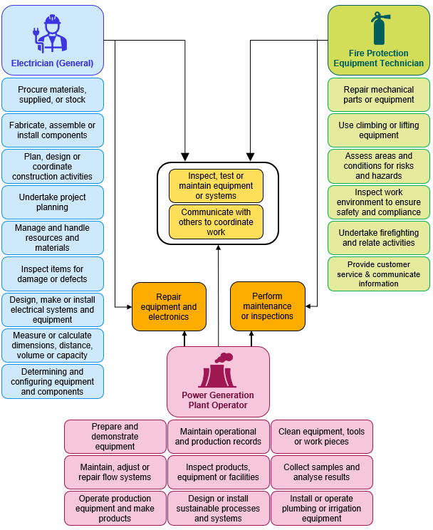
Source: JSA, Australian Skills Classification November 2022. Yellow skills are in common across all three occupations, while the orange skills are in common across two occupations.
Table 4.17 shows potential transition pathways for the largest Fossil Fuel Electricity Generation occupations using each of these methods
Table 4.17. Pathways for largest Fossil Fuel Electricity Generation occupations
Current Occupation | Common industries | Most common real-world transitions | Similar occupations (skills similarity)
Power Generation Plant Operator | On Selling Electricity and Electricity Market Operation  Electricity Distribution  Alumina Production  Hydroelectricity Generation  Other Electricity Generation | Earthmoving Plant Operator  Electrical Distribution Trades Workers^  Machine Operators nec | Boiler or Engine Operator (HIGH)  Electricians (HIGH)  Fire Protection Equipment Technician (HIGH)  Gas or Petroleum Operator (HIGH)  Electrical Engineering Technician (HIGH)  Electrical Distribution Trades Workers^ (HIGH)  Production or Plant Engineer (HIGH)  Lift Mechanic (MEDIUM)
Electrician (General) | Electrical Services  Electricity Distribution  Other Heavy and Civil Engineering Construction  Domestic Appliance Repair and Maintenance  Rail Passenger Transport | Electrical Engineering Technician^  Electrical Engineer  Electrical or Telecommunications Trades Assistant  Automotive Electrician  Electrical Distribution Trades Workers^  Airconditioning and Refrigeration Mechanic  Electronic Instrument Trades Worker^  Labourers  Technicians and Trades Workers nec  Motor Mechanic | Electrician (Special Class) (HIGH)  Electronic Instrument Trades Worker^ (HIGH)  Lift Mechanic (HIGH)  Electrical Engineering Technician^ (HIGH)  Electrical Distribution Trades Workers^ (HIGH)  Electrical Engineering Draftsperson (HIGH)  Telecommunications Trades Workers (HIGH)  Power Generation Plant Operator (HIGH)  Electronic Equipment Trades Worker (HIGH)  Mechanical Engineer (HIGH)
Fitter (General) | Other Machinery and Equipment Repair and Maintenance  Iron Ore Mining  Other Automotive Repair and Maintenance  Other Specialised Industrial Machinery and Equipment Wholesaling | Fitter and Turner  Diesel Motor Mechanic  Motor Mechanics  Miner  Fitter-Welder  Mechanical Engineer  Mechanical Engineering Technician  Maintenance Planner  Metal Fabricator^  Mine Deputy | Metal Machinist (First Class) (HIGH)  Welder (First Class) (HIGH)  Toolmaker (HIGH)  Precision Instrument Maker and Repairer (HIGH)  Metal Fabricator^ (HIGH)  Precision Metal Trades Workers (HIGH)  Metal Casting, Forging & Finishing Workers (HIGH)  Product Assemblers (HIGH)  Sheetmetal Trades Workers (HIGH)  Engineering Patternmaker (MEDIUM)
Electrical Engineer | Engineering Design and Engineering Consulting Services  Electricity Distribution  Electrical Services  Other Heavy and Civil Engineering Construction  Electricity Transmission | Electrician  Electronics Engineer  Electrical Engineering Technician^  Mechanical Engineer^  Computer Network and Systems Engineer | Production or Plant Engineer (HIGH)  Engineering Technologist (HIGH)  Mechanical Engineer^ (HIGH)  Industrial Engineer (HIGH)  Electrical Distribution Trades Workers (HIGH)  Electrical Engineering Technician^ (HIGH)  Electrical Engineering Draftsperson (HIGH)  Telecommunications Engineering Professional. (HIGH)  Materials Engineer (HIGH)
Mechanical Engineer | Engineering Design and Engineering Consulting Services  Other Heavy and Civil Engineering Construction  Manufacturing, nfd  Motor Vehicle Manufacturing  Iron Ore Mining | Engineering Manager  Mechanical Engineering Technician^  Construction Project Manager  Motor Mechanic (General)  Civil Engineer | Production or Plant Engineer (HIGH)  Industrial Engineer (HIGH)  Engineering Technologist (HIGH)  Materials Engineer (HIGH)  Structural Engineer (HIGH)  Mechanical Engineering Technician^ (HIGH)  Electrical Engineers (HIGH)  Chemical Engineer (HIGH)  Geotechnical Engineer (HIGH)  Aeronautical Engineer (HIGH)
Metal Fabricator | Iron Smelting and Steel Manufacturing  Basic Non-Ferrous Metal Manufacturing, nfd  Manufacturing, nfd  Structural Steel Fabricating  Other Heavy and Civil Engineering Construction | Welder (First Class)^  Fabrication Engineering Trades Workers nfd  Fitter (General)^  Mechanical Engineering Trades Workers nfd  Truck Driver (General)  Sheetmetal Trades Worker^ | Welder (First Class) ^ (HIGH)  Metal Casting, Forging & Finishing Workers (HIGH)  Metal Machinist (First Class) (HIGH)  Fitter (General)^ (HIGH)  Precision Metal Trades Workers (HIGH)  Toolmaker (HIGH)  Sheetmetal Trades Workers^ (HIGH)  Structural Steel Erector (HIGH)  Product Assemblers (MEDIUM)  Engineering Production Workers (MEDIUM)
Electrical Engineering Technician | Electrical Services  Electricity Distribution  Scientific Testing and Analysis Services  Other Heavy and Civil Engineering Construction  Oil and Gas Extraction | Electrician (General) ^  Electrical Engineer^  Electronic Engineering Technician^ | Electrical Engineering Draftsperson (HIGH)  Mechanical Engineering Technician (HIGH)  Electronic Engineering Draftspersons & Technicians^  Civil Engineering Technician (HIGH)  Electrician (General) ^ (HIGH)  Electrical Engineers^ (HIGH)  Mechanical Engineering Draftsperson (HIGH)  Electronic Instrument Trades Worker (General) (HIGH)  Electrician (Special Class) (HIGH)  Engineering Technologist (HIGH)
^ occupations that appear in common real-world transitions and skills similarity (columns 3 and 4)


Chapter 5:
Future states

Demand for clean energy workers to 2050. What jobs do we need, which regions do they need to be in and where will the workers come from?

Introduction
This chapter explores pathways for Australia’s transition to net zero and presents preliminary analysis of the workforce implications of them. We analyse the jobs that will be in demand; the industries that will change; the regions where clean energy jobs will be needed most; and the likely skills gaps that we need to prepare for. We also identify the jobs and regions that are likely to be impacted by the transition away from fossil fuels but also the opportunities that will arise from this broader economic transformation, including in those same regions. In doing so, this chapter offers insights to some of the big questions in the broader study:
- What are the jobs needed to support our transition to net zero: In which industry sectors, for which occupations, in which regions, and by when?
- What are the jobs impacted by transitioning away from fossil fuels: again, in which industry sectors, for which occupations, in which regions, and by when?
- Do we have the supply of workers and skills we need and considering the broader shifts across the workforce, what is the optimal approach to filling clean energy roles?
- What are the opportunities to support workers and communities transitioning from fossil-fuels into new jobs?
- What are the gaps – both in terms of filling clean energy roles and supporting workers transitioning from fossil fuel-based sectors – and how might the education and migration systems assist?
Modelling is being undertaken for Jobs and Skills Australia by Deloitte Access Economics and uses a computable general equilibrium model with an integrated assessment model, incorporating damages caused by climate change. Analysis of this preliminary modelling is in progress and this chapter presents a selection of the main preliminary findings.
Our central scenario for the transition to net zero broadly aligns with current Government climate and energy policy, and future policy intent. This scenario is contrasted with two alternative pathways to net zero that illustrate different possible policy and technology directions that could emerge. The bulk of the chapter’s analysis relates to the central scenario for this reason.
Preliminary modelling results finds that achieving the current national 2030 interim emissions and renewable energy targets is necessary for higher economic and jobs growth in the face of the economic damage associated with climate change. Our central scenario models sustained investment (at an increasing rate), resulting in the delivery of the target of 82% renewable energy in the NEM by 2030 and supporting the achievement of the interim emission reduction target of 43% (below 2005 levels) at a relatively lower transition cost.

Following this, our scenarios focus in on different possible policy interventions and coordination at the national level and plot different paths the Australian economy could follow. All three scenarios achieve net zero by 2050 but differ in the extent to which they assume implementation of Rewiring the Nation and achieve electrification and the use of alternative low-emission technologies for industry. All three scenarios were constructed with reference to AEMO’s 2023 proposed scenarios including the main Net Zero Central scenario which is a variation of AEMO’s Orchestrated Step Change scenario.
Much of the benefits to the economy of the clean energy transformation are realised beyond 2050. In fact, the preliminary modelling suggests the long-term economic benefits that occur after transition on meeting net-zero are not captured in this study. The study period focuses on the impacts of the transition and thus by definition, reflects the points in time where economic impacts are more prominent. The long-term net economic, social, and environmental benefits of having transitioned occur post-2050.
This study acknowledges the uncertainties that come with climate change modelling, however the methodological approach for this study helps us focus policy attention on the how the labour market may change through this transformation. Thus, the accompanying preliminary results are not forecasts but offer some insights into the long-term view of the impacts of climate change, Australia’s response to this, and what conclusions we can draw about changes in industries, regional economies and ultimately occupations.

5a. The central and other scenarios
The preliminary occupation and regional analysis outlined in the following sections has been tested across three scenarios which model how sectors and regions interact based on different assumptions about technology, investment, consumption, wages and broader economic activities (Figure 5.1). This allows us to identify what jobs we will likely need, which regions they need to be in and how many workers we will need to fill them. We can then examine the different workforce, training, and migration pathways Australia might need for the net zero transition. The main scenario is:
- a central scenario that sees coordinated policy action with increased investment into low-emissions activities. Australia delivers Rewiring the Nation, and the national electricity system has 82% renewable energy by 2030. Beyond 2030, continued coordination of investment across higher emitting sectors, such as agriculture, reduces the costs of transition by increasing new low-emission activities. This scenario broadly aligns to current government climate and energy policy to 2030, including Government support for hard-to-abate sectors and reflects the stated policy intent to meet net zero by 2050.
The other two scenarios are:
- a low scenario that sees slow implementation, does not deliver current Federal Government policy settings and sees slower progress in expanding the share of renewable energy in the national electricity system with only 69% renewable energy by 2030.
- a high scenario that sees more ambitious and coordinated policy action, giving the national electricity system over 90% renewable energy by 2030. The investment in low-emission technologies is three times larger and more renewable energy capacity supports exporting green manufacturing (including iron) and a larger critical minerals mining and processing industry. Australia becomes a renewable energy and green industrial superpower due to its role in global supply chains. While there is increasing interest in the notion of Australia becoming a clean energy superpower, the assumptions underpinning this scenario are more ambitious than the measures outlined within current Government policies.

Key differences across the scenarios
Co-ordinated investment would likely drive employment growth
The central scenario is broadly aligned to current Government climate change and energy policy settings to 2030 and represents a stylised view to policy intent to 2050. By 2030, Australia achieves 82% renewables in the NEM through coordinated implementation of Government policy, including full implementation of the Rewiring the Nation policy. Investment into low-emissions activity and renewable energy increases.
The 43% interim emissions reduction target by 2030 is met and the scenario assumes that this is achieved with a lower economic cost of transition due to increases in alternative industry activity within particular hard to abate sectors. By maintaining output and employment within these sectors, alternative activities offset the costs of high-emission industry transition (the economic abatement cost is lower). The central scenario assumes continued investment post 2030 (to capitalise on the investments already made to 2030), resulting in higher regional growth in employment and across industries through to 2050.
In the decade following meeting Australia’s interim targets, Australia starts to see higher growth rates in industries, such as manufacturing, construction and agriculture, and continued growth in the clean energy sectors compared to the low scenario. The preliminary modelling suggests the central scenario is likely to result in 1.2 million more workers in the economy in 2050 compared to low scenario through increased labour force participation. There is also a relatively higher paid workforce and the creation of higher skilled jobs in this scenario compared to the low scenario.
Figure 5.1. Central scenario
Scenario ​ | Scenario alignment | Emissions reduction | Renewable energy mix | Key policy differences
Central | Full implementation of global target commitments  SSP1-2.6, 1.7°C by 2050 | 43% emissions reduction below 2005 levels by 2030  Net zero emissions by 2050 | 82% clean energy in the NEM by 2030 | - AEMO: Orchestrated Step Change, ISP2023  - Rewiring the Nation: full and coordinated implementation to 2030  - Global climate alignment: SSP1-2.6, 1.7°C by 2050, full implementation of global target commitments

A slower implementation of a clean energy market likely means a harder structural adjustment
The low scenario provides a contrast to existing Government policy commitments. In this scenario, by 2030 Australia has not met current Government policy to achieve 82% renewables in the NEM or implemented Rewiring the Nation. The 43% interim emissions reduction target is still met by broader declines in emissions, but this is achieved through industry determining its own abatement cost. This is assumed to occur at a higher economic transition cost due to the reduced role of renewable energy. There is some regional and industry growth in employment to 2030, as some effort is made to transform the NEM.
However, with an assumption of only 69% share of clean energy achieved in the NEM by 2030, preliminary modelling suggests growth in employment slows over the following decades to 2050, with some regions likely experiencing declines in employment due to higher transition costs. It is a ‘harder’ structural adjustment. From 2040 to 2050, Australia’s cost of transition remains relatively high resulting in much slower employment and industry growth.
By 2050, the scenario assumes that emissions intensive activity declines and is not replaced. As global demand for low emissions goods and services ramps up post 2030, Australia is not able to meet this demand leading to declines in employment outcomes for some sectors.
Becoming a clean energy superpower increases the benefits of transition by 2050, but requires significant effort
The third scenario imagines a situation where investment in Australia’s natural endowments are supercharged, and Australia becomes a significant clean energy exporter. The high scenario assumes targeted investment in Australia’s competitive advantages and strong global action to transition to a low-emission industrial economy. From the 2030’s this leads to the deployment of new technologies to enable economy-wide emissions reduction. This occurs as the world steps up decarbonisation and limits global temperature rise to 1.5˚C by 2050. The scenario assumes that Australia invests in new and emerging technologies such as hydrogen; expands critical minerals mining and green manufacturing (especially green iron); and builds its competitive advantage in the export of low-emissions goods and services as global demand increases. In this scenario, there is a significant transformation in Australia’s processing and manufacturing capabilities, underpinned by a growing green hydrogen sector and significantly larger volumes of renewable energy.
The modelling of this scenario assumes that a substantial amount of investment (around three times the level under the low scenario) is directed to clean energy. This accelerates and exceeds the 2030 targets (achieving almost over 90% renewable energy in the NEM by 2030), with preliminary results indicating likely higher growth in employment in the next decade compared to the other scenarios.
On exceeding 2030 targets, the high scenario assumes that Australia has signalled to global markets its role as a clean energy superpower in the global transition to net zero. Significant effort is required to build domestic industrial capabilities to meet increased foreign demand. Further, this scenario assumes that by 2050, Australia’s cost of transition is offset by diversifying economic activity to low-emission exports and increasing industrial competitiveness in terms of industry output and associated net employment growth facilitated by higher participation in the labour market.
In his book The Superpower Transformation, Professor Ross Garnaut suggests that Australia could become a major exporter of net-zero emissions manufactured goods. By using our own green hydrogen, Australia could refine and smelt iron ore and bauxite competitively. However, to realise this goal Australia would require around 10,000 terawatt-hours of annual power generation, which is over 50 times the current capacity of the NEM and 10 times the capacity required under AEMO’s hydrogen superpower scenario.
Figure 5.2. Alternative scenarios
Scenario ​ | Scenario alignment | Emissions reduction | Renewable energy mix | Key policy differences
Low | Full implementation of global target commitments  SSP1-2.6, 1.7°C by 2050 | 43% emissions reduction below 2005 levels by 2030  Net zero emissions by 2050 | 69% clean energy in the NEM by 2030 | - AEMO: Orchestrated Step Change, ISP2023  - Rewiring the Nation: lack of coordinated implementation and no targeted investment (public and private) to 2030  - Global climate alignment: SSP1-2.6, 1.7°C by 2050, full implementation of global target commitments
High | Net Zero Emissions by 2050 – global coordinated action  SSP1-1.9, 1.5.0°C by 2050  AEMO: Net zero (energy exports)  IEA: Net Zero Emissions by 2050. | 43% emissions reduction below 2005 levels by 2030  Net zero emissions by 2050 | 92% clean energy in the NEM by 2030 | - AEMO: Net Zero (green energy exports scenario)  - Rewiring the Nation: fully implemented earlier, with the energy system transformed beyond current policy settings by 2030 and a larger quantum of clean energy in the economy  - Global climate alignment: SSP1-1.9, 1.5°C by 2050, global coordinated action to meet net zero by 2050

Comparison with other estimates of future employment impacts of net zero
The modelling approach uses both integrated assessment modelling (IAM) and labour market supply and demand modelling undertaken by Deloitte Access Economics. This approach is different from the methodology used to produce other forecasts for the clean energy workforce, which rely on employment factors to produce workforce numbers based on ratios of workers to units of energy production (or similar). The approach adopted here models how regional workforces transform under different scenarios. Global conditions and changes in technology over time are included in the assumptions. The regions of Australia have been constructed to coincide wherever possible with REZs.
The preliminary results from the model presented here looks to solve for an outcome – in this case net zero emissions by 2050 – in an economically efficient way. It considers the availability of capital and labour (including the distribution of skills within the labour force) as well as relative prices for inputs and outputs across the different sectors of the economy. This is a more sophisticated framework than that deployed by analyses of the future clean energy workforce in Australia that use an employment factors approach.

5b. Workforce demand
Under the three scenarios, the preliminary modelling leads to different employment impacts, industry transformation, job growth and demand across the country and regions. All three scenarios involve structural change across the economy and higher than average growth in the core clean energy sectors is likely. Again, across all three, the strongest employment growth is likely to occur in the next seven years, driven by investments in clean energy. The preliminary modelling shows employment growth is likely to be around 7.6% across the next seven years in the clean energy supply sector in the main central scenario. Post 2030, the intensity and structure of employment growth begins to diverge across scenarios. Overall, the clean energy supply workforce is likely to grow from around 53,000 today to 84,000 by 2050 in the central scenario.
The shift from emissions intensive power sources to clean electricity means that construction and renewable energy are likely to see particularly high growth in employment demand under central and high scenarios. This is driven by large-scale investment and requires a significant workforce to support construction and ongoing operations.
Industries that contribute to the supply of electricity or facilitate the demand of electricity experience growth as Australia’s economy transitions. The significant investment in renewable energy capacity results in likely strong jobs growth in wind, offshore wind, solar and hydroelectricity over the next seven years. Employment growth in these emerging sectors outpaces that of the low scenario over the same period. Some industries decline in importance, but new industries also emerge.
From an occupational perspective, the preliminary modelling shows the sum of all 38 critical clean energy occupations exhibits a higher growth rate of jobs growth than the overall labour market and there is high demand for trades and technician workers especially electricians, including in the regions. In the central scenario, demand for these 38 occupations is likely to increase by around 15% in the next seven years to deliver the net zero transformation. This represents an increase of almost 240,000 workers.

How are industries likely to transform?
Our preliminary analysis shows under the central scenario there is likely to be strong growth in the hydro-electricity generation, wind generation, solar generation, and offshore wind generation sectors. These sectors would add around 14,000 jobs by 2030 and around 70,000 by 2050.
Construction is also likely to grow because much of the activity to build and replace transmission infrastructure is in the civil construction sector. These emerging energy supply industries are reliant on a strong construction pipeline. This pipeline would create around 450,000 jobs in the next seven years – almost one third of all the jobs growth expected over this period. Many of these jobs are in NSW.
Employment growth in construction would likely slow in the following decades. There is also likely to be relative growth in industries like offshore wind. Preliminary analysis also shows declines are likely across all scenarios in emissions intensive sectors including fossil-fuel intensive electricity generation and coal mining, driven by legacy coal plants reaching end of life being replaced by renewable generation and storage, with associated mine closures as well as international and other factors.
Due to scheduled closures of ageing assets, preliminary analysis shows fossil fuel energy generation is likely to record the largest falls in percentage terms, but in terms of levels the largest falls are likely in coal mining, both associated with closing coal mines and due to international demand changes. This could contract by around 15,000 employees by 2030. However, it should be noted that this will occur over a period in which the economy is likely to add around 1.5 million jobs overall.

What occupations are likely to be in demand?
In total, the preliminary modelling indicates we are likely to see demand for the 38 critical clean energy occupations to follow a higher growth rate than the broader workforce (see Figure 5.3).
Figure 5.3. Employment growth by scenario (all occupations and critical clean energy occupations)
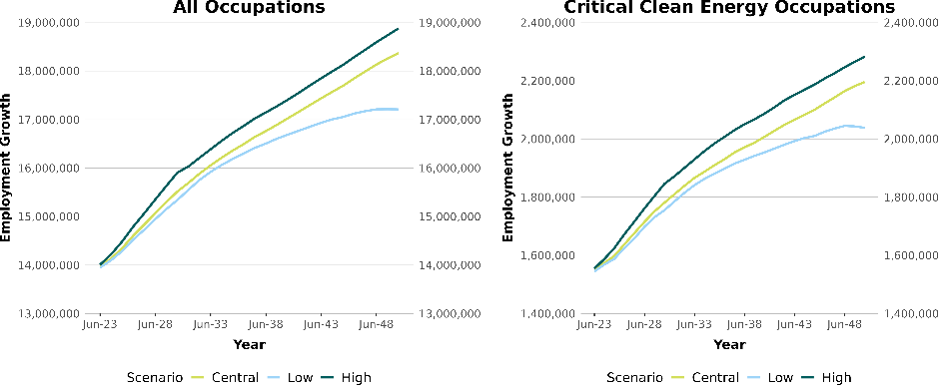
Source: Deloitte Access Economics 2023.
As the economy transforms to align with net zero and renewable targets, industries that contribute to the supply of electricity, or facilitate the demand for electricity, are likely to grow as Australia’s economy transitions (Figure 5.4). These industries are likely to experience some of the highest rates of growth as Australia invests heavily in renewable energy generation and supports industries which can leverage the opportunity of electrification. Growth is, largely, highest in the first decade as rapid investment is rolled out to reach 2030 targets.
Figure 5.4. Average Annual Growth Rates (%) by clean energy segments, 2023-2050
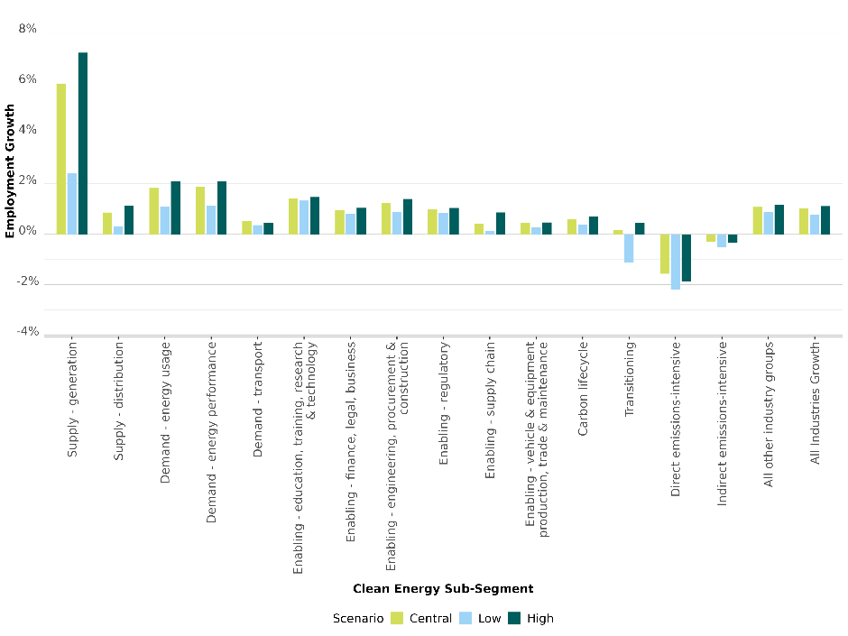Source: Deloitte Access Economics 2023.
In the following discussion we focus on the growth for a selection of these 38 occupations, based on the preliminary modelling, which represent the most critically important occupations to support the transformation.
Occupations with the highest growth rates in the next seven years (2023-2030) include Telecommunications Trades Workers, Electronics Trades Workers, Electrical Engineering Draftspersons and Technicians, Structural Steel Construction Workers, Construction Managers, Plumbers and Electricians. The growth rates for these occupations are comparable across the low and central scenarios, but much higher under the high scenario.
In the decade leading to 2050, occupational growth is still dominated by the above listed occupations although at a significantly slower rate compared to the initial period. Also, it should be noted that the employment growth rates for the central and high scenarios are very similar for the decade while the low scenario lags due to a lack of sustained investment.

Table 5.1. Average Annual Change (%) in employment by occupation – 2023 to 2030
Occupation | Low | Central | High
Telecommunications Trades Workers | 7.9 | 8.0 | 8.4
Electronics Trades Workers | 6.0 | 6.1 | 6.5
Electronic Engineering Draftspersons and Technicians | 5.2 | 5.1 | 5.4
Structural Steel Construction Workers | 3.0 | 3.2 | 3.9
Construction Managers | 2.6 | 2.9 | 3.7
Plumbers | 2.3 | 2.6 | 3.4
Electricians | 2.1 | 2.5 | 3.3
Airconditioning and Refrigeration Mechanics | 2.4 | 2.6 | 3.2
Agricultural and Forestry Scientists | 2.7 | 2.9 | 3.2
Urban and Regional Planners | 2.3 | 2.4 | 2.7
Other Engineering Professionals | 2.2 | 2.3 | 2.6
Industrial, Mechanical and Production Engineers | 2.0 | 2.1 | 2.4
Civil Engineering Professionals | 1.5 | 1.5 | 1.9
Engineering Managers | 1.7 | 1.7 | 2.0
Electrical Engineers | 1.5 | 1.6 | 1.9
Source: Deloitte Access Economics 2023.
Table 5.2. Average Annual Change (%) in employment by occupation – 2030 to 2040
Occupation | Low | Central | High
Telecommunications Trades Workers | 2.7 | 2.8 | 2.8
Electronics Trades Workers | 2.5 | 2.6 | 2.6
Electronic Engineering Draftspersons and Technicians | 2.4 | 2.6 | 2.8
Structural Steel Construction Workers | 1.5 | 1.6 | 2.0
Construction Managers | 1.7 | 1.8 | 1.8
Plumbers | 1.2 | 1.4 | 1.5
Electricians | 1.3 | 1.4 | 1.3
Airconditioning and Refrigeration Mechanics | 1.2 | 1.4 | 1.4
Agricultural and Forestry Scientists | 1.2 | 1.4 | 1.2
Urban and Regional Planners | 1.4 | 1.5 | 1.5
Other Engineering Professionals | 1.2 | 1.3 | 1.4
Industrial, Mechanical and Production Engineers | 1.0 | 1.2 | 1.2
Civil Engineering Professionals | 1.0 | 1.3 | 1.5
Engineering Managers | 1.1 | 1.2 | 1.4
Electrical Engineers | 1.1 | 1.2 | 1.3
Source: Deloitte Access Economics 2023.
Table 5.3: Average Annual Change (%) in employment by occupation – 2040 to 2050
Occupation | Low | Central | High
Telecommunications Trades Workers | 0.8 | 1.3 | 1.4
Electronics Trades Workers | 0.8 | 1.3 | 1.4
Electronic Engineering Draftspersons and Technicians | 1.1 | 1.4 | 1.2
Structural Steel Construction Workers | 0.4 | 0.9 | 0.6
Construction Managers | 0.7 | 1.3 | 1.3
Plumbers | 0.4 | 1.0 | 1.0
Electricians | 0.4 | 1.0 | 1.2
Airconditioning and Refrigeration Mechanics | 0.4 | 1.0 | 1.1
Agricultural and Forestry Scientists | 0.7 | 1.1 | 1.1
Urban and Regional Planners | 0.8 | 1.2 | 1.2
Other Engineering Professionals | 0.7 | 1.1 | 1.0
Industrial, Mechanical and Production Engineers | 0.4 | 0.8 | 0.7
Civil Engineering Professionals | 0.8 | 1.2 | 1.0
Engineering Managers | 0.7 | 1.1 | 1.0
Electrical Engineers | 0.7 | 1.1 | 1.0
Source: Deloitte Access Economics 2023.

What regions are likely to experience jobs growth?
Generally, the preliminary modelling shows employment growth is stronger in regional Australia than metropolitan Australia under the central scenario, although there is some variation across regions. The continued investment in the central scenario post 2030 capitalises on the investments in low-emissions activity and renewable energy in the first decade, resulting in higher regional growth in employment and across industries through to 2050.
Likely clean energy jobs growth in various regions to 2030
Under the central scenario the preliminary modelling shows many regions are likely to have average annual employment growth rates close to 2% between 2023 and 2030, including Northern NSW and Southern NSW. Eastern Victoria and the Northern Territory also have relatively high growth rates but in these two regions growth is off a smaller base. This growth reflects renewable energy projects and the associated construction pipelines. Some of these regions, for example Northern NSW and Eastern Victoria, also have transitioning sectors. These regions are also likely to have stronger growth rates under the high scenario. Under this scenario Tasmania and South-Eastern Queensland are also likely to have annual average growth above 2%.
In the decade to 2050 overall annual employment growth across regions is likely to be slower than the early periods of the transformation. Under the central scenario Western and Eastern Victoria and Southern NSW are likely to see the relatively largest average annual growth rates. Under the high scenario South Eastern and North and Far North Queensland are also likely to have relatively high growth rates in addition to regional Victoria.
Figure 5.5. Overview of regional average annual employment growth – 2023-2030
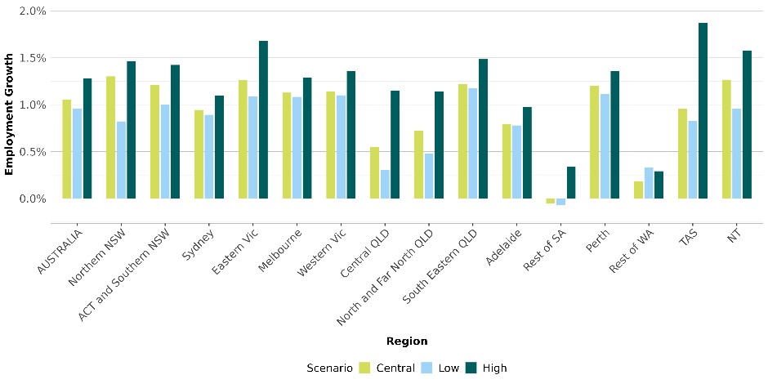Source: Deloitte Access Economics 2023.
Note: Tasmania benefits in the initial forecast period as it gains relatively more renewable energy early and does not have to transition away from high emitting activity and can therefore export renewable energy to the rest of the country. It is a much lower cost and high net gain transition for Tasmania. It should be noted that the ‘levels’ of employment are relatively small.
Figure 5.6. Overview of regional average annual employment growth – 2030-2040
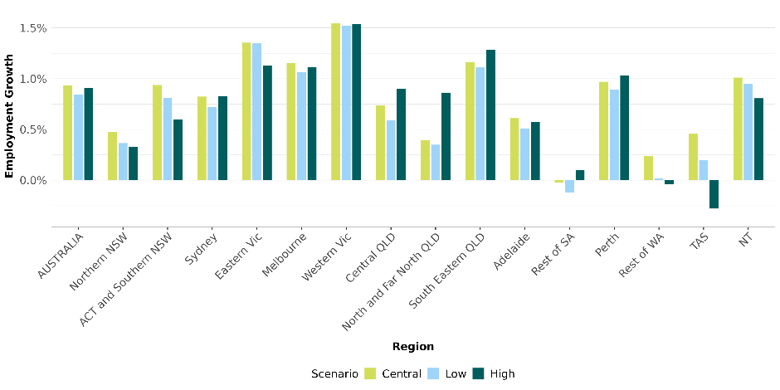
Source: Deloitte Access Economics 2023.
Figure 5.7. Overview of regional average annual employment growth – 2040-2050
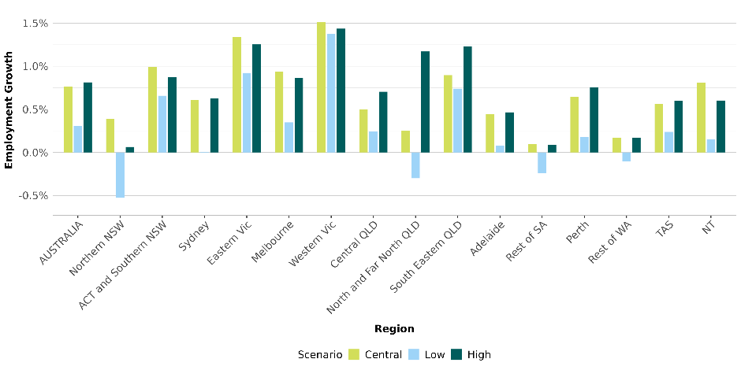Source: Deloitte Access Economics 2023.

5c. Workforce supply and shortfalls
The preliminary modelling for the study suggests that in total, Australia is likely to have enough workers to meet demand for the transition period across all scenarios, but demand is likely to exceed supply for clean energy occupations in the first decade.
Electrical trade roles and nearly all the building and engineering trades that are critical to the construction and maintenance of renewable energy are likely to experience shortfalls. This will be apparent in regional areas across all three scenarios and is even the case under the low scenario. We are likely to have enough engineers but there are some gaps for some professional occupations like environmental scientists. These are the potential shortages Australia needs to plan for.

What occupations are likely to be in short supply?
While overall the preliminary modelling suggests there is likely to be sufficient workers to meet the demand of the transformation to net zero, we see tight demand for VET qualified occupations. At the more detailed occupational level, we still expect to see ongoing and severe shortages for several critical clean energy occupations.

Electrical trade roles shortages likely the largest
Electricians are the leading example of the critical occupation where total demand is expected to be higher over the next seven years, even under the low scenario. Labour supply for electricians is forecast to grow only slowly, due to relatively flat completions and a relatively older current workforce. This means that there are likely to be growing supply gaps under all scenarios unless a significant increase in electrician completions from the VET system occurs, with those completions also converting into actual employment as electricians.
The gap is the largest single occupational gap observed and is at risk of growing over time unless there is substantial change. Preliminary modelling under our central scenario we would likely need almost 85,000 more electricians by 2050. This is a 27% relative gap. More immediately in the next seven years, we will likely need around 32,000 more electricians.
Under the central and high scenarios other electrical trade roles are expected to experience supply gaps – even though supply is growing, it is not expected to be sufficient to keep pace. These include:
  - Electrical Engineering Draftspersons and Technicians
  - Airconditioning and Refrigeration Mechanics
  - Electronics Trades workers
  - Telecommunications Trades workers

Electrical Distribution Trades Workers are an electrical trade role that is not likely to experience a shortfall under our central scenario over the next thirty years. There would likely be a minor shortage in the medium term (2031-2040) under the high scenario but there is a stable pipeline for this occupation to 2050. However, this is based on the current educational attainment profile of the occupation. If all new entrants to the industry require at least Certificate III level training (noting varying licensing requirements across States and Territories at present), then this would very likely result in this occupation also experiencing a shortfall under the Net Zero Central scenario.

Building and engineering trade shortages likely also a problem
Nearly all the building and engineering trades that are critical to the construction (and maintenance) phases of renewable electricity generation are also likely to experience supply gaps under our central scenario, drawing on the preliminary modelling.
Under all scenarios, there are likely to be shortfalls of Civil Engineering Draftspersons & Technicians and Architectural, Building & Surveying Technicians. In the longer term, the supply estimates suggest that an additional 2,200 Civil Engineering Draftspersons and Technicians will be needed. There is an even bigger shortage of Architectural, Building & Surveying Technicians across most of the transition period to 2050. If the education pipeline does not keep pace with demand for this occupation by 2050, Australia is likely to need an additional 25,000 workers in this occupation with a relative supply gap of 44%.
While there may be more growth in the future supply of Metal Fitters and Machinists and for Structural Steel and Welding Trades workers, it will likely not be enough to keep up with expected demand, particularly in the next twenty years. Growth in demand for Metal Fitters and Machinists is expected to outpace supply across all scenarios for most of the transition period. From 2028 onwards, under our main scenario there is a likely shortfall of over 5,000 workers which increases to around 8,000 workers within a decade before decreasing to around 4,000 for Metal Fitters and Machinists by 2050. Structural Steel and Welding Trades workers also have a supply gap, climbing to roughly 10,000 by 2037 and hovering around that mark until 2050.
Significantly, there is likely to be an emerging supply gap in Chemical, Gas, Petroleum and Power Generation Plant Operators emerge from approximately 2030. This is despite the expected employment declines in fossil fuel power generation and gas production and distribution, with offsetting employment growth in renewable energy and hydrogen.

Figure 5.8. Demand (all scenarios) and supply for electrical trades and technicians, 2023-2050
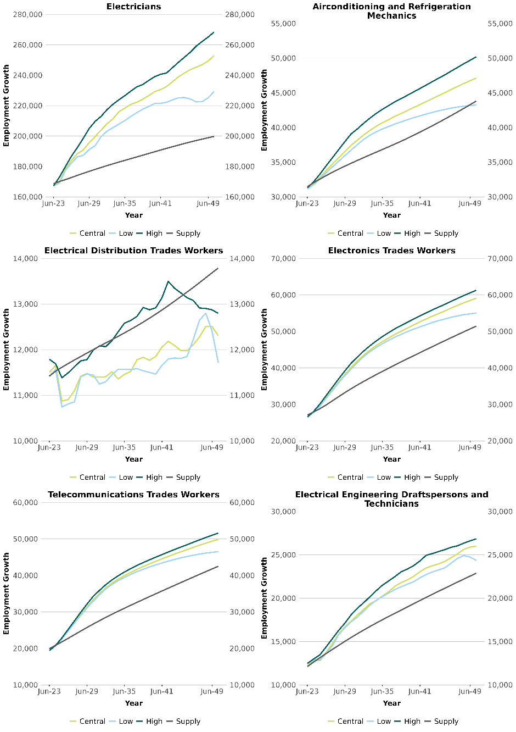
Source: Deloitte Access Economics 2023.
Figure 5.9. Demand (all scenarios) and supply for other trades and technicians, 2023-2050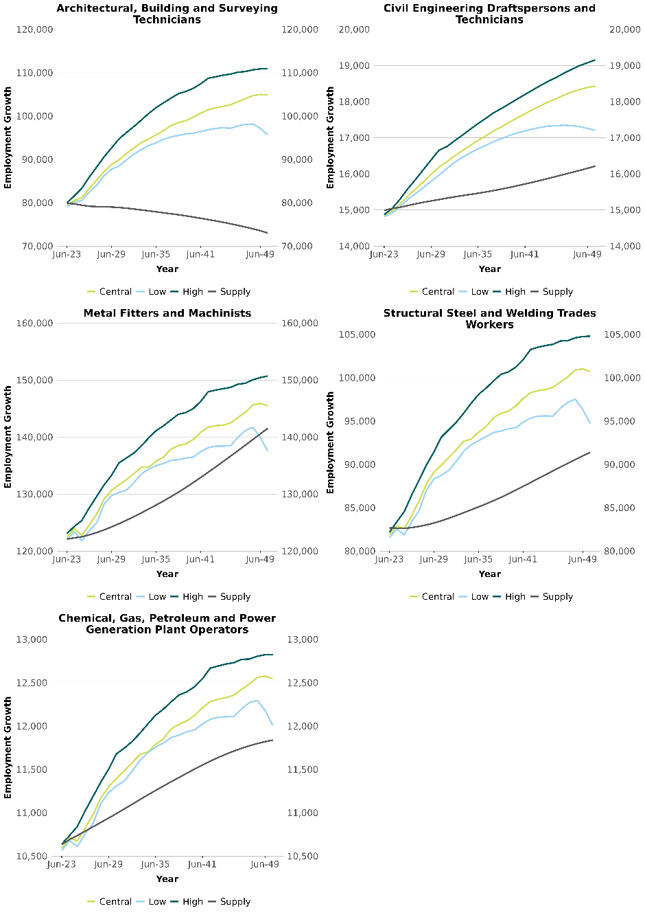Source: Deloitte Access Economics 2023.

A likely steady supply of engineers, but some scientist shortfalls
The preliminary modelling results for professional occupations are more varied. Engineering occupations are likely to have sufficient supply under both demand scenarios, with the only exception being Mining Engineers, where the projected supply is rapidly declining. However, supply is close to expected demand for Chemical and Materials Engineers, Civil Engineering Professionals and Other Engineering Professionals, so there is still a high risk of skill shortages occurring (see below).
The preliminary modelling suggests that there is an increasing supply of Electrical Engineers, notwithstanding current shortages. A shortage of Mining Engineers is likely to be most acute in the medium term.
Unlike engineering occupations, demand for professional occupations like Agricultural and Forestry Scientists and Environmental Scientists are likely to experience some shortfalls as we transition to Net Zero. The shortfalls are likely around 1,000-3,000 workers at 2050 for both Agricultural and Forestry Scientists and Environmental Scientists. On the other hand, there will likely be a sufficient supply of Geologists, Geophysicists and Hydrogeologists.
Our assessment about the supply of engineers in general being adequate, should be qualified with the following caveats. First, it is important to note that these projections of labour supply for engineers (indeed, for all professional occupations) are based on past trends in higher education attainment. This has been significantly shaped by the demand driven system of higher education, where there was a substantial expansion of university graduates. There continues to be strong pipeline growth on the number of graduates as a result.
However, the demand-driven system has been discontinued and the future size of the higher education sector is uncertain. It is currently under review as part the Universities Accord Review process. An adequate supply of engineers to enable the clean energy transition will be an important priority of the system going forward. Second, even if we continue to have strong pipeline of engineering graduates we need to ensure that they have the attributes required for the available jobs. Skills shortages could still happen for reasons outlined below.

Figure 5.10. Demand (all scenarios) and supply for engineering professionals, 2023-2050
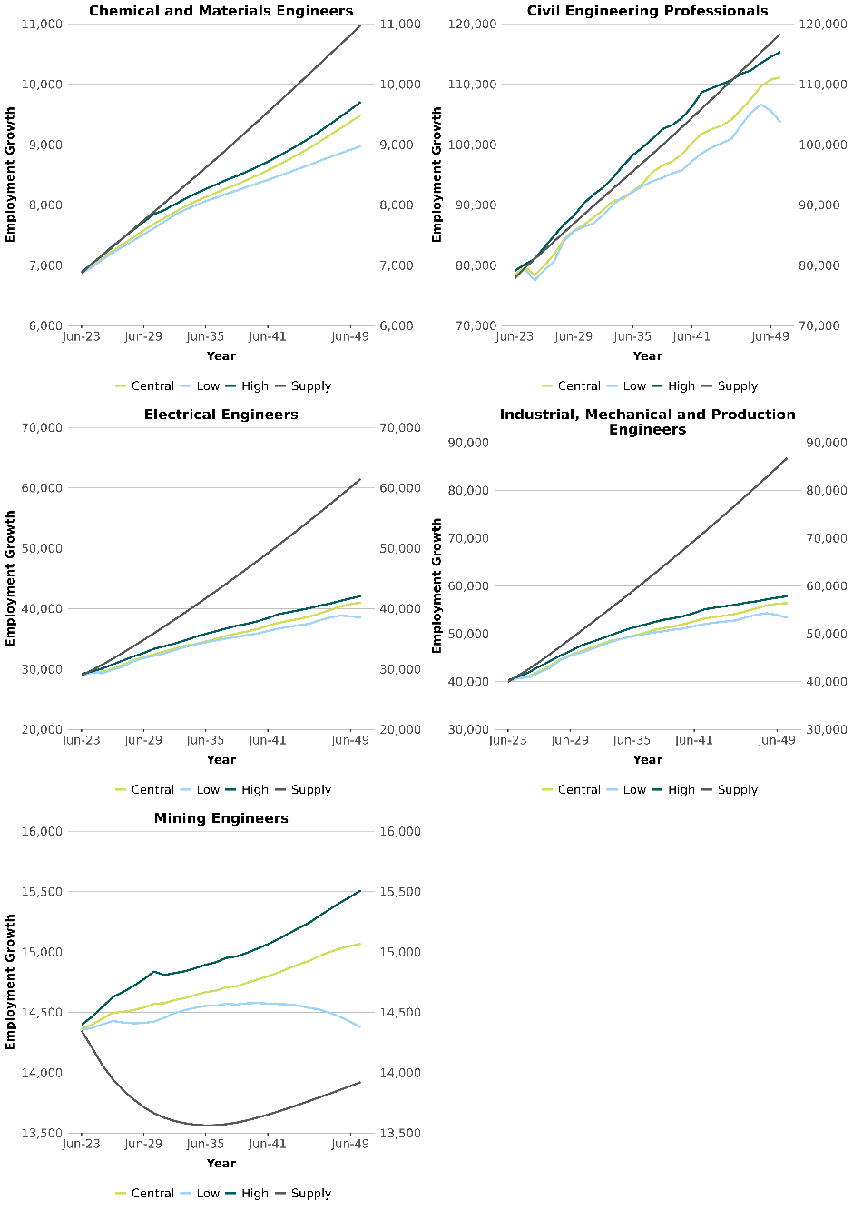
Source: Deloitte Access Economics 2023.
Figure 5.11. Demand (all scenarios) and supply for selected other professionals, 2023-2050
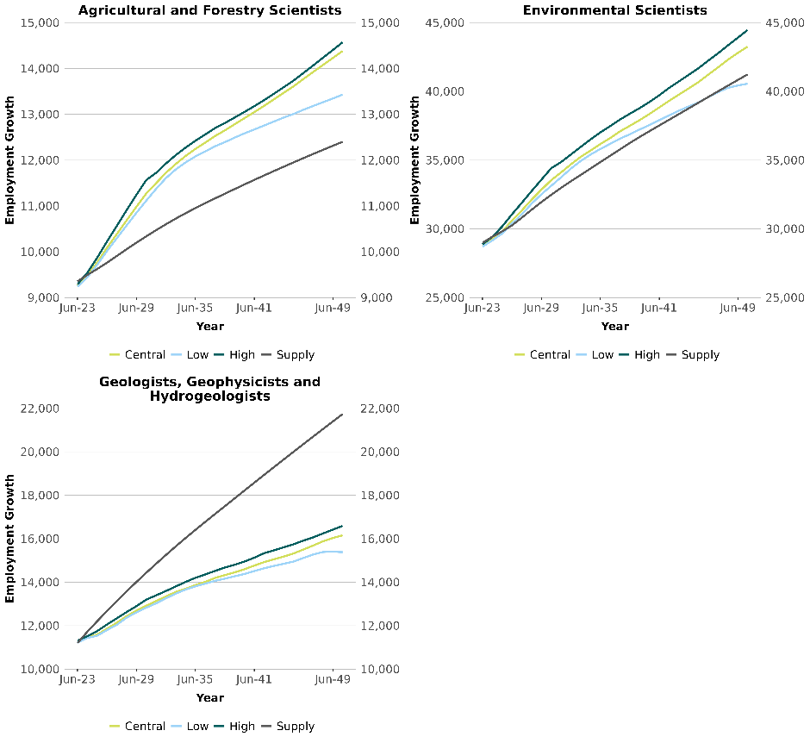
Source: Deloitte Access Economics 2023.

Skills shortages for occupations could still happen
It is important to be very clear that skill shortages for a given occupation can still occur even when the preliminary modelling suggests there is sufficient supply. Skill shortages can exist when:
- There is an insufficient number of available workers with the required skills
- Potential workers have the requisite general skills but lack the required level of experience or other attributes sought by employers
- There are sufficient workers with the skills, but relative wages and other employment conditions mean that many prefer to work in alternative roles (even ones that do not make full use of their qualifications and skills).
Recent JSA analysis of engineers demonstrates this situation. While employers report they attract sufficient applicants for engineering vacancies with the required qualifications, applicants often lack the amount or type of experience employers want for the role.
For these reasons, it is very difficult (and likely misleading) to attempt to forecast skill shortages well into the future. The labour supply projections here are a benchmark based on current trends, around which to assess expected demand, and an indicator of where gaps may otherwise emerge.
As well as the quantity of graduate engineers coming into the labour market, particular attention will need to be given to their employability attributes. It will be important for industry and tertiary education providers to work closely together to provide work experience to students and support the development of their employability skills, an issue that is also discussed in Chapters 4 and 7.

Chapter summary
This chapter has explored the workforce implications of three different pathways to reach net zero. With active investment and clear policy direction to ensure all emissions-intensive sectors have the incentives to transition to lower emissions technology, Australia can achieve a higher level of employment and industrial diversity, while still decarbonising the economy. With a higher level of ambition and investment, Australia could expand its production of low emissions goods to create an export market to replace what we can expect to lose from fossil fuels.
There are clear workforce challenges associated with both the central and high scenarios. Indeed, even under the low scenario, there are the same challenges in the next ten years as we look to convert our electricity grid to renewable sources.
These are the strong growth in trades and technical occupations, particularly the occupations that are critical to clean energy such as electricians, metal fitters and machinists, and plant operators. The preliminary modelling supply results suggest there may not be sufficient capacity in the training and migration pipelines based on recent trends to meet this demand.
Growth in these occupations are likely to be concentrated in regional Australia. There is great opportunity here, as it will continue to provide well paid employment opportunities that might otherwise be lost as global demand for fossil fuels decreases. However, the concentration of growth in trades and technical employment in regional Australia will require an even more substantial uplift in the training infrastructure if local students and workers are going to share in the opportunities. These are issues we further explore in Chapters 7 and 8.
In examining workforce trends over a thirty-year period, there is necessarily a lot of uncertainty. In this chapter, we have looked at the set of broader economic relationships, focusing on the clean energy sectors such as renewable electricity and hydrogen where there is more data available. To better understand the skill gaps as emerging occupations become more established, as well as capturing the impacts as the sectoral plans are finalised, there is merit in repeating such modelling exercises regularly.
Recommendation 5.1

The Australian Government could sponsor regular modelling exercises to update the potential employment impacts of the transition to net zero so that further policy work can be incorporated into the results, particularly the sectoral plans under development.

Appendix 5A – Definition of Regions
Database Regions | Code | State | SA4 Name | Renewable Energy Zone | Total Employment
Sydney | SYD | NSW | Central Coast, Sydney - Baulkham Hills and Hawkesbury, Sydney - Blacktown, Sydney - City and Inner South, Sydney - Eastern Suburbs, Sydney - Inner South West, Sydney - Inner West, Sydney - North Sydney and Hornsby, Sydney - Northern Beaches, Sydney - Outer South West, Sydney - Outer West and Blue Mountains, Sydney - Parramatta, Sydney - Ryde, Sydney - South West, Sydney - Sutherland |  | 2,310,013
Southern New South Wales | South NSW | NSW | Capital Region, Illawarra, Murray, Riverina, Southern Highlands and Shoalhaven, ACT | South West REZ, Illawarra REZ | 678,277
Northern New South Wales | North NSW | NSW | Central West, Coffs Harbour - Grafton, Far West and Orana, Mid North Coast, New England and North West, Newcastle and Lake Macquarie, Richmond - Tweed | Hunter-Central Coast REZ, New England REZ, Central West REZ | 766,687
Eastern Victoria | East VIC | VIC | Latrobe – Gippsland, Hume, Shepparton | Gippsland REZ, Ovens Murray REZ, Central North REZ | 262,276
Melbourne | MEL | VIC | Melbourne - Inner, Melbourne - Inner East, Melbourne - Inner South, Melbourne - North East, Melbourne - North West, Melbourne - Outer East, Melbourne - South East, Melbourne - West, Mornington Peninsula |  | 2,327,525
Western Victoria | West VIC | VIC | Ballarat, Bendigo, Geelong, North West, Warrnambool and South West | Geelong Warnambul and Murray River REZ, Western Victoria REZ, Southern West REZ | 425,397
South Eastern Queensland | SEQ | QLD | Brisbane - East, Brisbane - North, Brisbane - South, Brisbane - West, Brisbane Inner City, Darling Downs - Maranoa, Gold Coast, Ipswich, Logan - Beaudesert, Moreton Bay - North, Moreton Bay - South, Sunshine Coast, Toowoomba | Southern REZ | 1,788,185
North and Far North Queensland | North QLD | QLD | Cairns, Mackay - Isaac - Whitsunday, Townsville, Queensland - Outback | Northern REZ | 334,695
Central Queensland | Central QLD | QLD | Central Queensland, Wide Bay | Central REZ | 208,369
Adelaide | ADL | SA | Adelaide - Central and Hills, Adelaide - North, Adelaide - South, Adelaide - West |  | 649,031
Rest of SA | Rest of SA | SA | Barossa - Yorke - Mid North, South Australia - Outback, South Australia - South East |  | 162,158
Rest of WA | Rest of WA | WA | Bunbury, Western Australia - Wheat Belt, Western Australia - Outback |  | 235,378
Perth | PER | WA | Mandurah, Perth - Inner, Perth - North East, Perth - North West, Perth - South East, Perth - South West |  | 1,008,776
Tasmania | TAS | TAS | Hobart, Launceston and North East, South East, West and North West |  | 248,655
Northern Territory | NT | NT | Darwin, Northern Territory - Outback |  | 102,299
Alignment of regions with Renewable Energy Zones
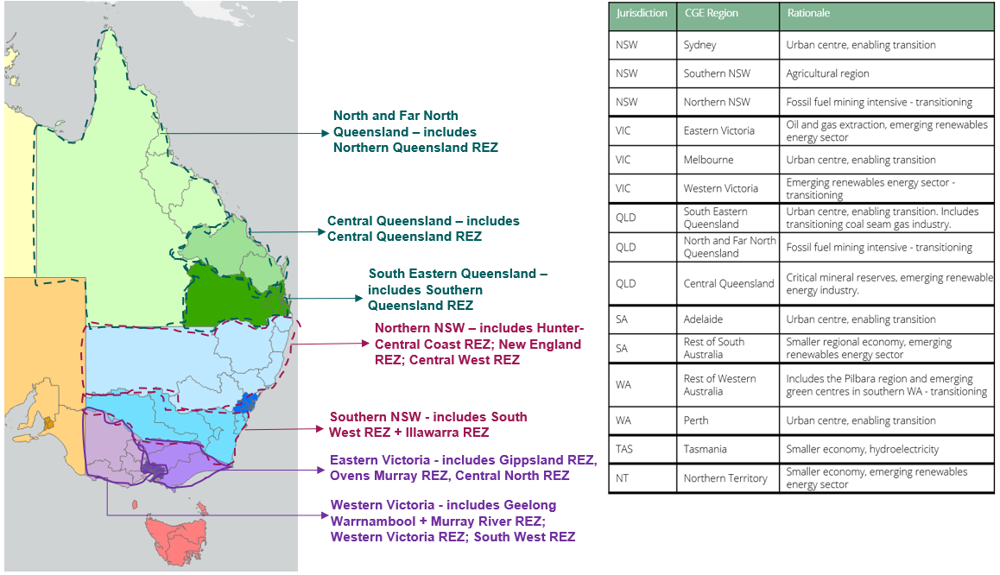


Chapter 6:
Emerging and transforming sectors

Exploring how occupations may change overtime as new technologies and sectors emerge.

New skills and new contexts
Workforce change means more than just the number of jobs that will be created or lost. While it’s easy to assume that the biggest impact will be in the sectors that need to grow the most, this is not necessarily the case. Increasingly over the next thirty years, the skills and roles of existing occupations will change in response to decarbonisation, even if overall demand does not increase. New occupations are also emerging which, even in small numbers, can be particularly difficult to grow.
These types of changes will greatly impact the labour market and education and training sectors, but are impossible to capture with the kind of modelling exercise presented in Chapter 5. The purpose of this chapter is to explore how the transition to clean energy is likely to impact jobs across many of the segments we identified in Chapter 2, including:
- fuels and storage, including hydrogen, biofuels, batteries and pumped hydro
- transport, including road passenger vehicles, road freight vehicles, rail, aviation and maritime
- energy performance, covering energy efficiency and energy management
- manufacturing and processing, including opportunities to onshore
- land use and the circular economy, including agriculture, forestry, and recycling and waste management.
As a preview of the types of impacts we discuss in this chapter:
- The bioenergy sector provides opportunities for skilled employment opportunities and economic growth across regional areas. With many bioenergy feedstocks stemming from agricultural activities including sugarcane waste and livestock industries, and with most of these industries located in regional Australia, bioenergy investment could support long-term regional employment, and provide additional revenue streams to support employment in agricultural industries.
- In transport, we consider the job impacts on Mechanics and Service Station Operators. As combustible passenger vehicles are replaced with EVs, demand for specialist EV Mechanics will increase, as will demand for Mechanics able to work across both vehicle types (something touched on in Chapter 4). There is debate about whether the transition to EVs will reduce overall demand for Mechanics.
- In energy performance, we look at the roles of Energy Auditors on the one hand, and Air-conditioning and Refrigeration Mechanics and Facility Managers on the other, as examples of new growing roles and existing roles which will have changed skill and knowledge requirements.
While clean energy will transform our economy – and workforce – it’s important to remember that our economy is always in a state of change. As shown by the imagery in this chapter, even in with emerging sectors we have past skills and experience to draw on.
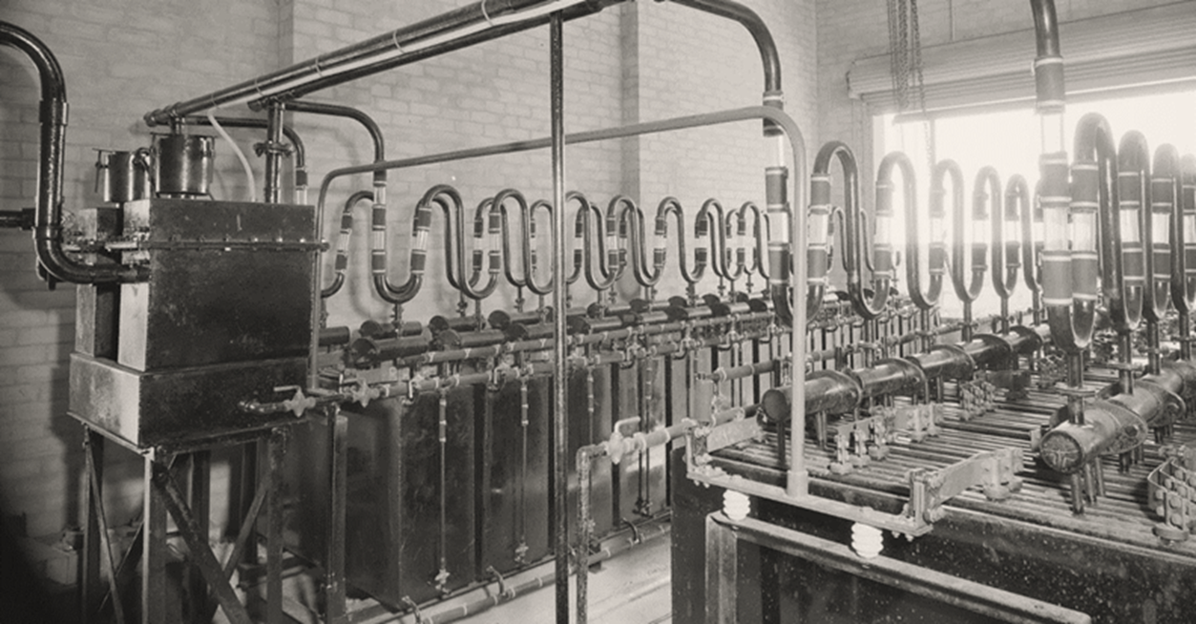
Hydrogen generation plant, Australia 1955. National Archives of Australia – 9671915.

6a. Fuels and storage

Hydrogen
Hydrogen could be the missing link that solves three wicked problems for Australia:
- Replacing fossil fuels in hard to abate sectors like manufacturing and heavy transport that rely on high density fuels
- Storing energy when we have too much, and accessing it when we have too little
- Transporting renewable energy across large distances to enable export markets.
Australia could play a significant role in the global hydrogen industry by leveraging its untapped renewable energy potential, skilled workforce and long history as a trusted energy exporter. The Australian Government has announced several measures to kickstart the market for hydrogen, including a $2 billion investment under the Hydrogen Headstart program. This is joined by significant investments from state and territory governments, industry and research organisations.
Hydrogen production through electrolysis is not a new concept and has been done for many years, including in Australia. What is new is the mammoth scale of production and how we intend to use it. Like any energy sector, this will require a large workforce with a diverse mix of skills. However, unlike other energy sectors, large scale hydrogen production is still nascent across the globe, limiting our ability to draw on overseas talent. Until the hydrogen industry truly scales and matures, we will not know the exact skills mix we need.
As of now, employment in hydrogen is likely to be very low, with our LinkedIn analysis suggesting most employment is predominantly in research and development. Australia’s broader industrial gas manufacturing industry (which includes hydrogen and ammonia) employed around 1,900 people in 2021, with a mix of occupations like Gas or Petroleum Operators, Chemical Engineers, and Chemical Plant Operators. Most of this employment is in capital cities like Sydney, Melbourne, Brisbane, Perth and Adelaide.
In the first instance, hydrogen will require a large construction and fabrication workforce to establish new facilities and electrolysers. While electrolysers are predominantly manufactured overseas, companies like Fortescue Future Industries intend to begin domestic manufacturing. As hydrogen facilities come online, a smaller but important workforce for operations and maintenance will be required.
Beyond manufacturing hydrogen, Australia will also need workers to build pipelines and other infrastructure like refuelling stations. There are around 2,100 people already working in pipeline transport, with a mix of Engineers and Gasfitters. Australia will be able to leverage its large and skilled natural gas workforce to support these types of infrastructure works. The Minerals Council of Australia noted that a successful clean hydrogen industry will require similar skills to those already required by mining, oil and gas, meaning significant re-skilling won’t be needed.
Like many other elements of clean energy, hydrogen builds on existing trade, technician and engineering roles, rather than needing entirely bespoke occupations. There are several specialist units and electives already being delivered in VET and Higher Education for hydrogen technology. For example, the Gas Industry Training Package includes a unit Apply safety practices, procedures and compliance standards for handling hydrogen gas that provides skills and knowledge for handling hydrogen. Additionally, both Swinburne, Federation University Australia, RMIT, Curtin University and Victoria University deliver engineering units for hydrogen. A full list of specialist units can be found in Attachment B.
It’s important to note that a domestic hydrogen industry will also require much larger generation and transmission capacity. To become a ‘hydrogen superpower’, AEMO have suggested it would take a grid about eight times the current size, which would drive enormous demand for workers in other segments of the economy. Reaching the ambition of other estimates, like those by Emeritus Professor Ross Garnaut and Net Zero Australia, could require a grid around 50 times the current size. Some hydrogen and ammonia production may also take place in proximity to large scale renewable generation, which is often away from major population centres and could make it difficult to source workers.
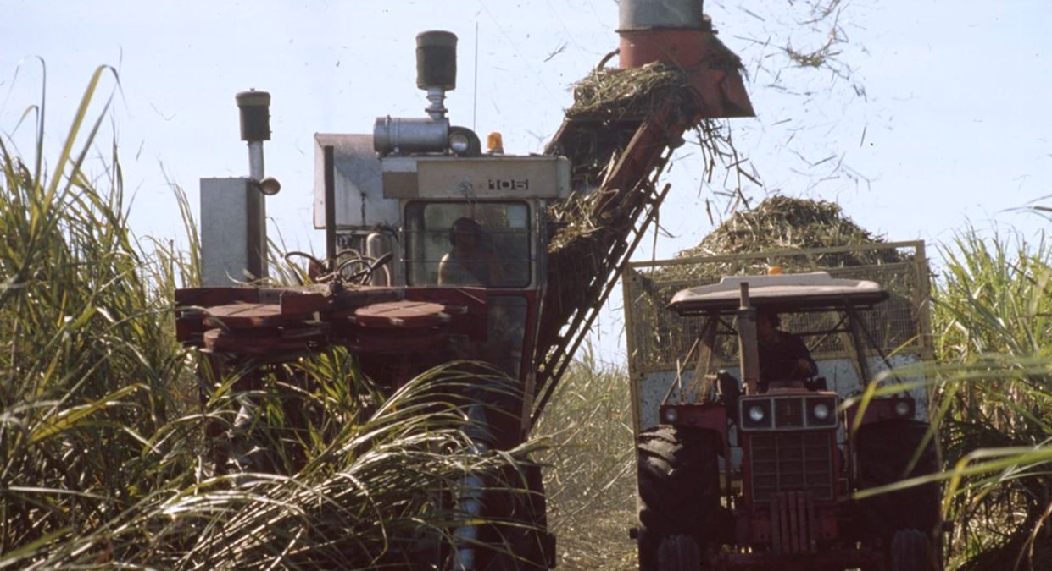
Sugarcane harvesting, Mackay QLD 1989. National Archives of Australia, item 11672299.

Bioenergy
Bioenergy is generated from converting biomass (like sugarcane) into heat, electricity, biogas and liquified fuels. Unlike other types of renewable fuels and storage, bioenergy can be integrated into existing infrastructure with relative ease. Biodiesel and bioethanol are examples of this, which Australia already produces in significant quantities: 180 million litres of fuel ethanol and 18 million litres of biodiesel in 2021.
The ABS estimates that in 2018-19 biomass accounted for around 1,580 jobs across Australia, with the vast majority in Queensland (1,230) followed by New South Wales (190). According to the International Renewable Energy Agency (IRENA), global employment in the bioenergy sector grew to 3.18 million jobs in 2018. Australia’s Bioenergy Roadmap (2021) estimates that if supported adequately, the bioenergy sector could create an extra 26,200 new local jobs by 2030.
JSA heard from stakeholders that in many cases, the manufacturing processes involved in producing biofuels are similar to those in refined fossil fuels. Therefore, it’s likely that existing workers in petroleum refining (around 1,500 in 2021) could easily transition to biofuel employment, including at the same worksite. It also means that the VET and higher education sectors already produce many of the requisite skills. Another 500 workers are already employed in Basic Organic Chemical Manufacturing which includes producing ethanol that can be blended with petroleum fuels (Figure 6.1).

Figure 6.1. Employment in biofuel related industries, 2021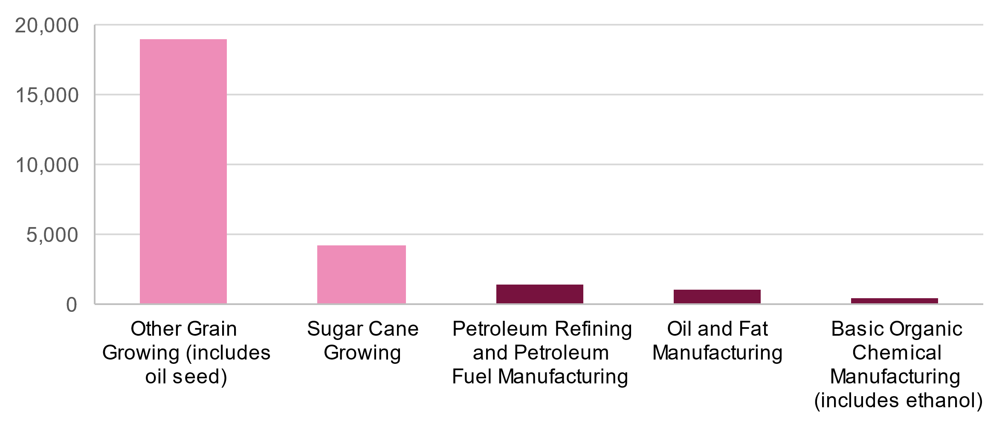
Source: ABS Census of Population and Housing 2021
Canola, sugar cane, tallow and vegetable oil are key biofuel feedstocks that Australia produces in large quantities. Australia is the world’s third largest exporter of sugar cane, and the majority of Australia’s canola seed exports in 2021-22 will be used to make biofuel in the European Union ($5.7b). In 2021, there were around 4,200 employed in sugar cane growing and almost 19,000 in other grain growing (including oil seeds like canola). Another 1,100 work in manufacturing oils and fats, which includes tallow and vegetable oil for biofuels. While there are crops dedicated to biofuel feedstocks, residues from other crops (like chaff, husks and bagasse) can also be used for fuels, although for now much of this is burned off instead.
There are very few courses specific to bioenergy. The Manufacturing Training Package includes two skill sets: bioprocessing using fermentation and bioprocessing using pyrolysis. These cover the skills and knowledge required for staff responsible for monitoring bioprocessing equipment and processes to produce a range of products and bi-products, such as biochar, bio-oil, ethanol, livestock feed and fertiliser. TAFE Gippsland now offers a five day course in biomanufacturing that was designed as an industry-led collaboration with Opal Australian Paper and Federation University.
The University of Newcastle has offered courses on biomass technology options for the production of renewable energy (heat and electric power), fuels, and chemicals that are suitable as substitutes for fossil fuels and their refined products. In its Chemical Engineering course, the University of Adelaide offers subject matter covering biofuels, biomass and wastes, aiming to provide a fundamental understanding on the characteristics of biomass resources, and the design and operations of biomass energy systems.
Many bioenergy projects are already underway across Australia. Between 2012 and 2020 ARENA committed around $131 million to bioenergy related projects. In total, ARENA has funded 38 bioenergy related projects, including $57.3 million to 7 projects in Western Australia, $34.3 million to 11 projects in Queensland, and $28.9 million to 13 projects in NSW. The Bioenergy sector provides opportunities for skilled employment opportunities and economic growth across regional areas. With many bioenergy feedstocks stemming from agricultural activities including sugarcane waste and livestock industries, and with most of these industries located in regional Australia, bioenergy investment could support long-term regional employment, and provide additional revenue streams to support employment in agricultural industries.
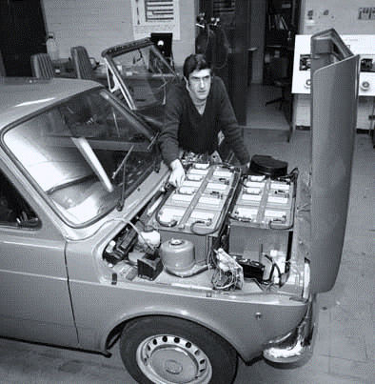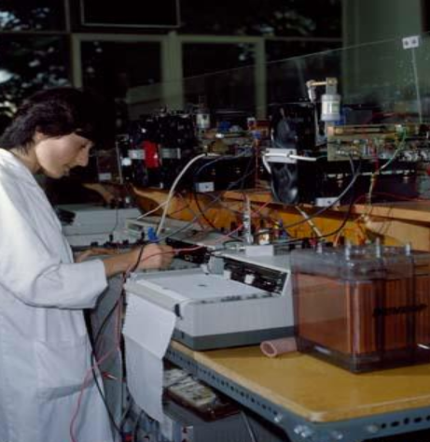
CSIRO Battery Research, 1980. National Archives of Australia, item 11897428
Electric car conversion, SA 1976. National Archives of Australia, item 11412438

Batteries
Battery storage will be a critical feature of Australia’s future energy supply, both at grid-scale to support transmission but also in tandem with small-scale solar on houses and businesses. Energy storage systems enable access to energy during peak time when renewable energy output is usually low, reducing energy grid reliance on fossil fuel generated power. Additionally, the global demand for lithium-ion batteries is expected to surge as the EV market is rapidly expanding worldwide.
Australia is a dominant player in the mining of raw battery materials with around half the global lithium market and a leading role in other key metals, but processing and battery manufacturing mostly takes place through complex overseas value chains . Analysis of the LinkedIn Talent Insights database suggests that the batteries sector is still in the development phase in Australia – four of the five largest employers are universities, although the largest industries (based on the LinkedIn categories) are Renewables Environment, and Electrical and Electronic Manufacturing. Slightly more than 800 LinkedIn job posts in the last 12 months listed one or more of the battery skills (Batteries; Battery Management Systems; Battery Design; BEV).

The ABS estimates that in 2018-19, around 2,380 people were employed working on small-scale batteries, and only 30 on large scale batteries. It is very likely that employment in both groups has grown considerably since then as record numbers of batteries are installed. As explored in Chapter 4, there are a number of new units relevant to battery installation, maintenance and design for Electricians. The number of enrolments in these units has grown from 482 in 2017 to 2,626 in 2022 which may be linked to CEC industry accreditation requirements (Table 6.1).
Table 6.1. Battery VET unit enrolments
CEC Battery Accreditation units | 2017 | 2018 | 2019 | 2020 | 2021 | 2022 | Total
UEERE4001 - Install, maintain and fault find battery storage systems for grid-connected photovoltaic systems | 234 | 625 | 952 | 762 | 1,037 | 1,299 | 4,905
UEERE5001 - Design battery storage systems for grid-connected photovoltaic systems | 247 | 621 | 887 | 720 | 1,021 | 1,155 | 4,646
VU22125 - Design a grid-connected battery storage system to meet client requirements | 0 | 0 | 72 | 57 | 11 | 179 | 317
Total | 481 | 1,252 | 1,908 | 1,530 | 2,067 | 2,627 | 9,870
Source: NCVER Total VET Activity Data, 2023
There are around 6,400 people employed in electrical equipment manufacturing (including battery manufacturing). The top occupations are Electricians, Product Assemblers, Electrical Engineers, Draftspersons and Technicians.
Currently Australia employs around 3,400 people in Non-metallic mineral mining (including lithium and graphite), with the largest occupations being Miners, Fitters and Engineering Technicians. Also important are materials like nickel, cobalt and aluminium. As the demand for batteries grows, it is likely that this type of mining employment will also grow. Occupations like Geoscientists, which are in severe shortage, and Mining Engineers, Metallurgists, Surveyors and Geotechnical Engineers will continue to be needed.
“The dearth of geoscientists, which is replicated globally, threatens to crimp Australia’s ability to find, define and mine key minerals needed in a decarbonised future”.
Australian Geoscience Council.
Workers in these mining industries are employed right across Australia, but particularly in regional Queensland and Western Australia (Figure 6.2). In some instances this work is done on a fly-in/fly-out basis (like in the Pilbara) or is based out of mining towns (like Kalgoorlie). There are also an number of jobs in our cities, particularly Perth, where large numbers of professionals work.

Figure 6.2. Employment in battery-related mining industries, by region
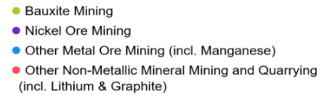
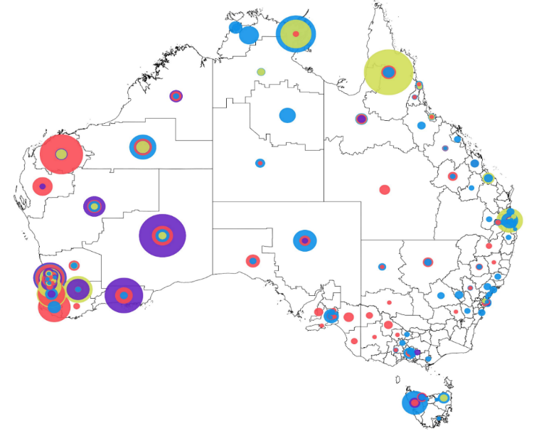
Source: ABS Census 2021, Place of Work by ANZSIC industry and SA3. JSA analysis. Note: circle sizes reflect the proportion of that industry’s total employment in that region, not just the workers employed on mining sites. This explains why there is a large number of workers in capital cities.
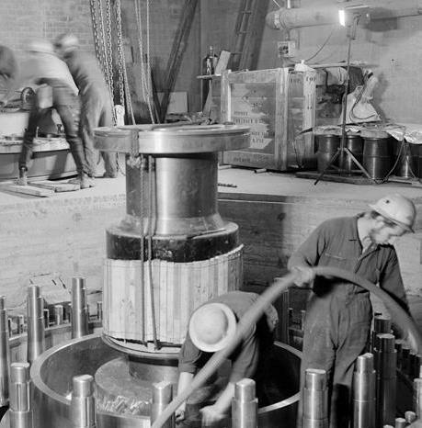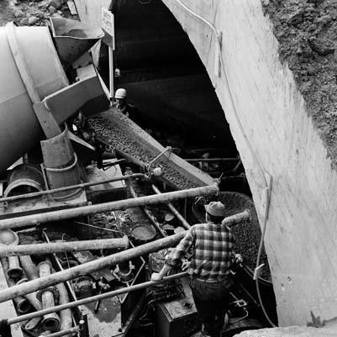
Snow Mountains Hydro Sceme.1961. National Archives of Australia, item 7425446
Snowy Mountains Hydro Scheme 1968. National Archives of Australia, item 7648393

Pumped Hydro
Pumped hydro energy storage (PHES) is expected to play a significant role in helping Australia transition to renewable energy. PHES operates by utilising surplus energy held in the existing energy grid or generated by wind, solar, or other renewable energy sources to pump water uphill into a reservoir, which is then released downhill immediately generating inertial energy that is available as required during outages, periods of increased demand, and low or unreliable energy generation. In effect, PHES functions much like a large store, or battery.
Pumped hydro projects require a range of both trades and professional occupations including Electricians, Metal Workers, Earth Movers, Construction Labourers and Managers, Drillers, Drivers, Hydrographers, Surveyors, Spatial Analysts, Environmental Scientists, Hydrologists, Geologists and a range of Engineering professionals. Like most large-scale energy projects, workforce needs differ considerably between construction, operational and maintenance phases, with employment typically frontloaded.
There are two main forms of PHES: on-river and off-river. On-river pumped hydro draws on natural reservoirs by damming existing waterways. Historically, the majority of Australia’s hydroelectricity developments have capitalised on the natural waterways and alpine lakes of south-eastern Australia, including the well-known Snowy Mountains Hydro-Electric Scheme and Hydro Tasmania’s Battery of the Nation.

Battery of the Nation
Tasmania opened Australia’s first hydroelectricity power station at Waddamana in 1916 and hydro continues to provide much of the state’s electricity today.
Battery of the Nation is a Hydro Tasmania initiative to expand Tasmania’s renewable electricity generation capacity to supply mainland Australia. The project includes hydropower system improvements and new pumped hydro opportunities. The Australian Government has provided $65 million to the upgrade of the Tarraleah hydropower scheme, a key Battery of the Nation asset, through the Bilateral Energy and Emissions Reduction Agreement. The initiative is expected to generate up to 250 jobs during peak construction.
Snowy 2.0
The Snowy Mountains Hydro-Electric Scheme launched in 1949 and engaged over 100,000 workers (of whom 65% were migrants, many fleeing postwar Europe) in the following decades until it became operational in 1972. Annual employment peaked at 7,300 in 1959. Heralded as a marvel of civil engineering, the scheme saw the construction of seven power stations, 16 dams, 80 kilometres of aqueducts, 145 kilometres of tunnels, and 1,600 kilometres of roads and railway.
In 2016, the Snowy Scheme generated 32% of renewable capacity in the NEM. Snowy 2.0 will expand the original Snowy Mountains Hydro Scheme with an additional 2,000 MW of electricity generation capacity and 350,000 MW hours of energy storage, enough power for 500,000 homes. Snowy 2.0 will be critical to the future security and reliability of our electricity grid by providing much needed dispatchable generation capacity and energy storage, reducing our reliance on fossil fuel power at night. Snowy 2.0 represents the largest energy storage project in the southern hemisphere and the largest renewable energy project in Australia. First power is expected from Snowy 2.0 in 2028. In 2022 Snowy 2.0 employs more than 2,100 workers.
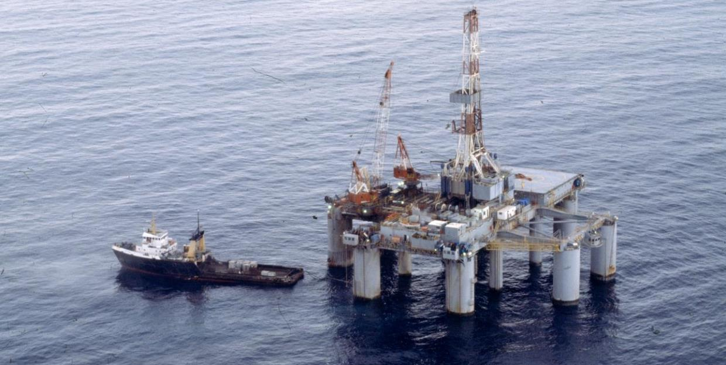
Offshore drilling rig, Bass Strait 1979. National Archives of Australia, 11853302.

Offshore wind
Offshore wind energy is expected to be a vital component of Australia’s clean energy mix over the coming decades, but as yet there are no operational offshore wind developments in Australian waters. Star of the South (SOTS), located off the south-east Victoria coast, is Australia’s first proposed offshore wind project, and is expected to generate up to 20% of Victoria’s energy needs and create 2,000 jobs over its 30-year life, 200 of which are expected to be ongoing local opportunities.
In 2022 the Australian Government announced its participation in the Global Offshore Wind Alliance, intended to draw on the knowledge, expertise and support of other nations in establishing Australia’s offshore wind industry. A further six regions have been tapped for potential offshore wind development, with $0.5 million included in the 2022–23 Budget to support the establishment of offshore wind and other offshore renewables. DCCEEW estimates job opportunities will range from 3,000 to 8,000 jobs annually.
As part of the development of SOTS, Copenhagen Infrastructure Partners released an Offshore Wind Jobs Guide in consultation with education, industry and union organisations and with the support of the Victorian Government through the Energy Innovation Fund. This comprehensive guide provides an overview of more than 50 occupations critical to offshore wind projects, including the qualifications and skills required to support project development safely and effectively. It steps out opportunities for workers transitioning from other sectors including Mariners, Offshore Oil and Gas Workers, and Coal Power and Mining Workers. Whilst not all transitioning workers will have a 100% skills match with offshore wind opportunities, tailored skills matching both capitalises on existing skills and reduces the re-training burden on workers.

New tram, Melbourne 1974. National Archives of Australia – 11963155.

6b. Transport
Transport makes up around one-fifth of Australia’s total emissions, with most of that coming from road transport (Figure 6.3). Reaching net zero by 2050 will require substantial change across all transport sectors which may impact manufacturing, maintenance, operation and fuelling workforces. It also presents an opportunity to reduce our reliance on imports and develop more technology onshore.
Figure 6.3. Australian transport emissions, 2020
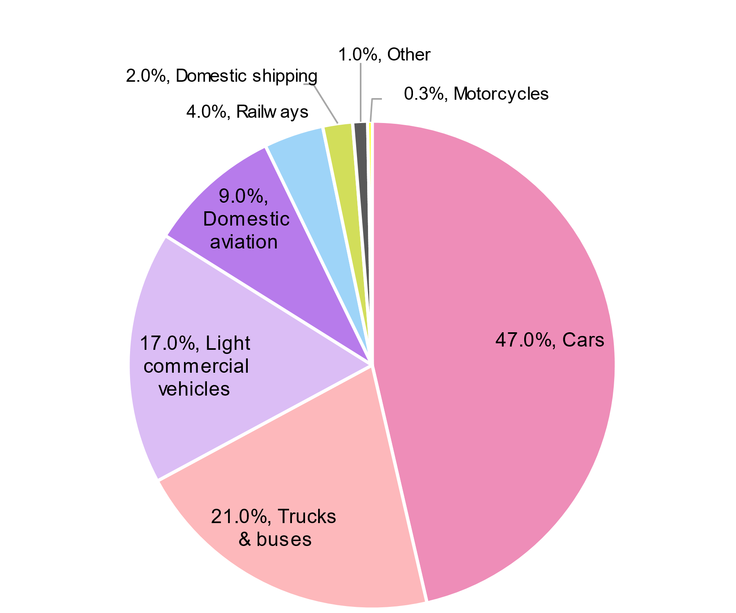
Source: Climate Change Authority, Fact Sheet 6, Transport, 2021. Aviation emissions may be understated due to the impacts of COVID-19.

Electric vehicles
Recently, Australia has experienced a rapid growth in EV sales (3.8% in 2022, an 86% increase from 2021), however it is still lower than the global EV uptake (14% of all new car sales in the world in 2022). It is estimated that Australia will have 3 million EVs by 2030, requiring 2.8 million charging points, while 83,000 EVs are currently on our roads.
There are at least 275,000 Australians employed in road transport related industries (excluding freight), ranging from manufacturing, driving and maintenance (Figure 6.4). The largest industry, Automotive Repair and Maintenance, is likely to undergo the greatest skills change to cater for EVs. This includes Motor Mechanics and Automotive Electricians. As EV maintenance is less labour intense compared to fossil fuelled vehicles, total demand for mechanics may be comparatively lower than it otherwise would have been. In our central scenario (see chapter 5), demand for Motor Mechanics grows from 116,000 in 2023 to around 134,000 in 2050. Similarly, demand for automotive electricians grows from 8,800 to 11,500. Ensuring that our existing automotive workforce can upskill to work safely with EVs will be a major challenge, particularly as internal combustion engine vehicles will likely remain in circulation for many years to come.
Figure 6.4. Employment in road transport industries (excluding freight)
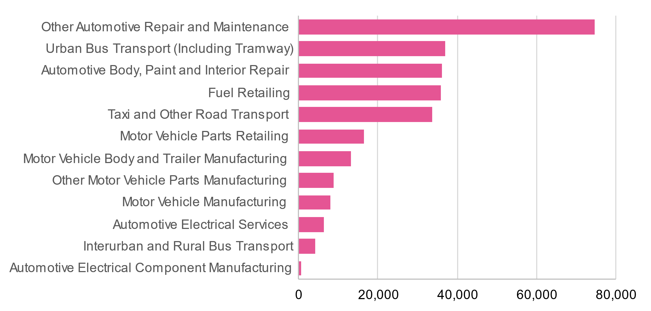
Source: ABS Census of Population and Housing 2021.
As discussed in Chapter 4, new EV elective units in traditional automotive apprenticeships have been recently developed, with around 4,000 enrolments in 2022. A new Certificate III in Automotive Elective Vehicle Technology (AUR32721) was also released in June 2022. As explored in Chapter 7, proprietary technologies and practices may hinder the VET sector's ability to develop and deliver consistent training for EVs. Potential overlap and blurring between automotive and electrical work may also act as a source of contention until standard approaches are adopted. EV charging infrastructure installation is typically carried out by Electricians who have completed manufacturers’ training, while skills to manufacture charging equipment can be obtained through Certificate II in Engineering Production Technology.

Recommendation 6.1

Jobs and Skills Councils should work closely with stakeholders to develop a consistent and constructive approach to qualification design for electric vehicles. Accessible, low-barrier pathways will also be needed for qualified mechanics to transition to electric vehicles.

So long to the servo?
By employment size, fuel retailing is one of the largest segments in the transitioning group of industries – at the last census it employed approximately 35,000 all across Australia.
This workforce segment looks very different to the other clean energy and transitioning segments. The occupational mix is predominantly sales workers – service station attendants and checkout operators and office cashiers. It is somewhat more gender balanced (46% female), most (55%) work part-time hours, and more than a third (35%) are aged under 30. A very large proportion of the workforce (42%) is born overseas. The segment has had issues with underpayment of wages, especially to migrant workers.
EVs will reduce the demand for service stations – drivers will be able to recharge their EVs at home, and standalone charging stations will continue to appear in shopping centre carparks and other public places. Some demand will remain – for long-range driving and for vehicles (particularly freight) using hydrogen and biofuels.
Fuel supplier Viva Energy, which operates Liberty and Shell service stations in Australia, is looking to diversify its sales base. In April 2023, it acquired the “On the Run” convenience brand, which has achieved 70% of profits from non-fuel sales. It is anticipating that EV drivers will be happy to spend their money onsite while they wait to recharge. That could mean more baristas, fast food cooks and food attendants working in service stations.
Change is nothing new for the service station workforce – attendants once commonly filled the petrol tank for motorists and onsite mechanics were common. So while service stations are unlikely to disappear completely, their numbers will reduce as EV coverage increases and their business model, along with their jobs profile, will evolve.
Source: National Archives of Australia, item 31507036

Aviation
Sustainable Air Fuel (SAF) refers to aviation fuels developed from sources other than fossil fuels. This can include cooking oils, plant oils, municipal waste, waste gases, agricultural residue and non-biological alternative low or zero carbon fuels. To support the global emergence of SAF industries, various government bodies around the world have implemented policies to foster the uptake of SAF. There is also a great deal of research and development on electric aircraft, however this is unlikely to be deployed on a large scale in the short term.
Various industry initiatives have been established to explore the use of SAFs. For example, according to Bioenergy Australia, 95% of Qantas Airways’ greenhouse gas emissions come from jet fuel. To commercialise biofueled alternatives, the airline has teamed with Australian farmers and with bioenergy and agricultural technology companies in North America.
In 2021 there were around 37,500 people employed in Air and Space Transport, 11,500 in Airport Operations and Other Air Transport Support Services, and 7,300 in Aircraft Manufacturing and Repair Services. While these jobs are unlikely to experience major change as a result of decarbonisation, they will require new training to work with SAF. Demand for these fuels would also increase demand for a local workforce.
“The introduction of new fuels and technologies will require new operational skills from the aviation workforce, including at regional airports. Regionally based operators, with smaller workforces and less training capacity compared to larger operators may face difficulties in training and attracting a workforce that is prepared for the adoption of these technologies and fuels.
For operators, there are uncertainties about the costs associated with electric aircraft. The scenario planning work undertaken for the Department indicates airlines procuring new electric aircraft will likely incur substantial capital costs, which would typically be offset through high aircraft utilisation. This higher utilisation requirement may diminish their suitability for regional routes”.
– Aviation Green Paper.

Road freight
Like passenger vehicles, road freight will gradually shift from fossil-fuels to renewables. Due to the high energy requirements of heavy road freight, hydrogen powered vehicles may be a common alternative alongside battery power. While the core skills of a Truck Driver won’t change, there will be a need for drivers to become familiar with new technologies and learn how to operate them safely, as will Mechanics. The Australian Government is currently consulting on national safety standards for electric and hydrogen-fuelled vehicles. As road freight is a major user of fuel, decarbonising this sector will drive demand for new infrastructure like charging stations and hydrogen service stations as explored above.

Maritime
The International Transport Forum, an intergovernmental organisation with 59 member countries including Australia, is a think-tank for transport policy and organises the Annual Summit of Transport Ministers. Its 2018 report, Decarbonising Maritime Transport: Pathways to zero-carbon shipping by 2035, found that the maximum deployment of currently known technologies may make it possible to reach near complete decarbonisation of maritime shipping by 2035.
The report cited that the use of alternative low or zero carbon fuels and renewable energy could facilitate much of these reductions. Biofuels are already available for use and could in time be complemented by other natural or synthetic low or zero carbon fuels such as methanol, ammonia and hydrogen. Wind assistance could also reap additional reductions, and the first electric ships are already in operation albeit currently only over shorter distances. Production improvements including hull design improvements, air lubrication and bulbous bows were also cited as influencing factors.
To achieve these targets, developments and collaboration will be required between the likes of energy companies, ports, shipping companies and cargo owners, and increased demand for transferable and new skills will likely rise. Ports, for example, will need to help support maritime decarbonisation via skills in storing and bunkering new fuels and onshore power supplies. They are also likely to require skills in retrofitting ships running on alternative low or zero carbon fuels.
According to the United Nations Conference on Trade and Development (UNCTAD), shipbuilders and engine manufacturers skilled in building crafts with engines capable of operating efficiently on the likes of methanol, and fuel oil will likely be required in greater numbers. Increased demand for skills in ship design and manufacturing in the likes of hydrodynamic hull design and wind support, assembly, maintenance, refitting, and end-of-life recycling is anticipated. The ability to supply and refuel vessels with these new fuels will of course be imperative, and likewise cited is a likely increased demand for the production of related equipment and the skills to use them.
Australia employs almost 8,000 people in Port and Water Transport Terminal Operations, 2,300 in Water Passenger Transport, and 2,250 in Water Freight Transport. The main occupations are Waterside Workers, Ship’s Masters and Deck Hands.


Electrical appliance store, Melbourne. National Archives of Australia, 31488579.

6c. Energy performance
Energy performance will help Australia reduce its demand for energy and decarbonise faster through electrification and energy efficiency. The IRENA estimates that electrification will contribute about 20% of emissions reduction, with energy efficiency contributing 25%.
The Australian Government is developing a National Energy Performance Strategy to uplift demand across residential, commercial, and industrial settings, alongside a range of initiatives implemented by the state and territory governments. The Strategy will build on a number of energy efficiency and electrification policies, including:
- Nationwide House Energy Rating Scheme (NatHERS)
- National Construction Code energy efficiency requirements
- National Australian Built Environment Rating System (NABERS)
- Equipment Energy Efficiency (E3) Program
- YourHome online guide to sustainable homes, and
- Trajectory for Low Energy Buildings.

Additionally, the 2023-24 budget announced several initiatives for households and businesses to boost their energy performance. Key measures include:
- $1.3 billion Household Energy Upgrades Fund:
  - $1 billion provided to the Clean Energy Corporation to deliver over 110,000 low-interest loans
  - Partnering with states and territories to provide $300 million for upgraded social housing energy performance.
- Small Business Energy Incentives ($310 million in tax relief) building on the
$62.6 million Energy Efficiency Grants for Small and Medium Enterprises
- $36.7 million towards expanding the NatHERS and Greenhouse and Energy Minimum Standards program.
The combination of these new policies and measures will ultimately grow the demand for workers across a variety of roles in both residential, commercial and industrial settings.
Our analysis suggests that Energy Auditors and Assessors will play an increasingly important role in the clean energy workforce. There were around 1,000 online job advertisements for Energy Auditors in 2021, up from 400 in 2020. The relevant qualification for these roles is the Certificate IV in Home Energy Efficiency and Sustainability, which had 244 program enrolments in 2022, up from 61 in 2019. The NatHERS provides guidance on training requirements and pathways for energy assessors on its website.
There are currently around 4,400 Building Insulation Installers in Australia. There are a number of insulation units of competency in the Construction, Plumbing and Services Training Package, which average around 1,500 enrolments each year. The installation of energy efficient appliances is typically carried out by trades persons including Electricians, Air Conditioning and Mechanical Service Plumbers, Air Conditioning and Refrigeration Mechanics, and Plumbers.
The EEC stated that many energy performance occupations, such as Performance Measurement and Verification Analyst and Energy Management System Advisors, are not recognised by ANZSCO and do not have dedicated national training courses. Consequently, the EEC provides a broad range of training and certification programs, including the Certified Insulation Installer program, and is working with industry and government to establish an ongoing insulation installer certification program. The former NSC also identified Energy Efficiency Engineers as an emerging occupation, which we mapped to around 300 online job advertisements in 2022.

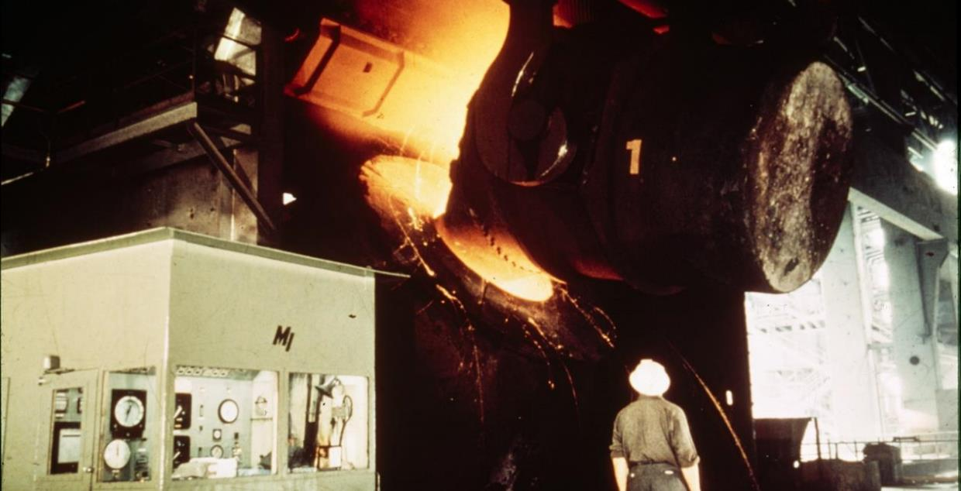
BHP steel furnace 1975. National Archives of Australia – 31505561.

6d. Manufacturing and processing
Clean energy brings new opportunities for Australia’s manufacturing industries. Beyond just decarbonisation, it has the potential to give us a comparative and competitive edge. By harnessing our abundant solar and wind reserves, Australia could manufacture low carbon metals and other products using renewables instead of coal and gas. If this potential was met with substantial capital investment, research and the right policy settings, Australia’s dwindling manufacturing workforces and communities could experience renewal.

Cement production
Cement is a material manufactured from limestone and clay and is a key ingredient in concrete. Cement and lime production produced around 4 million tons of CO2 in 2020-21, accounting for just under 1% of all emissions in Australia. Over half of the emissions from cement production are ‘process emissions’ that come from a chemical process. The remainder of emissions come from generating heating, using electricity and transport.
Australia produced 9.6 million tons of cement in 2020-21 and employed around 3,000 workers in the industry. The most common occupations are Truck Drivers, Cement Production Plant Operator, and Forklift Drivers. The Certificate III in Manufactured Mineral Products is an available pathway for Cement Production Workers, although there are only around 35 enrolments each year.

SmartCrete is a Cooperative Research Centre (CRC) with members across industry and academia. Their goal is to guarantee the long-term viability of vital concrete infrastructure in Australia while leveraging concrete sector efforts to meet global sustainability targets. It has five research programs:
- Engineered Solutions program: Focused on improving the way we engineer concrete structures and includes development of smart cladding, reduced noise pavements, 3-d printed concrete structures, lightweight concretes and safety in design.
- Asset Management program: Concerned with the way we manage our concrete assets, which includes development of sensing systems to monitor structural health and usage and inform lifetime models.
- Environmental program: Includes bio-concrete, use of artificial aggregate, CO2 absorbing concrete, luminescent concrete, energy producing concrete, waste disposal in concrete and cementless concrete.
- Sustainability program: Concerned with the development of self-healing, fire resistant stronger and more durable concrete.
- Disposal program: This program includes recycling and reuse.

Metals
Australia is one of the world’s largest producers of raw minerals, including iron ore, bauxite and nickel. However, for the most part, these raw minerals are exported as is, with little local processing, smelting or manufacturing. By investing in local manufacturing and renewable generation, Australia could reinvigorate its metals industries and the communities that depend on them. Global demand for metals will likely grow to support the manufacturing of renewable technologies.
Liberty Steel in Whyalla South Australia has recently invested $485 million in a low carbon electric arc furnace. Not only will this furnace increase the steel mill’s capacity by 50%, but will help reduce emissions overtime as energy inputs are decarbonised. A recent report by Geoscience Australia and Monash University found that replacing 1% of global steel production would require 35 GW of well-optimised wind and solar photovoltaics (PV), 11 GW of hydrogen electrolysers, and 1,000 square kilometres of land. For comparison, Australia only installed 5.3 GW of new renewable capacity in 2022, meaning a much larger pipeline of renewables would be required.
Over the past decade, employment has dropped across all metal refining and smelting industries (Figure 6.5). Iron Smelting and Steel Manufacturing is the largest employing industry by far, followed by Alumina Production and Aluminium Smelting. Engineering Production Workers are common across each of these industries, as are Metal Fabricators and Fitters (Table 6.2). Relevant VET pathways include Certificate IIIs in Resource Processing (1,600 enrolments in 2022), Process Plant Operations (693) and Engineering – Fabrication Trade (17,024).
Employment in metals manufacturing is located across most states and territories, with the largest regions being Port Kembla (NSW, 3,217), Gladstone (QLD, 2,779), Bunbury (WA, 1,909), Mandurah (WA, 1,280) and the Eyre Peninsula (SA, 1,167) (Table 6.3).
Figure 6.5. Employment in metals manufacturing
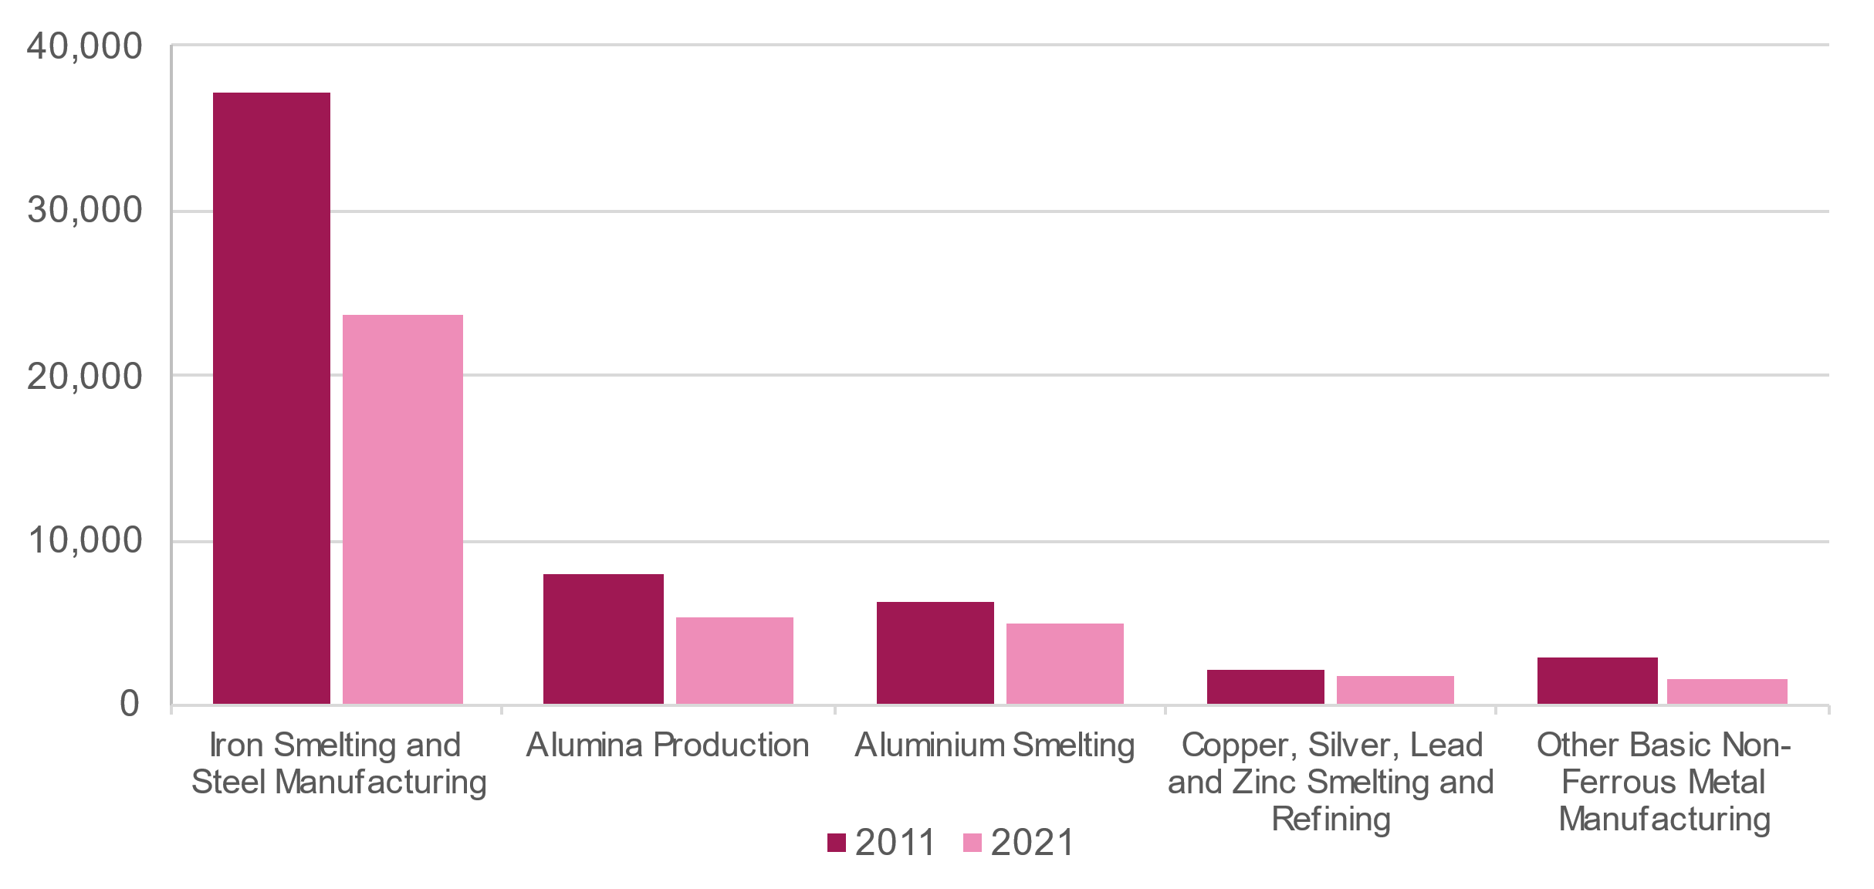
Source: ABS Census of Population and Housing 2021
Table 6.2. Top occupations in metals manufacturing
Iron Smelting and Steel Manufacturing | Alumina Production | Aluminium Smelting | Copper, Silver, Lead & Zinc Smelting & Refining | Other Basic Non-Ferrous Metal Manufacturing
Metal Fabricator | Engineering Production Worker | Engineering Production Worker | Engineering Production Worker | Miner
Engineering Production Worker | Fitter (General) | Fitter (General) | Electrician (General) | Fitter (General)
Metal Engineering Process Worker | Miner | Electrician (General) | Miner | Engineering Production Worker
Welder (First Class) | Electrician (General) | Metal Fabricator | Metal Fabricator | Stationary Plant Operators nec
Production Manager (Manufacturing) | Maintenance Planner | Production Manager (Manufacturing) | Fitter (General) | Electrician (General)
Source: ABS Census of Population and Housing 2021
Table 6.3. Top regions for employment in metals manufacturing industries
Iron Smelting and Steel Manufacturing | Alumina Production | Aluminium Smelting | Copper, Silver, Lead and Zinc Smelting and Refining | Other Basic Non-Ferrous Metal Manufacturing
Dapto – Port Kembla (NSW) | Bunbury (WA) | Gladstone (QLD) | Mid North (SA) | Goldfields (WA)
Eyre Peninsula and Southwest (SA) | Mandurah (WA) | Port Stephens (NSW) | Hobart – Northwest (TAS) | Mid-West (WA)
Newcastle (NSW) | Gladstone (QLD) | Northeast (TAS) | Townsville (QLD) | Rockingham (WA)
Mornington Peninsula (VIC) | Kwinana (WA) | Glenelg – Southern Grampians (VIC) | Outback – North (QLD) | Marrickville – Sydenham – Petersham (NSW)
Dandenong (VIC) | Wheat Belt South (WA) | Dandenong (VIC) | Hobart Inner (TAS) | Kwinana (WA)
Source: ABS Census of Population and Housing 2021

Manufacturing renewable technology
The net zero transformation will require a rapid increase in production of technologies like solar panels, wind turbines, and EVs, presenting an opportunity for manufacturing industries to expand. Australia is a relatively small manufacturer of renewable technology, however there are some examples of recent progress:
- Tritium is an advanced manufacturing company based in Brisbane that designs, builds and sells EV chargers around the world. The company has created around 600 jobs in Australia with and describes its staffing profile as a mix of “…communications engineers, electronics engineers, electrical, mechatronics, mechanical, software. So a very diverse workforce, and also a workforce that staff can walk in off the street, and we can train them up in two to three weeks into manufacturing jobs”.
- Volgren is Australia’s largest bus body builder, having built its first bus in 1979. In 2019 Volgren produced its first electric bus, and has recently delivered its 50th. As state and territory governments look to decarbonise their bus fleets, local manufacturers may benefit from increased demand. For example, NSW has committed to replacing its entire 8,000 bus fleet by 2030.
- Fortescue Future Industries is developing a multi-gigawatt-scale electrolyser factory in Gladstone, with the first electrolyser expected to be complete in 2023. Electrolysers are already in high demand as investments in hydrogen production ramp up.
- Tindo Solar launched Australia’s only solar panel production facility earlier this year in Adelaide. The 150MW facility produces around 350 panels a day and employs around 50 staff.

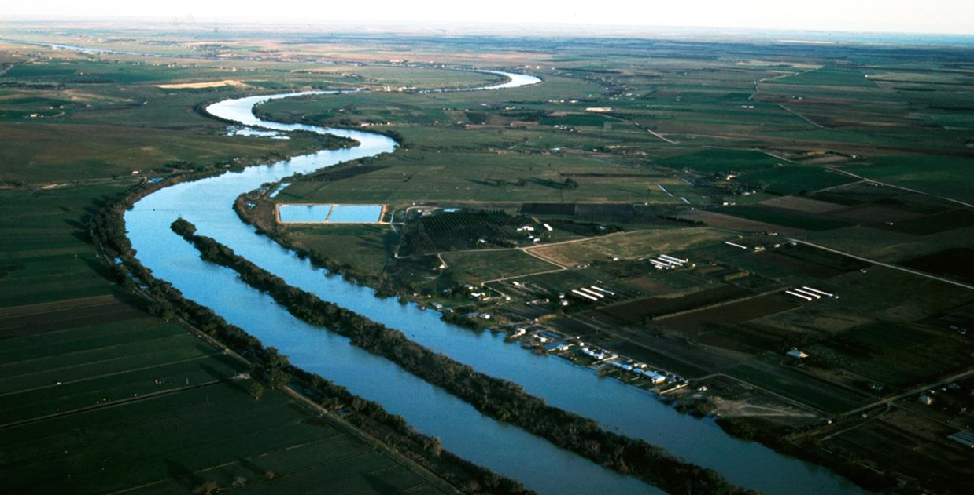
Murray River, South Australia 1975. National Archives of Australia – 11930857.

6e. Land use and the circular economy

Agriculture
Agriculture is a significant contributor to Australia’s greenhouse gas emissions, responsible for 17.5%of Australia’s national inventory in the year to March 2023. Unlike most other sectors, methane (from livestock) and nitrous oxide (from fertiliser use) are the main source of emissions. Some agricultural sectors also require substantial amounts of electricity, such as dairy farming, fruit orchards and wineries, while energy for tractors and other mobile and stationary plants typically relies on diesel. Therefore, the path to net zero and the workforce implications are distinct for agriculture.
The most directly related clean energy job roles relate to advisers and technicians who can help devise and implement solutions to reduce direct and indirect energy inputs and convert to renewable energy sources, including fertiliser usage, irrigation, electricity for a wide range of purposes including refrigeration and operating other machinery, and fuel for plant machinery. Many of those agriculture roles are likely to be based off-farm, but there will be requirements for on-farm workers to operate and maintain new machinery and equipment that is more efficient and/or uses renewable energy sources. In the context of an industry that is continually becoming more capital intensive, these roles are unlikely to greatly add to the overall size of the agriculture workforce.

Data from LinkedIn Talent Insights suggests that at the moment clean energy-focused job roles in Land Use remain concentrated in agricultural services firms (such as irrigation services) and in research activities by the CSIRO, state-based agriculture departments and universities. Although as mentioned earlier, this data is likely skewed towards workers in professions. Common job roles include Agronomist and Farmer. While more than 10,000 professionals list one or more of the related skills (sustainable agriculture, sustainable forest management, carbon management), fewer than 50 job posts in the last 12 months referred to one or more of the land use skills.
There is also the prospect for clean energy activities primarily driven by other sectors to have some workforce implications for agriculture. For example, circular waste opportunities to harvest rather than discard (or burn off) sugar cane waste or wheat straw for biofuel would generate some additional demand for workers to harvest, transport and process the waste to an interim product. Agriculture also has a complementary role in the land use and forestry space via the use of integrated farming practices to provide carbon sinks and other sequestration practices, which many farmers have embraced.

Land use and forestry
Land use and forestry play a distinct role in Australia’s transition to net zero as sectors that absorb emissions. The main drivers of emissions reduction in this sector are changes in land use – such as the conversion of forest land – and harvested wood products. The contribution of land use to net emissions was not something that we were able to capture in the modelling in Chapter 5. As further data and research become available and the contribution of land use to emissions reduction becomes clearer, there will be merit in revisiting employment and skills implications.
Maximising the contribution that Australia’s land mass can make to reducing net emissions crosses over many sectors – forestry, national parks, agriculture (through minimising clearing and pursuing replanting opportunities), and construction (in terms of release of land for new residential, industrial and commercial development).
Afforestation – increasing the amount of Australia’s land mass covered by forests – is one means of significantly reducing net emissions, but has potential implications for other economic activities, particularly agriculture, as well as requiring partnership with local First Nations communities. There is no strong evidence that new job roles would be required but better managing existing and new forests will draw on the current skills of foresters, other forestry and logging workers, and park rangers (including Indigenous rangers, as discussed later in Chapter 8).

Recycling and waste management
Just as so many realms of clean energy technology, production and employment are new and emerging, so too is the ensuing end-of-life sector within the circular economy – recycling and re-use. In their 2018 report, World Employment Social Outlook, the International Labour Organisation (ILO) estimated global job demands for recycling in the millions, led by recycling of steel, aluminium, other metals, and wood products.

As the widespread investment and use of new clean energy technologies grows, so too does waste from by-products and once technology reaches its end-life. The increasing scale of investment in and adoption of clean energy technologies is creating new challenges, accelerating waste streams.
Likewise, the decommissioning of former oil and gas, coal mining, and coal fired power stations will generate demand for workers to recycle materials as well as with the skills required to safely shutdown and dismantle infrastructure. The Australian Government is developing a roadmap for establishing a decommissioning industry in Australia. This roadmap will position Australia to harness the estimated $60 billion of offshore petroleum decommissioning activities expected to occur over the next 30 to 50 years.
Re-use and recycling will be critical in dealing with this challenge. As the alternative to landfill, it could provide additional and significant negative environmental impacts. CEC for example has estimated that by 2034 for wind turbines alone, a total of 15,000 tonnes of blade composite waste will have been created in Australia due to decommissioned wind farms, at up to 4,000 tonnes in any given year.
Sustainability Victoria state that across the nation, PV systems, including solar panels, inverters and batteries, are being installed in record numbers. They estimate that more than 100,000 tonnes of solar panels will enter Australia’s waste stream by 2035.
Not only will the sustainable reuse or recycling of this waste become an environmental imperative, but recycling will also likely become increasingly important for participation in related economic markets. The EU, for example, has passed a law requiring the labelling of recycling content on batteries. Just as the eventuality of this waste is problematic, it also provides opportunities.
According to the ISF report, ‘Employment, Skills and Supply Chains: Renewable Energy in NSW’, based on current data it is estimated that recycling creates around 3.5 times as many jobs as landfill disposal creates. Their analysis found that 9.2 jobs are created per 10,000 tonnes of waste recycled compared to 2.8 jobs per 10,000 tonnes of waste disposed.
Skills required in this end-of-life section of the circular economy will vary based upon components and materials. They will for example include roles in decommissioning, recycling, waste management, sorting, shedding, crushing and processing, and disassembly. Not all skills required will be new – for example, the ISF cites that skills will be transferable from the manufacturing sector to the assembly and disassembly of renewable energy technologies, while ensuring the highest value recycling.
There are a number of active initiatives aimed to help develop Australia’s circular economy. The National Waste Policy Action Plan aims to prevent waste via the likes of better product design and more efficient production processes. In 2022 it was expanded to strengthen Australia’s efforts towards our 2030 emissions reduction target.
The $A250 million Recycling Modernisation Fund is a national initiative aiming to expand Australia’s capacity to sort, process and remanufacture glass, plastic, tyres, paper and cardboard. The A$15 billion National Reconstruction Fund aims to drive investment in priority areas focusing on projects that diversify and transform the Australian economy. One of the priority areas is renewables and low emission technologies. The government has announced a target investment level of up to $3 billion of NRF finance for renewables and low emission technologies.
Data from LinkedIn Talent Insights further shows how new and dispersed the job roles are in the circular economy at present. Waste management and recycling companies are well represented as the most common types of employers, along with universities. However, ‘policy officer’ is the most common job title and research roles feature strongly in the fastest growing job titles – the job roles associated with industry are not apparent. By volume, the majority of sector-based jobs are likely to be labourer or trades-level roles, which may be susceptible to automation over future decades.

Carbon Capture, Utilisation and Storage
Carbon Capture, Utilisation and Storage (CCUS) refers to a range of technologies intended to capture emissions of carbon dioxide or other greenhouse gases and either safely store it underground (storage) or use the carbon dioxide as an input into an industrial process to produce products such as ammonia and urea.
CCUS technology remains under development and the modelling in Chapter 5 has not assumed that CCUS will be required for Australia to reach net zero. However, if innovation continues and concerns about safety and cost can be met, CCUS has the potential to assist Australia and the world reach net zero. The Minerals Council of Australia emphasised that Australia must invest in affordable and scalable CCUS technologies, and that with greater development and use it could allow Australia to remain competitive as a leading energy exporter.
The Australian Petroleum Production and Exploration Association (APPEA) pointed out that CCUS is an essential technology that will assist in transitioning to a net zero emissions economy and requires workers to deploy at a sufficient scale. APPEA further suggests CCUS will likely play a role in reducing electricity sector emissions and emissions from hard-to-abate sectors such as cement, steel making and critical minerals processing.
As at mid-2022, the Gorgon carbon capture and storage project on Barrow Island, off the coast of the Pilbara region in Western Australia, is the world’s largest CCUS project. The Gorgon project is a joint venture between the Australian subsidiaries of Chevron, ExxonMobil, Shell, Osaka Gas, Tokyo Gas and JERA. The Australian Government has committed $60 million to the Gorgon Carbon Dioxide Injection Project as part of the Low Emissions Technology Demonstration Fund (LETDF). CCUS can potentially provide a useful second life for depleted oil and gas fields, such as in the Cooper and Otway basins of South Australia, becoming part of the decommissioning process for these sites.
CCUS projects are complex, requiring input from Geologists, Engineers from multiple specialities (including mining, process, electrical, mechanical and chemical/materials), as well as advanced project management skills. CCUS requires technical and trade roles similar to oil and gas extraction – Drillers, Fitters, and Electricians, potentially providing expansion and transition opportunities for this workforce.


Chapter 7:
Education and
training reform

Explores opportunities to address barriers faced by students and providers of education and training.

Overview
Through our extensive consultation, we’ve identified many barriers faced by education and training providers and students. Without addressing these fundamental, underlying constraints, the student pipeline won’t be match-fit to address the growing and evolving skills needs of the sector. Some of these barriers are common across VET and higher education, while others are specific (or more prominent) in one or the other.
It is important to note that as of writing, a new National Skills Agreement and Universities Accord are both under active development. The outcomes of these two negotiations will greatly impact the design and delivery of any recommendations explored below.
This chapter explores these barriers and potential reforms to address them. These have been organised into the following themes:
7a. System design
    - Frameworks for deeper collaboration between VET, higher education and industry
    - New models for course delivery to better align graduates with emerging needs
    - Clearer pathways for students to navigate and access
    - A cohesive and connected tertiary education system with fewer obstacles
    - Consistent occupational licencing.
7b. Funding and program design
    - New and responsive curriculum development for emerging needs
    - Servicing thin markets and regions through competitive models
    - Minimising capital constraints through collaboration
    - Incentivising employer involvement in education and training.
7c. Student pipeline
    - Increasing student participation in STEM
    - Growing and supporting the trainer, teacher and researcher workforce
    - Doubling down on efforts to get more women into trades
    - Supporting more First Nations people into education and training
    - Better targeting of incentives and supports for apprentices.
Chapter 8b explores opportunities to mature the sector and lift training rates by stimulating a training culture amongst employers. It also explores opportunities to better utilise international students in relevant fields. Chapter 4b explores the education and training pathways that currently exist for clean energy.

7a. System design

Frameworks for deeper collaboration
The fast pace of technological innovation in clean energy means skill requirements and job roles are constantly evolving. Therefore, it is critical to have arrangements where industry, VET, and higher education can collaborate as technologies are developed and deployed. Through our consultations we found some examples of this happening already:
- Dual sector universities have a unique advantage in fostering industry, higher education and VET collaboration. Federation University has established itself as a centre of innovation and research on renewable energy as the site of the Asia Pacific Renewable Energy Training Centre (an initiative that received support from wind energy companies, Vestas, Acciona, Tilt Renewables and GPG). The training centre includes a wind turbine onsite at the Mt St Helens (Ballarat) campus for training students. Federation University is also home to the Centre for New Energy Transition Research.
- TAFE Institutes that are approved non-university higher education providers, such as Chisholm Institute, are also identifying ways to bridge higher levels of learning associated with bachelor degrees and the strong workplace learning and industry connection of VET (explored further in the next section).
- TAFE SA and South Metropolitan TAFE (WA) pointed to the benefits of their involvement in two CRCs – the Heavy Industry Low-carbon Transition CRC (HILTCRC), and the Future Battery Industry CRC. In both cases, the two TAFEs have been able to quickly identify skill implications of new technology and begin development of training responses.
- The University of Wollongong received an investment of $10 million from the Australian Government to establish an Energy Future Skills Centre. A second investment, valued at $2.5 million, helped upgrade equipment and teaching aids to create a Renewable Energy Training facility at Wollongong TAFE. Through a combined partnership, the two facilities will work together to utilise these state-of-the-art teaching laboratories and upgraded equipment to provide real life examples of clean energy technology.
Much more of this style of collaboration will be needed, and it should not be contained to specific organisational forms such as the public dual sector universities. Rather, options will need to exist to draw in the traditional standalone forms of universities and TAFEs. The proposed TAFE Centres of Excellence (Recommendation 7.1), if adopted, will be well placed to lead on new collaborative approaches to qualification design. JSCs also have an important role in promoting and facilitating collaboration between industry, education and training.

New models for course delivery
The pace and complexity of work in the clean energy sector lends itself to new models of course design and delivery. In many regards, clean energy is an ideal testbed for new course delivery approaches, given the sector’s emerging nature and the fact that it straddles traditional trades and professions. For example, to address electrification in the industrial segment of the economy, there is likely to be growing demand for Electrical Engineers with A-Grade electrical licenses.
There would be great value in expanding opportunities for mid-tier work-based and integrated learning, including higher apprenticeships and top-upskilling. One example is a pilot led by the Ai Group to combine an electrical engineering degree with a Certificate III electrical trade, delivered as an apprenticeship. This blended qualification will seek to combine the theoretical aspects of higher education and the practical skills and experience associated with a trade apprenticeship. Federation University are planning to launch a 6-year apprenticeship with NECA to provide a Certificate III in parallel with an Electrical Engineering degree. Teaching will be delivered in 9 week blocks each year, with NECA Education acting as the VET RTO.
Chisholm Institute has a partnership with Renewable Energy Design Engineering and Integration (REDEI), an enterprise that designs, engineers, manufactures, and integrates bespoke renewable energy generation and battery storage systems. Chisholm Institute engineering students have undertaken vocational placements at REDEI Services through a program that targets the occupational gap between trade-qualified and fourth-year engineering degree graduates. Currently, Chisholm offers this program only on a full-fee basis (with students eligible for FEE HELP).
In many respects, increasing training opportunities for technician-level roles within clean energy is an extension of a higher apprenticeship pilot in advanced manufacturing that began in 2017. This pilot program involved a collaboration between Siemens (which employed the participants) and Swinburne University (which created a customised higher education Diploma of Advanced Technology, articulating to a Bachelor of Technology). The Australian Government established further programs in 2021 through the Advanced Apprenticeships (Industry 4.0) pilot involving seven universities and engaging a broader range of industries, including defence and aerospace.
These types of new delivery models will require national collaboration, as state and territory training authorities are ultimately responsible for determining which qualifications are available as apprenticeships. Training that spans VET and higher education is also subject to different funding and regulatory arrangements, further complicating the ability to design and deliver new course models.
While the number of pilot programs is promising, these are typically targeted to either VET or higher education, and often to a particular state or territory. Moving towards a substantial, nationally consistent approach would be more impactful and could benefit from a ‘regulatory sandbox’ approach, where participants can test innovative concepts in the market under relaxed requirements, on a time-limited basis.

Recommendation 7.1

Establish TAFE Clean Energy Centres of Excellence to collaborate with industry, communities, universities and governments on new curriculum and course offerings that meet the emerging needs of industry and can keep pace with rapid technological change. This will require a ‘regulatory sandbox’ approach that relaxes current funding and regulatory constraints that inhibit such cross-sectoral collaboration.

Recommendation 7.2
In collaboration with states and territories, consider expanding opportunities for mid-tier work-based and integrated learning, including higher apprenticeships, top-up training and microcredentials.

Clearer tertiary pathways
Clearer tertiary education and training pathways are desperately needed for the clean energy workforce. This means boosting the status of VET as a viable and rewarding post-school pathway, and dispelling the idea that tertiary education is a once off, binary choice between two disparate systems.
Workshop discussions undertaken for this study suggested that improving communications and messaging for VET and Higher Education pathways may help improve parity of esteem between the VET and higher education sectors. As noted by the Universities Accord Interim Report, “we need to eliminate some of the cultural barriers that have historically existed between the VET and higher education sectors and see both sectors as distinct but equally important parts of the skills development system”.
Attracting students to clean energy is also difficult without clear and consistent career pathways. Because this sector is relatively new and continuing to evolve, it can be difficult to provide information that is current and to showcase success stories. Pathways into clean energy are not always straightforward. For a young person to work on large scale solar or battery installations, they may first need to do a four-year electrical apprenticeship in a traditional sector like construction. This is because opportunities to immediately work on clean-energy projects can be limited. Similarly, students may associate some pathways, like earth sciences, as being linked to the fossil fuel sector and not be aware that these roles are critical for decarbonisation.
The lack of a standardised curriculum for clean energy courses can also create confusion among students and employers about what skills and knowledge are necessary for jobs and careers in the clean energy sector.

Careers guidance and advice for clean energy pathways needs to be substantially improved. Greater clarity and consistency can support more young people to identify and access the plethora of opportunities in this sector. The National Careers Institute will need to work closely with state and territory governments, industry groups (like the CEC), careers practitioners and education providers to ensure careers advice is consistent, reflects genuine pathways, and clearly communicates the sector’s value proposition. Career information should acknowledge the electives and pathways that exist within qualifications and their role in supporting skills specific to roles in clean energy, as explored in Chapter 4.
Recommendation 7.3

The National Careers Institute should collaborate with tertiary providers, industry and other stakeholders to improve awareness of clean energy career pathways, including the many different education and training options to specialise.

A harmonised tertiary system
Stakeholders have long yearned for a harmonised tertiary education system in Australia, creating opportunities for student mobility between the VET and Higher Education as the pinnacle goal for long-term workforce and policy development. The Ai Group noted that the ongoing disconnect between VET and Higher Education has led to industry needs not being met and new innovations being stifled, compounding the overall growth of the sector.
The draft VET Reform Roadmap published in April 2021 had amongst its goals improving cross-sector cooperation and integration, citing “stronger alignment and integration between VET and Higher Education as one of the seven destinations that will need to be reached”. More recently, the Universities Accord Interim Report emphasised the importance of bringing together VET and higher education, particularly in areas of critical skills needs. However, the Interim Report noted that the reform of the Australian Qualifications Framework (AQF) could be a critical element of a new tertiary education system.
“Increasingly skills development in many areas of study will require both the best elements of VET and higher education. An Accord for the future of the tertiary sector needs to bring together governments, education providers, employers, regulators, peak bodies for the professions and the labour movement in a shared purpose to better align skills development across the tertiary sector with the skills needs of employers and workers”.
– Australian Universities Accord - Interim Report.
Addressing these barriers will be critical to reducing friction and enable collaboration, but will take the effort of both systems. Given VET and higher education systems are also in the midst of major reforms, the time for genuine action should be now.

Consistent occupational licencing
Occupational licencing exists to ensure quality and protect the safety of consumers and workers. However, licencing can also act as a barrier and reduce the number of people that can work in that occupation. This is particularly true for migrants who may satisfy skills assessment requirements but fail to meet licencing requirements, leaving them in a labour market limbo.
Each state and territory is responsible for deciding which occupations need registration or licencing, and the requirements that go with it. This has resulted in inconsistent approaches across Australia that can limit worker mobility, something that is particularly important in a highly mobile and trade-dominant workforce like clean energy. Some stakeholders have raised the need for better harmonisation of licencing across Australia, which is something that could be facilitated through the National Energy Workforce Strategy as a priority focus.
State and Federal governments must take immediate action to update, streamline and nationally harmonise relevant occupational licences to reduce barriers to labour mobility where this will not jeopardise safety. Licensing should enable modern training pathways in new technologies such as small-scale renewables and electric vehicles.
– Powering the Transition, Committee for Economic Development of Australia (CEDA).
The establishment of the Automatic Mutual Recognition (AMR) from 1 July 2021 has improved the recognition of occupational licensing across Australian states and territories. This new approach has removed additional licensing and registration fees when working in another state or territory. However, not all occupations are covered, and Queensland has yet to join the scheme.
Further, inconsistences currently exist across multiple state and territory jurisdictions in the list of AMR occupations. For example, licensed Electricians from Queensland, Victoria and the ACT allow automatic recognition under the East Coast Electricians scheme, with activities under electrical wiring work slated to commence under the AMR scheme in NSW from 1 July 2024. On the other hand, executive powers under state ministers provide the opportunity to exempt registrations from automatic deemed registration (ADR) occupations if it poses a significant risk to consumer protection, the environment, animal welfare or the health or safety of workers or the public. As an example, the ACT Government has exempted the following occupations from achieving the AMR, including but not limited to Electricians, Gasfitters, Plumbers, and Builders, to name a few.
Although significant progress has been made in the harmonisation of mutual recognition of occupations through the AMR scheme, not all occupations that require licensing have been recognised. The absence of Queensland under this initiative potentially impedes the overall progress of the nation’s transition towards net zero. Addressing these issues and the inclusion of Queensland under the AMR scheme will be critical to achieve a cohesive licensing arrangement that is fit for purpose across all states and territories.

7b. Funding and program design

New and responsive curriculum
As new technologies appear, and emerging sectors start to grow, new courses will be needed to deliver graduates with the right skills. The speed at which some of these changes are happening leaves the tertiary sector little time to respond, meaning anticipation and agility are key. Apprentices and undergraduate degrees are typically three to four year commitments, creating an in-built lag of at least several years in the system. Consultation has indicated that even industry is struggling to identify its current skill needs, let alone future needs.
Designing and delivering new courses can be particularly challenging for emerging sectors. High upfront capital costs, low initial demand from students and employers, and a lack of trainers with industry experience are just some of the challenges. Roundtable discussions suggested that the Australian Government could play a greater role by providing seed funding to support curriculum development, and to consider reforming funding models.
JSCs will have an important role to ensure VET training packages remain relevant by working closely with industry and other key stakeholders like unions, training providers, peak bodies and professional associations. Unlike in higher education, VET providers are unable to self-accredit courses in many cases, therein limiting their overall ability to quickly respond to emerging skills needs. If established, TAFE Centres of Excellence may be well placed to trial self-accreditation in their area of focus, improving the sectors ability to respond to rapid change. We also heard from stakeholders that universities are not typically incentivised to design or deliver courses in areas of national priority, including clean energy. This is a result of current funding structures and could be explored as part of the Universities Accord.
As explored in Chapter 4, the VET sector will benefit from course design that can be sustainably delivered. Highly specialised, firm-specific training will limit workers’ ability to apply their skills in different settings, and make it difficult for the VET sector to deliver. Specialised electives, core units and skillsets may be more cost effective and timely than bespoke qualifications. Similarly, industry led training and certification plays an important role to bridge the gap between what is sustainable and appropriate for tertiary education to deliver, and what is needed in the workplace.

Recommendation 7.4
Consider giving TAFE Centres of Excellence authority to self-accredit courses in their areas of expertise to expedite new training.
Recommendation 7.5

Explore mechanisms to provide seed funding to universities, TAFE Centres of Excellence and other education providers to develop curriculum in priority areas. These areas would need to be identified through robust criteria co-designed with state and territory governments.

Servicing thin markets and regions
RTOs can only deliver training sustainably where there is a supply of learners willing and able to enrol. This can be particularly difficult for specialised training where the number of workers needed is small, limiting the number of students prepared to commit to that career path. In the past, employment in energy supply has been concentrated in a handful of regions, allowing education and training providers to scale up delivery for local industry needs. This approach is difficult to apply to clean energy because the sector is more mobile and often dispersed where tertiary markets are thin. Clean energy training can also be capital and equipment intensive, making it unviable for smaller, regionally located providers to offer.
“Communities in regional locations have little sense of what ongoing employment opportunities exist on a wind, solar, battery or hydropower site. Training organisations are also unsure of the skills and qualifications to offer locals in preparation for upcoming renewable energy projects in the region.”
– Clean Energy Council.
An as example of mitigating this barrier, TAFE NSW are considering hub-and-spoke models of training that align with the NSW REZs. Instead of TAFE NSW constructing its own training facilities across multiple locations, it will consult with industry and gain access to existing infrastructure where possible. This will be supplemented with virtual learning where appropriate.
Clean energy workers are needed right across Australia, including in regional and remote areas away from sources of labour supply. In some instances, this requires short-term moves or fly-in-fly-out work, which can be inaccessible for apprentices, particularly in their first year. Working in remote areas is also impractical for apprentices who need to access in-class training or other work sites to gain all of their competencies.
Some stakeholders suggested that group training models can work better in remote locations at ensuring apprentices are exposed to all the skills that their apprenticeship requires of them. There is also evidence to suggest completion rates for GTO apprentices have been higher than those employed directly by small and medium employers, including better rates for some disadvantaged groups. There is merit in further exploring group training in the context of clean energy, including whether it could lead to higher completion rates in regional areas and for historically underrepresented groups.
As part of the Northern Territory First Nations Clean Energy Strategy workshop held in Alice Springs in May 2023, peak bodies and community representatives highlighted that young people wanted to be able to train to get jobs within or closer to their communities rather than having to travel to Alice Springs or even Queensland.
Because VET is typically hands-on and competency based, delivery can sometimes be less flexible than in higher education. Trade training can often require access to industrial equipment in workplace like environments, making it difficult to offer solely online or through mobile delivery. Without flexibility, RTOs may struggle to work around the needs and circumstances of students, particularly those in regional and remote areas that need to travel long distances for face-to-face training.
Flexible and non-traditional delivery models should be explored to support tertiary education and training in regional areas. This is particularly important for courses relevant to clean energy that are capital intensive and require face to face delivery. Collaboration between VET providers (including TAFEs), universities and industry is another way that training can be provided more sustainably in regional communities. Targeted training centres may be appropriate in regions with long-term energy projects where new training facilities cam be sustained with students, trainers and a demand for workers.
Recommendation 7.6

Explore mechanisms for identifying and servicing thin markets in higher education and VET to ensure training provision in areas critical to the clean energy transition, including hub and spoke models of delivery.
Recommendation 7.7

Explore the merits of fostering group training schemes as a means of employing apprentices in clean energy roles. This may help apprentices access shorter-term energy projects and gain broad experience with different technologies.

Addressing capital requirements
As new sectors emerge, education and training providers need access to new technologies, tools and facilities. Without these, providers can’t give students the skills and experience needed by industry. Roundtable discussions highlighted the difficulty that some providers face finding funds for new equipment and facilities, and often there are long delays. There was also considerable concern about the inflated costs and difficulties in accessing training materials. In the current environment of supply chain lags and high inflation, this has left some TAFE institutes with a shortfall in the purchase of equipment and building fit out.
By working with industry to gain in-kind support such as access to existing infrastructure and technologies, some education and training providers could avoid having to construct their own facilities. As mentioned earlier, there is benefit in increased collaboration not just with industry, but between educational institutions sector wide. This could help facilitate the sharing of learning and enable cost-sharing opportunities, leading to cost savings via bulk-purchases of common training materials and equipment. Similarly in higher education, a model could be explored by establishing a nationally coordinated program where multiple universities contribute to the design of courses in new priority areas, where thin and emerging markets would otherwise be underserved.
All governments can also play an important role by injecting capital into infrastructure projects like buildings, facilities and equipment. This is particularly valuable in emerging areas, like clean energy, that can benefit from a kick start of funding to gain momentum. The Revitalising TAFE Campuses Across Australia agreement is an example of this.

Recommendation 7.8

Continue to make dedicated capital funding available, along the lines of the Revitalising TAFE Campuses Across Australia agreement, and similar programs in higher education, to ensure training facilities have access to current equipment. Ideally this will include ways to incentivise industry financial and in-kind support.

Incentivising employer engagement
Apprenticeships can only take place if employers are familiar and willing to engage with the VET system. There is a risk that employers in the clean energy sector may not be fully engaging with the VET system due to their lack of familiarity with it. This could be driven by the fact there are many overseas firms joining the sector, and some employers have stronger connections with higher education and research institutions, with inherent preferences to hiring skilled workers rather than investing in apprentices. It’s important that governments actively engage with clean energy industries and support employers to:
- hire apprentices and support them through to completion
- access incentives and in-training supports
- support course design and updates
- allow trainers to maintain the currency of their industry skills and knowledge, and
- provide opportunities for on-site training by industry and RTO trainers.
Employer involvement is also a crucial ingredient in successful higher education programs. Work placements have long been embedded in engineering degree programs and stakeholders report that students who select work-integrated learning placements are more likely to secure an ongoing role post completion. Monash University has fostered strong connections with industry, where third and fourth-year students are able to select a unit and undertake a 6-month paid internship within the chosen field.
“The general low level of partnership between the clean energy industry and education and training providers affects the volume of graduates, knowledge and skills taught, skills alignment and the readiness of graduates.”
– Ai Group.
While most universities offer internships, unpaid internships are more common. Students may be less likely to participate in unpaid internships if the cost equates to forgoing paid employment, which can be particularly difficult for those from low socioeconomic backgrounds.
While many employers may be interested in providing paid internships or other supports for higher education students, there can be regulatory or funding barriers that make this too difficult. As higher education institutions are large employers themselves, there may be merit in exploring a group training model for the sector.
This type of model could help industry access higher education students for paid placements without needing to assume the responsibilities of an employer. It also means students can more easily move between different worksites, while maintaining their employment rights and conditions provided by the higher education institution.

Recommendation 7.9
Consider establishing a pilot program that, along similar lines to the group training model, allows employers to access higher education students for paid placements without needing to assume the responsibilities of an employer. The program would need to consider rights, responsibilities and protections.

7c. Student pipeline

Increasing participation in STEM
As explored in Chapter 4, low participation in STEM subjects is a significant concern, particularly for the future of clean energy. Australia will need many more graduates in existing STEM fields like Earth Sciences and Electrical, Civil and Mechanical Engineering, alongside graduates of more specialised courses. Demand for these fundamental skills is also growing across other sectors, like information technology and healthcare, putting further pressure on our dwindling supply.
“We need to look at the entire STEM pathway in a broad and holistic way. Opportunities to reach equity in STEM are in our communities, education settings and workplaces, in our systems of government and decision-making – even in ourselves. All organisations, institutions and people in the STEM ecosystem will benefit from a bigger, more diverse, STEM workforce. Achieving this requires a collective response”.
– Diversity in STEM Review, Draft Recommendations.
One constraint to scaling up higher education engineering enrolments is the decline in advanced STEM enrolments in secondary schools. Anecdotally, many students forgo mathematics and science subjects as they are perceived as difficult and will not help students achieve a high ATAR score. This could be the result of poor messaging, or an ATAR system that acts as a disincentive to STEM.
Roundtable discussions emphasised the importance of schools engaging with career advisors and educating parents on the benefits of enrolling in STEM subjects. Additionally, the integration of industry workplace simulations at the beginning of secondary school may influence student decision-making by improving awareness of unfamiliar professions and trades. Informal exposure to STEM knowledge and pathways outside of the schooling environment can also support efforts to increase young people’s awareness of and interest in further STEM study and careers.
Aside from foundational STEM knowledge, participants observed that a constraint on the pipeline of students is a lack of awareness of the strong demand for engineers and the variety of possible engineering careers. Scholarships for undergraduate students in clean energy (or engineering and earth sciences more generally) could help attract more students, in the same vein as state governments have pursued for teaching and nursing.
Minimising pre-requisites for higher education degrees may be one solution to increase enrolments, however stakeholders noted that removing pre-requisites meant that students will often need bridging and enabling courses to cover the required knowledge. Greater participation in STEM will also require a teacher and trainer workforce with STEM skills.

Recommendation 7.10

Education and training providers should consider entry requirements and supported pathways, like pre-apprenticeships and elective substitutes, to encourage more students from underrepresented backgrounds into full qualifications. Governments should consider the adequacy of funding of these programs, including appropriate wrap-around supports, scholarships and industry connections.
Recommendation 7.11

Supercharge efforts to increase the uptake and availability of STEM education and training as a coordinated, whole of government priority. This includes supporting programs that inspire young people towards STEM careers and break down barriers to make career paths more accessible. It is important that VET, particularly trade qualifications, is supported and communicated as a critical STEM pathway.

The trainer, teacher and researcher workforce
Trainers and teachers are integral in developing a flexible workforce with the skills required by industry to power the clean energy transition. They play a pivotal role in not only linking industry expertise with training delivery, but also offer support, guidance and mentorship to students. Attracting industry experts into teaching and training roles has been recognised as an ongoing challenge, with the demand for industry trainers to grow exponentially as the transition continues. In simple terms, the transformation of our workforce will require the assistance from both teachers and trainers to effectively impart the knowledge and skills onto the next generation of the workforce.
Finding trainers to deliver courses is particularly difficult in emerging industries with nascent workforces like clean energy. Due to the high demand for these skills, it can be hard to attract workers from industry to join the teacher and trainer workforce. Competitive behaviours can also limit the willingness of employers to share staff, facilities and equipment to facilitate on the job learning and assessment. An increased demand for trades training across the board has also put added pressure on RTOs to find new trainers to scale delivery.
The added requirement to complete the Certificate IV in Training and Assessment can deter experienced tradespeople from moving into a training role, especially if they have not engaged in formal learning themselves for some time. Anecdotal evidence from TAFE practitioners working in the sector suggests that the workforce of trainers delivering many of these high-demand qualifications is ageing, meaning a large amount of training capacity may soon leave the sector.
With limited trainers in Australia, there needs to be greater collaboration and sharing between and within RTOs and industry. Industry also needs to support flexible integration opportunities for trainers to maintain their skill proficiency and familiarity with the latest technologies – a common challenge for RTOs. For electrical trades, the level of supervision an apprentice needs while working is very high because of the safety issues related to working with electricity. This makes it difficult for employers to take on multiple apprentices at once, in contrast to non-trade qualifications or at universities where large numbers of students can be trained simultaneously by each qualified trainer.
TAFEs are well aware of this issue, which extends beyond clean energy to many other trades and subject areas, and have trialled various initiatives. For example, TAFE NSW has a suite of initiatives to attract industry professionals into teacher roles, including scholarships to undertake the Certificate IV in Training and Assessment and a “Pay to Learn” program to support and fast-track industry entrants.
Nationally, the Australian Government has committed to developing a VET Workforce Blueprint to improve the attractiveness of careers in VET and assure a supply of qualified VET teachers, trainers and assessors. JSA will also be undertaking a study into the VET teacher workforce, in partnership with DEWR and the National Centre for Vocational Education Research (NCVER).
Training providers, industry and unions all raised the criticality of increasing the number of workplace-based trainers and assessors to make the best use of current industry knowledge and to co-locate training with work that may be taking place far from established TAFE campuses (e.g. solar farm installation and transmission projects in regional and remote Australia).
However, industry faces barriers in making its experienced workers available to perform training and assessing roles:
- training and assessing activities divert time away from critical project work
- the time needed to credential workplace trainers and assessors is a further constraint, as well as the availability of training
- rewarding such senior workers for their training activities, when they are already often well remunerated for the work they do
- a preference for proprietary training and reluctance to share their best workers with competitors was also raised.
These barriers might be more easily overcome in larger, more established entities such as transmission firms and some examples were provided during consultations. Stakeholders did not perceive that there were teacher and researcher workforce shortages to the same extent in higher education. Australia is able to recruit postdoctoral talent globally and remains an attractive destination. Of more concern is the challenges in attracting a large number of domestic research students.
Universities agreed on the importance of having a future supply of domestic PhD students to support the future requirements of clean-energy skills within the Australian labour market. There has been a reduction in local PhD students, which was exacerbated by COVID-19, with the University of South Australia raising that the lack of domestic students enrolling in post graduate qualifications led to universities relying on the international student market for post graduate qualification enrolments.

Recommendation 7.12

Work in partnership with industry and education and training providers to deliver upskilling opportunities for the teaching workforce to maintain their skills currency as new technologies emerge.
Recommendation 7.13

Governments should explore opportunities to support and incentivise experienced electricians and other tradespersons and technicians in critical occupations to become VET teachers and trainers.
Recommendation 7.14

Investigate initiatives to promote workplace trainers and assessors embedded in industry, working collaboratively with trainers and teachers based in TAFEs and other RTOs. Any initiatives would need to consider how to appropriately reward participating trainers and their employers.

Women in education and training
Chapter 8 explores the workplace barriers that women face in the clean energy sector more broadly.
If Australia is serious about transforming its energy sector, many more women need to be supported into this workforce. Women only represented around 7% of Electrotechnology Engineering commencements in 2021 (Figure 7.1), and under 6% of Electrical apprentice commencements in 2022 (Figure 7.2). For there to be genuine transformational change, women’s participation needs to be front of mind in every aspect of education and training programs and supports. It also requires a critical mass of women and girls in classrooms, on worksites, as teachers and trainers, and as employers and supervisors.
Figure 7.1. Female Electrotechnology Engineering commencements (domestic)
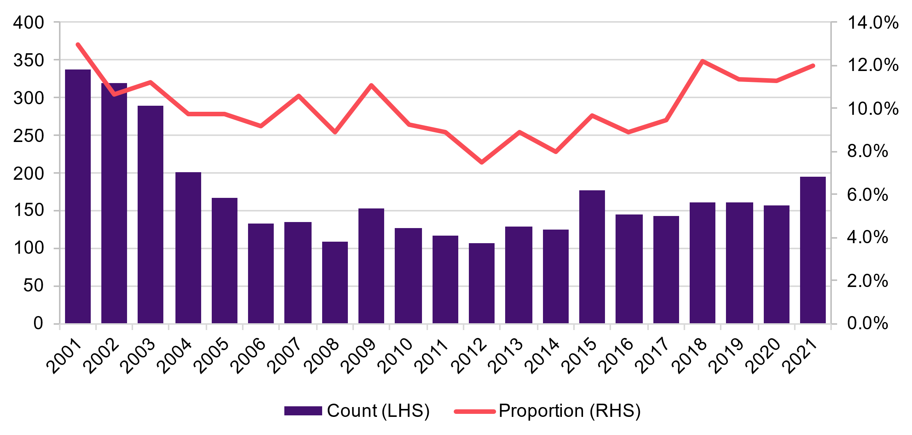
Source: Department of Education commencement data
Figure 7.2. Female electrotechnology apprenticeship commencements
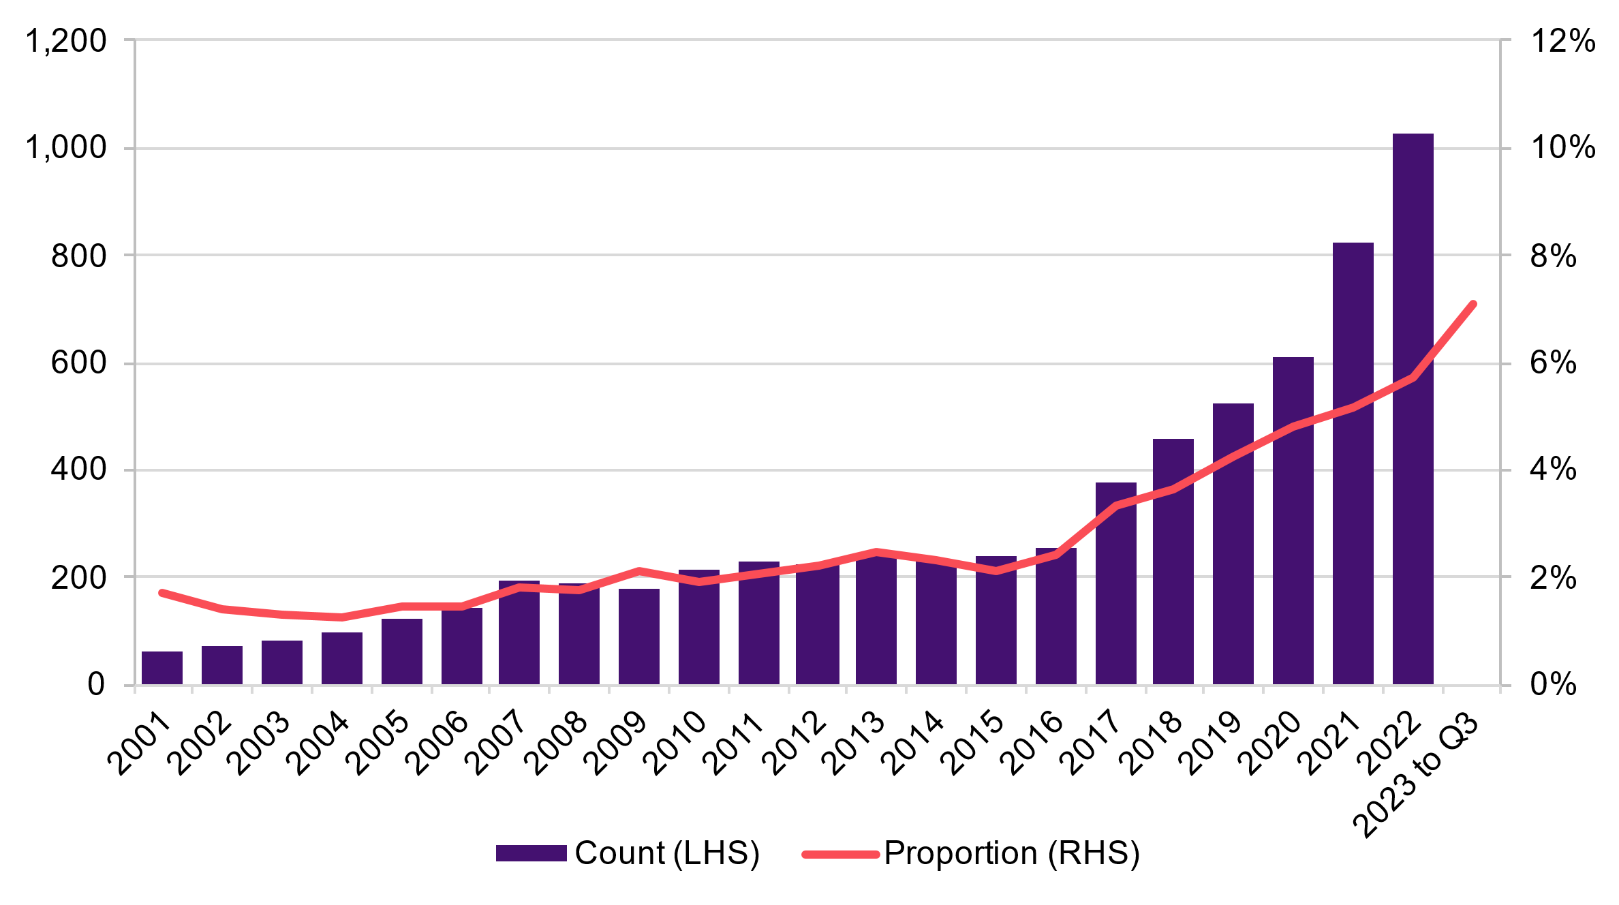Source: NCVER Apprentices and Trainees December 2022
Longstanding issues in trade occupations remain prevalent, such as a gender-segregated workforce, inflexible arrangements, low pay and inadequate support for women. This is despite considerable efforts being made to ensure that the apprenticeship model remains viable and sustainable in the modern work and education landscape. Some progress has been made to remove the stigmas women currently face within the workforce, however, more needs to be done to ensure women are provided equal and flexible opportunities in male-dominated industries, particularly those that rely on apprenticeships.
Addressing these barriers is a shared responsibility and requires efforts by governments, employers, industry peaks and education and training providers. Further, existing workers have a critical role to play in embracing and nurturing more gender-sensitive, safe and flexible working environments and arrangements. Stigmas and gendered cultural norms are also driven by people outside of the sector, including family members, teachers and community leaders and more work is needed to raise public awareness around the suite of economic opportunities for women in traditional trades occupations.
Within the trade occupations, women face barriers at all levels – from recruitment through to employment post-apprenticeship. Discrimination, bias and barriers such as perceptions around the need for physical strength to work in trade occupations are consistently used to limit opportunities for young women to enter male-dominated employment. Coupled with parental concerns relating to safety (both physical and emotional) and a lack of female role models, young women are less likely to see a trade apprenticeship as a viable post-school option.
– Jobs Queensland.
In roundtable discussions, participants cited the need for greater flexibility to be provided for women, alongside affordable and quality childcare which can also impact the workforce participation of women. The costs associated with accessing childcare can be a prohibitive and deterring aspect for women seeking to re-enter the workforce. We also heard about the importance of having groups of women on worksites and in training facilities to ensure there is an environment of peer support and cultural change:
…when you're trying to change culture on a worksite, particularly, having a group of women together means you get a better result. If, instead of spreading a couple of women really thinly, you say, 'On this project, we're going to have 15 or 20 per cent women,' you really change the culture of the whole worksite, because quite different work practices are adopted.
– Department of Employment and Workplace Relations, senior official.
The importance and effectiveness of group learning and training opportunities for female electrical apprentices specifically was echoed by Total Solar Solutions Australia at the second Women in Energy national roundtable.

The Australian Skills Guarantee is an example of how government investment can be leveraged to drive long-term change in the composition of our workforce. The Skills Guarantee will introduce national targets to increase the proportion of women on major projects, which will be increased each year. Similar initiatives are being explored or delivered in states and territories. NECA has also encouraged governments to invest in exemplar sites, schemes and trials with much higher targets for women to deliver larger cohorts of female apprentices.

Recommendation 7.15
Ensure financial supports and incentives for women in trades are genuinely at the scale required to generate transformational change in the workforce’s composition and culture.

Recommendation 7.16
Explore opportunities to directly support employers to attract, employ, mentor, train and cluster female trade apprentices to increase retention outcomes.

Recommendation 7.17
Explore opportunities to provide more support for bridging courses, group learning and study-to-employment pathways, particularly for underrepresented cohorts.

First Nations education and training
Between 2016 and 2023, significant progress has been made in First Nations school attendance, high school completions, and completions of non-school qualifications at Certificate level III or above (Closing the Gap Targets 3, 5 & 6), highlighting a slow, but positive direction of change. However, this progress has not yet translated to improved outcomes in STEM fields, in which First Nations student enrolments and outcomes have remained significantly lower than non-Indigenous students for the past 20 years.
First Nations enrolments in tertiary study are gradually increasing but tend to be concentrated in the broad fields of health, education and liberal arts. This trend is attributed to First Nations students aspiring to work in fields that are perceived to have direct benefits for their communities. Due to the limited incorporation of First Nations knowledge into the STEM curriculum at all levels of education and training, many First Nations students see STEM as unrelated to their culture and communities. Providing students of all ages with more explicit examples of how First Nations knowledge and culture relates to STEM disciplines and careers and expanding our collective national understanding and respect of First Nations culture and knowledge, could pique more interest from First Nations students in pursuing education and employment in these fields.
Group learning is an effective tool to improve confidence and address the challenges that First Nations students may experience in underrepresented fields and tertiary institutions more generally. CSIRO runs a residential Aboriginal Summer School for Excellence in Technology and Science for high school students with an aim of improving student confidence, aspiration and knowledge of STEM career pathways and networks. 79% of participants reported an intention to study in a STEM field at university.
Some First Nations graduates are unfamiliar with navigating the labour market and benefit from bridging programs that link education and training with employment opportunities. This is particularly true for students from regional and remote areas and students who are the first in their families, and sometimes their communities, to undertake tertiary study.
CareerTrackers is a national non-profit organisation that supports Aboriginal and Torres Strait Islander university students to intern with organisations, develop their workplace skills and to create employment networks. In the majority of cases, this experience and exposure to the labour market results in high levels of participant employment, with over 80% securing relevant full-time employment within 3 months of graduating. However, this program is limited to university students and commensurate supports do not exist for First Nations in VET. As many employment opportunities in the clean energy transition will be enabled by VET pathways, there may be benefit in drawing on the success of the CareerTrackers program and developing similar supports for First Nations students in the VET system.

Incentives and supports for apprentices
Financial barriers can be a major deterrent for both apprentices and their employers. Several government incentives currently exist for both groups to help ease this burden and encourage more commencements. Financial incentives can also make apprenticeships a more attractive pathway in a highly competitive market for workers and students, particularly in their first years when wages are lower. The current Australian Apprenticeship Incentives System has only been in place since 2022, and given apprenticeships generally take up to 4 years, the impacts of any changes to these systems can take time to examine.
The New Energy Apprenticeships Program (explored in Chapter 4) is an example of how financial incentives can be used to target commencements towards areas of skills needs. However, given the newness of some roles, targeted incentives also need to be flexible enough to cater to a wide range of changing, emerging needs.
“It is not possible to complete the requirements for an electrical license while working on just solar panels alone, so until other technologies emerge, more nuanced policy settings are required to support and encourage enterprises focused on renewable energy generation rather than seeking to identify renewable-only skills as a separate vocation”
– NECA.
While incentives can make a positive impact, there are several limitations with current approaches that may be limiting their effectiveness:
- Incentives need to be effectively targeted. Long lists of eligible qualifications and overlapping incentives may reduce the effectiveness of targeted programs and add unnecessary complexity.
- Apprenticeships are tied to full qualifications, meaning separate incentive arrangements would be required to encourage greater participation in the top-up and post-trade training pathways explored above. This includes short courses, industry accredited training, and training at higher AQF levels.
- The Australian Apprenticeships Incentives System can be complex for employers to navigate. While some industries have a high degree of familiarity with the VET system, this may not be the case for emerging industries like in clean energy. Incentives like the New Energy Apprenticeships Program target apprentices, rather than employers, and may not do enough to attract industry to the VET sector.
- Comparatively, the clean energy sector only employs a small share of Australia’s electrical trades and other relevant occupations. At least in the short-term, a much larger share of workers will gain their initial skills by working in larger, adjacent sectors like construction, mining and manufacturing. Australia will need to utilise these traditional sectors to help grow the overall pool of qualified workers at the pace and scale required. This requires a whole-of-sector approach to incentives, rather than bespoke approaches that only target clean energy employers.
Recommendation 7.18

Explore options to expand eligibility of New Energy Apprentices to include employers without current clean energy activity, provided they commit to supporting apprentices to undertake relevant clean energy electives. A whole-of-economy approach would be easier to scale and will ultimately benefit the clean energy sector.

Recommendation 7.19
Financial incentives and supports like the New Energy Apprentices Program could be replicated or extended to cover critical short courses, including industry accredited training, and training at higher AQF levels, like post-trade qualifications, with an appropriate level of industry-led oversight. Incentives could target current apprentices and workers with existing, relevant qualifications.


Chapter 8:
Workplaces and communities

Explores the changes needed within workplaces, industries and communities.

Overview
Historically, Australia’s energy work has been overwhelmingly homogenous, largely populated by non-Indigenous, able-bodied, Australian-born men (see Chapter 3 for a detailed overview of the demographics of the current workforce). This is also true for key enabling sectors, like construction and mining. However, to grow the energy workforce at the scale and pace required, we need to diversify the workforce and broaden the talent pool.
Further, there is a moral and economic imperative to ensure that the benefits of the transition are shared with all Australians. This is particularly important for communities impacted by decarbonisation and groups that were excluded and underutilised in traditional energy.
This chapter explores:
- Opportunities to attract and involve social cohorts which have previously been excluded and underutilised by the energy sector, specifically: women, First Nations people, people living with disability, and CALD Australians.
- Options to mature the clean energy sector as a means of developing sustainable workforce development practices and culture.
- Challenges in hiring and retaining workers, how the sector can become more competitive on remuneration and working conditions, best practice support for workers undergoing transition, and opportunities to ensure communities can adapt to change.

8a. Participation and attraction
This section explores opportunities for, and barriers to, full participation in the clean energy sector for women, First Nations people, people with a disability, CALD Australians as well as the intersectional identities between them. Whilst some findings and recommendations apply across these cohorts, others are particularly relevant to specific groups.
There are also important distinctions to be made between absolute and relative barriers. The latter can be addressed by adjusting current policy settings, while the former requires more transformative social and cultural change.
The Australian Government has committed to several key reforms to improve employment opportunities and outcomes for key cohorts and is exploring ways to better support underrepresented groups within existing programs for the entire Australian workforce. This chapter is written in the context of these ongoing reforms and notes that future work should also explore barriers for other underrepresented groups based on sexuality and gender identity as data availability improves.

Gender
The clean energy sector cannot grow at the scale required without the participation of half of Australia’s population. As explored in Chapter 3, the clean energy workforce is predominantly male, especially amongst the critical occupations for clean energy supply and demand. Little has been done to counter this. Recent JSA analysis has shown that the majority of occupations in shortage have a substantially gendered workforce, most of which are male dominated – this is concerning for the clean energy sector.
The clean energy sector, like the traditional energy sector before it, will not attract, support or retain women in the workforce without transformational change and targeted policy reform. Women’s participation needs to be front of mind in every aspect of workforce development, including the provision of career guidance.
“Programs to develop the workforce must include both promotion and engagement of women to the sector, AND cultural change of the sector, particularly given the legacy industries that are being drawn upon to build the industry.”
– Women in Adult Vocational Education.

The ongoing challenges of high gender segregation and unequal pay
Gender segregation is deeply entrenched across the Australian labour market and is reflective of trends throughout the OECD. The 2022 Workplace Gender Equality Agency Scorecard revealed that more than half of all Australians work in an industry dominated by one gender and that the national gender pay gap (GPG) sits at 22.8%. The industries and occupations that make up the clean energy workforce are even more segregated and have persistent gender pay gaps. For example, see Table 8.1 for industry segregation and gender pay gap levels by industry.
As explored in Chapter 3, occupations key to the clean energy transition are also male dominated. The gender pay gap for these occupations is at 27.5% for Technicians and Trade Workers, at 14.9% for Labourers and 13.5% for Machinery Operators, with Drivers at 13.5%.
Table 8.1. Level of Gender Segregation and Gender Pay Gap in Clean Energy Focused Industries
Industry | Gender Segregation | Gender Pay Gap
Mining | 80% | 14.4%
Construction | 76% | 39%
Electricity, Gas, Water and Waste Services | 74% | 15.9%
Source: Workplace Gender Equality Agency Australia’s Gender Equality Scorecard 2022
Reports from the sector itself also confirm the significant challenge of gender segregation in the industry. The Women in Engineering report reveals that whilst male and female Engineers equally enjoy and take pride in the social value of their work, they have divergent perspectives on workplace culture and the opportunity landscape. Female Engineers are markedly less confident about their career prospects than their male peers from early in their careers and earn on average 89% of their male counterparts. As is the case in other male-dominated industries, women are severely underrepresented in executive and managerial roles in the energy sector, meaning that overwhelmingly decisions around hiring, working arrangements, remuneration and career progression are made by men.
The importance of promoting gender diversity at all levels of the clean energy workforce was echoed by the Australian Ambassadors to the Equality in Energy Transitions Initiative at the second Women in Energy national roundtable.
The CEC and the Australian Hydrogen Council (AHC) reported that clean energy employers are “more inclusive and compare favourably” than other sectors; however, women are still underrepresented in senior leadership within the clean energy sector. They also identified three workplace failures highlighted by the ETU, including insufficient amenities (i.e., toilets, sanitary bins and breast-feeding facilities), inadequate personal protective equipment and a lack of mechanisms to address gender-based workplace discrimination.
Many female Engineers report experiencing gender discrimination and bullying in the workplace and do not feel they have equal access to career progression opportunities, salary advancement or mentoring. However, 78% of male Engineers report that women and men have equal opportunities, highlighting the role of unconscious bias. A 2018 survey by the Australian Gender Equality Council revealed 47% of female Engineers had experienced workplace gender discrimination in the previous three years, including an average gender pay gap of $12,000 among engineering professionals.
The EEC advised that a lack of diversity across the sector presents challenges in scaling the workforce to transition to clean energy. It suggested that clean energy organisations are working to improve diversity and representation within the sector through practical programs. For instance, the Australian Power Institute runs the ‘POWERful Women Program’, which aims to develop the leadership capabilities of more than 70 women, whether they are early career professionals or experienced technical professionals. The EEC advised that it is developing an emerging leaders' program, offering more places to women and other underrepresented groups. However, it highlighted that larger scaled programs are needed to bring a broader range of professionals into the workforce.
Alarming rates of sexual harassment and low workplace safety for women in energy
Workplace safety is an absolute barrier to the full participation of women in the energy sector. The Australian labour market has high rates of gender discrimination and sexual harassment across all industries, as captured at length in the Sex Discrimination Commissioner’s Time for Respect report. On average, 41% of women have experienced workplace sexual harassment in the last five years, with 4% of those surviving rape or sexual assault. The situation is starker yet in the energy sector, which boasts the third highest incidence of workplace sexual harassment, with 71% of women having experienced sexual harassment in the last five years.
Indeed, the energy sector has most of the workplace settings that create a higher risk of sexual harassment, including:
- male-dominated industries
- workplaces with a masculine culture
- workplaces with a high-level of contact with third parties, including customers, clients or patients
- workplaces that are isolated or remote
- workplaces that are organised according to a hierarchical structure.
Despite the high incidence of sexual harassment, employees in the energy and mining sectors were among those least likely to make a formal report or complaint. Further, very few reports result in formal reprimand, and extremely few are externally pursued by unions, courts or anti-discrimination bodies, feeding the notion that there is little point to reporting. Without intervention, there is a major risk that these unsafe work cultures will continue and carry over into the emerging clean energy sector. A 2018 survey of women in engineering revealed that 47.1% of female respondents reported they had experienced gender discrimination. Women were also far more likely to report age discrimination than their male counterparts.

Workplace sexual harassment is primarily caused by imbalances in power and whilst governments have an important role in legislating, enforcing and promoting safe workplaces in Australia, transformative cultural change is also needed. This report supports the findings and reforms that have come out of the Respect@Work: Sexual Harassment National Inquiry Report (2020) by the Australian Human Rights Commission, including the more multifaceted and whole-of-community response needed to tackle sexual harassment and providing employers with the guidance they need. However, considering the scale of the workforce needed for the transition to clean energy, there should be pre-emptive, targeted approaches to ensure workplace safety for women in the sector and an acknowledgement that safe workplaces are ultimately the responsibility of industry (employers and employees) to improve the sector’s culture.

Recommendation 8.1
A leading priority for the National Energy Workforce Strategy and the Jobs and Skills Councils should be to explore pre-emptive targeted interventions to increase women’s safe and successful participation in the clean energy workforce. This includes measures such as:
- Targeted recruitment drives and training programs, as well as accountability measures and targets
- Employer focused initiatives to promote gender representation in hiring processes and women’s independence and decision making in the workplace
- Support for flexible working arrangements, including for apprentices
- Mandating the provision of suitable amenities for all workers
- Concrete and practical programs to improve the safety, culture and appeal of the sector for women and all underrepresented groups.

First Nations
Aboriginal and Torres Strait Islander people are the First Nations peoples of Australia, comprising an estimated 3.8% of the total population. The National Agreement on Closing the Gap is the primary vehicle through which Australian governments track progress on addressing and reversing socioeconomic disadvantages experienced by First Nations people. For this study and our remit to explore opportunities for, and barriers to, full participation in the clean energy sector for First Nations people, the outcomes and targets that are most front-of-mind are those relating to education and training; (see Chapter 7), employment; and rights and interests in land and waters.

Low First Nations employment and large barriers to overcome
Australia has a long and complicated history of ineffective policy responses to low levels of First Nations employment, which has been significantly lower than the non-Indigenous population, less secure and lower paid. At the most recent census the employment rate for First Nations people aged 15–64 was 52% compared to the population wide employment rate of 64.5%. Employment provides financial and economic security and has positive flow on effects for the health and wellbeing of individuals and communities. First Nations people are critical to Australia’s workforce and economy, yet continue to face significant structural barriers to work, spurred by poor health outcomes, lower levels of education and training, higher levels of contact with the criminal justice system, and experiences of racism and discrimination that impact hiring, retention and career progression.
Further, the Gari Yala Report highlights the role of identity strain and cultural load carried by First Nations people and their impacts on hiring and retention. The report recommends employers invest in improving the cultural safety of their workplaces and the cultural competence of non-Indigenous staff as a means of improving the wellbeing and retention of First Nations employees.
The transitioning energy sector, particularly coal mining, has been a major employer of First Nations people, with employment levels at 3.4% (above the labour force average of 1.9%). The clean energy sector is yet to reach these levels, with First Nations employment levels around 1.9% (See Chapter 3 for a detailed breakdown of First Nations representation by Clean Energy overall and the Sub-Segments).
Lessons learnt from First Nations participation in mining
There has been some success in the transitioning energy sector and the mining industry in engaging First Nations employees, following a proactive approach to targeted First Nations employment in the early 2000’s. However, most of this employment has been in lower-paid unskilled or semi-skilled roles, with the majority occupying truck or plant operator positions. Further, First Nations women, who make up approximately 23% of the First Nations workforce in the mining industry, experience compounding racial and gendered workplace stratification and are similarly concentrated in lower-paid and unskilled or semi-skilled roles, commonly in administration and as cleaners and kitchen staff.
Whilst this ‘bottom heavy’ approach to targeted workforce participation has had a positive impact on regional and remote employment levels, it has had less of an impact on regional and remote skill growth and has deprived First Nations employees from occupying highly skilled, professional and senior leadership positions.
Industry reports a genuine desire to engage more First Nations employees in higher skilled roles, with initiatives such as Rio Tinto’s ‘Indigenous Leadership Development Program’ and Fortescue’s ‘Leadership and Excellence in Aboriginal People Program’ (LEAP) but cites the limited supply of suitably qualified First Nations candidates in the regional and remote labour pools where large-scale energy generation and extractive heavy industry are located.
CSIRO’s new Indigenous Jobs Map tool, which combines Census, higher education and VET data to form a picture on the profile of the First Nations workforce, confirms the understanding that highly skilled First Nations employees with Bachelor level and above qualifications in the Engineering and related technologies field are limited.
A possible solution to this is to complement targeted employment strategies with on-site education and training targets for local, entry-level First Nations employees who may not have had the preference or opportunities and support to pursue education and training opportunities off country.
Persistent disconnects between industry and First Nations service providers in clean energy
The CEC and the AHC advised that the employment of First Nations people across the clean energy sector is low. The two councils consider there is a “persistent disconnect” between industry and established dedicated First Nations service providers in recruitment, labour hire and community consultation. Further, they noted that the clean energy industry must compete with other sectors, including the transitioning sector, to attract a limited number of First Nations graduates.
Lifting educational outcomes will take time
Growing the supply of First Nations tertiary graduates will take time, but it is critical to ensuring First Nations employment in the clean energy sector does not mimic the trends of the transitioning sector in concentrating First Nations employment at the lower skilled and lower paid operational level of the workforce.
One category in which First Nations participation is especially critical is the carbon lifecycle workforce, which broadly manages carbon capture, the circular economy, forestry and living biomass. First Nations workforce participation is highest in this category, at 4.4%, and is expected to grow following increased funding for Indigenous Ranger programs in the 2023-24 Budget. Indigenous Rangers, by way of the Jobs, Land and Economy Program, the Indigenous Ranger Biosecurity Program, and other formalised Caring for Country programs, operationalise vital cultural knowledge that enables the effective care, preservation and restoration of country. This work is expected to play a critical role in decommissioning heavy industrial activities as mines and other large-scale projects with major impacts on country cease operations. Growing this workforce also supports progress on Closing the Gap targets 15 and 16, which centre on maintaining connections to country and preserving cultural knowledge.

Barriers to licensed occupations
The Australian Law Reform Commission’s Pathways to Justice–Inquiry into the Incarceration Rate of Aboriginal and Torres Strait Islander Peoples report highlights the overrepresentation of First Nations people in the criminal justice and correctional systems. First Nations represent 3.8% of the total population, yet they form 27% of the total national prison population, and that rate is increasing.
Criminal records are shown to be a strong deterrent to employers regardless of conviction details. Thus, the overrepresentation of First Nations people in the criminal justice and correctional systems contributes to an overrepresentation of First Nations people experiencing unemployment more broadly.
Further, this is an absolute barrier to entering a range of licensed occupations in the clean energy sector, including electrician and several engineering occupations. The disproportionate conviction rate for minor traffic and driving offences also limits opportunities in various occupations requiring regular or heavy vehicle licences, as well as limiting First Nations peoples’ ability to travel to and from work. Governments, employers and industry should explore adjusting eligibility requirements for licenced occupations in favour of where First Nations peoples hold or are working towards the qualifications that need them.

Commercial land interests have trumped Native Title
Land held under Native Title, Aboriginal Land Rights and other land stewardship determinations are the largest communally held assets in many First Nations communities but have not been leveraged to benefit First Nations people. This is likely due to the relative weakness of these rights in legal practice and the deliberate exclusion of sub-surface resource rights.
Closing the Gap sets a target of a 15% increase in Australia’s land and seas being subject to First Nations people’s legal rights or interests by 2030. The land target is currently on track to be met. However, the sea country target is not and there are clear examples in clean energy where commercial land interests continue to trump Native Title. For example, it has been raised by First Nations community organisations that the Western Australian Government’s allocation of land in the Pilbara to major industrial players for hydrogen and ammonia development prior to seeking the informed consent of the Ngarluma Aboriginal Corporation. This example highlights the limitations of the current Native Title legislation in adhering to the free, prior and informed consent (FPIC) principles of the United Nations Declaration on the Rights of Indigenous Peoples.
Ensuring that First Nations communities are well positioned to have a controlling stake in clean energy on their land provides a genuine opportunity to address the high levels of unemployment and related poverty and welfare dependence that is a structural reality in remote Australia.
The Commonwealth Indigenous Procurement Policy (IPP) sets targets for First Nations employment and the volume and value of contracts to be awarded to Indigenous enterprises. The government has a role in nurturing and incentivising First Nations communities’ economic development and entrepreneurialism and extending clean energy developments on lands under Native Title in consultation with local Traditional Owners.

Canadian Success Stories for First Nations Clean Energy Strategy
Over the course of this study, JSA has participated in the First Nations Clean Energy Strategy Roundtable Discussions, as part of the Commonwealth's National Energy Transformation Partnership. This strategy is working to ensure First Nations people have a say in energy policies and programs in the transition to net-zero and help identify priority reforms and areas for future investment.
The strategy draws heavily from the success of First Nations communities in Canada owning and operating large-scale renewable energy projects. Canada and Australia have very different colonial histories and thus different approaches to both Indigenous relations and land rights. Land rights are critical to Indigenous development, not just in coverage, but legal strength. In contrast with the interplay between land stewardship and energy developments in Australia, First Nations people and Inuit populations in Canada, who hold around 6.3% of the total landmass, have been able to leverage and develop these natural assets to become the second largest clean energy asset owners and partners in the country.
This progress has been supported by longstanding project ownership targets for the First Nations on whose lands the projects were proposed over the last 20 years, with adequate seed funding and ongoing funding from Federal, Provincial and Territory governments. These projects have led to community training and local job creation, reduced greenhouse gas emissions, advanced gender equity, materially improved economic stability and cultural and linguistic preservation.
The First Nations Clean Energy Strategy will be developed through to the end of 2024 and is slated to produce recommendations for actions, policies and programs that the Federal Government can implement to ensure that First Nations people benefit from the energy transformation.

Recommendation 8.2
Consider expanding the Indigenous Ranger and Caring for Country programs across all states and territories where there is no existing equivalent.
Recommendation 8.3

Through the First Nations Clean Energy Strategy, explore employment, training and general education targets for clean energy developments on lands under Aboriginal Land Rights, Native title and other land stewardship arrangements in consultation with local Traditional Owners.
Recommendation 8.4

Explore opportunities for greater take-up of the Commonwealth Indigenous Procurement Policy targets, including Mandatory Minimum Indigenous Participation Requirements, for clean energy supply chains.

People with disability
People with disability face multiple barriers to employment and are particularly underrepresented in the clean energy workforce. From a whole of population perspective,18% of Australians are living with disability and almost half of working age people living with disability are employed (48%). In contrast, 80% of people of working age without disability are employed. A recent survey by the CEC revealed that people with disability account for only 3% of the Australian clean energy workforce.
The Disability Royal Commission uncovered many employment barriers for people living with disability, such as employer prejudices, lack of career progression opportunities, and lack of transition support from school to employment, including career guidance. There are many people with disability successfully working in occupations that require post-school qualifications; however, many people are also missing out on further education opportunities, such as apprenticeships, due to perceived limitations and lack of awareness when making a career decision at school.
The Australian Government provides a range of support to address these barriers, including:
- Australian Disability Clearinghouse on Education and Training — information to support students with disability in post-secondary education
- Apprenticeships support — financial assistance and wrap-around support
- Employment Assistance Fund — financial support to enable workplace adjustment and access specialist services
- JobAccess — a national workplace and employment information hub. Services include telephone advice and National Disability Recruitment Coordinator
- Disability Employment Services and Australian Disability Enterprises, and
- Aurora Neurodiversity Program — work experience opportunities in the APS for people who are neurodivergent, recognising skills they can bring to work.
There is limited understanding within government, industry and education and training of accessible career options within clean energy for people with disability. If this understanding could be improved, all stakeholders could better tailor their policies, supports and communication.

Recommendation 8.5
Government to collaborate with clean energy employers and disability support organisations to identify suitable career options for people with disability, in alignment with a commitment to diversity and inclusion within the clean energy sector especially in the regions.

Migrants
Undervalued international qualifications, training and skills
Engineers Australia highlighted that migrant Engineers experience a lack of local work experience and an undervaluing of their home qualifications. As a result, overseas-born Engineers are significantly more likely to be unemployed or underemployed (i.e. employed in roles at a more junior level than their skills and experience warrant). In this context, Engineers Australia suggested an immediate solution to the potential skills gaps in engineering was needed, highlighting that overseas-born engineers are more likely to be underutilised compared to their Australian-born counterparts, representing a missed opportunity for Australia. Census data indicates that between 45 and 50% of engineers are born overseas for particular engineering occupations (See Figure 3.8 in Chapter 3 for occupation specific analysis).
JSA analysis shows that a high proportion of non-citizens with Electrical Engineer degrees are working in lower skilled jobs (Figure 8.1), indicating there is a large potential untapped pool of migrants in Australia, while recognising their skills and qualifications may not be commensurate with Australian standards.
Despite holding Australian higher education qualifications, international students can also face difficulties finding skilled employment due to low English proficiency, poor employability skills and a lack of local work experience, which underscores the importance of embedding real industry experience in education and training programs to ensure graduates are experienced and connected after their studies.
Figure 8.1. Electrical Engineering degree holders by skill level of current job
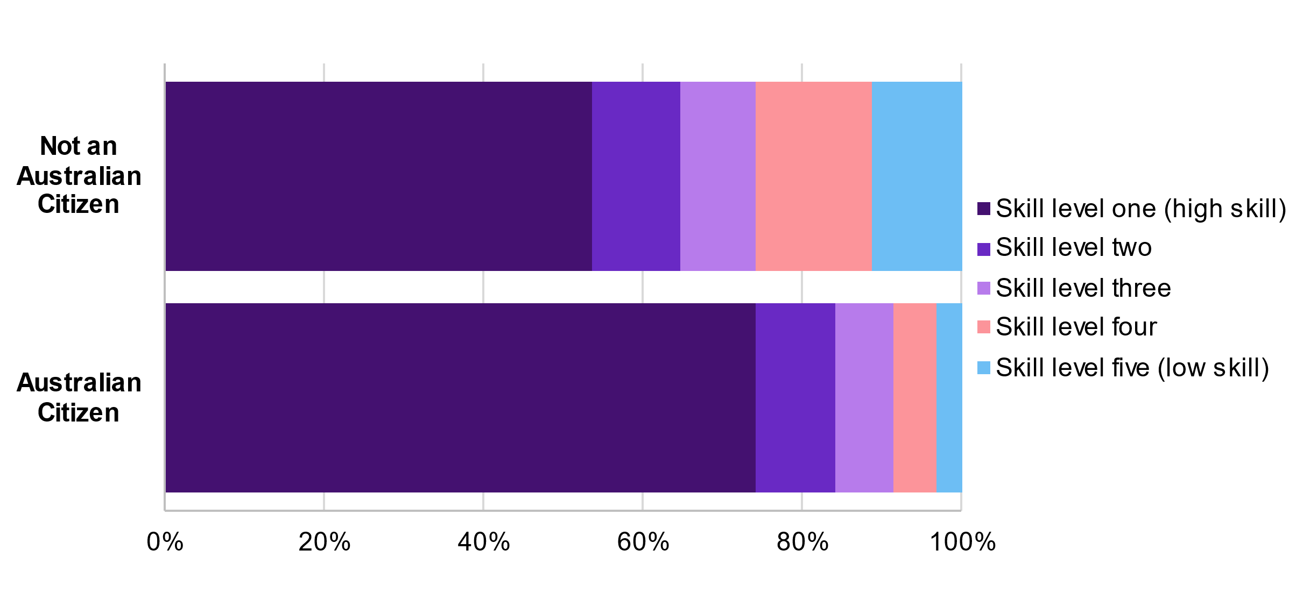
Source: ABS Census of Population and Housing 2021, JSA analysis. Highest level of education is bachelor degree or higher.
Recommendation 8.6

Explore opportunities to retain international students completing studies in areas of skills needs in Australia.
Institutionalised racism is a factor
The Diversity Council Australia's (DCA) Racism at Work survey revealed the extent and variety of racial discrimination experienced and witnessed in Australian workplaces, showing that nearly nine in ten respondents saw racism as a problem in their workplace. These experiences encompass both structural and interpersonal discrimination and vary depending on religion, language, accent, skin colour and migrant status. The DCA report also found that a major barrier to combatting institutionalised racism is the Anglo-Celtic and Europe background of senior leadership in Australia’s organisations and institutions, which sits at 95%.
More targeted research in the clean energy sector suggests that the incidence of racial discrimination may be lower in the emerging clean energy workforce than the transitioning energy sector and adjacent mining industry. In a 2021 survey only 4% of clean energy employees reported experiences of racism at work in the CEC’s Empowering Everyone survey. Whereas 10.9% of Australian-born and 15.1% of foreign-born Rio Tinto employees in Australia reported experiencing direct racism at work in a 2022 survey. The National Energy Workforce Strategy should prioritise initiatives to promote more diverse leaders in clean energy to combat institutionalised racism in the sector.

8b. Maturing the clean energy sector
Our study identified the nascent nature of the clean energy sector, particularly in solar and wind installation and operation, as a barrier to developing and embedding a sustainable workforce development approach. Stakeholder submissions and roundtable contributions identified that young firms (or firms with only a short period operating in Australia) installing and operating solar and wind do not have established processes and cultures to promote introductory and ongoing training and development. For example:
- Engagements (especially in the construction phase) are project-based, despite the long pipeline of planned and approved projects. This limits the engagement of apprentices, whose training duration may extend beyond a particular project’s life.
- Business models (including tendering based on the lowest cost and reliance on venture capital) may be focused on short-term returns, removing any incentive to invest in long-term staff development.
- Enterprise agreements are rarely used, which could provide more opportunities for workers to access regular training and career development.
- The sector is rapidly growing, meaning the landscape is constantly evolving, and there is intensive competition between firms (including as a result of proprietary technologies), reducing incentives to collaborate on promoting career opportunities in the sectors.
These behaviours not only hinder progress but negatively impact employers within the sector. The consequence is lower apprenticeship training rates and reluctance to invest in accredited training for workers and make experienced workers available as workplace trainers or assessors (see Chapters 4 and 7).
There can be a higher degree of variability and project-based work in clean energy, unlike traditional energy employment. For example, large-scale solar farms are a project-based industry where businesses may lack certainty while waiting to win contracts, secure finance or gain approvals. Workforce needs are also typically front-ended (during construction phases), meaning there are fewer long-term employment opportunities. These challenges can make it unsustainable for employers to commit to hiring and retaining apprentices under the traditional model.
Workers can experience challenges transitioning from one project to another. Potential solutions could be standardising qualifications and training, as well as the introduction of transferable leave entitlements. In addition, the clean energy sector struggles to compete with established industries regarding salaries and entitlements.
Knowledge sharing and collaboration are critical components of the global effort to decarbonise. Study tours provide governments, industry, workers and experts with an opportunity to share knowledge and gain insights and exposure to emerging technologies and training methodologies that are not yet available in the local context. This practice has long been a common feature of developments in the clean energy sector, particularly within and among European nations. Australian delegations have also successfully engaged with international partners on study tours to support the development of our domestic clean energy sector and nurture trade relations in this space. Recent examples of this include Australian delegations to visit Danish offshore wind sites and meet with German energy efficiency and transition experts.
International literature affirms the value of clean energy study tours in supporting collaborative relations and raising political and social awareness on the value of exploring innovative solutions to energy transition challenges. However, in order to get the most out of these activities, it is strongly recommended that future delegations work to include more workers and experts, who are ultimately best positioned to operationalise both the practical and specialist knowledge and skills imparted.

Recommendation 8.7
The Australian Government should consider facilitating a 'Clean Energy Study Tour' program with industry. This could allow selected participants to visit international firms to observe and learn from diverse technologies and training methodologies and then integrate this knowledge into the Australian clean energy sector.

Stimulating a training culture
Fundamentally, this study highlights the need to increase the number of apprenticeships across the most relevant trades: Electro-Technology and Electrical Distribution and Transmission. Yet the starkest examples of underinvestment in apprenticeship training during this study have been observed in the transmission and distribution sector, which crosses over into the broader network long reliant on coal-fired power (Figure 8.2).
For electrical trades, the level of supervision an apprentice needs while working is very high because of the safety issues related to working with electricity. This can make it difficult for employers to take on multiple apprentices at once, in contrast to non-trade qualifications or at universities where large numbers of students can be trained simultaneously for each qualified trainer.
Declines in apprenticeship training rates among electricity generation and transmission entities were observed as far back as the 1990s, with a number of causes suggested including privatisation and the adoption of profit-maximising corporate structures for those entities that remained government-owned. However, the substantial pipeline of new transmission projects necessitates a more sustainable view.

Figure 8.2. In-training apprentices as a proportion of total employment, by industry
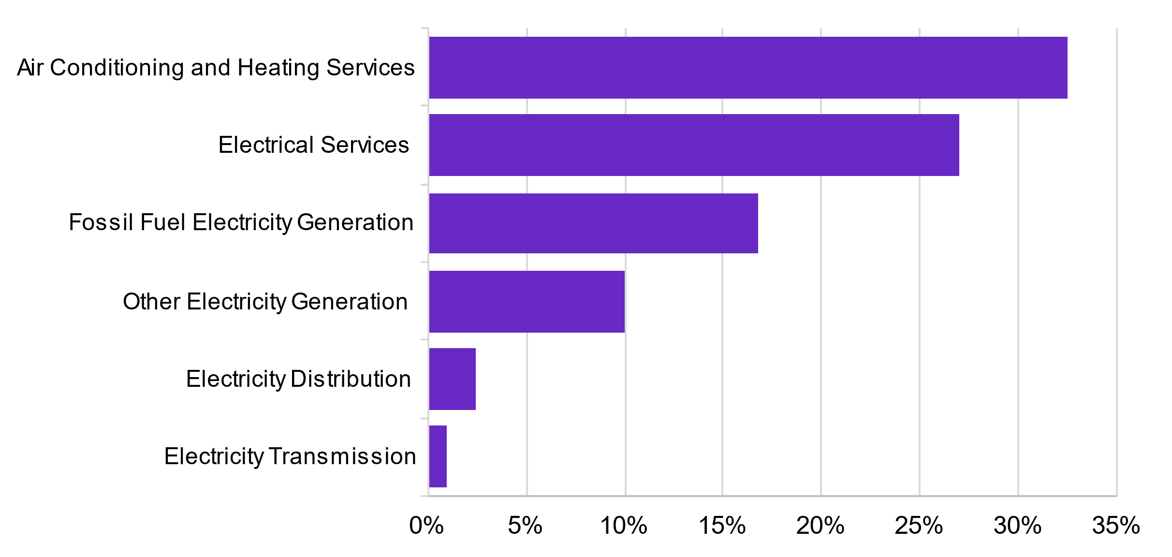
Source: NCVER Apprentices and trainees July-September 2021; ABS Census of Population and Housing, 2021
Firms can choose to invest in the longer-term development of their workforce. The three publicly-owned electricity firms in Queensland – Energex, Ergon and Powerlink – have commitments included in enterprise agreements to establish a minimum number of at least 700 in-training apprentices at any one time. This commitment is enforceable through the Fair Work Commission. These entities have also committed to increasing that number by 10% a year for the next ten years. In contrast, the study heard of other transmission agencies that in recent years have not had any apprentices in training, opting instead to rely on migrant labour.
Implementing such a hard mechanism across the entire energy sector and related industries is unlikely to be feasible or desirable in the short-term. However, providing more visibility on the variable investment firms are making in apprenticeship training would be a worthwhile next step. Improving reporting, accountability and transparency by publishing apprenticeship commencement and completion numbers was outlines as one of the six priority reform areas of the ILO’s ‘A framework for quality apprenticeships’ report.
Improving reporting, accountability and transparency by publishing apprenticeship commencement and completion numbers was outlined as one of six priority reform areas of the ILO's A framework for quality apprenticeships report.
Recommendation 8.8

Consider establishing a reporting mechanism for large firms to publicly report their apprenticeship numbers (and ratio of apprentices to total employees). Such a scheme would perform a similar function to gender reporting by the Workplace Gender Equality Agency or the Safeguard Mechanism but would ideally draw on data already collected by agencies like the NCVER.
Recommendation 8.9

Continue to sponsor and promote reporting on apprenticeship training and completion rates by industry and employer size, to inform strategies to increase rates where appropriate.
One means of stimulating a training culture, and sustainable workplace conditions more broadly, is leveraging the influence of government procurement and financing. This can be done to set standards regarding apprenticeship uptake, workplace gender equality, and secure employment. This is consistent with the Australian Skills Guarantee, which will introduce new national targets to ensure one in 10 workers on Australian Government funded major projects is an apprentice, trainee or paid cadet. The Australian Skills Guarantee will also introduce national targets for women to increase the proportion of women working on major projects and drive long term sustainable change to reduce gender segregation in the apprenticeship system.
Consideration could also be given to past performance of training activity, inclusive employment, and completions in the assessment of procurements and grants. This could help ensure that employers are committed to retaining and supporting apprentices through to completion, particularly on projects that are shorter than a full 4-year apprenticeship.
Recommendation 8.10

Explore options to expand the Australian Skills Guarantee to energy generation and transmissions projects. Consideration should also be given to state and territory funded projects that are not already covered by existing mandated targets.
Similar initiatives introduced at state and territory level have been successful. For example, the Infrastructure Skills Legacy Program (ISLP) introduced by the NSW Government included targets for First Nations employment as well as local employment, alongside apprenticeship targets. The importance of providing opportunities for First Nations employment and engaging local workforces has been raised by multiple stakeholders.
Targets are likely to have the most impact if they are core components of tenders for additional renewable energy capacity being managed through entities such as Energy Co (NSW), the State Electricity Corporation (Victoria), and Clean Co (Queensland). The same applies to tenders for transmission infrastructure upgrades. Under Victoria’s Major Projects Skills Guarantee, projects valued over $20m must use utilise Victorian registered apprentices, trainees or cadets for at least 10% of the total estimated labour hours.
As the NSW experience with ISLP demonstrates, head contractors will be better placed to meet targets if there are supporting programs in place – this is not a case for ‘set and forget’. Government can assist with this process by providing more certainty over the pipeline of projects, playing an active role in brokering relationships between the head EPC contractor, subcontractors and local institutions (such as local governments and land councils, TAFEs and other training providers, schools, employment services agencies, GTOs and community groups). In NSW, the Electricity Industry Jobs Advocate was established to advise on strategies and incentives to encourage investment, development, workforce development, with an explicit regional focus.
Maintaining standards across the value chain when subcontracting is widespread is a challenge in clean energy as in many other sectors. Unions have suggested that established construction firms with union negotiated Enterprise Bargaining Agreements (EBA) were involved in earlier clean energy construction projects but have not been successful in subsequent tenders. Visibility of subcontractor behaviour and enforcement of standards along the value chain is a further issue for governments issuing tenders to consider as part of their contracting arrangements.
Governments can also boost the uptake of clean energy courses by tying rebates and incentives to accreditation. Victoria has done this with its Solar Homes Program, where rebates are only offered for work undertaken by a solar installer with CEC accreditation, which requires workers to complete a number of relevant units. The outcome of this has been significant, with the state increasing VET clean energy enrolments by 278% between 2019-2021 and its share of national enrolments to 52% (Figure 8.3). Victoria also has its own VET accreditation authority (Victorian Registrations and Qualifications Authority) expediting the approval of courses – an approach this report recommends extending to TAFE Centres of Excellence.

Figure 8.3. Clean energy related enrolments by state and territory
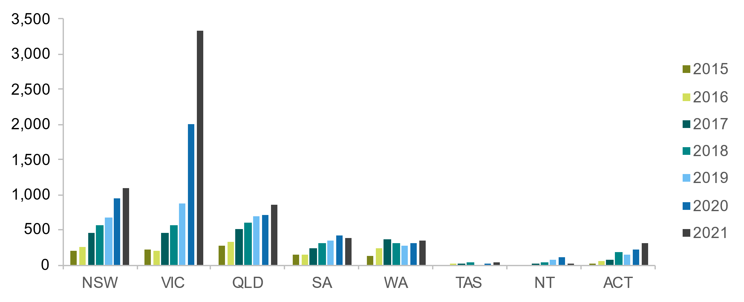
Source: ABS, 2023 training microdata, 2016-17 to 2020-21.
Recommendation 8.11

In a similar vein to the Victorian Solar Homes Program, all levels of governments should explore ways to link government loans and rebates with training requirements for adoption of clean energy technologies and electrification across the residential, transport, commercial and industry sectors.

Promoting and enforcing a safety culture
Installing and operating renewable electricity infrastructure is high risk work, as is handling hazardous materials including hydrogen, ammonia and biofuels. Promoting and enforcing a safety culture across clean energy is vital and must acknowledge particular challenges:
Remoteness
Clean energy activities are common in regional or remote areas, where it can be difficult for regulators to conduct site visits.
Unfamiliar technologies and processes
Nascent technologies and industries can also mean that regulators may be unfamiliar with new types of work, making them hard to assess. Unions are waiting for Safe Work Australia to action a request to institute a special licence for very large cranes (3,000 tonne) required at ports to handle components for offshore wind turbines.
Inconsistencies across jurisdictions
The clean energy transformation is a national effort, with employers, employees and networks operating across borders. However, states and territories have different licencing, registration and safety requirements. As highlighted by CEDA, these differences can create barries to job mobility. It can also lead to differences in training development and delivery.
“There must be an immediate and coordinated effort by federal and state governments to update licensing – and regulation more generally – to enable nationally accredited skillsets that are proportionate and properly calibrated to the safety risks of new technologies.”
CEDA, Powering the Transition 2023
Low awareness of Australian institutions and their roles
As a relatively new sector, there is also a risk that new businesses (including overseas firms) are unfamiliar with Australian institutions. This includes Safe Work Australia, the Fair Work Ombudsman, and the role of unions. The Clean Energy Council is currently working with clean energy developers on a standardised industry induction package to facilitate improved occupational health and safety and worker mobility awareness among firms operating in the Australian clean energy market. Government has a role to play in supporting and complementing these efforts.

Industry collaboration
With limited trainers in Australia, there needs to be greater collaboration and sharing between and within RTOs and industry. Industry also needs to support flexible integration opportunities for trainers to maintain their skill proficiency and familiarity with the latest technologies – a common challenge for RTOs. The role of employers in facilitating trainers in the industry is important. Industry could be more supportive of rotational training where workers can also engage in teaching or teacher training.
The ETU considered that it is necessary to adopt a flexible integration of VET educators into the clean energy sector on a rotational basis to ensure they remain proficiently skilled and familiar with the latest technologies in the sector.
There is also concern about the control that some employers have over proprietary training, which may limit worker recognition of skills and mobility and scalability. For example:
- Global Wind Organisation (GWO) Standards dominates training standards for wind power
- Each vehicle manufacturer is developing their own standards which will need to be managed with vendor training rather than having consistent standards that can be integrated more easily into a training package.
- Training for 3,000 tonne crane operation is limited to a British Government accreditation through a private provider.
The Ai Group stated that limited partnership between the clean energy sector and education, and training providers affects the knowledge and skills taught, skills alignment to work, the quality and quantity of graduates and their readiness for the industry. It suggested that greater collaboration on skills development can ensure training meets employer needs and is updated or developed to meet emerging requirements. For example, BAE Systems Australia formed a strategic alliance with universities by circulating a Request for Information to collaborate on education and training initiatives that align with their future needs.
Recommendation 8.12

Jobs and Skills Councils should work with industry to ensure that proprietary training does not lead to the monopolisation of particular skills knowledge or technology and that there is a sustainable, whole-of-sector training culture.

8c. Hiring and retention

Appeal to values
Throughout the study, the social value of working in the sector was raised as a significant motivator for many. A recent Accenture report revealed that 77% of young people (aged 15 - 39) in Asia-Pacific aspire to careers with a positive impact on the environment and climate change within the next decade. Emerging research is also furthering our understanding of the relationship between gender, climate-consciousness and career ideation, supporting the assumption that female students are more likely to pursue tertiary studies and careers in areas that are seen to have a positive, or at least benign, impact on the environment. This may be particularly significant for attracting future generations and women in particular, to pursue STEM qualifications and careers.

Raise awareness of career pathways
Career guidance and advice for clean energy pathways need to be substantially improved. Greater clarity and consistency can support more young people to identify and access the plethora of opportunities in this sector. The National Careers Institute should work closely with state and territory governments and industry groups (like the CEC) to ensure career advice is consistent, reflects genuine pathways, and communicates the sector’s value proposition.
“Clearer pathway resources that promote careers in clean energy will be useful. Many potential applicants may not realise that a career in clean energy can start with an electrical apprenticeship or for that matter an engineering degree or a certificate in civil construction.”
– Energy Skills Australia.

Work-based learning partnerships as recruitment opportunities
The Ai Group advised that employers face challenges in recruiting and retaining entry level workers and existing workers due to limited partnerships with industry, inadequate information to attract skilled workers to the industry, a lack of work-integrated learning opportunities, and limited access to reskilling and upskilling training.
This sentiment was echoed by stakeholders throughout our roundtables, who called for greater collaboration between VET and higher education providers and the clean energy sector to establish clear and attractive pathways from education and training to employment. As well as improving the relevance and depth of students’ coursework (see Chapter 7), work-integrated learning, graduate programs, paid internships and equivalent offerings can work to offset the hesitation and anxiety some students feel in pursuing an unmapped career in an emerging sector.

Make conditions and pay competitive
As described in Chapter 3, the remuneration for roles in the clean energy sector is on average lower than for comparable roles in fossil-fuel sectors such as coal mining and coal-fired power generation. The established resources and coal-fired power generation businesses have enterprise agreements and (in the case of mining) attract a wage premium for remote and hazardous work. Current workplace relations laws mean that EBA are prohibitive for short-term projects, even for larger wind and solar projects and are a barrier to attracting more people with the relevant skills to the clean energy sector. There is also a heavy reliance on labour hire during construction phases.
The ETU argued that wages, benefits, job security and safety conditions must be improved in clean energy industries as they lag behind comparable work in established industries. It stated that the sector “has been marred with examples of poor safety work standards, unlicensed electrical work, migrant worker exploitation, lack of investment in training and avoidance of standard employment conditions”.

8d. Transitioning workers and communities
The commitment to reduce emissions will present both opportunities and challenges – while new employment opportunities will be created, jobs will be lost. As explored in Chapters 4 and 5, the most immediate impact will be for workers employed in fossil fuel power stations and thermal coal mining. This chapter explores the barriers these transitioning workers face. Australia’s new Net Zero Authority (explored in Chapter 1) will have an important role in supporting workers and communities to overcome these barriers.
The best outcomes for the individual
While some transitioning workers will move into clean energy jobs, this isn’t the only (or necessarily the best) outcome. The most positive and sustainable outcomes for workers and employers are individualised ones. Local support networks play a crucial role in this as does timing, especially for workers at different stages of their career and local support. Various considerations include:
- Is there a clean energy job available in their region? If not, are they willing or able to relocate or commute?
- Does that job provide the conditions and flexibility they need? Including things like caring responsibilities and remuneration.
- Is it a permanent, long-term opportunity? Many clean energy jobs are in the short-term construction phase.
- Does the job require upskilling or reskilling? Is education and training something that they are willing or able to do? This can be particularly important for people who haven’t been in a training environment for a long time. Workers approaching retirement may be reluctant to invest their time in major reskilling.
- Do they want to explore a career in a new industry or occupation?
- Do they want to continue working at all? A successful transition outcome for an older worker may be early retirement enabled by a redundancy payout. In previous transitions, people have left the workforce to take up caring responsibilities, supporting their partner’s return to work.
The transition to clean energy should also be acknowledged as a potential negative experience for many transitioning workers, communities and regions. Long-term industry heritage is often a local source of pride and sense of identity. Opportunities should be taken wherever possible to recognise and promote the crucial contributions of these workers and communities who have helped contribute to Australia’s prosperity.
As explored in Chapter 1, the new Net Zero Authority will have an important role to support workers in sectors that are emissions-intensive, and coordinate programs and policies across government.

Recommendation 8.13

Government entities should ensure transition outcomes aren’t predetermined for workers. While some workers may move into clean energy roles, government policy shouldn’t be based solely on the expectation of such a shift. The employment needs, circumstances and preferences of each worker should drive government interventions.
Forward planning
Open dialogue between business, unions and government to give maximum notice about future site closures provides the starting point for considered forward planning. Short notification periods prior to large-scale business closures have been well documented and demonstrate what not to do. For example, the 2017 Hazelwood power plant closure in Latrobe Valley (Gippsland VIC), only gave five months’ notice. Early notification and lead-in time offer benefits that work across all domains when designing and implementing industry transition supports.
For government, advanced notice allows time to establish robust governance and coordination arrangements, and to engage wider stakeholder and supply chain networks. Detailed regional planning can be conducted to stimulate investment and diversification, and additional supports can be mobilised that add to or enhance existing services.
A well-planned, values-driven approach can also demonstrate good will by the employer and supports the business’ ongoing legacy and reputation. Inclusive engagement with workers can also better enable the business to meet operational requirements until the closure date.
For workers, it allows adjustment time to the initial shock of closure announcements. There is opportunity to explore a wider range of options and access a variety of supports. It also allows enough time to complete longer-term training such as Certificate III and IV qualifications. Labour market engagement can be conducted to promote worker skill sets and engage potential new employers via events such as career fairs.
Early engagement with individual support
Even where closure notifications have been provided with years of forward notice, the effective use of lead time is critical. Early messaging and access to case management services and other worker transitions supports during initial transition phases are important. They help workers process the impact of closure announcements, seek early health and wellbeing supports, and set-up a well-planned approach that best meets their needs and goals.
This is likely to occur in the coal-fired power sector, where power-plant closures have been scheduled well in advance. While these timeframes are expected to accelerate in some cases, a 42-month minimum notice period is now required by the Australian Energy Regulator for NEM generator closures.
JSA also heard of many instances where workers chose to remain in coal-fired generation after their plant closes (by moving to a different worksite or employer), rather than transition out of the industry altogether. While this has a short-term benefit for the worker and potentially helps some reach retirement), eventually this will not be an option.
An integrated model of transition support services
Employers, the federal government, and state and territory governments can mobilise a wide range of services to support workers impacted by industry transition events, as listed in Table 8.2. The table sets out the supports typically available to help affected workers during a transition, based on best practice. The supports offered can vary depending on the circumstances of individual events, including the length of notice periods and the resources of the employer. Transition supports work most effectively when all relevant stakeholders, including state and territory governments, the federal government, and employers, work together cooperatively to deliver them. The following breakdown provides insights into the services offered by each party.
Employers retain primary responsibility to fund and deliver transition supports from the initial closure announcement up until the worker’s end-date, with some extensions beyond. Access to these services is also commonly made available to workers in higher-tier supply chain companies. Employer support packages are often managed by internal HR teams, with delivery by contracted HR outplacement specialists. The examples listed in the table are broadly representative of components commonly offered by employers, as seen in previous and current transition events. In past large-scale industry events, employer support packages have also included federal and state co-funding components that add further enhancements to the worker services made available by employers.
Australian Government employment services, administered by DEWR under the Workforce Australia program, can offer eligible retrenched workers and their partners early access to services up to three months prior to the workplace exit date, and for six-months after. Outside of these timeframes, general access remains available via Centrelink registration processes. Workforce Australia employment services are generally used by workers following workplace departure, with some crossover enabled by the capacity for pre-exit registrations. In addition to case management supports and referrals to allied services, employment service providers can also draw on the Employment Fund pool for expenses that assist registered participants to gain and retain employment. Funding categories include work-related licensing, tools and equipment, work clothing, short course and accredited training, as well as relocation assistance payments and employer wage subsidies (dependent on eligibility requirements).
State and territory government services can be varied across different jurisdictions, and may include some, all, or additional supports to those listed in the table. Generally, workers will have access to fully funded or subsidised foundational skill and VET training as a base offering, with additional levels of support that can be varyingly mobilised for specific events, or locational settings. For example, as a component of the WA Government’s Collie Just Transition Package, the TAFE based Skills and Job Centre located in Collie has been allocated additional funding to provide enhanced walk-in career counselling, job search, and training support services for workers and community members. Similar supports were made available to workers via the Worker Transition Service during the closure of the Hazelwood coal-fired power plant in the Latrobe Valley, Victoria. These supports will also be made available for the upcoming Yallourn closure in 2028. Adding to this, the Victorian Government is currently funding a full suite of transition support services for workers and impacted communities under the Forestry Transition Program, following the policy decision to end old growth logging within the state. The NSW Government Royalties for Rejuvenation Fund also offers funding to support workers and coal mining communities.

Table 8.2. Employer and government worker transition supports
Type of Support | Description
Individual support and guidance | Individual transition plans
Individual support and guidance | Career guidance, skill gaps and training plans
Individual support and guidance | Retirement planning
Individual support and guidance | Self-employment and small business support
Individual support and guidance | Redeployment - new location within same business
Job search  assistance | Resume preparation, job applications and interview coaching
Job search  assistance | Onsite job boards and online recruitment portals
Job search  assistance | Career fairs and employer networking events
Job search  assistance | Facilitated job placements
Workshops and Information Sessions | Health and wellbeing
Workshops and Information Sessions | Financial planning
Workshops and Information Sessions | Occupational and industry insights
Workshops and Information Sessions | Training pathways
Workshops and Information Sessions | Labour market information
Access to Training | Foundational skills (LLN and digital literacy)
Access to Training | Licences and tickets
Access to Training | Skills recognition – formal RPL
Access to Training | Short courses, micro-credentials
Access to Training | Certificate qualifications
Access to Training | Tertiary degrees
Access to Training | Adult apprenticeships
Access to Training | On-the-job training and mentoring
Transition support centres | Workplace walk-in advice services/resources
Transition support centres | Open access walk-in advice services/resources
Transition support centres | Employment Service Provider outlets
Other supports | Employee Assistance Programs
Other supports | Mental health and allied health service referrals
Other supports | Relocation assistance

A worker-centred approach
A worker-centred approach could have the following elements, to guide individuals through understanding the environment, identifying options, maximising their potential, and maintaining wellbeing.

Case management
Case management is one of the strongest contributors to enable positive transition outcomes and is highly valued by workers. It offers a tailored and flexible approach to mobilise resources while encouraging individual ownership. Case management typically sits within the support packages offered by employer, and early engagement by workers should be strongly encouraged.
Case managers are generally qualified career coaches from outplacement services but can also be supported by internal staff members who have undertaken a relevant qualification. They offer informed guidance to develop transition plans aligned with individual goals and needs and act as a central coordination point to link the full suite of available services and supports. Case managers can come to be regarded as trusted intermediaries who can also liaise across informal networks.
A ‘transition passport’ can be an effective case management tool to capture individual goals and development needs, and to identify relevant supports. Progress can be tracked via a record of services accessed and skill gaps yet to be addressed.

Recognition of Prior Learning
RPL can translate skills that have been gained in a specific workplace setting into competencies that are recognisable by other employers or industry areas. Transferable skills are often poorly understood by workers, despite being one of their strongest assets. Engaging with RPL early can help to provide the worker with confidence and re-engage them with formal learning. RPL processes can also identify skill gap areas and foundation skills training needs.

Foundation skills
Foundation skills encompass language, literacy, numeracy training, digital literacy training, and employability skills. Foundation skills are highly valuable and should be promoted widely as an investment in the worker’s own capabilities. However, some workers are reluctant to engage in foundation training because of perceived stigmas. The ABS and Productivity Commission have shown improved literacy and numeracy skills can significantly increase hourly wage rates, which could present a strong individual incentive to workers. Tailored foundation skills training adapted to suit the cultural background and employment experiences of affected workers is warranted in firm closure situations.

Labour market information and Job search assistance
Up-to-date labour market information matching workforce profiles and transferable skills with state and regional employment trends can provide workers with good insights into viable career options, based on realistic expectations. Job search assistance will also be of value to most workers but can be particularly valuable for individuals who have been in the same job for long periods, with limited experience in the job market. Localised job search assistance is highly valued in site closure scenarios:
- Onsite job boards with regularly updated vacancy listings are valued by workers.
- Online talent community portals can also be created to match worker’s interests, skills and attributes with available jobs and prospective employers.
- Workplace tours, industry information sessions with guest speakers, and onsite career fairs can offer workers with practical insights that better informs their career options.

Training pathways
The importance of training is well recognised as a strong enabler to support successful worker transitions. Amidst the many challenges posed by industry transition events, training pathways can offer strong opportunities to enhance worker career options and increase the workforce skill base more broadly within labour markets.
RPL, refresher, top-up training is key for transitioning workers and this report maps out the skills transferability and flexible non-traditional training pathways that should be used in transitions. One way of delivering RPL is through local skills centres, such as the TAFE based Collie Jobs and Skills Centre, which can expedite fee-free skill assessments for transitioning workers. These type of initiatives have seen success in other sectors, including the transition of Australia’s car manufacturing sector.
Notwithstanding the value of a full qualification, experience from former transitions shows that workers can benefit from completing tickets or licensing courses (such as forklift driving) or other short courses/micro-credentials. Short courses and micro-credential training can be particularly valuable to tailor delivery for worker needs and target specific skill sets required by employers. The Ai Group advised that clean energy employers need access to shorter programs (within VET and higher education) to reskill workers transitioning from sectors that are emissions intensive.
This is where having an established relationship with a reputable local training provider is extremely valuable, to provide the shortest possible skill pathway to a future job. The best outcomes are generally achieved when training is individually tailored, part of an informed career plan, and linked to specific job opportunities. For workers undertaking reskilling training for new job roles, combining training with work experience will improve the chances of finding a suitable job.

Recommendation 8.14
Consider establishing local skills recognition centres in communities experiencing clean energy growth and those transitioning from fossil fuels to provide intensive, individualised training plans and supports, with priority given to providing skills recognition for experienced workers without current post-school qualifications and delivering gap training to assist transitioning workers find new roles (whether in clean energy or other growing sectors).

Onsite workplace delivery of training to benefit workers and employers
Onsite availability of support services in the workplace and the use of paid work time for training increases worker engagement and makes for more successful transitions. Onsite access to services and using work hours for information sessions and workshops, case management sessions, and career fair events are effective to increase worker take-up. Feedback from unions indicates a key barrier to the utilisation of training has been the requirement to complete course work after work hours causing a barrier. There is potential benefit for employers too: retention commitments from workers who undertake training during paid work time could also further support the employer’s operational needs up to the business or site closure date. Transition support centres established in workplaces or community settings offer ‘drop-in’ access to supports and resources that workers can access when ready, at their own pace are also tried and tested options.

Support for wellbeing and financial advice
Health and wellbeing supports, together with financial advice, are also essential supports for workers. Closure announcements can cause high anxiety and may present multiple challenges for individuals and families as they progress throughout transition and post-closure processes. Health and wellbeing information sessions and workshops can be combined with access to counselling and support services such as internal EAP. A minimum number of required counselling sessions can be included within individual transition plans to encourage take-up of services. Themed workplace events such as morning teas can also serve as an informal opportunity for workers to connect with each other in a supportive setting. Referrals to external counselling and mental health services can be enabled via the case management model. Health and wellbeing impacts can be experienced for extended periods long after worker exit dates, so the availability of post-closure supports is essential.
Financial security will be a primary focus for workers and access to sound information and resources can both help reduce concerns and enable practical planning based on informed options. Information sessions by Financial Information Services Officers (FISO) from Services Australia are very valuable to place emphasis on the management of redundancy payouts. Workers can also be encouraged to use self-help resources such as the ASIC MoneySmart website, as well as to seek early, independent financial advice from a licenced practitioner. Specialist advice is valuable for older workers who may be exploring end-of-career options such as reduced working hours or retirement.

Ongoing support post closure
The availability of ongoing support to workers post-closure is also important. While efforts to pre-secure employment prior to closure are highly recommended, for most workers, their job searching efforts will commence after exit. Additionally, workers may not initially opt to undertake training but later discover that it may improve their employment prospects after entering the jobs market.
As previously mentioned, health and wellbeing impacts can also play out for extended period after closure. Ongoing access to counselling and other support services is valuable and can be combined with informal events such as regular morning teas or barbecues that build social-connectivity and promote available services and job opportunities.

Vulnerable workers
Groups such as mature age, female, CALD and First Nations workers can experience greater challenges securing employment during industry transition events. Additionally, part-time and casual workers, lower skilled workers, and workers with limited foundation skills are also at greater risk. The opportunity to increase foundational skills and upskilling can be particularly valuable to increase career options and wage levels. There may be opportunities to connect with government programs such as the Australian Skills Guarantee, which are aimed to boost social inclusion and workforce diversity.
There are a range of strategies that can be mobilised for older workers. Notably, training is often under-utilised by older workers but when appropriately tailored can be very effective.

Investing in communities
New clean energy projects offer many positives for communities, including employment opportunities. Yet, the construction of these projects, essential to clean energy infrastructure, can present significant challenges, especially in local contexts.
Insights from Jobs Queensland, drawing from the construction phases of large-scale gas plant projects in the Gladstone area, have shown that successful planning involves analysis of the local skills base alongside social impact plans. This approach ensures the identification of skills gaps to maximise opportunities for local workers and prepare for the increased demand for housing, local services and infrastructure. Importantly, planning should also extend to address the decline in activity as construction nears completion to prevent local “boom and bust” cycles.
In regional areas, these fluctuations can have wider-ranging ramifications where economic diversity and adaptability are typically lower. Regional workers generally experience greater challenges when transitioning to new employment than those in metropolitan areas. Each region will have unique conditions that may intensify or diminish certain impacts. When assessing each region, it’s important to consider:
- The economic diversity of the regional labour market and its adaptability.
- The capability of local institutions to allocate and utilise resources. The adaptability of the workforce regarding skills, levels and ability to transition between industries.
Underlying these are risk indicators such as regional unemployment rates and the locations of socioeconomic disadvantage. An informed regional approach, supported by effective communication strategies, can reassure and uplift local workers and communities.
Recommendation 8.15

Government should consider developing targeted education plans for communities experiencing clean energy growth and those transitioning from fossil fuels to ensure that there is a general uplift in educational attainment, including Year 12 equivalence and post-school qualifications.

Recommendation 8.16

Government should provide support and leadership to ensure job opportunities from large clean energy projects (including during construction phases) are genuinely accessible by local communities. Ensuring the use of local workers where possible and upskilling communities should be a key priority.

Addressing impacts on local supply chains
The supply chain encompasses many operations and services, and may include materials and parts, suppliers, contracted maintenance trades, and site services such as waste removal. Insights from past industry transition events indicate that support mechanisms available are often underutilised by the supply chain sector. For example, during the structural adjustment in the automotive sector, many of the supports offered by car manufacturers were available to workers from supply chain companies, but uptake was much lower.
Emphasis should be on ensuring active engagement with management. Managers from the closing company can leverage their relationships with supply chain companies to involve them in the transition process and ensure supports are available for workers.
Beyond the main supply chain, there is likely to be a network of workers from directly impacted Small to Medium Enterprises who may not have access to support from larger employers. Often, these businesses lack the human resources or funding capacity to offer similar supports. For this reason, broad engagement is essential for promoting available support and connecting workers to vital services.
In some cases, government may provide specific transition support packages to workers and businesses. In the transition to clean energy, we see this in activities such as plant maintenance and waste management. Initiatives such as AGL’s Hunter Energy Hub are actively demonstrating the opportunities to keep supply chains engaged following coal-fired power station closures.
Active local economic planning and development assistance is one way to ensure ongoing demand for services in the supply chain and maintaining as much as possible of the existing economic and employment diversity within impacted communities. Locally owned economic development plans should ensure that there is broad-based initiatives to address any gaps in educational attainment, so that there is a local pool of potential workers able to meet any skills gaps experienced by new or growing industries.


Chapter 9:
Findings and opportunities

Learnings from what is working well and innovative approaches to workforce development.

Overview
The Clean Energy Generation offers a unique contribution to both workforce policy and the challenges Australia faces in its transition to net zero. It offers an Australian first definition of the clean energy workforce; takes a holistic view of tertiary education and training and migration pathways; uses new data to reflect real-world job transitions; explores the barriers workers face and the potential solutions that can help; and very importantly provides a gap analysis to help Government pre-empt and mitigate skills shortages. We also identify the jobs and regions that will be impacted by the transition away from fossil fuels but also the new industries that will emerge from this broader economic transformation, including in some of those same regions.
The report has been anchored in three objectives:
Objective one: the energy transition isn’t hindered by skill shortages. Australia has the workforce it needs to reach and exceed our clean energy ambition.
Objective two: workforce opportunities are sustainable and equitably shared with all Australians, particularly communities impacted by decarbonisation and disadvantaged groups that were underutilised in traditional energy.
Objective three: people in transitioning sectors and their communities are given the support they need to access new employment opportunities that work for them.
This study has found that:
- Many of the skills needed to decarbonise already exist in the economy.
- We will likely have enough workers to meet overall demand based on preliminary modelling, but set and forget will not work: likely skills gaps in critical clean energy occupations means real reform is needed.
- We will likely need 4,000 more workers in clean energy supply over the next seven years with the workforce projected to reach around 84,000 in 2050, based on the preliminary modelling.
- Strategies need to look beyond state borders, be regularly updated to reflect both new and revised policy settings; and align with rapidly changing technologies.
- Co-ordinated investment in renewables in line with current Government commitments to 2030 would likely drive overall employment growth. In contrast, a slower implementation of a clean energy market likely means a harder structural adjustment for Australia. Becoming a clean energy superpower could offset the cost of transition by 2050, but requires significant effort.
- Electricians and other electrical trade roles are likely to be experience the biggest shortages, but there will also likely be gaps in the other building and engineering trades. There is likely to be a steady supply of engineers.

- We will need to dramatically increase the number of tradespersons we move through the VET system. Likewise, without addressing the capacity of the VET system, Australia will not be able deliver the workforce it needs for the transition. On the job skilling and industry led training is crucial. We need to embed industry across all training and continue to innovate training options like TAFE Centres of Excellence.
- We have a shared responsibility for inclusive pathways so that we can match the scale and pace required for the net zero transition and offer solutions to the barriers Women, First Nations people and workers born overseas face in participating in this part of the economy.
- Global competition for clean energy skills is high and Australia needs to play catch up on skilled migration.
- A worker-centered approach to support people in transitioning regions is a must.
- Regional Australia can benefit from the Net Zero Transformation.
- Better Data = Better Workforce Planning: clean energy workforce planning must be underpinned by current and comprehensive data and a whole-of-government collaborative approach.
This chapter reflects on these key findings and highlights the innovative opportunities for moving forward.

Many of the skills needed to decarbonise already exist in our economy
In an Australian first, we have defined the jobs and industries that make up our clean energy workforce. Clean energy jobs are found across the workforce, extending well beyond the obvious sectors such as wind, solar and hydroelectric electricity generation. Instead it include sin parts of construction, manufacturing, mining, research and development, and scientific and technical services among many others. While there are many occupations that form part of the clean energy workforce, the most critical are mainly in trades, technicians and engineering occupations, where training times and licensing and accreditation requirements impose justified barriers to entry.
“The alignment between current skills and the future renewable workforce is a benefit: while it makes it almost impossible to invest in skills that purely support renewables, it means that a majority of the VET structure required to support renewable energy skills already exists, we simply need to grow capacity”
– NECA.

38 critical clean energy occupations, and plenty of emerging new roles
We have identified 38 critical occupations where there will be increased demand for clean energy work. Electricians and Electrical Engineers recur across multiple segments but so too do engineering trades such as Metal Fitters and Machinists, engineering roles such as Industrial, Mechanical and Production Engineers, and managerial occupations such as Production Managers and Construction Managers. The report also identifies the emerging occupations in clean energy like solar installers, winder turbine technicians, energy auditors and energy efficiency engineers.
In total, the modelling for the study suggests that demand for these 38 critical clean energy occupations in total will experience higher growth rates than the broader workforce over the next 30 years. In the central scenario (which aligns closest with current Government climate and energy policy), the preliminary modelling shows demand for these 38 occupations is likely to increase by around 15%in the next seven years. This represents an increase of almost 240,000 workers.
Occupations with the highest growth rates (2023-2030) include Telecommunications Trades Workers, Electronics Trades Workers, Electrical Engineering Draftspersons and Technicians, Structural Steel Construction Workers, Construction Managers, Plumbers and Electricians.
Set and forget will not work: high risks mean real reform is needed
While new occupations will emerge, many existing jobs will undergo skills and context change, like Mechanics learning to work on electric vehicles. The impact of these changes, particularly on the skills system, should not be underestimated.
Reaching net zero by 2050 will require a workforce transformation in Australia that is substantial but not unprecedented. The scale resembles our post-war industrial transformation and the digital transformation of the late twentieth century that spawned new roles in information technology and impacted many more.
We will likely have sufficient workers overall and enough higher education graduates over the next thirty years. What we are at high risk of experiencing, is:
- A shortfall of workers with the necessary VET qualifications and workplace experience to fill the large numbers of expected roles for electricians and other trades and technicians.
- Competition between the clean energy workforce and other sectors requiring electrical, mechanical and civil trades, technicians and professionals (as well as competition for these workers from overseas).
- A mismatch between employment demand and available skills. The risk of this mismatch is particularly high in regional Australia, which otherwise has so much to gain from the path to net zero.
- Ongoing challenges in growing the workforce at the pace and scale required if large groups of the population are excluded especially women, First Nations people and recent migrants whose skills’ potential is underutilised.
- A tertiary skills, training and qualifications system that is not fit-for-purpose to keep pace with rapidly changing technologies and emerging occupations.
Mitigating these risks will require sustained, national level coordination. This is not a time for set and forget. Strategies need to look beyond state borders, be regularly updated to reflect both new and revised policy settings; and align with rapidly changing technologies.
Australia must consider the full range of levers across education, training, migration and workplace relations systems to not just mitigate these risks but ensure a sustainable and equitable path towards net zero. This planning framework must be underpinned by current and comprehensive data and whole-of-government collaborative approach.
1.1 | The upcoming National Energy Workforce Strategy should be empowered to provide a coordinated, whole-of-government and whole-of-sector approach for this workforce, serving as a singular, coherent voice.
1.2 | The National Energy Workforce Strategy should involve all states and territories, leverage the National Energy Transformation Partnership and pursue genuine collaboration and consolidation opportunities.
1.3 | Clearly identify, differentiate and communicate the roles of the Net Zero Authority and existing government agencies to avoid confusion and duplication of effort.

2.1 | In consultation with stakeholders, JSA and the ABS should explore opportunities for a new mechanism to identify emerging occupations in the labour market that don’t meet ANZSCO criteria. A consistent and evidence-based approach could allow government systems, like migration and VET, to better respond to and acknowledge emerging roles without undermining the core principles of ANZSCO and the restructure work underway.
2.2 | The Australian Government could commission a comprehensive and regular AEER. This will be critical to address data gaps limiting Australia’s ability to identify and project future needs, especially in emerging sectors and energy-focused roles in industries outside core sectors. The AEER should build on the whole-of-labour-market mapping initiated by this study to provide a consistent approach for identifying and measuring the workforce.
2.3 | The ABS could be supported to re-run the Employment in Renewable Energy Activities series on an annual basis. A consistent, regular release of data is critical for governments to monitor the workforce’s progress.

We will likely need 32,000 more electricians by 2030
The biggest shortage is likely to be for Electricians. Preliminary modelling suggests that under the central scenario Australia will likely need around 32,000 more Electricians in the next seven years and around 85,000 by 2050. This represents 27% more than the projected supply.
Rapid growth of Electricians will require rapid growth of VET trainers. Without addressing the capacity of the VET system, Australia will not be able deliver the workforce it needs. This isn’t something that the governments or RTOs can solve alone, industry will also need to be involved.
Other electrical related trade roles are also likely to be in short supply even though more and more workers are choosing these career paths. These include:
- Electrical Engineering Draftspersons and Technicians
- Airconditioning and Refrigeration Mechanics
- Electronics Trades Workers
- Telecommunications Trades Workers.
The preliminary modelling indicates there is also likely to be shortages of all the building and engineering trades that are critical to the construction (and maintenance) phases of renewable electricity generation. In the next 20 years especially, we will likely need more Metal Fitters and Machinists, and Structural Steel and Welding Trades workers. Likewise, we will likely need more Architectural, Building and Surveying Technicians as well as Civil Engineering Draftspersons and Technicians. The preliminary modelling suggests we broadly have enough Engineers for the clean energy transition; however, Mining Engineers are an exception. In fact, despite broader employment declines in the emissions intensive industries, there are likely to be some shortages of Chemical, Gas, Petroleum and Power Generation Plant Operators from 2030. This is largely driven by expected growth in renewable energy and hydrogen.

Close to 2 million workers in building and engineering trades likely needed by 2050
Alignment across all sectors of the economy is needed to drive long-term change. Businesses, workers and all levels of government will need to coordinate to overcome the structural changes arising from climate change and environmental degradation. Long term policy guidance from governments can catalyse the necessary investments in our industries and regions.
As the transformation takes place, significant labour and capital will be needed to prepare Australia’s energy grid and industrial base for net zero. This is expected to increase employment in related sectors through the construction phase of transitioning to renewables. The preliminary modelling suggests we will likely need close to 2 million workers in building and engineering trades by 2050.

The preliminary modelling shows that the clean energy supply workforce will need to grow from approximately 53,000 workers today to 84,000 by 2050 to deliver the energy transformation that is fundamental to the Government’s commitment to achieve net zero by 2050 under the central scenario presented in this report.
A likely steady supply of engineers, but scientist shortfall
The preliminary modelling results for professional occupations are more varied. Engineering occupations are likely to have sufficient supply under both demand scenarios, with the only exception being Mining Engineers, where there is rapidly declining supply. However, supply is close to likely demand for Chemical and Materials Engineers, Civil Engineering Professionals and Other Engineering Professionals.
The preliminary modelling suggests that there is an increasing supply of Electrical Engineers, notwithstanding current shortages. A shortage of mining engineers is likely to be most acute in the medium term.
Unlike engineering occupations, demand for other professional occupations like Agricultural and Forestry Scientists; Environmental Scientists and Geologists, Geophysicists and Hydrogeologists is likely to outrun supply as we transition to Net Zero.
These results rely on continuation of past trends in growth for higher education qualified workers. This should not be taken for granted.

On the job skilling and industry leadership is crucial
The three pathways into clean energy jobs – tertiary education, migration, and transitions from other sectors – need to be scaled and better targeted. We also need to further embed industry in all stages of the skills system and increase collaboration across VET, higher education and industry in systemic ways. Industry-led unaccredited training is an important bridge between tertiary qualifications and the specific, in-house skills needs of employers. Clean energy top-ups, refresher options, electives, microcredentials and short courses, both accredited and unaccredited allow workers to build on their broad-based qualifications, gain specific clean energy skills and specialise in clean energy in fast low-cost ways. These top-up skilling opportunities are not just for recent graduates.

Global competition for clean energy skills is high and Australia needs to play catch-up
Competition for skilled migrants is high and workers with clean energy skills are heavily concentrated in Asia and the Asia-Pacific but we have been slow to attract and support them. Positioning Australia as a destination of choice will be key to ensuring we can attract and retain a skilled workforce, while setting up our domestic labour market for success. Migration settings will also need to be better targeted and more responsive, as highlighted by the migration review. While skilled and specialist migration is key, so is international education and arrangements with nations in our region.
4.1 | Jobs and Skills Councils should explore and advise on mechanisms for dual-trade pathways that harness existing training packages and training capacity for emerging roles. Delivery models will need to be sustainable for employers, apprentices and RTOs, which may require funding changes by governments.
4.2 | Explore funding, incentives and support mechanisms for the tertiary sector to develop, and students to complete, higher and dual sector apprenticeships in clean energy.
4.3 | Through the Universities Accord, explore opportunities for the Australian Government to incentivise higher education providers to design and deliver specific courses in identified areas of shortage and national priority, including clean energy.
4.4 | Where appropriate, support unaccredited and industry accredited courses, including microcredentials, as fast, low-cost options to bridge skills gaps for emerging roles and for workers with existing qualifications. This includes exploring appropriate and stable funding mechanisms and expedited quality assurance and recognition. Training should be agnostic as to sector of delivery and pilot innovative collaborations.
4.5 | Governments could explore the possibility of allowing international students to undertake an electrical apprenticeship in Australia, to enhance the supply of electricians. This would require an adjustment to rules for international students on hours of work they can undertake while studying.
4.6 | As committed through the Migration System Review, ensure that skilled migration genuinely targets areas of shortage and national priority. JSA will have an important role going forward to identify skill shortages from a whole of economy perspective and consider their relative impacts. In relation to clean energy specifically this report recommends:  - Parity of treatment between higher education graduates and VET graduates in the identified critical clean energy occupations.  - Regular assessment to ensure that Australian clean energy employers are not disadvantaged globally by specific visa pathways such as Canada’s Federal Skilled Trades Program (Express Entry) and the EU Blue Card Directive  - Expedited recognition of foreign qualifications relevant to clean energy  - Efficient processing of international organisations sponsoring workers internally  - Ensuring that employers utilising migration are also investing in domestic training for the same skills and job roles.
4.7 | Jobs and Skills Councils should explore accessible familiarisation training for qualified trade workers to gain exposure and experience with clean energy technologies and practices. This will be particularly important for supporting and encouraging workers in transitioning sectors to access clean energy jobs.

5.1 | The Australian Government could sponsor regular modelling exercises to update the potential employment impacts of the transition to net zero so that further policy work can be incorporated into the results, particularly the sectoral plans under development.

6.1 | Jobs and Skills Councils should work closely with stakeholders to develop a consistent and constructive approach to qualification design for electric vehicles. Accessible, low-barrier pathways will also be needed for qualified mechanics to transition to electric vehicles.

A connected and cohesive and training system with a step change in how we train trades and technical workers
While there are niche and emerging roles that will require new pathways, the bigger challenge is increasing the number of graduates from foundation trades such as electrotechnology, mechanical and fabrication, sustaining large numbers of engineering graduates from multiple disciplines and ensuring that smaller graduate disciplines such as geology are sustained despite comparatively low numbers of employment.
We will need to dramatically increase the number of tradespersons we move through the VET system. This applies to electricians but also to electrical distribution trades, mechanical engineering trades and technicians (among others). This will require doing many things at once:
- Investing in capital so that there are the facilities to train, including in regional areas where there is likely to be strong growth.
- Attracting and retaining more VET teachers and trainers to the field, including through new types of partnerships with industry where senior practitioners are more engaged in on the job training.
- Being more ambitious about the number of apprentices that businesses engage, especially large business best placed to support apprentices successfully. This could include setting apprenticeship training targets.
- Opening up trades career pathways for women and First Nations people in particular. To succeed, we will need to tackle the issue at the source – workplace cultures that have not been inclusive. For First Nations people, we also need to invest more in successful pre-apprentice pathways that have the active support of both community and industry.
- We need to acknowledge the appeal of higher education pathways for young people and provide those who would otherwise be interested in a trades career with that option – whether through higher apprenticeships or post-trade pathways. Promoting the opportunity and value of these pathways, and VET delivered at the Diploma and Advanced Diploma level, will be key.
- Even if we do all this, it may not be enough, so we have to be prepared to think differently about alternative training pathways, alternative job roles to support trades with shorter training pathways, or both.
We can meet the demand for the many emerging roles in clean energy, provided:
- We have a strong base of qualified tradespeople (see above) and core graduates (engineering, geology, environmental science, etc.) to draw on. This means ensuring that the policy and funding settings for both recognise cost of delivery can’t become a disincentive for universities, TAFEs and other education and training providers to offer courses in critical skills areas.
- We do more to promote industry involvement in undergraduate training, so that recent graduates are familiar with both general workplace capabilities and new technology.
- We have the right industry-led apprenticeship support systems in place.
- We have spaces to promote collaboration between industry, higher education (including Non-University Higher Education Providers), TAFEs and others in the early stages of technology adoption and deployment to explore what job roles look like. The introduction of Cooperative Skills Centres explored in the Australian Universities Accord Interim Report and establishment of TAFE Centres of Excellence, if adopted, will be well placed to promote this collaborative approach between the tertiary system, industry and the community.
- We don’t over-engineer the initial training pathways. Often unaccredited training provides the rapid flexibility that is needed for post-qualification skilling. The considerations are to ensure that initial funding is available for unaccredited training to be developed, with a framework so that training can then be transitioned to something more formalised and recognised over time (including providing formal recognition for those who undertook the initial unaccredited training).
7.1 | Establish TAFE Clean Energy Centres of Excellence to collaborate with industry, communities, universities and governments on new curriculum and course offerings that meet the emerging needs of industry and can keep pace with rapid technological change. This will require a ‘regulatory sandbox’ approach that relaxes current funding and regulatory constraints that inhibit such cross-sectoral collaboration.
7.2 | In collaboration with states and territories, consider expanding opportunities for mid-tier work-based and integrated learning, including higher apprenticeships, top-up training and microcredentials.
7.3 | The National Careers Institute should collaborate with tertiary providers, industry and other stakeholders to improve awareness of clean energy career pathways, including the many different education and training options to specialise.
7.4 | Consider giving TAFE Centres of Excellence authority to self-accredit courses in their areas of expertise to expedite new training.
7.5 | Explore mechanisms to provide seed funding to universities, TAFE Centres of Excellence and other education providers to develop curriculum in priority areas. These areas would need to be identified through robust criteria co-designed with state and territory governments.
7.6 | Explore mechanisms for identifying and servicing thin markets in higher education and VET to ensure training provision in areas critical to the clean energy transition, including hub and spoke models of delivery.
7.7 | Explore the merits of fostering group training schemes as a means of employing apprentices in clean energy roles. This may help apprentices access shorter-term energy projects and gain broad experience with different technologies.
7.8 | Continue to make dedicated capital funding available, along the lines of the Revitalising TAFE Campuses Across Australia agreement, and similar programs in higher education, to ensure training facilities have access to current equipment. Ideally this will include ways to incentivise industry financial and in-kind support.
7.9 | Consider establishing a pilot program that, along similar lines to the group training model, allows employers to access higher education students for paid placements without needing to assume the responsibilities of an employer. The program would need to consider rights, responsibilities and protections.

7.10 | Education and training providers should consider entry requirements and supported pathways, like pre-apprenticeships and elective substitutes, to encourage more students from underrepresented backgrounds into full qualifications. Governments should consider the adequacy of funding of these programs, including appropriate wrap-around supports, scholarships and industry connections.
7.11 | Supercharge efforts to increase the uptake and availability of STEM education and training as a coordinated, whole of government priority. This includes supporting programs that inspire young people towards STEM careers and break down barriers to make career paths more accessible. It is important that VET, particularly trade qualifications, is supported and communicated as a critical STEM pathway.
7.12 | Work in partnership with industry and education and training providers to deliver upskilling opportunities for the teaching workforce to maintain their skills currency as new technologies emerge.
7.13 | Governments should explore opportunities to support and incentivise experienced electricians and other tradespersons and technicians in critical occupations to become VET teachers and trainers.
7.14 | Investigate initiatives to promote workplace trainers and assessors embedded in industry, working collaboratively with trainers and teachers based in TAFEs and other RTOs. Any initiatives would need to consider how to appropriately reward participating trainers and their employers.
7.15 | Ensure financial supports and incentives for women in trades are genuinely at the scale required to generate transformational change in the workforce’s composition and culture.
7.16 | Explore opportunities to directly support employers to attract, employ, mentor, train and cluster female trade apprentices to increase retention outcomes.
7.17 | Explore opportunities to provide more support for bridging courses, group learning and study-to-employment pathways for First Nations, CALD and female students.
7.18 | Explore options to expand eligibility of New Energy Apprentices to include employers without current clean energy activity, provided they commit to supporting apprentices to undertake relevant clean energy electives. A whole-of-economy approach would be easier to scale and will ultimately benefit the clean energy sector.
7.19 | Financial incentives and supports like the New Energy Apprentices Program could be replicated or extended to cover critical short courses, including industry accredited training, and training at higher AQF levels, like post-trade qualifications, with an appropriate level of industry-led oversight. Incentives could target current apprentices and workers with existing, relevant qualifications.

A shared responsibility for inclusive pathways
The transition to net zero requires a shared commitment between industry, government and communities to share the benefits of clean energy work, through foundational and pre-vocational training, clear diversity targets and a transition framework built around the individual worker.
Trend evidence and preliminary modelling shows a continued shift to higher skilled jobs, including in the regions. But without a much more concerted effort to improve general educational outcomes in regional areas, Australians in regional communities will find themselves locked out of these new jobs – they will need to be filled by domestic or international migration or left unfilled, leading to ongoing skill shortages. This is a particular issue for First Nations people and the outer regional areas such as the Central West NSW, where there is limited industry and skilled workers to draw on.
We can’t grow the workforce at the pace and scale required if large groups of the population are excluded, including women, First Nations people, people with disability and recent migrants whose skills’ potential are underutilised. We need to address the fundamental employment barriers these people face to improve diversity and get the skills we need. However, we are starting from behind – clean energy work draws on sectors and occupations with low levels of diversity.
- Initiatives such as the ISLP in NSW (and the Australian Skills Guarantee under development) provide clear targets to increase opportunities for women, First Nations people, and other priority groups (and support to help employers reach them)
- We need to highlight how there are preconditions for participation that need to be addressed – e.g. Year 12 completion.
There is a high degree of general skills transferability – we need to focus more on employer-specific skills through microcredentials, or on-the-job training. Bigger challenges are likely to be mismatches in terms of region, income and working arrangements, and general levels of educational attainment in impacted communities.
Regional Australia can benefit from the Net Zero Transformation
Generally, the preliminary modelling suggests employment growth is likely to be stronger in regional Australia than metropolitan Australia under our central modelling scenario. The continued investment in renewables and low-emissions activity post 2030 will also likely result in higher regional growth in employment and across industries to 2050. Eastern Victoria and Northern NSW in particular are likely to experience relatively high employment growth becoming active clean energy-industry focused regions.
For example, in the next seven years, the preliminary modelling shows most of the clean energy jobs growth under the central scenario are likely to be in Northern NSW with significant demand for workers in hydro-electricity generation, solar generation, onshore and offshore wind. Significant job gains are also likely in South-Eastern Queensland and Southern NSW over the seven years to 2030.
The implications of the workforce transformation at the local level will be more significant in some parts of Australia, particularly those with a high proportion of employment based on fossil-fuels, namely coal mining and coal-fired power generation. Overall economic growth and development provides good prospects for supporting these communities, provided there is local investment in new industries and impacted workers receive targeted training and other forms of support to transition to roles that build on their existing skills.
At the same time, workers in emissions-intensive industries will need to retrain, relocate or in some cases may retire. Supporting workers in emissions-intensive industries into alternative employment is an important part of ensuring our regions remain vibrant and prosperous. However, there will be many barriers, including addressing comparatively low educational attainment in impacted regions.

A worker-centred approach to support transitioning regions is needed
While some transitioning workers will move into clean energy jobs, this isn’t the only (or necessarily the best) outcome for those workers. Open dialogue between business, unions and governments is key to ensuring the maximum notice possible around site closures so the best planning can be done. Distinct roles and responsibilities for all levels of governments, employers and community stakeholders in supporting transitioning workers is also crucial. There is potential for duplicated services and missed opportunities in planning and support services. Case management, recognition of prior learning, job search assistance, onsite workplace delivery of training and wellbeing supports are all key to a worker-centred approach.
8.1 | A leading priority for the National Energy Workforce Strategy and the Jobs and Skills Councils should be to explore pre-emptive targeted interventions to increase women’s safe and successful participation in the clean energy workforce. This includes measures such as:  - Targeted recruitment drives and training programs, as well as accountability measures and targets  - Employer focused initiatives to promote gender representation in hiring processes and women’s independence and decision making in the workplace  - Support for flexible working arrangements, including for apprentices  - Mandating the provision of suitable amenities for all workers  - Concrete and practical programs to improve the safety, culture and appeal of the sector for women and all underrepresented groups.
8.2 | Consider expanding the Indigenous Ranger and Caring for Country programs across all states and territories where there is no existing equivalent.
8.3 | Through the First Nations Clean Energy Strategy, explore employment, training and general education targets for clean energy developments on lands under Aboriginal Land Rights, Native title and other land stewardship arrangements in consultation with local Traditional Owners.
8.4 | Explore opportunities for greater take-up of the Commonwealth Indigenous Procurement Policy targets, including Mandatory Minimum Indigenous Participation Requirements, for clean energy supply chains.

8.5 | Government to collaborate with clean energy employers and disability support organisations to identify suitable career options for people with disability, in alignment with a commitment to diversity and inclusion within the clean energy sector especially in the regions.
8.6 | Explore opportunities to retain international students completing studies in areas of skills needs in Australia.
8.7 | The Australian Government should consider facilitating a ‘Clean Energy Study Tour’ program with industry. This could allow selected participants to visit international firms to observe and learn from diverse technologies and training methodologies and then integrate this knowledge into the Australian clean energy sector.
8.8 | Consider establishing a reporting mechanism for large firms to publicly report their apprenticeship numbers (and ratio of apprentices to total employees). Such a scheme would perform a similar function to gender reporting by the Workplace Gender Equality Agency or the Safeguard Mechanism but would ideally draw on data already collected by agencies like the NCVER.
8.9 | Continue to sponsor and promote reporting on apprenticeship training and completion rates by industry and employer size, to inform strategies to increase rates where appropriate.
8.10 | Explore options to expand the Australian Skills Guarantee to energy generation and transmissions projects. Consideration should also be given to state and territory funded projects that are not already covered by existing mandated targets.
8.11 | In a similar vein to the Victorian Solar Homes Program, all levels of governments should explore ways to link government loans and rebates with training requirements for adoption of clean energy technologies and electrification across the residential, transport, commercial and industry sectors.
8.12 | Jobs and Skills Councils should work with industry to ensure that proprietary training does not lead to the monopolisation of particular skills knowledge or technology and that there is a sustainable, whole-of-sector training culture.

8.13 | Government entities should ensure transition outcomes aren’t predetermined for workers. While some workers may move into clean energy roles, government policy shouldn’t be based solely on the expectation of such a shift. The employment needs, circumstances and preferences of each worker should drive government interventions.
8.14 | Consider establishing local skills recognition centres in communities experiencing clean energy growth and those transitioning from fossil fuels to provide intensive, individualised training plans and supports, with priority given to providing skills recognition for experienced workers without current post-school qualifications and delivering gap training to assist transitioning workers find new roles (whether in clean energy or other growing sectors).
8.15 | Government should consider developing targeted education plans for communities experiencing clean energy growth and those transitioning from fossil fuels to ensure that there is a general uplift in educational attainment, including Year 12 equivalence and post-school qualifications.
8.16 | Government should provide support and leadership to ensure job opportunities from large clean energy projects (including during construction phases) are genuinely accessible by local communities. Ensuring the use of local workers where possible and upskilling communities should key a key priority.

Becoming a clean energy superpower likely offsets the cost of transition by 2050, but requires significant effort
There is a possible path for Australia to take even fuller advantage of decarbonisation, expanding its production of renewable energy beyond our current domestic requirement. This would see Australia exporting renewable energy to the world, in the form of hydrogen, as well as extending further along the minerals value chain to process and refine more iron, aluminium, and critical minerals such as lithium here in Australia.
It could provide communities impacted by decarbonisation – and deindustrialisation before that – with opportunities to expand industrial activities such as iron ore, bauxite and critical minerals processing, iron and alumina smelting. Other opportunities arise through manufacturing clean energy technology components such as wind turbines, and other specialised areas of advanced manufacturing.
To achieve this, we would need to expand our electricity production many-fold (by six, seven or eight times). The preliminary modelling suggests that under this scenarios the requirements for more Electricians and Engineers would increase and very high demand for these roles would need to be sustained over a longer period. More radical approaches to education and training (involving greater use of technology, accelerated modes of delivery, special measures to fast-track new teachers and trainers, and institutional and international collaboration), and higher levels of targeted migration, would be required.

Next steps for harnessing the Australian clean energy workforce
This report has sought to bring together the important, detailed work underway to develop strategies and action plans for the many components of the clean energy transition – different sectors and technologies, different states and territories and regions, separate parts of the education and training system. In doing so, we highlight areas of common cause as well as areas of potential conflict and competition for skills and resources.
This report has also used the clean energy transition to highlight the potential benefits of reform and innovation to our education and training system. To succeed, these reform ideas must move to concrete action through initiatives such as the Universities Accord, National Skills Agreement and Working Future White Paper.

Future possibilities for workers in Australia
Embedded in this report, amongst the datapoints and charts, is analysis of changes that will impact the careers of multiple generations of Australians over the next thirty years. Some of these Australians are yet to be born or arrive here.
For the 50-year-old working today in a coal-fired power station, this report sets out the framework that will hopefully provide them with the starting point to plan to transition to the next phase of their working life in a way that builds on their skills, experience, values and community.
For the 38-year-old mid-career electrician who wants to enter the VET teaching workforce or make a career change to solar or EV battery production, there are training options, funding and incentives to explore and advocate for in this report.
For the 22-year-old female electrical apprentice, there is recognition of the barriers still faced by women looking to enter the trades but also recommendations on how the classroom and workshop can become more inclusive, as well as policies that can support and fund her to stay in the sector and thrive.
For the 17-year-old school leaver, there is advice on pathways to promising careers in existing trades and emerging occupations right across the clean energy value chain.
For the primary school student in regional Australia still ten years from full-time working life, there is confirmation that their schooling and post-school training matters – not just for them and a more equal Australia, but for realising the economic possibilities of a decarbonised economy.
This is the “capacity” to which our study refers – the human capacity to be found within every worker in Australia.

References

Not all hydrogen is generated using renewable energy sources and only ‘green’ or zero carbon hydrogen will assist in the energy transition. Where this report refers to, or encourages, domestic hydrogen production it is referring to renewable hydrogen unless otherwise stated.
This scenario was developed with input from Dr Alan Finkel AC, Professor Ross Garnaut AC and Rod Sims AO, and JSA would like to thank them for their contribution.
The clean energy supply workforce includes the Generation, Distribution and Supply segments. This includes the following industries: Hydroelectricity Generation (2612), Other Electricity Generation (2619), Electricity Transmission (2620), Electricity Distribution (2630) and On Selling Electricity Market Operation (2640). The Hydrogen workforce has been included.
CEC in collaboration with Australian Power Institute and Electrical Trades Union surveyed the Australian renewable energy sector in 2021. The sector comprises small-scale solar and battery sector including manufactures, retailers and installers, and utility scale sector including construction trade-based workforce, trade and technician workforce for operation and maintenance and the office-based workforce.
NSC (National Skills Commission), Australia’s current, emerging and future workforce skills needs, DEWR (Department of Employment and Workplace Relations), Australian Government, 28 November 2022, accessed September 2023.
P Karvelas, Patricia Karvelas interviews the Hon Chris Bowen MP: Interview with Patricia Karvelas, ABC Radio National [interview transcript], DCCEEW (Department of Climate Change, Energy, the Environment and Water), 16 August 2023, accessed September 2023.
DCCEEW, Annual Climate Change Statement 2022, DCCEEW, Australian Government, 1 December 2022, accessed September 2023.
The Treasury, Budget 2023-24: Building a clean energy future [fact sheet], IThe Treasury, Australian Government, n.d., accessed September 2023.
AEMC (Australian Energy Market Commission), National Energy Governance, AEMC website, n.d., accessed September 2023.
Energy Ministers, National Energy Transformation Partnership [PDF 2.8MB], Commonwealth, State and Territory Energy Ministers, 2022, p 2, accessed September 2022.
DCCEEW, The National Electric Vehicle Strategy, DCCEEW website, Australian Government, 19 April 2023, accessed September 2023.
airswift, The Global Energy Talent Index Report 2023, airswift website, n.d., accessed September 2023.
EU (European Commission), The Grean Deal Industrial Plan: Putting Europe’s net-zero industry in the lead, EU website, 1 February 2023, accessed September 2023.
Prime Minister, Treasurer, Minister for Climate Change and Energy, National Net Zero Authority [media release], Prime Minister of Australia website, Australian Government, 5 May 2023, accessed September 2023.
CEC (Clean Energy Council), Skilling the Energy Transition, CEC, 25 August 2022, accessed September 2023.
DCCEEW, National Energy Transformation Partnership, DCCEEW website, Australian Government, 12 August 2022, accessed September 2023.
CEC, Skilling the Energy Transition [PDF 2.5MB], CEC, 25 August 2022, accessed September 2023.
CEC, ‘Clean Energy Australia Report’, CEC, 17 April 2023, accessed September 2023.
ABS (Australian Bureau of Statistics), Employment in Renewable Energy Activities, Australia, ABS website, 6 April 2020, accessed September 2023.
ABS, Employment in Renewable Energy Activities, Australia, ABS website, 6 April 2020, accessed September 2023.
AEMO (Australian Energy Market Operator), The Australian Electricity Workforce for the 2022 Integrated System Plan: Projections to 2050, AEMO website, January 2023, accessed September 2023.
ABS, Employment in Renewable Energy Activities, Australia, ABS website, 6 April 2020, accessed September 2023.
ABS, Building Activity, Australia. ABS website, December 2022, accessed September 2023.
Federal Chamber of Automotive Industries (FCAI), New Vehicle Sales Remain Solid at End of Financial Year [media release], FCAI, 5 July 2023, accessed September 2023.
Australian Research Council, Renewable Energy Research and Development in Australia’s Universities A Discussion Paper, ARENA website, 2013, accessed September 2023. This report by ARENA found that 1-3% of university research outputs were related to renewables and increasing. Based on 2010 data – assume it would be closer to 5% now. The assumption is researchers are teaching in adjacent fields.
IEA (International Energy Agency), World Energy Employment, IEA website, August 2022, accessed September 2023.
ISF (Institute of Sustainable Futures), ‘Renewable Energy Jobs in Australia 2020’ [published presentation], June 2020, accessed September 2023.
APSC (Australian Public Service Commission), APS Employment Data 31 December 2022, APSC website, Australian Government, 24 March 2023, accessed September 2023.
Victorian Government, Wind Turbines Bring Manufacturing Jobs To Geelong [media release], Victorian Government, 14 February 2019, accessed September 2023.
DCCEEW, National Waste Policy Action Plan 2019, 2022, DCCEEW website, Australian Government, 9 December 2022, accessed September 2023.
The Hon Tanya Plibersek MP, Speech to launch the National Clothing Product Stewardship Scheme [speech], Minister for the Environment and Water, Australian Government, 7 June 2023, accessed September 2023.
CSIRO (Commonwealth Scientific and Industrial Research Organisation), Australia’s carbon sequestration potential, CSIRO website, November 2022, accessed September 2023.
Clean Energy Regulator, Australia’s scope 1 emissions by industry for NGER reporters, Clean Energy Regulator, Australian Government, 22 October 2019, accessed September 2023.
ABS, Energy Account, Australia, ABS website, 27 April 2023, accessed September 2023.
NSC, Emerging Occupations, NSC website, 26 August 2020, accessed September 2023.
ABS, 2021 Targeted Update of Australian and New Zealand Standard (ANZSCO), ABS website, n.d, accessed September 2023.
CEC, Empowering Everyone: Diversity in the Australian Clean Energy Sector, CEC website, 28 October 2021, accessed September 2023.
Source notes for Solar projects: Energy Transition Hub, Fotowatio Renewable Ventures (FRV), Energy Transition Hub, n.d, accessed September 2023; J Gifford, Abdul Latif Jameel completes FRV acquisition, pv magazine website, April 8 2015, accessed September 2023; Neoen, About Us, Neon website, n.d, accessed September 2023; A Macdonald-Smith, Neoen starts building its fifth big battery in Australia, Australian Financial Review website, 5 January 2023, accessed September 2023; D Carroll, Neoen connects 460 MW solar farm to grid in Australia, pv magazine website, 29 October 2021, accessed September 2023; NSW Government Investment Concierge, Case study: The Future of Neoen Australia Made in Sydney and NSW, Investment NSW website, 2019, accessed September 2023; Griffith Solar Farm, About, Griffith Solar Farm website, n.d., accessed September 2023; Numurkah Solar Farm, About, Numurkah Solar Farm website, n.d. accessed September 2023; Enel, Enel signs deal to sell 50% of Enel Green Power Australia to INPEX corporation [media release], Enel, 13 July 2023, accessed September 2023; D Carroll, Enel looks to sell major stake in Australian wind, solar portfolio, pv magazine website, 25 July 2022, accessed September 2023; AGL, How we source Energy, AGL website, n.d., accessed September 2023.
Source notes for Wind energy: AGL, How we source Energy, AGL website, n.d., accessed September 2023; Iberdrola Australia, Home page, Iberdrola Australia website, n.d., accessed September 2023; Iberdrola Australia, Interactive Asset Map, Iberdrola Australia website, n.d., accessed September 2023; Squadron Energy, Our Wind Products, Squadron Energy website, n.d., accessed September 2023.
CSIRO, Hydrogen storage and distribution, CSIRO website, n.d., accessed September 2023.
CSIRO, Hunter Hydrogen Hub, CSIRO website, 7 August 2023, accessed September 2023.
CSIRO, Central Queensland Hydrogen Project, CSIRO website, 30 July 2023, accessed September 2023.
CSIRO, Central Queensland Hydrogen Project, CSIRO website, 30 July 2023, accessed September 2023.
Australasian Bus and Coach, Inside the State of the Current Australian Electric Bus Industry, Australasian Bus and Coach website, 21 March 2023, accessed September 2023.
Government News, Queensland boosts electric bus fleet, Government News website, 18 January 2023, accessed September 2023.
Australasian Fleet Management Association (AfMA), Australian New Car Sales Surge in June 2023, AfMA website, 7 July 2023, accessed September 2023.
H Man, Electric car servicing explained: What do EVs cost to maintain?, Which Car? website, 25 June 2023, accessed September 2023.
R Proudlove, C Bravo, A Denis-Ryan, Net Zero Momentum Tracker – Banking Report, Climateworks Centre website, October 2019, accessed September 2023.
R Proudlove, C Bravo, A Denis-Ryan, Net Zero Momentum Tracker – Superannuation Sector, Climateworks Centre website, September 2020, accessed September 2023.
DISR (Department of Industry, Science and Resources), Critical Minerals Strategy 2023–2030, DISR website, Australian Government, June 2023, accessed September 2023.
Australian Trade and Investment Commission (Austrade), Australian Critical Minerals Prospectus 2022, Austrade website, Australian Government, December 2022, pp 21-22, accessed September 2023.
DISR, Resources and Energy Quarterly June 2023, DISR website, Australian Government, June 2023, p 149, accessed September 2023.
DISR, Resources and Energy Quarterly June 2023, DISR website, Australian Government, June 2023, p 150, accessed September 2023.
Victorian Government, Wind Turbines Bring Manufacturing Jobs To Geelong [media release], Victorian Government, 14 February 2019, accessed September 2023.
Government News, Queensland boosts electric bus fleet, Government News website, 18 January 2023, accessed September 2023; J Dudley-Nicholson, Australia to make electric buses go round, The Canberra Times website, 18 January 2023, accessed September 2023.
DCCEEW, National Waste Report 2022, report prepared by Blue Environment Pty Ltd, DCCEEW website, Australian Government, 16 December 2022, accessed September 2023.
ARENA (Australian Renewable Energy Agency), Kwinana Waste to Energy Project, ARENA website, Australian Government, n.d., accessed September 2023.
bp Australia, bp plans for biorefinery at Kwinana energy hub reach new milestone [media release], bp Australia, 17 February 2023, accessed September 2023.
Source notes for coal and gas-fired power stations: AGL, How we source Energy, AGL website, n.d., accessed September 2023; EnergyAustralia, Generating energy, EnergyAustralia website, n.d. accessed September 2023; M Carabott, The timeline for coal exit in Australia’s power generation fleet, Leading Edge Energy website, March 28 2022, accessed September 2023.
EEC (Energy Efficiency Council), Submission 10, Clean Energy Capacity Study Discussion paper, p 3.
Department of Education, ‘Universities Accord Interim Report’, Department of Education, Australian Government, 19 July 2023, p 58, accessed September 2023.
P Canavan, Degree Apprenticeships are coming to Queensland, Ai Group website, 1 March 2023, accessed September 2023.
RMIT University, Bachelor of Environmental Science/Bachelor of Engineering (Environmental Engineering) overview, RMIT website, accessed September 2023.
EU (European Commission), European approach to micro-credentials, EU website, 2022, accessed September 2023.
Department of Education, Microcredentials Pilot in Higher Education, Department of Education website, Australian Government, 13 June 2023, accessed September 2023.
Star of the South, ‘Making the move to offshore wind: A guide for workers’, Star of the South website, 2023, accessed September 2023.
ARENA, Renewable Energy Projects, ARENA website, Australian Government, 2023, accessed September 2023.
S Findlay, Breakthrough opens door to low-cost green hydrogen [media release], University of Wollongong Australia website, 16 March 2022, accessed September 2023.
Australian Institute for Teaching and School Leadership (AITSL), Australian Teacher Workforce Data (ATWD) National Trends, AITSL website, 2023, accessed September 2023.
DISR, Stem Equity Monitor, DISR website, Australian Government, accessed September 2023.
G Casati, V Savic, V de Miguel, T Gruzin and Y Tachibana, ‘Youthquake meets green economy: Why businesses need to care’, Accenture, 2022, accessed September 2023.
DISR, Stem Equity Monitor, DISR website, Australian Government, accessed September 2023.
NCVER (National Centre for Vocational Education Research), VOCSTATS Apprentices and Trainees, NCVER, September 2022, accessed September 2023.
YouthInsight, 2021 Youth in STEM report, report to the Australian Government Department of Industry, Science, Energy and Resources (DISR), YouthInsight, 2021, accessed September 2023.
L Simon, K Clarke, Apprenticeships should work for women too!, Education & Training, 2016, 58(6): 578 – 596, doi:10.1108/ET-01-2016-0013, accessed September 2023.
NCVER, VOCSTATS Apprentices and Trainees, NCVER, September 2022, accessed September 2023.
International Renewable Energy Agency (IRENA) and International Labour Organization (ILO), Renewable energy and jobs: Annual review 2022 [PDF 12.4MB], IRENA, Abu Dhabi and ILO, Geneva, 2022, accessed September 2023.
A Tyagi, C Lata, J Korsh, A Nagarwal, D Rai, S Kwatra, N Kuldeep and P Saxena, India’s Expanding Clean Energy Workforce [PDF 2.6MB], Council on Energy, Environment and Water, Natural Resources Defense Council, and Skill Council for Green Jobs, 2022, accessed September 2023.
Centre for World University Rankings, Global 2000 List: 2022-23 Edition, Centre for World University Rankings website, 2023, accessed September 2023.
D Matthews, A Radloff, J Doyle and L Clarke, International Graduate Outcomes Survey – 2018 [PDF 1.9MB], report to the Australian Government Department of Education, ACER, 2019, accessed September 2023.
F Martin, Dreams of Flight: mobility and gendered subjectivity among China’s student transmigrants, Duke University Press, 2022.
Department of Home Affairs, ‘Review of The Migration System Final Report’, Department of Home Affairs website, Australian Government, 2023, accessed September 2023
The Hon Clare O’Neil MP, Jobs and Skills Summit - A migration system for Australia’s future [media release], Minister for Home Affairs, Australian Government, 2 September 2022, accessed September 2023.
O Kovács-Ondrejkovic, R Strack, J Baier, P Antebi, K Kavanagh, and A López Gobernado, Decoding Global Talent, Onsite and Virtual [PDF 4.1MB], Boston Consulting Group, 2021, accessed September 2023.
OECD (Organisation for Economic Co-operation and Development), Talent attractiveness 2023, OECD website, 2023, accessed September 2023.
IEA, World Energy Employment [PDF 2.1MB], IEA, 2022, accessed September 2023.
Government of Canada, Eligibility to apply for the Federal Skilled Trades Program (Express Entry), Government of Canada website, 25 August 2023, accessed September 2023.
M Tuccio, Measuring and Assessing Talent Attractiveness in OECD Countries [PDF 3.0MB], OECD Social, Employment and Migration Working Papers No. 229, OECD, 2019, accessed September 2023.
OECD, Talent attractiveness 2023, OECD website, 2023, accessed September 2023.
Department of Home Affairs, ‘Review of the Migration System – Final Report 2023’, Department of Home Affairs, Australian Government, 2023, accessed September 2023.
PALM (Pacific Australia Labour Mobility), Welcome to the PALM scheme, PALM website, Australian Government, accessed September 2023.
PALM, Budget 2022-23: Building a stronger Pacific family - reforming the PALM scheme [PDF 133KB], PALM, Australian Government, 2023, accessed September 2023.
R Garnaut, The Superpower Transformation, La Trobe University Press, 2022.
JSA (Jobs and Skills Australia), ‘Skills Shortage Quarterly June 2023’, JSA website, accessed September 2023.
DCCEEW, ‘State of Hydrogen 2022’, DCCEEW, Australian Government, 2023, accessed September 2023.
ABS, Occupation by Industry of Employment, 2021 Census of Population and Housing, ABS, 2022, accessed September 2023.
Minerals Council of Australia, Submission 21, Clean Energy Capacity Study Discussion paper, p 4.
training.gov.au, UEG – Gas Industry Training Package, training.gov.au website, 9 December 2022, accessed September 2023.
AEMO, 2022 Integrated System Plan (ISP) , AEMO website, June 2022, accessed September 2023.
Department of Agriculture, Fisheries and Forestry (DAFF), Snapshot - World biofuels trade, DAFF website, Australian Government, 12 December 2022, accessed September 2023.
ENEA Australia and Deloitte Financial Advisory, ‘Australia’s Bioenergy Roadmap’, report to Australian Renewable Energy Agency (ARENA), ENEA Australia and Deloitte Financial Advisory, ARENA website, 2021, accessed September 2023.
DAFF, Snapshot - World biofuels trade, DAFF website, Australian Government, 12 December 2022, accessed September 2023.
training.gov.au, MSM - Manufacturing Training Package, training.gov.au website, 8 February 2023, accessed September 2023.
ENEA Australia and Deloitte Financial Advisory, ‘Australia’s Bioenergy Roadmap’, report for Australian Renewable Energy Agency (ARENA), ENEA Australia and Deloitte Financial Advisory, ARENA website, 2021, accessed September 2023.
Accenture, Future Charge: Building Australia's Battery Industries [PDF 1.86MB], commissioned by Future Batteries Industries Cooperative Research Centre, Accenture, 2021, accessed September 2023.
ABS, Employment in Renewable Energy Activities, Australia, ABS website, 2020, accessed September 2023.
ABS, Occupation by Industry of Employment, 2021 Census of Population and Housing, ABS, 2022, accessed September 2023.
ABS, Occupation by Industry of Employment, 2021 Census of Population and Housing, ABS, 2022, accessed September 2023.
Australian Geoscience Council, Urgent Action Needed to Stem Slump in Geoscience Graduates [media release], Australian Geoscience Council website, 31 January 2023, accessed September 2023.
Star of the South, ‘Making the move to offshore wind: A guide for workers’, Star of the South website, 2023, accessed September 2023.
The Hon Chris Bowen MP, Australia joins global drive to boost offshore wind [media release], Minister for Climate Change and Energy, Australian Government, 15 November 2022.
DCCEEW, Creating jobs and spurring investment in new energy industries - Budget October 2022-23 [PDF 247KB], DCCEEW, Australian Government, 2022, accessed September 2023.
Star of the South, ‘Making the move to offshore wind: A guide for workers’, Star of the South website, 2023, accessed September 2023.
IEA, ‘Global EV Outlook 2023’, IEA, 2023, accessed September 2023.
McKinsey & Company, Sydney 2022: Scaling EV infrastructure to meet net-zero targets, McKinsey & Company website, 2022, accessed September 2023.
training.gov.au, AUR – Automotive Retail, Service and Repair Training Package, training.gov.au website, 9 December 2022, accessed September 2023.
South Metropolitan TAFE, Western Australia, ‘Vocational skills gap assessment and workforce development plan’, commissioned by Future Batteries Industries Cooperative Research Centre, South Metropolitan TAFE, Western Australia, 2021, accessed September 2023.
DCCEEW, The National Electric Vehicle Strategy, DCCEEW website, Australian Government, 19 April 2023, accessed September 2023.
Viva Energy Australia, Viva Energy to acquire OTR Group, transforming Viva Energy’s Convenience and Mobility retail business [media release], Viva Energy Australia website, 5 April 2023, accessed September 2023.
GHD, Turning Circle: How bioenergy can supercharge Australia’s circular economy [PDF 1.542MB], report to Bioenergy Australia, GHD, Bioenergy Australia website, 2022, accessed September 2023.
Department of Infrastructure, Transport, Regional Development, Communications and the Arts, ‘Aviation Green Paper – Towards 2050’, Department of Infrastructure, Transport, Regional Development, Communications and the Arts website, Australian Government, 7 September 2023, accessed September 2023.
OECD International Transport Forum (ITF), "Decarbonising Maritime Transport: Pathways to zero-carbon shipping by 2035", International Transport Forum Policy Papers, No. 47, OECD Publishing, Paris, 26 March 2018, doi:10.1787/b1a7632c-en, accessed September 2023.
Global Maritime Forum, ‘Shipping’s Energy Transition: Strategic Opportunities in South Africa’, Global Maritime Forum website, June 2022, accessed September 2023.
M Lind, W Lehmacher, S Åhlén Björk, S Haraldson, C Pålsson, R Penttilä, K Tikka and RT Watson, ‘Decarbonising the maritime sector: Mobilizing coordinated action in the industry using an ecosystems approach’, UNCTAD Transport and Trade Facilitation Newsletter, Article No. 89, No.94, 8 June 2022, United Nations Conference on Trade and Development (UNCTAD) website, accessed September 2023.
ABS, Occupation by Industry of Employment, 2021 Census of Population and Housing, ABS, 2022, accessed September 2023.
IRENA, ‘World Energy Transitions Outlook 2022’, IRENA, 2022, accessed September 2023.
EEC, Submission 13, Clean Energy Capacity Study Discussion paper.
DCCEEW, National Inventory Report 2021, DCCEEW, Australian Government, 2023, accessed September 2023.
VDZ, Decarbonisation Pathways for the Australian Cement and Concrete Sector [PDF 3.1MB], VDZ, Cement Industry Federation website, 2021, accessed September 2023.
Cement Industry Federation, Australian Clinker and Cement Production, Cement Industry Federation website, accessed September 2023.
ABS, Occupation by Industry of Employment, 2021 Census of Population and Housing, ABS, 2022, accessed September 2023.
RMIT University, SmartCrete CRC, RMIT website, accessed September 2023.
Energy & Mining, GFG to phase out coal-based steelmaking at Whyalla with $485 million investment, Energy & Mining website, Government of South Australia, 4 April 2023, accessed September 2023.
C Wang, SDC Walsh, Z Weng, MW Haynes, A Feitz and D Summerfield, ‘Green steel: synergies between the Australian iron ore industry and the production of green hydrogen’, International Journal of Hydrogen Energy, 48(1) 32277-32293, October 2023, doi:org/10.1016/j.ijhydene.2023.05.041, accessed September 2023.
Clean Energy Regulator, 2. State of Total Renewables, Clean Energy Regulator website, Australian Government, 2023, accessed September 2023.
NCVER, VOCSTATS Program Enrolments, NCVER, 2022, accessed September 2023.
The Hon Anthony Albanese MP, Doorstop Interview – Brisbane: 19 April 2022, Prime Minister of Australia, Parliament of Australia website, Australian Government, 19 April 2022, accessed September 2023.
Transport NSW, Zero Emissions Buses, Transport NSW website, NSW Government, 30 January 2023, accessed September 2023.
State Development, Infrastructure, Local Government and Planning, Fortescue Future Industries, State Development, Infrastructure, Local Government and Planning website, Queensland Government, 16 September 2022, accessed September 2023.
Energy & Mining, Tindo Solar – New production facility, Energy & Mining website, Government of South Australia, accessed September 2023
DCCEEW, ‘Quarterly Update of Australia’s National Greenhouse Gas Inventory: March 2023’, DCCEEW website, Australian Government, 2023, accessed September 2023.
Climate Change Authority, Agriculture - Fact Sheet 7 [PDF 273KB], Climate Change Authority, Australian Government, February 2021, accessed September 2023.
DCCEEW, Agriculture, DCCEEW website, Australian Government, accessed September 2023.
DCCEEW, ‘Quarterly Update of Australia’s National Greenhouse Gas Inventory: March 2023’, DCCEEW website, Australian Government, 2023, accessed September 2023.
D Davis, M Lopez Peralta, R Keenan, R Eckard and M Brear, Downscaling – the role of forestry in enhancing the Australian land CO2 sink [PDF 7.3MB], Net Zero Australia, 2023, accessed September 2023.
Australian Petroleum Production and Exploration Association (APPEA), Submission 3, Clean Energy Capacity Discussion paper.
Chevron, gorgon carbon capture and storage fact sheet [PDF 257KB], Chevron, 2022, accessed September 2023.
Energy & Mining, Carbon capture and storage, Government of South Australia, Energy & Mining website, accessed September 2023.
Department of Education, Advanced Apprenticeships (Industry 4.0) pilot, Department of Education website, Australian Government, accessed July 2023.
Department of Education, Advanced Apprenticeships (Industry 4.0) pilot, Department of Education website, Australian Government, accessed July 2023.
NCVER, ‘Higher apprenticeships in Australia: what are we talking about?’, NCVER, 2019, accessed September 2023.
AEMC (Australian Energy Market Commission), Regulatory Sandboxes – Advice to COAG Energy Council on Rule Drafting [PDF 148KB], AEMC, 26 March 2020, accessed September 2023.
Department of Education, ‘Universities Accord Interim Report’, Department of Education, Australian Government, 2023, accessed September 2023.
DESE (Department of Education, Skills and Employment), ‘Vocational Education and Training (VET) Reform Roadmap Draft’, DESE, Australian Government, 2021, accessed September 2023.
Department of Education, ‘Universities Accord Interim Report’, Department of Education, Australian Government, 19 July 2023, accessed September 2023.
Productivity Commission, 5-year Productivity Inquiry: A more productive labour market, Inquiry report no.100, Productivity Commission, Australian Government, 2023, accessed September 2023.
CEDA (Committee for Economic Development of Australia), ‘Powering the Transition: The net-zero workforce challenge’, CEDA, 2023, accessed September 2023.
Commonwealth of Australia, Mutual Recognition Act 1922 (Cth) subsection 3A, Federal Register of Legislation, Australian Government, accessed September 2023.
DEWR, Mutual Recognition, DEWR website, Australian Government, 9 August 2022, accessed September 2023.
NSW Government, Automatic Mutual Recognition, NSW Government website, 1 July 2023, accessed September 2023.
ACT Government, Automatic Mutual Recognition, Access Canberra, ACT Government website, accessed September 2023.
CEC, Skilling the Energy Transition, CEC, 25 August 2022, accessed September 2023.
L O’Dwyer, P Korbe, ‘Completion rates for group training organisations and direct employers: how do they compare?’, NCVER website, 2019, accessed September 2023.
PM&C (Department of the Prime Minister and Cabinet), ‘Strengthening Skills: expert Review of Australia’s Vocational Education and Training System‘, PM&C, Australian Government, 2019, accessed August 2023.
Ai Group, Submission 1, Clean Energy Capacity Study Discussion paper, p 7.
DISR, Diversity in STEM Review: draft recommendations, DISR website, Australian Government, accessed September 2023.
M Tyler, D Dymock, Attracting industry experts to become VET practitioners: a journey, not a destination [PDF 1.185MB], NCVER, 2021, p 7, accessed September 2023.
L Simon, K Clarke, ‘Apprenticeships should work for women too!’, Education & Training, 2016, 58(6): 578 – 596, doi:10.1108/ET-01-2016-0013.
Jobs Queensland, ‘Apprenticeship, women and workplace culture: A literature review’, Jobs Queensland, Queensland Government, 2021, accessed September 2023.
Australian Senate, Education and Employment Legislation Committee, Estimates [PDF 1.242MB], Wednesday 31 May 2023, accessed September 2023.
NECA (National Electrical and Communications Association), See & Be - Joint Industry Submission: National Strategy to Achieve Gender Equality [PDF 3.4MB], NECA, 2023, accessed September 2023.
Department of Education, National STEM education resources toolkit, Department of Education website, Australian Government, 16 August 2023, accessed September 2023.
C Kutay, E Leigh, JK Prpic and L Ormond-Parker [eds.], Indigenous Engineering for an Enduring Culture, Cambridge Scholars Publishing, 2022.
CareerTrackers, About Us, CareerTrackers website, accessed September 2023.
NECA, Submission 24, Clean Energy Capacity Study Discussion paper, p 5.
The Hon Minister O’Connor MP, Gender imbalance in workforce contributing to skills shortages [media release], Minister for Skills and Training, Australian Government, DEWR website, 6 March 2023, accessed September 2023.
Women in Adult Vocational Education, Submission 32, Clean Energy Capacity Study Discussion paper, p 38.
WGEA (Workplace Gender Equality Agency), ‘WGEA Scorecard 2022: The state of gender equality in Australia’, WGEA website, Australian Government, 2022, accessed September 2023.
WGEA, ‘WGEA Scorecard 2022: The state of gender equality in Australia’, WGEA website, Australian Government, 2022, accessed September 2023.
Engineers Australia, ‘Women in Engineering’, Engineers Australia, 2022, accessed September 2023.
Professionals Australia, Women in Engineering: realising productivity and innovation through diversity [PDF 1.454MB], Professionals Australia, 2017, Australian Gender Equality Council website, accessed September 2023.
CEC and Australian Hydrogen Council, Submission 13, Clean Energy Capacity Study Discussion paper pp 5-6.
Professionals Australia, Women in Engineering: realising productivity and innovation through diversity [PDF 1.454MB], Professionals Australia, 2017, Australian Gender Equality Council website, accessed September 2023.
EEC, Submission 13, Clean Energy Capacity Study Discussion paper, p 3.
Australian Human Rights Commission, ‘Time for respect: Fifth national survey on sexual harassment in Australian workplaces’, Australian Human Rights Commission website, 2022, accessed September 2023.
Australian Human Rights Commission, ‘Time for respect: Fifth national survey on sexual harassment in Australian workplaces’, Australian Human Rights Commission website, 2022, accessed September 2023.
Respect at Work, What Causes Workplace Sexual Harassment Factsheet [PDF 1.675MB], Respect at Work website, 2022, accessed September 2023.
Australian Human Rights Commission, ‘Time for respect: Fifth national survey on sexual harassment in Australian workplaces’, Australian Human Rights Commission website, 2022, accessed September 2023, p. 121.
ABS, Estimates of Aboriginal and Torres Strait Islander Australians, ABS website, 2021, accessed September 2023.
AIHW (Australian Institute of Health and Welfare), Aboriginal and Torres Strait Islander Health Performance Framework – Employment, AIHW website, Australian Government, 2023, accessed September 2023.
JSA, First Nations people Workforce Analysis, JSA website, Australian Government, 2023, accessed September 2023.
WGEA, Gari Yala (Speak the Truth): Gendered Insights, 2021, WGEA website, Australian Government, accessed September 2023.
J Parmenter, F Drummond, 'What did I get myself into?' Indigenous women and mining employment in Australia’, The Extractive Industries and Society, 2022, 12(1), Centre for Social Responsibility in Mining (CSRM), Sustainable Minerals Institute (SMI) The University of Queensland website, Australia, doi:10.1016/j.exis.2022.101189, accessed September 2023.
J Parmenter, R Barnes, ‘Factors supporting indigenous employee retention in the Australian mining industry: A case study of the Pilbara region’, The Extractive Industries and Society, 2021, 8(1): 423-433, doi:10.1016/j.exis.2020.11.009, Sustainable Minerals Institute (SMI), The University of Queensland website, accessed September 2023.
J Parmenter, R Barnes, ‘Factors supporting indigenous employee retention in the Australian mining industry: A case study of the Pilbara region’, The Extractive Industries and Society, 2021, 8(1): 423-433, doi:10.1016/j.exis.2020.11.009, Sustainable Minerals Institute (SMI), The University of Queensland website, accessed September 2023.
CSIRO, Indigenous Jobs Map, 2023, CSIRO website, accessed 6 September 2023.
CEC and Australian Hydrogen Council, Submission 7, Clean Energy Capacity Study Discussion paper p. [5–6].
D Brereton, J Parmenter, ‘Indigenous Employment in the Australian Mining Industry’, Journal of Energy & Natural Resources Law, 2008, 26(1), 66-90, accessed September 2023, doi:10.1080/02646811.2008.11435178.
NIAA (National Indigenous Australians Agency), 2023-24 Budget: Investing in a better future for Aboriginal and Torres Strait Islander People [media release], NIAA website, Australian Government, 9 May 2023, accessed September 2023.
S Holcombe, V Elliott, A Keeling, M Berryman, R Hall, R Ngaamo, C Beckett, W Moon, M Hudson, N Kusabs and Ross River Lands Office, ‘Indigenous Exchange Forum: Transitions in mine closure’, St Lucia: Centre for Social Responsibility in Mining, University of Queensland, 2022, accessed September 2023.
Australian Law Reform Commission (ALRC), ‘Pathways to Justice - Inquiry into the Incarceration Rate of Aboriginal and Torres Strait Islander Peoples’, Final Report No 133, ARLC, 2017, accessed September 2023.
Australian Human Rights Commission, Discrimination in Employment on the Basis of Criminal Record, Australian Human Rights Commission website, Australian Government, 1 April 2013, accessed September 2023.
Z Staines, J Altman, E Klein and F Markham, Remote Access: guiding principles for a new livelihood and work program in remote Indigenous Australia [PDF 673KB],The Australia Institute, 2021, accessed September 2023.
WA Government, Land allocation approvals for green industrial precinct in the Pilbara Government of Western Australia, WA Government website, 2023, accessed September 2023.
J Altman, The political ecology and political economy of the Indigenous titling ‘revolution’ in Australia [PDF 1.82MB], Maori Law Review: Indigenous Law Speaker Series, 2014, accessed September 2023.
DCCEEW, First Nations Clean Energy Strategy, DCCEEW website, Australian Government, 2023, accessed September 203.
OECD, ‘Linking Indigenous Communities with Regional Development in Canada’, OECD Rural Policy Reviews, OECD Publishing, 2020, https://doi.org/10.1787/fa0f60c6-en.
AIHW, People with Disability in Australia, Prevalence of Disability, 5 July 2022, AIHW website, Australian Government, accessed September 2023.
CEC, ‘Empowering Everyone: Diversity in the Australian Clean Energy Sector’, CEC, 2021, accessed September 2023; ABS, Disability, Ageing and Carers Australia: Summary of Findings, ABS website, 24 October 2019, accessed September 2023.
Commonwealth of Australia, Royal Commission into Violence, Abuse, Neglect and Exploitation of People with Disability, Royal Commission website, 2019-ongoing, accessed September 2023.
J Romanis, ‘Barriers to employment for migrant engineers’, Engineers Australia, 2021, accessed September 2023.
JSA, Australian Labour Market for Migrants—April 2023, JSA, 2023
P Anderson, Racism at work: a call to anti-racist action for Australian organisations, Diversity Council Australia website, 5 April 2022, accessed September 2023.
Australian Human Rights Commission, ‘Leading for Change: A blueprint for cultural diversity and inclusive leadership revisited’, Australian Human Rights Commission, 2018, p. 1.
CEC, ‘Empowering Everyone: Diversity in the Australian Clean Energy Sector’, CEC, 2021, accessed September 2023.
Elizabeth Broderick & Co, Report into Workplace Culture at Rio Tinto [PDF 1.433MB], report to Rio Tinto, Elizabeth Broderick & Co, 2022, p. 49, accessed September 2023.
P Medved, U Golob and T Kamin, ‘Learning and diffusion of knowledge in clean energy communities’, Environmental Innovation and Societal Transitions, Volume 46, 2023, p 10, doi:10.1016/j.eist.2023.100701, accessed September 2023.
The Trade Council of Denmark in Australia and New Zealand, The Trade Council of Denmark in Australia & New Zealand’s Post, LinkedIn website, 2023, accessed September 2023; Renewables Academy (RENAC), Energy Cooperation Australia and Germany, 2022, RENAC website, accessed September 2023.
P Medved, U Golob and T Kamin, ‘Learning and diffusion of knowledge in clean energy communities’, Environmental Innovation and Societal Transitions, Volume 46, 2023, p 10, doi:10.1016/j.eist.2023.100701, accessed September 2023.
P Toner, ‘Supply-Side and Demand-Side Explanations of Declining Apprentice Training Rates: A Critical Overview’, Journal of Industrial Relations, 2003, 45(4), accessed September 2023, doi:10.1111/j.0022-1856.2003.00094.x; P Toner, ‘Trends in NSW government apprentice intake: causes and implications’, Australian Bulletin of Labour, 24(2), 141–157, accessed September 2023, doi:10.3316/ielapa.990100869.
ILO, A framework for quality apprenticeships, Report [PDF 2.8MB], ILO, 2021, accessed September 2023.
NSW Electricity Infrastructure Jobs Advocate, Electricity Infrastructure Jobs Advocate’s first report to the Minister for Energy [PDF 842KB], NSW Government, 2022, accessed September 2023.
ETU (Electrical Trades Union of Australia), Submission 12, Clean Energy Capacity Study Discussion paper, p 3.
Ai Group, Submission 1, Clean Energy Capacity Study Discussion paper, p 7.
G Casati, V Savic, V de Miguel, T Gruzin and Y Tachibana, Youthquake meets green economy: Why businesses need to care [PDF 7.23MB], Accenture, 2022, accessed September 2023.
S Pfautsch, T Gray, ‘Low factual understanding and high anxiety about climate warming impedes university students to become sustainability stewards: An Australian case study’, International Journal of Sustainability in Higher Education, 2017, 18(7):1157-1175, accessed September 2023, doi.org/10.1108/IJSHE-09-2016-0179.
Energy Skills Australia, Submission 14, Clean Energy Capacity Study Discussion Paper, p 4.
Ai Group, Submission 1, Clean Energy Capacity Study Discussion paper, p 7.
ETU, Submission 12, Clean Energy Capacity Study Discussion paper, p 2.
G Edwards, C Hanmer, S Park, R MacNeil, M Bojovic, J Kucic-Riker, D Musil and Gemma Viney, ‘Towards a Just Transition from Coal in Australia?’, Sydney Environment Institute, University of Sydney, 2022, p13, accessed September 2023.
J Wiseman, A Workman, S Fastenrath and F Jotzo, ‘After the Hazelwood coal fired power station closure: Latrobe Valley regional transition policies and outcomes 2017-2020’, CCEP Working Paper 2010, Crawford School of Public Policy, Australian National University, 2020, p 3, accessed September 2023.
ACIL Allen, Transition of the Australian Car Manufacturing Sector: Outcomes and Best Practice’, report to DESE, ACIL Allen, 2020, p 65, accessed September 2023.
Australian Energy Regulator (AER), Notice of closure exemptions, Australian Government, AER website, accessed September 2023.
Examples of employer support packages offered by Ford, Holden and Toyota: ACIL Allen, Transition of the Australian Car Manufacturing Sector: Outcomes and Best Practice’, report to DESE, ACIL Allen, 2020, pp 16-20, accessed September 2023; Current examples of employer support packages for the coal-fired sector include: EnergyAustralia, EnergyAustralia helps Yallourn workers prepare for life after coal [media release], EnergyAustralia website, 17 November 2022, accessed September 2023; Synergy, Muja Workforce Transition Program, Synergy website, n.d, accessed September 2023.
ACIL Allen, Transition of the Australian Car Manufacturing Sector: Outcomes and Best Practice’, report to DESE, ACIL Allen, 2020, pp 21-22, accessed September 2023
DEWR, Next steps if you lose your job, DEWR website, Australian Government, 14 March 2023, accessed September 2023.
Department of Premier and Cabinet, Collie Transition Package, Department of Premier and Cabinet, WA Government website, 25 November 2022, accessed September 2023.
Latrobe Valley Authority (LVA), Worker Support Service, LVA website, Victorian Government, n.d., accessed September 2023.
Department of Energy, Environment and Climate Action (DEECA), Forestry Transition Program, DEECA website, Victorian Government, 12 September 2023, accessed September 2023.
Department of Regional NSW, Royalties for Rejuvenation Fund, Department of Regional NSW website, NSW Government, n.d., accessed September 2023.
ACIL Allen, Transition of the Australian Car Manufacturing Sector: Outcomes and Best Practice’, report to DESE, ACIL Allen, 2020, p 72, accessed September 2023.
Nous Group, Lessons learnt from large firm closures – case studies (volume 3) [PDF 714KB], report to the Australian Government Department of Industry, Innovation, Science, Research and Tertiary Education, Nous Group, 2013, p 23, accessed September 2023.
D Snell, V Gekara and A Schermuly, ‘The Occupational Mobility and Skills Transferability of Australian Auto Industry Employees: A Final Report for Automotive Manufacturing Transition’, report to the Australian Government Department of Education and Training, RMIT University, 2016, p 6, accessed September 2023
J Stanwick, M Circelli and T Lu, ‘The end of car manufacturing in Australia: What is the role of training?’, NCVER, 2015, accessed September 2023.
A Shomos, Links Between Literacy and Numeracy Skills and Labour Market Outcomes: Productivity Commission Staff Working Paper [PDF 600KB], Productivity Commission, Australian Government, 2010, accessed September 2023.
D Snell, V Gekara and A Schermuly, ‘The Occupational Mobility and Skills Transferability of Australian Auto Industry Employees: A Final Report for Automotive Manufacturing Transition’, report to the Australian Government Department of Education and Training, RMIT University, 2016, p 6, accessed September 2023.
J Stanwick, M Circelli and T Lu, ‘The end of car manufacturing in Australia: What is the role of training?’, NCVER, 2015, accessed September 2023
ACIL Allen, Transition of the Australian Car Manufacturing Sector: Outcomes and Best Practice’, report to DESE ACIL Allen, 2020, pp 16-20, accessed September 2023.
ACIL Allen, Transition of the Australian Car Manufacturing Sector: Outcomes and Best Practice’, report to DESE, ACIL Allen, 2020, p 38, accessed September 2023.
Ai Group, Submission 1, Clean Energy Capacity Study Discussion paper, p 8.
OECD, Assessment and Recommendations, Back to work Australia: improving the re-employment prospects of displaced workers, OECD, 2016, p 21, doi.org/10.1787/23063831, accessed September 2023.
Nous Group, Lessons learnt from large firm closures – main report (volume 1) [PDF 489KB], report to the Australian Government Department of Industry, Innovation, Science, Research and Tertiary Education, Nous Group, 2013, p 17, accessed September 2023.
ACIL Allen, Transition of the Australian Car Manufacturing Sector: Outcomes and Best Practice’, report to DESE, ACIL Allen, 2020, p 70, accessed September 2023.
VJ Callan, K Bowman, ‘Industry restructuring and job loss: helping older workers get back into employment’, NCVER, 2015, accessed September 2023.
Jobs Queensland, ‘Supporting workforces during industry transition: Key elements for success’, Jobs Queensland, Queensland Government, 2018, p 16, accessed September 2023.
Nous Group, Lessons learnt from large firm closures – main report (volume 1) [PDF 489KB], report to the Australian Government Department of Industry, Innovation, Science, Research and Tertiary Education, Nous Group, 2013, p 8, accessed September 2023.
ACIL Allen, Transition of the Australian Car Manufacturing Sector: Outcomes and Best Practice’, report to DESE, ACIL Allen, 2020, p 88, accessed September 2023.
NECA, Submission 24, Clean Energy Capacity Study Discussion paper, p 6.
The Treasury, ‘Working Future: The Australian Government’s White Paper on Jobs and Opportunities’, The Treasury, Australian Government, 25 September 2023.

